## Explanation of web element (P2)

### Communication protocol (P2)[4]

#### What is communication protocol

Communication protocol is a set of rules that must be followed for the exchange of information in a network between data receiving and transmitting devices. Simply put, the communication protocol is like a set of rules and they must comply with those mandatory rules. Each rule is defined under different terms and is also assigned a unique name. These are essential to send information through communication channels, so that devices can connect and exchange information with each other.

The protocols used for the transmission of digital signals in computer networks have many features to ensure reliable data exchange over an imperfect communication channel. There are theoretical protocol models, relatively respected by the IT industry as the OSI model. There are also widely deployed and applied protocols such as TCP, IP, HTTP, FTP, SMTP, POP3 ...

#### Some typical communication protocols

There are many protocols that are used to communicate or impart information on the Internet, here are some typical protocols:

* ***Transmission Control Protocol (TCP)***

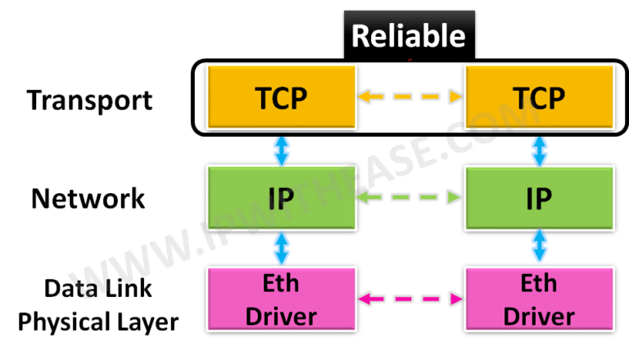Is the core protocol of Internet Protocol Suite. Transmission Control Protocol originates from the implementation of the network, which complements the Internet Protocol. Hence, Internet Protocol Suite is often referred to as TCP / IP. TCP provides a method of reliably distributing an octet stream (a block of data of size 8 bits) over an IP network. The main feature of TCP is its ability to issue commands and check for errors. All major Internet applications like the World Wide Web, email and file transfers rely on TCP.

Figure 6 Transmission Control Protocol

* ***Hypertext Transfer Protocol (HTTP)***

Hypertext transfer protocol. they're one among the five standard Internet protocols. This protocol is employed to speak between a service provider (Web server) and a service machine (Web client). They add the Client / Server model used for the planet Wide Web (www).

The default HTTP port is: 80.

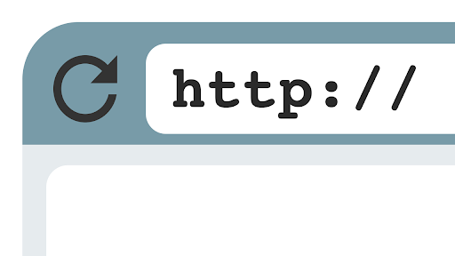

Figure 7 Hypertext Transfer Protocol

* ***File Transfer Protocol (FTP)***

File transfer protocol. and therefore the direction is employed to exchange files over network communications using the TCP / IP protocol.

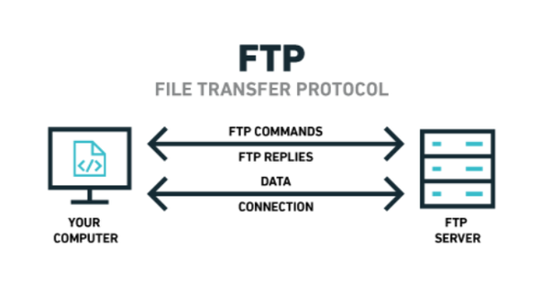The default FTP port is 20/21.

Figure 8 File Transfer Protocol

* ***Secured Shell (SSH)***

May be a network protocol wont to establish a secure network connection. SSH operates at the upper layer of the TCP / IP subclass model. SSH are often said to be the most method wont to securely manage network devices at the command level. it's replacing Telnet for safer security.

The default SSH port is 22.

* ***Telnet (Terminal Network)***

Is that the primary method wont to manage network devices at the command level. Or they're used over connections to the web or connections at an area computer LAN.

Telnet's default port is 23.

* ***Simple Mail Transfer Protocol (SMTP)***

Simple mail transmission protocol, may be a standard for the transmission of email over the web . Their primary function is to maneuver email from the source mail server to the destination mail server and to maneuver email from the top user to the mail system.

The default SMTP port is 25 and therefore the SMTPS port (secured) is 465.

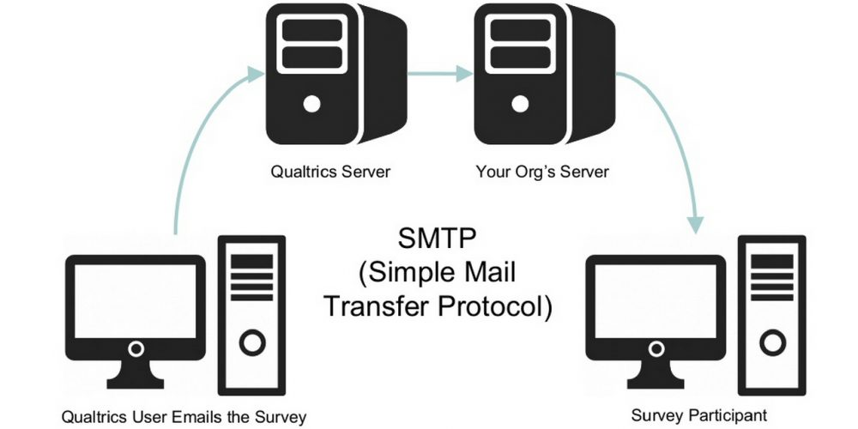

Figure 9 Simple Mail Transfer Protocol

* ***Domain name System (DNS)***

Name resolution system. This technique may be a system that permits to determine correspondence between IP address and name on the web . because of this protocol it's possible to convert domain names into IP addresses.

The default DNS gateway is 53.

* ***Post Office Protocol version 3 (POP3)***

Is an application layer protocol, wont to retrieve email from the mail server, over a TCP / IP connection. In version 3 this enables the client to urge complete content from the server's mailbox and delete the content from that server.

The default POP3 port is 110 and therefore the secure POP3 port is 995.

* ***Internet Message Access Protocol (IMAP)***

Is that the standard Internet protocol employed by email applications to retrieve email messages from a mail server over a TCP / IP connection. IMAP doesn't delete content from the server mailbox.

The default IMAP port is 143 and therefore the secure IMAP port is 993.

* ***Simple Network Management Protocol (SNMP)***

May be a set of protocols that not only allows checking network devices like routers, switches, servers ... to work , but also support the optimal operation of those devices. The SNMP function is to remotely monitor, configure and control network devices. SNMP traps also can be configured on network devices to notify when there's specific activity.

The SNMP default port is 161/162.

* ***Hypertext Transfer Protocol over SSL / TLS (HTTPS)***

May be a protocol that mixes the HTTP protocol and therefore the secure SSL or TLS protocol to permit secure exchange of data over the web .

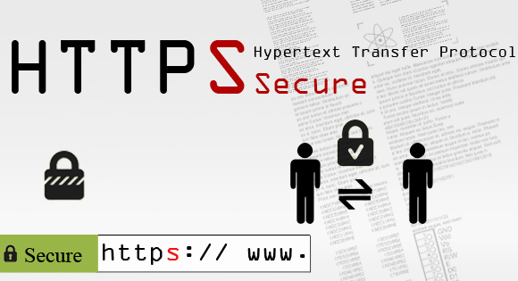HTTPS default port is 443.

Figure 10 Hypertext Transfer Protocol over SSL / TLS

### Server hardware (P2)[2]

#### Overview of server

The main server is a complex system tasked with storing data sources, processing and accessing information from other computers over the Internet connection. The server hardware devices for complete setup are similar to desktop computers (also known as PCs), but the main difference is the reliability and performance of the server much higher than the machine. common sense.

Depending on the server's application there will be different hardware requirements for that server. The task of the server is to provide services to many users on a network so the requirements will inevitably be different.

Servers typically operate for long periods of time, uninterrupted, requiring very high availability, so hardware reliability and durability are extremely important. Because of this, when choosing a server, users should choose branded and reputable lines. Many server hardware configurations take a long time to boot and load the operating system. Servers typically do memory checks before booting and starting up remote management services.

The hard drive controllers then boot the drives continuously, not all at once, so as not to overload the power supply with incremental startup, and then they start running to the system. RAID requires testing for correct redundant device operation. It may take longer than a computer that only takes a few minutes to boot, but it may not need to restart for months or years.

#### Components of the server system

* ***Server board:***

If the motherboards of the common PC are mostly running on the old chipsets like Intel 845, 865 or the new Intel 945, 975, ... then the Chipsets of the motherboards of the Server hardware are commonly used. using specialized chipsets like Intel E7520, Intel 3000, Intel 5000X,…. with the power to support high-speed communication like RAM ECC, HDD SCSI - SAS, Raid or support to mount multiple Xeon series CPUs,….

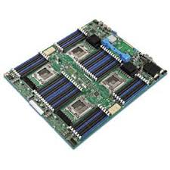

Figure 11 Server board

* ***Processor (CPU):***

For normal PCs you employ Socket type 478, 775 with Pentium 4, Pentium D, Duo core, Quad core series, most of CPUs for server are Xeon series with completely different architecture, operating on sockets 771, 603, 604 with high L2 cache capacity, hard virtualization, other specialized scripts ... Some low-end servers still use Socket 775 CPU as their main processor.

Figure 12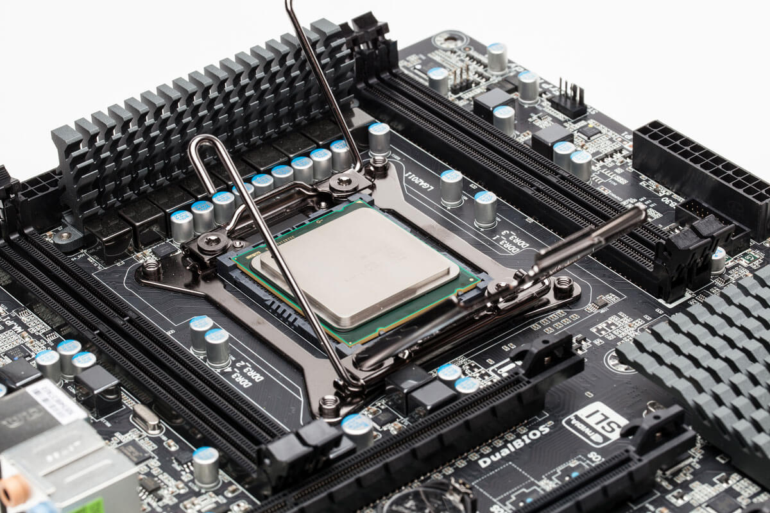 CPU

* ***Memory (RAM):***

The types of RAM that you simply often see on the market are the kinds of DDR RAM I, II with Bus 400, 800, ... while the RAM for Server also has such types but they even have ECC (Error Correction Code). ) helps your computer to not crash, dump the blue screen when there's any 1 bit error in processing . additionally , these sorts of RAM also can be hot-swapped for replacement when damaged without you having to pack up the system. Of course, to use this sort of RAM the motherboard must support this new standard of RAM.

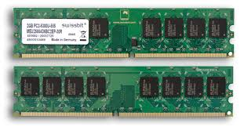

Figure 13 RAM

* ***Disk drive (HDD):***

Unlike the HDDs of the PC that sometimes have IDE, SATA I, SATA II interface with the very best rotation speed of 7200RPM and speed of 300MB / s, the HDD for Server operates on SCSI or SAS interface. (Serial Attached SCSI) features a higher bandwidth (600MB / s) and features a revolving rate nearly 30% higher (10,000RPM) or some new SAS drives even hit 15,000 RPM for max acceleration data read / write speed.

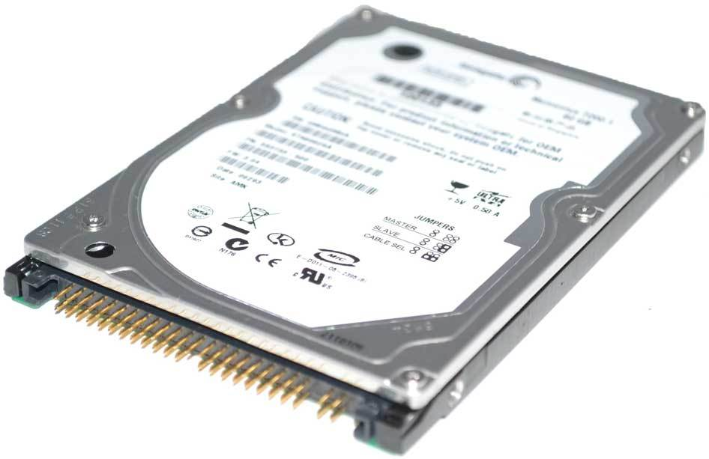

Figure 14 Disk drive (HDD)

* ***Raid controller board (Raid controller):***

This is a crucial component of the server hardware during a modern server, this controller board will combine the hard drives into a unified unit with backup and error prevention mechanisms to assist keep your data safe. There are physical problems.

Depending on the board, the power to support different levels of raids but Raid 1 and Raid 5 are common in most servers. Some server boards have this controller chip inbuilt , so you'll not need it.

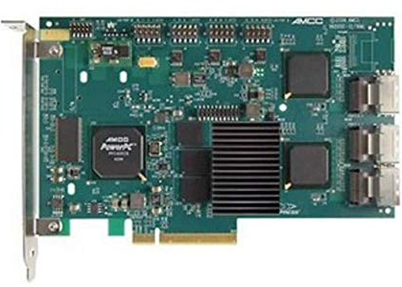

Figure 15 Raid controller board

* ***Power supply unit (PSU):***

The components that power the interior devices play a crucial role within the server's operation, so dedicated server lines often accompany replaceable real power sources. or backup when the most power supply fails.

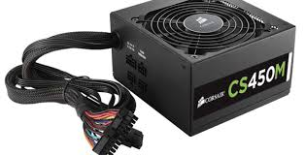

Figure 16 Power supply unit (PSU)

#### Types of servers

* ***Tower Server:***

As a vertical server, almost sort of a PC case, they operate quite sort of a personal computer . With a compact design, but can expand by upgrading RAM, CPU, disk drive , ... great for a rapidly growing business.

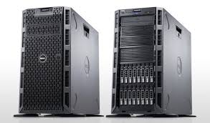

Figure 17 Tower Server

* ***Rack - mount Server (Server rack):***

As a lying server, take up less space and may stack many things during a rack and operate with more needs. There are many brackets inside a rack, many standard sizes to settle on from and may be pulled out and inserted easily sort of a drawer. It processes and monitors its own energy.

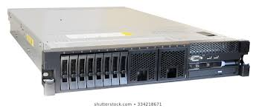

Figure 18 Rack - mount Server (Server rack):

* ***Blade Server:***

As the newest architecture they're now replacing traditional server servers like tower or rack-mount. Blade is modular, compact and straightforward to assemble. Blade servers are the newest in server technology. Blades use compact hard drives that don't hold their own power sources. this suggests it'll process the matter faster.

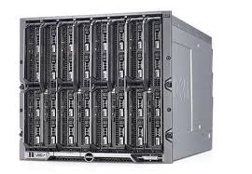

Figure 19 Blade Server

### Server software[3]

#### Operating Systems

* ***Definition:***

An Operating Systems (OS) may be a piece of software running on a computer, used to operate and manage hardware devices and software resources on the pc . The OS acts as an intermediary for the communication between the user and therefore the hardware , providing an environment during which the user can develop and execute their applications with ease.

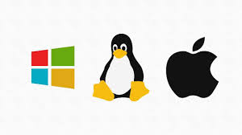

Figure 20 Operating Systems

* ***Types of operating systems:***

***Windows Server***: is that the OS line produced by Microsoft Corporation with a friendly interface, familiar to users who are already conversant in Windows. The newest version of the family for this OS is Windows Server 2012.

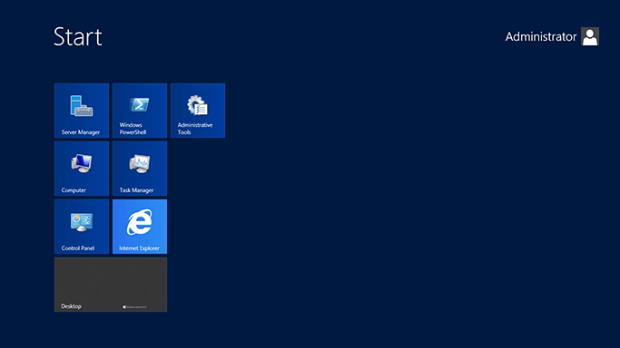

Figure 21 Windows Server

***Linux***: The open source OS was invented by Linus Torvalds in 1991. Nowadays, Linux is continuously developed by programmers round the world. The specialty of Linux is that it's completely free and features a higher level of reliability compared to Windows. Most servers today use this OS.

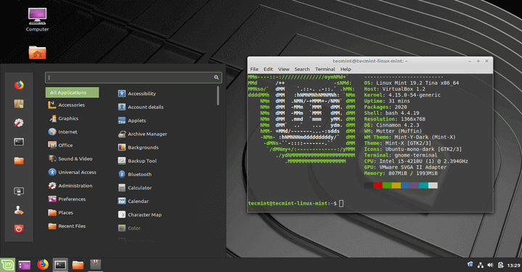

Figure 22 Linux

***Mac OS X Server***: may be a server OS produced by Apple, including tools to facilitate workgroup management of the OS X series, and supply network services. This OS is employed on Mac Pro and Mac Mini servers running OS X. the newest version is codenamed Mavericks Server (OS X 10.9) released on October 22, 2013.

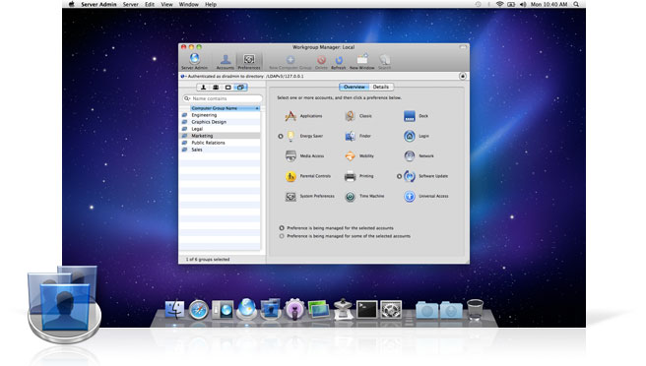

Figure 23 Mac OS X Server

#### Web server

* ***Definition:***

Web server means web server, which may be a mainframe connected to an in depth set of computer networks. The server contains all data that it's authorized to manage. Each server has its own IP and may read various languages like HTML, HTM, File, ... The server has large capacity and really high speed to be ready to store and operate well data warehouse on the web . Through each server's separate communication port, the pc system is in a position to work more smoothly. The server must ensure continuous operation to be ready to provide data to its network of computers.

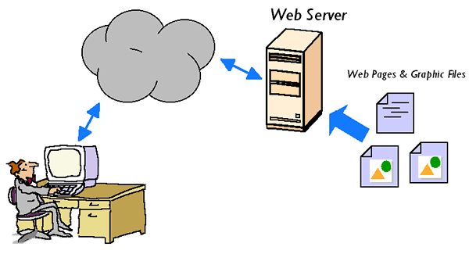

Figure 24 Web Server

* ***Web server software***

Table 4 List of most popular web server software

|  |  |  |
| --- | --- | --- |
| **Software** | **Supplier** | **Percentage** |
| Apache HTTP Server | Apache | 44.8% |
| IIS | Microsoft | 8.4% |

***Apache HTTP Server***

Apache HTTP Server (commonly mentioned as Apache) is an open source and cross-platform web server software. Apache is released under the Apache License 2.0 license, and actually the Apache license is additionally one among the foremost popular sorts of open source licensing. Apache is developed and maintained by an open community of the many open developers under the umbrella of the Apache Software Foundation.



Figure 25 Apache http server

***IIS***

IIS (short for Internet Information Services) may be a web server software created by Microsoft and developed to be used on Windows operating systems. IIS supports HTTP, HTTP / 2, HTTPS, FTP, FTPS, SMTP and NNTP.

It are often said that IIS is that the oldest server software, first released on May 30, 1999. IIS is written in C ++ and works on all versions of Windows NT OS . IIS has an equivalent license format as Windows NT license and therefore the latest version is IIS 10.0.x.x.



Figure 26 IIS

### Host Operating System

#### What is host operating system

With the pairing of computers into the network, it's necessary to possess a software with the function of managing resources, calculating and processing unified access on the network. Each network resource like files, disks, and peripherals is managed by a specific process, and therefore the host OS controls the interaction between the processes and access to those processes. supported the resource access on the network, people divide the entities within the network into two sorts of server and client, where the client can access the network's resources but might not share its resources. with the network, while the server (Server) is that the computer on the network and shares its resources with other network users. Currently, server operating systems are generally divided into two categories: peer-to-peer operating systems and differentiated network operating systems (client / server). With a peer-to-peer OS , each computer on the network can act both as host and guest, meaning that they will both use the network's resources and share its resources with the network. With a network OS , computers are distinguished between the host and therefore the client, during which the server is that the server and therefore the machines for the user to be the client. When there's a requirement to access resources on the network the stations make requests and send them to the server then the server executes and sends the response.

#### Main functions of the OS

In principle, an OS should satisfy the subsequent two main functions:

Resource sharing management.

Emulates an expansion machine.

In addition, you'll divide the functions of the OS consistent with the subsequent four functions:

Process management.

Memory management (memory management).

Management of storage systems.

User interaction.

#### The tasks of the OS

Direct control and management of hardware like motherboard, graphics card and sound board, ...

Performs some basic computer operations like reading, writing files, managing the filing system (file system) and data warehouses.

Providing a primitive interface system for applications is usually through a library of ordinary functions that operate the hardware from which the applications can call.

Provide a basic command system to work the machine. These commands are called system commands.

In addition the OS , in some cases, also provides basic services for common application software like Web browsers, word editors, etc.

#### Relationship

Relationship between communication protocols, server hardware, operating systems and web server software with regards to designing and accessing a website:

To begin with, communication protocol may be a system of rules that allow two or more entities of a communication system to transmit information through any quite variation of physical quantity and represents an agreement between communicating devices. Similarly, without a protocol just two devices will be connected but can't be communicated and protocol defines the format of packets and therefore the rules for communicating them across the network also as different protocol provide different levels of service such as simple error correction, multimedia data retrieval et al. too. Additionally, there are four components of data communication and that they are Message, sender, receiver, transmission medium and protocol also as there are many properties of a transfer that a convention can describe.

Similarly, Web server hardware helps to deliver web page which will be accessed through the web and it matters the online traffic because it's got to be ensured that HTTP requests are serviced within minimum response time and web server hardware also matters the customer’s view through which it’s considered to be rude if service provider make his customer wait mainly on the online . Similarly, web server computer uses multiple processor and few desktop PCs have quite one processor and there are differing types of server hardware like web servers, mail servers and file servers and therefore the work of web servers is that it run Apache HTTP server which give access to websites over the web .

Additionally, the web server software runs Apache or Microsoft IIS, which is provided access to the pages hosted on the web. Most Web servers are connected to the web via a high-speed connection, offering OC-3 or faster data transmission rates and any computer are often used as web server until it connects with the web and it's a program that uses HTTP to serve the files from sites to user as well because it consists of physical server, server OS and therefore the software which is employed facilitate HTTP communication.

Moreover, to work those web server hardware, software and communication protocol a OS is needed which knows as host OS and host OS uses container-based virtualization through which containers are logical partitions that's wont to separate application on an equivalent server and allows application on an equivalent server to share an equivalent OS but still provide hardware isolation. The most benefits of host OS are that it can use multiple OS environments on an equivalent computer and when a virtualization machine is made then it also creates a virtual hard disc through which all the info are going to be store therein virtual hard disc and if it's crashed then it will not affect the host machine.

Finally, to publish and for accessing the web site communication protocol, web server hardware, software and OS is required if anyone is absent then we cannot publish or access the web site . Similarly, to publish the web site both web server hardware and software is required and to speak or send message to the admin communication protocol is required also . additionally , website is published by hosting so host OS is additionally required and that they are interconnected with one another if one isn't working then website won't function or work properly. eventually all the components are required to publish and access the web site.

**CONCLUSION**

Through this report, I feel that I have gained a lot of knowledge after studying the Web subject. This knowledge can help me in the future. I would like to thank the instructors and friends at BTEC for helping me complete this report.

Through the report I have gained some knowledge such as: P1: I know the concepts and definitions of DNS, its importance. What is the purpose of DNS in the network? Learn how Domain names work. Types of DNS, how to organize DNS, how DNS works, what kinds of domain names are there, ... M1: Tell me the concepts and properties related to server hardware, server software. Related server and database requirements. Some software and structure. P2 Through here I know the basic concepts of communication protocol. Know some of the most popular typical communication protocols. Concepts and information related to them. Some server concepts, the critical operating system of the computer, Hosting in the network, the main function of the operating system, the main tasks of the operating system and the relationship between them. M2 Through M2 I know the importance and impact of SEO. Some popular browsers, how SEO works, why SEO is necessary, some benefits and advantages of SEO, ... P3 Discuss the capabilities and relationships between front-end and back-end website technologies and explain how these relate to presentation and application layers. I know the concepts of front-end and back-end. The corresponding languages ​​and tools work. From that knowledge, a relationship between front-end and back-end is drawn.M3 I evaluate a wide range of tools and techniques available to design and develop a custom built website. Then, get experience and work.P4 Describe sample web design tools, their functions, and how they work. Then give the advantages and disadvantages of templates and custom built.

Nowadays, a website is very important for everyone who wants to expand their business through the web. In website development, different tools and techniques are used for many different purposes. In my custom built website, I used HTML, CSS, and JavaScript for front-end development where PHP is used for back-end development. Shop Online's website has been built with the help of multiple software such as Photoshop, Wireframe Sketcher, VS Code and XAMMP.

**Critical Evaluation**

**REFERENCES**

[1] Arends, R., Austein, R., Larson, M., Massey, D. and Rose, S., 2005. *DNS security introduction and requirements* (pp. 1-21). RFC 4033.

[2] Kubala, J.P., International Business Machines Corp, 1996. Method and apparatus for providing a server function in a logically partitioned hardware machine. U.S. Patent 5,564,040.

[3] Feller, J. and Fitzgerald, B., 2002. Understanding open source software development. London: Addison-Wesley.

[4] Bochmann, G. and Sunshine, C., 1980. Formal methods in communication protocol design. IEEE Transactions on communications, 28(4), pp.624-631.

[5] Dover, D. and Dafforn, E., 2011. Search engine optimization (SEO) secrets. Wiley publishing.

[6] Smith, P.G., 2012. Professional Website Performance: Optimizing the Front-End and Back-End. John Wiley & Sons.

[7] Elling, S., Lentz, L. and De Jong, M., 2007, September. Website evaluation questionnaire: development of a research-based tool for evaluating informational websites. In International Conference on Electronic Government (pp. 293-304). Springer, Berlin, Heidelberg.

[8] Cebi, S., 2013. Determining importance degrees of website design parameters based on interactions and types of websites. Decision Support Systems, 54(2), pp.1030-1043.