03_model-analysis_infection-endpoint_status

Bryony Allen

09/05/2019

# Part 1: Import data

**N.B.** At the moment this code chuck reads in a .csv file with endpoint infection data, originally compiled in excel and then cleaned in “02_tidy_data-qpcr”script. In the future you will read in the .csv file of merged qPCR outputs (created, checked and cleaned in “02_tidy_data-qpcr”script) and experiment metadata (checked and cleaned in “02_tidy_data-metadata”script).

## Observations: 321  
## Variables: 26  
## $ ID <fct> A1.1, A1.2, A1.3, A1.4, A1.5, A1.6, A1...  
## $ Species <fct> Bb, Bb, Bb, Bb, Bb, Bb, Bb, Bb, Bb, Bb...  
## $ ExperimentNo <int> 1, 1, 1, 1, 1, 1, 1, 1, 1, 1, 1, 1, 1,...  
## $ Scenario <fct> Coinfection, Coinfection, Coinfection,...  
## $ Treatment <fct> Rv-Bd, Rv-Bd, Rv-Bd, Rv-Bd, Rv-Bd, Rv-...  
## $ Exposure.1 <fct> rv, rv, rv, rv, rv, rv, rv, rv, rv, rv...  
## $ Exposure.2 <fct> bd, bd, bd, bd, bd, bd, bd, bd, bd, bd...  
## $ endpoint.date <fct> 06/06/2018, 26/05/2018, 06/06/2018, 27...  
## $ endpoint.code <fct> EU, MORT, EU, MORT, EU, MORT, EU, MORT...  
## $ Bd.endpoint.status <int> 1, 1, 1, 1, 1, 1, 1, 1, 1, 1, 1, 1, 1,...  
## $ Bd.endpoint.CTmean <dbl> 30.94989, 37.30877, 32.19301, 36.65141...  
## $ Bd.endpoint.Qmean <dbl> 23.6021347, 0.4950310, 11.0839987, 0.7...  
## $ Rv.MCPendpoint.status <int> 0, 1, 0, 1, 0, 1, 0, 1, 0, 1, 0, 0, 0,...  
## $ Rv.MCPendpoint.CTmean <dbl> 0.00000, 24.75441, 0.00000, 22.90014, ...  
## $ Rv.MCPendpoint.Qmean <dbl> 0.000000e+00, 2.462007e+05, 0.000000e+...  
## $ Rv.EBF3Nendpoint.status <int> 0, 1, 0, 1, 0, 1, 0, 1, 0, 1, 0, 0, 0,...  
## $ Rv.EBF3Nendpoint.CTmean <dbl> NA, 33.46544, NA, 31.07020, NA, 34.558...  
## $ Rv.EBF3Nendpoint.Qmean <dbl> NA, 357.7631, NA, 1496.9165, NA, 182.4...  
## $ EMA.YN <int> 1, 0, 1, 0, 1, 1, 1, NA, NA, NA, NA, N...  
## $ EMA.date <fct> , NA, , NA, , , , NA, NA, NA, NA, NA, ...  
## $ EMA.GE.EMA <dbl> 0.004041085, NA, 0.479822159, NA, 0.00...  
## $ EMA.GE.WS <dbl> 0.026650012, NA, 0.005265172, NA, 0.00...  
## $ Bd.endpoint.GE <dbl> 236.021347, 4.950310, 110.839987, 7.37...  
## $ viable.GE <dbl> 0.004041085, NA, 0.479822159, NA, 0.00...  
## $ dead.GE <dbl> 0.022608927, NA, -0.474556987, NA, -0....  
## $ Rv.endpoint.load <dbl> NA, 1.376334e+03, NA, 9.135792e+02, NA...

# Part 2: Visualise data

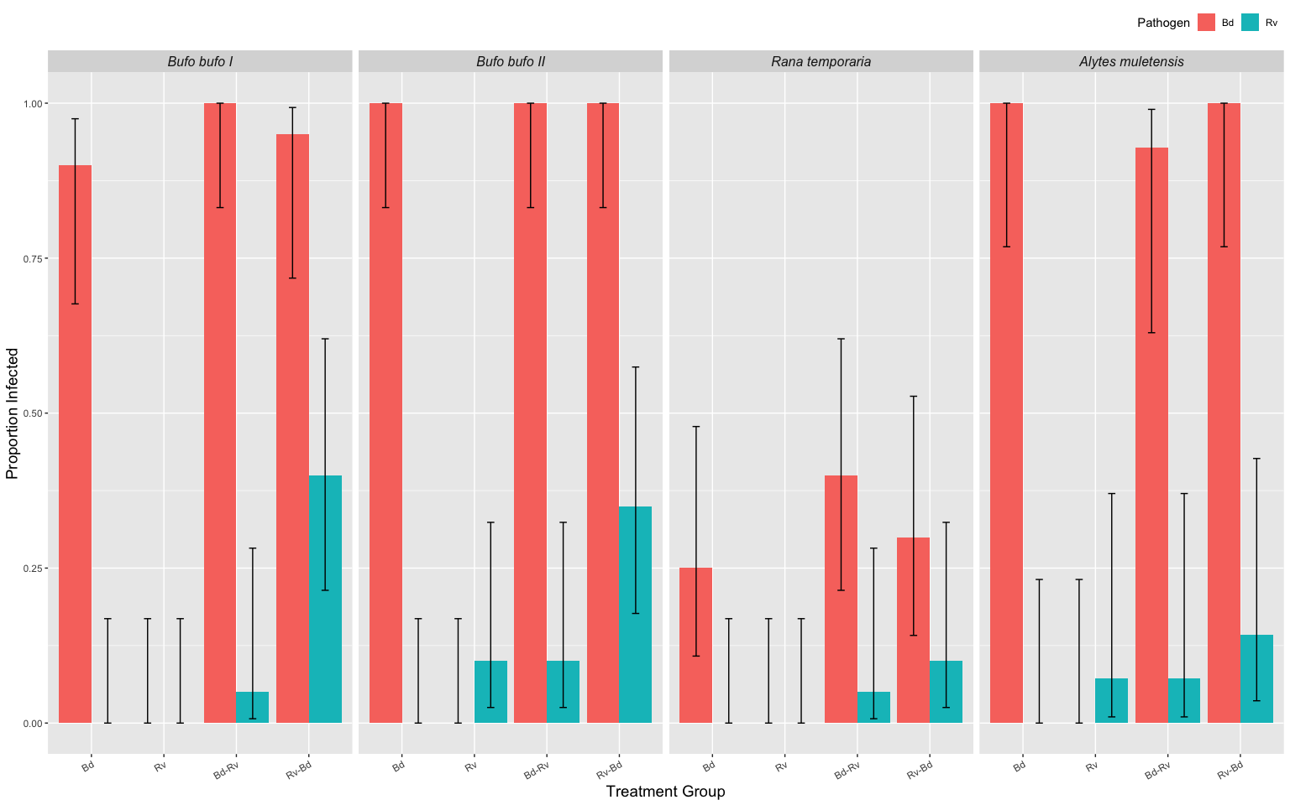

Fig.1. Proportion of individuals infected, by pathogen, within a treatment group for the three host species. Please note that Alytes II has been excluded.

# Part 3: Apply models to Endpoint Infection Status

Binomial GLM’s where  
 response variable = Endpoint status [binary; 0,1]  
 explanatory variable(s) = Treatment [categorical] & ExperimentNo. [categorical]

**N.B.** I use ExperimentNo as a proxy for species where

|  |  |  |  |  |
| --- | --- | --- | --- | --- |
| Experiment No. | Species | total Bd zsp’s | min. temp. (oC) | max. temp. (oC) |
| 1 | *Bufo bufo* I | 3,675,000 | 16.6 | 23.5 |
| 2 | *Bufo bufo* II | 1,443,750 | 16.7 | 27.6 |
| 3 | *Rana temporaria* | 2,336,250 | 16.7 | 27.6 |
| 4 | *Alytes muletensis* I | 472,500 | 15 | 16.6 |
| 5 | *Alytes muletensis* II | 294,759 | 15 | 16.6 |

… as this also accounts for Bd dose and room temperature variation between experiments.

## Part 3a: Endpoint Infection Status: **Bd**

Here I create a dataframe with the Rv-only treatment group removed (as they have never been exposed to Bd) and without *Alytes muletensis* babies as they only have one treatment group which I analyse seperately later.

Bd.status <- data.endpoint %>%  
 filter(!Treatment=="Rv") %>% # removal of Rv only treatment group   
 filter(!ExperimentNo=='5') %>% # removal of Alytes babies  
 mutate(ExperimentNo = as.factor(ExperimentNo)) %>%   
 select(ID, Species, ExperimentNo, Scenario, Treatment, Bd.endpoint.status, Bd.endpoint.GE)   
  
droplevels(Bd.status)

### Model Comparison

The four models:

Bd.status1 <- glm(Bd.endpoint.status ~ Treatment * ExperimentNo, data=Bd.status, family=binomial)  
  
Bd.status2 <- glm(Bd.endpoint.status ~ Treatment + ExperimentNo, data=Bd.status, family=binomial)  
  
Bd.status3 <- glm(Bd.endpoint.status ~ Treatment, data=Bd.status, family=binomial)  
  
Bd.status4 <- glm(Bd.endpoint.status ~ ExperimentNo, data=Bd.status, family=binomial)

Models compared using analysis of deviance with test='Chi' selected because of the binomial error family. This tests whether… “the more complex model is significantly better at capturing the data than the simpler model. If the resulting p-value is sufficiently low (usually less than 0.05), we conclude that the more complex model is significantly better than the simpler model, and thus favor the more complex model. If the p-value is not sufficiently low (usually greater than 0.05), we should favor the simpler model.”

anova(Bd.status2, Bd.status4, test="Chisq") # compares Trt and Sp to just Sp

## Analysis of Deviance Table  
##   
## Model 1: Bd.endpoint.status ~ Treatment + ExperimentNo  
## Model 2: Bd.endpoint.status ~ ExperimentNo  
## Resid. Df Resid. Dev Df Deviance Pr(>Chi)  
## 1 216 106.75   
## 2 218 108.19 -2 -1.4378 0.4873

anova(Bd.status2, Bd.status3, test="Chisq") # compares Trt and Sp to just Trt

## Analysis of Deviance Table  
##   
## Model 1: Bd.endpoint.status ~ Treatment + ExperimentNo  
## Model 2: Bd.endpoint.status ~ Treatment  
## Resid. Df Resid. Dev Df Deviance Pr(>Chi)   
## 1 216 106.75   
## 2 219 223.16 -3 -116.41 < 2.2e-16 ***  
## ---  
## Signif. codes: 0 '***' 0.001 '**' 0.01 '*' 0.05 '.' 0.1 ' ' 1

anova(Bd.status1, Bd.status2, test="Chisq") # compare more complex model to one with interaction

## Analysis of Deviance Table  
##   
## Model 1: Bd.endpoint.status ~ Treatment * ExperimentNo  
## Model 2: Bd.endpoint.status ~ Treatment + ExperimentNo  
## Resid. Df Resid. Dev Df Deviance Pr(>Chi)  
## 1 210 102.00   
## 2 216 106.75 -6 -4.7578 0.5752

ANOVA 1: suggests we should reject the more complex model (Treatment + ExperimentNo) in favour for just the model with ExperimentNo only (pvalue = 0.48)

ANOVA 2: suggests we should favour the more complex model (Treatment + ExperimentNo) over the model with Treatment only (pvalue = < .001) as adding ExperimentNo did lead to significantly improved fit

ANOVA 3: shows adding a interaction term between Treatment and ExperimentNo did not significantly imporve fit (p-value = 0.5752)

**Conclusion**: we should choose the model with just ExperimentNo (aka species)

### Model Fit:

To see the fitted values from a regression object (the values of the dependent variable predicted by the model), access the fitted.values attribute from a regression object with `$fitted.values.

names(Bd.status4) # look at the components of the glm object  
  
Bd.status$bi.glm <- Bd.status4$fitted.values # add logisitic fitted values back to the dataframe as a new col  
  
head(Bd.status)

### Model Plotting:

To plot the model you need a range of values for which to produce fitted values. Then use the predict() function to create the model for all the values. predict() gives you the predicted values based on your (fitted) linear model, the argument type=“response” will give you the predicted probabilities

Bd.status4 <- glm(Bd.endpoint.status ~ ExperimentNo, data=Bd.status, family=binomial)  
  
# create a dataframe of "new" data   
newdat <- expand.grid(ExperimentNo=c("1", "2", "3", "4"),Treatment=c("Bd", "Bd-Rv", "Rv-Bd"))  
  
# predict the value/result of the new data using the glm  
newdat <-cbind(newdat, predict(object = Bd.status4, # the model   
 newdata=newdat, se=TRUE, type="response", print.matrix=T)) # dataframe of new data   
newdat

## ExperimentNo Treatment fit se.fit residual.scale  
## 1 1 Bd 0.9500000 2.813657e-02 1  
## 2 2 Bd 1.0000000 4.416308e-06 1  
## 3 3 Bd 0.3166667 6.005399e-02 1  
## 4 4 Bd 0.9761905 2.352437e-02 1  
## 5 1 Bd-Rv 0.9500000 2.813657e-02 1  
## 6 2 Bd-Rv 1.0000000 4.416308e-06 1  
## 7 3 Bd-Rv 0.3166667 6.005399e-02 1  
## 8 4 Bd-Rv 0.9761905 2.352437e-02 1  
## 9 1 Rv-Bd 0.9500000 2.813657e-02 1  
## 10 2 Rv-Bd 1.0000000 4.416308e-06 1  
## 11 3 Rv-Bd 0.3166667 6.005399e-02 1  
## 12 4 Rv-Bd 0.9761905 2.352437e-02 1

expl.var <- c(1:3) # chose the range for the x-axis (Treatment)  
exp.labs <- c("1" = "Bufo bufo I", "2" = "Bufo bufo II", "3" = "Rana temporaria", "4" = "Alytes muletensis")  
  
# subset the data so you can plot each seperatly   
newdat1<- subset(newdat, ExperimentNo== "1")   
newdat2<- subset(newdat, ExperimentNo=="2")  
newdat3<- subset(newdat, ExperimentNo=="3")  
newdat4<- subset(newdat, ExperimentNo=="4")

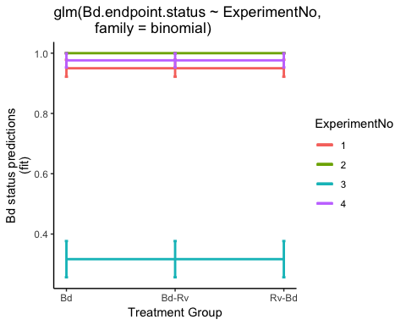

Fig. 2. Probability of Bd infection status (GE) predicted by model

?? **QUESTION** have I plotted this correctly? Wonder whether Experiment No. should be the explanatory variable ??

This is the model predictions for Bd status with ExperimentNo. and Treatment

## ExperimentNo Treatment fit se.fit residual.scale  
## 1 1 Bd 0.9321182 4.194738e-02 1  
## 2 2 Bd 1.0000000 6.122604e-06 1  
## 3 3 Bd 0.2406850 8.609302e-02 1  
## 4 4 Bd 0.9674240 3.322510e-02 1  
## 5 1 Bd-Rv 0.9658986 2.364628e-02 1  
## 6 2 Bd-Rv 1.0000000 2.968210e-06 1  
## 7 3 Bd-Rv 0.3953450 1.028446e-01 1  
## 8 4 Bd-Rv 0.9839377 1.725382e-02 1  
## 9 1 Rv-Bd 0.9519832 3.174231e-02 1  
## 10 2 Rv-Bd 1.0000000 4.240509e-06 1  
## 11 3 Rv-Bd 0.3139700 9.581011e-02 1  
## 12 4 Rv-Bd 0.9772097 2.396191e-02 1

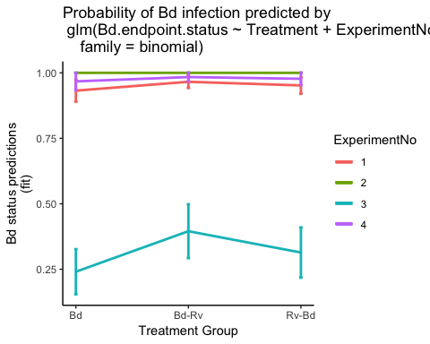

### Models Checks

Here I check the two best models.

#### Maximal Model: Species + Treamtent (no interaction)

Fit the most complex model first, with the main effects for ExperimentNo. and Treatment.

Look at the estimates of the coefficients using summary()

##   
## Call:  
## glm(formula = Bd.endpoint.status ~ Treatment + ExperimentNo,   
## family = binomial, data = Bd.status)  
##   
## Deviance Residuals:   
## Min 1Q Median 3Q Max   
## -2.87447 0.00007 0.17996 0.30114 1.68776   
##   
## Coefficients:  
## Estimate Std. Error z value Pr(>|z|)   
## (Intercept) 2.6197 0.6629 3.952 7.76e-05 ***  
## TreatmentBd-Rv 0.7240 0.6103 1.186 0.235   
## TreatmentRv-Bd 0.3673 0.6087 0.603 0.546   
## ExperimentNo2 16.6135 1379.7561 0.012 0.990   
## ExperimentNo3 -3.7686 0.6628 -5.686 1.30e-08 ***  
## ExperimentNo4 0.7714 1.1742 0.657 0.511   
## ---  
## Signif. codes: 0 '***' 0.001 '**' 0.01 '*' 0.05 '.' 0.1 ' ' 1  
##   
## (Dispersion parameter for binomial family taken to be 1)  
##   
## Null deviance: 223.83 on 221 degrees of freedom  
## Residual deviance: 106.76 on 216 degrees of freedom  
## AIC: 118.76  
##   
## Number of Fisher Scoring iterations: 18

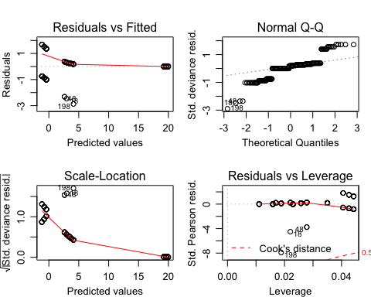

The diagnostic plots for glm(Bd.endpoint.status ~ Treatment + ExperimentNo) aren’t ideal - residual vs. fitted shows patterning meaning the variance is non-consistent - residual vs. leverage also shows patterning suggesting certain data points have strong influence

#### Simplified Model: Species

Now fit a simpler model has an with only ExperimentNo.

##   
## Call:  
## glm(formula = Bd.endpoint.status ~ ExperimentNo, family = binomial,   
## data = Bd.status)  
##   
## Deviance Residuals:   
## Min 1Q Median 3Q Max   
## -2.73411 0.00008 0.21953 0.32029 1.51651   
##   
## Coefficients:  
## Estimate Std. Error z value Pr(>|z|)   
## (Intercept) 2.9444 0.5923 4.971 6.67e-07 ***  
## ExperimentNo2 16.6216 1388.3372 0.012 0.990   
## ExperimentNo3 -3.7136 0.6541 -5.677 1.37e-08 ***  
## ExperimentNo4 0.7691 1.1727 0.656 0.512   
## ---  
## Signif. codes: 0 '***' 0.001 '**' 0.01 '*' 0.05 '.' 0.1 ' ' 1  
##   
## (Dispersion parameter for binomial family taken to be 1)  
##   
## Null deviance: 223.83 on 221 degrees of freedom  
## Residual deviance: 108.19 on 218 degrees of freedom  
## AIC: 116.19  
##   
## Number of Fisher Scoring iterations: 18

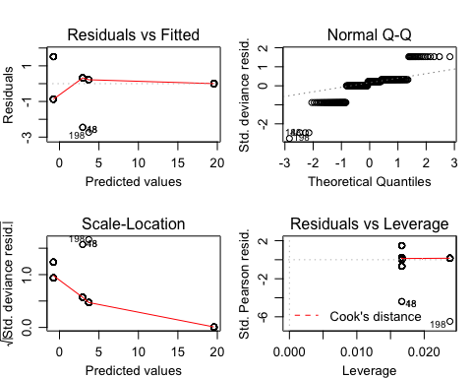

The diagnostic plots for glm(Bd.endpoint.status ~ ExperimentNo) aren’t much better

* residual vs. fitted shows patterning meaning the variance is non-consistent
* residual vs. leverage also shows patterning suggesting certain data points have strong influence

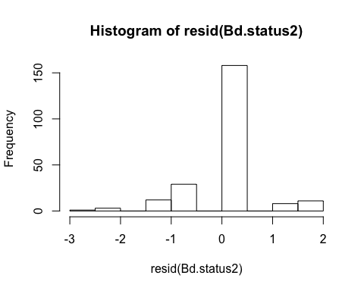

## Part 3b: Endpoint Infection Status: **Ranavirus**

Here I create a dataframe with the Bd-only treatment group removed (as they have never been exposed to Rv) and without *Alytes muletensis* babies as they don’t have Rv tratment groups.

Rv.status <- data.endpoint %>%  
 filter(!Treatment=="Bd") %>%  
 filter(!ExperimentNo=='5') %>%   
 mutate(ExperimentNo = as.factor(ExperimentNo)) %>%   
 select(ID, Species, ExperimentNo, Scenario, Treatment, Rv.MCPendpoint.status, Rv.endpoint.load)   
  
droplevels(Rv.status)

### Model Comparison

The four models:

Rv.status1 <- glm(Rv.MCPendpoint.status ~ Treatment * ExperimentNo, data=Rv.status, family=binomial)  
  
Rv.status2 <- glm(Rv.MCPendpoint.status ~ Treatment + ExperimentNo, data=Rv.status, family=binomial)  
  
Rv.status3 <- glm(Rv.MCPendpoint.status ~ Treatment, data=Rv.status, family=binomial)  
  
Rv.status4 <- glm(Rv.MCPendpoint.status ~ ExperimentNo, data=Rv.status, family=binomial)

Again models compared using analysis of deviance with test='Chi' selected because of the binomial error family. This tests whether… “the more complex model is significantly better at capturing the data than the simpler model. If the resulting p-value is sufficiently low (usually less than 0.05), we conclude that the more complex model is significantly better than the simpler model, and thus favor the more complex model. If the p-value is not sufficiently low (usually greater than 0.05), we should favor the simpler model.”

anova(Rv.status2, Rv.status4, test="Chisq") # compares Trt and Sp to just Sp

## Analysis of Deviance Table  
##   
## Model 1: Rv.MCPendpoint.status ~ Treatment + ExperimentNo  
## Model 2: Rv.MCPendpoint.status ~ ExperimentNo  
## Resid. Df Resid. Dev Df Deviance Pr(>Chi)   
## 1 216 139.25   
## 2 218 158.13 -2 -18.887 7.921e-05 ***  
## ---  
## Signif. codes: 0 '***' 0.001 '**' 0.01 '*' 0.05 '.' 0.1 ' ' 1

anova(Rv.status2, Rv.status3, test="Chisq") # compares Trt and Sp to just Trt

## Analysis of Deviance Table  
##   
## Model 1: Rv.MCPendpoint.status ~ Treatment + ExperimentNo  
## Model 2: Rv.MCPendpoint.status ~ Treatment  
## Resid. Df Resid. Dev Df Deviance Pr(>Chi)   
## 1 216 139.25   
## 2 219 146.02 -3 -6.7695 0.07962 .  
## ---  
## Signif. codes: 0 '***' 0.001 '**' 0.01 '*' 0.05 '.' 0.1 ' ' 1

anova(Rv.status1, Rv.status2, test="Chisq") # compare more complex model to one with interaction

## Analysis of Deviance Table  
##   
## Model 1: Rv.MCPendpoint.status ~ Treatment * ExperimentNo  
## Model 2: Rv.MCPendpoint.status ~ Treatment + ExperimentNo  
## Resid. Df Resid. Dev Df Deviance Pr(>Chi)  
## 1 210 133.60   
## 2 216 139.25 -6 -5.6442 0.4642

ANOVA 1: suggests we should favour the more complex model (Treatment + ExperimentNo) in favour for just the model with ExperimentNo only (pvalue = < .001) adding Treatment did lead to significantly improved fit

ANOVA 2: suggests we should reject the more complex model (Treatment + ExperimentNo) over the model with Treatment only (pvalue = 0.07962)

ANOVA 3: shows adding a interaction term between Treatment and ExperimentNo did not significantly imporve fit (p-value = 0.4642)

**Conclusion**: we should choose the model with just Treatment

### Model Fit:

To see the fitted values from a regression object (the values of the dependent variable predicted by the model), access the fitted.values attribute from a regression object with `$fitted.values.

## ID Species ExperimentNo Scenario Treatment Rv.MCPendpoint.status  
## 1 A1.1 Bb 1 Coinfection Rv-Bd 0  
## 2 A1.2 Bb 1 Coinfection Rv-Bd 1  
## 3 A1.3 Bb 1 Coinfection Rv-Bd 0  
## 4 A1.4 Bb 1 Coinfection Rv-Bd 1  
## 5 A1.5 Bb 1 Coinfection Rv-Bd 0  
## 6 A1.6 Bb 1 Coinfection Rv-Bd 1  
## Rv.endpoint.load bi.glm  
## 1 NA 0.2567568  
## 2 1376.3337 0.2567568  
## 3 NA 0.2567568  
## 4 913.5792 0.2567568  
## 5 NA 0.2567568  
## 6 811.7093 0.2567568

?? **QUESTION** Is this good enough ?? It looks like the model is struggling to predict the probability of Rv infection status accurately.

### Model Plotting:

## ExperimentNo Treatment fit se.fit residual.scale  
## 1 1 Bd-Rv 0.06756757 0.02917835 1  
## 2 2 Bd-Rv 0.06756757 0.02917835 1  
## 3 3 Bd-Rv 0.06756757 0.02917835 1  
## 4 4 Bd-Rv 0.06756757 0.02917835 1  
## 5 1 Rv 0.04054055 0.02292120 1  
## 6 2 Rv 0.04054055 0.02292120 1  
## 7 3 Rv 0.04054055 0.02292120 1  
## 8 4 Rv 0.04054055 0.02292120 1  
## 9 1 Rv-Bd 0.25675676 0.05078209 1  
## 10 2 Rv-Bd 0.25675676 0.05078209 1  
## 11 3 Rv-Bd 0.25675676 0.05078209 1  
## 12 4 Rv-Bd 0.25675676 0.05078209 1

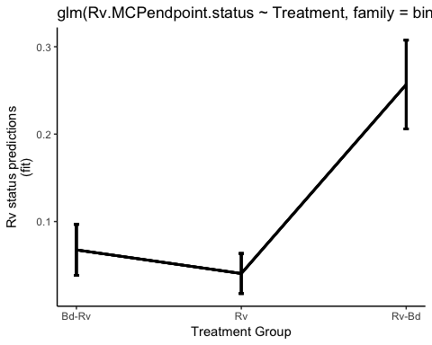

Fig. 3. Probability of Rv infection status (GE) predicted by model

?? **QUESTION** have I plotted this correctly? I think it makes sense, there is one overal effect of Treatment so i groups or has overlaid the ExxperimentNo./Species

### Models Checks

Here I check the two best models.

#### Maximal Model: Species + Treamtent (no interaction)

Fit the most complex model first, with the main effects for ExperimentNo. and Treatment.

Look at the estimates of the coefficients using summary()

##   
## Call:  
## glm(formula = Rv.MCPendpoint.status ~ Treatment + ExperimentNo,   
## family = binomial, data = Rv.status)  
##   
## Deviance Residuals:   
## Min 1Q Median 3Q Max   
## -0.9738 -0.4766 -0.3213 -0.2217 2.7269   
##   
## Coefficients:  
## Estimate Std. Error z value Pr(>|z|)   
## (Intercept) -2.3911 0.5616 -4.258 2.07e-05 ***  
## TreatmentRv -0.5467 0.7545 -0.725 0.46869   
## TreatmentRv-Bd 1.6181 0.5431 2.979 0.00289 **   
## ExperimentNo2 0.2731 0.5241 0.521 0.60234   
## ExperimentNo3 -1.3023 0.7170 -1.816 0.06931 .   
## ExperimentNo4 -0.5684 0.6675 -0.851 0.39453   
## ---  
## Signif. codes: 0 '***' 0.001 '**' 0.01 '*' 0.05 '.' 0.1 ' ' 1  
##   
## (Dispersion parameter for binomial family taken to be 1)  
##   
## Null deviance: 164.34 on 221 degrees of freedom  
## Residual deviance: 139.25 on 216 degrees of freedom  
## AIC: 151.25  
##   
## Number of Fisher Scoring iterations: 6

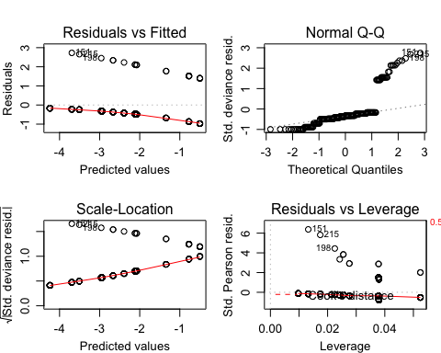

The diagnostic plots for glm(Rv.MCPendpoint.status ~ Treatment + ExperimentNo) again aren’t ideal

* QQ plot is iffy
* residual vs. fitted shows patterning meaning the variance is non-consistent
* residual vs. leverage also shows patterning suggesting certain data points have strong influence

#### Simplified Model: Treatment

Now fit a simpler model has an with only Treatment

##   
## Call:  
## glm(formula = Rv.MCPendpoint.status ~ Treatment, family = binomial,   
## data = Rv.status)  
##   
## Deviance Residuals:   
## Min 1Q Median 3Q Max   
## -0.7704 -0.3741 -0.3741 -0.2877 2.5320   
##   
## Coefficients:  
## Estimate Std. Error z value Pr(>|z|)   
## (Intercept) -2.6247 0.4631 -5.667 1.45e-08 ***  
## TreatmentRv -0.5394 0.7495 -0.720 0.47172   
## TreatmentRv-Bd 1.5618 0.5341 2.924 0.00346 **   
## ---  
## Signif. codes: 0 '***' 0.001 '**' 0.01 '*' 0.05 '.' 0.1 ' ' 1  
##   
## (Dispersion parameter for binomial family taken to be 1)  
##   
## Null deviance: 164.34 on 221 degrees of freedom  
## Residual deviance: 146.02 on 219 degrees of freedom  
## AIC: 152.02  
##   
## Number of Fisher Scoring iterations: 5

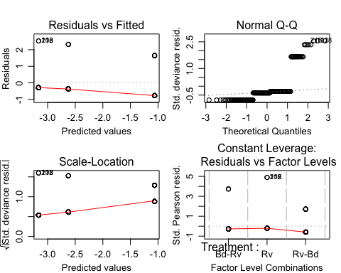

The diagnostic plots for glm(Bd.endpoint.status ~ Treatment) aren’t much better - I don’t understand why the residuals vs. fitted plot is so different this time ?!?