**Institute of Integrative Biology**

**Full-time PhD Biological Sciences**

**Progress Report 3**

**SESSION 2018 – 2019**

**Name of Student:** Bryony Allen[1]

**Names of Supervisors**: Professor Andy Fenton[2], Dr. Jenny Hodgson, Professor Trent Garner & Ben Tapley

**Title of Project:** From individual behaviour to population-level transmission: bridging disease ecology scales with the amphibian pathogen *Batrachochytrium dendrobatidis*.

Table of Contents

Progress and Development 2

A | Knowledge & Intellectual Abilities 2

B | Personal Effectiveness 2

C | Research Governance & Organisation 2

D | Engagement Influence & Impact 2

PhD overview 3

Project 1: Co-infection & shedding in a multi-pathogen / multi-host system 4

1 | Abstract 4

2 | Aims 6

3 | Methods 6

4 | Results 11

5 | Discussion & Further Work 13

Aims (updated): 16

Thesis Plan 16

References 17

Supplementary Material 21

# Progress and Development

To-date, I have successfully run four disease-challenge experiments, exploring how exposure scenario influences disease outcome (Project 1a) and the contributions of experimentally infected individuals to the environmental pool of infectious particles (Project 1b). I have processed and analysed the results from Project 1a, using the results to inform my plan for processing the shedding samples (Project 1b). I intend to process and analyse the shedding samples while based down with my CASE partner. The results from Project 1a have also shaped my objectives moving forwards in designing experiments for this year and overall for the PhD, see the Updated Aims section. The experimental design and ethics forms for this year’s experiments are currently being drawn up.

This year, I have shifted my focus to developing in the area of communication, engagement and outreach which I highlighted as an area of weakness in my first year. Since the last Progress Report, I have given four oral presentations, three poster presentations, and written a blog post for the general public. I have also taken the time this year to develop my programming and statistical skills, learning to use RMarkdown to generate reproducible reports and create a website page, and establishing a working GitHub repository.

## A | Knowledge & Intellectual Abilities

* Nov 2018 ZSL Symposium: Linking behaviour to populations and communities: how can behavioural ecology inform conservation?
* Mar 2019 Nature Masterclass - [workshop](https://masterclasses.nature.com)
* Apr 2019 ZSL Symposium and workshop: Mitigating single pathogen and co-infections that threaten amphibian biodiversity

## B | Personal Effectiveness

* Apr 2019 ACCE training: [Data and Project Management](https://shef.us14.list-manage.com/track/click?u=d65c2a01f942754b438678c9c&id=b509933efc&e=58c76629d2)
* Apr 2019 IIB training: Meet the Viva Panel

## C | Research Governance & Organisation

* Mar 2019 Nature Masterclass - workshop

## D | Engagement Influence & Impact

* Sep 2018 ACCE Student Conference 2018 - talk
* Dec 2018 BES Conference 2018 - poster
* Dec 2018 [EEGID website bio](https://eegid.wordpress.com/phd-students/bryony-allen/)
* Feb 2019 EEGID seminar - talk
* Mar 2019 IIB Faculty Poster Day - poster
* Mar 2019 IoZ Student Conference 2019 - talk
* Apr 2019 [ZSL website bio](https://www.zsl.org/science/users/bryony-allen)
* Apr 2019 ZSL Symposium: Mitigating single pathogen and co-infections that threaten amphibian biodiversity - poster
* Apr 2019 ZSL Symposium: Mitigating single pathogen and co-infections that threaten amphibian biodiversity - [blog](https://www.zsl.org/blogs/science/upping-the-threat-level-can-we-mitigate-combined-threats-to-amphibian-biodiversity) - *“Upping the threat level: can we mitigate combined threats to amphibian biodiversity?”*
* Apr 2019 ZSL Symposium: Mitigating single pathogen and co-infections that threaten amphibian biodiversity – social media – live tweeted from three accounts (@ZSLScience, @ParasiteSIG, and @livEEGID)
* Apr 2019 ZSL Symposium: Mitigating single pathogen and co-infections that threaten amphibian biodiversity - workshop - *“Strategies for dealing with coinfections.”*
* May 2019 ACCE training: [Communication and Media Training](https://acce.shef.ac.uk/event/acce-communication-and-media-training-2019/)
* May 2019 CASE partner: Progress Update – talk
* May 2019 EEID19: poster abstract selected

# PhD overview

Chytridiomycosis and Ranavirus are two emerging infectious diseases that infect a wide range of amphibian species globally. The observed mass mortality events in amphibian populations (Berger et al., 1998; Fox et al., 2006; Green, Converse, & Schrader, 2002), multiple species declines (Daszak et al., 1999b; Price et al., 2014; Stuart et al., 2004; Teacher, Cunningham, & Garner, 2010) and local extinctions (Lips et al., 2006) have been attributed to the multi-host nature, global distribution and virulence of both pathogens. The overlap between host species and global distribution increases the potential for complex host-pathogen dynamics, where multiple hosts can be parasitized by multiple pathogens.

Co-infection situations are common in wildlife (Hellard et al., 2015; Petney & Andrews, 1998; Rigaud, Perrot-Minnot, & Brown, 2010) and have been linked with an increase in susceptibility to subsequent infections (Lello et al., 2018). In theory, there are grounds to believe that the effect of infection by one pathogen, such as immune suppression (Grayfer et al., 2012) or resource depletion (Voyles et al., 2007) facilitates co-infection interactions and potentially leads to downstream differences in transmission according to host species and pathogen (Pedersen & Fenton, 2007). However, this remains an understudied area. The few field studies of amphibian populations which have sampled for both pathogens have recorded co-infection as commonplace (Reshetnikov et al., 2014; Rosa et al., 2017; Souza et al., 2012). However, experimental evidence of co-infection patterns in amphibians remains sparse. To date, the majority of information on co-infection occurrence comes from opportunistic, post-mortem sampling (Martel et al., 2012; Miller et al., 2008) which fails to capture any within-host dynamics.

While both pathogens are host generalist, significant heterogeneity exists in host susceptibility, infectiousness and burden of each disease, at a species and individual level. Thus, conforming to a wider body of literature showing host species unevenly contribute to disease transmission in multi-host communities (Begon et al., 1999; Duffus, Nichols, & Garner, 2014; Fenton et al., 2015; Fernández-Beaskoetxea, Bosch, & Bielby, 2016; Woolhouse et al., 1997). As a result, pathogen persistence at a community level is largely dictated by the composition of host species (Holt et al., 2003; Keesing, Holt, & Ostfeld, 2006). Host species have been recorded to perform different functional roles: reservoirs, who act as a source of infection enabling a pathogen to be maintained within a community (Fenton & Pedersen, 2005; Haydon et al., 2002); amplifiers, hosts which increase transmission often through increasing the number of pathogenic particles available and dilution hosts, which buffer against disease transmission in the population by absorbing infectious stages with no onward transmission (Johnson & Thieltges, 2010; Keesing et al., 2006; Logiudice et al., 2003; Searle et al., 2011).

Broadly, amphibian species infected with the fungus Batrachochytrium dendrobatidis (*Bd*), the pathogen causing Chytridiomycosis, have been found to follow the categories of host type outlined above (DiRenzo, Langhammer, Zamudio, & Lips, 2014a; Fernández-Beaskoetxea et al., 2016; Reeder et al., 2012; Searle et al., 2011). For example, Reeder et al. (2012) described a reservoir species that has *Bd* loads substantially higher than the load found to be lethal in a sympatric and declining species. Infection occurs by *Bd* zoospores establishing in the keratinized epidermis of metamorphosed amphibians or the mouthparts of larvae (Berger et al., 1998; Fellers, Green, & Longcore, 2001; Longcore, Pessier, & Nichols, 1999; Marantelli, Berger, Speare, & Keegan, 2004). Once developed the sporangia encyst releasing flagellated zoospore into the aquatic environment (Berger, Marantelli, Skerratt, & Speare, 2005; Longcore et al., 1999). These *Bd* zoospores shed from an infected host are fundamental to pathogen transmission, with amplifier hosts releasing dramatically higher numbers of zoospores (DiRenzo et al., 2014a).

Amphibian species are seen as a major reservoir for ranaviruses, large viral pathogens, which infect a broad range of ectothermic vertebrates (Granoff et al., 1965; Mao et al 1999; Gray et al., 2009; Schock et al 2008). Although, this variation in amphibian species response to the disease (Gray & Chinchar, 2015; Schock, Bollinger, Gregory Chinchar, Jancovich, & Collins, 2008) and the frequency at which secondary infections occur alongside ranavirus infections (Miller et al., 2008; Cunningham et al., 1996) make clinical signs of ranaviral disease challenging to discern, meaning diagnosis often depends on post-mortem confirmation.

# Project 1: Co-infection & shedding in a multi-pathogen / multi-host system

## 1 | Abstract

The notable, global decline of amphibians has been widely linked to parasitism; the two pathogens of greatest conservation concern being Ranavirus and *Batrachochytrium dendrobatidis* (*Bd*). While both pathogens have been studied extensively the majority of these studies have taken a one-host, one-pathogen approach. In nature, things are rarely that simple; pathogens often infect multiple host species and hosts can be parasitised by multiple pathogens. Increasingly, we are seeing field studies reporting co-infection occurring in multiple host species. Yet our understanding of these complex host-pathogen interactions and the implications on disease transmission and persistence within a host community remains limited.

To help unpick the tangled dynamics of this multi-host, multi-pathogen system we empirically tested how susceptibility, infectiousness and burden of disease changed with infection scenario (single vs coinfection) across a panel of host species (*Bufo bufo*, *Rana temporaria* and *Alytes muletensis*) that range in their reported susceptibility. We measured the contributions of each host, at an individual level, to the environmental pool of infectious particles, by quantifying Bd zoospores and ranavirus virion outputs for four days post exposure. Endpoint infection load of each host was also measured to link the hosts' infection burdens with their infectiousness. We also examined how *Bd* infection outcome is affected by larval developmental stage, in a highly susceptible species (*A. muletensis*), to see whether there are age-dependent patterns of *Bd* prevalence and load in larval amphibians.

We demonstrate that disease prevalence and infection burden is context dependent. Exposure to *Bd* resulted in infection detected in individuals across all host species and treatment groups with host species the greatest determiner of infection status and load. In particular, *Bufo bufo* exhibited higher *Bd* loads regardless of the exposure regime. In contrast, the exposure sequence best explained the extent of ranavirial infection across species with, significantly higher viral loads in co-infection scenarios, particularly when Bd was introduced before ranavirus.

Understanding the susceptibility and infectiousness of each host at an individual level allows us to predict how host species community composition influences the establishment and persistence of both pathogens, singularly and as coinfections, at the community level. Our study provides previously lacking empirical evidence of within-host and between-host dynamics under different infection scenarios (single vs co-infection).

**Key-words:** *Batrachochytrium dendrobatidis*, chytridiomycosis, ranavirus, coinfection, multi-host, within-host interactions, between-host interactions, host-pathogen interaction, amphibian

## 2 | Aims

1. Ascertain whether the exposure scenario (singel vs. co-infection) of two amphibian pathogens (*Bd* and Rv) alters the disease outcome for the host and subsequent transmission of the pathogens.
2. Establish the contributions of hosts to the environmental “pool” of infectious particles, across species at an individual level, to understand variations in host infectiousness and by proxy transmission.
   1. Understand how host infectiousness, measured by quantifying *Bd* zoospore and ranavirus virons shed into the water body, changes with the exposure regime in single pathogen vs. co-infection scenarios.
   2. Assess the viability of infectious particles shed into the aquatic environment.

## 3 | Methods

We collected, under licence, wild amphibian egg masses (*R. temporaria* and *B. bufo*) and reared them in an approved facility. For *A. muletensis*, larvae we received hatched tadpoles from the Zological Society of London’s Living Collections, after ethical approval. All eggs were hatched in captivity to minimise chances of disease exposure and sentinel individuals were tested for pre-experiment infection. Larvae were raised until free-swimming and of similar mass and developmental stage (Gosner 25; Gosner, 1960) before being transferred to the experimental room. Tadpoles were acclimatised to the experimental rooms and housed, individually, for 7 days prior to experimetnal procedures.

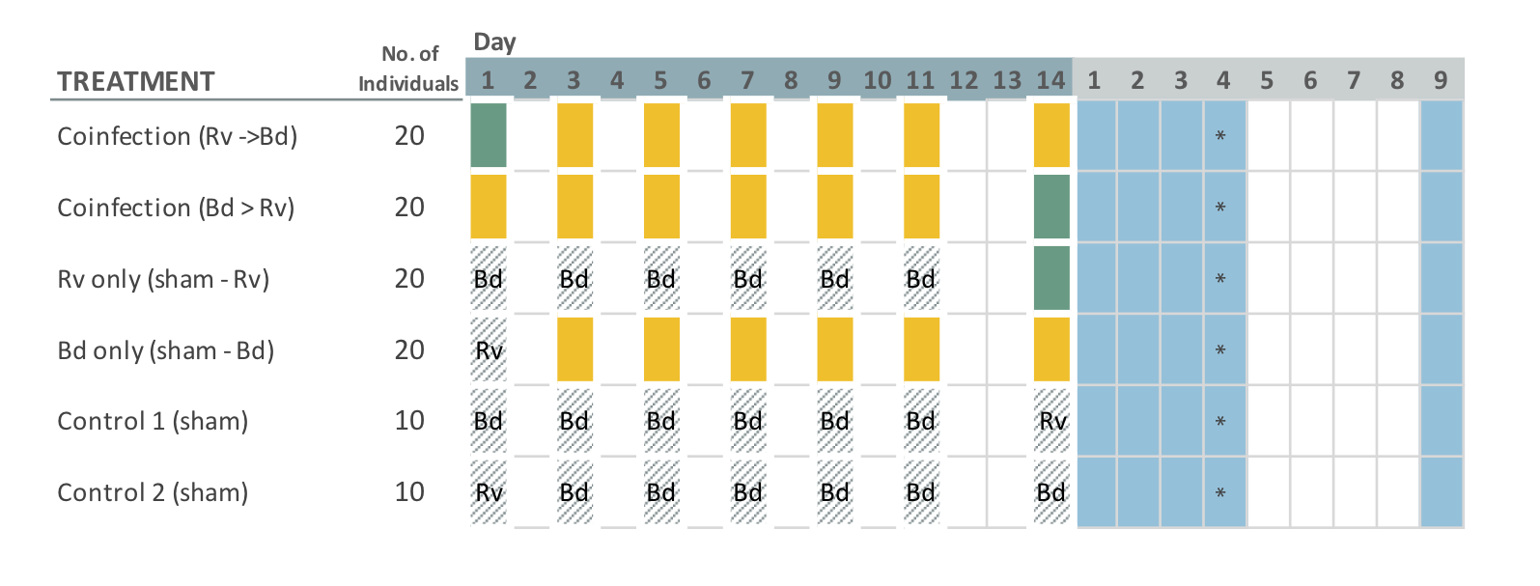

Figure 1. Schedule of exposures and sampling, by treatment group. A dose is denoted by a green (Rv) or yellow (Bd) coloured square, and sham doses are displayed as cross-hatched squares. The blue squares indicate when “soak” water samples were collected from individuals and filtered. EMA water samples (for quantification of viable Bd zoospores) are collected directly from the housing container and shown by an asterisk.

We ran the experiment as four sequential batches, split by species. In chronological order the experiments consisted of two *B.bufo* (n= 2 x 100), one *R.temporaria* (n= 100), and one *A.muletensis* (n=70). We randomly assigned individuals to one of five treatment groups which covered all single and co-infection scenarios (*Bd* only, Rv only, *Bd*-Rv and Rv-*Bd*), as outlined in Figure 1. Each treatment group consisted of 20 individuals per species, or 14 individuals for the *A.muletensis* I.

In addition, we conducted a parallel experiment alongside the *A.muletensis* batch to assess whether larval development stage influenced the infection success (prevalence and burden) of *Bd* on *Alytes muletensis*, a highly susceptible species. We compared the *A. muletensis* (referred to as *Alytes* I) Bd-only treatment group (n=14, Gosner 26-37; Gosner, 1960) to less developed tadpoles, *Alytes* II (n=37, Gosner 25; Gosner, 1960). Results from a previous experiment (Garner et al., unpublished) reveal that disease outcome in *Bufo bufo* was influenced by development stage, with earlier stages more likely to be infected and with a higher pathogen load than tadpoles exposed to *Bd* at a later development stage. Tadpoles of the Alytidae clade can have an extended larval development window, often overwintering before completing metamorphosis. Studies have shown that overwintering amphibian larvae act as a reservoir of disease, maintaining high infection loads which may allow them to reintroduction the pathogen to the following year’s larval cohort (Brunner et al., 2004; Fernández-Beaskoetxea et al 2016).

We exposed all larval individually to controlled doses of *Bd*, Rv or the correlating sham media (see Figure 1). Tadpoles were exposed to their respective dose by directly pipetting the inoculums into 0.075L Really Useful Boxes (here on referred to as housing container(s)) filled with 210mL aged tap water, after a 100% water change. Following the 6-hour exposure period, we raised the water volume to 375mL to maintain water quality. The *A.muletensis* I tadpoles being larger was housed in 1.7L RUBs with 1L aged tap water which we reduced to 520mL for exposure periods.

Individuals designated to receive ranavirus were exposed to a single dose of 105µL (or 263µL for *A.muletensis* I) meaning an effective exposure of 10 4.5 TCID50/ml of FV-3 like ranavirus. The dose was deemed suitable based on previous work where similar inoculums induced infection, but not rapid mortality as seen at higher dosages (Duffus et al., 2014; Pearman et al., 2004). For *Bd* exposures, we used an strain from the hypervirulent *Bd*GPL lineage (O’Hanlon et al., 2018) isolated during an epidemic at Ibón Acherito (Pyrenees, Spain) in 2013 by Prof. M. Fisher and cultured in the lab. A *Bd* positive dose consistent of 15,000 to 600,000 active zoospores in 210µL liquid media, or 525µL for *A.muletensis* II. Zoospore concentrations of each dose were quantified prior to exposure using a haemocytometer. The volume of media was standardised across doses in order to maintain water quality during the exposure period. The total number of *Bd* zoospores an individual was exposed to is shown in Table 1.

Table 1**.** Total number of *Bd* zoospores an individual was exposed by experimental batch.

|  |  |
| --- | --- |
| Experiment | Total zoospores |
| *Bufo bufo* I | 3,675,000 |
| *Bufo bufo* II | 1,443,750 |
| *Rana temporaria* | 2,336,250 |
| *Alytes muletensis* I | 472,500 |
| *Alytes muletensis* II | 294,759 |
|  |  |

The number of exposures to each pathogen was determined by the characteristics of the pathogens. Ranavirus is considered more pathogenic and able to generate infections from a single dose. In comparison, studies have shown that *Bd* infection is normally acquired by multiple exposures, with infection building over time, as opposed to one single, high dose (Daversa et al., 2018).

We conducted water parameter tests throughout the experiment, on both the housing and shedding containers, to test for nitrates, nitrites and ammonia levels. All larvae were fed 200µL of ground Tetra Tabimin tablets and Spirulina dispersed in double-distilled water to the ratio 1g/100mL, bar *A.muletensis* I who received double fed, every other day. The temperature of the animal rooms followed natural ambient conditions (averaging 20˚C ± 2) with a 14:10 light: dark schedule.

### 3.1 | Within-host Dynamics

#### Endpoint Tissue Samples

To compare host response to exposure scenarios across species we collected tissue samples from all individuals at a specified time point post-exposure. Nine days post-exposure (9 dpe; Day 23) tadpoles were euthanised, under licence, by buffered (pH 7.0) 5 mg/L tricaine methylsulfonate (MS-222) and then stored in 100% ethanol for subsequent molecular quantification of infection burden. The infection status (uninfected 0, infected 1) and pathogen load was recorded for both pathogens. Infection by *Bd* was confirmed by excision and DNA extraction of mouthparts, the site of *Bd* colonization and infection in tadpoles (Berger et al., 1998; Longcore, Pessier, & Nichols, 1999), using Prepman Ultra (Life Technologies) as per Hyatt et al. (2007). Extracts were screened by the qPCR diagnostic, targetting the ITS-1 and 5.8S regions, outlined in Boyle et al. (2004) with modifications from Garner et al. (2009). We express *Bd* infection load in genomic equivalents (GE) where one GE is equivalent to a single zoospore. We quantified ranaviral DNA from tissue samples by DNeasy Blood and Tissue (Qiagen) extraction following the manufacturer’s protocol. Tissues targeted were kidney, liver and intestine, known to be sites of ranaviral infection (Robert et al., 2011). DNA samples were then analysed with a qPCR assay specific to the ranaviral major capsid protein (MCP) sequence and normalised by host cell quantity as outlined in Leung et al. (2017).

### 3.2 | Between-host Dynamics

#### Shedding Samples

Water samples were obtained every day for the first four days and then again on day nine post-exposure, to capture the *Bd* reproduction cycle (DiRenzo, Langhammer, Zamudio, & Lips, 2014b; Garmyn et al., 2012) and Rv attenuation (Duffus et al., 2014). We modified the soak technique used by Di Renzo et al. (2014) and Reeder et al. (2012), increasing the soak period to 4 hours in 50ml of aged tap water to balance the need to sensitively detect zoospores/virions shed with the considerations of the tadpoles welfare needs. The soak water was filtered through a cellulose nitrate filter membrane (Nalgene Analytical Test Filter Funnel, ThermoFisher), 0.45um pore size to capture 1-2µm to 3-5µm zoospores (Berger, Speare, & Kent, 1999; Longcore et al., 1999), by a vacuum manifold. Following filtration, each membrane was removed from the filter unit, cut in half using a sterile scalpel blade, and stored at -20˚C for a week before being transferred to -80˚C until processing. After the last shedding period and water filtration (dpe 9) tadpoles were euthanised, under licence, by buffered (pH 7.0) 5 mg/L tricaine methylsulfonate (MS-222) and then stored in 100% ethanol. DNA extractions were performed for each filter membrane half. One half underwent extraction by Prepman Ultra (Life Technologies) following the procedure described in Hyatt et al. (2007) to target *Bd*. Whereas DNeasy Blood & Tissue kit was used to isolate Rv DNA following the protocol Goldberg et al. (2011) with the modifications outlined by (Kosch & Summers (2013). All DNA extractions will be assayed by quantitative polymerase chain reaction (qPCR) specific to each pathogen and run in duplicate. A positive result was scored if both wells amplify above the detection threshold when compared to the curve of standards.

#### Viability Samples

Quantification of viable zoospores shed into the housing container over the course of the shedding period (1 to 4 dpe) was achieved by ethidium monoazide (EMA) treatment following the protocol in (Blooi, Martel, Vercammen, & Pasmans, 2013). In brief, at 4 days post-exposure, two sub-samples were taken from the housing container, one to be treated with EMA and the other untreated before DNA extraction by Prepman Ultra, see Figure 2. EMA binds to dead zoospores penetrating their compromised membranes and blocks PCR amplification thus EMA treated samples represent the viable proportion of *Bd* zoospores in a sample compared to an untreated sample that records both the viable and dead fractions.

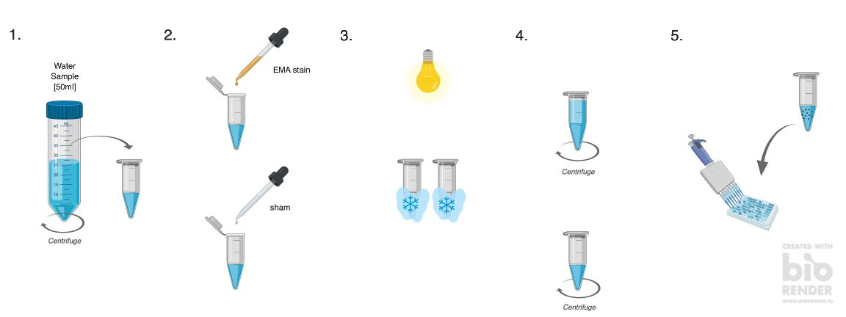

Figure 2. Viability staining protocol for quantification of live vs. dead Bd zoospores.

### 3.3 | Statistical Analysis

All analyses were conducted in R v.3.5.1 (RStudio Team, 2015) with the packages listed in the Supplementary Materials and scripts provided at my [GitHub](https://github.com/bea-22/P1_CoinfectionShedding_2018) repository.

### 3.3.1 | Within-Host Dynamics

To analyse the effect of exposure scenario (*Bd* only, Rv only, *Bd*-Rv and Rv-*Bd*) and host species (*B.bufo*, *R.temporaria* and *A.muletensis*) on infection status (uninfected vs. infected) and load, we used generalized linear model (GLMs). Each level of statistical comparison (exposure scenario, species) on the response variable (infection status or load) was carried out individually for each pathogen. For the probability of infection, we used a GLM with a binomial distribution. In the case of *Bd* status, we implemented a Bayesian GLM as separation was evident in the data, where a predictor perfectly predicts a binary response variable (Gelman et al., 2008). For infection load, where the response variable was recorded as GE score for *Bd* positive infections and as a normalised viral load for ranavirus, we used a GLM with Gamma error structure and log-link transformation. The Gamma error structure with a log-link transformation often provides a flexible distribution for skewed data that is always positive, such as in our case of non-zero infection loads. We verified the choice of distribution by comparing the goodness-of-fit of data to both Gaussian, Gaussian with log-transformed data, Gamma, and Gamma with log-link (to account for left skewed data). For both pathogen datasets, Gamma with the log-link function performed the best. We compared models with combinations of the explanatory variables (species and exposure scenario) using ANOVA tests for GLMs (χ2 for GLMs with binomial error structures and F for GLMs with Gaussian error structures). We implemented Tukey’s post hoc test to examine the significant effects of the explanatory variables highlighted as significant by the GLMs, using the glht function in the multcomp package.

All statistical analysis used experiment number as a proxy for species, to account for the slight variations in *Bd* dose. The effects of body size and weight were not included as these variables did not differ among treatment groups and are challenging to record accurately for larval amphibians. The control groups were excluded from all models as individuals were uninfected by design and did not develop detectable infections by either pathogen during the experiment. We have excluded *A.muletensis* II from the models looking at the pathogen infection status and load, as that experiment did not have the full range of exposure scenarios.

### 3.3.2 | Between-Host Dynamics

data pending

### 3.3.3 | Survival Analysis

Survivorship will be analysed using Cox proportional hazard models, again with exposure scenario and host species as explanatory vairables, with the ‘‘coxph’’ function and the Survival package.

## 4 | Results

Five tadpoles in the unexposed control groups experienced mortality (n=3) or were euthanised following ethics protocol (n=2), all tested negative for both pathogens. The mortality count for all experiments was low (n= 19) and confined to *B.bufo* (n=15) and *R.temporaria* (n=4) tadpoles (see Supplementary Materials for results). One *R.temporaria* tadpole in the Rv-only group died before the experiment endpoint otherwise all mortalities occurred in co-infection treatment groups (Bd-Rv, n=3; Rv-Bd n=15).

### 4.2 | Within-Host Dynamics

We detected substainally fewer ranaviral infections than Bd infection, across species and treatment groups (Rv, n= 27; Bd, n = 172; Figure 3). The majority of the ranavirus infections occurred in co-infection treatment groups (GLM; *Bd* - Rv Z = -5.667; p < 0.01, Rv - *Bd* Z = 2.924; p < 0.01). Exposure scenario predicted both infection status and load for ranavirus: tadpoles exposed to both pathogens were significantly more likely to develop ranaviral infections (binomial GLM; *Bd*-Rv Z = -5.667; p < 0.001, Rv-*Bd* Z = 2.924; p < 0.01; Table S4b), which were more likely to be at a high viral titre (GLM; *Bd*-Rv t = 3.561, p < 0.01; Rv-*Bd* t = 8.142, p < 0.001; Table S5b). The sequence of pathogen exposure influenced both the number of individuals infected with ranavirus and the viral load (Tukey, Rv-*Bd* - *Bd*-Rv p < 0.001, Figure 5) with exposure to Rv and then Bd accounting for a higher proportion of infected individuals (70%; Rv-Bd = 19, total infected = 27). Host species did not significantly improve the model fit for ranavirus infection status or load, nor did we detect an interaction between host species and treatment group/eposure scenario.

In constrast, host species predicted infection prevalence for Bd with *R.temporaria* tadpoles less likely to develop Bd infection (bayesGLM, *B.bufo* I Z = 5.314; p < 0.01; *B.bufo* II Z = 1.475; p = 0.140; *R.temporaria* Z = -5.994, p < 0.01; *A.muletensis* I Z = 0.600, p = 0.549; Table S4a). The tadpoles in both *B.bufo* batches developed significantly high infection loads (GLM; *B.bufo* I t = 3.561, p < 0.01; *B.bufo* I t = 31.708, p < 0.01; *B.bufo* II t = -1.289, p = 0.199; *R.temporaria* t = -10.530, p < 0.001; *A.muletensis* I t = -8.873, p < 0.001; Table S5a) with no difference between batches (Tukey, *B.bufo* II- *B.bufo* I p = 0.562, Figure S2b), despite variation in the total number of Bd zoospores used for exposure. While the total dose of *Bd* zoospores varied between experiments, all experimental exposures are considered high dose.

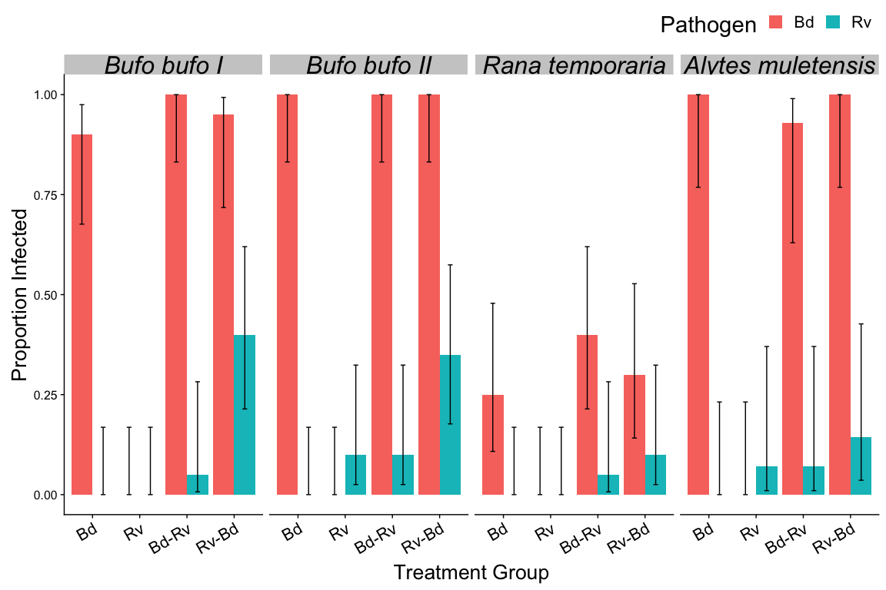

Figure 3. Proportion of individuals infected at endpoint (Day 23) as an outcome of pathogen exposure scenario and host species. The negative control groups are not included as they have no infection status. Error bars are binomial confidence intervals calculated using logit parameterization.

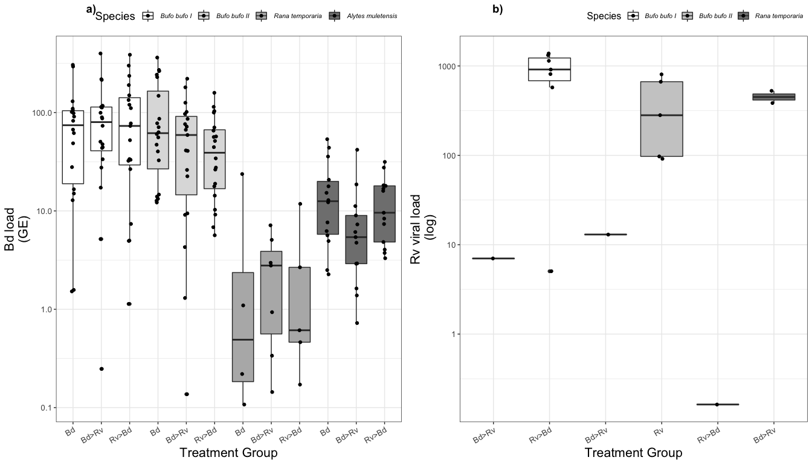

Figure 4. Mean non-zero infection burden, at endpoint (Day 23), as a function of exposure scenario/regime and host species. a) Bd load quantified as genomic equivalents (GE) where 1 GE represents 1 Bd zoospore, for individuals over the 0.1 GE detection threshold. b) normalised ranaviral load (see Leung et al.’s (2017)). Error bars are standard errors. The negative controls are not included as they receive no pathogen exposure and therefore have no infection status.

### 

Figure 5. ﻿Post hoc Tukey tests output for Ranavirus infection status.

### 4.3 | Between-Host Dynamics

results pending

## 5 | Further Work

### Project 3: Priority and dose-dependent ﻿effects of ranavirus exposure in co-infection scenarios

The exposure regimes and dose used in **Project 1** reflects that seen in the wild. Infections are often seasonal, particularly in the case of larval animals as they have a short window in the aquatic environment (Gray et al., 2015). However, the experimental sampling regime for Project 1b required a lower dose of ranavirus that would establish an infection but not cause rapid mortality.

Studies into dose-dependent responses to ranavirus infection in larval amphibians indicate that there is a threshold, over which mortality occurs rapidly (Duffus et al., 2014; Warne et al., 2011). In our study we saw a limited number of ranavirus infections with the ranavirus only treatment group experiencing the lowest proportion of infections and pathogen load. Co-exposure to Bd, particularly after ranavirus exposure increased ranaviral load within an individual.

The sequence of exposure in the co-infection treatment groups could be influencing the resulting infection burden of the host, as identified in many co-infection systems (Hoverman, Hoye & Johnson, 2013; Pathirana et al., 2019). While *Bd* and ranavirus are antigenically distinct and spatial separated by their tissue tropisms the effect of infection by one pathogen, such as immune suppression (Grayfer et al., 2012) or resource depletion (Voyles et al., 2007) can determine infection outcome of secondary pathogen.

We hypothesis that the dose-dependent threshold for infection shifts with Bd exposure. In **Project 3** we will investigate how dose of ranavirus and the sequence of exposure in co-infection scenarios influences mortality and infection burden. The results from **Project 1b** will determine whether it is possible to examine ranaviral disease progression through shedding samples.

### Project 4: Species-specific transmission of *Bd*

#### Our results indicate that host species plays a key role in disease outcome after Bd exposure regardless of the nature of the exposure, whether single or co-infection. Interestingly, *Bufo bufo* and *Alytes muletensis,* show a similar probability of acquiring *Bd* infection (infection status) but differ in infection load with individuals in both *B.bufo* experiments generating higher loads than *A.muletensis* I tadpoles.

Predicting how these heterogeneities in disease contribution across different host species relates to the establishment and persistence of a pathogen in a host community, revolves around understanding the transmission process between the infectious stage of a pathogen and a susceptible individual (Begon et al., 2002; McCallum, Barlow, & Hone, 2001; McCallum et al., 2017), and how variations in the contact between susceptible and infected hosts can alter the functional form of transmission (Fenton et al., 2002; McCallum et al., 2017).

For Project 4 we plan to investigate disease transmission of *Bd* in two highly susceptible host species (*Bufo bufo* and *Alytes muletensis*) by altering contact rates between infected and uninfected individuals. The results from **Project 1b** will link *Bd* zoospores shed from individuals to their endpoint infection load and establish the viability of the zoospores released into the aquatic environment.

# Aims (updated):

1. Ascertain whether the exposure scenario to co-infecting pathogens (Bd and Rv) alters the disease outcome for the host and subsequent transmission of the pathogens.
2. Establish the contributions of hosts to the environmental “pool” of infectious particles, across species at an individual level, to understand variations in host infectiousness and by proxy transmission.
   1. Understand how host infectiousness, measured by quantifying *Bd* zoospore and ranavirus virons shed into the water body, changes with the exposure regime in single pathogen vs. co-infection scenarios.
   2. Assess the viability of infectious particles shed into the aquatic environment.
3. Ascertain the role of ranavirus in co-infection scenarios.
   1. How does ranavirus dose influence disease dynamics in co-infection scenarios?
   2. Does the sequence of exposure determine ranaviral infection success and disease burden?
4. Build an understanding of the spatial dynamics of *Bd* zoospores in the aquatic environment, focussing on zoospore activity and trajectory.
5. Elucidate the role of host contact rates in disease transmission, intra- and inter- specifically, for *Bd*. and how that influences transmission rates, within and between species.
   1. Identify which species-to-species and individual-to-individual contacts alter pathogen transmission.
   2. Assess how transmission rates change under different scenarios that encourage shifts in contact rates (e.g. variations in host density, light response, temperature and food availability).
6. Parametrizing the transmission coefficients of *Bd* in a multi-host system to develop realistic models.
7. Combine these results into a predictive framework to understand how individual-level behaviours influence disease transmission in natural ecological communities.

## References

Araujo, A., Kirschman, L., & Warne, R. W. (2016). Behavioural phenotypes predict disease susceptibility and infectiousness. *Biology Letters*, *12*(8), 20160480. doi:10.1098/rsbl.2016.0480

Begon, M., Bennett, M., Bowers, R. G., French, N. P., Hazel, S. M., & Turner, J. (2002). A clarification of transmission terms in host-microparasite models: numbers, densities and areas. *Epidemiology and Infection*, *129*, 147–153. doi:10.1017/S0950268802007148

Begon, M., Hazel, S. M., Baxby, D., Bown, K., Cavanagh, R., Chantrey, J., … Bennett, M. (1999). Transmission dynamics of a zoonotic pathogen within and between wildlife host species. *Proceedings. Biological Sciences / The Royal Society*, *266*(1432), 1939–1945. doi:10.1098/rspb.1999.0870

Berger, L., Marantelli, G., Skerratt, L. F., & Speare, R. (2005). Virulence of the amphibian chytrid fungus Batrachochytrium dendrobatidis varies with the strain. *Diseases of Aquatic Organisms*, *68*, 47–50. Retrieved from papers3://publication/uuid/68DF5957-3DB2-4485-8087-CC445362FAE4

Berger, L., Speare, R., Daszak, P., Green, D. E., Cunningham, A. A., Goggin, C. L., … Parkes, H. (1998). Chytridiomycosis causes amphibian mortality associated with population declines in the rain forests of Australia and Central America. *Proc. Natl. Acad. Sci. USA*, *95*, 9031–9036. Retrieved from http://www.pnas.org/content/95/15/9031.full.pdf

Berger, L., Speare, R., & Kent, A. (1999). Diagnosis of chytridiomycosis in amphibians by hystological examination. *Zoos’ Print Journal*, *15*(1), 184–190. doi:10.11609/JoTT.ZPJ.15.1.184-90

Blooi, M., Martel, A., Vercammen, F., & Pasmans, F. (2013). Combining ethidium monoazide treatment with real-time PCR selectively quantifies viable Batrachochytrium dendrobatidis cells. *Fungal Biology*, *117*(2), 156–162. doi:10.1016/J.FUNBIO.2013.01.004

Boyle, D., Boyle, D., Olsen, V., Morgan, J., & Hyatt, A. (2004). Rapid quantitative detection of chytridiomycosis (Batrachochytrium dendrobatidis) in amphibian samples using real-time Taqman PCR assay. *Diseases of Aquatic Organisms*, *60*(2), 141–148. doi:10.3354/dao060141

Briggs, C. J., Knapp, R. A., & Vredenburg, V. T. (2010). Enzootic and epizootic dynamics of the chytrid fungal pathogen of amphibians. *Proceedings of the National Academy of Sciences*, *107*(21), 9695–9700. doi:10.1073/pnas.0912886107

Brunner, J. L., Beaty, L., Guitard, A., & Russell, D. (2017). Heterogeneities in the infection process drive ranavirus transmission. *Ecology*, *98*(2), 576–582. doi:10.1002/ecy.1644

Cunningham, A. A., Hyatt, A. D., Russell, P., & Bennett, P. M. (2007). Experimental transmission of a ranavirus disease of common toads (Bufo bufo) to common frogs (Rana temporaria). *Epidemiology and Infection*, *135*(7), 1213–1216. doi:10.1017/S0950268807007935

Daszak, P., Berger, L., Cunningham, a. a., Hyatt, a. D., Green, D. E., & Speare, R. (1999a). Emerging infectious diseases and amphibian population declines. *Emerging Infectious Diseases*, *5*(6), 735–748. doi:10.3201/eid0506.990601

Daszak, P., Berger, L., Cunningham, A. A., Hyatt, A. D., Green, D. E., & Speare, R. (1999b). Emerging infectious diseases and amphibian population declines. *Emerging Infectious Diseases*, *5*(6), 735–48. doi:10.3201/eid0506.990601

Daversa, D. R., Manica, A., Bosch, J., Jolles, J. W., & Garner, T. W. (2018). Routine habitat switching alters the likelihood and persistence of infection with a pathogenic parasite. *Functional ecology,*32(5), 1262-1270.

DiRenzo, G. V., Langhammer, P. F., Zamudio, K. R., & Lips, K. R. (2014a). Fungal infection intensity and zoospore output of Atelopus zeteki, a potential acute chytrid supershedder. *PLoS ONE*, *9*(3), 1–6. doi:10.1371/journal.pone.0093356

DiRenzo, G. V., Langhammer, P. F., Zamudio, K. R., & Lips, K. R. (2014b). Fungal Infection Intensity and Zoospore Output of Atelopus zeteki, a Potential Acute Chytrid Supershedder. *PLoS ONE*, *9*(3), e93356. doi:10.1371/journal.pone.0093356

Drewe, J. A. (2010). Who infects whom? Social networks and tuberculosis transmission in wild meerkats. *Proc. R. Soc. B*, *277*, 633–642. doi:10.1098/rspb.2009.1775

Duffus, A. L. J., Nichols, R. A., & Garner, T. W. J. (2014). Experimental evidence in support of single host maintenance of a multihost pathogen. *Ecosphere*, *5*(11), 1–11. doi:10.1890/ES14-00074.1

Fellers, G. M., Green, D. E., & Longcore, J. E. (2001). Oral Chytridiomycosis in the Mountain Yellow-Legged Frog (Rana muscosa). *Copeia*, (4), 945–953.

Fenton, A., Fairbairn, J. P., Norman, R., & Hudson, P. J. (2002). Parasite transmission: reconciling theory and reality. *Journal of Animal Ecology*, *71*(71), 893–905. Retrieved from https://pdfs.semanticscholar.org/4203/132eb39dcfefa5b5e1649be7f8418f613e82.pdf

Fenton, A., & Pedersen, A. B. (2005). Community epidemiology framework for classifying disease threats. *Emerging Infectious Diseases*, *11*(12), 1815–1821. doi:10.3201/eid1112.050306

Fenton, A., Streicker, D. G., Petchey, O. L., & Pedersen, A. B. (2015). Are All Hosts Created Equal? Partitioning Host Species Contributions to Parasite Persistence in Multihost Communities. *The American Naturalist*, *186*(5), 610–622. doi:10.1086/683173

Fernández-Beaskoetxea, S., Bosch, J., & Bielby, J. (2016). Infection and transmission heterogeneity of a multi-host pathogen (Batrachochytrium dendrobatidis) within an amphibian community. *Diseases of Aquatic Organisms*, *118*(1), 11–20. doi:10.3354/dao02963

Fox, S. F., Greer, A. L., Torres-Cervantes, R., & Collins, J. P. (2006). First case of ranavirus-associated morbidity and mortality in natural populations of the South American frog Atelognathus patagonicus. *Diseases of Aquatic Organisms*, *72*, 87–92.

Garmyn, A., Van Rooij, P., Pasmans, F., Hellebuyck, T., Van Den Broeck, W., Haesebrouck, F., & Martel, A. (2012). Waterfowl: Potential Environmental Reservoirs of the Chytrid Fungus Batrachochytrium dendrobatidis. *PLoS ONE*, *7*(4), e35038. doi:10.1371/journal.pone.0035038

Gelman, A., Jakulin, A., Pittau, M. G., & Su, Y. S. (2008). A weakly informative default prior distribution for logistic and other regression models. The Annals of Applied Statistics, 2(4), 1360-1383.

Goldberg, C. S., Pilliod, D. S., Arkle, R. S., & Waits, L. P. (2011). Molecular detection of vertebrates in stream water: A demonstration using rocky mountain tailed frogs and Idaho giant salamanders. *PLoS ONE*, *6*(7). doi:10.1371/journal.pone.0022746

Gosner, K. L. . (1960). A Simplified Table for Staging Anuran Embryos and Larvae with Notes on Identification, *16*(3), 183–190.

Gray, M. J., & Chinchar, V. G. (Eds.). (2015). *Ranaviruses: Lethal Pathogens of Ectothermic Vertebrates*. Springer. doi:10.1007/978-3-319-13755-1

Grayfer, L., Andino, F. D. J., Chen, G., Chinchar, G. V., Robert, J., Grayfer, L., … Robert, J. (2012). Immune Evasion Strategies of Ranaviruses and Innate Immune Responses to These Emerging Pathogens. *Viruses*, *4*(7), 1075–1092. doi:10.3390/v4071075

Green, D. E., Converse, K. A., & Schrader, A. K. (2002). Epizootiology of sixty-four amphibian morbidity and mortality events in the USA, 1996-2001. *Annals of the New York Academy of Sciences*, *969*, 323–39. doi:10.1111/j.1749-6632.2002.tb04400.x

Han, B. A., Bradley, P. W., & Blaustein, A. R. (2008). Ancient behaviors of larval amphibians in response to an emerging fungal pathogen, Batrachochytrium dendrobatidis. *Behavioural Ecology and Sociobiology*, *63*, 241–250. doi:10.1007/s00265-008-0655-8

Haydon, D. T., Cleaveland, S., Taylor, L. H., & Laurenson, M. K. (2002). Identifying reservoirs of infection: A conceptual and practical challenge. *Emerging Infectious Diseases*. doi:10.3201/eid0812.010317

Hellard, E., Fouchet, D., Vavre, F., & Pontier, D. (2015). Parasite–Parasite Interactions in the Wild: How To Detect Them? *Trends in Parasitology*, *31*(12), 640–652. doi:10.1016/j.pt.2015.07.005

Holt, R. D., Dobson, A. P., Begon, M., Bowers, R. G., & Schauber, E. M. (2003). Parasite establishment in host communities. *Ecology Letters*, *6*, 837–842. doi:10.1046/j.1461-0248.2003.00501.x

﻿Hoverman, J. T., Hoye, B. J., & Johnson, P. T. J. (2013). Does timing matter? How priority effects influence the outcome of parasite interactions within hosts. Oecologia, 173, 1471–1480. https://doi.org/10.1007/

Hyatt, A. D., Boyle, D. G., Olsen, V., Boyle, D. B., Berger, L., Obendorf, D., … Colling, A. (2007). Diagnostic assays and sampling protocols for the detection of Batrachochytrium dendrobatidis. *Diseases of Aquatic Organisms*. doi:10.3354/dao073175

Johnson, M. L., Berger, L., Philips, L., & Speare, R. (2003). Fungicidal effects of chemical disinfectants, UV light, desiccation and heat on the amphibian chytrid Batrachochytrium dendrobatidis. *Diseases of Aquatic Organisms*, *57*(3), 255–260. doi:10.3354/dao057255

Johnson, P. T. J., & Thieltges, D. W. (2010). Diversity, decoys and the dilution effect: how ecological communities affect disease risk. *Journal of Experimental Biology*, *213*, 961–970. doi:10.1242/jeb.037721

Keeling, M. J. (1999). The effects of local spatial structure on epidemiological invasions. *The Royal Society / Proc. R. Soc. Lond. B*, *266*, 859–867. Retrieved from https://www.ncbi.nlm.nih.gov/pmc/articles/PMC1689913/pdf/10343409.pdf

Keesing, F., Holt, R. D., & Ostfeld, R. S. (2006). Effects of species diversity on disease risk. *Ecology Letters*, *9*(4), 485–498. doi:10.1111/j.1461-0248.2006.00885.x

Kosch, T. A., & Summers, K. (2013). Techniques for minimizing the effects of PCR inhibitors in the chytridiomycosis assay. *Molecular Ecology Resources*, *13*(2), 230–236. doi:10.1111/1755-0998.12041

Lello, J., McClure, S. J., Tyrrell, K., & Viney, M. E. (2018). Predicting the effects of parasite co-infection across species boundaries. *Proceedings of the Royal Society B: Biological Sciences*, *285*(1874). doi:10.1098/rspb.2017.2610

Leung, W. T., Thomas-Walters, L., Garner, T. W., Balloux, F., Durrant, C., & Price, S. J. (2017). A quantitative-PCR based method to estimate ranavirus viral load following normalisation by reference to an ultraconserved vertebrate target A quantitative-PCR based method to estimate ranavirus viral load following normalisation by reference to an. *Journal of Virological Methods*. doi:10.1016/j.jviromet.2017.08.016

Lips, K. R., Brem, F., Brenes, R., Reeve, J. D., Alford, R. A., Voyles, J., … Collins, J. P. (2006). Emerging infectious disease and the loss of biodiversity in a Neotropical amphibian community. *PNAS*, *103*(9), 3165–3170. Retrieved from http://www.pnas.org/content/103/9/3165.full.pdf

Lloyd-Smith, J. O., Schreiber, S. J., Kopp, P. E., & Getz, W. M. (2005). Superspreading and the effect of individual variation on disease emergence. *Nature*, *438*(7066), 355–359. doi:10.1038/nature04153

Logiudice, K., Ostfeld, R. S., Schmidt, K. A., & Keesing, F. (2003). The ecology of infectious disease: Effects of host diversity and community composition on Lyme disease risk. *PNAS*, *100*(2), 567–571. Retrieved from http://www.pnas.org/content/100/2/567.full.pdf

Longcore, J. E., Pessier, A. P., & Nichols, D. K. (1999). Batrachochytrium Dendrobatidis gen. et sp. nov., a Chytrid Pathogenic to Amphibians. *Mycologia*, *91*(2), 219–227. Retrieved from http://www.jstor.org/stable/3761366

Marantelli, G., Berger, L., Speare, R., & Keegan, L. (2004). Distribution of the amphibian chytrid Batrachochytrium dendrobatidis and keratin during tadpole development. *Pacific Conservation Biology*, *10*(2–3), 173–179. doi:10.1071/PC040173

Martel, A., Fard, M. S., Van Rooij, P., Jooris, R., Boone, F., Haesebrouck, F., … Pasmans, F. (2012). Road-killed Common Toads (Bufo bufo) in Flanders (Belgium) Reveal Low Prevalence of Ranaviruses and Batrachochytrium dendrobatidis. *Journal of Wildlife Diseases*, *48*(3), 835–839. doi:10.7589/0090-3558-48.3.835

McCallum, H., Barlow, N., & Hone, J. (2001). How should pathogen transmission be modelled? *Trends in Ecology and Evolution*, *16*(6), 295–300. doi:10.1016/S0169-5347(01)02144-9

McCallum, H., Fenton, A., Hudson, P. J., Lee, B., Levick, B., Norman, R., … Lello, J. (2017). Breaking beta: deconstructing the parasite transmission function. *Philosophical Transactions of the Royal Society B: Biological Sciences*, *372*(1719), 20160084. doi:10.1098/rstb.2016.0084

Miller, D. L., Rajeev, S., Brookins, M., Cook, J., Whittington, L., & Baldwin, C. A. (2008). Concurrent Infection with Ranavirus, Batrachochytrium dendrobatidis, and Aeromonas in a Captive Anuran Colony. *Journal of Zoo and Wildlife Medicine*, *39*(3), 445–449. doi:10.1638/2008-0012.1

O’Hanlon, S. J., Rieux, A., Farrer, R. A., Rosa, G. M., Waldman, B., Bataille, A., ... & Martin, M. D. (2018). Recent Asian origin of chytrid fungi causing global amphibian declines. *Science*, *360*(6389), 621-627.

Orlofske, S. A., Flaxman, S. M., Joseph, M. B., Fenton, A., Melbourne, B. A., & Johnson, P. T. J. (2017). Experimental investigation of alternative transmission functions: quantitative evidence for the importance of non-linear transmission dynamics in host-parasite systems. *Parasite and Disease Ecology*, *12*(10), 3218–3221. doi:10.1111/ijlh.12426

Parris, M. J., & Cornelius, T. O. (2004). Fungal Pathogen Causes Competitive and Developmental Stress in Larval Amphibian Communities. *Ecology*, *85*(8512), 3385–3395. Retrieved from http://www.jstor.org/stable/3450517

Pathirana, N. U., Meegaskumbura, M., & Rajakaruna, R. S. (2019). Infection sequence alters disease severity—Effects of the sequential exposure of two larval trematodes to Polypedates cruciger tadpoles. *Ecology and Evolution*

Pearman, P. B., Garner, T. W. J., Straub, M., & Greber, U. F. (2004). Response of the Italian agile frog (Rana latastei) to a Ranavirus, frog virus 3: a model for viral emergence in naïve populations. *Journal of Wildlife Diseases*, *40*(4), 660–669. doi:40/4/660 [pii]

Pedersen, A. B., & Fenton, A. (2007). Emphasizing the ecology in parasite community ecology. *Trends in Ecology and Evolution*, *22*(3), 133–139. doi:10.1016/j.tree.2006.11.005

Petney, T. N., & Andrews, R. H. (1998). Multiparasite communities in animals and humans: Frequency, structure and pathogenic significance. *International Journal for Parasitology*, *28*(3), 377–393. doi:10.1016/S0020-7519(97)00189-6

Piotrowski, J. S., Annis, S. L., & Longcore, J. E. (2004). Physiology of Batrachochytrium dendrobatidis, a chytrid pathogen of amphibians. *Mycologia*, *96*(1), 9–15. doi:10.2307/3761981

Price, S. J., Garner, T. W. J., Nichols, R. A., Balloux, F., Ayres, C., Mora-Cabello De Alba, A., & Bosch, J. (2014). Collapse of amphibian communities due to an introduced ranavirus. *Current Biology*, *24*(21), 2586–2591. doi:10.1016/j.cub.2014.09.028

Reed, L. J., & Muench, H. (1938). A simple method of estimating fifty per cent endpoints. *American Journal of Epidemiology*, *27*(3), 493–497. doi:10.1093/oxfordjournals.aje.a118408

Reeder, N. M. M., Pessier, A. P., Vredenburg, V. T., & Litvintseva, A. P. (2012). A Reservoir Species for the Emerging Amphibian Pathogen Batrachochytrium dendrobatidis Thrives in a Landscape Decimated by Disease. *PLOS ONE*, *7*(3). doi:10.1371/journal.pone.0033567

Reshetnikov, A. N., Chestnut, T., Brunner, J. L., Charles, K., Nebergall, E. E., & Olson, D. H. (2014). Detection of the emerging amphibian pathogens batrachochytrium dendrobatidis and ranavirus in Russia. *Diseases of Aquatic Organisms*, *110*(3), 235–240. doi:10.3354/dao02757

Rigaud, T., Perrot-Minnot, M.-J., & Brown, M. J. F. (2010). Parasite and host assemblages: embracing the reality will improve our knowledge of parasite transmission and virulence. *Proceedings. Biological Sciences*, *277*(1701), 3693–702. doi:10.1098/rspb.2010.1163

Robert, J., George, E., Andino, F. D. J., & Chen, G. (2011). Waterborne infectivity of the Ranavirus frog virus 3 in Xenopus laevis. *Virology*, 417(2), 410-417.

Rosa, G. M., Sabino-Pinto, J., Laurentino, T. G., Martel, A., Pasmans, F., Rebelo, R., … Bosch, J. (2017). Impact of asynchronous emergence of two lethal pathogens on amphibian assemblages. *Scientific Reports*, *7*, 1–10. doi:10.1038/srep43260

Schock, D. M., Bollinger, T. K., Gregory Chinchar, V., Jancovich, J. K., & Collins, J. P. (2008). Experimental Evidence that Amphibian Ranaviruses Are Multi-Host Pathogens. *Copeia*, *2008*(1), 133–143. doi:10.1643/CP-06-134

Searle, C. L., Biga, L. M., Spatafora, J. W., & Blaustein, a. R. (2011). A dilution effect in the emerging amphibian pathogen Batrachochytrium dendrobatidis. *Proceedings of the National Academy of Sciences*, *108*(39), 16322–16326. doi:10.1073/pnas.1108490108

Smith, M. J., Telfer, S., Kallio, E. R., Burthe, S., Cook, A. R., Lambin, X., & Begon, M. (2009). Host–pathogen time series data in wildlife support a transmission function between density and frequency dependence. *PNAS*, *106*(19), 7905–7909. Retrieved from http://www.pnas.org/content/106/19/7905.full.pdf

Souza, M. J., Gray, M. J., Colclough, P., & Miller, D. L. (2012). Prevalence of Infection by Batrachochytrium dendrobatidis and Ranavirus in Eastern Hellbenders (Cryptobranchus alleganiensis alleganiensis) in Eastern Tennessee. *Journal of Wildlife Diseases*, *48*(3), 560–566.

Stein, R. A. (2011). Super-spreaders in infectious diseases. *International Journal of Infectious Diseases*, *15*(8), 510–513. doi:10.1016/j.ijid.2010.06.020

Stuart, S. N., Chanson, J. S., Cox, N. A., Young, B. E., Rodrigues, A. S. L., Fischman, D., & Walker, R. W. (2004). Status and Trends of Amphibian Declines and Extinctions Worldwide. *Science*, *309*(5743), 1999c–1999c. doi:10.1126/science.1113265

Teacher, A. G. F., Cunningham, A. A., & Garner, T. W. J. (2010). Assessing the long-term impact of Ranavirus infection in wild common frog populations. *Animal Conservation*, *13*(5), 514–522. doi:10.1111/j.1469-1795.2010.00373.x

Venesky, M. D., Kerby, J. L., Storfer, A., & Parris, M. J. (2011). Can differences in host behavior drive patterns of disease prevalence in tadpoles? *PLoS ONE*, *6*(9). doi:10.1371/journal.pone.0024991

Venesky, M. D., Parris, M. J., & Storfer, A. (2009). Impacts of Batrachochytrium dendrobatidis Infection on Tadpole Foraging Performance. *EcoHealth*, *6*(4), 565–575. doi:10.1007/s10393-009-0272-7

Voyles, J., Berger, L., Young, S., Speare, R., Webb, R., Warner, J., … Skerratt, L. F. (2007). Electrolyte depletion and osmotic imbalance in amphibians with chytridiomycosis. *Diseases of Aquatic Organisms*, *77*(2), 113–118. doi:10.3354/dao01838

Warne, R. W., Crespi, E. J., & Brunner, J. L. (2011). Escape from the pond: stress and developmental responses to ranavirus infection in wood frog tadpoles. *Functional Ecology*, 25(1), 139-146.

Webster, J. P., Borlase, A., & Rudge, J. W. (2017). Who acquires infection from whom and how? Disentangling multi-host and multi-mode transmission dynamics in the “elimination” era. *Philosophical Transactions of the Royal Society of London. Series B, Biological Sciences*, *372*(1719), 20160091. doi:10.1098/rstb.2016.0091

Woolhouse, M. E. J., Dye, C., Etard, J. F., Smith, T., Charlwood, J. D., Garnett, G. P., … Anderson, R. M. (1997). Heterogeneities in the transmission of infectious agents. *Proceedings of the National Academy of Sciences of the United States of America*, *94*(January), 338–342.

Woolhouse, M. E. J., Taylor, L. H., & Haydon, D. T. (2001). Population Biology of Multihost Pathogens. *Science*, *292*(5519), 1109–1112. doi:10.1126/science.1059026

## Supplementary Material

**Ethics** All work was carried out under British Home Office licencing following ethical approval by the Zoological Society of London’s Ethics Committee.  
Personal Licence (PIL): Bryony Allen I41AEB105 Project Licence (PPL): Trenton Garner P8897246A

**Biosecurity** In line with ZSL guidelines all equipment and infectious material (water and animals) was decontaminated by exposure to 1% Virkon (Johnson et al., 2003) or by autoclaving and incineration.

**Data accessibility** All data, scripts for analysis and documentation are available on my [GitHub page] (<https://github.com/bea-22/P1_CoinfectionShedding_2018>).

### R packages

* **dplyr**: Hadley Wickham, Romain François, Lionel Henry and Kirill Müller (2018). dplyr: A Grammar of Data Manipulation. R package version 0.7.6. https://CRAN.R-project.org/package=dplyr
* **tidyr**: Hadley Wickham and Lionel Henry (2018). tidyr: Easily Tidy Data with 'spread()' and 'gather()' Functions. R package version 0.8.1. https://CRAN.R-project.org/package=tidyr
* **ggplot2**: H. Wickham. ggplot2: Elegant Graphics for Data Analysis. Springer-Verlag New York, 2016.
* **ggridges**: Claus O. Wilke (2018). ggridges: Ridgeline Plots in 'ggplot2'. R package version 0.5.1. https://CRAN.R-project.org/package=ggridges
* **cowplot**: Claus O. Wilke (2019). cowplot: Streamlined Plot Theme and Plot Annotations for 'ggplot2'. R package version 0.9.4. <https://CRAN.R-project.org/package=cowplot>
* **binom:** Sundar Dorai-Raj (2014). binom: Binomial Confidence Intervals For Several Parameterizations. R package version 1.1-1. https://CRAN.R-project.org/package=binom
* **multcomp**: Torsten Hothorn, Frank Bretz and Peter Westfall (2008). Simultaneous Inference in General Parametric Models. Biometrical Journal 50(3), 346--363.
* **arm**: Andrew Gelman and Yu-Sung Su (2018). arm: Data Analysis Using Regression and Multilevel/Hierarchical Models. R package version 1.10-1. https://CRAN.R-project.org/package=arm
* **knitr**: Yihui Xie (2018). knitr: A General-Purpose Package for Dynamic Report Generation in R. R package version 1.20

Yihui Xie (2015) Dynamic Documents with R and knitr. 2nd edition. Chapman and Hall/CRC. ISBN 978-1498716963

Yihui Xie (2014) knitr: A Comprehensive Tool for Reproducible Research in R. In Victoria Stodden, Friedrich Leisch and Roger D. Peng, editors, Implementing Reproducible Computational Research. Chapman and Hall/CRC. ISBN 978-1466561595

* **bookdown**: Yihui Xie (2018). bookdown: Authoring Books and Technical Documents with R Markdown. R package version 0.9.

Yihui Xie (2016). bookdown: Authoring Books and Technical Documents with R Markdown. Chapman and Hall/CRC. ISBN 978-1138700109

### S1 | Pathogen Details

Ranavirus (RUK13 isolate; Cunningham, Hyatt, Russell, & Bennett, 2007) was cultivated on epithelioma papillosum carp (EPC) cell line at 18oC and 5% CO2 (courtesy of S.J.Price, C.Owen and L. Brookes), and quantified using the TCID50 method (Reed & Muench, 1938) .

*Bd* strain IA’9’13, isolated during an epidemic at Ibón Acherito (Pyrenees, Spain) in 2013 by Prof. M. Fisher, was cultured in TGhL broth, in a 25cm2 cell culture flasks, at 18˚C.

### S2 | Mortalities

Table S1. Summary of mortality records for tadpoles, split by species and exposure regime.

|  |  |  |  |  |  |
| --- | --- | --- | --- | --- | --- |
| ID | Species | Treatment | Date | Bd status | Rv status |
| A1.2 | Bb I | Rv-Bd | 26/05/2018 | 1 | 1 |
| A1.4 | Bb I | Rv-Bd | 27/05/2018 | 1 | 1 |
| A1.6 | Bb I | Rv-Bd | 04/06/2018 | 1 | 1 |
| A1.8 | Bb I | Rv-Bd | 02/06/2018 | 1 | 1 |
| A1.10 | Bb I | Rv-Bd | 21/05/2018 | 1 | 1 |
| A1.16 | Bb I | Rv-Bd | 30/05/2018 | 1 | 1 |
| A1.18 | Bb I | Rv-Bd | 21/05/2018 | 0 | 1 |
| A1.20 | Bb I | Rv-Bd | 28/05/2018 | 1 | 1 |
| B1.14 | Bb I | Bd-Rv | 19/05/2018 | 1 | 0 |
| A2.3 | Bb II | Rv-Bd | 02/07/2018 | 1 | 1 |
| A2.5 | Bb II | Rv-Bd | 01/07/2018 | 1 | 1 |
| A2.7 | Bb II | Rv-Bd | 27/06/2018 | 1 | 1 |
| A2.11 | Bb II | Rv-Bd | 01/07/2018 | 1 | 1 |
| A2.14 | Bb II | Rv-Bd | 26/06/2018 | 1 | 1 |
| B2.2 | Bb II | Bd-Rv | 29/06/2018 | 1 | 0 |
| Q6 | Rt | Rv-Bd | 28/06/2018 | 1 | 1 |
| Q12 | Rt | Rv-Bd | 01/07/2018 | 0 | 0 |
| R9 | Rt | Bd-Rv | 20/06/2018 | 1 | 0 |
| S10 | Rt | Rv | 30/06/2018 | 0 | 0 |

### S3 | Data for Statistical Analysis

Table S2**.** Mean proportion of individuals infected as a function of species and pathogen exposure category.

|  |  |  |  |  |
| --- | --- | --- | --- | --- |
| Species | Treatment | Rv: proportion infected | Bd: proportion infected | n |
| Bb I | Bd | 0.000 | 0.900 | 20 |
| Bb I | Bd-Rv | 0.050 | 1.000 | 20 |
| Bb I | Rv | 0.000 | 0.000 | 20 |
| Bb I | Rv-Bd | 0.400 | 0.950 | 20 |
| Bb II | Bd | 0.000 | 1.000 | 20 |
| Bb II | Bd-Rv | 0.100 | 1.000 | 20 |
| Bb II | Rv | 0.100 | 0.000 | 20 |
| Bb II | Rv-Bd | 0.350 | 1.000 | 20 |
| Rt | Bd | 0.000 | 0.250 | 20 |
| Rt | Bd-Rv | 0.050 | 0.400 | 20 |
| Rt | Rv | 0.000 | 0.000 | 20 |
| Rt | Rv-Bd | 0.100 | 0.300 | 20 |
| Am I | Bd | 0.000 | 1.000 | 14 |
| Am I | Bd-Rv | 0.071 | 0.929 | 14 |
| Am I | Rv | 0.071 | 0.000 | 14 |
| Am I | Rv-Bd | 0.143 | 1.000 | 14 |
| Am II | Bd | 0.000 | 1.000 | 25 |
|  |  |  |  |  |

Table S3. Mean proportion of individuals infected as a function of species and pathogen exposure category where a) Bd load expressed as GE and b) normalised viral load for ranavirus.

**a)**

|  |  |  |  |  |  |
| --- | --- | --- | --- | --- | --- |
| Species | Treatment | n | mean GE | sd | se |
| Bb I | Bd | 18 | 87.19 | 87.27 | 20.57 |
| Bb I | Bd-Rv | 20 | 95.38 | 93.04 | 20.80 |
| Bb I | Rv-Bd | 19 | 103.88 | 108.33 | 24.85 |
| Bb II | Bd | 20 | 105.87 | 107.14 | 23.96 |
| Bb II | Bd-Rv | 19 | 65.26 | 60.95 | 13.98 |
| Bb II | Rv-Bd | 20 | 49.63 | 42.13 | 9.42 |
| Rt | Bd | 4 | 6.28 | 11.62 | 5.81 |
| Rt | Bd-Rv | 7 | 2.77 | 2.60 | 0.98 |
| Rt | Rv-Bd | 5 | 3.14 | 4.93 | 2.21 |
| Am I | Bd | 14 | 17.23 | 16.11 | 4.30 |
| Am I | Bd-Rv | 13 | 8.75 | 11.07 | 3.07 |
| Am I | Rv-Bd | 13 | 13.02 | 9.23 | 2.56 |
| Am II | Bd | 25 | 18.65 | 12.91 | 2.58 |

**b)**

|  |  |  |  |  |  |
| --- | --- | --- | --- | --- | --- |
| Species | Treatment | n | mean.viral load | sd | se |
| Bb I | Bd-Rv | 1 | 7.01 | NA | NA |
| Bb I | Rv-Bd | 7 | 877.70 | 478.04 | 180.68 |
| Bb II | Bd-Rv | 1 | 13.01 | NA | NA |
| Bb II | Rv-Bd | 6 | 815.32 | 1086.46 | 443.55 |
| Rt | Bd-Rv | 1 | 0.16 | NA | NA |
| Rt | Rv-Bd | 2 | 454.96 | 99.83 | 70.59 |
|  |  |  |  |  |  |

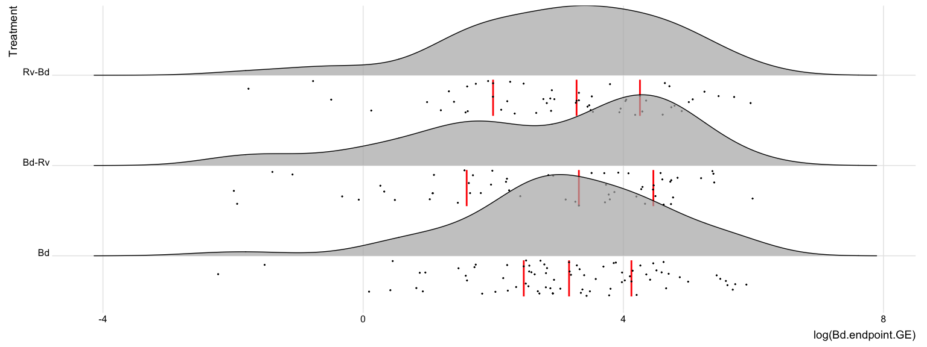

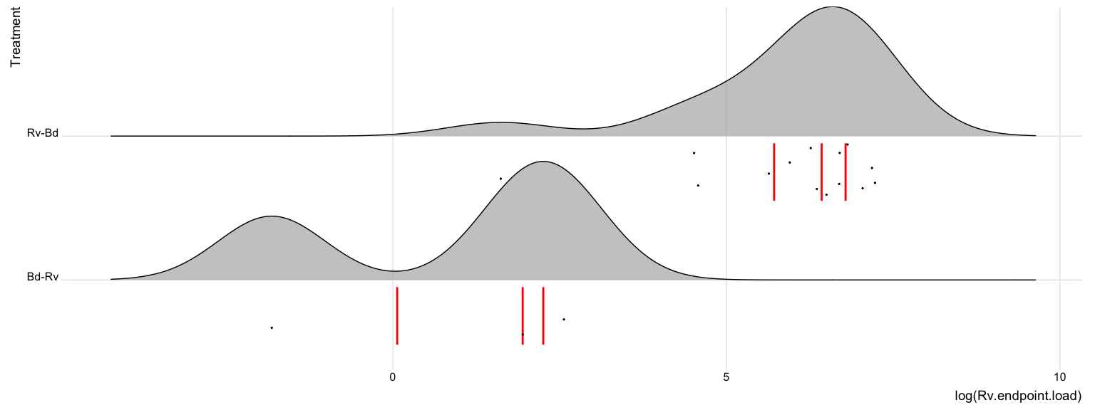

Figure S1. The distribution of a) log-transformed infection loads (GE) for Bd-positive tadpoles and b) log-transformed normalised infection loads for ranavirus-positive tadpoles, groups across all species for exposure scenarios. Red lines indicate quantiles and black dots the log-transformed data points.

### S4 | Statistical Analysis Output

Table S4. Generalized Linear Model (GLMs) outputs for endpoint infection status in amphibian larvae by pathogen type a) *Bd*, as a function of species (*Bufo bufo*, *Rana temporaria*, and *Alytes muletensis*), and b) ranavirus, as a function of exposure scenario (*Bd* only, Rv only, *Bd*-Rv and Rv-*Bd*) after model selection and simplification.

**a)**

|  |  |  |  |  |
| --- | --- | --- | --- | --- |
|  | Estimate | Std. Error | z value | Pr(>|z|) |
| B.bufo I (Intercept) | 2.983 | 0.561 | 5.314 | 0.000 |
| B.bufo II | 2.173 | 1.473 | 1.475 | 0.140 |
| R.temporaria | -3.725 | 0.622 | -5.994 | 0.000 |
| A.muletensis I | 0.576 | 0.960 | 0.600 | 0.549 |
| A.muletensis II | 0.000 | 2.500 | 0.000 | 1.000 |
|  |  |  |  |  |

**b)**

|  |  |  |  |  |
| --- | --- | --- | --- | --- |
|  | Estimate | Std. Error | z value | Pr(>|z|) |
| Bd-Rv (Intercept) | -2.625 | 0.463 | -5.667 | 0.000 |
| Rv | -0.539 | 0.749 | -0.720 | 0.472 |
| Rv-Bd | 1.562 | 0.534 | 2.924 | 0.003 |
|  |  |  |  |  |

Table S5. Generalized Linear Model (GLMs) outputs for endpoint infection load in amphibian larvae by pathogen/infection type a) *Bd*, expressed as zoospore genomic equivalents (GE), and b) ranavirus as normalised ranaviral load as the response variable. The following factors were used as explanatory variables for a) species (*Bufo bufo*, *Rana temporaria*, and *Alytes muletensis*), and b) exposure scenario (*Bd* only, Rv only, *Bd*-Rv and Rv-*Bd*) after model selection and simplification.

**a)**

|  |  |  |  |  |
| --- | --- | --- | --- | --- |
|  | Estimate | Std. Error | t value | Pr(>|t|) |
| B.bufo I (Intercept) | 4.560 | 0.144 | 31.708 | 0.000 |
| B.bufo II | -0.260 | 0.202 | -1.289 | 0.199 |
| R.temporaria | -3.235 | 0.307 | -10.530 | 0.000 |
| A.muletensis I | -1.987 | 0.224 | -8.873 | 0.000 |
|  |  |  |  |  |

**b)**

|  |  |  |  |  |
| --- | --- | --- | --- | --- |
|  | Estimate | Std. Error | t value | Pr(>|t|) |
| Bd- Rv (Intercept) | 1.906 | 0.535 | 3.561 | 0.003 |
| Rv-Bd | 4.774 | 0.586 | 8.142 | 0.000 |

Figure S2. Tukey test output for Bd a) infection status and b) infection load where 1 = *Bufo bufo* I, 2 = *Bufo bufo* II, 3 = *Rana temporaria*, 4 = *Alytes muletensis* I

**a)**

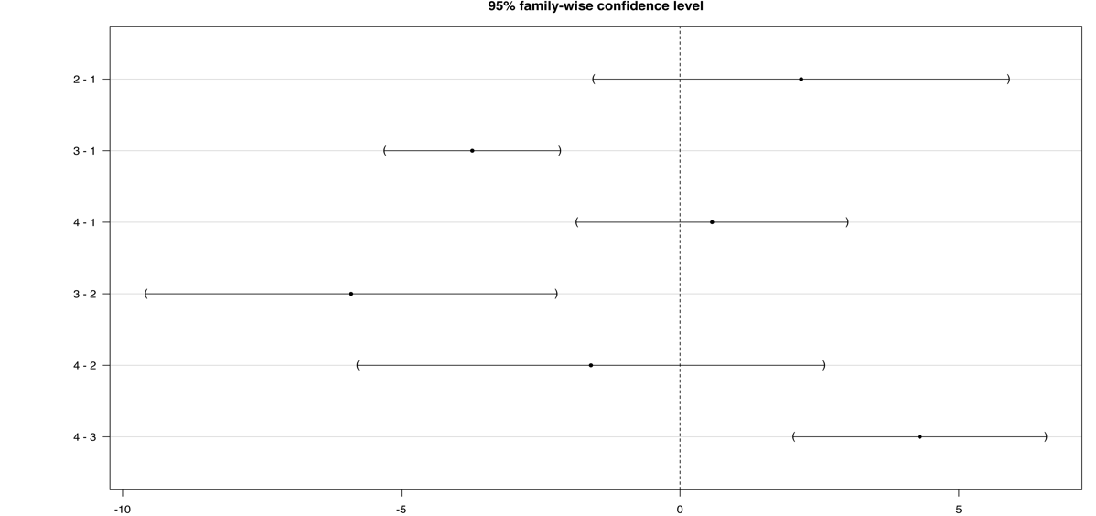

**b)**

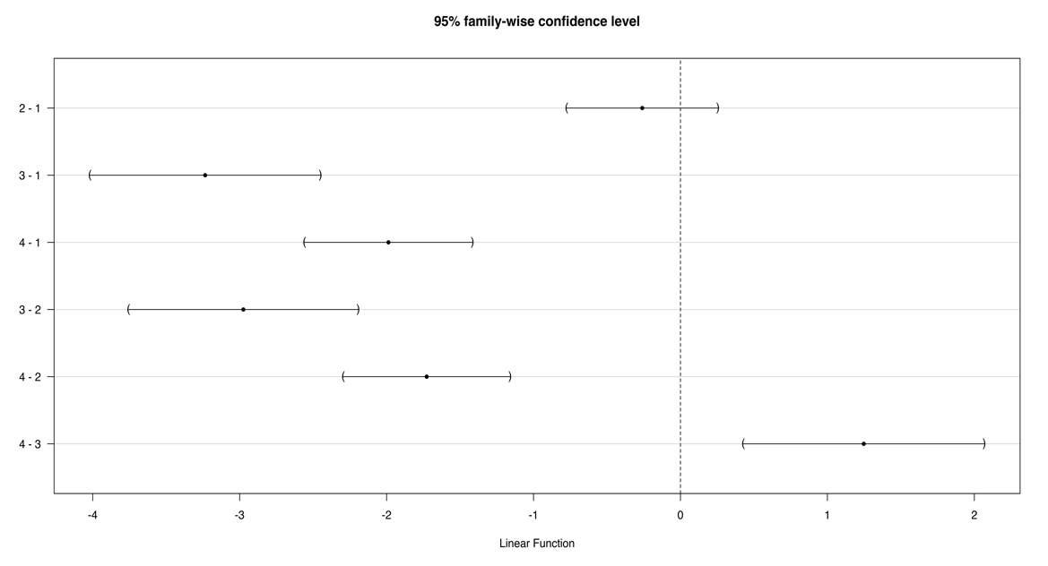

1. University of Liverpool & Zoological Society of London
2. University of Liverpool