Beatrice Garcia

February 11, 2018

Homework 1

**Topic:** Abortion

**Side:** Prochoice

**Collect a small data set from a social media site of your choosing (1K+ posts)**

* Twitter
* About 1100 tweets collected
* Used the streaming service to search for tweets with #prochoice or #abortion
* Python code used to collect tweets is called tweet_collector.py

**Identify the top 10 nodes based on degree, betweenness, closeness, and eigenvector centralities.**

Degree Centrality

* fernhilldammit with score 0.00587467362924
* ginger6516 with score 0.00522193211488
* theoldone1919 with score 0.00456919060052
* gotothelimit with score 0.00456919060052
* S_ergeyR_omanov with score 0.00456919060052
* rosecaroline9 with score 0.00391644908616
* bart_liao with score 0.00391644908616
* WityCindy with score 0.00391644908616
* HouseValyrian with score 0.00391644908616
* markalexander_1 with score 0.0032637075718

Betweenness Centrality

* fernhilldammit with score 3.06971842155e-05
* ginger6516 with score 2.38755877232e-05
* theoldone1919 with score 1.79066907924e-05
* gotothelimit with score 1.79066907924e-05
* S_ergeyR_omanov with score 1.79066907924e-05
* rosecaroline9 with score 1.27904934231e-05
* bart_liao with score 1.27904934231e-05
* WityCindy with score 1.27904934231e-05
* HouseValyrian with score 1.27904934231e-05
* markalexander_1 with score 8.52699561542e-06

Closeness Centrality

* fernhilldammit with score 0.00587467362924
* ginger6516 with score 0.00522193211488
* theoldone1919 with score 0.00456919060052
* gotothelimit with score 0.00456919060052
* S_ergeyR_omanov with score 0.00456919060052
* rosecaroline9 with score 0.00391644908616
* bart_liao with score 0.00391644908616
* WityCindy with score 0.00391644908616
* HouseValyrian with score 0.00391644908616
* markalexander_1 with score 0.0032637075718

Eigenvector Centrality

* fernhilldammit with score 0.707106781187
* evangie with score 0.235702260396
* GMA4Trump_ with score 0.235702260396
* DavidGr78574965 with score 0.235702260396
* ride_stuff with score 0.235702260396
* melBELL_USA with score 0.235702260396
* jilladairmakeup with score 0.235702260396
* auntmushy with score 0.235702260396
* billbow47 with score 0.235702260396
* Bluepuppy with score 0.235702260396

**Calculate the diameter of the largest network component.**

Diameter – 2

**Select one opinion leader from the top nodes and explore its neighbors.**

I choose *fernhilldammit* as my opinion leader because it had the highest score for all the centrality measures. Below is the subgraph of fernhilldammit’s network. Ego-network forces that may be acting upon the central node are:

* Simelian ties – upon first inspection, I noticed the tweet was used as a counterargument between fernhilldammit and every user she mentioned. Therefore, the similar ties between her and the people in her network created a stronger ego network.
* HERE
* HERE

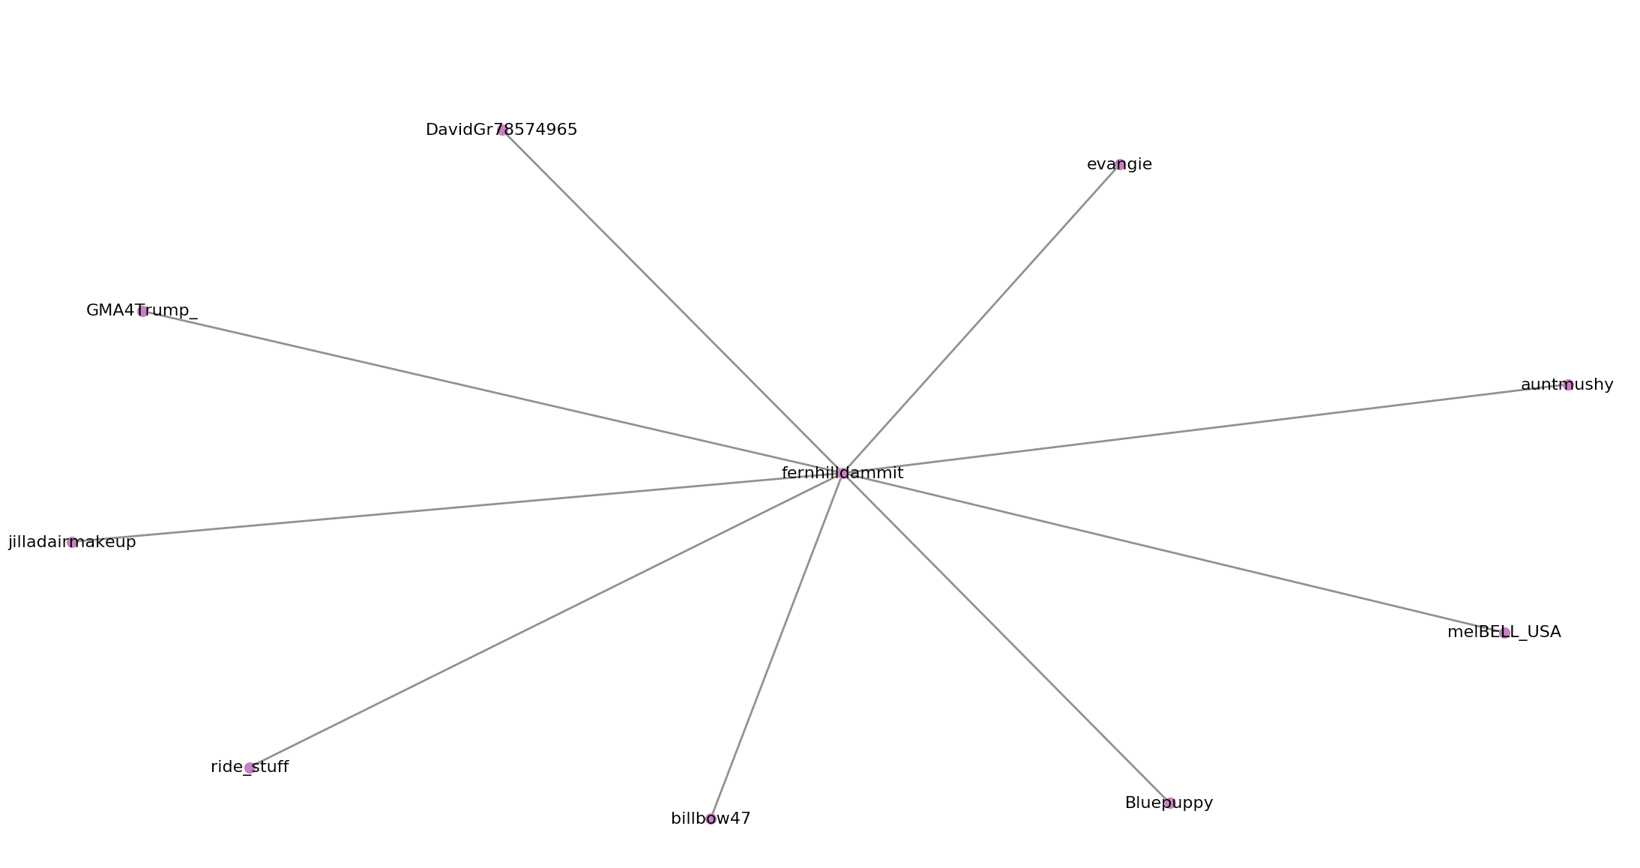

**Display a diagram of your network where nodes are colored based on a cohesive network clustering algorithm.**

Clustering algorithm – Louvain method

I did not include the labels because it made the graph very messy.

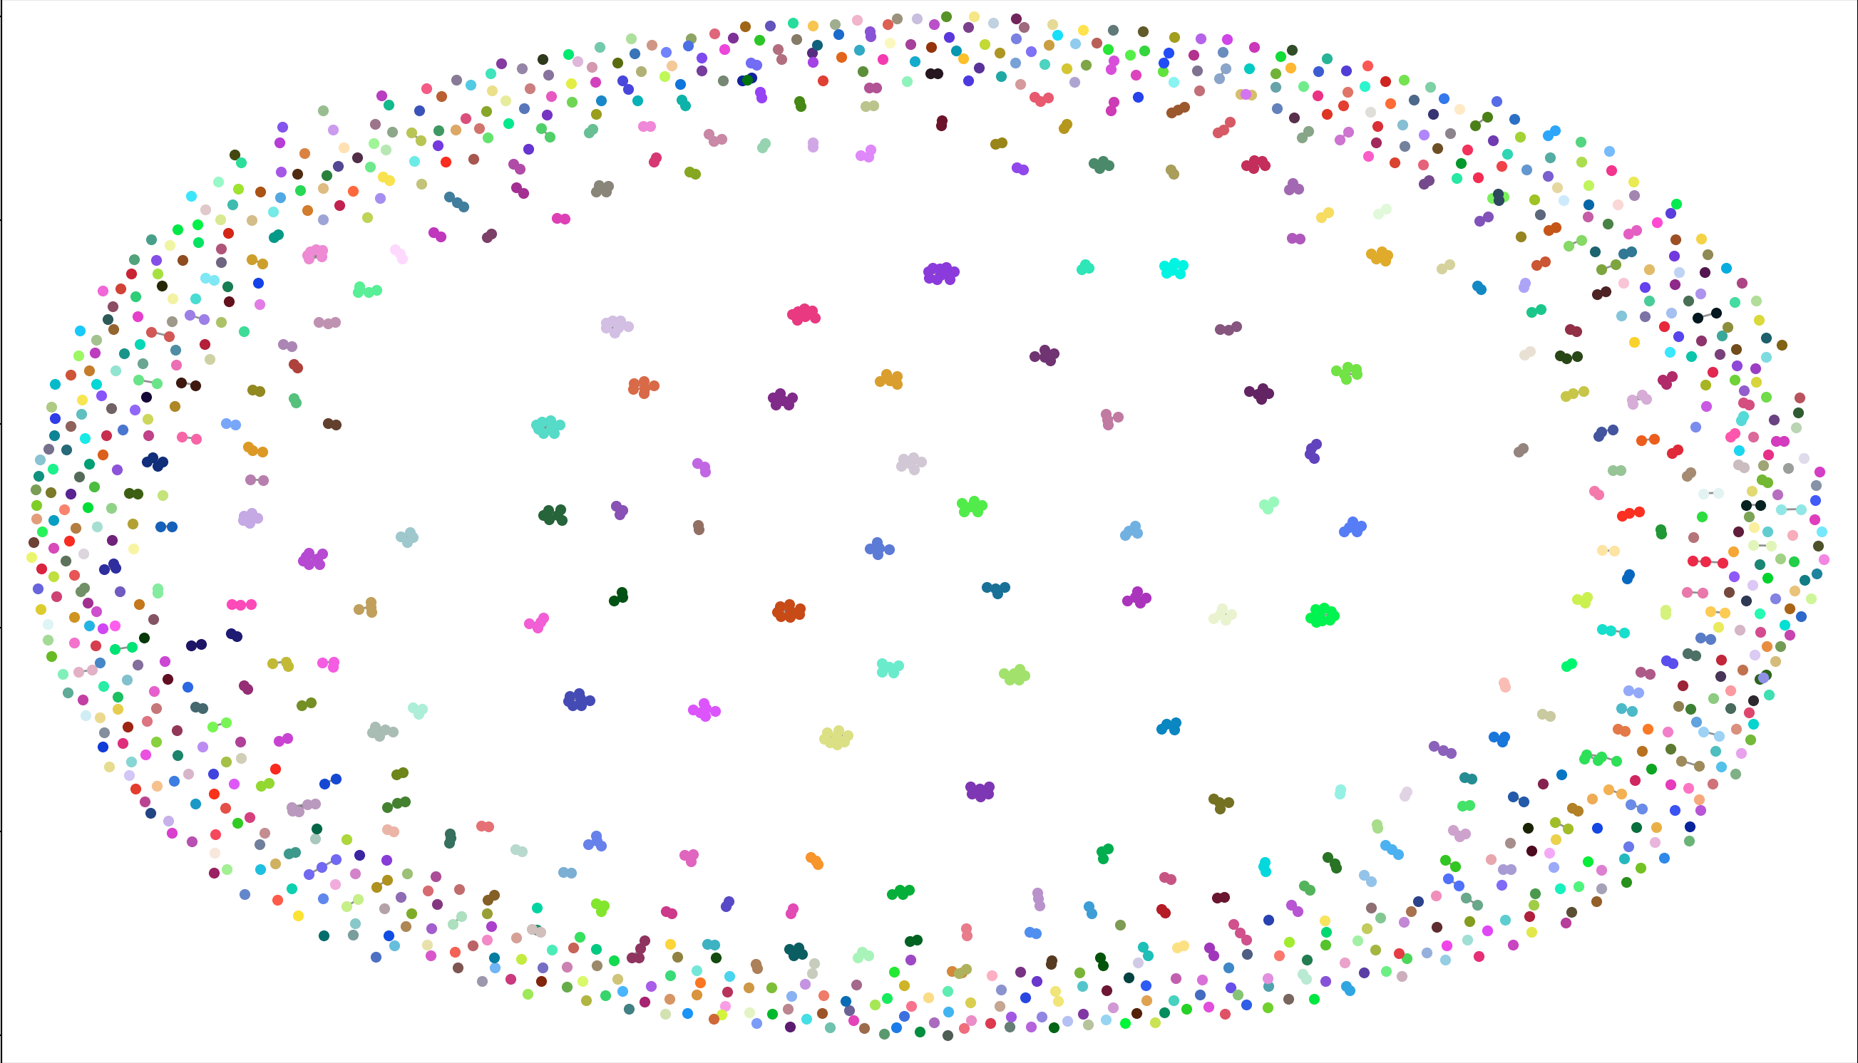

**What recommendations would you provide to promote your opinion leader’s content on social media?**

Upon close inspection, fernhilldammit was having a Twitter disagreement with the people on her network. She had posted an image with a statistic on how many people died from postpartum depression as an aide to a previous argument. In order to promote her opinion, I would Retweet the image of the statistic and I could even tag on the other top opinion leaders that were not already on her subnetwork but that were also on the prochoice side.

**What recommendations would you provide to demote your opinion leader’s content on social media?**

In order to demote my opinion leader’s content on social media, I could simply ignore it. People did not seem to respond to the image outside the original users in that subnetwork. If I ignored it and started tweeting to the users on her network on the prolife side, her content would be buried. Another way to demote, is to flood hashtags on #abortion #prochoice with the opposing perspective.

~~Collect a small data set from a social media site of your choosing (1K+ posts)~~

~~2 (15%) Identify the top 10 nodes based on degree, betweenness, closeness, eigenvector centrality. Report centrality values.~~

~~3 (5%) Calculate the diameter of the largest network component.~~

4 ~~Select one opinion leader from the top nodes and explore its neighbors.~~

~~a. (15%) Justify why you chose your node as an opinion leader~~

~~b. (15%) Provide a figure of the subgraph consisting of your chosen node, first order connections, and relationships between those first order connections. It is OK to include pendants (e.g. 2nd order nodes).~~

c. (15%) What ego-network forces may be acting upon your chosen central node.

~~5 (15%) Display a diagram of your network, where nodes are colored based on a cohesive network clustering algorithm of your choosing.~~

~~6 (10%) What recommendations would you provide to promote your opinion leader’s content on social media?~~

~~7 (10%) What recommendations would you provide to demote your opinion leader’s content on social media?~~