Propagation of Misleading News on Twitter

On the Subject Matter “Donald Trump”

Beatrice Garcia

Johns Hopkins University

Engineering for Professionals Program

Baltimore, MD

Bgarci16@jhu.edu

*Abstract*—Because 62% of Americans primarily get their news from a social media site where most posts go unfiltered, it is important to know how much misleading news propagates through social media, specifically the Twitter community, and whether its audiences believe what they are reading. After a 4-day data collection tracking URLs about Donald Trump, I have found that the highest propagation rates found until (and including peak) are 453.33 tweets per hour that contain the tracked URL. News sources initiates propagation by tweeting their articles which Twitter users Retweet instead of Twitter users finding these articles themselves by going on the news website and sharing on Twitter. Sentiment analysis that most users that reply to the original article postings believe with what the articles are saying.

Keywords—social media analysis; data science; sentiment analysis; time series; fake news

# Introduction

According to Forbes, 62% of American adults get their news from a social media site. Specifically, 59% of Twitter users are using Twitter to seek news. This is significant because those social media sites are not fact checked. Therefore, it is important to ask how many of those 59% of Twitter users or 62% of Americans believing false facts?

Then, when the recent election came up with an unexpected result, the significance of fake news became inescapable. How many of the 59% of Twitter users changed their perspectives after reading false facts or even propaganda? Therefore, my topic is about these recent events: the propagation of misleading news about Donald Trump on Twitter. Specifically, I am to answer two questions: What is the propagation rate of misleading news about Donald Trump on Twitter? How susceptible are its audiences?

# Background

## Definitions

Most of the articles and papers about this topic track and follow fake news. Stanford’s definition fo “fake news” is news articles that are intentionally and verifiably false and could mislead audiences. In there case, “fake news” does not include biased news sources. But, after talking with a journalist[1], about what he defined as “fake new” which included biased news sources and concluding that “fake news,” I am using the term “misleading news” instead of “fake news,” because both have similar purposes: to persuade an audience to a certain view. Therefore, my definition of “misleading news” is any news article, social media posting, or website post that could be verifiably false, but also uses persuading language.

## Existing Work

There are some existing work done on the study of the virality of fake news on social media. Many of the work are case studies, making them more subjective as a lot of the bloggers or journalists create their own “fake news” and then track how viral their news have gotten. Another limitation of the previous studies is that it only tracked “fake news.” This research topic includes “misleading news” to include biased news sources.

### “How Fake News Goes Viral: A Case Study” by Sapna Maheshwari

In this case study was done by The New York Times, Maheshwari tracks Eric Tucker’s tweet reporting about paid protesters being bused to demonstrations against then-President-elect Donald Trump. This case study was published on November 20, 2016. Already this case study addresses several components of my study including the subject matter, social media platform, and a more generalized version of the research question.

Althought, there are several limitations in this case study that conclusively make it insufficient. First, the researcher is only tracking one tweet. Maheshwari does not go into detail about how they chose the tweet and if they were actually tracking several tweets, but this case study only showcases one. This means that this is case study, not to experiment with the virality of fake news, but displays the virality of fake news.

### “This Analysis Shows How Viral Fake Election News Stories Outperformed Real News on Facebook” by Craig Silverman

This BuzzFeed News analysis tracked the top five election stories on Facebook and the top 5 mainstream news stories on Facebook. There methods and analysis are more quantitative than Maheshwari’s Case Study and tracks several stories to show case a richer conclusion.

Although the general research question and the subject matter are both similar, the social media platform is not the same as my study. Also, the analysis defines mainstream news sources such as CNN, the New York Times, and Huffington Post and are using it as a comparison to the fake news. But, my research defines them as misleading news. Therefore, this analysis is insufficient for my research question.

### “Social Media and Fake News in the 2016 Election” by Hunt Allcot and Matthew Gentzkow

This research paper discusses the economics of fake news which includes where the fake news come from, how they propagate, and how susceptible the audiences are. They define “fake news” as news articles that are intentionally and verifiably false. It is important to note that they define news in the traditional sense as an article written by a journalist or reporter while the other analysis and case studies would count social media postings, such as a tweet, as news.

Also the paper does not focus on social media platforms. The paper concludes that social media was “an important but not dominant source of election news,” which means they have reached out to sources outside of social media. Therefore, the paper is insufficient in answering questions about the virality of fake news in social media.

# Methods

## Resources

## Data used for research is from Twitter

## Python is used to retrieve and analyze data

## ArangoDB is used to store data

## Data Collection

First, I collected 100,000 tweets with the keyword “Donald Trump” to get the top 10 most tweeted URLs. Following is the summary of my data collection steps:

1. Set up an ArangoDB database. Create a collection to keep the tweets.
2. Use Python and the free Twitter API to open a stream searching with tweets with the keyword “Donald Trump”.
3. As each tweet comes in, write it to the ArangoDB.
4. Stop the stream when the collection reaches 100,000 tweets.
5. Use Python to find the 25 most tweeted URLs.
6. For each URL, manually determine if it is a misleading news source according to the definition in *Background; Definitions*. If it aligns with the definition, add it to the list of URLs to be tracked

After there was a list of about 10 URLs, I opened the stream back up to get tweets with those URLS. Following is the summary of my data collection steps:

1. Set up an ArangoDB database. Create a collection to keep the misleading tweets.
2. Use Python and the free Twitter API to open a stream searching with tweets with the URLs as the keywords.
3. Close stream. I closed the stream after four days.

After the 4 days, I was able to collect 10,839 tweets with any of the target URLs.

## Model of Data

Below is an example of tweet from the collection of tweets received. In summary, I retrieved metadata such as user ID, count of likes, posted date, tweet ID, if the tweet is a Retweet, etc.

{

"_key":"522282",

"_id":"misleads/522282",

"_rev":"_U3IBa5K---",

"text":"RT @TheAffinityMag: Wow, she's so brave. Thank you for sharing your story <https://t.co/SEO4CUuzjq>",

"In_reply_to_status_id":"1234",

"Favorite_count":0,

"User_id":710258742,

"source":"<a href=\"http://twitter.com/download/iphone\" rel=\"nofollow\">Twitter for iPhone</a>",

"created_at":"Sat Apr 22 18:23:31 +0000 2017",

"Tweet_id":855849565211250700,

"In_reply_to_screen_name":"@bob",

"Is_retweet":false,

"Place":"Laurel, MD",

"Retweet_count":0,

"User_name":"karlavalito",

"In_reply_to_user_id":"1234"

}

# Analysis

Because I was aiming to answer two different questions, I had to use several methods of analysis to answer them. The Time Series and Bar Chart comparisons are used to answer the question of: What is the propagation rate of misleading news about Donald Trump on Twitter? The Sentiment Analysis and Bar Chart comparisons are used to answer the question of: How susceptible are its audiences?

## Time Series

I used time series to index the amount of tweets tweeted with a certain URL at a certain point in time. Times series not only show the gravity of the virality of a certain URL, but also when and how fast its virality degraded. This an effective method to track virality because all URLs can be put in the same visual for comparing.

## Comparisons of Retweets

I counted the number of tweets collected over the four days that started with “RT” and added in the number said in the original tweet to get the number of times the tweets were retweeted. Using this information and displaying it in a bar chart can show which tweets were the most retweeted. Pairing this with the time series, I can determine if there is a correlation between number of retweets and how viral the post got.

## Sentiment Analysis

For each original tweet, I retrieved the replies to that tweet and used a Naïve Bayes Classifier to classify those tweets as positive or negative. Then, depending on the original tweet, determined if they were True Positives, True Negatives, False Positive, or False negatives. The sentiment analysis show audience susceptibility. The number of True Positives or True Negatives, depending on the post, can determine if the audience believed that post.

# Results

## Tracked Posts

Following is a description of the posts that came up as the top 10 URLs that appeared in the 100,000 tweets gathered with the keyword “Donald Trump” and why they were defined as misleading (in no particular order):

### “Caitlyn Jenner Took a Stand Against Donald Trump By Turning Down a Recent Invitation to Play Gold” by Bobby Finger

Jezebel, a blog geared towards women, posted a link with this article on April 21, 2017 and is defined as misleading because it comes from a blog, not an accredited news source.

### “Donald Trump has ‘dangerous mental illness’, say psychiatry experts at Yale conference” by May Bulman

The Independent, a British online newspaper, posted several links with this article on April 21, 2017 and is defined as misleading because their audience have been considered as more liberal and therefore, may offer bias[9].

### “Mulvaney says White House has offered Dems $1 in Obamacare funds for $1 in wall funds in Bloomberg Live interview” by Sarah Ferris

Ferris, a reporter for Politico, posted this tweet on April 21, 2017 and is defined as misleading because their audience have been considered as more liberal and therefore, may offer bias[9].

### “Thousands Across the U.S. And the Globe March For Science in Defiance of Donald Trump” by Sebastian Murdock

The Huffington Post’s Politics group tweeted this out with their account (@HuffPostPol) on April 22, 2017 and is defined as misleading because their audience have been considered as more liberal and therefore, may offer bias[9].

### Several Spam-type URLs

Spam or lists-type websites with slideshows of pictures and “facts” about the Donald Trump and his family such as “Truly Inappropriate Trump Photo Gone Viral” and “Some Ridiculously Hot Photos of Ivanka Trump” were among the top 10 URLs. The two websites that came up were twentytwowords.com and viralfactamazing.com.

## Most Viral Tweet

The following visual, which can be viewed interactively on the web [here](https://plot.ly/~beatricegarcia93/35/jezebel-jezebel-twentytwowords-viralfactamazing-melania-trump-dashing-summit-vir/), is the time series created from the number of times a URL has appeared in the dataset collected over the four days. According to the time series, the Jezebel article has gone the most viral with 626 appearances on April 22, 2017 at 8:00pm EST. Following is the Huffington Post article with 234 tweets with its URL.

1. Time Series of Number of Tweets per Hour

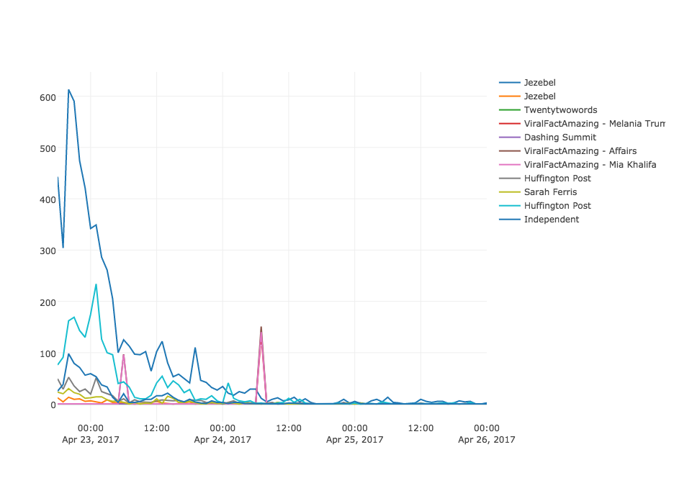

Note: Some tracked URLs link back to the same article

## Propagation Rate

Below is the table of propagation rates before peak and after peak. The spam-type URLs that come from websites such as twentytwowords and viralfactamazing are not account for in this table as they had no appearances within the four days. This may be because they change URLs. Propagation rates are defined as the average number of tweets with the tracked URL per hour until reaching its peak (highes number of appearance) in the four day span.

1. Propagation Rates of Each Tracked URL

|  |  |  |  |  |  |  |
| --- | --- | --- | --- | --- | --- | --- |
| **Tracked URL** | **Jezebel 1** | **Jezebel 1** | **Huffington Post 1** | **Sarah Ferris** | **Huffington Post 2** | **Independent** |
| **Peak Time** | April 22, 2017 at 8pm (3 hrs after start) | April 22, 2017 at 8pm (3 hrs after start) | April 23, 2017 at 1pm (8 hrs after start) | April 22, 2017 at 8pm (3 hrs after start) | April 23, 2017 at 1pm (8 hrs after start) | April 22, 2017 at 8pm (3 hrs after start) |
| **Before Peak** | 453.3 | 13 | 147.5 | 24.3 | 36 | 54 |
| **After Peak** | 62.5 | 1.07 | 12.9 | 2.5 | 3.5 | 7 |

Note: Some tracked URLs link back to the same article

According to the table, Jezebel 1 had the highest propagation rates. On average, the propagation rate before peak is 54.96 tweets with a tracked URL (excluding Jezebel 1 as it is an outlier). The Huffington Post follows behind with a propagation rate before peak of 147.5 tweets per hour.

Below is a bar chart showing the number of Retweets associated with the tracked URL.

1. Bar Chart of Number of Retweets for Tracked Urls

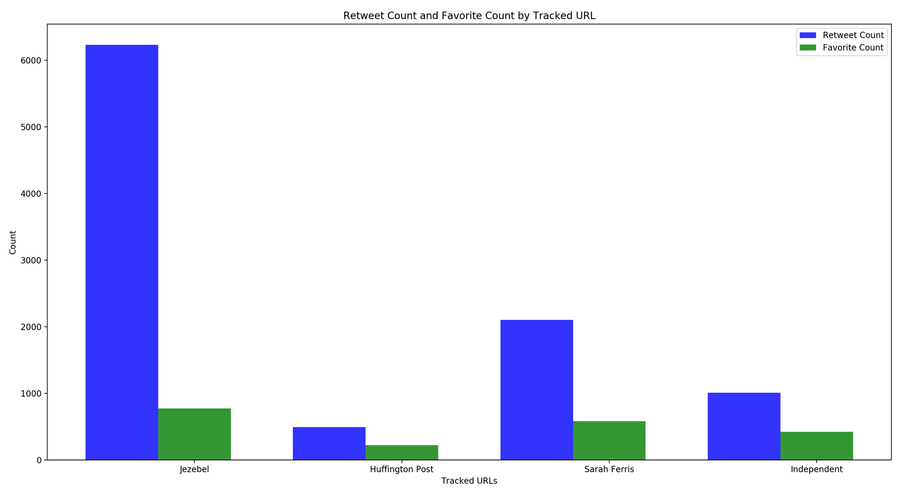 Note: Some tracked URLs link back to the same article are now condensed

## From the bar chart and the time series, there is strong correlation between the virality of the tracked URL and the amount of times Twitter users have Retweeted it. This shows that users rarely go to the news website and using Twitter to show their followers an article they discovered. But, the news sources are actually tweeting out their articles and users are getting their news directly from those tweets and sharing those posts by Retweeting it.

## Audience Susceptibility

Below is the table showing the results from a sentiment analysis of the replies to the original posting:

1. Sentiment Analysis of Tweet Replies

|  |  |  |  |  |
| --- | --- | --- | --- | --- |
| **Tracked URL** | **Jezebel** | **Huffington Post** | **Sarah Ferris** | **Independent** |
| **True Value** | Negative | Negative | Negative | Negative |
| **Postive** | 50 | 8 | 51 | 7 |
| **Negative** | 105 | 9 | 81 | 11 |

Note: Some tracked URLs link back to the same article are now condensed

Overall, after quickly reviewing the tweet replies, much of the texts ended up being sarcasm such as “Anyone can be president! Even the mentally ill! – What a great and fair country we live in!!!” from the Sarah Ferris tweet. This reply would generate a “positive” value from the Naïve Bayes Classifier but its true value would be a False Positive, or a truly negative comment. I believe that’s what explains a high number of positive tweets. But most of the replies ended up being negative, which matches up with the true value of the article’s sentiment. This usually means that the audience generally has had some kind of reaction to it, which suggests that they believed in what the article was saying. Generally, the audience that replied back to the post believes the content of the article and displays extreme views about it.

# Conclusion

Gathered from the results, the most propagated article posted via URL from April 22-26, 2017 with the keyword “Donald Trump” is an article from a blog, Jezebel about Caitlyn Jenner’s refusal to golf with Donald Trump. It reached the highest number of appearances in tweets and also the highest number of retweets. But all of the tracked URL’s virality peaks after only a few hours (3 or 8 hours after positing, in this case). Most of the sentiment analysis has extreme views that say more about Caitlyn Jenner than Donald Trump.

Overall, it is interesting to note that from all the tweets gathered, most of are Retweets. This suggests that people are not finding these articles by going to the news website and sharing from there. The news sources have actually posted a tweet about their article and that is when people are discovering the news and deciding to share it by retweeting it.

## Limitations

There are several limitations in the research done for this topic. First, unlike the Stanford study, I did not have an independent variable. In other words, I did not track the virality of real news and how it compares to the misleading news. This is mostly due to the lack of the definition of “real news” and lack of knowledge to find “real news.”

Second, there was no access to big data Twitter APIs such as the decahose or the firehose. Because I used the free Twitter API, I had to stream the tweets to get as much data as I could. Therefore, streaming in 100,000 tweets is not as representable of the Twitter community as a million tweets or so from said “hoses.” Then, I again used the open stream to gather data for the next 4 days. Again, there could have been a lot more data missed without the paid APIs that could have changed the results.

Third, bots were not accounted for. Actually, about half of the tracked URLs are from spam-like websites such as viralfactamazing.com and many of the tweets with those URLs, I suspect, may have come from bots.

The sentiment analysis is limited by current natural language processing limitations such as inability to detect sarcasm and inability to classify images or emojis as positive or negative. In addition, all the top articles all had a negative view, so it was not factored in how audience would react to a positive article.

## Future Work

There is potential to make this resesarch a lot more accurate and fruitful by eliminating the points mentioned in the limitations. Access to bigger Twitter datasets would allow a more accurate representation of what the Twitter community is talking about and using a bot filter would ensure that the top URLs tweeted are human-dependent. Also, advancing technologies in natural language processing and image/emoji classification would allow a more accurate sentiment analysis. Lastly, finding a more efficient way of tracking posts without having to search tweets based on URL would show more about the community engagement with that post.

##### References

Below are the references for various facts said in the paper as well as the actual posts I tracked:

1. Bell, Jacob. "Definition of Fake News." Telephone interview. 13 Apr. 2017.
2. Fletcher, Paul. "Two-Thirds Of Adults Get News From Social Media." Forbes. Forbes Magazine, 04 June 2016. Web. 29 Apr. 2017.
3. Maheshwari, Sapna. "How Fake News Goes Viral: A Case Study." The New York Times. The New York Times, 20 Nov. 2016. Web. 29 Apr. 2017.
4. Silverman, Craig. "This Analysis Shows How Viral Fake Election News Stories Outperformed Real News On Facebook."BuzzFeed. BuzzFeed, 16 Nov. 2016. Web. 29 Apr. 2017.
5. Finger, Bobby. "Caitlyn Jenner Took a Stand Against Donald Trump By Turning Down a Recent Invitation to Play Golf." Jezebel. Jezebel.com, 21 Apr. 2017. Web. 30 Apr. 2017.
6. Bulman, May. "Donald Trump Has 'dangerous Mental Illness', Say Psychiatry Experts at Yale Conference." The Independent. Independent Digital News and Media, 21 Apr. 2017. Web. 30 Apr. 2017.
7. Ferris, Sarah. "Mulvaney Says White House Has Offered Dems $1 in Obamacare Funds for $1 in Wall Funds in Bloomberg Live Interview." Twitter. Twitter, 21 Apr. 2017. Web. 30 Apr. 2017.
8. Murdock, Sebastian, Alexander C. Kaufman, Sam Levine, and Chris D'Angelo. "Thousands Across The U.S. And The Globe March For Science In Defiance Of Trump." The Huffington Post. TheHuffingtonPost.com, 22 Apr. 2017. Web. 30 Apr. 2017.
9. Blake, Aaron. "Ranking the Media from Liberal to Conservative, Based on Their Audiences."The Washington Post. WP Company, 21 Oct. 2014. Web. 30 Apr. 2017.