Authors: B. Bock, N. McKay, N.C. Johnson, C.A. Gehring
Goal journal: Nature

Title options:
Global Patterns of Fungal Endophyte Presence Reveal Ubiquity and Geographic Bias
Every Studied Plant Hosts Fungal Endophytes- What About the Rest?
Ubiquitous Symbionts, Sparse Sampling: Global Patterns of Plant-Fungal Endophytes
Universal Within Observation: Fungal Endophytes Across Plant Lineages and the Limits of Sampling

Abstract
Fungal endophytes have been detected in every plant taxon studied, from bryophytes and ferns to gymnosperms and angiosperms. To our knowledge, this study represents the first systematic synthesis confirming this pattern across the plant kingdom. Despite this remarkable breadth, our analysis of 19,071 research articles reveals that apparent ubiquity is based on extremely limited and biased sampling. Fewer than 0.5% of described plant species have ever been examined for fungal endophytes, and research is concentrated in the Global North (77% of studies), particularly the United States and Europe. Using a machine learning-driven pipeline, we distinguish genuine detection from assumption, quantify the rarity of true absences, and map geographic and taxonomic biases in endophyte research. These findings demonstrate the extraordinary reach of fungal endophytes across studied taxa while clarifying the limits of current knowledge, reframing ubiquity as "everywhere studied" rather than "present in all plants at all times."
Introduction
Fungal endophytes are fungi that inhabit plant tissues without causing disease and are widely recognized as pervasive components of plant microbiomes^{1,2}. They influence plant stress tolerance, pathogen resistance, growth, and overall fitness, and they play key roles in ecological interactions and evolutionary trajectories^{3,4}. Studies in diverse plant lineages, from bryophytes to angiosperms, consistently report endophyte presence, leading to the long-standing notion that all plants harbor these fungia^{5,6}.
Despite this apparent universality, a comprehensive, systematic evaluation of fungal endophyte distribution across plant taxa and regions has been lacking. Critical knowledge gaps include limited taxonomic coverage, geographic bias, and methodological variation. Fewer than 0.5% of global plant species have been examined for endophytes (Figure 1), with extreme geographic concentration in the United States and Europe, while species-rich regions in the Global South remain underrepresented (Figure 2). Detection methods have shifted over time from culture-based to molecular approaches, which may affect apparent patterns of presence and absence (Supp Fig XXX). Finally, explicit documentation of natural endophyte-free plants is exceedingly rare, and many reported absences are methodological artifacts.
Here, we present a global synthesis of fungal endophyte literature using a machine learning pipeline to classify over 21,000 abstracts. We quantify detection versus assumption, examine taxonomic and geographic biases, and assess evidence for true absences. This approach allows us to rigorously evaluate the universality paradigm while highlighting the limits imposed by biased and incomplete sampling.

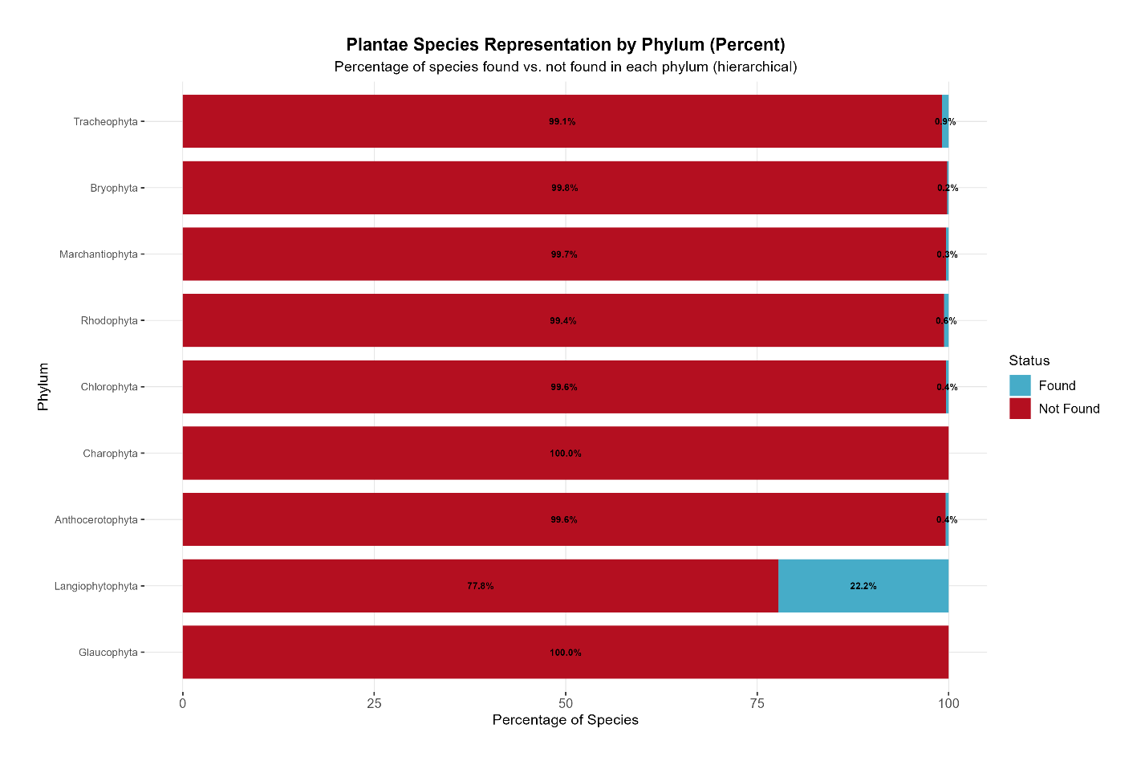
Figure 1: Plant species represented in the fungal endophyte literature, grouped by phylum as determined by GBIF.
Results
Endophytes in Every Lineage Studied
Across 19,071 relevant abstracts, fungal endophytes were reported from all major plant lineages, including bryophytes, lycophytes, ferns, gymnosperms, and angiosperms. No representation was found in the Charophyta plant phylum. Every species examined harbored fungal endophytes.
Depth of Coverage
Despite this breadth, fewer than 0.5% of described plant species have been studied for fungal endophytes. Research focuses primarily on temperate crops and model species.
Geographic Bias
Endophyte research is overwhelmingly concentrated in the Global North (77% of studies), particularly the United States (45%) and Europe (23%). Biodiversity-rich regions such as Brazil (3%), India (1%), and Indonesia (0.3%) are severely underrepresented (Figure 2).
Evidence for Absence
Among 19,071 abstracts, only 89 (0.5%) indicated endophyte absence. Manual validation showed a single genuine absence, in Phragmites australis⁷, while all other absence reports reflected methodological artifacts, where plants were experimentally rendered endophyte-free. In the case of P. australis, other studies have reported the presence of fungal endophytes in this species^{8,9}, meaning that this taxon is not considered to be endophyte-free for the purposes of this study.
Universality Claims
Explicit statements of universality were rare (0.2% of abstracts) in this dataset, but a search for ubiquity statements from Web of Science and Google Scholar on 3 October 2025 revealed 540 abstracts (Web of Science) and 738 papers (Google Scholar) containing variations of the universality claim. Perceived ubiquity arises from consistent detection across studied taxa rather than exhaustive sampling.

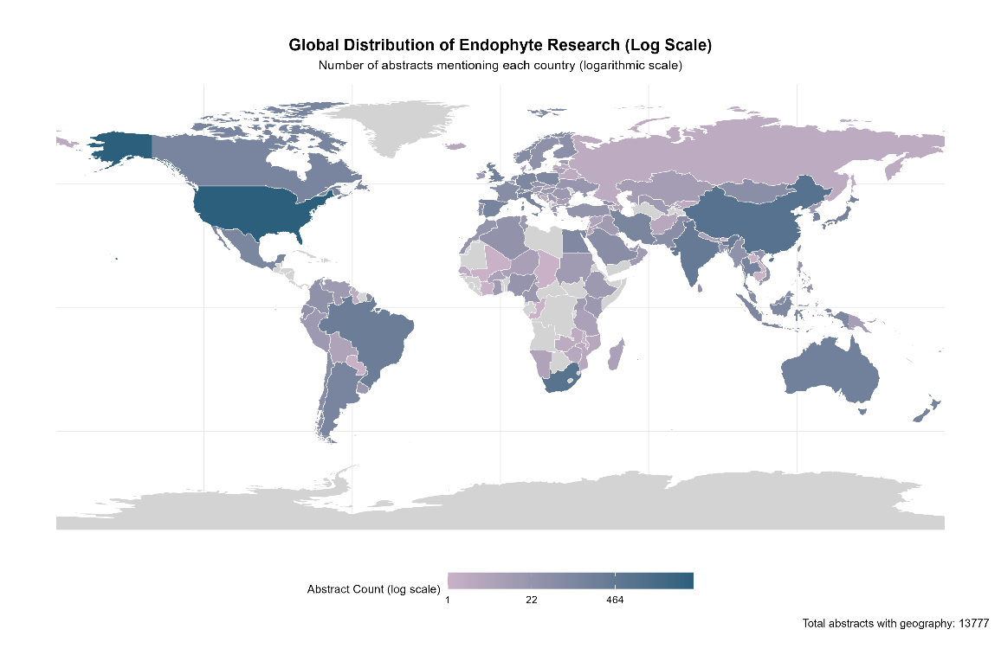

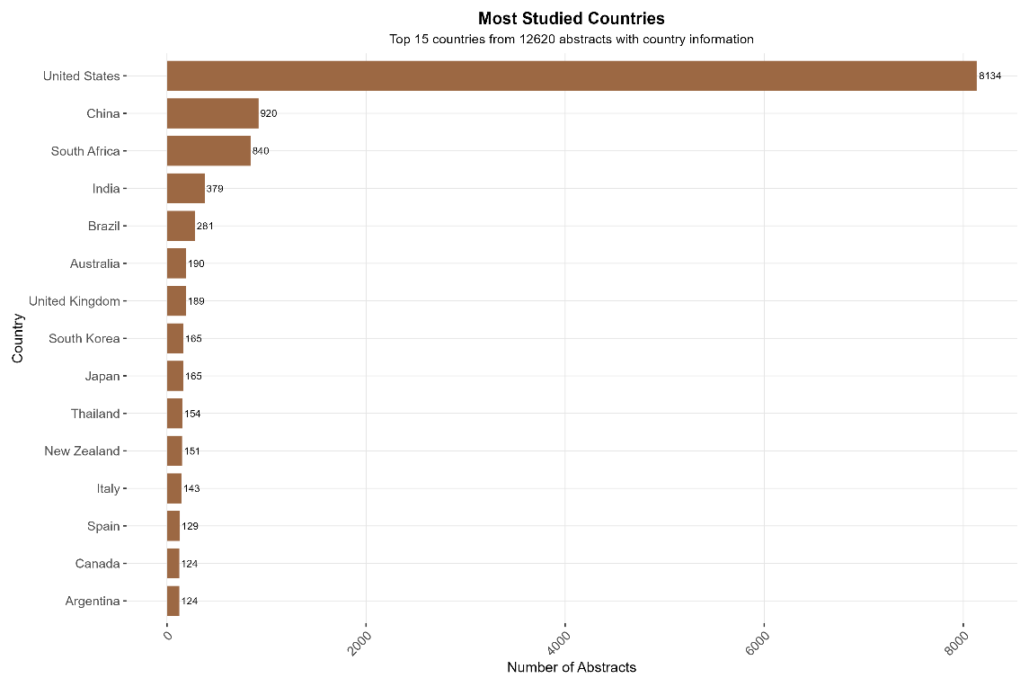
Figure 2: Top: Map displaying abstract count on a log scale, where darker blue indicates more abstracts mentioning those countries, and lighter pink indicating fewer records. Grey indicates no records. Bottom: Bar plot of the top 15 countries mentioned in the dataset.

Discussion
Our synthesis confirms that fungal endophytes are consistently present across all plant taxa studied, reinforcing their role as fundamental and widespread components of plant microbiomes. This ubiquity suggests that endophytes may contribute broadly to plant stress tolerance, pathogen resistance, growth, and overall fitness, and may influence community assembly and evolutionary trajectories across lineages. Detection even in distantly related plant groups indicates that endophytes are likely core associates rather than occasional or opportunistic partners.
However, the apparent universality of fungal endophytes must be interpreted in the context of extremely limited and biased sampling. Fewer than 0.5% of described plant species have been examined, and research is heavily concentrated in the Global North, particularly the United States and Europe. Large portions of biodiversity-rich regions in the Global South remain virtually unstudied, and many lineages are represented by only a handful of species. As a result, the perception of universal endophyte presence reflects consistent detection in a narrow subset of species rather than comprehensive global coverage.
Our machine learning pipeline enabled rigorous quantification of presence and absence evidence across more than 19,000 abstracts, providing the first large-scale, systematic synthesis of this kind. Manual validation revealed that genuine absences are exceedingly rare, with most reported absences reflecting methodological artifacts, such as experimental sterilization. This underscores the value of computational approaches for synthesizing vast, heterogeneous literature and distinguishing true biological patterns from assumptions or incomplete reporting.
Looking forward, expanding surveys to understudied lineages and underrepresented geographic regions is critical for fully capturing endophyte diversity and distribution. We provide a comprehensive list of unrepresented plant taxa from our dataset (Supp Data XXX), highlighting immediate targets for future study. Standardized, integrative sampling strategies that combine culture-based and molecular detection will improve data reliability and allow researchers to explore ecological and evolutionary drivers of endophyte distribution. Moreover, the framework developed here can be applied to other microbial symbionts, offering a path for rigorous, large-scale synthesis of microbiome patterns across taxa and ecosystems.
Fungal endophytes are everywhere we have looked, yet the majority of the plant kingdom remains unexplored. Their confirmed ubiquity in studied taxa underscores their ecological and evolutionary significance, while our analysis clarifies the limits imposed by biased and incomplete sampling. Recognizing these limitations reframes endophytes as both pervasive and underexplored, revealing substantial opportunities for discovery and advancing our understanding of plant-microbe interactions at a global scale.

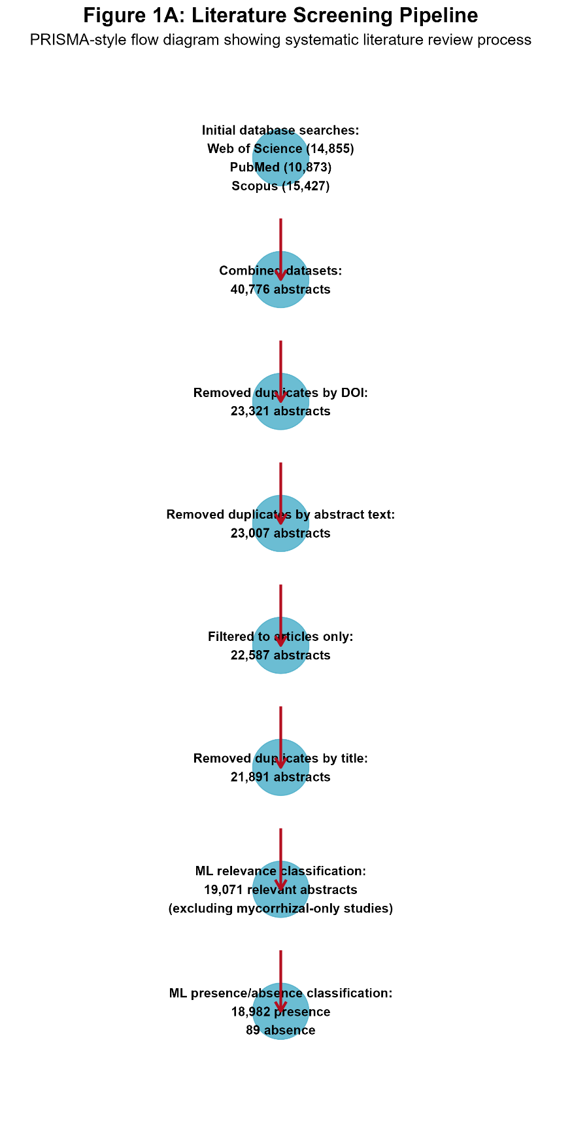
Methods
Supplemental Figure 1: PRISMA diagram of data collection and processing
Literature Search and Data Acquisition
We conducted a comprehensive literature search across Web of Science Core Collection (1926–present), PubMed (1946–present), and Scopus (1930–present) on 14 August 2025. Search terms combined fungal endophyte terminology with plant hosts (Supplementary Methods). Only primary research articles were retained. This search yielded 14,855 abstracts from Web of Science, 10,873 abstracts from PubMed, and 15,427 abstracts from Scopus.
Data Processing and Harmonization
All abstracts were merged across sources, producing an initial dataset of 40,776 abstracts. After removing duplicates and review articles, 21,891 abstracts remained. The final dataset consisted of 20,967 abstracts with complete metadata.
Machine Learning Classification Pipeline
We implemented a two-stage pipeline in R (version 4.3.0). First, relevance filtering was performed using a regularized logistic regression (glmnet) trained on 3,500 manually labeled abstracts, achieving 89.2% accuracy (precision 91.3%, recall 88.7%). Second, presence/absence classification was performed using an ensemble of logistic regression and linear SVM trained on 2,800 relevant abstracts. This stage achieved 87.3% accuracy (presence recall 91.6%, absence recall 82.6%), with an overall pipeline accuracy of 89.8%.
Information Extraction and Analysis
Plant species were automatically detected using the GBIF backbone of 4.9 million species, with 83.7% accuracy. Geographic information was extracted via the Geonames database, and detection methods (culture, microscopy, molecular) were identified using text mining. Studies focusing exclusively on mycorrhizal fungi (376 abstracts) were excluded, leaving 19,071 abstracts for downstream analysis.
Validation
Manual review of 102 high-confidence absence predictions identified a single genuine natural absence, while all other cases reflected methodological artifacts. Explicit natural absences were rare, with 10 high-confidence and 304 medium-confidence cases. Presence validation indicated approximately 65% true detections, 15% false positives, and 20% irrelevant studies. Claims of universality appeared in 0.2% of abstracts.

References
1. Stone, J. K., Bacon, C. W. & White, F. An Overview of Endophytic Microbes: Endophytism Defined. in Microbial Endophytes 1–28 (CRC Press, 2000).
2. Porras-Alfaro, A. & Bayman, P. Hidden Fungi, Emergent Properties: Endophytes and Microbiomes. Annu. Rev. Phytopathol. 49, 291–315 (2011).
3. Rodriguez, R. J., White Jr, J. F., Arnold, A. E. & Redman, R. S. Fungal endophytes: diversity and functional roles. New Phytol. 182, 314–330 (2009).
4. Giauque, H., Connor, E. W. & Hawkes, C. V. Endophyte traits relevant to stress tolerance, resource use and habitat of origin predict effects on host plants. New Phytol. 221, 2239–2249 (2019).
5. Arnold, A., Maynard, Z., Gilbert, G., Coley, P. & Kursar, T. Are tropical fungal endophytes hyperdiverse? Ecol. Lett. 3, 267–274 (2000).
6. Arnold, A. & Lutzoni, F. Diversity and host range of foliar fungal endophytes: Are tropical leaves biodiversity hotspots? ECOLOGY 88, 541–549 (2007).
7. Lambert, A. & Casagrande, R. No evidence of fungal endophytes in native and exotic Phragmites australis. Northeast. Nat. 13, 561–568 (2006).
8. Angelini, P. et al. The endophytic fungal communities associated with the leaves and roots of the common reed (Phragmites australis) in Lake Trasimeno (Perugia, Italy) in declining and healthy stands. FUNGAL Ecol. 5, 683–693 (2012).
9. Clay, K., Shearin, Z., Bourke, K., Bickford, W. & Kowalski, K. Diversity of fungal endophytes in non-native Phragmites australis in the Great Lakes. Biol. INVASIONS 18, 2703–2716 (2016).

Additional figures (not necessarily to be included but maybe):

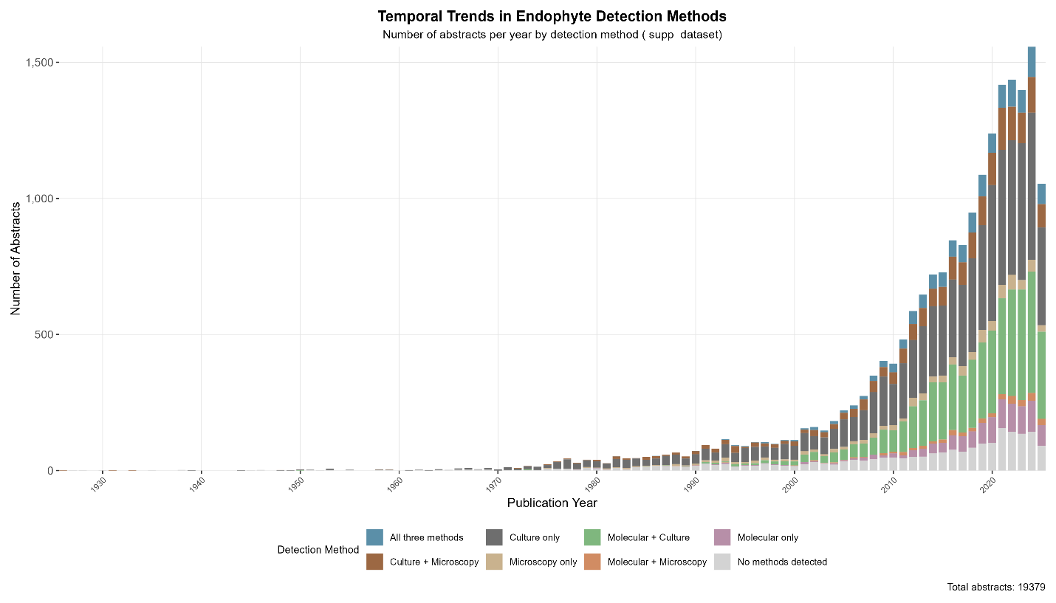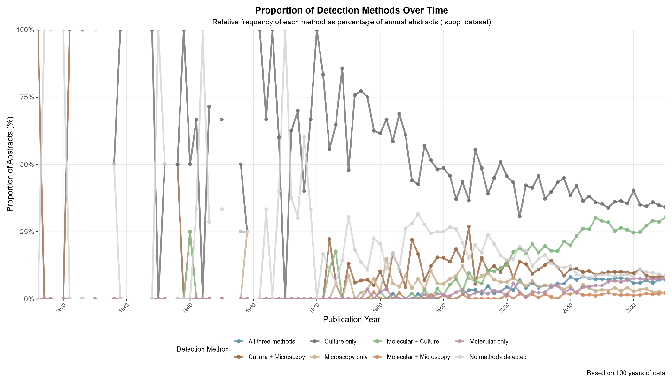

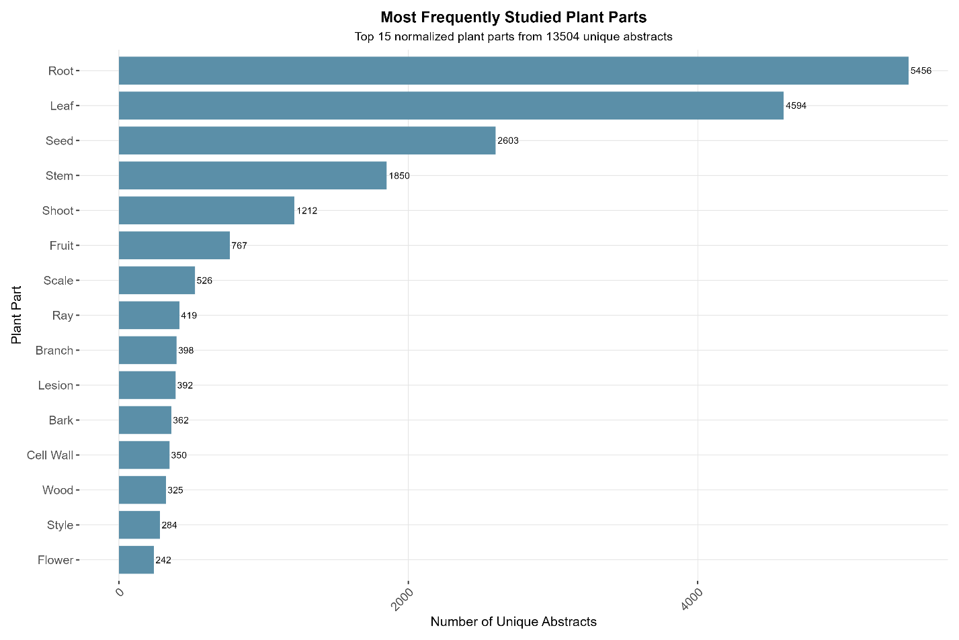

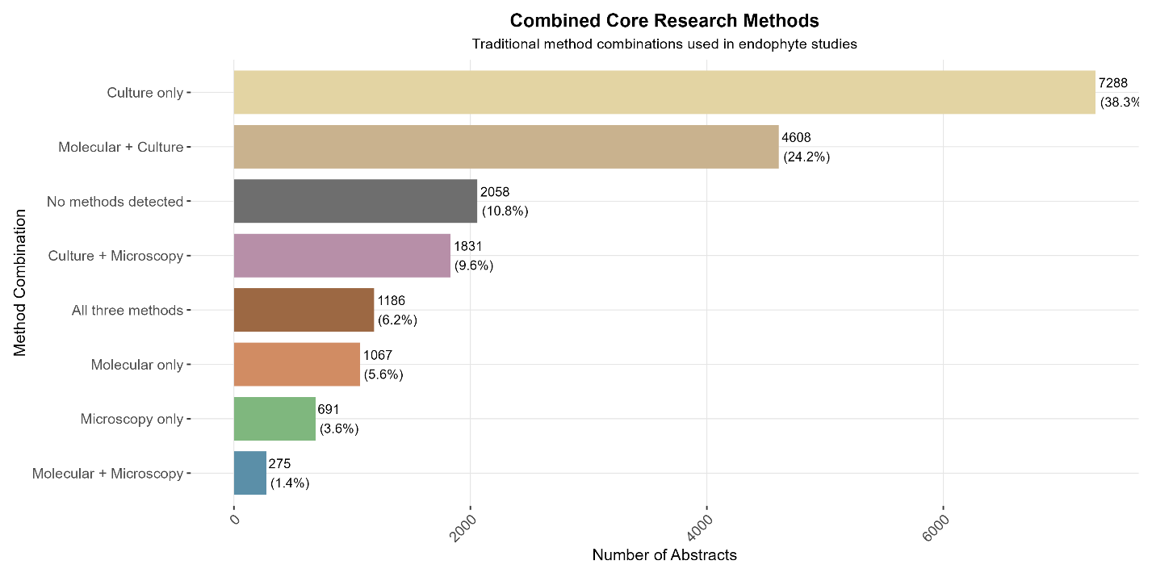

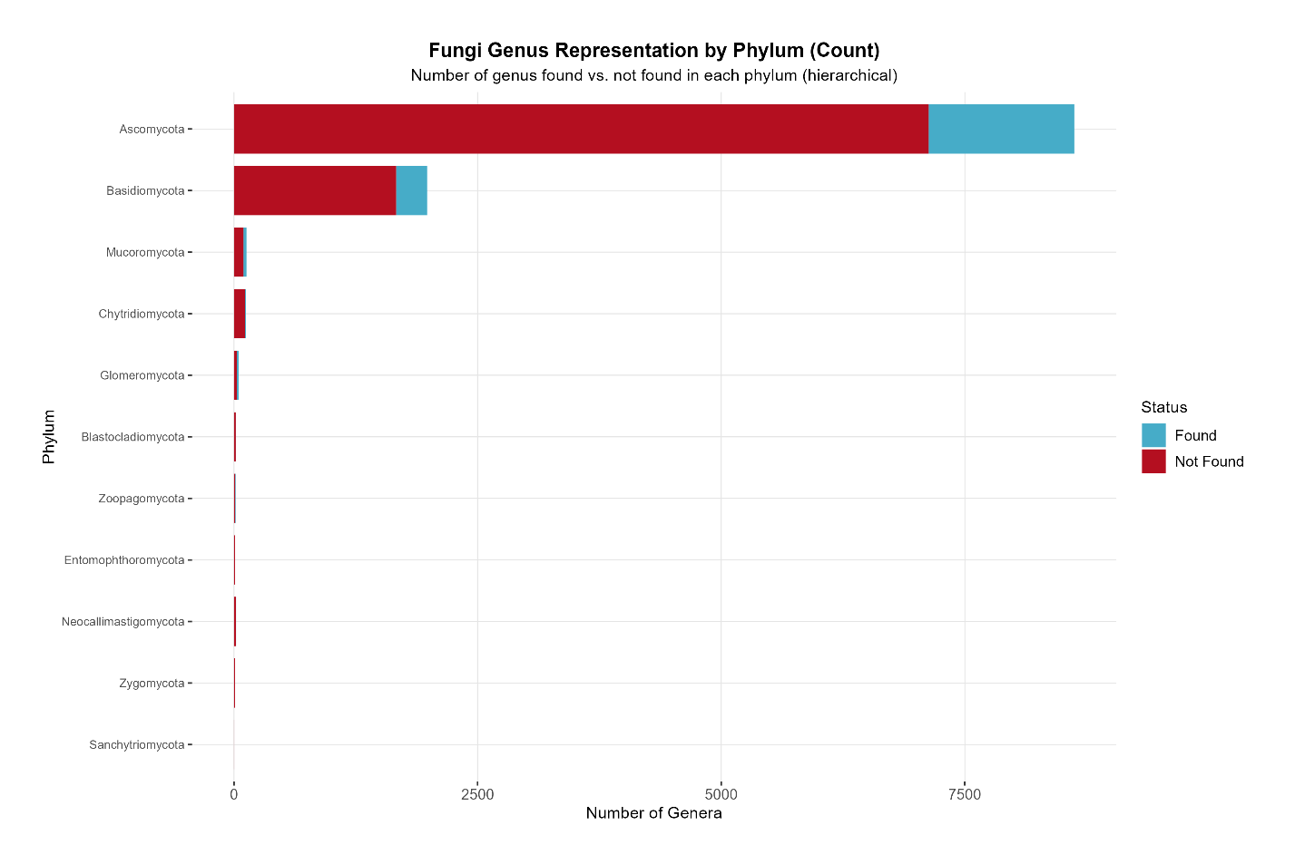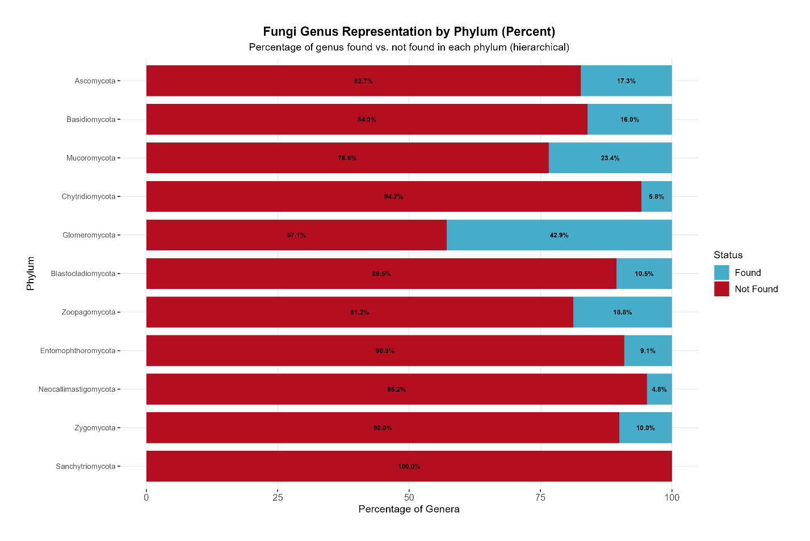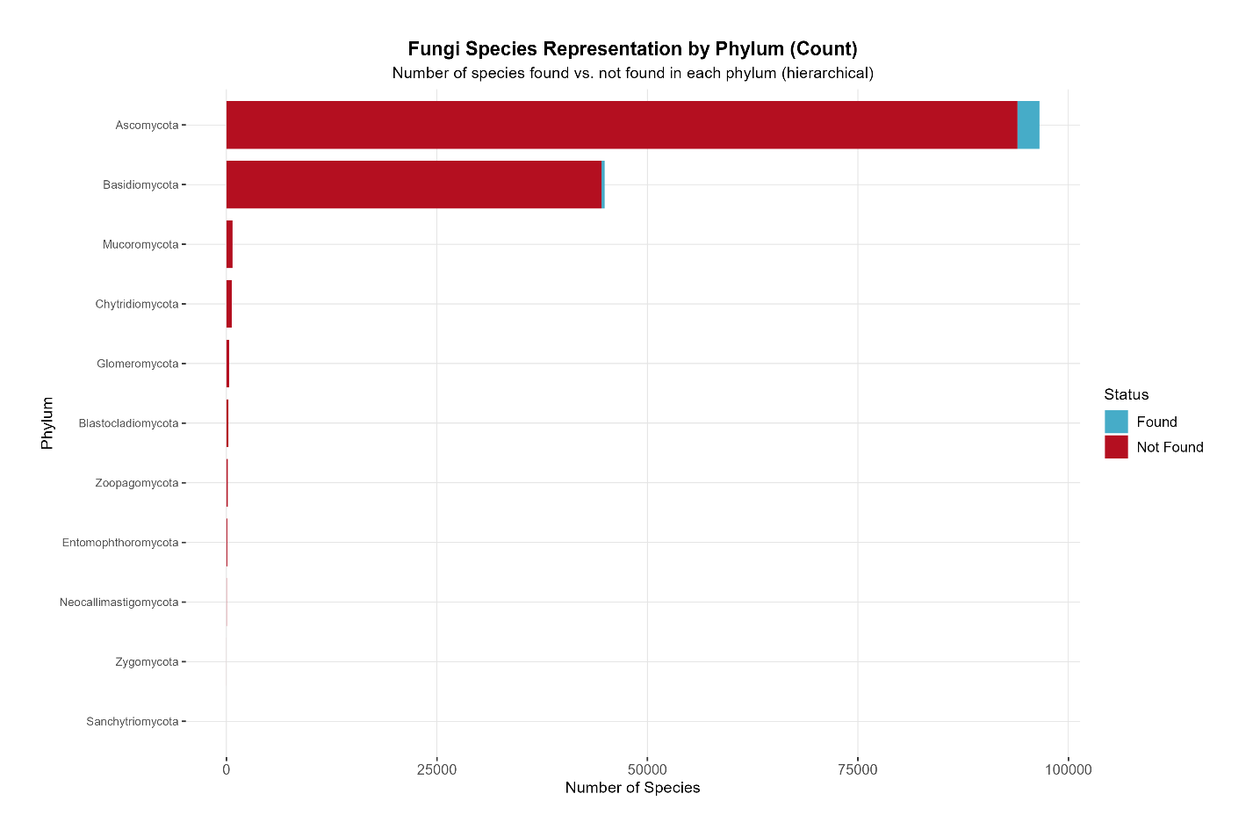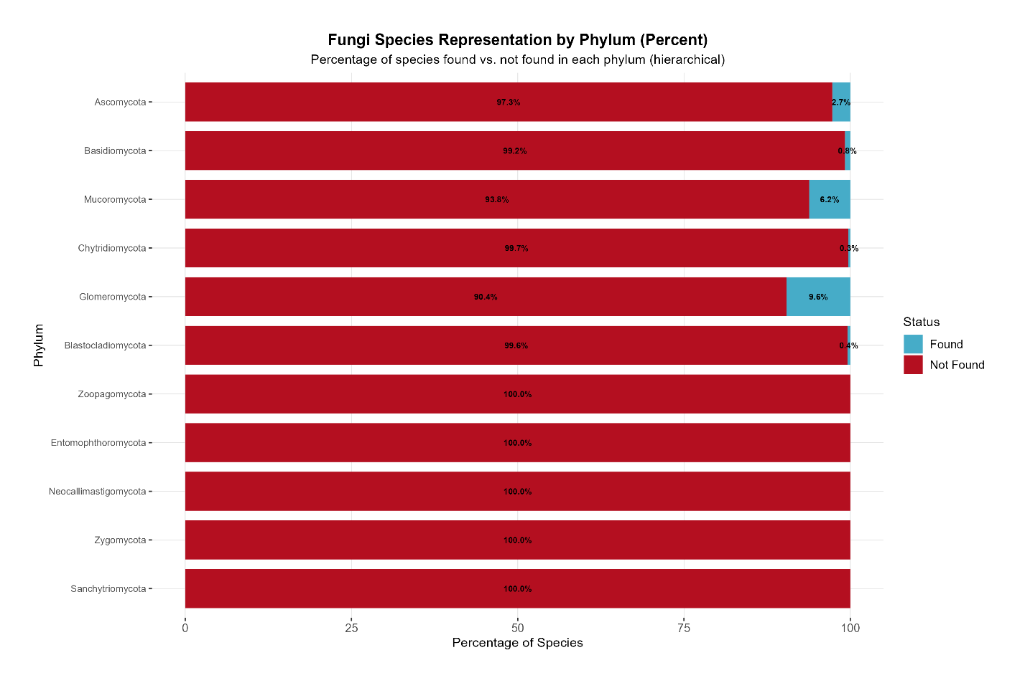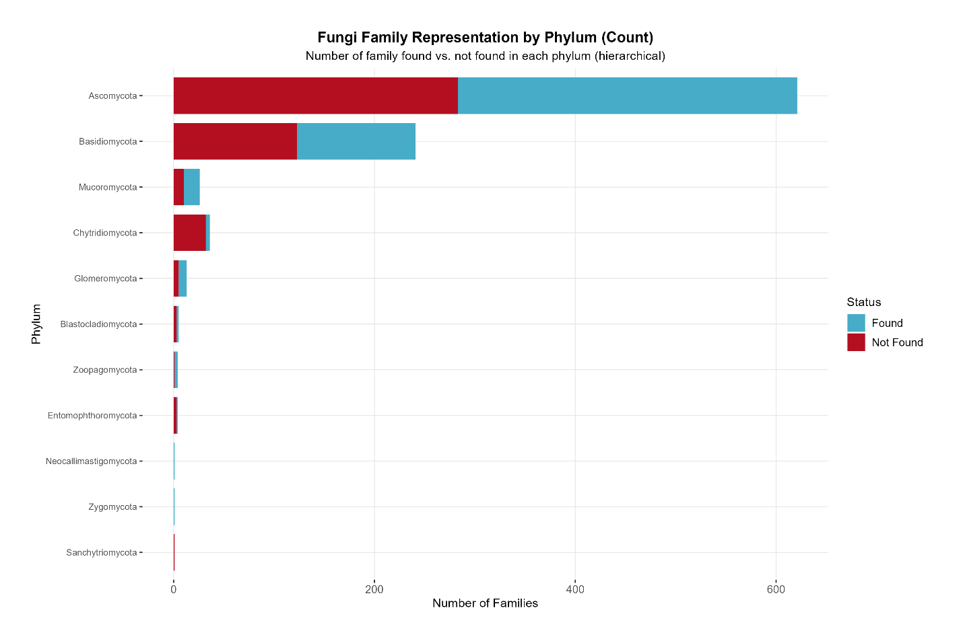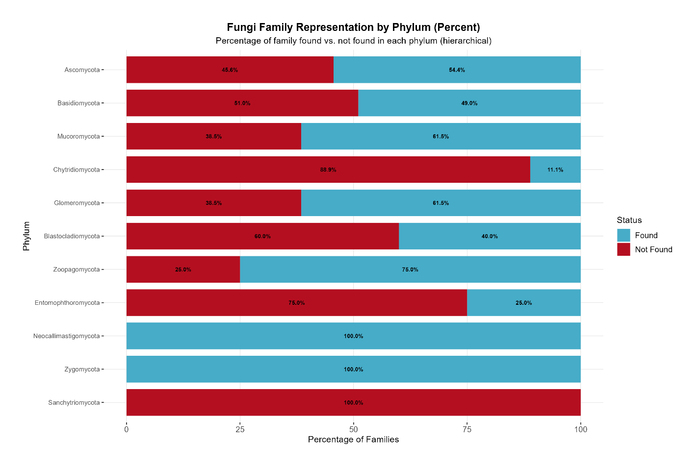

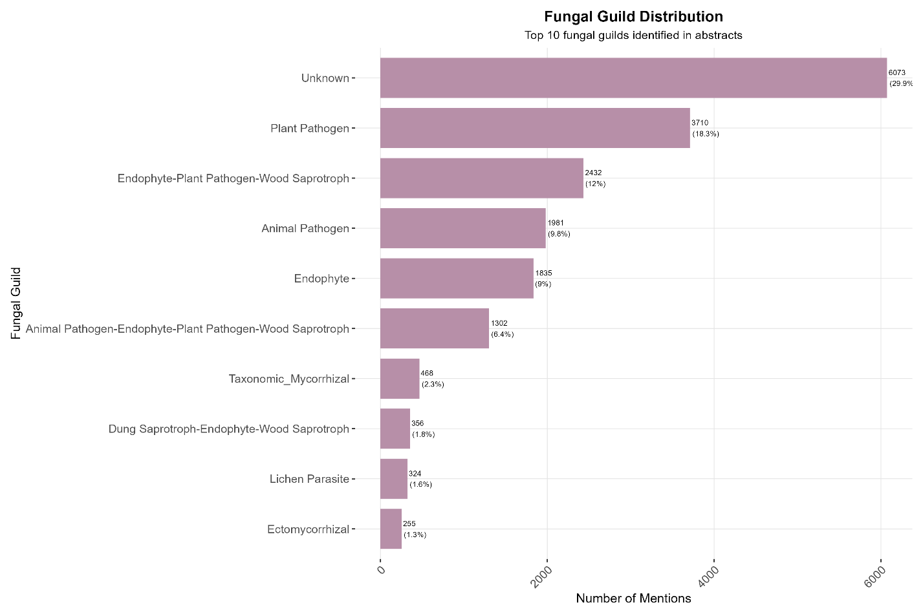
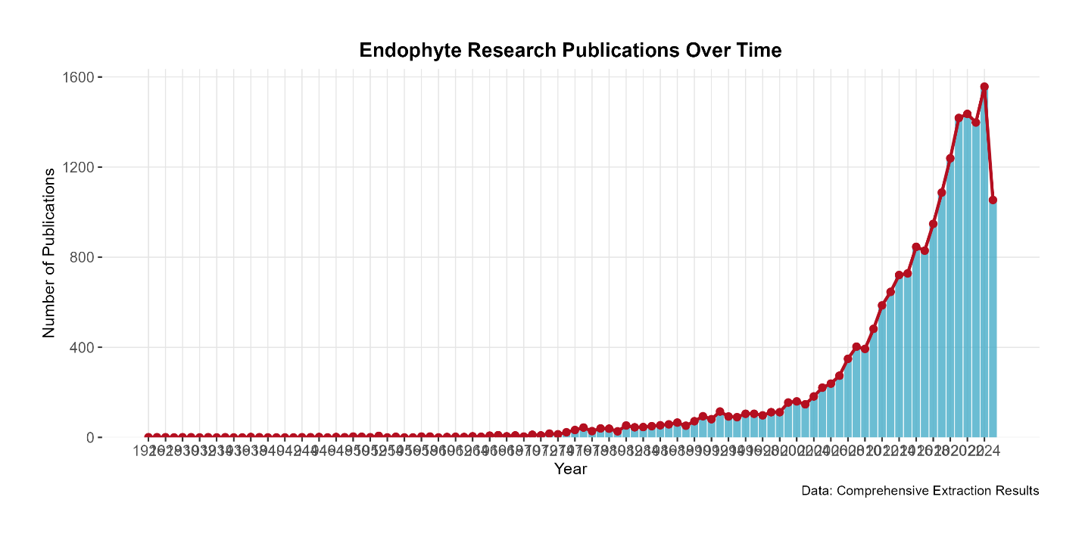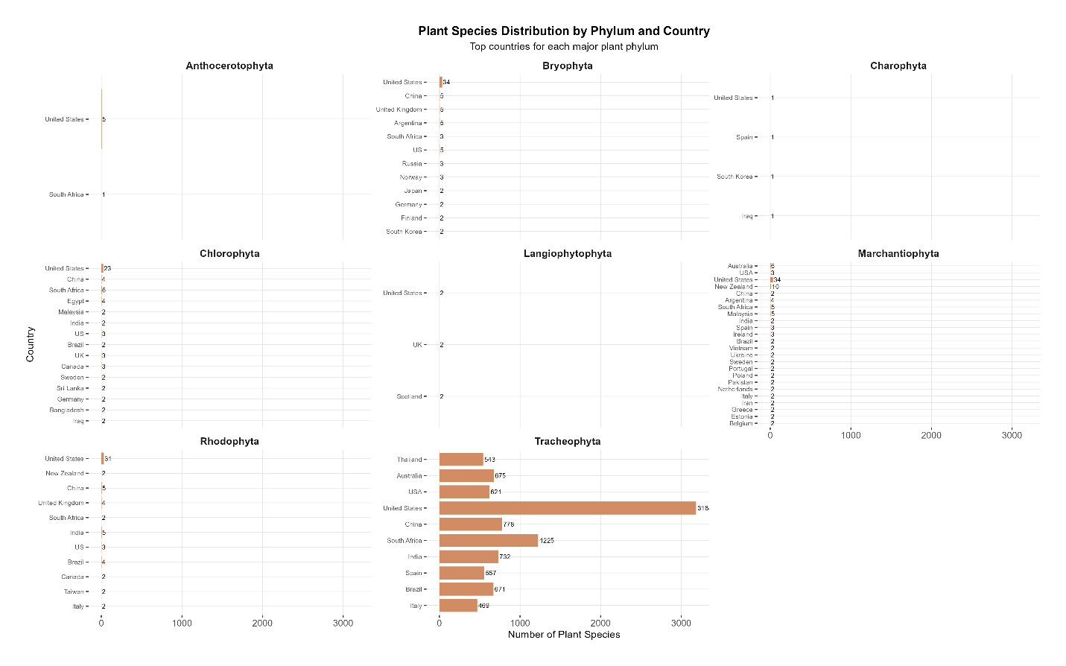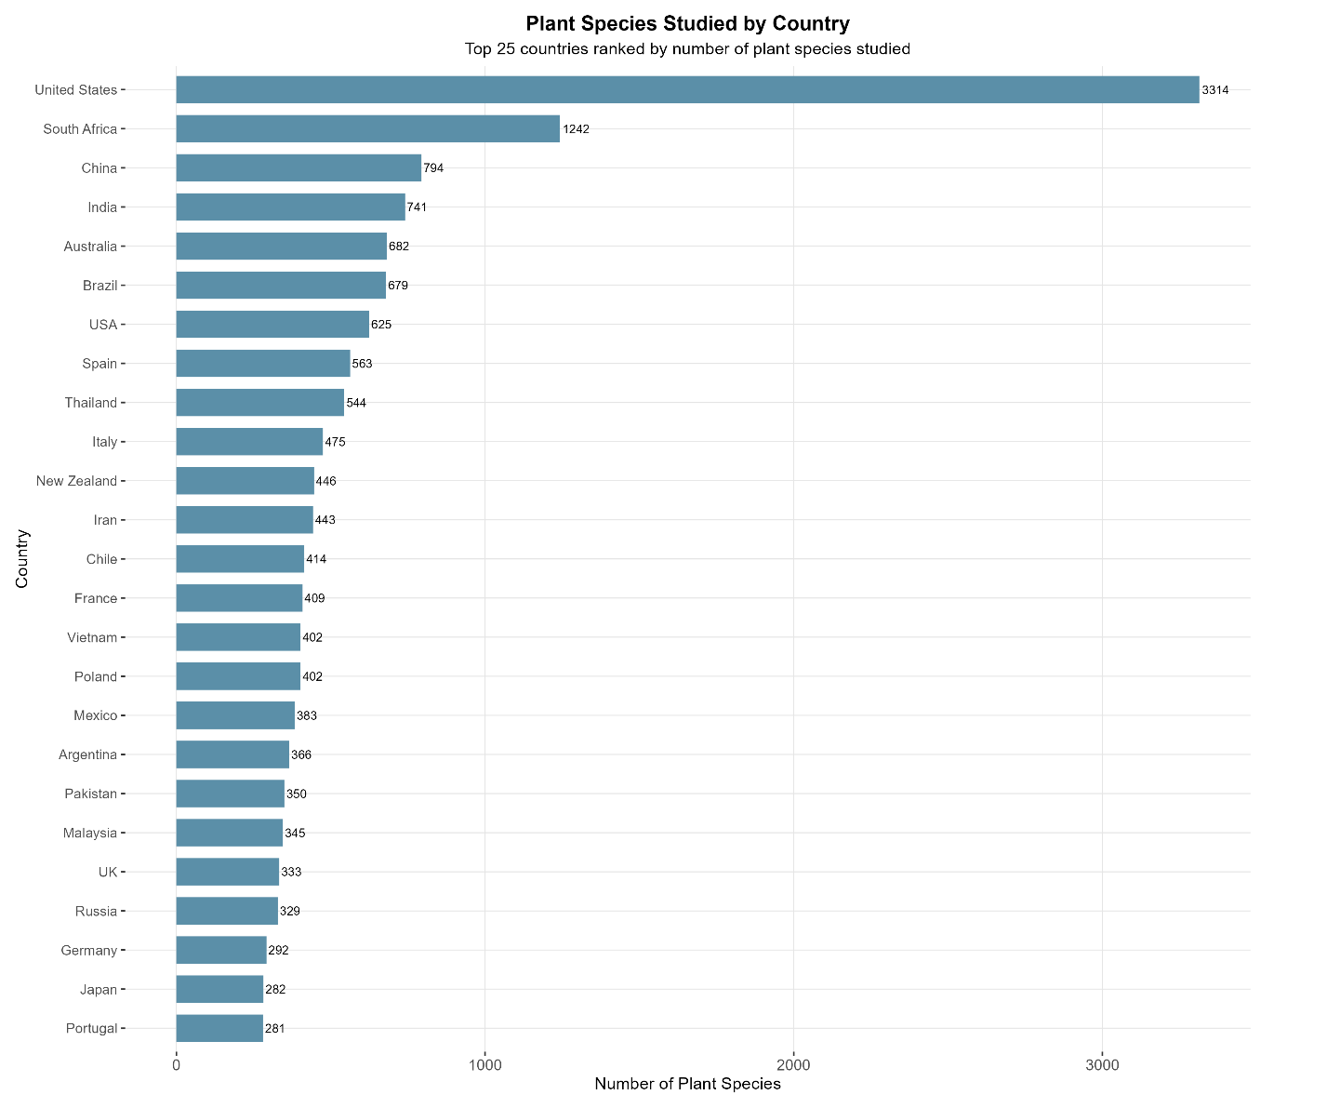

Model-related figures:
