Title:
Mapping the geographic, taxonomic, and socioeconomic biases of global fungal endophyte research

Submitting to: New Phytologist
Authors: B. M. Bock^{1,2}, N. P. McKay³, N.C. Johnson^{1, 3}, C.A. Gehring^{1,2}

1. Department of Biological Sciences, Northern Arizona University
2. Center for Adaptable Western Landscapes, Northern Arizona University
3. School of Earth and Sustainability, Northern Arizona University

Summary
Fungal endophytes are microorganisms that reside within plant tissues without causing apparent disease. The foundational assumption that these fungi are ubiquitous across all plants is frequently asserted in the literature, yet this paradigm lacks the support of a rigorous, global-scale synthesis. Understanding the actual geographic, taxonomic, and functional distribution of fungal endophyte research is essential in evaluating the reliability of broad ecological generalizations. To map this evidence base, we conducted an automated, abstract-led audit of 18,750 publications, harmonizing host and fungal nomenclature against the Global Biodiversity Information Facility (GBIF) backbone. Automated text analysis revealed that assumption of universal distribution appears in 2.7% of the published literature. However, the global sampling effort is systematically biased. Research is heavily concentrated in wealthy temperate nations and taxonomically skewed, leaving early-diverging plant lineages (e.g., Charophyta, Bryophyta) severely underexamined. The literature is functionally biased toward applied agricultural contexts, with over one-third (35.1%) of documented interactions focused on pathogens rather than asymptomatic associations. Consequently, the current map of endophyte ecology reflects socioeconomic priorities rather than the functional breadth and biogeographic distribution of fungal endophytes. While current data show that every sampled plant lineage hosts endophytes, the globally aggregated evidence base remains insufficient to support unqualified claims of global ubiquity. To guide more representative plant-fungal research, we provide a data-driven priority roadmap of under-sampled regions and taxa.

Introduction
Fungal endophytes, microorganisms that reside within plant tissues for at least a portion of their lifecycle without causing apparent disease, represent a critical component of terrestrial ecosystems (Petrini, 1991; Wilson, 1995; Stone et al., 2000). Their ecological significance is increasingly recognized, from shaping plant community dynamics to producing a vast arsenal of secondary metabolites with applications in medicine and agriculture (Strobel, 2003; Rodriguez et al., 2009; Kusari et al., 2012). A foundational assumption often repeated in the literature is that these fungi are ubiquitous, inhabiting all plants in every biome on Earth (Stone et al., 2000; Strobel, 2003; Arnold & Lutzoni, 2007; Rodriguez et al., 2009). While this claim is appealing and consistent with the positive evidence gathered to date, it has been propagated without a rigorous, global-scale quantitative synthesis testing this assumption against the actual geographic and taxonomic distribution of published research efforts.
The conclusions of any study are fundamentally constrained by the distribution of its sampling (Soberon & Peterson, 2005; Mörsdorf et al., 2015). If the evidence base for an entire field is geographically or taxonomically skewed, our understanding of global patterns becomes unreliable (Pyšek et al., 2008; Hughes et al., 2020; Christie et al., 2021). In the context of fungal endophytes, foundational ecological generalizations such as theories on plant-fungal co-evolution, community assembly rules, and biome-level adaptation are highly vulnerable to sampling bias (Arnold & Lutzoni, 2007; Davis & Shaw, 2008; U’Ren et al., 2012).
Evaluating this evidence base is fundamentally complicated by the fluid definition of endophytism itself. The traditional classification of endophytes as strictly asymptomatic is frequently confounded by the biological reality of latent pathogens and overlapping mycorrhizal lifestyles. Prior syntheses have provided valuable snapshots of endophyte distribution (Stone et al., 2000; Schulz & Boyle, 2005; Arnold & Lutzoni, 2007; U’Ren et al., 2012; Harrison & Griffin, 2020; Cosner et al., 2025), but the field currently lacks a comprehensive global synthesis integrating geographic, taxonomic, and socioeconomic factors. We aim to reframe the conversation from asking if fungal endophytes are ubiquitous to asking where we have sufficient evidence to test ecological and evolutionary hypotheses, thereby providing a data-driven foundation for the next generation of global endophyte research. To begin this reframe, this study provides the first integrated, global-scale audit of the fungal endophyte literature, directly evaluating the evidence for the ubiquity claim. We systematically quantify the distribution of research effort to map where ecological inferences are robust and where they are more speculative. Our objectives are to: (1) map the geographic concentration of endophyte studies; (2) assess the distribution of sampling effort across biomes and host plant lineages; (3) determine the relationship between research intensity and national economic capacity (GDP); and (4) produce an actionable roadmap of understudied regions and taxa to guide future research.
Based on these objectives, we predict that:
- (Prediction 1) The current, globally aggregated evidence base is insufficient to support an unqualified claim of endophyte ubiquity.
- (Prediction 2) Research effort is highly geographically clustered, with gaps across the Global South (e.g., Africa, Central Asia, and South America)
- (Prediction 3) Sampling is non-randomly distributed across biomes and host lineages, favoring certain well-studied groups.
- (Prediction 4) The intensity of endophyte research is positively correlated with a country’s GDP, reflecting socioeconomic rather than purely biological drivers of sampling.
By systematically testing these predictions, this study moves beyond localized snapshots to chart the current boundaries of our ecological knowledge, establishing a more rigorous framework for future plant-fungal symbiosis research.

Materials and Methods

Dataset Assembly and Scope
To construct our evidence base, publication records from Web of Science, Scopus, and PubMed were consolidated on November 18, 2024 using a standardized set of search terms related to fungal endophytes (see Supporting Information for more detail). To process this massive corpus, we deployed an automated natural language processing (NLP) pipeline utilizing a large language model (Mistral 7B) to extract distinct plant-fungal interactions, geographic locations, biomes, and functional guilds directly from the text.
This workflow (Figure 1) utilized two distinct datasets. First, an initial screening corpus of 21,891 unique records was assembled to audit the prevalence of the endophyte ubiquity claim. This broader set was intentionally maintained prior to final relevance filtering to ensure we captured the propagation of the claim across the wider ecological literature, including studies that may mention endophytes as background context without being primary fungal endophyte research. Second, after applying strict relevance and deduplication filters, a final analysis corpus of 18,750 unique fungal endophyte publications was established for the detailed mapping of geographic, taxonomic, and socioeconomic biases.

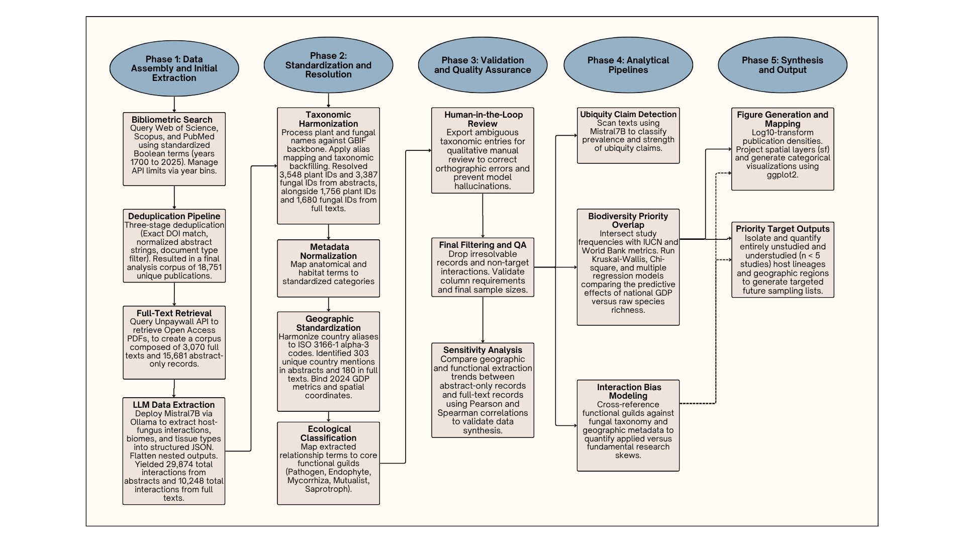
Figure 1: Workflow pipeline for the automated bibliometric audit. The initial dataset was assembled by querying Web of Science, Scopus, and PubMed, followed by a rigorous three-stage deduplication process. Where available, open-access full texts were retrieved via the Unpaywall API. Automated data extraction was executed on a high-performance computing cluster using a large language model (Mistral 7B) to isolate distinct plant-fungal interactions, geographic locations, biomes, and primary functional guilds. Extracted taxa were subsequently algorithmically harmonized against the Global Biodiversity Information Facility (GBIF) backbone. Finally, geographic metadata were standardized to ISO country codes and linked to World Bank macroeconomic indicators prior to statistical synthesis.
A barrier to global synthesis in this field remains the accessibility of primary literature (Cvitanovic et al., 2014; Orlando et al., 2018; Nuñez et al., 2021) (Scherer et al., 2018). Our retrieval process secured open-access full texts for 3,068 records (16.4%) within the final corpus, leaving the majority (n = 15,682) accessible only at the abstract level. To validate the reliability of this approach, we partitioned the final corpus into these two access tiers (abstract-only vs. full-text) and performed a comparative sensitivity analysis. We computed Jaccard similarity indices to evaluate the consistency of understudied taxonomic and geographic categories across both datasets. Additionally, we used Spearman rank correlations to test whether the primary socioeconomic signals remained stable regardless of text extraction depth. This validation step supported that major gaps detected in the abstract record reliably map underexplored themes in the broader published literature.

Taxonomic Resolution and Synonym Handling
To ensure robust lineage-level counts across decades of research, we developed a reproducible pipeline to harmonize plant and fungal taxonomy. All extracted plant and fungal names were processed against the Global Biodiversity Information Facility (GBIF) backbone taxonomy (GBIF Secretariat, 2023). Custom scripts algorithmically mapped and resolved obsolete or changing nomenclature to their currently accepted taxonomies. This process reconciled historical taxonomic shifts, such as changes in fungal phyla, ensuring that the analysis of biological coverage was based on a consistent and contemporary taxonomic framework.

Core Analyses
Following the data mining and extraction protocols detailed in the Supplementary Methods, we performed a series of interconnected analyses to quantify multi-dimensional sampling biases. Geographic concentration was initially assessed by mapping endophyte publication counts to countries, revealing global research hotspots. We then evaluated the relationship between research effort and economic capacity by correlating these per-country publication counts with national Gross Domestic Product (GDP) data sourced from the World Bank (World Bank, 2026).
To identify well-studied and neglected host lineages, taxonomic coverage was summarized across plant species, genera, families, and phyla using the resolved GBIF data (GBIF Secretariat, 2023). We also extracted and categorized the primary ecological guilds (e.g., pathogen, mutualist, mycorrhizal) to evaluate the functional focus of the literature, in addition to biome information. Finally, a large language model workflow was deployed to screen the entire corpus for explicit and implicit claims of endophyte ubiquity, allowing us to directly test this foundational assumption against the historical weight of the published record.
To guide future sampling efforts, we generated priority lists of understudied regions and host taxa (defined by a threshold of fewer than five publications).

Reproducibility and Validation
All data preprocessing, harmonization, and statistical analyses were performed programmatically to ensure full reproducibility. We developed a highly structured, version-controlled pipeline using both R (version 4.3.0) and Python (version 3.13.5) development environments within Visual Studio Code (VSCode)(R Core Team, 2023; Python Software Foundation, 2025; Microsoft, 2026).
All custom scripts used in this pipeline have been documented and are available to facilitate reproducing these analyses and figures in a Zenodo repository: link XXX.
Further details about the methods are included in the Supplementary Information.

Results
The final analysis dataset (n = 18,750) was narrowed from the initial screening set (n = 21,891) by filtering out off-target records, including review papers and studies focused on bacterial endophytes. Within this final dataset, open-access full texts were accessible for 3,068 records (16.4%), while the remaining 15,682 records were evaluated at the abstract level. We used this combined evidence base to test our remaining predictions, as sensitivity analyses confirmed statistical consistency between abstract-only and full-text subsets (see Supplementary Methods).

Prediction 1: The Evidence Base for Evaluating Endophyte Ubiquity
To evaluate the prevalence of the ubiquity claim, the available texts of the initial screening dataset (n = 21,891) were screened. The large language model (LLM) pipeline successfully identified 586 positive ubiquity claims, representing 2.7% of this broader dataset. These results comprised 334 explicit statements and 252 qualified ones. The natural language processing model proved highly reliable, producing an average internal confidence score of 0.91 (scale 0-1). Nearly half (49.1%) of the identified ubiquity claims lacked exact keyword matches (e.g., 'ubiquitous', 'cosmopolitan', 'all plants'). An evaluation of the taxonomic scope revealed that 545 of the 586 claims (93.0%) were constructed as universal generalizations covering all fungal endophytes, with fewer than 7% qualifying ubiquity specifically to an isolated fungal clade.

Prediction 2: Research Effort is Geographically Clustered
Shifting from the textual prevalence of the ubiquity claim to the spatial distribution of the underlying data, we found that that fungal endophyte research is strongly concentrated in a small number of countries (Figure 2). Of the 234 countries and territories analyzed, 133 yielded fewer than five studies, classifying the majority of countries as under-studied. The research was concentrated in North America, Europe, and East Asia, leaving large regions of Africa, Central Asia, and South America with highly fragmented evidence of sampling.
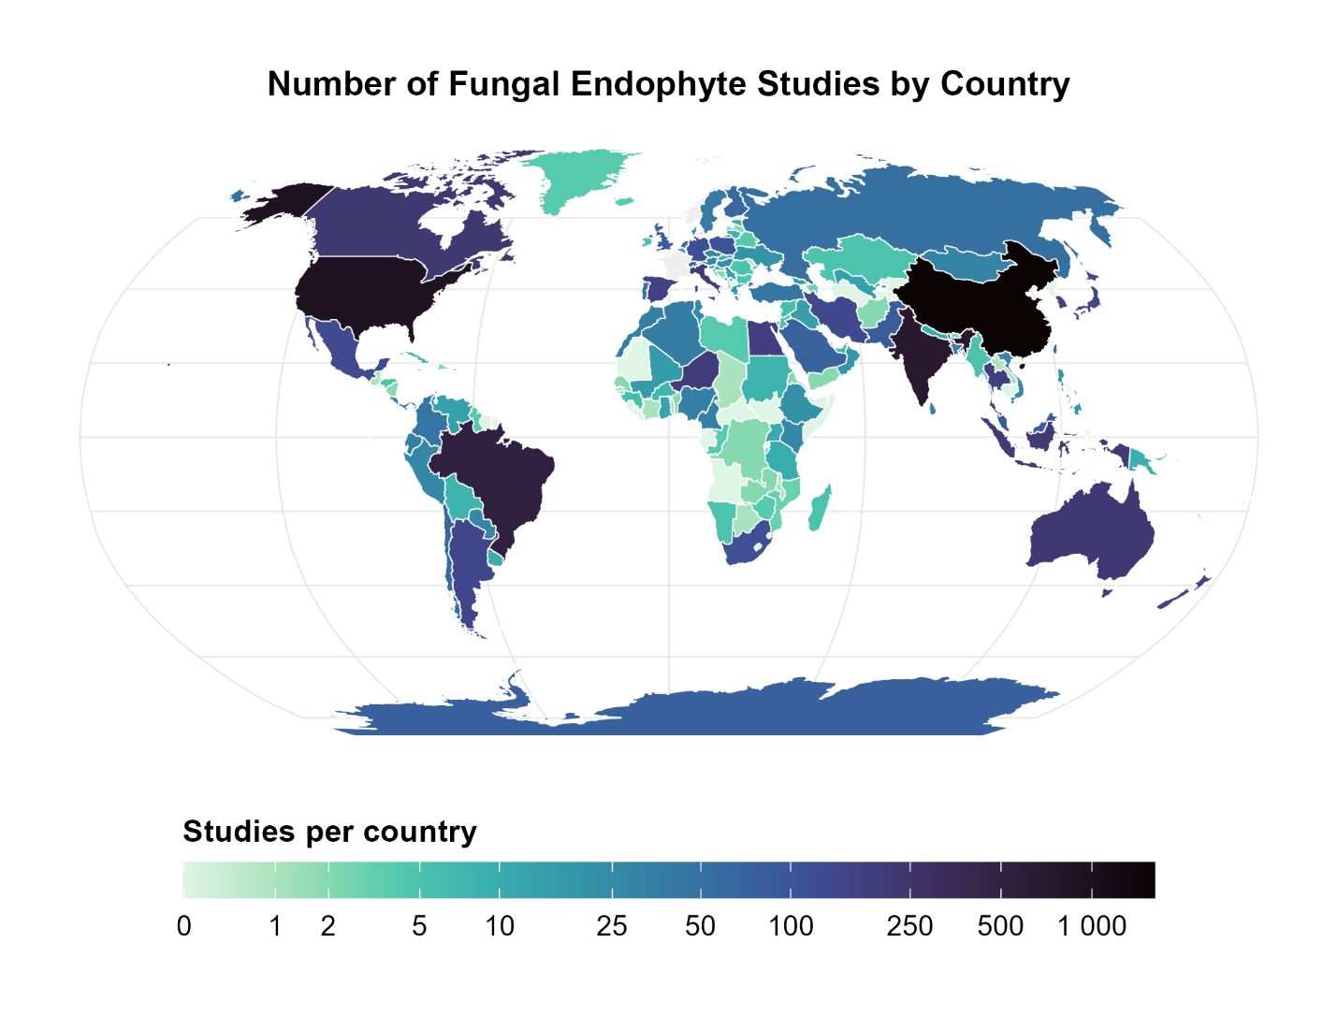
Figure 2: Global distribution of fungal endophyte research effort, Robinson projection. The map displays the number of studies per country based on a dataset of 18,750 publications. Of the 234 countries and territories analyzed, 133 have fewer than five recorded endophyte studies in our dataset. Research is heavily concentrated in North America, Europe, and East Asia, with large regions of Africa, Central Asia, and South America showing little to no research activity.

Prediction 3: Biome and Host Representation are Non-Random
Consistent with Prediction 3, sampling effort was not only geographically clustered but also highly skewed across biomes and host taxa. Within and across countries, research was disproportionately focused on temperate forests and agricultural biomes, while biomes such as tropical and subtropical grasslands, savannas, and shrublands were under-sampled (Figure 3).
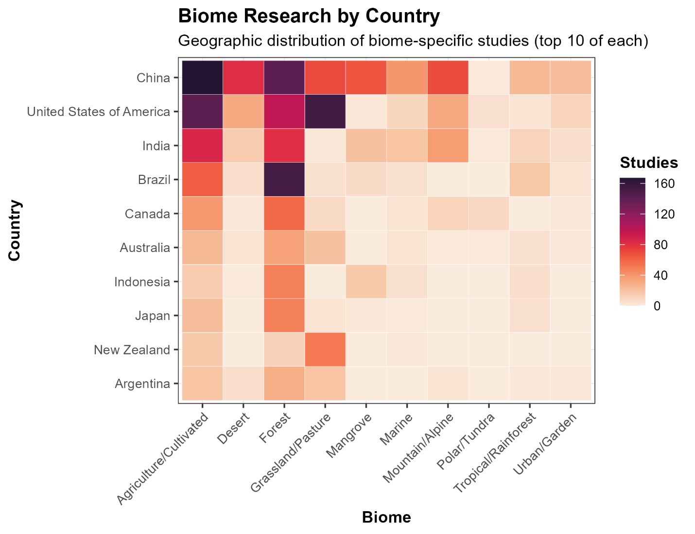
Figure 3: Heatmap of study counts by biome and country, displaying the top 10 categories of each.
Host taxonomic representation is heavily imbalanced dominated by economically important agricultural grasses. The family Poaceae accounts for 24.4% of all host records, including the four most-studied species overall: Lolium arundinaceum (tall fescue), Oryza sativa (rice), Zea mays (corn), and Lolium perenne (perennial ryegrass) (Figure 4) (Supplementary Figure 1). Furthermore, major agricultural genera collectively constitute 38.8% of studied host plants.). Conversely, our analysis revealed that numerous plant phyla and families have no recorded endophyte studies.
This pattern of narrow focus extends to the plants’ fungal partners. The most frequently studied fungal genera are those with well-known roles as agricultural pathogens, plant mutualists, or human health concerns. Genera such as Fusarium (11.1% of the dataset), Aspergillus (8.1% of the dataset), and the grass symbiont Epichloë (7.8% of the dataset) dominate the literature, while the broader diversity of fungal life remains largely unexplored in the context of endophytism.
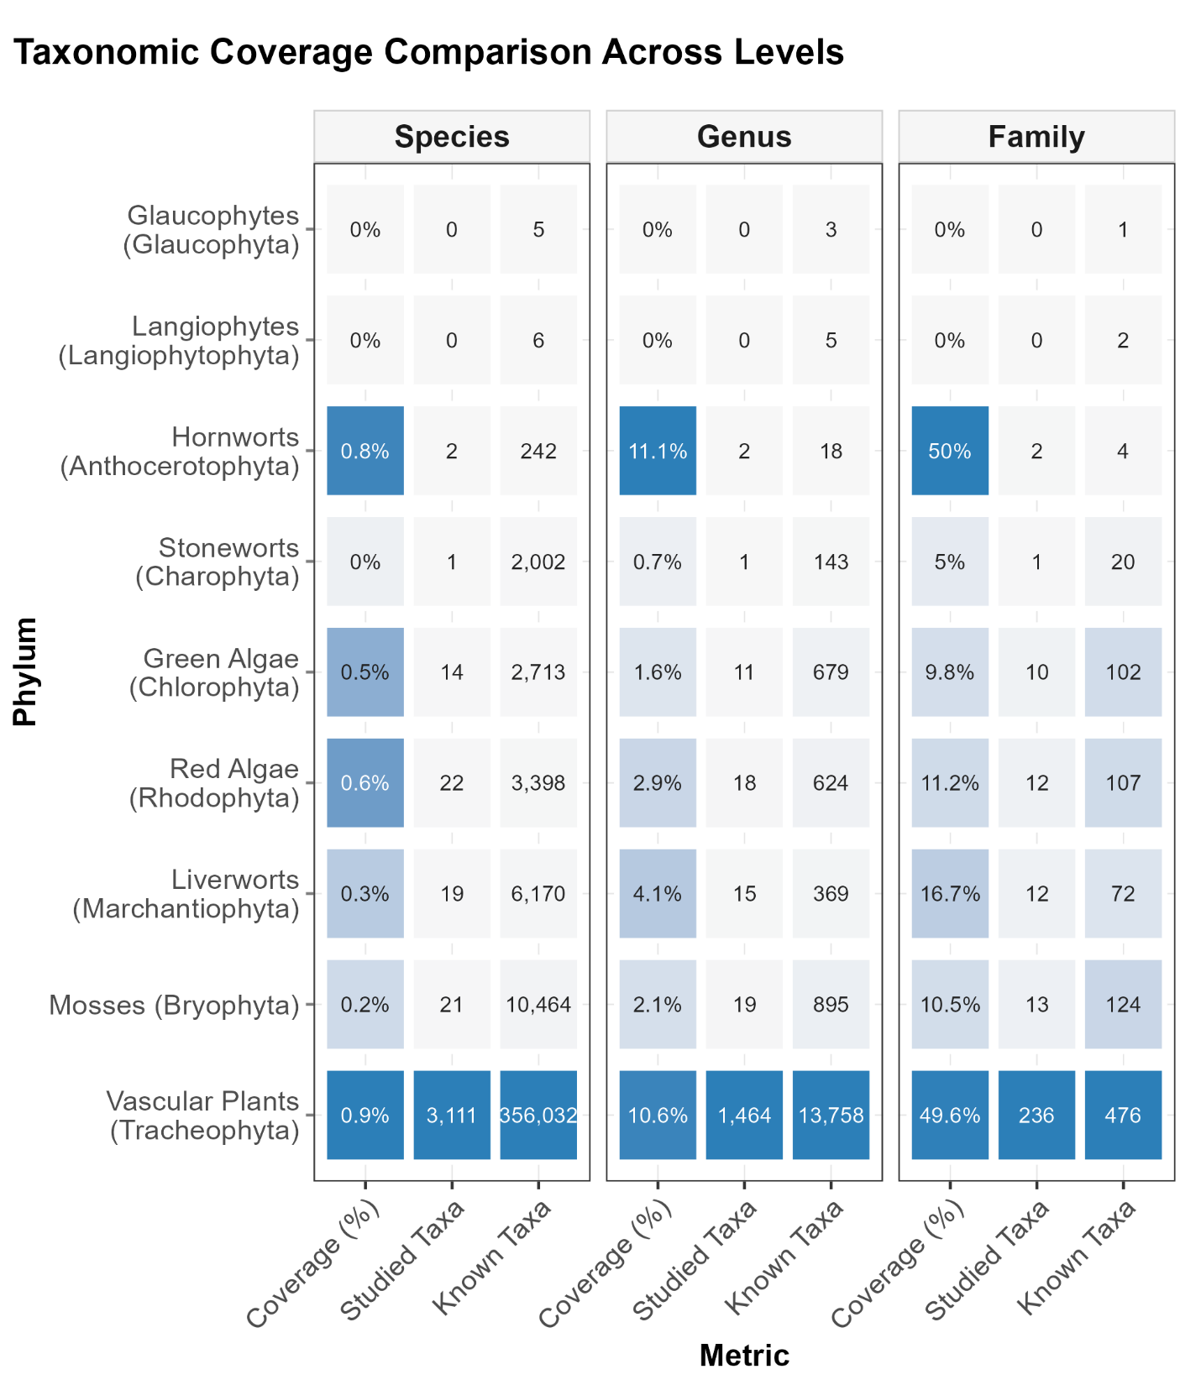
Figure 4: Host taxonomic representation in the endophyte literature. This heatmap shows the concentration of studies across plant species, genera, and families.

Prediction 4: Study Intensity Increases with GDP
Consistent with Prediction 4, we found a strong, positive, and significant correlation between a country's economic output and its endophyte research intensity. A country's log-transformed Gross Domestic Product (GDP) was a significant predictor of its log-transformed study count (Spearman's ρ = 0.84, P < 0.001), indicating that wealthier nations are studied more frequently (Figure 5). Further multiple regression modeling revealed that GDP was a much superior predictor of study count compared to ecological metrics. When modeled together, the predictive coefficient for economic status (log10 GDP: coefficient ~0.56, P < 0.001) overwhelmingly dominated the predictive effect of raw biodiversity (total species richness: coefficient < 0.001, P = 0.003). Likewise, independent non-parametric assessments confirmed that economic output (Spearman's ρ = 0.84) correlates much more robustly with sampling intensity than does absolute species richness (Spearman's ρ = 0.58).
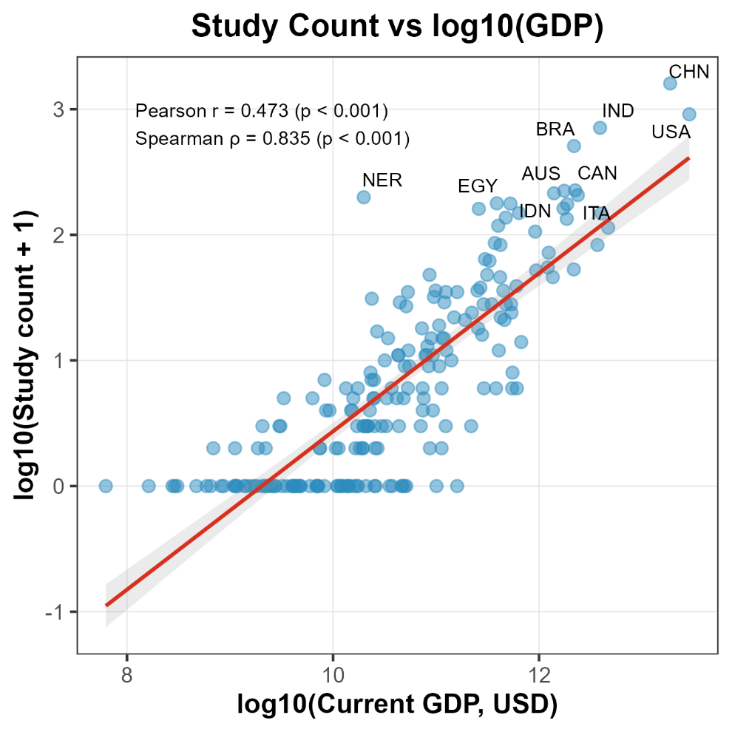
Figure 5: Relationship between a country's economic status and its endophyte research effort. The plot displays a country's log-transformed Gross Domestic Product (GDP) against its log-transformed study count. The line represents a linear regression fit, with the shaded area showing the 95% confidence interval.

Priority Outputs for Future Sampling

Based on these identified gaps, the pipeline generated priority lists of understudied (n<5 studies) countries and host taxa, lists of which are included in the Supplementary Files. The results highlight numerous plant genera and families with minimal representation in the literature, including early-diverging lineages such as Charophyta and Bryophyta (Figure 4). Likewise, the majority of countries (133), including high-biodiversity locations including Angola, Armenia, and the Bahamas (Figure 2), remain severely understudied, with fewer than five studies captured in our global dataset.

Functional Guild Representation in the Literature
While geographic and taxonomic gaps represent a limitation of the current evidence base, it was also necessary to determine if the literature was functionally constrained. To evaluate the functional focus of the global evidence base, the primary ecological guilds reported across the extracted plant-fungus interactions were categorized. Results indicate that the literature is not exclusively focused on benign commensalism and instead reflects a broad functional continuum. While purely endophytic (asymptomatic) relationships comprised the plurality of documented interactions (42.5%; representing 50.9% of studies), a substantial proportion of the literature focuses on pathogenic relationships (35.1% of interactions; 27.1% of studies). These metrics diverge because individual publications frequently document multiple distinct plant-fungus interaction pairs across different guilds; discrete interaction pairs provide the highest-resolution unit for quantifying explicit functional focus. The dataset captured significant functional overlap with other established guilds, with 10.3% of documented endophyte interactions explicitly involving mycorrhizal contexts, and 4.9% focused on antagonistic or biocontrol applications.

Sensitivity Analysis: Abstract and Full-Text Consistency
To test the reliability of our abstract-led audit, we performed a comparative sensitivity analysis between the abstract and full-text datasets. The abstract-only dataset comprised 29,874 distinct plant-fungal interactions extracted from 15,682 publications, while the open-access full-text subset yielded 10,248 interactions across 3,068 publications. Full-text parsing captured a higher density of records per document (3.34 interactions per paper) compared to abstracts (1.91 interactions per paper), reflecting the omission of fine-scale species tables and descriptions from introductory texts. The abstract-only dataset captured a higher absolute taxonomic volume, representing 0.69% of known plant species and 1.42% of described fungal taxa, whereas the full-text subset captured 0.35% and 0.66%, respectively.
To assess how these different datasets reflect the knowledge gaps discussed in this manuscript, we computed the Jaccard similarity index for understudied categories across both datasets. The identity of understudied (n<5) host taxa was nearly identical between the abstract and full-text datasets, demonstrating high overlap at the family (Jaccard index = 0.857), genus (0.943), and species (0.994) levels. The overlap of understudied (n < 5) countries was more moderate (0.466), but this is a predictable drop given the absolute reduction in sample size between the abstract-only (n = 15,682) and full-text (n = 3,068) datasets. Despite this, the near-perfect taxonomic consistency suggests that host lineages missing from abstract records are equally absent from full texts.
Correlation testing demonstrated that global structural signals remained robust between the two datasets. The dominant socioeconomic predictor discovered in this study (the relationship between log-transformed GDP and publication volume) was similar between the abstract-only dataset (Spearman’s ρ=0.78, P<0.001) and the full-text dataset (ρ=0.83, P<0.001). These results support that abstract-led text mining accurately detects the broader systemic biases operating across the global endophyte literature landscape in this study.

Discussion
Our analysis of the global endophyte literature reveals a research landscape that is geographically and taxonomically constrained. The patterns of data availability are not random. Rather, they are strongly shaped by socioeconomic factors that are decoupled from the planet’s biological richness. This uneven distribution has profound implications for the robustness of endophyte ecological theory. Because the current literature is heavily dominated by a few economically vital agricultural grasses (Poaceae) and highly studied symbionts like Epichloë, our foundational frameworks for symbiotic pest defense and mutualism are based on a narrow, agronomic baseline. Extrapolating these models globally leaves the field with limitations regarding how symbioses operate in hyper-diverse natural ecosystems or tropical plant lineages.
This socioeconomic and functional skew necessitates a critical re-evaluation of how we interpret ubiquity in the context of global sampling effort. As anticipated by our initial prediction, these findings demonstrate that while the ubiquity claim is a recurring theme across the literature, the globally aggregated evidence base remains heavily constrained and insufficient to support unqualified ecological generalizations. Rather than asserting absolute global ubiquity, the available data support a more precise conclusion: every plant lineage examined to date has been found to host fungal endophytes.

Interpreting the Evidence Gaps
A primary finding of our study is the existence of a substantial evidence gap, with a high proportion of countries, biomes, and plant taxa represented by fewer than five recorded fungal endophyte studies in our analysis. At this threshold (n < 5), study-level variance becomes indistinguishable from true biological patterns, rendering regional extrapolations invalid. In these data-starved regions, fundamental ecological inferences including estimates of host specificity, microbial endemism, and community assembly rules become ungrounded. As a result, it is difficult to verify whether understudied tropical ecosystems harbor distinct endophyte community structures or functional roles that are absent from temperate zones.
This data scarcity is most apparent at the taxonomic level. Despite aggregating decades of research across 18,750 publications, the combined record captures only 0.69% of known plant species and 1.42% of described fungal taxa. Because early-diverging, non-vascular lineages such as bryophytes are almost entirely neglected in this record, our current understanding of how plant-fungal symbioses originated and evolved remains fundamentally skewed toward vascular tracheophytes. For example, we find zero recorded instances of fungal endophytes associated with bryophytes in Colombia, despite South America possessing high non-vascular plant diversity (Renvoize et al., 2000; Soto et al., 2023). These gaps reveal a disconnect between research effort and actual biodiversity patterns. Numerous countries recognized for their high conservation priority receive disproportionately little attention in the endophyte literature. For example, biologically diverse nations such as Angola, Kyrgyzstan, and Suriname remain under-sampled in our dataset. Instead of charting true biological boundaries, current field-level generalizations mirror wealthy sampling footprints, rendering claims about global fungal distribution and function highly speculative.

Ecological Implications of Sampling Bias
The concentration of research in temperate, high-GDP nations has significant ecological consequences. Fungal biogeography is structured by environmental gradients, evolutionary history, and dispersal limitations (Tedersoo et al., 2014). By over-sampling a narrow range of temperate and agricultural systems, the field risks inflating its confidence in patterns of endophyte diversity, host affinity, and ecological function that may not hold true in other contexts. For example, conclusions about community assembly or transmission modes derived predominantly from North American and European forests may be poor predictors of the dynamics in under-sampled tropical systems, which harbor a different suite of host plants and environmental pressures (Townsend et al., 2008; Myers et al., 2013; Zuk, 2016). This bias represents an untapped opportunity to understand the full spectrum of endophyte symbioses and their roles in ecosystem processes across the globe.

The Functional Continuum: Beyond Benign Ubiquity
Beyond constraints in geographic and taxonomic sampling, our dataset reveals a severe functional skew. The classification of interaction types reveals that 35.1% of the plant-fungal associations in the dataset focus explicitly on pathology. This suggests that a substantial portion of our global understanding of 'endophytes' is derived from agricultural disease vectors or latent pathogens, which may not accurately reflect the dynamics of stable, asymptomatic residents in natural ecosystems. This functional overlap reveals an inconsistent use of the term 'endophyte', conflicting with its classical definition as an explicitly asymptomatic state. Rather than forcing complex plant-fungal interactions into rigid, asymptomatic definitions, future syntheses should explicitly embrace this functional fluidity, acknowledging that endophytism often represents a transitional ecological state.
This functional fluidity is further evidenced by the blurring of boundaries with mycorrhizal research, which accounts for 10.3% of the interactions captured under endophyte search criteria. As established by others (Jumpponen, 2001; Schulz & Boyle, 2005; Mandyam & Jumpponen, 2015), the endophytic state is not a rigid taxonomic grouping but a fluid ecological state that frequently transitions into pathogenicity or mutualism. Additionally, fungi definitionally classified as mycorrhizal are sometimes documented as endophytes due to overlapping spatial definitions of root colonization. Global assertions of endophyte ubiquity are inherently conflated with pathogenic and mycorrhizal literature, requiring future syntheses to explicitly define their functional scope.
Economic Capacity Drives Global Research Disparities
Restricting fieldwork to wealthy, temperate nations creates a systematic data-deficit that leaves an immense repository of fungal novelty undiscovered (Newman & Cragg, 2012). For example, targeted exploration of extreme environments has isolated endemic endophytes from the Antarctic vascular plant Colobanthus quitensis that possess entirely novel metabolic pathways (Bertini et al., 2022). Additionally, discoveries of volatile-producing endophytes like Muscodor albus from remote Honduran rainforests highlight the potential biochemical value of studying fungal endophytes in currently undersampled locations (Strobel, 2003, 2018; Saxena & Strobel, 2021). From a taxonomic perspective, these regions are prime candidates for finding undescribed lineages. For example, localized sampling of the living sapwood of wild Hevea populations in the Amazon Basin yielded multiple entirely novel lineages of Tolypocladium (Gazis et al., 2014). These discoveries highlight the opportunity cost of a research landscape driven by institutional economics rather than global biodiversity.

The Utility and Limitations of an Abstract-Dominated Audit
Given that over 83% of the analyzed dataset remains behind paywalls, conducting a global-scale synthesis requires utilizing abstract-level data. While this approach inherently misses endophyte occurrences buried in full texts or supplementary next-generation sequencing tables, our methodology serves as a robust, systematic field audit of the most visible and accessible scientific evidence.
Our direct comparison of the abstract-only and full-text datasets supports the validity of this approach. While full-text parsing extracted a higher relative density of plant-fungal rows (10,248 interactions from 3,068 papers) than abstract mining (29,874 interactions from 15,682 papers), the underlying macroecological signals remained unchanged. The strong socioeconomic bias linking research intensity to national wealth was statistically similar between abstract-level data (Spearman’s ρ=0.78) and full-text subsets (ρ=0.83). While abstract-mining captured a lower density of total interactions per document compared to full-text parsing, it demonstrated high fidelity in identifying host-taxonomic knowledge gaps, yielding Jaccard similarity indices above 0.85 for family-level lineages. This indicates that abstract-led mining is a reliable tool for identifying broad-scale taxonomic biases in this study, even if it lacks the granular resolution of full-text primary data.
This approach highlights the systematic barriers created by paywalled science. By relying on the most commonly accessible part of a publication, our analysis maps the boundaries of our default knowledge. Ultimately, these boundaries are defined less by biology than by the accessibility of the literature itself.

A Roadmap for Future Sampling
Based on these findings, we propose a strategic roadmap for future endophyte research. To build a more robust and representative understanding of endophyte ecology, sampling efforts should be intentionally directed toward two key areas. First, there is a critical need to explore host lineages that are currently underrepresented in the literature. We provide comprehensive priority lists of these understudied taxa at the phylum, family, genus, and species levels, alongside a list of 133 severely under-sampled countries, as Supplementary Data. Our analysis shows a heavy concentration on economically important plant families (e.g. Poaceae, Fabaceae), all within the Tracheophyta phylum. A concerted effort to sample early-diverging and non-vascular plant lineages would provide crucial insights into the evolutionary history of endophytism. Second, research must expand into high-biodiversity, low-GDP regions. Countries such as Tonga, Angola, and Armenia, along with large portions of Africa and Central Asia, represent gaps in our knowledge. A targeted, collaborative effort to sample in these regions is essential for discovering novel fungal diversity and for testing the generality of ecological theories developed in temperate zones. Such a program would not only advance the field of endophyte ecology but also contribute to global biodiversity conservation goals. These outputs provide a concrete roadmap for targeted sampling efforts designed to fill the most significant gaps in our current understanding of global endophyte diversity.

Conclusions

While the foundational premise of endophyte ubiquity is frequently repeated, the globally aggregated evidence base is currently insufficient to validate unqualified ecological generalizations across the Tree of Life. More precisely, the data demonstrate that every plant lineage examined to date hosts fungal endophytes. However, the scope of what has been examined is fundamentally constrained by human economics. The current literature represents a structural reflection of national wealth and applied agricultural priorities rather than a strategic effort to document global biodiversity. Addressing these deep systemic gaps presents an immense opportunity for ecological discovery.

Moving forward, endophyte ecology must proactively decouple research intensity from national institutional capacity. We recommend implementing the data-driven priority roadmap established in this study by specifically targeting early-diverging plant lineages and under-sampled, high-biodiversity regions. This will allow the next generation of plant-fungal ecological research to transition from simply asserting universal distribution to systematically uncovering the true functional and evolutionary mechanics of these critical plant-fungal symbioses.

Acknowledgements
This work was supported by National Science Foundation (NSF) MacroSystems grant DEB-1340852 (C.A.G.), US Department of Energy program in Systems Biology Research to Advance Sustainable Bioenergy Crop Development (DE-FOA-0002214)(N.C.J.), the Lucking Family Professorship (C.A.G.), the ARCS Foundation (B.M.B.), the Presidential Fellowship Program at NAU (B.M.B.), the Arizona Mushroom Society (B.M.B.), the Support for Graduate Students program at NAU (B.M.B.), and the American Association of University Women’s American Dissertation Fellowship (B.M.B.).

Author Contributions
B.M.B. conceived the study, developed the pipeline, and wrote the manuscript. N.M., N.C.J., and C.A.G. advised throughout the project and edited the manuscript.

Supplementary Figures
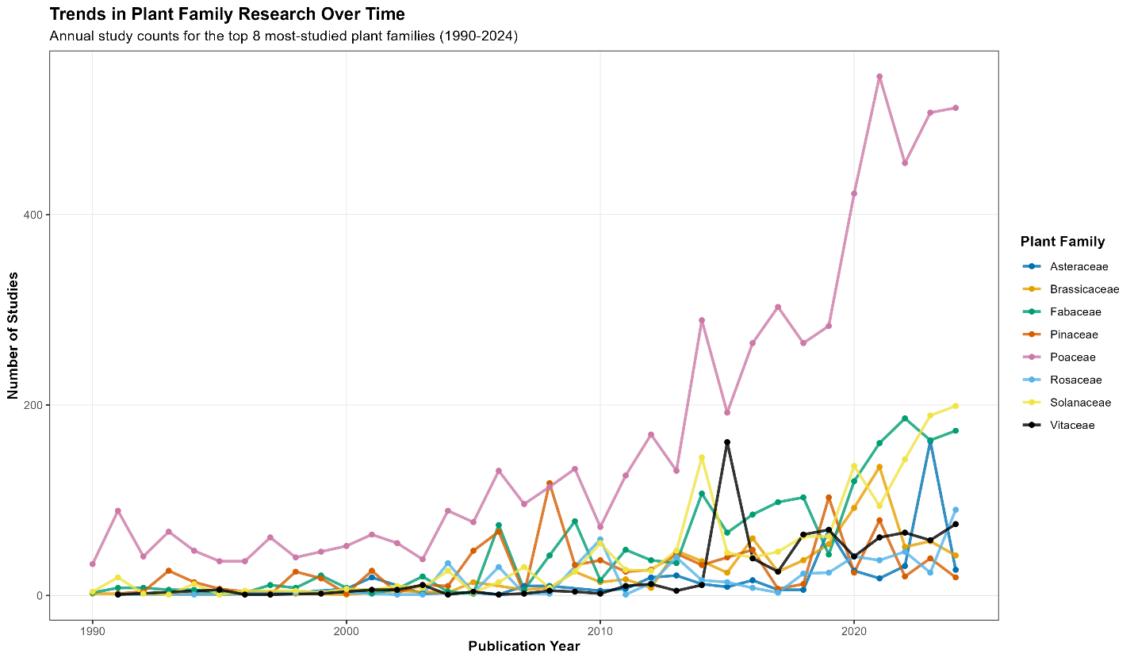
Figure S1. Top 8 most studied plant families in the dataset over time, showing the prevalence of Poaceae in the dataset of studied plant hosts.
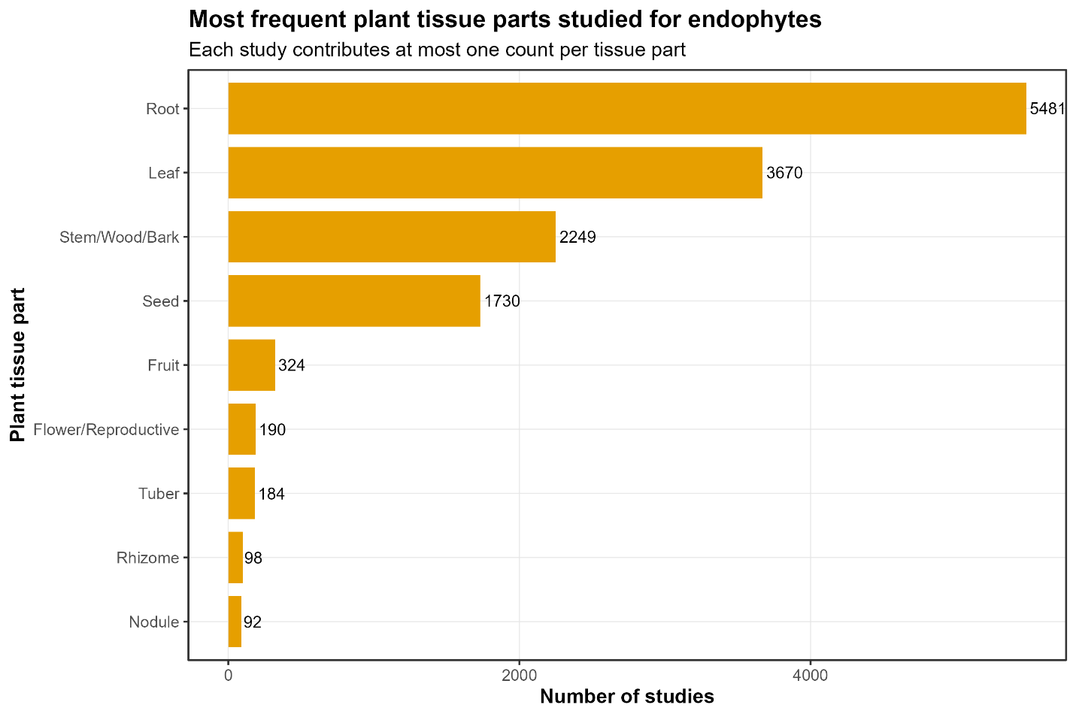
Figure S2: Most frequently studied plant tissues for fungal endophytes.
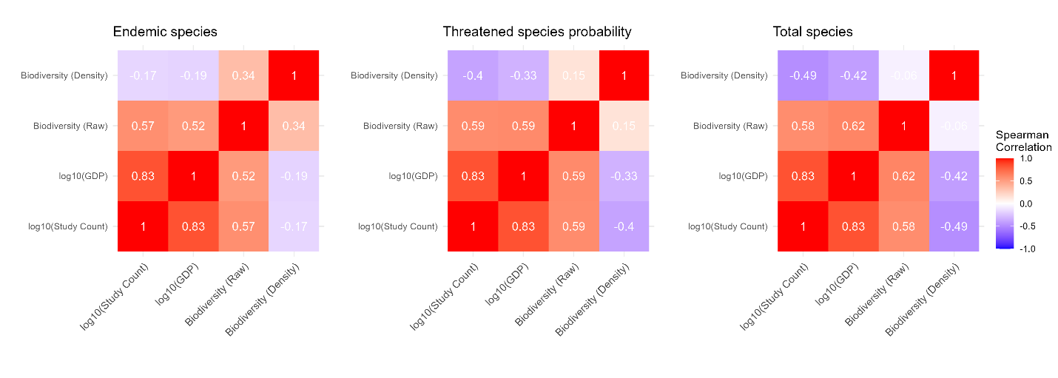
Figure S3. Correlation heatmap of research effort, socioeconomic status, and biodiversity metrics. This figure shows the pairwise correlations between a country’s study count, its Gross Domestic Product (GDP), and various metrics of biodiversity. GDP is the variable most strongly correlated with study count, indicating that economic factors are a primary driver of research intensity.

Other potential supplemental figures we can include:

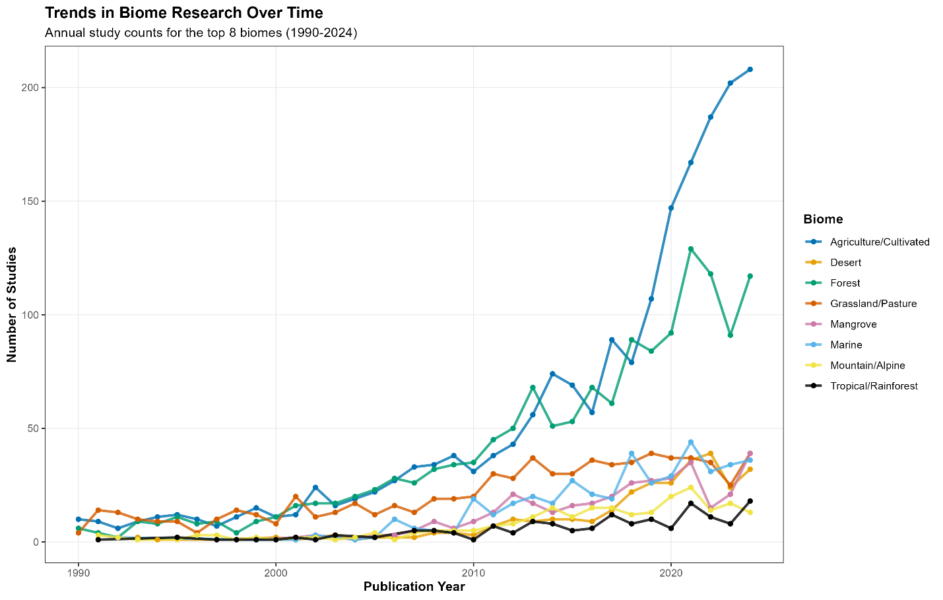

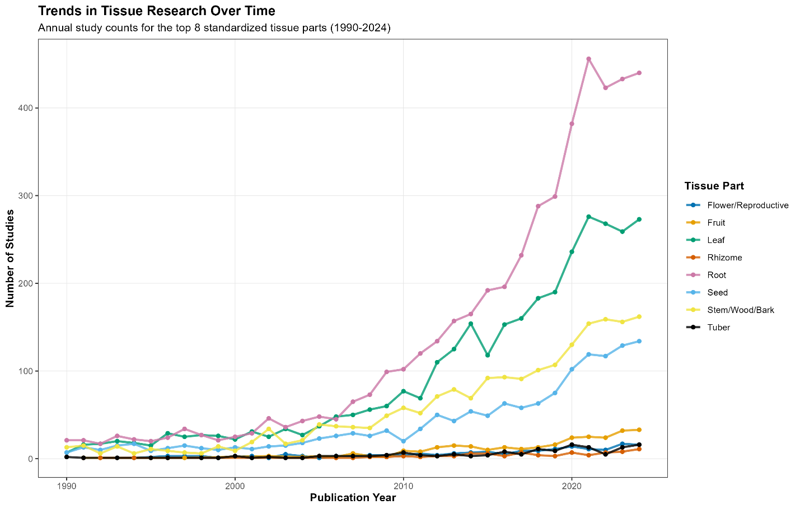
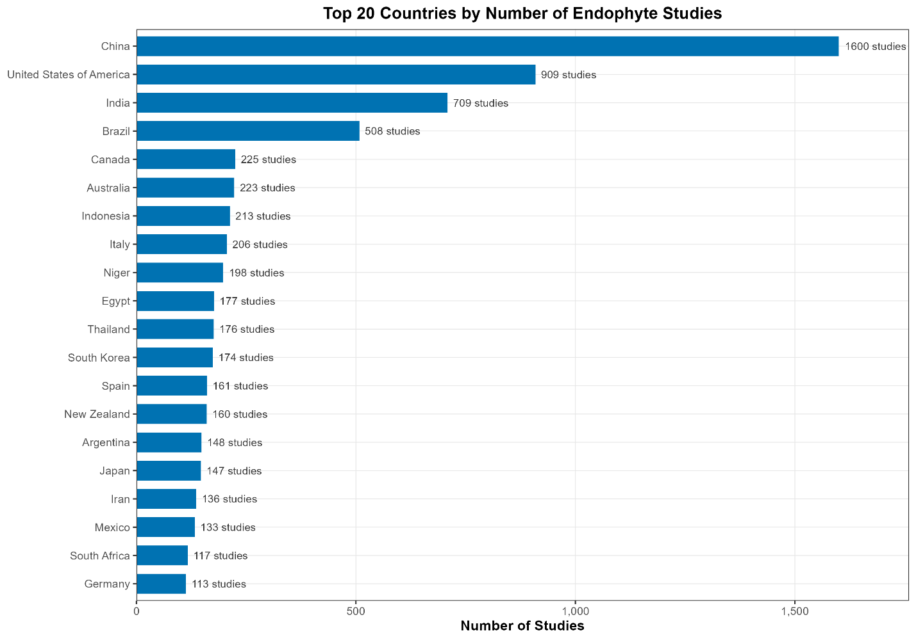

Works Cited
Arnold A, Lutzoni F. 2007. Diversity and host range of foliar fungal endophytes: Are tropical leaves biodiversity hotspots? Ecology 88: 541–549.
Bertini L, Perazzolli M, Proietti S, Capaldi G, Savatin D, Bigini V, Longa C, Basaglia M, Favaro L, Casella S, et al. 2022. Biodiversity and Bioprospecting of Fungal Endophytes from the Antarctic Plant Colobanthus quitensis. Journal of Fungi 8.
Christie AP, Amano T, Martin PA, Petrovan SO, Shackelford GE, Simmons BI, Smith RK, Williams DR, Wordley CFR, Sutherland WJ. 2021. The challenge of biased evidence in conservation. Conservation Biology 35: 249–262.
Cosner J, Pandharikar G, Tremble K, Nash J, Rush TA, Vilgalys R, Veneault-Fourrey C. 2025. Fungal endophytes. Current Biology 35: R904–R910.
Cvitanovic C, Fulton CJ, Wilson SK, Van Kerkhoff L, Cripps IL, Muthiga N. 2014. Utility of primary scientific literature to environmental managers: An international case study on coral-dominated marine protected areas. Ocean & Coastal Management 102: 72–78.
Davis EC, Shaw AJ. 2008. Biogeographic and phylogenetic patterns in diversity of liverwort‐associated endophytes. American Journal of Botany 95: 914–924.
Gazis R, Skaltsas D, Chaverri P. 2014. Novel endophytic lineages of Tolypocladium provide new insights into the ecology and evolution of Cordyceps -like fungi. Mycologia 106: 1090–1105.
GBIF Secretariat. 2023. GBIF Backbone Taxonomy.
Harrison JG, Griffin EA. 2020. The diversity and distribution of endophytes across biomes, plant phylogeny and host tissues: how far have we come and where do we go from here? Environmental Microbiology 22: 2107–2123.
Hughes A, Orr M, Ma K, Costello M, Waller J, Provoost P, Zhu C, Qiao H. 2020. Sampling biases shape our view of the natural world.
Jumpponen A. 2001. Dark septate endophytes - are they mycorrhizal? Mycorrhiza 11: 207–211.
Kusari S, Hertweck C, Spiteller M. 2012. Chemical Ecology of Endophytic Fungi: Origins of Secondary Metabolites. Chemistry & Biology 19: 792–798.
Mandyam KG, Jumpponen A. 2015. Mutualism-parasitism paradigm synthesized from results of root-endophyte models. Frontiers in Microbiology 5.
Microsoft. 2026. Visual Studio Code.
Mörsdorf MA, Ravolainen VT, Støvern LE, Yoccoz NG, Jónsdóttir IS, Bråthen KA. 2015. Definition of sampling units begets conclusions in ecology: the case of habitats for plant communities. PeerJ 3: e815.
Myers JA, Chase JM, Jiménez I, Jørgensen PM, Araujo‐Murakami A, Paniagua‐Zambrana N, Seidel R. 2013. Beta‐diversity in temperate and tropical forests reflects dissimilar mechanisms of community assembly (H Cornell, Ed.). Ecology Letters 16: 151–157.
Newman DJ, Cragg GM. 2012. Natural Products As Sources of New Drugs over the 30 Years from 1981 to 2010. Journal of Natural Products 75: 311–335.
Nuñez MA, Chiuffo MC, Pauchard A, Zenni RD. 2021. Making ecology really global. Trends in Ecology & Evolution 36: 766–769.
Orlando L, Rivera-Rebella C, Pinelli V, Pereira-Garbero R, Hernandez D, Ortiz E, Ziegler L. 2018. 100 articles every ecologist can actually read? Neotropical Biology and Conservation 13: 334–336.
Petrini O. 1991. Fungal Endophytes of Tree Leaves. In: Andrews JH, Hirano SS, eds. Brock/Springer Series in Contemporary Bioscience. Microbial Ecology of Leaves. New York, NY: Springer New York, 179–197.
Pyšek P, Richardson DM, Pergl J, Jarošík V, Sixtová Z, Weber E. 2008. Geographical and taxonomic biases in invasion ecology. Trends in Ecology & Evolution 23: 237–244.
Python Software Foundation. 2025. Python Language Reference, Version 3.13.5.
R Core Team. 2023. R: A Language and Environment for Statistical Computing.
Renvoize S, Luteyn JL, Churchill SP, Iii DG, Gradstein SR, Sipman HJM, A. MRG. 2000. Paramos: A Checklist of Plant Diversity, Geographical Distribution, and Botanical Literature (Memoirs of the New York Botanical Garden Volume 84). Kew Bulletin 55: 1017.
Rodriguez RJ, White Jr JF, Arnold AE, Redman RS. 2009. Fungal endophytes: diversity and functional roles. New Phytologist 182: 314–330.
Saxena S, Strobel GA. 2021. Marvellous Muscodor spp.: Update on Their Biology and Applications. Microbial Ecology 82: 5–20.
Scherer RW, Meerpohl JJ, Pfeifer N, Schmucker C, Schwarzer G, Von Elm E. 2018. Full publication of results initially presented in abstracts (Cochrane Methodology Review Group, Ed.). Cochrane Database of Systematic Reviews 2018.
Schulz B, Boyle C. 2005. The endophytic continuum. Mycological Research 109: 661–686.
Soberon J, Peterson AT. 2005. Interpretation of Models of Fundamental Ecological Niches and Species’ Distributional Areas. Biodiversity Informatics 2.
Soto E, Montoya C, Castaño A, Granobles J. 2023. Diversity patterns of vascular and non-vascular epiphytes along tropical dry forest. Revista de Biología Tropical 71: e53522.
Stone JK, Bacon CW, White F. 2000. An Overview of Endophytic Microbes: Endophytism Defined. In: Microbial Endophytes. CRC Press, 1–28.
Strobel GA. 2003. Endophytes as sources of bioactive products. Microbes and Infection 5: 535–544.
Strobel G. 2018. The Emergence of Endophytic Microbes and Their Biological Promise. JOURNAL OF FUNGI 4.
Tedersoo L, Bahram M, Põlme S, Kõljalg U, Yorou NS, Wijesundera R, Ruiz LV, Vasco-Palacios AM, Thu PQ, Suija A, et al. 2014. Global diversity and geography of soil fungi. Science 346: 1256688.
Townsend A, Asner G, Cleveland C. 2008. The biogeochemical heterogeneity of tropical forests. Trends in Ecology & Evolution 23: 424–431.
U’Ren JM, Lutzoni F, Miadlikowska J, Laetsch AD, Arnold AE. 2012. Host and geographic structure of endophytic and endolichenic fungi at a continental scale. American Journal of Botany 99: 898–914.
Wilson D. 1995. Fungal Endophytes Which Invade Insect Galls - Insect Pathogens, Benign Saprophytes, or Fungal Inquilines. Oecologia 103: 255–260.
World Bank. 2026. World Bank Open Data: GDP (Current US$).
Zuk M. 2016. Temperate Assumptions: How Where We Work Influences How We Think. The American Naturalist 188: S1–S7.

