Title options:
1. Global Sampling Biases in Fungal Endophyte Research
2. Mapping the Underexplored Biomes, Hosts, and Economies of Fungal Endophyte Ecology

Submitting to: New Phytologist
Authors: B. M. Bock^{1,2}, N. McKay³, N.C. Johnson^{1, 3}, C.A. Gehring^{1,2}

1. Department of Biological Sciences, Northern Arizona University
2. Center for Adaptable Western Landscapes, Northern Arizona University
3. School of Earth and Sustainability, Northern Arizona University

Summary
The foundational assumption that fungal endophytes are ubiquitous, in that they inhabit all plants, is frequently asserted in the literature, yet this paradigm lacks a rigorous, global-scale synthesis. Understanding the actual geographic, taxonomic, and functional distribution of endophyte research is essential to evaluate the reliability of broad ecological generalizations. To map this evidence base, we conducted an automated, abstract-led audit of 18,750 publications, harmonizing host and fungal nomenclature against the Global Biodiversity Information Facility (GBIF) backbone. Semantic text-mining revealed that the ubiquity premise appears in 2.7% of the published literature. However, global sampling effort is systematically biased. Research is heavily concentrated in temperate nations, strongly predicted by national Gross Domestic Product (GDP), and taxonomically skewed, leaving early-diverging plant lineages (e.g., Charophyta, Bryophyta) severely underexamined. Crucially, the literature is functionally biased toward applied agricultural contexts, with over one-third (35.1%) of documented interactions focused on pathogens rather than asymptomatic associations. Consequently, the current map of endophyte ecology reflects economic priorities rather than biological reality. A data-driven priority roadmap of under-sampled regions and taxa is provided to guide more representative plant-fungal research.

Introduction
Fungal endophytes, microorganisms that reside within plant tissues for at least a portion of their lifecycle without causing apparent disease, represent a critical component of terrestrial ecosystems (Petrini, 1991; Wilson, 1995; Stone et al., 2000). Their ecological significance is increasingly recognized, from shaping plant community dynamics to producing a vast arsenal of secondary metabolites with significant potential for medicine and agriculture (Strobel, 2003; Rodriguez et al., 2009; Kusari et al., 2012). A foundational assumption often repeated in the literature is that these fungi are ubiquitous, inhabiting all plants in every biome on Earth (Stone et al., 2000; Strobel, 2003; Arnold & Lutzoni, 2007; Rodriguez et al., 2009). While this claim is appealing and consistent with the positive evidence gathered to date, it has been propagated without a rigorous, global-scale quantitative synthesis. Our semantic analysis of the literature captured over 550 assertions of endophyte ubiquity across the corpus. The widespread propagation of this claim underscores the critical necessity of testing this baseline assumption against the actual geographic and taxonomic distribution of published research efforts. Crucially, this traditional definition of endophytism as a commensal state is often complicated by the frequent overlap between endophytic, latent pathogenic, and mycorrhizal lifestyles in the primary literature.
The conclusions of any study are fundamentally constrained by the distribution of its sampling (Soberon & Peterson, 2005; Mörsdorf et al., 2015). If the evidence base for an entire field is geographically or taxonomically skewed, our understanding of global patterns becomes unreliable (Pyšek et al., 2008; Hughes et al., 2020; Christie et al., 2021). Ecological generalizations about endophyte diversity, host specificity, and biome-level adaptation are vulnerable to such sampling bias (Arnold & Lutzoni, 2007; Davis & Shaw, 2008; U’Ren et al., 2012). Prior syntheses have provided valuable, yet spatially or taxonomically limited, snapshots of endophyte distribution (Stone et al., 2000; Schulz & Boyle, 2005; Arnold & Lutzoni, 2007; U’Ren et al., 2012; Harrison & Griffin, 2020; Cosner et al., 2025). However, a comprehensive global analysis that integrates geographic, taxonomic, and economic factors has been missing. This gap is particularly critical because we find that over 80% of the primary literature on fungal endophytes remains behind paywalls, making large-scale synthesis largely dependent on abstract-level data mining (Orlando et al., 2018). Because the abstract record is a biased sample of the literature, a well-studied region or host group is more likely to appear repeatedly there; by the same logic, absence from abstracts is suggestive of limited attention, but not proof of ecological absence.
This study provides the first integrated, global-scale audit of the fungal endophyte literature, directly evaluating the evidence for the ubiquity claim. We systematically quantify the distribution of research effort to map where ecological inferences are robust and where they are more speculative. Our objectives are to: (1) map the geographic concentration of endophyte studies; (2) assess the distribution of sampling effort across biomes and host plant lineages; (3) determine the relationship between research intensity and national economic capacity (GDP); and (4) produce an actionable roadmap of understudied regions and taxa to guide future research.
Based on these objectives, we predict that:
- (Prediction U) The current, globally aggregated evidence base is insufficient to support an unqualified claim of endophyte ubiquity.
- (Prediction A) Research effort is highly clustered geographically, with significant gaps in major regions of the world.
- (Prediction B) Sampling is non-randomly distributed across biomes and host lineages, favoring certain well-studied groups.
- (Prediction C) The intensity of endophyte research is positively correlated with a country’s GDP, reflecting economic rather than purely biological drivers of sampling.
By testing these predictions, we aim to reframe the conversation from asking if fungal endophytes are ubiquitous to asking where we have sufficient evidence to test ecological and evolutionary hypotheses, thereby providing a data-driven foundation for the next generation of global endophyte research.

Materials and Methods

Corpus Assembly and Scope
To construct our evidence base, publication records from Web of Science, Scopus, and PubMed were consolidated using a standardized set of search terms related to fungal endophytes. This workflow utilized two distinct data scales. First, an initial screening corpus of 21,891 unique records was assembled to audit the prevalence of the endophyte ubiquity claim. This broader set was intentionally maintained prior to final relevance filtering to ensure we captured the propagation of the claim across the wider ecological literature, including studies that may mention endophytes as background context without being primary fungal endophyte research. Second, after applying strict relevance and deduplication filters, a final analysis corpus of 18,750 unique publications was established for the detailed mapping of geographic, taxonomic, and economic biases.
A critical barrier to global synthesis in this field remains the accessibility of primary literature (Cvitanovic et al., 2014; Orlando et al., 2018; Nuñez et al., 2021). Our retrieval process secured open-access full texts for 3,068 records (16.4%) within the final corpus, leaving the majority (n = 15,682) accessible only at the abstract level. This approach provides a conservative screen for global research trends because abstracts, titles, and keywords do not capture the full literature uniformly (Scherer et al., 2018). Consequently, major gaps detected in the abstract record suggest underexplored themes in the published literature.

Taxonomic Resolution and Synonym Handling
To ensure robust lineage-level counts across decades of research, we developed a reproducible pipeline to harmonize plant and fungal taxonomy. All extracted plant and fungal names were processed against the Global Biodiversity Information Facility (GBIF) backbone taxonomy (GBIF Secretariat, 2023). Custom scripts algorithmically mapped and resolved obsolete or changing nomenclature to their currently accepted taxonomies. This process reconciled historical taxonomic shifts, such as changes in fungal phyla, ensuring that the analysis of biological coverage was based on a consistent and contemporary taxonomic framework.

Core Analyses

To quantify sampling bias, we performed a series of interconnected analyses. Geographic concentration was initially assessed by mapping study counts to countries, revealing global research hotspots. We then evaluated the relationship between research effort and economic capacity by correlating per-country study counts with national Gross Domestic Product (GDP). To identify well-studied and neglected host lineages, taxonomic coverage was summarized across plant species, genera, families, and phyla. Furthermore, we categorized the reported ecological interactions and biomes (e.g., endophytic, pathogenic, mutualistic) to evaluate the functional focus of the literature. Finally, a large language model workflow was deployed to screen the entire corpus for explicit and implicit claims of endophyte ubiquity, allowing us to directly test this foundational assumption.

Reproducibility and Validation
All data preprocessing, harmonization, and statistical analyses were performed programmatically to ensure full reproducibility. We developed a highly structured, version-controlled pipeline using both R (version 4.3.0) and Python (version 3.13.5) development environments within Visual Studio Code (VSCode)(R Core Team, 2023; Python Software Foundation, 2025; Microsoft, 2026).
All custom scripts used in this pipeline have been documented and are available to facilitate reproducing these analyses and figures in a Github repository: https://github.com/beabock/Endo-Review.
Further details about the methods are included in the Supplementary Methods section.

Supplementary Methods

1. Corpus Assembly and Data Extraction
We compiled the initial corpus by querying Web of Science, Scopus, and PubMed using a standardized, boolean search string:
("fungal endophyte" OR "fungal endophytes" OR "endophytic fungus" OR "endophytic fungi" OR "latent fungus" OR "latent fungi" OR "systemic fungus" OR "systemic fungi" OR "internal fungi" OR "resident fungi" OR "seed-borne fungi" OR "seed-transmitted fungi" OR "dark septate endophyte" OR "dark septate fungi" OR "DSE fungi") AND
(plant* OR moss* OR bryophyte* OR liverwort* OR hornwort* OR fern* OR lycophyte* OR pteridophyte* OR tree* OR shrub* OR grass* OR "graminoid*" OR herb* OR crop* OR seedling* OR sapling* OR seed* OR root* OR leaf* OR foliage OR shoot* OR stem* OR twig* OR rhizome* OR thallus OR frond* OR algae OR "green alga*" OR macroalga* OR cyanobacteria OR cyanobiont* OR photobiont* OR lichen*)
The query was designed to capture a broad range of modern and historic fungal endophyte terminology (e.g., endophyte, latent fungus, dark septate endophyte) cross-referenced against diverse plant host classifications (e.g., angiosperms, gymnosperms, bryophytes, charophytes, agricultural crops) and limited to "Journal Article" document types. To manage API limits, data was requested iteratively in six publication year bins spanning from 1700 to 2025 (api_pull_abstracts.R, using rentrez, rscopus, and wosr)(Winter, 2017; Baker, 2018; Muschelli, 2025).
The raw data exports were standardized and consolidated using Combo_abstracts_pull2.R and 01_csv_cleanup.py. Given the multi-database approach, we implemented a rigorous three-stage deduplication pipeline: (1) exact-match deduplication by Digital Object Identifier (DOI); (2) text-based deduplication comparing normalized abstract strings (lowercased, collapsed whitespace, stripped punctuation) for records lacking DOIs; and (3) a final document-type filter to remove erroneous non-primary literature. The deduplicated dataset was assembled into a final global metadata file using merge_final_data.py.
To move beyond abstract-only limitations where possible, we systematically queried the Unpaywall API for all valid DOIs in our dataset using download_pdfs.py(Priem et al., 2016; Piwowar et al., 2018). This step successfully located and downloaded the best available Open Access PDF for 3,068 records (16.4% of the corpus).
For automated data extraction, we developed a highly structured Large Language Model (LLM) pipeline (monsoon_extract.py) deployed on the Northern Arizona University Monsoon high-performance computing cluster. The pipeline processed the text from the abstracts and the first 12 pages of the full-text PDFs (extracted via PyMuPDF)(Artifex Software, 2026). We prompted an open-weights model (Mistral7B via the Ollama framework) to act as an expert mycologist, extracting every unique plant-host and fungal-taxon interaction pair into a strictly formatted JSON array (Jiang et al., 2023) . The model simultaneously coded context for each interaction, including the sampled tissue, geographic country, biome, and assumed primary trophic guild. Custom Python logic flattened nested LLM outputs and separated comma-delimited taxa strings (e.g., multiple hosts targeted by a single fungus) prior to storing them in our structured analysis dataset.

2. Taxonomic Resolution and Synonym Handling
To ensure robust lineage-level counts across decades of research, we processed all plant and fungal names extracted by the LLM through a centralized, automated taxonomic standardization pipeline. The core workflow (taxa_synonym_resolution.py) algorithmically matched raw names against the Global Biodiversity Information Facility (GBIF) backbone taxonomy (GBIF Secretariat, 2023). Because the taxonomic bounds and names of fungi and plants frequently shift (such as corrections to historical morphology-based misclassifications), this standardization ensured all taxa were evaluated using a contemporary and consistent framework.
The resolution utilized multiple algorithmic strategies to maximize matches:
- Normalization & Pre-filtering: Raw tokens were text-normalized (lowercased, punctuation stripped, Unicode equivalents resolved) and filtered against a centralized dictionary (taxon_mapping_config.json via taxon_mapping.py) that categorized nulls (e.g., "unknown", "sp."), generic non-taxon phrases (e.g., "mycorrhizal fungi", "host plants"), and off-target outgroups (e.g., bacteria, oomycetes) which were explicitly excluded from alignment.
- Alias Mapping: Known idiosyncratic abbreviations or historically problematic names from the endophyte literature were overridden securely using predefined alias-to-canonical dictionaries before API submission.
- GBIF Querying: The normalized names were queried against the GBIF backbone. The pipeline matched accepted canonical names, resolved objective synonyms to their currently accepted equivalent, and accepted fuzzy matches only if they met a high-confidence threshold on exact rank alignments.
- Taxonomic Backfilling: For successfully resolved taxa, the script populated higher taxonomic ranks (Kingdom, Phylum, Class, Order, Family, Genus), allowing us to map research effort across missing or historically fractured branches of the Tree of Life.
Any remaining names that failed automated resolution (e.g., highly ambiguous novel operational taxonomic units or poorly digitized culture names) were flagged in the pipeline outputs and subsequently underwent manual review.

3. Metadata Extraction and Standardization
Following data extraction, all metadata fields underwent systematic normalization to prepare the dataset for quantitative synthesis. The main Python script (01_standardize_metadata.py) first normalized extracted string values (e.g., lowercasing, stripping punctuation, resolving unicode limits) and mapped idiosyncratic ecological terminology to standardized categories. For instance, diverse plant anatomical terms (e.g., "culm", "shoot", "xylem") were algorithmically mapped to parent tissue categories (e.g., "stem"), and fine-scale habitat descriptors were binned into a structured vocabulary of primary terrestrial biomes (e.g., translating "farmland" and "orchard" to "agriculture"). The script also implemented aggressive rule-sets to remove technical extraction artifacts and null responses (e.g., "not specified in text", "n/a").
To control for temporal trends in research effort, each record was cross-referenced to extract the original publication year (01a_enrich_publication_year.py). The dataset was then aggressively filtered (02_dataset_filtering.py) to drop irresolvable records or studies confirmed to fall outside the scope of the synthesis (e.g., non-target interactions involving bacteria or non-plant hosts).
Geographic standardization was implemented natively in R to interface with shapefile databases (03_geographic_standardizing.R). A centralized utility mapping nearly 1,000 spelling variants and regional aliases was applied to harmonize country names into standardized ISO 3166-1 alpha-3 codes (country_mapping.R and country_mapping.py) (Codes for the representation of names of countries and their subdivisions — Part 1: Country codes, 2020). The pipeline explicitly stripped broad regional descriptors that lacked country-level resolution (e.g., "Middle East", "Tropics", "South America"). To ensure geospatial consistency, disputed territories and overseas dependencies were programmatically assigned to their parent or administrative ISO codes where appropriate using disputed_territory_parent_iso.R (e.g., assigning records from French Guiana to France for socio-economic linking).
Finally, we utilized 04_country_enrichment.R to bind coordinate centroids (latitude and longitude) and relevant macroeconomic metrics to each harmonized ISO code. Gross Domestic Product (GDP) values for the year 2024 were sourced from the World Bank to map the relationship between national economic capacity and research effort (World Bank, 2024). Final pipeline checkpoints (05_dataset_summary.py and 06_preanalysis_check.py) were run to assert dataset integrity by validating column requirements and tabulating final sample sizes prior to core statistical analyses.

4. Relationship and Bias Classification Rules
To assess potential biases in the functional or applied focus of the field, we classified the reported ecological relationship between each fungus-host pair. Initial classifications were performed during the Large Language Model (LLM) data extraction phase. The model was prompted to infer the primary guild of the fungus based on the context of the abstract or full-text, selecting from a constrained list (Endophytic, Pathogenic, Mutualistic, Saprotrophic, Mycorrhizal, or Unknown).
Because LLM outputs still exhibited idiosyncratic phrasing across tens of thousands of records, we implemented a deterministic normalization dictionary in 01_standardize_metadata.py. This script mapped raw terminology variants to a standardized set of core functional guilds:
- Pathogen: Mapped from terms like "phytopathogen", "pathogenic", etc.
- Endophyte: Mapped from "endophyte", "endophytic", "latent fungus", etc.
- Mycorrhiza: Mapped from "mycorrhizal", "ectomycorrhiza", etc.
- Biocontrol/PGPR: Applied contexts mapped from terms like "biological control agent", "antagonist", "nematophagous", "plant growth promoting", etc.
- Mutualist/Symbiont: Mapped from generic beneficial synonyms lacking further specificity.
- Saprotroph: Mapped from "saprobic", "decomposer", etc.
After standardization, we deployed 07_relationship_type_summary.R to compute aggregate counts of these interaction types by study, country, and year. To determine whether the global evidence base is disproportionately skewed toward applied economics (e.g., disease mitigation or crop yields) rather than fundamental ecology, we cross-referenced these functional guilds against fungal taxonomy and geographic metadata using 04_interaction_bias.R and 03_fungal_taxonomic_bias.py. This allowed us to report the relative weighting of pathogenic, biocontrol, and endophytic interactions across the corpus.

5. Biodiversity Priority Overlap Analysis
To evaluate whether sampling efforts in fungal endophyte research spatially align with global conservation needs, we intersected geographic study frequencies with established national biodiversity priority metrics. Data on endemic species richness and threatened species probabilities were aggregated natively from World Bank and integrated International Union for Conservation of Nature (IUCN) indicator datasets (Ooms, 2024; International Union for Conservation of Nature (IUCN), 2026; World Bank, 2026). Rather than relying on binary hotspot delineations, we utilized continuous numeric predictors to provide higher statistical sensitivity during modeling.
The initial intersections and spatial overlaps were generated using an R pipeline (08_biodiversity_priority_overlap.R), which cross-referenced national study counts against priority indicators while explicitly normalizing for national land area. To statistically validate the relationship between global study effort and actual biodiversity value, we utilized a dedicated Python toolkit (09_biodiversity_priority_robustness.py) to systematically test for sampling unevenness. These validation steps included Spearman rank correlations comparing baseline study counts against priority metrics, as well as Kruskal-Wallis tests to assess the variance of study distribution across distinct biodiversity quartiles. Furthermore, we conducted chi-square tests of independence to determine whether a country's status as understudied diverged significantly from its expected status as a high-priority biodiversity zone. Finally, sensitivity analyses utilizing varied quantile thresholds, regional subsampling by continent, and direct correlations against Gross Domestic Product (GDP) were employed to disentangle whether observed geographical research biases are driven primarily by actual biodiversity density or by underlying regional economic disparities.

6. Ubiquity Claim Detection and Full-Text Screening
To systematically evaluate the prevalence of the assertion that fungal endophytes are "ubiquitous" or universally distributed across all plant species, we conducted an automated text-mining analysis utilizing a Large Language Model, Mistral 7B (Jiang et al., 2023). The corpus for this step consisted of full-text documents (PDF, TXT, and Markdown formats) alongside parsed abstracts. Full-text PDFs were scraped using a custom Python pipeline (06_detect_ubiquity_claims_ollama.py), which compressed whitespace and extracted up to the first 8,000 characters of each document. This length threshold successfully captured the title, abstract, and introductory paragraphs, which is where foundational background claims regarding global distribution are typically located.
Due to the computational intensity of scanning thousands of full-text documents, inference was executed on the Northern Arizona University Monsoon high-performance computing cluster. The task was subdivided into discrete parallel shards (submit_ubiquity_shards.sh) and managed via SLURM job scheduling (run_06_ubiquity_claims_ollama.sbatch), querying a local, GPU-accelerated Ollama server to ensure secure and rapid processing without external API limits.
The LLM was prompted to act as an information extraction model for scientific literature, with explicit instructions to determine whether the provided text contained a claim that fungal endophytes are "ubiquitous, near-universal, or found in nearly all plants." To guarantee programmatic reproducibility, the model was constrained to output responses in a strict JSON format. The required schema encoded a boolean classification flag, an evaluation of the claim's strength (explicit, qualified, or none), the taxonomic scope of the claim, the model's confidence score, and the exact extracted evidence sentences. Furthermore, the model was instructed to extract the specific citations attached to these claims, allowing us to trace the root literature underpinning the ubiquity paradigm. Following inference, the independent output shards were aggregated via a dedicated merge protocol (merge_ubiquity_shards.py) to produce the final categorical dataset utilized in the manuscript's discussion.

7. Validation
To ensure the trustworthiness of our automated pipeline, we implemented a structured validation approach covering data parsing, taxonomic resolution, and downstream spatial analytics. Prior to statistical modeling, the dataset was strictly filtered using 02_dataset_filtering.py, which systematically removed irrelevant interactions, non-target ecological guilds, and unsupported phylogenetic lineages. The integrity of this filtered dataset was subsequently verified using a dedicated QA audit (06_preanalysis_check.py) to confirm the successful capture of valid geographic and interaction pairings. During the taxonomic normalization phase, any organism string that the computational backbones could not reliably match to a known, valid lineage was exported as an independent audit file. These ambiguous taxonomic entries underwent qualitative human-in-the-loop review to resolve orthographic errors and actively prevent language model hallucinations from entering the baseline taxonomy. The sanitized datasets were subsequently analyzed in 02_taxonomy.R, while entirely unstudied and understudied host lineages were explicitly isolated and quantified using 03_identify_understudied_taxa.R.

8. Figure Generation and Presentation
All statistical data visualizations and geographic projections were generated natively within the R programming environment utilizing the ggplot2 package (Wickham, 2016). To construct the global study-density maps, national boundary multipolygons were sourced programmatically using rnaturalearth and sf (simple features), and spatial layers were projected to visualize cumulative geographic sampling efforts (geographic_plotting.R) (Pebesma, 2018; Massicotte & South, 2026). To accommodate the extreme positive right-skew inherent to publication densities (i.e., a small number of countries host the vast majority of studies), study counts were log10-transformed prior to mapping. Visualizations for taxonomic saturation (taxonomy_representation.R) and ecological relationship frequencies (relationship_type_plots.R) were primarily generated as percentage-coverage bar charts, temporal trend-lines, and cross-tabulation heatmaps (tidyr, reshape2)(Wickham, 2007; Wickham et al., 2014). To ensure accessibility and strict aesthetic consistency across the entirety of the manuscript, a custom stylistic and typographic configuration (theme_utils.R) was sourced globally by all plotting scripts. All categorical visualizations strictly utilized a high-contrast, colorblind-safe color palette (inspired by the Okabe-Ito spectrum), while spatial maps adopted sequential, color-scaled gradients to accurately model data density variances without perceptual artifacts (Okabe & Ito, 2008).

9. Reproducibility
The computational pipeline was partitioned into local and high-performance computing (HPC) workflows based on hardware demands.
Local Processing: Lightweight computational processes, such as the initial bibliometric dataset cleanup (01_csv_cleanup.py), metadata standardization (01_standardize_metadata.py), taxonomic harmonization (taxa_synonym_resolution.py), and aggregate summary statistics, were processed locally. This local pipeline phase included the execution of all spatial mapping and aesthetic plotting routines (e.g., geographic_plotting.R, biome_plots.R), as well as the polynomial regression modeling used to analyze global Gross Domestic Product (GDP) and latitudinal trends (01_country_gdp_latitude_analysis.R).
High-Performance Computing (Monsoon): The computationally intensive Natural Language Processing (NLP) components of the study, specifically the foundational extraction of metadata (monsoon_extract.py) and the subsequent detection of global ubiquity claims (06_detect_ubiquity_claims_ollama.py), were executed on Northern Arizona University's Monsoon HPC cluster. These text-mining analyses leveraged a self-hosted Large Language Model (Ollama; Mistral 7B) and were parallelized across sharded dataset chunks utilizing SLURM job scheduling arrays (e.g., run_06_ubiquity_claims_ollama.sbatch). To guarantee secure and continuous processing without external API throttling, individual SLURM tasks were provisioned with 1 node, 4 CPUs, 16 GB of memory, and 1 GPU. This hardware configuration ensured robust throughput for iterating over the final corpus of 18,750 abstracts and 3,068 full texts.

Results

Prediction U: The Evidence Base for Evaluating Endophyte Ubiquity
To evaluate the prevalence of the ubiquity claim, the available texts of the initial screening corpus (n = 21,891) were screened. The large language model (LLM) pipeline successfully identified 586 positive ubiquity claims, representing 2.7% of this broader corpus. These results comprised 334 explicit statements and 252 qualified ones. The natural language processing model proved highly reliable, producing an average internal confidence score of 0.91 (scale 0-1). Crucially, nearly half (49.1%) of the identified ubiquity claims lacked exact keyword matches (e.g., 'ubiquitous', 'cosmopolitan', 'all plants'). Because the model evaluated semantic context rather than relying on simple keyword detection, it successfully captured implicit ecological assumptions that traditional string-matching programs would have missed. Furthermore, an evaluation of the taxonomic claim scope revealed that 545 of the 586 claims (93.0%) were constructed as broad generalized maxims covering all fungal endophytes universally, with fewer than 7% qualifying ubiquity specifically to an isolated fungal clade. This finding supports the assumption outlined in Prediction U, demonstrating that while the ubiquity claim is a recurring theme across the literature, the globally aggregated evidence base is heavily constrained. Analysis of the final corpus (n = 18,750) revealed that full texts were accessible for only 3,068 records (16.4%), with the remaining 15,682 records analyzed at the abstract level. The following results present the audit of this evidence base, structured to test the remaining predictions regarding sampling bias.

Prediction A: Research Effort is Geographically Clustered
Supporting our second prediction (Prediction A), we found that fungal endophyte research is strongly concentrated in a small number of countries (Figure 1). Of the 234 countries and territories analyzed, 133 yielded fewer than five studies, classifying vast swaths of the globe as severely under-studied. The majority of research was concentrated in North America, Europe, and East Asia, leaving large regions of Africa, Central Asia, and South America with highly fragmented evidence of sampling.
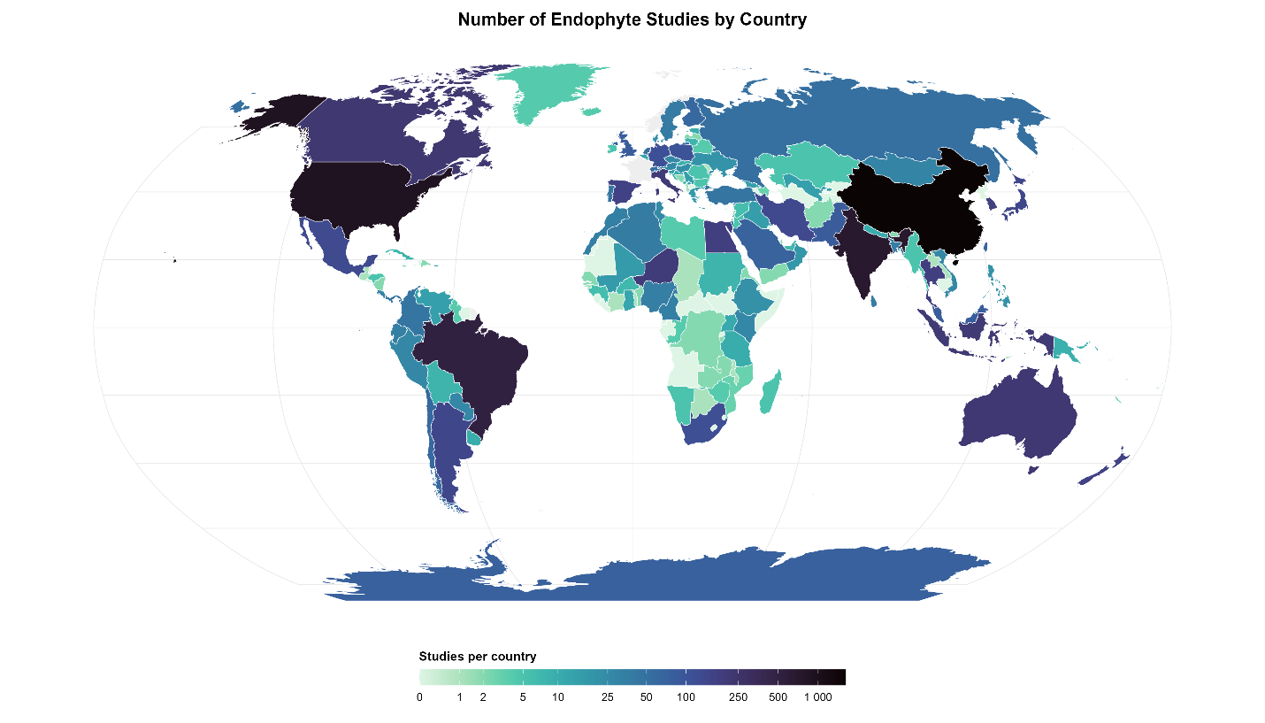
Figure 1. Global distribution of fungal endophyte research effort, Robinson projection. The map displays the number of studies per country based on a corpus of 18,750 publications. Of the 234 countries and territories analyzed, 133 have fewer than five recorded endophyte studies in our corpus. Research is heavily concentrated in North America, Europe, and East Asia, with large regions of Africa, Central Asia, and South America showing little to no research activity.

Prediction B: Biome and Host Representation are Non-Random
Consistent with Prediction B, sampling effort was not only geographically clustered but also highly skewed across biomes and host taxa. Within and across countries, research was disproportionately focused on temperate forests and agricultural biomes, while biomes such as tropical and subtropical grasslands, savannas, and shrublands were under-sampled (Figure 2). This finding carries the caveat that biome-level information is often missing from abstracts, so our analysis likely underestimates the full extent of this bias.
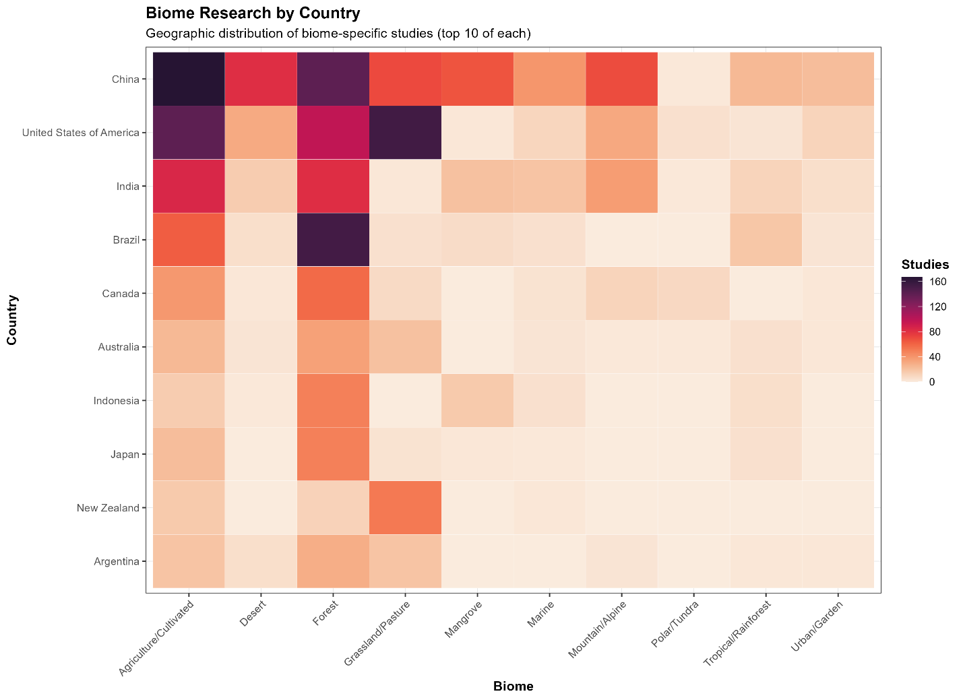
Figure 2. Heatmap of study counts by biome and country, displaying the top 10 categories of each. This figure reveals that research effort is not only geographically clustered but also heavily skewed toward certain biomes. Temperate forests and agricultural systems are overrepresented in the literature, while biomes such as tropical and subtropical grasslands, savannas, and shrublands are significantly underrepresented, even within well-studied countries.
Host taxonomic representation was similarly imbalanced (Figure 3). A small number of plant families, notably Poaceae and Fabaceae, have received the vast majority of research attention. The analysis, which standardized host taxonomy against the GBIF backbone (GBIF Secretariat, 2023), revealed that numerous plant phyla and families have no recorded endophyte studies, representing major gaps in our knowledge of host-fungus interactions. A strong taxonomic bias is also evident in the choice of studied host plants. The research landscape is dominated by a few economically important agricultural grass species. The top four most-studied host plants, Lolium arundinaceum (tall fescue), Oryza sativa (rice), Zea mays (corn), and Lolium perenne (perennial ryegrass), all belong to the family Poaceae. This narrow focus on agricultural systems leaves the vast majority of plant diversity unsampled.
This pattern of narrow focus extends to the fungal partners. The most frequently studied fungal genera are those with well-known roles as agricultural pathogens, plant mutualists, or human health concerns. Genera such as Fusarium, Aspergillus, and the grass symbiont Epichloë dominate the literature, while the broader diversity of fungal life remains largely unexplored in the context of endophytism.
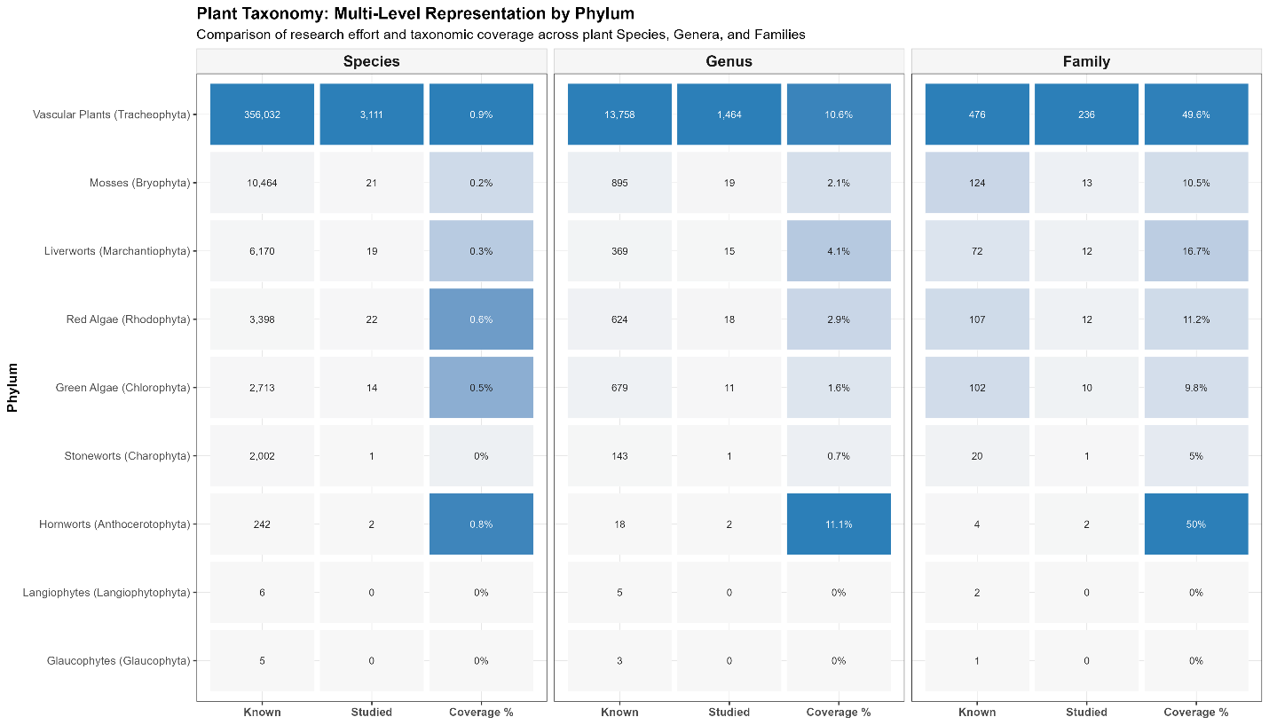
Figure 3. Host taxonomic representation in the endophyte literature. This heatmap shows the concentration of studies on a limited number of plant species, genera, and families. Research is heavily biased toward economically important families such as Poaceae and Fabaceae, while numerous other plant phyla and families, including early-diverging lineages like Charophyta and Bryophyta, have few recorded endophyte studies.

Prediction C: Study Intensity Increases with GDP
In line with Prediction C, we found a strong, positive correlation between a country's economic output and its endophyte research intensity. A country's log-transformed Gross Domestic Product (GDP) was a significant predictor of its log-transformed study count (Spearman's ρ = 0.83, P < 0.001), indicating that wealthier nations are studied more frequently (Figure 4). Further multiple regression modeling revealed that GDP was a vastly superior predictor of study count compared to ecological metrics. When modeled together, the predictive coefficient for economic status (log10 GDP: coefficient ~0.56, P < 0.001) overwhelmingly dominated the predictive effect of raw biodiversity (total species richness: coefficient < 0.001, P = 0.003). Likewise, independent non-parametric assessments confirmed that economic output (Spearman's ρ = 0.83) correlates much more robustly with sampling intensity than does absolute species richness (Spearman's ρ = 0.58). This indicates that the global distribution of endophyte research is more a map of economic capacity than it is a map of biodiversity. This creates a critical knowledge gap, as high-biodiversity, low-GDP countries are systematically under-represented in the current body of endophyte research.
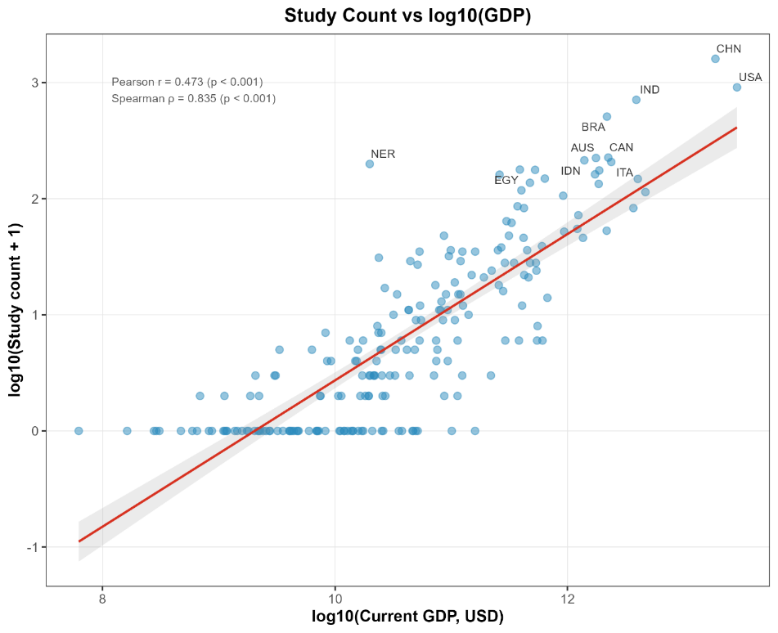
Figure 4. Relationship between a country's economic status and its endophyte research effort. A strong, positive correlation exists between a country's log-transformed Gross Domestic Product (GDP) and its log-transformed study count (Spearman’s ρ = 0.84, P < 0.001), indicating that wealthier countries receive robmore research attention. The line represents a linear regression fit (lm), with the shaded area showing the 95% confidence interval.

Priority Outputs for Future Sampling

Based on these identified gaps, the pipeline generated priority lists of understudied (n<5 studies) countries and host taxa. The results highlight numerous plant genera and families with minimal representation in the literature, including early-diverging lineages such as Charophyta and Bryophyta (Figure 3). Likewise, many countries, including Angola, Armenia, and the Bahamas (Figure 1), remain severely understudied, with fewer than five studies captured in our global dataset. These outputs provide a concrete roadmap for targeted sampling efforts designed to fill the most significant gaps in our current understanding of global endophyte diversity. These gaps reveal a significant disconnect between research effort and actual biodiversity patterns. Numerous countries recognized for their high conservation priority receive disproportionately little attention. For example, nations with high endemic species densities, such as Belize, remain critically understudied, yielding fewer than five captured records. This geographic bias extends even to high-biodiversity microstates like Liechtenstein and Monaco, highlighting severe blind spots in the global understanding of endophyte distribution.

Functional Guild Representation in the Literature
While geographic and taxonomic gaps represent a critical limitation of the current evidence base, it was also necessary to determine if the literature was functionally constrained. To evaluate the functional focus of the global evidence base, the primary ecological guilds reported across the extracted plant-fungus interactions were categorized. Results indicate that the literature is not monolithically focused on benign commensalism; rather, it reflects a broad functional continuum. While purely endophytic (asymptomatic) relationships comprised the plurality of documented interactions (42.5%; representing 50.9% of studies), a substantial proportion of the literature focuses on pathogenic relationships (35.1% of interactions; 27.1% of studies). Furthermore, the dataset captured significant functional overlap with other established guilds, with 10.3% of documented endophyte interactions explicitly involving mycorrhizal contexts, and 4.9% focused on antagonistic or biocontrol applications. Furthermore, cross-referencing these guilds against geographic and anatomical data revealed that while fungal phyla are not studied equally across continents (P = 0.008), there is no significant taxonomic bias in which host tissues (leaves, roots, etc.) are sampled (P = 0.074)(Figure S2).

Discussion
Our analysis of the global endophyte literature reveals a research landscape that is geographically and taxonomically constrained. The patterns of data availability are not random; instead, they are strongly shaped by economic factors that are decoupled from the planet’s biological richness. This uneven distribution has profound implications for the robustness of endophyte ecological theory, necessitating a critical re-evaluation of how we interpret ubiquity in the context of sampling effort.

Interpreting the Evidence Gaps

A primary finding of our study is the vast number of countries, biomes, and plant taxa with fewer than five recorded endophyte studies in our corpus. This deficit reveals critical thematic blind spots in the global research effort. The absence of accessible data from these regions limits the validity of broad-scale generalizations and creates a systematic geographic bias in the published record. Ultimately, these gaps highlight areas where our collective knowledge is simply too sparse to support sweeping claims about fungal distribution and function.

Ecological Implications of Sampling Bias
The concentration of research in temperate, high-GDP nations has significant ecological consequences. Fungal biogeography is structured by strong environmental gradients and historical factors (Tedersoo et al., 2014). By over-sampling a narrow range of temperate and agricultural systems, the field risks inflating its confidence in patterns of endophyte diversity, host affinity, and ecological function that may not hold true in other contexts. For example, conclusions about community assembly or transmission modes derived predominantly from North American and European forests may be poor predictors of the dynamics in under-sampled tropical systems, which harbor a vastly different suite of host plants and environmental pressures (Townsend et al., 2008; Myers et al., 2013; Zuk, 2016). This bias represents an untapped opportunity to understand the full spectrum of endophyte symbioses and their roles in ecosystem processes across the globe.

Economic Privilege as a Driver of Research Effort
Our results demonstrate that research effort follows economic privilege rather than biological richness. The strong positive correlation between a country’s GDP and its study count indicates that the current map of endophyte knowledge is more a reflection of funding and infrastructure than of a strategic effort to explore global biodiversity. Consequently, the global map of endophyte ecology is a reflection of institutional capacity rather than biological distribution, resulting in a systematic blind spot in regions where fungal novelty and ecosystem service potential are likely highest. This is a critical missed opportunity, as these under-explored ecosystems may harbor unique fungal lineages with novel ecological functions and potential for bioprospecting (Newman & Cragg, 2012; Bertini et al., 2022).

The Functional Continuum: Beyond Benign Ubiquity
A critical consequence of relying on the generalized claim of ubiquity is that it masks the immense functional diversity of the fungi being studied. Our classification of interaction types reveals that over one-third (35.1%) of the specific plant-fungus interactions captured in the endophyte literature are fundamentally focused on pathology. This suggests that a significant portion of our global understanding of fungal endophytes is actually derived from studies of latent pathogens, agricultural disease vectors, and biocontrol antagonists, rather than asymptomatic residents of natural ecosystems. This functional blurring indicates an inconsistent and often ambiguous application of the term 'endophyte' across the literature.
Furthermore, the explicit capture of mycorrhizal interactions (10.3%) within the endophyte search parameters highlights a pervasive blurring of functional boundaries in the literature. As noted by previous authors (Jumpponen, 2001; Schulz & Boyle, 2005; Mandyam & Jumpponen, 2015), the endophytic continuum frequently overlaps with both latent pathogenicity and mycorrhizal mutualisms. By demonstrating that the global evidence base is heavily weighted toward applied and overlapping guilds, we propose a critical biological caveat: the 'ubiquity' of fungal endophytes is a construct that cannot be decoupled from the agricultural and pathogenic contexts in which these fungi are primarily studied.

The Utility and Limitations of an Abstract-Dominated Audit
Given that over 83% of the analyzed corpus remains behind paywalls, relying on abstracts when full texts are not available is a necessary limitation of this study. This approach inherently misses endophyte occurrences buried in full texts or supplementary next-generation sequencing (NGS) tables. However, this method serves as a conservative field audit of the most visible evidence. If a study’s core findings on endophyte presence are not mentioned in the abstract, their utility for broad-scale synthesis is inherently limited. Furthermore, this approach highlights the systematic barriers created by paywalled science; by relying on the most commonly accessible part of a publication, our analysis maps the boundaries of our default knowledge, which is shaped by what is readily available to the global research community.

A Roadmap for Future Sampling
Based on these findings, we propose a strategic roadmap for future endophyte research. To build a more robust and representative understanding of endophyte ecology, sampling efforts should be intentionally directed toward two key areas. First, there is a critical need to explore host lineages that are currently underrepresented in the literature. Our analysis shows a heavy concentration on economically important plant families. A concerted effort to sample early-diverging and non-vascular plant lineages, such as Charophyta and Bryophyta, would provide crucial insights into the evolutionary history of endophytism. Second, research must expand into high-biodiversity, low-GDP regions. Countries such as Tonga and large portions of Africa and Central Asia represent significant gaps in our knowledge. A targeted, collaborative effort to sample in these regions is essential for discovering novel fungal diversity and for testing the generality of ecological theories developed in temperate zones. Such a program would not only advance the field of endophyte ecology but also contribute to global biodiversity conservation goals.

Acknowledgements
This work was supported by National Science Foundation (NSF) MacroSystems grant DEB-1340852 (C.A.G.), US Department of Energy program in Systems Biology Research to Advance Sustainable Bioenergy Crop Development (DE-FOA-0002214)(N.C.J.), the Lucking Family Professorship (C.A.G.), the ARCS Foundation (B.M.B.), the Presidential Fellowship Program at NAU (B.M.B.), the Arizona Mushroom Society (B.M.B.), the Support for Graduate Students program at NAU (B.M.B.), and the American Association of University Women’s American Dissertation Fellowship (B.M.B.).

Author Contributions
B.M.B. conceived the study, developed the pipeline, and wrote the manuscript. N.M., N.C.J., and C.A.G. advised throughout the project and edited the manuscript.

Supplementary Figures
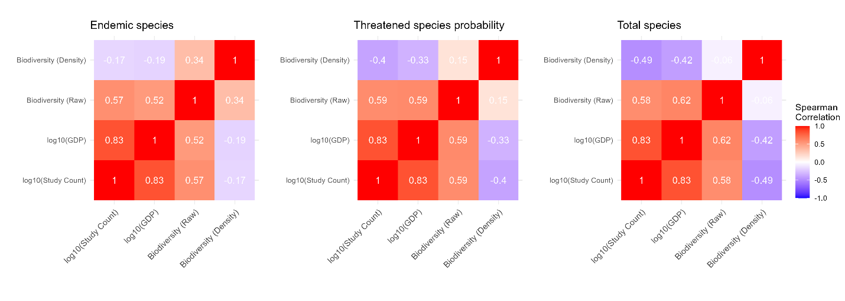
Figure S1. Correlation heatmap of research effort, economic status, and biodiversity metrics. This figure shows the pairwise correlations between a country’s study count, its Gross Domestic Product (GDP), and various metrics of biodiversity. GDP is the variable most strongly correlated with study count, indicating that economic factors are a primary driver of research intensity.
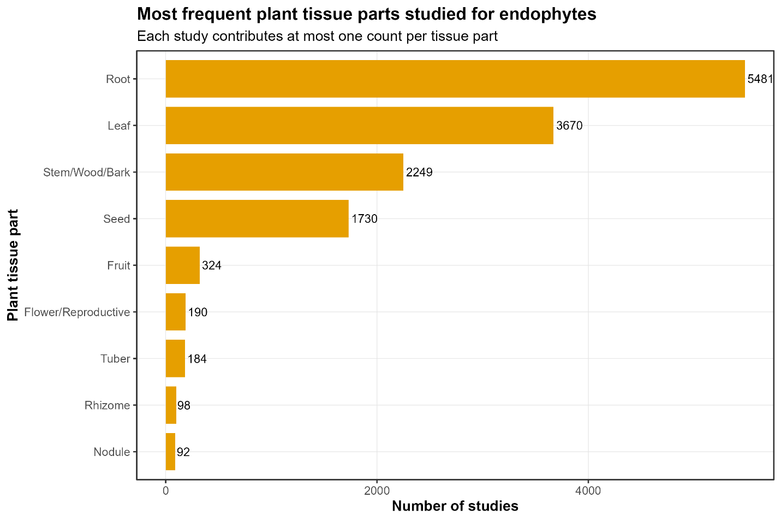
Figure S2: Most frequently studied plant tissues for fungal endophytes.
Other potential supplemental figures we can include:

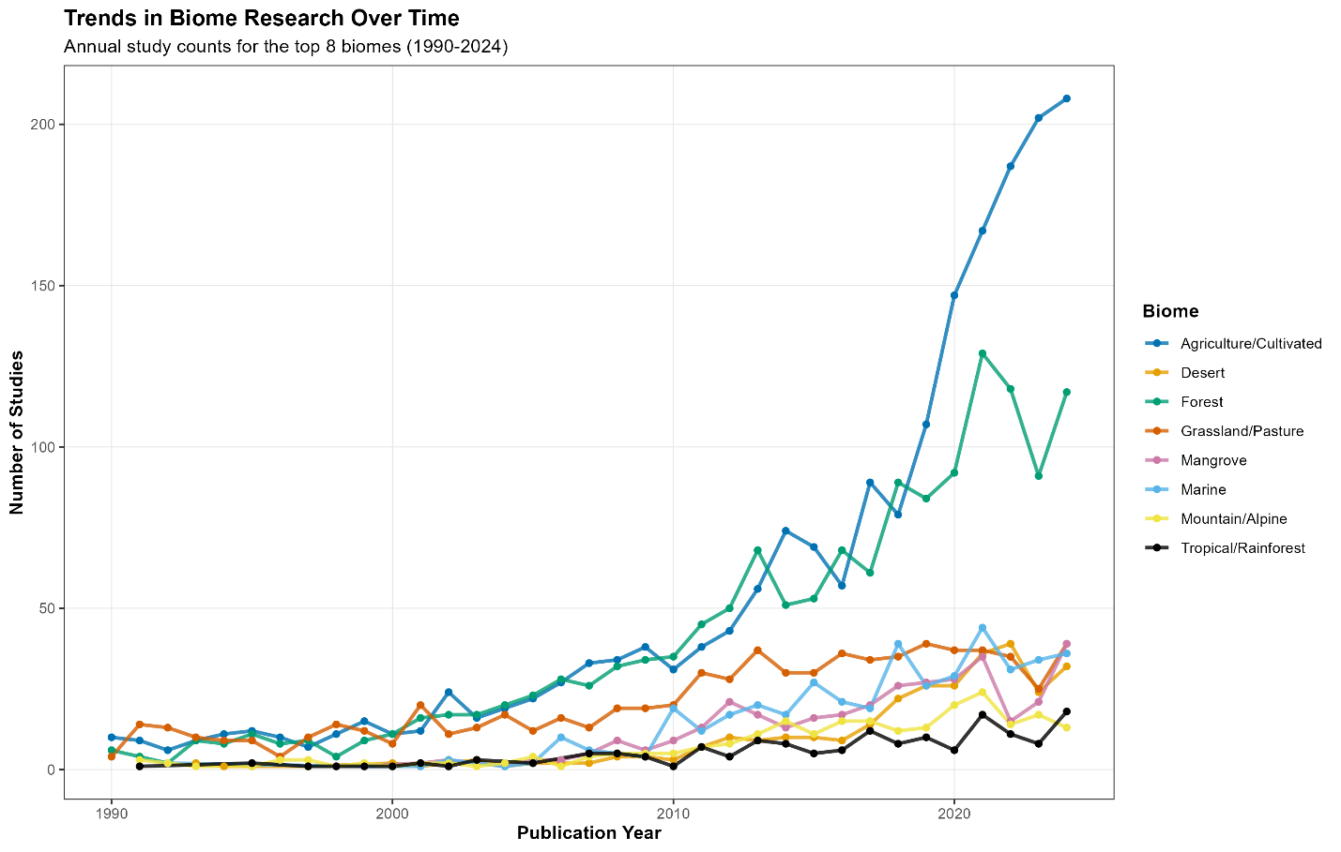
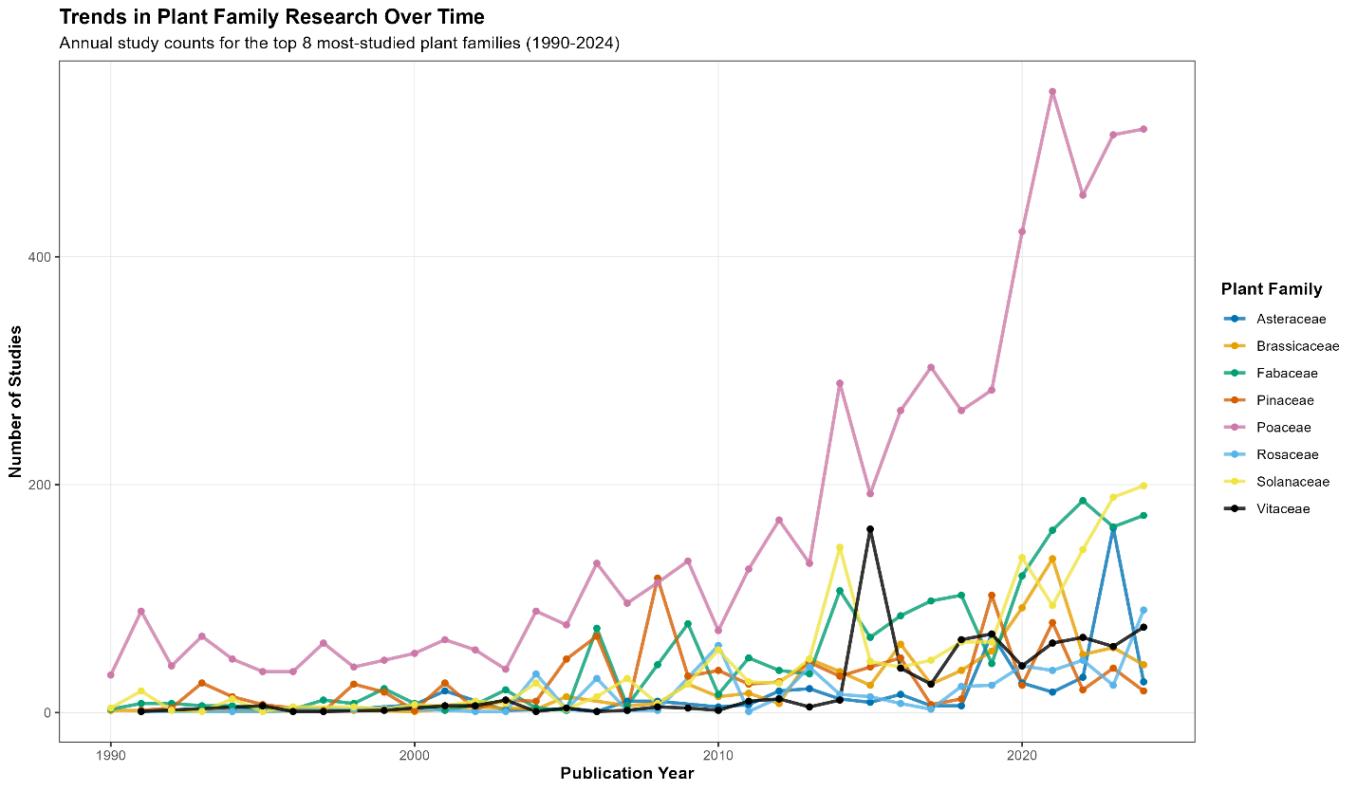
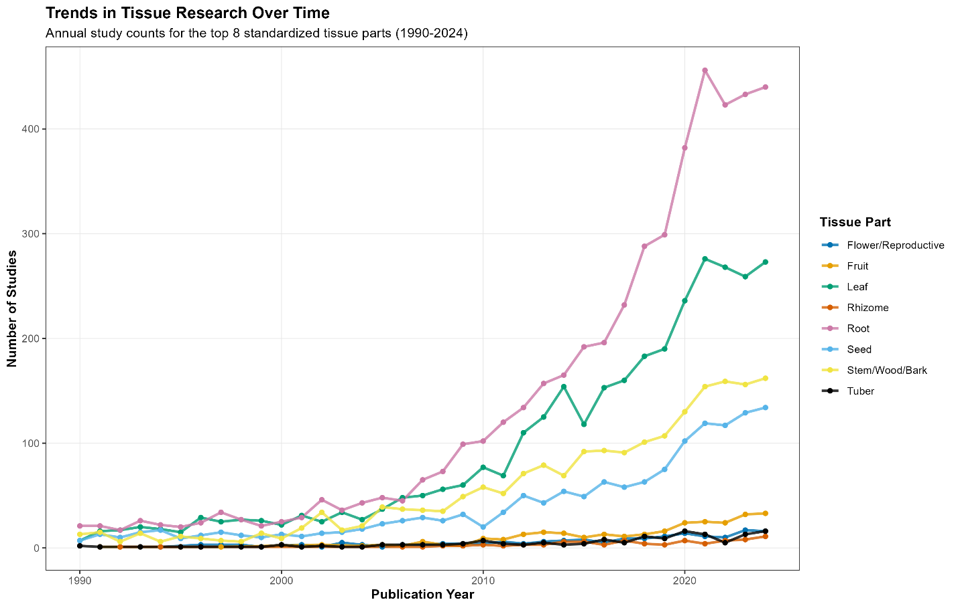
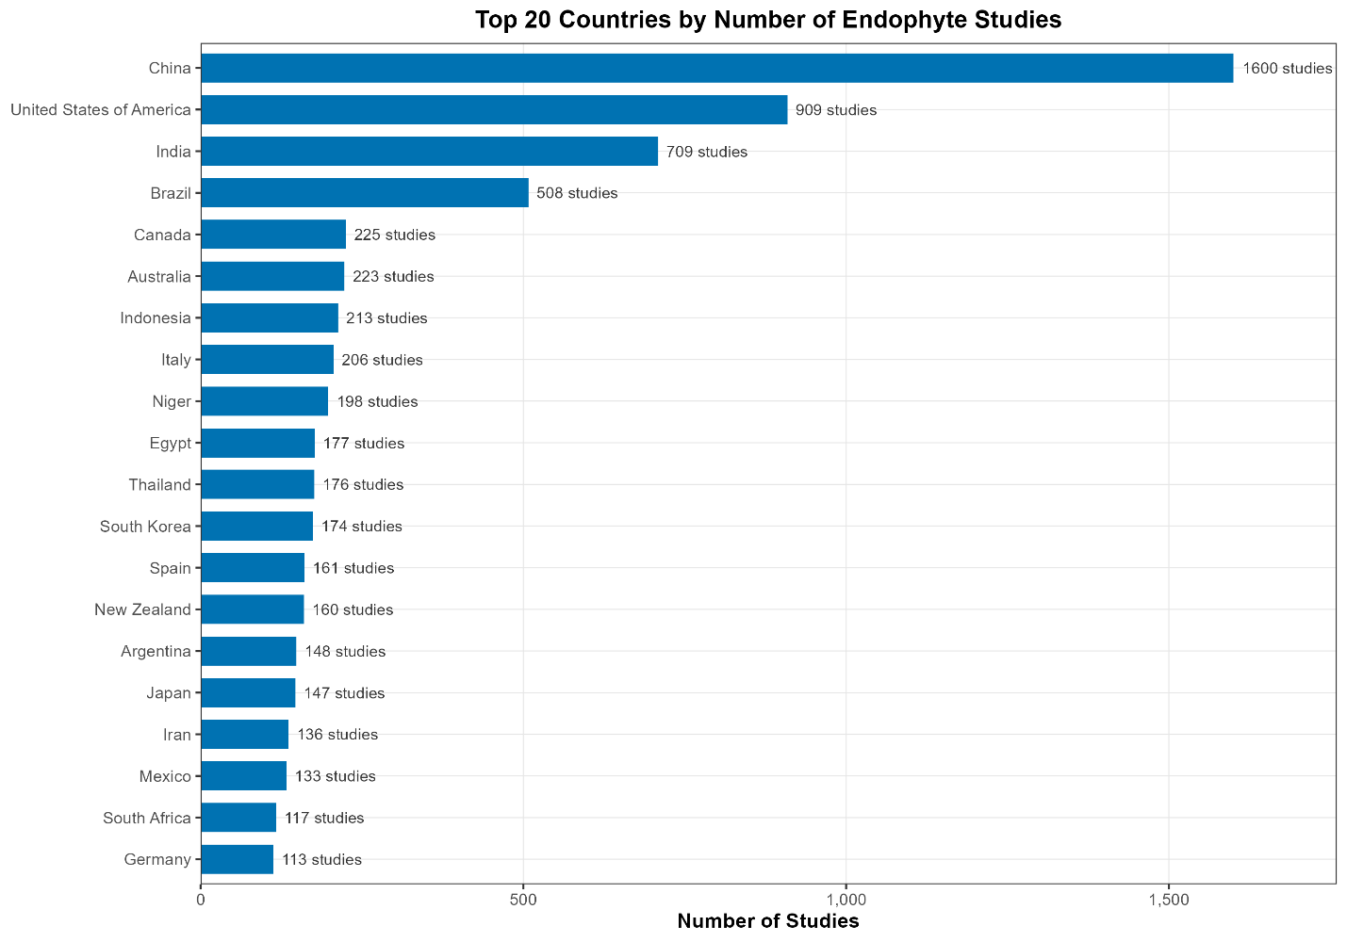

Works Cited
Arnold A, Lutzoni F. 2007. Diversity and host range of foliar fungal endophytes: Are tropical leaves biodiversity hotspots? Ecology 88: 541–549.
Artifex Software Inc. 2026. PyMuPDF Documentation.
Baker C. 2018. wosr: Clients to the ‘Web of Science’ and ‘InCites’ APIs.
Bertini L, Perazzolli M, Proietti S, Capaldi G, Savatin D, Bigini V, Longa C, Basaglia M, Favaro L, Casella S, et al. 2022. Biodiversity and Bioprospecting of Fungal Endophytes from the Antarctic Plant Colobanthus quitensis. Journal of Fungi 8.
Christie AP, Amano T, Martin PA, Petrovan SO, Shackelford GE, Simmons BI, Smith RK, Williams DR, Wordley CFR, Sutherland WJ. 2021. The challenge of biased evidence in conservation. Conservation Biology 35: 249–262.
Codes for the representation of names of countries and their subdivisions — Part 1: Country codes. 2020. Geneva, Switzerland: International Organization for Standardization.
Cosner J, Pandharikar G, Tremble K, Nash J, Rush TA, Vilgalys R, Veneault-Fourrey C. 2025. Fungal endophytes. Current Biology 35: R904–R910.
Cvitanovic C, Fulton CJ, Wilson SK, Van Kerkhoff L, Cripps IL, Muthiga N. 2014. Utility of primary scientific literature to environmental managers: An international case study on coral-dominated marine protected areas. Ocean & Coastal Management 102: 72–78.
Davis EC, Shaw AJ. 2008. Biogeographic and phylogenetic patterns in diversity of liverwort‐associated endophytes. American Journal of Botany 95: 914–924.
GBIF Secretariat. 2023. GBIF Backbone Taxonomy.
Harrison JG, Griffin EA. 2020. The diversity and distribution of endophytes across biomes, plant phylogeny and host tissues: how far have we come and where do we go from here? Environmental Microbiology 22: 2107–2123.
Hughes A, Orr M, Ma K, Costello M, Waller J, Provoost P, Zhu C, Qiao H. 2020. Sampling biases shape our view of the natural world.
International Union for Conservation of Nature (IUCN). 2026. The IUCN Red List of Threatened Species.
Jiang AQ, Sablayrolles A, Mensch A, Bamford C, Chaplot DS, Casas D de L, Bressand F, Lengyel G, Lample G, Saulnier L, et al. 2023. Mistral 7B.
Jumpponen A. 2001. Dark septate endophytes - are they mycorrhizal? Mycorrhiza 11: 207–211.
Kusari S, Hertweck C, Spiteller M. 2012. Chemical Ecology of Endophytic Fungi: Origins of Secondary Metabolites. Chemistry & Biology 19: 792–798.
Mandyam KG, Jumpponen A. 2015. Mutualism-parasitism paradigm synthesized from results of root-endophyte models. Frontiers in Microbiology 5.
Massicotte P, South A. 2026. rnaturalearth: World Map Data from Natural Earth.
Microsoft. 2026. Visual Studio Code.
Mörsdorf MA, Ravolainen VT, Støvern LE, Yoccoz NG, Jónsdóttir IS, Bråthen KA. 2015. Definition of sampling units begets conclusions in ecology: the case of habitats for plant communities. PeerJ 3: e815.
Muschelli J. 2025. rscopus: Scopus Database ‘API’ Interface.
Myers JA, Chase JM, Jiménez I, Jørgensen PM, Araujo‐Murakami A, Paniagua‐Zambrana N, Seidel R. 2013. Beta‐diversity in temperate and tropical forests reflects dissimilar mechanisms of community assembly (H Cornell, Ed.). Ecology Letters 16: 151–157.
Newman DJ, Cragg GM. 2012. Natural Products As Sources of New Drugs over the 30 Years from 1981 to 2010. Journal of Natural Products 75: 311–335.
Nuñez MA, Chiuffo MC, Pauchard A, Zenni RD. 2021. Making ecology really global. Trends in Ecology & Evolution 36: 766–769.
Okabe M, Ito K. 2008. Color Universal Design (CUD): How to make figures and presentations that are friendly to colorblind people.
Ooms J. 2024. jsonlite: A Robust, High-Performance JSON Parser and Generator for R.
Orlando L, Rivera-Rebella C, Pinelli V, Pereira-Garbero R, Hernandez D, Ortiz E, Ziegler L. 2018. 100 articles every ecologist can actually read? Neotropical Biology and Conservation 13: 334–336.
Pebesma E. 2018. Simple Features for R: Standardized Support for Spatial Vector Data. The R Journal 10: 439–446.
Petrini O. 1991. Fungal Endophytes of Tree Leaves. In: Andrews JH, Hirano SS, eds. Brock/Springer Series in Contemporary Bioscience. Microbial Ecology of Leaves. New York, NY: Springer New York, 179–197.
Piwowar H, Priem J, Larivière V, Alperin JP, Matthias L, Norlander B, Farley A, West J, Haustein S. 2018. The state of OA: a large-scale analysis of the prevalence and impact of Open Access articles. PeerJ 6: e4375.
Priem J, Piwowar H, Orr R. 2016. Unpaywall API.
Pyšek P, Richardson DM, Pergl J, Jarošík V, Sixtová Z, Weber E. 2008. Geographical and taxonomic biases in invasion ecology. Trends in Ecology & Evolution 23: 237–244.
Python Software Foundation. 2025. Python Language Reference, Version 3.13.5.
R Core Team. 2023. R: A Language and Environment for Statistical Computing.
Rodriguez RJ, White Jr JF, Arnold AE, Redman RS. 2009. Fungal endophytes: diversity and functional roles. New Phytologist 182: 314–330.
Rosenthal R. 1979. The file drawer problem and tolerance for null results. Psychological Bulletin 86: 638–641.
Scherer RW, Meerpohl JJ, Pfeifer N, Schmucker C, Schwarzer G, Von Elm E. 2018. Full publication of results initially presented in abstracts (Cochrane Methodology Review Group, Ed.). Cochrane Database of Systematic Reviews 2018.
Schulz B, Boyle C. 2005. The endophytic continuum. Mycological Research 109: 661–686.
Soberon J, Peterson AT. 2005. Interpretation of Models of Fundamental Ecological Niches and Species’ Distributional Areas. Biodiversity Informatics 2.
Stone JK, Bacon CW, White F. 2000. An Overview of Endophytic Microbes: Endophytism Defined. In: Microbial Endophytes. CRC Press, 1–28.
Strobel GA. 2003. Endophytes as sources of bioactive products. Microbes and Infection 5: 535–544.
Tedersoo L, Bahram M, Põlme S, Kõljalg U, Yorou NS, Wijesundera R, Ruiz LV, Vasco-Palacios AM, Thu PQ, Suija A, et al. 2014. Global diversity and geography of soil fungi. Science 346: 1256688.
Townsend A, Asner G, Cleveland C. 2008. The biogeochemical heterogeneity of tropical forests. Trends in Ecology & Evolution 23: 424–431.
U’Ren JM, Lutzoni F, Miadlikowska J, Laetsch AD, Arnold AE. 2012. Host and geographic structure of endophytic and endolichenic fungi at a continental scale. American Journal of Botany 99: 898–914.
Wickham H. 2007. Reshaping Data with the reshape Package. Journal of Statistical Software 21: 1–20.
Wickham H. 2016. ggplot2: elegant graphics for data analysis. Cham: Springer international publishing.
Wickham H, Vaughan D, Girlich M. 2014. tidyr: Tidy Messy Data. : 1.3.1.
Wilson D. 1995. Fungal Endophytes Which Invade Insect Galls - Insect Pathogens, Benign Saprophytes, or Fungal Inquilines. Oecologia 103: 255–260.
Winter D J. 2017. rentrez: An R package for the NCBI eUtils API. The R Journal 9: 520.
World Bank. 2024. GDP (current US$).
World Bank. 2026. World Bank Open Data: GDP (Current US$).
Zuk M. 2016. Temperate Assumptions: How Where We Work Influences How We Think. The American Naturalist 188: S1–S7.

