**Republic of the Philippines**

**Region IV-A CALABARZON**

**Tayabas City**

**Luis Palad Integrated High School**

**PROJECT WARI: Weather Application for Real-time Information**

Cabalsa, Giem Rebert A. Fernandez, Sean C.

Ursolino, Jim Cedric R. Ambas, Shelem Anne E.

Argete, Bea Chandelle F. Bebida, Reizel Cyrene A.

Jarito, Princess A. Moises, Izelle Jardine D.

**Proponents**

**March 2020**

Mrs. Zenaida A. Moreno

**Research Adviser**

**ABSTRACT**

Weather forecasting is the prediction of the current atmospheric status in a specific place and time. The researchers innovated the idea of weather forecasting by creating a mobile application that will predict the most suitable crop to be planted based on current atmospheric condition. The application displays the current temperature, humidity, rain and the information about the predicted crop. This study focused on helping people, especially farmers to plan their plants through the information shown by the application. The application was programmed using HTML, CSS and JavaScript. K-nearest neighbor algorithm was used in predicting and calculating the most suitable crop to be planted. The manual computation of the distance of each plants’ climatic requirements to the current atmospheric status and the prediction of the application were relevant to each other. The outcome accepted the alternative hypothesis showing that the results of predicted crops shown in the application is accurate based on solving using K-nearest neighbor algorithm in different cities on different atmospheric status. Also based on the survey conducted, the application will be of great help to farmers and even to the one interested in planting crops. Overall, the application can be used as an innovation in the sector of agriculture.

**INTRODUCTION**

Weather application has a great contribution for everyday lives of people. People can be alarmed for the application that will give an update regarding weather information such as weather temperature and plants information. However, they are not just giving an update but they act as honest, fast, accurate and reliable source. This weather application can save number of plants. Farmers can be informed after they were given an update about the current state of a plant including the rainfall tolerance and the weather suited for that certain kind of plant. Thus, farmers can take an immediate action for the safety of their own crop. Eventually, they can save and plant their crops with accurate temperature needed and enough water requirements for the plant to grow healthy.

According to AgriTech (2018), other than heat and cold there are some factors that can affect their crops and it can cause loos and devastation to their crops. Many factors can leave a huge damage in every farm. And it feels horrifying for every farmer that invests hard works in order to grow and build their farm. With that, weather applications were made to give them prior information of what will happen so that they can prepare for any events that the weather application can predict.

Project WARI: Weather Application for Real-time Information can offer farmers better, faster and precise information about the weather. It has different features that made its unique compared to the other group. The application will have its own focus of target and own purpose.

**BACKROUND OF THE STUDY**

Weather is one of the key factors affecting prospects for production and commodity prices. It plays a major role in determining the success of agricultural pursuits. Most field crops are dependent solely upon weather to provide life sustaining water and energy. Livestock are also dependent upon weather for their comfort and food supplies. Occasionally, adverse weather conditions can cause production losses, especially if experienced during critical stages of growth.

According to Stefan Siebert, Heidi Webber, and Ehsan Eyshi Rezaei (2017), weather effects on crop yields are manifold, making their assessment challenging. Information on the extent to which crop yields are affected by specific extreme weather events are important for many applications such as in the insurance sector, food security studies, and climate change impact assessments, to guide extension services and policy making or support crop breeding efforts.

According to Len Calderon (2018), when extreme weather strikes, lives and livelihoods are ruined, and farms are altered. Severe weather can cause loss and devastation to a farm. The result of extreme weather can`t be avoided by most farmers no matter where their farm is located.

According to Ian Ocampo Flora (2018), rice farmer’s country’s rice granary region in Central Luzon experience heavy damage to their crops every year. As years pass by, typhoons are getting stronger as well as the damage to rice and agricultural crops.

The purpose of the study is to provide appropriate climate and weather information, including climate change information, for farmers in order to meet their decision-making better across a wide range of timescale. The researchers came up with this idea to offer honest, faster, precise information and have an edge compare to the other weather application.

**STATEMENT OF THE PROBLEM**

The researchers created a weather application for real- time information that will help the farmers and other people to monitor the weather and to predict the most appropriate plants to be planted for that day.

This study specially aims to answer the following:

1. What is the innovation of the application?

2. How accurate are the results predicted by WARI in terms of the plants shown in the application and the manual computation of the data?

3. How effective is the WARI: Weather Application for Real-time Information in terms of its reliability?

**SIGNIFICANCE OF THE STUDY**

This study aims to create a weather application that will provide a possible prediction for what will happen and give warning for the weather.

The following sectors will be benefited by the outcome of the study:

The result of making the application will benefit the agricultural sector which the forecast will help for suitable planning of farm. The application will also help other operation related to farming such as sowing, irrigate the crop, apply fertilizer, and start complete harvesting. It also helps in measures to protect livestock.

This study will not only benefit the community but also the country providing them an updated weather forecast for them to be prepared of the weather conditions such as what to wear, planning of outdoor activities, transportation hazards, severe weather, and what weather to expect.

Furthermore, to students and future researchers, this study can be used as reference and a basis for further researches relating to weather applications.

**SCOPE AND LIMITATION**

This study involves the use of weather application for the real-time information. The result of the study was used to determine accuracy and timeliness of the application. The researchers mainly focused on farmers and plant enthusiast as target user to help them with problems such as alerting the farmers on the current state of weather and give tips for their plants. The application suggested three crops that are suitable to be planted for the weather of a particular place. The number of plants can be changed in the codes based on the user’s preference. It also suggested the planting time and brief explanation of the suggested plants. The weather application can only be used in different locations in Quezon Province. The app was created with the use of JavaScript, HTML, CSS and K-Nearest Neighbors Algorithm. The ideal outcome of the researchers is for the application to benefit the agricultural sector. The application will work with the use of internet. The information regarding the current atmospheric status needs to be updated every 3 hours to provide accurate results. This study was conducted at Luis Palad Integrated High School from December 2019 to March 2020.

**REVIEW OF RELATED LITERATURE AND RELATED STUDIES**

**Related Literature**

Project WARI: Weather Agri-Application for Real-Time Information is a software application that applies the principle of weather forecasting. According to Cahir (2020), weather forecasting is the prediction of the weather through the principles of physics with a variety of statistical and empirical techniques. It also includes the predictions of changes in Earth’s surface caused by atmospheric conditions such as storm tides, and floods. Weather forecasting is still carried out in basically the same way as it was by the earliest humans, which is making observations and predicting changes. Digital computers made it possible to calculate changes in atmospheric conditions mathematically and objectively.

The weather greatly affects the productivity in the agricultural sector. The Philippines is still primarily an agricultural country. The country’s main agricultural crops are rice, corn, coconut, sugarcane, bananas, pineapple, coffee, mangoes and abaca. The secondary crops include cassava, garlic, onion, cabbage, eggplant, rubber and cotton. The Philippines exports its agricultural products around the world. Sunlight, temperature, and rainfall are the main drivers of crop production; hence, agriculture is directly affected by climate change. This Project WARI will apply weather forecasting in order to predict the most appropriate crop for a certain period of time by analyzing the current atmospheric status.

The program in this application was encoded and three programming languages were used: HTML, JavaScript, and CSS. HTML (Hyper Text Markup Language) is responsible for the display of elements in the browser or application. It describes the structure of the web page. JavaScript on the other hand, is a scripting language used to create and control dynamic website content. It makes the application dynamic. It is used to automate processes that the application needs to execute, step-by-step. Lastly, CSS (Cascading Style Sheet) is a simple mechanism for the design of the application such as colors, fonts, spacing, etc.

K-nearest neighbors (KNN) is the algorithm used to compute and analyze the most appropriate crops to be predicted in the application. It is a type of supervised ML algorithm which can be used for both classification as well as regression predictive problems. It uses ‘feature similarity’ to predict the values of new datapoints. It works based on minimum distance from the query instance to the training samples to determine the K-nearest neighbors. (Yildirim, 2018)

As an innovation to the project, geolocation and prediction for other places is applied. Geolocation is the geographical (latitudinal and longitudinal) location of an Internet-connected device. It uses Global Positioning System and other related technologies to assess and specify geographical locations. Through this, the prediction of plant crops will not be limited to a single place or city but rather also to close areas.

**Related Studies**

As stated by Bondarenko (2017), modern technologies have significantly reshaped the weather forecasting industry. Nowadays there are hundreds of scientists, computers, satellites, radar and weather stations working all over the world just to help you decide what should complement your shoes: a light T-shirt or a warm jacket. One more piece of good news about weather app development is that the hardest & trickiest part — the forecasting itself — is done by others and just pick a ready-to-use solution that fits an idea the best. The key is a unique value point which one needs. It can be either targeting a specific audience or providing some features that let the application stand out from competitors.

According to Zabini (2016), a huge change has occurred in the way people obtain weather information in the last few years and a large percentage of the population now get weather forecasts on their mobile phones. There is currently a wide range of smartphone weather apps available: in 2014, iTunes App Store alone offered 5043 active applications in the weather category. The rapid penetration of new broadcasting technologies strongly affects the way weather forecasts are communicated to, and used by, people. Portability, permanent connectivity and geolocalization allow location‐specific and time‐sensitive weather forecasts to be provided. This paper explores the main features emerging in the 39 most popular weather apps in the United States, United Kingdom and Italy, and focuses on the implications in the communication of uncertainty. The results show that even if the advances in mobile communication technologies could, in principle, improve the effectiveness of weather communication enormously, the expectations created around weather forecasts appear to be inconsistent with current forecasting capabilities, particularly with their inherent uncertainties in space and time, as well as in the nature of the predicted weather events.

According to Rouse (2019), web application development is the creation of application programs that reside on remote servers and are delivered to the user’s device over the Internet. A web application (web app) does not need to be downloaded and is instead accessed through a network. An end user can access a web application through a web browser such as Google Chrome, Safari, or Mozilla Firefox. A majority of web applications can be written in JavaScript, Cascading Style Sheets (CSS), and HTML5.

Web application development will typically have a short development life-cycle lead by a small development team. Front-end development for web applications is accomplished through client-side programming. Client refers to a computer application such as a web browser. Client-side programming will typically utilize HTML, CSS and JavaScript. HTML programming will instruct a browser how to display the on-screen content of web pages, while CSS keeps displayed information in the correct format. JavaScript will run JavaScript code on a web page, making some of the content interactive.

According to Eddy (2017), when Mother Nature is in a bad mood, it helps to keep an eye on what's going on in the sky and one of the most important tools for that is a mobile weather app. A good weather app can be used for simple decision-making, such as determining whether you'll need to bring an umbrella to work, or for more serious preparation and warnings. With dangerous weather conditions across the country, and especially hurricanes threatening coastal states, it's a good idea to check the forecast or radar for upcoming conditions.

According to Siebert (2017), weather effects on crop yields are manifold, making their assessment challenging. Information on the extent to which crop yields are affected by specific extreme weather events is important for many applications such as in the insurance sector, food security studies, and climate change impact assessments, to guide extension services and policy making or support crop breeding efforts.

On the article by Calderone (2017), farmers know that the weather is a significant factor for crops and livestock. The growing season is the phase when temperatures remain above freezing. Temperature, sunlight and rainfall have major effects on their crops. For livestock, temperatures and adequate water and food are essential. Most farmers already know something about the weather, but we can go even beyond that if we get into the science of weather and see how it can help the typical farmer.

Based from Jensen, Moller, Thiemann, JavaScript is the main scripting language for Web browsers, and it is essential to modern Web applications. Programmers have started using it for writing complex applications, but there is still little tool support available during development. Preliminary experiments conducted on real-life JavaScript code indicate that the approach is promising regarding analysis precision on small and medium size programs, which constitute the majority of JavaScript applications. With potential for further improvement, we propose the analysis as a foundation for building tools that can aid JavaScript programmers

**METHODOLOGY**

**Procedure/Equipment of Experimentation**

**Equipment**

The researchers will need laptop and smartphone for programming the application. Sublime Text 3 and Android Studio were used in coding and building the application on the mobile phone.

**Procedures**

Programming the codes for the application

1. **Designing a Logo**

The researchers sketched the design for the application’s logo and then they layout it in Adobe Photoshop. The logo created was related to the main function of the application.

1. **Learning Programming**

The researchers learned the programming languages such as HTML, JavaScript, and CSS in Codecademy. They created the web page using HTML and it is also used to display the content and features of the web page. Meanwhile, JavaScript is used to enhance the HTML pages and its function can run after a web page has loaded without communicating with the server. The researchers applied their knowledge in CSS for designing and improving the layout of the application.

1. **Coding Using Sublime Text 3**

The researchers downloaded Sublime Text 3. This application is used by the researchers because it edits the text and code needed to make the application and it helps the researchers to display their codes on the website. Different tables were created including the information about the plants such as the planting time and climatic requirements. The table for the atmospheric status was also coded. The researchers were guided by a programmer in coding the function of the application. As an innovation, the researchers added the latitude and longitude of different cities to enable the prediction of plants in various cities in Quezon.

1. **Accessing API**

They open the openweathermap.org website on accessing the API. The researchers used the 5-day forecast to display five days temperature and the day by day prediction on the suggested plants on their application. The API was accessed in order to update the atmospheric status such as the temperature, humidity and rain.

1. **Learning K-Nearest Neighbours Algorithm**

The researchers studied how KNN works and they applied it to their study. KNN can be used for both classification and regression predictive problem. Temperature, humidity, precipitation and seasons are the factors that help on computing the distance in KNN. In finding the nearest neighbours the Euclidean 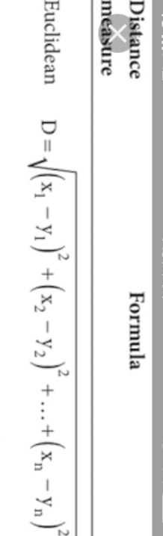distance formula is used in computing the nearest possible crop suggested to be planted in a specific atmospheric state. In order to check the accuracy of the application the researchers calculated manually the K-nearest neighbour of the current temperature and the climatic requirement of the plants. The smallest value calculated indicates that that plant is the most suitable plant to be planted.

1. **Android Studio**

The researchers downloaded the android studio. It helps the researchers in building the application on the mobile phones. The phone is connected to the laptop and the codes were transferred to it as a mobile application.

1. **Testing**

The researchers tested their application by manual computation for the accuracy of the application and they also surveyed 20 farmers. The researchers recorded the data displayed on the application. Using the Euclidean distance formula, every plant is computed per city and three plants that have the smallest value were predicted by the application. The survey forms have 5 questions to rate 1-5 to test if our application will be helpful and if the people, especially farmers will use the application.

**Conceptual Framework**

Debug and Test the Application

Learn Programming (JAVASCRIPT, CSS, HTML)

Get an API

Connect the API to the application

Design the logo of the application

Create the applicationusing Javascript, CSS and HTML

Debug and Test the Application

**Definition of Terms**

**Agriculture-** It is the science or practice of farming, including cultivation of the soil for the growing of crops and the rearing of animals to provide food, wool, and other products.

**CSS** (Cascading Style Sheet)**-** it describes the style of how HTML elements or document should be displayed. CSS is used for styling and lay outing.

**Geolocation-** refers to the identification of the geographic location of a user or computing device via a variety of data collection mechanisms

**HTML**(Hypertext Markup Language)- another programming language used for creating a website. It defines the meaning and structure of web content.

**JavaScript-** programming language of HTML and the web. It has first-class functions used as scripting language for Web pages.

**K-Nearest Neighbour Algorithm-** simple, easy-to-implement supervised machine learning algorithm that can be used to solve both classification and regression problems

**Weather Forecast**- a [statement](https://dictionary.cambridge.org/us/dictionary/english/statement) of what the [weather](https://dictionary.cambridge.org/us/dictionary/english/weather) is [likely](https://dictionary.cambridge.org/us/dictionary/english/likely) to be for the next [day](https://dictionary.cambridge.org/us/dictionary/english/day) or few [days](https://dictionary.cambridge.org/us/dictionary/english/day), usually [broadcast](https://dictionary.cambridge.org/us/dictionary/english/broadcast) on [television](https://dictionary.cambridge.org/us/dictionary/english/television) or [radio](https://dictionary.cambridge.org/us/dictionary/english/radio) or [printed](https://dictionary.cambridge.org/us/dictionary/english/printed) in a [newspaper](https://dictionary.cambridge.org/us/dictionary/english/newspaper)

**Experimental Design**

**Independent Variable Dependent Variable**

Predicted plants using the Project WARI: Weather Application for Real-time Information in different locations in Quezon Province

Data Input

* Temperature
* Humidity
* Precipitation

Codes

* Javascript
* Html
* CSS
* KNN

**Figure 1. Experimental Design on the Weather Agri-Application for Real-Time Information**

Figure 1 shows the relationship between the variables in the study. The independent variables of the study are the data and codes used to build the application and the dependent variable will be the predicted plants based on the temperature of the current day in different locations in Quezon Province.

**Appendix**

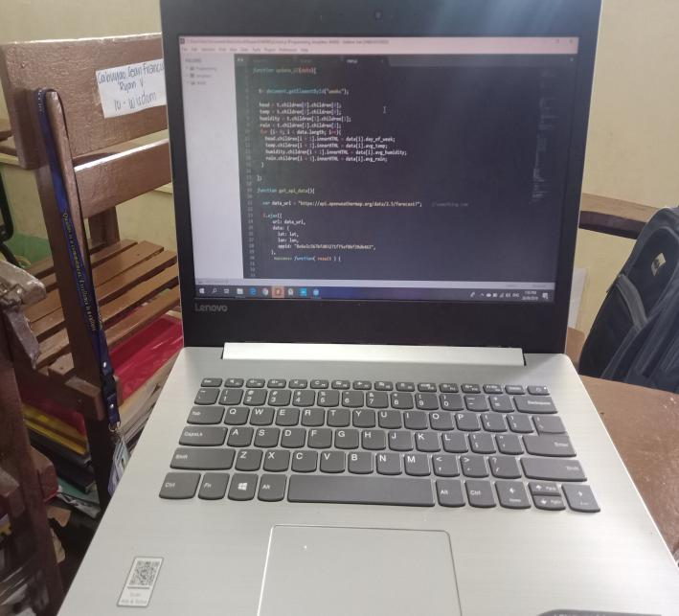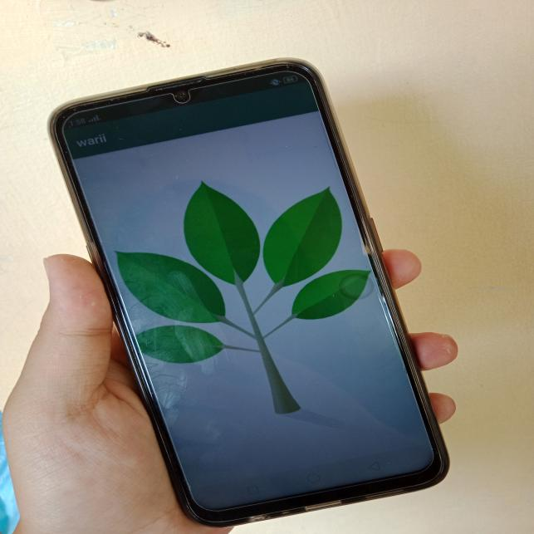**Materials**

Laptop Cellphone

**Procedures**

1. 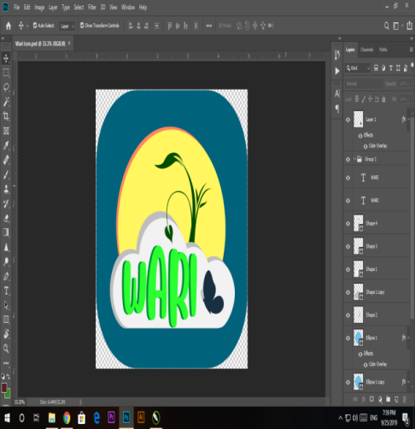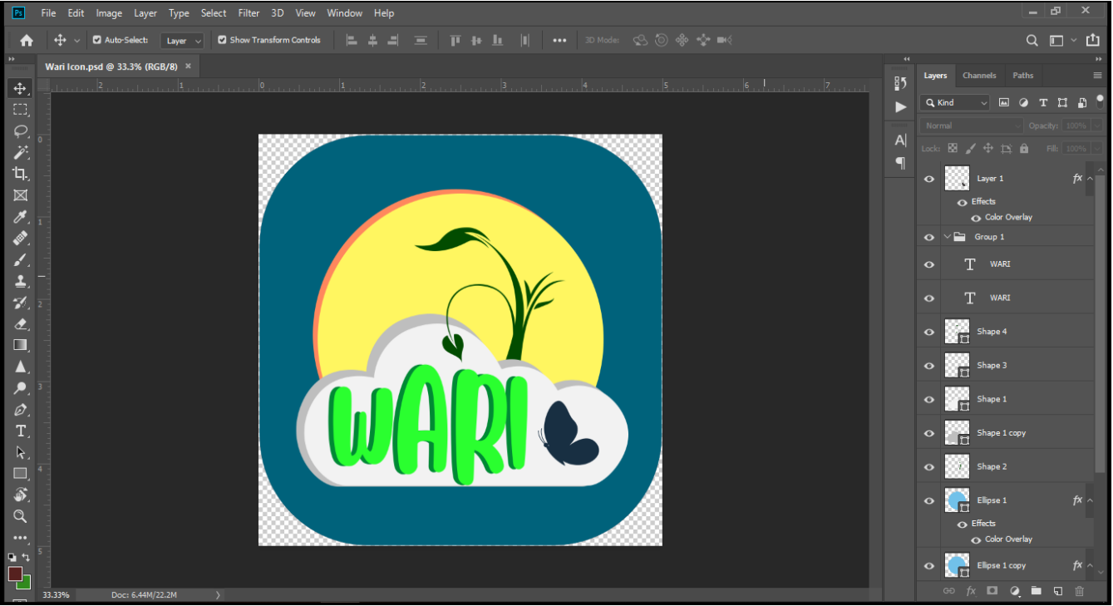**Designing a Logo**

Layouting the logo with Adobe Photoshop

1. 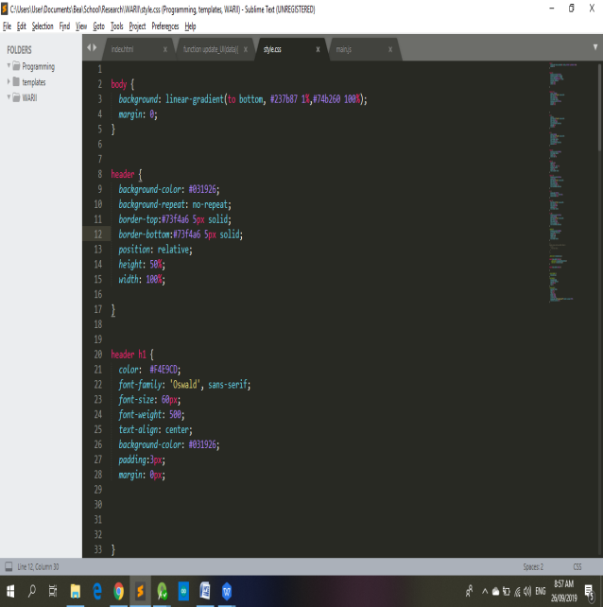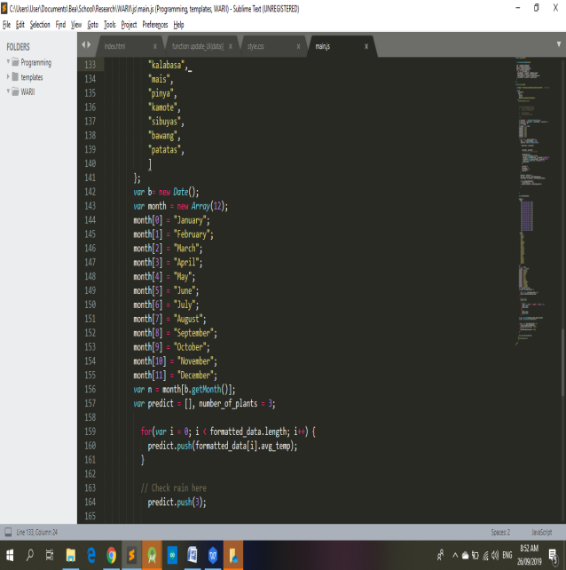**Programming**

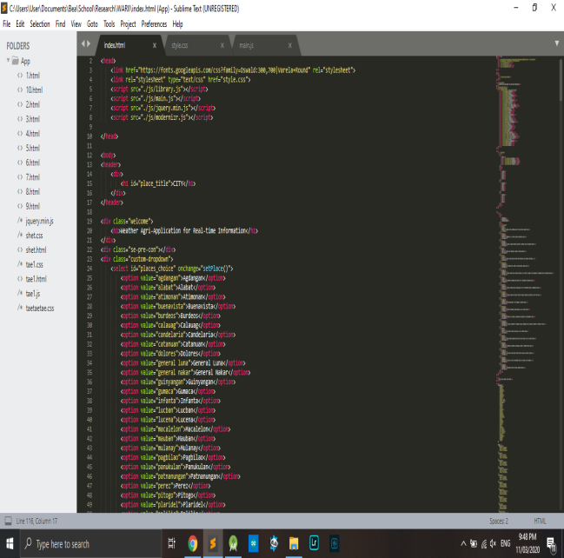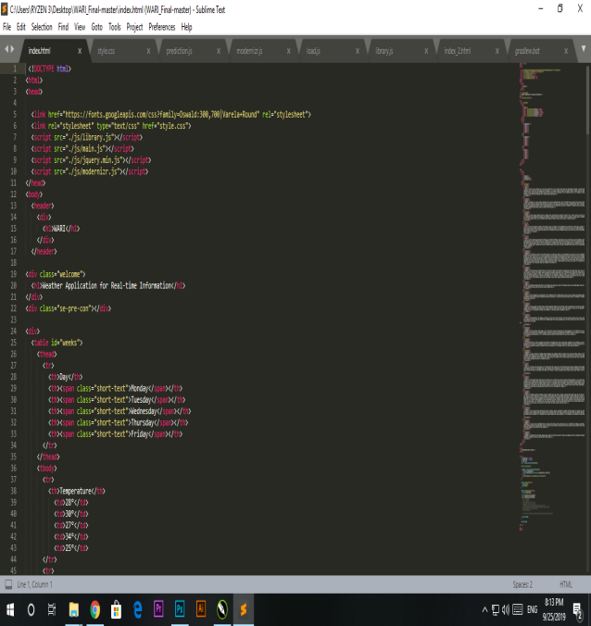

Coding using Sublime Text 3

1. 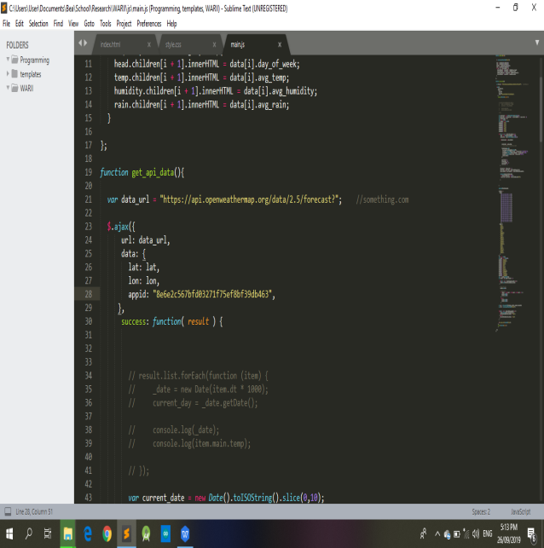**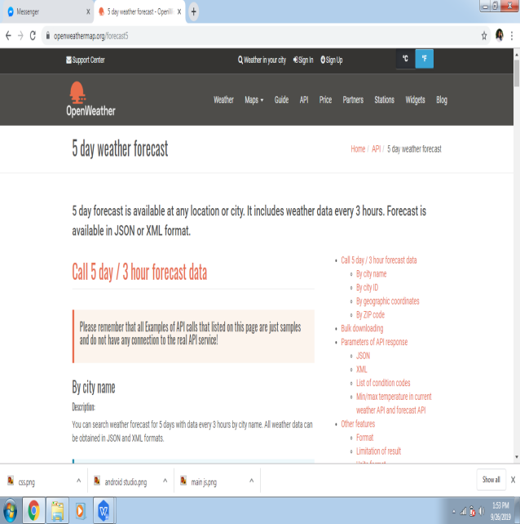Accessing API**
2. 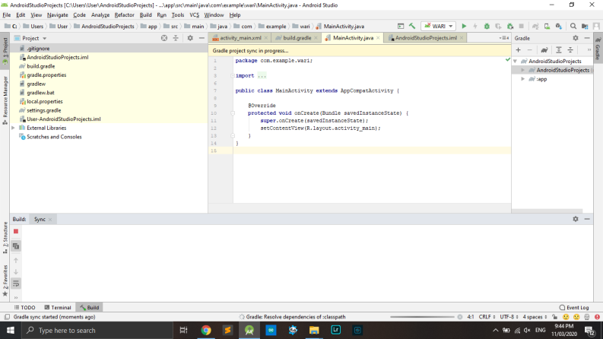**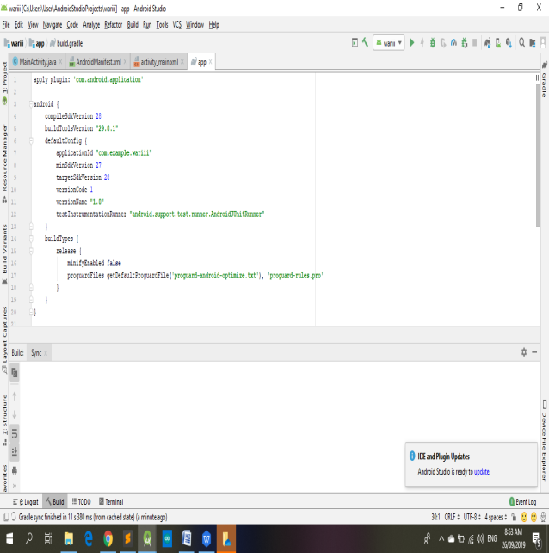Android Studio**

Building the application on the mobile device

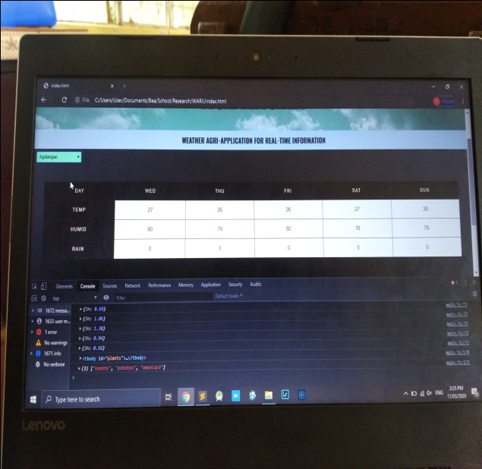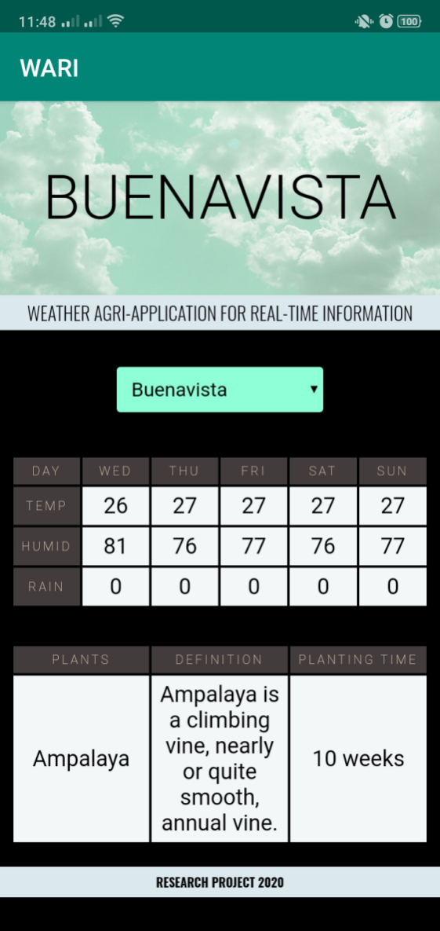**E.Testing**

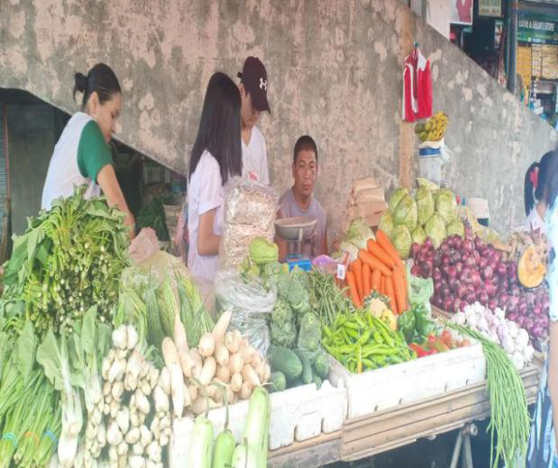

Survey conducted to farmers and the result of the K-nearest neighbor

**RESULTS AND DISCUSSIONS**

This chapter of the research discusses the outcome of the study. The result of K-Nearest Neighbor algorithm is tabulated and discussed. It shows the result of the testing of the application based on the prediction of the application. The accuracy and credibility of the application was also discussed.

**Table 1. The Result of the K- Nearest Neighbor Algorithm Using Manual Computation and Compared to the Prediction of Application**





Table 1shows the result of the manual computation of K-nearest neighbor using Euclidean Distance formula. The results include the nearest value to 0, the ones highlighted in yellow, in the different municipalities in Quezon. Most of the plants predicted during the specific date are patola, upo, luya, ampalaya, mais, kamote, patatas and pinya. The numbers highlighted in green are the ones having the same value as one of the three plants.

**Table 2. Comparison Between the Manual Computation and the Prediction of the Application**

|  |  |  |
| --- | --- | --- |
| **Place** | **Manual Computation** | **Prediction of the Application** |
| Agdangan | kamote patatas ampalaya upo | kamote patatas ampalaya |
| Alabat | ampalaya upo kamote | ampalaya upo kamote |
| Atimonan | kamote patatas ampalaya upo | kamote patatas ampalaya |
| Buenavista | ampalaya kamote patatas upo | ampalaya kamote patatas |
| Burdeos | ampalaya upo patola | ampalaya upo patola |
| Calauag | patola luya mais | patola luya mais |
| Candelaria | patola luya pinya | patola luya pinya |
| Catanauan | ampalaya upo kamote | ampalaya upo kamote |
| Dolores | patola luya mais | patola luya mais |
| General Luna | ampalaya upo patola | ampalaya upo patola |
| General Nakar | patola luya mais | patola luya mais |
| Guinyangan | patola luya mais | patola luya mais |
| Gumaca | ampalaya upo kamote | ampalaya upo kamote |
| Infanta | patola luya mais | patola luya mais |
| Lucban | patola luya pinya | patola luya pinya |
| Lucena | patola luya pinya | patola luya pinya |
| Macalelon | ampalaya upo kamote | ampalaya upo kamote |
| Mauban | patola luya pinya | patola luya pinya |
| Mulanay | ampalaya upo kamote | ampalaya upo kamote |
| Pagbilao | patola luya pinya | patola luya pinya |
| Panukulan | ampalaya upo patola | ampalaya upo patola |
| Pantanungan | ampalaya upo patola | ampalaya upo patola |
| Perez | ampalaya upo kamote | ampalaya upo kamote |
| Pitogo | ampalaya upo kamote | ampalaya upo kamote |
| Plaridel | ampalaya upo kamote | ampalaya upo kamote |
| Polilio | kamote patatas ampalaya | kamote patatas ampalaya |
| Quezon | ampalaya upo kamote | ampalaya upo kamote |
| Real | patola luya mais | patola luya mais |
| Sampaloc | patola luya pinya | patola luya pinya |
| San Andres | ampalaya upo kamote | ampalaya upo kamote |
| San Antonio | patola luya pinya | patola luya pinya |
| San Francisco | patola luya pinya | patola luya pinya |
| San Narciso | ampalaya upo kamote | ampalaya upo kamote |
| Sariaya | patola luya pinya | patola luya pinya |
| Tagkawayan | patola luya mais | patola luya mais |
| Tayabas | patola luya pinya | patola luya pinya |
| Tiaong | patola luya pinya | patola luya pinya |
| Unisan | kamote patatas ampalaya upo | kamote patatas ampalaya upo |

Table 2 shows the comparison of the manual computation of the K-nearest neighbor and the prediction of the application. It shows the relevance of the results proving the accuracy of the prediction. All the places shows accurate results and these can be used as basis of farmers in selecting the most suitable crop to be planted.

**Table 3. Weighted Arithmetic Mean of the Results of the Survey Conducted**

|  |  |  |  |  |  |  |  |  |
| --- | --- | --- | --- | --- | --- | --- | --- | --- |
| **WAM** | | | | | | | | |
| **Questions** | **RATE** | | | | | **Total** | **Result** | **Verbal Interpretation** |
| **1** | **2** | **3** | **4** | **5** |
| **1** | 0 | 0 | 4 | 8 | 8 | 20 | 4.2 | Yes |
| **2** | 0 | 1 | 5 | 6 | 8 | 20 | 4.05 | Yes |
| **3** | 0 | 0 | 8 | 5 | 7 | 20 | 3.95 | Yes |
| **4** | 0 | 1 | 2 | 6 | 11 | 20 | 4.35 | Yes |
| **5** | 0 | 0 | 1 | 9 | 10 | 20 | 4.45 | Yes |

The table 3 shows the result of the survey conducted using the weighted arithmetic mean. All the five questions interprets that the application is preferred by 20 farmers in Tayabas City. Question number four shows that the farmers are interested in the application. In conclusion, the application is recommended by the farmers.

**SUMMARY, CONCLUSIONS AND RECOMMENDATIONS**

**Summary**

This research aimed to create an innovation in the WARI: Weather Agri-Application for Real-Time Information. The community, mainly the farmers, is the main focus of the outcome of the study. Accuracy, credibility and reliability of the results were given emphasis in programming the data and codes.

In programming the application, Sublime Text 3 and Android Studio was used. The programming languages applied are HTML (Hypertext Markup Language), CSS (Cascading Style Sheet) and JavaScript. API (Application Program Interface) was accessed to update the current atmospheric status such as temperature, humidity and rain. In order to calculate the most suitable crop to be planted, K-Nearest Neighbor Algorithm or Euclidean Distance was the formula used. The results of the manual computation for the KNN were compared to the prediction of the application to test its accuracy. Twenty farmers were asked to answer a survey to determine whether the application will be of great help to them.

The application can predict the most appropriate crop to be planted in the different municipalities in Quezon Province. It is available online for the continuous update of the atmospheric status.

**Conclusions**

After conducting the study and creating the application, the researchers conclude the following:

* + - 1. The innovation of the study was making it available not only for Tayabas City but also for the different municipalities and cities in Quezon Province. It was localized in our province for Quezon remains top agricultural producer in Region 4A. New design was also applied and it includes the search tab for the cities.
      2. The predicted plants in the application were accurate based on manual computation of the K-nearest neighbor.
      3. On the survey conducted, the researchers conclude that the application was reliable based on the ratings and comments of different farmers.

**Recommendations**

For the following studies to be conducted related to this research, the researchers recommend the following:

Provide additional cities and plants for a wider range of the application

Make the application show the plants predicted for the following days

**BIBLIOGRAPHY**

AMS100. *“Weather Analysis and Forecasting.”*<https://www.ametsoc.org/index.cfm/ams/about-ams/ams-statements/statements-of-the-ams-in-force/weather-analysis-and-forecasting/?fbclid=IwAR3r4vdAcBZy0E8yYXCnTr_8f1RFRJ4NcGTScsxRnOBwAuv0KYgSue7EAJo> (Accessed April 23, 2019)

Bondarenko, Andrew. *“How to Make a Weather App."* stormotion.io. <https://stormotion.io/blog/how-to-make-a-weather-app/> (Accessed April 23, 2019)

Cahir, John. *“ Weather Forecasting.”*<https://www.britannica.com/science/weather-forecasting/Practical-applications> (Accessed February 1, 2020)

Calderone, Len. *“How Can Farmers Track the Weather.”*Agritechtomorrow.com. <https://www.agritechtomorrow.com/article/2017/09/how-can-farmers-track-the-weather/10211> (Accessed April 23, 2019)

Calderone, Len. *“Top Article for 2018-Effects of Extreme Weather on Farming.”*[https://www.agritechtomorrow.com/article/2018/06/top-article-fo](https://www.agritechtomorrow.com/article/2017/09/how-can-farmers-track-the-weather/10211)r-2018-effects-of-extreme-weather-on-farming/10806 (Accessed April 26, 2019)

Eddy, Max. *“Stay Safe With a Free Weather App.”* Pcmag.com. <https://www.pcmag.com/article/324867/stay-safe-with-a-free-weather-app> (Accessed April 23, 2019)

Elliot, Eric. *“10 Must See Web Apps & Games.”*<https://medium.com/javascript-scene/10-must-see-web-apps-games-36ab9ca60754> (Accessed April 26, 2019)

Flora, Ian Ocampo. *“Agriculture sector faces greatest impact from climate change.”*<https://www.sunstar.com.ph/article/426910> (Accessed April 26, 2019)

Gregory, Paul, Rea, Anthony, Dietachmayer, Gary, Braganza, Karl. *“Weather forecasting is about to get even better.”*<https://theconversation.com/weather-forecasting-is-about-to-get-even-better-44594> (Accessed April 26, 2019)

Jensen, S., Moller, A., Thiemann P. *“Type Analysis For JavaScript.”*<https://cs.au.dk/~amoeller/papers/tajs/paper.pdf> (Accessed April 26, 2019)

NASA SCIENCE SHARE THE SCIENCE. *“Weather.”*<https://science.nasa.gov/earth-science/focus-areas/earth-weather?fbclid=IwAR2G-odNbUi5HOTEcRzAzKTO_zEmK7H7CgTLJhXr6SvKKdCGwU7iJBTutv4> (Accessed April 23, 2019)

OMICS International. *“Climatology & Weather Forecasting Importance.”*<https://www.omicsonline.org/climatology-and-weather-forecasting-importance.php?fbclid=IwAR324tmFDcrn6kRKLS6ja_BndlU76519uBvtBJn17TyMuoUHLvtlBCJzGog> (Accessed April 23, 2019)

Science Daily. *“Weather forecasting.”*Sciencedaily.com. <https://www.sciencedaily.com/terms/weather_forecasting.htm>(Accessed April 23, 2019)

Siebert, Siebert,Webber, Heidi, and Rezaei, Ehsan Eyshi.*“Weather impact on crop yields.”* <https://iopscience.iop.org/article/10.1088/1748-9326/aa7f15> (Accessed April 26, 2019)

Toledo, Judi. *“Why Millions Of Developers Us Javascript For Web Application Development”*<https://torquemag.io/2018/06/why-millions-of-developers-use-javascript-for-web-application-development/> (Accessed April 26, 2019)

United States Environmental Protection Agency. *“Climate Impacts on Agriculture and Food Supply.”*19january2017snapshot.epa.gov. <https://19january2017snapshot.epa.gov/climate-impacts/climate-impacts-agriculture-and-food-supply.html> (Accessed April 23, 2019)

Vining, Kevin. *“Effects of weather on agricultural crops and livestock: an overview.”* tandfonline.com.<https://www.tandfonline.com/doi/abs/10.1080/00207239008710581>(Accessed April 23, 2019)

Yildirim, Soner. *“K-Nearest Neighbor Explained.”*<https://towardsdatascience.com/k-nearest-neighbors-knn-explained-cbc31849a7e3> (Accessed February 21, 2020)

**ACKNOWLEDGEMENT**

The researchers would like to recognize and express their deepest appreciation to all the people who gave their time in helping the researchers to accomplish their Science Investigatory Project:

Mr. Marvin J. Rosales, Head Teacher of Science Department, who provided insight and expertise that greatly assisted the research and helped the study to improve;

Mrs. Zenaida A. Moreno, their Research Teacher, for helping the researchers in revising the mistakes for the improvement of the research manuscript and write-ups;

To the panel of judges during the pre-oral defense, for their constructive criticism, professional comments, and sharing of suggestions that greatly improves the study;

Ms. Margaret Elaine E. Calvendra, the researchers’ class adviser, who extended her moral support and encouragement;

To the researchers’ beloved parents who shared their financial support and motivation during the conduction of the study;

To the farmers who gave their time to answer the researchers’ questions and survey form for the result of the application.

To Lord God Almighty, for leading the proponents well and giving them the power, strength, wisdom and providence which made the difficult tasks easier to do.