Three.js Beginner Handbook:

Project Structure:
Every three.js project needs at least one HTML file to define the webpage, and a JavaScript file to run your three.js code. So, to begin, create an index.html and a main.js file.

By default you can use this html boilerplate:
<!DOCTYPE html>
<html lang="en">
<head>
<meta charset="utf-8">
<title>My first three.js app</title>
<style>
body { margin: 0; }
</style>
</head>
<body>
<script type="module" src="/main.js"></script>
</body>
</html>

Your main.js must include the following line at the top:
import * as THREE from 'three';

Installation:
To install three.js into your project you must use npm for installing the necessary JS packages and a build tool to link all the necessary dependencies and run your project.
- Install Node.js. you need it to load and manage dependencies and to run the build tool
- Install three.js and a build tool, Vite, using a terminal in your project folder. Vite will be used during development, but it isn't part of the final webpage.

Run the following two commands in your terminal:
npm install –save three

npm install –save-dev vite

- Launch the project

Run this command in the terminal:
npx vite

If everything went well, you'll see a URL like http://localhost:5173 appear in your terminal. Open this URL in your browser to see your webpage.
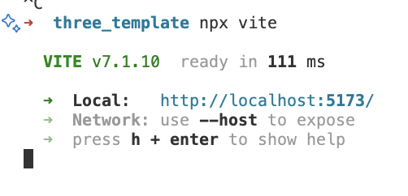

Create a Scene:
To be able to display anything with three.js, we need three things:
- A scene, where you will place your assets and animations
- A camera, which will capture the scene
- A renderer, to render (output) the scene from the camera perspective.

Rember, you should always import three.js into your main.js project as stated before!
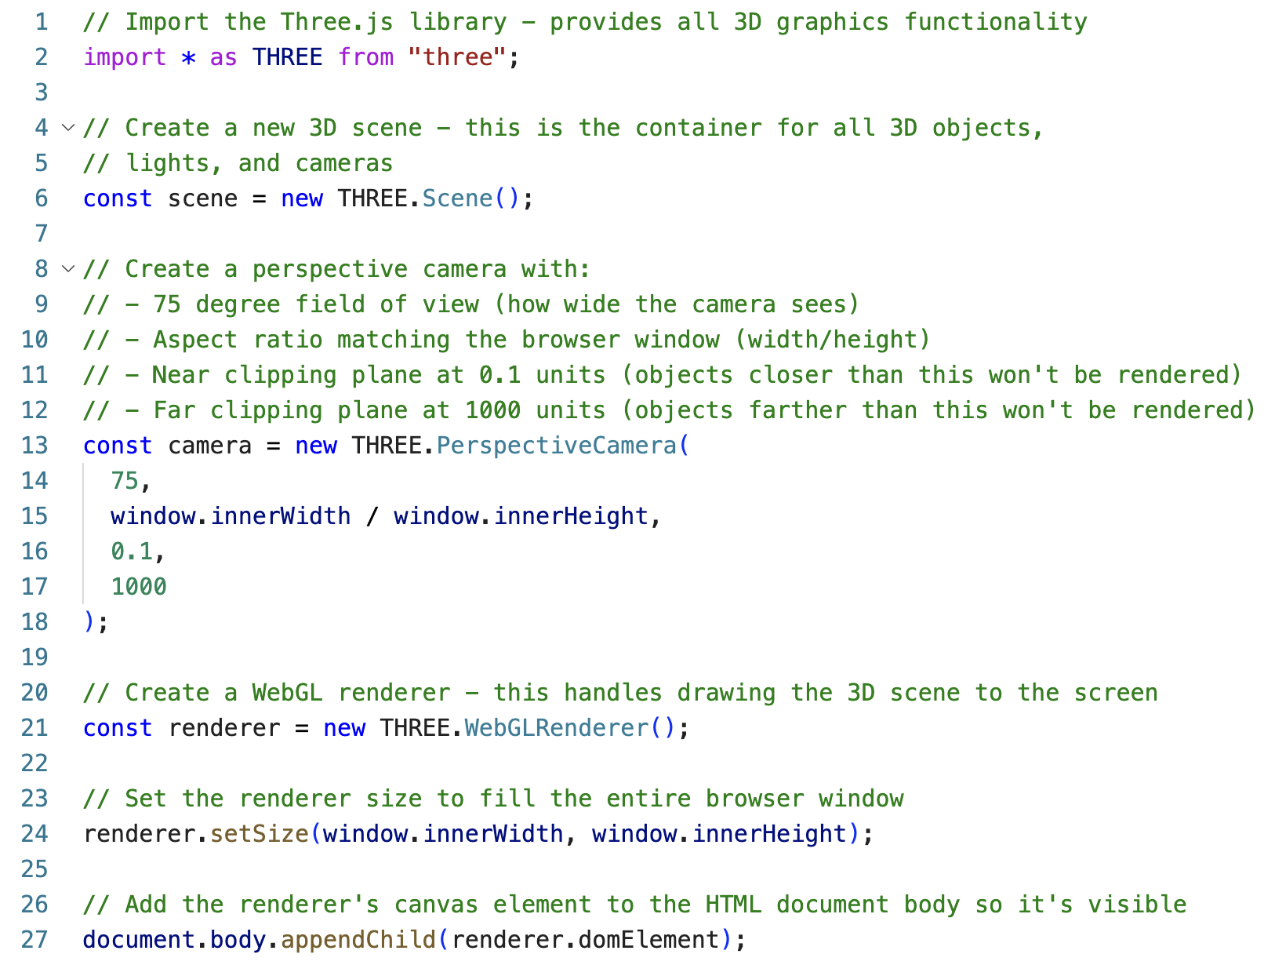

Add Some Geometry
We now have everything set up to add some 3D geometry to our scene and render it.
Just like P5.js, three.js has a whole lot of 2D and 3D primitive shapes ready made for you to use. You can find the whole list of shapes available here.

Below the code we have just written, we can declare, initialise and add our geometry to the three.js scene.

- First, we must create some geometry, here we use the BoxGeometry primitive. Note, the geometry primitives provide the vertex data of the shape, they don’t create the shape (that comes later).
- Second, we create a material to give our shape a surface, otherwise it will be a mesh of vertices. We do that we the THREE.MeshBasicMaterial() function.
- We combine the vertex data and the material data using the THREE.Mesh() function. This creates an object which we can then position in the scene.
- We add the object to the scene.

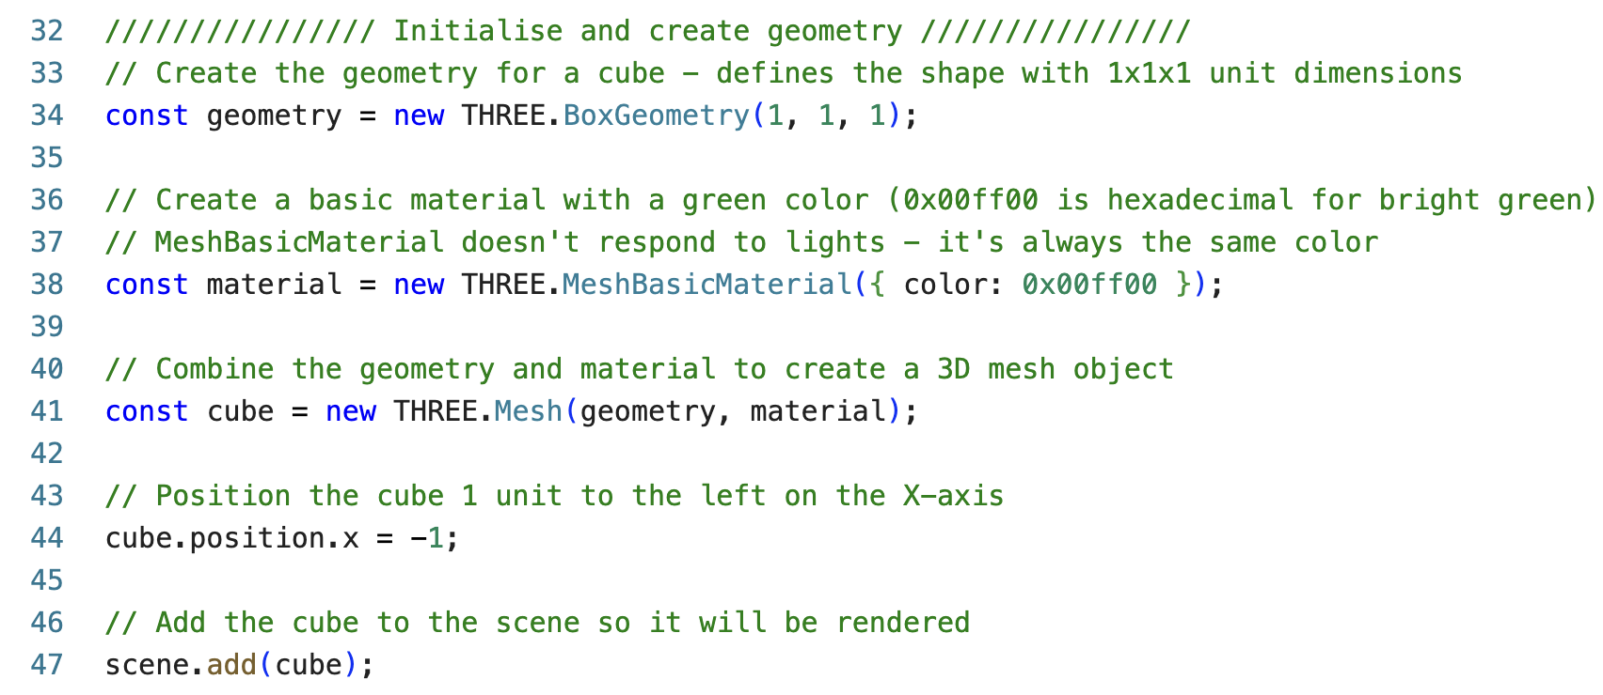
4
2
1
3

Animate the Geometry
To animate the cube we added to our scene we must create an animation loop, in which we will modify the parameters of our object.

The animate loop also needs to continually pass the scene and whatever the camera is looking at to our renderer so that the render updates and displays the objects new state.

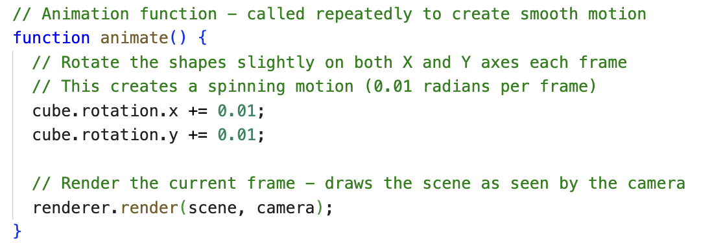

Finally, back in the renderer setup, we must set the renderer’s animation loop to our animate function.

