1. Design and develop a reprogrammable embedded computer using 8051 microcontrollers and to show the following aspects. a. Programming b. Execution c. Debugging

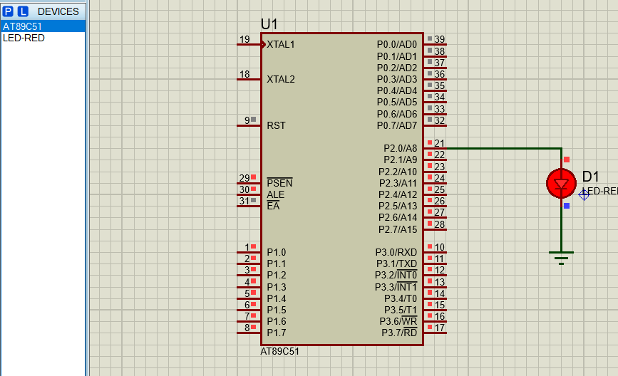

2A :- A Configure timer control registers of 8051 and develop a program to generate given time delay

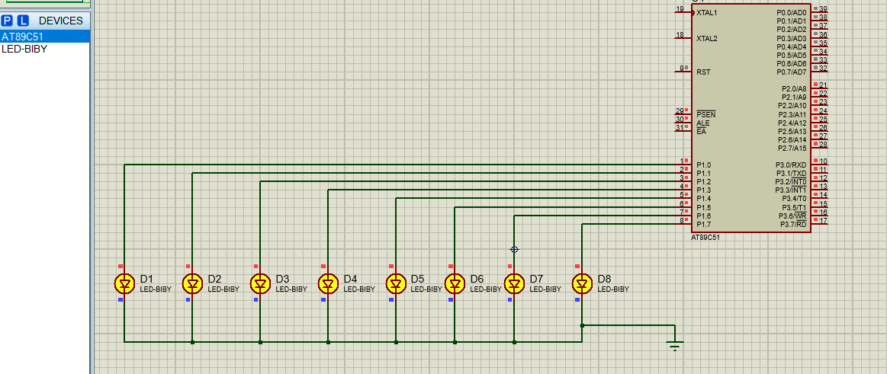

2B. :- To demonstrate use of general purpose port i.e. Input/ output port of two controllers for data transfer between them.

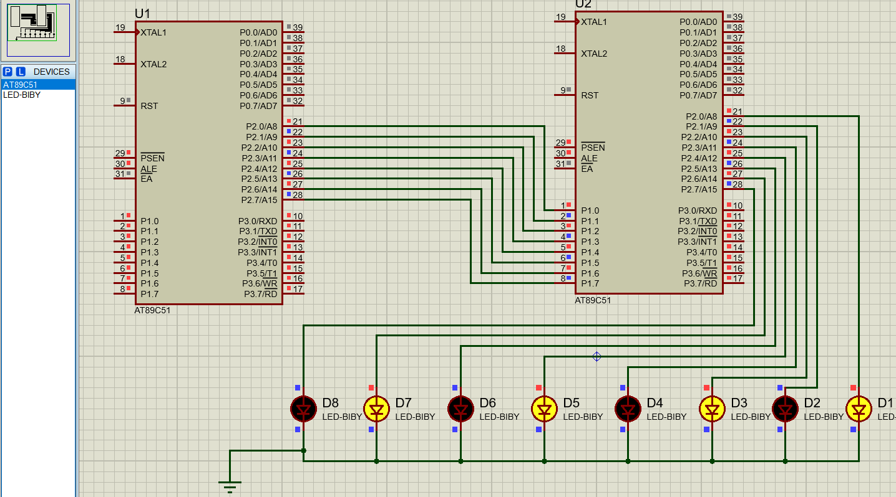

3A:- Port I / O: Use one of the four ports of 8051 for O/P interfaced to eight LED’s. Simulate binary counter (8 bit) on LED’s

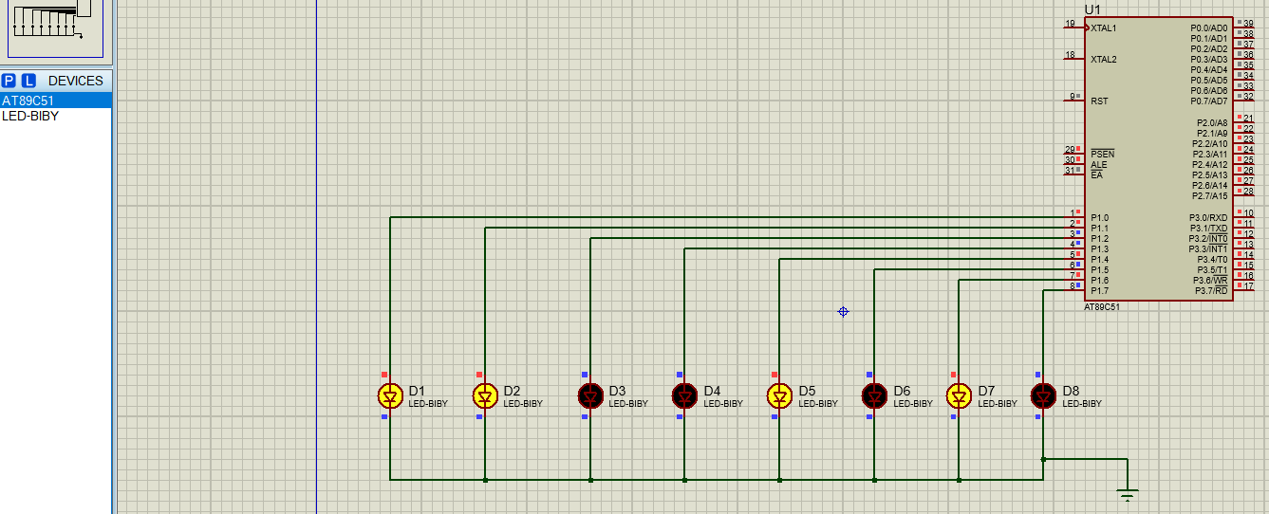

3B:- To interface 8 LEDs at Input-output port and create different patterns.

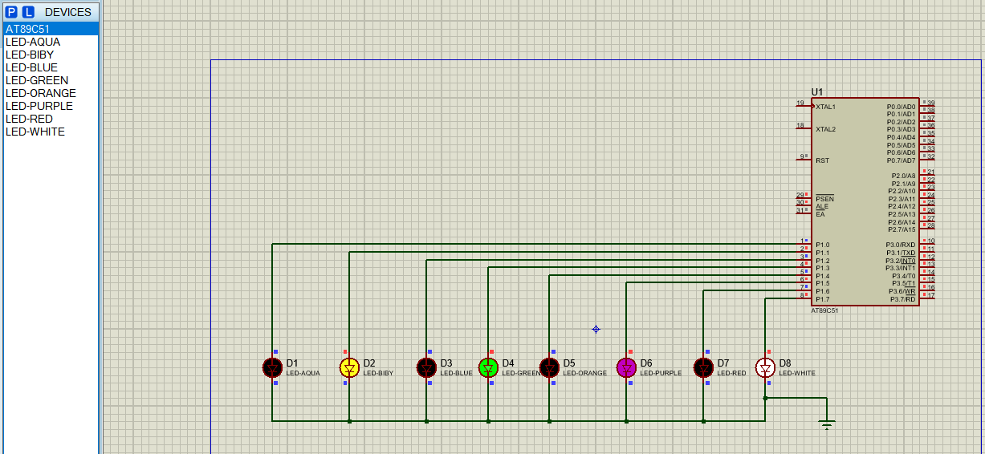

3C :- To demonstrate timer working in timer mode and blink LED without using any loop delay routine.

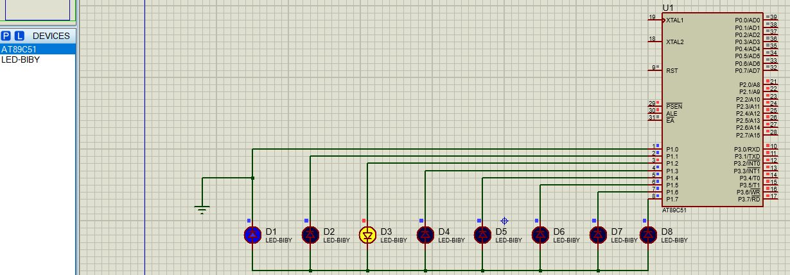

4. A Serial I / O: Configure 8051 serial port for asynchronous serial communication with serial port of PC exchange text messages to PC and display on PC screen. Signify end of message by carriage return.

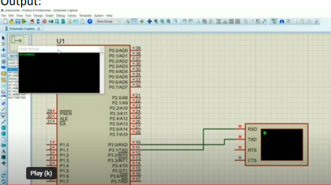

4B To demonstrate interfacing of seven-segment LED display and generate counting from 0 to 99 with fixed time delay.

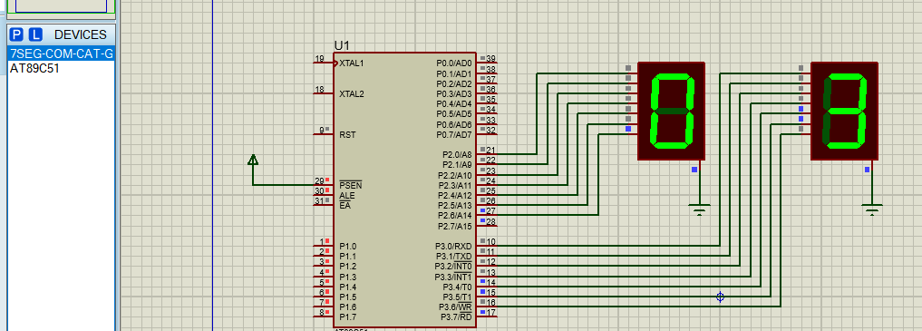

4C Interface 8051 with D/A converter and generate square wave of given frequency on oscilloscope.

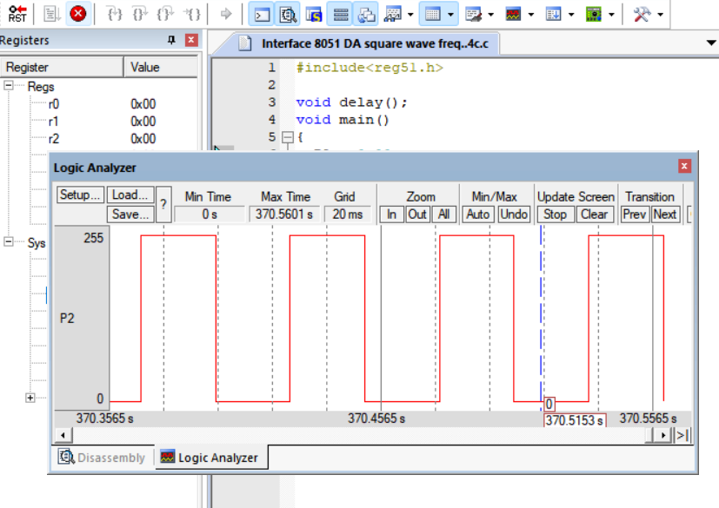

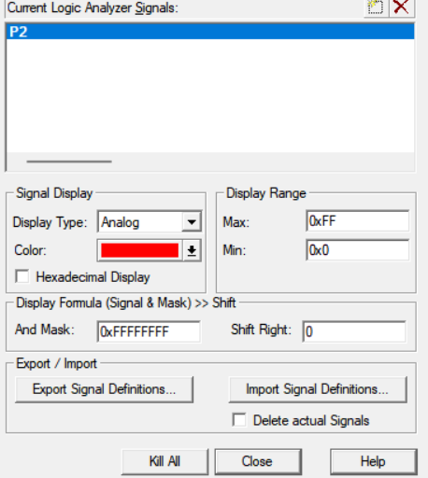

5. A Interface 8051 with D/A converter and generate triangular wave of given frequency on oscilloscope

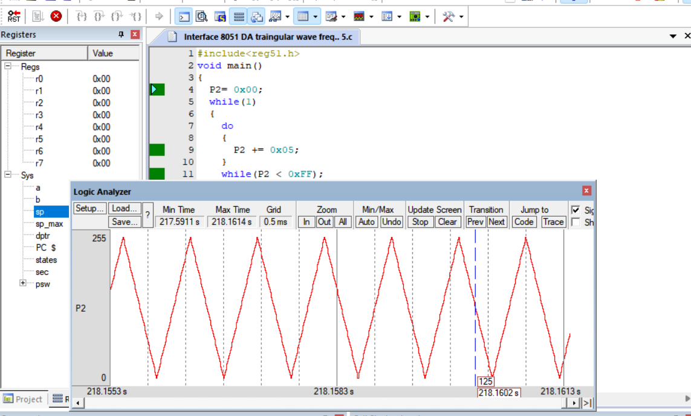

6. Interface stepper motor with 8051 and write a program to move the motor through a given angle in clock wise or counter clock wise direction.

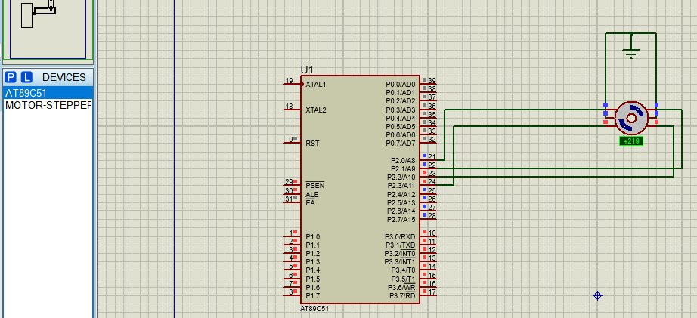

7.Traffic signal

