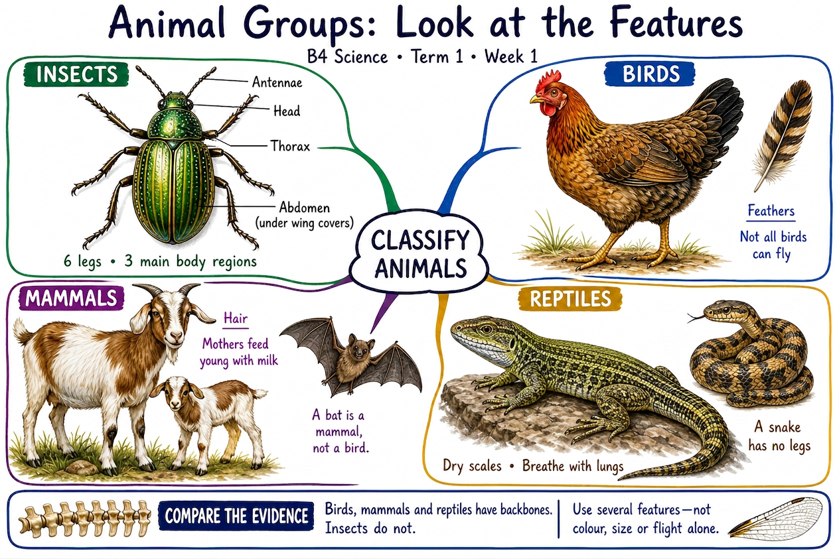
AI-generated instructional illustration with annotation review. Teacher-review draft. These two previews do not replace all maps in the existing teaching packs.

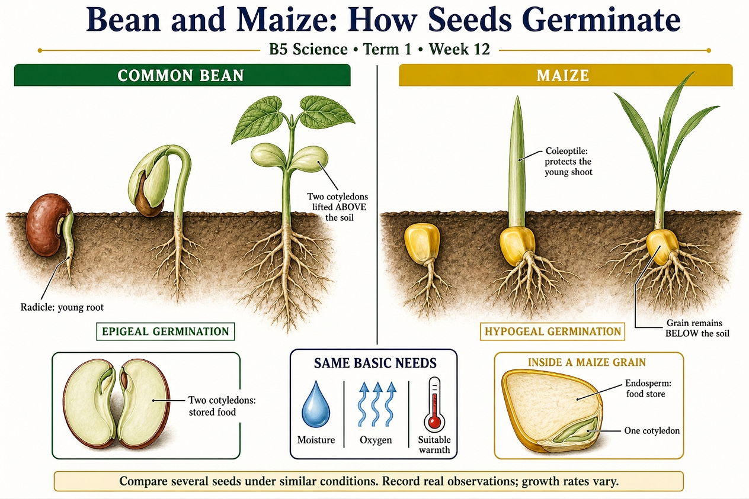
AI-generated instructional illustration with annotation review. Teacher-review draft. These two previews do not replace all maps in the existing teaching packs.

