Basic 4 Computing — Week 1
  - Parts of a computer and their functions • Term 1 • Week 1 ONLY
Name: __________________________________ Class: __________
Date: __________________ Teacher: ________________________
SCOPE: WEEK 1 ONLY. Later weeks and both tests for this subject are NOT included in this partial batch. Emergency teacher-review draft — rebuilt edition.
Sequence source: BASIC 4 SCHEME OF LEARNING.pdf, p54; indicator reference B4.1.1.1.1. Topic descriptions informed by the local curriculum data. Explanations and activities are newly prepared, including supporting concepts.

Learning outcomes
- Explain the key ideas in parts of a computer and their functions using accurate vocabulary.
- Identify examples and justify classification or tool choices using evidence.
- Apply the ideas to familiar school or home situations and correct a common misconception.

Teacher lesson notes
One consolidated weekly unit. Suggested organisation: three 40-minute teaching sessions plus guided practice and assessment in the remaining timetable periods. Spread the questions over the week.
Prior knowledge: elicit a familiar example and ask for a reason. Record one correct idea and one misconception to revisit at the end of the week.

Session 1 — Observe
5 minutes: recall examples; 10: demonstrate or show pictures; 15: pairs describe features; 10: introduce the first five key terms and check explanations.

Session 2 — Investigate
5 minutes: retrieve vocabulary; 10: model an explanation; 15: perform the specific activity below; 10: compare observations and introduce the remaining terms.

Session 3 — Apply
5 minutes: correct a misconception; 10: explain map branches; 15: use application questions; 10: collect an exit response and identify who needs reteaching.

Topic-specific activity
Label a switched-off desktop or pictures. Model typing a sentence: input → processing → output → storage. Match keyboard, mouse, monitor, system unit, speakers and storage to their roles.

Safety and resources
Do not open computer cases or touch sockets. Use dry hands and keep liquids away.
Resources: the examples or pictures specified in the activity, board, pencils, exercise books and the supplied visual map. If equipment is unavailable, use labelled drawings and role-play rather than claiming a practical was performed.

Support and extension
Support: offer picture labels, read technical vocabulary aloud and accept an oral explanation before writing. Extension: compare related concepts, propose a counterexample and justify a new application. Use wrong MCQ choices to diagnose misconceptions, not merely score letters.

Study notes

Keyboard
An input device mainly used to enter letters, numbers and commands with keys.
Pressing keys sends input; the monitor displays the result. Entering text and displaying it are different roles.

Mouse
An input device used to move a pointer and select on-screen items.
Moving the device controls the pointer and clicking selects an item. Holding a button while moving can drag an item instead.

Monitor
An output device displaying text and images.
The screen presents visual output but does not itself guarantee that the document has been saved to persistent storage.

System unit
The main desktop case containing components such as processor and memory.
The case houses several components. The CPU is the processor inside, not a precise name for the whole case.

Processor
The component that executes instructions and performs calculations and control operations.
It works with memory to execute instructions. A keyboard supplies input and a monitor can display the processed answer.

Speakers
Output devices that convert audio signals into audible sound.
These devices reproduce sound. A microphone captures sound as input, which is the opposite information direction.

Printer
A device producing physical copies of digital text or pictures.
A paper printout is hard copy. The electronic document displayed on screen is soft copy.

Storage drive
A component retaining saved files for later use, including after power is removed.
Persistent storage keeps saved files without continuous power. Unsaved changes in working memory may still be lost.

RAM
Working memory for data and programs currently in use, normally losing contents without power.
This memory supports current work but does not replace saving to persistent storage. Its ordinary contents are volatile.

USB flash drive
A small removable storage device commonly connecting to a USB port.
Use approved devices to reduce malware risk, and follow safe-eject procedures to reduce the chance of losing data.
Revision routine: cover each definition, explain the idea, supply a new example and compare it with a related term. Reconstruct the map from memory before checking it.

Week 1 — Visual mind-map
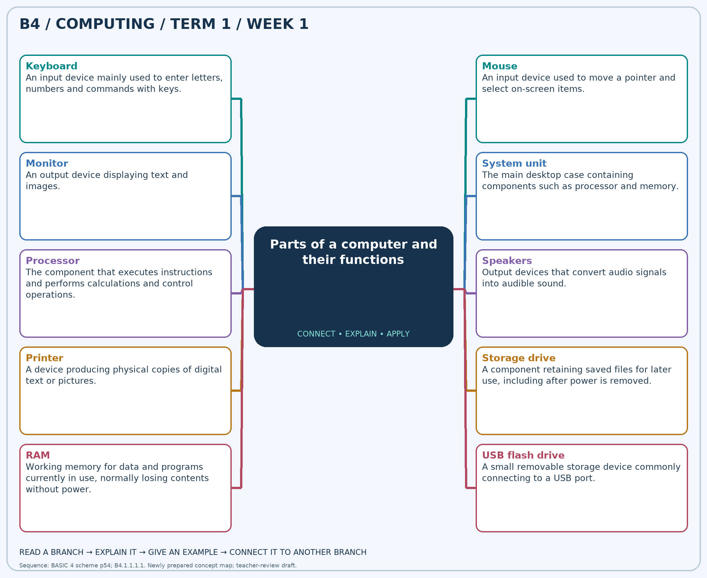
Explain each branch and supply another example. A separate high-resolution PNG is included.

Week 1 — Practice

Section A — Multiple-choice questions
Choose ONE correct answer for each question. Each question has four alternatives.
1. Which term best matches this description: an input device mainly used to enter letters, numbers and commands with keys?
A. Keyboard B. Printer C. Monitor D. Speaker
2. Which term best matches this description: an input device used to move a pointer and select on-screen items?
A. Mouse B. Speaker C. Printer D. Monitor
3. Which term best matches this description: an output device displaying text and images?
A. Mouse B. Microphone C. Keyboard D. Monitor
4. Which term best matches this description: the main desktop case containing components such as processor and memory?
A. Mouse B. System unit C. Speaker D. Keyboard
5. Which term best matches this description: the component that executes instructions and performs calculations and control operations?
A. Keyboard B. Monitor C. Processor D. Speaker
6. Which term best matches this description: output devices that convert audio signals into audible sound?
A. Keyboard B. Mouse C. Scanner D. Speakers
7. Which term best matches this description: a device producing physical copies of digital text or pictures?
A. Keyboard B. Printer C. Microphone D. Monitor
8. Which term best matches this description: a component retaining saved files for later use, including after power is removed?
A. Keyboard B. Speaker C. Mouse D. Storage drive
9. Which term best matches this description: working memory for data and programs currently in use, normally losing contents without power?
A. Printed page B. Hard disk C. RAM D. USB flash drive
10. Which term best matches this description: a small removable storage device commonly connecting to a USB port?
A. Speaker B. USB flash drive C. Monitor D. Mouse pad
11. Ama wants to type her name in a document. Which device should she use?
A. Printer B. Speaker C. Monitor D. Keyboard
12. Kojo wants to click a desktop icon. Which device is suitable?
A. Speaker B. Mouse C. Printer D. Monitor
13. A learner wants to see the sentence just typed. Which device shows it?
A. Mouse B. Microphone C. Keyboard D. Monitor
14. A teacher points to the main case connected to a desktop monitor. What is it?
A. System unit B. Speaker C. Keyboard D. Mouse
15. A computer carries out an addition instruction. Which component performs this processing?
A. Speaker B. Keyboard C. Processor D. Monitor
16. A class needs to hear recorded instructions. Which devices provide the sound?
A. Speakers B. Keyboard C. Mouse D. Scanner
17. A pupil needs a paper invitation to take home. Which device is required?
A. Monitor B. Keyboard C. Printer D. Microphone
18. A saved document is reopened the next day. Which component retained it?
A. Storage drive B. Mouse C. Speaker D. Keyboard
19. Which memory normally loses its current contents when a computer is switched off?
A. Hard disk B. USB flash drive C. RAM D. Printed page
20. A teacher transfers an approved presentation using a pocket-sized storage device. Which device is it?
A. Monitor B. Mouse pad C. Speaker D. USB flash drive

Section B — 10 structured essay questions
Answer every part (a), (b), (c) in your exercise book. Suggested marks: (a) 1, (b) 1, (c) 2, giving 4 marks per question. Explain relationships and use examples where requested.

Question 1
(a) Explain the term “Keyboard”.
(b) Ama wants to type her name in a document. Which device should she use?
(c) Explain the different roles of keyboard and monitor when typing a name.

Question 2
(a) Explain the term “Mouse”.
(b) Kojo wants to click a desktop icon. Which device is suitable?
(c) Describe how to select an icon without accidentally dragging it.

Question 3
(a) Explain the term “Monitor”.
(b) A learner wants to see the sentence just typed. Which device shows it?
(c) Explain why seeing a sentence on screen does not mean it is saved.

Question 4
(a) Explain the term “System unit”.
(b) A teacher points to the main case connected to a desktop monitor. What is it?
(c) Explain why the whole case and the CPU are not the same thing.

Question 5
(a) Explain the term “Processor”.
(b) A computer carries out an addition instruction. Which component performs this processing?
(c) Describe its role in an input–process–output example.

Question 6
(a) Explain the term “Speakers”.
(b) A class needs to hear recorded instructions. Which devices provide the sound?
(c) Distinguish these devices from a microphone.

Question 7
(a) Explain the term “Printer”.
(b) A pupil needs a paper invitation to take home. Which device is required?
(c) Explain the difference between the paper invitation and its on-screen version.

Question 8
(a) Explain the term “Storage drive”.
(b) A saved document is reopened the next day. Which component retained it?
(c) Explain why work should be saved before shutdown.

Question 9
(a) Explain the term “RAM”.
(b) Which memory normally loses its current contents when a computer is switched off?
(c) Contrast working memory with storage when editing a document.

Question 10
(a) Explain the term “USB flash drive”.
(b) A teacher transfers an approved presentation using a pocket-sized storage device. Which device is it?
(c) State two precautions for using removable storage.

