Basic 4 Mathematics
  - Term 1 • Weeks 1–12 • Lesson notes, study notes, mind-maps and weekly practice
Name: __________________________________ Class: __________
Date: __________________ Teacher: ________________________
EMERGENCY TEACHER-REVIEW DRAFT — REBUILT EDITION. Topic order follows the supplied Alpha Examinations first-term scheme. Notes, examples and diagrams are newly prepared. This is not an official curriculum approval or a guarantee of full indicator-by-indicator validation.
Each week contains one consolidated weekly lesson unit, one visual mind-map, 20 four-option MCQs and 10 structured questions with parts (a), (b), (c). Daily sessions are suggested, not separate full daily lesson plans. Answers are in the separate teacher book.
The source reserves Weeks 13–15 for revision/examinations/vacation. Mid-term assessment assumes Weeks 1–6; end-of-term assumes Weeks 1–12. Confirm school dates and pacing. Some task structures repeat with new values for fluency practice.

Weekly contents
01 — Place value and expanded form / Reading and writing large numbers
02 — Number charts and counting steps / Comparing and ordering whole numbers
03 — Rounding whole numbers / Skip counting
04 — Roman numerals
05 — Factors, primes and even numbers / Highest common factor
06 — Lowest common multiple / Factors, primes and even numbers
07 — Multiplication facts and related division
08 — Multiplication strategies / Division and checking
09 — Division and checking / Multi-step number problems
10 — Unit fractions and number lines / Equivalent fractions
11 — Simplest form and improper fractions
12 — Comparing fractions

Week 1 — Place value and expanded form / Reading and writing large numbers
Sequence source: BASIC 4 SCHEME OF LEARNING.pdf, first-term Mathematics, page 20. One consolidated weekly unit.

Learning outcomes
- Explain and apply place value and expanded form, solve examples and justify the method.
- Explain and apply reading and writing large numbers, solve examples and justify the method.

Teaching notes and suggested sessions
Suggested schedule: five 40-minute sessions, adjusted to the school timetable. Spread the question bank through the week; it is not intended to be completed in one lesson.

1 — Explore and diagnose
5 minutes: recall an earlier skill; 10: demonstrate a concrete or pictorial model; 15: pairs investigate and explain; 10: identify a misconception and set an exit task.

2 — Model and practise
5 minutes: review the exit task; 10: work an example aloud; 15: pairs solve parallel examples; 10: compare methods and correct errors.

3 — Connect representations
5 minutes: recall vocabulary; 10: explain the mind-map; 15: connect a model, a drawing and a symbolic calculation; 10: independent practice.

4 — Apply and explain
5 minutes: estimate or predict; 10: solve a contextual example; 15: attempt selected structured-question parts; 10: compare reasoning and check units.

5 — Check and respond
5 minutes: retrieve the main rule; 15: use selected MCQs diagnostically; 10: explain distractors and misconceptions; 10: reteach or extend in response to evidence.

Topic-specific activities
- Build numbers with digit cards on a place-value chart. Exchange two digits and explain the change.
- Partners dictate numbers and write figures, checking every place on a chart.
Resources: board, pencils, number cards, counters, paper strips and squared paper as appropriate. Prior-knowledge check: ask a learner to explain a representation used in the first example before introducing a new rule.
Support: reduce number size without changing the concept; offer a partially completed chart or model; allow oral reasoning before writing. Extension: create a counterexample to a false rule and explain why it fails.

Study notes and worked examples

Place value and expanded form
- Our system is base ten. Ten units in one place exchange for one unit in the next place to the left.
- The digit 3 in 43,216 has value 3,000. Face value and place value are different.
- Expanded form shows a sum of place values: 43,216 = 40,000 + 3,000 + 200 + 10 + 6.
- Zero holds an empty place. Removing the zero from 40,216 changes the number.
Worked example: What is the value of the digit in the thousands place in 34,384?
Solution: The digit is 4; 4 × 1,000 = 4,000.
Common misconception: Do not confuse the digit itself with the value of the place it occupies.

Reading and writing large numbers
- Group digits in threes from the right: ones, thousands, millions and billions.
- Read each non-zero group, followed by its scale name.
- When writing figures from words, put zeros in the places not named.
- Six hundred and three thousand and eight is 603,008. Read the result back to check it.
Worked example: Write in figures: sixty-six thousand, six hundred and thirty.
Solution: Place each named group in its correct scale: 66,630.
Common misconception: Do not write 603,800 for six hundred and three thousand and eight.
Independent study: read the map, cover it and reconstruct the branches. Solve an unused question from each skill and explain the reasoning to a partner. Consult the teacher key only after an honest attempt.

Week 1 — Visual mind-map
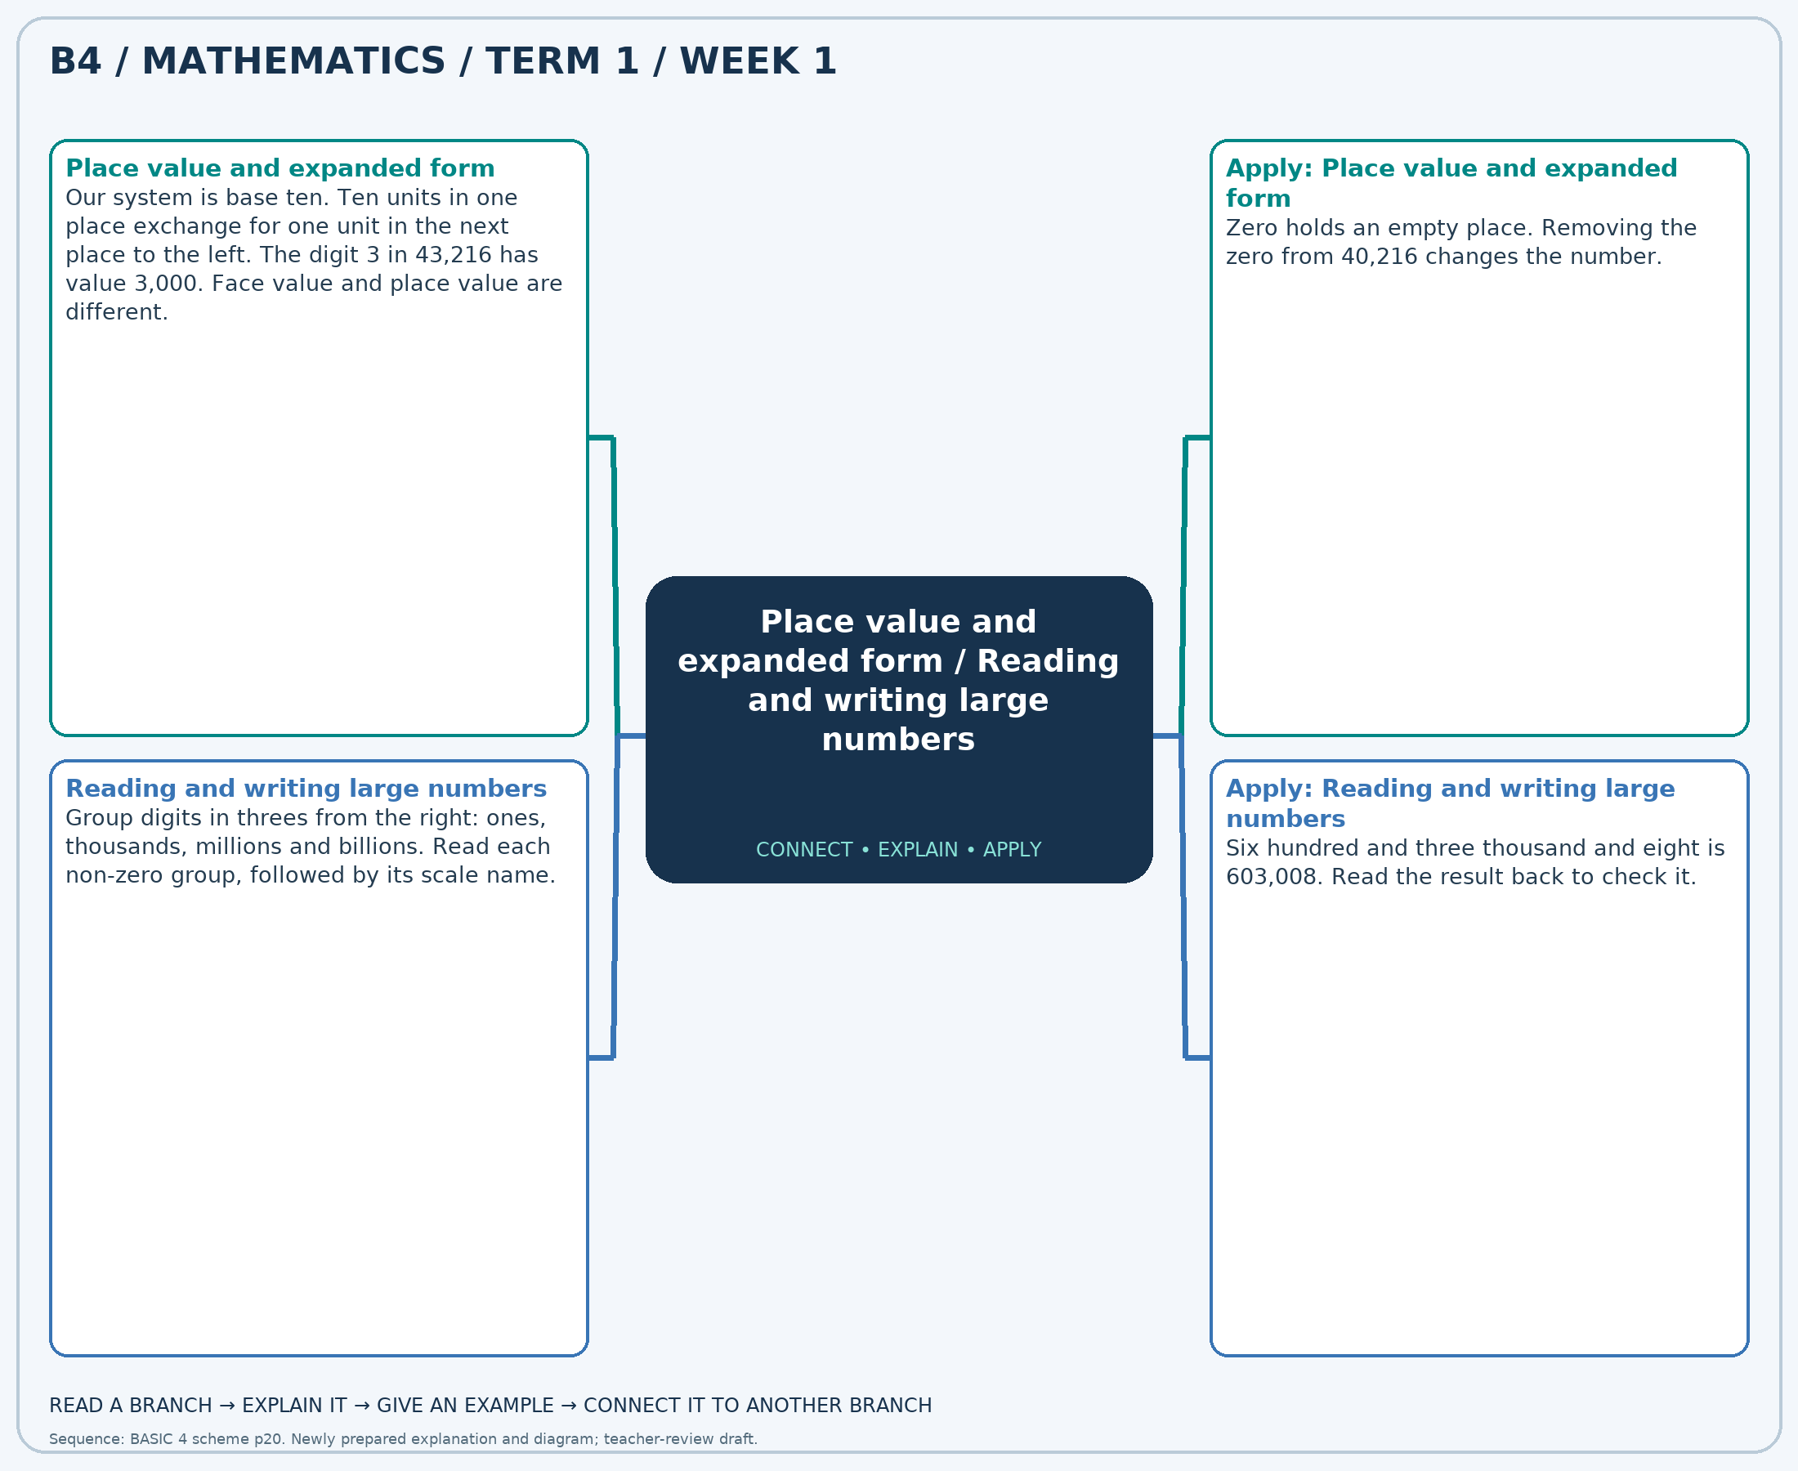
The separate high-resolution PNG can be projected or printed larger. Explain each branch and connect it with an example.

Week 1 — Practice

Section A — Multiple-choice questions
Choose ONE correct answer for each question. Each question has four alternatives.
1. What is the value of the digit in the tens place in 92,627?
A. 2 B. 200 C. 20 D. 23
2. Write in figures: twenty-six thousand, four hundred and eighty-eight.
A. 26588 B. 25488 C. 26488 D. 27488
3. A number has 5 ten-thousands, 9 hundreds and 5 ones, with zeros elsewhere. Write it in figures.
A. 50905 B. 50950 C. 59005 D. 5905
4. Write in figures: twenty-two thousand, five hundred and twenty-four.
A. 23524 B. 22624 C. 22524 D. 21524
5. What is the value of the digit in the tens place in 81,136?
A. 3 B. 30 C. 33 D. 300
6. Write in figures: thirty-nine thousand, six hundred and sixty-two.
A. 40662 B. 39662 C. 38662 D. 39762
7. What is the value of the digit in the thousands place in 26,225?
A. 60000 B. 600 C. 6000 D. 6
8. Write in figures: forty-four thousand, seven hundred and ninety.
A. 45790 B. 44890 C. 44790 D. 43790
9. A number has 5 ten-thousands, 9 hundreds and 8 ones, with zeros elsewhere. Write it in figures.
A. 59008 B. 50908 C. 5908 D. 50980
10. Write in figures: fifty-two thousand, six hundred and twenty-six.
A. 52626 B. 52726 C. 53626 D. 51626
11. What is the value of the digit in the thousands place in 77,634?
A. 7 B. 7000 C. 700 D. 70000
12. Write in figures: eighty-two thousand, one hundred and sixty-four.
A. 82164 B. 83164 C. 81164 D. 82264
13. What is the value of the digit in the tens place in 54,335?
A. 30 B. 33 C. 3 D. 300
14. Write in figures: eighty-nine thousand, five hundred and fifty-three.
A. 90553 B. 89653 C. 88553 D. 89553
15. A number has 2 ten-thousands, 4 hundreds and 4 ones, with zeros elsewhere. Write it in figures.
A. 24004 B. 2404 C. 20404 D. 20440
16. Write in figures: eighty-eight thousand, nine hundred and five.
A. 88905 B. 89905 C. 89005 D. 87905
17. What is the value of the digit in the hundreds place in 38,110?
A. 1 B. 10 C. 100 D. 1000
18. Write in figures: ninety thousand, seven hundred and seventy-four.
A. 90874 B. 91774 C. 89774 D. 90774
19. What is the value of the digit in the thousands place in 69,835?
A. 900 B. 9 C. 9000 D. 90000
20. Write in figures: forty-eight thousand, six hundred and forty-six.
A. 48746 B. 49646 C. 47646 D. 48646

Section B — Structured essay questions
Answer every part (a), (b), (c). Show your method or explain your choice. Write in a separate answer booklet. Each part: 1 mark for valid working/explanation and 1 for the correct result; 6 marks per question.

1. Apply the related skills and show working or give a reason for each answer.
(a) What is the value of the digit in the hundreds place in 66,702?
(b) Write in figures: fifty-four thousand, seven hundred and fifty-seven.
(c) What is the value of the digit in the tens place in 80,012?

2. Apply the related skills and show working or give a reason for each answer.
(a) Write in figures: sixty-two thousand, two hundred and eight.
(b) What is the value of the digit in the hundreds place in 39,750?
(c) Write in figures: forty-two thousand and forty-three.

3. Apply the related skills and show working or give a reason for each answer.
(a) What is the value of the digit in the thousands place in 44,582?
(b) Write in figures: fifty thousand, nine hundred and fifty-six.
(c) A number has 5 ten-thousands, 7 hundreds and 6 ones, with zeros elsewhere. Write it in figures.

4. Apply the related skills and show working or give a reason for each answer.
(a) Write in figures: fifty-seven thousand, four hundred and fifteen.
(b) A number has 7 ten-thousands, 8 hundreds and 7 ones, with zeros elsewhere. Write it in figures.
(c) Write in figures: sixty-nine thousand, two hundred and forty-four.

5. Apply the related skills and show working or give a reason for each answer.
(a) A number has 8 ten-thousands, 2 hundreds and 2 ones, with zeros elsewhere. Write it in figures.
(b) Write in figures: ninety-three thousand, five hundred and eighty-nine.
(c) What is the value of the digit in the tens place in 39,512?

6. Apply the related skills and show working or give a reason for each answer.
(a) Write in figures: thirty thousand, one hundred and seventy-six.
(b) What is the value of the digit in the thousands place in 31,232?
(c) Write in figures: eighty-six thousand, five hundred and eighty.

7. Apply the related skills and show working or give a reason for each answer.
(a) What is the value of the digit in the tens place in 54,332?
(b) Write in figures: seventy-eight thousand, two hundred and eighteen.
(c) What is the value of the digit in the thousands place in 23,124?

8. Apply the related skills and show working or give a reason for each answer.
(a) Write in figures: twenty-four thousand, one hundred and seventy-seven.
(b) What is the value of the digit in the hundreds place in 59,740?
(c) Write in figures: sixty-three thousand and fifty-seven.

9. Apply the related skills and show working or give a reason for each answer.
(a) What is the value of the digit in the tens place in 20,727?
(b) Write in figures: eighty-seven thousand, one hundred and thirteen.
(c) A number has 4 ten-thousands, 6 hundreds and 3 ones, with zeros elsewhere. Write it in figures.

10. Apply the related skills and show working or give a reason for each answer.
(a) Write in figures: seventy thousand, six hundred and twenty-six.
(b) A number has 8 ten-thousands, 8 hundreds and 4 ones, with zeros elsewhere. Write it in figures.
(c) Write in figures: twenty-eight thousand, two hundred and twenty-nine.

Week 2 — Number charts and counting steps / Comparing and ordering whole numbers
Sequence source: BASIC 4 SCHEME OF LEARNING.pdf, first-term Mathematics, page 20. One consolidated weekly unit.

Learning outcomes
- Explain and apply number charts and counting steps, solve examples and justify the method.
- Explain and apply comparing and ordering whole numbers, solve examples and justify the method.

Teaching notes and suggested sessions
Suggested schedule: five 40-minute sessions, adjusted to the school timetable. Spread the question bank through the week; it is not intended to be completed in one lesson.

1 — Explore and diagnose
5 minutes: recall an earlier skill; 10: demonstrate a concrete or pictorial model; 15: pairs investigate and explain; 10: identify a misconception and set an exit task.

2 — Model and practise
5 minutes: review the exit task; 10: work an example aloud; 15: pairs solve parallel examples; 10: compare methods and correct errors.

3 — Connect representations
5 minutes: recall vocabulary; 10: explain the mind-map; 15: connect a model, a drawing and a symbolic calculation; 10: independent practice.

4 — Apply and explain
5 minutes: estimate or predict; 10: solve a contextual example; 15: attempt selected structured-question parts; 10: compare reasoning and check units.

5 — Check and respond
5 minutes: retrieve the main rule; 15: use selected MCQs diagnostically; 10: explain distractors and misconceptions; 10: reteach or extend in response to evidence.

Topic-specific activities
- Draw a five-by-ten chart. Cover entries and reconstruct them from neighbouring numbers.
- Sort number cards and explain which place decides each comparison.
Resources: board, pencils, number cards, counters, paper strips and squared paper as appropriate. Prior-knowledge check: ask a learner to explain a representation used in the first example before introducing a new rule.
Support: reduce number size without changing the concept; offer a partially completed chart or model; allow oral reasoning before writing. Extension: create a counterexample to a false rule and explain why it fails.

Study notes and worked examples

Number charts and counting steps
- A number chart has a stated number of columns and a regular step along each row.
- In a ten-column chart counting in ones, moving right adds 1 and moving down adds 10.
- Moving left or up reverses the appropriate change.
- If the chart counts in tens, a ten-column downward move adds 100. Always check both width and step.
Worked example: A 5-column chart increases by 10 along each row. 6,193 is an interior entry. What number is immediately right it?
Solution: Change = +10; 6,193 +10 = 6,203.
Common misconception: A downward move does not always add 10; the width and counting step determine the change.

Comparing and ordering whole numbers
- Compare the greatest place first. A positive whole number with more digits is larger.
- For equally long numbers, compare left to right until the first unequal digit.
- The open side of > or < faces the larger quantity. The symbol = means equal value.
- Ascending order is least to greatest; descending order is greatest to least.
Worked example: Which is the least number: 4,324, 4,877, 4,527, 4,603?
Solution: Compare from the left. Ascending order: 4,324, 4,527, 4,603, 4,877.
Common misconception: A number containing the largest individual digit is not necessarily the largest number.
Independent study: read the map, cover it and reconstruct the branches. Solve an unused question from each skill and explain the reasoning to a partner. Consult the teacher key only after an honest attempt.

Week 2 — Visual mind-map
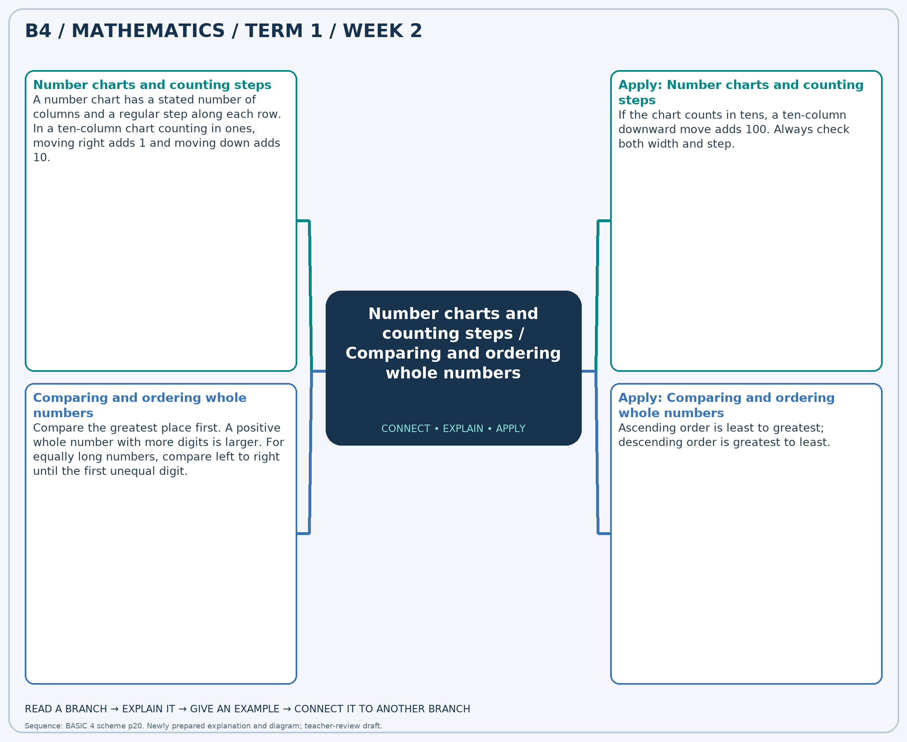
The separate high-resolution PNG can be projected or printed larger. Explain each branch and connect it with an example.

Week 2 — Practice

Section A — Multiple-choice questions
Choose ONE correct answer for each question. Each question has four alternatives.
1. A 5-column chart increases by 10 along each row. 7,646 is an interior entry. What number is immediately above it?
A. 7546 B. 7646 C. 7696 D. 7596
2. Which is the greatest number: 6,650, 7,116, 6,817, 6,763?
A. 6650 B. 6817 C. 6763 D. 7116
3. A 10-column chart increases by 10 along each row. 7,729 is an interior entry. What number is immediately above it?
A. 7529 B. 7829 C. 7729 D. 7629
4. Which is the least number: 4,295, 4,473, 4,845, 4,424?
A. 4845 B. 4473 C. 4424 D. 4295
5. A 5-column chart increases by 10 along each row. 2,198 is an interior entry. What number is immediately above it?
A. 2198 B. 2148 C. 2248 D. 2098
6. Which is the greatest number: 5,946, 5,745, 5,348, 5,311?
A. 5946 B. 5745 C. 5348 D. 5311
7. A 10-column chart increases by 1 along each row. 7,679 is an interior entry. What number is immediately left it?
A. 7679 B. 7677 C. 7678 D. 7680
8. Which is the greatest number: 2,305, 1,771, 2,027, 2,089?
A. 2305 B. 2027 C. 2089 D. 1771
9. A 5-column chart increases by 50 along each row. 6,294 is an interior entry. What number is immediately below it?
A. 6544 B. 6294 C. 6794 D. 6044
10. Which is the least number: 3,586, 3,332, 3,595, 3,434?
A. 3595 B. 3586 C. 3332 D. 3434
11. A 5-column chart increases by 10 along each row. 7,214 is an interior entry. What number is immediately left it?
A. 7214 B. 7194 C. 7224 D. 7204
12. Which is the greatest number: 5,128, 4,831, 5,092, 4,436?
A. 5128 B. 5092 C. 4436 D. 4831
13. A 5-column chart increases by 1 along each row. 6,908 is an interior entry. What number is immediately left it?
A. 6908 B. 6907 C. 6906 D. 6909
14. Which is the greatest number: 7,630, 7,691, 7,748, 7,237?
A. 7691 B. 7748 C. 7630 D. 7237
15. A 10-column chart increases by 1 along each row. 3,261 is an interior entry. What number is immediately left it?
A. 3260 B. 3259 C. 3262 D. 3261
16. Which is the least number: 2,844, 3,603, 3,384, 2,946?
A. 3384 B. 3603 C. 2844 D. 2946
17. A 10-column chart increases by 50 along each row. 4,928 is an interior entry. What number is immediately below it?
A. 5928 B. 5428 C. 4428 D. 4928
18. Which is the greatest number: 4,309, 4,382, 4,357, 4,073?
A. 4357 B. 4073 C. 4309 D. 4382
19. A 5-column chart increases by 1 along each row. 1,556 is an interior entry. What number is immediately above it?
A. 1561 B. 1546 C. 1551 D. 1556
20. Which is the greatest number: 3,547, 3,233, 3,650, 3,478?
A. 3547 B. 3233 C. 3478 D. 3650

Section B — Structured essay questions
Answer every part (a), (b), (c). Show your method or explain your choice. Write in a separate answer booklet. Each part: 1 mark for valid working/explanation and 1 for the correct result; 6 marks per question.

1. Apply the related skills and show working or give a reason for each answer.
(a) A 10-column chart increases by 10 along each row. 8,631 is an interior entry. What number is immediately right it?
(b) Which is the least number: 6,589, 7,195, 7,179, 6,912?
(c) A 10-column chart increases by 10 along each row. 7,529 is an interior entry. What number is immediately below it?

2. Apply the related skills and show working or give a reason for each answer.
(a) Which is the least number: 5,841, 5,780, 5,993, 5,752?
(b) A 10-column chart increases by 10 along each row. 2,138 is an interior entry. What number is immediately right it?
(c) Which is the greatest number: 7,168, 6,992, 7,137, 7,266?

3. Apply the related skills and show working or give a reason for each answer.
(a) A 10-column chart increases by 1 along each row. 3,191 is an interior entry. What number is immediately right it?
(b) Which is the greatest number: 7,077, 7,053, 6,896, 7,054?
(c) A 5-column chart increases by 1 along each row. 2,559 is an interior entry. What number is immediately right it?

4. Apply the related skills and show working or give a reason for each answer.
(a) Which is the greatest number: 7,891, 8,144, 8,566, 8,636?
(b) A 10-column chart increases by 1 along each row. 1,700 is an interior entry. What number is immediately right it?
(c) Which is the greatest number: 4,439, 4,286, 4,258, 5,152?

5. Apply the related skills and show working or give a reason for each answer.
(a) A 10-column chart increases by 50 along each row. 4,634 is an interior entry. What number is immediately above it?
(b) Which is the greatest number: 6,186, 6,046, 5,873, 6,567?
(c) A 5-column chart increases by 1 along each row. 7,097 is an interior entry. What number is immediately left it?

6. Apply the related skills and show working or give a reason for each answer.
(a) Which is the greatest number: 9,208, 8,635, 8,522, 8,595?
(b) A 10-column chart increases by 50 along each row. 5,578 is an interior entry. What number is immediately right it?
(c) Which is the least number: 6,023, 5,616, 5,596, 5,931?

7. Apply the related skills and show working or give a reason for each answer.
(a) A 10-column chart increases by 10 along each row. 7,181 is an interior entry. What number is immediately below it?
(b) Which is the least number: 2,153, 2,703, 2,020, 2,078?
(c) A 10-column chart increases by 50 along each row. 3,308 is an interior entry. What number is immediately left it?

8. Apply the related skills and show working or give a reason for each answer.
(a) Which is the least number: 5,547, 5,204, 5,684, 5,499?
(b) A 10-column chart increases by 10 along each row. 1,720 is an interior entry. What number is immediately below it?
(c) Which is the greatest number: 3,329, 3,069, 3,776, 3,219?

9. Apply the related skills and show working or give a reason for each answer.
(a) A 5-column chart increases by 50 along each row. 4,301 is an interior entry. What number is immediately below it?
(b) Which is the greatest number: 2,394, 1,702, 2,103, 2,324?
(c) A 10-column chart increases by 50 along each row. 1,494 is an interior entry. What number is immediately right it?

10. Apply the related skills and show working or give a reason for each answer.
(a) Which is the greatest number: 8,610, 8,692, 9,057, 8,359?
(b) A 10-column chart increases by 10 along each row. 7,552 is an interior entry. What number is immediately above it?
(c) Which is the greatest number: 5,091, 5,149, 5,177, 4,392?

Week 3 — Rounding whole numbers / Skip counting
Sequence source: BASIC 4 SCHEME OF LEARNING.pdf, first-term Mathematics, page 20. One consolidated weekly unit.

Learning outcomes
- Explain and apply rounding whole numbers, solve examples and justify the method.
- Explain and apply skip counting, solve examples and justify the method.

Teaching notes and suggested sessions
Suggested schedule: five 40-minute sessions, adjusted to the school timetable. Spread the question bank through the week; it is not intended to be completed in one lesson.

1 — Explore and diagnose
5 minutes: recall an earlier skill; 10: demonstrate a concrete or pictorial model; 15: pairs investigate and explain; 10: identify a misconception and set an exit task.

2 — Model and practise
5 minutes: review the exit task; 10: work an example aloud; 15: pairs solve parallel examples; 10: compare methods and correct errors.

3 — Connect representations
5 minutes: recall vocabulary; 10: explain the mind-map; 15: connect a model, a drawing and a symbolic calculation; 10: independent practice.

4 — Apply and explain
5 minutes: estimate or predict; 10: solve a contextual example; 15: attempt selected structured-question parts; 10: compare reasoning and check units.

5 — Check and respond
5 minutes: retrieve the main rule; 15: use selected MCQs diagnostically; 10: explain distractors and misconceptions; 10: reteach or extend in response to evidence.

Topic-specific activities
- Place numbers between neighbouring multiples of ten, a hundred or a thousand.
- Mark equal jumps on a number line and explain both forward and backward patterns.
Resources: board, pencils, number cards, counters, paper strips and squared paper as appropriate. Prior-knowledge check: ask a learner to explain a representation used in the first example before introducing a new rule.
Support: reduce number size without changing the concept; offer a partially completed chart or model; allow oral reasoning before writing. Extension: create a counterexample to a false rule and explain why it fails.

Study notes and worked examples

Rounding whole numbers
- Name the place to which the number is being rounded.
- Inspect the digit immediately to its right: 0–4 keep the target digit; 5–9 increase it by one for nearest rounding.
- Replace lower whole-number places with zeros. Check between neighbouring multiples on a number line.
- Rounding to the nearest value is different from always rounding upward or downward.
Worked example: Round 3,181 to the nearest 10.
Solution: Neighbouring multiples: 3,180 and 3,190. Nearest (halfway values rounded upward): 3,180.
Common misconception: Do not remove place-holding zeros from a rounded whole number.

Skip counting
- Skip counting adds or subtracts a fixed step repeatedly.
- Find the difference between neighbouring terms before extending a sequence.
- Check a missing middle term against the numbers on both sides.
- Crossing a hundred or thousand boundary does not change the counting step.
Worked example: Find the next term: 2,150, 2,100, 2,050, …
Solution: The constant step is -50; next term = 2,000.
Common misconception: Keep the interval constant rather than copying a pattern in only the last digit.
Independent study: read the map, cover it and reconstruct the branches. Solve an unused question from each skill and explain the reasoning to a partner. Consult the teacher key only after an honest attempt.

Week 3 — Visual mind-map
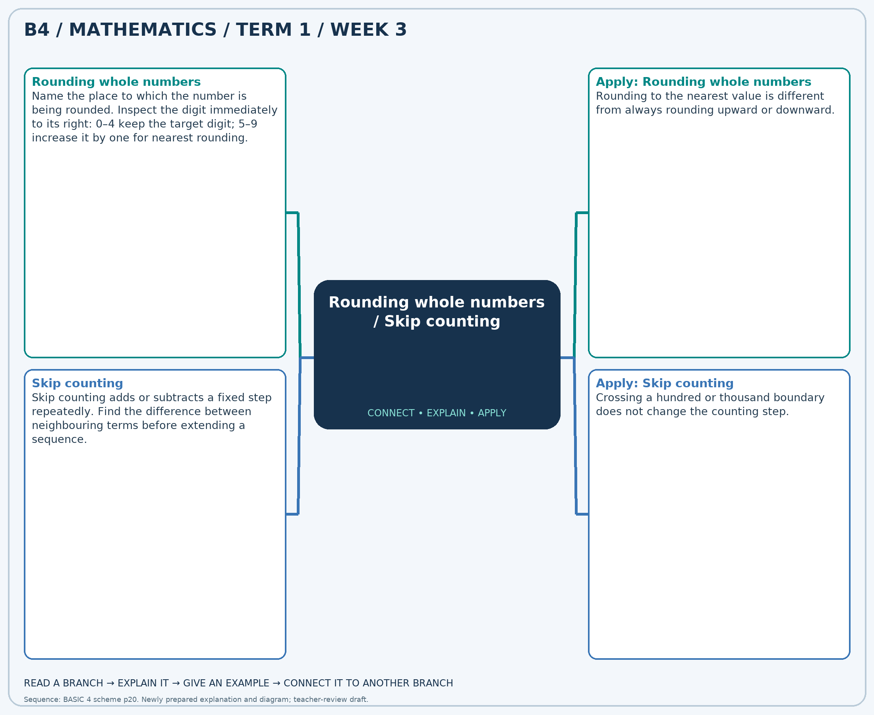
The separate high-resolution PNG can be projected or printed larger. Explain each branch and connect it with an example.

Week 3 — Practice

Section A — Multiple-choice questions
Choose ONE correct answer for each question. Each question has four alternatives.
1. Round 5,624 to the nearest 10.
A. 5640 B. 5610 C. 5620 D. 5630
2. Find the next term: 1,300, 1,400, 1,500, …
A. 1500 B. 1700 C. 1600 D. 1800
3. Round 5,994 to the nearest 1,000.
A. 6000 B. 8000 C. 5000 D. 7000
4. Find the next term: 3,400, 3,500, 3,600, …
A. 3800 B. 3600 C. 3700 D. 3900
5. Round 3,653 to the nearest 10.
A. 3640 B. 3670 C. 3660 D. 3650
6. Find the next term: 1,000, 900, 800, …
A. 600 B. 500 C. 700 D. 800
7. Round 7,280 to the nearest 10.
A. 7290 B. 7300 C. 7270 D. 7280
8. Find the next term: 1,850, 1,900, 1,950, …
A. 1950 B. 2050 C. 2100 D. 2000
9. Round 5,073 to the nearest 1,000.
A. 6000 B. 5000 C. 4000 D. 7000
10. Find the next term: 1,400, 1,300, 1,200, …
A. 1200 B. 1100 C. 1000 D. 900
11. Round 9,841 to the nearest 10.
A. 9850 B. 9830 C. 9840 D. 9860
12. Find the next term: 4,600, 4,700, 4,800, …
A. 5000 B. 5100 C. 4900 D. 4800
13. Round 9,165 to the nearest 1,000.
A. 8000 B. 10000 C. 11000 D. 9000
14. Find the next term: 2,200, 2,300, 2,400, …
A. 2500 B. 2600 C. 2700 D. 2400
15. Round 1,104 to the nearest 1,000.
A. 2000 B. 3000 C. 1000 D. 0
16. Find the next term: 2,500, 2,600, 2,700, …
A. 2800 B. 2700 C. 2900 D. 3000
17. Round 5,690 to the nearest 100.
A. 5700 B. 5600 C. 5900 D. 5800
18. Find the next term: 950, 900, 850, …
A. 850 B. 700 C. 750 D. 800
19. Round 8,741 to the nearest 1,000.
A. 11000 B. 10000 C. 9000 D. 8000
20. Find the next term: 1,250, 1,200, 1,150, …
A. 1150 B. 1050 C. 1100 D. 1000

Section B — Structured essay questions
Answer every part (a), (b), (c). Show your method or explain your choice. Write in a separate answer booklet. Each part: 1 mark for valid working/explanation and 1 for the correct result; 6 marks per question.

1. Apply the related skills and show working or give a reason for each answer.
(a) Round 9,982 to the nearest 100.
(b) Find the next term: 1,850, 1,900, 1,950, …
(c) Round 3,926 to the nearest 10.

2. Apply the related skills and show working or give a reason for each answer.
(a) Find the next term: 5,000, 5,100, 5,200, …
(b) Round 3,026 to the nearest 100.
(c) Find the next term: 3,600, 3,500, 3,400, …

3. Apply the related skills and show working or give a reason for each answer.
(a) Round 8,250 to the nearest 100.
(b) Find the next term: 1,850, 1,900, 1,950, …
(c) Round 7,058 to the nearest 10.

4. Apply the related skills and show working or give a reason for each answer.
(a) Find the next term: 1,400, 1,450, 1,500, …
(b) Round 3,722 to the nearest 10.
(c) Find the next term: 1,800, 1,750, 1,700, …

5. Apply the related skills and show working or give a reason for each answer.
(a) Round 5,539 to the nearest 100.
(b) Find the next term: 1,500, 1,600, 1,700, …
(c) Round 6,592 to the nearest 10.

6. Apply the related skills and show working or give a reason for each answer.
(a) Find the next term: 4,600, 4,500, 4,400, …
(b) Round 3,446 to the nearest 10.
(c) Find the next term: 2,150, 2,100, 2,050, …

7. Apply the related skills and show working or give a reason for each answer.
(a) Round 3,800 to the nearest 100.
(b) Find the next term: 1,550, 1,600, 1,650, …
(c) Round 8,424 to the nearest 100.

8. Apply the related skills and show working or give a reason for each answer.
(a) Find the next term: 4,800, 4,700, 4,600, …
(b) Round 4,064 to the nearest 100.
(c) Find the next term: 3,100, 3,200, 3,300, …

9. Apply the related skills and show working or give a reason for each answer.
(a) Round 1,365 to the nearest 1,000.
(b) Find the next term: 900, 850, 800, …
(c) Round 4,659 to the nearest 100.

10. Apply the related skills and show working or give a reason for each answer.
(a) Find the next term: 3,200, 3,300, 3,400, …
(b) Round 4,972 to the nearest 100.
(c) Find the next term: 2,200, 2,250, 2,300, …

Week 4 — Roman numerals
Sequence source: BASIC 4 SCHEME OF LEARNING.pdf, first-term Mathematics, page 20. One consolidated weekly unit.

Learning outcomes
- Explain and apply roman numerals, solve examples and justify the method.

Teaching notes and suggested sessions
Suggested schedule: five 40-minute sessions, adjusted to the school timetable. Spread the question bank through the week; it is not intended to be completed in one lesson.

1 — Explore and diagnose
5 minutes: recall an earlier skill; 10: demonstrate a concrete or pictorial model; 15: pairs investigate and explain; 10: identify a misconception and set an exit task.

2 — Model and practise
5 minutes: review the exit task; 10: work an example aloud; 15: pairs solve parallel examples; 10: compare methods and correct errors.

3 — Connect representations
5 minutes: recall vocabulary; 10: explain the mind-map; 15: connect a model, a drawing and a symbolic calculation; 10: independent practice.

4 — Apply and explain
5 minutes: estimate or predict; 10: solve a contextual example; 15: attempt selected structured-question parts; 10: compare reasoning and check units.

5 — Check and respond
5 minutes: retrieve the main rule; 15: use selected MCQs diagnostically; 10: explain distractors and misconceptions; 10: reteach or extend in response to evidence.

Topic-specific activities
- Use letter cards to build numbers and convert them back to ordinary figures.
Resources: board, pencils, number cards, counters, paper strips and squared paper as appropriate. Prior-knowledge check: ask a learner to explain a representation used in the first example before introducing a new rule.
Support: reduce number size without changing the concept; offer a partially completed chart or model; allow oral reasoning before writing. Extension: create a counterexample to a false rule and explain why it fails.

Study notes and worked examples

Roman numerals
- I=1, V=5, X=10, L=50 and C=100.
- Usually values are added from left to right. Permitted subtractive pairs include IV=4, IX=9, XL=40 and XC=90.
- Write the largest values first, using standard forms: XXIV is 24.
- Roman numerals do not use a place-value zero.
Worked example: Write 10 using standard Roman numerals.
Solution: 10 = X using I=1, V=5, X=10, L=50, C=100 and permitted subtractive pairs.
Common misconception: Use IX, not VIIII, for 9; use XL, not XXXX, for 40.
Independent study: read the map, cover it and reconstruct the branches. Solve an unused question from each skill and explain the reasoning to a partner. Consult the teacher key only after an honest attempt.

Week 4 — Visual mind-map
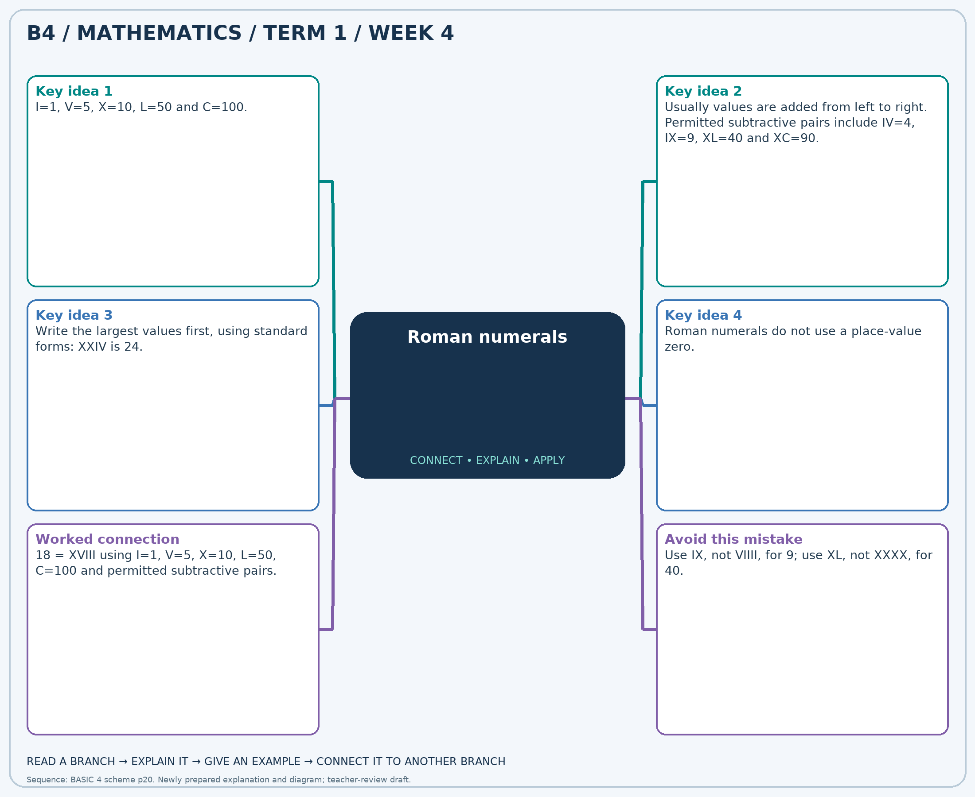
The separate high-resolution PNG can be projected or printed larger. Explain each branch and connect it with an example.

Week 4 — Practice

Section A — Multiple-choice questions
Choose ONE correct answer for each question. Each question has four alternatives.
1. Write 11 using standard Roman numerals.
A. XIII B. XII C. XI D. X
2. Write XXIV in ordinary figures.
A. 26 B. 23 C. 24 D. 25
3. Write 30 using standard Roman numerals.
A. XXXII B. XXX C. XXIX D. XXXI
4. Write 25 using standard Roman numerals.
A. XXVII B. XXVI C. XXV D. XXIV
5. Write XVI in ordinary figures.
A. 16 B. 18 C. 17 D. 15
6. Write 29 using standard Roman numerals.
A. XXX B. XXXI C. XXIX D. XXVIII
7. Write IV in ordinary figures.
A. 3 B. 6 C. 5 D. 4
8. Write 16 using standard Roman numerals.
A. XV B. XVII C. XVI D. XVIII
9. Write 27 using standard Roman numerals.
A. XXVI B. XXIX C. XXVIII D. XXVII
10. Write VIII in ordinary figures.
A. 8 B. 7 C. 10 D. 9
11. Write 14 using standard Roman numerals.
A. XIV B. XV C. XIII D. XVI
12. Write V in ordinary figures.
A. 7 B. 5 C. 6 D. 4
13. Write 23 using standard Roman numerals.
A. XXV B. XXII C. XXIII D. XXIV
14. Write 8 using standard Roman numerals.
A. IX B. X C. VIII D. VII
15. Write III in ordinary figures.
A. 5 B. 4 C. 3 D. 2
16. Write 9 using standard Roman numerals.
A. IX B. X C. VIII D. XI
17. Write 24 using standard Roman numerals.
A. XXIV B. XXIII C. XXVI D. XXV
18. Write XXV in ordinary figures.
A. 26 B. 24 C. 25 D. 27
19. Write 6 using standard Roman numerals.
A. V B. VIII C. VI D. VII
20. Write 26 using standard Roman numerals.
A. XXVI B. XXV C. XXVIII D. XXVII

Section B — Structured essay questions
Answer every part (a), (b), (c). Show your method or explain your choice. Write in a separate answer booklet. Each part: 1 mark for valid working/explanation and 1 for the correct result; 6 marks per question.

1. Apply the related skills and show working or give a reason for each answer.
(a) Write 18 using standard Roman numerals.
(b) Write XII in ordinary figures.
(c) Write 24 using standard Roman numerals.

2. Apply the related skills and show working or give a reason for each answer.
(a) Write IX in ordinary figures.
(b) Write 28 using standard Roman numerals.
(c) Write 12 using standard Roman numerals.

3. Apply the related skills and show working or give a reason for each answer.
(a) Write 27 using standard Roman numerals.
(b) Write 22 using standard Roman numerals.
(c) Write VII in ordinary figures.

4. Apply the related skills and show working or give a reason for each answer.
(a) Write 22 using standard Roman numerals.
(b) Write XVII in ordinary figures.
(c) Write 13 using standard Roman numerals.

5. Apply the related skills and show working or give a reason for each answer.
(a) Write XIX in ordinary figures.
(b) Write 9 using standard Roman numerals.
(c) Write 2 using standard Roman numerals.

6. Apply the related skills and show working or give a reason for each answer.
(a) Write 11 using standard Roman numerals.
(b) Write 4 using standard Roman numerals.
(c) Write VIII in ordinary figures.

7. Apply the related skills and show working or give a reason for each answer.
(a) Write 21 using standard Roman numerals.
(b) Write XII in ordinary figures.
(c) Write 19 using standard Roman numerals.

8. Apply the related skills and show working or give a reason for each answer.
(a) Write XIII in ordinary figures.
(b) Write 25 using standard Roman numerals.
(c) Write 23 using standard Roman numerals.

9. Apply the related skills and show working or give a reason for each answer.
(a) Write 17 using standard Roman numerals.
(b) Write 13 using standard Roman numerals.
(c) Write XXIV in ordinary figures.

10. Apply the related skills and show working or give a reason for each answer.
(a) Write 24 using standard Roman numerals.
(b) Write XXII in ordinary figures.
(c) Write 20 using standard Roman numerals.

Week 5 — Factors, primes and even numbers / Highest common factor
Sequence source: BASIC 4 SCHEME OF LEARNING.pdf, first-term Mathematics, page 20. One consolidated weekly unit.

Learning outcomes
- Explain and apply factors, primes and even numbers, solve examples and justify the method.
- Explain and apply highest common factor, solve examples and justify the method.

Teaching notes and suggested sessions
Suggested schedule: five 40-minute sessions, adjusted to the school timetable. Spread the question bank through the week; it is not intended to be completed in one lesson.

1 — Explore and diagnose
5 minutes: recall an earlier skill; 10: demonstrate a concrete or pictorial model; 15: pairs investigate and explain; 10: identify a misconception and set an exit task.

2 — Model and practise
5 minutes: review the exit task; 10: work an example aloud; 15: pairs solve parallel examples; 10: compare methods and correct errors.

3 — Connect representations
5 minutes: recall vocabulary; 10: explain the mind-map; 15: connect a model, a drawing and a symbolic calculation; 10: independent practice.

4 — Apply and explain
5 minutes: estimate or predict; 10: solve a contextual example; 15: attempt selected structured-question parts; 10: compare reasoning and check units.

5 — Check and respond
5 minutes: retrieve the main rule; 15: use selected MCQs diagnostically; 10: explain distractors and misconceptions; 10: reteach or extend in response to evidence.

Topic-specific activities
- Arrange counters into rectangles and record every factor pair.
- Make identical packs from two colours of counters and identify the largest possible number of packs.
Resources: board, pencils, number cards, counters, paper strips and squared paper as appropriate. Prior-knowledge check: ask a learner to explain a representation used in the first example before introducing a new rule.
Support: reduce number size without changing the concept; offer a partially completed chart or model; allow oral reasoning before writing. Extension: create a counterexample to a false rule and explain why it fails.

Study notes and worked examples

Factors, primes and even numbers
- A factor divides a positive whole number exactly, with no remainder.
- Find factor pairs systematically: 18 has pairs 1×18, 2×9 and 3×6.
- A prime number has exactly two positive factors. A composite has more than two; 1 is neither.
- An even number is divisible by 2. The only even prime is 2.
Worked example: How many positive factors does 38 have?
Solution: Factors: 1, 2, 19, 38. Count = 4.
Common misconception: Do not confuse a factor with a multiple. A positive factor cannot exceed the number.

Highest common factor
- List the factors of the given numbers or use their prime factors.
- Common factors occur in every list. The HCF is the greatest positive common factor.
- With prime factors, use shared primes with their smallest powers.
- The HCF can determine the largest equal grouping that leaves nothing over.
Worked example: Find the HCF of 8 and 24.
Solution: Common factors: 1, 2, 4, 8. Greatest = 8.
Common misconception: Do not choose the lowest common multiple when the question asks for a factor.
Independent study: read the map, cover it and reconstruct the branches. Solve an unused question from each skill and explain the reasoning to a partner. Consult the teacher key only after an honest attempt.

Week 5 — Visual mind-map
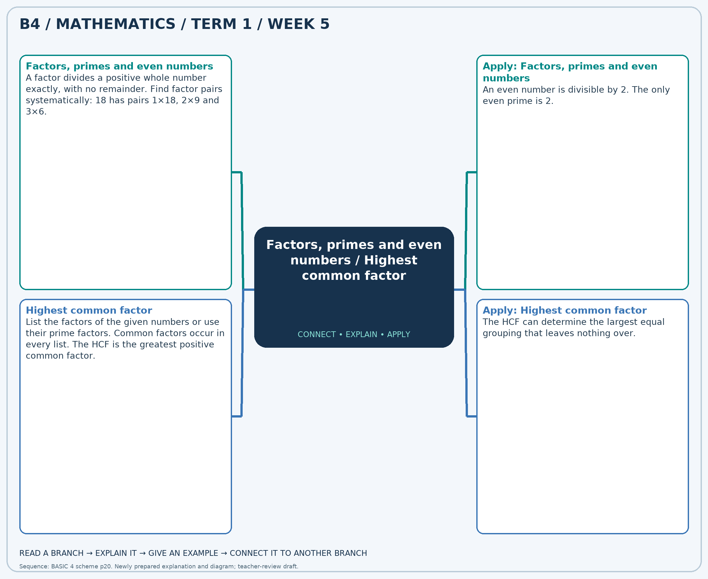
The separate high-resolution PNG can be projected or printed larger. Explain each branch and connect it with an example.

Week 5 — Practice

Section A — Multiple-choice questions
Choose ONE correct answer for each question. Each question has four alternatives.
1. How many positive factors does 44 have?
A. 7 B. 8 C. 6 D. 5
2. Find the HCF of 18 and 6.
A. 6 B. 7 C. 8 D. 5
3. Which number is prime: 22, 24, 47, 57?
A. 22 B. 57 C. 47 D. 24
4. Find the HCF of 8 and 24.
A. 7 B. 10 C. 8 D. 9
5. Which number is even: 2, 31, 43, 49?
A. 31 B. 49 C. 2 D. 43
6. Find the HCF of 30 and 24.
A. 6 B. 8 C. 5 D. 7
7. How many positive factors does 23 have?
A. 4 B. 1 C. 2 D. 3
8. Find the HCF of 18 and 15.
A. 4 B. 3 C. 5 D. 2
9. Which number is prime: 22, 37, 38, 52?
A. 38 B. 37 C. 52 D. 22
10. Find the HCF of 4 and 4.
A. 3 B. 5 C. 6 D. 4
11. Which number is even: 23, 53, 60, 89?
A. 89 B. 53 C. 60 D. 23
12. Find the HCF of 24 and 24.
A. 23 B. 25 C. 24 D. 26
13. How many positive factors does 14 have?
A. 3 B. 5 C. 4 D. 6
14. Find the HCF of 25 and 10.
A. 5 B. 7 C. 6 D. 4
15. Which number is prime: 5, 48, 54, 68?
A. 68 B. 48 C. 54 D. 5
16. Find the HCF of 16 and 24.
A. 8 B. 10 C. 7 D. 9
17. Which number is even: 37, 41, 50, 91?
A. 41 B. 91 C. 50 D. 37
18. Find the HCF of 9 and 6.
A. 4 B. 3 C. 5 D. 2
19. Which number is prime: 37, 45, 84, 94?
A. 84 B. 94 C. 45 D. 37
20. Find the HCF of 30 and 25.
A. 4 B. 6 C. 7 D. 5

Section B — Structured essay questions
Answer every part (a), (b), (c). Show your method or explain your choice. Write in a separate answer booklet. Each part: 1 mark for valid working/explanation and 1 for the correct result; 6 marks per question.

1. Apply the related skills and show working or give a reason for each answer.
(a) How many positive factors does 36 have?
(b) Find the HCF of 20 and 30.
(c) Which number is even: 25, 40, 61, 69?

2. Apply the related skills and show working or give a reason for each answer.
(a) Find the HCF of 30 and 25.
(b) Which number is even: 17, 21, 53, 76?
(c) Find the HCF of 4 and 8.

3. Apply the related skills and show working or give a reason for each answer.
(a) Which number is even: 11, 29, 65, 86?
(b) Find the HCF of 9 and 6.
(c) Which number is prime: 19, 36, 69, 95?

4. Apply the related skills and show working or give a reason for each answer.
(a) Find the HCF of 8 and 10.
(b) Which number is prime: 36, 57, 69, 71?
(c) Find the HCF of 6 and 6.

5. Apply the related skills and show working or give a reason for each answer.
(a) Which number is prime: 12, 25, 56, 79?
(b) Find the HCF of 12 and 8.
(c) How many positive factors does 42 have?

6. Apply the related skills and show working or give a reason for each answer.
(a) Find the HCF of 36 and 12.
(b) How many positive factors does 44 have?
(c) Find the HCF of 10 and 15.

7. Apply the related skills and show working or give a reason for each answer.
(a) How many positive factors does 34 have?
(b) Find the HCF of 10 and 25.
(c) Which number is even: 41, 69, 72, 91?

8. Apply the related skills and show working or give a reason for each answer.
(a) Find the HCF of 15 and 10.
(b) Which number is even: 17, 23, 36, 71?
(c) Find the HCF of 10 and 10.

9. Apply the related skills and show working or give a reason for each answer.
(a) Which number is even: 2, 51, 71, 87?
(b) Find the HCF of 8 and 10.
(c) Which number is prime: 13, 26, 58, 78?

10. Apply the related skills and show working or give a reason for each answer.
(a) Find the HCF of 12 and 16.
(b) Which number is prime: 12, 14, 79, 84?
(c) Find the HCF of 12 and 24.

Week 6 — Lowest common multiple / Factors, primes and even numbers
Sequence source: BASIC 4 SCHEME OF LEARNING.pdf, first-term Mathematics, page 20. One consolidated weekly unit.

Learning outcomes
- Explain and apply lowest common multiple, solve examples and justify the method.
- Explain and apply factors, primes and even numbers, solve examples and justify the method.

Teaching notes and suggested sessions
Suggested schedule: five 40-minute sessions, adjusted to the school timetable. Spread the question bank through the week; it is not intended to be completed in one lesson.

1 — Explore and diagnose
5 minutes: recall an earlier skill; 10: demonstrate a concrete or pictorial model; 15: pairs investigate and explain; 10: identify a misconception and set an exit task.

2 — Model and practise
5 minutes: review the exit task; 10: work an example aloud; 15: pairs solve parallel examples; 10: compare methods and correct errors.

3 — Connect representations
5 minutes: recall vocabulary; 10: explain the mind-map; 15: connect a model, a drawing and a symbolic calculation; 10: independent practice.

4 — Apply and explain
5 minutes: estimate or predict; 10: solve a contextual example; 15: attempt selected structured-question parts; 10: compare reasoning and check units.

5 — Check and respond
5 minutes: retrieve the main rule; 15: use selected MCQs diagnostically; 10: explain distractors and misconceptions; 10: reteach or extend in response to evidence.

Topic-specific activities
- Draw two jump sequences on one number line and find their first shared positive landing point.
- Arrange counters into rectangles and record every factor pair.
Resources: board, pencils, number cards, counters, paper strips and squared paper as appropriate. Prior-knowledge check: ask a learner to explain a representation used in the first example before introducing a new rule.
Support: reduce number size without changing the concept; offer a partially completed chart or model; allow oral reasoning before writing. Extension: create a counterexample to a false rule and explain why it fails.

Study notes and worked examples

Lowest common multiple
- Multiples of a number are obtained by multiplying it by whole numbers.
- List positive multiples of the given numbers; the first shared one is their LCM.
- The LCM is useful for repeated events and common fraction denominators.
- Zero is a common multiple but is not used as the least positive common multiple in these questions.
Worked example: Find the LCM of 30 and 36.
Solution: HCF=6. LCM=(30×36)÷6=180.
Common misconception: The HCF divides both numbers; the LCM is divisible by both numbers.

Factors, primes and even numbers
- A factor divides a positive whole number exactly, with no remainder.
- Find factor pairs systematically: 18 has pairs 1×18, 2×9 and 3×6.
- A prime number has exactly two positive factors. A composite has more than two; 1 is neither.
- An even number is divisible by 2. The only even prime is 2.
Worked example: Which number is prime: 16, 39, 48, 97?
Solution: 97 has exactly two positive factors: 1 and 97.
Common misconception: Do not confuse a factor with a multiple. A positive factor cannot exceed the number.
Independent study: read the map, cover it and reconstruct the branches. Solve an unused question from each skill and explain the reasoning to a partner. Consult the teacher key only after an honest attempt.

Week 6 — Visual mind-map
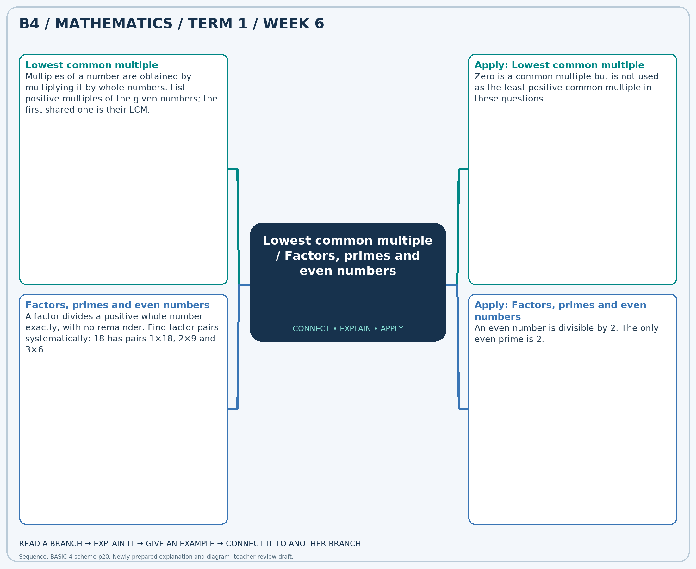
The separate high-resolution PNG can be projected or printed larger. Explain each branch and connect it with an example.

Week 6 — Practice

Section A — Multiple-choice questions
Choose ONE correct answer for each question. Each question has four alternatives.
1. Find the LCM of 12 and 18.
A. 37 B. 35 C. 38 D. 36
2. How many positive factors does 49 have?
A. 4 B. 5 C. 2 D. 3
3. Find the LCM of 6 and 10.
A. 30 B. 29 C. 32 D. 31
4. Which number is prime: 15, 60, 72, 97?
A. 97 B. 72 C. 15 D. 60
5. Find the LCM of 9 and 12.
A. 35 B. 36 C. 38 D. 37
6. Which number is even: 15, 79, 80, 93?
A. 93 B. 80 C. 79 D. 15
7. Find the LCM of 30 and 30.
A. 29 B. 30 C. 32 D. 31
8. How many positive factors does 41 have?
A. 1 B. 2 C. 4 D. 3
9. Find the LCM of 12 and 24.
A. 26 B. 24 C. 23 D. 25
10. Which number is prime: 9, 26, 59, 76?
A. 26 B. 9 C. 76 D. 59
11. Find the LCM of 12 and 12.
A. 11 B. 12 C. 13 D. 14
12. Which number is even: 42, 57, 65, 71?
A. 65 B. 71 C. 57 D. 42
13. Find the LCM of 18 and 9.
A. 17 B. 19 C. 20 D. 18
14. How many positive factors does 31 have?
A. 3 B. 2 C. 1 D. 4
15. Find the LCM of 16 and 16.
A. 18 B. 17 C. 16 D. 15
16. Which number is prime: 73, 76, 77, 84?
A. 73 B. 84 C. 77 D. 76
17. Find the LCM of 24 and 30.
A. 120 B. 121 C. 122 D. 119
18. Which number is even: 41, 73, 75, 76?
A. 75 B. 76 C. 73 D. 41
19. Find the LCM of 20 and 12.
A. 61 B. 60 C. 59 D. 62
20. How many positive factors does 36 have?
A. 10 B. 8 C. 11 D. 9

Section B — Structured essay questions
Answer every part (a), (b), (c). Show your method or explain your choice. Write in a separate answer booklet. Each part: 1 mark for valid working/explanation and 1 for the correct result; 6 marks per question.

1. Apply the related skills and show working or give a reason for each answer.
(a) Find the LCM of 36 and 12.
(b) Which number is prime: 56, 59, 80, 99?
(c) Find the LCM of 12 and 18.

2. Apply the related skills and show working or give a reason for each answer.
(a) Which number is prime: 14, 53, 68, 87?
(b) Find the LCM of 15 and 9.
(c) How many positive factors does 30 have?

3. Apply the related skills and show working or give a reason for each answer.
(a) Find the LCM of 12 and 8.
(b) How many positive factors does 32 have?
(c) Find the LCM of 12 and 24.

4. Apply the related skills and show working or give a reason for each answer.
(a) How many positive factors does 44 have?
(b) Find the LCM of 6 and 12.
(c) Which number is even: 7, 24, 49, 69?

5. Apply the related skills and show working or give a reason for each answer.
(a) Find the LCM of 25 and 10.
(b) Which number is even: 8, 55, 75, 99?
(c) Find the LCM of 12 and 20.

6. Apply the related skills and show working or give a reason for each answer.
(a) Which number is even: 3, 14, 65, 99?
(b) Find the LCM of 24 and 18.
(c) Which number is prime: 15, 19, 40, 88?

7. Apply the related skills and show working or give a reason for each answer.
(a) Find the LCM of 8 and 12.
(b) Which number is prime: 16, 29, 62, 92?
(c) Find the LCM of 25 and 25.

8. Apply the related skills and show working or give a reason for each answer.
(a) Which number is prime: 2, 8, 44, 93?
(b) Find the LCM of 10 and 12.
(c) How many positive factors does 25 have?

9. Apply the related skills and show working or give a reason for each answer.
(a) Find the LCM of 24 and 8.
(b) How many positive factors does 21 have?
(c) Find the LCM of 36 and 18.

10. Apply the related skills and show working or give a reason for each answer.
(a) How many positive factors does 12 have?
(b) Find the LCM of 8 and 12.
(c) Which number is even: 39, 63, 86, 91?

Week 7 — Multiplication facts and related division
Sequence source: BASIC 4 SCHEME OF LEARNING.pdf, first-term Mathematics, page 20. One consolidated weekly unit.

Learning outcomes
- Explain and apply multiplication facts and related division, solve examples and justify the method.

Teaching notes and suggested sessions
Suggested schedule: five 40-minute sessions, adjusted to the school timetable. Spread the question bank through the week; it is not intended to be completed in one lesson.

1 — Explore and diagnose
5 minutes: recall an earlier skill; 10: demonstrate a concrete or pictorial model; 15: pairs investigate and explain; 10: identify a misconception and set an exit task.

2 — Model and practise
5 minutes: review the exit task; 10: work an example aloud; 15: pairs solve parallel examples; 10: compare methods and correct errors.

3 — Connect representations
5 minutes: recall vocabulary; 10: explain the mind-map; 15: connect a model, a drawing and a symbolic calculation; 10: independent practice.

4 — Apply and explain
5 minutes: estimate or predict; 10: solve a contextual example; 15: attempt selected structured-question parts; 10: compare reasoning and check units.

5 — Check and respond
5 minutes: retrieve the main rule; 15: use selected MCQs diagnostically; 10: explain distractors and misconceptions; 10: reteach or extend in response to evidence.

Topic-specific activities
- Build arrays with counters and write two multiplication and two division statements.
Resources: board, pencils, number cards, counters, paper strips and squared paper as appropriate. Prior-knowledge check: ask a learner to explain a representation used in the first example before introducing a new rule.
Support: reduce number size without changing the concept; offer a partially completed chart or model; allow oral reasoning before writing. Extension: create a counterexample to a false rule and explain why it fails.

Study notes and worked examples

Multiplication facts and related division
- Multiplication describes equal groups: 7×8 is seven groups of eight.
- The commutative property gives 8×7=56 from 7×8=56.
- Related division facts are 56÷7=8 and 56÷8=7.
- Use arrays, doubling and known facts to derive an unfamiliar fact.
Worked example: Calculate 3 × 4.
Solution: 3 equal groups of 4 contain 12. Check: 12÷3=4.
Common misconception: Seven groups of eight is not 7+8.
Independent study: read the map, cover it and reconstruct the branches. Solve an unused question from each skill and explain the reasoning to a partner. Consult the teacher key only after an honest attempt.

Week 7 — Visual mind-map
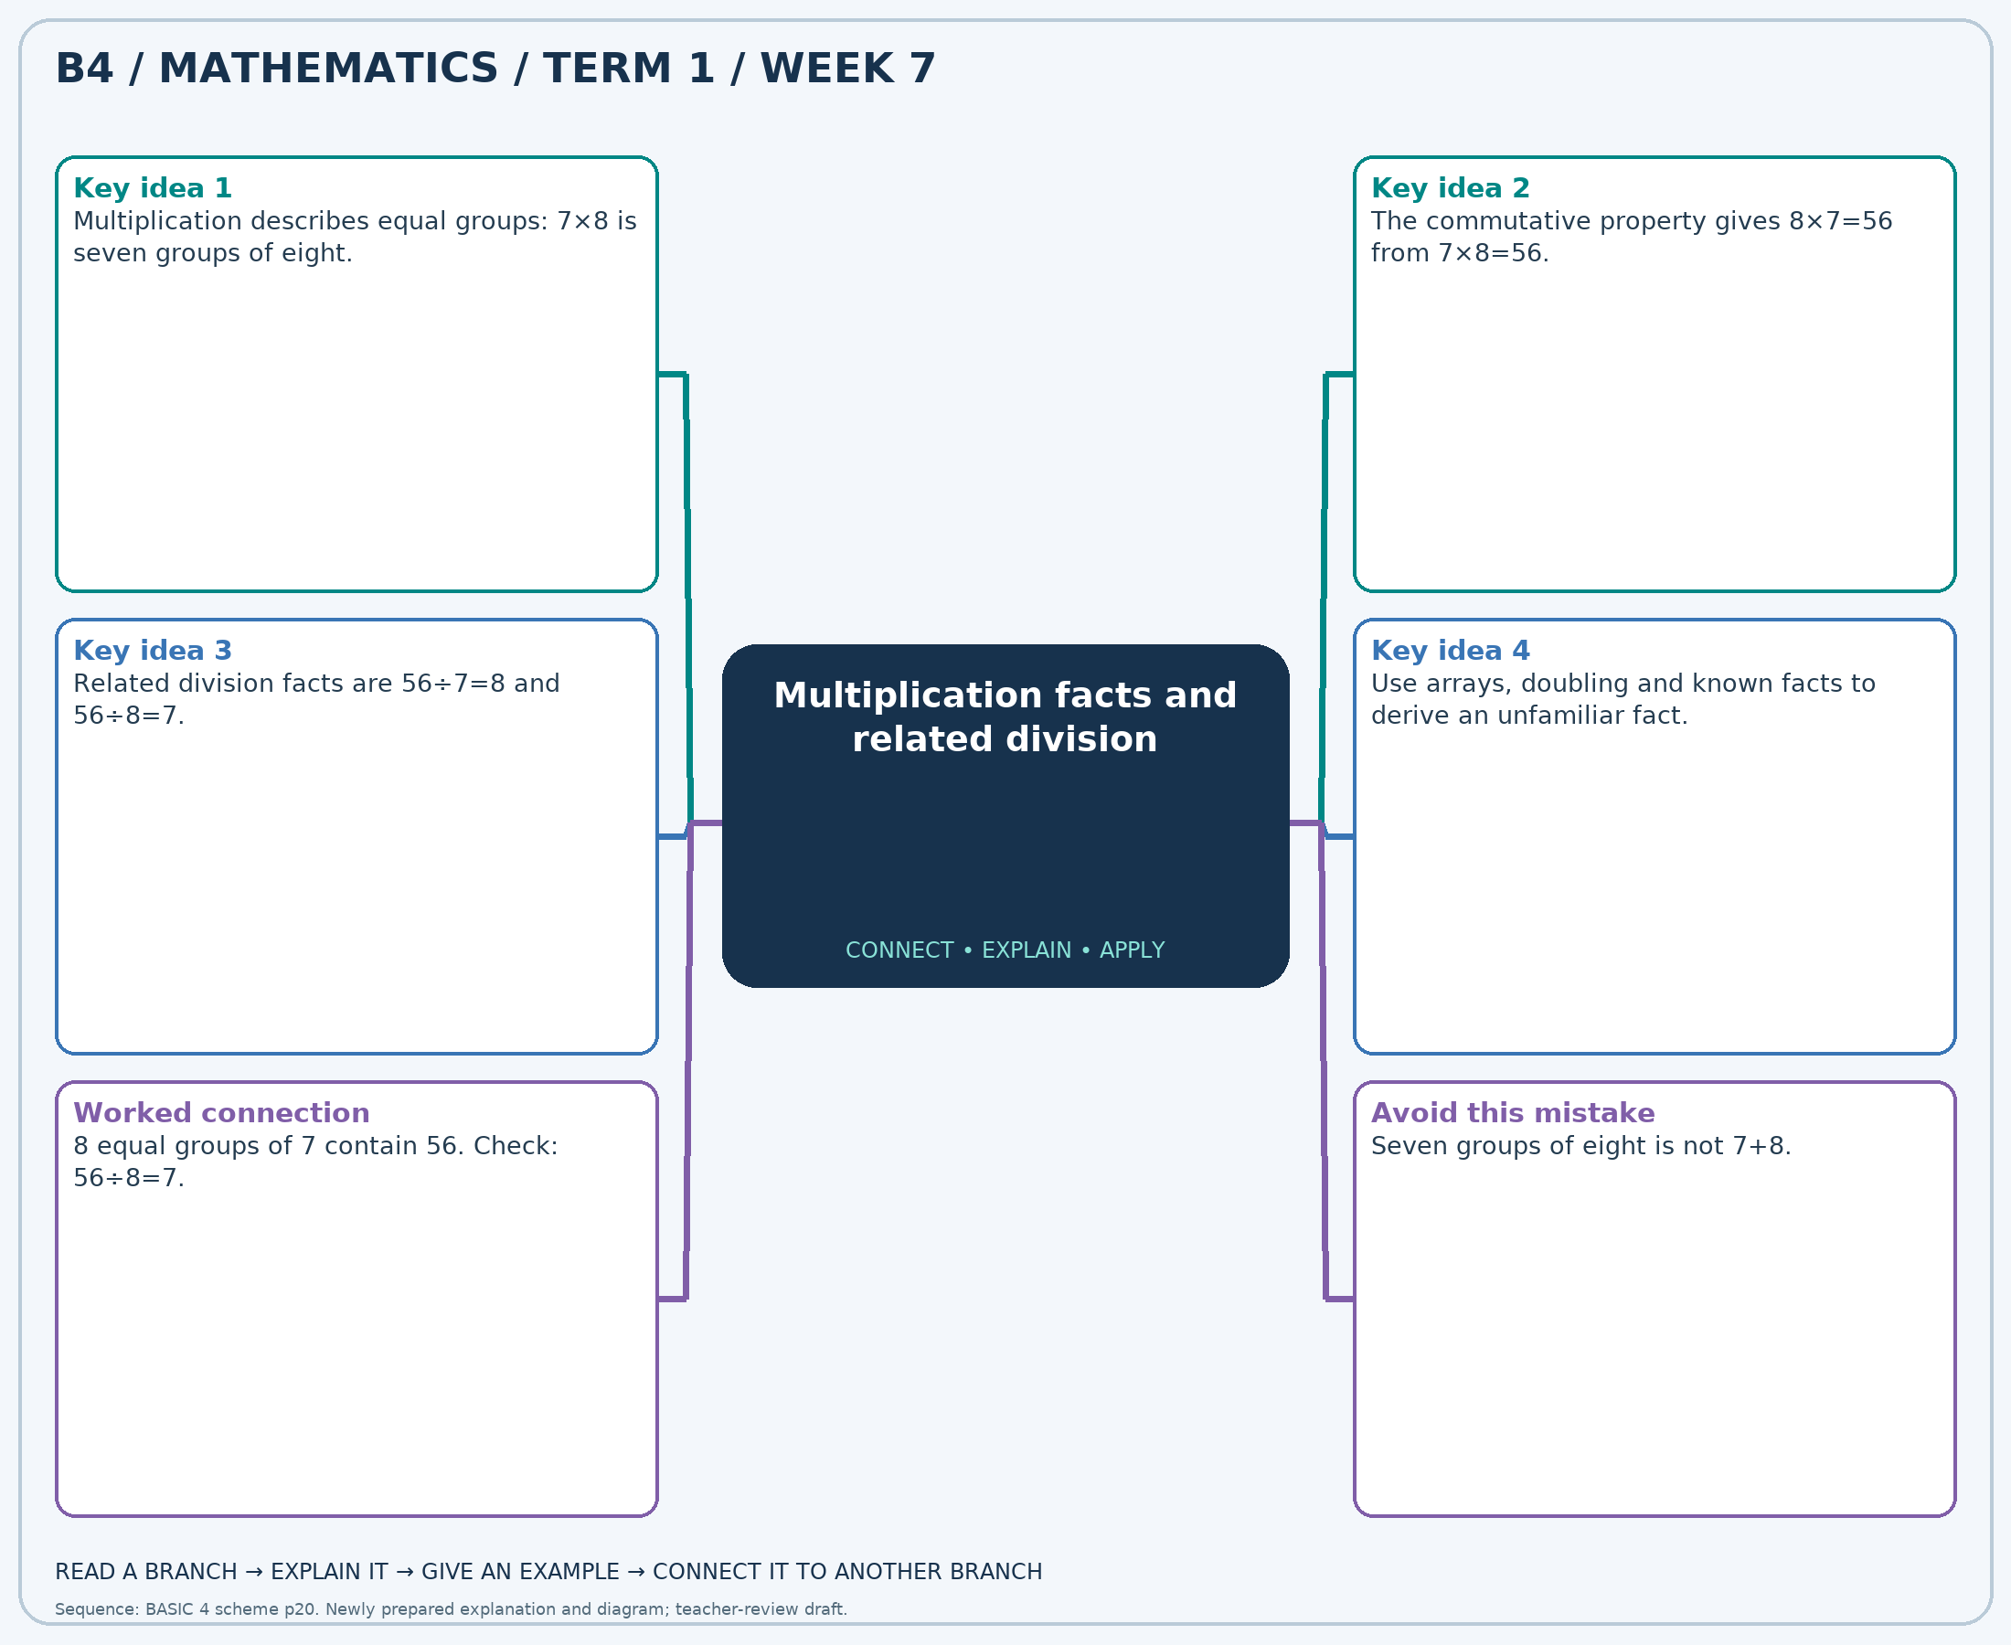
The separate high-resolution PNG can be projected or printed larger. Explain each branch and connect it with an example.

Week 7 — Practice

Section A — Multiple-choice questions
Choose ONE correct answer for each question. Each question has four alternatives.
1. Calculate 8 × 6.
A. 47 B. 50 C. 48 D. 49
2. Calculate 88 ÷ 8.
A. 10 B. 12 C. 13 D. 11
3. Calculate 3 × 5.
A. 16 B. 15 C. 14 D. 17
4. Calculate 90 ÷ 10.
A. 10 B. 9 C. 11 D. 8
5. Calculate 8 × 12.
A. 98 B. 95 C. 96 D. 97
6. Calculate 12 × 10.
A. 120 B. 122 C. 121 D. 119
7. Calculate 50 ÷ 5.
A. 10 B. 12 C. 11 D. 9
8. Calculate 4 × 7.
A. 28 B. 27 C. 30 D. 29
9. Calculate 120 ÷ 12.
A. 12 B. 9 C. 11 D. 10
10. Calculate 12 × 12.
A. 144 B. 145 C. 143 D. 146
11. Calculate 10 × 12.
A. 122 B. 119 C. 121 D. 120
12. Calculate 108 ÷ 9.
A. 12 B. 13 C. 11 D. 14
13. Calculate 4 × 11.
A. 44 B. 45 C. 43 D. 46
14. Calculate 8 × 3.
A. 26 B. 23 C. 24 D. 25
15. Calculate 21 ÷ 7.
A. 5 B. 3 C. 2 D. 4
16. Calculate 11 × 6.
A. 68 B. 66 C. 65 D. 67
17. Calculate 60 ÷ 5.
A. 11 B. 13 C. 12 D. 14
18. Calculate 6 × 9.
A. 53 B. 55 C. 56 D. 54
19. Calculate 12 × 4.
A. 47 B. 49 C. 48 D. 50
20. Calculate 63 ÷ 9.
A. 7 B. 9 C. 6 D. 8

Section B — Structured essay questions
Answer every part (a), (b), (c). Show your method or explain your choice. Write in a separate answer booklet. Each part: 1 mark for valid working/explanation and 1 for the correct result; 6 marks per question.

1. Apply the related skills and show working or give a reason for each answer.
(a) Calculate 3 × 2.
(b) Calculate 35 ÷ 7.
(c) Calculate 6 × 2.

2. Apply the related skills and show working or give a reason for each answer.
(a) Calculate 24 ÷ 3.
(b) Calculate 10 × 12.
(c) Calculate 11 × 6.

3. Apply the related skills and show working or give a reason for each answer.
(a) Calculate 7 × 3.
(b) Calculate 10 × 3.
(c) Calculate 24 ÷ 8.

4. Apply the related skills and show working or give a reason for each answer.
(a) Calculate 9 × 2.
(b) Calculate 60 ÷ 12.
(c) Calculate 6 × 3.

5. Apply the related skills and show working or give a reason for each answer.
(a) Calculate 22 ÷ 2.
(b) Calculate 2 × 10.
(c) Calculate 5 × 3.

6. Apply the related skills and show working or give a reason for each answer.
(a) Calculate 4 × 8.
(b) Calculate 9 × 10.
(c) Calculate 50 ÷ 5.

7. Apply the related skills and show working or give a reason for each answer.
(a) Calculate 10 × 8.
(b) Calculate 132 ÷ 11.
(c) Calculate 12 × 5.

8. Apply the related skills and show working or give a reason for each answer.
(a) Calculate 50 ÷ 10.
(b) Calculate 2 × 5.
(c) Calculate 7 × 10.

9. Apply the related skills and show working or give a reason for each answer.
(a) Calculate 12 × 6.
(b) Calculate 4 × 4.
(c) Calculate 20 ÷ 4.

10. Apply the related skills and show working or give a reason for each answer.
(a) Calculate 11 × 7.
(b) Calculate 20 ÷ 4.
(c) Calculate 12 × 5.

Week 8 — Multiplication strategies / Division and checking
Sequence source: BASIC 4 SCHEME OF LEARNING.pdf, first-term Mathematics, page 20. One consolidated weekly unit.

Learning outcomes
- Explain and apply multiplication strategies, solve examples and justify the method.
- Explain and apply division and checking, solve examples and justify the method.

Teaching notes and suggested sessions
Suggested schedule: five 40-minute sessions, adjusted to the school timetable. Spread the question bank through the week; it is not intended to be completed in one lesson.

1 — Explore and diagnose
5 minutes: recall an earlier skill; 10: demonstrate a concrete or pictorial model; 15: pairs investigate and explain; 10: identify a misconception and set an exit task.

2 — Model and practise
5 minutes: review the exit task; 10: work an example aloud; 15: pairs solve parallel examples; 10: compare methods and correct errors.

3 — Connect representations
5 minutes: recall vocabulary; 10: explain the mind-map; 15: connect a model, a drawing and a symbolic calculation; 10: independent practice.

4 — Apply and explain
5 minutes: estimate or predict; 10: solve a contextual example; 15: attempt selected structured-question parts; 10: compare reasoning and check units.

5 — Check and respond
5 minutes: retrieve the main rule; 15: use selected MCQs diagnostically; 10: explain distractors and misconceptions; 10: reteach or extend in response to evidence.

Topic-specific activities
- Draw a partitioned rectangle and connect its smaller areas to the partial products.
- Share counters into equal groups and check the result by multiplication.
Resources: board, pencils, number cards, counters, paper strips and squared paper as appropriate. Prior-knowledge check: ask a learner to explain a representation used in the first example before introducing a new rule.
Support: reduce number size without changing the concept; offer a partially completed chart or model; allow oral reasoning before writing. Extension: create a counterexample to a false rule and explain why it fails.

Study notes and worked examples

Multiplication strategies
- Partition a factor and use the distributive property: 24×6=(20×6)+(4×6)=144.
- Doubling one factor and halving an even other factor preserves the product.
- In multi-digit multiplication, include every partial product and align place values.
- Estimate first, calculate carefully and compare the product with the estimate.
Worked example: Calculate 15 × 7.
Solution: 15×(0+7) = 0+105 = 105.
Common misconception: The tens digit contributes tens, not units: the 2 in 23×14 represents 20×14.

Division and checking
- Division may mean sharing equally or finding how many equal groups fit.
- Multiplication reverses division: 7×8=56 means 56÷7=8.
- Work from the greatest place and regroup when needed. Record a zero in an empty quotient place.
- Check: divisor × quotient + remainder = dividend. The remainder is smaller than the divisor.
Worked example: Calculate 42 ÷ 6.
Solution: 6×7=42, so the quotient is 7.
Common misconception: Do not leave an empty place in the quotient when a zero is needed.
Independent study: read the map, cover it and reconstruct the branches. Solve an unused question from each skill and explain the reasoning to a partner. Consult the teacher key only after an honest attempt.

Week 8 — Visual mind-map
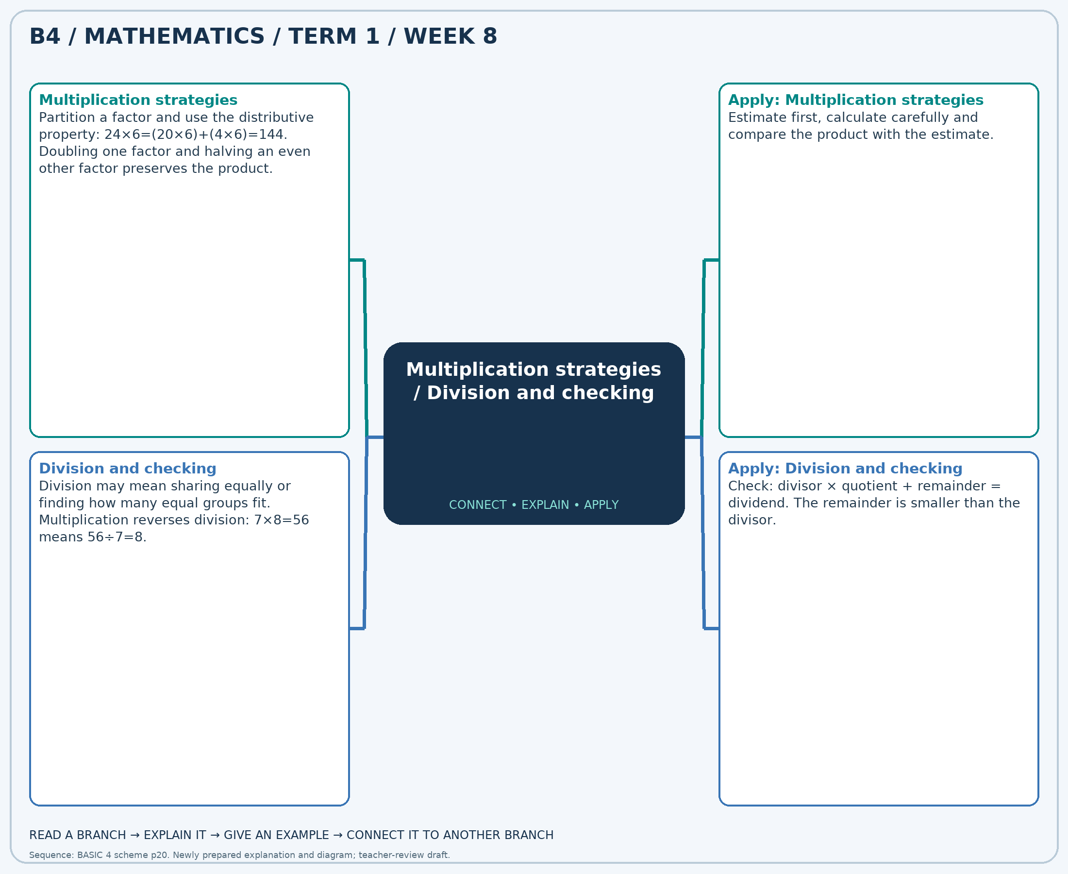
The separate high-resolution PNG can be projected or printed larger. Explain each branch and connect it with an example.

Week 8 — Practice

Section A — Multiple-choice questions
Choose ONE correct answer for each question. Each question has four alternatives.
1. Calculate 71 × 4.
A. 284 B. 75 C. 213 D. 355
2. Calculate 70 ÷ 7.
A. 63 B. 11 C. 9 D. 10
3. Calculate 23 × 9.
A. 184 B. 32 C. 230 D. 207
4. Calculate 32 ÷ 8.
A. 24 B. 4 C. 5 D. 3
5. Calculate 74 × 9.
A. 592 B. 666 C. 83 D. 740
6. Calculate 56 ÷ 8.
A. 8 B. 7 C. 6 D. 48
7. Calculate 54 × 9.
A. 486 B. 63 C. 540 D. 432
8. Calculate 6 ÷ 2.
A. 6 B. 3 C. 4 D. 2
9. Calculate 32 × 3.
A. 35 B. 64 C. 96 D. 128
10. Calculate 25 ÷ 5.
A. 6 B. 4 C. 5 D. 20
11. Calculate 34 × 8.
A. 306 B. 42 C. 272 D. 238
12. Calculate 36 ÷ 6.
A. 7 B. 30 C. 5 D. 6
13. Calculate 15 × 5.
A. 60 B. 20 C. 90 D. 75
14. Calculate 40 ÷ 8.
A. 32 B. 5 C. 6 D. 4
15. Calculate 79 × 3.
A. 237 B. 316 C. 82 D. 158
16. Calculate 24 ÷ 4.
A. 7 B. 20 C. 6 D. 5
17. Calculate 88 × 3.
A. 176 B. 264 C. 91 D. 352
18. Calculate 40 ÷ 5.
A. 9 B. 7 C. 8 D. 35
19. Calculate 33 × 7.
A. 198 B. 40 C. 264 D. 231
20. Calculate 60 ÷ 6.
A. 9 B. 10 C. 54 D. 11

Section B — Structured essay questions
Answer every part (a), (b), (c). Show your method or explain your choice. Write in a separate answer booklet. Each part: 1 mark for valid working/explanation and 1 for the correct result; 6 marks per question.

1. Apply the related skills and show working or give a reason for each answer.
(a) Calculate 67 × 3.
(b) Calculate 54 ÷ 6.
(c) Calculate 43 × 2.

2. Apply the related skills and show working or give a reason for each answer.
(a) Calculate 36 ÷ 6.
(b) Calculate 17 × 8.
(c) Calculate 30 ÷ 3.

3. Apply the related skills and show working or give a reason for each answer.
(a) Calculate 66 × 8.
(b) Calculate 72 ÷ 8.
(c) Calculate 30 × 2.

4. Apply the related skills and show working or give a reason for each answer.
(a) Calculate 9 ÷ 3.
(b) Calculate 88 × 3.
(c) Calculate 20 ÷ 4.

5. Apply the related skills and show working or give a reason for each answer.
(a) Calculate 64 × 3.
(b) Calculate 36 ÷ 9.
(c) Calculate 55 × 8.

6. Apply the related skills and show working or give a reason for each answer.
(a) Calculate 18 ÷ 2.
(b) Calculate 24 × 2.
(c) Calculate 30 ÷ 5.

7. Apply the related skills and show working or give a reason for each answer.
(a) Calculate 37 × 3.
(b) Calculate 54 ÷ 6.
(c) Calculate 49 × 4.

8. Apply the related skills and show working or give a reason for each answer.
(a) Calculate 30 ÷ 3.
(b) Calculate 22 × 9.
(c) Calculate 16 ÷ 2.

9. Apply the related skills and show working or give a reason for each answer.
(a) Calculate 25 × 4.
(b) Calculate 24 ÷ 4.
(c) Calculate 68 × 5.

10. Apply the related skills and show working or give a reason for each answer.
(a) Calculate 56 ÷ 8.
(b) Calculate 43 × 6.
(c) Calculate 21 ÷ 7.

Week 9 — Division and checking / Multi-step number problems
Sequence source: BASIC 4 SCHEME OF LEARNING.pdf, first-term Mathematics, page 20. One consolidated weekly unit.

Learning outcomes
- Explain and apply division and checking, solve examples and justify the method.
- Explain and apply multi-step number problems, solve examples and justify the method.

Teaching notes and suggested sessions
Suggested schedule: five 40-minute sessions, adjusted to the school timetable. Spread the question bank through the week; it is not intended to be completed in one lesson.

1 — Explore and diagnose
5 minutes: recall an earlier skill; 10: demonstrate a concrete or pictorial model; 15: pairs investigate and explain; 10: identify a misconception and set an exit task.

2 — Model and practise
5 minutes: review the exit task; 10: work an example aloud; 15: pairs solve parallel examples; 10: compare methods and correct errors.

3 — Connect representations
5 minutes: recall vocabulary; 10: explain the mind-map; 15: connect a model, a drawing and a symbolic calculation; 10: independent practice.

4 — Apply and explain
5 minutes: estimate or predict; 10: solve a contextual example; 15: attempt selected structured-question parts; 10: compare reasoning and check units.

5 — Check and respond
5 minutes: retrieve the main rule; 15: use selected MCQs diagnostically; 10: explain distractors and misconceptions; 10: reteach or extend in response to evidence.

Topic-specific activities
- Share counters into equal groups and check the result by multiplication.
- Use a shop-stock or shopping story. Draw a bar model and compare two solution methods.
Resources: board, pencils, number cards, counters, paper strips and squared paper as appropriate. Prior-knowledge check: ask a learner to explain a representation used in the first example before introducing a new rule.
Support: reduce number size without changing the concept; offer a partially completed chart or model; allow oral reasoning before writing. Extension: create a counterexample to a false rule and explain why it fails.

Study notes and worked examples

Division and checking
- Division may mean sharing equally or finding how many equal groups fit.
- Multiplication reverses division: 7×8=56 means 56÷7=8.
- Work from the greatest place and regroup when needed. Record a zero in an empty quotient place.
- Check: divisor × quotient + remainder = dividend. The remainder is smaller than the divisor.
Worked example: Calculate 14 ÷ 2.
Solution: 2×7=14, so the quotient is 7.
Common misconception: Do not leave an empty place in the quotient when a zero is needed.

Multi-step number problems
- Identify the quantities, units and the final question before calculating.
- Use a diagram or a written plan to select the operations from the relationships.
- Label intermediate answers, then complete the remaining steps.
- Estimate and interpret the answer in the original situation.
Worked example: A shop has 8 packs of 7 pencils and sells 30 pencils. How many pencils remain?
Solution: Start with 8×7=56; subtract 30 to obtain 26 pencils.
Common misconception: A correct intermediate calculation may not answer the final question.
Independent study: read the map, cover it and reconstruct the branches. Solve an unused question from each skill and explain the reasoning to a partner. Consult the teacher key only after an honest attempt.

Week 9 — Visual mind-map
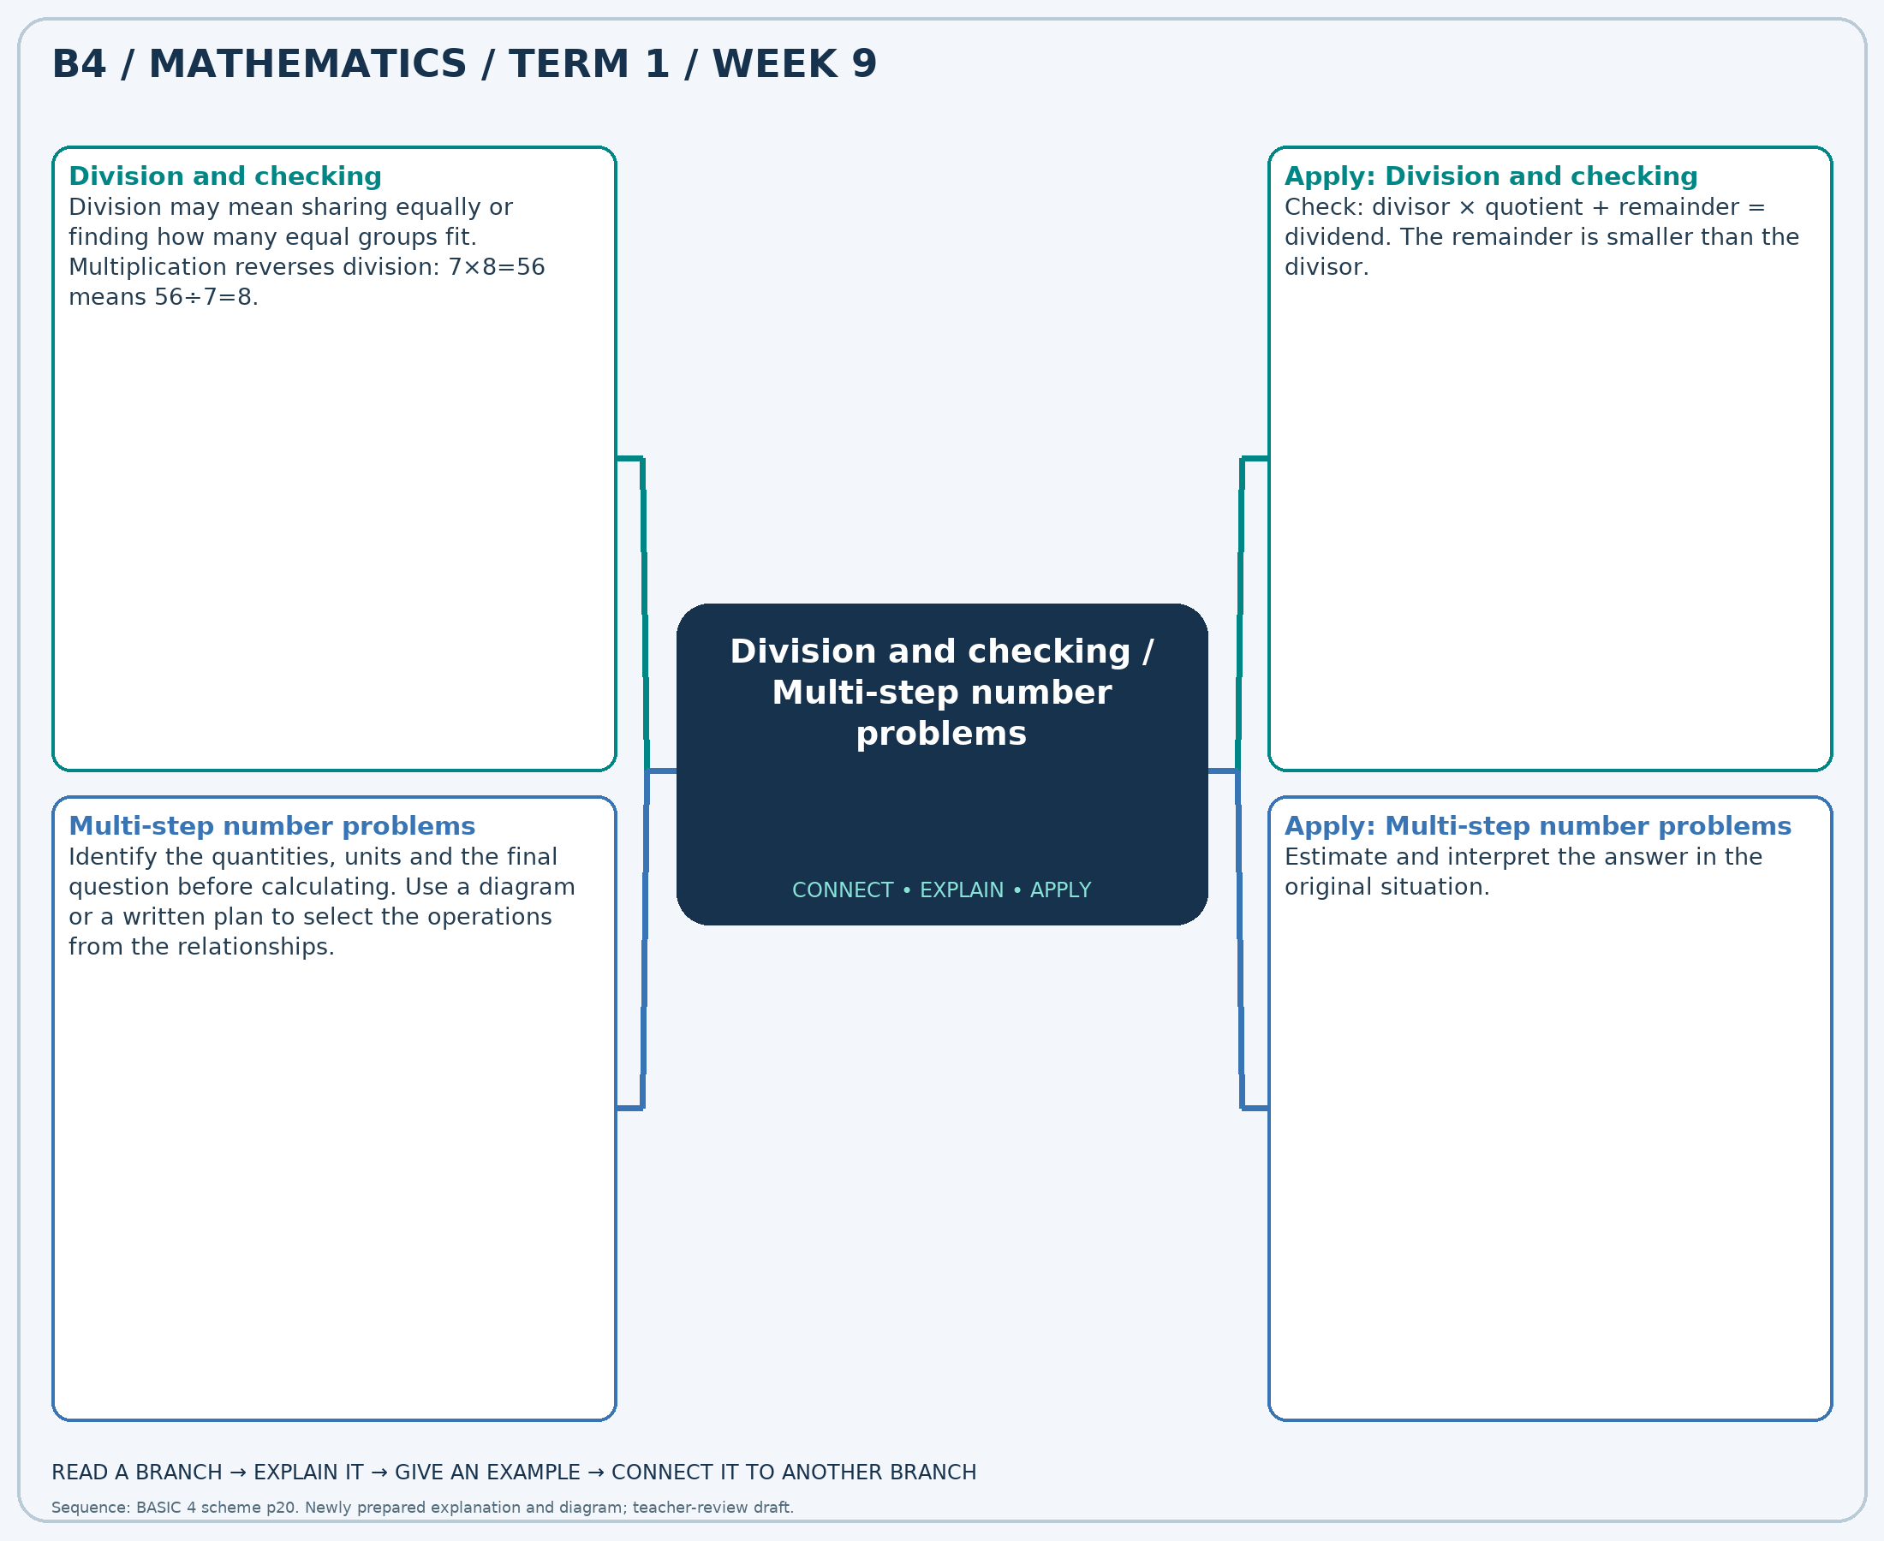
The separate high-resolution PNG can be projected or printed larger. Explain each branch and connect it with an example.

Week 9 — Practice

Section A — Multiple-choice questions
Choose ONE correct answer for each question. Each question has four alternatives.
1. Calculate 35 ÷ 5.
A. 6 B. 8 C. 7 D. 30
2. A shop has 6 packs of 9 pencils and sells 44 pencils. How many pencils remain?
A. 19 B. 59 C. 10 D. 98
3. Calculate 42 ÷ 7.
A. 6 B. 35 C. 7 D. 5
4. A shop has 9 packs of 7 pencils and sells 28 pencils. How many pencils remain?
A. 42 B. 35 C. 91 D. 44
5. Calculate 40 ÷ 4.
A. 11 B. 10 C. 36 D. 9
6. A shop has 7 packs of 9 pencils and sells 61 pencils. How many pencils remain?
A. 2 B. 124 C. 77 D. 11
7. Calculate 20 ÷ 5.
A. 15 B. 5 C. 4 D. 3
8. A shop has 4 packs of 7 pencils and sells 13 pencils. How many pencils remain?
A. 24 B. 22 C. 15 D. 41
9. Calculate 24 ÷ 3.
A. 8 B. 9 C. 7 D. 21
10. A shop has 9 packs of 9 pencils and sells 31 pencils. How many pencils remain?
A. 59 B. 112 C. 49 D. 50
11. Calculate 50 ÷ 5.
A. 10 B. 9 C. 45 D. 11
12. A shop has 8 packs of 10 pencils and sells 60 pencils. How many pencils remain?
A. 140 B. 30 C. 78 D. 20
13. Calculate 24 ÷ 8.
A. 4 B. 16 C. 3 D. 2
14. A shop has 9 packs of 5 pencils and sells 2 pencils. How many pencils remain?
A. 16 B. 43 C. 47 D. 48
15. Calculate 63 ÷ 9.
A. 8 B. 54 C. 7 D. 6
16. A shop has 9 packs of 9 pencils and sells 41 pencils. How many pencils remain?
A. 49 B. 122 C. 40 D. 59
17. Calculate 45 ÷ 9.
A. 5 B. 6 C. 36 D. 4
18. A shop has 5 packs of 6 pencils and sells 7 pencils. How many pencils remain?
A. 23 B. 18 C. 29 D. 37
19. Calculate 24 ÷ 6.
A. 3 B. 4 C. 5 D. 18
20. A shop has 5 packs of 4 pencils and sells 14 pencils. How many pencils remain?
A. 6 B. 10 C. 34 D. 23

Section B — Structured essay questions
Answer every part (a), (b), (c). Show your method or explain your choice. Write in a separate answer booklet. Each part: 1 mark for valid working/explanation and 1 for the correct result; 6 marks per question.

1. Apply the related skills and show working or give a reason for each answer.
(a) Calculate 35 ÷ 5.
(b) A shop has 4 packs of 11 pencils and sells 18 pencils. How many pencils remain?
(c) Calculate 6 ÷ 2.

2. Apply the related skills and show working or give a reason for each answer.
(a) A shop has 9 packs of 4 pencils and sells 34 pencils. How many pencils remain?
(b) Calculate 40 ÷ 5.
(c) A shop has 3 packs of 4 pencils and sells 5 pencils. How many pencils remain?

3. Apply the related skills and show working or give a reason for each answer.
(a) Calculate 10 ÷ 2.
(b) A shop has 8 packs of 9 pencils and sells 45 pencils. How many pencils remain?
(c) Calculate 18 ÷ 6.

4. Apply the related skills and show working or give a reason for each answer.
(a) A shop has 5 packs of 4 pencils and sells 16 pencils. How many pencils remain?
(b) Calculate 14 ÷ 2.
(c) A shop has 9 packs of 6 pencils and sells 28 pencils. How many pencils remain?

5. Apply the related skills and show working or give a reason for each answer.
(a) Calculate 30 ÷ 5.
(b) A shop has 3 packs of 6 pencils and sells 13 pencils. How many pencils remain?
(c) Calculate 45 ÷ 5.

6. Apply the related skills and show working or give a reason for each answer.
(a) A shop has 9 packs of 9 pencils and sells 32 pencils. How many pencils remain?
(b) Calculate 56 ÷ 7.
(c) A shop has 7 packs of 8 pencils and sells 6 pencils. How many pencils remain?

7. Apply the related skills and show working or give a reason for each answer.
(a) Calculate 30 ÷ 5.
(b) A shop has 7 packs of 10 pencils and sells 24 pencils. How many pencils remain?
(c) Calculate 24 ÷ 4.

8. Apply the related skills and show working or give a reason for each answer.
(a) A shop has 5 packs of 7 pencils and sells 24 pencils. How many pencils remain?
(b) Calculate 54 ÷ 9.
(c) A shop has 5 packs of 9 pencils and sells 9 pencils. How many pencils remain?

9. Apply the related skills and show working or give a reason for each answer.
(a) Calculate 12 ÷ 4.
(b) A shop has 5 packs of 8 pencils and sells 7 pencils. How many pencils remain?
(c) Calculate 10 ÷ 2.

10. Apply the related skills and show working or give a reason for each answer.
(a) A shop has 8 packs of 5 pencils and sells 17 pencils. How many pencils remain?
(b) Calculate 60 ÷ 6.
(c) A shop has 4 packs of 7 pencils and sells 26 pencils. How many pencils remain?

Week 10 — Unit fractions and number lines / Equivalent fractions
Sequence source: BASIC 4 SCHEME OF LEARNING.pdf, first-term Mathematics, page 20. One consolidated weekly unit.

Learning outcomes
- Explain and apply unit fractions and number lines, solve examples and justify the method.
- Explain and apply equivalent fractions, solve examples and justify the method.

Teaching notes and suggested sessions
Suggested schedule: five 40-minute sessions, adjusted to the school timetable. Spread the question bank through the week; it is not intended to be completed in one lesson.

1 — Explore and diagnose
5 minutes: recall an earlier skill; 10: demonstrate a concrete or pictorial model; 15: pairs investigate and explain; 10: identify a misconception and set an exit task.

2 — Model and practise
5 minutes: review the exit task; 10: work an example aloud; 15: pairs solve parallel examples; 10: compare methods and correct errors.

3 — Connect representations
5 minutes: recall vocabulary; 10: explain the mind-map; 15: connect a model, a drawing and a symbolic calculation; 10: independent practice.

4 — Apply and explain
5 minutes: estimate or predict; 10: solve a contextual example; 15: attempt selected structured-question parts; 10: compare reasoning and check units.

5 — Check and respond
5 minutes: retrieve the main rule; 15: use selected MCQs diagnostically; 10: explain distractors and misconceptions; 10: reteach or extend in response to evidence.

Topic-specific activities
- Fold equal paper strips into halves, quarters and eighths, then mark the fractions on a number line.
- Shade equal lengths on strips partitioned into thirds and sixths.
Resources: board, pencils, number cards, counters, paper strips and squared paper as appropriate. Prior-knowledge check: ask a learner to explain a representation used in the first example before introducing a new rule.
Support: reduce number size without changing the concept; offer a partially completed chart or model; allow oral reasoning before writing. Extension: create a counterexample to a false rule and explain why it fails.

Study notes and worked examples

Unit fractions and number lines
- A fraction names equal-sized parts of a whole.
- The denominator counts equal parts and the numerator counts selected parts.
- A unit fraction has numerator 1. Divide the interval from 0 to 1 into equal spaces, not an equal number of tick marks.
- For the same whole, a larger denominator makes a unit fraction smaller.
Worked example: A strip is divided into 7 equal pieces. What fraction is one piece?
Solution: One of 7 equal parts is 1/7.
Common misconception: Unequal pieces cannot be counted as equal fractions of the same whole.

Equivalent fractions
- Equivalent fractions have the same value even though their numerators and denominators differ.
- Multiply or divide the numerator and denominator by the same non-zero number.
- For example, 2/3=4/6=6/9. The amount stays the same.
- Common denominators help compare or add fractions.
Worked example: Complete: 2/10 = ?/40.
Solution: Multiply both terms by 4; numerator = 2×4=8.
Common misconception: Adding the same number to the numerator and denominator does not generally preserve value.
Independent study: read the map, cover it and reconstruct the branches. Solve an unused question from each skill and explain the reasoning to a partner. Consult the teacher key only after an honest attempt.

Week 10 — Visual mind-map
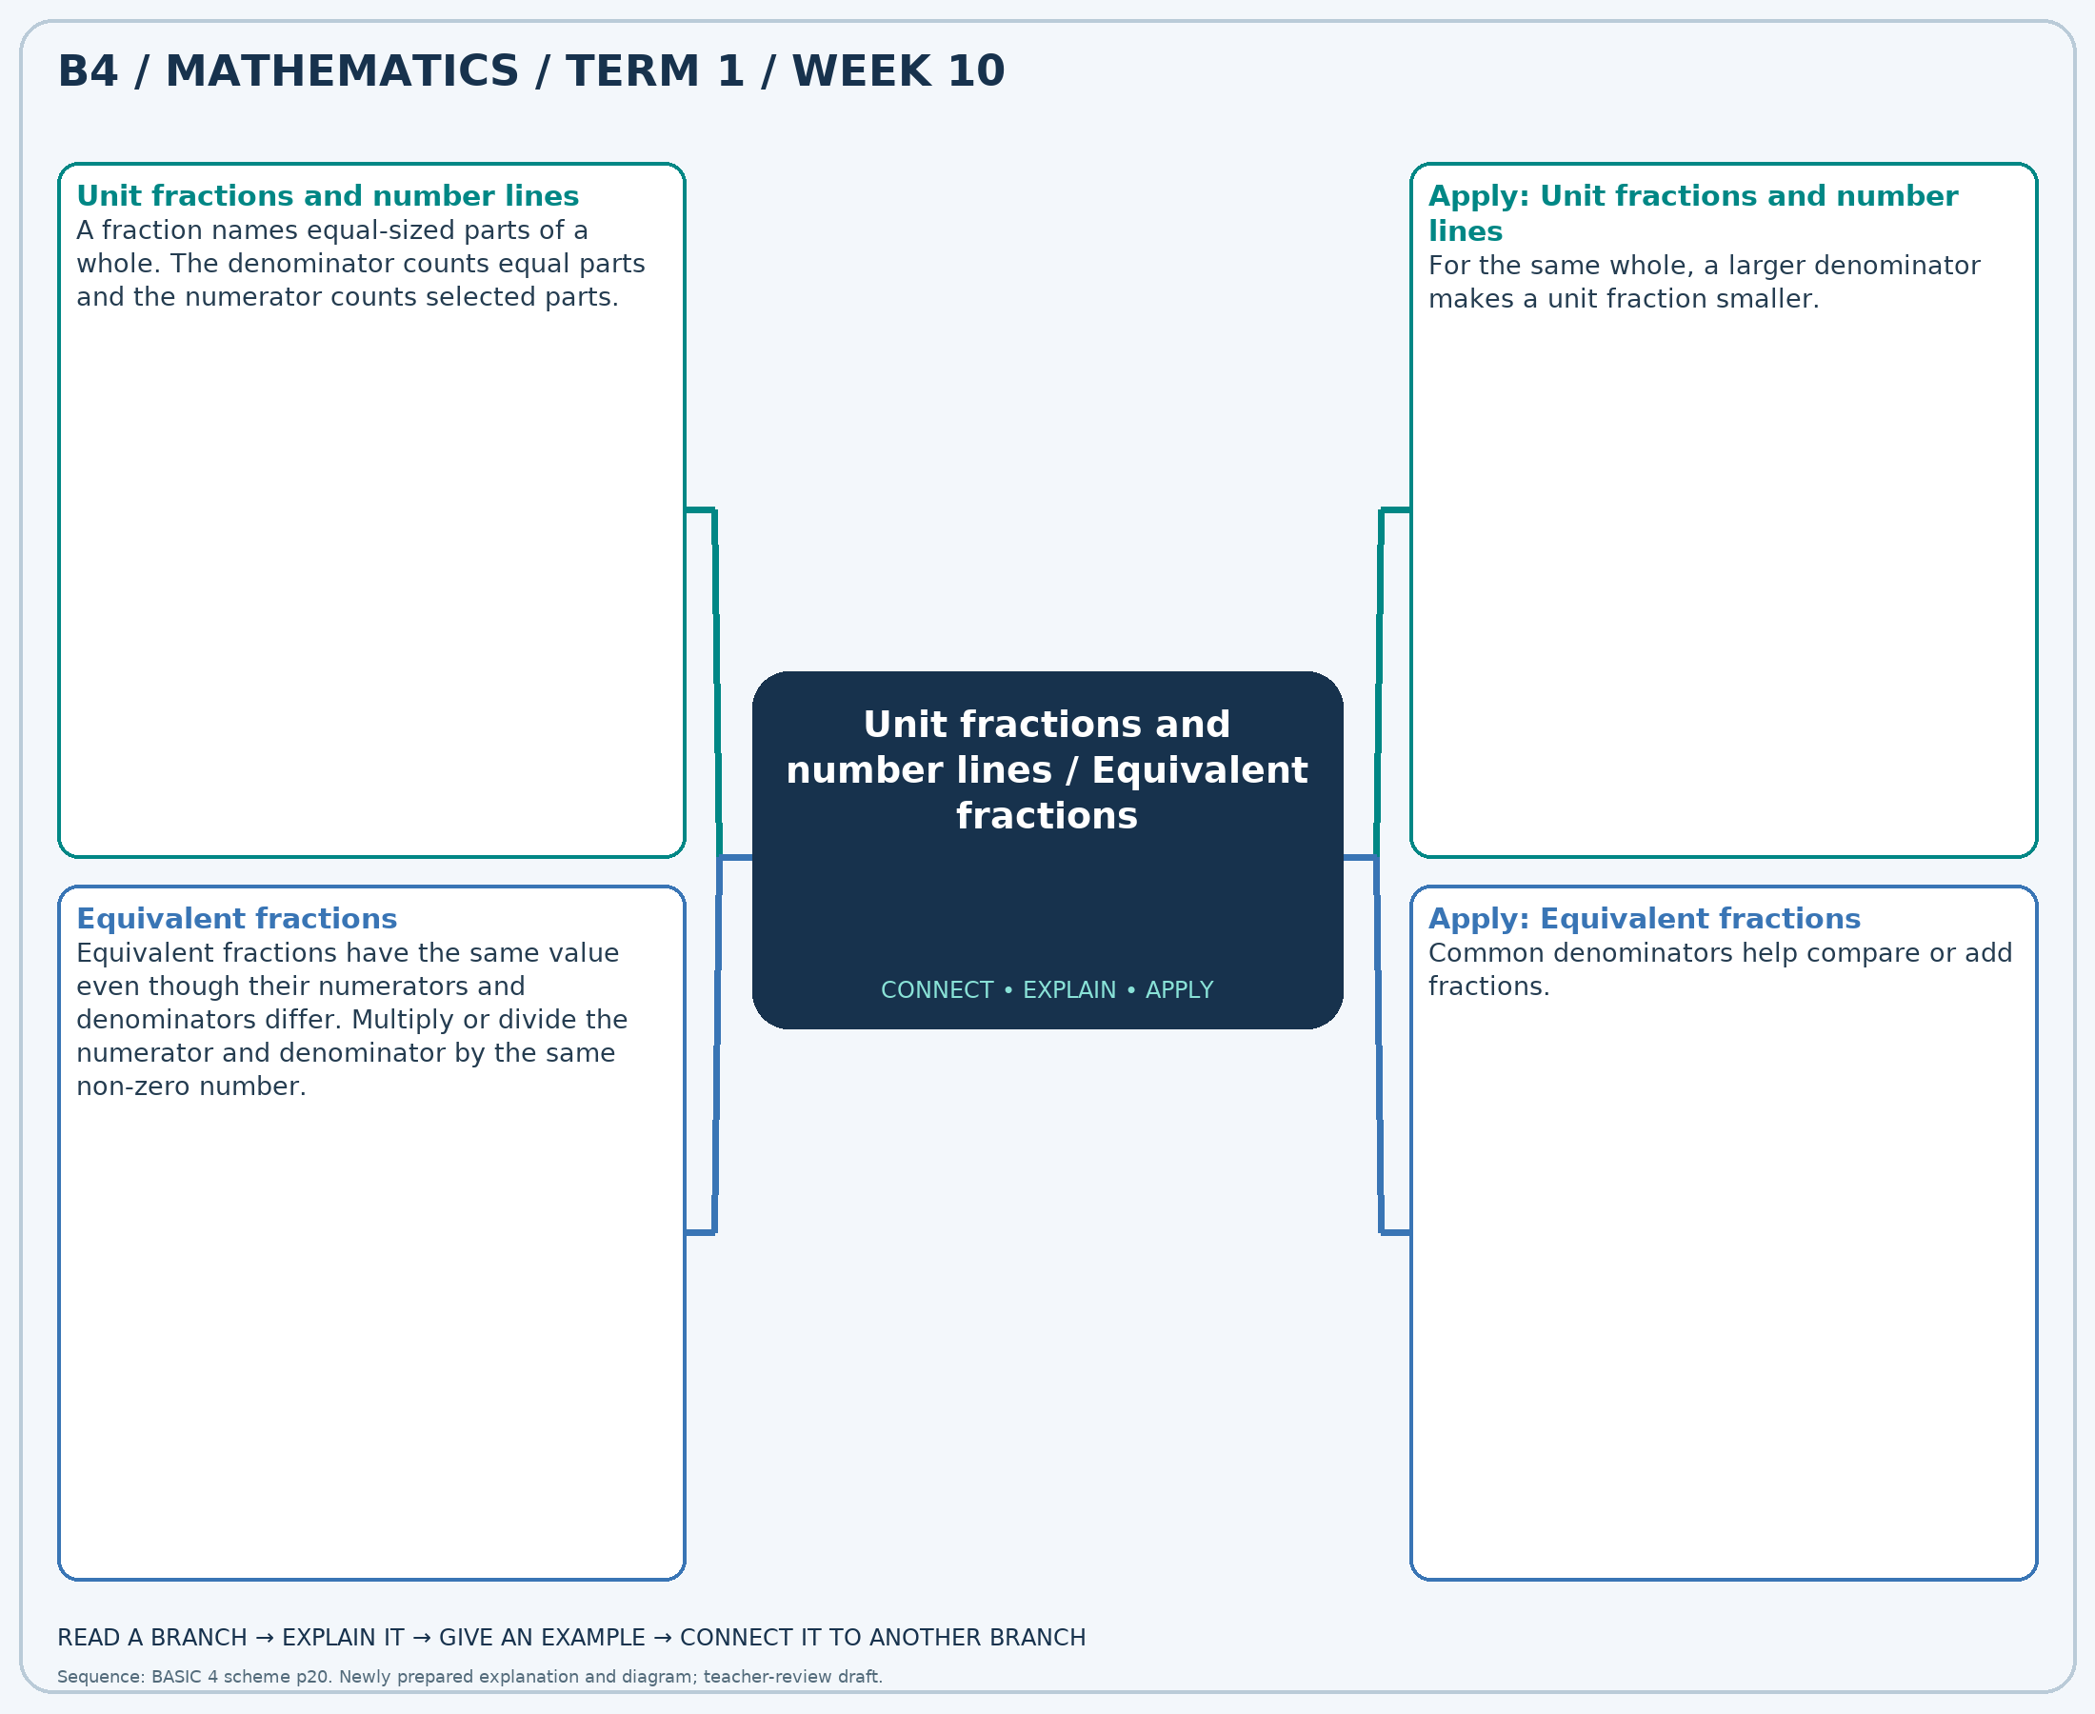
The separate high-resolution PNG can be projected or printed larger. Explain each branch and connect it with an example.

Week 10 — Practice

Section A — Multiple-choice questions
Choose ONE correct answer for each question. Each question has four alternatives.
1. A strip is divided into 11 equal pieces. What fraction is one piece?
A. 23/11 B. -10/11 C. 12/11 D. 1/11
2. Complete: 1/10 = ?/50.
A. 10 B. 5 C. 6 D. 1
3. How many jumps of 1/5 go from 0 to 1 on a number line?
A. 5 B. 6 C. 7 D. 4
4. Complete: 3/7 = ?/42.
A. 24 B. 9 C. 3 D. 18
5. One of 9 equal slices is eaten. What fraction remains?
A. 26/9 B. -1/9 C. 8/9 D. 17/9
6. Complete: 3/12 = ?/60.
A. 3 B. 20 C. 8 D. 15
7. A strip is divided into 6 equal pieces. What fraction is one piece?
A. 7/6 B. 13/6 C. 1/6 D. -5/6
8. Complete: 3/5 = ?/20.
A. 7 B. 12 C. 16 D. 3
9. One of 4 equal slices is eaten. What fraction remains?
A. 3/4 B. 11/4 C. -1/4 D. 7/4
10. Complete: 3/4 = ?/12.
A. 6 B. 3 C. 9 D. 12
11. A strip is divided into 3 equal pieces. What fraction is one piece?
A. 4/3 B. 7/3 C. -2/3 D. 1/3
12. Complete: 2/5 = ?/20.
A. 12 B. 6 C. 8 D. 2
13. How many jumps of 1/6 go from 0 to 1 on a number line?
A. 8 B. 6 C. 5 D. 7
14. Complete: 4/7 = ?/42.
A. 10 B. 30 C. 4 D. 24
15. One of 11 equal slices is eaten. What fraction remains?
A. 32/11 B. -1/11 C. 21/11 D. 10/11
16. Complete: 9/12 = ?/48.
A. 40 B. 13 C. 36 D. 9
17. A strip is divided into 10 equal pieces. What fraction is one piece?
A. 11/10 B. 21/10 C. -9/10 D. 1/10
18. Complete: 1/4 = ?/20.
A. 10 B. 5 C. 6 D. 1
19. How many jumps of 1/3 go from 0 to 1 on a number line?
A. 4 B. 3 C. 2 D. 5
20. Complete: 5/6 = ?/30.
A. 10 B. 25 C. 30 D. 5

Section B — Structured essay questions
Answer every part (a), (b), (c). Show your method or explain your choice. Write in a separate answer booklet. Each part: 1 mark for valid working/explanation and 1 for the correct result; 6 marks per question.

1. Apply the related skills and show working or give a reason for each answer.
(a) A strip is divided into 7 equal pieces. What fraction is one piece?
(b) Complete: 1/6 = ?/24.
(c) One of 9 equal slices is eaten. What fraction remains?

2. Apply the related skills and show working or give a reason for each answer.
(a) Complete: 5/6 = ?/30.
(b) One of 11 equal slices is eaten. What fraction remains?
(c) Complete: 2/4 = ?/16.

3. Apply the related skills and show working or give a reason for each answer.
(a) One of 9 equal slices is eaten. What fraction remains?
(b) Complete: 2/6 = ?/36.
(c) How many jumps of 1/5 go from 0 to 1 on a number line?

4. Apply the related skills and show working or give a reason for each answer.
(a) Complete: 1/3 = ?/12.
(b) How many jumps of 1/10 go from 0 to 1 on a number line?
(c) Complete: 7/10 = ?/30.

5. Apply the related skills and show working or give a reason for each answer.
(a) How many jumps of 1/4 go from 0 to 1 on a number line?
(b) Complete: 7/12 = ?/60.
(c) A strip is divided into 6 equal pieces. What fraction is one piece?

6. Apply the related skills and show working or give a reason for each answer.
(a) Complete: 2/12 = ?/48.
(b) A strip is divided into 8 equal pieces. What fraction is one piece?
(c) Complete: 2/12 = ?/36.

7. Apply the related skills and show working or give a reason for each answer.
(a) A strip is divided into 8 equal pieces. What fraction is one piece?
(b) Complete: 8/12 = ?/72.
(c) One of 12 equal slices is eaten. What fraction remains?

8. Apply the related skills and show working or give a reason for each answer.
(a) Complete: 1/9 = ?/36.
(b) One of 11 equal slices is eaten. What fraction remains?
(c) Complete: 3/4 = ?/24.

9. Apply the related skills and show working or give a reason for each answer.
(a) One of 3 equal slices is eaten. What fraction remains?
(b) Complete: 4/7 = ?/21.
(c) How many jumps of 1/8 go from 0 to 1 on a number line?

10. Apply the related skills and show working or give a reason for each answer.
(a) Complete: 3/10 = ?/20.
(b) How many jumps of 1/10 go from 0 to 1 on a number line?
(c) Complete: 1/3 = ?/9.

Week 11 — Simplest form and improper fractions
Sequence source: BASIC 4 SCHEME OF LEARNING.pdf, first-term Mathematics, page 20. One consolidated weekly unit.

Learning outcomes
- Explain and apply simplest form and improper fractions, solve examples and justify the method.

Teaching notes and suggested sessions
Suggested schedule: five 40-minute sessions, adjusted to the school timetable. Spread the question bank through the week; it is not intended to be completed in one lesson.

1 — Explore and diagnose
5 minutes: recall an earlier skill; 10: demonstrate a concrete or pictorial model; 15: pairs investigate and explain; 10: identify a misconception and set an exit task.

2 — Model and practise
5 minutes: review the exit task; 10: work an example aloud; 15: pairs solve parallel examples; 10: compare methods and correct errors.

3 — Connect representations
5 minutes: recall vocabulary; 10: explain the mind-map; 15: connect a model, a drawing and a symbolic calculation; 10: independent practice.

4 — Apply and explain
5 minutes: estimate or predict; 10: solve a contextual example; 15: attempt selected structured-question parts; 10: compare reasoning and check units.

5 — Check and respond
5 minutes: retrieve the main rule; 15: use selected MCQs diagnostically; 10: explain distractors and misconceptions; 10: reteach or extend in response to evidence.

Topic-specific activities
- Build more than one whole with fraction strips and record improper and mixed forms.
Resources: board, pencils, number cards, counters, paper strips and squared paper as appropriate. Prior-knowledge check: ask a learner to explain a representation used in the first example before introducing a new rule.
Support: reduce number size without changing the concept; offer a partially completed chart or model; allow oral reasoning before writing. Extension: create a counterexample to a false rule and explain why it fails.

Study notes and worked examples

Simplest form and improper fractions
- A fraction is simplest when its numerator and denominator have no common factor greater than 1.
- Divide both terms by their HCF: 12/18=2/3.
- An improper fraction has numerator at least as large as denominator and represents at least one whole.
- Divide the numerator by denominator to form a mixed number: the remainder becomes the new numerator.
Worked example: Write 12/15 in simplest form.
Solution: Divide both terms by 3: 4/5.
Common misconception: An improper fraction is not an incorrect fraction; it is a valid representation.
Independent study: read the map, cover it and reconstruct the branches. Solve an unused question from each skill and explain the reasoning to a partner. Consult the teacher key only after an honest attempt.

Week 11 — Visual mind-map
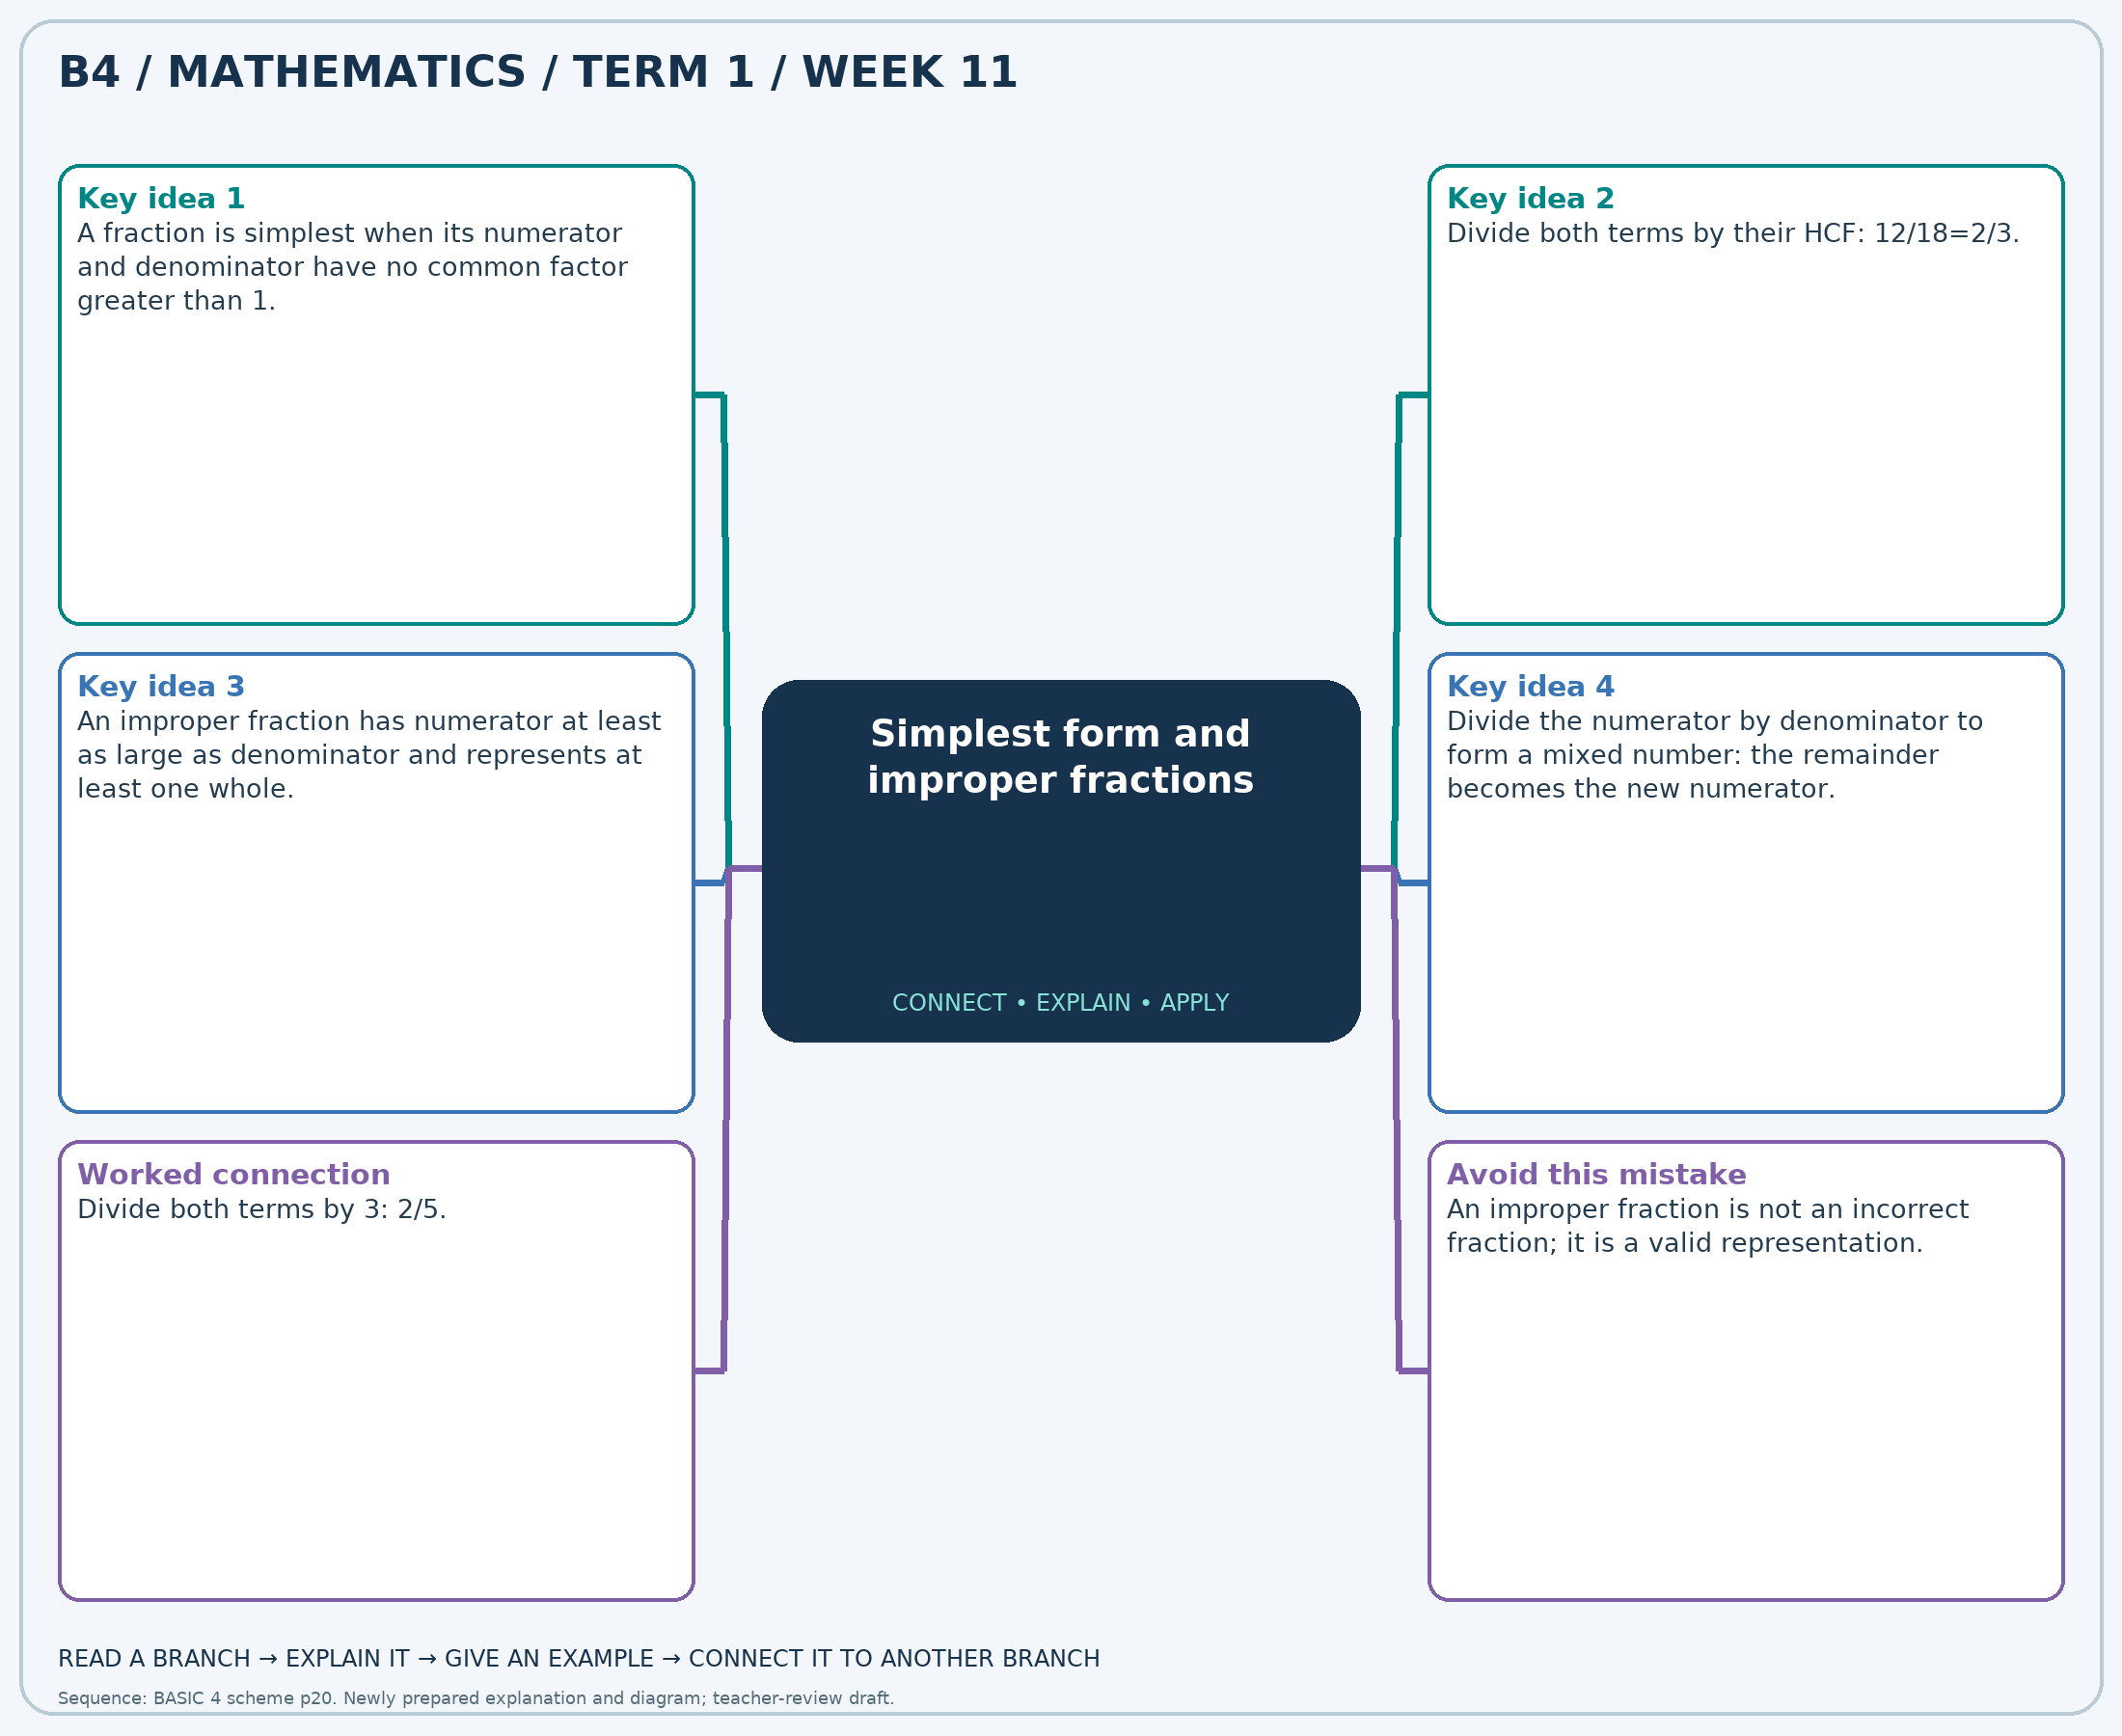
The separate high-resolution PNG can be projected or printed larger. Explain each branch and connect it with an example.

Week 11 — Practice

Section A — Multiple-choice questions
Choose ONE correct answer for each question. Each question has four alternatives.
1. Write 6/10 in simplest form.
A. 3/5 B. 13/5 C. -2/5 D. 8/5
2. Write 30/7 as a mixed number.
A. 5 2/7 B. 4 2/7 C. 4 2/8 D. 4 5/7
3. Write 5/25 in simplest form.
A. 11/5 B. 6/5 C. 1/5 D. -4/5
4. Write 6/42 in simplest form.
A. -6/7 B. 8/7 C. 1/7 D. 15/7
5. Write 18/7 as a mixed number.
A. 2 3/7 B. 3 4/7 C. 2 4/8 D. 2 4/7
6. Write 6/21 in simplest form.
A. 16/7 B. 9/7 C. -5/7 D. 2/7
7. Write 4/6 in simplest form.
A. 2/3 B. 8/3 C. -1/3 D. 5/3
8. Write 32/7 as a mixed number.
A. 4 3/7 B. 4 4/8 C. 5 4/7 D. 4 4/7
9. Write 12/18 in simplest form.
A. 5/3 B. 2/3 C. 8/3 D. -1/3
10. Write 9/33 in simplest form.
A. 25/11 B. 3/11 C. 14/11 D. -8/11
11. Write 18/5 as a mixed number.
A. 3 2/5 B. 3 3/5 C. 4 3/5 D. 3 3/6
12. Write 12/20 in simplest form.
A. 13/5 B. 8/5 C. 3/5 D. -2/5
13. Write 42/66 in simplest form.
A. 7/11 B. -4/11 C. 29/11 D. 18/11
14. Write 14/3 as a mixed number.
A. 4 2/4 B. 4 2/3 C. 5 2/3 D. 4 1/3
15. Write 6/18 in simplest form.
A. -2/3 B. 7/3 C. 4/3 D. 1/3
16. Write 28/44 in simplest form.
A. 7/11 B. 29/11 C. -4/11 D. 18/11
17. Write 31/11 as a mixed number.
A. 2 9/11 B. 2 2/11 C. 2 9/12 D. 3 9/11
18. Write 8/28 in simplest form.
A. 2/7 B. 16/7 C. 9/7 D. -5/7
19. Write 8/20 in simplest form.
A. -3/5 B. 7/5 C. 12/5 D. 2/5
20. Write 12/11 as a mixed number.
A. 1 1/11 B. 2 1/11 C. 1 10/11 D. 1 1/12

Section B — Structured essay questions
Answer every part (a), (b), (c). Show your method or explain your choice. Write in a separate answer booklet. Each part: 1 mark for valid working/explanation and 1 for the correct result; 6 marks per question.

1. Apply the related skills and show working or give a reason for each answer.
(a) Write 28/44 in simplest form.
(b) Write 4/3 as a mixed number.
(c) Write 4/12 in simplest form.

2. Apply the related skills and show working or give a reason for each answer.
(a) Write 22/5 as a mixed number.
(b) Write 36/44 in simplest form.
(c) Write 6/42 in simplest form.

3. Apply the related skills and show working or give a reason for each answer.
(a) Write 24/44 in simplest form.
(b) Write 6/9 in simplest form.
(c) Write 23/5 as a mixed number.

4. Apply the related skills and show working or give a reason for each answer.
(a) Write 15/25 in simplest form.
(b) Write 49/11 as a mixed number.
(c) Write 3/15 in simplest form.

5. Apply the related skills and show working or give a reason for each answer.
(a) Write 9/7 as a mixed number.
(b) Write 12/18 in simplest form.
(c) Write 10/15 in simplest form.

6. Apply the related skills and show working or give a reason for each answer.
(a) Write 6/15 in simplest form.
(b) Write 4/6 in simplest form.
(c) Write 12/11 as a mixed number.

7. Apply the related skills and show working or give a reason for each answer.
(a) Write 10/22 in simplest form.
(b) Write 17/5 as a mixed number.
(c) Write 4/6 in simplest form.

8. Apply the related skills and show working or give a reason for each answer.
(a) Write 45/11 as a mixed number.
(b) Write 24/30 in simplest form.
(c) Write 2/14 in simplest form.

9. Apply the related skills and show working or give a reason for each answer.
(a) Write 5/15 in simplest form.
(b) Write 12/15 in simplest form.
(c) Write 24/7 as a mixed number.

10. Apply the related skills and show working or give a reason for each answer.
(a) Write 20/55 in simplest form.
(b) Write 46/11 as a mixed number.
(c) Write 16/44 in simplest form.

Week 12 — Comparing fractions
Sequence source: BASIC 4 SCHEME OF LEARNING.pdf, first-term Mathematics, page 20. One consolidated weekly unit.

Learning outcomes
- Explain and apply comparing fractions, solve examples and justify the method.

Teaching notes and suggested sessions
Suggested schedule: five 40-minute sessions, adjusted to the school timetable. Spread the question bank through the week; it is not intended to be completed in one lesson.

1 — Explore and diagnose
5 minutes: recall an earlier skill; 10: demonstrate a concrete or pictorial model; 15: pairs investigate and explain; 10: identify a misconception and set an exit task.

2 — Model and practise
5 minutes: review the exit task; 10: work an example aloud; 15: pairs solve parallel examples; 10: compare methods and correct errors.

3 — Connect representations
5 minutes: recall vocabulary; 10: explain the mind-map; 15: connect a model, a drawing and a symbolic calculation; 10: independent practice.

4 — Apply and explain
5 minutes: estimate or predict; 10: solve a contextual example; 15: attempt selected structured-question parts; 10: compare reasoning and check units.

5 — Check and respond
5 minutes: retrieve the main rule; 15: use selected MCQs diagnostically; 10: explain distractors and misconceptions; 10: reteach or extend in response to evidence.

Topic-specific activities
- Place fraction cards on a number line and justify each position.
Resources: board, pencils, number cards, counters, paper strips and squared paper as appropriate. Prior-knowledge check: ask a learner to explain a representation used in the first example before introducing a new rule.
Support: reduce number size without changing the concept; offer a partially completed chart or model; allow oral reasoning before writing. Extension: create a counterexample to a false rule and explain why it fails.

Study notes and worked examples

Comparing fractions
- Fractions must refer to the same-sized whole for a fair comparison.
- With the same denominator, compare numerators. With the same numerator, a smaller positive denominator gives a larger fraction.
- For unlike denominators, convert to a common denominator.
- Use 0, 1/2 and 1 as benchmarks to check an ordering.
Worked example: Which fraction is the greatest: 4/5, 1/10, 3/5, 7/8?
Solution: Use denominator 40: 4/5=32/40, 1/10=4/40, 3/5=24/40, 7/8=35/40. Answer: 7/8.
Common misconception: A larger denominator does not by itself mean a larger fraction.
Independent study: read the map, cover it and reconstruct the branches. Solve an unused question from each skill and explain the reasoning to a partner. Consult the teacher key only after an honest attempt.

Week 12 — Visual mind-map
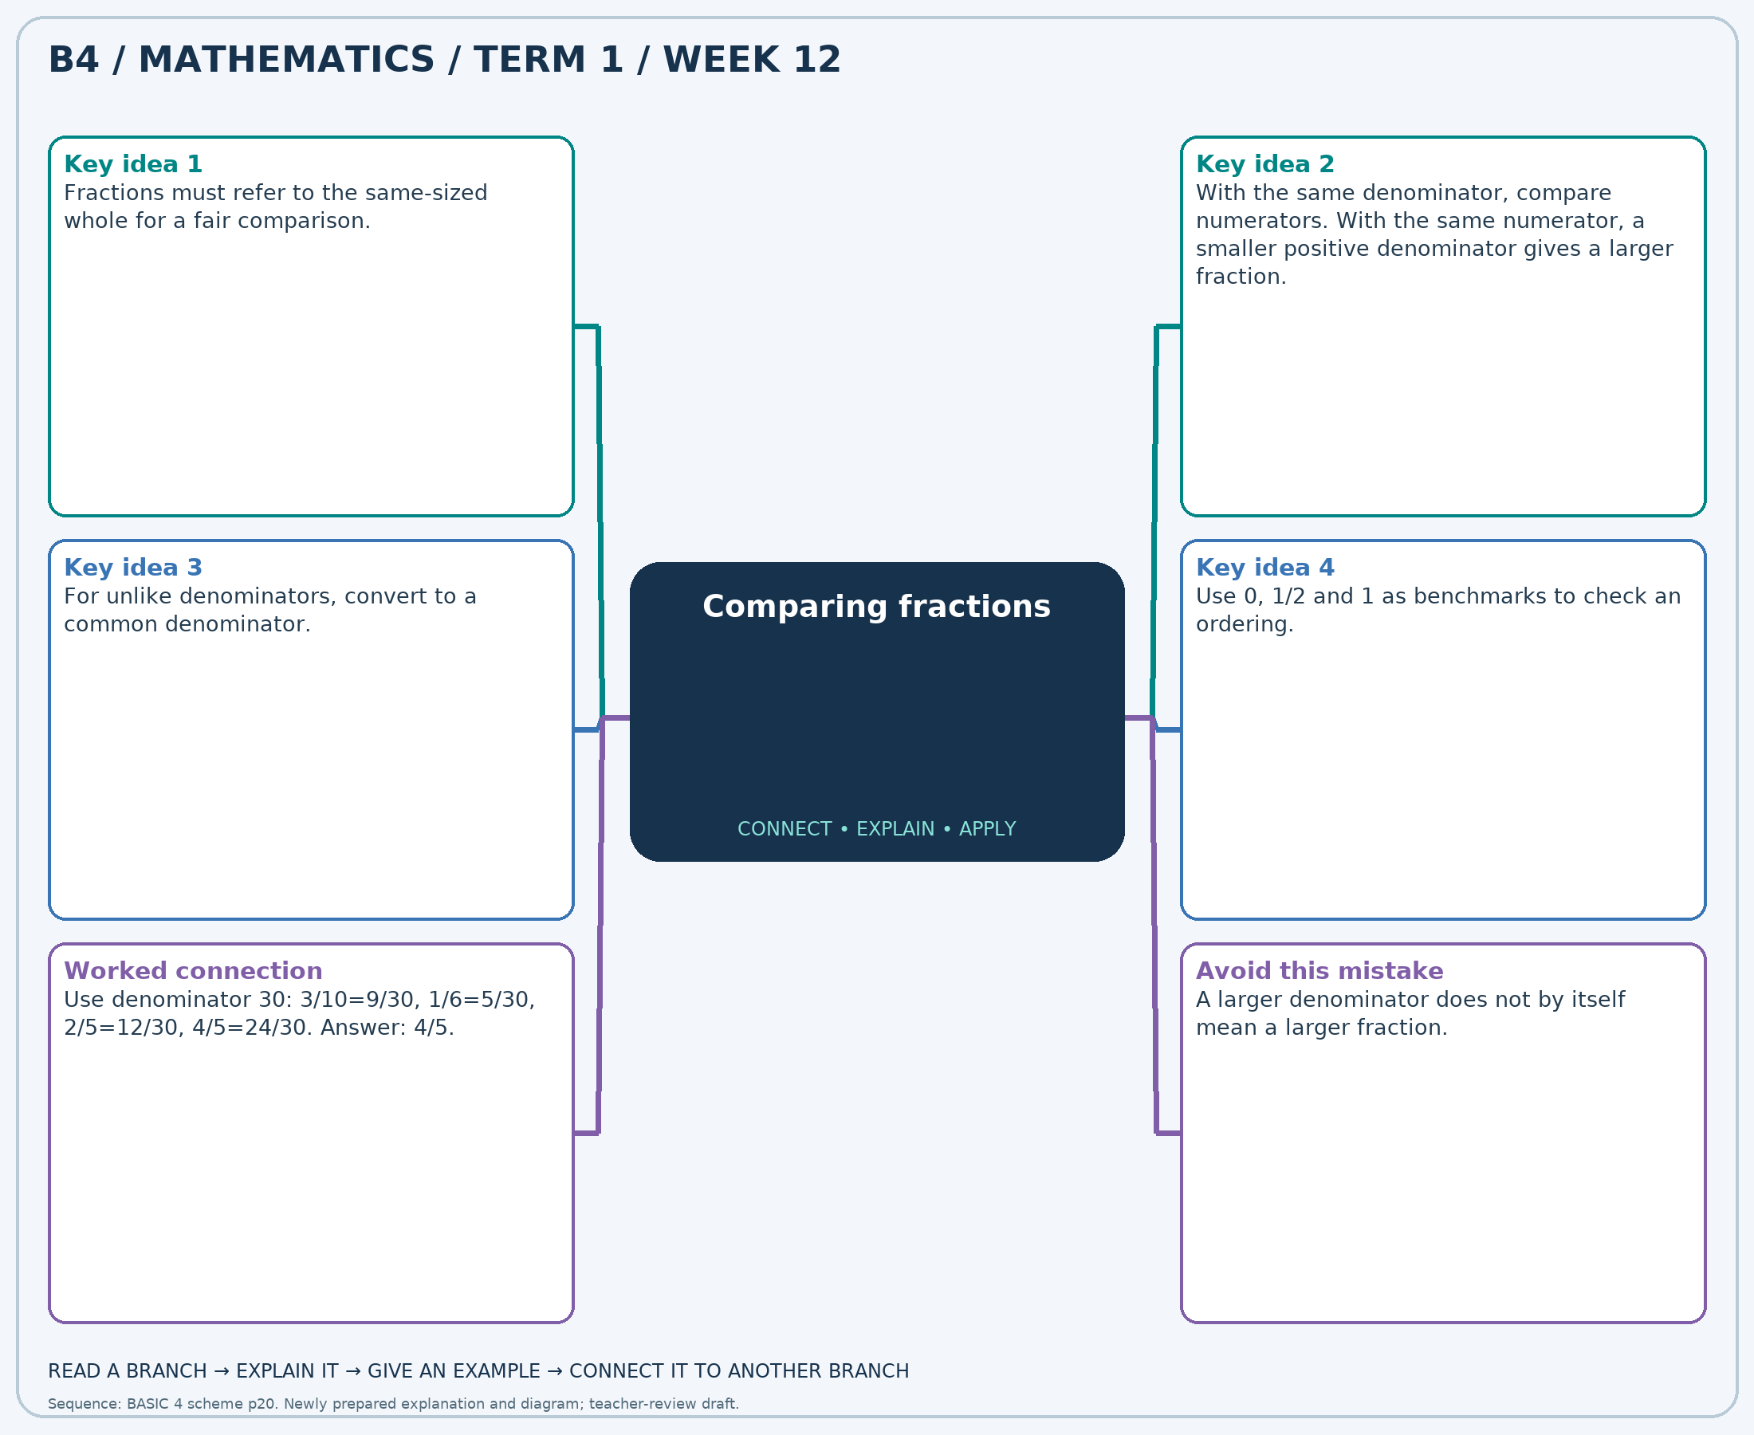
The separate high-resolution PNG can be projected or printed larger. Explain each branch and connect it with an example.

Week 12 — Practice

Section A — Multiple-choice questions
Choose ONE correct answer for each question. Each question has four alternatives.
1. Which fraction is the greatest: 5/12, 1/12, 9/10, 3/5?
A. 9/10 B. 1/12 C. 5/12 D. 3/5
2. Which fraction is the least: 9/10, 5/8, 7/10, 4/5?
A. 4/5 B. 9/10 C. 5/8 D. 7/10
3. Which fraction is the greatest: 7/8, 1/5, 1/6, 11/12?
A. 11/12 B. 1/5 C. 7/8 D. 1/6
4. Which fraction is the greatest: 1/10, 5/6, 1/8, 2/5?
A. 5/6 B. 1/8 C. 2/5 D. 1/10
5. Which fraction is the least: 1/4, 5/6, 4/5, 1/12?
A. 1/4 B. 1/12 C. 5/6 D. 4/5
6. Which fraction is the greatest: 7/8, 2/3, 9/10, 3/10?
A. 7/8 B. 9/10 C. 3/10 D. 2/3
7. Which fraction is the greatest: 11/12, 3/5, 4/5, 7/8?
A. 11/12 B. 7/8 C. 4/5 D. 3/5
8. Which fraction is the least: 5/12, 9/10, 1/2, 4/5?
A. 4/5 B. 1/2 C. 9/10 D. 5/12
9. Which fraction is the greatest: 1/10, 1/3, 1/12, 3/10?
A. 1/10 B. 1/12 C. 3/10 D. 1/3
10. Which fraction is the greatest: 1/6, 4/5, 3/8, 1/12?
A. 1/6 B. 3/8 C. 1/12 D. 4/5
11. Which fraction is the least: 2/5, 3/5, 5/12, 4/5?
A. 5/12 B. 3/5 C. 4/5 D. 2/5
12. Which fraction is the greatest: 1/12, 1/8, 7/12, 3/10?
A. 1/12 B. 1/8 C. 3/10 D. 7/12
13. Which fraction is the greatest: 2/5, 3/10, 4/5, 5/8?
A. 2/5 B. 4/5 C. 3/10 D. 5/8
14. Which fraction is the least: 1/5, 2/5, 7/8, 9/10?
A. 9/10 B. 1/5 C. 2/5 D. 7/8
15. Which fraction is the greatest: 3/10, 1/6, 9/10, 1/8?
A. 1/6 B. 3/10 C. 9/10 D. 1/8
16. Which fraction is the greatest: 1/3, 7/10, 1/4, 3/5?
A. 1/3 B. 3/5 C. 7/10 D. 1/4
17. Which fraction is the least: 7/12, 5/12, 9/10, 1/2?
A. 5/12 B. 7/12 C. 1/2 D. 9/10
18. Which fraction is the greatest: 5/8, 1/4, 1/3, 3/10?
A. 1/4 B. 3/10 C. 1/3 D. 5/8
19. Which fraction is the greatest: 3/10, 3/5, 1/8, 7/10?
A. 7/10 B. 3/5 C. 1/8 D. 3/10
20. Which fraction is the least: 1/10, 7/12, 11/12, 5/8?
A. 1/10 B. 11/12 C. 5/8 D. 7/12

Section B — Structured essay questions
Answer every part (a), (b), (c). Show your method or explain your choice. Write in a separate answer booklet. Each part: 1 mark for valid working/explanation and 1 for the correct result; 6 marks per question.

1. Apply the related skills and show working or give a reason for each answer.
(a) Which fraction is the greatest: 2/5, 1/8, 1/2, 7/10?
(b) Which fraction is the least: 1/12, 3/4, 3/10, 7/8?
(c) Which fraction is the greatest: 1/6, 4/5, 1/2, 5/6?

2. Apply the related skills and show working or give a reason for each answer.
(a) Which fraction is the least: 11/12, 2/3, 1/4, 1/12?
(b) Which fraction is the greatest: 7/8, 5/12, 7/12, 1/10?
(c) Which fraction is the greatest: 3/5, 7/10, 3/8, 5/6?

3. Apply the related skills and show working or give a reason for each answer.
(a) Which fraction is the greatest: 3/8, 3/10, 11/12, 1/8?
(b) Which fraction is the greatest: 5/12, 4/5, 2/5, 2/3?
(c) Which fraction is the least: 11/12, 5/12, 5/6, 3/5?

4. Apply the related skills and show working or give a reason for each answer.
(a) Which fraction is the greatest: 5/12, 1/5, 7/8, 4/5?
(b) Which fraction is the least: 7/12, 5/12, 1/2, 1/5?
(c) Which fraction is the greatest: 3/4, 1/8, 1/3, 11/12?

5. Apply the related skills and show working or give a reason for each answer.
(a) Which fraction is the least: 5/8, 1/6, 3/4, 11/12?
(b) Which fraction is the greatest: 5/12, 1/8, 7/8, 5/8?
(c) Which fraction is the greatest: 5/6, 2/3, 3/10, 1/3?

6. Apply the related skills and show working or give a reason for each answer.
(a) Which fraction is the greatest: 1/3, 7/10, 1/4, 5/8?
(b) Which fraction is the greatest: 9/10, 7/12, 3/8, 3/4?
(c) Which fraction is the least: 1/5, 5/8, 3/10, 1/12?

7. Apply the related skills and show working or give a reason for each answer.
(a) Which fraction is the greatest: 5/6, 3/10, 7/10, 11/12?
(b) Which fraction is the least: 7/10, 3/5, 1/6, 1/8?
(c) Which fraction is the greatest: 1/2, 1/5, 5/8, 1/6?

8. Apply the related skills and show working or give a reason for each answer.
(a) Which fraction is the least: 5/12, 9/10, 5/6, 2/3?
(b) Which fraction is the greatest: 4/5, 5/8, 9/10, 3/8?
(c) Which fraction is the greatest: 1/8, 1/3, 7/8, 1/6?

9. Apply the related skills and show working or give a reason for each answer.
(a) Which fraction is the greatest: 11/12, 2/5, 1/4, 2/3?
(b) Which fraction is the greatest: 1/8, 1/3, 1/4, 3/10?
(c) Which fraction is the least: 5/12, 1/8, 1/4, 1/5?

10. Apply the related skills and show working or give a reason for each answer.
(a) Which fraction is the greatest: 1/2, 1/6, 7/10, 1/4?
(b) Which fraction is the least: 3/10, 1/8, 7/12, 1/6?
(c) Which fraction is the greatest: 1/12, 1/2, 2/5, 7/8?

