Basic 4 Science — Week 1
  - Classifying insects, birds, mammals and reptiles • Term 1 • Week 1 ONLY
Name: __________________________________ Class: __________
Date: __________________ Teacher: ________________________
SCOPE: WEEK 1 ONLY. Later weeks and both tests for this subject are NOT included in this partial batch. Emergency teacher-review draft — rebuilt edition.
Sequence source: BASIC 4 SCHEME OF LEARNING.pdf, p24; indicator reference B4.1.1.1.1. Topic descriptions informed by the local curriculum data. Explanations and activities are newly prepared, including supporting concepts.

Learning outcomes
- Explain the key ideas in classifying insects, birds, mammals and reptiles using accurate vocabulary.
- Identify examples and justify classification or tool choices using evidence.
- Apply the ideas to familiar school or home situations and correct a common misconception.

Teacher lesson notes
One consolidated weekly unit. Suggested organisation: three 40-minute teaching sessions plus guided practice and assessment in the remaining timetable periods. Spread the questions over the week.
Prior knowledge: elicit a familiar example and ask for a reason. Record one correct idea and one misconception to revisit at the end of the week.

Session 1 — Observe
5 minutes: recall examples; 10: demonstrate or show pictures; 15: pairs describe features; 10: introduce the first five key terms and check explanations.

Session 2 — Investigate
5 minutes: retrieve vocabulary; 10: model an explanation; 15: perform the specific activity below; 10: compare observations and introduce the remaining terms.

Session 3 — Apply
5 minutes: correct a misconception; 10: explain map branches; 15: use application questions; 10: collect an exit response and identify who needs reteaching.

Topic-specific activity
Sort photographs of an ant, butterfly, hen, bat, goat, snake and lizard. Justify each group by body features, not habitat alone. Include a fish as an example outside the four target groups. Draw and label one representative of each target group.

Safety and resources
Use pictures; do not handle unknown animals, reptiles or stinging insects.
Resources: the examples or pictures specified in the activity, board, pencils, exercise books and the supplied visual map. If equipment is unavailable, use labelled drawings and role-play rather than claiming a practical was performed.

Support and extension
Support: offer picture labels, read technical vocabulary aloud and accept an oral explanation before writing. Extension: compare related concepts, propose a counterexample and justify a new application. Use wrong MCQ choices to diagnose misconceptions, not merely score letters.

Study notes

Insect
An animal in a group whose adults have six legs and three main body regions.
Adult ants and butterflies have six legs attached to the thorax. Wings alone are unreliable because not all insects have them and birds also have wings.

Bird
An animal belonging to the group characterised by feathers.
Feathers identify the group. Flight is not essential: hens and ostriches are birds even though their flight abilities differ.

Mammal
An animal in a group with hair at some life stage and milk production by females for their young.
Hair and feeding young with milk support classification as a mammal. Movement alone does not determine the group.

Reptile
An animal in a group generally characterised by dry scaly skin and breathing through lungs.
Snakes and lizards share these features. Snakes lack legs, so legs cannot be required for the group; fish scales also show why multiple features matter.

Thorax
The middle of the three main body regions of an insect, carrying its legs.
The thorax lies between the head and abdomen. Legs and, when present, wings attach there.

Antennae
Paired sensory structures on an insect’s head.
These structures detect environmental information such as touch and chemicals. They are not extra walking legs.

Feathers
The distinctive body covering of birds, helping insulation and in many birds flight.
Both have feathers despite different habits. Covering is useful classification evidence whereas habitat alone is not.

Hair
A characteristic mammalian covering that may be dense or sparse.
Goats have hair and females feed young with milk. Using more than one feature makes the classification stronger.

Backbone
An internal supporting structure shared by vertebrates.
Birds, mammals and reptiles have backbones. Insects have an external supporting covering and no backbone.

Classification
Grouping organisms according to shared features.
Good grouping uses consistent evidence about shared features. Colour, fear or whether an animal is liked is less useful for these biological groups.
Revision routine: cover each definition, explain the idea, supply a new example and compare it with a related term. Reconstruct the map from memory before checking it.

Week 1 — Visual mind-map
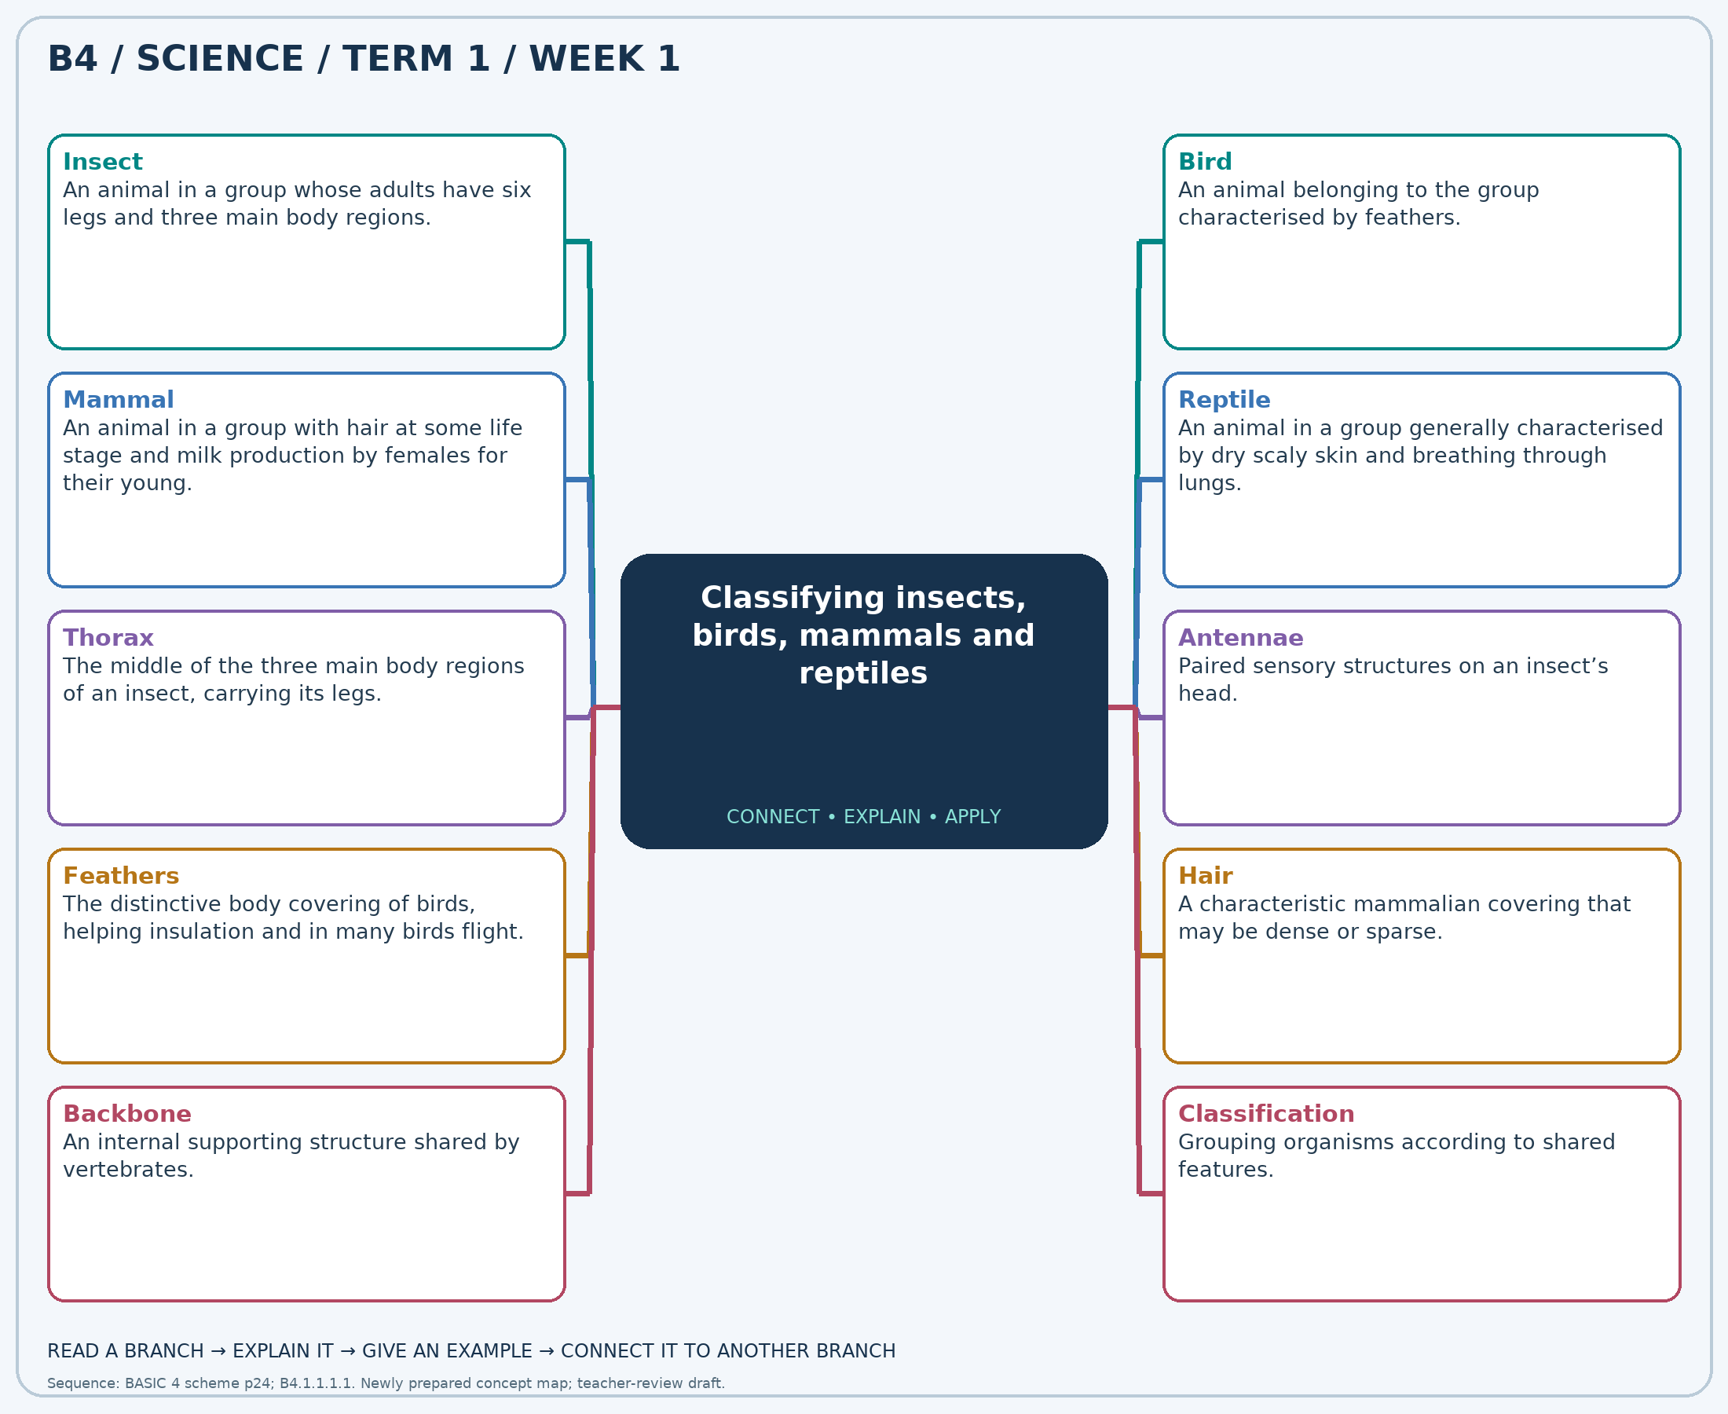
Explain each branch and supply another example. A separate high-resolution PNG is included.

Week 1 — Practice

Section A — Multiple-choice questions
Choose ONE correct answer for each question. Each question has four alternatives.
1. Which term best matches this description: an animal in a group whose adults have six legs and three main body regions?
A. Reptile B. Mammal C. Bird D. Insect
2. Which term best matches this description: an animal belonging to the group characterised by feathers?
A. Bird B. Mammal C. Insect D. Reptile
3. Which term best matches this description: an animal in a group with hair at some life stage and milk production by females for their young?
A. Insect B. Bird C. Mammal D. Reptile
4. Which term best matches this description: an animal in a group generally characterised by dry scaly skin and breathing through lungs?
A. Reptile B. Insect C. Bird D. Mammal
5. Which term best matches this description: the middle of the three main body regions of an insect, carrying its legs?
A. Abdomen B. Head C. Thorax D. Tail
6. Which term best matches this description: paired sensory structures on an insect’s head?
A. Antennae B. Feathers C. Scales D. Hooves
7. Which term best matches this description: the distinctive body covering of birds, helping insulation and in many birds flight?
A. Dry reptile scales B. Hair C. Feathers D. Insect shell
8. Which term best matches this description: a characteristic mammalian covering that may be dense or sparse?
A. Feathers B. Fish scales C. Insect wings D. Hair
9. Which term best matches this description: an internal supporting structure shared by vertebrates?
A. Backbone B. Feathers C. Antennae D. Six legs
10. Which term best matches this description: grouping organisms according to shared features?
A. Germination B. Condensation C. Evaporation D. Classification
11. An adult animal has six legs, antennae, a head, thorax and abdomen. Which group fits it?
A. Mammal B. Reptile C. Bird D. Insect
12. A hen cannot fly far but has feathers. In which group should it be classified?
A. Mammal B. Bird C. Reptile D. Insect
13. A bat flies but has hair and feeds its young milk. Which group includes it?
A. Bird B. Mammal C. Insect D. Reptile
14. An animal has dry scales, breathes with lungs and crawls on land. Which target group best fits it?
A. Mammal B. Reptile C. Bird D. Insect
15. Which insect body region should connect to all six legs in a butterfly drawing?
A. Abdomen B. Tail C. Head D. Thorax
16. An ant touches objects with two slender structures on its head. What are these?
A. Scales B. Feathers C. Hooves D. Antennae
17. A duck and a hen share which distinctive body covering?
A. Hair B. Feathers C. Insect shell D. Dry reptile scales
18. Which covering on a goat helps distinguish it from a hen?
A. Hair B. Feathers C. Fish scales D. Insect wings
19. A hen, goat and lizard share which structure that an insect lacks?
A. Antennae B. Feathers C. Six legs D. Backbone
20. Pupils group animal cards using covering, leg number and feeding of young. What process are they using?
A. Germination B. Condensation C. Classification D. Evaporation

Section B — 10 structured essay questions
Answer every part (a), (b), (c) in your exercise book. Suggested marks: (a) 1, (b) 1, (c) 2, giving 4 marks per question. Explain relationships and use examples where requested.

Question 1
(a) Explain the term “Insect”.
(b) An adult animal has six legs, antennae, a head, thorax and abdomen. Which group fits it?
(c) Explain why legs and body regions are better evidence than wings alone when identifying an adult insect.

Question 2
(a) Explain the term “Bird”.
(b) A hen cannot fly far but has feathers. In which group should it be classified?
(c) Explain why an ostrich remains in this group even though it cannot fly.

Question 3
(a) Explain the term “Mammal”.
(b) A bat flies but has hair and feeds its young milk. Which group includes it?
(c) Explain how a bat and a goat can belong to the same group despite moving differently.

Question 4
(a) Explain the term “Reptile”.
(b) An animal has dry scales, breathes with lungs and crawls on land. Which target group best fits it?
(c) Explain why lacking legs does not prevent a snake from belonging to this group.

Question 5
(a) Explain the term “Thorax”.
(b) Which insect body region should connect to all six legs in a butterfly drawing?
(c) Describe the location of this region and state what attaches to it.

Question 6
(a) Explain the term “Antennae”.
(b) An ant touches objects with two slender structures on its head. What are these?
(c) Explain why an insect with two of these structures still has six legs.

Question 7
(a) Explain the term “Feathers”.
(b) A duck and a hen share which distinctive body covering?
(c) Explain how this covering supports grouping a hen and a duck together.

Question 8
(a) Explain the term “Hair”.
(b) Which covering on a goat helps distinguish it from a hen?
(c) Give two features that support classifying a goat as a mammal.

Question 9
(a) Explain the term “Backbone”.
(b) A hen, goat and lizard share which structure that an insect lacks?
(c) Explain how this structure separates an insect from a bird without referring to wings.

Question 10
(a) Explain the term “Classification”.
(b) Pupils group animal cards using covering, leg number and feeding of young. What process are they using?
(c) Explain why grouping only by colour is less useful than grouping by body structure.

