Basic 5 Computing — Week 1
  - Output devices and analogue/digital representation • Term 1 • Week 1 ONLY
Name: __________________________________ Class: __________
Date: __________________ Teacher: ________________________
SCOPE: WEEK 1 ONLY. Later weeks and both tests for this subject are NOT included in this partial batch. Emergency teacher-review draft — rebuilt edition.
Sequence source: BASIC 5 SCHEME OF LEARNING.pdf, p54; indicator reference B5.1.1.1.1–3. Topic descriptions informed by the local curriculum data. Explanations and activities are newly prepared, including supporting concepts.

Learning outcomes
- Explain the key ideas in output devices and analogue/digital representation using accurate vocabulary.
- Identify examples and justify classification or tool choices using evidence.
- Apply the ideas to familiar school or home situations and correct a common misconception.

Teacher lesson notes
One consolidated weekly unit. Suggested organisation: three 40-minute teaching sessions plus guided practice and assessment in the remaining timetable periods. Spread the questions over the week.
Prior knowledge: elicit a familiar example and ask for a reason. Record one correct idea and one misconception to revisit at the end of the week.

Session 1 — Observe
5 minutes: recall examples; 10: demonstrate or show pictures; 15: pairs describe features; 10: introduce the first five key terms and check explanations.

Session 2 — Investigate
5 minutes: retrieve vocabulary; 10: model an explanation; 15: perform the specific activity below; 10: compare observations and introduce the remaining terms.

Session 3 — Apply
5 minutes: correct a misconception; 10: explain map branches; 15: use application questions; 10: collect an exit response and identify who needs reteaching.

Topic-specific activity
Match a screen, printout, speakers and projector to classroom tasks. Compare a continuously moving pointer with a numeric display. Distinguish representation from the entire internal design of a device.

Safety and resources
Keep audio at a safe volume. Do not touch hot printer parts or remove equipment covers.
Resources: the examples or pictures specified in the activity, board, pencils, exercise books and the supplied visual map. If equipment is unavailable, use labelled drawings and role-play rather than claiming a practical was performed.

Support and extension
Support: offer picture labels, read technical vocabulary aloud and accept an oral explanation before writing. Extension: compare related concepts, propose a counterexample and justify a new application. Use wrong MCQ choices to diagnose misconceptions, not merely score letters.

Study notes

Output device
Equipment presenting information from a computer to a user.
The information travels outward to the user. Input travels into the computer instead.

Monitor
A device providing visual output on a screen.
An electronic preview can be corrected before paper is used, reducing unnecessary printing.

Printer
A device producing a physical copy on paper or another suitable material.
Check the document and permission to print, then ensure paper and ink or toner are available.

Speakers
Devices providing audible output to nearby listeners.
Clear sound needs suitable placement and volume. Excessive volume can harm hearing or disturb other classes.

Headphones
Devices providing sound output mainly to the wearer.
They reduce disturbance but still require a safe volume. A headset may add a microphone, whereas listening alone is output.

Projector
A device displaying an enlarged visual image on a screen or wall.
A suitable light-coloured surface and controlled room lighting improve visibility; learners need an unobstructed view.

Hard copy
Information in a physically printed form.
A printed copy is readable without a screen. A digital copy is easier to update, but requires a suitable device to view.

Soft copy
Information in electronic form, commonly viewed on a screen.
An electronic document can be edited and redistributed without reprinting all copies. Access still depends on an appropriate device.

Analogue representation
A representation varying continuously with the quantity represented.
Pointer position can vary continuously. This example concerns the displayed representation, not a claim about all internal electronics.

Digital representation
A representation using distinct values or symbols rather than a continuous range of states.
Distinct symbols encode separate values. Digital computers commonly use binary states to encode information.
Revision routine: cover each definition, explain the idea, supply a new example and compare it with a related term. Reconstruct the map from memory before checking it.

Week 1 — Visual mind-map
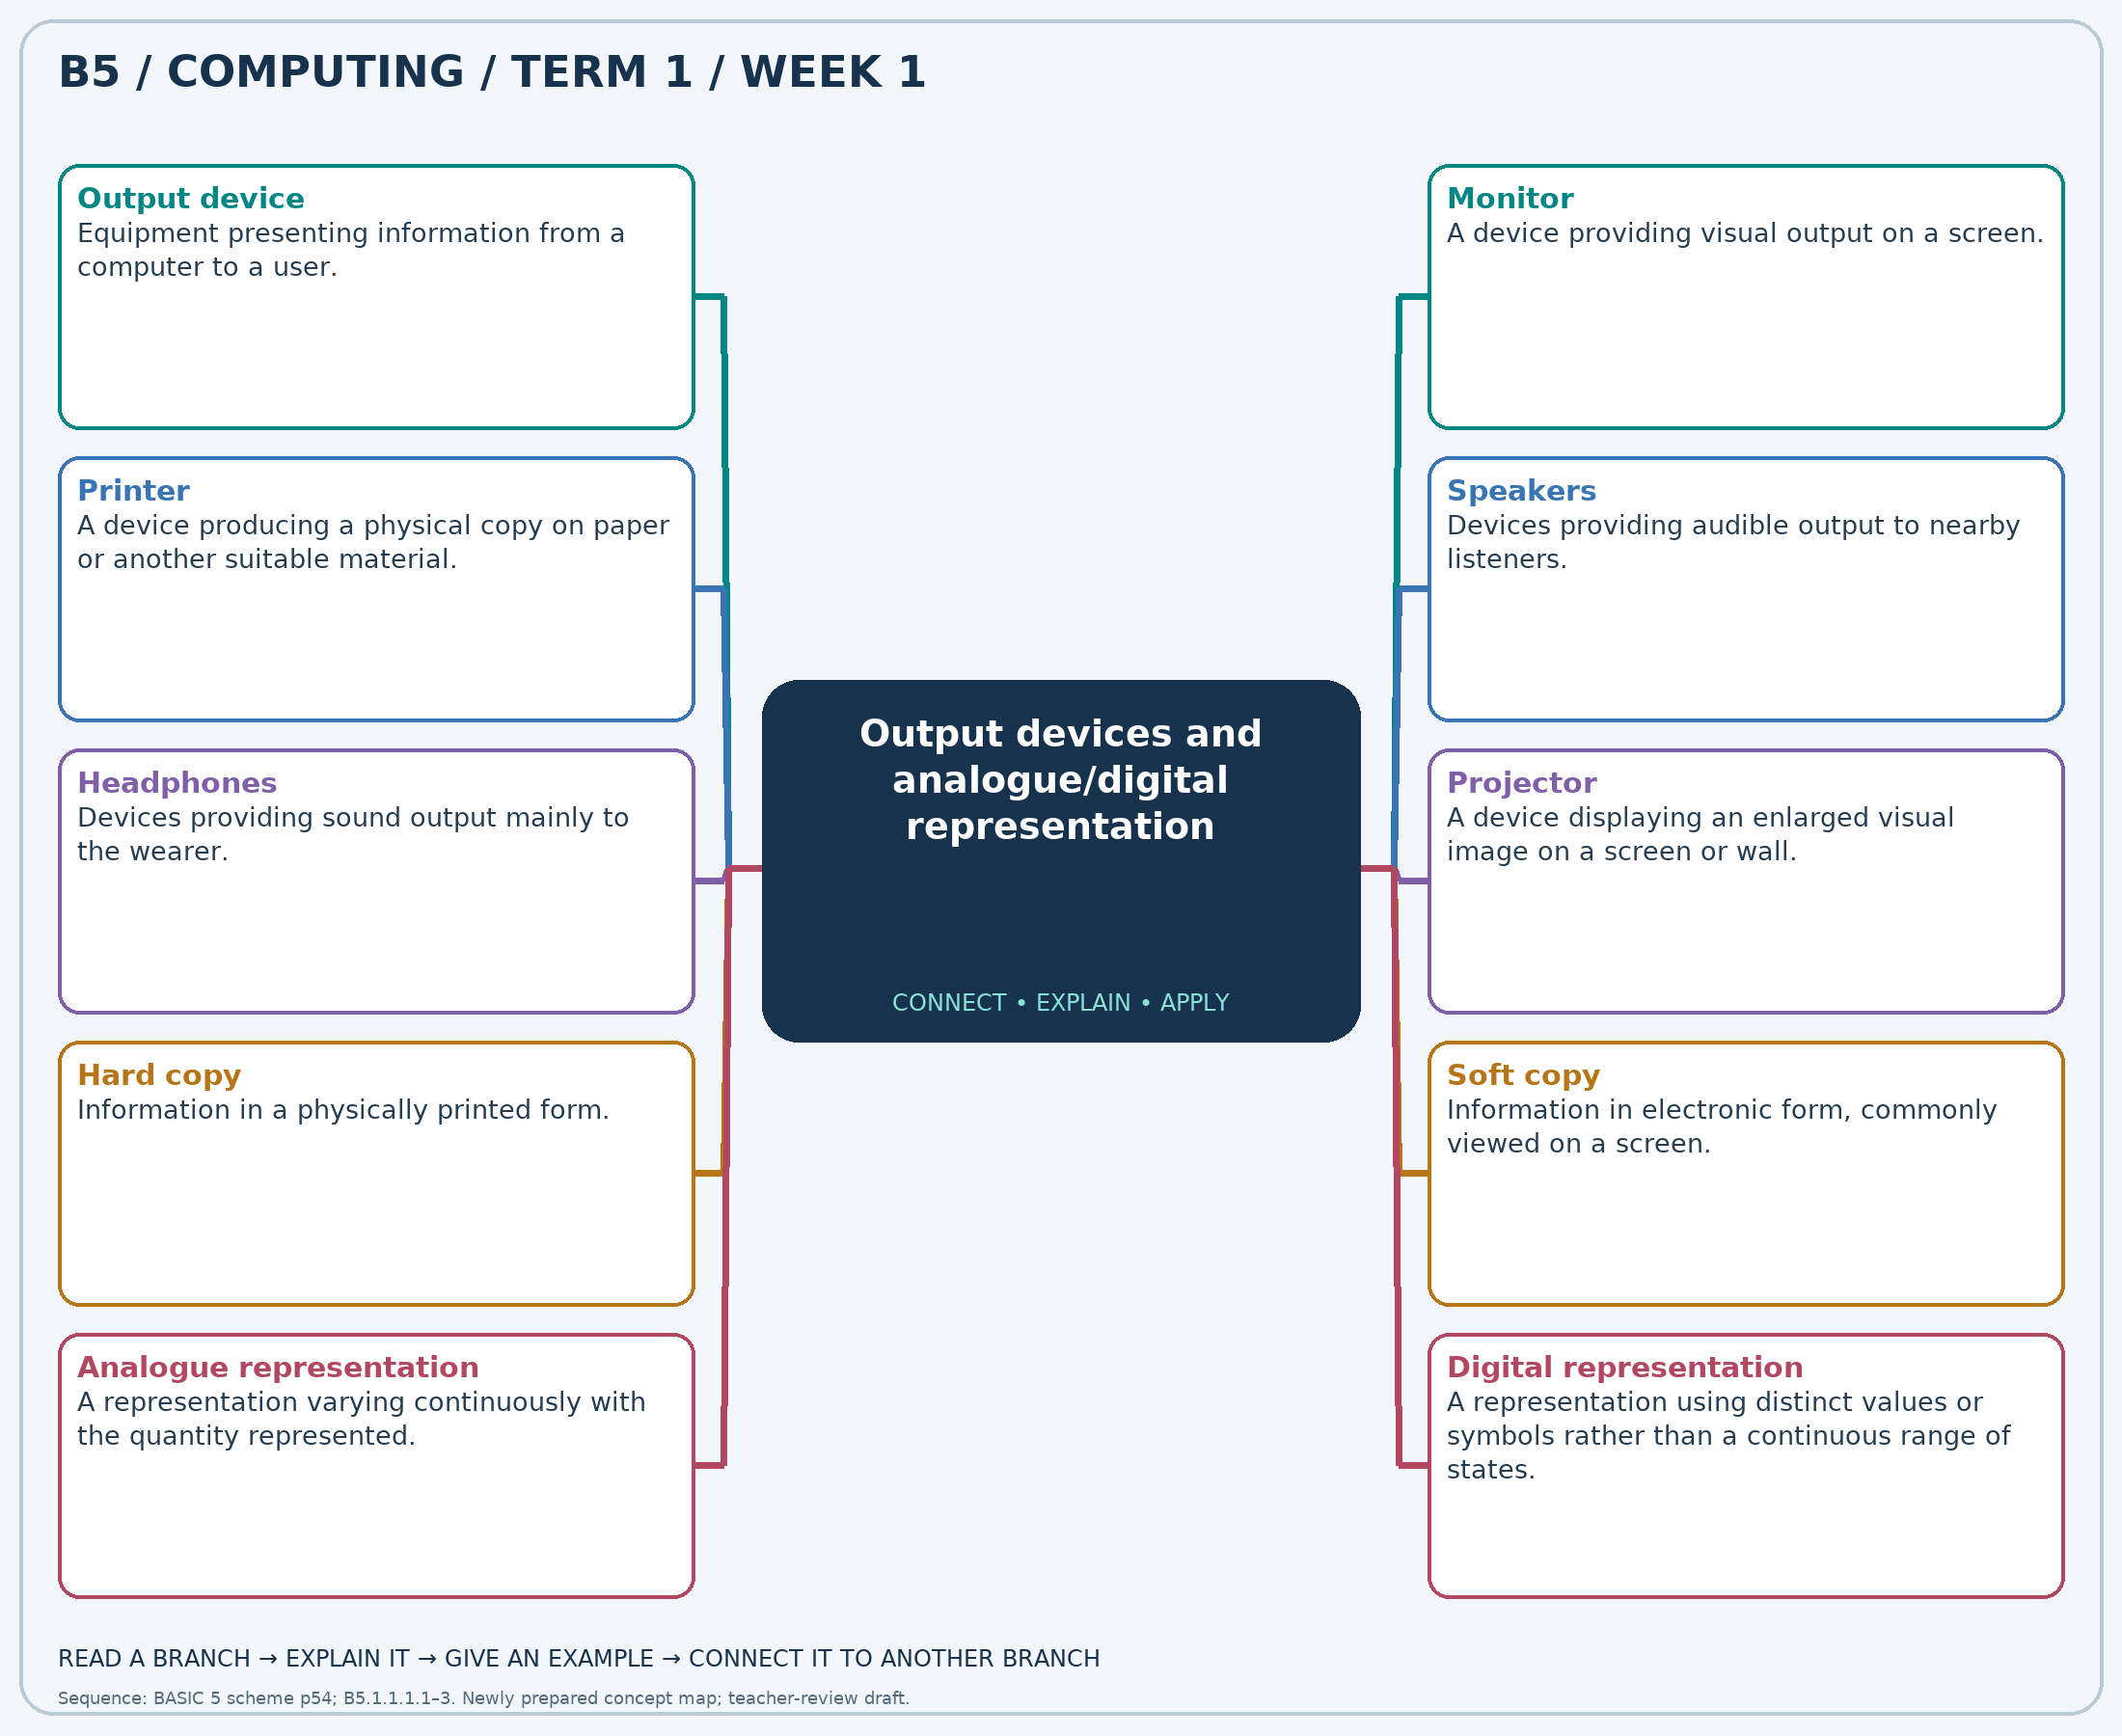
Explain each branch and supply another example. A separate high-resolution PNG is included.

Week 1 — Practice

Section A — Multiple-choice questions
Choose ONE correct answer for each question. Each question has four alternatives.
1. Which term best matches this description: equipment presenting information from a computer to a user?
A. Storage medium B. Input device C. Output device D. Processing unit
2. Which term best matches this description: a device providing visual output on a screen?
A. Scanner B. Mouse C. Monitor D. Keyboard
3. Which term best matches this description: a device producing a physical copy on paper or another suitable material?
A. Microphone B. Mouse C. Printer D. Keyboard
4. Which term best matches this description: devices providing audible output to nearby listeners?
A. Scanner B. Mouse C. Keyboard D. Speakers
5. Which term best matches this description: devices providing sound output mainly to the wearer?
A. Headphones B. Printer C. Scanner D. Projector
6. Which term best matches this description: a device displaying an enlarged visual image on a screen or wall?
A. Microphone B. Projector C. Mouse D. Keyboard
7. Which term best matches this description: information in a physically printed form?
A. Hard copy B. Program code only C. Audio signal D. Soft copy
8. Which term best matches this description: information in electronic form, commonly viewed on a screen?
A. Paper record B. Soft copy C. Printed photograph D. Hard copy
9. Which term best matches this description: a representation varying continuously with the quantity represented?
A. Printed code only B. Binary file only C. Digital representation D. Analogue representation
10. Which term best matches this description: a representation using distinct values or symbols rather than a continuous range of states?
A. Continuous dial position B. Unmarked liquid level C. Digital representation D. Analogue representation
11. A computer sends a finished picture to a screen. Which device category does the screen belong to?
A. Processing unit B. Output device C. Input device D. Storage medium
12. Which device lets a learner preview a poster without printing it?
A. Scanner B. Keyboard C. Mouse D. Monitor
13. A school needs paper copies of a letter for parents. Which device is suitable?
A. Microphone B. Printer C. Keyboard D. Mouse
14. The whole class listens to a recorded story. Which devices can play it aloud?
A. Speakers B. Mouse C. Scanner D. Keyboard
15. One learner needs pronunciation practice without disturbing others. Which device is suitable?
A. Scanner B. Printer C. Headphones D. Projector
16. A teacher wants the whole class to see a presentation. Which output device is suitable?
A. Mouse B. Projector C. Keyboard D. Microphone
17. A pupil holds a printed timetable. Which form of output is it?
A. Program code only B. Soft copy C. Audio signal D. Hard copy
18. A timetable is opened on a tablet but not printed. Which form is being viewed?
A. Soft copy B. Paper record C. Hard copy D. Printed photograph
19. A pointer moves smoothly as a measured value changes. Which representation is illustrated?
A. Printed code only B. Binary file only C. Analogue representation D. Digital representation
20. A counter shows 101 and then 102 as separate numeric steps. Which representation is illustrated?
A. Analogue representation B. Continuous dial position C. Digital representation D. Unmarked liquid level

Section B — 10 structured essay questions
Answer every part (a), (b), (c) in your exercise book. Suggested marks: (a) 1, (b) 1, (c) 2, giving 4 marks per question. Explain relationships and use examples where requested.

Question 1
(a) Explain the term “Output device”.
(b) A computer sends a finished picture to a screen. Which device category does the screen belong to?
(c) Explain how information direction distinguishes input and output.

Question 2
(a) Explain the term “Monitor”.
(b) Which device lets a learner preview a poster without printing it?
(c) Explain how previewing can save paper.

Question 3
(a) Explain the term “Printer”.
(b) A school needs paper copies of a letter for parents. Which device is suitable?
(c) State two checks or resources needed before printing a class set of letters.

Question 4
(a) Explain the term “Speakers”.
(b) The whole class listens to a recorded story. Which devices can play it aloud?
(c) Explain two considerations for classroom audio output.

Question 5
(a) Explain the term “Headphones”.
(b) One learner needs pronunciation practice without disturbing others. Which device is suitable?
(c) Explain why these devices suit independent audio practice.

Question 6
(a) Explain the term “Projector”.
(b) A teacher wants the whole class to see a presentation. Which output device is suitable?
(c) Describe two arrangements that improve a projected image.

Question 7
(a) Explain the term “Hard copy”.
(b) A pupil holds a printed timetable. Which form of output is it?
(c) Compare one advantage of printed and electronic timetables.

Question 8
(a) Explain the term “Soft copy”.
(b) A timetable is opened on a tablet but not printed. Which form is being viewed?
(c) Explain why this form is useful when a timetable changes.

Question 9
(a) Explain the term “Analogue representation”.
(b) A pointer moves smoothly as a measured value changes. Which representation is illustrated?
(c) Explain continuous change using the pointer example.

Question 10
(a) Explain the term “Digital representation”.
(b) A counter shows 101 and then 102 as separate numeric steps. Which representation is illustrated?
(c) Contrast the counter with a smoothly moving dial pointer.

