Basic 5 Mathematics
  - Term 1 • Weeks 1–12 • Lesson notes, study notes, mind-maps and weekly practice
Name: __________________________________ Class: __________
Date: __________________ Teacher: ________________________
EMERGENCY TEACHER-REVIEW DRAFT — REBUILT EDITION. Topic order follows the supplied Alpha Examinations first-term scheme. Notes, examples and diagrams are newly prepared. This is not an official curriculum approval or a guarantee of full indicator-by-indicator validation.
Each week contains one consolidated weekly lesson unit, one visual mind-map, 20 four-option MCQs and 10 structured questions with parts (a), (b), (c). Daily sessions are suggested, not separate full daily lesson plans. Answers are in the separate teacher book.
The source reserves Weeks 13–15 for revision/examinations/vacation. Mid-term assessment assumes Weeks 1–6; end-of-term assumes Weeks 1–12. Confirm school dates and pacing. Some task structures repeat with new values for fluency practice.

Weekly contents
01 — Place value and expanded form / Reading and writing large numbers / Number charts and counting steps
02 — Comparing and ordering whole numbers / Rounding whole numbers / Skip counting
03 — Roman numerals
04 — Factors, primes and even numbers
05 — Highest common factor / Lowest common multiple
06 — Multiplication strategies
07 — Multiplication strategies / Division and checking
08 — Multi-step number problems / Positive and negative integers
09 — Equivalent fractions / Comparing fractions
10 — Adding and subtracting fractions
11 — Multiplying fractions and finding a fraction of a quantity
12 — Percentages

Week 1 — Place value and expanded form / Reading and writing large numbers / Number charts and counting steps
Sequence source: BASIC 5 SCHEME OF LEARNING.pdf, first-term Mathematics, page 22. One consolidated weekly unit.

Learning outcomes
- Explain and apply place value and expanded form, solve examples and justify the method.
- Explain and apply reading and writing large numbers, solve examples and justify the method.
- Explain and apply number charts and counting steps, solve examples and justify the method.

Teaching notes and suggested sessions
Suggested schedule: five 40-minute sessions, adjusted to the school timetable. Spread the question bank through the week; it is not intended to be completed in one lesson.

1 — Explore and diagnose
5 minutes: recall an earlier skill; 10: demonstrate a concrete or pictorial model; 15: pairs investigate and explain; 10: identify a misconception and set an exit task.

2 — Model and practise
5 minutes: review the exit task; 10: work an example aloud; 15: pairs solve parallel examples; 10: compare methods and correct errors.

3 — Connect representations
5 minutes: recall vocabulary; 10: explain the mind-map; 15: connect a model, a drawing and a symbolic calculation; 10: independent practice.

4 — Apply and explain
5 minutes: estimate or predict; 10: solve a contextual example; 15: attempt selected structured-question parts; 10: compare reasoning and check units.

5 — Check and respond
5 minutes: retrieve the main rule; 15: use selected MCQs diagnostically; 10: explain distractors and misconceptions; 10: reteach or extend in response to evidence.

Topic-specific activities
- Build numbers with digit cards on a place-value chart. Exchange two digits and explain the change.
- Partners dictate numbers and write figures, checking every place on a chart.
- Draw a five-by-ten chart. Cover entries and reconstruct them from neighbouring numbers.
Resources: board, pencils, number cards, counters, paper strips and squared paper as appropriate. Prior-knowledge check: ask a learner to explain a representation used in the first example before introducing a new rule.
Support: reduce number size without changing the concept; offer a partially completed chart or model; allow oral reasoning before writing. Extension: create a counterexample to a false rule and explain why it fails.

Study notes and worked examples

Place value and expanded form
- Our system is base ten. Ten units in one place exchange for one unit in the next place to the left.
- The digit 3 in 43,216 has value 3,000. Face value and place value are different.
- Expanded form shows a sum of place values: 43,216 = 40,000 + 3,000 + 200 + 10 + 6.
- Zero holds an empty place. Removing the zero from 40,216 changes the number.
Worked example: What is the value of the digit in the tens place in 712,321?
Solution: The digit is 2; 2 × 10 = 20.
Common misconception: Do not confuse the digit itself with the value of the place it occupies.

Reading and writing large numbers
- Group digits in threes from the right: ones, thousands, millions and billions.
- Read each non-zero group, followed by its scale name.
- When writing figures from words, put zeros in the places not named.
- Six hundred and three thousand and eight is 603,008. Read the result back to check it.
Worked example: Write in figures: six hundred and thirty-three thousand, one hundred and thirty-four.
Solution: Place each named group in its correct scale: 633,134.
Common misconception: Do not write 603,800 for six hundred and three thousand and eight.

Number charts and counting steps
- A number chart has a stated number of columns and a regular step along each row.
- In a ten-column chart counting in ones, moving right adds 1 and moving down adds 10.
- Moving left or up reverses the appropriate change.
- If the chart counts in tens, a ten-column downward move adds 100. Always check both width and step.
Worked example: A 5-column chart increases by 10 along each row. 11,950 is an interior entry. What number is immediately right it?
Solution: Change = +10; 11,950 +10 = 11,960.
Common misconception: A downward move does not always add 10; the width and counting step determine the change.
Independent study: read the map, cover it and reconstruct the branches. Solve an unused question from each skill and explain the reasoning to a partner. Consult the teacher key only after an honest attempt.

Week 1 — Visual mind-map
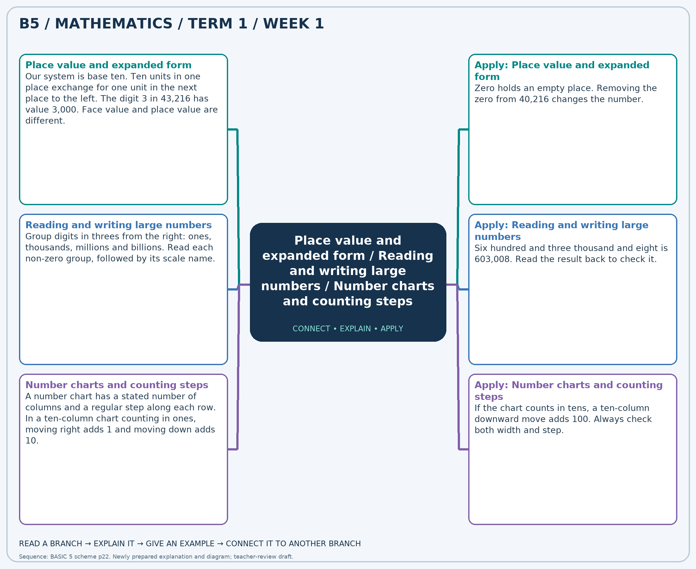
The separate high-resolution PNG can be projected or printed larger. Explain each branch and connect it with an example.

Week 1 — Practice

Section A — Multiple-choice questions
Choose ONE correct answer for each question. Each question has four alternatives.
1. What is the value of the digit in the ten-thousands place in 865,515?
A. 6000 B. 600000 C. 6 D. 60000
2. Write in figures: three hundred and sixteen thousand, six hundred and ninety.
A. 316790 B. 317690 C. 316690 D. 315690
3. A 10-column chart increases by 1 along each row. 43,900 is an interior entry. What number is immediately right it?
A. 43899 B. 43901 C. 43900 D. 43902
4. A number has 6 ten-thousands, 3 hundreds and 8 ones, with zeros elsewhere. Write it in figures.
A. 63008 B. 60308 C. 6308 D. 60380
5. Write in figures: three hundred and sixty-six thousand, eight hundred and sixty-three.
A. 365863 B. 366863 C. 367863 D. 366963
6. A 5-column chart increases by 10 along each row. 14,240 is an interior entry. What number is immediately below it?
A. 14290 B. 14340 C. 14190 D. 14240
7. What is the value of the digit in the thousands place in 941,437?
A. 1000 B. 10000 C. 100 D. 1
8. Write in figures: three hundred and thirty-four thousand, five hundred and seventy-seven.
A. 334577 B. 334677 C. 333577 D. 335577
9. A 10-column chart increases by 10 along each row. 53,660 is an interior entry. What number is immediately left it?
A. 53660 B. 53640 C. 53650 D. 53670
10. What is the value of the digit in the hundreds place in 746,262?
A. 2000 B. 20 C. 2 D. 200
11. Write in figures: seven hundred and three thousand, two hundred and seventy-five.
A. 702275 B. 703375 C. 704275 D. 703275
12. A 5-column chart increases by 1 along each row. 17,750 is an interior entry. What number is immediately below it?
A. 17755 B. 17750 C. 17745 D. 17760
13. A number has 8 ten-thousands, 4 hundreds and 6 ones, with zeros elsewhere. Write it in figures.
A. 84006 B. 80460 C. 8406 D. 80406
14. Write in figures: seven hundred and twenty-four thousand, three hundred and sixty-six.
A. 724466 B. 724366 C. 723366 D. 725366
15. A 10-column chart increases by 10 along each row. 85,910 is an interior entry. What number is immediately left it?
A. 85890 B. 85920 C. 85910 D. 85900
16. What is the value of the digit in the hundreds place in 756,323?
A. 3000 B. 30 C. 300 D. 3
17. Write in figures: seven hundred and twelve thousand, nine hundred and ninety-six.
A. 713996 B. 711996 C. 712996 D. 713096
18. A 10-column chart increases by 50 along each row. 73,180 is an interior entry. What number is immediately below it?
A. 74180 B. 73180 C. 72680 D. 73680
19. What is the value of the digit in the ten-thousands place in 868,975?
A. 600000 B. 6000 C. 60000 D. 6
20. Write in figures: six hundred and fourteen thousand, six hundred and forty-eight.
A. 614748 B. 614648 C. 615648 D. 613648

Section B — Structured essay questions
Answer every part (a), (b), (c). Show your method or explain your choice. Write in a separate answer booklet. Each part: 1 mark for valid working/explanation and 1 for the correct result; 6 marks per question.

1. Apply the related skills and show working or give a reason for each answer.
(a) What is the value of the digit in the ten-thousands place in 843,323?
(b) Write in figures: seven hundred and eighty-nine thousand, four hundred and ninety-six.
(c) A 5-column chart increases by 50 along each row. 30,500 is an interior entry. What number is immediately right it?

2. Apply the related skills and show working or give a reason for each answer.
(a) Write in figures: two hundred and sixty-six thousand, two hundred and thirteen.
(b) A 10-column chart increases by 50 along each row. 22,180 is an interior entry. What number is immediately left it?
(c) What is the value of the digit in the ten-thousands place in 895,657?

3. Apply the related skills and show working or give a reason for each answer.
(a) A 5-column chart increases by 50 along each row. 14,330 is an interior entry. What number is immediately above it?
(b) What is the value of the digit in the hundreds place in 731,406?
(c) Write in figures: five hundred and fifty-seven thousand, two hundred and sixty-six.

4. Apply the related skills and show working or give a reason for each answer.
(a) What is the value of the digit in the thousands place in 937,823?
(b) Write in figures: six hundred and seventeen thousand, three hundred and ninety.
(c) A 10-column chart increases by 50 along each row. 28,650 is an interior entry. What number is immediately left it?

5. Apply the related skills and show working or give a reason for each answer.
(a) Write in figures: eight hundred and forty-six thousand and eighty-two.
(b) A 10-column chart increases by 1 along each row. 16,670 is an interior entry. What number is immediately right it?
(c) What is the value of the digit in the tens place in 399,549?

6. Apply the related skills and show working or give a reason for each answer.
(a) A 10-column chart increases by 50 along each row. 12,080 is an interior entry. What number is immediately right it?
(b) What is the value of the digit in the tens place in 506,487?
(c) Write in figures: nine hundred and sixty-one thousand, five hundred and sixty-nine.

7. Apply the related skills and show working or give a reason for each answer.
(a) What is the value of the digit in the thousands place in 277,287?
(b) Write in figures: six hundred and eighty thousand and forty-nine.
(c) A 10-column chart increases by 1 along each row. 24,190 is an interior entry. What number is immediately above it?

8. Apply the related skills and show working or give a reason for each answer.
(a) Write in figures: eight hundred and seventeen thousand, nine hundred and ninety-two.
(b) A 10-column chart increases by 10 along each row. 80,570 is an interior entry. What number is immediately below it?
(c) What is the value of the digit in the ten-thousands place in 513,492?

9. Apply the related skills and show working or give a reason for each answer.
(a) A 10-column chart increases by 10 along each row. 77,910 is an interior entry. What number is immediately right it?
(b) What is the value of the digit in the thousands place in 267,263?
(c) Write in figures: five hundred and thirty-five thousand, five hundred and twelve.

10. Apply the related skills and show working or give a reason for each answer.
(a) What is the value of the digit in the ten-thousands place in 212,365?
(b) Write in figures: nine hundred and forty-six thousand, seven hundred and twenty-five.
(c) A 5-column chart increases by 10 along each row. 49,600 is an interior entry. What number is immediately left it?

Week 2 — Comparing and ordering whole numbers / Rounding whole numbers / Skip counting
Sequence source: BASIC 5 SCHEME OF LEARNING.pdf, first-term Mathematics, page 22. One consolidated weekly unit.

Learning outcomes
- Explain and apply comparing and ordering whole numbers, solve examples and justify the method.
- Explain and apply rounding whole numbers, solve examples and justify the method.
- Explain and apply skip counting, solve examples and justify the method.

Teaching notes and suggested sessions
Suggested schedule: five 40-minute sessions, adjusted to the school timetable. Spread the question bank through the week; it is not intended to be completed in one lesson.

1 — Explore and diagnose
5 minutes: recall an earlier skill; 10: demonstrate a concrete or pictorial model; 15: pairs investigate and explain; 10: identify a misconception and set an exit task.

2 — Model and practise
5 minutes: review the exit task; 10: work an example aloud; 15: pairs solve parallel examples; 10: compare methods and correct errors.

3 — Connect representations
5 minutes: recall vocabulary; 10: explain the mind-map; 15: connect a model, a drawing and a symbolic calculation; 10: independent practice.

4 — Apply and explain
5 minutes: estimate or predict; 10: solve a contextual example; 15: attempt selected structured-question parts; 10: compare reasoning and check units.

5 — Check and respond
5 minutes: retrieve the main rule; 15: use selected MCQs diagnostically; 10: explain distractors and misconceptions; 10: reteach or extend in response to evidence.

Topic-specific activities
- Sort number cards and explain which place decides each comparison.
- Place numbers between neighbouring multiples of ten, a hundred or a thousand.
- Mark equal jumps on a number line and explain both forward and backward patterns.
Resources: board, pencils, number cards, counters, paper strips and squared paper as appropriate. Prior-knowledge check: ask a learner to explain a representation used in the first example before introducing a new rule.
Support: reduce number size without changing the concept; offer a partially completed chart or model; allow oral reasoning before writing. Extension: create a counterexample to a false rule and explain why it fails.

Study notes and worked examples

Comparing and ordering whole numbers
- Compare the greatest place first. A positive whole number with more digits is larger.
- For equally long numbers, compare left to right until the first unequal digit.
- The open side of > or < faces the larger quantity. The symbol = means equal value.
- Ascending order is least to greatest; descending order is greatest to least.
Worked example: Which is the greatest number: 24,674, 24,595, 24,569, 23,875?
Solution: Compare from the left. Ascending order: 23,875, 24,569, 24,595, 24,674.
Common misconception: A number containing the largest individual digit is not necessarily the largest number.

Rounding whole numbers
- Name the place to which the number is being rounded.
- Inspect the digit immediately to its right: 0–4 keep the target digit; 5–9 increase it by one for nearest rounding.
- Replace lower whole-number places with zeros. Check between neighbouring multiples on a number line.
- Rounding to the nearest value is different from always rounding upward or downward.
Worked example: Round 20,800 to the nearest 100.
Solution: Neighbouring multiples: 20,800 and 20,900. Nearest (halfway values rounded upward): 20,800.
Common misconception: Do not remove place-holding zeros from a rounded whole number.

Skip counting
- Skip counting adds or subtracts a fixed step repeatedly.
- Find the difference between neighbouring terms before extending a sequence.
- Check a missing middle term against the numbers on both sides.
- Crossing a hundred or thousand boundary does not change the counting step.
Worked example: Find the next term: 33,000, 32,000, 31,000, …
Solution: The constant step is -1,000; next term = 30,000.
Common misconception: Keep the interval constant rather than copying a pattern in only the last digit.
Independent study: read the map, cover it and reconstruct the branches. Solve an unused question from each skill and explain the reasoning to a partner. Consult the teacher key only after an honest attempt.

Week 2 — Visual mind-map
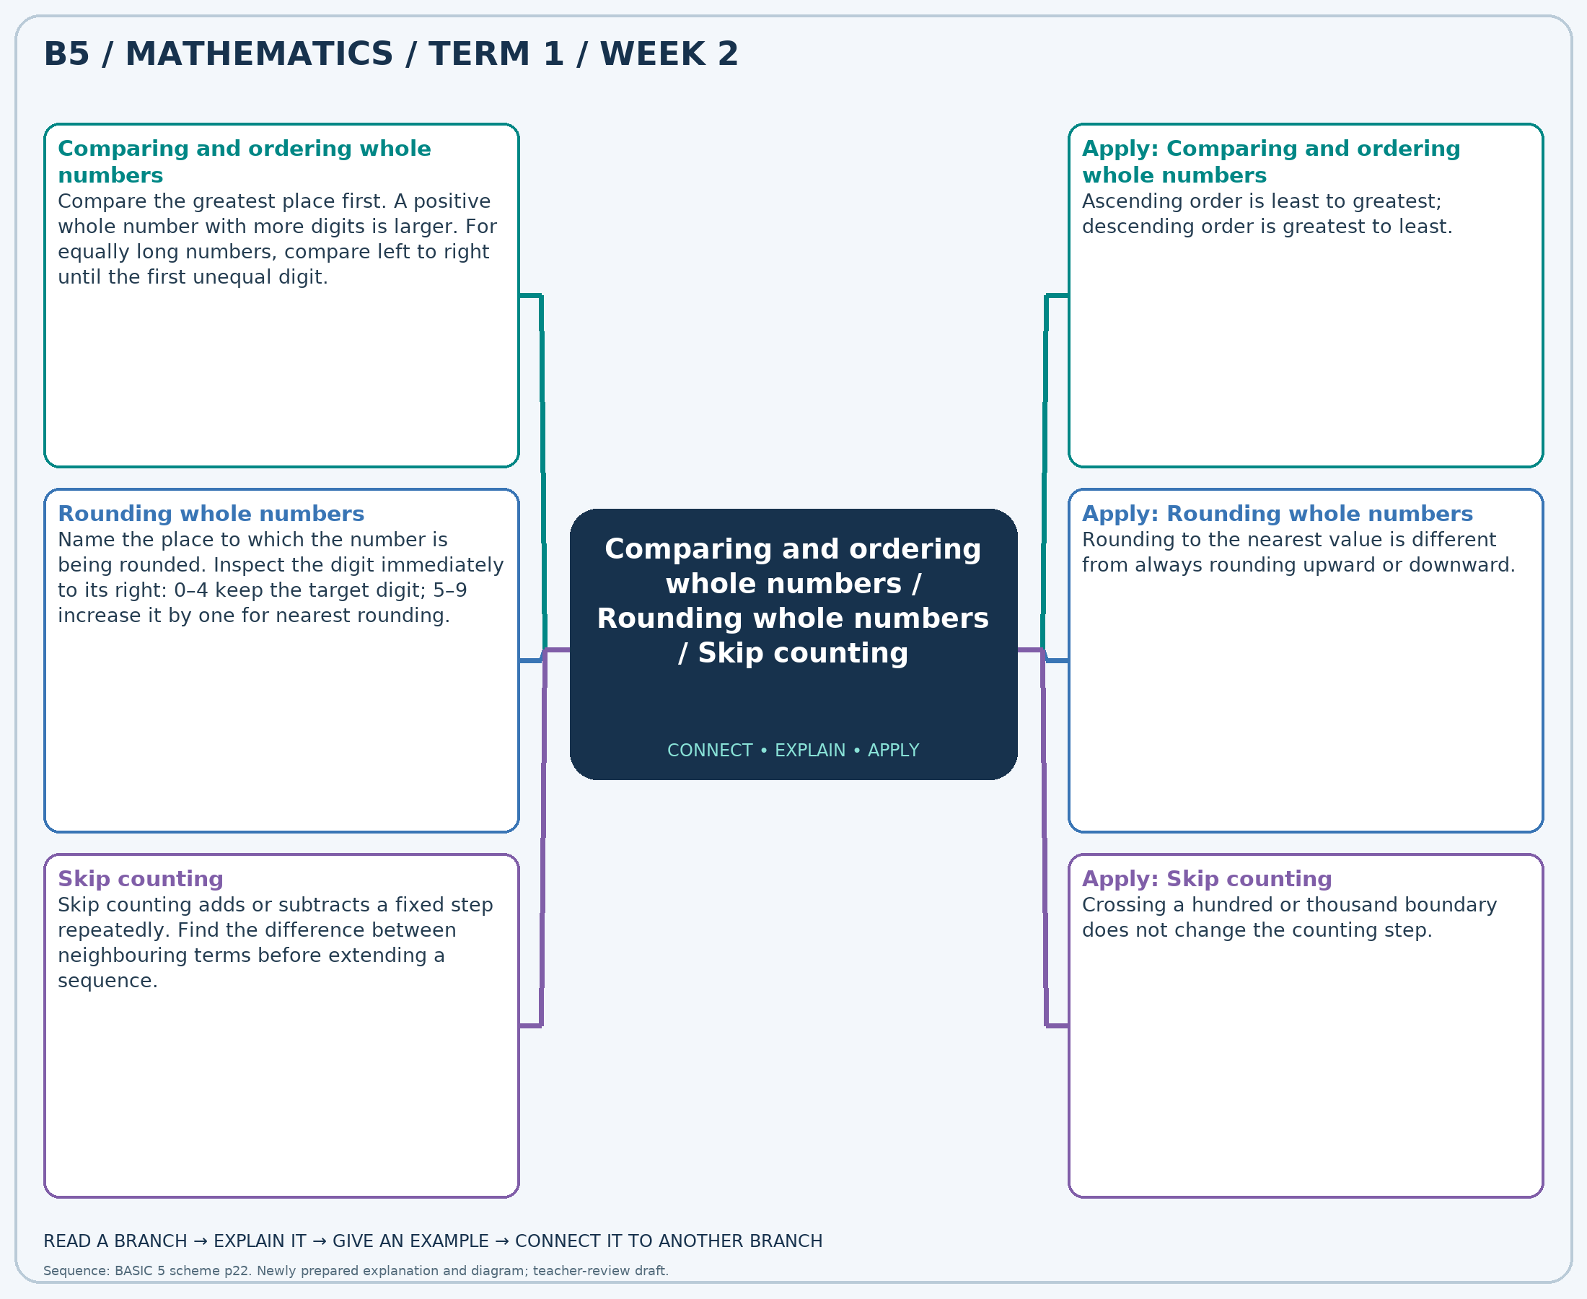
The separate high-resolution PNG can be projected or printed larger. Explain each branch and connect it with an example.

Week 2 — Practice

Section A — Multiple-choice questions
Choose ONE correct answer for each question. Each question has four alternatives.
1. Which is the greatest number: 14,096, 14,127, 14,784, 14,788?
A. 14096 B. 14127 C. 14788 D. 14784
2. Round 91,155 to the nearest 10.
A. 91150 B. 91160 C. 91180 D. 91170
3. Find the next term: 21,000, 20,000, 19,000, …
A. 18000 B. 19000 C. 16000 D. 17000
4. Which is the least number: 53,337, 54,326, 53,622, 54,293?
A. 54326 B. 53622 C. 54293 D. 53337
5. Round 62,949 to the nearest 100.
A. 62900 B. 62800 C. 63100 D. 63000
6. Find the next term: 23,500, 23,000, 22,500, …
A. 21000 B. 22500 C. 21500 D. 22000
7. Which is the greatest number: 61,558, 61,673, 61,181, 62,020?
A. 61181 B. 61558 C. 61673 D. 62020
8. Round 92,517 to the nearest 100.
A. 92700 B. 92500 C. 92600 D. 92400
9. Find the next term: 33,000, 34,000, 35,000, …
A. 37000 B. 36000 C. 38000 D. 35000
10. Which is the greatest number: 70,836, 70,988, 70,459, 70,305?
A. 70836 B. 70459 C. 70988 D. 70305
11. Round 71,849 to the nearest 100.
A. 71900 B. 72000 C. 71800 D. 71700
12. Find the next term: 30,000, 29,000, 28,000, …
A. 26000 B. 25000 C. 28000 D. 27000
13. Which is the least number: 70,413, 70,299, 70,072, 70,338?
A. 70413 B. 70072 C. 70299 D. 70338
14. Round 98,178 to the nearest 10.
A. 98170 B. 98190 C. 98180 D. 98200
15. Find the next term: 20,500, 20,000, 19,500, …
A. 18500 B. 19000 C. 18000 D. 19500
16. Which is the greatest number: 36,844, 37,173, 37,065, 36,478?
A. 36844 B. 36478 C. 37065 D. 37173
17. Round 82,795 to the nearest 10.
A. 82800 B. 82810 C. 82820 D. 82790
18. Find the next term: 17,500, 18,000, 18,500, …
A. 20000 B. 19500 C. 18500 D. 19000
19. Which is the greatest number: 64,032, 63,814, 64,252, 64,325?
A. 63814 B. 64252 C. 64032 D. 64325
20. Round 17,267 to the nearest 1,000.
A. 17000 B. 16000 C. 18000 D. 19000

Section B — Structured essay questions
Answer every part (a), (b), (c). Show your method or explain your choice. Write in a separate answer booklet. Each part: 1 mark for valid working/explanation and 1 for the correct result; 6 marks per question.

1. Apply the related skills and show working or give a reason for each answer.
(a) Which is the greatest number: 33,274, 33,528, 33,775, 33,657?
(b) Round 80,892 to the nearest 1,000.
(c) Find the next term: 21,000, 21,500, 22,000, …

2. Apply the related skills and show working or give a reason for each answer.
(a) Round 82,910 to the nearest 1,000.
(b) Find the next term: 15,000, 14,000, 13,000, …
(c) Which is the greatest number: 52,275, 52,294, 51,873, 51,958?

3. Apply the related skills and show working or give a reason for each answer.
(a) Find the next term: 48,000, 49,000, 50,000, …
(b) Which is the greatest number: 66,748, 67,179, 67,329, 66,400?
(c) Round 84,017 to the nearest 1,000.

4. Apply the related skills and show working or give a reason for each answer.
(a) Which is the greatest number: 27,108, 26,804, 27,099, 26,821?
(b) Round 47,066 to the nearest 10.
(c) Find the next term: 13,500, 14,000, 14,500, …

5. Apply the related skills and show working or give a reason for each answer.
(a) Round 55,326 to the nearest 100.
(b) Find the next term: 20,000, 21,000, 22,000, …
(c) Which is the greatest number: 46,934, 46,177, 46,552, 46,128?

6. Apply the related skills and show working or give a reason for each answer.
(a) Find the next term: 18,000, 17,500, 17,000, …
(b) Which is the greatest number: 75,403, 75,285, 75,935, 75,901?
(c) Round 59,946 to the nearest 1,000.

7. Apply the related skills and show working or give a reason for each answer.
(a) Which is the greatest number: 35,753, 35,515, 36,285, 35,562?
(b) Round 54,520 to the nearest 100.
(c) Find the next term: 19,000, 18,500, 18,000, …

8. Apply the related skills and show working or give a reason for each answer.
(a) Round 85,366 to the nearest 1,000.
(b) Find the next term: 5,500, 5,000, 4,500, …
(c) Which is the greatest number: 46,000, 46,270, 46,708, 46,232?

9. Apply the related skills and show working or give a reason for each answer.
(a) Find the next term: 6,500, 7,000, 7,500, …
(b) Which is the greatest number: 78,306, 77,967, 78,050, 78,022?
(c) Round 55,502 to the nearest 100.

10. Apply the related skills and show working or give a reason for each answer.
(a) Which is the greatest number: 59,264, 60,162, 59,689, 59,487?
(b) Round 88,915 to the nearest 100.
(c) Find the next term: 48,000, 49,000, 50,000, …

Week 3 — Roman numerals
Sequence source: BASIC 5 SCHEME OF LEARNING.pdf, first-term Mathematics, page 22. One consolidated weekly unit.

Learning outcomes
- Explain and apply roman numerals, solve examples and justify the method.

Teaching notes and suggested sessions
Suggested schedule: five 40-minute sessions, adjusted to the school timetable. Spread the question bank through the week; it is not intended to be completed in one lesson.

1 — Explore and diagnose
5 minutes: recall an earlier skill; 10: demonstrate a concrete or pictorial model; 15: pairs investigate and explain; 10: identify a misconception and set an exit task.

2 — Model and practise
5 minutes: review the exit task; 10: work an example aloud; 15: pairs solve parallel examples; 10: compare methods and correct errors.

3 — Connect representations
5 minutes: recall vocabulary; 10: explain the mind-map; 15: connect a model, a drawing and a symbolic calculation; 10: independent practice.

4 — Apply and explain
5 minutes: estimate or predict; 10: solve a contextual example; 15: attempt selected structured-question parts; 10: compare reasoning and check units.

5 — Check and respond
5 minutes: retrieve the main rule; 15: use selected MCQs diagnostically; 10: explain distractors and misconceptions; 10: reteach or extend in response to evidence.

Topic-specific activities
- Use letter cards to build numbers and convert them back to ordinary figures.
Resources: board, pencils, number cards, counters, paper strips and squared paper as appropriate. Prior-knowledge check: ask a learner to explain a representation used in the first example before introducing a new rule.
Support: reduce number size without changing the concept; offer a partially completed chart or model; allow oral reasoning before writing. Extension: create a counterexample to a false rule and explain why it fails.

Study notes and worked examples

Roman numerals
- I=1, V=5, X=10, L=50 and C=100.
- Usually values are added from left to right. Permitted subtractive pairs include IV=4, IX=9, XL=40 and XC=90.
- Write the largest values first, using standard forms: XXIV is 24.
- Roman numerals do not use a place-value zero.
Worked example: Write 63 using standard Roman numerals.
Solution: 63 = LXIII using I=1, V=5, X=10, L=50, C=100 and permitted subtractive pairs.
Common misconception: Use IX, not VIIII, for 9; use XL, not XXXX, for 40.
Independent study: read the map, cover it and reconstruct the branches. Solve an unused question from each skill and explain the reasoning to a partner. Consult the teacher key only after an honest attempt.

Week 3 — Visual mind-map
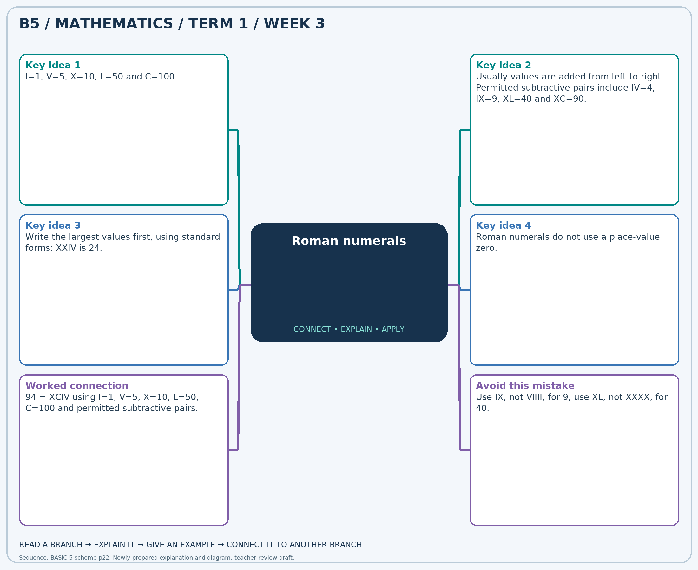
The separate high-resolution PNG can be projected or printed larger. Explain each branch and connect it with an example.

Week 3 — Practice

Section A — Multiple-choice questions
Choose ONE correct answer for each question. Each question has four alternatives.
1. Write 22 using standard Roman numerals.
A. XXI B. XXII C. XXIV D. XXIII
2. Write LXXXVII in ordinary figures.
A. 88 B. 86 C. 89 D. 87
3. Write 71 using standard Roman numerals.
A. LXXII B. LXXI C. LXXIII D. LXX
4. Write 84 using standard Roman numerals.
A. LXXXIV B. LXXXV C. LXXXIII D. LXXXVI
5. Write LXXVII in ordinary figures.
A. 78 B. 76 C. 79 D. 77
6. Write 44 using standard Roman numerals.
A. XLIII B. XLVI C. XLIV D. XLV
7. Write 90 using standard Roman numerals.
A. XCII B. LXXXIX C. XCI D. XC
8. Write 82 using standard Roman numerals.
A. LXXXI B. LXXXIII C. LXXXIV D. LXXXII
9. Write LXVII in ordinary figures.
A. 67 B. 66 C. 68 D. 69
10. Write 86 using standard Roman numerals.
A. LXXXV B. LXXXVII C. LXXXVIII D. LXXXVI
11. Write XCVIII in ordinary figures.
A. 97 B. 98 C. 100 D. 99
12. Write 72 using standard Roman numerals.
A. LXXII B. LXXIII C. LXXI D. LXXIV
13. Write 98 using standard Roman numerals.
A. XCVIII B. XCIX C. XCVII D. C
14. Write XIII in ordinary figures.
A. 15 B. 12 C. 14 D. 13
15. Write 31 using standard Roman numerals.
A. XXX B. XXXII C. XXXI D. XXXIII
16. Write 9 using standard Roman numerals.
A. X B. XI C. VIII D. IX
17. Write III in ordinary figures.
A. 3 B. 4 C. 5 D. 2
18. Write 74 using standard Roman numerals.
A. LXXVI B. LXXIII C. LXXV D. LXXIV
19. Write 75 using standard Roman numerals.
A. LXXV B. LXXVII C. LXXIV D. LXXVI
20. Write LXXVI in ordinary figures.
A. 77 B. 78 C. 75 D. 76

Section B — Structured essay questions
Answer every part (a), (b), (c). Show your method or explain your choice. Write in a separate answer booklet. Each part: 1 mark for valid working/explanation and 1 for the correct result; 6 marks per question.

1. Apply the related skills and show working or give a reason for each answer.
(a) Write 95 using standard Roman numerals.
(b) Write LI in ordinary figures.
(c) Write 81 using standard Roman numerals.

2. Apply the related skills and show working or give a reason for each answer.
(a) Write XCIV in ordinary figures.
(b) Write 22 using standard Roman numerals.
(c) Write 86 using standard Roman numerals.

3. Apply the related skills and show working or give a reason for each answer.
(a) Write 88 using standard Roman numerals.
(b) Write 61 using standard Roman numerals.
(c) Write LIX in ordinary figures.

4. Apply the related skills and show working or give a reason for each answer.
(a) Write 80 using standard Roman numerals.
(b) Write XCVI in ordinary figures.
(c) Write 66 using standard Roman numerals.

5. Apply the related skills and show working or give a reason for each answer.
(a) Write XLIII in ordinary figures.
(b) Write 18 using standard Roman numerals.
(c) Write 95 using standard Roman numerals.

6. Apply the related skills and show working or give a reason for each answer.
(a) Write 94 using standard Roman numerals.
(b) Write 76 using standard Roman numerals.
(c) Write XXXIII in ordinary figures.

7. Apply the related skills and show working or give a reason for each answer.
(a) Write 43 using standard Roman numerals.
(b) Write XCVIII in ordinary figures.
(c) Write 29 using standard Roman numerals.

8. Apply the related skills and show working or give a reason for each answer.
(a) Write LXXXVIII in ordinary figures.
(b) Write 57 using standard Roman numerals.
(c) Write 72 using standard Roman numerals.

9. Apply the related skills and show working or give a reason for each answer.
(a) Write 41 using standard Roman numerals.
(b) Write 67 using standard Roman numerals.
(c) Write LIV in ordinary figures.

10. Apply the related skills and show working or give a reason for each answer.
(a) Write 13 using standard Roman numerals.
(b) Write LXXXI in ordinary figures.
(c) Write 28 using standard Roman numerals.

Week 4 — Factors, primes and even numbers
Sequence source: BASIC 5 SCHEME OF LEARNING.pdf, first-term Mathematics, page 22. One consolidated weekly unit.

Learning outcomes
- Explain and apply factors, primes and even numbers, solve examples and justify the method.

Teaching notes and suggested sessions
Suggested schedule: five 40-minute sessions, adjusted to the school timetable. Spread the question bank through the week; it is not intended to be completed in one lesson.

1 — Explore and diagnose
5 minutes: recall an earlier skill; 10: demonstrate a concrete or pictorial model; 15: pairs investigate and explain; 10: identify a misconception and set an exit task.

2 — Model and practise
5 minutes: review the exit task; 10: work an example aloud; 15: pairs solve parallel examples; 10: compare methods and correct errors.

3 — Connect representations
5 minutes: recall vocabulary; 10: explain the mind-map; 15: connect a model, a drawing and a symbolic calculation; 10: independent practice.

4 — Apply and explain
5 minutes: estimate or predict; 10: solve a contextual example; 15: attempt selected structured-question parts; 10: compare reasoning and check units.

5 — Check and respond
5 minutes: retrieve the main rule; 15: use selected MCQs diagnostically; 10: explain distractors and misconceptions; 10: reteach or extend in response to evidence.

Topic-specific activities
- Arrange counters into rectangles and record every factor pair.
Resources: board, pencils, number cards, counters, paper strips and squared paper as appropriate. Prior-knowledge check: ask a learner to explain a representation used in the first example before introducing a new rule.
Support: reduce number size without changing the concept; offer a partially completed chart or model; allow oral reasoning before writing. Extension: create a counterexample to a false rule and explain why it fails.

Study notes and worked examples

Factors, primes and even numbers
- A factor divides a positive whole number exactly, with no remainder.
- Find factor pairs systematically: 18 has pairs 1×18, 2×9 and 3×6.
- A prime number has exactly two positive factors. A composite has more than two; 1 is neither.
- An even number is divisible by 2. The only even prime is 2.
Worked example: How many positive factors does 38 have?
Solution: Factors: 1, 2, 19, 38. Count = 4.
Common misconception: Do not confuse a factor with a multiple. A positive factor cannot exceed the number.
Independent study: read the map, cover it and reconstruct the branches. Solve an unused question from each skill and explain the reasoning to a partner. Consult the teacher key only after an honest attempt.

Week 4 — Visual mind-map
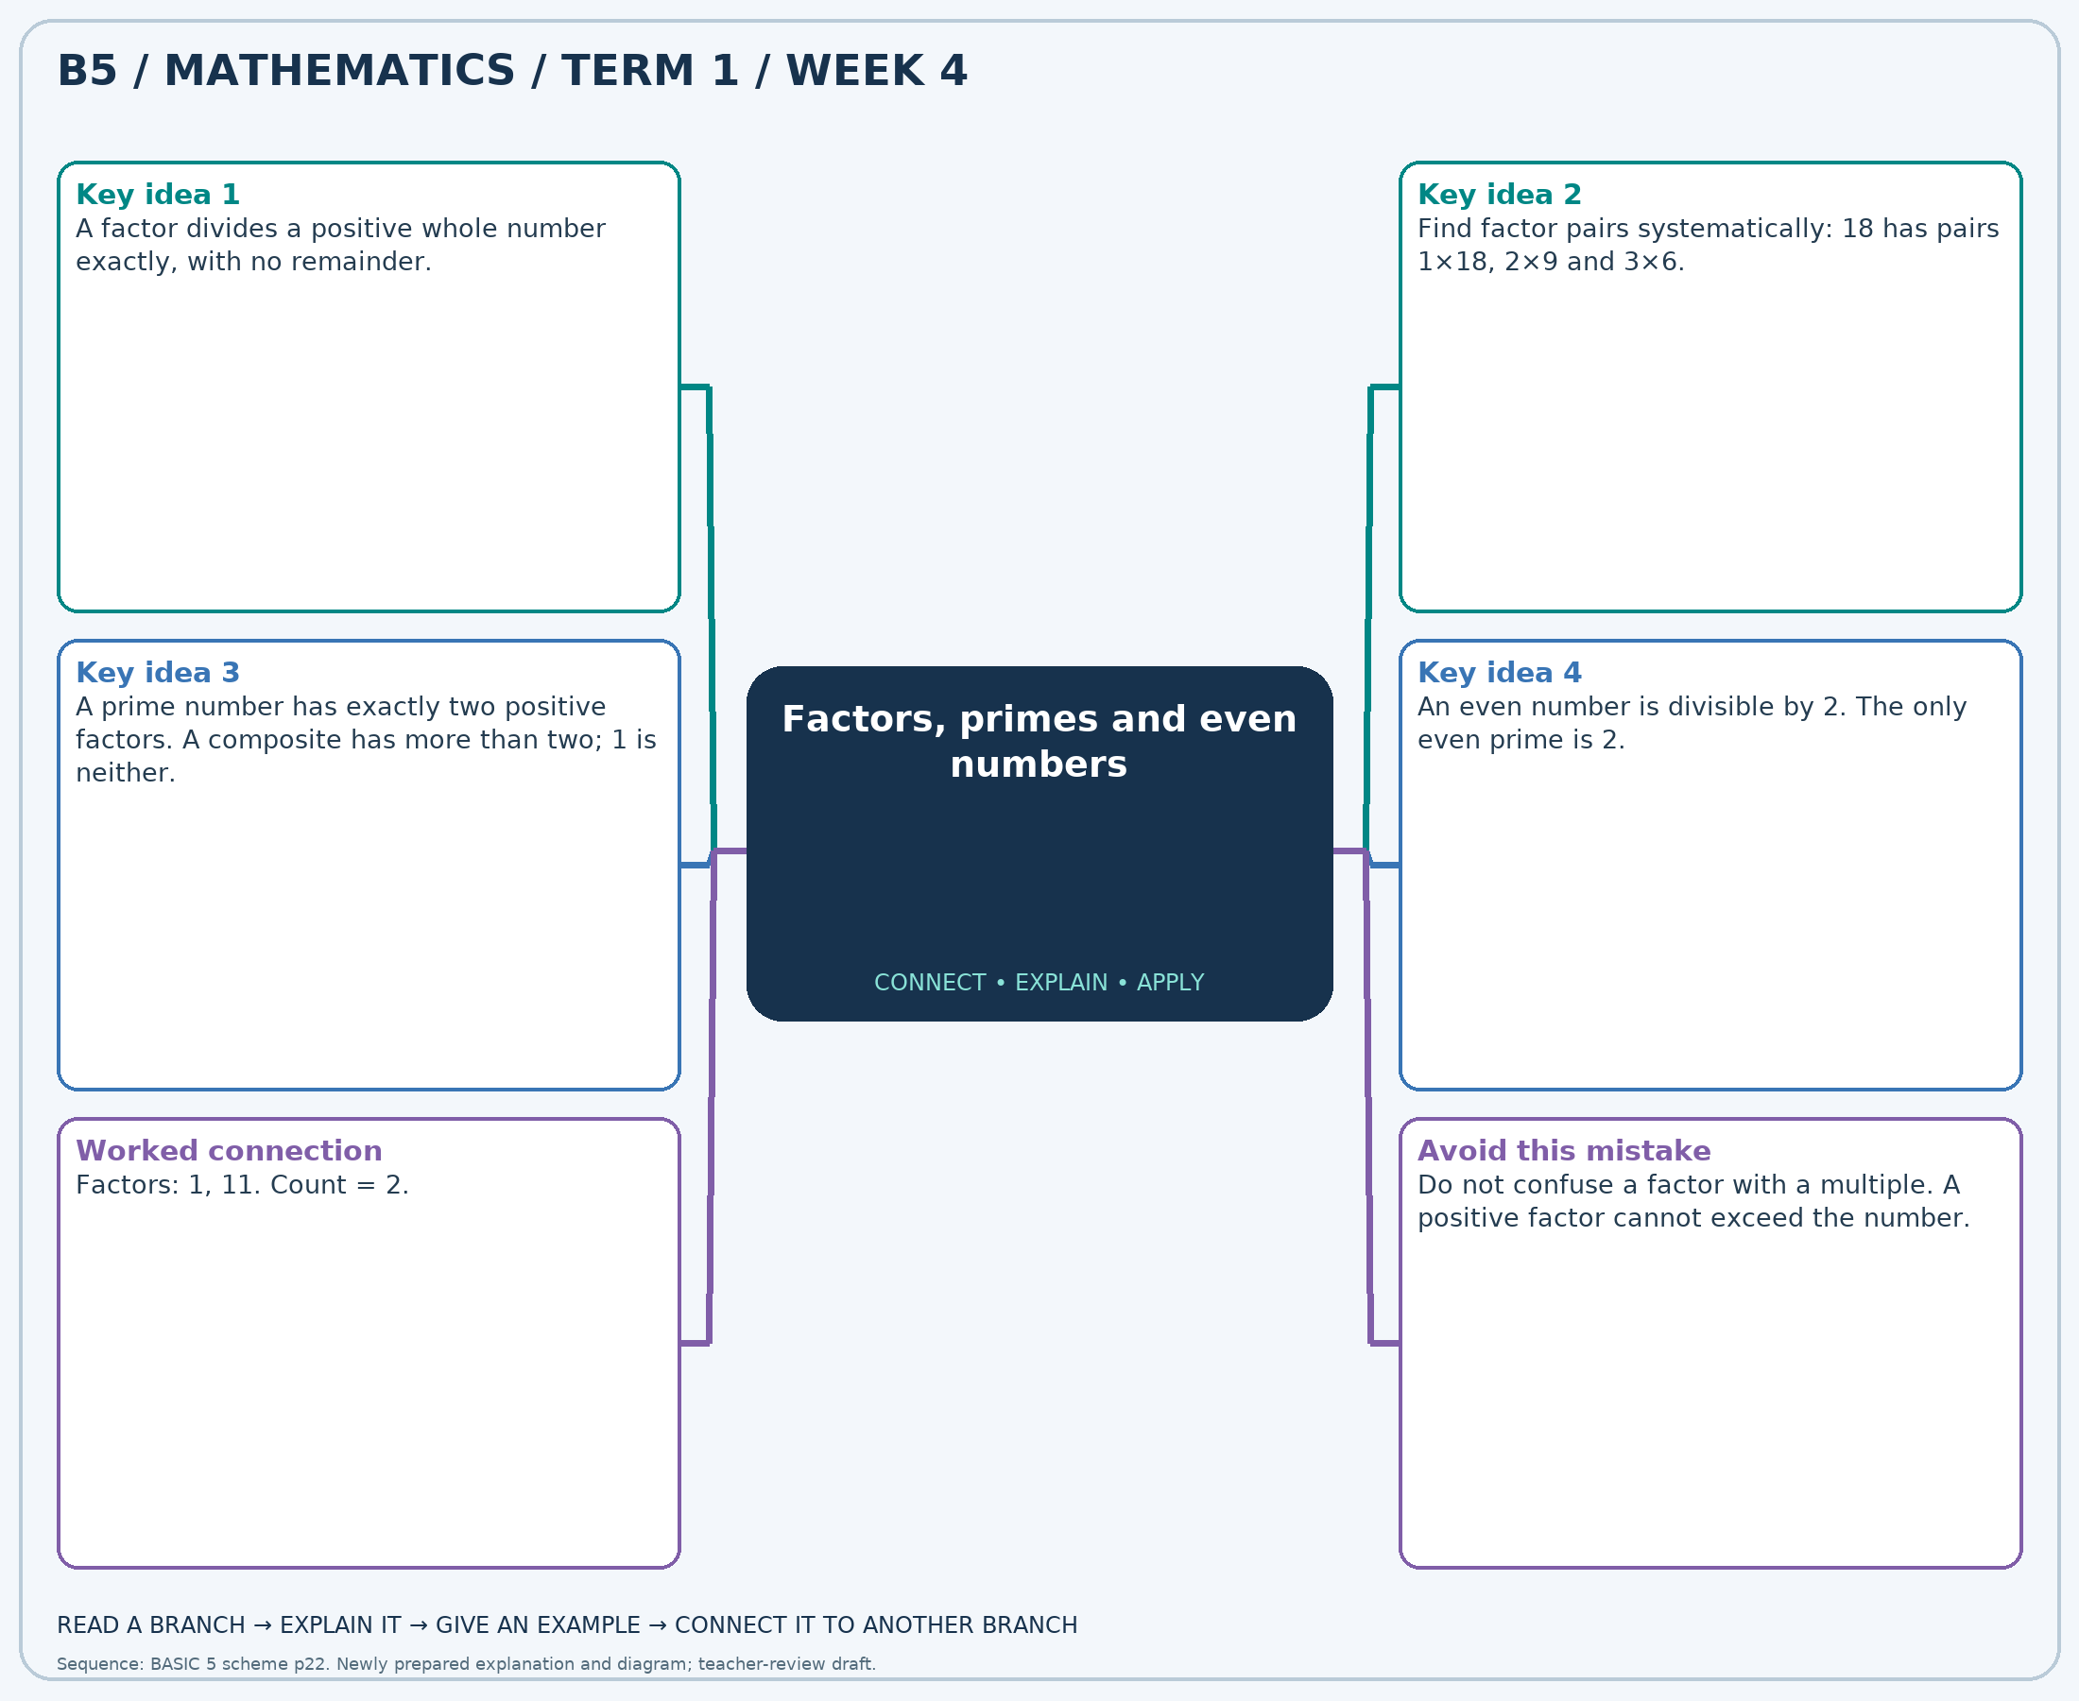
The separate high-resolution PNG can be projected or printed larger. Explain each branch and connect it with an example.

Week 4 — Practice

Section A — Multiple-choice questions
Choose ONE correct answer for each question. Each question has four alternatives.
1. How many positive factors does 47 have?
A. 3 B. 4 C. 2 D. 1
2. Which number is prime: 15, 20, 25, 73?
A. 20 B. 73 C. 25 D. 15
3. Which number is even: 48, 49, 71, 97?
A. 97 B. 48 C. 71 D. 49
4. How many positive factors does 99 have?
A. 8 B. 7 C. 6 D. 5
5. Which number is prime: 43, 55, 56, 75?
A. 55 B. 75 C. 43 D. 56
6. Which number is even: 27, 53, 76, 89?
A. 53 B. 89 C. 76 D. 27
7. How many positive factors does 18 have?
A. 7 B. 5 C. 6 D. 8
8. Which number is prime: 21, 55, 72, 83?
A. 21 B. 83 C. 72 D. 55
9. Which number is even: 5, 34, 71, 99?
A. 34 B. 99 C. 71 D. 5
10. How many positive factors does 50 have?
A. 6 B. 5 C. 7 D. 8
11. Which number is prime: 33, 76, 79, 91?
A. 79 B. 33 C. 91 D. 76
12. Which number is even: 27, 29, 42, 79?
A. 29 B. 79 C. 42 D. 27
13. How many positive factors does 95 have?
A. 3 B. 4 C. 5 D. 6
14. Which number is prime: 9, 17, 30, 92?
A. 9 B. 92 C. 17 D. 30
15. Which number is even: 13, 21, 23, 72?
A. 23 B. 13 C. 21 D. 72
16. How many positive factors does 44 have?
A. 8 B. 7 C. 5 D. 6
17. Which number is prime: 23, 28, 68, 80?
A. 68 B. 80 C. 28 D. 23
18. Which number is even: 23, 24, 59, 75?
A. 75 B. 59 C. 23 D. 24
19. How many positive factors does 94 have?
A. 4 B. 6 C. 5 D. 3
20. Which number is prime: 19, 24, 28, 74?
A. 74 B. 19 C. 24 D. 28

Section B — Structured essay questions
Answer every part (a), (b), (c). Show your method or explain your choice. Write in a separate answer booklet. Each part: 1 mark for valid working/explanation and 1 for the correct result; 6 marks per question.

1. Apply the related skills and show working or give a reason for each answer.
(a) How many positive factors does 35 have?
(b) Which number is prime: 4, 38, 47, 52?
(c) Which number is even: 7, 21, 54, 73?

2. Apply the related skills and show working or give a reason for each answer.
(a) Which number is prime: 42, 53, 77, 92?
(b) Which number is even: 27, 76, 81, 97?
(c) How many positive factors does 99 have?

3. Apply the related skills and show working or give a reason for each answer.
(a) Which number is even: 61, 72, 73, 93?
(b) How many positive factors does 45 have?
(c) Which number is prime: 23, 52, 91, 95?

4. Apply the related skills and show working or give a reason for each answer.
(a) How many positive factors does 41 have?
(b) Which number is prime: 30, 39, 69, 79?
(c) Which number is even: 54, 55, 77, 95?

5. Apply the related skills and show working or give a reason for each answer.
(a) Which number is prime: 25, 41, 54, 77?
(b) Which number is even: 25, 35, 65, 84?
(c) How many positive factors does 91 have?

6. Apply the related skills and show working or give a reason for each answer.
(a) Which number is even: 15, 39, 61, 72?
(b) How many positive factors does 10 have?
(c) Which number is prime: 33, 58, 70, 83?

7. Apply the related skills and show working or give a reason for each answer.
(a) How many positive factors does 66 have?
(b) Which number is prime: 3, 42, 72, 85?
(c) Which number is even: 15, 68, 79, 81?

8. Apply the related skills and show working or give a reason for each answer.
(a) Which number is prime: 41, 66, 81, 92?
(b) Which number is even: 9, 18, 61, 95?
(c) How many positive factors does 93 have?

9. Apply the related skills and show working or give a reason for each answer.
(a) Which number is even: 23, 51, 72, 87?
(b) How many positive factors does 76 have?
(c) Which number is prime: 10, 18, 29, 64?

10. Apply the related skills and show working or give a reason for each answer.
(a) How many positive factors does 52 have?
(b) Which number is prime: 7, 9, 62, 80?
(c) Which number is even: 41, 49, 65, 86?

Week 5 — Highest common factor / Lowest common multiple
Sequence source: BASIC 5 SCHEME OF LEARNING.pdf, first-term Mathematics, page 22. One consolidated weekly unit.

Learning outcomes
- Explain and apply highest common factor, solve examples and justify the method.
- Explain and apply lowest common multiple, solve examples and justify the method.

Teaching notes and suggested sessions
Suggested schedule: five 40-minute sessions, adjusted to the school timetable. Spread the question bank through the week; it is not intended to be completed in one lesson.

1 — Explore and diagnose
5 minutes: recall an earlier skill; 10: demonstrate a concrete or pictorial model; 15: pairs investigate and explain; 10: identify a misconception and set an exit task.

2 — Model and practise
5 minutes: review the exit task; 10: work an example aloud; 15: pairs solve parallel examples; 10: compare methods and correct errors.

3 — Connect representations
5 minutes: recall vocabulary; 10: explain the mind-map; 15: connect a model, a drawing and a symbolic calculation; 10: independent practice.

4 — Apply and explain
5 minutes: estimate or predict; 10: solve a contextual example; 15: attempt selected structured-question parts; 10: compare reasoning and check units.

5 — Check and respond
5 minutes: retrieve the main rule; 15: use selected MCQs diagnostically; 10: explain distractors and misconceptions; 10: reteach or extend in response to evidence.

Topic-specific activities
- Make identical packs from two colours of counters and identify the largest possible number of packs.
- Draw two jump sequences on one number line and find their first shared positive landing point.
Resources: board, pencils, number cards, counters, paper strips and squared paper as appropriate. Prior-knowledge check: ask a learner to explain a representation used in the first example before introducing a new rule.
Support: reduce number size without changing the concept; offer a partially completed chart or model; allow oral reasoning before writing. Extension: create a counterexample to a false rule and explain why it fails.

Study notes and worked examples

Highest common factor
- List the factors of the given numbers or use their prime factors.
- Common factors occur in every list. The HCF is the greatest positive common factor.
- With prime factors, use shared primes with their smallest powers.
- The HCF can determine the largest equal grouping that leaves nothing over.
Worked example: Find the HCF of 14 and 6.
Solution: Common factors: 1, 2. Greatest = 2.
Common misconception: Do not choose the lowest common multiple when the question asks for a factor.

Lowest common multiple
- Multiples of a number are obtained by multiplying it by whole numbers.
- List positive multiples of the given numbers; the first shared one is their LCM.
- The LCM is useful for repeated events and common fraction denominators.
- Zero is a common multiple but is not used as the least positive common multiple in these questions.
Worked example: Find the LCM of 25 and 20.
Solution: HCF=5. LCM=(25×20)÷5=100.
Common misconception: The HCF divides both numbers; the LCM is divisible by both numbers.
Independent study: read the map, cover it and reconstruct the branches. Solve an unused question from each skill and explain the reasoning to a partner. Consult the teacher key only after an honest attempt.

Week 5 — Visual mind-map
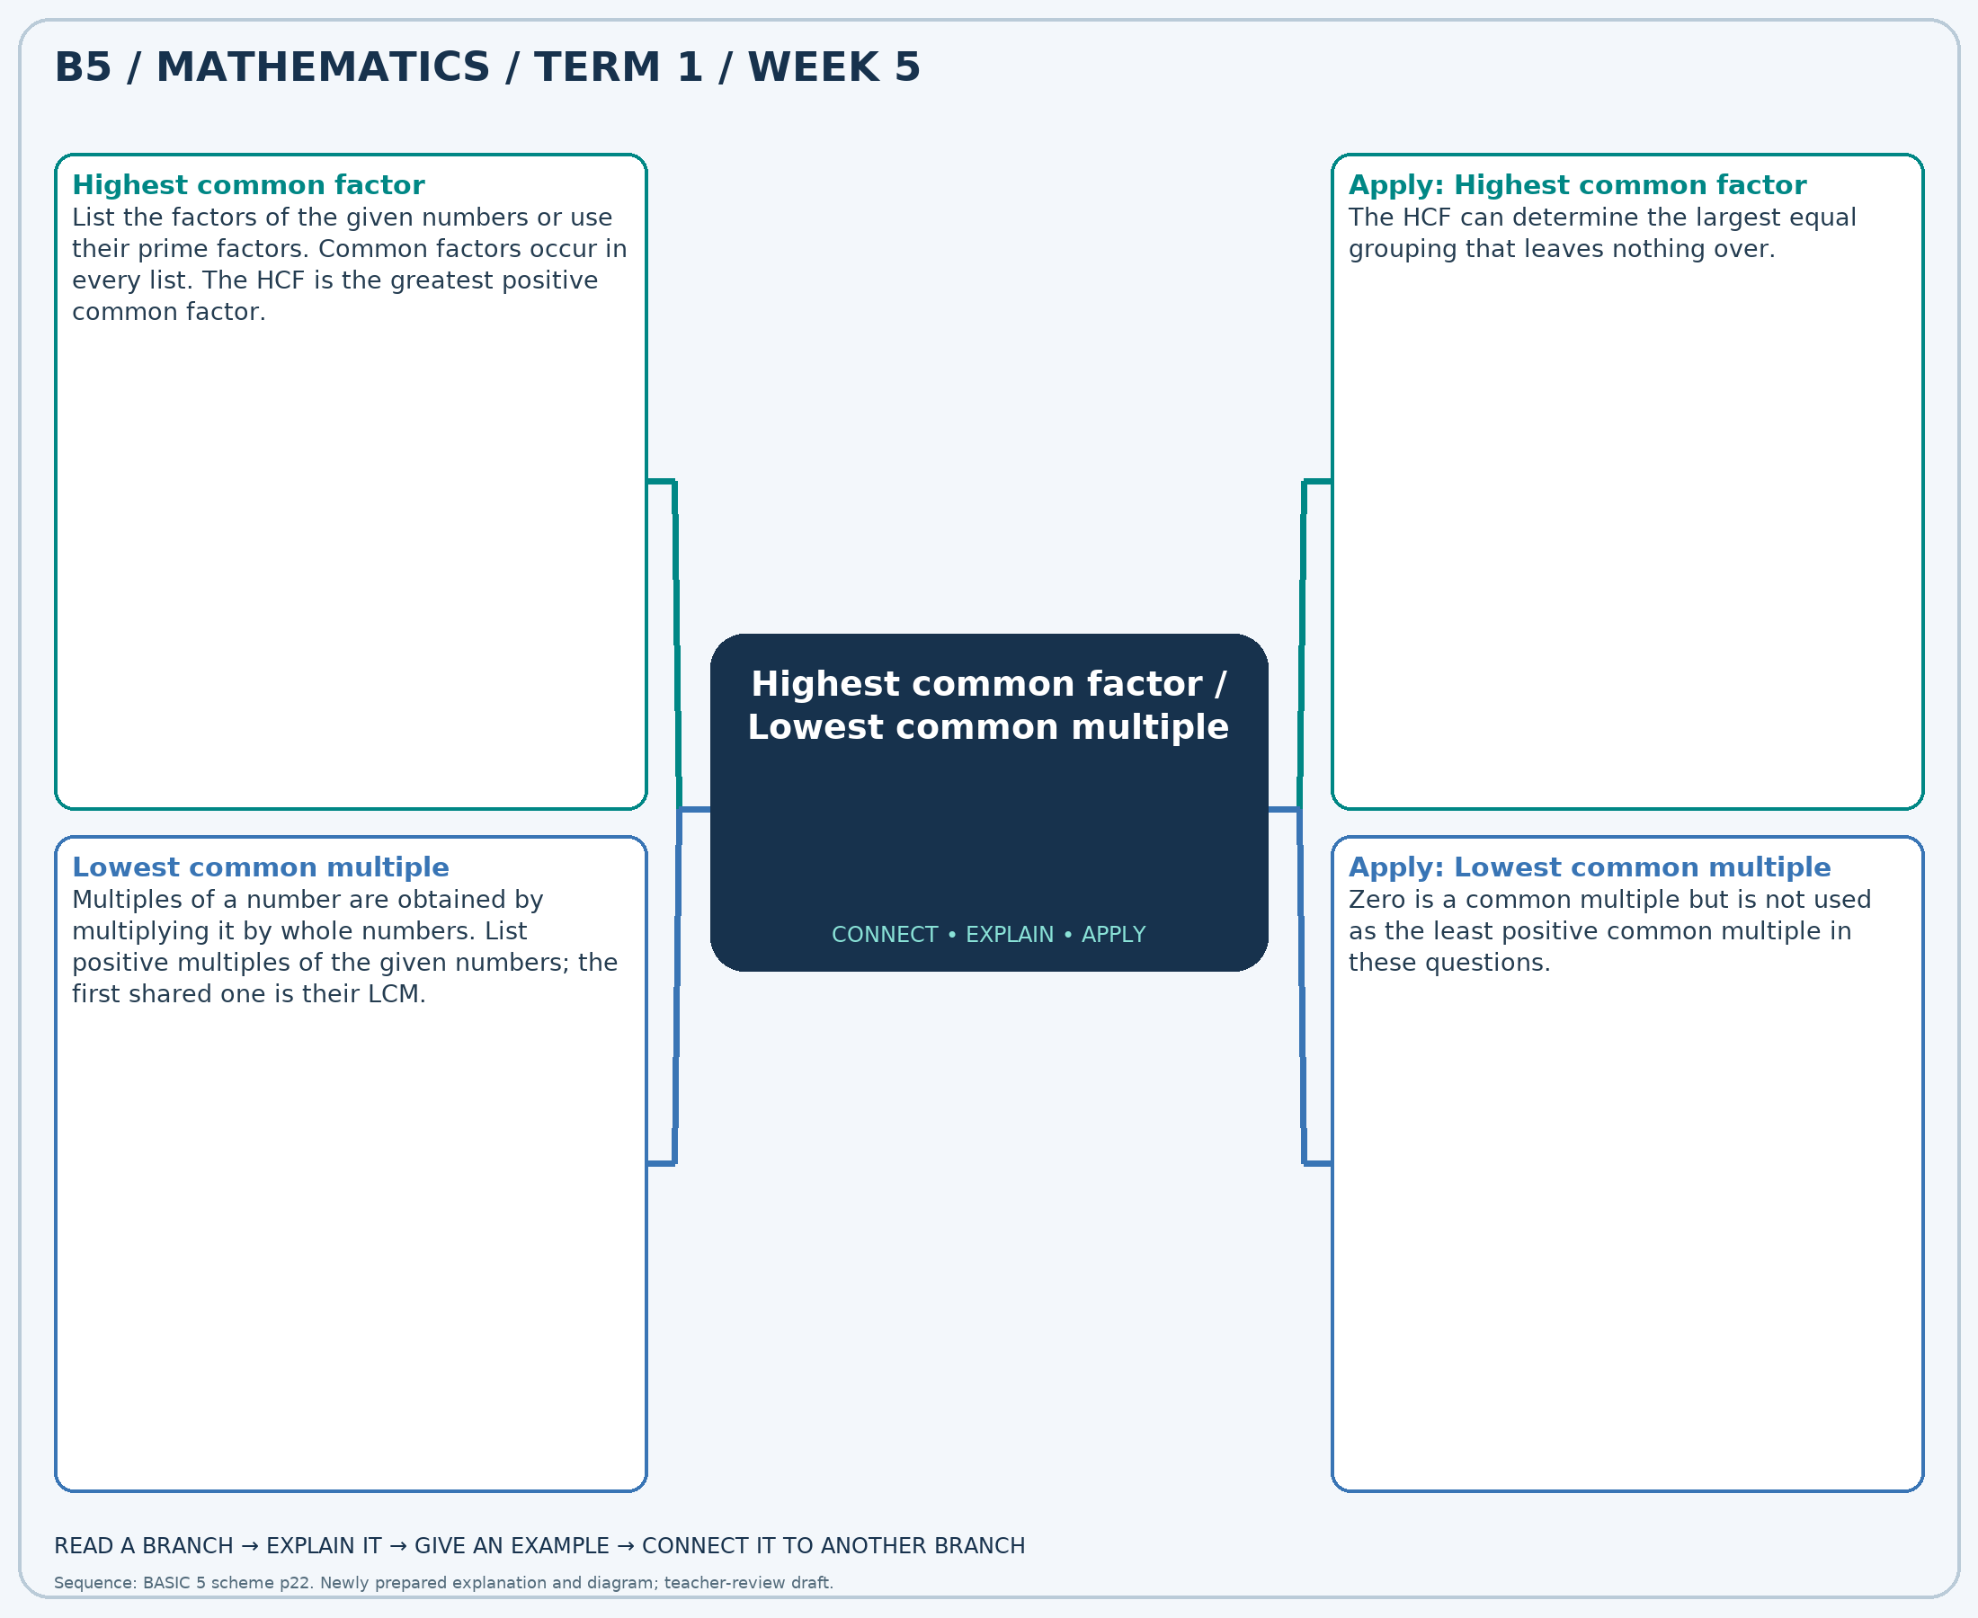
The separate high-resolution PNG can be projected or printed larger. Explain each branch and connect it with an example.

Week 5 — Practice

Section A — Multiple-choice questions
Choose ONE correct answer for each question. Each question has four alternatives.
1. Find the HCF of 40 and 15.
A. 5 B. 4 C. 7 D. 6
2. Find the LCM of 42 and 12.
A. 84 B. 83 C. 85 D. 86
3. Find the HCF of 35 and 15.
A. 4 B. 6 C. 7 D. 5
4. Find the LCM of 42 and 18.
A. 126 B. 125 C. 128 D. 127
5. Find the HCF of 42 and 30.
A. 6 B. 8 C. 5 D. 7
6. Find the LCM of 32 and 32.
A. 33 B. 31 C. 32 D. 34
7. Find the HCF of 30 and 45.
A. 14 B. 16 C. 15 D. 17
8. Find the LCM of 14 and 14.
A. 14 B. 13 C. 15 D. 16
9. Find the HCF of 72 and 72.
A. 72 B. 74 C. 71 D. 73
10. Find the LCM of 30 and 48.
A. 239 B. 240 C. 241 D. 242
11. Find the HCF of 32 and 20.
A. 6 B. 5 C. 4 D. 3
12. Find the LCM of 25 and 40.
A. 200 B. 199 C. 202 D. 201
13. Find the HCF of 24 and 32.
A. 7 B. 10 C. 8 D. 9
14. Find the LCM of 63 and 14.
A. 125 B. 127 C. 128 D. 126
15. Find the HCF of 42 and 54.
A. 5 B. 6 C. 8 D. 7
16. Find the LCM of 24 and 54.
A. 216 B. 218 C. 215 D. 217
17. Find the HCF of 21 and 14.
A. 9 B. 7 C. 8 D. 6
18. Find the LCM of 49 and 14.
A. 97 B. 99 C. 98 D. 100
19. Find the HCF of 24 and 24.
A. 26 B. 23 C. 24 D. 25
20. Find the LCM of 16 and 36.
A. 146 B. 145 C. 143 D. 144

Section B — Structured essay questions
Answer every part (a), (b), (c). Show your method or explain your choice. Write in a separate answer booklet. Each part: 1 mark for valid working/explanation and 1 for the correct result; 6 marks per question.

1. Apply the related skills and show working or give a reason for each answer.
(a) Find the HCF of 24 and 72.
(b) Find the LCM of 36 and 12.
(c) Find the HCF of 16 and 8.

2. Apply the related skills and show working or give a reason for each answer.
(a) Find the LCM of 14 and 10.
(b) Find the HCF of 20 and 35.
(c) Find the LCM of 64 and 64.

3. Apply the related skills and show working or give a reason for each answer.
(a) Find the HCF of 6 and 18.
(b) Find the LCM of 21 and 9.
(c) Find the HCF of 14 and 6.

4. Apply the related skills and show working or give a reason for each answer.
(a) Find the LCM of 4 and 6.
(b) Find the HCF of 6 and 18.
(c) Find the LCM of 18 and 42.

5. Apply the related skills and show working or give a reason for each answer.
(a) Find the HCF of 30 and 40.
(b) Find the LCM of 16 and 8.
(c) Find the HCF of 21 and 14.

6. Apply the related skills and show working or give a reason for each answer.
(a) Find the LCM of 8 and 24.
(b) Find the HCF of 18 and 27.
(c) Find the LCM of 54 and 12.

7. Apply the related skills and show working or give a reason for each answer.
(a) Find the HCF of 4 and 6.
(b) Find the LCM of 9 and 9.
(c) Find the HCF of 30 and 30.

8. Apply the related skills and show working or give a reason for each answer.
(a) Find the LCM of 72 and 32.
(b) Find the HCF of 21 and 21.
(c) Find the LCM of 35 and 35.

9. Apply the related skills and show working or give a reason for each answer.
(a) Find the HCF of 12 and 9.
(b) Find the LCM of 6 and 9.
(c) Find the HCF of 56 and 35.

10. Apply the related skills and show working or give a reason for each answer.
(a) Find the LCM of 6 and 9.
(b) Find the HCF of 24 and 12.
(c) Find the LCM of 24 and 12.

Week 6 — Multiplication strategies
Sequence source: BASIC 5 SCHEME OF LEARNING.pdf, first-term Mathematics, page 22. One consolidated weekly unit.

Learning outcomes
- Explain and apply multiplication strategies, solve examples and justify the method.

Teaching notes and suggested sessions
Suggested schedule: five 40-minute sessions, adjusted to the school timetable. Spread the question bank through the week; it is not intended to be completed in one lesson.

1 — Explore and diagnose
5 minutes: recall an earlier skill; 10: demonstrate a concrete or pictorial model; 15: pairs investigate and explain; 10: identify a misconception and set an exit task.

2 — Model and practise
5 minutes: review the exit task; 10: work an example aloud; 15: pairs solve parallel examples; 10: compare methods and correct errors.

3 — Connect representations
5 minutes: recall vocabulary; 10: explain the mind-map; 15: connect a model, a drawing and a symbolic calculation; 10: independent practice.

4 — Apply and explain
5 minutes: estimate or predict; 10: solve a contextual example; 15: attempt selected structured-question parts; 10: compare reasoning and check units.

5 — Check and respond
5 minutes: retrieve the main rule; 15: use selected MCQs diagnostically; 10: explain distractors and misconceptions; 10: reteach or extend in response to evidence.

Topic-specific activities
- Draw a partitioned rectangle and connect its smaller areas to the partial products.
Resources: board, pencils, number cards, counters, paper strips and squared paper as appropriate. Prior-knowledge check: ask a learner to explain a representation used in the first example before introducing a new rule.
Support: reduce number size without changing the concept; offer a partially completed chart or model; allow oral reasoning before writing. Extension: create a counterexample to a false rule and explain why it fails.

Study notes and worked examples

Multiplication strategies
- Partition a factor and use the distributive property: 24×6=(20×6)+(4×6)=144.
- Doubling one factor and halving an even other factor preserves the product.
- In multi-digit multiplication, include every partial product and align place values.
- Estimate first, calculate carefully and compare the product with the estimate.
Worked example: Calculate 477 × 38.
Solution: 477×(30+8) = 14310+3816 = 18126.
Common misconception: The tens digit contributes tens, not units: the 2 in 23×14 represents 20×14.
Independent study: read the map, cover it and reconstruct the branches. Solve an unused question from each skill and explain the reasoning to a partner. Consult the teacher key only after an honest attempt.

Week 6 — Visual mind-map
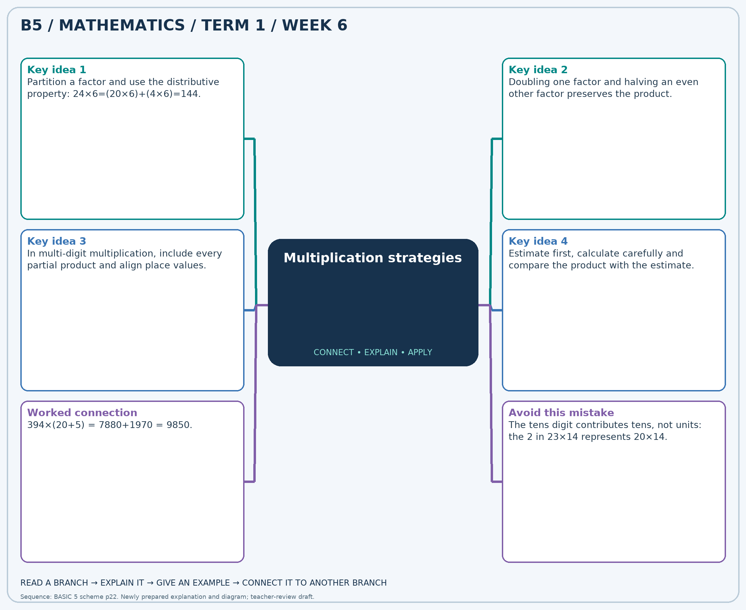
The separate high-resolution PNG can be projected or printed larger. Explain each branch and connect it with an example.

Week 6 — Practice

Section A — Multiple-choice questions
Choose ONE correct answer for each question. Each question has four alternatives.
1. Calculate 318 × 18.
A. 6042 B. 336 C. 5406 D. 5724
2. Calculate 332 × 37.
A. 11952 B. 369 C. 12284 D. 12616
3. Calculate 255 × 38.
A. 9435 B. 9945 C. 9690 D. 293
4. Calculate 499 × 37.
A. 18463 B. 536 C. 18962 D. 17964
5. Calculate 407 × 30.
A. 12617 B. 11803 C. 12210 D. 437
6. Calculate 310 × 33.
A. 10230 B. 343 C. 10540 D. 9920
7. Calculate 433 × 33.
A. 466 B. 14289 C. 13856 D. 14722
8. Calculate 218 × 37.
A. 255 B. 8066 C. 7848 D. 8284
9. Calculate 448 × 22.
A. 9856 B. 9408 C. 470 D. 10304
10. Calculate 348 × 26.
A. 9048 B. 9396 C. 374 D. 8700
11. Calculate 190 × 30.
A. 5890 B. 220 C. 5510 D. 5700
12. Calculate 299 × 17.
A. 316 B. 5083 C. 4784 D. 5382
13. Calculate 114 × 23.
A. 2622 B. 2508 C. 2736 D. 137
14. Calculate 488 × 13.
A. 5856 B. 6344 C. 6832 D. 501
15. Calculate 406 × 38.
A. 15428 B. 444 C. 15022 D. 15834
16. Calculate 492 × 20.
A. 512 B. 10332 C. 9840 D. 9348
17. Calculate 108 × 32.
A. 3348 B. 3564 C. 140 D. 3456
18. Calculate 156 × 12.
A. 168 B. 1716 C. 1872 D. 2028
19. Calculate 219 × 14.
A. 3066 B. 233 C. 2847 D. 3285
20. Calculate 319 × 15.
A. 4785 B. 5104 C. 334 D. 4466

Section B — Structured essay questions
Answer every part (a), (b), (c). Show your method or explain your choice. Write in a separate answer booklet. Each part: 1 mark for valid working/explanation and 1 for the correct result; 6 marks per question.

1. Apply the related skills and show working or give a reason for each answer.
(a) Calculate 208 × 12.
(b) Calculate 320 × 32.
(c) Calculate 244 × 26.

2. Apply the related skills and show working or give a reason for each answer.
(a) Calculate 249 × 32.
(b) Calculate 283 × 29.
(c) Calculate 287 × 13.

3. Apply the related skills and show working or give a reason for each answer.
(a) Calculate 407 × 26.
(b) Calculate 268 × 33.
(c) Calculate 118 × 20.

4. Apply the related skills and show working or give a reason for each answer.
(a) Calculate 127 × 33.
(b) Calculate 404 × 19.
(c) Calculate 446 × 18.

5. Apply the related skills and show working or give a reason for each answer.
(a) Calculate 129 × 20.
(b) Calculate 439 × 23.
(c) Calculate 264 × 18.

6. Apply the related skills and show working or give a reason for each answer.
(a) Calculate 310 × 22.
(b) Calculate 326 × 31.
(c) Calculate 373 × 18.

7. Apply the related skills and show working or give a reason for each answer.
(a) Calculate 491 × 29.
(b) Calculate 414 × 34.
(c) Calculate 396 × 37.

8. Apply the related skills and show working or give a reason for each answer.
(a) Calculate 347 × 23.
(b) Calculate 222 × 19.
(c) Calculate 224 × 38.

9. Apply the related skills and show working or give a reason for each answer.
(a) Calculate 349 × 24.
(b) Calculate 288 × 29.
(c) Calculate 442 × 38.

10. Apply the related skills and show working or give a reason for each answer.
(a) Calculate 449 × 22.
(b) Calculate 238 × 37.
(c) Calculate 323 × 37.

Week 7 — Multiplication strategies / Division and checking
Sequence source: BASIC 5 SCHEME OF LEARNING.pdf, first-term Mathematics, page 22. One consolidated weekly unit.

Learning outcomes
- Explain and apply multiplication strategies, solve examples and justify the method.
- Explain and apply division and checking, solve examples and justify the method.

Teaching notes and suggested sessions
Suggested schedule: five 40-minute sessions, adjusted to the school timetable. Spread the question bank through the week; it is not intended to be completed in one lesson.

1 — Explore and diagnose
5 minutes: recall an earlier skill; 10: demonstrate a concrete or pictorial model; 15: pairs investigate and explain; 10: identify a misconception and set an exit task.

2 — Model and practise
5 minutes: review the exit task; 10: work an example aloud; 15: pairs solve parallel examples; 10: compare methods and correct errors.

3 — Connect representations
5 minutes: recall vocabulary; 10: explain the mind-map; 15: connect a model, a drawing and a symbolic calculation; 10: independent practice.

4 — Apply and explain
5 minutes: estimate or predict; 10: solve a contextual example; 15: attempt selected structured-question parts; 10: compare reasoning and check units.

5 — Check and respond
5 minutes: retrieve the main rule; 15: use selected MCQs diagnostically; 10: explain distractors and misconceptions; 10: reteach or extend in response to evidence.

Topic-specific activities
- Draw a partitioned rectangle and connect its smaller areas to the partial products.
- Share counters into equal groups and check the result by multiplication.
Resources: board, pencils, number cards, counters, paper strips and squared paper as appropriate. Prior-knowledge check: ask a learner to explain a representation used in the first example before introducing a new rule.
Support: reduce number size without changing the concept; offer a partially completed chart or model; allow oral reasoning before writing. Extension: create a counterexample to a false rule and explain why it fails.

Study notes and worked examples

Multiplication strategies
- Partition a factor and use the distributive property: 24×6=(20×6)+(4×6)=144.
- Doubling one factor and halving an even other factor preserves the product.
- In multi-digit multiplication, include every partial product and align place values.
- Estimate first, calculate carefully and compare the product with the estimate.
Worked example: Calculate 122 × 17.
Solution: 122×(10+7) = 1220+854 = 2074.
Common misconception: The tens digit contributes tens, not units: the 2 in 23×14 represents 20×14.

Division and checking
- Division may mean sharing equally or finding how many equal groups fit.
- Multiplication reverses division: 7×8=56 means 56÷7=8.
- Work from the greatest place and regroup when needed. Record a zero in an empty quotient place.
- Check: divisor × quotient + remainder = dividend. The remainder is smaller than the divisor.
Worked example: Calculate 168 ÷ 3.
Solution: 3×56=168, so the quotient is 56.
Common misconception: Do not leave an empty place in the quotient when a zero is needed.
Independent study: read the map, cover it and reconstruct the branches. Solve an unused question from each skill and explain the reasoning to a partner. Consult the teacher key only after an honest attempt.

Week 7 — Visual mind-map
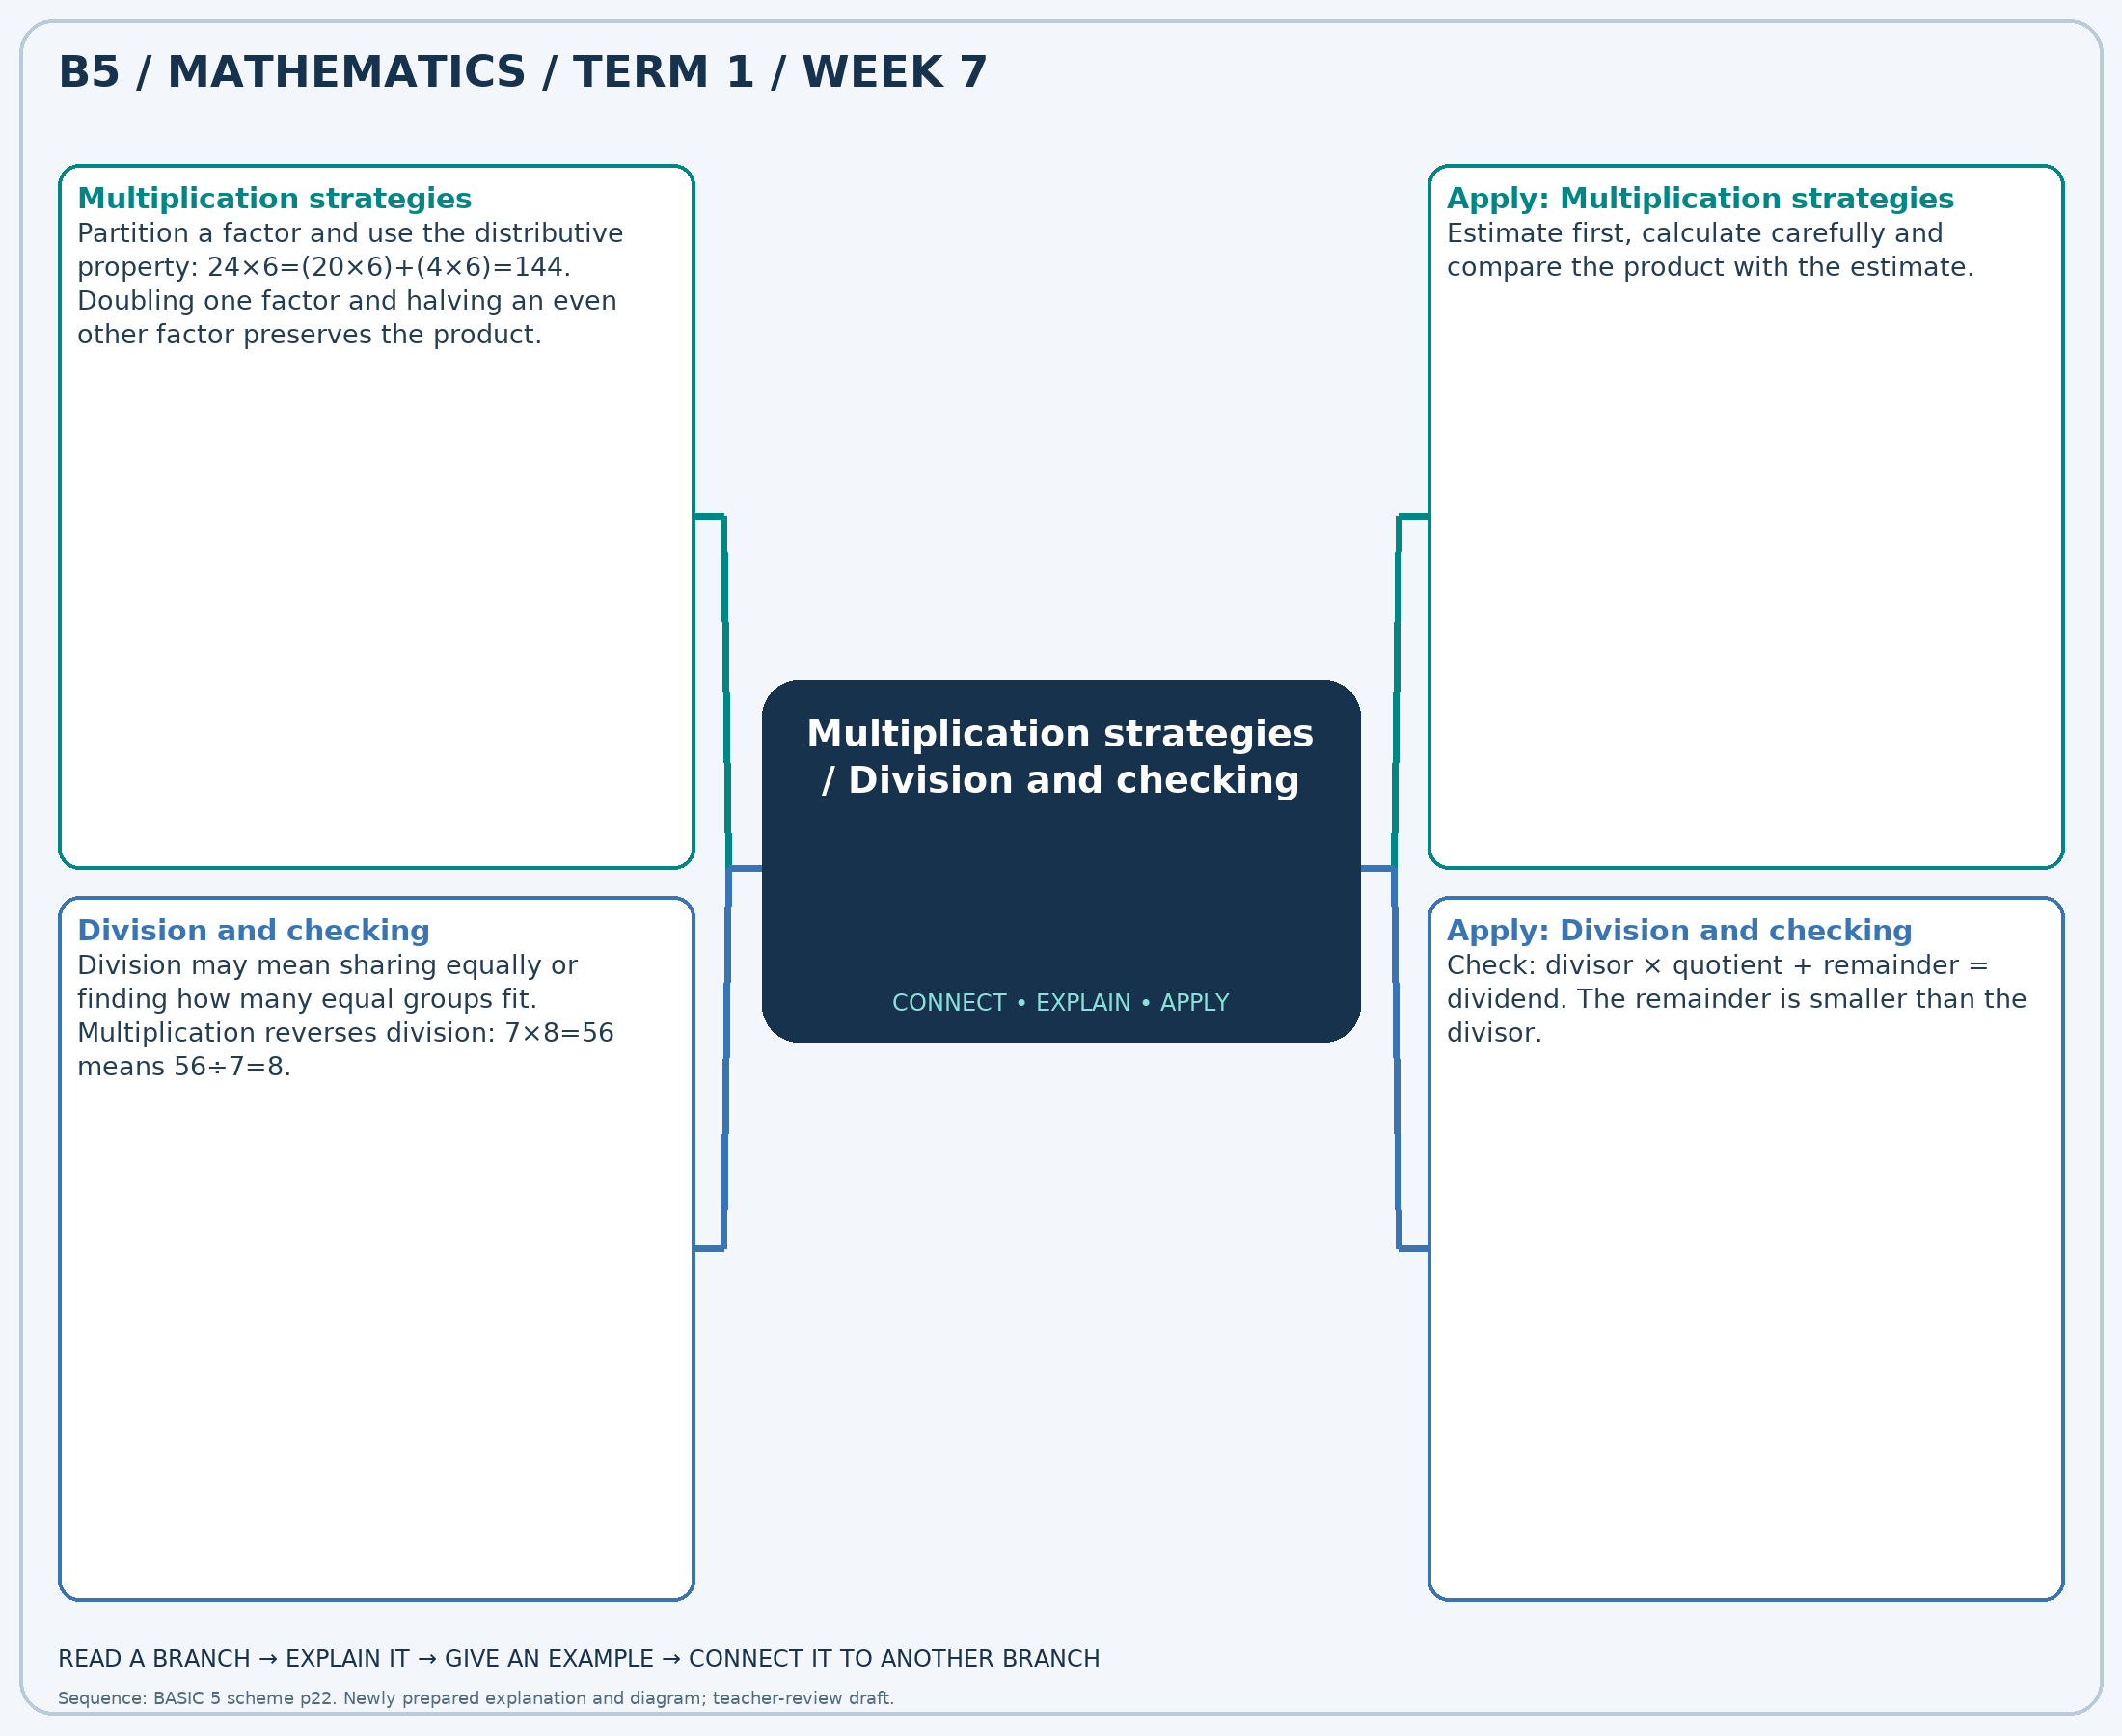
The separate high-resolution PNG can be projected or printed larger. Explain each branch and connect it with an example.

Week 7 — Practice

Section A — Multiple-choice questions
Choose ONE correct answer for each question. Each question has four alternatives.
1. Calculate 315 × 29.
A. 9450 B. 344 C. 9135 D. 8820
2. Calculate 196 ÷ 7.
A. 29 B. 189 C. 27 D. 28
3. Calculate 499 × 13.
A. 6986 B. 6487 C. 5988 D. 512
4. Calculate 198 ÷ 3.
A. 65 B. 195 C. 66 D. 67
5. Calculate 276 × 19.
A. 295 B. 5520 C. 4968 D. 5244
6. Calculate 480 ÷ 6.
A. 79 B. 81 C. 80 D. 474
7. Calculate 145 × 13.
A. 1740 B. 158 C. 1885 D. 2030
8. Calculate 273 ÷ 7.
A. 39 B. 40 C. 38 D. 266
9. Calculate 197 × 19.
A. 3546 B. 216 C. 3743 D. 3940
10. Calculate 612 ÷ 9.
A. 67 B. 69 C. 68 D. 603
11. Calculate 333 × 12.
A. 3996 B. 345 C. 4329 D. 3663
12. Calculate 648 ÷ 9.
A. 639 B. 72 C. 73 D. 71
13. Calculate 274 × 22.
A. 296 B. 5754 C. 6302 D. 6028
14. Calculate 408 ÷ 8.
A. 50 B. 51 C. 400 D. 52
15. Calculate 296 × 27.
A. 323 B. 7992 C. 8288 D. 7696
16. Calculate 371 ÷ 7.
A. 52 B. 364 C. 53 D. 54
17. Calculate 226 × 26.
A. 252 B. 5876 C. 6102 D. 5650
18. Calculate 324 ÷ 9.
A. 37 B. 36 C. 35 D. 315
19. Calculate 400 × 32.
A. 12400 B. 13200 C. 432 D. 12800
20. Calculate 216 ÷ 6.
A. 37 B. 36 C. 210 D. 35

Section B — Structured essay questions
Answer every part (a), (b), (c). Show your method or explain your choice. Write in a separate answer booklet. Each part: 1 mark for valid working/explanation and 1 for the correct result; 6 marks per question.

1. Apply the related skills and show working or give a reason for each answer.
(a) Calculate 109 × 15.
(b) Calculate 792 ÷ 9.
(c) Calculate 209 × 35.

2. Apply the related skills and show working or give a reason for each answer.
(a) Calculate 475 ÷ 5.
(b) Calculate 290 × 15.
(c) Calculate 630 ÷ 9.

3. Apply the related skills and show working or give a reason for each answer.
(a) Calculate 459 × 34.
(b) Calculate 264 ÷ 6.
(c) Calculate 107 × 20.

4. Apply the related skills and show working or give a reason for each answer.
(a) Calculate 184 ÷ 2.
(b) Calculate 442 × 27.
(c) Calculate 272 ÷ 4.

5. Apply the related skills and show working or give a reason for each answer.
(a) Calculate 359 × 18.
(b) Calculate 400 ÷ 8.
(c) Calculate 456 × 20.

6. Apply the related skills and show working or give a reason for each answer.
(a) Calculate 252 ÷ 6.
(b) Calculate 191 × 12.
(c) Calculate 128 ÷ 8.

7. Apply the related skills and show working or give a reason for each answer.
(a) Calculate 390 × 15.
(b) Calculate 450 ÷ 5.
(c) Calculate 466 × 19.

8. Apply the related skills and show working or give a reason for each answer.
(a) Calculate 686 ÷ 7.
(b) Calculate 461 × 21.
(c) Calculate 637 ÷ 7.

9. Apply the related skills and show working or give a reason for each answer.
(a) Calculate 388 × 25.
(b) Calculate 195 ÷ 5.
(c) Calculate 419 × 19.

10. Apply the related skills and show working or give a reason for each answer.
(a) Calculate 205 ÷ 5.
(b) Calculate 129 × 36.
(c) Calculate 368 ÷ 8.

Week 8 — Multi-step number problems / Positive and negative integers
Sequence source: BASIC 5 SCHEME OF LEARNING.pdf, first-term Mathematics, page 22. One consolidated weekly unit.

Learning outcomes
- Explain and apply multi-step number problems, solve examples and justify the method.
- Explain and apply positive and negative integers, solve examples and justify the method.

Teaching notes and suggested sessions
Suggested schedule: five 40-minute sessions, adjusted to the school timetable. Spread the question bank through the week; it is not intended to be completed in one lesson.

1 — Explore and diagnose
5 minutes: recall an earlier skill; 10: demonstrate a concrete or pictorial model; 15: pairs investigate and explain; 10: identify a misconception and set an exit task.

2 — Model and practise
5 minutes: review the exit task; 10: work an example aloud; 15: pairs solve parallel examples; 10: compare methods and correct errors.

3 — Connect representations
5 minutes: recall vocabulary; 10: explain the mind-map; 15: connect a model, a drawing and a symbolic calculation; 10: independent practice.

4 — Apply and explain
5 minutes: estimate or predict; 10: solve a contextual example; 15: attempt selected structured-question parts; 10: compare reasoning and check units.

5 — Check and respond
5 minutes: retrieve the main rule; 15: use selected MCQs diagnostically; 10: explain distractors and misconceptions; 10: reteach or extend in response to evidence.

Topic-specific activities
- Use a shop-stock or shopping story. Draw a bar model and compare two solution methods.
- Walk along a floor number line to show addition and subtraction.
Resources: board, pencils, number cards, counters, paper strips and squared paper as appropriate. Prior-knowledge check: ask a learner to explain a representation used in the first example before introducing a new rule.
Support: reduce number size without changing the concept; offer a partially completed chart or model; allow oral reasoning before writing. Extension: create a counterexample to a false rule and explain why it fails.

Study notes and worked examples

Multi-step number problems
- Identify the quantities, units and the final question before calculating.
- Use a diagram or a written plan to select the operations from the relationships.
- Label intermediate answers, then complete the remaining steps.
- Estimate and interpret the answer in the original situation.
Worked example: A shop has 6 packs of 4 pencils and sells 8 pencils. How many pencils remain?
Solution: Start with 6×4=24; subtract 8 to obtain 16 pencils.
Common misconception: A correct intermediate calculation may not answer the final question.

Positive and negative integers
- Integers include negative whole numbers, zero and positive whole numbers.
- On a number line, numbers increase to the right.
- Adding a positive amount moves right; subtracting a positive amount moves left.
- Use changes in balances or temperature to interpret signed quantities.
Worked example: Calculate (13) + 8.
Solution: Start at 13 and move 8 places right: 21.
Common misconception: -8 is less than -3 even though 8 is greater than 3.
Independent study: read the map, cover it and reconstruct the branches. Solve an unused question from each skill and explain the reasoning to a partner. Consult the teacher key only after an honest attempt.

Week 8 — Visual mind-map
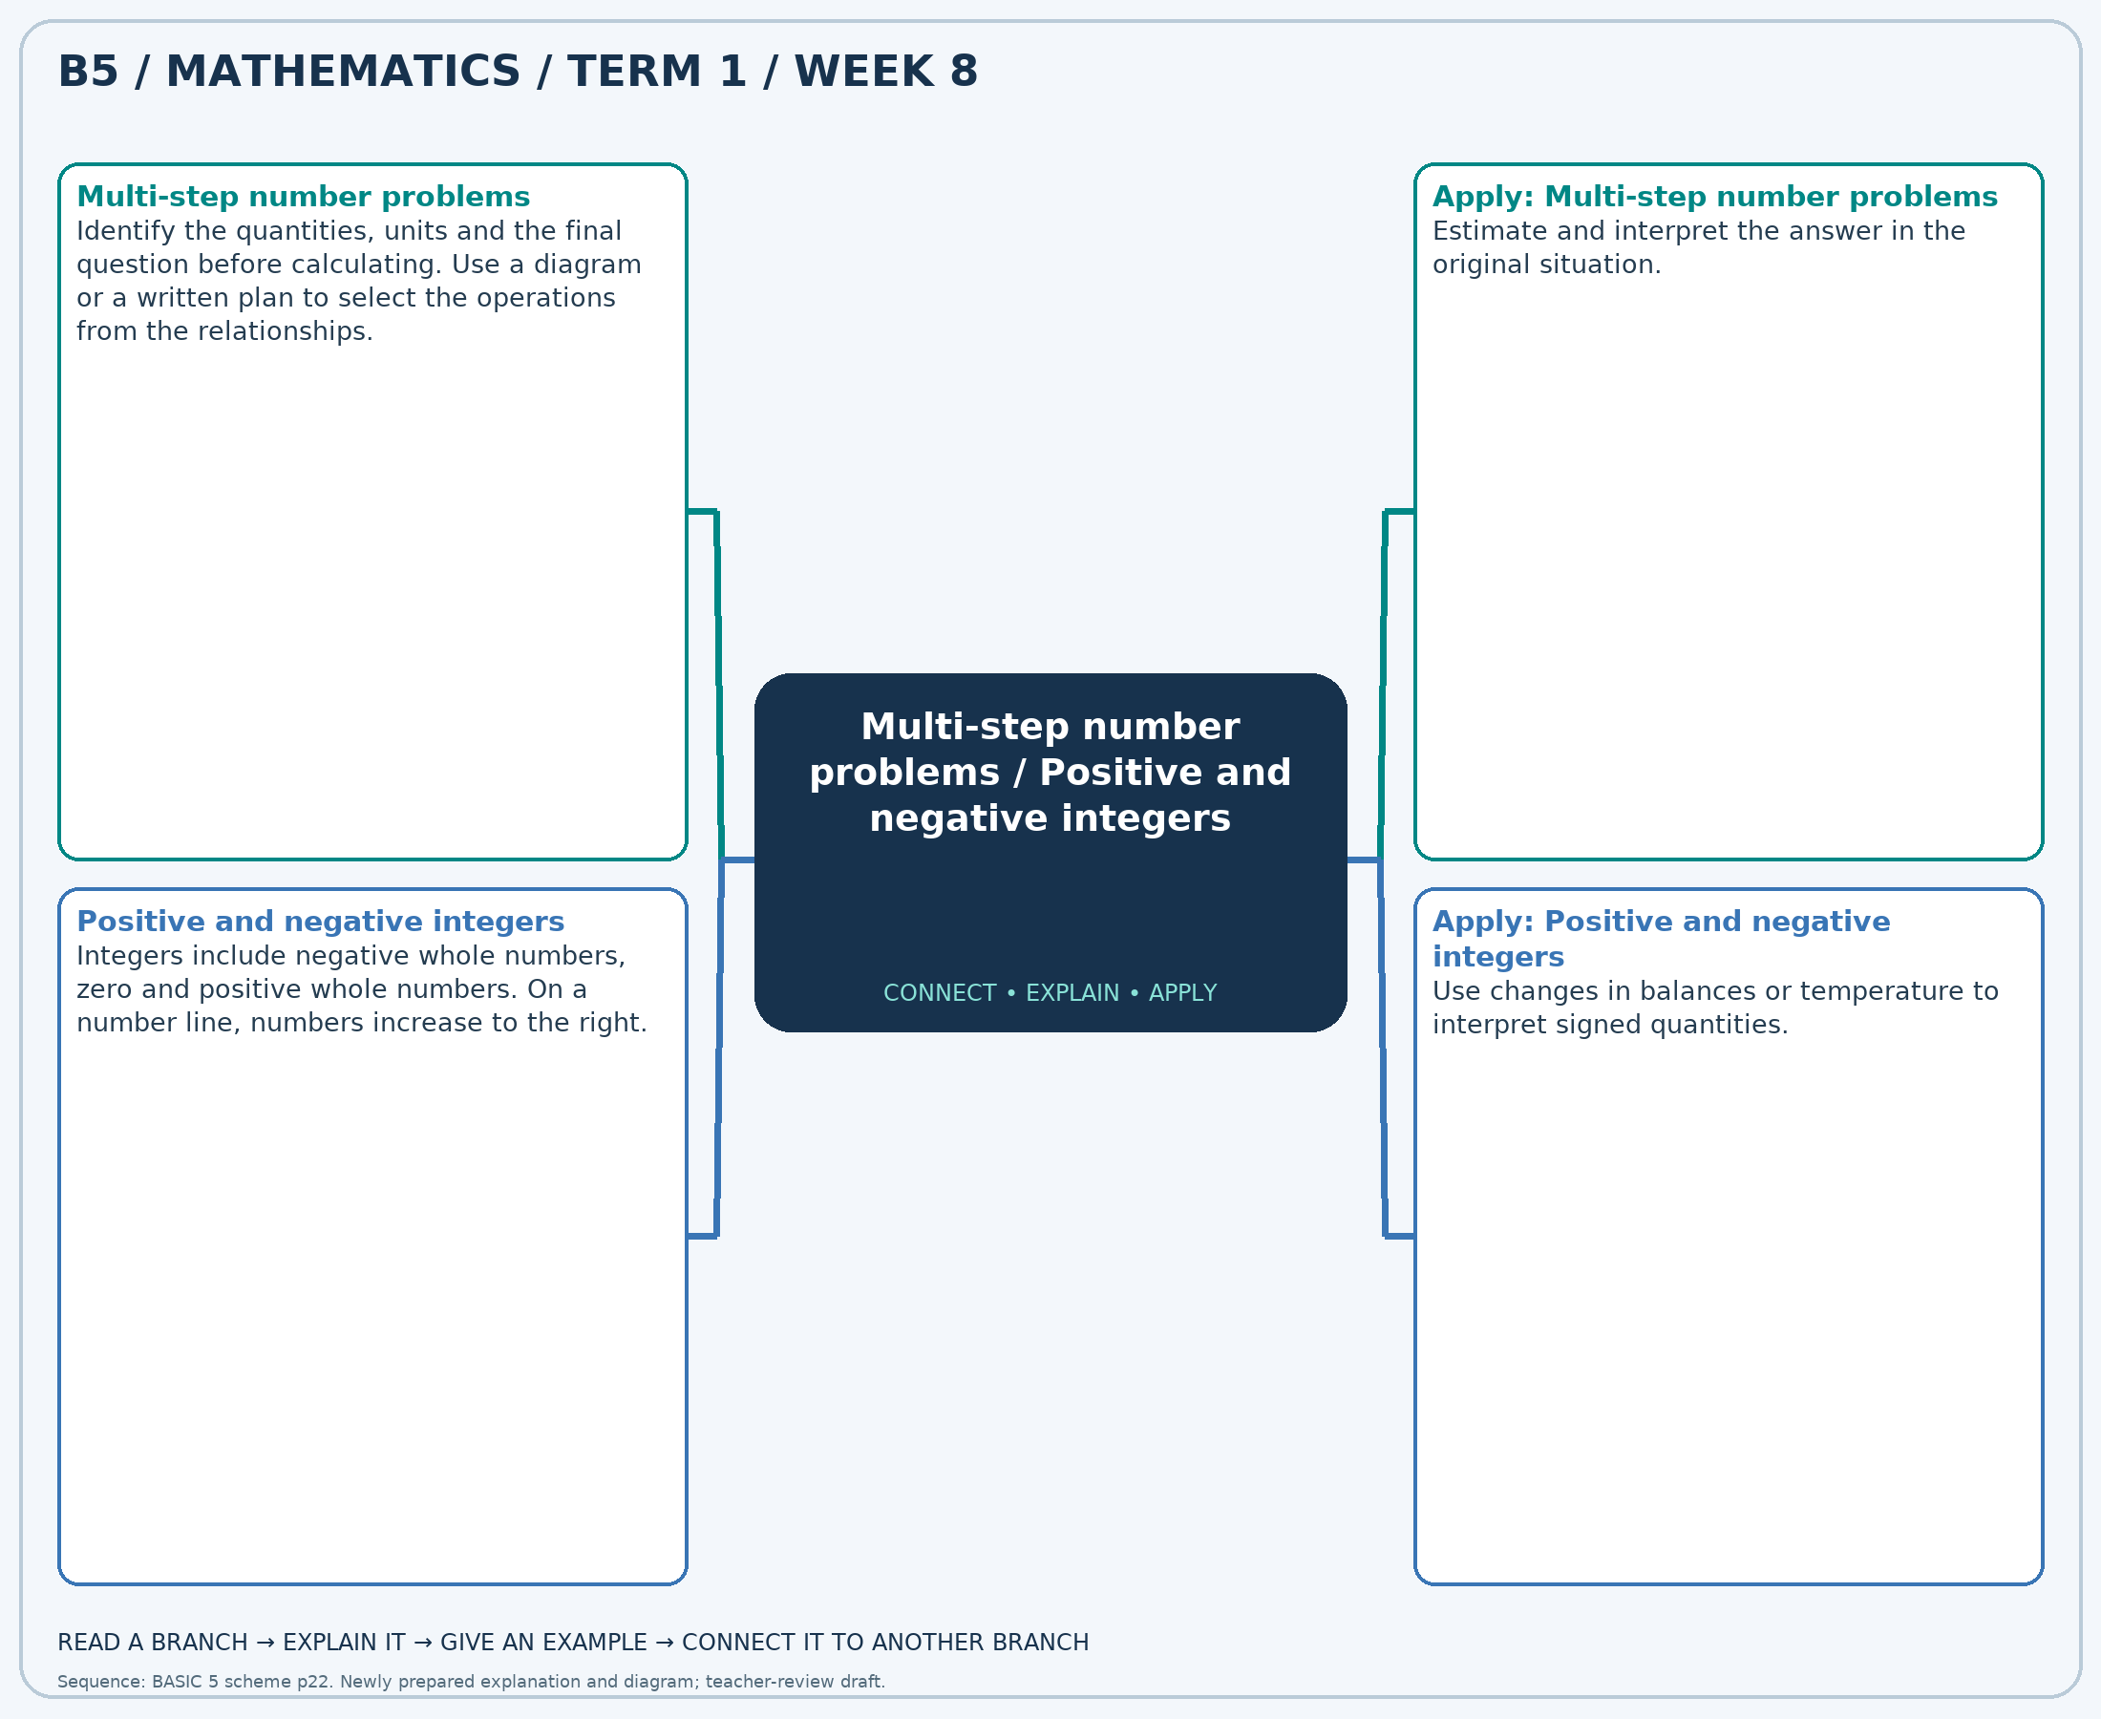
The separate high-resolution PNG can be projected or printed larger. Explain each branch and connect it with an example.

Week 8 — Practice

Section A — Multiple-choice questions
Choose ONE correct answer for each question. Each question has four alternatives.
1. A shop has 4 packs of 10 pencils and sells 38 pencils. How many pencils remain?
A. 2 B. 12 C. 78 D. 52
2. Calculate (-7) − 7.
A. -12 B. -13 C. -15 D. -14
3. A shop has 3 packs of 7 pencils and sells 11 pencils. How many pencils remain?
A. 17 B. 21 C. 32 D. 10
4. Calculate (-20) − 12.
A. -30 B. -33 C. -31 D. -32
5. A shop has 9 packs of 7 pencils and sells 52 pencils. How many pencils remain?
A. 68 B. 18 C. 11 D. 115
6. Calculate (5) + 5.
A. 11 B. 10 C. 12 D. 9
7. A shop has 5 packs of 4 pencils and sells 10 pencils. How many pencils remain?
A. 19 B. 10 C. 30 D. 14
8. Calculate (-16) + 7.
A. -9 B. -10 C. -7 D. -8
9. A shop has 3 packs of 9 pencils and sells 16 pencils. How many pencils remain?
A. 11 B. 28 C. 20 D. 43
10. Calculate (-17) − 2.
A. -17 B. -19 C. -18 D. -20
11. A shop has 5 packs of 7 pencils and sells 4 pencils. How many pencils remain?
A. 39 B. 16 C. 38 D. 31
12. Calculate (3) − 6.
A. -4 B. -1 C. -3 D. -2
13. A shop has 8 packs of 10 pencils and sells 58 pencils. How many pencils remain?
A. 22 B. 138 C. 32 D. 76
14. Calculate (-10) − 13.
A. -21 B. -24 C. -22 D. -23
15. A shop has 7 packs of 4 pencils and sells 6 pencils. How many pencils remain?
A. 17 B. 34 C. 22 D. 26
16. Calculate (19) + 5.
A. 26 B. 23 C. 24 D. 25
17. A shop has 6 packs of 6 pencils and sells 14 pencils. How many pencils remain?
A. 28 B. 50 C. 26 D. 22
18. Calculate (4) + 15.
A. 20 B. 18 C. 21 D. 19
19. A shop has 6 packs of 6 pencils and sells 34 pencils. How many pencils remain?
A. 8 B. 46 C. 2 D. 70
20. Calculate (6) − 2.
A. 3 B. 6 C. 4 D. 5

Section B — Structured essay questions
Answer every part (a), (b), (c). Show your method or explain your choice. Write in a separate answer booklet. Each part: 1 mark for valid working/explanation and 1 for the correct result; 6 marks per question.

1. Apply the related skills and show working or give a reason for each answer.
(a) A shop has 3 packs of 4 pencils and sells 11 pencils. How many pencils remain?
(b) Calculate (4) − 7.
(c) A shop has 8 packs of 6 pencils and sells 26 pencils. How many pencils remain?

2. Apply the related skills and show working or give a reason for each answer.
(a) Calculate (-1) + 13.
(b) A shop has 7 packs of 6 pencils and sells 27 pencils. How many pencils remain?
(c) Calculate (9) − 4.

3. Apply the related skills and show working or give a reason for each answer.
(a) A shop has 9 packs of 10 pencils and sells 15 pencils. How many pencils remain?
(b) Calculate (10) − 5.
(c) A shop has 6 packs of 11 pencils and sells 57 pencils. How many pencils remain?

4. Apply the related skills and show working or give a reason for each answer.
(a) Calculate (-3) + 11.
(b) A shop has 3 packs of 12 pencils and sells 10 pencils. How many pencils remain?
(c) Calculate (-9) − 10.

5. Apply the related skills and show working or give a reason for each answer.
(a) A shop has 9 packs of 12 pencils and sells 77 pencils. How many pencils remain?
(b) Calculate (12) + 12.
(c) A shop has 7 packs of 8 pencils and sells 27 pencils. How many pencils remain?

6. Apply the related skills and show working or give a reason for each answer.
(a) Calculate (-9) − 4.
(b) A shop has 3 packs of 5 pencils and sells 5 pencils. How many pencils remain?
(c) Calculate (-19) − 5.

7. Apply the related skills and show working or give a reason for each answer.
(a) A shop has 9 packs of 9 pencils and sells 29 pencils. How many pencils remain?
(b) Calculate (-17) + 6.
(c) A shop has 4 packs of 11 pencils and sells 25 pencils. How many pencils remain?

8. Apply the related skills and show working or give a reason for each answer.
(a) Calculate (15) − 13.
(b) A shop has 4 packs of 4 pencils and sells 11 pencils. How many pencils remain?
(c) Calculate (10) − 6.

9. Apply the related skills and show working or give a reason for each answer.
(a) A shop has 3 packs of 6 pencils and sells 5 pencils. How many pencils remain?
(b) Calculate (1) + 10.
(c) A shop has 5 packs of 5 pencils and sells 8 pencils. How many pencils remain?

10. Apply the related skills and show working or give a reason for each answer.
(a) Calculate (3) − 6.
(b) A shop has 9 packs of 9 pencils and sells 22 pencils. How many pencils remain?
(c) Calculate (11) − 9.

Week 9 — Equivalent fractions / Comparing fractions
Sequence source: BASIC 5 SCHEME OF LEARNING.pdf, first-term Mathematics, page 22. One consolidated weekly unit.

Learning outcomes
- Explain and apply equivalent fractions, solve examples and justify the method.
- Explain and apply comparing fractions, solve examples and justify the method.

Teaching notes and suggested sessions
Suggested schedule: five 40-minute sessions, adjusted to the school timetable. Spread the question bank through the week; it is not intended to be completed in one lesson.

1 — Explore and diagnose
5 minutes: recall an earlier skill; 10: demonstrate a concrete or pictorial model; 15: pairs investigate and explain; 10: identify a misconception and set an exit task.

2 — Model and practise
5 minutes: review the exit task; 10: work an example aloud; 15: pairs solve parallel examples; 10: compare methods and correct errors.

3 — Connect representations
5 minutes: recall vocabulary; 10: explain the mind-map; 15: connect a model, a drawing and a symbolic calculation; 10: independent practice.

4 — Apply and explain
5 minutes: estimate or predict; 10: solve a contextual example; 15: attempt selected structured-question parts; 10: compare reasoning and check units.

5 — Check and respond
5 minutes: retrieve the main rule; 15: use selected MCQs diagnostically; 10: explain distractors and misconceptions; 10: reteach or extend in response to evidence.

Topic-specific activities
- Shade equal lengths on strips partitioned into thirds and sixths.
- Place fraction cards on a number line and justify each position.
Resources: board, pencils, number cards, counters, paper strips and squared paper as appropriate. Prior-knowledge check: ask a learner to explain a representation used in the first example before introducing a new rule.
Support: reduce number size without changing the concept; offer a partially completed chart or model; allow oral reasoning before writing. Extension: create a counterexample to a false rule and explain why it fails.

Study notes and worked examples

Equivalent fractions
- Equivalent fractions have the same value even though their numerators and denominators differ.
- Multiply or divide the numerator and denominator by the same non-zero number.
- For example, 2/3=4/6=6/9. The amount stays the same.
- Common denominators help compare or add fractions.
Worked example: Complete: 6/8 = ?/16.
Solution: Multiply both terms by 2; numerator = 6×2=12.
Common misconception: Adding the same number to the numerator and denominator does not generally preserve value.

Comparing fractions
- Fractions must refer to the same-sized whole for a fair comparison.
- With the same denominator, compare numerators. With the same numerator, a smaller positive denominator gives a larger fraction.
- For unlike denominators, convert to a common denominator.
- Use 0, 1/2 and 1 as benchmarks to check an ordering.
Worked example: Which fraction is the least: 3/4, 1/6, 1/8, 1/12?
Solution: Use denominator 24: 3/4=18/24, 1/6=4/24, 1/8=3/24, 1/12=2/24. Answer: 1/12.
Common misconception: A larger denominator does not by itself mean a larger fraction.
Independent study: read the map, cover it and reconstruct the branches. Solve an unused question from each skill and explain the reasoning to a partner. Consult the teacher key only after an honest attempt.

Week 9 — Visual mind-map
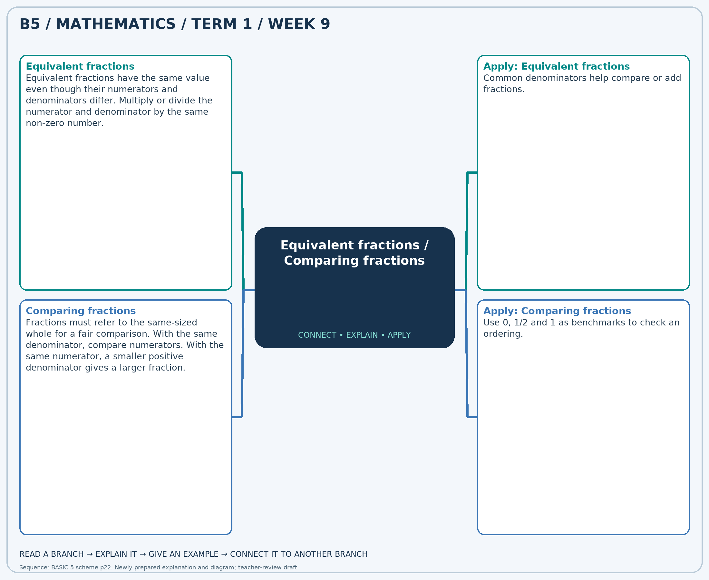
The separate high-resolution PNG can be projected or printed larger. Explain each branch and connect it with an example.

Week 9 — Practice

Section A — Multiple-choice questions
Choose ONE correct answer for each question. Each question has four alternatives.
1. Complete: 3/4 = ?/24.
A. 18 B. 3 C. 24 D. 9
2. Which fraction is the greatest: 5/6, 1/5, 1/6, 5/12?
A. 5/12 B. 1/6 C. 5/6 D. 1/5
3. Complete: 1/3 = ?/12.
A. 1 B. 8 C. 4 D. 5
4. Which fraction is the least: 1/10, 5/12, 9/10, 5/6?
A. 5/6 B. 5/12 C. 1/10 D. 9/10
5. Complete: 2/3 = ?/12.
A. 12 B. 8 C. 2 D. 6
6. Which fraction is the greatest: 1/8, 1/6, 4/5, 5/8?
A. 4/5 B. 5/8 C. 1/6 D. 1/8
7. Complete: 1/4 = ?/20.
A. 1 B. 5 C. 6 D. 10
8. Which fraction is the greatest: 4/5, 7/12, 1/8, 1/3?
A. 7/12 B. 1/3 C. 4/5 D. 1/8
9. Complete: 8/10 = ?/40.
A. 32 B. 8 C. 12 D. 36
10. Which fraction is the least: 5/6, 3/4, 7/12, 9/10?
A. 9/10 B. 7/12 C. 5/6 D. 3/4
11. Complete: 2/7 = ?/28.
A. 2 B. 8 C. 6 D. 12
12. Which fraction is the greatest: 7/8, 5/12, 1/2, 7/10?
A. 7/8 B. 7/10 C. 1/2 D. 5/12
13. Complete: 4/5 = ?/25.
A. 9 B. 4 C. 20 D. 25
14. Which fraction is the greatest: 7/8, 7/10, 7/12, 2/5?
A. 7/12 B. 2/5 C. 7/10 D. 7/8
15. Complete: 7/9 = ?/54.
A. 42 B. 13 C. 7 D. 48
16. Which fraction is the least: 7/8, 7/10, 5/6, 5/8?
A. 5/8 B. 7/10 C. 5/6 D. 7/8
17. Complete: 1/5 = ?/30.
A. 7 B. 1 C. 6 D. 12
18. Which fraction is the greatest: 1/12, 1/10, 2/3, 3/10?
A. 3/10 B. 1/12 C. 2/3 D. 1/10
19. Complete: 5/9 = ?/27.
A. 18 B. 8 C. 15 D. 5
20. Which fraction is the least: 5/8, 4/5, 7/12, 5/6?
A. 5/8 B. 7/12 C. 4/5 D. 5/6

Section B — Structured essay questions
Answer every part (a), (b), (c). Show your method or explain your choice. Write in a separate answer booklet. Each part: 1 mark for valid working/explanation and 1 for the correct result; 6 marks per question.

1. Apply the related skills and show working or give a reason for each answer.
(a) Complete: 3/4 = ?/24.
(b) Which fraction is the least: 1/2, 1/4, 1/12, 3/5?
(c) Complete: 2/10 = ?/40.

2. Apply the related skills and show working or give a reason for each answer.
(a) Which fraction is the least: 7/12, 11/12, 4/5, 7/10?
(b) Complete: 6/10 = ?/60.
(c) Which fraction is the greatest: 1/3, 2/5, 9/10, 5/6?

3. Apply the related skills and show working or give a reason for each answer.
(a) Complete: 4/5 = ?/15.
(b) Which fraction is the greatest: 1/8, 1/2, 1/12, 1/4?
(c) Complete: 7/10 = ?/60.

4. Apply the related skills and show working or give a reason for each answer.
(a) Which fraction is the greatest: 2/5, 5/12, 9/10, 1/10?
(b) Complete: 3/12 = ?/48.
(c) Which fraction is the greatest: 1/2, 7/8, 5/8, 1/4?

5. Apply the related skills and show working or give a reason for each answer.
(a) Complete: 1/6 = ?/30.
(b) Which fraction is the greatest: 1/6, 1/10, 1/8, 1/12?
(c) Complete: 4/5 = ?/10.

6. Apply the related skills and show working or give a reason for each answer.
(a) Which fraction is the greatest: 2/3, 9/10, 11/12, 1/5?
(b) Complete: 1/12 = ?/72.
(c) Which fraction is the least: 1/6, 2/3, 5/12, 7/10?

7. Apply the related skills and show working or give a reason for each answer.
(a) Complete: 3/8 = ?/40.
(b) Which fraction is the least: 1/6, 1/4, 2/5, 1/3?
(c) Complete: 1/9 = ?/45.

8. Apply the related skills and show working or give a reason for each answer.
(a) Which fraction is the least: 1/12, 2/3, 1/6, 3/5?
(b) Complete: 5/6 = ?/36.
(c) Which fraction is the greatest: 9/10, 3/5, 11/12, 2/3?

9. Apply the related skills and show working or give a reason for each answer.
(a) Complete: 3/8 = ?/24.
(b) Which fraction is the greatest: 1/10, 5/8, 5/6, 2/5?
(c) Complete: 1/9 = ?/36.

10. Apply the related skills and show working or give a reason for each answer.
(a) Which fraction is the greatest: 3/4, 2/3, 1/2, 1/6?
(b) Complete: 3/6 = ?/30.
(c) Which fraction is the greatest: 5/12, 1/2, 1/8, 1/4?

Week 10 — Adding and subtracting fractions
Sequence source: BASIC 5 SCHEME OF LEARNING.pdf, first-term Mathematics, page 22. One consolidated weekly unit.

Learning outcomes
- Explain and apply adding and subtracting fractions, solve examples and justify the method.

Teaching notes and suggested sessions
Suggested schedule: five 40-minute sessions, adjusted to the school timetable. Spread the question bank through the week; it is not intended to be completed in one lesson.

1 — Explore and diagnose
5 minutes: recall an earlier skill; 10: demonstrate a concrete or pictorial model; 15: pairs investigate and explain; 10: identify a misconception and set an exit task.

2 — Model and practise
5 minutes: review the exit task; 10: work an example aloud; 15: pairs solve parallel examples; 10: compare methods and correct errors.

3 — Connect representations
5 minutes: recall vocabulary; 10: explain the mind-map; 15: connect a model, a drawing and a symbolic calculation; 10: independent practice.

4 — Apply and explain
5 minutes: estimate or predict; 10: solve a contextual example; 15: attempt selected structured-question parts; 10: compare reasoning and check units.

5 — Check and respond
5 minutes: retrieve the main rule; 15: use selected MCQs diagnostically; 10: explain distractors and misconceptions; 10: reteach or extend in response to evidence.

Topic-specific activities
- Repartition fraction strips into matching units before combining or taking away parts.
Resources: board, pencils, number cards, counters, paper strips and squared paper as appropriate. Prior-knowledge check: ask a learner to explain a representation used in the first example before introducing a new rule.
Support: reduce number size without changing the concept; offer a partially completed chart or model; allow oral reasoning before writing. Extension: create a counterexample to a false rule and explain why it fails.

Study notes and worked examples

Adding and subtracting fractions
- Use a common denominator so the parts being combined are equal-sized.
- Add or subtract the numerators and keep the common denominator.
- For example, 1/2+1/3=3/6+2/6=5/6.
- Convert mixed numbers to improper fractions if helpful, simplify and check against an estimate.
Worked example: Calculate 1/4 + 8/3. Give the answer in simplest form.
Solution: Common denominator 12: (3 + 32)/12 = 35/12.
Common misconception: Do not add denominators: 1/2+1/3 is not 2/5.
Independent study: read the map, cover it and reconstruct the branches. Solve an unused question from each skill and explain the reasoning to a partner. Consult the teacher key only after an honest attempt.

Week 10 — Visual mind-map
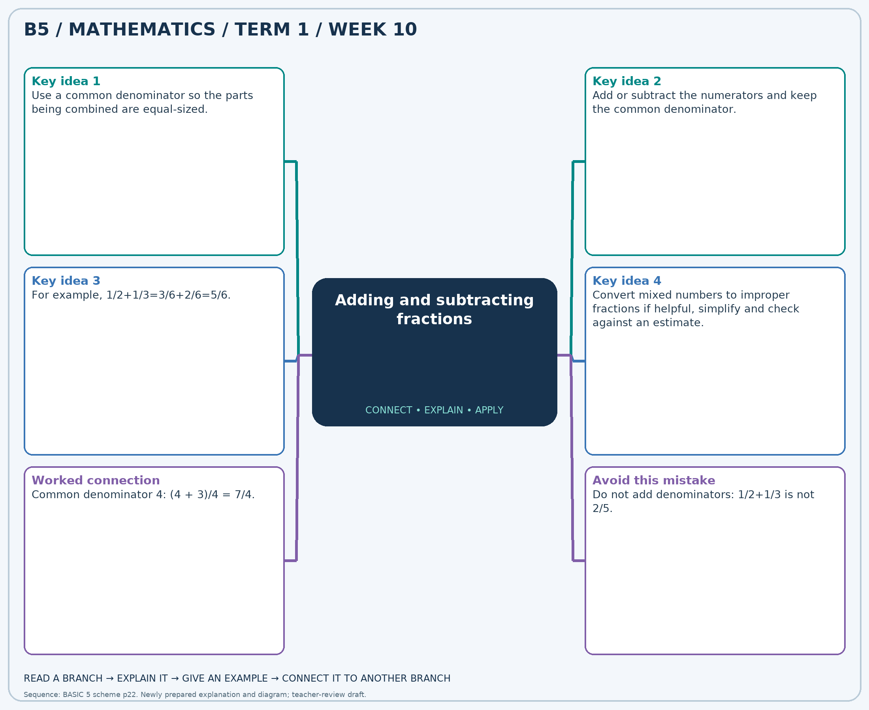
The separate high-resolution PNG can be projected or printed larger. Explain each branch and connect it with an example.

Week 10 — Practice

Section A — Multiple-choice questions
Choose ONE correct answer for each question. Each question has four alternatives.
1. Calculate 1/4 + 4/3. Give the answer in simplest form.
A. 43/12 B. 31/12 C. 19/12 D. 7/12
2. Calculate 2 − 1. Give the answer in simplest form.
A. 3 B. 1 C. 0 D. 2
3. Calculate 2/3 + 4. Give the answer in simplest form.
A. 20/3 B. 17/3 C. 11/3 D. 14/3
4. Calculate 4/3 + 7/4. Give the answer in simplest form.
A. 37/12 B. 25/12 C. 49/12 D. 61/12
5. Calculate 1/3 − 1/6. Give the answer in simplest form.
A. 13/6 B. -5/6 C. 7/6 D. 1/6
6. Calculate 1/4 + 7/2. Give the answer in simplest form.
A. 15/4 B. 23/4 C. 11/4 D. 19/4
7. Calculate 2/3 + 4/3. Give the answer in simplest form.
A. 4 B. 2 C. 1 D. 3
8. Calculate 1 − 2/3. Give the answer in simplest form.
A. 1/3 B. 7/3 C. -2/3 D. 4/3
9. Calculate 2/3 + 1/3. Give the answer in simplest form.
A. 3 B. 2 C. 1 D. 0
10. Calculate 5/4 + 5/6. Give the answer in simplest form.
A. 37/12 B. 25/12 C. 13/12 D. 49/12
11. Calculate 4 − 4/3. Give the answer in simplest form.
A. 14/3 B. 5/3 C. 11/3 D. 8/3
12. Calculate 4 + 3. Give the answer in simplest form.
A. 8 B. 9 C. 6 D. 7
13. Calculate 2 + 1/2. Give the answer in simplest form.
A. 9/2 B. 5/2 C. 7/2 D. 3/2
14. Calculate 3 − 7/4. Give the answer in simplest form.
A. 9/4 B. 13/4 C. 1/4 D. 5/4
15. Calculate 5/3 + 1/3. Give the answer in simplest form.
A. 4 B. 1 C. 2 D. 3
16. Calculate 1 + 2/3. Give the answer in simplest form.
A. 11/3 B. 5/3 C. 2/3 D. 8/3
17. Calculate 1 + 7/6. Give the answer in simplest form.
A. 25/6 B. 19/6 C. 13/6 D. 7/6
18. Calculate 1/3 + 3. Give the answer in simplest form.
A. 7/3 B. 13/3 C. 10/3 D. 16/3
19. Calculate 2/3 − 1/3. Give the answer in simplest form.
A. 7/3 B. 1/3 C. 4/3 D. -2/3
20. Calculate 2 + 4/3. Give the answer in simplest form.
A. 13/3 B. 7/3 C. 16/3 D. 10/3

Section B — Structured essay questions
Answer every part (a), (b), (c). Show your method or explain your choice. Write in a separate answer booklet. Each part: 1 mark for valid working/explanation and 1 for the correct result; 6 marks per question.

1. Apply the related skills and show working or give a reason for each answer.
(a) Calculate 4/3 + 1/3. Give the answer in simplest form.
(b) Calculate 4 − 5/4. Give the answer in simplest form.
(c) Calculate 5/3 + 1/4. Give the answer in simplest form.

2. Apply the related skills and show working or give a reason for each answer.
(a) Calculate 8/3 − 2. Give the answer in simplest form.
(b) Calculate 1/2 + 4/3. Give the answer in simplest form.
(c) Calculate 5/6 + 4/3. Give the answer in simplest form.

3. Apply the related skills and show working or give a reason for each answer.
(a) Calculate 1/4 + 3/2. Give the answer in simplest form.
(b) Calculate 4/3 + 3/2. Give the answer in simplest form.
(c) Calculate 2 − 3/2. Give the answer in simplest form.

4. Apply the related skills and show working or give a reason for each answer.
(a) Calculate 2/3 + 3/2. Give the answer in simplest form.
(b) Calculate 4 − 1/2. Give the answer in simplest form.
(c) Calculate 5/4 + 8/3. Give the answer in simplest form.

5. Apply the related skills and show working or give a reason for each answer.
(a) Calculate 1/3 − 1/3. Give the answer in simplest form.
(b) Calculate 1 + 1/3. Give the answer in simplest form.
(c) Calculate 2/3 + 4. Give the answer in simplest form.

6. Apply the related skills and show working or give a reason for each answer.
(a) Calculate 2 + 2/3. Give the answer in simplest form.
(b) Calculate 8/3 + 1. Give the answer in simplest form.
(c) Calculate 3 − 4/3. Give the answer in simplest form.

7. Apply the related skills and show working or give a reason for each answer.
(a) Calculate 1/2 + 1/2. Give the answer in simplest form.
(b) Calculate 5/2 − 1/2. Give the answer in simplest form.
(c) Calculate 1 + 1. Give the answer in simplest form.

8. Apply the related skills and show working or give a reason for each answer.
(a) Calculate 1 − 2/3. Give the answer in simplest form.
(b) Calculate 7/2 + 3/4. Give the answer in simplest form.
(c) Calculate 1 + 1. Give the answer in simplest form.

9. Apply the related skills and show working or give a reason for each answer.
(a) Calculate 1 + 3/2. Give the answer in simplest form.
(b) Calculate 4 + 1/4. Give the answer in simplest form.
(c) Calculate 1 − 1/2. Give the answer in simplest form.

10. Apply the related skills and show working or give a reason for each answer.
(a) Calculate 7/4 + 3/4. Give the answer in simplest form.
(b) Calculate 4 − 1. Give the answer in simplest form.
(c) Calculate 5/6 + 7/3. Give the answer in simplest form.

Week 11 — Multiplying fractions and finding a fraction of a quantity
Sequence source: BASIC 5 SCHEME OF LEARNING.pdf, first-term Mathematics, page 22. One consolidated weekly unit.

Learning outcomes
- Explain and apply multiplying fractions and finding a fraction of a quantity, solve examples and justify the method.

Teaching notes and suggested sessions
Suggested schedule: five 40-minute sessions, adjusted to the school timetable. Spread the question bank through the week; it is not intended to be completed in one lesson.

1 — Explore and diagnose
5 minutes: recall an earlier skill; 10: demonstrate a concrete or pictorial model; 15: pairs investigate and explain; 10: identify a misconception and set an exit task.

2 — Model and practise
5 minutes: review the exit task; 10: work an example aloud; 15: pairs solve parallel examples; 10: compare methods and correct errors.

3 — Connect representations
5 minutes: recall vocabulary; 10: explain the mind-map; 15: connect a model, a drawing and a symbolic calculation; 10: independent practice.

4 — Apply and explain
5 minutes: estimate or predict; 10: solve a contextual example; 15: attempt selected structured-question parts; 10: compare reasoning and check units.

5 — Check and respond
5 minutes: retrieve the main rule; 15: use selected MCQs diagnostically; 10: explain distractors and misconceptions; 10: reteach or extend in response to evidence.

Topic-specific activities
- Use counters for a fraction of a set and a shaded rectangle for a fraction of a fraction.
Resources: board, pencils, number cards, counters, paper strips and squared paper as appropriate. Prior-knowledge check: ask a learner to explain a representation used in the first example before introducing a new rule.
Support: reduce number size without changing the concept; offer a partially completed chart or model; allow oral reasoning before writing. Extension: create a counterexample to a false rule and explain why it fails.

Study notes and worked examples

Multiplying fractions and finding a fraction of a quantity
- A fraction of a quantity means multiplication.
- For example, 3/4 of 20 = (20÷4)×3 = 15.
- Multiply fractions by multiplying numerators and denominators; simplify before or after multiplying.
- Multiplying a positive quantity by a fraction between 0 and 1 makes it smaller.
Worked example: Find 1/2 of 44.
Solution: 44÷4×2=22.
Common misconception: Multiplication does not always make the quantity larger.
Independent study: read the map, cover it and reconstruct the branches. Solve an unused question from each skill and explain the reasoning to a partner. Consult the teacher key only after an honest attempt.

Week 11 — Visual mind-map
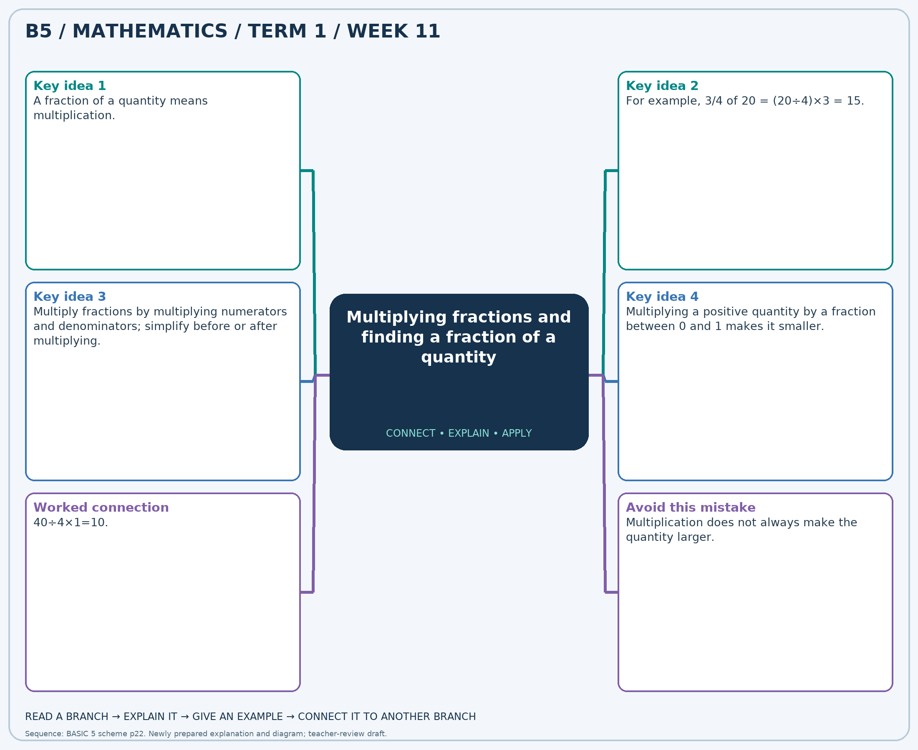
The separate high-resolution PNG can be projected or printed larger. Explain each branch and connect it with an example.

Week 11 — Practice

Section A — Multiple-choice questions
Choose ONE correct answer for each question. Each question has four alternatives.
1. Find 2/5 of 30.
A. 11 B. 14 C. 12 D. 13
2. Find 3/4 of 28.
A. 22 B. 23 C. 21 D. 20
3. Find 4/5 of 20.
A. 17 B. 18 C. 15 D. 16
4. Find 2/3 of 18.
A. 13 B. 11 C. 12 D. 14
5. Find 3/8 of 96.
A. 38 B. 36 C. 37 D. 35
6. Find 1/5 of 60.
A. 12 B. 14 C. 13 D. 11
7. Find 1/5 of 25.
A. 5 B. 6 C. 7 D. 4
8. Find 1/2 of 24.
A. 14 B. 13 C. 11 D. 12
9. Find 1/4 of 20.
A. 4 B. 6 C. 5 D. 7
10. Find 1/3 of 18.
A. 8 B. 5 C. 6 D. 7
11. Find 1/3 of 27.
A. 9 B. 10 C. 8 D. 11
12. Find 3/4 of 32.
A. 25 B. 24 C. 23 D. 26
13. Find 1/5 of 45.
A. 11 B. 10 C. 8 D. 9
14. Find 3/5 of 20.
A. 13 B. 14 C. 12 D. 11
15. Find 2/3 of 15.
A. 10 B. 11 C. 9 D. 12
16. Find 2/3 of 21.
A. 14 B. 13 C. 16 D. 15
17. Find 2/3 of 24.
A. 16 B. 15 C. 17 D. 18
18. Find 1/4 of 44.
A. 10 B. 12 C. 13 D. 11
19. Find 1/4 of 56.
A. 14 B. 15 C. 16 D. 13
20. Find 4/5 of 45.
A. 37 B. 35 C. 38 D. 36

Section B — Structured essay questions
Answer every part (a), (b), (c). Show your method or explain your choice. Write in a separate answer booklet. Each part: 1 mark for valid working/explanation and 1 for the correct result; 6 marks per question.

1. Apply the related skills and show working or give a reason for each answer.
(a) Find 3/4 of 32.
(b) Find 4/5 of 25.
(c) Find 7/8 of 96.

2. Apply the related skills and show working or give a reason for each answer.
(a) Find 1/4 of 24.
(b) Find 1/2 of 20.
(c) Find 1/4 of 80.

3. Apply the related skills and show working or give a reason for each answer.
(a) Find 3/5 of 50.
(b) Find 2/5 of 50.
(c) Find 1/4 of 20.

4. Apply the related skills and show working or give a reason for each answer.
(a) Find 2/5 of 45.
(b) Find 1/3 of 15.
(c) Find 1/5 of 15.

5. Apply the related skills and show working or give a reason for each answer.
(a) Find 2/3 of 27.
(b) Find 3/4 of 24.
(c) Find 3/8 of 56.

6. Apply the related skills and show working or give a reason for each answer.
(a) Find 1/3 of 24.
(b) Find 1/4 of 88.
(c) Find 1/2 of 44.

7. Apply the related skills and show working or give a reason for each answer.
(a) Find 3/4 of 20.
(b) Find 4/5 of 15.
(c) Find 3/4 of 12.

8. Apply the related skills and show working or give a reason for each answer.
(a) Find 3/5 of 15.
(b) Find 4/5 of 35.
(c) Find 1/2 of 24.

9. Apply the related skills and show working or give a reason for each answer.
(a) Find 7/8 of 24.
(b) Find 1/2 of 24.
(c) Find 1/3 of 15.

10. Apply the related skills and show working or give a reason for each answer.
(a) Find 2/5 of 35.
(b) Find 5/8 of 80.
(c) Find 1/3 of 18.

Week 12 — Percentages
Sequence source: BASIC 5 SCHEME OF LEARNING.pdf, first-term Mathematics, page 22. One consolidated weekly unit.

Learning outcomes
- Explain and apply percentages, solve examples and justify the method.

Teaching notes and suggested sessions
Suggested schedule: five 40-minute sessions, adjusted to the school timetable. Spread the question bank through the week; it is not intended to be completed in one lesson.

1 — Explore and diagnose
5 minutes: recall an earlier skill; 10: demonstrate a concrete or pictorial model; 15: pairs investigate and explain; 10: identify a misconception and set an exit task.

2 — Model and practise
5 minutes: review the exit task; 10: work an example aloud; 15: pairs solve parallel examples; 10: compare methods and correct errors.

3 — Connect representations
5 minutes: recall vocabulary; 10: explain the mind-map; 15: connect a model, a drawing and a symbolic calculation; 10: independent practice.

4 — Apply and explain
5 minutes: estimate or predict; 10: solve a contextual example; 15: attempt selected structured-question parts; 10: compare reasoning and check units.

5 — Check and respond
5 minutes: retrieve the main rule; 15: use selected MCQs diagnostically; 10: explain distractors and misconceptions; 10: reteach or extend in response to evidence.

Topic-specific activities
- Use a 100-square and shop price cards to model percentages and discounts.
Resources: board, pencils, number cards, counters, paper strips and squared paper as appropriate. Prior-knowledge check: ask a learner to explain a representation used in the first example before introducing a new rule.
Support: reduce number size without changing the concept; offer a partially completed chart or model; allow oral reasoning before writing. Extension: create a counterexample to a false rule and explain why it fails.

Study notes and worked examples

Percentages
- Percent means per hundred: 25%=25/100=1/4.
- Find a percentage of a quantity by multiplying by the percentage divided by 100.
- Useful benchmarks are 50%=1/2, 25%=1/4, 10%=1/10 and 75%=3/4.
- For a discount, find the reduction and subtract it from the original price.
Worked example: Find 25% of 80.
Solution: 25/100 × 80 = 20.
Common misconception: The discount amount is not the final selling price.
Independent study: read the map, cover it and reconstruct the branches. Solve an unused question from each skill and explain the reasoning to a partner. Consult the teacher key only after an honest attempt.

Week 12 — Visual mind-map
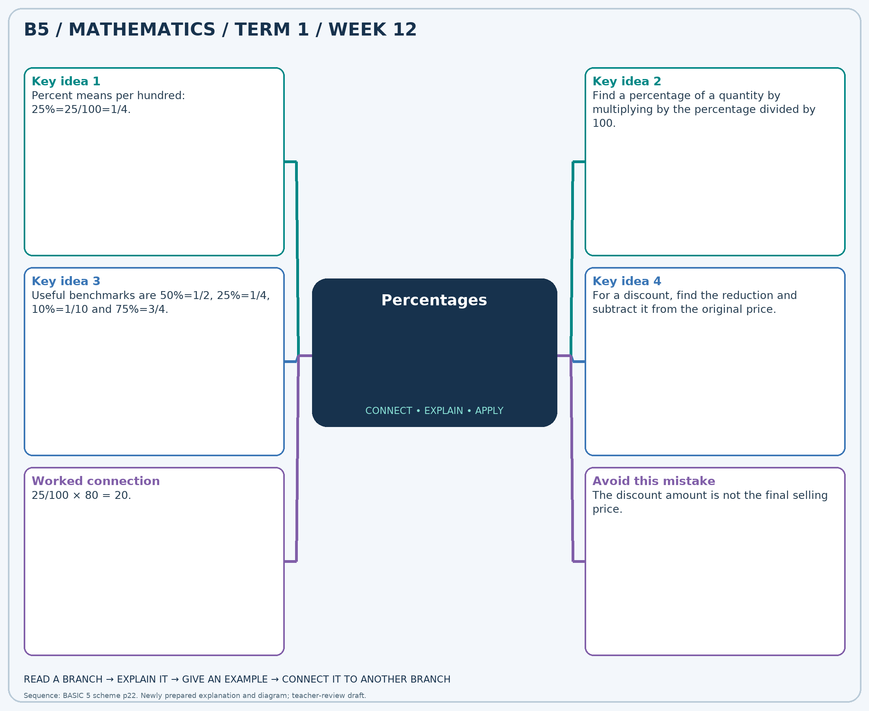
The separate high-resolution PNG can be projected or printed larger. Explain each branch and connect it with an example.

Week 12 — Practice

Section A — Multiple-choice questions
Choose ONE correct answer for each question. Each question has four alternatives.
1. Find 10% of 60.
A. 7 B. 8 C. 6 D. 5
2. A GH₵40 item has a 50% discount. Find the new price in Ghana cedis.
A. 20 B. 22 C. 21 D. 19
3. Find 25% of 60.
A. 16 B. 15 C. 14 D. 17
4. Find 20% of 40.
A. 8 B. 9 C. 7 D. 10
5. A GH₵20 item has a 50% discount. Find the new price in Ghana cedis.
A. 12 B. 11 C. 10 D. 9
6. Find 10% of 20.
A. 3 B. 4 C. 1 D. 2
7. A GH₵40 item has a 25% discount. Find the new price in Ghana cedis.
A. 29 B. 30 C. 31 D. 32
8. Find 20% of 60.
A. 12 B. 11 C. 14 D. 13
9. Find 50% of 60.
A. 30 B. 32 C. 29 D. 31
10. A GH₵80 item has a 20% discount. Find the new price in Ghana cedis.
A. 63 B. 65 C. 66 D. 64
11. Find 75% of 80.
A. 60 B. 62 C. 59 D. 61
12. Find 20% of 20.
A. 6 B. 5 C. 4 D. 3
13. A GH₵60 item has a 10% discount. Find the new price in Ghana cedis.
A. 54 B. 53 C. 56 D. 55
14. Find 50% of 20.
A. 10 B. 11 C. 9 D. 12
15. Find 75% of 60.
A. 47 B. 45 C. 44 D. 46
16. A GH₵40 item has a 20% discount. Find the new price in Ghana cedis.
A. 32 B. 31 C. 34 D. 33
17. A GH₵20 item has a 10% discount. Find the new price in Ghana cedis.
A. 18 B. 19 C. 20 D. 17
18. Find 50% of 80.
A. 39 B. 40 C. 42 D. 41
19. Find 50% of 40.
A. 20 B. 19 C. 22 D. 21
20. A GH₵60 item has a 75% discount. Find the new price in Ghana cedis.
A. 16 B. 17 C. 14 D. 15

Section B — Structured essay questions
Answer every part (a), (b), (c). Show your method or explain your choice. Write in a separate answer booklet. Each part: 1 mark for valid working/explanation and 1 for the correct result; 6 marks per question.

1. Apply the related skills and show working or give a reason for each answer.
(a) Find 25% of 40.
(b) A GH₵60 item has a 25% discount. Find the new price in Ghana cedis.
(c) Find 25% of 20.

2. Apply the related skills and show working or give a reason for each answer.
(a) A GH₵80 item has a 10% discount. Find the new price in Ghana cedis.
(b) Find 50% of 60.
(c) Find 10% of 40.

3. Apply the related skills and show working or give a reason for each answer.
(a) Find 50% of 60.
(b) Find 20% of 80.
(c) A GH₵60 item has a 75% discount. Find the new price in Ghana cedis.

4. Apply the related skills and show working or give a reason for each answer.
(a) Find 20% of 80.
(b) A GH₵60 item has a 75% discount. Find the new price in Ghana cedis.
(c) Find 75% of 80.

5. Apply the related skills and show working or give a reason for each answer.
(a) A GH₵80 item has a 75% discount. Find the new price in Ghana cedis.
(b) Find 50% of 20.
(c) Find 75% of 40.

6. Apply the related skills and show working or give a reason for each answer.
(a) Find 50% of 80.
(b) Find 10% of 80.
(c) A GH₵20 item has a 50% discount. Find the new price in Ghana cedis.

7. Apply the related skills and show working or give a reason for each answer.
(a) Find 20% of 20.
(b) A GH₵60 item has a 25% discount. Find the new price in Ghana cedis.
(c) Find 50% of 40.

8. Apply the related skills and show working or give a reason for each answer.
(a) A GH₵80 item has a 20% discount. Find the new price in Ghana cedis.
(b) Find 50% of 60.
(c) Find 25% of 20.

9. Apply the related skills and show working or give a reason for each answer.
(a) Find 50% of 80.
(b) Find 75% of 40.
(c) A GH₵20 item has a 50% discount. Find the new price in Ghana cedis.

10. Apply the related skills and show working or give a reason for each answer.
(a) Find 20% of 40.
(b) A GH₵80 item has a 10% discount. Find the new price in Ghana cedis.
(c) Find 50% of 60.

