Basic 5 Science — Week 1
  - Growth, sensitivity, respiration and excretion • Term 1 • Week 1 ONLY
Name: __________________________________ Class: __________
Date: __________________ Teacher: ________________________
SCOPE: WEEK 1 ONLY. Later weeks and both tests for this subject are NOT included in this partial batch. Emergency teacher-review draft — rebuilt edition.
Sequence source: BASIC 5 SCHEME OF LEARNING.pdf, p26; indicator reference B5.1.1.1.1. Topic descriptions informed by the local curriculum data. Explanations and activities are newly prepared, including supporting concepts.

Learning outcomes
- Explain the key ideas in growth, sensitivity, respiration and excretion using accurate vocabulary.
- Identify examples and justify classification or tool choices using evidence.
- Apply the ideas to familiar school or home situations and correct a common misconception.

Teacher lesson notes
One consolidated weekly unit. Suggested organisation: three 40-minute teaching sessions plus guided practice and assessment in the remaining timetable periods. Spread the questions over the week.
Prior knowledge: elicit a familiar example and ask for a reason. Record one correct idea and one misconception to revisit at the end of the week.

Session 1 — Observe
5 minutes: recall examples; 10: demonstrate or show pictures; 15: pairs describe features; 10: introduce the first five key terms and check explanations.

Session 2 — Investigate
5 minutes: retrieve vocabulary; 10: model an explanation; 15: perform the specific activity below; 10: compare observations and introduce the remaining terms.

Session 3 — Apply
5 minutes: correct a misconception; 10: explain map branches; 15: use application questions; 10: collect an exit response and identify who needs reteaching.

Topic-specific activity
Record a seedling’s height and leaf number on several dates. Make a four-column table for growth, sensitivity, respiration and excretion. Separate what can be directly observed from what is explained using biological knowledge.

Safety and resources
Use safe observation. No tasting unknown substances, prolonged breath-holding or contact with hot objects.
Resources: the examples or pictures specified in the activity, board, pencils, exercise books and the supplied visual map. If equipment is unavailable, use labelled drawings and role-play rather than claiming a practical was performed.

Support and extension
Support: offer picture labels, read technical vocabulary aloud and accept an oral explanation before writing. Extension: compare related concepts, propose a counterexample and justify a new application. Use wrong MCQ choices to diagnose misconceptions, not merely score letters.

Study notes

Growth
A lasting increase in an organism’s size and usually its dry mass.
Repeated measurements of the same plant support the conclusion. A brief change in water content alone is not enough to demonstrate lasting growth.

Sensitivity
The ability to detect and respond to changes in the surroundings.
Heat is the stimulus and withdrawing the hand is the response. The response protects the person from injury.

Respiration
Chemical processes in cells that release usable energy from food.
Cells require energy for movement, growth and repair, even when the person is not visibly active. Respiration is not simply moving air in and out.

Excretion
Removal of waste products made by the body’s chemical processes.
Carbon dioxide is a metabolic waste produced during aerobic respiration. Removing it is excretion, unlike removing undigested food by egestion.

Stimulus
A detectable change that can trigger a response.
The light is the change detected. Narrowing the eyes is the response, not the stimulus.

Response
A change in an organism’s activity caused by a detected stimulus.
The direction of light is the stimulus and bending growth is the response. Plants can respond slowly without walking.

Kidneys
Organs that remove urea and excess water from blood to form urine.
Kidneys form urine, whereas the bladder stores it before release. Both contribute to the urinary system but perform different jobs.

Carbon dioxide
A gaseous waste of aerobic respiration removed through human lungs.
Cells produce carbon dioxide; blood carries it to the lungs and breathing removes it. Oxygen is taken in for aerobic respiration rather than being its waste gas.

Breathing
Movement of air into and out of the lungs.
Breathing exchanges air. Cellular respiration releases energy chemically; breathing supports it by supplying oxygen and removing carbon dioxide.

Energy
The resource released from food during respiration that supports life activities.
Food contains chemical energy. Cells transfer some of this into useful forms to power their activities.
Revision routine: cover each definition, explain the idea, supply a new example and compare it with a related term. Reconstruct the map from memory before checking it.

Week 1 — Visual mind-map
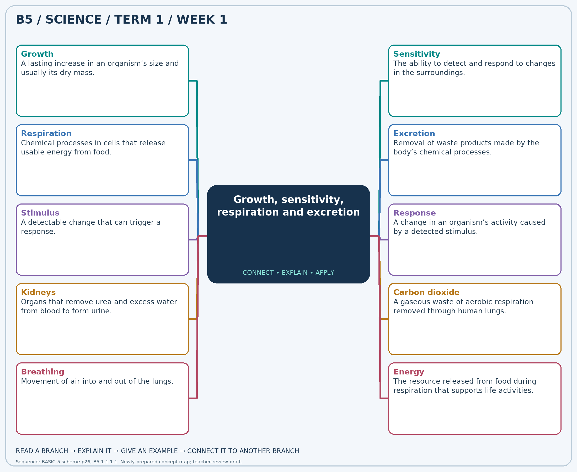
Explain each branch and supply another example. A separate high-resolution PNG is included.

Week 1 — Practice

Section A — Multiple-choice questions
Choose ONE correct answer for each question. Each question has four alternatives.
1. Which term best matches this description: a lasting increase in an organism’s size and usually its dry mass?
A. Respiration B. Excretion C. Growth D. Sensitivity
2. Which term best matches this description: the ability to detect and respond to changes in the surroundings?
A. Growth B. Sensitivity C. Reproduction D. Excretion
3. Which term best matches this description: chemical processes in cells that release usable energy from food?
A. Growth B. Pollination C. Excretion D. Respiration
4. Which term best matches this description: removal of waste products made by the body’s chemical processes?
A. Nutrition B. Reproduction C. Germination D. Excretion
5. Which term best matches this description: a detectable change that can trigger a response?
A. Nutrient B. Stimulus C. Excretory organ D. Response
6. Which term best matches this description: a change in an organism’s activity caused by a detected stimulus?
A. Waste product B. Response C. Organ D. Stimulus
7. Which term best matches this description: organs that remove urea and excess water from blood to form urine?
A. Stomach B. Lungs C. Kidneys D. Heart
8. Which term best matches this description: a gaseous waste of aerobic respiration removed through human lungs?
A. Carbon dioxide B. Nitrogen only C. Helium D. Oxygen
9. Which term best matches this description: movement of air into and out of the lungs?
A. Breathing B. Urine formation C. Cellular respiration D. Digestion
10. Which term best matches this description: the resource released from food during respiration that supports life activities?
A. Sunlight directly B. Soil C. Energy D. Feathers
11. A seedling becomes taller and develops more leaves over two weeks. Which life process is shown?
A. Excretion B. Growth C. Respiration D. Sensitivity
12. A person withdraws a hand from an uncomfortably hot surface. Which life process is shown?
A. Reproduction B. Excretion C. Sensitivity D. Growth
13. Muscle cells release energy from food while a child runs. Which process is involved?
A. Pollination B. Respiration C. Growth D. Excretion
14. The lungs remove carbon dioxide produced by cells. Which life process is this?
A. Reproduction B. Excretion C. Germination D. Nutrition
15. Bright light causes a person to narrow their eyes. What role does the bright light play?
A. Response B. Excretory organ C. Stimulus D. Nutrient
16. A plant shoot bends towards a light source. What is the bending in general biological terms?
A. Response B. Organ C. Stimulus D. Waste product
17. Which organs form urine rather than merely storing it?
A. Heart B. Lungs C. Kidneys D. Stomach
18. Which respiratory waste gas moves from the blood into the lungs to be breathed out?
A. Carbon dioxide B. Nitrogen only C. Helium D. Oxygen
19. The chest rises and falls as air moves in and out. Which process can be observed?
A. Urine formation B. Cellular respiration C. Breathing D. Digestion
20. What does respiration supply for movement, growth and repair?
A. Soil B. Sunlight directly C. Feathers D. Energy

Section B — 10 structured essay questions
Answer every part (a), (b), (c) in your exercise book. Suggested marks: (a) 1, (b) 1, (c) 2, giving 4 marks per question. Explain relationships and use examples where requested.

Question 1
(a) Explain the term “Growth”.
(b) A seedling becomes taller and develops more leaves over two weeks. Which life process is shown?
(c) Describe how you would collect evidence that a seedling is growing.

Question 2
(a) Explain the term “Sensitivity”.
(b) A person withdraws a hand from an uncomfortably hot surface. Which life process is shown?
(c) Identify the stimulus and response and explain the benefit of the response.

Question 3
(a) Explain the term “Respiration”.
(b) Muscle cells release energy from food while a child runs. Which process is involved?
(c) Explain why a sleeping person still needs this process.

Question 4
(a) Explain the term “Excretion”.
(b) The lungs remove carbon dioxide produced by cells. Which life process is this?
(c) Explain why carbon-dioxide removal counts as this process.

Question 5
(a) Explain the term “Stimulus”.
(b) Bright light causes a person to narrow their eyes. What role does the bright light play?
(c) Distinguish the stimulus from the response in the bright-light example.

Question 6
(a) Explain the term “Response”.
(b) A plant shoot bends towards a light source. What is the bending in general biological terms?
(c) Explain how this observation shows that plants have sensitivity.

Question 7
(a) Explain the term “Kidneys”.
(b) Which organs form urine rather than merely storing it?
(c) Distinguish the roles of the kidneys and bladder.

Question 8
(a) Explain the term “Carbon dioxide”.
(b) Which respiratory waste gas moves from the blood into the lungs to be breathed out?
(c) Describe the route of this waste from cells to the outside air.

Question 9
(a) Explain the term “Breathing”.
(b) The chest rises and falls as air moves in and out. Which process can be observed?
(c) Give one difference and one connection between breathing and respiration.

Question 10
(a) Explain the term “Energy”.
(b) What does respiration supply for movement, growth and repair?
(c) Name two activities needing energy and explain how respiration supports them.

