Basic 6 Computing — Week 1
  - Computer generations and system components • Term 1 • Week 1 ONLY
Name: __________________________________ Class: __________
Date: __________________ Teacher: ________________________
SCOPE: WEEK 1 ONLY. Later weeks and both tests for this subject are NOT included in this partial batch. Emergency teacher-review draft — rebuilt edition.
Sequence source: BASIC 6 SCHEME OF LEARNING.pdf, p51; indicator reference B6.1.1.1.1–2. Topic descriptions informed by the local curriculum data. Explanations and activities are newly prepared, including supporting concepts.

Learning outcomes
- Explain the key ideas in computer generations and system components using accurate vocabulary.
- Identify examples and justify classification or tool choices using evidence.
- Apply the ideas to familiar school or home situations and correct a common misconception.

Teacher lesson notes
One consolidated weekly unit. Suggested organisation: three 40-minute teaching sessions plus guided practice and assessment in the remaining timetable periods. Spread the questions over the week.
Prior knowledge: elicit a familiar example and ask for a reason. Record one correct idea and one misconception to revisit at the end of the week.

Session 1 — Observe
5 minutes: recall examples; 10: demonstrate or show pictures; 15: pairs describe features; 10: introduce the first five key terms and check explanations.

Session 2 — Investigate
5 minutes: retrieve vocabulary; 10: model an explanation; 15: perform the specific activity below; 10: compare observations and introduce the remaining terms.

Session 3 — Apply
5 minutes: correct a misconception; 10: explain map branches; 15: use application questions; 10: collect an exit response and identify who needs reteaching.

Topic-specific activity
Construct a picture timeline: vacuum tubes, transistors, integrated circuits, microprocessors. Sort examples into hardware, software and liveware, then explain how the categories cooperate to create a school document.

Safety and resources
Use photographs for internal components. Do not dismantle equipment or handle exposed electrical parts.
Resources: the examples or pictures specified in the activity, board, pencils, exercise books and the supplied visual map. If equipment is unavailable, use labelled drawings and role-play rather than claiming a practical was performed.

Support and extension
Support: offer picture labels, read technical vocabulary aloud and accept an oral explanation before writing. Extension: compare related concepts, propose a counterexample and justify a new application. Use wrong MCQ choices to diagnose misconceptions, not merely score letters.

Study notes

Hardware
The physical equipment of a computer system.
Physical equipment is tangible. A word-processing program is a set of instructions rather than another physical keyboard.

Software
Programs and instructions telling computer hardware what to do.
Installing a program adds instructions or data to storage, not a new physical input device. Hardware executes those instructions.

Liveware
The people who use, manage or support computer systems.
People choose tasks, enter accurate data and interpret output. The system does not remove human responsibility for mistakes.

Input device
Equipment sending data or instructions into a computer.
It sends a digital representation inward. The image may then be processed, displayed and saved.

Output device
Equipment presenting information from a computer.
A monitor or projector presents visual output; a printer can present the same graph as hard copy.

Storage
Keeping files and programs for future use.
Saving retains the working file; a separate backup supports recovery if that copy is lost. Sensitive records also need access controls.

Vacuum tubes
Electronic components associated with first-generation computers.
Many early computers using this technology were large, produced substantial heat and required more power than later transistor designs.

Transistors
Electronic components associated with the second generation, replacing many tube functions.
These components were smaller and generally used less power than tubes, supporting improved size and reliability.

Integrated circuits
Many electronic components combined on a small chip, associated with the third generation.
Combining components reduces space and supports more complex circuits. A microprocessor is a particular highly integrated processor, not every circuit chip.

Microprocessor
A processor implementing CPU functions on an integrated-circuit chip.
Integration helped make smaller, affordable general-purpose systems possible. Modern devices still differ in power and purpose.
Revision routine: cover each definition, explain the idea, supply a new example and compare it with a related term. Reconstruct the map from memory before checking it.

Week 1 — Visual mind-map
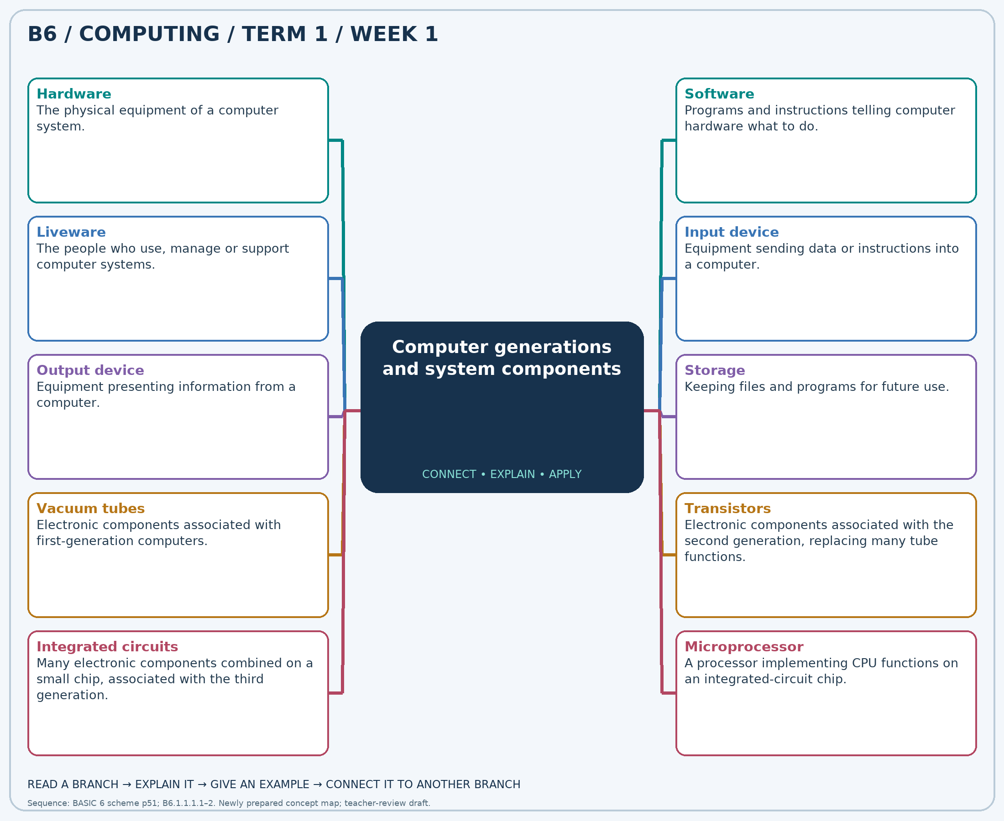
Explain each branch and supply another example. A separate high-resolution PNG is included.

Week 1 — Practice

Section A — Multiple-choice questions
Choose ONE correct answer for each question. Each question has four alternatives.
1. Which term best matches this description: the physical equipment of a computer system?
A. Hardware B. Data only C. Software D. Liveware
2. Which term best matches this description: programs and instructions telling computer hardware what to do?
A. Liveware B. Software C. Furniture D. Hardware
3. Which term best matches this description: the people who use, manage or support computer systems?
A. Storage B. Software C. Liveware D. Hardware
4. Which term best matches this description: equipment sending data or instructions into a computer?
A. Output device B. Input device C. Liveware D. Storage only
5. Which term best matches this description: equipment presenting information from a computer?
A. Input device B. Liveware C. Processor D. Output device
6. Which term best matches this description: keeping files and programs for future use?
A. Pointing B. Audio output only C. Scanning only D. Storage
7. Which term best matches this description: electronic components associated with first-generation computers?
A. Transistors only B. Vacuum tubes C. Microprocessors D. Integrated circuits
8. Which term best matches this description: electronic components associated with the second generation, replacing many tube functions?
A. Transistors B. Quantum bits only C. Microprocessors only D. Mechanical abacus only
9. Which term best matches this description: many electronic components combined on a small chip, associated with the third generation?
A. Vacuum tubes B. Integrated circuits C. Paper tape alone D. Mechanical gears
10. Which term best matches this description: a processor implementing CPU functions on an integrated-circuit chip?
A. Microprocessor B. Mechanical relay C. Paper card D. Vacuum tube
11. A learner can touch a keyboard and monitor. Which system category contains them?
A. Data only B. Liveware C. Software D. Hardware
12. A word-processing application is installed. Which category does it belong to?
A. Software B. Hardware C. Liveware D. Furniture
13. A teacher enters marks and checks the results. Which system category describes the teacher?
A. Storage B. Liveware C. Hardware D. Software
14. A scanner captures a drawing for a computer. Which role is it performing?
A. Storage only B. Output device C. Input device D. Liveware
15. A completed graph is displayed to the class. Which device role presents the result?
A. Processor B. Output device C. Input device D. Liveware
16. Pupil records must be reopened next term. Which system function is required?
A. Pointing B. Scanning only C. Audio output only D. Storage
17. A museum describes an early electronic computer built with tubes that used substantial space and power. Which technology is described?
A. Vacuum tubes B. Transistors only C. Microprocessors D. Integrated circuits
18. A timeline shows smaller switching components replacing vacuum tubes. Which technology marks the change?
A. Transistors B. Mechanical abacus only C. Quantum bits only D. Microprocessors only
19. A timeline moves from separate transistors to many components on one chip. Which technology follows?
A. Integrated circuits B. Paper tape alone C. Mechanical gears D. Vacuum tubes
20. A timeline links personal computers with CPU-on-a-chip technology. What is it?
A. Mechanical relay B. Paper card C. Microprocessor D. Vacuum tube

Section B — 10 structured essay questions
Answer every part (a), (b), (c) in your exercise book. Suggested marks: (a) 1, (b) 1, (c) 2, giving 4 marks per question. Explain relationships and use examples where requested.

Question 1
(a) Explain the term “Hardware”.
(b) A learner can touch a keyboard and monitor. Which system category contains them?
(c) Distinguish a keyboard from a word-processing program in system classification.

Question 2
(a) Explain the term “Software”.
(b) A word-processing application is installed. Which category does it belong to?
(c) Explain why installing a program is not the same as adding a physical device.

Question 3
(a) Explain the term “Liveware”.
(b) A teacher enters marks and checks the results. Which system category describes the teacher?
(c) Explain one responsibility of a user in producing accurate results.

Question 4
(a) Explain the term “Input device”.
(b) A scanner captures a drawing for a computer. Which role is it performing?
(c) Trace a scanned drawing through input, processing and output.

Question 5
(a) Explain the term “Output device”.
(b) A completed graph is displayed to the class. Which device role presents the result?
(c) Name two output forms for the graph and suitable devices.

Question 6
(a) Explain the term “Storage”.
(b) Pupil records must be reopened next term. Which system function is required?
(c) Explain the difference between saving and backing up school records.

Question 7
(a) Explain the term “Vacuum tubes”.
(b) A museum describes an early electronic computer built with tubes that used substantial space and power. Which technology is described?
(c) Explain two practical disadvantages compared with later designs.

Question 8
(a) Explain the term “Transistors”.
(b) A timeline shows smaller switching components replacing vacuum tubes. Which technology marks the change?
(c) Explain why this replacement was important.

Question 9
(a) Explain the term “Integrated circuits”.
(b) A timeline moves from separate transistors to many components on one chip. Which technology follows?
(c) Explain how combining components on chips can reduce computer size.

Question 10
(a) Explain the term “Microprocessor”.
(b) A timeline links personal computers with CPU-on-a-chip technology. What is it?
(c) Explain how this technology helped personal computers develop.

