Basic 6 Mathematics
  - Term 1 • Weeks 1–12 • Lesson notes, study notes, mind-maps and weekly practice
Name: __________________________________ Class: __________
Date: __________________ Teacher: ________________________
EMERGENCY TEACHER-REVIEW DRAFT — REBUILT EDITION. Topic order follows the supplied Alpha Examinations first-term scheme. Notes, examples and diagrams are newly prepared. This is not an official curriculum approval or a guarantee of full indicator-by-indicator validation.
Each week contains one consolidated weekly lesson unit, one visual mind-map, 20 four-option MCQs and 10 structured questions with parts (a), (b), (c). Daily sessions are suggested, not separate full daily lesson plans. Answers are in the separate teacher book.
The source reserves Weeks 13–15 for revision/examinations/vacation. Mid-term assessment assumes Weeks 1–6; end-of-term assumes Weeks 1–12. Confirm school dates and pacing. Some task structures repeat with new values for fluency practice.

Weekly contents
01 — Place value and expanded form
02 — Reading and writing large numbers / Number charts and counting steps
03 — Comparing and ordering whole numbers / Rounding whole numbers
04 — Multiplication facts and related division
05 — Multiplication strategies
06 — Division and checking
07 — Fractions, decimals and percentages / Adding and subtracting fractions
08 — Multiplying fractions and finding a fraction of a quantity
09 — Ratios in simplest form
10 — Equivalent ratios
11 — Direct proportion
12 — Rates and scale / Direct proportion

Week 1 — Place value and expanded form
Sequence source: BASIC 6 SCHEME OF LEARNING.pdf, first-term Mathematics, page 19. One consolidated weekly unit.

Learning outcomes
- Explain and apply place value and expanded form, solve examples and justify the method.

Teaching notes and suggested sessions
Suggested schedule: five 40-minute sessions, adjusted to the school timetable. Spread the question bank through the week; it is not intended to be completed in one lesson.

1 — Explore and diagnose
5 minutes: recall an earlier skill; 10: demonstrate a concrete or pictorial model; 15: pairs investigate and explain; 10: identify a misconception and set an exit task.

2 — Model and practise
5 minutes: review the exit task; 10: work an example aloud; 15: pairs solve parallel examples; 10: compare methods and correct errors.

3 — Connect representations
5 minutes: recall vocabulary; 10: explain the mind-map; 15: connect a model, a drawing and a symbolic calculation; 10: independent practice.

4 — Apply and explain
5 minutes: estimate or predict; 10: solve a contextual example; 15: attempt selected structured-question parts; 10: compare reasoning and check units.

5 — Check and respond
5 minutes: retrieve the main rule; 15: use selected MCQs diagnostically; 10: explain distractors and misconceptions; 10: reteach or extend in response to evidence.

Topic-specific activities
- Build numbers with digit cards on a place-value chart. Exchange two digits and explain the change.
Resources: board, pencils, number cards, counters, paper strips and squared paper as appropriate. Prior-knowledge check: ask a learner to explain a representation used in the first example before introducing a new rule.
Support: reduce number size without changing the concept; offer a partially completed chart or model; allow oral reasoning before writing. Extension: create a counterexample to a false rule and explain why it fails.

Study notes and worked examples

Place value and expanded form
- Our system is base ten. Ten units in one place exchange for one unit in the next place to the left.
- The digit 3 in 43,216 has value 3,000. Face value and place value are different.
- Expanded form shows a sum of place values: 43,216 = 40,000 + 3,000 + 200 + 10 + 6.
- Zero holds an empty place. Removing the zero from 40,216 changes the number.
Worked example: What is the value of the digit in the hundreds place in 370,530?
Solution: The digit is 5; 5 × 100 = 500.
Common misconception: Do not confuse the digit itself with the value of the place it occupies.
Independent study: read the map, cover it and reconstruct the branches. Solve an unused question from each skill and explain the reasoning to a partner. Consult the teacher key only after an honest attempt.

Week 1 — Visual mind-map
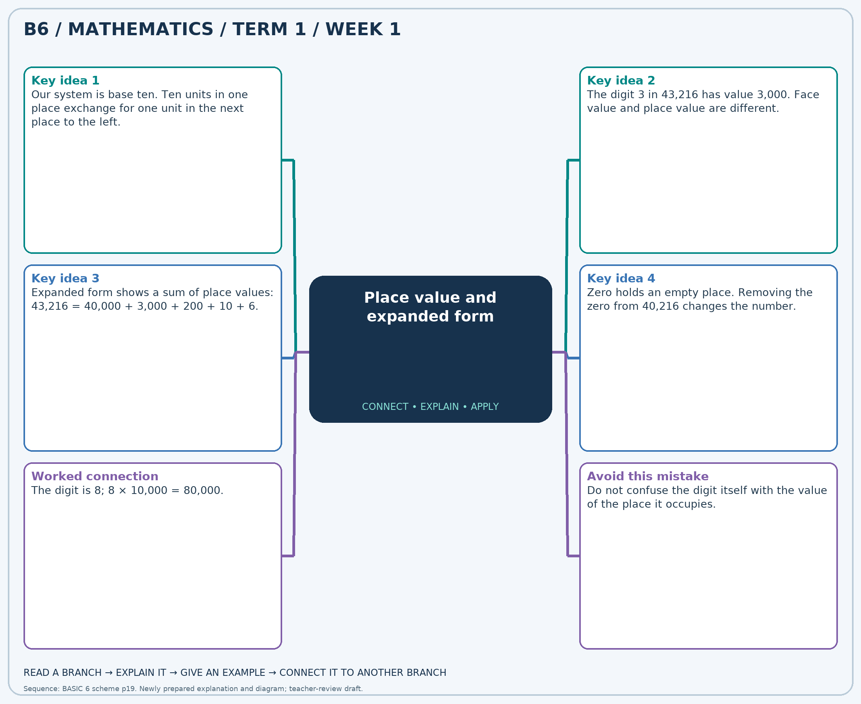
The separate high-resolution PNG can be projected or printed larger. Explain each branch and connect it with an example.

Week 1 — Practice

Section A — Multiple-choice questions
Choose ONE correct answer for each question. Each question has four alternatives.
1. What is the value of the digit in the tens place in 331,325?
A. 2 B. 20 C. 23 D. 200
2. A number has 2 ten-thousands, 6 hundreds and 3 ones, with zeros elsewhere. Write it in figures.
A. 20630 B. 2603 C. 26003 D. 20603
3. What is the value of the digit in the tens place in 851,512?
A. 10 B. 100 C. 13 D. 1
4. What is the value of the digit in the ten-thousands place in 917,992?
A. 100000 B. 1000 C. 10000 D. 1
5. A number has 7 ten-thousands, 9 hundreds and 4 ones, with zeros elsewhere. Write it in figures.
A. 70904 B. 79004 C. 7904 D. 70940
6. What is the value of the digit in the hundreds place in 721,302?
A. 3 B. 300 C. 30 D. 3000
7. What is the value of the digit in the tens place in 733,429?
A. 20 B. 200 C. 2 D. 23
8. A number has 9 ten-thousands, 8 hundreds and 6 ones, with zeros elsewhere. Write it in figures.
A. 9806 B. 90860 C. 90806 D. 98006
9. What is the value of the digit in the hundreds place in 756,210?
A. 2000 B. 2 C. 20 D. 200
10. What is the value of the digit in the ten-thousands place in 258,015?
A. 5 B. 500000 C. 5000 D. 50000
11. A number has 2 ten-thousands, 6 hundreds and 8 ones, with zeros elsewhere. Write it in figures.
A. 20680 B. 20608 C. 2608 D. 26008
12. What is the value of the digit in the thousands place in 421,809?
A. 1 B. 10000 C. 1000 D. 100
13. What is the value of the digit in the tens place in 663,649?
A. 400 B. 43 C. 4 D. 40
14. A number has 7 ten-thousands, 9 hundreds and 6 ones, with zeros elsewhere. Write it in figures.
A. 79006 B. 70906 C. 70960 D. 7906
15. What is the value of the digit in the ten-thousands place in 955,706?
A. 500000 B. 5 C. 50000 D. 5000
16. What is the value of the digit in the ten-thousands place in 380,812?
A. 80000 B. 8 C. 8000 D. 800000
17. A number has 7 ten-thousands, 2 hundreds and 3 ones, with zeros elsewhere. Write it in figures.
A. 70203 B. 7203 C. 70230 D. 72003
18. What is the value of the digit in the thousands place in 344,820?
A. 400 B. 4000 C. 40000 D. 4
19. What is the value of the digit in the tens place in 938,044?
A. 40 B. 43 C. 400 D. 4
20. A number has 8 ten-thousands, 5 hundreds and 2 ones, with zeros elsewhere. Write it in figures.
A. 80520 B. 80502 C. 8502 D. 85002

Section B — Structured essay questions
Answer every part (a), (b), (c). Show your method or explain your choice. Write in a separate answer booklet. Each part: 1 mark for valid working/explanation and 1 for the correct result; 6 marks per question.

1. Apply the related skills and show working or give a reason for each answer.
(a) What is the value of the digit in the hundreds place in 744,919?
(b) A number has 3 ten-thousands, 7 hundreds and 5 ones, with zeros elsewhere. Write it in figures.
(c) What is the value of the digit in the hundreds place in 909,846?

2. Apply the related skills and show working or give a reason for each answer.
(a) A number has 8 ten-thousands, 6 hundreds and 7 ones, with zeros elsewhere. Write it in figures.
(b) What is the value of the digit in the hundreds place in 718,661?
(c) What is the value of the digit in the thousands place in 296,993?

3. Apply the related skills and show working or give a reason for each answer.
(a) What is the value of the digit in the thousands place in 687,225?
(b) What is the value of the digit in the ten-thousands place in 932,087?
(c) A number has 3 ten-thousands, 9 hundreds and 3 ones, with zeros elsewhere. Write it in figures.

4. Apply the related skills and show working or give a reason for each answer.
(a) What is the value of the digit in the hundreds place in 841,329?
(b) A number has 2 ten-thousands, 9 hundreds and 8 ones, with zeros elsewhere. Write it in figures.
(c) What is the value of the digit in the ten-thousands place in 988,204?

5. Apply the related skills and show working or give a reason for each answer.
(a) A number has 9 ten-thousands, 3 hundreds and 8 ones, with zeros elsewhere. Write it in figures.
(b) What is the value of the digit in the hundreds place in 864,149?
(c) What is the value of the digit in the thousands place in 996,695?

6. Apply the related skills and show working or give a reason for each answer.
(a) What is the value of the digit in the ten-thousands place in 865,238?
(b) What is the value of the digit in the tens place in 314,915?
(c) A number has 2 ten-thousands, 8 hundreds and 8 ones, with zeros elsewhere. Write it in figures.

7. Apply the related skills and show working or give a reason for each answer.
(a) What is the value of the digit in the hundreds place in 773,637?
(b) A number has 8 ten-thousands, 2 hundreds and 8 ones, with zeros elsewhere. Write it in figures.
(c) What is the value of the digit in the ten-thousands place in 733,068?

8. Apply the related skills and show working or give a reason for each answer.
(a) A number has 3 ten-thousands, 9 hundreds and 5 ones, with zeros elsewhere. Write it in figures.
(b) What is the value of the digit in the tens place in 358,316?
(c) What is the value of the digit in the thousands place in 324,626?

9. Apply the related skills and show working or give a reason for each answer.
(a) What is the value of the digit in the thousands place in 391,867?
(b) What is the value of the digit in the hundreds place in 428,699?
(c) A number has 2 ten-thousands, 8 hundreds and 5 ones, with zeros elsewhere. Write it in figures.

10. Apply the related skills and show working or give a reason for each answer.
(a) What is the value of the digit in the ten-thousands place in 913,263?
(b) A number has 2 ten-thousands, 4 hundreds and 6 ones, with zeros elsewhere. Write it in figures.
(c) What is the value of the digit in the ten-thousands place in 730,356?

Week 2 — Reading and writing large numbers / Number charts and counting steps
Sequence source: BASIC 6 SCHEME OF LEARNING.pdf, first-term Mathematics, page 19. One consolidated weekly unit.

Learning outcomes
- Explain and apply reading and writing large numbers, solve examples and justify the method.
- Explain and apply number charts and counting steps, solve examples and justify the method.

Teaching notes and suggested sessions
Suggested schedule: five 40-minute sessions, adjusted to the school timetable. Spread the question bank through the week; it is not intended to be completed in one lesson.

1 — Explore and diagnose
5 minutes: recall an earlier skill; 10: demonstrate a concrete or pictorial model; 15: pairs investigate and explain; 10: identify a misconception and set an exit task.

2 — Model and practise
5 minutes: review the exit task; 10: work an example aloud; 15: pairs solve parallel examples; 10: compare methods and correct errors.

3 — Connect representations
5 minutes: recall vocabulary; 10: explain the mind-map; 15: connect a model, a drawing and a symbolic calculation; 10: independent practice.

4 — Apply and explain
5 minutes: estimate or predict; 10: solve a contextual example; 15: attempt selected structured-question parts; 10: compare reasoning and check units.

5 — Check and respond
5 minutes: retrieve the main rule; 15: use selected MCQs diagnostically; 10: explain distractors and misconceptions; 10: reteach or extend in response to evidence.

Topic-specific activities
- Partners dictate numbers and write figures, checking every place on a chart.
- Draw a five-by-ten chart. Cover entries and reconstruct them from neighbouring numbers.
Resources: board, pencils, number cards, counters, paper strips and squared paper as appropriate. Prior-knowledge check: ask a learner to explain a representation used in the first example before introducing a new rule.
Support: reduce number size without changing the concept; offer a partially completed chart or model; allow oral reasoning before writing. Extension: create a counterexample to a false rule and explain why it fails.

Study notes and worked examples

Reading and writing large numbers
- Group digits in threes from the right: ones, thousands, millions and billions.
- Read each non-zero group, followed by its scale name.
- When writing figures from words, put zeros in the places not named.
- Six hundred and three thousand and eight is 603,008. Read the result back to check it.
Worked example: Write in figures: six hundred and ninety-nine million, three hundred and fifty-two thousand, three hundred and ninety-three.
Solution: Place each named group in its correct scale: 699,352,393.
Common misconception: Do not write 603,800 for six hundred and three thousand and eight.

Number charts and counting steps
- A number chart has a stated number of columns and a regular step along each row.
- In a ten-column chart counting in ones, moving right adds 1 and moving down adds 10.
- Moving left or up reverses the appropriate change.
- If the chart counts in tens, a ten-column downward move adds 100. Always check both width and step.
Worked example: A 5-column chart increases by 1 along each row. 796,600 is an interior entry. What number is immediately right it?
Solution: Change = +1; 796,600 +1 = 796,601.
Common misconception: A downward move does not always add 10; the width and counting step determine the change.
Independent study: read the map, cover it and reconstruct the branches. Solve an unused question from each skill and explain the reasoning to a partner. Consult the teacher key only after an honest attempt.

Week 2 — Visual mind-map
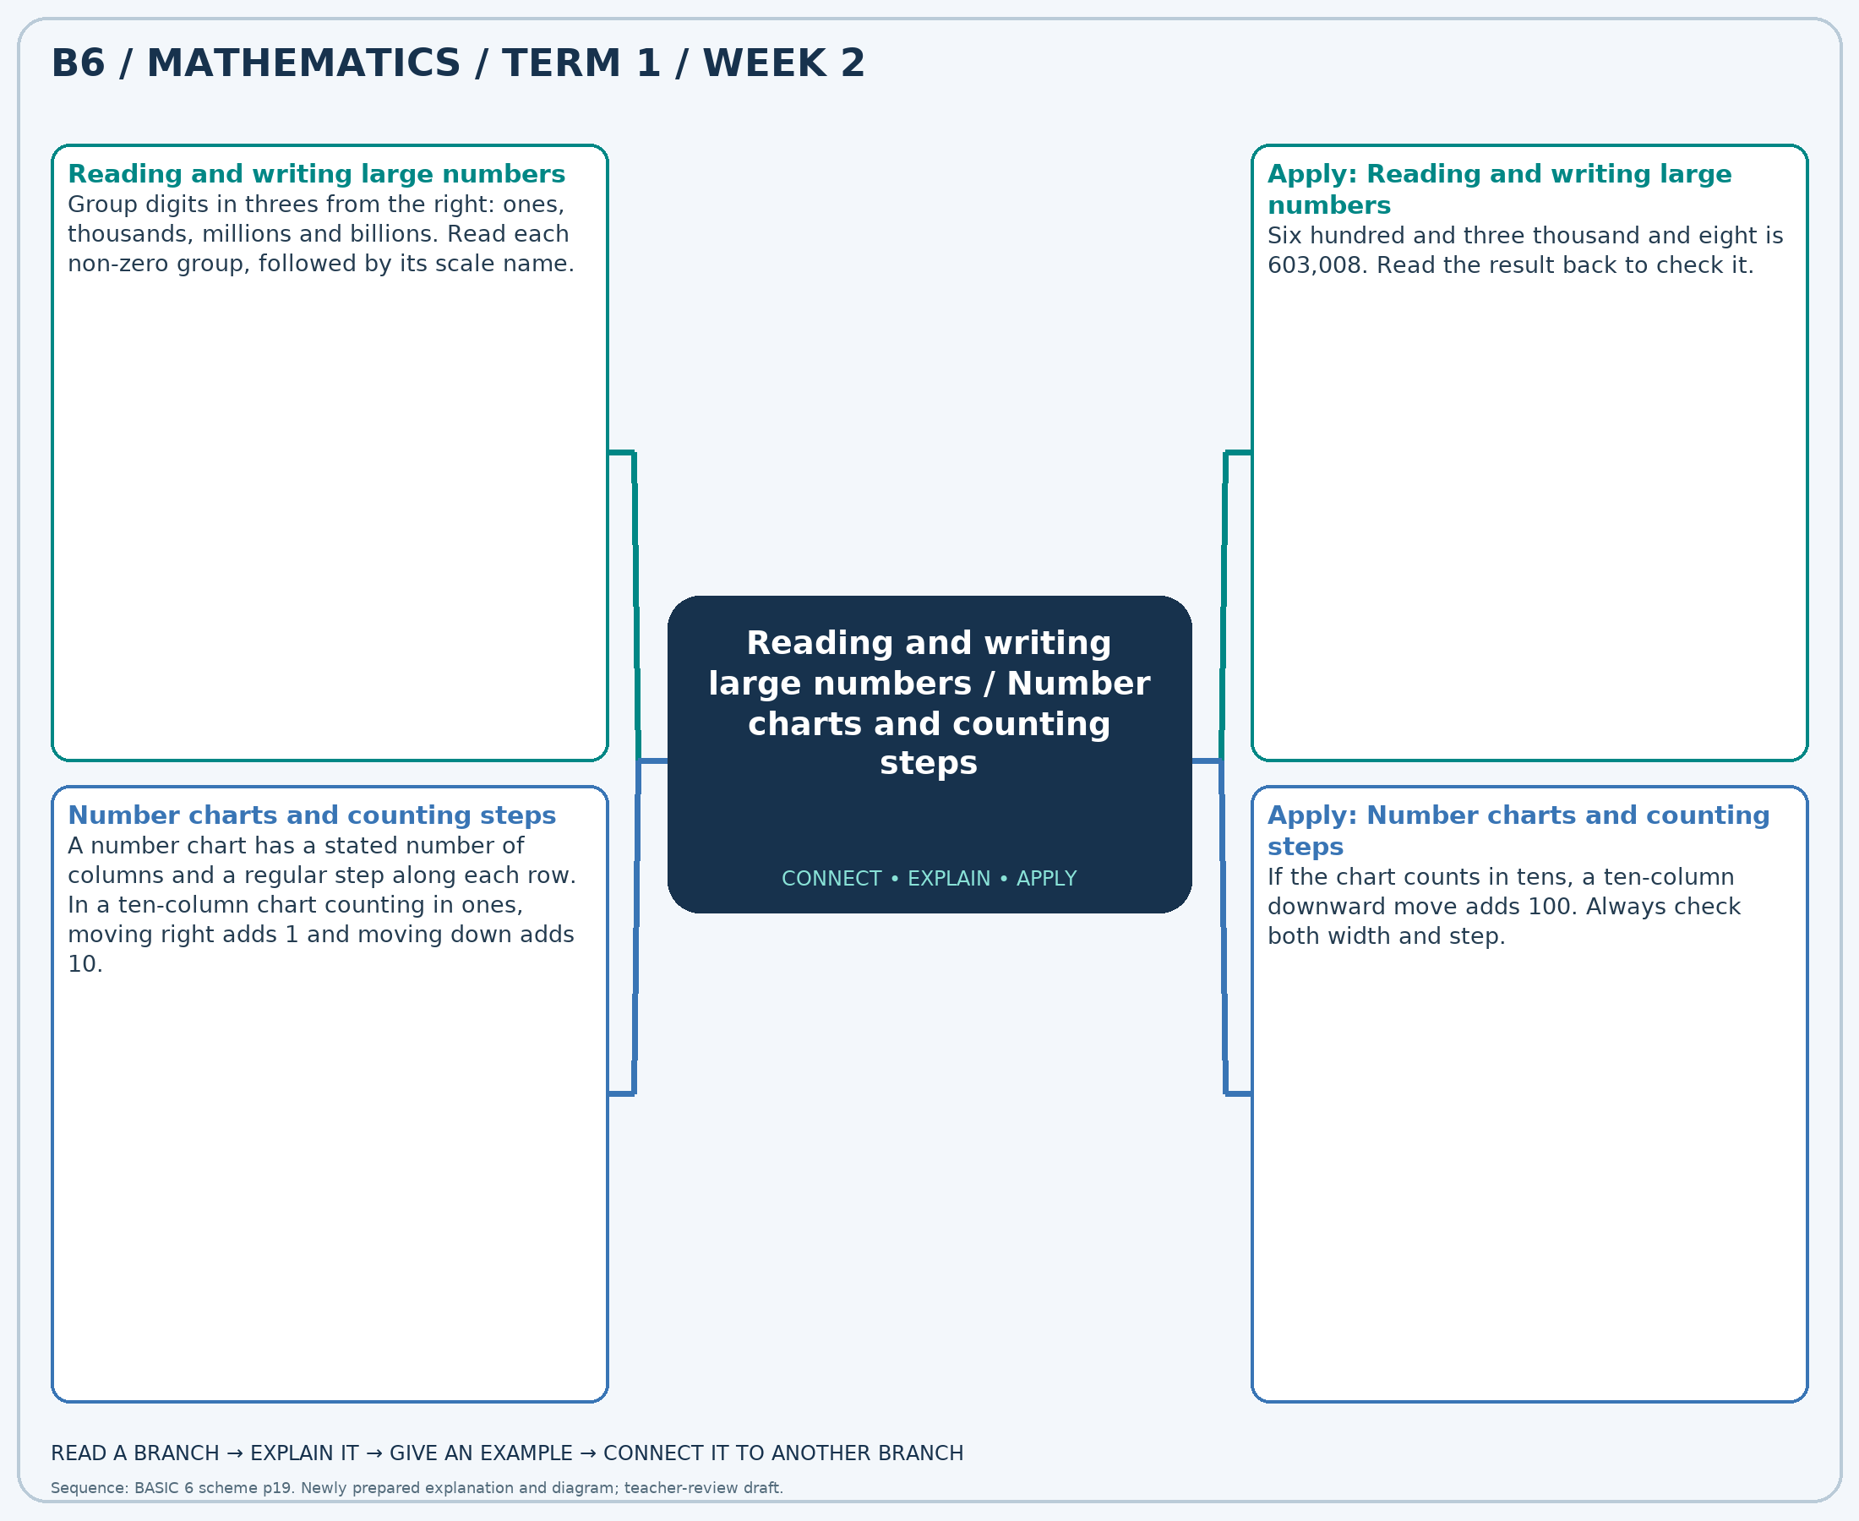
The separate high-resolution PNG can be projected or printed larger. Explain each branch and connect it with an example.

Week 2 — Practice

Section A — Multiple-choice questions
Choose ONE correct answer for each question. Each question has four alternatives.
1. Write in figures: nine hundred and fifty-seven million, six hundred and forty-five thousand, six hundred and thirty.
A. 957645730 B. 957645630 C. 957646630 D. 957644630
2. A 5-column chart increases by 1 along each row. 458,900 is an interior entry. What number is immediately above it?
A. 458905 B. 458890 C. 458895 D. 458900
3. Write in figures: three hundred and seventy-six million, four hundred and ninety-nine thousand, eight hundred and eight.
A. 376499808 B. 376499908 C. 376500808 D. 376498808
4. A 5-column chart increases by 10 along each row. 397,000 is an interior entry. What number is immediately left it?
A. 397000 B. 396990 C. 397010 D. 396980
5. Write in figures: three hundred and thirty-six million, six hundred and sixty-two thousand, nine hundred and four.
A. 336663904 B. 336662904 C. 336663004 D. 336661904
6. A 10-column chart increases by 1 along each row. 137,500 is an interior entry. What number is immediately left it?
A. 137501 B. 137498 C. 137500 D. 137499
7. Write in figures: nine hundred and seventeen million, six hundred and fourteen thousand, one hundred and thirty-seven.
A. 917614137 B. 917614237 C. 917613137 D. 917615137
8. A 10-column chart increases by 50 along each row. 155,900 is an interior entry. What number is immediately right it?
A. 155850 B. 156000 C. 155900 D. 155950
9. Write in figures: three hundred and eighty-one million, seven hundred and twelve thousand, four hundred and ten.
A. 381712510 B. 381712410 C. 381711410 D. 381713410
10. A 10-column chart increases by 1 along each row. 571,200 is an interior entry. What number is immediately below it?
A. 571210 B. 571200 C. 571220 D. 571190
11. Write in figures: two hundred and forty-seven million, one hundred and sixty thousand and twenty-six.
A. 247161026 B. 247160026 C. 247160126 D. 247159026
12. A 5-column chart increases by 1 along each row. 566,400 is an interior entry. What number is immediately right it?
A. 566401 B. 566402 C. 566399 D. 566400
13. Write in figures: six hundred and fifty-nine million, forty-six thousand, nine hundred and seventy-six.
A. 659045976 B. 659046976 C. 659047076 D. 659047976
14. A 5-column chart increases by 50 along each row. 215,600 is an interior entry. What number is immediately right it?
A. 215600 B. 215550 C. 215700 D. 215650
15. Write in figures: six hundred and sixty-three million, eight hundred and two thousand, three hundred and eighty-two.
A. 663802482 B. 663803382 C. 663802382 D. 663801382
16. A 10-column chart increases by 50 along each row. 639,800 is an interior entry. What number is immediately right it?
A. 639900 B. 639750 C. 639800 D. 639850
17. Write in figures: four hundred and thirty million, two hundred and thirty-eight thousand, six hundred and fifty-eight.
A. 430237658 B. 430238758 C. 430238658 D. 430239658
18. A 10-column chart increases by 10 along each row. 607,600 is an interior entry. What number is immediately above it?
A. 607600 B. 607400 C. 607500 D. 607700
19. Write in figures: six hundred and forty-two million, fourteen thousand, seven hundred and eighty-two.
A. 642014782 B. 642014882 C. 642013782 D. 642015782
20. A 5-column chart increases by 50 along each row. 549,900 is an interior entry. What number is immediately above it?
A. 550150 B. 549400 C. 549900 D. 549650

Section B — Structured essay questions
Answer every part (a), (b), (c). Show your method or explain your choice. Write in a separate answer booklet. Each part: 1 mark for valid working/explanation and 1 for the correct result; 6 marks per question.

1. Apply the related skills and show working or give a reason for each answer.
(a) Write in figures: eight hundred and thirty-one million, seven hundred and sixty-two thousand, four hundred and twenty.
(b) A 5-column chart increases by 10 along each row. 681,400 is an interior entry. What number is immediately above it?
(c) Write in figures: five hundred and thirty-eight million, four hundred and twenty-eight thousand, four hundred and thirty-two.

2. Apply the related skills and show working or give a reason for each answer.
(a) A 5-column chart increases by 10 along each row. 164,300 is an interior entry. What number is immediately right it?
(b) Write in figures: two hundred and twenty-one million, seventy-four thousand and sixty-seven.
(c) A 5-column chart increases by 50 along each row. 757,800 is an interior entry. What number is immediately left it?

3. Apply the related skills and show working or give a reason for each answer.
(a) Write in figures: three hundred and ninety-seven million, nine hundred and seventy-three thousand, eight hundred and thirty-four.
(b) A 10-column chart increases by 1 along each row. 236,400 is an interior entry. What number is immediately above it?
(c) Write in figures: two hundred and forty-one million, one hundred and forty-five thousand, eight hundred and thirty-six.

4. Apply the related skills and show working or give a reason for each answer.
(a) A 5-column chart increases by 50 along each row. 200,500 is an interior entry. What number is immediately left it?
(b) Write in figures: four hundred and ninety-six million, one hundred and nine thousand and eighty-one.
(c) A 10-column chart increases by 1 along each row. 363,600 is an interior entry. What number is immediately above it?

5. Apply the related skills and show working or give a reason for each answer.
(a) Write in figures: five hundred and seventy-three million, seventy-seven thousand, one hundred and sixty-two.
(b) A 5-column chart increases by 10 along each row. 176,000 is an interior entry. What number is immediately right it?
(c) Write in figures: seven hundred and thirty-nine million, six hundred and ninety-three thousand, nine hundred and nineteen.

6. Apply the related skills and show working or give a reason for each answer.
(a) A 5-column chart increases by 10 along each row. 193,000 is an interior entry. What number is immediately right it?
(b) Write in figures: five hundred and forty-one million, two hundred and seventy thousand, five hundred and eleven.
(c) A 5-column chart increases by 10 along each row. 647,000 is an interior entry. What number is immediately below it?

7. Apply the related skills and show working or give a reason for each answer.
(a) Write in figures: two hundred and ninety-three million, nine hundred and thirty-six thousand and eighteen.
(b) A 5-column chart increases by 10 along each row. 145,000 is an interior entry. What number is immediately above it?
(c) Write in figures: two hundred and sixty-four million, two hundred and eighty-eight thousand, three hundred and eighty-seven.

8. Apply the related skills and show working or give a reason for each answer.
(a) A 5-column chart increases by 50 along each row. 640,700 is an interior entry. What number is immediately left it?
(b) Write in figures: five hundred and eighteen million, four hundred and twenty-nine thousand, three hundred and sixteen.
(c) A 5-column chart increases by 1 along each row. 465,500 is an interior entry. What number is immediately right it?

9. Apply the related skills and show working or give a reason for each answer.
(a) Write in figures: six hundred and fifty-one million, eight hundred and sixty-one thousand, nine hundred and fifteen.
(b) A 5-column chart increases by 1 along each row. 781,800 is an interior entry. What number is immediately above it?
(c) Write in figures: three hundred and forty-six million, six hundred and forty-one thousand, two hundred and eighty-three.

10. Apply the related skills and show working or give a reason for each answer.
(a) A 10-column chart increases by 1 along each row. 506,500 is an interior entry. What number is immediately left it?
(b) Write in figures: four hundred and ninety million, three hundred and twenty-eight thousand, two hundred and ninety-three.
(c) A 10-column chart increases by 50 along each row. 875,000 is an interior entry. What number is immediately left it?

Week 3 — Comparing and ordering whole numbers / Rounding whole numbers
Sequence source: BASIC 6 SCHEME OF LEARNING.pdf, first-term Mathematics, page 19. One consolidated weekly unit.

Learning outcomes
- Explain and apply comparing and ordering whole numbers, solve examples and justify the method.
- Explain and apply rounding whole numbers, solve examples and justify the method.

Teaching notes and suggested sessions
Suggested schedule: five 40-minute sessions, adjusted to the school timetable. Spread the question bank through the week; it is not intended to be completed in one lesson.

1 — Explore and diagnose
5 minutes: recall an earlier skill; 10: demonstrate a concrete or pictorial model; 15: pairs investigate and explain; 10: identify a misconception and set an exit task.

2 — Model and practise
5 minutes: review the exit task; 10: work an example aloud; 15: pairs solve parallel examples; 10: compare methods and correct errors.

3 — Connect representations
5 minutes: recall vocabulary; 10: explain the mind-map; 15: connect a model, a drawing and a symbolic calculation; 10: independent practice.

4 — Apply and explain
5 minutes: estimate or predict; 10: solve a contextual example; 15: attempt selected structured-question parts; 10: compare reasoning and check units.

5 — Check and respond
5 minutes: retrieve the main rule; 15: use selected MCQs diagnostically; 10: explain distractors and misconceptions; 10: reteach or extend in response to evidence.

Topic-specific activities
- Sort number cards and explain which place decides each comparison.
- Place numbers between neighbouring multiples of ten, a hundred or a thousand.
Resources: board, pencils, number cards, counters, paper strips and squared paper as appropriate. Prior-knowledge check: ask a learner to explain a representation used in the first example before introducing a new rule.
Support: reduce number size without changing the concept; offer a partially completed chart or model; allow oral reasoning before writing. Extension: create a counterexample to a false rule and explain why it fails.

Study notes and worked examples

Comparing and ordering whole numbers
- Compare the greatest place first. A positive whole number with more digits is larger.
- For equally long numbers, compare left to right until the first unequal digit.
- The open side of > or < faces the larger quantity. The symbol = means equal value.
- Ascending order is least to greatest; descending order is greatest to least.
Worked example: Which is the greatest number: 876,539, 876,185, 875,688, 875,714?
Solution: Compare from the left. Ascending order: 875,688, 875,714, 876,185, 876,539.
Common misconception: A number containing the largest individual digit is not necessarily the largest number.

Rounding whole numbers
- Name the place to which the number is being rounded.
- Inspect the digit immediately to its right: 0–4 keep the target digit; 5–9 increase it by one for nearest rounding.
- Replace lower whole-number places with zeros. Check between neighbouring multiples on a number line.
- Rounding to the nearest value is different from always rounding upward or downward.
Worked example: Round 69,506 to the nearest 100.
Solution: Neighbouring multiples: 69,500 and 69,600. Nearest (halfway values rounded upward): 69,500.
Common misconception: Do not remove place-holding zeros from a rounded whole number.
Independent study: read the map, cover it and reconstruct the branches. Solve an unused question from each skill and explain the reasoning to a partner. Consult the teacher key only after an honest attempt.

Week 3 — Visual mind-map
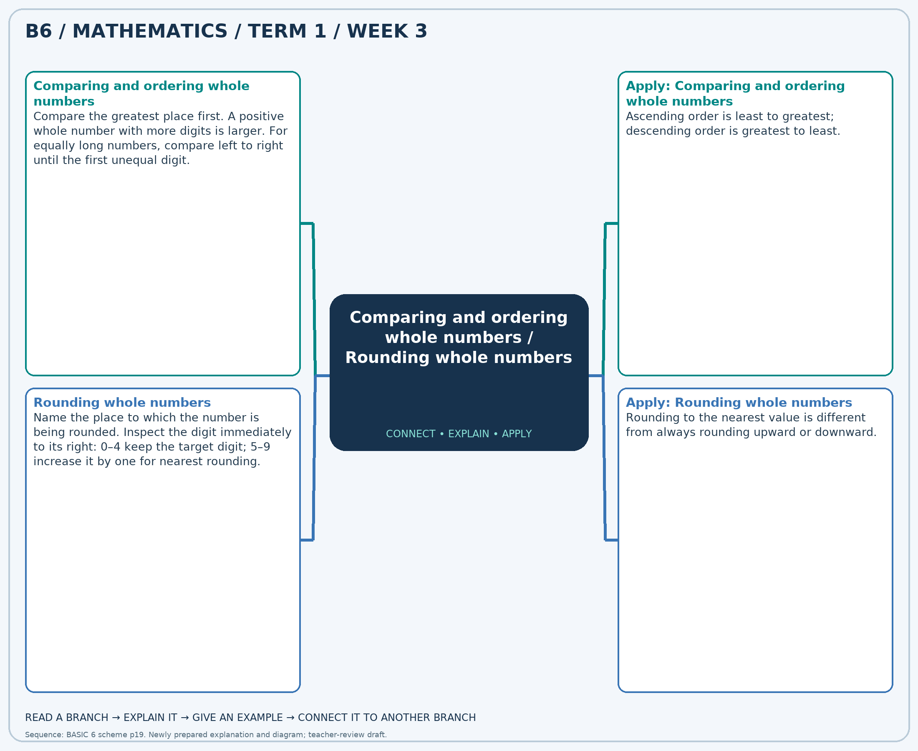
The separate high-resolution PNG can be projected or printed larger. Explain each branch and connect it with an example.

Week 3 — Practice

Section A — Multiple-choice questions
Choose ONE correct answer for each question. Each question has four alternatives.
1. Which is the greatest number: 410,785, 410,696, 410,295, 410,857?
A. 410295 B. 410696 C. 410857 D. 410785
2. Round 56,440 to the nearest 10.
A. 56430 B. 56440 C. 56450 D. 56460
3. Which is the least number: 506,228, 506,114, 505,413, 505,995?
A. 505413 B. 506114 C. 505995 D. 506228
4. Round 16,053 to the nearest 1,000.
A. 18000 B. 15000 C. 16000 D. 17000
5. Which is the greatest number: 853,997, 854,506, 854,262, 854,720?
A. 854262 B. 854506 C. 854720 D. 853997
6. Round 54,286 to the nearest 1,000.
A. 53000 B. 56000 C. 55000 D. 54000
7. Which is the greatest number: 251,764, 252,154, 251,721, 252,355?
A. 251721 B. 252355 C. 252154 D. 251764
8. Round 51,474 to the nearest 1,000.
A. 53000 B. 52000 C. 50000 D. 51000
9. Which is the least number: 347,643, 347,810, 347,862, 347,485?
A. 347643 B. 347862 C. 347810 D. 347485
10. Round 91,524 to the nearest 10.
A. 91520 B. 91510 C. 91540 D. 91530
11. Which is the greatest number: 250,250, 250,240, 249,900, 249,792?
A. 249792 B. 250240 C. 249900 D. 250250
12. Round 75,423 to the nearest 100.
A. 75400 B. 75300 C. 75600 D. 75500
13. Which is the greatest number: 496,753, 496,298, 496,277, 496,696?
A. 496298 B. 496753 C. 496277 D. 496696
14. Round 68,642 to the nearest 1,000.
A. 68000 B. 71000 C. 70000 D. 69000
15. Which is the least number: 214,844, 215,588, 215,014, 215,148?
A. 215588 B. 215014 C. 214844 D. 215148
16. Round 13,684 to the nearest 1,000.
A. 15000 B. 16000 C. 13000 D. 14000
17. Which is the greatest number: 813,727, 813,856, 814,022, 813,538?
A. 813856 B. 814022 C. 813727 D. 813538
18. Round 12,365 to the nearest 100.
A. 12600 B. 12500 C. 12300 D. 12400
19. Which is the greatest number: 584,577, 584,616, 584,733, 584,725?
A. 584577 B. 584733 C. 584616 D. 584725
20. Round 80,838 to the nearest 1,000.
A. 80000 B. 82000 C. 83000 D. 81000

Section B — Structured essay questions
Answer every part (a), (b), (c). Show your method or explain your choice. Write in a separate answer booklet. Each part: 1 mark for valid working/explanation and 1 for the correct result; 6 marks per question.

1. Apply the related skills and show working or give a reason for each answer.
(a) Which is the greatest number: 118,363, 118,229, 118,202, 118,406?
(b) Round 67,812 to the nearest 100.
(c) Which is the greatest number: 313,813, 313,638, 313,005, 312,921?

2. Apply the related skills and show working or give a reason for each answer.
(a) Round 47,477 to the nearest 10.
(b) Which is the greatest number: 801,525, 802,148, 801,313, 802,162?
(c) Round 94,843 to the nearest 1,000.

3. Apply the related skills and show working or give a reason for each answer.
(a) Which is the greatest number: 511,258, 510,604, 510,741, 511,265?
(b) Round 52,658 to the nearest 1,000.
(c) Which is the least number: 650,471, 650,011, 650,726, 650,518?

4. Apply the related skills and show working or give a reason for each answer.
(a) Round 42,156 to the nearest 100.
(b) Which is the least number: 644,500, 644,499, 644,986, 644,314?
(c) Round 66,821 to the nearest 1,000.

5. Apply the related skills and show working or give a reason for each answer.
(a) Which is the least number: 806,014, 805,412, 805,858, 805,577?
(b) Round 34,538 to the nearest 100.
(c) Which is the greatest number: 683,816, 684,228, 683,664, 683,792?

6. Apply the related skills and show working or give a reason for each answer.
(a) Round 13,725 to the nearest 100.
(b) Which is the greatest number: 875,427, 874,866, 874,968, 875,007?
(c) Round 73,060 to the nearest 1,000.

7. Apply the related skills and show working or give a reason for each answer.
(a) Which is the greatest number: 650,395, 650,268, 650,225, 650,956?
(b) Round 42,321 to the nearest 1,000.
(c) Which is the greatest number: 198,542, 198,946, 198,607, 198,766?

8. Apply the related skills and show working or give a reason for each answer.
(a) Round 11,573 to the nearest 10.
(b) Which is the greatest number: 359,142, 359,231, 358,742, 359,205?
(c) Round 96,215 to the nearest 10.

9. Apply the related skills and show working or give a reason for each answer.
(a) Which is the greatest number: 812,312, 812,571, 812,850, 812,986?
(b) Round 82,691 to the nearest 1,000.
(c) Which is the least number: 180,697, 181,067, 180,826, 181,345?

10. Apply the related skills and show working or give a reason for each answer.
(a) Round 89,885 to the nearest 100.
(b) Which is the least number: 572,608, 572,807, 573,450, 572,920?
(c) Round 63,923 to the nearest 10.

Week 4 — Multiplication facts and related division
Sequence source: BASIC 6 SCHEME OF LEARNING.pdf, first-term Mathematics, page 19. One consolidated weekly unit.

Learning outcomes
- Explain and apply multiplication facts and related division, solve examples and justify the method.

Teaching notes and suggested sessions
Suggested schedule: five 40-minute sessions, adjusted to the school timetable. Spread the question bank through the week; it is not intended to be completed in one lesson.

1 — Explore and diagnose
5 minutes: recall an earlier skill; 10: demonstrate a concrete or pictorial model; 15: pairs investigate and explain; 10: identify a misconception and set an exit task.

2 — Model and practise
5 minutes: review the exit task; 10: work an example aloud; 15: pairs solve parallel examples; 10: compare methods and correct errors.

3 — Connect representations
5 minutes: recall vocabulary; 10: explain the mind-map; 15: connect a model, a drawing and a symbolic calculation; 10: independent practice.

4 — Apply and explain
5 minutes: estimate or predict; 10: solve a contextual example; 15: attempt selected structured-question parts; 10: compare reasoning and check units.

5 — Check and respond
5 minutes: retrieve the main rule; 15: use selected MCQs diagnostically; 10: explain distractors and misconceptions; 10: reteach or extend in response to evidence.

Topic-specific activities
- Build arrays with counters and write two multiplication and two division statements.
Resources: board, pencils, number cards, counters, paper strips and squared paper as appropriate. Prior-knowledge check: ask a learner to explain a representation used in the first example before introducing a new rule.
Support: reduce number size without changing the concept; offer a partially completed chart or model; allow oral reasoning before writing. Extension: create a counterexample to a false rule and explain why it fails.

Study notes and worked examples

Multiplication facts and related division
- Multiplication describes equal groups: 7×8 is seven groups of eight.
- The commutative property gives 8×7=56 from 7×8=56.
- Related division facts are 56÷7=8 and 56÷8=7.
- Use arrays, doubling and known facts to derive an unfamiliar fact.
Worked example: Calculate 8 × 9.
Solution: 8 equal groups of 9 contain 72. Check: 72÷8=9.
Common misconception: Seven groups of eight is not 7+8.
Independent study: read the map, cover it and reconstruct the branches. Solve an unused question from each skill and explain the reasoning to a partner. Consult the teacher key only after an honest attempt.

Week 4 — Visual mind-map
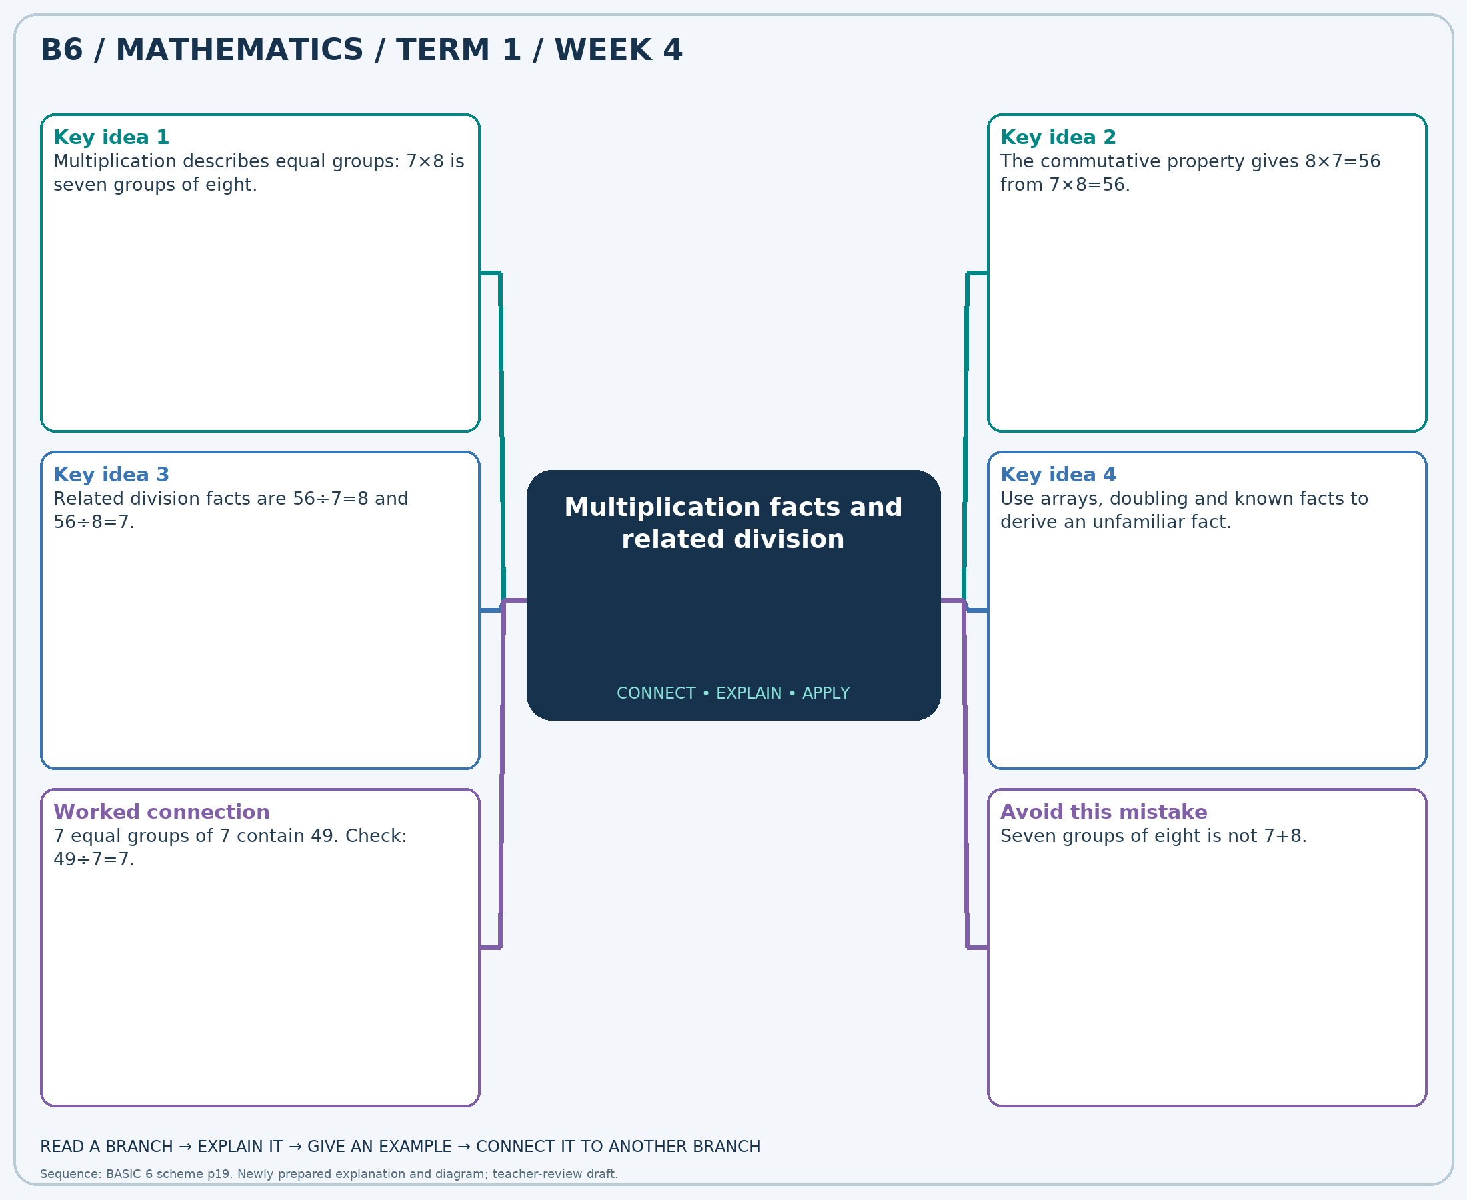
The separate high-resolution PNG can be projected or printed larger. Explain each branch and connect it with an example.

Week 4 — Practice

Section A — Multiple-choice questions
Choose ONE correct answer for each question. Each question has four alternatives.
1. Calculate 7 × 8.
A. 58 B. 57 C. 55 D. 56
2. Calculate 56 ÷ 7.
A. 9 B. 8 C. 10 D. 7
3. Calculate 9 × 2.
A. 19 B. 18 C. 20 D. 17
4. Calculate 5 × 5.
A. 26 B. 24 C. 27 D. 25
5. Calculate 64 ÷ 8.
A. 7 B. 9 C. 10 D. 8
6. Calculate 7 × 9.
A. 64 B. 62 C. 65 D. 63
7. Calculate 3 × 7.
A. 23 B. 20 C. 22 D. 21
8. Calculate 6 ÷ 2.
A. 5 B. 3 C. 2 D. 4
9. Calculate 5 × 4.
A. 20 B. 19 C. 21 D. 22
10. Calculate 5 × 6.
A. 32 B. 31 C. 29 D. 30
11. Calculate 48 ÷ 6.
A. 10 B. 8 C. 9 D. 7
12. Calculate 7 × 6.
A. 41 B. 42 C. 44 D. 43
13. Calculate 9 ÷ 3.
A. 4 B. 5 C. 2 D. 3
14. Calculate 2 × 3.
A. 8 B. 5 C. 6 D. 7
15. Calculate 2 × 7.
A. 16 B. 14 C. 13 D. 15
16. Calculate 28 ÷ 7.
A. 3 B. 4 C. 6 D. 5
17. Calculate 3 × 2.
A. 5 B. 6 C. 8 D. 7
18. Calculate 8 × 2.
A. 15 B. 17 C. 16 D. 18
19. Calculate 28 ÷ 4.
A. 8 B. 9 C. 6 D. 7
20. Calculate 4 × 9.
A. 35 B. 38 C. 37 D. 36

Section B — Structured essay questions
Answer every part (a), (b), (c). Show your method or explain your choice. Write in a separate answer booklet. Each part: 1 mark for valid working/explanation and 1 for the correct result; 6 marks per question.

1. Apply the related skills and show working or give a reason for each answer.
(a) Calculate 9 × 5.
(b) Calculate 42 ÷ 6.
(c) Calculate 4 × 8.

2. Apply the related skills and show working or give a reason for each answer.
(a) Calculate 36 ÷ 4.
(b) Calculate 5 × 7.
(c) Calculate 6 × 2.

3. Apply the related skills and show working or give a reason for each answer.
(a) Calculate 2 × 7.
(b) Calculate 8 × 9.
(c) Calculate 32 ÷ 4.

4. Apply the related skills and show working or give a reason for each answer.
(a) Calculate 5 × 9.
(b) Calculate 49 ÷ 7.
(c) Calculate 2 × 8.

5. Apply the related skills and show working or give a reason for each answer.
(a) Calculate 28 ÷ 4.
(b) Calculate 6 × 5.
(c) Calculate 9 × 5.

6. Apply the related skills and show working or give a reason for each answer.
(a) Calculate 2 × 2.
(b) Calculate 7 × 2.
(c) Calculate 21 ÷ 7.

7. Apply the related skills and show working or give a reason for each answer.
(a) Calculate 6 × 3.
(b) Calculate 64 ÷ 8.
(c) Calculate 3 × 4.

8. Apply the related skills and show working or give a reason for each answer.
(a) Calculate 16 ÷ 2.
(b) Calculate 5 × 5.
(c) Calculate 8 × 7.

9. Apply the related skills and show working or give a reason for each answer.
(a) Calculate 7 × 6.
(b) Calculate 3 × 4.
(c) Calculate 18 ÷ 3.

10. Apply the related skills and show working or give a reason for each answer.
(a) Calculate 8 × 7.
(b) Calculate 36 ÷ 6.
(c) Calculate 7 × 6.

Week 5 — Multiplication strategies
Sequence source: BASIC 6 SCHEME OF LEARNING.pdf, first-term Mathematics, page 19. One consolidated weekly unit.

Learning outcomes
- Explain and apply multiplication strategies, solve examples and justify the method.

Teaching notes and suggested sessions
Suggested schedule: five 40-minute sessions, adjusted to the school timetable. Spread the question bank through the week; it is not intended to be completed in one lesson.

1 — Explore and diagnose
5 minutes: recall an earlier skill; 10: demonstrate a concrete or pictorial model; 15: pairs investigate and explain; 10: identify a misconception and set an exit task.

2 — Model and practise
5 minutes: review the exit task; 10: work an example aloud; 15: pairs solve parallel examples; 10: compare methods and correct errors.

3 — Connect representations
5 minutes: recall vocabulary; 10: explain the mind-map; 15: connect a model, a drawing and a symbolic calculation; 10: independent practice.

4 — Apply and explain
5 minutes: estimate or predict; 10: solve a contextual example; 15: attempt selected structured-question parts; 10: compare reasoning and check units.

5 — Check and respond
5 minutes: retrieve the main rule; 15: use selected MCQs diagnostically; 10: explain distractors and misconceptions; 10: reteach or extend in response to evidence.

Topic-specific activities
- Draw a partitioned rectangle and connect its smaller areas to the partial products.
Resources: board, pencils, number cards, counters, paper strips and squared paper as appropriate. Prior-knowledge check: ask a learner to explain a representation used in the first example before introducing a new rule.
Support: reduce number size without changing the concept; offer a partially completed chart or model; allow oral reasoning before writing. Extension: create a counterexample to a false rule and explain why it fails.

Study notes and worked examples

Multiplication strategies
- Partition a factor and use the distributive property: 24×6=(20×6)+(4×6)=144.
- Doubling one factor and halving an even other factor preserves the product.
- In multi-digit multiplication, include every partial product and align place values.
- Estimate first, calculate carefully and compare the product with the estimate.
Worked example: Calculate 159 × 129.
Solution: 159×(120+9) = 19080+1431 = 20511.
Common misconception: The tens digit contributes tens, not units: the 2 in 23×14 represents 20×14.
Independent study: read the map, cover it and reconstruct the branches. Solve an unused question from each skill and explain the reasoning to a partner. Consult the teacher key only after an honest attempt.

Week 5 — Visual mind-map
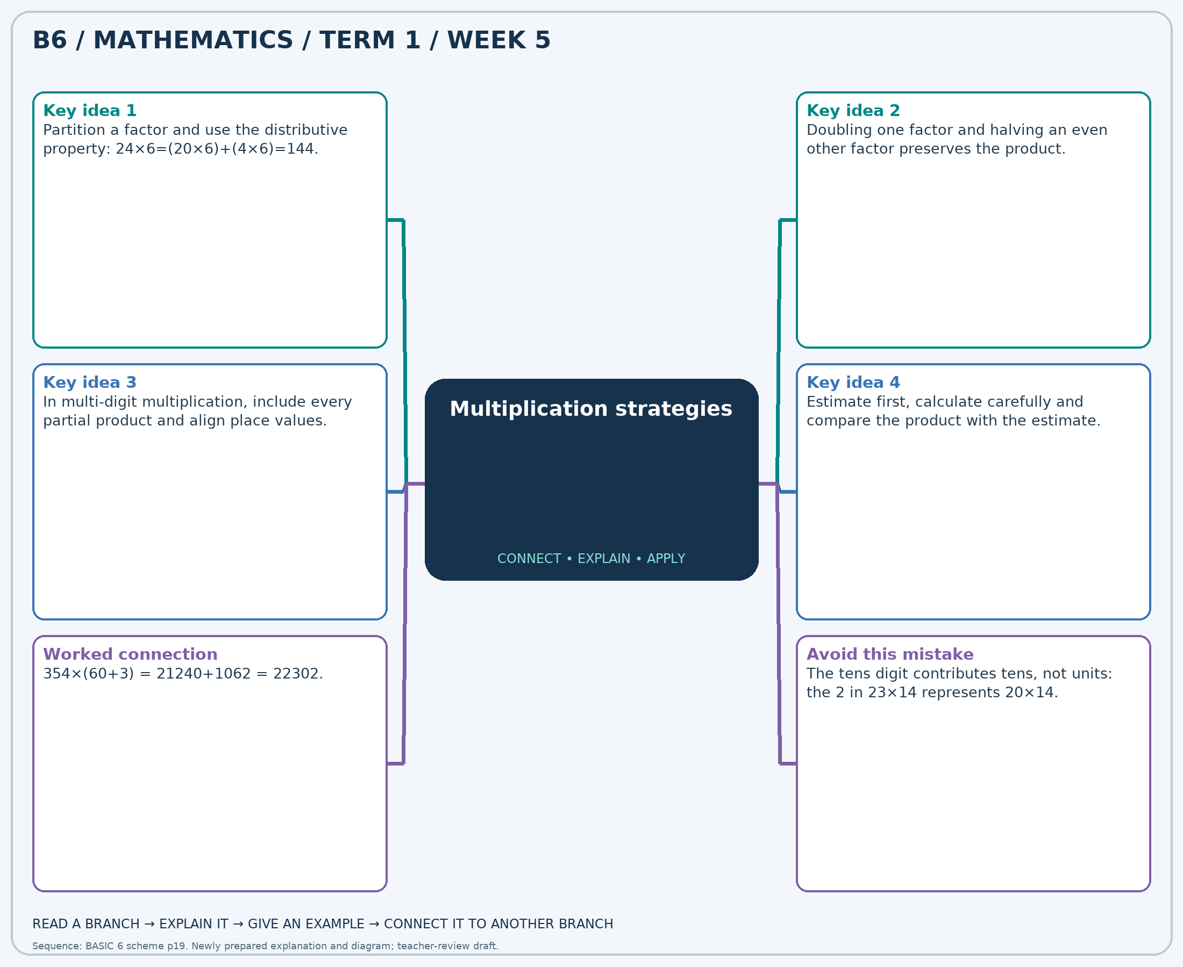
The separate high-resolution PNG can be projected or printed larger. Explain each branch and connect it with an example.

Week 5 — Practice

Section A — Multiple-choice questions
Choose ONE correct answer for each question. Each question has four alternatives.
1. Calculate 263 × 99.
A. 26037 B. 26300 C. 25774 D. 362
2. Calculate 372 × 175.
A. 65472 B. 547 C. 64728 D. 65100
3. Calculate 227 × 187.
A. 42676 B. 42222 C. 414 D. 42449
4. Calculate 316 × 198.
A. 62252 B. 62568 C. 62884 D. 514
5. Calculate 439 × 43.
A. 482 B. 18438 C. 19316 D. 18877
6. Calculate 101 × 13.
A. 114 B. 1414 C. 1212 D. 1313
7. Calculate 430 × 31.
A. 12900 B. 13760 C. 13330 D. 461
8. Calculate 452 × 22.
A. 474 B. 9492 C. 10396 D. 9944
9. Calculate 448 × 70.
A. 31360 B. 30912 C. 518 D. 31808
10. Calculate 447 × 87.
A. 38889 B. 38442 C. 39336 D. 534
11. Calculate 237 × 35.
A. 8058 B. 272 C. 8532 D. 8295
12. Calculate 186 × 286.
A. 53010 B. 53196 C. 53382 D. 472
13. Calculate 135 × 213.
A. 28755 B. 28620 C. 348 D. 28890
14. Calculate 498 × 261.
A. 130476 B. 129480 C. 129978 D. 759
15. Calculate 264 × 78.
A. 342 B. 20592 C. 20328 D. 20856
16. Calculate 306 × 189.
A. 57834 B. 58140 C. 57528 D. 495
17. Calculate 414 × 65.
A. 479 B. 27324 C. 26910 D. 26496
18. Calculate 264 × 118.
A. 30888 B. 382 C. 31416 D. 31152
19. Calculate 432 × 20.
A. 452 B. 8640 C. 9072 D. 8208
20. Calculate 349 × 85.
A. 434 B. 29316 C. 30014 D. 29665

Section B — Structured essay questions
Answer every part (a), (b), (c). Show your method or explain your choice. Write in a separate answer booklet. Each part: 1 mark for valid working/explanation and 1 for the correct result; 6 marks per question.

1. Apply the related skills and show working or give a reason for each answer.
(a) Calculate 103 × 16.
(b) Calculate 464 × 84.
(c) Calculate 254 × 140.

2. Apply the related skills and show working or give a reason for each answer.
(a) Calculate 215 × 196.
(b) Calculate 133 × 293.
(c) Calculate 197 × 191.

3. Apply the related skills and show working or give a reason for each answer.
(a) Calculate 458 × 219.
(b) Calculate 462 × 100.
(c) Calculate 120 × 64.

4. Apply the related skills and show working or give a reason for each answer.
(a) Calculate 191 × 200.
(b) Calculate 342 × 71.
(c) Calculate 474 × 81.

5. Apply the related skills and show working or give a reason for each answer.
(a) Calculate 109 × 43.
(b) Calculate 235 × 92.
(c) Calculate 471 × 249.

6. Apply the related skills and show working or give a reason for each answer.
(a) Calculate 251 × 250.
(b) Calculate 193 × 51.
(c) Calculate 214 × 140.

7. Apply the related skills and show working or give a reason for each answer.
(a) Calculate 274 × 114.
(b) Calculate 300 × 214.
(c) Calculate 494 × 163.

8. Apply the related skills and show working or give a reason for each answer.
(a) Calculate 342 × 138.
(b) Calculate 177 × 282.
(c) Calculate 186 × 132.

9. Apply the related skills and show working or give a reason for each answer.
(a) Calculate 196 × 102.
(b) Calculate 281 × 130.
(c) Calculate 349 × 76.

10. Apply the related skills and show working or give a reason for each answer.
(a) Calculate 269 × 153.
(b) Calculate 194 × 40.
(c) Calculate 474 × 299.

Week 6 — Division and checking
Sequence source: BASIC 6 SCHEME OF LEARNING.pdf, first-term Mathematics, page 19. One consolidated weekly unit.

Learning outcomes
- Explain and apply division and checking, solve examples and justify the method.

Teaching notes and suggested sessions
Suggested schedule: five 40-minute sessions, adjusted to the school timetable. Spread the question bank through the week; it is not intended to be completed in one lesson.

1 — Explore and diagnose
5 minutes: recall an earlier skill; 10: demonstrate a concrete or pictorial model; 15: pairs investigate and explain; 10: identify a misconception and set an exit task.

2 — Model and practise
5 minutes: review the exit task; 10: work an example aloud; 15: pairs solve parallel examples; 10: compare methods and correct errors.

3 — Connect representations
5 minutes: recall vocabulary; 10: explain the mind-map; 15: connect a model, a drawing and a symbolic calculation; 10: independent practice.

4 — Apply and explain
5 minutes: estimate or predict; 10: solve a contextual example; 15: attempt selected structured-question parts; 10: compare reasoning and check units.

5 — Check and respond
5 minutes: retrieve the main rule; 15: use selected MCQs diagnostically; 10: explain distractors and misconceptions; 10: reteach or extend in response to evidence.

Topic-specific activities
- Share counters into equal groups and check the result by multiplication.
Resources: board, pencils, number cards, counters, paper strips and squared paper as appropriate. Prior-knowledge check: ask a learner to explain a representation used in the first example before introducing a new rule.
Support: reduce number size without changing the concept; offer a partially completed chart or model; allow oral reasoning before writing. Extension: create a counterexample to a false rule and explain why it fails.

Study notes and worked examples

Division and checking
- Division may mean sharing equally or finding how many equal groups fit.
- Multiplication reverses division: 7×8=56 means 56÷7=8.
- Work from the greatest place and regroup when needed. Record a zero in an empty quotient place.
- Check: divisor × quotient + remainder = dividend. The remainder is smaller than the divisor.
Worked example: Calculate 186 ÷ 3.
Solution: 3×62=186, so the quotient is 62.
Common misconception: Do not leave an empty place in the quotient when a zero is needed.
Independent study: read the map, cover it and reconstruct the branches. Solve an unused question from each skill and explain the reasoning to a partner. Consult the teacher key only after an honest attempt.

Week 6 — Visual mind-map
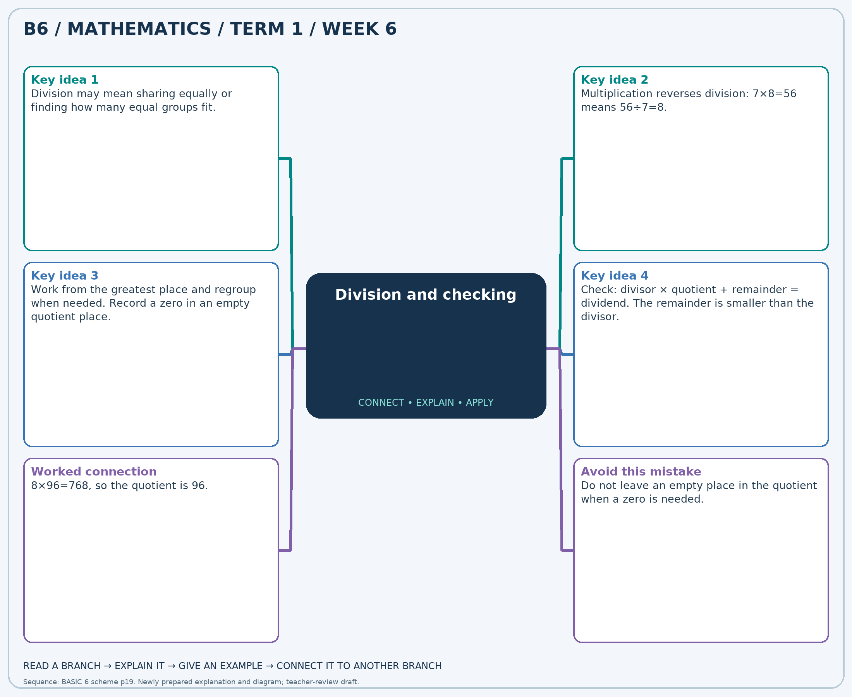
The separate high-resolution PNG can be projected or printed larger. Explain each branch and connect it with an example.

Week 6 — Practice

Section A — Multiple-choice questions
Choose ONE correct answer for each question. Each question has four alternatives.
1. Calculate 396 ÷ 6.
A. 390 B. 65 C. 67 D. 66
2. Calculate 297 ÷ 9.
A. 33 B. 34 C. 32 D. 288
3. Calculate 567 ÷ 7.
A. 560 B. 82 C. 80 D. 81
4. Calculate 192 ÷ 8.
A. 184 B. 25 C. 24 D. 23
5. Calculate 153 ÷ 3.
A. 52 B. 50 C. 150 D. 51
6. Calculate 185 ÷ 5.
A. 38 B. 37 C. 180 D. 36
7. Calculate 399 ÷ 7.
A. 57 B. 56 C. 392 D. 58
8. Calculate 328 ÷ 4.
A. 324 B. 82 C. 81 D. 83
9. Calculate 720 ÷ 9.
A. 80 B. 711 C. 79 D. 81
10. Calculate 651 ÷ 7.
A. 93 B. 94 C. 644 D. 92
11. Calculate 126 ÷ 3.
A. 42 B. 41 C. 123 D. 43
12. Calculate 355 ÷ 5.
A. 350 B. 72 C. 70 D. 71
13. Calculate 132 ÷ 6.
A. 126 B. 21 C. 23 D. 22
14. Calculate 273 ÷ 3.
A. 91 B. 92 C. 90 D. 270
15. Calculate 504 ÷ 7.
A. 71 B. 73 C. 497 D. 72
16. Calculate 60 ÷ 2.
A. 58 B. 30 C. 31 D. 29
17. Calculate 792 ÷ 9.
A. 89 B. 783 C. 88 D. 87
18. Calculate 468 ÷ 9.
A. 53 B. 459 C. 51 D. 52
19. Calculate 160 ÷ 2.
A. 80 B. 79 C. 158 D. 81
20. Calculate 92 ÷ 2.
A. 45 B. 47 C. 90 D. 46

Section B — Structured essay questions
Answer every part (a), (b), (c). Show your method or explain your choice. Write in a separate answer booklet. Each part: 1 mark for valid working/explanation and 1 for the correct result; 6 marks per question.

1. Apply the related skills and show working or give a reason for each answer.
(a) Calculate 105 ÷ 3.
(b) Calculate 236 ÷ 4.
(c) Calculate 316 ÷ 4.

2. Apply the related skills and show working or give a reason for each answer.
(a) Calculate 546 ÷ 6.
(b) Calculate 94 ÷ 2.
(c) Calculate 531 ÷ 9.

3. Apply the related skills and show working or give a reason for each answer.
(a) Calculate 133 ÷ 7.
(b) Calculate 480 ÷ 8.
(c) Calculate 288 ÷ 9.

4. Apply the related skills and show working or give a reason for each answer.
(a) Calculate 318 ÷ 6.
(b) Calculate 210 ÷ 3.
(c) Calculate 288 ÷ 9.

5. Apply the related skills and show working or give a reason for each answer.
(a) Calculate 237 ÷ 3.
(b) Calculate 260 ÷ 4.
(c) Calculate 335 ÷ 5.

6. Apply the related skills and show working or give a reason for each answer.
(a) Calculate 273 ÷ 7.
(b) Calculate 180 ÷ 4.
(c) Calculate 180 ÷ 9.

7. Apply the related skills and show working or give a reason for each answer.
(a) Calculate 259 ÷ 7.
(b) Calculate 304 ÷ 8.
(c) Calculate 80 ÷ 2.

8. Apply the related skills and show working or give a reason for each answer.
(a) Calculate 216 ÷ 4.
(b) Calculate 470 ÷ 5.
(c) Calculate 680 ÷ 8.

9. Apply the related skills and show working or give a reason for each answer.
(a) Calculate 469 ÷ 7.
(b) Calculate 186 ÷ 3.
(c) Calculate 296 ÷ 4.

10. Apply the related skills and show working or give a reason for each answer.
(a) Calculate 456 ÷ 6.
(b) Calculate 477 ÷ 9.
(c) Calculate 693 ÷ 7.

Week 7 — Fractions, decimals and percentages / Adding and subtracting fractions
Sequence source: BASIC 6 SCHEME OF LEARNING.pdf, first-term Mathematics, page 19. One consolidated weekly unit.

Learning outcomes
- Explain and apply fractions, decimals and percentages, solve examples and justify the method.
- Explain and apply adding and subtracting fractions, solve examples and justify the method.

Teaching notes and suggested sessions
Suggested schedule: five 40-minute sessions, adjusted to the school timetable. Spread the question bank through the week; it is not intended to be completed in one lesson.

1 — Explore and diagnose
5 minutes: recall an earlier skill; 10: demonstrate a concrete or pictorial model; 15: pairs investigate and explain; 10: identify a misconception and set an exit task.

2 — Model and practise
5 minutes: review the exit task; 10: work an example aloud; 15: pairs solve parallel examples; 10: compare methods and correct errors.

3 — Connect representations
5 minutes: recall vocabulary; 10: explain the mind-map; 15: connect a model, a drawing and a symbolic calculation; 10: independent practice.

4 — Apply and explain
5 minutes: estimate or predict; 10: solve a contextual example; 15: attempt selected structured-question parts; 10: compare reasoning and check units.

5 — Check and respond
5 minutes: retrieve the main rule; 15: use selected MCQs diagnostically; 10: explain distractors and misconceptions; 10: reteach or extend in response to evidence.

Topic-specific activities
- Match fraction, decimal and percentage cards and place them on a number line.
- Repartition fraction strips into matching units before combining or taking away parts.
Resources: board, pencils, number cards, counters, paper strips and squared paper as appropriate. Prior-knowledge check: ask a learner to explain a representation used in the first example before introducing a new rule.
Support: reduce number size without changing the concept; offer a partially completed chart or model; allow oral reasoning before writing. Extension: create a counterexample to a false rule and explain why it fails.

Study notes and worked examples

Fractions, decimals and percentages
- A fraction, a decimal and a percentage can represent the same quantity.
- Divide numerator by denominator for a decimal. Multiply the decimal by 100 for a percent value.
- Benchmarks include 1/2=0.5=50%, 1/4=0.25=25% and 3/4=0.75=75%.
- Convert to a common form before ordering mixed representations.
Worked example: Write 2/5 as a decimal.
Solution: 2÷5=0.4.
Common misconception: 0.5 is 50%, not 5%.

Adding and subtracting fractions
- Use a common denominator so the parts being combined are equal-sized.
- Add or subtract the numerators and keep the common denominator.
- For example, 1/2+1/3=3/6+2/6=5/6.
- Convert mixed numbers to improper fractions if helpful, simplify and check against an estimate.
Worked example: Calculate 1 − 5/6. Give the answer in simplest form.
Solution: Common denominator 6: (6 − 5)/6 = 1/6.
Common misconception: Do not add denominators: 1/2+1/3 is not 2/5.
Independent study: read the map, cover it and reconstruct the branches. Solve an unused question from each skill and explain the reasoning to a partner. Consult the teacher key only after an honest attempt.

Week 7 — Visual mind-map
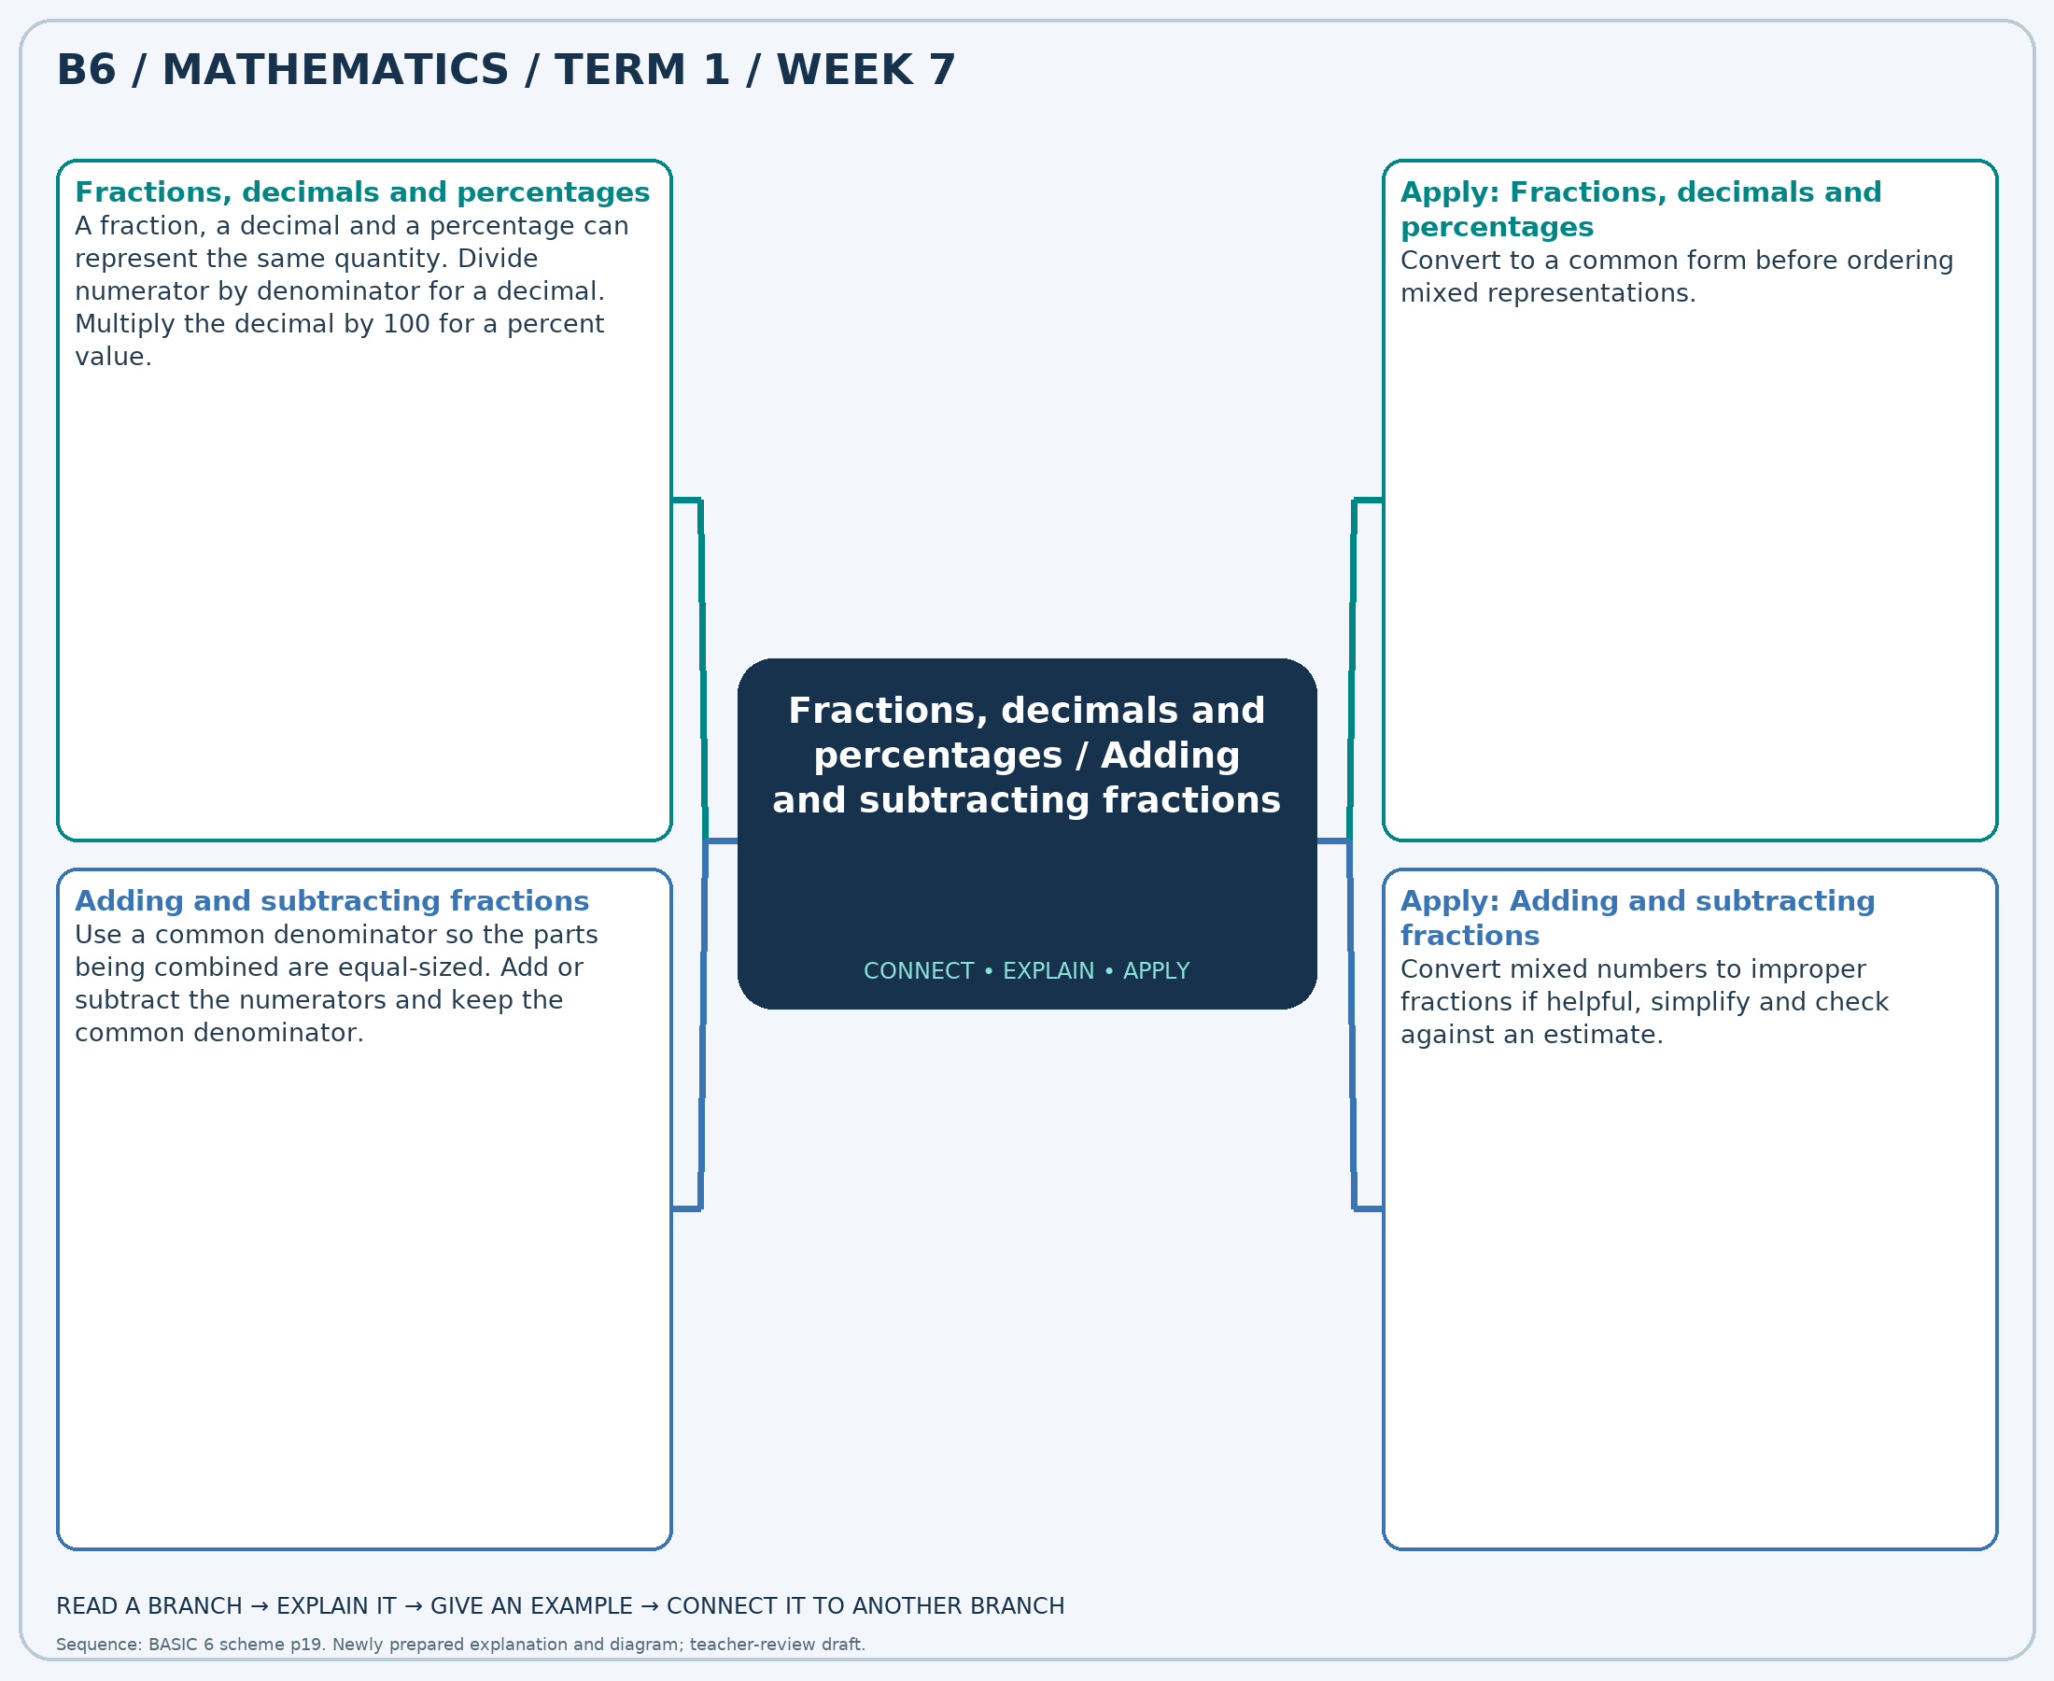
The separate high-resolution PNG can be projected or printed larger. Explain each branch and connect it with an example.

Week 7 — Practice

Section A — Multiple-choice questions
Choose ONE correct answer for each question. Each question has four alternatives.
1. Write 7/10 as a decimal.
A. 0.7 B. 1.7 C. -0.3 D. 2.7
2. Calculate 1/3 + 5/4. Give the answer in simplest form.
A. 7/12 B. 31/12 C. 19/12 D. 43/12
3. Write 4/5 as a percentage. Give the numerical percent value.
A. 80 B. 81 C. 79 D. 82
4. Calculate 5/2 − 4/3. Give the answer in simplest form.
A. 19/6 B. 13/6 C. 7/6 D. 1/6
5. Write 25% as a fraction in simplest form.
A. 9/4 B. 1/4 C. -3/4 D. 5/4
6. Calculate 2 + 5/4. Give the answer in simplest form.
A. 13/4 B. 9/4 C. 21/4 D. 17/4
7. Write 4/5 as a decimal.
A. -0.2 B. 1.8 C. 0.8 D. 2.8
8. Calculate 7/6 + 8/3. Give the answer in simplest form.
A. 29/6 B. 17/6 C. 35/6 D. 23/6
9. Write 1/10 as a percentage. Give the numerical percent value.
A. 10 B. 12 C. 11 D. 9
10. Calculate 3 − 8/3. Give the answer in simplest form.
A. 7/3 B. 1/3 C. -2/3 D. 4/3
11. Write 60% as a fraction in simplest form.
A. 8/5 B. 3/5 C. -2/5 D. 13/5
12. Calculate 1/3 + 3/2. Give the answer in simplest form.
A. 11/6 B. 5/6 C. 17/6 D. 23/6
13. Write 3/5 as a decimal.
A. 0.6 B. 2.6 C. 1.6 D. -0.4
14. Calculate 1/3 + 8/3. Give the answer in simplest form.
A. 4 B. 5 C. 3 D. 2
15. Write 7/10 as a percentage. Give the numerical percent value.
A. 69 B. 71 C. 72 D. 70
16. Calculate 1/4 − 1/6. Give the answer in simplest form.
A. 25/12 B. -11/12 C. 13/12 D. 1/12
17. Write 20% as a fraction in simplest form.
A. -4/5 B. 1/5 C. 11/5 D. 6/5
18. Calculate 5/3 + 4/3. Give the answer in simplest form.
A. 2 B. 3 C. 5 D. 4
19. Write 1/2 as a decimal.
A. -0.5 B. 1.5 C. 0.5 D. 2.5
20. Calculate 5/2 + 2/3. Give the answer in simplest form.
A. 31/6 B. 25/6 C. 13/6 D. 19/6

Section B — Structured essay questions
Answer every part (a), (b), (c). Show your method or explain your choice. Write in a separate answer booklet. Each part: 1 mark for valid working/explanation and 1 for the correct result; 6 marks per question.

1. Apply the related skills and show working or give a reason for each answer.
(a) Write 3/5 as a decimal.
(b) Calculate 7/4 − 1/3. Give the answer in simplest form.
(c) Write 60% as a fraction in simplest form.

2. Apply the related skills and show working or give a reason for each answer.
(a) Calculate 2 − 1. Give the answer in simplest form.
(b) Write 50% as a fraction in simplest form.
(c) Calculate 1 + 1/2. Give the answer in simplest form.

3. Apply the related skills and show working or give a reason for each answer.
(a) Write 40% as a fraction in simplest form.
(b) Calculate 1/6 + 3/4. Give the answer in simplest form.
(c) Write 4/5 as a percentage. Give the numerical percent value.

4. Apply the related skills and show working or give a reason for each answer.
(a) Calculate 1 + 1/3. Give the answer in simplest form.
(b) Write 3/10 as a percentage. Give the numerical percent value.
(c) Calculate 2 + 4/3. Give the answer in simplest form.

5. Apply the related skills and show working or give a reason for each answer.
(a) Write 1/4 as a percentage. Give the numerical percent value.
(b) Calculate 8/3 + 3/2. Give the answer in simplest form.
(c) Write 1/10 as a decimal.

6. Apply the related skills and show working or give a reason for each answer.
(a) Calculate 5/6 + 1/3. Give the answer in simplest form.
(b) Write 4/5 as a decimal.
(c) Calculate 5/3 − 4/3. Give the answer in simplest form.

7. Apply the related skills and show working or give a reason for each answer.
(a) Write 3/10 as a decimal.
(b) Calculate 5/2 − 1. Give the answer in simplest form.
(c) Write 60% as a fraction in simplest form.

8. Apply the related skills and show working or give a reason for each answer.
(a) Calculate 1 − 5/6. Give the answer in simplest form.
(b) Write 50% as a fraction in simplest form.
(c) Calculate 1 + 1/2. Give the answer in simplest form.

9. Apply the related skills and show working or give a reason for each answer.
(a) Write 50% as a fraction in simplest form.
(b) Calculate 4/3 + 2. Give the answer in simplest form.
(c) Write 3/5 as a percentage. Give the numerical percent value.

10. Apply the related skills and show working or give a reason for each answer.
(a) Calculate 1 + 8/3. Give the answer in simplest form.
(b) Write 3/10 as a percentage. Give the numerical percent value.
(c) Calculate 7/2 + 3/4. Give the answer in simplest form.

Week 8 — Multiplying fractions and finding a fraction of a quantity
Sequence source: BASIC 6 SCHEME OF LEARNING.pdf, first-term Mathematics, page 19. One consolidated weekly unit.

Learning outcomes
- Explain and apply multiplying fractions and finding a fraction of a quantity, solve examples and justify the method.

Teaching notes and suggested sessions
Suggested schedule: five 40-minute sessions, adjusted to the school timetable. Spread the question bank through the week; it is not intended to be completed in one lesson.

1 — Explore and diagnose
5 minutes: recall an earlier skill; 10: demonstrate a concrete or pictorial model; 15: pairs investigate and explain; 10: identify a misconception and set an exit task.

2 — Model and practise
5 minutes: review the exit task; 10: work an example aloud; 15: pairs solve parallel examples; 10: compare methods and correct errors.

3 — Connect representations
5 minutes: recall vocabulary; 10: explain the mind-map; 15: connect a model, a drawing and a symbolic calculation; 10: independent practice.

4 — Apply and explain
5 minutes: estimate or predict; 10: solve a contextual example; 15: attempt selected structured-question parts; 10: compare reasoning and check units.

5 — Check and respond
5 minutes: retrieve the main rule; 15: use selected MCQs diagnostically; 10: explain distractors and misconceptions; 10: reteach or extend in response to evidence.

Topic-specific activities
- Use counters for a fraction of a set and a shaded rectangle for a fraction of a fraction.
Resources: board, pencils, number cards, counters, paper strips and squared paper as appropriate. Prior-knowledge check: ask a learner to explain a representation used in the first example before introducing a new rule.
Support: reduce number size without changing the concept; offer a partially completed chart or model; allow oral reasoning before writing. Extension: create a counterexample to a false rule and explain why it fails.

Study notes and worked examples

Multiplying fractions and finding a fraction of a quantity
- A fraction of a quantity means multiplication.
- For example, 3/4 of 20 = (20÷4)×3 = 15.
- Multiply fractions by multiplying numerators and denominators; simplify before or after multiplying.
- Multiplying a positive quantity by a fraction between 0 and 1 makes it smaller.
Worked example: Find 5/8 of 96.
Solution: 96÷8×5=60.
Common misconception: Multiplication does not always make the quantity larger.
Independent study: read the map, cover it and reconstruct the branches. Solve an unused question from each skill and explain the reasoning to a partner. Consult the teacher key only after an honest attempt.

Week 8 — Visual mind-map
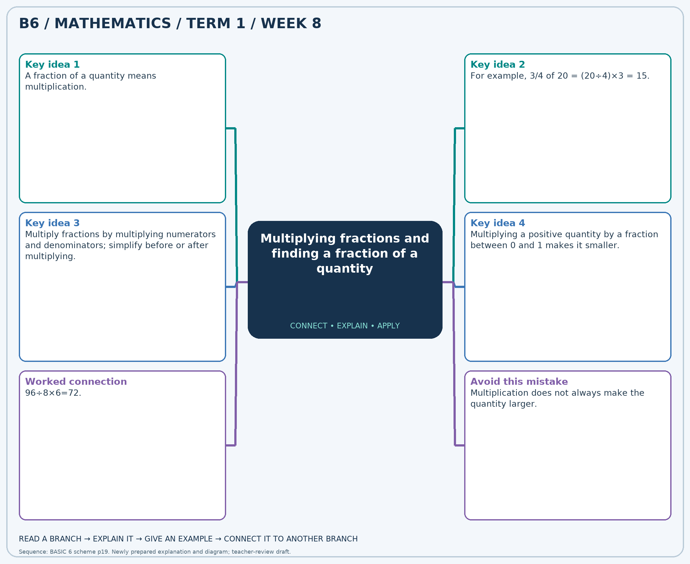
The separate high-resolution PNG can be projected or printed larger. Explain each branch and connect it with an example.

Week 8 — Practice

Section A — Multiple-choice questions
Choose ONE correct answer for each question. Each question has four alternatives.
1. Find 3/8 of 72.
A. 29 B. 27 C. 26 D. 28
2. Find 2/5 of 40.
A. 16 B. 18 C. 15 D. 17
3. Calculate 1/5 × 1/3.
A. 31/15 B. -14/15 C. 16/15 D. 1/15
4. Find 2/5 of 25.
A. 10 B. 12 C. 9 D. 11
5. Find 1/2 of 24.
A. 13 B. 12 C. 14 D. 11
6. Calculate 1/3 × 1/4.
A. 1/12 B. 25/12 C. -11/12 D. 13/12
7. Find 3/5 of 45.
A. 29 B. 26 C. 27 D. 28
8. Find 5/8 of 32.
A. 22 B. 19 C. 21 D. 20
9. Calculate 1/2 × 1/7.
A. 15/14 B. -13/14 C. 29/14 D. 1/14
10. Find 2/3 of 9.
A. 7 B. 6 C. 8 D. 5
11. Find 3/5 of 15.
A. 9 B. 11 C. 8 D. 10
12. Calculate 1/2 × 2/9.
A. 19/9 B. -8/9 C. 1/9 D. 10/9
13. Find 1/4 of 28.
A. 7 B. 6 C. 8 D. 9
14. Find 2/3 of 21.
A. 14 B. 13 C. 15 D. 16
15. Calculate 1/2 × 3/8.
A. 19/16 B. 35/16 C. 3/16 D. -13/16
16. Find 3/4 of 40.
A. 32 B. 29 C. 30 D. 31
17. Find 1/4 of 24.
A. 8 B. 6 C. 5 D. 7
18. Calculate 1/3 × 1/2.
A. 7/6 B. 13/6 C. 1/6 D. -5/6
19. Find 3/4 of 24.
A. 20 B. 18 C. 17 D. 19
20. Find 2/3 of 33.
A. 23 B. 21 C. 22 D. 24

Section B — Structured essay questions
Answer every part (a), (b), (c). Show your method or explain your choice. Write in a separate answer booklet. Each part: 1 mark for valid working/explanation and 1 for the correct result; 6 marks per question.

1. Apply the related skills and show working or give a reason for each answer.
(a) Find 1/4 of 24.
(b) Find 1/3 of 12.
(c) Calculate 1/5 × 1/2.

2. Apply the related skills and show working or give a reason for each answer.
(a) Find 3/8 of 32.
(b) Calculate 1/4 × 1/3.
(c) Find 1/5 of 55.

3. Apply the related skills and show working or give a reason for each answer.
(a) Calculate 2/3 × 2/9.
(b) Find 1/8 of 40.
(c) Find 1/4 of 36.

4. Apply the related skills and show working or give a reason for each answer.
(a) Find 1/5 of 15.
(b) Find 2/3 of 27.
(c) Calculate 1/8 × 1/3.

5. Apply the related skills and show working or give a reason for each answer.
(a) Find 1/5 of 55.
(b) Calculate 2/3 × 1/5.
(c) Find 1/3 of 24.

6. Apply the related skills and show working or give a reason for each answer.
(a) Calculate 1/8 × 2/5.
(b) Find 2/5 of 60.
(c) Find 1/3 of 21.

7. Apply the related skills and show working or give a reason for each answer.
(a) Find 4/5 of 20.
(b) Find 3/4 of 48.
(c) Calculate 3/8 × 2/5.

8. Apply the related skills and show working or give a reason for each answer.
(a) Find 3/8 of 56.
(b) Calculate 2/5 × 1/2.
(c) Find 1/8 of 40.

9. Apply the related skills and show working or give a reason for each answer.
(a) Calculate 7/8 × 4/9.
(b) Find 3/4 of 72.
(c) Find 1/4 of 48.

10. Apply the related skills and show working or give a reason for each answer.
(a) Find 3/4 of 16.
(b) Find 3/5 of 60.
(c) Calculate 1/5 × 1/9.

Week 9 — Ratios in simplest form
Sequence source: BASIC 6 SCHEME OF LEARNING.pdf, first-term Mathematics, page 19. One consolidated weekly unit.

Learning outcomes
- Explain and apply ratios in simplest form, solve examples and justify the method.

Teaching notes and suggested sessions
Suggested schedule: five 40-minute sessions, adjusted to the school timetable. Spread the question bank through the week; it is not intended to be completed in one lesson.

1 — Explore and diagnose
5 minutes: recall an earlier skill; 10: demonstrate a concrete or pictorial model; 15: pairs investigate and explain; 10: identify a misconception and set an exit task.

2 — Model and practise
5 minutes: review the exit task; 10: work an example aloud; 15: pairs solve parallel examples; 10: compare methods and correct errors.

3 — Connect representations
5 minutes: recall vocabulary; 10: explain the mind-map; 15: connect a model, a drawing and a symbolic calculation; 10: independent practice.

4 — Apply and explain
5 minutes: estimate or predict; 10: solve a contextual example; 15: attempt selected structured-question parts; 10: compare reasoning and check units.

5 — Check and respond
5 minutes: retrieve the main rule; 15: use selected MCQs diagnostically; 10: explain distractors and misconceptions; 10: reteach or extend in response to evidence.

Topic-specific activities
- Compare groups of two colours of counters, then distinguish part-to-part from part-to-whole ratios.
Resources: board, pencils, number cards, counters, paper strips and squared paper as appropriate. Prior-knowledge check: ask a learner to explain a representation used in the first example before introducing a new rule.
Support: reduce number size without changing the concept; offer a partially completed chart or model; allow oral reasoning before writing. Extension: create a counterexample to a false rule and explain why it fails.

Study notes and worked examples

Ratios in simplest form
- A ratio compares quantities in a stated order.
- The ratio 8:12 simplifies to 2:3 by dividing both terms by 4.
- Multiply or divide every term by the same non-zero number to preserve the ratio.
- In a part-to-part ratio 2:3, the first part is 2/5 of the total, not 2/3.
Worked example: Simplify the ratio 56:48.
Solution: Divide both terms by 8: 7:6.
Common misconception: Reversing the order of the quantities reverses the ratio.
Independent study: read the map, cover it and reconstruct the branches. Solve an unused question from each skill and explain the reasoning to a partner. Consult the teacher key only after an honest attempt.

Week 9 — Visual mind-map
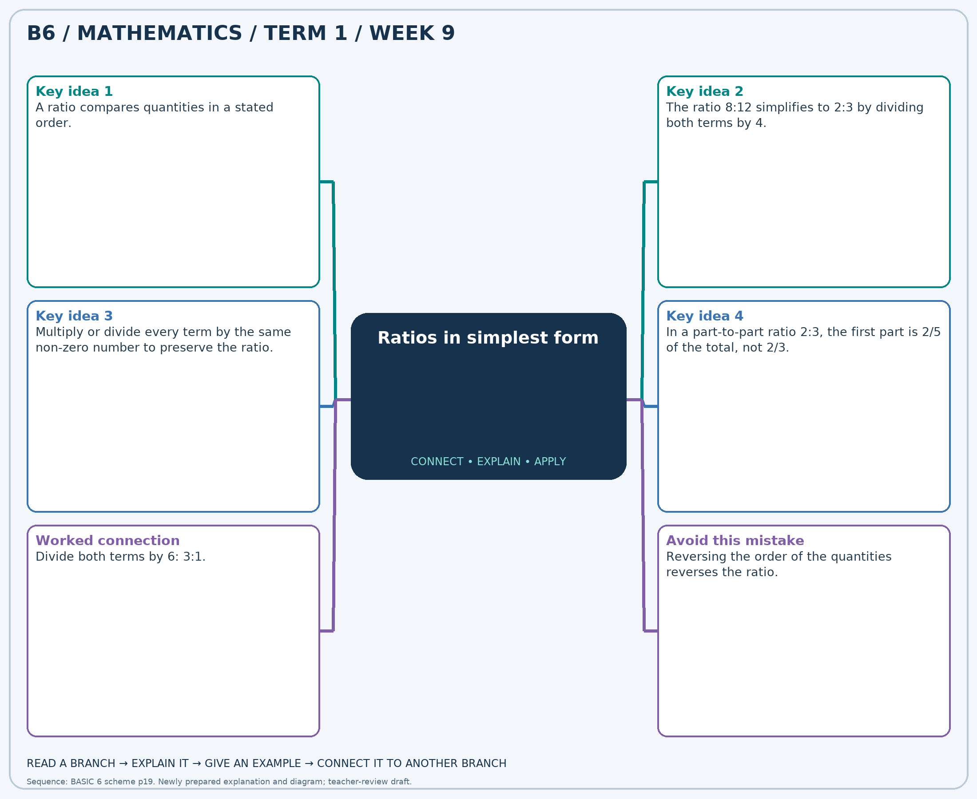
The separate high-resolution PNG can be projected or printed larger. Explain each branch and connect it with an example.

Week 9 — Practice

Section A — Multiple-choice questions
Choose ONE correct answer for each question. Each question has four alternatives.
1. Simplify the ratio 12:27.
A. 5:9 B. 4:10 C. 4:9 D. 6:9
2. Simplify the ratio 16:36.
A. 4:9 B. 5:9 C. 4:10 D. 6:9
3. Simplify the ratio 28:56.
A. 2:2 B. 1:3 C. 1:2 D. 3:2
4. Simplify the ratio 10:35.
A. 4:7 B. 3:7 C. 2:7 D. 2:8
5. Simplify the ratio 24:32.
A. 3:4 B. 4:4 C. 5:4 D. 3:5
6. Simplify the ratio 9:21.
A. 3:8 B. 3:7 C. 5:7 D. 4:7
7. Simplify the ratio 24:28.
A. 6:7 B. 7:7 C. 6:8 D. 8:7
8. Simplify the ratio 15:35.
A. 3:7 B. 5:7 C. 4:7 D. 3:8
9. Simplify the ratio 30:10.
A. 3:1 B. 4:1 C. 5:1 D. 3:2
10. Simplify the ratio 18:18.
A. 3:1 B. 1:2 C. 2:1 D. 1:1
11. Simplify the ratio 12:10.
A. 7:5 B. 8:5 C. 6:5 D. 6:6
12. Simplify the ratio 18:10.
A. 9:6 B. 11:5 C. 10:5 D. 9:5
13. Simplify the ratio 40:25.
A. 9:5 B. 8:5 C. 8:6 D. 10:5
14. Simplify the ratio 12:30.
A. 3:5 B. 4:5 C. 2:6 D. 2:5
15. Simplify the ratio 56:40.
A. 7:6 B. 9:5 C. 7:5 D. 8:5
16. Simplify the ratio 6:9.
A. 2:3 B. 2:4 C. 3:3 D. 4:3
17. Simplify the ratio 12:42.
A. 2:8 B. 3:7 C. 2:7 D. 4:7
18. Simplify the ratio 49:56.
A. 7:8 B. 7:9 C. 8:8 D. 9:8
19. Simplify the ratio 40:32.
A. 6:4 B. 5:4 C. 7:4 D. 5:5
20. Simplify the ratio 25:25.
A. 3:1 B. 2:1 C. 1:1 D. 1:2

Section B — Structured essay questions
Answer every part (a), (b), (c). Show your method or explain your choice. Write in a separate answer booklet. Each part: 1 mark for valid working/explanation and 1 for the correct result; 6 marks per question.

1. Apply the related skills and show working or give a reason for each answer.
(a) Simplify the ratio 24:27.
(b) Simplify the ratio 8:32.
(c) Simplify the ratio 72:48.

2. Apply the related skills and show working or give a reason for each answer.
(a) Simplify the ratio 36:8.
(b) Simplify the ratio 48:30.
(c) Simplify the ratio 6:15.

3. Apply the related skills and show working or give a reason for each answer.
(a) Simplify the ratio 56:48.
(b) Simplify the ratio 16:12.
(c) Simplify the ratio 12:36.

4. Apply the related skills and show working or give a reason for each answer.
(a) Simplify the ratio 24:20.
(b) Simplify the ratio 49:21.
(c) Simplify the ratio 48:18.

5. Apply the related skills and show working or give a reason for each answer.
(a) Simplify the ratio 48:18.
(b) Simplify the ratio 72:24.
(c) Simplify the ratio 25:45.

6. Apply the related skills and show working or give a reason for each answer.
(a) Simplify the ratio 30:40.
(b) Simplify the ratio 10:20.
(c) Simplify the ratio 28:56.

7. Apply the related skills and show working or give a reason for each answer.
(a) Simplify the ratio 27:6.
(b) Simplify the ratio 10:14.
(c) Simplify the ratio 6:24.

8. Apply the related skills and show working or give a reason for each answer.
(a) Simplify the ratio 10:20.
(b) Simplify the ratio 54:30.
(c) Simplify the ratio 10:30.

9. Apply the related skills and show working or give a reason for each answer.
(a) Simplify the ratio 42:36.
(b) Simplify the ratio 14:49.
(c) Simplify the ratio 42:63.

10. Apply the related skills and show working or give a reason for each answer.
(a) Simplify the ratio 18:6.
(b) Simplify the ratio 35:28.
(c) Simplify the ratio 8:36.

Week 10 — Equivalent ratios
Sequence source: BASIC 6 SCHEME OF LEARNING.pdf, first-term Mathematics, page 19. One consolidated weekly unit.

Learning outcomes
- Explain and apply equivalent ratios, solve examples and justify the method.

Teaching notes and suggested sessions
Suggested schedule: five 40-minute sessions, adjusted to the school timetable. Spread the question bank through the week; it is not intended to be completed in one lesson.

1 — Explore and diagnose
5 minutes: recall an earlier skill; 10: demonstrate a concrete or pictorial model; 15: pairs investigate and explain; 10: identify a misconception and set an exit task.

2 — Model and practise
5 minutes: review the exit task; 10: work an example aloud; 15: pairs solve parallel examples; 10: compare methods and correct errors.

3 — Connect representations
5 minutes: recall vocabulary; 10: explain the mind-map; 15: connect a model, a drawing and a symbolic calculation; 10: independent practice.

4 — Apply and explain
5 minutes: estimate or predict; 10: solve a contextual example; 15: attempt selected structured-question parts; 10: compare reasoning and check units.

5 — Check and respond
5 minutes: retrieve the main rule; 15: use selected MCQs diagnostically; 10: explain distractors and misconceptions; 10: reteach or extend in response to evidence.

Topic-specific activities
- Build a ratio table with counters, scaling both colours together.
Resources: board, pencils, number cards, counters, paper strips and squared paper as appropriate. Prior-knowledge check: ask a learner to explain a representation used in the first example before introducing a new rule.
Support: reduce number size without changing the concept; offer a partially completed chart or model; allow oral reasoning before writing. Extension: create a counterexample to a false rule and explain why it fails.

Study notes and worked examples

Equivalent ratios
- Equivalent ratios describe the same relative amounts.
- Multiply or divide all terms by the same positive number: 2:3=4:6=10:15.
- Compare ratios using common second terms or equivalent fractions.
- Equivalent ratios may describe groups with different totals.
Worked example: Complete: 9:4 = ?:28.
Solution: Multiply both terms by 7; missing term=9×7=63.
Common misconception: Changing only one term generally changes the ratio.
Independent study: read the map, cover it and reconstruct the branches. Solve an unused question from each skill and explain the reasoning to a partner. Consult the teacher key only after an honest attempt.

Week 10 — Visual mind-map
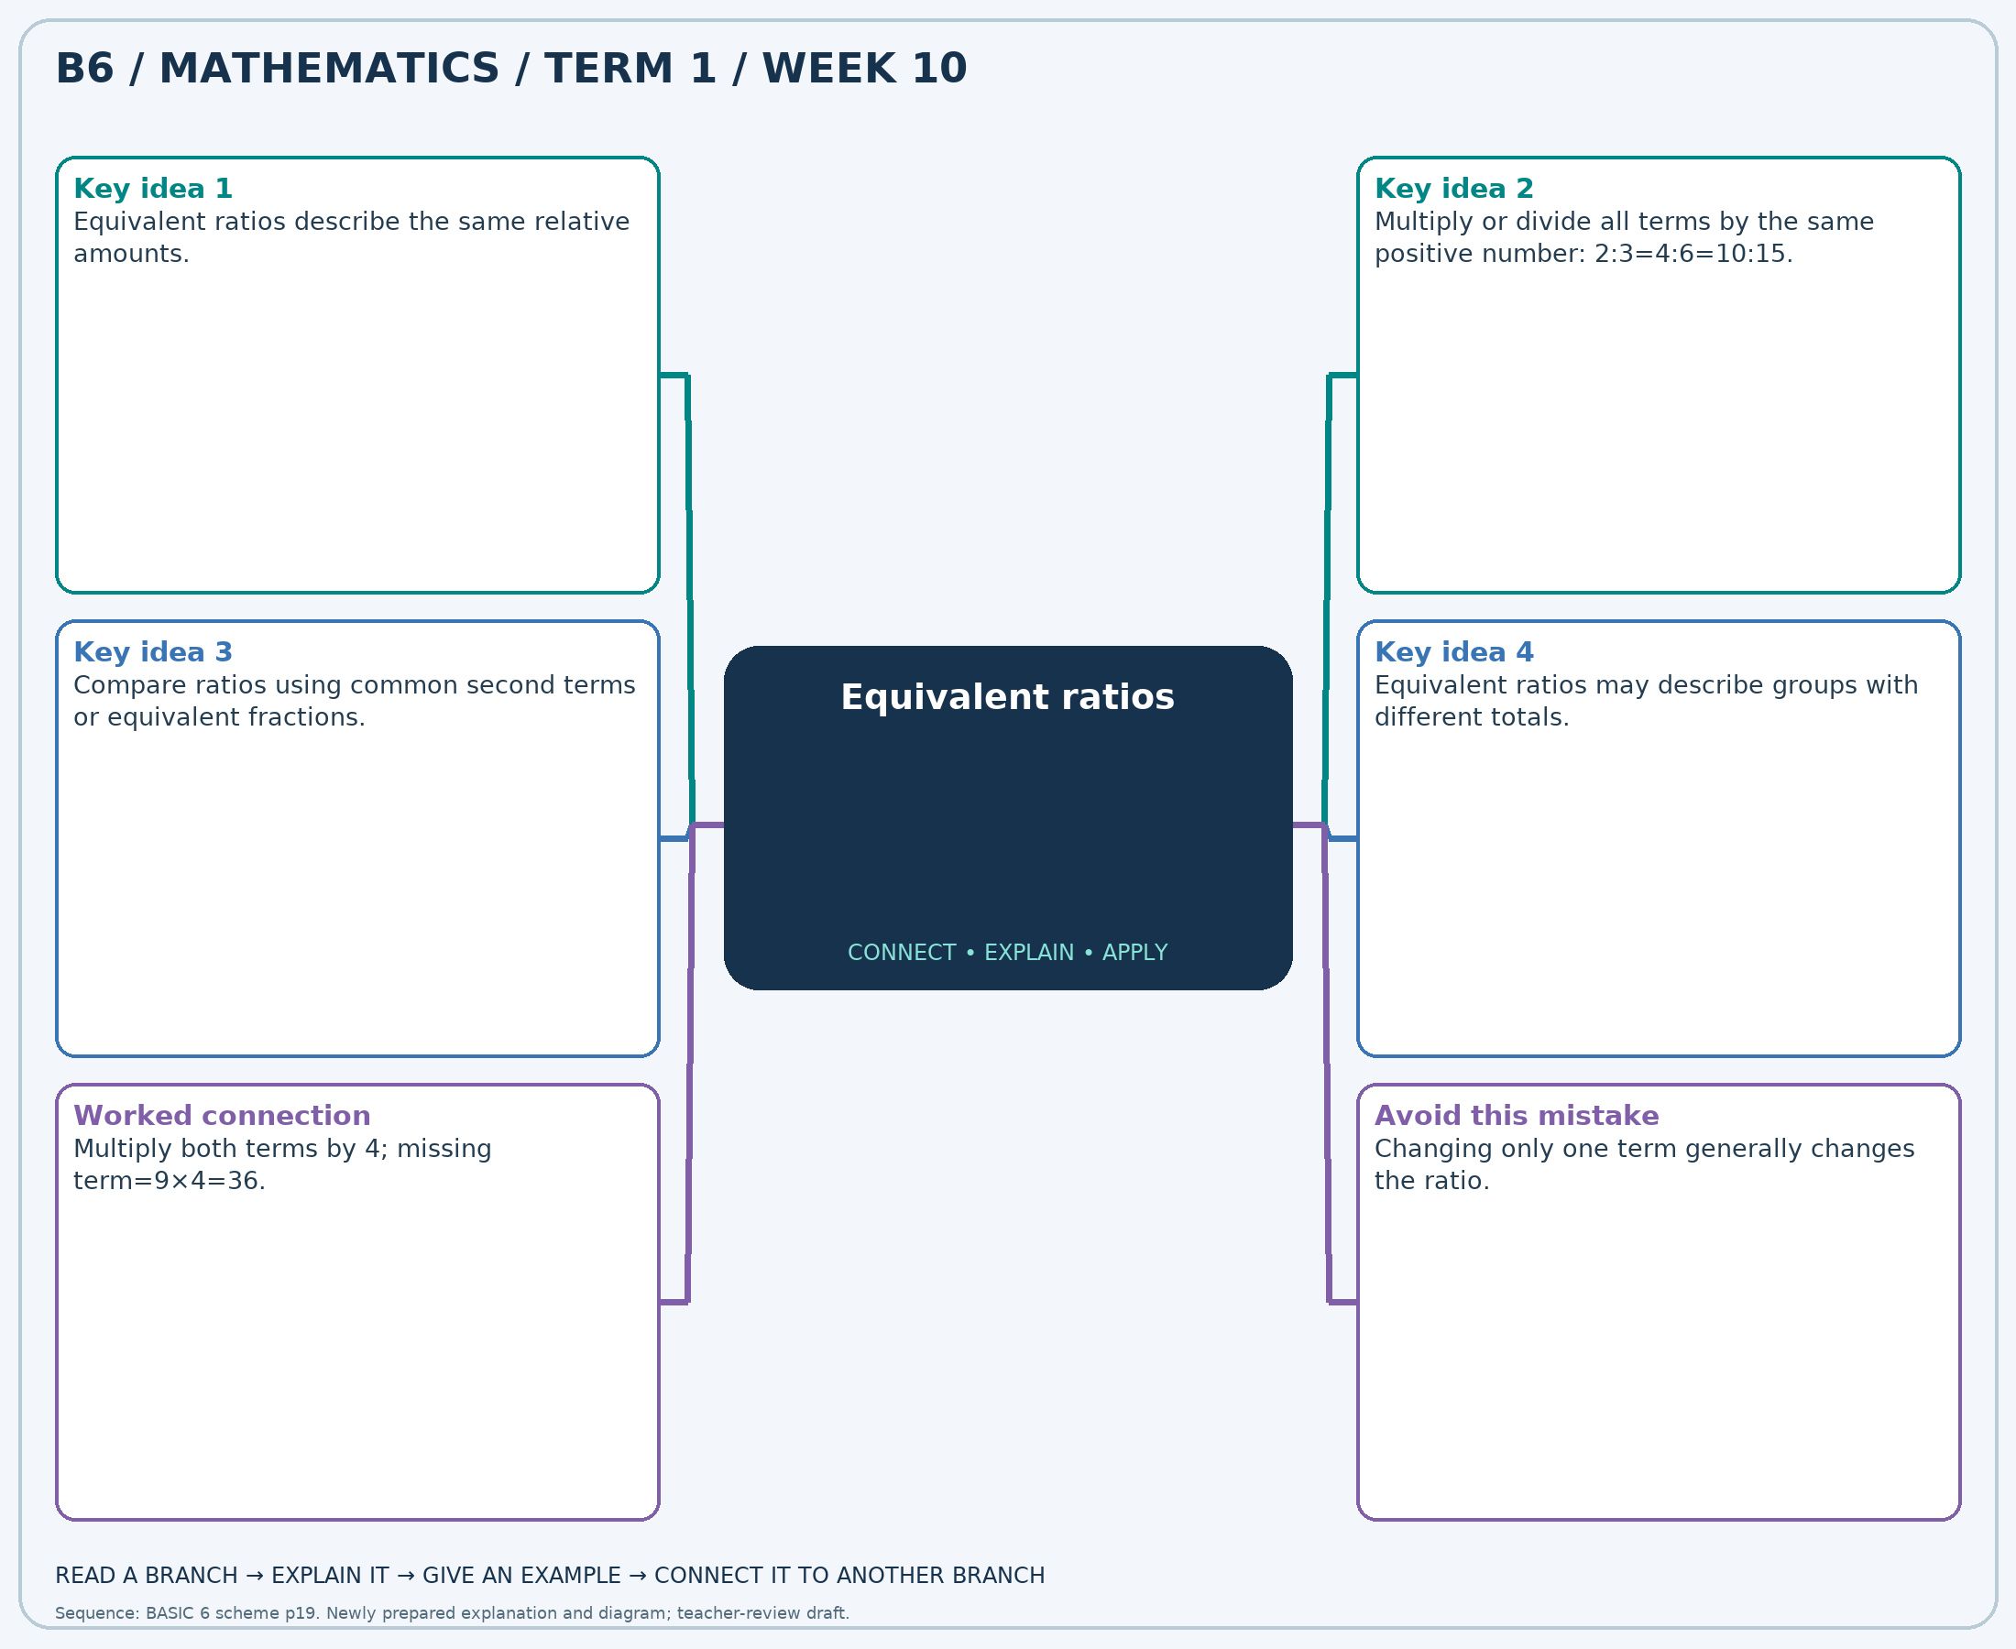
The separate high-resolution PNG can be projected or printed larger. Explain each branch and connect it with an example.

Week 10 — Practice

Section A — Multiple-choice questions
Choose ONE correct answer for each question. Each question has four alternatives.
1. Complete: 6:2 = ?:8.
A. 24 B. 26 C. 23 D. 25
2. Complete: 6:8 = ?:48.
A. 38 B. 36 C. 35 D. 37
3. Complete: 9:6 = ?:42.
A. 62 B. 65 C. 64 D. 63
4. Complete: 2:2 = ?:14.
A. 13 B. 16 C. 15 D. 14
5. Complete: 2:9 = ?:18.
A. 6 B. 4 C. 3 D. 5
6. Complete: 8:8 = ?:48.
A. 48 B. 47 C. 50 D. 49
7. Complete: 4:4 = ?:32.
A. 31 B. 32 C. 33 D. 34
8. Complete: 5:6 = ?:42.
A. 36 B. 35 C. 34 D. 37
9. Complete: 2:7 = ?:14.
A. 6 B. 5 C. 3 D. 4
10. Complete: 8:3 = ?:9.
A. 23 B. 26 C. 25 D. 24
11. Complete: 4:7 = ?:42.
A. 26 B. 23 C. 24 D. 25
12. Complete: 4:6 = ?:12.
A. 8 B. 9 C. 10 D. 7
13. Complete: 9:6 = ?:24.
A. 36 B. 35 C. 37 D. 38
14. Complete: 9:2 = ?:8.
A. 36 B. 37 C. 38 D. 35
15. Complete: 4:8 = ?:16.
A. 7 B. 8 C. 10 D. 9
16. Complete: 3:8 = ?:56.
A. 21 B. 20 C. 23 D. 22
17. Complete: 2:9 = ?:36.
A. 8 B. 10 C. 7 D. 9
18. Complete: 5:5 = ?:15.
A. 16 B. 15 C. 14 D. 17
19. Complete: 6:5 = ?:15.
A. 19 B. 18 C. 17 D. 20
20. Complete: 4:2 = ?:12.
A. 26 B. 25 C. 23 D. 24

Section B — Structured essay questions
Answer every part (a), (b), (c). Show your method or explain your choice. Write in a separate answer booklet. Each part: 1 mark for valid working/explanation and 1 for the correct result; 6 marks per question.

1. Apply the related skills and show working or give a reason for each answer.
(a) Complete: 5:3 = ?:24.
(b) Complete: 8:9 = ?:18.
(c) Complete: 3:9 = ?:45.

2. Apply the related skills and show working or give a reason for each answer.
(a) Complete: 6:9 = ?:54.
(b) Complete: 6:5 = ?:35.
(c) Complete: 7:6 = ?:48.

3. Apply the related skills and show working or give a reason for each answer.
(a) Complete: 9:5 = ?:30.
(b) Complete: 9:7 = ?:49.
(c) Complete: 4:2 = ?:12.

4. Apply the related skills and show working or give a reason for each answer.
(a) Complete: 7:2 = ?:8.
(b) Complete: 3:9 = ?:36.
(c) Complete: 7:9 = ?:63.

5. Apply the related skills and show working or give a reason for each answer.
(a) Complete: 4:4 = ?:28.
(b) Complete: 6:2 = ?:12.
(c) Complete: 3:5 = ?:10.

6. Apply the related skills and show working or give a reason for each answer.
(a) Complete: 9:8 = ?:32.
(b) Complete: 2:7 = ?:49.
(c) Complete: 2:8 = ?:56.

7. Apply the related skills and show working or give a reason for each answer.
(a) Complete: 5:9 = ?:18.
(b) Complete: 4:8 = ?:64.
(c) Complete: 6:5 = ?:15.

8. Apply the related skills and show working or give a reason for each answer.
(a) Complete: 9:7 = ?:14.
(b) Complete: 3:2 = ?:4.
(c) Complete: 3:7 = ?:42.

9. Apply the related skills and show working or give a reason for each answer.
(a) Complete: 8:2 = ?:6.
(b) Complete: 5:8 = ?:64.
(c) Complete: 4:7 = ?:49.

10. Apply the related skills and show working or give a reason for each answer.
(a) Complete: 3:2 = ?:14.
(b) Complete: 6:9 = ?:18.
(c) Complete: 3:7 = ?:14.

Week 11 — Direct proportion
Sequence source: BASIC 6 SCHEME OF LEARNING.pdf, first-term Mathematics, page 19. One consolidated weekly unit.

Learning outcomes
- Explain and apply direct proportion, solve examples and justify the method.

Teaching notes and suggested sessions
Suggested schedule: five 40-minute sessions, adjusted to the school timetable. Spread the question bank through the week; it is not intended to be completed in one lesson.

1 — Explore and diagnose
5 minutes: recall an earlier skill; 10: demonstrate a concrete or pictorial model; 15: pairs investigate and explain; 10: identify a misconception and set an exit task.

2 — Model and practise
5 minutes: review the exit task; 10: work an example aloud; 15: pairs solve parallel examples; 10: compare methods and correct errors.

3 — Connect representations
5 minutes: recall vocabulary; 10: explain the mind-map; 15: connect a model, a drawing and a symbolic calculation; 10: independent practice.

4 — Apply and explain
5 minutes: estimate or predict; 10: solve a contextual example; 15: attempt selected structured-question parts; 10: compare reasoning and check units.

5 — Check and respond
5 minutes: retrieve the main rule; 15: use selected MCQs diagnostically; 10: explain distractors and misconceptions; 10: reteach or extend in response to evidence.

Topic-specific activities
- Make a table of item counts and costs at a fixed price per item.
Resources: board, pencils, number cards, counters, paper strips and squared paper as appropriate. Prior-knowledge check: ask a learner to explain a representation used in the first example before introducing a new rule.
Support: reduce number size without changing the concept; offer a partially completed chart or model; allow oral reasoning before writing. Extension: create a counterexample to a false rule and explain why it fails.

Study notes and worked examples

Direct proportion
- Two quantities are directly proportional when their ratio stays constant.
- Find the amount for one unit, then scale to the required number of units.
- If 3 notebooks cost GH₵18, one costs GH₵6 and five cost GH₵30 at the same unit price.
- A direct-proportion table contains equivalent ratios and pairs zero with zero.
Worked example: 4 notebooks cost GH₵20. At the same unit price, what do 7 notebooks cost in Ghana cedis?
Solution: Unit price=20÷4=5; cost=7×5=35.
Common misconception: Two quantities increasing together does not by itself prove direct proportion.
Independent study: read the map, cover it and reconstruct the branches. Solve an unused question from each skill and explain the reasoning to a partner. Consult the teacher key only after an honest attempt.

Week 11 — Visual mind-map
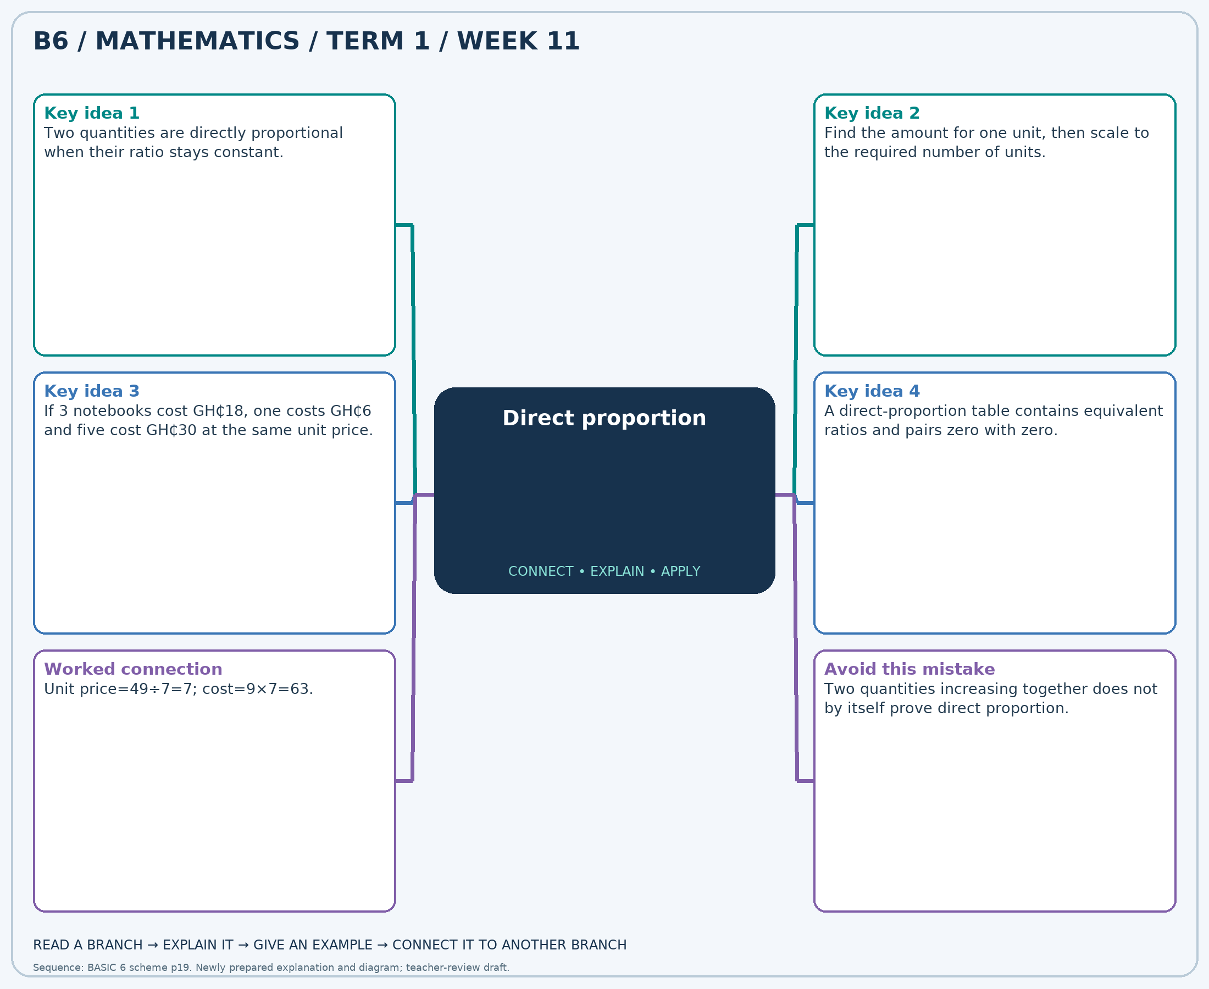
The separate high-resolution PNG can be projected or printed larger. Explain each branch and connect it with an example.

Week 11 — Practice

Section A — Multiple-choice questions
Choose ONE correct answer for each question. Each question has four alternatives.
1. 7 notebooks cost GH₵28. At the same unit price, what do 13 notebooks cost in Ghana cedis?
A. 53 B. 51 C. 52 D. 54
2. 3 notebooks cost GH₵6. At the same unit price, what do 5 notebooks cost in Ghana cedis?
A. 10 B. 12 C. 9 D. 11
3. 6 notebooks cost GH₵84. At the same unit price, what do 11 notebooks cost in Ghana cedis?
A. 153 B. 156 C. 154 D. 155
4. 3 notebooks cost GH₵39. At the same unit price, what do 7 notebooks cost in Ghana cedis?
A. 90 B. 93 C. 92 D. 91
5. 4 notebooks cost GH₵44. At the same unit price, what do 9 notebooks cost in Ghana cedis?
A. 101 B. 98 C. 99 D. 100
6. 4 notebooks cost GH₵52. At the same unit price, what do 8 notebooks cost in Ghana cedis?
A. 106 B. 103 C. 105 D. 104
7. 7 notebooks cost GH₵70. At the same unit price, what do 13 notebooks cost in Ghana cedis?
A. 129 B. 131 C. 132 D. 130
8. 3 notebooks cost GH₵21. At the same unit price, what do 7 notebooks cost in Ghana cedis?
A. 51 B. 50 C. 48 D. 49
9. 5 notebooks cost GH₵65. At the same unit price, what do 10 notebooks cost in Ghana cedis?
A. 129 B. 130 C. 131 D. 132
10. 3 notebooks cost GH₵12. At the same unit price, what do 10 notebooks cost in Ghana cedis?
A. 41 B. 42 C. 40 D. 39
11. 6 notebooks cost GH₵78. At the same unit price, what do 8 notebooks cost in Ghana cedis?
A. 103 B. 106 C. 105 D. 104
12. 5 notebooks cost GH₵35. At the same unit price, what do 12 notebooks cost in Ghana cedis?
A. 83 B. 85 C. 86 D. 84
13. 3 notebooks cost GH₵24. At the same unit price, what do 9 notebooks cost in Ghana cedis?
A. 74 B. 71 C. 72 D. 73
14. 3 notebooks cost GH₵9. At the same unit price, what do 6 notebooks cost in Ghana cedis?
A. 19 B. 20 C. 17 D. 18
15. 5 notebooks cost GH₵45. At the same unit price, what do 10 notebooks cost in Ghana cedis?
A. 89 B. 92 C. 91 D. 90
16. 7 notebooks cost GH₵35. At the same unit price, what do 9 notebooks cost in Ghana cedis?
A. 46 B. 44 C. 47 D. 45
17. 5 notebooks cost GH₵10. At the same unit price, what do 10 notebooks cost in Ghana cedis?
A. 21 B. 22 C. 19 D. 20
18. 5 notebooks cost GH₵30. At the same unit price, what do 10 notebooks cost in Ghana cedis?
A. 60 B. 59 C. 61 D. 62
19. 5 notebooks cost GH₵25. At the same unit price, what do 10 notebooks cost in Ghana cedis?
A. 52 B. 50 C. 51 D. 49
20. 3 notebooks cost GH₵42. At the same unit price, what do 9 notebooks cost in Ghana cedis?
A. 126 B. 127 C. 125 D. 128

Section B — Structured essay questions
Answer every part (a), (b), (c). Show your method or explain your choice. Write in a separate answer booklet. Each part: 1 mark for valid working/explanation and 1 for the correct result; 6 marks per question.

1. Apply the related skills and show working or give a reason for each answer.
(a) 3 notebooks cost GH₵27. At the same unit price, what do 6 notebooks cost in Ghana cedis?
(b) 4 notebooks cost GH₵60. At the same unit price, what do 9 notebooks cost in Ghana cedis?
(c) 5 notebooks cost GH₵35. At the same unit price, what do 7 notebooks cost in Ghana cedis?

2. Apply the related skills and show working or give a reason for each answer.
(a) 7 notebooks cost GH₵14. At the same unit price, what do 12 notebooks cost in Ghana cedis?
(b) 6 notebooks cost GH₵84. At the same unit price, what do 11 notebooks cost in Ghana cedis?
(c) 5 notebooks cost GH₵55. At the same unit price, what do 8 notebooks cost in Ghana cedis?

3. Apply the related skills and show working or give a reason for each answer.
(a) 5 notebooks cost GH₵25. At the same unit price, what do 11 notebooks cost in Ghana cedis?
(b) 7 notebooks cost GH₵70. At the same unit price, what do 11 notebooks cost in Ghana cedis?
(c) 5 notebooks cost GH₵55. At the same unit price, what do 8 notebooks cost in Ghana cedis?

4. Apply the related skills and show working or give a reason for each answer.
(a) 7 notebooks cost GH₵35. At the same unit price, what do 14 notebooks cost in Ghana cedis?
(b) 3 notebooks cost GH₵36. At the same unit price, what do 5 notebooks cost in Ghana cedis?
(c) 4 notebooks cost GH₵44. At the same unit price, what do 10 notebooks cost in Ghana cedis?

5. Apply the related skills and show working or give a reason for each answer.
(a) 6 notebooks cost GH₵48. At the same unit price, what do 11 notebooks cost in Ghana cedis?
(b) 6 notebooks cost GH₵48. At the same unit price, what do 13 notebooks cost in Ghana cedis?
(c) 5 notebooks cost GH₵20. At the same unit price, what do 7 notebooks cost in Ghana cedis?

6. Apply the related skills and show working or give a reason for each answer.
(a) 3 notebooks cost GH₵45. At the same unit price, what do 10 notebooks cost in Ghana cedis?
(b) 5 notebooks cost GH₵75. At the same unit price, what do 11 notebooks cost in Ghana cedis?
(c) 4 notebooks cost GH₵40. At the same unit price, what do 6 notebooks cost in Ghana cedis?

7. Apply the related skills and show working or give a reason for each answer.
(a) 3 notebooks cost GH₵45. At the same unit price, what do 5 notebooks cost in Ghana cedis?
(b) 4 notebooks cost GH₵20. At the same unit price, what do 6 notebooks cost in Ghana cedis?
(c) 7 notebooks cost GH₵56. At the same unit price, what do 13 notebooks cost in Ghana cedis?

8. Apply the related skills and show working or give a reason for each answer.
(a) 7 notebooks cost GH₵98. At the same unit price, what do 10 notebooks cost in Ghana cedis?
(b) 3 notebooks cost GH₵30. At the same unit price, what do 10 notebooks cost in Ghana cedis?
(c) 5 notebooks cost GH₵60. At the same unit price, what do 9 notebooks cost in Ghana cedis?

9. Apply the related skills and show working or give a reason for each answer.
(a) 7 notebooks cost GH₵63. At the same unit price, what do 9 notebooks cost in Ghana cedis?
(b) 6 notebooks cost GH₵48. At the same unit price, what do 13 notebooks cost in Ghana cedis?
(c) 4 notebooks cost GH₵36. At the same unit price, what do 10 notebooks cost in Ghana cedis?

10. Apply the related skills and show working or give a reason for each answer.
(a) 4 notebooks cost GH₵36. At the same unit price, what do 6 notebooks cost in Ghana cedis?
(b) 4 notebooks cost GH₵24. At the same unit price, what do 6 notebooks cost in Ghana cedis?
(c) 7 notebooks cost GH₵56. At the same unit price, what do 10 notebooks cost in Ghana cedis?

Week 12 — Rates and scale / Direct proportion
Sequence source: BASIC 6 SCHEME OF LEARNING.pdf, first-term Mathematics, page 19. One consolidated weekly unit.

Learning outcomes
- Explain and apply rates and scale, solve examples and justify the method.
- Explain and apply direct proportion, solve examples and justify the method.

Teaching notes and suggested sessions
Suggested schedule: five 40-minute sessions, adjusted to the school timetable. Spread the question bank through the week; it is not intended to be completed in one lesson.

1 — Explore and diagnose
5 minutes: recall an earlier skill; 10: demonstrate a concrete or pictorial model; 15: pairs investigate and explain; 10: identify a misconception and set an exit task.

2 — Model and practise
5 minutes: review the exit task; 10: work an example aloud; 15: pairs solve parallel examples; 10: compare methods and correct errors.

3 — Connect representations
5 minutes: recall vocabulary; 10: explain the mind-map; 15: connect a model, a drawing and a symbolic calculation; 10: independent practice.

4 — Apply and explain
5 minutes: estimate or predict; 10: solve a contextual example; 15: attempt selected structured-question parts; 10: compare reasoning and check units.

5 — Check and respond
5 minutes: retrieve the main rule; 15: use selected MCQs diagnostically; 10: explain distractors and misconceptions; 10: reteach or extend in response to evidence.

Topic-specific activities
- Measure distances on a drawn map using a stated scale.
- Make a table of item counts and costs at a fixed price per item.
Resources: board, pencils, number cards, counters, paper strips and squared paper as appropriate. Prior-knowledge check: ask a learner to explain a representation used in the first example before introducing a new rule.
Support: reduce number size without changing the concept; offer a partially completed chart or model; allow oral reasoning before writing. Extension: create a counterexample to a false rule and explain why it fails.

Study notes and worked examples

Rates and scale
- A rate compares quantities with different units, such as Ghana cedis per notebook.
- Divide the total amount by the number of units to find a unit rate.
- A map scale links a map measurement with a real-world distance.
- Keep units explicit and reverse the calculation to check the result.
Worked example: A map uses 1 cm for 4 km. What distance in kilometres does 11 cm represent?
Solution: 11×4=44 km.
Common misconception: Do not confuse centimetres on a map with kilometres in the real world.

Direct proportion
- Two quantities are directly proportional when their ratio stays constant.
- Find the amount for one unit, then scale to the required number of units.
- If 3 notebooks cost GH₵18, one costs GH₵6 and five cost GH₵30 at the same unit price.
- A direct-proportion table contains equivalent ratios and pairs zero with zero.
Worked example: 7 notebooks cost GH₵105. At the same unit price, what do 10 notebooks cost in Ghana cedis?
Solution: Unit price=105÷7=15; cost=10×15=150.
Common misconception: Two quantities increasing together does not by itself prove direct proportion.
Independent study: read the map, cover it and reconstruct the branches. Solve an unused question from each skill and explain the reasoning to a partner. Consult the teacher key only after an honest attempt.

Week 12 — Visual mind-map
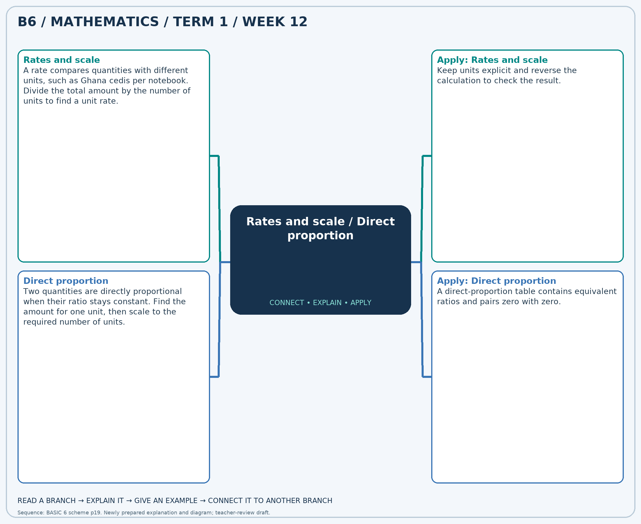
The separate high-resolution PNG can be projected or printed larger. Explain each branch and connect it with an example.

Week 12 — Practice

Section A — Multiple-choice questions
Choose ONE correct answer for each question. Each question has four alternatives.
1. A map uses 1 cm for 5 km. What distance in kilometres does 5 cm represent?
A. 26 B. 24 C. 27 D. 25
2. 3 notebooks cost GH₵9. At the same unit price, what do 6 notebooks cost in Ghana cedis?
A. 18 B. 20 C. 19 D. 17
3. A map uses 1 cm for 5 km. What distance in kilometres does 7 cm represent?
A. 36 B. 37 C. 34 D. 35
4. 6 notebooks cost GH₵36. At the same unit price, what do 13 notebooks cost in Ghana cedis?
A. 80 B. 78 C. 79 D. 77
5. A map uses 1 cm for 2 km. What distance in kilometres does 3 cm represent?
A. 6 B. 7 C. 8 D. 5
6. 3 notebooks cost GH₵33. At the same unit price, what do 10 notebooks cost in Ghana cedis?
A. 111 B. 110 C. 109 D. 112
7. A map uses 1 cm for 5 km. What distance in kilometres does 12 cm represent?
A. 59 B. 60 C. 62 D. 61
8. 5 notebooks cost GH₵70. At the same unit price, what do 12 notebooks cost in Ghana cedis?
A. 170 B. 167 C. 168 D. 169
9. A map uses 1 cm for 5 km. What distance in kilometres does 11 cm represent?
A. 56 B. 57 C. 54 D. 55
10. 5 notebooks cost GH₵20. At the same unit price, what do 8 notebooks cost in Ghana cedis?
A. 31 B. 32 C. 34 D. 33
11. A map uses 1 cm for 8 km. What distance in kilometres does 4 cm represent?
A. 32 B. 31 C. 33 D. 34
12. 6 notebooks cost GH₵84. At the same unit price, what do 11 notebooks cost in Ghana cedis?
A. 153 B. 156 C. 155 D. 154
13. A map uses 1 cm for 6 km. What distance in kilometres does 8 cm represent?
A. 47 B. 50 C. 49 D. 48
14. 3 notebooks cost GH₵21. At the same unit price, what do 10 notebooks cost in Ghana cedis?
A. 69 B. 70 C. 72 D. 71
15. A map uses 1 cm for 8 km. What distance in kilometres does 3 cm represent?
A. 24 B. 23 C. 26 D. 25
16. 7 notebooks cost GH₵56. At the same unit price, what do 13 notebooks cost in Ghana cedis?
A. 106 B. 103 C. 105 D. 104
17. A map uses 1 cm for 3 km. What distance in kilometres does 12 cm represent?
A. 35 B. 36 C. 38 D. 37
18. 4 notebooks cost GH₵12. At the same unit price, what do 10 notebooks cost in Ghana cedis?
A. 29 B. 30 C. 31 D. 32
19. A map uses 1 cm for 3 km. What distance in kilometres does 6 cm represent?
A. 20 B. 19 C. 18 D. 17
20. 7 notebooks cost GH₵21. At the same unit price, what do 13 notebooks cost in Ghana cedis?
A. 40 B. 41 C. 39 D. 38

Section B — Structured essay questions
Answer every part (a), (b), (c). Show your method or explain your choice. Write in a separate answer booklet. Each part: 1 mark for valid working/explanation and 1 for the correct result; 6 marks per question.

1. Apply the related skills and show working or give a reason for each answer.
(a) A map uses 1 cm for 5 km. What distance in kilometres does 3 cm represent?
(b) 7 notebooks cost GH₵35. At the same unit price, what do 13 notebooks cost in Ghana cedis?
(c) A map uses 1 cm for 5 km. What distance in kilometres does 12 cm represent?

2. Apply the related skills and show working or give a reason for each answer.
(a) 5 notebooks cost GH₵40. At the same unit price, what do 7 notebooks cost in Ghana cedis?
(b) A map uses 1 cm for 4 km. What distance in kilometres does 4 cm represent?
(c) 3 notebooks cost GH₵12. At the same unit price, what do 5 notebooks cost in Ghana cedis?

3. Apply the related skills and show working or give a reason for each answer.
(a) A map uses 1 cm for 8 km. What distance in kilometres does 9 cm represent?
(b) 4 notebooks cost GH₵36. At the same unit price, what do 11 notebooks cost in Ghana cedis?
(c) A map uses 1 cm for 2 km. What distance in kilometres does 3 cm represent?

4. Apply the related skills and show working or give a reason for each answer.
(a) 5 notebooks cost GH₵15. At the same unit price, what do 10 notebooks cost in Ghana cedis?
(b) A map uses 1 cm for 6 km. What distance in kilometres does 5 cm represent?
(c) 6 notebooks cost GH₵54. At the same unit price, what do 11 notebooks cost in Ghana cedis?

5. Apply the related skills and show working or give a reason for each answer.
(a) A map uses 1 cm for 5 km. What distance in kilometres does 11 cm represent?
(b) 4 notebooks cost GH₵8. At the same unit price, what do 10 notebooks cost in Ghana cedis?
(c) A map uses 1 cm for 2 km. What distance in kilometres does 9 cm represent?

6. Apply the related skills and show working or give a reason for each answer.
(a) 7 notebooks cost GH₵28. At the same unit price, what do 9 notebooks cost in Ghana cedis?
(b) A map uses 1 cm for 3 km. What distance in kilometres does 8 cm represent?
(c) 4 notebooks cost GH₵12. At the same unit price, what do 9 notebooks cost in Ghana cedis?

7. Apply the related skills and show working or give a reason for each answer.
(a) A map uses 1 cm for 3 km. What distance in kilometres does 3 cm represent?
(b) 5 notebooks cost GH₵75. At the same unit price, what do 11 notebooks cost in Ghana cedis?
(c) A map uses 1 cm for 9 km. What distance in kilometres does 6 cm represent?

8. Apply the related skills and show working or give a reason for each answer.
(a) 4 notebooks cost GH₵20. At the same unit price, what do 11 notebooks cost in Ghana cedis?
(b) A map uses 1 cm for 2 km. What distance in kilometres does 10 cm represent?
(c) 6 notebooks cost GH₵36. At the same unit price, what do 11 notebooks cost in Ghana cedis?

9. Apply the related skills and show working or give a reason for each answer.
(a) A map uses 1 cm for 9 km. What distance in kilometres does 4 cm represent?
(b) 3 notebooks cost GH₵39. At the same unit price, what do 5 notebooks cost in Ghana cedis?
(c) A map uses 1 cm for 3 km. What distance in kilometres does 10 cm represent?

10. Apply the related skills and show working or give a reason for each answer.
(a) 7 notebooks cost GH₵28. At the same unit price, what do 9 notebooks cost in Ghana cedis?
(b) A map uses 1 cm for 4 km. What distance in kilometres does 4 cm represent?
(c) 3 notebooks cost GH₵33. At the same unit price, what do 9 notebooks cost in Ghana cedis?

