Basic 6 Science — Week 1
  - Classifying plants by root system • Term 1 • Week 1 ONLY
Name: __________________________________ Class: __________
Date: __________________ Teacher: ________________________
SCOPE: WEEK 1 ONLY. Later weeks and both tests for this subject are NOT included in this partial batch. Emergency teacher-review draft — rebuilt edition.
Sequence source: BASIC 6 SCHEME OF LEARNING.pdf, p23; indicator reference B6.1.1.1.1. Topic descriptions informed by the local curriculum data. Explanations and activities are newly prepared, including supporting concepts.

Learning outcomes
- Explain the key ideas in classifying plants by root system using accurate vocabulary.
- Identify examples and justify classification or tool choices using evidence.
- Apply the ideas to familiar school or home situations and correct a common misconception.

Teacher lesson notes
One consolidated weekly unit. Suggested organisation: three 40-minute teaching sessions plus guided practice and assessment in the remaining timetable periods. Spread the questions over the week.
Prior knowledge: elicit a familiar example and ask for a reason. Record one correct idea and one misconception to revisit at the end of the week.

Session 1 — Observe
5 minutes: recall examples; 10: demonstrate or show pictures; 15: pairs describe features; 10: introduce the first five key terms and check explanations.

Session 2 — Investigate
5 minutes: retrieve vocabulary; 10: model an explanation; 15: perform the specific activity below; 10: compare observations and introduce the remaining terms.

Session 3 — Apply
5 minutes: correct a misconception; 10: explain map branches; 15: use application questions; 10: collect an exit response and identify who needs reteaching.

Topic-specific activity
Compare teacher-provided bean and grass seedlings or clear photographs. Draw the entire root arrangement. Identify a dominant main root or many similar roots; classify with reasons. Replant viable specimens.

Safety and resources
Do not uproot protected plants or taste roots. Wash hands after handling soil.
Resources: the examples or pictures specified in the activity, board, pencils, exercise books and the supplied visual map. If equipment is unavailable, use labelled drawings and role-play rather than claiming a practical was performed.

Support and extension
Support: offer picture labels, read technical vocabulary aloud and accept an oral explanation before writing. Extension: compare related concepts, propose a counterexample and justify a new application. Use wrong MCQ choices to diagnose misconceptions, not merely score letters.

Study notes

Taproot system
A root arrangement with a prominent main root and smaller side roots.
The prominent main root is the deciding feature. Side roots branch from it rather than all arising as similar roots at the stem base.

Fibrous root system
A root arrangement with many relatively thin, similarly sized roots near the stem base.
The spreading network grips surface soil. Many roots distribute the anchorage rather than relying on a single main root.

Lateral root
A side branch from another root.
Side branches spread into more soil and increase the area reached by the root system. Their presence does not prevent the main root from being dominant.

Root hairs
Tiny root-surface extensions that increase the absorbing area.
These extensions increase contact with water films around soil particles. They are much smaller than the main roots of a fibrous system.

Absorption
Taking water and dissolved mineral nutrients into a root.
Roots take in water and dissolved nutrients rather than swallowing lumps of soil. The plant still makes sugars by photosynthesis.

Anchorage
Holding a plant firmly in the ground.
Both major root systems can hold plants in place. A main root and a spread of many smaller roots are different arrangements for support.

Storage root
A root enlarged to hold stored food.
A carrot is a storage root. Not all underground storage organs are roots: a potato tuber is a stem, so position alone does not settle the classification.

Grass
A familiar plant usually showing a fibrous root system.
Its root arrangement is fibrous, with no dominant main root in the usual specimen. Examine the arrangement rather than relying only on a plant name.

Bean
A familiar seedling that typically develops a taproot system.
A young bean commonly shows a main root with side branches. The contrast with a cluster of similar roots should be visible in a labelled drawing.

Root system
The complete collection and arrangement of a plant’s roots.
The overall arrangement is needed for classification. A broken fragment may not show whether a main root dominated the original system.
Revision routine: cover each definition, explain the idea, supply a new example and compare it with a related term. Reconstruct the map from memory before checking it.

Week 1 — Visual mind-map
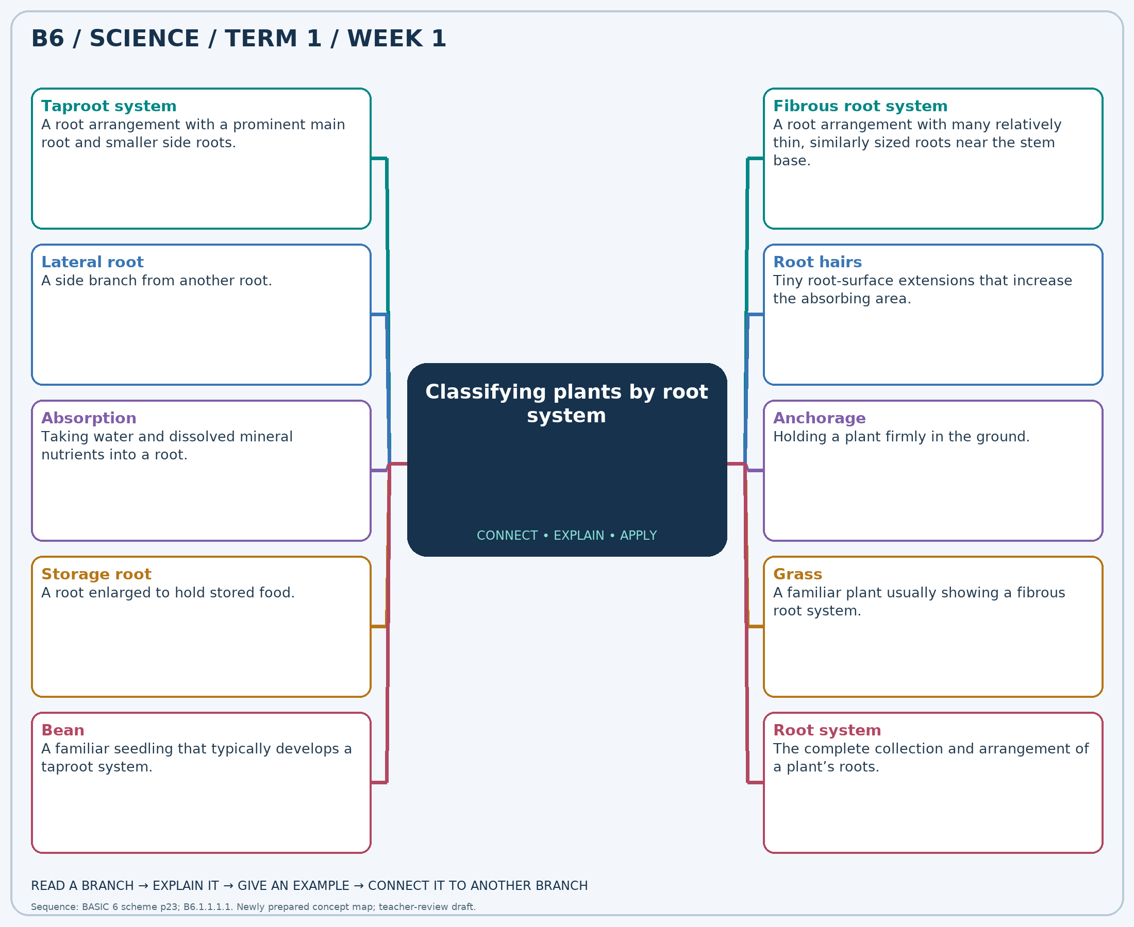
Explain each branch and supply another example. A separate high-resolution PNG is included.

Week 1 — Practice

Section A — Multiple-choice questions
Choose ONE correct answer for each question. Each question has four alternatives.
1. Which term best matches this description: a root arrangement with a prominent main root and smaller side roots?
A. Fibrous root system B. Leaf network C. Flower cluster D. Taproot system
2. Which term best matches this description: a root arrangement with many relatively thin, similarly sized roots near the stem base?
A. Leaf network B. Taproot system C. Flowering system D. Fibrous root system
3. Which term best matches this description: a side branch from another root?
A. Leaf blade B. Lateral root C. Stamen D. Petal
4. Which term best matches this description: tiny root-surface extensions that increase the absorbing area?
A. Root hairs B. Seeds C. Thorns D. Petals
5. Which term best matches this description: taking water and dissolved mineral nutrients into a root?
A. Absorption B. Seed dispersal C. Photosynthesis D. Pollination
6. Which term best matches this description: holding a plant firmly in the ground?
A. Fruit formation B. Anchorage C. Pollination D. Seed dispersal
7. Which term best matches this description: a root enlarged to hold stored food?
A. Leaf stalk B. Storage root C. Seed coat D. Flower bud
8. Which term best matches this description: a familiar plant usually showing a fibrous root system?
A. Mango seedling B. Grass C. Carrot D. Bean
9. Which term best matches this description: a familiar seedling that typically develops a taproot system?
A. Bean B. Onion C. Maize D. Rice
10. Which term best matches this description: the complete collection and arrangement of a plant’s roots?
A. Seed coat B. Single leaf C. Flower head D. Root system
11. A bean seedling has one thick main root with thinner branches. Which root system is it?
A. Fibrous root system B. Taproot system C. Leaf network D. Flower cluster
12. Grass has many thin roots without one dominant main root. Which root system is present?
A. Taproot system B. Fibrous root system C. Flowering system D. Leaf network
13. A thin root branches from a thick central root. What is the thin branch called?
A. Stamen B. Lateral root C. Petal D. Leaf blade
14. A magnified root shows many fine hair-like extensions. What are they?
A. Thorns B. Seeds C. Petals D. Root hairs
15. A watered seedling takes up water through its roots. Which root function is shown?
A. Pollination B. Seed dispersal C. Photosynthesis D. Absorption
16. Roots grip the soil and help stop a plant blowing over. Which function is shown?
A. Anchorage B. Pollination C. Fruit formation D. Seed dispersal
17. A carrot’s thick underground root contains food reserves. How can it be described?
A. Flower bud B. Storage root C. Leaf stalk D. Seed coat
18. Which plant is a suitable common specimen for a dense cluster of similarly sized roots?
A. Mango seedling B. Carrot C. Grass D. Bean
19. Which seedling is a suitable taproot comparison with grass?
A. Maize B. Bean C. Rice D. Onion
20. A pupil draws a main root and all its visible branches. What complete structure is shown?
A. Seed coat B. Flower head C. Single leaf D. Root system

Section B — 10 structured essay questions
Answer every part (a), (b), (c) in your exercise book. Suggested marks: (a) 1, (b) 1, (c) 2, giving 4 marks per question. Explain relationships and use examples where requested.

Question 1
(a) Explain the term “Taproot system”.
(b) A bean seedling has one thick main root with thinner branches. Which root system is it?
(c) Explain the visible evidence used to classify the bean seedling.

Question 2
(a) Explain the term “Fibrous root system”.
(b) Grass has many thin roots without one dominant main root. Which root system is present?
(c) Explain how this root arrangement can help hold soil in place.

Question 3
(a) Explain the term “Lateral root”.
(b) A thin root branches from a thick central root. What is the thin branch called?
(c) Explain how side roots help a plant reach soil resources.

Question 4
(a) Explain the term “Root hairs”.
(b) A magnified root shows many fine hair-like extensions. What are they?
(c) Explain why many of these extensions can improve water uptake.

Question 5
(a) Explain the term “Absorption”.
(b) A watered seedling takes up water through its roots. Which root function is shown?
(c) Explain why roots do not need to take in lumps of soil to obtain minerals.

Question 6
(a) Explain the term “Anchorage”.
(b) Roots grip the soil and help stop a plant blowing over. Which function is shown?
(c) Explain how both taproot and fibrous systems can support a plant.

Question 7
(a) Explain the term “Storage root”.
(b) A carrot’s thick underground root contains food reserves. How can it be described?
(c) Explain why an underground organ is not automatically a root.

Question 8
(a) Explain the term “Grass”.
(b) Which plant is a suitable common specimen for a dense cluster of similarly sized roots?
(c) State the observations needed to confirm the classification of a grass specimen.

Question 9
(a) Explain the term “Bean”.
(b) Which seedling is a suitable taproot comparison with grass?
(c) Describe a drawing that clearly compares bean and grass roots.

Question 10
(a) Explain the term “Root system”.
(b) A pupil draws a main root and all its visible branches. What complete structure is shown?
(c) Explain why classification from one broken root may be unreliable.

