Basic 7 Computing — Week 1
  - Fourth-generation computers and input devices • Term 1 • Week 1 ONLY
Name: __________________________________ Class: __________
Date: __________________ Teacher: ________________________
SCOPE: WEEK 1 ONLY. Later weeks and both tests for this subject are NOT included in this partial batch. Emergency teacher-review draft — rebuilt edition.
Sequence source: BASIC 7 SCHEME OF LEARNING.pdf, p15; indicator reference B7.1.1.1.1–2. Topic descriptions informed by the local curriculum data. Explanations and activities are newly prepared, including supporting concepts.

Learning outcomes
- Explain the key ideas in fourth-generation computers and input devices using accurate vocabulary.
- Identify examples and justify classification or tool choices using evidence.
- Apply the ideas to familiar school or home situations and correct a common misconception.

Teacher lesson notes
One consolidated weekly unit. Suggested organisation: three 40-minute teaching sessions plus guided practice and assessment in the remaining timetable periods. Spread the questions over the week.
Prior knowledge: elicit a familiar example and ask for a reason. Record one correct idea and one misconception to revisit at the end of the week.

Session 1 — Observe
5 minutes: recall examples; 10: demonstrate or show pictures; 15: pairs describe features; 10: introduce the first five key terms and check explanations.

Session 2 — Investigate
5 minutes: retrieve vocabulary; 10: model an explanation; 15: perform the specific activity below; 10: compare observations and introduce the remaining terms.

Session 3 — Apply
5 minutes: correct a misconception; 10: explain map branches; 15: use application questions; 10: collect an exit response and identify who needs reteaching.

Topic-specific activity
Link microprocessors with the development of personal computers. Match product codes, paper images, speech and typed reports to appropriate input devices. Demonstrate only teacher-approved codes and files.

Safety and resources
Do not scan unknown links or use private learner data. Obtain permission before recording anyone.
Resources: the examples or pictures specified in the activity, board, pencils, exercise books and the supplied visual map. If equipment is unavailable, use labelled drawings and role-play rather than claiming a practical was performed.

Support and extension
Support: offer picture labels, read technical vocabulary aloud and accept an oral explanation before writing. Extension: compare related concepts, propose a counterexample and justify a new application. Use wrong MCQ choices to diagnose misconceptions, not merely score letters.

Study notes

Microprocessor
A CPU implemented on a chip, central to fourth-generation development.
A compact integrated processor is not merely a smaller monitor. It helped make smaller, affordable computer systems practical.

Personal computer
A general-purpose computer designed mainly for an individual user.
Both laptops and desktops can support one user’s general tasks. The physical shape alone does not define the category.

Input
Data or instructions supplied to a computer.
The code enters as input; software looks up the product and calculates a total; the screen or receipt presents output.

Barcode reader
A device reading an encoded pattern of bars or a supported product code.
The code is often an identifier used to retrieve the price from a database. It need not contain the price itself.

Scanner
A device capturing a paper document or picture as a digital image.
Scanning captures an image. Recognising printed characters as editable text requires an additional process such as OCR.

OCR
Recognition of printed characters in an image as machine-readable text.
Recognition can confuse similar characters, especially in poor-quality scans. Proofreading is needed to correct mistakes.

Microphone
A device capturing sound as input.
It captures sound, whereas speakers reproduce sound. Recording other people also requires attention to consent and privacy.

Keyboard
A keyed input device for entering text and commands.
Typing creates new text from the learner’s ideas. Scanning instead captures an existing page or picture.

Touchscreen
A device combining visual display with sensing of touch input.
The display presents output while the touch sensor receives input. One physical device may perform more than one role.

Data validation
Checking input against rules such as permitted types or ranges.
A range rule rejects implausible data. A plausible but wrong age may pass, so validation cannot guarantee truth.
Revision routine: cover each definition, explain the idea, supply a new example and compare it with a related term. Reconstruct the map from memory before checking it.

Week 1 — Visual mind-map
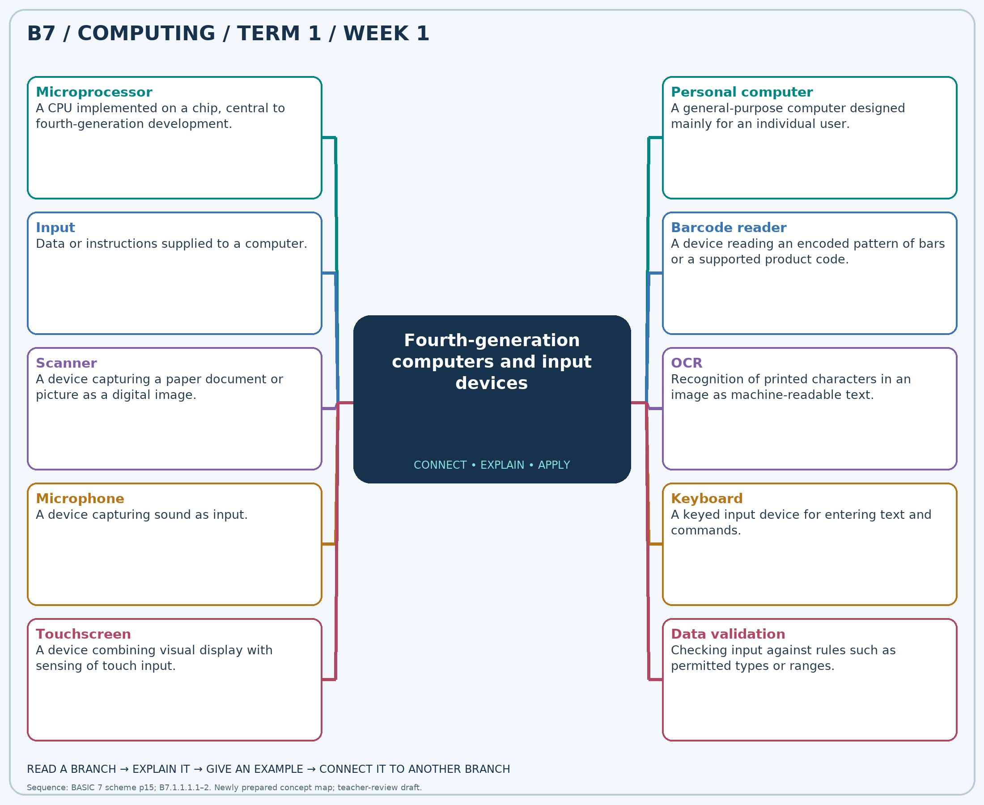
Explain each branch and supply another example. A separate high-resolution PNG is included.

Week 1 — Practice

Section A — Multiple-choice questions
Choose ONE correct answer for each question. Each question has four alternatives.
1. Which term best matches this description: a CPU implemented on a chip, central to fourth-generation development?
A. Punched cards alone B. Microprocessor C. Mechanical gears D. Vacuum tubes
2. Which term best matches this description: a general-purpose computer designed mainly for an individual user?
A. Mechanical calculator only B. Supercomputer only C. Network cable D. Personal computer
3. Which term best matches this description: data or instructions supplied to a computer?
A. Input B. Display C. Backup only D. Output
4. Which term best matches this description: a device reading an encoded pattern of bars or a supported product code?
A. Speaker B. Barcode reader C. Printer D. Projector
5. Which term best matches this description: a device capturing a paper document or picture as a digital image?
A. Projector B. Printer only C. Scanner D. Speaker
6. Which term best matches this description: recognition of printed characters in an image as machine-readable text?
A. Audio playback B. Paper printing C. Screen projection D. OCR
7. Which term best matches this description: a device capturing sound as input?
A. Printer B. Microphone C. Speaker D. Monitor
8. Which term best matches this description: a keyed input device for entering text and commands?
A. Speaker B. Keyboard C. Projector D. Monitor
9. Which term best matches this description: a device combining visual display with sensing of touch input?
A. Ordinary speaker B. Non-touch monitor C. Touchscreen D. Paper printout
10. Which term best matches this description: checking input against rules such as permitted types or ranges?
A. Audio output B. Data validation C. Printing D. Screen projection
11. A small computer processes instructions using a CPU on a chip. Which technology is involved?
A. Microprocessor B. Punched cards alone C. Vacuum tubes D. Mechanical gears
12. A learner uses a laptop for documents, calculations and learning. Which broad category fits?
A. Mechanical calculator only B. Supercomputer only C. Personal computer D. Network cable
13. A cashier enters a product code before a total is calculated. Which processing stage is this?
A. Output B. Input C. Backup only D. Display
14. A cashier scans stripes on a packaged item. Which input device is used?
A. Printer B. Projector C. Barcode reader D. Speaker
15. A school wants a digital image of an old printed photograph. Which device is suitable?
A. Speaker B. Projector C. Scanner D. Printer only
16. A teacher wants to edit text from a scanned letter without retyping it all. Which process can help?
A. OCR B. Screen projection C. Paper printing D. Audio playback
17. A learner records a spoken explanation. Which device provides the audio input?
A. Speaker B. Monitor C. Printer D. Microphone
18. A pupil is composing an entirely new long report. Which device best suits entering the text?
A. Keyboard B. Monitor C. Speaker D. Projector
19. A learner sees a menu and selects by touching that same screen. Which device is used?
A. Ordinary speaker B. Paper printout C. Touchscreen D. Non-touch monitor
20. A form rejects an age of 250 for a primary-school pupil. Which check is applied?
A. Screen projection B. Printing C. Data validation D. Audio output

Section B — 10 structured essay questions
Answer every part (a), (b), (c) in your exercise book. Suggested marks: (a) 1, (b) 1, (c) 2, giving 4 marks per question. Explain relationships and use examples where requested.

Question 1
(a) Explain the term “Microprocessor”.
(b) A small computer processes instructions using a CPU on a chip. Which technology is involved?
(c) Explain how this technology contributed to personal computers.

Question 2
(a) Explain the term “Personal computer”.
(b) A learner uses a laptop for documents, calculations and learning. Which broad category fits?
(c) Explain why a desktop and laptop can share this classification.

Question 3
(a) Explain the term “Input”.
(b) A cashier enters a product code before a total is calculated. Which processing stage is this?
(c) Describe input, processing and output in a checkout example.

Question 4
(a) Explain the term “Barcode reader”.
(b) A cashier scans stripes on a packaged item. Which input device is used?
(c) Explain why changing a price may not require changing a barcode.

Question 5
(a) Explain the term “Scanner”.
(b) A school wants a digital image of an old printed photograph. Which device is suitable?
(c) Explain why scanning a page does not automatically make its words editable.

Question 6
(a) Explain the term “OCR”.
(b) A teacher wants to edit text from a scanned letter without retyping it all. Which process can help?
(c) Explain why the converted text should be proofread.

Question 7
(a) Explain the term “Microphone”.
(b) A learner records a spoken explanation. Which device provides the audio input?
(c) Explain the input/output difference between this device and speakers.

Question 8
(a) Explain the term “Keyboard”.
(b) A pupil is composing an entirely new long report. Which device best suits entering the text?
(c) Explain why typing is more suitable than scanning for an entirely new report.

Question 9
(a) Explain the term “Touchscreen”.
(b) A learner sees a menu and selects by touching that same screen. Which device is used?
(c) Explain why classifying this device only as output is incomplete.

Question 10
(a) Explain the term “Data validation”.
(b) A form rejects an age of 250 for a primary-school pupil. Which check is applied?
(c) Explain why valid data may still be inaccurate.

