Basic 7 Mathematics
  - Term 1 • Weeks 1–12 • Lesson notes, study notes, mind-maps and weekly practice
Name: __________________________________ Class: __________
Date: __________________ Teacher: ________________________
EMERGENCY TEACHER-REVIEW DRAFT — REBUILT EDITION. Topic order follows the supplied Alpha Examinations first-term scheme. Notes, examples and diagrams are newly prepared. This is not an official curriculum approval or a guarantee of full indicator-by-indicator validation.
Each week contains one consolidated weekly lesson unit, one visual mind-map, 20 four-option MCQs and 10 structured questions with parts (a), (b), (c). Daily sessions are suggested, not separate full daily lesson plans. Answers are in the separate teacher book.
The source reserves Weeks 13–15 for revision/examinations/vacation. Mid-term assessment assumes Weeks 1–6; end-of-term assumes Weeks 1–12. Confirm school dates and pacing. Some task structures repeat with new values for fluency practice.

Weekly contents
01 — Place value and expanded form / Reading and writing large numbers
02 — Rounding whole numbers / Rounding decimals
03 — Significant figures / Multiplying and dividing by powers of ten
04 — Multiplication strategies / Multi-step number problems
05 — Whole-number and decimal operations / Multiplication strategies / Division and checking
06 — Whole-number and decimal operations / Powers and repeated factors
07 — Powers and repeated factors / Prime factorisation and HCF
08 — Powers and repeated factors / Highest common factor
09 — Fractions, decimals and percentages / Comparing fractions
10 — Adding and subtracting fractions
11 — Multiplying fractions and finding a fraction of a quantity
12 — Multiplying fractions and finding a fraction of a quantity

Week 1 — Place value and expanded form / Reading and writing large numbers
Sequence source: BASIC 7 SCHEME OF LEARNING.pdf, first-term Mathematics, page 40. One consolidated weekly unit.

Learning outcomes
- Explain and apply place value and expanded form, solve examples and justify the method.
- Explain and apply reading and writing large numbers, solve examples and justify the method.

Teaching notes and suggested sessions
Suggested schedule: five 40-minute sessions, adjusted to the school timetable. Spread the question bank through the week; it is not intended to be completed in one lesson.

1 — Explore and diagnose
5 minutes: recall an earlier skill; 10: demonstrate a concrete or pictorial model; 15: pairs investigate and explain; 10: identify a misconception and set an exit task.

2 — Model and practise
5 minutes: review the exit task; 10: work an example aloud; 15: pairs solve parallel examples; 10: compare methods and correct errors.

3 — Connect representations
5 minutes: recall vocabulary; 10: explain the mind-map; 15: connect a model, a drawing and a symbolic calculation; 10: independent practice.

4 — Apply and explain
5 minutes: estimate or predict; 10: solve a contextual example; 15: attempt selected structured-question parts; 10: compare reasoning and check units.

5 — Check and respond
5 minutes: retrieve the main rule; 15: use selected MCQs diagnostically; 10: explain distractors and misconceptions; 10: reteach or extend in response to evidence.

Topic-specific activities
- Build numbers with digit cards on a place-value chart. Exchange two digits and explain the change.
- Partners dictate numbers and write figures, checking every place on a chart.
Resources: board, pencils, number cards, counters, paper strips and squared paper as appropriate. Prior-knowledge check: ask a learner to explain a representation used in the first example before introducing a new rule.
Support: reduce number size without changing the concept; offer a partially completed chart or model; allow oral reasoning before writing. Extension: create a counterexample to a false rule and explain why it fails.

Study notes and worked examples

Place value and expanded form
- Our system is base ten. Ten units in one place exchange for one unit in the next place to the left.
- The digit 3 in 43,216 has value 3,000. Face value and place value are different.
- Expanded form shows a sum of place values: 43,216 = 40,000 + 3,000 + 200 + 10 + 6.
- Zero holds an empty place. Removing the zero from 40,216 changes the number.
Worked example: What is the value of the digit in the tens place in 3,859,317,518?
Solution: The digit is 1; 1 × 10 = 10.
Common misconception: Do not confuse the digit itself with the value of the place it occupies.

Reading and writing large numbers
- Group digits in threes from the right: ones, thousands, millions and billions.
- Read each non-zero group, followed by its scale name.
- When writing figures from words, put zeros in the places not named.
- Six hundred and three thousand and eight is 603,008. Read the result back to check it.
Worked example: Write in figures: eight billion, one hundred and eighty-four million, two hundred and sixty-eight thousand, seven hundred and eighty-four.
Solution: Place each named group in its correct scale: 8,184,268,784.
Common misconception: Do not write 603,800 for six hundred and three thousand and eight.
Independent study: read the map, cover it and reconstruct the branches. Solve an unused question from each skill and explain the reasoning to a partner. Consult the teacher key only after an honest attempt.

Week 1 — Visual mind-map
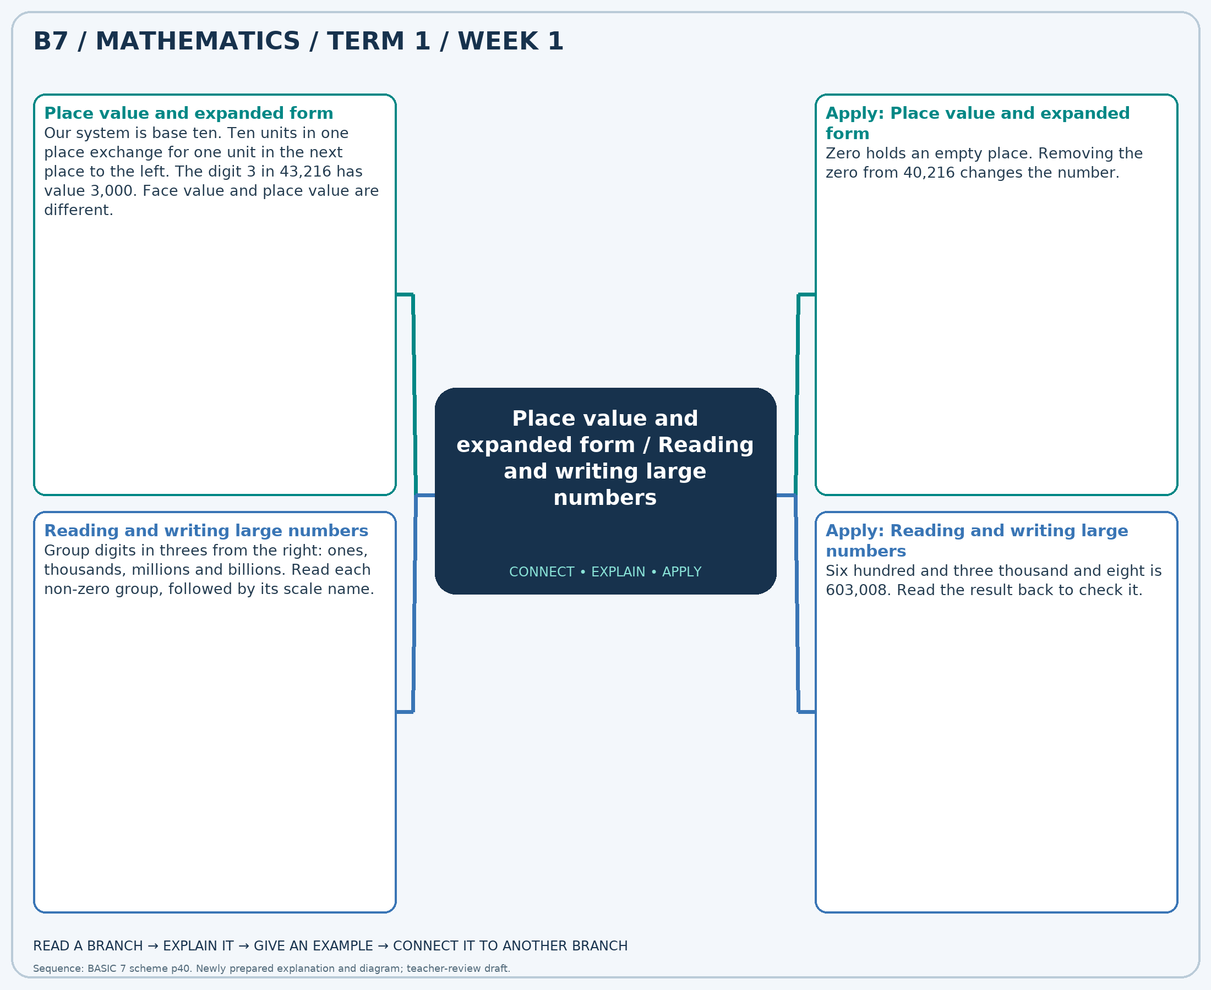
The separate high-resolution PNG can be projected or printed larger. Explain each branch and connect it with an example.

Week 1 — Practice

Section A — Multiple-choice questions
Choose ONE correct answer for each question. Each question has four alternatives.
1. What is the value of the digit in the hundred-thousands place in 6,804,154,845?
A. 1 B. 100000 C. 1000000 D. 10000
2. Write in figures: eight billion, seven hundred and eighteen million, forty-five thousand, three hundred and thirty-two.
A. 8718045332 B. 8718045432 C. 8718044332 D. 8718046332
3. A number has 2 ten-thousands, 4 hundreds and 7 ones, with zeros elsewhere. Write it in figures.
A. 20470 B. 20407 C. 24007 D. 2407
4. Write in figures: three billion, one hundred and forty-eight million, thirty-five thousand, one hundred and seventy-eight.
A. 3148034178 B. 3148035178 C. 3148036178 D. 3148035278
5. What is the value of the digit in the tens place in 6,501,051,592?
A. 900 B. 90 C. 93 D. 9
6. Write in figures: seven billion, three hundred and forty-four million, seven hundred and ninety-one thousand, seven hundred and seventy-six.
A. 7344791776 B. 7344790776 C. 7344792776 D. 7344791876
7. What is the value of the digit in the thousands place in 5,518,705,748?
A. 50000 B. 500 C. 5 D. 5000
8. Write in figures: five billion, five hundred and eight million, six hundred and sixty-nine thousand, two hundred and thirty-nine.
A. 5508668239 B. 5508670239 C. 5508669239 D. 5508669339
9. A number has 5 ten-thousands, 8 hundreds and 7 ones, with zeros elsewhere. Write it in figures.
A. 50807 B. 5807 C. 50870 D. 58007
10. Write in figures: five billion, six hundred and twenty-nine million, nine hundred and ninety-eight thousand, seven hundred and ninety-seven.
A. 5629998897 B. 5629999797 C. 5629998797 D. 5629997797
11. What is the value of the digit in the tens place in 4,496,032,619?
A. 10 B. 13 C. 1 D. 100
12. Write in figures: three billion, six hundred and seventy-six million, ninety-eight thousand, five hundred and fifty-five.
A. 3676098555 B. 3676097555 C. 3676098655 D. 3676099555
13. What is the value of the digit in the tens place in 6,291,960,897?
A. 900 B. 9 C. 90 D. 93
14. Write in figures: five billion, five hundred and thirty-two million, two hundred and thirty-eight thousand, six hundred and seventy-five.
A. 5532238775 B. 5532239675 C. 5532238675 D. 5532237675
15. A number has 6 ten-thousands, 8 hundreds and 2 ones, with zeros elsewhere. Write it in figures.
A. 60820 B. 6802 C. 68002 D. 60802
16. Write in figures: three billion, six hundred and forty-six million, eight hundred and eighty-four thousand, six hundred and eighty-six.
A. 3646885686 B. 3646883686 C. 3646884786 D. 3646884686
17. What is the value of the digit in the ten-millions place in 7,760,823,295?
A. 600000000 B. 6 C. 60000000 D. 6000000
18. Write in figures: five billion, two hundred and forty-five million, two hundred and fifty-four thousand, eight hundred and sixty.
A. 5245254860 B. 5245253860 C. 5245254960 D. 5245255860
19. What is the value of the digit in the hundred-thousands place in 7,740,449,328?
A. 4 B. 400000 C. 4000000 D. 40000
20. Write in figures: two billion, five hundred and twelve million, six hundred and twelve thousand, three hundred and sixty-nine.
A. 2512611369 B. 2512612469 C. 2512612369 D. 2512613369

Section B — Structured essay questions
Answer every part (a), (b), (c). Show your method or explain your choice. Write in a separate answer booklet. Each part: 1 mark for valid working/explanation and 1 for the correct result; 6 marks per question.

1. Apply the related skills and show working or give a reason for each answer.
(a) What is the value of the digit in the ten-millions place in 5,387,663,241?
(b) Write in figures: two billion, eight hundred and seventy-four million, seventy-seven thousand, one hundred and sixty-four.
(c) What is the value of the digit in the hundred-millions place in 5,817,661,881?

2. Apply the related skills and show working or give a reason for each answer.
(a) Write in figures: five billion, twenty-nine million, six hundred and ninety-five thousand, one hundred and thirty.
(b) What is the value of the digit in the hundred-thousands place in 2,924,154,679?
(c) Write in figures: two billion, nine hundred and eighty-seven million, six hundred and seventeen thousand, four hundred and seventy-nine.

3. Apply the related skills and show working or give a reason for each answer.
(a) What is the value of the digit in the ten-millions place in 4,069,783,851?
(b) Write in figures: three billion, one hundred and ninety-seven million, three hundred and eight thousand, three hundred and sixty-nine.
(c) A number has 8 ten-thousands, 3 hundreds and 7 ones, with zeros elsewhere. Write it in figures.

4. Apply the related skills and show working or give a reason for each answer.
(a) Write in figures: five billion, eight hundred and seventy-nine million, one hundred and seventy-six thousand and eleven.
(b) A number has 9 ten-thousands, 8 hundreds and 3 ones, with zeros elsewhere. Write it in figures.
(c) Write in figures: three billion, fifteen million, three hundred and eight thousand, one hundred and fourteen.

5. Apply the related skills and show working or give a reason for each answer.
(a) A number has 3 ten-thousands, 3 hundreds and 6 ones, with zeros elsewhere. Write it in figures.
(b) Write in figures: four billion, one hundred and seven million, three hundred and sixty-eight thousand, four hundred and twenty.
(c) What is the value of the digit in the hundred-millions place in 5,158,695,409?

6. Apply the related skills and show working or give a reason for each answer.
(a) Write in figures: seven billion, five hundred and seventy-three million, six hundred and fifteen thousand, two hundred and eighty-one.
(b) What is the value of the digit in the ten-millions place in 7,535,062,424?
(c) Write in figures: four billion, two hundred and thirty-four million, five hundred and forty-five thousand, four hundred and forty-five.

7. Apply the related skills and show working or give a reason for each answer.
(a) What is the value of the digit in the tens place in 5,702,503,323?
(b) Write in figures: two billion, five hundred and seventy-nine million, four hundred and seventy-six thousand, seven hundred and twenty-one.
(c) What is the value of the digit in the thousands place in 4,460,069,534?

8. Apply the related skills and show working or give a reason for each answer.
(a) Write in figures: five billion, five hundred and thirty-four million, three hundred and eighty-nine thousand, eight hundred and sixty-six.
(b) What is the value of the digit in the tens place in 7,414,488,628?
(c) Write in figures: eight billion, six hundred and forty-nine million, six hundred and eighty thousand and seventy-six.

9. Apply the related skills and show working or give a reason for each answer.
(a) What is the value of the digit in the ten-thousands place in 7,183,279,883?
(b) Write in figures: seven billion, five hundred and thirty-four million, seven hundred and six thousand, nine hundred and forty-six.
(c) A number has 5 ten-thousands, 8 hundreds and 2 ones, with zeros elsewhere. Write it in figures.

10. Apply the related skills and show working or give a reason for each answer.
(a) Write in figures: eight billion, eight hundred and eleven million, six hundred and eleven thousand, two hundred and twenty-eight.
(b) A number has 7 ten-thousands, 4 hundreds and 6 ones, with zeros elsewhere. Write it in figures.
(c) Write in figures: four billion, eighty-five million, five hundred and ten thousand, two hundred and fifty-seven.

Week 2 — Rounding whole numbers / Rounding decimals
Sequence source: BASIC 7 SCHEME OF LEARNING.pdf, first-term Mathematics, page 40. One consolidated weekly unit.

Learning outcomes
- Explain and apply rounding whole numbers, solve examples and justify the method.
- Explain and apply rounding decimals, solve examples and justify the method.

Teaching notes and suggested sessions
Suggested schedule: five 40-minute sessions, adjusted to the school timetable. Spread the question bank through the week; it is not intended to be completed in one lesson.

1 — Explore and diagnose
5 minutes: recall an earlier skill; 10: demonstrate a concrete or pictorial model; 15: pairs investigate and explain; 10: identify a misconception and set an exit task.

2 — Model and practise
5 minutes: review the exit task; 10: work an example aloud; 15: pairs solve parallel examples; 10: compare methods and correct errors.

3 — Connect representations
5 minutes: recall vocabulary; 10: explain the mind-map; 15: connect a model, a drawing and a symbolic calculation; 10: independent practice.

4 — Apply and explain
5 minutes: estimate or predict; 10: solve a contextual example; 15: attempt selected structured-question parts; 10: compare reasoning and check units.

5 — Check and respond
5 minutes: retrieve the main rule; 15: use selected MCQs diagnostically; 10: explain distractors and misconceptions; 10: reteach or extend in response to evidence.

Topic-specific activities
- Place numbers between neighbouring multiples of ten, a hundred or a thousand.
- Place decimals between neighbouring tenths or hundredths on a number line.
Resources: board, pencils, number cards, counters, paper strips and squared paper as appropriate. Prior-knowledge check: ask a learner to explain a representation used in the first example before introducing a new rule.
Support: reduce number size without changing the concept; offer a partially completed chart or model; allow oral reasoning before writing. Extension: create a counterexample to a false rule and explain why it fails.

Study notes and worked examples

Rounding whole numbers
- Name the place to which the number is being rounded.
- Inspect the digit immediately to its right: 0–4 keep the target digit; 5–9 increase it by one for nearest rounding.
- Replace lower whole-number places with zeros. Check between neighbouring multiples on a number line.
- Rounding to the nearest value is different from always rounding upward or downward.
Worked example: Round 2,526,773,283 to the nearest 100,000.
Solution: Neighbouring multiples: 2,526,700,000 and 2,526,800,000. Nearest (halfway values rounded upward): 2,526,800,000.
Common misconception: Do not remove place-holding zeros from a rounded whole number.

Rounding decimals
- Decimal places count digits to the right of the decimal point.
- To round to tenths inspect hundredths; to round to hundredths inspect thousandths.
- Retain the required number of decimal places, including a trailing zero when needed to show precision.
- A carry may cross the decimal point: 9.96 to one decimal place is 10.0.
Worked example: Round 80.201 to 1 decimal place(s).
Solution: Inspect the next digit and round directly: 80.2.
Common misconception: Round directly to the requested place instead of rounding in several stages.
Independent study: read the map, cover it and reconstruct the branches. Solve an unused question from each skill and explain the reasoning to a partner. Consult the teacher key only after an honest attempt.

Week 2 — Visual mind-map
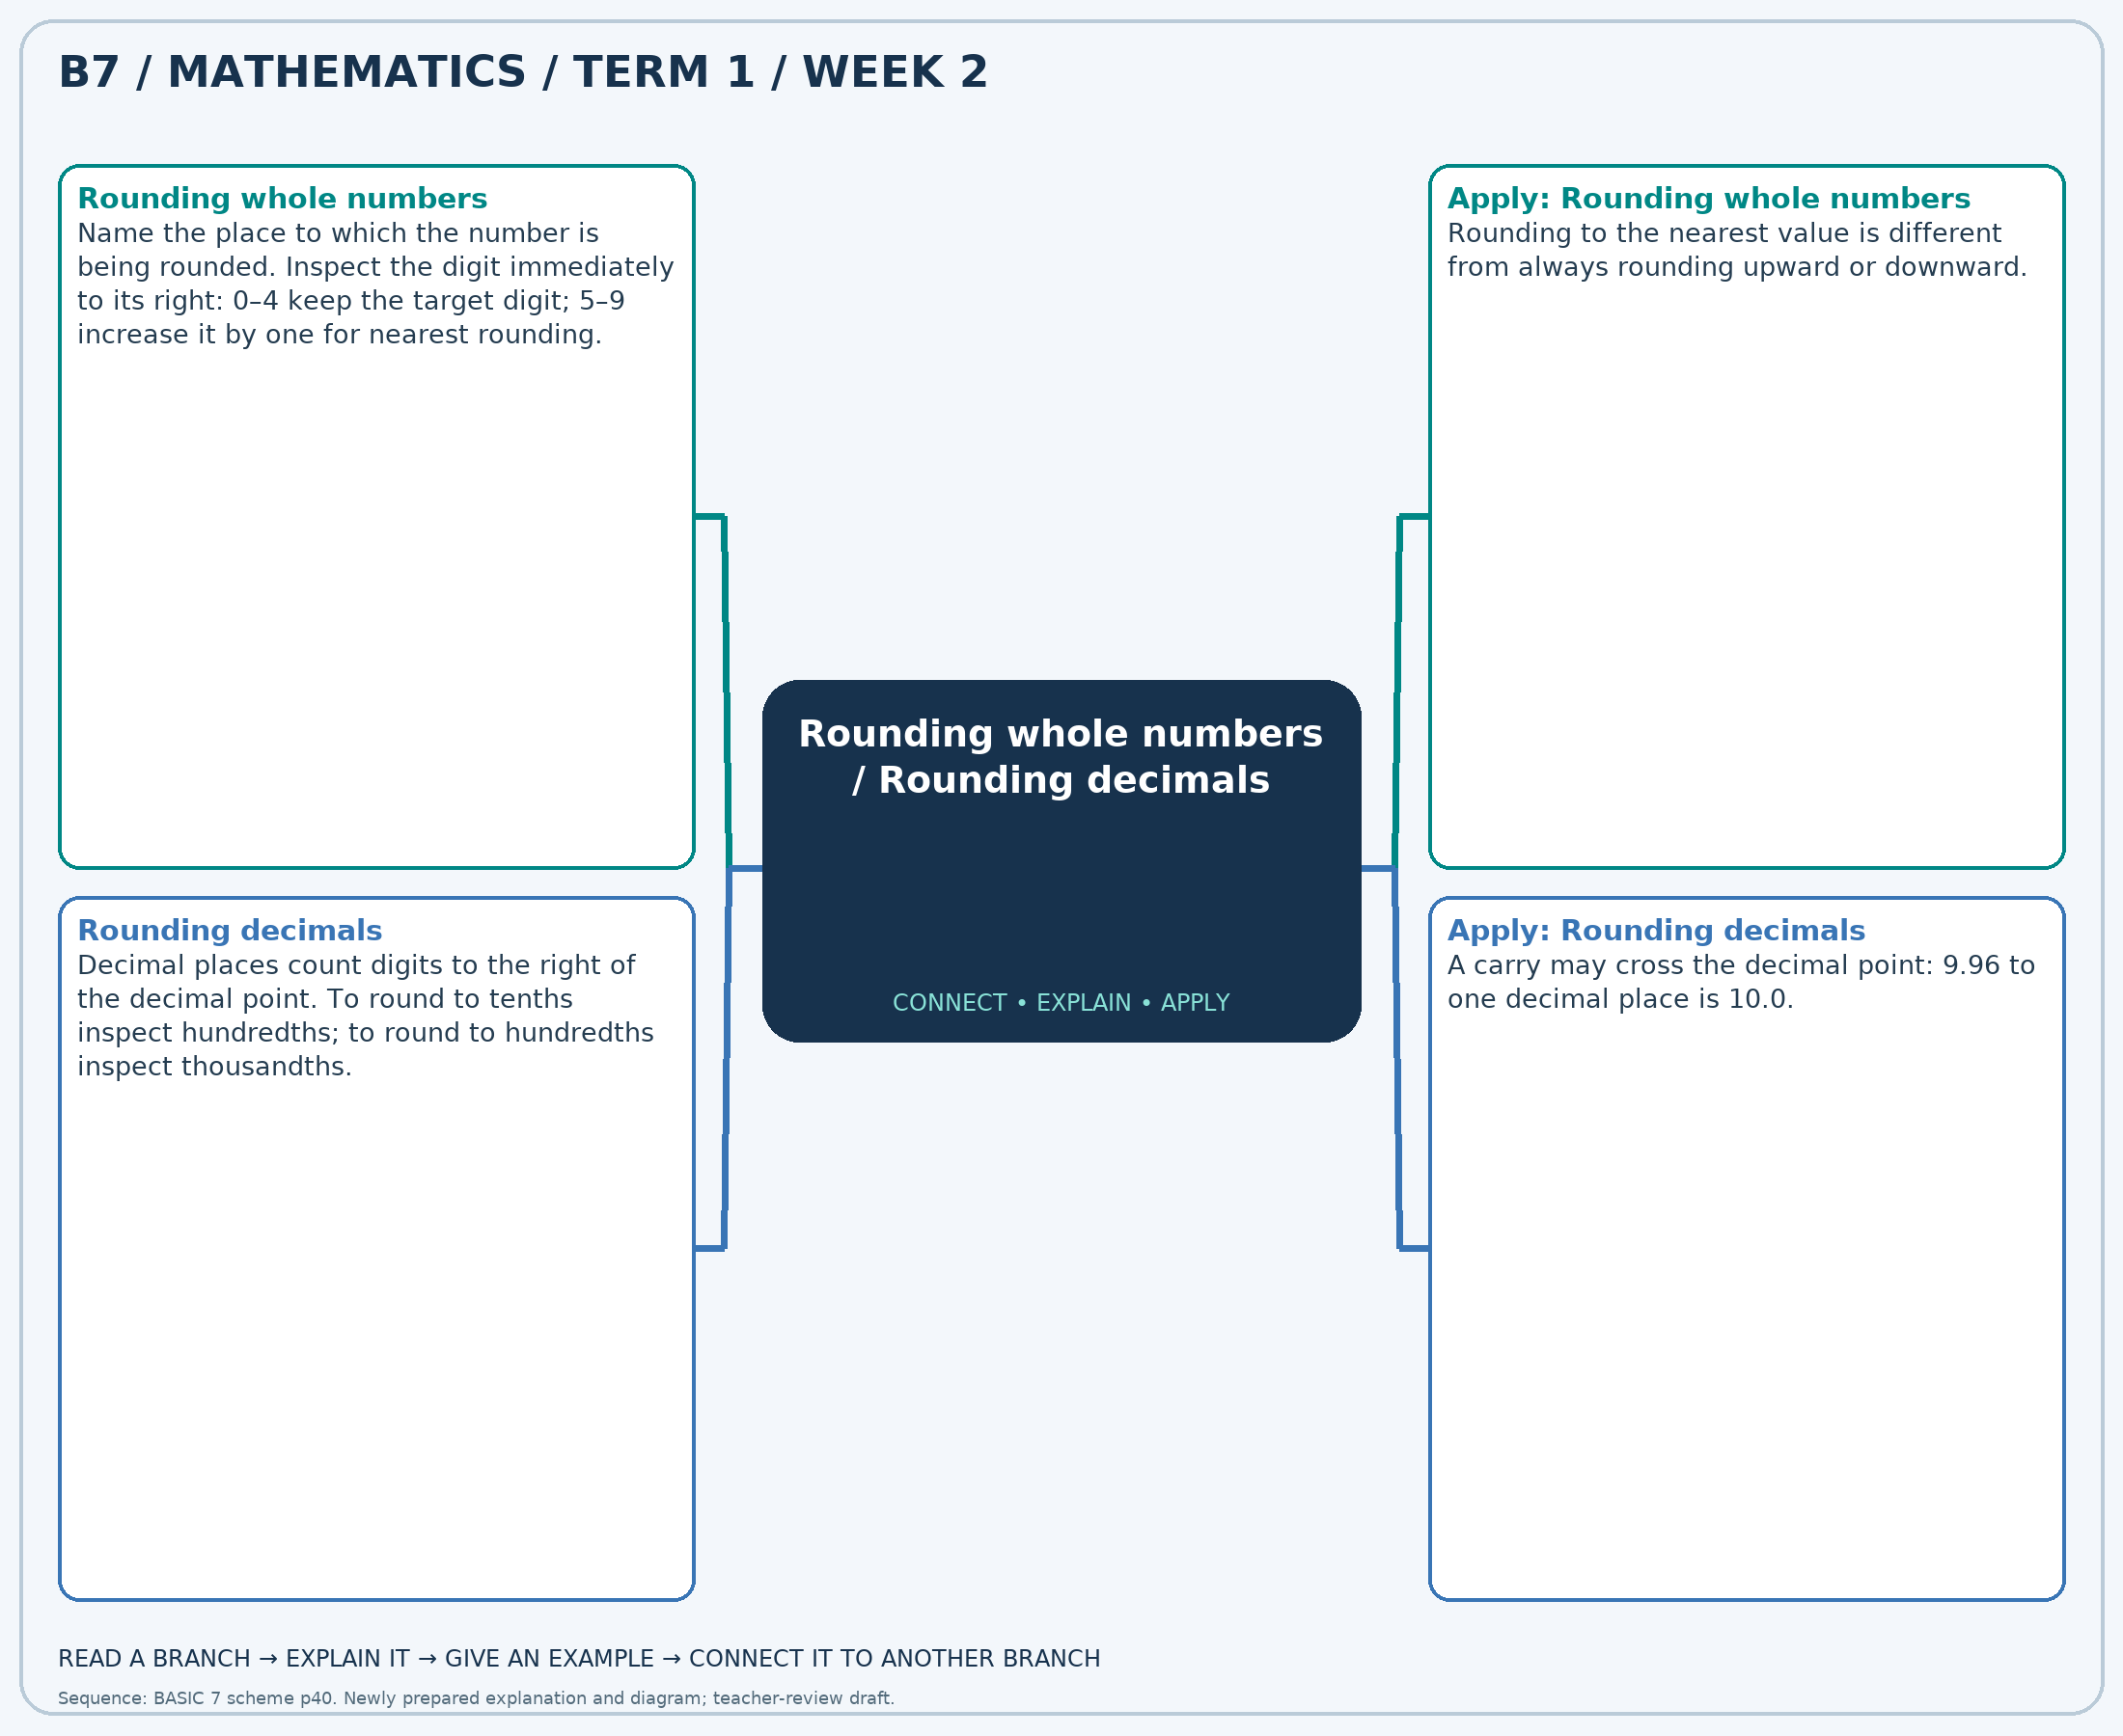
The separate high-resolution PNG can be projected or printed larger. Explain each branch and connect it with an example.

Week 2 — Practice

Section A — Multiple-choice questions
Choose ONE correct answer for each question. Each question has four alternatives.
1. Round 8,507,186,572 to the nearest 10,000.
A. 8507180000 B. 8507190000 C. 8507200000 D. 8507210000
2. Round 4.572 to 2 decimal place(s).
A. 4.56 B. 4.58 C. 4.57 D. 4.59
3. Round 4,073,085,968 to the nearest 100.
A. 4073085900 B. 4073086000 C. 4073086200 D. 4073086100
4. Round 11.149 to 2 decimal place(s).
A. 11.17 B. 11.15 C. 11.14 D. 11.16
5. Round 5,326,727,268 to the nearest 100.
A. 5326727200 B. 5326727400 C. 5326727300 D. 5326727500
6. Round 96.624 to 2 decimal place(s).
A. 96.64 B. 96.61 C. 96.63 D. 96.62
7. Round 3,332,071,634 to the nearest 1,000.
A. 3332074000 B. 3332073000 C. 3332072000 D. 3332071000
8. Round 77.208 to 2 decimal place(s).
A. 77.20 B. 77.21 C. 77.22 D. 77.23
9. Round 5,177,335,378 to the nearest 100,000.
A. 5177500000 B. 5177200000 C. 5177300000 D. 5177400000
10. Round 60.546 to 1 decimal place(s).
A. 60.7 B. 60.4 C. 60.6 D. 60.5
11. Round 4,058,313,009 to the nearest 100,000.
A. 4058400000 B. 4058300000 C. 4058500000 D. 4058200000
12. Round 19.919 to 2 decimal place(s).
A. 19.94 B. 19.91 C. 19.93 D. 19.92
13. Round 5,017,124,090 to the nearest 100.
A. 5017124200 B. 5017124100 C. 5017124000 D. 5017124300
14. Round 85.677 to 2 decimal place(s).
A. 85.68 B. 85.70 C. 85.67 D. 85.69
15. Round 5,840,785,772 to the nearest 100,000.
A. 5840700000 B. 5840900000 C. 5840800000 D. 5841000000
16. Round 35.66 to 2 decimal place(s).
A. 35.67 B. 35.68 C. 35.66 D. 35.65
17. Round 3,745,369,708 to the nearest 10,000.
A. 3745360000 B. 3745370000 C. 3745380000 D. 3745390000
18. Round 34.994 to 2 decimal place(s).
A. 35.00 B. 34.99 C. 35.01 D. 34.98
19. Round 6,039,731,003 to the nearest 1,000.
A. 6039733000 B. 6039730000 C. 6039731000 D. 6039732000
20. Round 49.892 to 1 decimal place(s).
A. 50.1 B. 49.8 C. 50.0 D. 49.9

Section B — Structured essay questions
Answer every part (a), (b), (c). Show your method or explain your choice. Write in a separate answer booklet. Each part: 1 mark for valid working/explanation and 1 for the correct result; 6 marks per question.

1. Apply the related skills and show working or give a reason for each answer.
(a) Round 5,164,785,952 to the nearest 100,000.
(b) Round 46.908 to 2 decimal place(s).
(c) Round 5,476,461,853 to the nearest 1,000.

2. Apply the related skills and show working or give a reason for each answer.
(a) Round 43.008 to 2 decimal place(s).
(b) Round 7,847,219,513 to the nearest 100,000.
(c) Round 60.406 to 1 decimal place(s).

3. Apply the related skills and show working or give a reason for each answer.
(a) Round 3,379,867,711 to the nearest 100,000.
(b) Round 80.074 to 2 decimal place(s).
(c) Round 4,591,749,623 to the nearest 10,000.

4. Apply the related skills and show working or give a reason for each answer.
(a) Round 74.559 to 1 decimal place(s).
(b) Round 6,082,842,216 to the nearest 10,000.
(c) Round 25.103 to 2 decimal place(s).

5. Apply the related skills and show working or give a reason for each answer.
(a) Round 3,733,881,569 to the nearest 100.
(b) Round 66.041 to 1 decimal place(s).
(c) Round 973,703,746 to the nearest 100.

6. Apply the related skills and show working or give a reason for each answer.
(a) Round 90.786 to 2 decimal place(s).
(b) Round 4,296,346,874 to the nearest 1,000.
(c) Round 98.393 to 2 decimal place(s).

7. Apply the related skills and show working or give a reason for each answer.
(a) Round 1,667,876,713 to the nearest 10,000.
(b) Round 10.709 to 1 decimal place(s).
(c) Round 6,644,912,428 to the nearest 1,000.

8. Apply the related skills and show working or give a reason for each answer.
(a) Round 57.748 to 1 decimal place(s).
(b) Round 3,930,118,995 to the nearest 100,000.
(c) Round 14.838 to 1 decimal place(s).

9. Apply the related skills and show working or give a reason for each answer.
(a) Round 8,441,301,993 to the nearest 10,000.
(b) Round 44.672 to 1 decimal place(s).
(c) Round 5,577,670,286 to the nearest 100.

10. Apply the related skills and show working or give a reason for each answer.
(a) Round 61.565 to 1 decimal place(s).
(b) Round 5,883,580,980 to the nearest 100,000.
(c) Round 40.912 to 1 decimal place(s).

Week 3 — Significant figures / Multiplying and dividing by powers of ten
Sequence source: BASIC 7 SCHEME OF LEARNING.pdf, first-term Mathematics, page 40. One consolidated weekly unit.

Learning outcomes
- Explain and apply significant figures, solve examples and justify the method.
- Explain and apply multiplying and dividing by powers of ten, solve examples and justify the method.

Teaching notes and suggested sessions
Suggested schedule: five 40-minute sessions, adjusted to the school timetable. Spread the question bank through the week; it is not intended to be completed in one lesson.

1 — Explore and diagnose
5 minutes: recall an earlier skill; 10: demonstrate a concrete or pictorial model; 15: pairs investigate and explain; 10: identify a misconception and set an exit task.

2 — Model and practise
5 minutes: review the exit task; 10: work an example aloud; 15: pairs solve parallel examples; 10: compare methods and correct errors.

3 — Connect representations
5 minutes: recall vocabulary; 10: explain the mind-map; 15: connect a model, a drawing and a symbolic calculation; 10: independent practice.

4 — Apply and explain
5 minutes: estimate or predict; 10: solve a contextual example; 15: attempt selected structured-question parts; 10: compare reasoning and check units.

5 — Check and respond
5 minutes: retrieve the main rule; 15: use selected MCQs diagnostically; 10: explain distractors and misconceptions; 10: reteach or extend in response to evidence.

Topic-specific activities
- Highlight the first significant digit, then count and mark the rounding place.
- Move digit cards on a chart including tenths, hundredths and thousandths.
Resources: board, pencils, number cards, counters, paper strips and squared paper as appropriate. Prior-knowledge check: ask a learner to explain a representation used in the first example before introducing a new rule.
Support: reduce number size without changing the concept; offer a partially completed chart or model; allow oral reasoning before writing. Extension: create a counterexample to a false rule and explain why it fails.

Study notes and worked examples

Significant figures
- Significant figures start with the first non-zero digit.
- Leading zeros do not count; zeros between significant digits do count.
- Keep the requested number of significant digits and use the next digit to round.
- 0.00476 to two significant figures is 0.0048; 47,600 to two significant figures is 48,000.
Worked example: Round 8,988 to 1 significant figure(s).
Solution: Count 1 places from the first non-zero digit, then round using the next digit: 9,000.
Common misconception: Significant figures and decimal places are different measures of precision.

Multiplying and dividing by powers of ten
- Multiplying by 10, 100 or 1,000 increases each digit’s place value by that factor.
- Dividing reverses the place-value shift.
- 4.26×100=426, while 4.26÷100=0.0426.
- Use a place-value chart; appending zeros to a decimal is not a general multiplication rule.
Worked example: Calculate 7.96 ÷ 1000.
Solution: Change each digit’s place value by the factor 1000: 0.00796.
Common misconception: 4.260 has the same value as 4.26; it is not ten times as large.
Independent study: read the map, cover it and reconstruct the branches. Solve an unused question from each skill and explain the reasoning to a partner. Consult the teacher key only after an honest attempt.

Week 3 — Visual mind-map
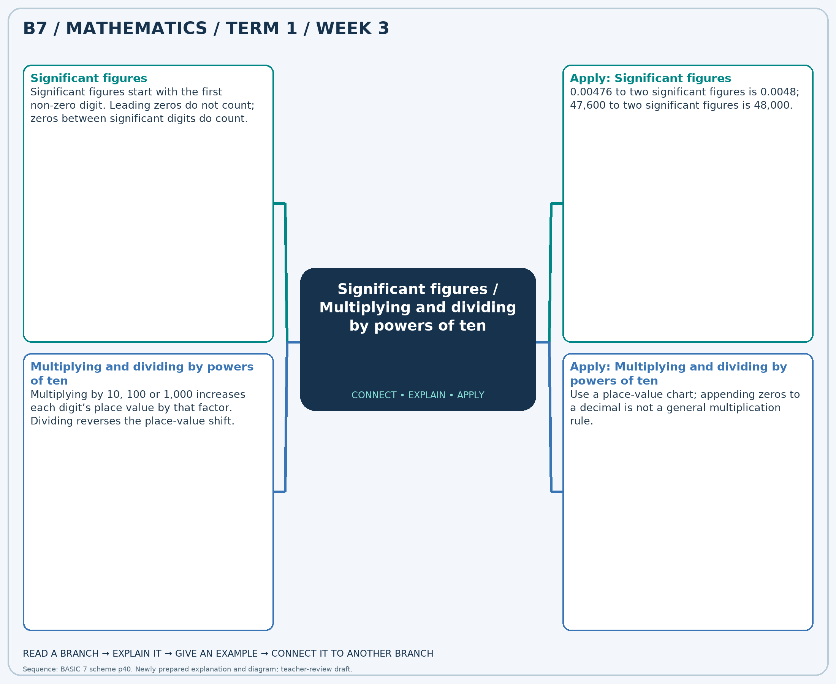
The separate high-resolution PNG can be projected or printed larger. Explain each branch and connect it with an example.

Week 3 — Practice

Section A — Multiple-choice questions
Choose ONE correct answer for each question. Each question has four alternatives.
1. Round 1,931 to 2 significant figure(s).
A. 2100 B. 2000 C. 1800 D. 1900
2. Calculate 4.15 × 1000.
A. 4152 B. 4151 C. 4150 D. 4149
3. Round 6,472 to 2 significant figure(s).
A. 6600 B. 6500 C. 6400 D. 6700
4. Calculate 4.81 ÷ 100.
A. 1.0481 B. 0.0481 C. 2.0481 D. -0.9519
5. Round 8,734 to 3 significant figure(s).
A. 8750 B. 8720 C. 8730 D. 8740
6. Calculate 2.01 × 1000.
A. 2010 B. 2012 C. 2009 D. 2011
7. Round 3,108 to 3 significant figure(s).
A. 3100 B. 3130 C. 3120 D. 3110
8. Calculate 9.05 × 10.
A. 91.5 B. 90.5 C. 89.5 D. 92.5
9. Round 1,668 to 3 significant figure(s).
A. 1690 B. 1680 C. 1660 D. 1670
10. Calculate 2.99 ÷ 10.
A. 1.299 B. -0.701 C. 2.299 D. 0.299
11. Round 7,492 to 3 significant figure(s).
A. 7500 B. 7480 C. 7490 D. 7510
12. Calculate 1.35 × 100.
A. 134 B. 137 C. 135 D. 136
13. Round 9,059 to 1 significant figure(s).
A. 8000 B. 11000 C. 9000 D. 10000
14. Calculate 5.04 × 1000.
A. 5041 B. 5040 C. 5042 D. 5039
15. Round 2,381 to 2 significant figure(s).
A. 2300 B. 2600 C. 2500 D. 2400
16. Calculate 8.9 ÷ 10.
A. 1.89 B. 0.89 C. -0.11 D. 2.89
17. Round 4,625 to 1 significant figure(s).
A. 4000 B. 7000 C. 5000 D. 6000
18. Calculate 3.72 × 100.
A. 373 B. 374 C. 372 D. 371
19. Round 8,251 to 3 significant figure(s).
A. 8270 B. 8260 C. 8240 D. 8250
20. Calculate 6.46 × 1000.
A. 6462 B. 6459 C. 6461 D. 6460

Section B — Structured essay questions
Answer every part (a), (b), (c). Show your method or explain your choice. Write in a separate answer booklet. Each part: 1 mark for valid working/explanation and 1 for the correct result; 6 marks per question.

1. Apply the related skills and show working or give a reason for each answer.
(a) Round 3,230 to 1 significant figure(s).
(b) Calculate 4.29 ÷ 10.
(c) Round 3,703 to 3 significant figure(s).

2. Apply the related skills and show working or give a reason for each answer.
(a) Calculate 8.16 ÷ 100.
(b) Round 9,102 to 3 significant figure(s).
(c) Calculate 9.15 × 100.

3. Apply the related skills and show working or give a reason for each answer.
(a) Round 8,853 to 2 significant figure(s).
(b) Calculate 4.8 × 10.
(c) Round 9,548 to 3 significant figure(s).

4. Apply the related skills and show working or give a reason for each answer.
(a) Calculate 6.21 × 1000.
(b) Round 6,829 to 1 significant figure(s).
(c) Calculate 1.55 × 10.

5. Apply the related skills and show working or give a reason for each answer.
(a) Round 5,802 to 3 significant figure(s).
(b) Calculate 6.66 × 1000.
(c) Round 2,590 to 2 significant figure(s).

6. Apply the related skills and show working or give a reason for each answer.
(a) Calculate 4.49 × 10.
(b) Round 1,295 to 1 significant figure(s).
(c) Calculate 4.38 ÷ 10.

7. Apply the related skills and show working or give a reason for each answer.
(a) Round 3,438 to 2 significant figure(s).
(b) Calculate 3.15 ÷ 1000.
(c) Round 8,263 to 2 significant figure(s).

8. Apply the related skills and show working or give a reason for each answer.
(a) Calculate 3.5 ÷ 1000.
(b) Round 4,159 to 1 significant figure(s).
(c) Calculate 5.5 × 10.

9. Apply the related skills and show working or give a reason for each answer.
(a) Round 5,741 to 2 significant figure(s).
(b) Calculate 9.1 × 100.
(c) Round 1,078 to 1 significant figure(s).

10. Apply the related skills and show working or give a reason for each answer.
(a) Calculate 2.51 × 100.
(b) Round 3,179 to 2 significant figure(s).
(c) Calculate 9.15 × 100.

Week 4 — Multiplication strategies / Multi-step number problems
Sequence source: BASIC 7 SCHEME OF LEARNING.pdf, first-term Mathematics, page 40. One consolidated weekly unit.

Learning outcomes
- Explain and apply multiplication strategies, solve examples and justify the method.
- Explain and apply multi-step number problems, solve examples and justify the method.

Teaching notes and suggested sessions
Suggested schedule: five 40-minute sessions, adjusted to the school timetable. Spread the question bank through the week; it is not intended to be completed in one lesson.

1 — Explore and diagnose
5 minutes: recall an earlier skill; 10: demonstrate a concrete or pictorial model; 15: pairs investigate and explain; 10: identify a misconception and set an exit task.

2 — Model and practise
5 minutes: review the exit task; 10: work an example aloud; 15: pairs solve parallel examples; 10: compare methods and correct errors.

3 — Connect representations
5 minutes: recall vocabulary; 10: explain the mind-map; 15: connect a model, a drawing and a symbolic calculation; 10: independent practice.

4 — Apply and explain
5 minutes: estimate or predict; 10: solve a contextual example; 15: attempt selected structured-question parts; 10: compare reasoning and check units.

5 — Check and respond
5 minutes: retrieve the main rule; 15: use selected MCQs diagnostically; 10: explain distractors and misconceptions; 10: reteach or extend in response to evidence.

Topic-specific activities
- Draw a partitioned rectangle and connect its smaller areas to the partial products.
- Use a shop-stock or shopping story. Draw a bar model and compare two solution methods.
Resources: board, pencils, number cards, counters, paper strips and squared paper as appropriate. Prior-knowledge check: ask a learner to explain a representation used in the first example before introducing a new rule.
Support: reduce number size without changing the concept; offer a partially completed chart or model; allow oral reasoning before writing. Extension: create a counterexample to a false rule and explain why it fails.

Study notes and worked examples

Multiplication strategies
- Partition a factor and use the distributive property: 24×6=(20×6)+(4×6)=144.
- Doubling one factor and halving an even other factor preserves the product.
- In multi-digit multiplication, include every partial product and align place values.
- Estimate first, calculate carefully and compare the product with the estimate.
Worked example: Calculate 390 × 25.
Solution: 390×(20+5) = 7800+1950 = 9750.
Common misconception: The tens digit contributes tens, not units: the 2 in 23×14 represents 20×14.

Multi-step number problems
- Identify the quantities, units and the final question before calculating.
- Use a diagram or a written plan to select the operations from the relationships.
- Label intermediate answers, then complete the remaining steps.
- Estimate and interpret the answer in the original situation.
Worked example: A shop has 3 packs of 4 pencils and sells 7 pencils. How many pencils remain?
Solution: Start with 3×4=12; subtract 7 to obtain 5 pencils.
Common misconception: A correct intermediate calculation may not answer the final question.
Independent study: read the map, cover it and reconstruct the branches. Solve an unused question from each skill and explain the reasoning to a partner. Consult the teacher key only after an honest attempt.

Week 4 — Visual mind-map
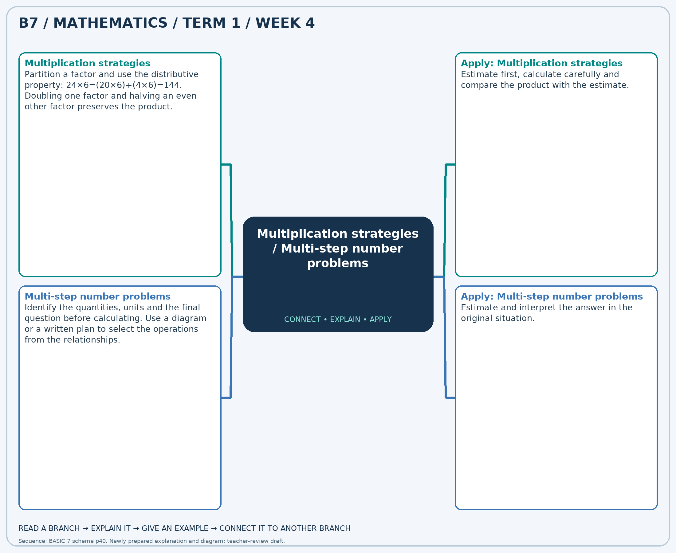
The separate high-resolution PNG can be projected or printed larger. Explain each branch and connect it with an example.

Week 4 — Practice

Section A — Multiple-choice questions
Choose ONE correct answer for each question. Each question has four alternatives.
1. Calculate 371 × 25.
A. 396 B. 8904 C. 9646 D. 9275
2. A shop has 5 packs of 8 pencils and sells 36 pencils. How many pencils remain?
A. 49 B. 76 C. 4 D. 12
3. Calculate 112 × 24.
A. 2576 B. 2800 C. 2688 D. 136
4. A shop has 3 packs of 8 pencils and sells 2 pencils. How many pencils remain?
A. 13 B. 30 C. 22 D. 26
5. Calculate 349 × 27.
A. 9074 B. 376 C. 9772 D. 9423
6. A shop has 9 packs of 5 pencils and sells 12 pencils. How many pencils remain?
A. 26 B. 57 C. 33 D. 38
7. Calculate 427 × 25.
A. 452 B. 11102 C. 10675 D. 10248
8. A shop has 3 packs of 8 pencils and sells 21 pencils. How many pencils remain?
A. 11 B. 45 C. 3 D. 32
9. Calculate 233 × 29.
A. 6524 B. 6757 C. 6990 D. 262
10. A shop has 9 packs of 12 pencils and sells 30 pencils. How many pencils remain?
A. 138 B. 51 C. 90 D. 78
11. Calculate 276 × 20.
A. 5796 B. 5244 C. 5520 D. 296
12. A shop has 7 packs of 12 pencils and sells 58 pencils. How many pencils remain?
A. 142 B. 38 C. 77 D. 26
13. Calculate 142 × 23.
A. 165 B. 3408 C. 3266 D. 3124
14. A shop has 4 packs of 9 pencils and sells 31 pencils. How many pencils remain?
A. 14 B. 5 C. 44 D. 67
15. Calculate 103 × 27.
A. 2884 B. 2678 C. 2781 D. 130
16. A shop has 8 packs of 6 pencils and sells 19 pencils. How many pencils remain?
A. 67 B. 33 C. 29 D. 35
17. Calculate 135 × 15.
A. 1890 B. 150 C. 2160 D. 2025
18. A shop has 7 packs of 7 pencils and sells 40 pencils. How many pencils remain?
A. 54 B. 9 C. 16 D. 89
19. Calculate 301 × 27.
A. 7826 B. 8127 C. 328 D. 8428
20. A shop has 3 packs of 4 pencils and sells 7 pencils. How many pencils remain?
A. 9 B. 19 C. 14 D. 5

Section B — Structured essay questions
Answer every part (a), (b), (c). Show your method or explain your choice. Write in a separate answer booklet. Each part: 1 mark for valid working/explanation and 1 for the correct result; 6 marks per question.

1. Apply the related skills and show working or give a reason for each answer.
(a) Calculate 384 × 35.
(b) A shop has 4 packs of 10 pencils and sells 20 pencils. How many pencils remain?
(c) Calculate 223 × 33.

2. Apply the related skills and show working or give a reason for each answer.
(a) A shop has 7 packs of 5 pencils and sells 32 pencils. How many pencils remain?
(b) Calculate 355 × 27.
(c) A shop has 9 packs of 6 pencils and sells 52 pencils. How many pencils remain?

3. Apply the related skills and show working or give a reason for each answer.
(a) Calculate 178 × 36.
(b) A shop has 5 packs of 11 pencils and sells 25 pencils. How many pencils remain?
(c) Calculate 358 × 18.

4. Apply the related skills and show working or give a reason for each answer.
(a) A shop has 9 packs of 11 pencils and sells 40 pencils. How many pencils remain?
(b) Calculate 142 × 20.
(c) A shop has 7 packs of 11 pencils and sells 70 pencils. How many pencils remain?

5. Apply the related skills and show working or give a reason for each answer.
(a) Calculate 127 × 21.
(b) A shop has 9 packs of 10 pencils and sells 55 pencils. How many pencils remain?
(c) Calculate 313 × 20.

6. Apply the related skills and show working or give a reason for each answer.
(a) A shop has 5 packs of 7 pencils and sells 18 pencils. How many pencils remain?
(b) Calculate 484 × 14.
(c) A shop has 8 packs of 4 pencils and sells 16 pencils. How many pencils remain?

7. Apply the related skills and show working or give a reason for each answer.
(a) Calculate 177 × 12.
(b) A shop has 6 packs of 11 pencils and sells 43 pencils. How many pencils remain?
(c) Calculate 337 × 18.

8. Apply the related skills and show working or give a reason for each answer.
(a) A shop has 7 packs of 5 pencils and sells 6 pencils. How many pencils remain?
(b) Calculate 454 × 29.
(c) A shop has 5 packs of 8 pencils and sells 24 pencils. How many pencils remain?

9. Apply the related skills and show working or give a reason for each answer.
(a) Calculate 336 × 34.
(b) A shop has 9 packs of 4 pencils and sells 10 pencils. How many pencils remain?
(c) Calculate 145 × 13.

10. Apply the related skills and show working or give a reason for each answer.
(a) A shop has 4 packs of 11 pencils and sells 14 pencils. How many pencils remain?
(b) Calculate 236 × 31.
(c) A shop has 7 packs of 10 pencils and sells 17 pencils. How many pencils remain?

Week 5 — Whole-number and decimal operations / Multiplication strategies / Division and checking
Sequence source: BASIC 7 SCHEME OF LEARNING.pdf, first-term Mathematics, page 40. One consolidated weekly unit.

Learning outcomes
- Explain and apply whole-number and decimal operations, solve examples and justify the method.
- Explain and apply multiplication strategies, solve examples and justify the method.
- Explain and apply division and checking, solve examples and justify the method.

Teaching notes and suggested sessions
Suggested schedule: five 40-minute sessions, adjusted to the school timetable. Spread the question bank through the week; it is not intended to be completed in one lesson.

1 — Explore and diagnose
5 minutes: recall an earlier skill; 10: demonstrate a concrete or pictorial model; 15: pairs investigate and explain; 10: identify a misconception and set an exit task.

2 — Model and practise
5 minutes: review the exit task; 10: work an example aloud; 15: pairs solve parallel examples; 10: compare methods and correct errors.

3 — Connect representations
5 minutes: recall vocabulary; 10: explain the mind-map; 15: connect a model, a drawing and a symbolic calculation; 10: independent practice.

4 — Apply and explain
5 minutes: estimate or predict; 10: solve a contextual example; 15: attempt selected structured-question parts; 10: compare reasoning and check units.

5 — Check and respond
5 minutes: retrieve the main rule; 15: use selected MCQs diagnostically; 10: explain distractors and misconceptions; 10: reteach or extend in response to evidence.

Topic-specific activities
- Calculate receipts and totals from a price list, comparing exact answers with estimates.
- Draw a partitioned rectangle and connect its smaller areas to the partial products.
- Share counters into equal groups and check the result by multiplication.
Resources: board, pencils, number cards, counters, paper strips and squared paper as appropriate. Prior-knowledge check: ask a learner to explain a representation used in the first example before introducing a new rule.
Support: reduce number size without changing the concept; offer a partially completed chart or model; allow oral reasoning before writing. Extension: create a counterexample to a false rule and explain why it fails.

Study notes and worked examples

Whole-number and decimal operations
- Align decimal points when adding or subtracting decimals.
- For multiplication, track the factors’ place values and check with an estimate.
- For division, an equivalent calculation with an integer divisor may be useful.
- State money answers with their currency; two decimal places are normally used for amounts in cedis.
Worked example: Calculate 84.34 + 98.64.
Solution: Add aligned hundredths: (8434+9864)/100=182.98.
Common misconception: Aligning final digits instead of decimal points changes the place values.

Multiplication strategies
- Partition a factor and use the distributive property: 24×6=(20×6)+(4×6)=144.
- Doubling one factor and halving an even other factor preserves the product.
- In multi-digit multiplication, include every partial product and align place values.
- Estimate first, calculate carefully and compare the product with the estimate.
Worked example: Calculate 261 × 27.
Solution: 261×(20+7) = 5220+1827 = 7047.
Common misconception: The tens digit contributes tens, not units: the 2 in 23×14 represents 20×14.

Division and checking
- Division may mean sharing equally or finding how many equal groups fit.
- Multiplication reverses division: 7×8=56 means 56÷7=8.
- Work from the greatest place and regroup when needed. Record a zero in an empty quotient place.
- Check: divisor × quotient + remainder = dividend. The remainder is smaller than the divisor.
Worked example: Calculate 408 ÷ 8.
Solution: 8×51=408, so the quotient is 51.
Common misconception: Do not leave an empty place in the quotient when a zero is needed.
Independent study: read the map, cover it and reconstruct the branches. Solve an unused question from each skill and explain the reasoning to a partner. Consult the teacher key only after an honest attempt.

Week 5 — Visual mind-map
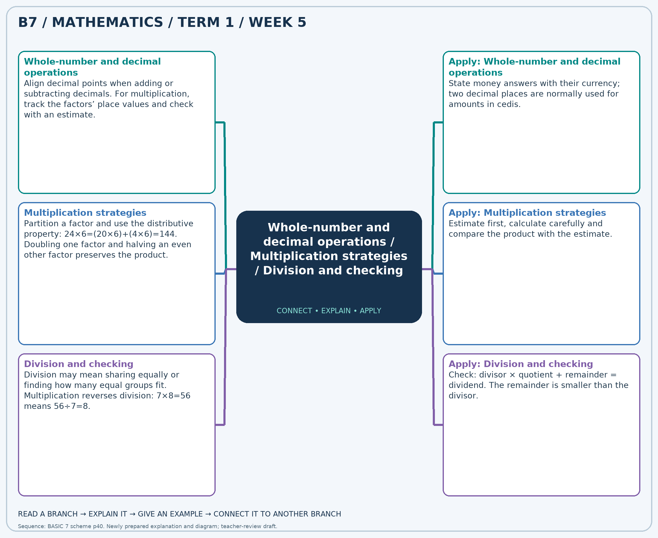
The separate high-resolution PNG can be projected or printed larger. Explain each branch and connect it with an example.

Week 5 — Practice

Section A — Multiple-choice questions
Choose ONE correct answer for each question. Each question has four alternatives.
1. Calculate 64.88 + 30.96.
A. 97.84 B. 96.84 C. 95.84 D. 94.84
2. Calculate 350 × 12.
A. 4200 B. 4550 C. 3850 D. 362
3. Calculate 154 ÷ 2.
A. 76 B. 152 C. 77 D. 78
4. Calculate 64.29 − 53.13.
A. 11.16 B. 12.16 C. 10.16 D. 13.16
5. Calculate 344 × 32.
A. 11352 B. 376 C. 10664 D. 11008
6. Calculate 234 ÷ 9.
A. 26 B. 225 C. 25 D. 27
7. 4 books cost GH₵3.02 each. Find the total cost in Ghana cedis.
A. 11.08 B. 14.08 C. 13.08 D. 12.08
8. Calculate 189 × 37.
A. 7182 B. 6993 C. 6804 D. 226
9. Calculate 536 ÷ 8.
A. 67 B. 68 C. 528 D. 66
10. Calculate 63.30 + 80.55.
A. 142.85 B. 145.85 C. 144.85 D. 143.85
11. Calculate 181 × 37.
A. 218 B. 6516 C. 6878 D. 6697
12. Calculate 164 ÷ 2.
A. 82 B. 83 C. 162 D. 81
13. Calculate 41.59 − 2.27.
A. 38.32 B. 39.32 C. 40.32 D. 41.32
14. Calculate 114 × 24.
A. 2622 B. 2850 C. 2736 D. 138
15. Calculate 658 ÷ 7.
A. 95 B. 94 C. 93 D. 651
16. 6 books cost GH₵53.41 each. Find the total cost in Ghana cedis.
A. 319.46 B. 321.46 C. 320.46 D. 322.46
17. Calculate 394 × 26.
A. 9850 B. 420 C. 10244 D. 10638
18. Calculate 693 ÷ 9.
A. 77 B. 684 C. 78 D. 76
19. Calculate 45.43 + 85.66.
A. 130.09 B. 133.09 C. 131.09 D. 132.09
20. Calculate 127 × 30.
A. 3683 B. 3810 C. 3937 D. 157

Section B — Structured essay questions
Answer every part (a), (b), (c). Show your method or explain your choice. Write in a separate answer booklet. Each part: 1 mark for valid working/explanation and 1 for the correct result; 6 marks per question.

1. Apply the related skills and show working or give a reason for each answer.
(a) Calculate 80.76 + 76.93.
(b) Calculate 431 × 14.
(c) Calculate 511 ÷ 7.

2. Apply the related skills and show working or give a reason for each answer.
(a) Calculate 125 × 38.
(b) Calculate 36 ÷ 2.
(c) Calculate 39.16 + 32.85.

3. Apply the related skills and show working or give a reason for each answer.
(a) Calculate 621 ÷ 9.
(b) Calculate 60.73 + 46.09.
(c) Calculate 348 × 30.

4. Apply the related skills and show working or give a reason for each answer.
(a) Calculate 36.84 + 78.18.
(b) Calculate 306 × 29.
(c) Calculate 350 ÷ 7.

5. Apply the related skills and show working or give a reason for each answer.
(a) Calculate 233 × 21.
(b) Calculate 93 ÷ 3.
(c) Calculate 31.95 + 87.32.

6. Apply the related skills and show working or give a reason for each answer.
(a) Calculate 738 ÷ 9.
(b) Calculate 29.67 + 90.89.
(c) Calculate 335 × 28.

7. Apply the related skills and show working or give a reason for each answer.
(a) Calculate 41.78 + 9.92.
(b) Calculate 285 × 27.
(c) Calculate 275 ÷ 5.

8. Apply the related skills and show working or give a reason for each answer.
(a) Calculate 156 × 28.
(b) Calculate 230 ÷ 5.
(c) Calculate 16.32 + 57.66.

9. Apply the related skills and show working or give a reason for each answer.
(a) Calculate 54 ÷ 2.
(b) Calculate 8.03 + 14.27.
(c) Calculate 269 × 18.

10. Apply the related skills and show working or give a reason for each answer.
(a) Calculate 93.58 + 40.88.
(b) Calculate 426 × 31.
(c) Calculate 255 ÷ 5.

Week 6 — Whole-number and decimal operations / Powers and repeated factors
Sequence source: BASIC 7 SCHEME OF LEARNING.pdf, first-term Mathematics, page 40. One consolidated weekly unit.

Learning outcomes
- Explain and apply whole-number and decimal operations, solve examples and justify the method.
- Explain and apply powers and repeated factors, solve examples and justify the method.

Teaching notes and suggested sessions
Suggested schedule: five 40-minute sessions, adjusted to the school timetable. Spread the question bank through the week; it is not intended to be completed in one lesson.

1 — Explore and diagnose
5 minutes: recall an earlier skill; 10: demonstrate a concrete or pictorial model; 15: pairs investigate and explain; 10: identify a misconception and set an exit task.

2 — Model and practise
5 minutes: review the exit task; 10: work an example aloud; 15: pairs solve parallel examples; 10: compare methods and correct errors.

3 — Connect representations
5 minutes: recall vocabulary; 10: explain the mind-map; 15: connect a model, a drawing and a symbolic calculation; 10: independent practice.

4 — Apply and explain
5 minutes: estimate or predict; 10: solve a contextual example; 15: attempt selected structured-question parts; 10: compare reasoning and check units.

5 — Check and respond
5 minutes: retrieve the main rule; 15: use selected MCQs diagnostically; 10: explain distractors and misconceptions; 10: reteach or extend in response to evidence.

Topic-specific activities
- Calculate receipts and totals from a price list, comparing exact answers with estimates.
- Build square arrays or repeated-factor diagrams and write matching index notation.
Resources: board, pencils, number cards, counters, paper strips and squared paper as appropriate. Prior-knowledge check: ask a learner to explain a representation used in the first example before introducing a new rule.
Support: reduce number size without changing the concept; offer a partially completed chart or model; allow oral reasoning before writing. Extension: create a counterexample to a false rule and explain why it fails.

Study notes and worked examples

Whole-number and decimal operations
- Align decimal points when adding or subtracting decimals.
- For multiplication, track the factors’ place values and check with an estimate.
- For division, an equivalent calculation with an integer divisor may be useful.
- State money answers with their currency; two decimal places are normally used for amounts in cedis.
Worked example: Calculate 55.84 + 56.49.
Solution: Add aligned hundredths: (5584+5649)/100=112.33.
Common misconception: Aligning final digits instead of decimal points changes the place values.

Powers and repeated factors
- A power writes repeated multiplication: 3^4=3×3×3×3=81.
- The base is the repeated factor; the exponent counts occurrences.
- For a non-zero base, power zero equals 1.
- A power is not multiplication by its exponent: 3^4 is not 3×4.
Worked example: Evaluate 6^0.
Solution: A non-zero base to power zero equals 1.
Common misconception: The zero-exponent rule here requires a non-zero base; do not apply it to 0^0.
Independent study: read the map, cover it and reconstruct the branches. Solve an unused question from each skill and explain the reasoning to a partner. Consult the teacher key only after an honest attempt.

Week 6 — Visual mind-map
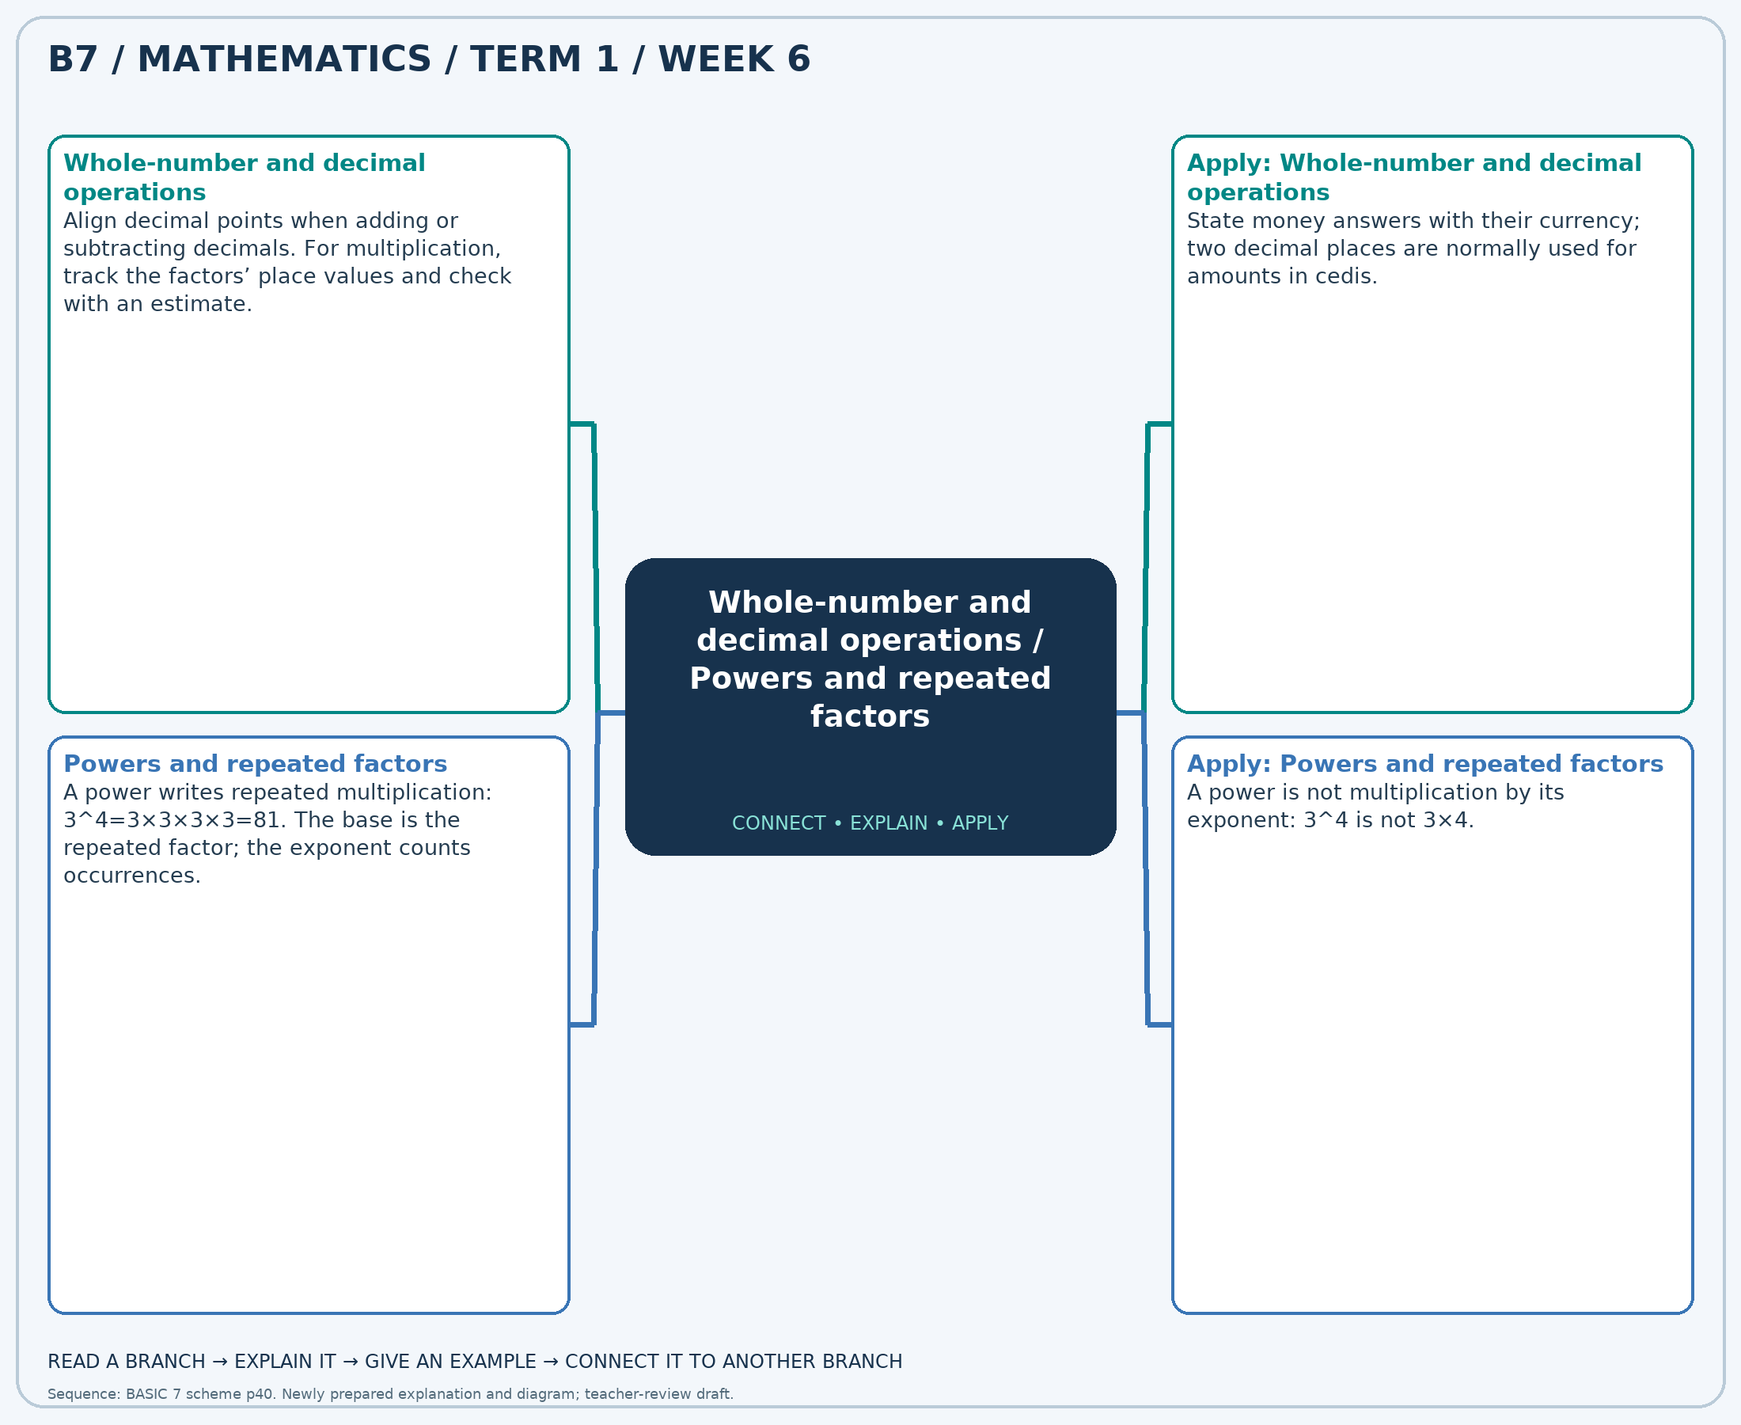
The separate high-resolution PNG can be projected or printed larger. Explain each branch and connect it with an example.

Week 6 — Practice

Section A — Multiple-choice questions
Choose ONE correct answer for each question. Each question has four alternatives.
1. Calculate 13.41 + 65.87.
A. 80.28 B. 81.28 C. 79.28 D. 78.28
2. Evaluate 7^3.
A. 344 B. 343 C. 342 D. 345
3. Calculate 96.47 − 60.19.
A. 35.28 B. 38.28 C. 36.28 D. 37.28
4. Evaluate 3^0.
A. 0 B. 1 C. 3 D. 2
5. 3 books cost GH₵44.92 each. Find the total cost in Ghana cedis.
A. 135.76 B. 136.76 C. 134.76 D. 133.76
6. Evaluate 3^2.
A. 9 B. 10 C. 11 D. 8
7. Calculate 34.14 + 86.28.
A. 122.42 B. 119.42 C. 121.42 D. 120.42
8. Evaluate 4^2.
A. 17 B. 15 C. 16 D. 18
9. Calculate 35.61 − 14.80.
A. 22.81 B. 20.81 C. 19.81 D. 21.81
10. Evaluate 5^0.
A. 3 B. 1 C. 2 D. 0
11. 8 books cost GH₵63.93 each. Find the total cost in Ghana cedis.
A. 511.44 B. 512.44 C. 513.44 D. 510.44
12. Evaluate 2^3.
A. 8 B. 10 C. 9 D. 7
13. Calculate 17.99 + 39.52.
A. 56.51 B. 59.51 C. 57.51 D. 58.51
14. Evaluate 7^2.
A. 49 B. 50 C. 51 D. 48
15. Calculate 69.69 − 6.43.
A. 63.26 B. 65.26 C. 64.26 D. 62.26
16. Evaluate 7^0.
A. 3 B. 0 C. 2 D. 1
17. 7 books cost GH₵12.94 each. Find the total cost in Ghana cedis.
A. 90.58 B. 92.58 C. 89.58 D. 91.58
18. Evaluate 2^4.
A. 15 B. 16 C. 18 D. 17
19. Calculate 83.83 + 84.46.
A. 167.29 B. 168.29 C. 169.29 D. 170.29
20. Evaluate 6^0.
A. 2 B. 0 C. 3 D. 1

Section B — Structured essay questions
Answer every part (a), (b), (c). Show your method or explain your choice. Write in a separate answer booklet. Each part: 1 mark for valid working/explanation and 1 for the correct result; 6 marks per question.

1. Apply the related skills and show working or give a reason for each answer.
(a) Calculate 48.43 + 60.06.
(b) Evaluate 7^0.
(c) 7 books cost GH₵33.34 each. Find the total cost in Ghana cedis.

2. Apply the related skills and show working or give a reason for each answer.
(a) Evaluate 7^0.
(b) 2 books cost GH₵9.68 each. Find the total cost in Ghana cedis.
(c) Evaluate 4^2.

3. Apply the related skills and show working or give a reason for each answer.
(a) 4 books cost GH₵55.34 each. Find the total cost in Ghana cedis.
(b) Evaluate 2^4.
(c) Calculate 99.39 − 78.85.

4. Apply the related skills and show working or give a reason for each answer.
(a) Evaluate 3^2.
(b) Calculate 64.35 − 63.26.
(c) Evaluate 2^4.

5. Apply the related skills and show working or give a reason for each answer.
(a) Calculate 71.36 − 1.39.
(b) Evaluate 7^2.
(c) Calculate 63.49 + 78.06.

6. Apply the related skills and show working or give a reason for each answer.
(a) Evaluate 5^3.
(b) Calculate 92.95 + 39.45.
(c) Evaluate 2^0.

7. Apply the related skills and show working or give a reason for each answer.
(a) Calculate 56.74 + 17.25.
(b) Evaluate 4^0.
(c) 2 books cost GH₵39.97 each. Find the total cost in Ghana cedis.

8. Apply the related skills and show working or give a reason for each answer.
(a) Evaluate 5^0.
(b) 4 books cost GH₵19.58 each. Find the total cost in Ghana cedis.
(c) Evaluate 2^3.

9. Apply the related skills and show working or give a reason for each answer.
(a) 3 books cost GH₵93.16 each. Find the total cost in Ghana cedis.
(b) Evaluate 4^2.
(c) Calculate 41.37 − 3.95.

10. Apply the related skills and show working or give a reason for each answer.
(a) Evaluate 6^2.
(b) Calculate 97.33 − 27.30.
(c) Evaluate 4^4.

Week 7 — Powers and repeated factors / Prime factorisation and HCF
Sequence source: BASIC 7 SCHEME OF LEARNING.pdf, first-term Mathematics, page 40. One consolidated weekly unit.

Learning outcomes
- Explain and apply powers and repeated factors, solve examples and justify the method.
- Explain and apply prime factorisation and hcf, solve examples and justify the method.

Teaching notes and suggested sessions
Suggested schedule: five 40-minute sessions, adjusted to the school timetable. Spread the question bank through the week; it is not intended to be completed in one lesson.

1 — Explore and diagnose
5 minutes: recall an earlier skill; 10: demonstrate a concrete or pictorial model; 15: pairs investigate and explain; 10: identify a misconception and set an exit task.

2 — Model and practise
5 minutes: review the exit task; 10: work an example aloud; 15: pairs solve parallel examples; 10: compare methods and correct errors.

3 — Connect representations
5 minutes: recall vocabulary; 10: explain the mind-map; 15: connect a model, a drawing and a symbolic calculation; 10: independent practice.

4 — Apply and explain
5 minutes: estimate or predict; 10: solve a contextual example; 15: attempt selected structured-question parts; 10: compare reasoning and check units.

5 — Check and respond
5 minutes: retrieve the main rule; 15: use selected MCQs diagnostically; 10: explain distractors and misconceptions; 10: reteach or extend in response to evidence.

Topic-specific activities
- Build square arrays or repeated-factor diagrams and write matching index notation.
- Draw factor trees for two numbers and circle their shared prime factors.
Resources: board, pencils, number cards, counters, paper strips and squared paper as appropriate. Prior-knowledge check: ask a learner to explain a representation used in the first example before introducing a new rule.
Support: reduce number size without changing the concept; offer a partially completed chart or model; allow oral reasoning before writing. Extension: create a counterexample to a false rule and explain why it fails.

Study notes and worked examples

Powers and repeated factors
- A power writes repeated multiplication: 3^4=3×3×3×3=81.
- The base is the repeated factor; the exponent counts occurrences.
- For a non-zero base, power zero equals 1.
- A power is not multiplication by its exponent: 3^4 is not 3×4.
Worked example: Evaluate 7^2.
Solution: 7 × 7 = 49.
Common misconception: The zero-exponent rule here requires a non-zero base; do not apply it to 0^0.

Prime factorisation and HCF
- Prime factorisation expresses a whole number as a product of primes.
- Repeated factors can be written as powers: 72=2^3×3^2.
- For the HCF, multiply shared primes using the fewest copies occurring in any of the given numbers.
- Multiply the factors back together to check the factorisation.
Worked example: Find the HCF of 48 and 32 using prime factors.
Solution: 48=2 × 2 × 2 × 2 × 3; 32=2 × 2 × 2 × 2 × 2. Multiply shared primes using the fewest copies of each: HCF=16.
Common misconception: End a factor-tree branch only at a prime; 1 is not prime.
Independent study: read the map, cover it and reconstruct the branches. Solve an unused question from each skill and explain the reasoning to a partner. Consult the teacher key only after an honest attempt.

Week 7 — Visual mind-map
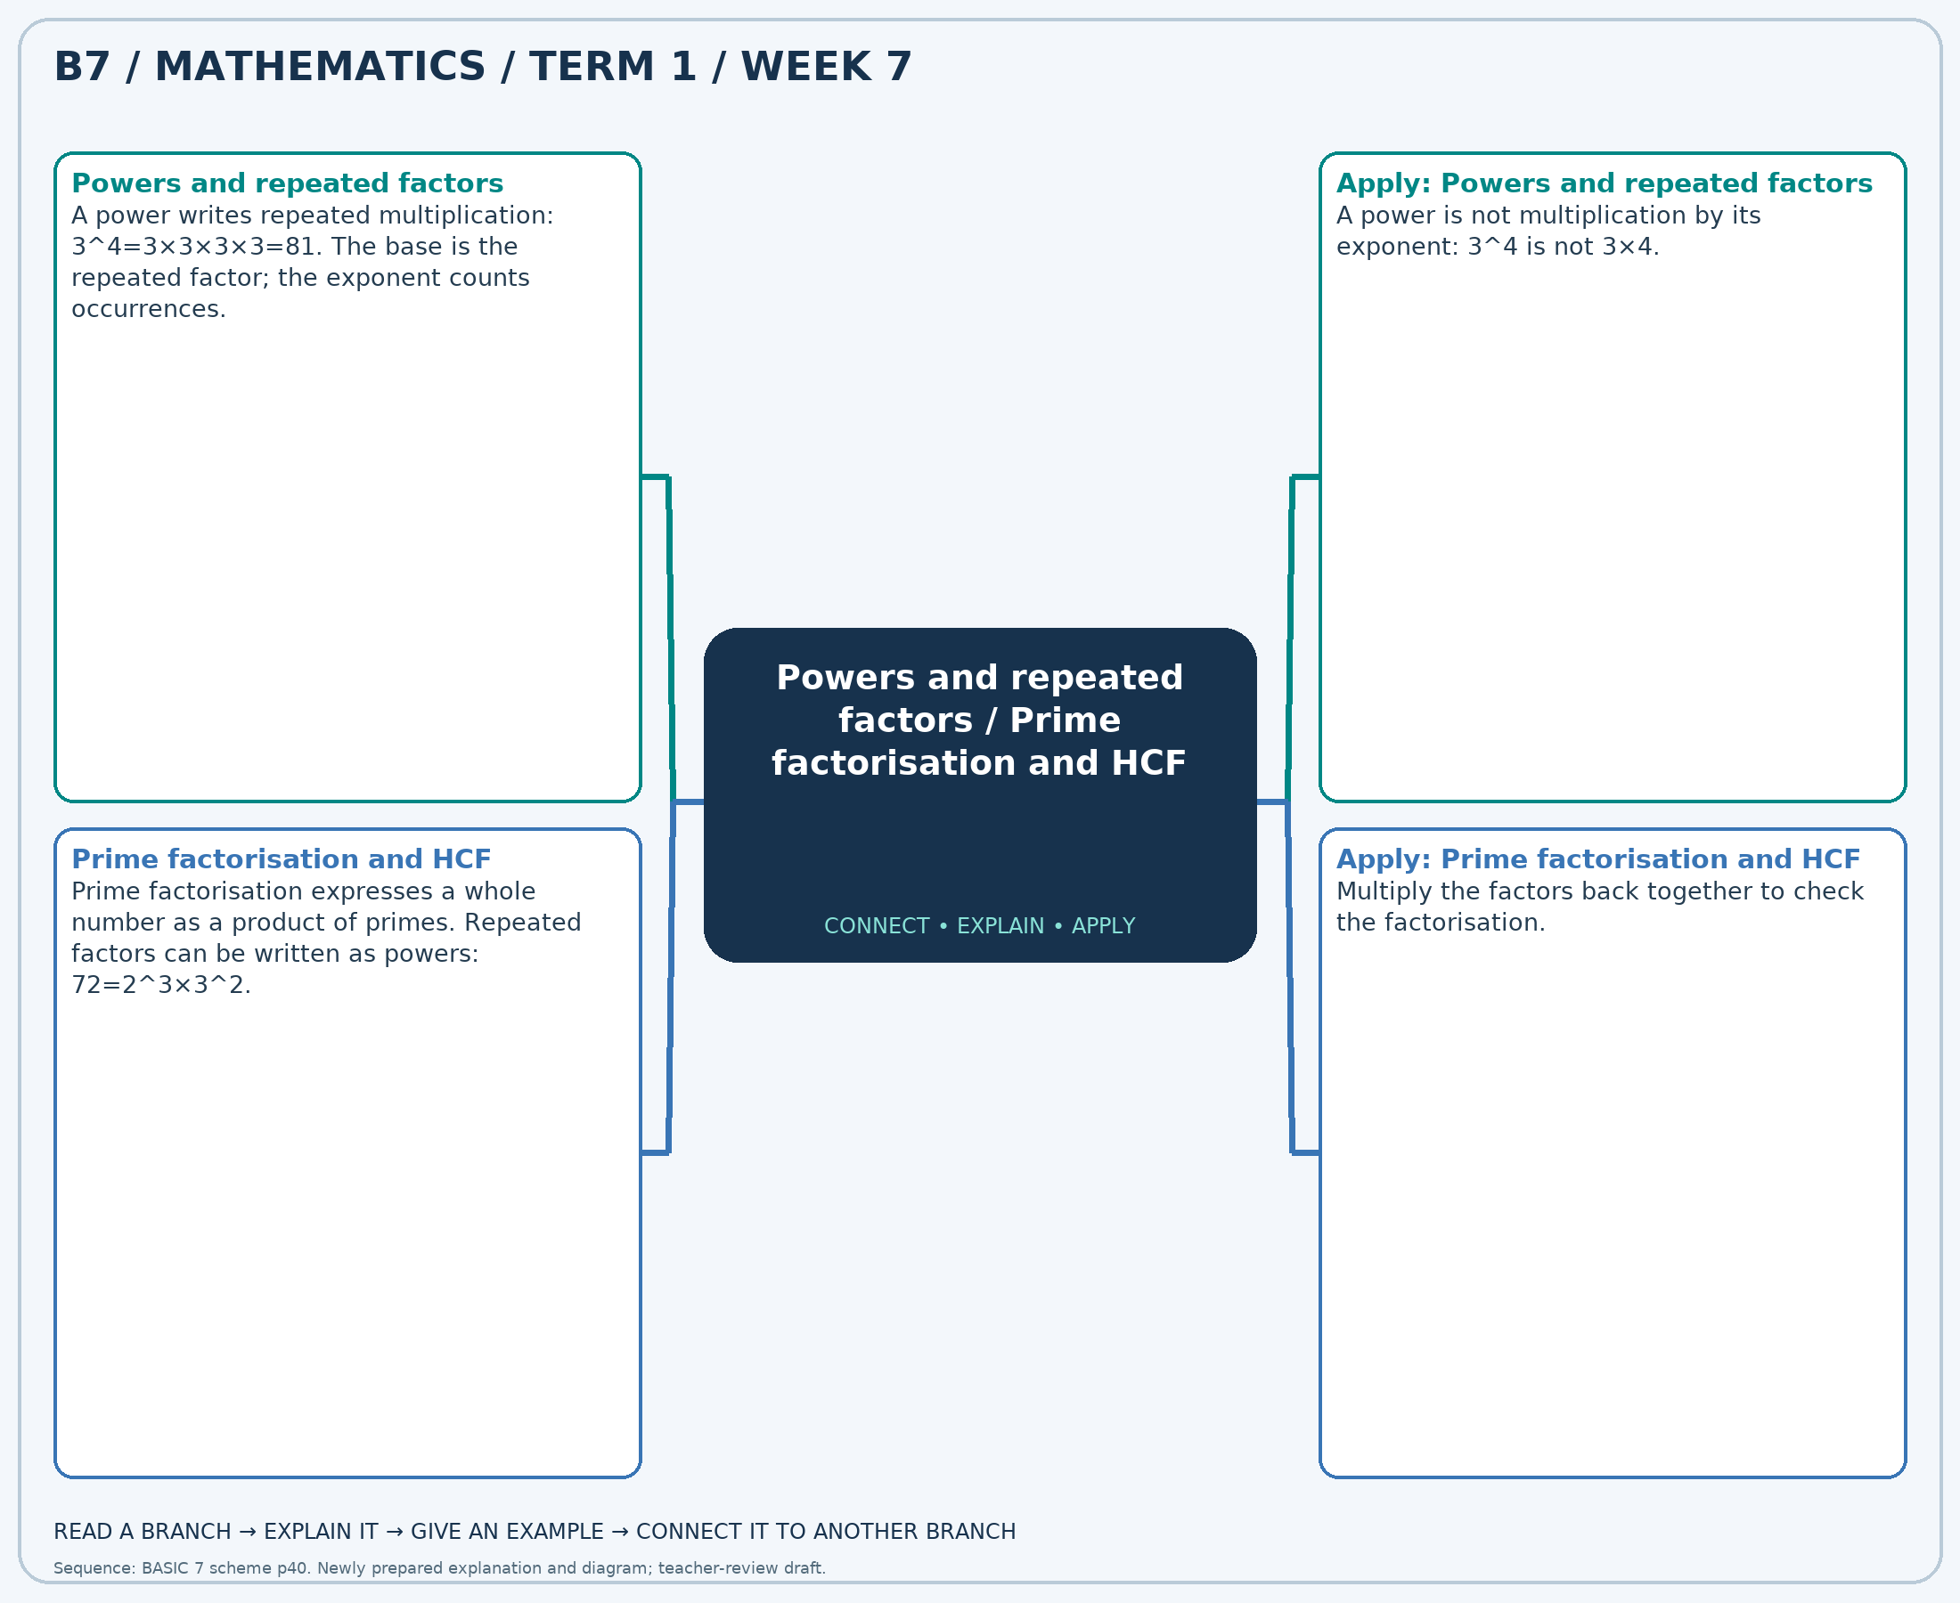
The separate high-resolution PNG can be projected or printed larger. Explain each branch and connect it with an example.

Week 7 — Practice

Section A — Multiple-choice questions
Choose ONE correct answer for each question. Each question has four alternatives.
1. Evaluate 6^3.
A. 216 B. 217 C. 215 D. 218
2. Find the HCF of 4 and 8 using prime factors.
A. 4 B. 3 C. 5 D. 6
3. Evaluate 7^0.
A. 2 B. 0 C. 3 D. 1
4. Find the HCF of 8 and 14 using prime factors.
A. 1 B. 3 C. 4 D. 2
5. Evaluate 6^4.
A. 1297 B. 1295 C. 1298 D. 1296
6. Find the HCF of 42 and 14 using prime factors.
A. 15 B. 16 C. 14 D. 13
7. Evaluate 3^3.
A. 28 B. 26 C. 27 D. 29
8. Find the HCF of 10 and 18 using prime factors.
A. 2 B. 1 C. 3 D. 4
9. Evaluate 3^0.
A. 1 B. 2 C. 0 D. 3
10. Find the HCF of 16 and 24 using prime factors.
A. 7 B. 9 C. 10 D. 8
11. Evaluate 7^2.
A. 49 B. 50 C. 48 D. 51
12. Find the HCF of 35 and 25 using prime factors.
A. 7 B. 5 C. 4 D. 6
13. Evaluate 7^3.
A. 345 B. 342 C. 343 D. 344
14. Find the HCF of 14 and 18 using prime factors.
A. 1 B. 2 C. 4 D. 3
15. Evaluate 5^0.
A. 2 B. 3 C. 0 D. 1
16. Find the HCF of 12 and 16 using prime factors.
A. 3 B. 6 C. 5 D. 4
17. Evaluate 2^3.
A. 10 B. 9 C. 7 D. 8
18. Find the HCF of 42 and 28 using prime factors.
A. 16 B. 15 C. 13 D. 14
19. Evaluate 2^0.
A. 3 B. 0 C. 2 D. 1
20. Find the HCF of 24 and 30 using prime factors.
A. 7 B. 8 C. 5 D. 6

Section B — Structured essay questions
Answer every part (a), (b), (c). Show your method or explain your choice. Write in a separate answer booklet. Each part: 1 mark for valid working/explanation and 1 for the correct result; 6 marks per question.

1. Apply the related skills and show working or give a reason for each answer.
(a) Evaluate 3^4.
(b) Find the HCF of 35 and 49 using prime factors.
(c) Evaluate 2^4.

2. Apply the related skills and show working or give a reason for each answer.
(a) Find the HCF of 40 and 25 using prime factors.
(b) Evaluate 7^4.
(c) Find the HCF of 6 and 10 using prime factors.

3. Apply the related skills and show working or give a reason for each answer.
(a) Evaluate 3^3.
(b) Find the HCF of 54 and 42 using prime factors.
(c) Evaluate 2^0.

4. Apply the related skills and show working or give a reason for each answer.
(a) Find the HCF of 18 and 48 using prime factors.
(b) Evaluate 3^0.
(c) Find the HCF of 12 and 12 using prime factors.

5. Apply the related skills and show working or give a reason for each answer.
(a) Evaluate 5^0.
(b) Find the HCF of 8 and 12 using prime factors.
(c) Evaluate 6^2.

6. Apply the related skills and show working or give a reason for each answer.
(a) Find the HCF of 48 and 56 using prime factors.
(b) Evaluate 6^4.
(c) Find the HCF of 15 and 25 using prime factors.

7. Apply the related skills and show working or give a reason for each answer.
(a) Evaluate 3^3.
(b) Find the HCF of 8 and 32 using prime factors.
(c) Evaluate 4^2.

8. Apply the related skills and show working or give a reason for each answer.
(a) Find the HCF of 48 and 72 using prime factors.
(b) Evaluate 3^2.
(c) Find the HCF of 10 and 8 using prime factors.

9. Apply the related skills and show working or give a reason for each answer.
(a) Evaluate 5^4.
(b) Find the HCF of 10 and 15 using prime factors.
(c) Evaluate 7^0.

10. Apply the related skills and show working or give a reason for each answer.
(a) Find the HCF of 18 and 18 using prime factors.
(b) Evaluate 7^0.
(c) Find the HCF of 18 and 12 using prime factors.

Week 8 — Powers and repeated factors / Highest common factor
Sequence source: BASIC 7 SCHEME OF LEARNING.pdf, first-term Mathematics, page 40. One consolidated weekly unit.

Learning outcomes
- Explain and apply powers and repeated factors, solve examples and justify the method.
- Explain and apply highest common factor, solve examples and justify the method.

Teaching notes and suggested sessions
Suggested schedule: five 40-minute sessions, adjusted to the school timetable. Spread the question bank through the week; it is not intended to be completed in one lesson.

1 — Explore and diagnose
5 minutes: recall an earlier skill; 10: demonstrate a concrete or pictorial model; 15: pairs investigate and explain; 10: identify a misconception and set an exit task.

2 — Model and practise
5 minutes: review the exit task; 10: work an example aloud; 15: pairs solve parallel examples; 10: compare methods and correct errors.

3 — Connect representations
5 minutes: recall vocabulary; 10: explain the mind-map; 15: connect a model, a drawing and a symbolic calculation; 10: independent practice.

4 — Apply and explain
5 minutes: estimate or predict; 10: solve a contextual example; 15: attempt selected structured-question parts; 10: compare reasoning and check units.

5 — Check and respond
5 minutes: retrieve the main rule; 15: use selected MCQs diagnostically; 10: explain distractors and misconceptions; 10: reteach or extend in response to evidence.

Topic-specific activities
- Build square arrays or repeated-factor diagrams and write matching index notation.
- Make identical packs from two colours of counters and identify the largest possible number of packs.
Resources: board, pencils, number cards, counters, paper strips and squared paper as appropriate. Prior-knowledge check: ask a learner to explain a representation used in the first example before introducing a new rule.
Support: reduce number size without changing the concept; offer a partially completed chart or model; allow oral reasoning before writing. Extension: create a counterexample to a false rule and explain why it fails.

Study notes and worked examples

Powers and repeated factors
- A power writes repeated multiplication: 3^4=3×3×3×3=81.
- The base is the repeated factor; the exponent counts occurrences.
- For a non-zero base, power zero equals 1.
- A power is not multiplication by its exponent: 3^4 is not 3×4.
Worked example: Evaluate 2^3.
Solution: 2 × 2 × 2 = 8.
Common misconception: The zero-exponent rule here requires a non-zero base; do not apply it to 0^0.

Highest common factor
- List the factors of the given numbers or use their prime factors.
- Common factors occur in every list. The HCF is the greatest positive common factor.
- With prime factors, use shared primes with their smallest powers.
- The HCF can determine the largest equal grouping that leaves nothing over.
Worked example: Find the HCF of 12 and 24.
Solution: Common factors: 1, 2, 3, 4, 6, 12. Greatest = 12.
Common misconception: Do not choose the lowest common multiple when the question asks for a factor.
Independent study: read the map, cover it and reconstruct the branches. Solve an unused question from each skill and explain the reasoning to a partner. Consult the teacher key only after an honest attempt.

Week 8 — Visual mind-map
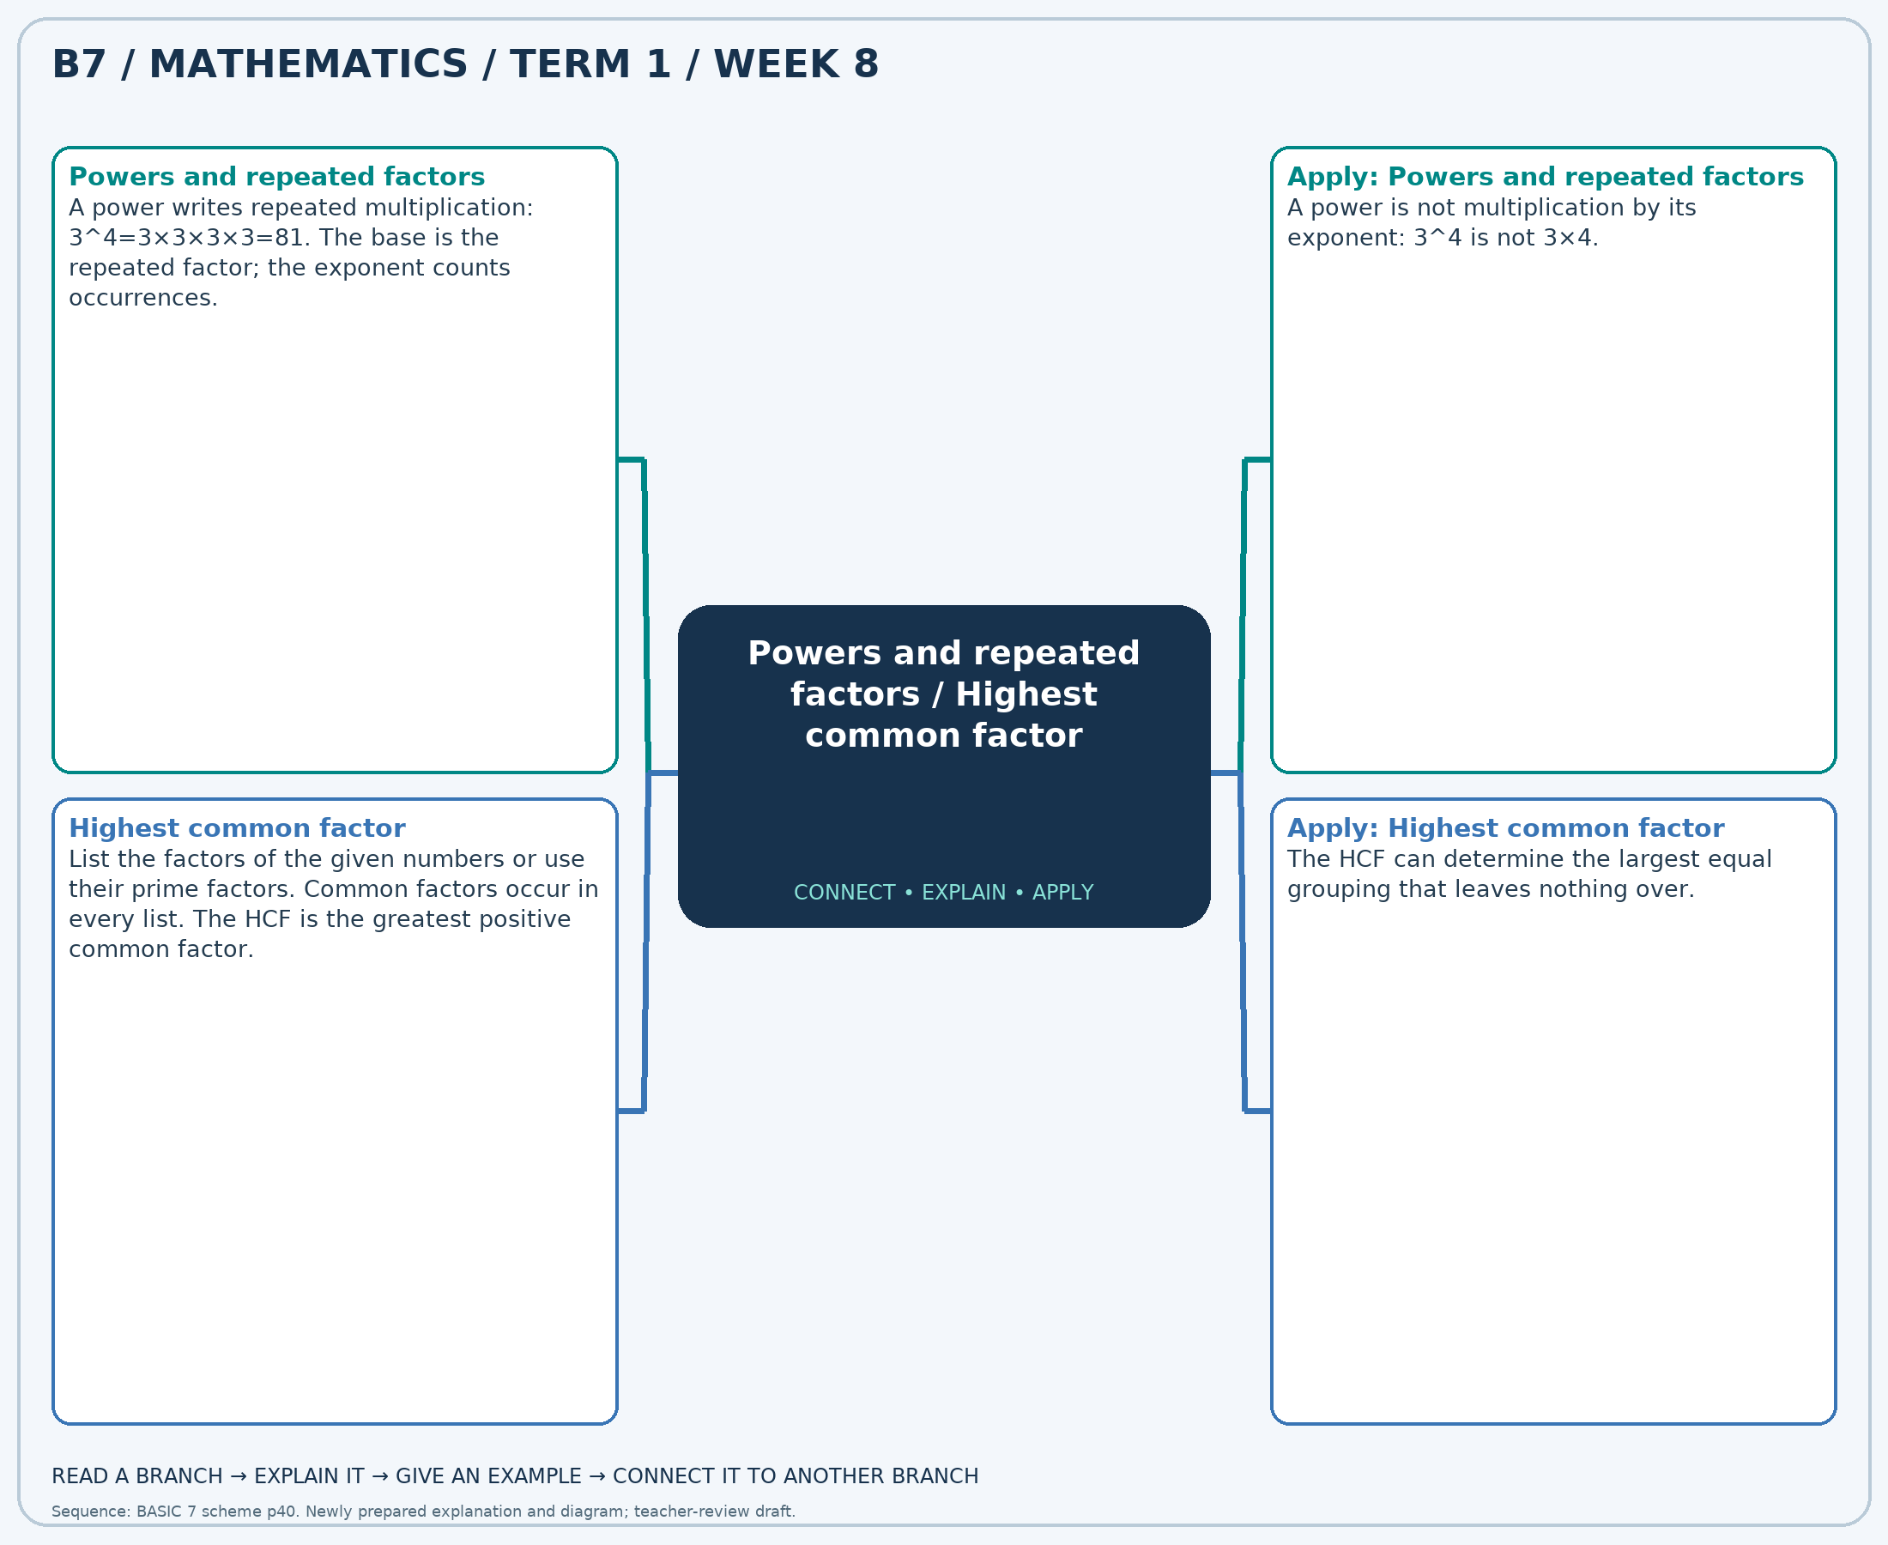
The separate high-resolution PNG can be projected or printed larger. Explain each branch and connect it with an example.

Week 8 — Practice

Section A — Multiple-choice questions
Choose ONE correct answer for each question. Each question has four alternatives.
1. Evaluate 3^4.
A. 80 B. 82 C. 83 D. 81
2. Find the HCF of 56 and 35.
A. 6 B. 8 C. 9 D. 7
3. Evaluate 7^0.
A. 2 B. 1 C. 0 D. 3
4. Find the HCF of 30 and 48.
A. 5 B. 8 C. 6 D. 7
5. Evaluate 5^2.
A. 25 B. 27 C. 26 D. 24
6. Find the HCF of 24 and 32.
A. 9 B. 7 C. 10 D. 8
7. Evaluate 2^2.
A. 4 B. 3 C. 5 D. 6
8. Find the HCF of 49 and 35.
A. 7 B. 9 C. 8 D. 6
9. Evaluate 2^0.
A. 3 B. 2 C. 1 D. 0
10. Find the HCF of 27 and 12.
A. 2 B. 3 C. 5 D. 4
11. Evaluate 7^3.
A. 345 B. 343 C. 342 D. 344
12. Find the HCF of 6 and 14.
A. 1 B. 2 C. 3 D. 4
13. Evaluate 3^3.
A. 27 B. 28 C. 29 D. 26
14. Find the HCF of 4 and 14.
A. 4 B. 3 C. 1 D. 2
15. Evaluate 3^0.
A. 1 B. 2 C. 0 D. 3
16. Find the HCF of 18 and 42.
A. 5 B. 7 C. 8 D. 6
17. Evaluate 4^2.
A. 15 B. 16 C. 17 D. 18
18. Find the HCF of 63 and 49.
A. 7 B. 6 C. 8 D. 9
19. Evaluate 5^3.
A. 126 B. 125 C. 127 D. 124
20. Find the HCF of 18 and 15.
A. 2 B. 3 C. 5 D. 4

Section B — Structured essay questions
Answer every part (a), (b), (c). Show your method or explain your choice. Write in a separate answer booklet. Each part: 1 mark for valid working/explanation and 1 for the correct result; 6 marks per question.

1. Apply the related skills and show working or give a reason for each answer.
(a) Evaluate 2^3.
(b) Find the HCF of 28 and 36.
(c) Evaluate 7^4.

2. Apply the related skills and show working or give a reason for each answer.
(a) Find the HCF of 35 and 42.
(b) Evaluate 3^2.
(c) Find the HCF of 49 and 14.

3. Apply the related skills and show working or give a reason for each answer.
(a) Evaluate 4^4.
(b) Find the HCF of 16 and 72.
(c) Evaluate 4^0.

4. Apply the related skills and show working or give a reason for each answer.
(a) Find the HCF of 6 and 12.
(b) Evaluate 2^0.
(c) Find the HCF of 30 and 18.

5. Apply the related skills and show working or give a reason for each answer.
(a) Evaluate 3^0.
(b) Find the HCF of 16 and 48.
(c) Evaluate 6^2.

6. Apply the related skills and show working or give a reason for each answer.
(a) Find the HCF of 20 and 16.
(b) Evaluate 4^4.
(c) Find the HCF of 12 and 18.

7. Apply the related skills and show working or give a reason for each answer.
(a) Evaluate 3^3.
(b) Find the HCF of 8 and 6.
(c) Evaluate 5^3.

8. Apply the related skills and show working or give a reason for each answer.
(a) Find the HCF of 30 and 36.
(b) Evaluate 3^2.
(c) Find the HCF of 63 and 14.

9. Apply the related skills and show working or give a reason for each answer.
(a) Evaluate 6^4.
(b) Find the HCF of 48 and 24.
(c) Evaluate 3^0.

10. Apply the related skills and show working or give a reason for each answer.
(a) Find the HCF of 40 and 56.
(b) Evaluate 2^0.
(c) Find the HCF of 15 and 15.

Week 9 — Fractions, decimals and percentages / Comparing fractions
Sequence source: BASIC 7 SCHEME OF LEARNING.pdf, first-term Mathematics, page 40. One consolidated weekly unit.

Learning outcomes
- Explain and apply fractions, decimals and percentages, solve examples and justify the method.
- Explain and apply comparing fractions, solve examples and justify the method.

Teaching notes and suggested sessions
Suggested schedule: five 40-minute sessions, adjusted to the school timetable. Spread the question bank through the week; it is not intended to be completed in one lesson.

1 — Explore and diagnose
5 minutes: recall an earlier skill; 10: demonstrate a concrete or pictorial model; 15: pairs investigate and explain; 10: identify a misconception and set an exit task.

2 — Model and practise
5 minutes: review the exit task; 10: work an example aloud; 15: pairs solve parallel examples; 10: compare methods and correct errors.

3 — Connect representations
5 minutes: recall vocabulary; 10: explain the mind-map; 15: connect a model, a drawing and a symbolic calculation; 10: independent practice.

4 — Apply and explain
5 minutes: estimate or predict; 10: solve a contextual example; 15: attempt selected structured-question parts; 10: compare reasoning and check units.

5 — Check and respond
5 minutes: retrieve the main rule; 15: use selected MCQs diagnostically; 10: explain distractors and misconceptions; 10: reteach or extend in response to evidence.

Topic-specific activities
- Match fraction, decimal and percentage cards and place them on a number line.
- Place fraction cards on a number line and justify each position.
Resources: board, pencils, number cards, counters, paper strips and squared paper as appropriate. Prior-knowledge check: ask a learner to explain a representation used in the first example before introducing a new rule.
Support: reduce number size without changing the concept; offer a partially completed chart or model; allow oral reasoning before writing. Extension: create a counterexample to a false rule and explain why it fails.

Study notes and worked examples

Fractions, decimals and percentages
- A fraction, a decimal and a percentage can represent the same quantity.
- Divide numerator by denominator for a decimal. Multiply the decimal by 100 for a percent value.
- Benchmarks include 1/2=0.5=50%, 1/4=0.25=25% and 3/4=0.75=75%.
- Convert to a common form before ordering mixed representations.
Worked example: Write 1/2 as a decimal.
Solution: 1÷2=0.5.
Common misconception: 0.5 is 50%, not 5%.

Comparing fractions
- Fractions must refer to the same-sized whole for a fair comparison.
- With the same denominator, compare numerators. With the same numerator, a smaller positive denominator gives a larger fraction.
- For unlike denominators, convert to a common denominator.
- Use 0, 1/2 and 1 as benchmarks to check an ordering.
Worked example: Which fraction is the least: 7/10, 3/5, 1/10, 3/8?
Solution: Use denominator 40: 7/10=28/40, 3/5=24/40, 1/10=4/40, 3/8=15/40. Answer: 1/10.
Common misconception: A larger denominator does not by itself mean a larger fraction.
Independent study: read the map, cover it and reconstruct the branches. Solve an unused question from each skill and explain the reasoning to a partner. Consult the teacher key only after an honest attempt.

Week 9 — Visual mind-map
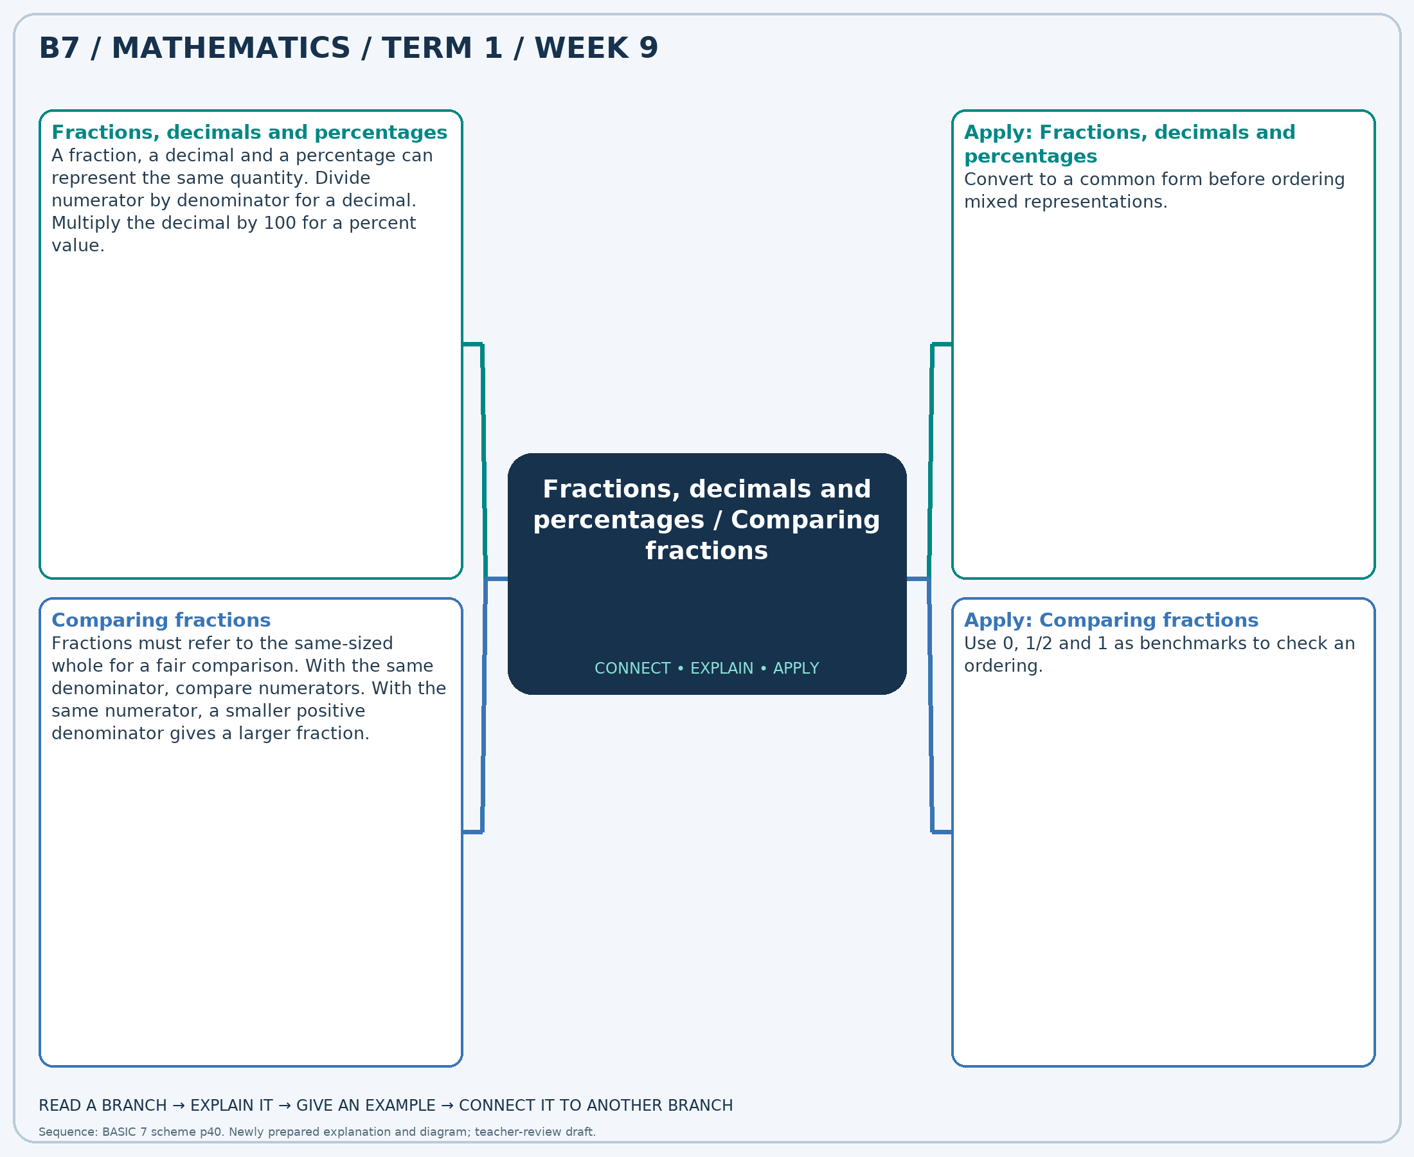
The separate high-resolution PNG can be projected or printed larger. Explain each branch and connect it with an example.

Week 9 — Practice

Section A — Multiple-choice questions
Choose ONE correct answer for each question. Each question has four alternatives.
1. Write 1/10 as a decimal.
A. 1.1 B. 2.1 C. 0.1 D. -0.9
2. Which fraction is the greatest: 7/12, 1/3, 2/3, 5/12?
A. 2/3 B. 1/3 C. 5/12 D. 7/12
3. Write 1/5 as a percentage. Give the numerical percent value.
A. 20 B. 19 C. 22 D. 21
4. Which fraction is the least: 1/6, 1/2, 1/10, 1/3?
A. 1/6 B. 1/3 C. 1/2 D. 1/10
5. Write 25% as a fraction in simplest form.
A. -3/4 B. 5/4 C. 1/4 D. 9/4
6. Which fraction is the greatest: 7/10, 4/5, 11/12, 1/3?
A. 4/5 B. 11/12 C. 7/10 D. 1/3
7. Write 7/10 as a decimal.
A. 0.7 B. -0.3 C. 2.7 D. 1.7
8. Which fraction is the greatest: 1/10, 1/8, 9/10, 1/5?
A. 1/8 B. 1/5 C. 9/10 D. 1/10
9. Write 1/2 as a percentage. Give the numerical percent value.
A. 49 B. 50 C. 52 D. 51
10. Which fraction is the least: 1/8, 5/8, 1/5, 2/3?
A. 1/8 B. 1/5 C. 2/3 D. 5/8
11. Write 80% as a fraction in simplest form.
A. 9/5 B. 4/5 C. 14/5 D. -1/5
12. Which fraction is the greatest: 1/10, 5/12, 9/10, 1/12?
A. 1/10 B. 9/10 C. 1/12 D. 5/12
13. Write 3/4 as a decimal.
A. 1.75 B. 2.75 C. -0.25 D. 0.75
14. Which fraction is the greatest: 5/6, 2/5, 1/3, 1/10?
A. 1/10 B. 1/3 C. 5/6 D. 2/5
15. Write 3/4 as a percentage. Give the numerical percent value.
A. 75 B. 77 C. 76 D. 74
16. Which fraction is the greatest: 11/12, 9/10, 2/5, 4/5?
A. 9/10 B. 11/12 C. 4/5 D. 2/5
17. Write 60% as a fraction in simplest form.
A. 8/5 B. -2/5 C. 13/5 D. 3/5
18. Which fraction is the greatest: 2/3, 3/4, 3/8, 5/12?
A. 5/12 B. 2/3 C. 3/8 D. 3/4
19. Write 7/10 as a percentage. Give the numerical percent value.
A. 71 B. 72 C. 70 D. 69
20. Which fraction is the least: 1/6, 7/12, 1/4, 7/10?
A. 7/10 B. 1/6 C. 7/12 D. 1/4

Section B — Structured essay questions
Answer every part (a), (b), (c). Show your method or explain your choice. Write in a separate answer booklet. Each part: 1 mark for valid working/explanation and 1 for the correct result; 6 marks per question.

1. Apply the related skills and show working or give a reason for each answer.
(a) Write 1/4 as a decimal.
(b) Which fraction is the least: 7/12, 5/12, 1/6, 4/5?
(c) Write 50% as a fraction in simplest form.

2. Apply the related skills and show working or give a reason for each answer.
(a) Which fraction is the least: 1/5, 7/10, 1/3, 1/12?
(b) Write 50% as a fraction in simplest form.
(c) Which fraction is the greatest: 4/5, 9/10, 5/12, 2/3?

3. Apply the related skills and show working or give a reason for each answer.
(a) Write 60% as a fraction in simplest form.
(b) Which fraction is the greatest: 7/8, 1/8, 7/10, 2/5?
(c) Write 1/5 as a percentage. Give the numerical percent value.

4. Apply the related skills and show working or give a reason for each answer.
(a) Which fraction is the greatest: 11/12, 1/4, 4/5, 9/10?
(b) Write 3/5 as a percentage. Give the numerical percent value.
(c) Which fraction is the greatest: 1/4, 11/12, 3/8, 7/8?

5. Apply the related skills and show working or give a reason for each answer.
(a) Write 1/4 as a percentage. Give the numerical percent value.
(b) Which fraction is the greatest: 5/6, 3/8, 3/5, 1/6?
(c) Write 1/2 as a decimal.

6. Apply the related skills and show working or give a reason for each answer.
(a) Which fraction is the greatest: 1/12, 1/5, 4/5, 3/5?
(b) Write 1/5 as a decimal.
(c) Which fraction is the least: 1/6, 1/5, 1/3, 11/12?

7. Apply the related skills and show working or give a reason for each answer.
(a) Write 3/5 as a decimal.
(b) Which fraction is the least: 7/10, 3/5, 1/8, 1/2?
(c) Write 75% as a fraction in simplest form.

8. Apply the related skills and show working or give a reason for each answer.
(a) Which fraction is the least: 1/6, 3/5, 5/6, 3/10?
(b) Write 30% as a fraction in simplest form.
(c) Which fraction is the greatest: 5/12, 1/8, 4/5, 3/10?

9. Apply the related skills and show working or give a reason for each answer.
(a) Write 30% as a fraction in simplest form.
(b) Which fraction is the greatest: 5/8, 7/10, 1/5, 1/6?
(c) Write 4/5 as a percentage. Give the numerical percent value.

10. Apply the related skills and show working or give a reason for each answer.
(a) Which fraction is the greatest: 3/8, 2/5, 5/6, 1/8?
(b) Write 1/2 as a percentage. Give the numerical percent value.
(c) Which fraction is the greatest: 1/10, 7/10, 4/5, 1/2?

Week 10 — Adding and subtracting fractions
Sequence source: BASIC 7 SCHEME OF LEARNING.pdf, first-term Mathematics, page 40. One consolidated weekly unit.

Learning outcomes
- Explain and apply adding and subtracting fractions, solve examples and justify the method.

Teaching notes and suggested sessions
Suggested schedule: five 40-minute sessions, adjusted to the school timetable. Spread the question bank through the week; it is not intended to be completed in one lesson.

1 — Explore and diagnose
5 minutes: recall an earlier skill; 10: demonstrate a concrete or pictorial model; 15: pairs investigate and explain; 10: identify a misconception and set an exit task.

2 — Model and practise
5 minutes: review the exit task; 10: work an example aloud; 15: pairs solve parallel examples; 10: compare methods and correct errors.

3 — Connect representations
5 minutes: recall vocabulary; 10: explain the mind-map; 15: connect a model, a drawing and a symbolic calculation; 10: independent practice.

4 — Apply and explain
5 minutes: estimate or predict; 10: solve a contextual example; 15: attempt selected structured-question parts; 10: compare reasoning and check units.

5 — Check and respond
5 minutes: retrieve the main rule; 15: use selected MCQs diagnostically; 10: explain distractors and misconceptions; 10: reteach or extend in response to evidence.

Topic-specific activities
- Repartition fraction strips into matching units before combining or taking away parts.
Resources: board, pencils, number cards, counters, paper strips and squared paper as appropriate. Prior-knowledge check: ask a learner to explain a representation used in the first example before introducing a new rule.
Support: reduce number size without changing the concept; offer a partially completed chart or model; allow oral reasoning before writing. Extension: create a counterexample to a false rule and explain why it fails.

Study notes and worked examples

Adding and subtracting fractions
- Use a common denominator so the parts being combined are equal-sized.
- Add or subtract the numerators and keep the common denominator.
- For example, 1/2+1/3=3/6+2/6=5/6.
- Convert mixed numbers to improper fractions if helpful, simplify and check against an estimate.
Worked example: Calculate 7/6 + 4/3. Give the answer in simplest form.
Solution: Common denominator 6: (7 + 8)/6 = 5/2.
Common misconception: Do not add denominators: 1/2+1/3 is not 2/5.
Independent study: read the map, cover it and reconstruct the branches. Solve an unused question from each skill and explain the reasoning to a partner. Consult the teacher key only after an honest attempt.

Week 10 — Visual mind-map
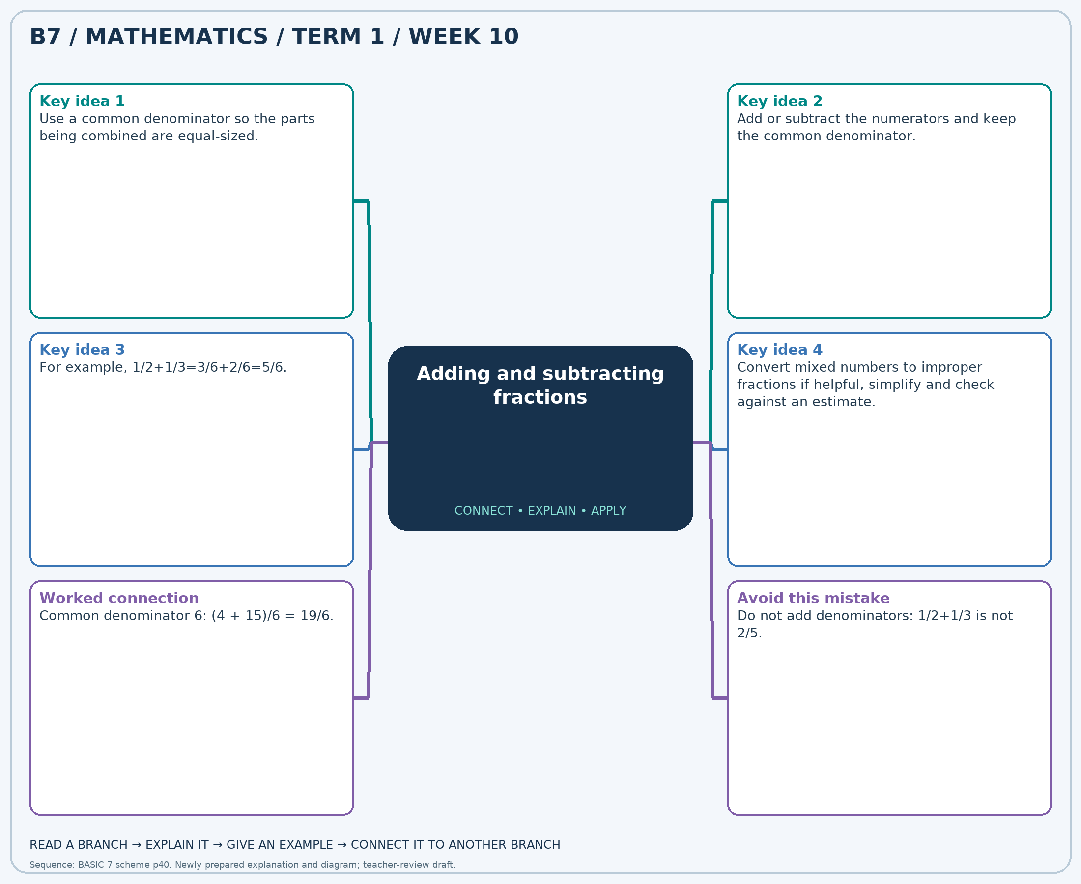
The separate high-resolution PNG can be projected or printed larger. Explain each branch and connect it with an example.

Week 10 — Practice

Section A — Multiple-choice questions
Choose ONE correct answer for each question. Each question has four alternatives.
1. Calculate 1/6 + 7/4. Give the answer in simplest form.
A. 47/12 B. 11/12 C. 35/12 D. 23/12
2. Calculate 5/2 − 1/3. Give the answer in simplest form.
A. 25/6 B. 7/6 C. 19/6 D. 13/6
3. Calculate 3/2 + 5/4. Give the answer in simplest form.
A. 11/4 B. 7/4 C. 15/4 D. 19/4
4. Calculate 3/4 + 5/3. Give the answer in simplest form.
A. 17/12 B. 29/12 C. 53/12 D. 41/12
5. Calculate 2 − 5/4. Give the answer in simplest form.
A. -1/4 B. 3/4 C. 7/4 D. 11/4
6. Calculate 1/4 + 4/3. Give the answer in simplest form.
A. 19/12 B. 31/12 C. 43/12 D. 7/12
7. Calculate 3/2 + 2. Give the answer in simplest form.
A. 5/2 B. 7/2 C. 11/2 D. 9/2
8. Calculate 7/3 − 2/3. Give the answer in simplest form.
A. 5/3 B. 11/3 C. 2/3 D. 8/3
9. Calculate 1 + 5/3. Give the answer in simplest form.
A. 14/3 B. 11/3 C. 5/3 D. 8/3
10. Calculate 3/2 + 2/3. Give the answer in simplest form.
A. 25/6 B. 13/6 C. 7/6 D. 19/6
11. Calculate 5/3 − 3/2. Give the answer in simplest form.
A. -5/6 B. 13/6 C. 7/6 D. 1/6
12. Calculate 1/4 + 7/6. Give the answer in simplest form.
A. 41/12 B. 5/12 C. 29/12 D. 17/12
13. Calculate 2/3 + 5/6. Give the answer in simplest form.
A. 3/2 B. 1/2 C. 7/2 D. 5/2
14. Calculate 2 − 1. Give the answer in simplest form.
A. 0 B. 2 C. 3 D. 1
15. Calculate 2 + 2. Give the answer in simplest form.
A. 4 B. 3 C. 6 D. 5
16. Calculate 4 + 1/2. Give the answer in simplest form.
A. 7/2 B. 11/2 C. 13/2 D. 9/2
17. Calculate 4/3 − 1/6. Give the answer in simplest form.
A. 19/6 B. 1/6 C. 7/6 D. 13/6
18. Calculate 8/3 + 1/2. Give the answer in simplest form.
A. 25/6 B. 19/6 C. 13/6 D. 31/6
19. Calculate 7/6 + 7/4. Give the answer in simplest form.
A. 35/12 B. 23/12 C. 59/12 D. 47/12
20. Calculate 2 − 3/2. Give the answer in simplest form.
A. 1/2 B. 5/2 C. -1/2 D. 3/2

Section B — Structured essay questions
Answer every part (a), (b), (c). Show your method or explain your choice. Write in a separate answer booklet. Each part: 1 mark for valid working/explanation and 1 for the correct result; 6 marks per question.

1. Apply the related skills and show working or give a reason for each answer.
(a) Calculate 1/6 + 7/6. Give the answer in simplest form.
(b) Calculate 7/2 − 1/3. Give the answer in simplest form.
(c) Calculate 3 + 1/6. Give the answer in simplest form.

2. Apply the related skills and show working or give a reason for each answer.
(a) Calculate 2/3 − 1/3. Give the answer in simplest form.
(b) Calculate 1/4 + 3/2. Give the answer in simplest form.
(c) Calculate 4/3 + 2/3. Give the answer in simplest form.

3. Apply the related skills and show working or give a reason for each answer.
(a) Calculate 1/3 + 1. Give the answer in simplest form.
(b) Calculate 7/4 + 7/2. Give the answer in simplest form.
(c) Calculate 2 − 5/4. Give the answer in simplest form.

4. Apply the related skills and show working or give a reason for each answer.
(a) Calculate 3/4 + 3/2. Give the answer in simplest form.
(b) Calculate 4/3 − 5/4. Give the answer in simplest form.
(c) Calculate 4/3 + 4/3. Give the answer in simplest form.

5. Apply the related skills and show working or give a reason for each answer.
(a) Calculate 4 − 5/3. Give the answer in simplest form.
(b) Calculate 1/2 + 1/3. Give the answer in simplest form.
(c) Calculate 1/3 + 5/2. Give the answer in simplest form.

6. Apply the related skills and show working or give a reason for each answer.
(a) Calculate 3/2 + 4/3. Give the answer in simplest form.
(b) Calculate 5/6 + 5/2. Give the answer in simplest form.
(c) Calculate 1 − 1/2. Give the answer in simplest form.

7. Apply the related skills and show working or give a reason for each answer.
(a) Calculate 1 + 5/3. Give the answer in simplest form.
(b) Calculate 4/3 − 5/6. Give the answer in simplest form.
(c) Calculate 5/6 + 1/6. Give the answer in simplest form.

8. Apply the related skills and show working or give a reason for each answer.
(a) Calculate 4/3 − 4/3. Give the answer in simplest form.
(b) Calculate 2 + 5/2. Give the answer in simplest form.
(c) Calculate 7/6 + 2/3. Give the answer in simplest form.

9. Apply the related skills and show working or give a reason for each answer.
(a) Calculate 3/2 + 7/6. Give the answer in simplest form.
(b) Calculate 4/3 + 2. Give the answer in simplest form.
(c) Calculate 3/4 − 1/2. Give the answer in simplest form.

10. Apply the related skills and show working or give a reason for each answer.
(a) Calculate 1/3 + 2/3. Give the answer in simplest form.
(b) Calculate 7/3 − 5/3. Give the answer in simplest form.
(c) Calculate 1/4 + 1/4. Give the answer in simplest form.

Week 11 — Multiplying fractions and finding a fraction of a quantity
Sequence source: BASIC 7 SCHEME OF LEARNING.pdf, first-term Mathematics, page 40. One consolidated weekly unit.

Learning outcomes
- Explain and apply multiplying fractions and finding a fraction of a quantity, solve examples and justify the method.

Teaching notes and suggested sessions
Suggested schedule: five 40-minute sessions, adjusted to the school timetable. Spread the question bank through the week; it is not intended to be completed in one lesson.

1 — Explore and diagnose
5 minutes: recall an earlier skill; 10: demonstrate a concrete or pictorial model; 15: pairs investigate and explain; 10: identify a misconception and set an exit task.

2 — Model and practise
5 minutes: review the exit task; 10: work an example aloud; 15: pairs solve parallel examples; 10: compare methods and correct errors.

3 — Connect representations
5 minutes: recall vocabulary; 10: explain the mind-map; 15: connect a model, a drawing and a symbolic calculation; 10: independent practice.

4 — Apply and explain
5 minutes: estimate or predict; 10: solve a contextual example; 15: attempt selected structured-question parts; 10: compare reasoning and check units.

5 — Check and respond
5 minutes: retrieve the main rule; 15: use selected MCQs diagnostically; 10: explain distractors and misconceptions; 10: reteach or extend in response to evidence.

Topic-specific activities
- Use counters for a fraction of a set and a shaded rectangle for a fraction of a fraction.
Resources: board, pencils, number cards, counters, paper strips and squared paper as appropriate. Prior-knowledge check: ask a learner to explain a representation used in the first example before introducing a new rule.
Support: reduce number size without changing the concept; offer a partially completed chart or model; allow oral reasoning before writing. Extension: create a counterexample to a false rule and explain why it fails.

Study notes and worked examples

Multiplying fractions and finding a fraction of a quantity
- A fraction of a quantity means multiplication.
- For example, 3/4 of 20 = (20÷4)×3 = 15.
- Multiply fractions by multiplying numerators and denominators; simplify before or after multiplying.
- Multiplying a positive quantity by a fraction between 0 and 1 makes it smaller.
Worked example: Find 1/4 of 12.
Solution: 12÷4×1=3.
Common misconception: Multiplication does not always make the quantity larger.
Independent study: read the map, cover it and reconstruct the branches. Solve an unused question from each skill and explain the reasoning to a partner. Consult the teacher key only after an honest attempt.

Week 11 — Visual mind-map
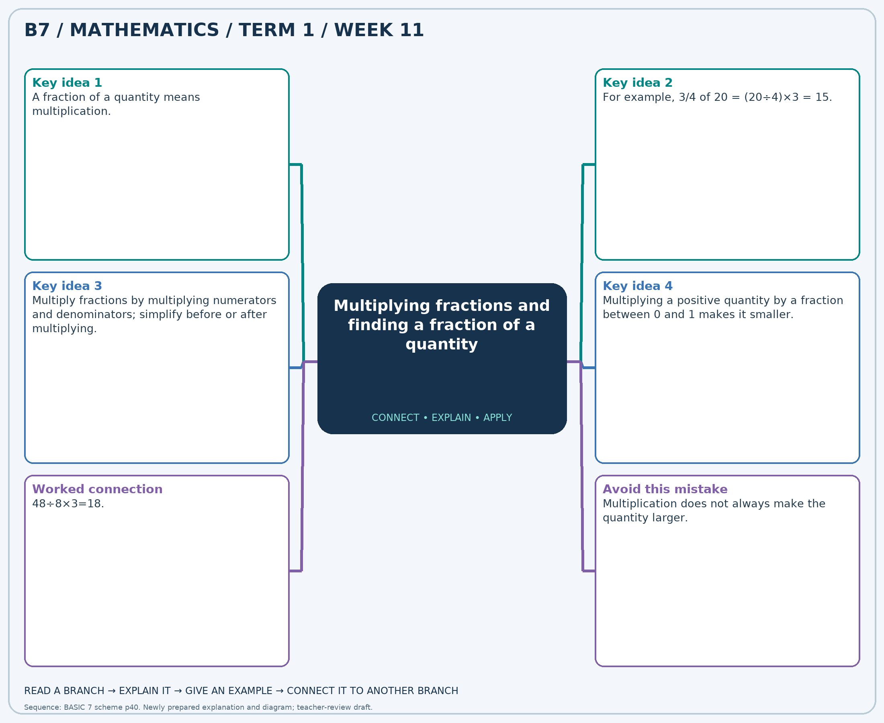
The separate high-resolution PNG can be projected or printed larger. Explain each branch and connect it with an example.

Week 11 — Practice

Section A — Multiple-choice questions
Choose ONE correct answer for each question. Each question has four alternatives.
1. Find 5/8 of 96.
A. 61 B. 59 C. 60 D. 62
2. Find 2/3 of 15.
A. 12 B. 11 C. 9 D. 10
3. Calculate 3/8 × 1/7.
A. -53/56 B. 115/56 C. 59/56 D. 3/56
4. Find 1/2 of 28.
A. 13 B. 15 C. 16 D. 14
5. Calculate 2/3 × 3/5.
A. 7/5 B. -3/5 C. 2/5 D. 12/5
6. Find 1/3 of 24.
A. 10 B. 9 C. 8 D. 7
7. Find 1/3 of 18.
A. 8 B. 5 C. 6 D. 7
8. Calculate 3/4 × 1/7.
A. 59/28 B. 31/28 C. -25/28 D. 3/28
9. Find 7/8 of 96.
A. 86 B. 84 C. 83 D. 85
10. Find 3/4 of 72.
A. 53 B. 54 C. 56 D. 55
11. Calculate 4/5 × 2/9.
A. 98/45 B. 8/45 C. 53/45 D. -37/45
12. Find 1/2 of 40.
A. 21 B. 22 C. 19 D. 20
13. Find 1/3 of 30.
A. 12 B. 11 C. 10 D. 9
14. Calculate 1/4 × 3/8.
A. 3/32 B. 67/32 C. -29/32 D. 35/32
15. Find 4/5 of 40.
A. 33 B. 31 C. 32 D. 34
16. Find 1/4 of 32.
A. 10 B. 8 C. 7 D. 9
17. Calculate 1/3 × 4/5.
A. -11/15 B. 4/15 C. 19/15 D. 34/15
18. Calculate 1/4 × 1/5.
A. 21/20 B. 41/20 C. -19/20 D. 1/20
19. Find 1/4 of 24.
A. 8 B. 7 C. 6 D. 5
20. Find 2/3 of 12.
A. 9 B. 7 C. 8 D. 10

Section B — Structured essay questions
Answer every part (a), (b), (c). Show your method or explain your choice. Write in a separate answer booklet. Each part: 1 mark for valid working/explanation and 1 for the correct result; 6 marks per question.

1. Apply the related skills and show working or give a reason for each answer.
(a) Find 2/5 of 55.
(b) Find 3/5 of 55.
(c) Calculate 1/2 × 3/5.

2. Apply the related skills and show working or give a reason for each answer.
(a) Find 1/2 of 12.
(b) Calculate 1/2 × 1/2.
(c) Find 1/4 of 96.

3. Apply the related skills and show working or give a reason for each answer.
(a) Calculate 3/8 × 4/5.
(b) Find 1/4 of 32.
(c) Find 1/4 of 44.

4. Apply the related skills and show working or give a reason for each answer.
(a) Find 1/2 of 16.
(b) Find 1/2 of 12.
(c) Calculate 1/3 × 1/3.

5. Apply the related skills and show working or give a reason for each answer.
(a) Find 1/2 of 80.
(b) Calculate 1/2 × 2/5.
(c) Find 1/4 of 88.

6. Apply the related skills and show working or give a reason for each answer.
(a) Calculate 2/3 × 3/5.
(b) Find 1/3 of 24.
(c) Find 5/8 of 64.

7. Apply the related skills and show working or give a reason for each answer.
(a) Find 3/4 of 48.
(b) Find 2/3 of 21.
(c) Calculate 2/5 × 4/5.

8. Apply the related skills and show working or give a reason for each answer.
(a) Find 1/2 of 80.
(b) Calculate 2/5 × 1/4.
(c) Find 3/4 of 44.

9. Apply the related skills and show working or give a reason for each answer.
(a) Calculate 3/4 × 1/2.
(b) Find 1/4 of 40.
(c) Find 4/5 of 15.

10. Apply the related skills and show working or give a reason for each answer.
(a) Find 3/8 of 96.
(b) Find 3/5 of 50.
(c) Calculate 4/5 × 1/5.

Week 12 — Multiplying fractions and finding a fraction of a quantity
Sequence source: BASIC 7 SCHEME OF LEARNING.pdf, first-term Mathematics, page 40. One consolidated weekly unit.

Learning outcomes
- Explain and apply multiplying fractions and finding a fraction of a quantity, solve examples and justify the method.

Teaching notes and suggested sessions
Suggested schedule: five 40-minute sessions, adjusted to the school timetable. Spread the question bank through the week; it is not intended to be completed in one lesson.

1 — Explore and diagnose
5 minutes: recall an earlier skill; 10: demonstrate a concrete or pictorial model; 15: pairs investigate and explain; 10: identify a misconception and set an exit task.

2 — Model and practise
5 minutes: review the exit task; 10: work an example aloud; 15: pairs solve parallel examples; 10: compare methods and correct errors.

3 — Connect representations
5 minutes: recall vocabulary; 10: explain the mind-map; 15: connect a model, a drawing and a symbolic calculation; 10: independent practice.

4 — Apply and explain
5 minutes: estimate or predict; 10: solve a contextual example; 15: attempt selected structured-question parts; 10: compare reasoning and check units.

5 — Check and respond
5 minutes: retrieve the main rule; 15: use selected MCQs diagnostically; 10: explain distractors and misconceptions; 10: reteach or extend in response to evidence.

Topic-specific activities
- Use counters for a fraction of a set and a shaded rectangle for a fraction of a fraction.
Resources: board, pencils, number cards, counters, paper strips and squared paper as appropriate. Prior-knowledge check: ask a learner to explain a representation used in the first example before introducing a new rule.
Support: reduce number size without changing the concept; offer a partially completed chart or model; allow oral reasoning before writing. Extension: create a counterexample to a false rule and explain why it fails.

Study notes and worked examples

Multiplying fractions and finding a fraction of a quantity
- A fraction of a quantity means multiplication.
- For example, 3/4 of 20 = (20÷4)×3 = 15.
- Multiply fractions by multiplying numerators and denominators; simplify before or after multiplying.
- Multiplying a positive quantity by a fraction between 0 and 1 makes it smaller.
Worked example: Find 1/4 of 48.
Solution: 48÷8×2=12.
Common misconception: Multiplication does not always make the quantity larger.
Independent study: read the map, cover it and reconstruct the branches. Solve an unused question from each skill and explain the reasoning to a partner. Consult the teacher key only after an honest attempt.

Week 12 — Visual mind-map
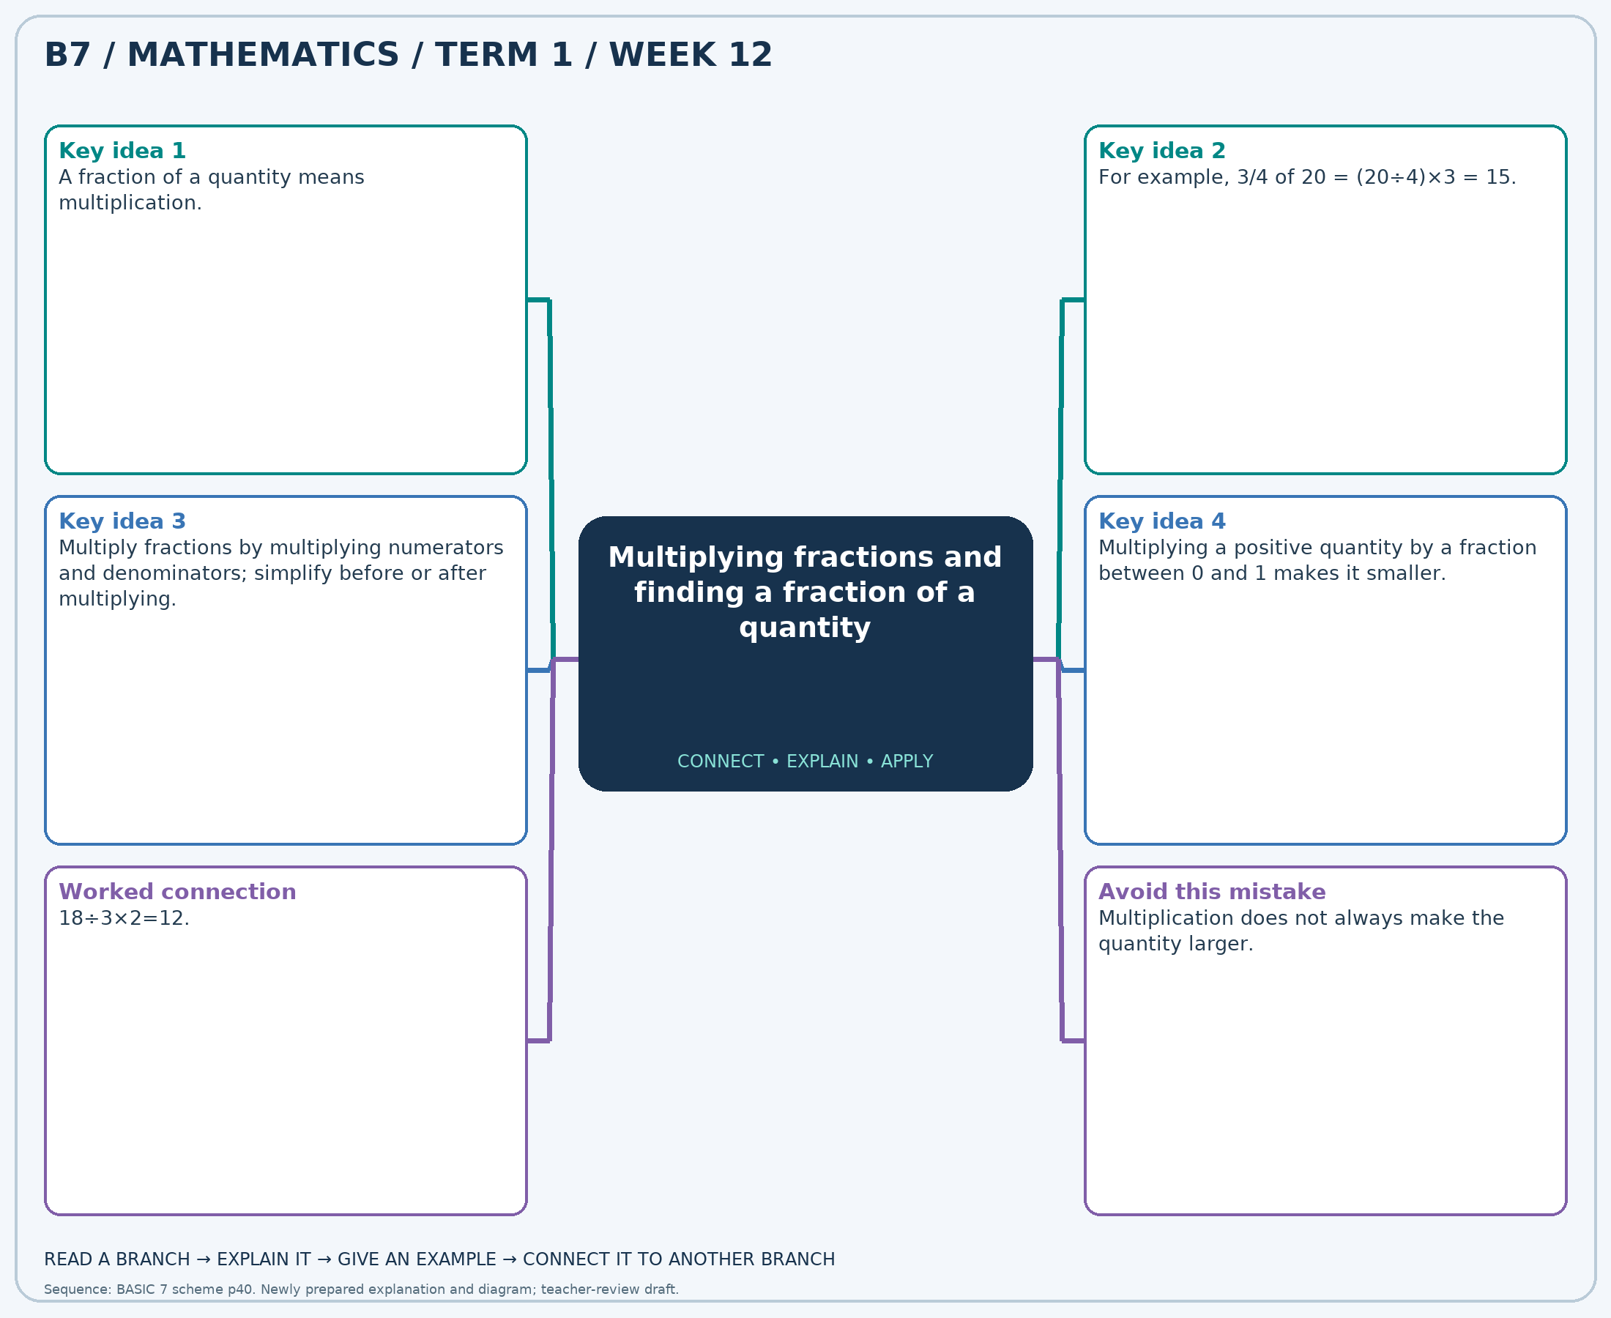
The separate high-resolution PNG can be projected or printed larger. Explain each branch and connect it with an example.

Week 12 — Practice

Section A — Multiple-choice questions
Choose ONE correct answer for each question. Each question has four alternatives.
1. Find 1/3 of 12.
A. 5 B. 6 C. 3 D. 4
2. Find 1/2 of 48.
A. 24 B. 25 C. 26 D. 23
3. Calculate 1/2 × 4/5.
A. 7/5 B. 12/5 C. -3/5 D. 2/5
4. Find 1/4 of 48.
A. 12 B. 13 C. 11 D. 14
5. Find 1/4 of 36.
A. 8 B. 11 C. 10 D. 9
6. Calculate 2/3 × 2/5.
A. 34/15 B. 4/15 C. 19/15 D. -11/15
7. Find 1/2 of 12.
A. 5 B. 8 C. 7 D. 6
8. Find 1/3 of 30.
A. 10 B. 12 C. 9 D. 11
9. Calculate 3/4 × 2/3.
A. -1/2 B. 1/2 C. 3/2 D. 5/2
10. Find 3/4 of 40.
A. 31 B. 30 C. 32 D. 29
11. Find 2/5 of 50.
A. 21 B. 20 C. 22 D. 19
12. Calculate 1/5 × 2/5.
A. -23/25 B. 27/25 C. 52/25 D. 2/25
13. Find 2/5 of 40.
A. 15 B. 18 C. 16 D. 17
14. Find 1/2 of 24.
A. 12 B. 14 C. 13 D. 11
15. Calculate 3/4 × 4/5.
A. 8/5 B. 13/5 C. 3/5 D. -2/5
16. Find 1/3 of 24.
A. 7 B. 9 C. 10 D. 8
17. Calculate 2/3 × 1/9.
A. 29/27 B. 2/27 C. 56/27 D. -25/27
18. Find 4/5 of 35.
A. 28 B. 27 C. 30 D. 29
19. Calculate 1/4 × 1/4.
A. 1/16 B. -15/16 C. 17/16 D. 33/16
20. Find 2/5 of 60.
A. 23 B. 25 C. 26 D. 24

Section B — Structured essay questions
Answer every part (a), (b), (c). Show your method or explain your choice. Write in a separate answer booklet. Each part: 1 mark for valid working/explanation and 1 for the correct result; 6 marks per question.

1. Apply the related skills and show working or give a reason for each answer.
(a) Find 7/8 of 32.
(b) Find 2/3 of 15.
(c) Calculate 2/3 × 2/3.

2. Apply the related skills and show working or give a reason for each answer.
(a) Find 1/4 of 48.
(b) Calculate 3/4 × 1/2.
(c) Find 3/8 of 48.

3. Apply the related skills and show working or give a reason for each answer.
(a) Calculate 1/4 × 1/2.
(b) Find 5/8 of 32.
(c) Find 1/8 of 88.

4. Apply the related skills and show working or give a reason for each answer.
(a) Find 1/3 of 15.
(b) Find 4/5 of 30.
(c) Calculate 2/3 × 1/7.

5. Apply the related skills and show working or give a reason for each answer.
(a) Find 1/3 of 33.
(b) Calculate 3/4 × 4/7.
(c) Find 1/4 of 48.

6. Apply the related skills and show working or give a reason for each answer.
(a) Calculate 3/8 × 1/8.
(b) Find 2/3 of 18.
(c) Find 3/4 of 88.

7. Apply the related skills and show working or give a reason for each answer.
(a) Find 1/3 of 12.
(b) Find 7/8 of 96.
(c) Calculate 3/5 × 1/7.

8. Apply the related skills and show working or give a reason for each answer.
(a) Find 1/2 of 16.
(b) Calculate 1/4 × 1/2.
(c) Find 3/5 of 40.

9. Apply the related skills and show working or give a reason for each answer.
(a) Calculate 1/3 × 1/2.
(b) Find 1/4 of 40.
(c) Find 1/4 of 20.

10. Apply the related skills and show working or give a reason for each answer.
(a) Find 2/3 of 18.
(b) Find 2/5 of 45.
(c) Calculate 1/3 × 4/9.

