Basic 7 Science — Week 1
  - States of matter and the importance of liquids • Term 1 • Week 1 ONLY
Name: __________________________________ Class: __________
Date: __________________ Teacher: ________________________
SCOPE: WEEK 1 ONLY. Later weeks and both tests for this subject are NOT included in this partial batch. Emergency teacher-review draft — rebuilt edition.
Sequence source: BASIC 7 SCHEME OF LEARNING.pdf, p55; indicator reference B7.1.1.1.1–2. Topic descriptions informed by the local curriculum data. Explanations and activities are newly prepared, including supporting concepts.

Learning outcomes
- Explain the key ideas in states of matter and the importance of liquids using accurate vocabulary.
- Identify examples and justify classification or tool choices using evidence.
- Apply the ideas to familiar school or home situations and correct a common misconception.

Teacher lesson notes
One consolidated weekly unit. Suggested organisation: three 40-minute teaching sessions plus guided practice and assessment in the remaining timetable periods. Spread the questions over the week.
Prior knowledge: elicit a familiar example and ask for a reason. Record one correct idea and one misconception to revisit at the end of the week.

Session 1 — Observe
5 minutes: recall examples; 10: demonstrate or show pictures; 15: pairs describe features; 10: introduce the first five key terms and check explanations.

Session 2 — Investigate
5 minutes: retrieve vocabulary; 10: model an explanation; 15: perform the specific activity below; 10: compare observations and introduce the remaining terms.

Session 3 — Apply
5 minutes: correct a misconception; 10: explain map branches; 15: use application questions; 10: collect an exit response and identify who needs reteaching.

Topic-specific activity
Compare a stone, water poured between two containers, and air in a balloon. Predict and record shape and volume behaviour. Draw particle models, then link liquid properties with safe daily uses.

Safety and resources
Use room-temperature water. Do not taste unknown liquids or heat sealed containers.
Resources: the examples or pictures specified in the activity, board, pencils, exercise books and the supplied visual map. If equipment is unavailable, use labelled drawings and role-play rather than claiming a practical was performed.

Support and extension
Support: offer picture labels, read technical vocabulary aloud and accept an oral explanation before writing. Extension: compare related concepts, propose a counterexample and justify a new application. Use wrong MCQ choices to diagnose misconceptions, not merely score letters.

Study notes

Solid
A state of matter with definite shape and approximately fixed volume under ordinary conditions.
Particles are closely arranged and vibrate about relatively fixed positions. This helps the material retain its shape rather than flow like a liquid.

Liquid
A state with approximately fixed volume but the shape of the occupied part of its container.
Particles stay close but can move past neighbours. Shape changes without a large change in the amount of space occupied.

Gas
A state with neither fixed shape nor fixed volume, spreading through available space.
Particles are widely separated and move freely. The material fills available space rather than forming a fixed-volume pool.

Volume
The amount of three-dimensional space a substance occupies.
Millilitres and cubic centimetres measure volume. A balance measures mass, which is a different property.

Flow
Movement of a liquid enabled by particles moving past one another.
Liquid particles can change neighbours while remaining close. This permits movement along a pipe or into another container.

Compression
Reduction of a substance’s volume by applying pressure.
Gas particles have much more space between them. Pressure reduces those separations; liquid particles already lie close together.

Water
A common liquid essential for human hydration.
Safe drinking water replaces losses such as sweat. A clear liquid may still contain harmful substances or organisms.

Solvent
A substance that dissolves a solute to form a solution.
Water dissolves the sugar, but the sugar still exists in the mixture. Individual grains are no longer visible because particles are distributed through the solution.

Lubrication
Use of a suitable material to reduce friction between moving surfaces.
A separating layer reduces direct rubbing and wear. The correct lubricant must be chosen for the equipment.

Meniscus
The curved liquid surface in a narrow container.
Read water at the bottom of its curve with the eye level with the mark. Place the cylinder upright on a level surface to avoid misleading readings.
Revision routine: cover each definition, explain the idea, supply a new example and compare it with a related term. Reconstruct the map from memory before checking it.

Week 1 — Visual mind-map
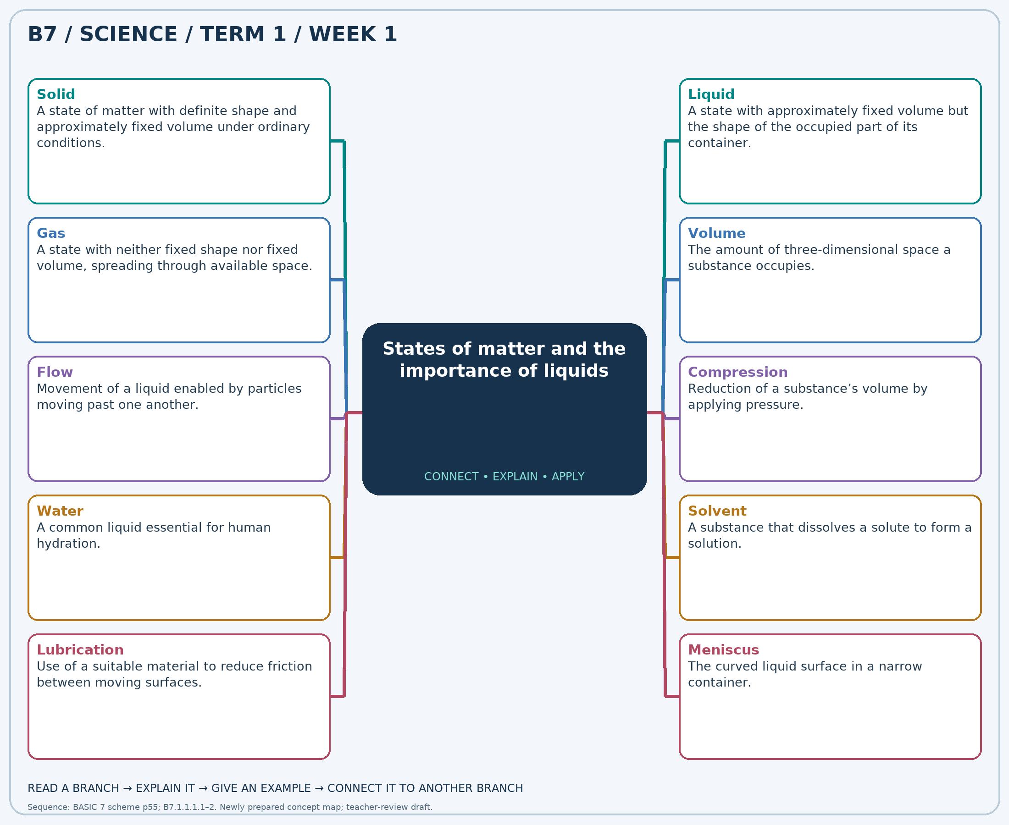
Explain each branch and supply another example. A separate high-resolution PNG is included.

Week 1 — Practice

Section A — Multiple-choice questions
Choose ONE correct answer for each question. Each question has four alternatives.
1. Which term best matches this description: a state of matter with definite shape and approximately fixed volume under ordinary conditions?
A. Liquid B. Gas C. Solid D. Vacuum
2. Which term best matches this description: a state with approximately fixed volume but the shape of the occupied part of its container?
A. Gas B. Vacuum C. Solid D. Liquid
3. Which term best matches this description: a state with neither fixed shape nor fixed volume, spreading through available space?
A. Ice B. Solid C. Gas D. Liquid
4. Which term best matches this description: the amount of three-dimensional space a substance occupies?
A. Length B. Mass C. Temperature D. Volume
5. Which term best matches this description: movement of a liquid enabled by particles moving past one another?
A. Flow B. Keeping a fixed shape C. Always expanding like a gas D. Having no particles
6. Which term best matches this description: reduction of a substance’s volume by applying pressure?
A. Freezing B. Boiling C. Compression D. Melting
7. Which term best matches this description: a common liquid essential for human hydration?
A. Petrol B. Paint thinner C. Kerosene D. Water
8. Which term best matches this description: a substance that dissolves a solute to form a solution?
A. Filter paper B. Solid solute C. Solvent D. Undissolved residue
9. Which term best matches this description: use of a suitable material to reduce friction between moving surfaces?
A. Freezing B. Lubrication C. Condensation D. Filtration
10. Which term best matches this description: the curved liquid surface in a narrow container?
A. Thermometer bulb B. Balance pointer C. Meniscus D. Ruler edge
11. A stone keeps its shape when moved from a bowl to a box. Which state is it in?
A. Vacuum B. Liquid C. Gas D. Solid
12. Water changes shape when poured into a wider bowl without spilling. Which state explains this?
A. Liquid B. Solid C. Vacuum D. Gas
13. Air spreads throughout an inflated balloon. Which state is represented?
A. Ice B. Liquid C. Gas D. Solid
14. A cylinder reading is 100 mL. Which quantity has been measured?
A. Mass B. Length C. Volume D. Temperature
15. Water travels through a pipe towards a tap. Which behaviour makes this possible?
A. Keeping a fixed shape B. Flow C. Having no particles D. Always expanding like a gas
16. A sealed air-filled syringe can be pushed inward more easily than a water-filled one. Which process is easier for air?
A. Melting B. Boiling C. Freezing D. Compression
17. After exercise, which substance is suitable for replacing lost body water when it is potable?
A. Paint thinner B. Petrol C. Kerosene D. Water
18. Sugar dissolves in water. What role does the water play?
A. Filter paper B. Undissolved residue C. Solvent D. Solid solute
19. A mechanic puts suitable oil between moving parts to reduce rubbing. What use of liquids is shown?
A. Lubrication B. Condensation C. Freezing D. Filtration
20. A learner reads the bottom of the water curve at eye level in a cylinder. What feature is being read?
A. Ruler edge B. Balance pointer C. Meniscus D. Thermometer bulb

Section B — 10 structured essay questions
Answer every part (a), (b), (c) in your exercise book. Suggested marks: (a) 1, (b) 1, (c) 2, giving 4 marks per question. Explain relationships and use examples where requested.

Question 1
(a) Explain the term “Solid”.
(b) A stone keeps its shape when moved from a bowl to a box. Which state is it in?
(c) Use a particle explanation for the stone’s fixed shape.

Question 2
(a) Explain the term “Liquid”.
(b) Water changes shape when poured into a wider bowl without spilling. Which state explains this?
(c) Explain why pouring changes shape but not the volume of the water.

Question 3
(a) Explain the term “Gas”.
(b) Air spreads throughout an inflated balloon. Which state is represented?
(c) Explain how particle arrangement helps this state fill a container.

Question 4
(a) Explain the term “Volume”.
(b) A cylinder reading is 100 mL. Which quantity has been measured?
(c) Distinguish volume from mass and name one measuring tool for each.

Question 5
(a) Explain the term “Flow”.
(b) Water travels through a pipe towards a tap. Which behaviour makes this possible?
(c) Use particle movement to explain this behaviour.

Question 6
(a) Explain the term “Compression”.
(b) A sealed air-filled syringe can be pushed inward more easily than a water-filled one. Which process is easier for air?
(c) Explain why trapped air is more compressible than water.

Question 7
(a) Explain the term “Water”.
(b) After exercise, which substance is suitable for replacing lost body water when it is potable?
(c) Explain why clear appearance does not prove a liquid is safe to drink.

Question 8
(a) Explain the term “Solvent”.
(b) Sugar dissolves in water. What role does the water play?
(c) Explain why dissolved sugar has not ceased to exist.

Question 9
(a) Explain the term “Lubrication”.
(b) A mechanic puts suitable oil between moving parts to reduce rubbing. What use of liquids is shown?
(c) Explain how a suitable oil can reduce wear on moving parts.

Question 10
(a) Explain the term “Meniscus”.
(b) A learner reads the bottom of the water curve at eye level in a cylinder. What feature is being read?
(c) Describe two steps for accurately measuring water volume.

