Basic 8 Computing — Week 1
  - Fifth-generation themes, AI and quantum computing • Term 1 • Week 1 ONLY
Name: __________________________________ Class: __________
Date: __________________ Teacher: ________________________
SCOPE: WEEK 1 ONLY. Later weeks and both tests for this subject are NOT included in this partial batch. Emergency teacher-review draft — rebuilt edition.
Sequence source: BASIC 8 SCHEME OF LEARNING.pdf, p21; indicator reference B8.1.1.1.1. Topic descriptions informed by the local curriculum data. Explanations and activities are newly prepared, including supporting concepts.

Learning outcomes
- Explain the key ideas in fifth-generation themes, ai and quantum computing using accurate vocabulary.
- Identify examples and justify classification or tool choices using evidence.
- Apply the ideas to familiar school or home situations and correct a common misconception.

Teacher lesson notes
One consolidated weekly unit. Suggested organisation: three 40-minute teaching sessions plus guided practice and assessment in the remaining timetable periods. Spread the questions over the week.
Prior knowledge: elicit a familiar example and ask for a reason. Record one correct idea and one misconception to revisit at the end of the week.

Session 1 — Observe
5 minutes: recall examples; 10: demonstrate or show pictures; 15: pairs describe features; 10: introduce the first five key terms and check explanations.

Session 2 — Investigate
5 minutes: retrieve vocabulary; 10: model an explanation; 15: perform the specific activity below; 10: compare observations and introduce the remaining terms.

Session 3 — Apply
5 minutes: correct a misconception; 10: explain map branches; 15: use application questions; 10: collect an exit response and identify who needs reteaching.

Topic-specific activity
Compare ordinary computers, AI applications and introductory quantum computing. Discuss speech recognition and image classification. Model a classical bit with two labelled cards but explain that coin-toss randomness is not a complete model of a qubit. Evaluate exaggerated claims about new technology.

Safety and resources
Use fictional data. Do not create learner accounts or upload private records or recordings for demonstrations.
Resources: the examples or pictures specified in the activity, board, pencils, exercise books and the supplied visual map. If equipment is unavailable, use labelled drawings and role-play rather than claiming a practical was performed.

Support and extension
Support: offer picture labels, read technical vocabulary aloud and accept an oral explanation before writing. Extension: compare related concepts, propose a counterexample and justify a new application. Use wrong MCQ choices to diagnose misconceptions, not merely score letters.

Study notes

Artificial intelligence
Computational methods for tasks associated with learning, reasoning or perception.
Such systems may make mistakes and depend on design and training data. Their output does not imply reliable human-like understanding of every situation.

Natural language processing
Computational work with human language.
Language applications include translation or question answering. Ambiguity and unfamiliar usage may cause errors.

Machine learning
Using examples and data to fit models that identify patterns for predictions or decisions.
The examples influence the learned patterns. Biased or unrepresentative training data can produce poor decisions.

Robotics
The study and use of machines that sense and act in the physical world under control or programming.
A robot has physical sensing and action. Not every robot uses AI and not every AI system is a physical robot.

Bit
A classical information unit with one of two logical values, commonly 0 or 1.
One such unit has two states; groups of units encode many patterns for numbers, letters and other information.

Qubit
A unit of quantum information described by a quantum state.
This is not simply a faster ordinary bit. Its state can involve superposition, while a computational-basis measurement produces 0 or 1.

Superposition
A quantum state formed as a combination of basis states before measurement.
This does not let a user read every possible classical answer at once. Measurement gives an outcome with probabilities determined by the quantum state.

Measurement
An operation producing a classical outcome from a quantum observation in a chosen basis.
One such observation gives a single classical outcome. Repeated experiments can estimate probabilities rather than revealing every outcome from one run.

Quantum computing
Information processing using quantum states and operations, potentially advantageous for selected specialised problems.
This is not faster for every task, and practical systems face noise and engineering limits. Ordinary computers remain appropriate for everyday documents.

Human oversight
People checking, guiding and taking responsibility for automated systems.
People should verify facts, consider bias and protect privacy. Output is something to evaluate, not an unquestionable authority.
Revision routine: cover each definition, explain the idea, supply a new example and compare it with a related term. Reconstruct the map from memory before checking it.

Week 1 — Visual mind-map
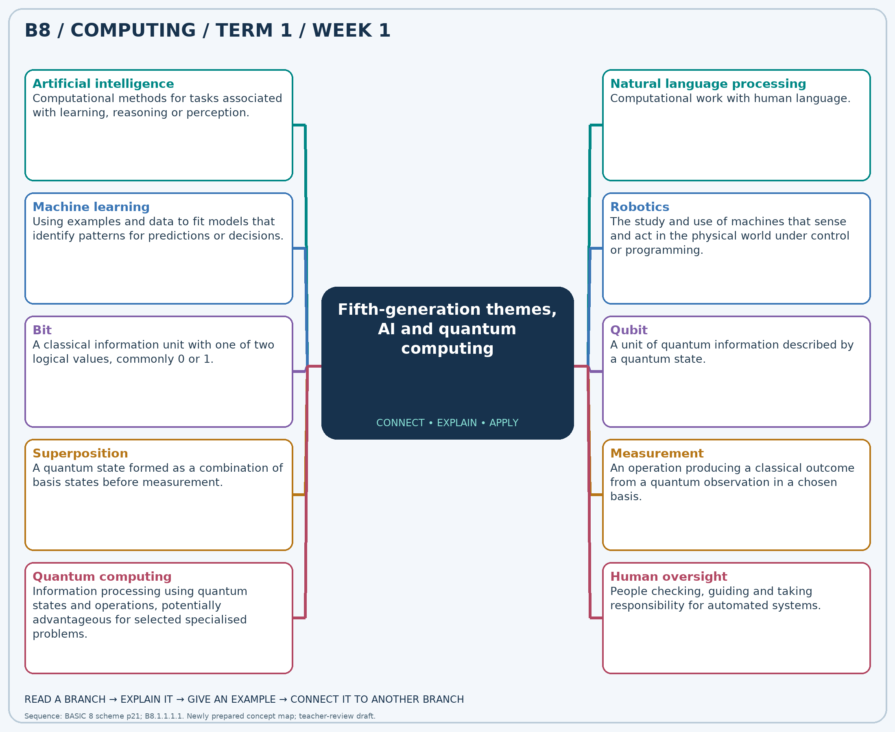
Explain each branch and supply another example. A separate high-resolution PNG is included.

Week 1 — Practice

Section A — Multiple-choice questions
Choose ONE correct answer for each question. Each question has four alternatives.
1. Which term best matches this description: computational methods for tasks associated with learning, reasoning or perception?
A. Manual filing B. Paper storage C. Artificial intelligence D. Mechanical printing only
2. Which term best matches this description: computational work with human language?
A. Paper binding B. Disk formatting C. Natural language processing D. Screen cleaning
3. Which term best matches this description: using examples and data to fit models that identify patterns for predictions or decisions?
A. Machine learning B. Manual sorting only C. File copying only D. Paper printing
4. Which term best matches this description: the study and use of machines that sense and act in the physical world under control or programming?
A. Robotics B. Word formatting only C. Audio playback only D. Paper filing
5. Which term best matches this description: a classical information unit with one of two logical values, commonly 0 or 1?
A. Paragraph B. Qubit superposition C. Printed page D. Bit
6. Which term best matches this description: a unit of quantum information described by a quantum state?
A. Mechanical gear B. Qubit C. Ordinary byte only D. Printed character
7. Which term best matches this description: a quantum state formed as a combination of basis states before measurement?
A. Paper copying B. Classical certainty only C. Ordinary file duplication D. Superposition
8. Which term best matches this description: an operation producing a classical outcome from a quantum observation in a chosen basis?
A. Paper scanning B. Keyboard printing C. Document formatting D. Measurement
9. Which term best matches this description: information processing using quantum states and operations, potentially advantageous for selected specialised problems?
A. Quantum computing B. Ordinary paper filing C. Mechanical typewriting D. Manual arithmetic only
10. Which term best matches this description: people checking, guiding and taking responsibility for automated systems?
A. Ignoring evidence B. Blind trust C. Human oversight D. Automatic copying
11. A program identifies likely objects in photographs using learned patterns. Which field is illustrated?
A. Manual filing B. Artificial intelligence C. Mechanical printing only D. Paper storage
12. A system analyses a typed question and produces a language-based response. Which area is involved?
A. Screen cleaning B. Natural language processing C. Disk formatting D. Paper binding
13. A spam filter is trained on labelled spam and non-spam messages. Which approach is used?
A. Manual sorting only B. File copying only C. Paper printing D. Machine learning
14. A moving machine uses sensors to avoid obstacles. Which field best describes this?
A. Robotics B. Audio playback only C. Paper filing D. Word formatting only
15. A stored switch state is represented as either 0 or 1. Which information unit is this?
A. Bit B. Printed page C. Paragraph D. Qubit superposition
16. A researcher manipulates the information units of a quantum processor. What are these units called?
A. Ordinary byte only B. Mechanical gear C. Printed character D. Qubit
17. A lesson describes a qubit state as a combination of the 0 and 1 basis states. Which concept is intended?
A. Ordinary file duplication B. Paper copying C. Classical certainty only D. Superposition
18. A scientist reads a qubit in the computational basis and records 0. What operation occurred?
A. Document formatting B. Paper scanning C. Measurement D. Keyboard printing
19. A team investigates algorithms implemented using qubits. Which approach is being studied?
A. Quantum computing B. Ordinary paper filing C. Mechanical typewriting D. Manual arithmetic only
20. A teacher checks an AI explanation against trusted sources before teaching it. Which practice is shown?
A. Human oversight B. Ignoring evidence C. Blind trust D. Automatic copying

Section B — 10 structured essay questions
Answer every part (a), (b), (c) in your exercise book. Suggested marks: (a) 1, (b) 1, (c) 2, giving 4 marks per question. Explain relationships and use examples where requested.

Question 1
(a) Explain the term “Artificial intelligence”.
(b) A program identifies likely objects in photographs using learned patterns. Which field is illustrated?
(c) Explain why an answer produced by such a system should be checked.

Question 2
(a) Explain the term “Natural language processing”.
(b) A system analyses a typed question and produces a language-based response. Which area is involved?
(c) Give one useful application and one reason its output needs checking.

Question 3
(a) Explain the term “Machine learning”.
(b) A spam filter is trained on labelled spam and non-spam messages. Which approach is used?
(c) Explain how unsuitable training examples affect a spam filter.

Question 4
(a) Explain the term “Robotics”.
(b) A moving machine uses sensors to avoid obstacles. Which field best describes this?
(c) Distinguish a robot from an AI text program.

Question 5
(a) Explain the term “Bit”.
(b) A stored switch state is represented as either 0 or 1. Which information unit is this?
(c) Explain how units with only two states can encode more complex information.

Question 6
(a) Explain the term “Qubit”.
(b) A researcher manipulates the information units of a quantum processor. What are these units called?
(c) Explain one difference between this unit and a classical bit.

Question 7
(a) Explain the term “Superposition”.
(b) A lesson describes a qubit state as a combination of the 0 and 1 basis states. Which concept is intended?
(c) Explain why this concept does not mean all answers can simply be read at once.

Question 8
(a) Explain the term “Measurement”.
(b) A scientist reads a qubit in the computational basis and records 0. What operation occurred?
(c) Explain why repeated runs can help interpret a quantum experiment.

Question 9
(a) Explain the term “Quantum computing”.
(b) A team investigates algorithms implemented using qubits. Which approach is being studied?
(c) Explain why this approach is not automatically the best tool for typing a school letter.

Question 10
(a) Explain the term “Human oversight”.
(b) A teacher checks an AI explanation against trusted sources before teaching it. Which practice is shown?
(c) State two checks a teacher should make before using an AI-produced resource.

