Basic 8 Mathematics
  - Term 1 • Weeks 1–12 • Lesson notes, study notes, mind-maps and weekly practice
Name: __________________________________ Class: __________
Date: __________________ Teacher: ________________________
EMERGENCY TEACHER-REVIEW DRAFT — REBUILT EDITION. Topic order follows the supplied Alpha Examinations first-term scheme. Notes, examples and diagrams are newly prepared. This is not an official curriculum approval or a guarantee of full indicator-by-indicator validation.
Each week contains one consolidated weekly lesson unit, one visual mind-map, 20 four-option MCQs and 10 structured questions with parts (a), (b), (c). Daily sessions are suggested, not separate full daily lesson plans. Answers are in the separate teacher book.
The source reserves Weeks 13–15 for revision/examinations/vacation. Mid-term assessment assumes Weeks 1–6; end-of-term assumes Weeks 1–12. Confirm school dates and pacing. Some task structures repeat with new values for fluency practice.

Weekly contents
01 — Reading and writing large numbers / Skip counting
02 — Comparing and ordering whole numbers / Standard form
03 — Significant figures
04 — Place value and expanded form / Sets, union, intersection and squares
05 — Sets, union, intersection and squares / Multiplying and dividing by powers of ten
06 — Multiplication strategies / Multi-step number problems
07 — Whole-number and decimal operations / Multiplication strategies / Division and checking
08 — Whole-number and decimal operations / Laws of indices
09 — Laws of indices / Simple exponential equations
10 — Powers and repeated factors / Gradient of a straight line
11 — Gradient of a straight line
12 — Gradient of a straight line

Week 1 — Reading and writing large numbers / Skip counting
Sequence source: BASIC 8 SCHEME OF LEARNING.pdf, first-term Mathematics, page 48. One consolidated weekly unit.

Learning outcomes
- Explain and apply reading and writing large numbers, solve examples and justify the method.
- Explain and apply skip counting, solve examples and justify the method.

Teaching notes and suggested sessions
Suggested schedule: five 40-minute sessions, adjusted to the school timetable. Spread the question bank through the week; it is not intended to be completed in one lesson.

1 — Explore and diagnose
5 minutes: recall an earlier skill; 10: demonstrate a concrete or pictorial model; 15: pairs investigate and explain; 10: identify a misconception and set an exit task.

2 — Model and practise
5 minutes: review the exit task; 10: work an example aloud; 15: pairs solve parallel examples; 10: compare methods and correct errors.

3 — Connect representations
5 minutes: recall vocabulary; 10: explain the mind-map; 15: connect a model, a drawing and a symbolic calculation; 10: independent practice.

4 — Apply and explain
5 minutes: estimate or predict; 10: solve a contextual example; 15: attempt selected structured-question parts; 10: compare reasoning and check units.

5 — Check and respond
5 minutes: retrieve the main rule; 15: use selected MCQs diagnostically; 10: explain distractors and misconceptions; 10: reteach or extend in response to evidence.

Topic-specific activities
- Partners dictate numbers and write figures, checking every place on a chart.
- Mark equal jumps on a number line and explain both forward and backward patterns.
Resources: board, pencils, number cards, counters, paper strips and squared paper as appropriate. Prior-knowledge check: ask a learner to explain a representation used in the first example before introducing a new rule.
Support: reduce number size without changing the concept; offer a partially completed chart or model; allow oral reasoning before writing. Extension: create a counterexample to a false rule and explain why it fails.

Study notes and worked examples

Reading and writing large numbers
- Group digits in threes from the right: ones, thousands, millions and billions.
- Read each non-zero group, followed by its scale name.
- When writing figures from words, put zeros in the places not named.
- Six hundred and three thousand and eight is 603,008. Read the result back to check it.
Worked example: Write in figures: seven billion, six hundred and one million, forty-one thousand, four hundred and seventy-one.
Solution: Place each named group in its correct scale: 7,601,041,471.
Common misconception: Do not write 603,800 for six hundred and three thousand and eight.

Skip counting
- Skip counting adds or subtracts a fixed step repeatedly.
- Find the difference between neighbouring terms before extending a sequence.
- Check a missing middle term against the numbers on both sides.
- Crossing a hundred or thousand boundary does not change the counting step.
Worked example: Find the next term: 1,775,200,000, 1,775,100,000, 1,775,000,000, …
Solution: The constant step is -100,000; next term = 1,774,900,000.
Common misconception: Keep the interval constant rather than copying a pattern in only the last digit.
Independent study: read the map, cover it and reconstruct the branches. Solve an unused question from each skill and explain the reasoning to a partner. Consult the teacher key only after an honest attempt.

Week 1 — Visual mind-map
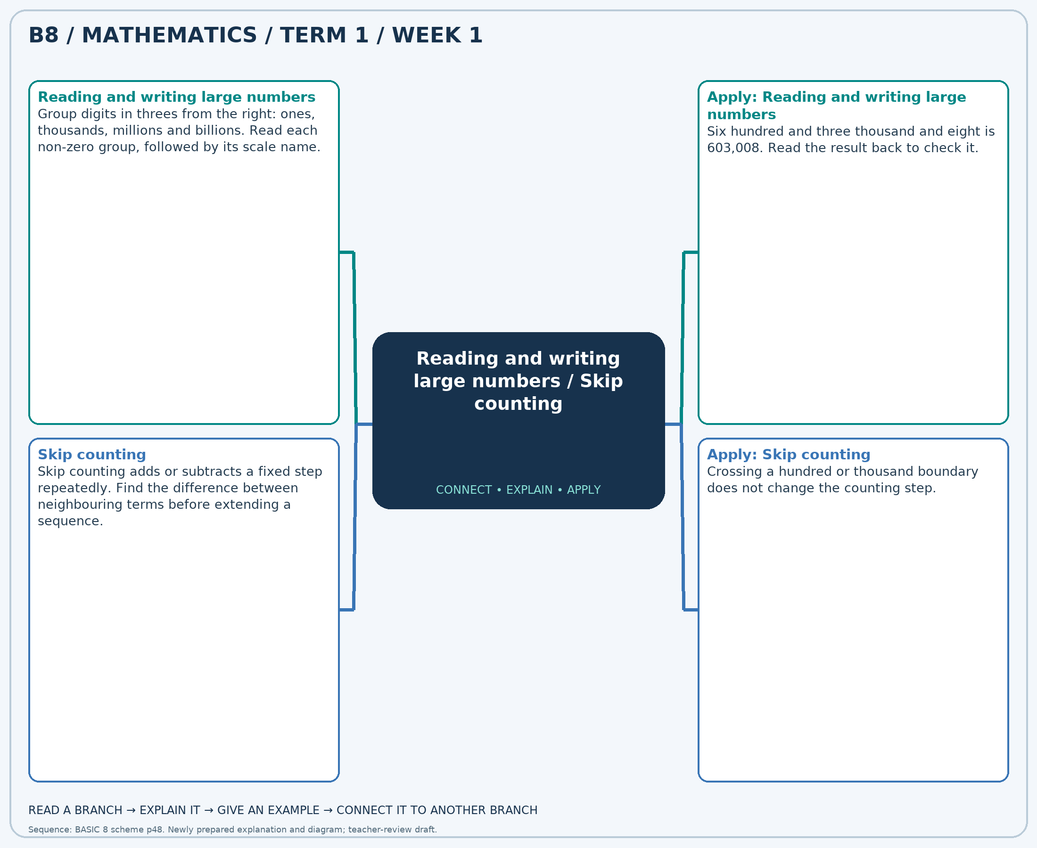
The separate high-resolution PNG can be projected or printed larger. Explain each branch and connect it with an example.

Week 1 — Practice

Section A — Multiple-choice questions
Choose ONE correct answer for each question. Each question has four alternatives.
1. Write in figures: three billion, three hundred and thirty million, three hundred and eighty-one thousand, three hundred and eighty.
A. 3330380380 B. 3330381480 C. 3330382380 D. 3330381380
2. Find the next term: 4,689,800,000, 4,689,700,000, 4,689,600,000, …
A. 4689400000 B. 4689500000 C. 4689300000 D. 4689600000
3. Write in figures: six billion, two hundred and thirty-four million, eight hundred and five thousand, five hundred and fifty-nine.
A. 6234806559 B. 6234805659 C. 6234804559 D. 6234805559
4. Find the next term: 4,646,300,000, 4,646,200,000, 4,646,100,000, …
A. 4645800000 B. 4646000000 C. 4646100000 D. 4645900000
5. Write in figures: seven billion, six hundred and six million, two hundred and fifty-seven thousand, six hundred and sixty-three.
A. 7606257663 B. 7606257763 C. 7606256663 D. 7606258663
6. Find the next term: 2,660,500,000, 2,660,490,000, 2,660,480,000, …
A. 2660460000 B. 2660480000 C. 2660470000 D. 2660450000
7. Write in figures: two billion, six hundred and eighteen million, nine hundred and ninety-nine thousand, two hundred and seventy-six.
A. 2618998276 B. 2619000276 C. 2618999276 D. 2618999376
8. Find the next term: 4,196,100,000, 4,196,000,000, 4,195,900,000, …
A. 4195900000 B. 4195600000 C. 4195700000 D. 4195800000
9. Write in figures: five billion, eight hundred and seven million, three hundred and thirty-four thousand, three hundred and eighty-two.
A. 5807334482 B. 5807334382 C. 5807335382 D. 5807333382
10. Find the next term: 3,462,300,000, 3,462,400,000, 3,462,500,000, …
A. 3462600000 B. 3462500000 C. 3462800000 D. 3462700000
11. Write in figures: seven billion, two hundred and forty-three million, one hundred and nineteen thousand, eight hundred and nineteen.
A. 7243120819 B. 7243119919 C. 7243119819 D. 7243118819
12. Find the next term: 1,837,400,000, 1,837,390,000, 1,837,380,000, …
A. 1837360000 B. 1837350000 C. 1837370000 D. 1837380000
13. Write in figures: two billion, two hundred and fifty-five million, one hundred and fifty thousand, five hundred and ninety-five.
A. 2255151595 B. 2255149595 C. 2255150595 D. 2255150695
14. Find the next term: 1,511,700,000, 1,511,600,000, 1,511,500,000, …
A. 1511500000 B. 1511300000 C. 1511400000 D. 1511200000
15. Write in figures: six billion, nine hundred and twenty-three million, five hundred and eighteen thousand and seventy-five.
A. 6923517075 B. 6923518175 C. 6923518075 D. 6923519075
16. Find the next term: 1,756,700,000, 1,756,710,000, 1,756,720,000, …
A. 1756750000 B. 1756730000 C. 1756740000 D. 1756720000
17. Write in figures: eight billion, nine hundred and ninety-six million, seven hundred and seventy-two thousand, seven hundred and ninety-nine.
A. 8996771799 B. 8996772799 C. 8996772899 D. 8996773799
18. Find the next term: 2,635,100,000, 2,635,000,000, 2,634,900,000, …
A. 2634900000 B. 2634800000 C. 2634600000 D. 2634700000
19. Write in figures: three billion, one hundred and two million, two hundred and thirty-three thousand, seven hundred and fifty-six.
A. 3102232756 B. 3102233756 C. 3102234756 D. 3102233856
20. Find the next term: 2,266,800,000, 2,266,700,000, 2,266,600,000, …
A. 2266500000 B. 2266300000 C. 2266400000 D. 2266600000

Section B — Structured essay questions
Answer every part (a), (b), (c). Show your method or explain your choice. Write in a separate answer booklet. Each part: 1 mark for valid working/explanation and 1 for the correct result; 6 marks per question.

1. Apply the related skills and show working or give a reason for each answer.
(a) Write in figures: six billion, ninety-seven million, six hundred and sixty-two thousand, nine hundred and forty-five.
(b) Find the next term: 4,048,000,000, 4,048,100,000, 4,048,200,000, …
(c) Write in figures: six billion, five hundred and seventy-three million, seven hundred and ninety-six thousand, one hundred and thirty-three.

2. Apply the related skills and show working or give a reason for each answer.
(a) Find the next term: 2,082,200,000, 2,082,190,000, 2,082,180,000, …
(b) Write in figures: six billion, five hundred and twelve million, eight hundred and eighty-three thousand, one hundred and seven.
(c) Find the next term: 3,632,200,000, 3,632,100,000, 3,632,000,000, …

3. Apply the related skills and show working or give a reason for each answer.
(a) Write in figures: six billion, five hundred and seventy-four million, eight hundred and seventy-nine thousand, seven hundred and thirty-eight.
(b) Find the next term: 2,475,200,000, 2,475,300,000, 2,475,400,000, …
(c) Write in figures: five billion, two hundred and fifty-three million, seven hundred and nineteen thousand, eight hundred and one.

4. Apply the related skills and show working or give a reason for each answer.
(a) Find the next term: 4,242,900,000, 4,243,000,000, 4,243,100,000, …
(b) Write in figures: three billion, two hundred and sixty-four million, nine hundred and twenty-four thousand, one hundred and seventy-seven.
(c) Find the next term: 1,966,800,000, 1,966,700,000, 1,966,600,000, …

5. Apply the related skills and show working or give a reason for each answer.
(a) Write in figures: seven billion, three hundred and sixty-two million, seven hundred and ninety-six thousand, seven hundred and twenty-one.
(b) Find the next term: 2,605,500,000, 2,605,510,000, 2,605,520,000, …
(c) Write in figures: four billion, eight hundred and seventy-five million, four hundred and forty-four thousand, seven hundred and fifty-eight.

6. Apply the related skills and show working or give a reason for each answer.
(a) Find the next term: 1,987,200,000, 1,987,100,000, 1,987,000,000, …
(b) Write in figures: three billion, four hundred and sixty-three million, seven hundred and thirty-nine thousand, nine hundred and forty-eight.
(c) Find the next term: 3,181,900,000, 3,181,910,000, 3,181,920,000, …

7. Apply the related skills and show working or give a reason for each answer.
(a) Write in figures: three billion, five hundred and eighty-seven million, three hundred and forty-seven thousand, eight hundred and eighty-eight.
(b) Find the next term: 4,203,100,000, 4,203,090,000, 4,203,080,000, …
(c) Write in figures: eight billion, seven hundred and eighty-four million, six hundred and twenty-one thousand, seven hundred and sixty-seven.

8. Apply the related skills and show working or give a reason for each answer.
(a) Find the next term: 3,338,000,000, 3,338,100,000, 3,338,200,000, …
(b) Write in figures: four billion, eight hundred and forty-two million, three hundred and fifty-three thousand, two hundred and seventy-nine.
(c) Find the next term: 3,766,900,000, 3,766,910,000, 3,766,920,000, …

9. Apply the related skills and show working or give a reason for each answer.
(a) Write in figures: seven billion, eight hundred and eight million, nine hundred and thirty-two thousand, nine hundred and ninety-seven.
(b) Find the next term: 1,662,200,000, 1,662,100,000, 1,662,000,000, …
(c) Write in figures: six billion, two hundred and seventy million, six hundred and thirty-one thousand and thirty-five.

10. Apply the related skills and show working or give a reason for each answer.
(a) Find the next term: 2,704,700,000, 2,704,690,000, 2,704,680,000, …
(b) Write in figures: six billion, twenty-seven million, six hundred and seventy-three thousand, one hundred and fifty-one.
(c) Find the next term: 2,270,200,000, 2,270,300,000, 2,270,400,000, …

Week 2 — Comparing and ordering whole numbers / Standard form
Sequence source: BASIC 8 SCHEME OF LEARNING.pdf, first-term Mathematics, page 48. One consolidated weekly unit.

Learning outcomes
- Explain and apply comparing and ordering whole numbers, solve examples and justify the method.
- Explain and apply standard form, solve examples and justify the method.

Teaching notes and suggested sessions
Suggested schedule: five 40-minute sessions, adjusted to the school timetable. Spread the question bank through the week; it is not intended to be completed in one lesson.

1 — Explore and diagnose
5 minutes: recall an earlier skill; 10: demonstrate a concrete or pictorial model; 15: pairs investigate and explain; 10: identify a misconception and set an exit task.

2 — Model and practise
5 minutes: review the exit task; 10: work an example aloud; 15: pairs solve parallel examples; 10: compare methods and correct errors.

3 — Connect representations
5 minutes: recall vocabulary; 10: explain the mind-map; 15: connect a model, a drawing and a symbolic calculation; 10: independent practice.

4 — Apply and explain
5 minutes: estimate or predict; 10: solve a contextual example; 15: attempt selected structured-question parts; 10: compare reasoning and check units.

5 — Check and respond
5 minutes: retrieve the main rule; 15: use selected MCQs diagnostically; 10: explain distractors and misconceptions; 10: reteach or extend in response to evidence.

Topic-specific activities
- Sort number cards and explain which place decides each comparison.
- Use a place-value chart to count the shifts needed for standard form.
Resources: board, pencils, number cards, counters, paper strips and squared paper as appropriate. Prior-knowledge check: ask a learner to explain a representation used in the first example before introducing a new rule.
Support: reduce number size without changing the concept; offer a partially completed chart or model; allow oral reasoning before writing. Extension: create a counterexample to a false rule and explain why it fails.

Study notes and worked examples

Comparing and ordering whole numbers
- Compare the greatest place first. A positive whole number with more digits is larger.
- For equally long numbers, compare left to right until the first unequal digit.
- The open side of > or < faces the larger quantity. The symbol = means equal value.
- Ascending order is least to greatest; descending order is greatest to least.
Worked example: Which is the greatest number: 3,226,111,043, 3,226,111,497, 3,226,111,493, 3,226,111,776?
Solution: Compare from the left. Ascending order: 3,226,111,043, 3,226,111,493, 3,226,111,497, 3,226,111,776.
Common misconception: A number containing the largest individual digit is not necessarily the largest number.

Standard form
- Standard form for a positive number is a×10^n, where 1≤a<10 and n is an integer.
- 4,500,000=4.5×10^6; the exponent is positive for this large number.
- 0.0045=4.5×10^-3; the negative exponent represents division by a power of ten.
- Convert back to ordinary notation to check coefficient and exponent.
Worked example: Write 380,000 in standard form.
Solution: 380,000=3.8 × 10^5; the coefficient is at least 1 and less than 10.
Common misconception: 45×10^5 has the right value for 4,500,000 but its coefficient is outside the standard-form range.
Independent study: read the map, cover it and reconstruct the branches. Solve an unused question from each skill and explain the reasoning to a partner. Consult the teacher key only after an honest attempt.

Week 2 — Visual mind-map
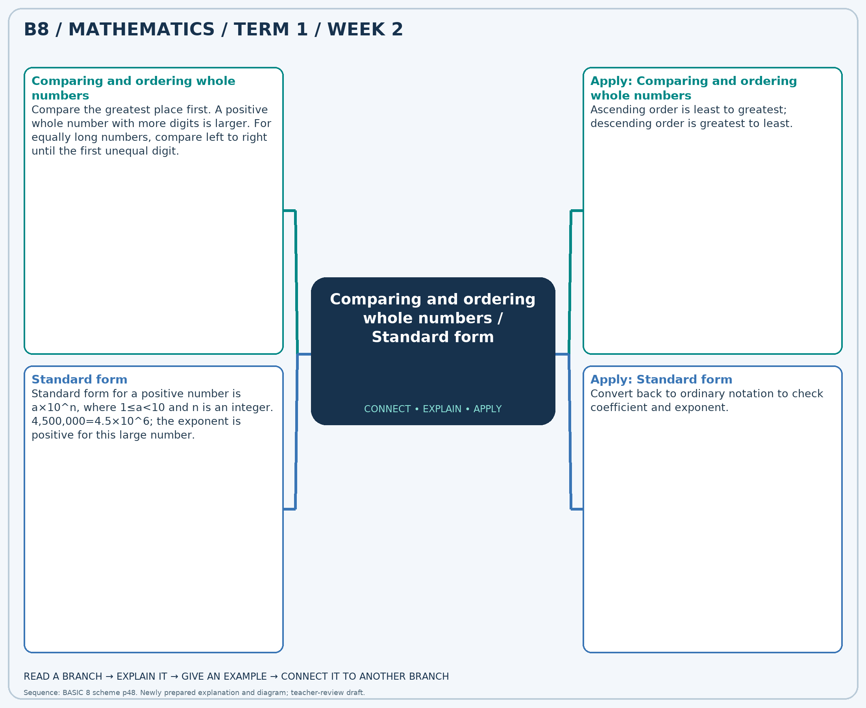
The separate high-resolution PNG can be projected or printed larger. Explain each branch and connect it with an example.

Week 2 — Practice

Section A — Multiple-choice questions
Choose ONE correct answer for each question. Each question has four alternatives.
1. Which is the greatest number: 5,048,423,832, 5,048,423,534, 5,048,423,869, 5,048,423,849?
A. 5048423849 B. 5048423832 C. 5048423869 D. 5048423534
2. Write 86,000,000 in standard form.
A. 8.6 × 10^6 B. 86 × 10^7 C. 8.6 × 10^7 D. 8.6 × 10^8
3. Which is the least number: 4,803,352,601, 4,803,353,001, 4,803,352,836, 4,803,352,676?
A. 4803352836 B. 4803352601 C. 4803353001 D. 4803352676
4. Write 800,000 in standard form.
A. 8 × 10^4 B. 8 × 10^5 C. 80 × 10^5 D. 8 × 10^6
5. Which is the greatest number: 2,754,328,278, 2,754,328,610, 2,754,328,491, 2,754,329,085?
A. 2754328491 B. 2754328610 C. 2754328278 D. 2754329085
6. Write 390,000,000 in standard form.
A. 39 × 10^8 B. 3.9 × 10^7 C. 3.9 × 10^9 D. 3.9 × 10^8
7. Which is the greatest number: 2,944,470,411, 2,944,470,212, 2,944,469,924, 2,944,470,718?
A. 2944470718 B. 2944469924 C. 2944470212 D. 2944470411
8. Write 2,300 in standard form.
A. 2.3 × 10^3 B. 2.3 × 10^2 C. 23 × 10^3 D. 2.3 × 10^4
9. Which is the least number: 4,020,076,103, 4,020,075,946, 4,020,076,104, 4,020,076,483?
A. 4020075946 B. 4020076483 C. 4020076104 D. 4020076103
10. Write 3,300 in standard form.
A. 3.3 × 10^2 B. 3.3 × 10^4 C. 33 × 10^3 D. 3.3 × 10^3
11. Which is the greatest number: 6,390,567,876, 6,390,567,040, 6,390,567,293, 6,390,567,715?
A. 6390567876 B. 6390567293 C. 6390567715 D. 6390567040
12. Write 20,000,000 in standard form.
A. 20 × 10^7 B. 2 × 10^8 C. 2 × 10^6 D. 2 × 10^7
13. Which is the greatest number: 3,822,254,276, 3,822,254,359, 3,822,253,974, 3,822,254,493?
A. 3822254493 B. 3822253974 C. 3822254359 D. 3822254276
14. Write 1,400 in standard form.
A. 1.4 × 10^3 B. 1.4 × 10^2 C. 1.4 × 10^4 D. 14 × 10^3
15. Which is the least number: 7,247,852,537, 7,247,852,737, 7,247,852,505, 7,247,852,454?
A. 7247852537 B. 7247852737 C. 7247852454 D. 7247852505
16. Write 130,000,000 in standard form.
A. 13 × 10^8 B. 1.3 × 10^8 C. 1.3 × 10^7 D. 1.3 × 10^9
17. Which is the greatest number: 1,654,012,862, 1,654,013,276, 1,654,012,878, 1,654,012,999?
A. 1654012878 B. 1654012862 C. 1654013276 D. 1654012999
18. Write 590,000,000 in standard form.
A. 59 × 10^8 B. 5.9 × 10^9 C. 5.9 × 10^8 D. 5.9 × 10^7
19. Which is the greatest number: 7,466,507,292, 7,466,507,527, 7,466,506,603, 7,466,506,754?
A. 7466506603 B. 7466507292 C. 7466507527 D. 7466506754
20. Write 7,700 in standard form.
A. 7.7 × 10^2 B. 77 × 10^3 C. 7.7 × 10^4 D. 7.7 × 10^3

Section B — Structured essay questions
Answer every part (a), (b), (c). Show your method or explain your choice. Write in a separate answer booklet. Each part: 1 mark for valid working/explanation and 1 for the correct result; 6 marks per question.

1. Apply the related skills and show working or give a reason for each answer.
(a) Which is the greatest number: 4,771,705,540, 4,771,704,835, 4,771,704,918, 4,771,705,444?
(b) Write 540,000,000 in standard form.
(c) Which is the greatest number: 4,341,494,453, 4,341,495,020, 4,341,494,527, 4,341,494,583?

2. Apply the related skills and show working or give a reason for each answer.
(a) Write 66,000,000 in standard form.
(b) Which is the greatest number: 1,200,269,183, 1,200,268,853, 1,200,269,118, 1,200,269,391?
(c) Write 560,000,000 in standard form.

3. Apply the related skills and show working or give a reason for each answer.
(a) Which is the greatest number: 5,392,406,019, 5,392,405,480, 5,392,405,649, 5,392,405,494?
(b) Write 13,000,000 in standard form.
(c) Which is the least number: 3,366,149,911, 3,366,150,102, 3,366,149,857, 3,366,150,506?

4. Apply the related skills and show working or give a reason for each answer.
(a) Write 46,000,000 in standard form.
(b) Which is the least number: 6,493,436,144, 6,493,436,680, 6,493,436,746, 6,493,437,045?
(c) Write 3,300,000 in standard form.

5. Apply the related skills and show working or give a reason for each answer.
(a) Which is the least number: 4,098,469,008, 4,098,469,445, 4,098,468,557, 4,098,469,107?
(b) Write 340,000 in standard form.
(c) Which is the greatest number: 7,085,606,956, 7,085,606,878, 7,085,607,158, 7,085,607,460?

6. Apply the related skills and show working or give a reason for each answer.
(a) Write 9,900 in standard form.
(b) Which is the greatest number: 6,129,853,012, 6,129,852,416, 6,129,852,154, 6,129,852,555?
(c) Write 620,000 in standard form.

7. Apply the related skills and show working or give a reason for each answer.
(a) Which is the greatest number: 2,232,666,788, 2,232,667,501, 2,232,666,700, 2,232,667,344?
(b) Write 960,000,000 in standard form.
(c) Which is the greatest number: 5,989,357,605, 5,989,357,603, 5,989,357,710, 5,989,357,874?

8. Apply the related skills and show working or give a reason for each answer.
(a) Write 740,000 in standard form.
(b) Which is the greatest number: 2,385,967,882, 2,385,968,196, 2,385,967,881, 2,385,968,024?
(c) Write 140,000,000 in standard form.

9. Apply the related skills and show working or give a reason for each answer.
(a) Which is the greatest number: 3,516,849,627, 3,516,849,922, 3,516,849,699, 3,516,849,532?
(b) Write 460,000 in standard form.
(c) Which is the least number: 3,558,795,939, 3,558,796,510, 3,558,796,133, 3,558,796,013?

10. Apply the related skills and show working or give a reason for each answer.
(a) Write 410,000 in standard form.
(b) Which is the least number: 3,680,511,199, 3,680,511,444, 3,680,511,196, 3,680,511,266?
(c) Write 89,000 in standard form.

Week 3 — Significant figures
Sequence source: BASIC 8 SCHEME OF LEARNING.pdf, first-term Mathematics, page 48. One consolidated weekly unit.

Learning outcomes
- Explain and apply significant figures, solve examples and justify the method.

Teaching notes and suggested sessions
Suggested schedule: five 40-minute sessions, adjusted to the school timetable. Spread the question bank through the week; it is not intended to be completed in one lesson.

1 — Explore and diagnose
5 minutes: recall an earlier skill; 10: demonstrate a concrete or pictorial model; 15: pairs investigate and explain; 10: identify a misconception and set an exit task.

2 — Model and practise
5 minutes: review the exit task; 10: work an example aloud; 15: pairs solve parallel examples; 10: compare methods and correct errors.

3 — Connect representations
5 minutes: recall vocabulary; 10: explain the mind-map; 15: connect a model, a drawing and a symbolic calculation; 10: independent practice.

4 — Apply and explain
5 minutes: estimate or predict; 10: solve a contextual example; 15: attempt selected structured-question parts; 10: compare reasoning and check units.

5 — Check and respond
5 minutes: retrieve the main rule; 15: use selected MCQs diagnostically; 10: explain distractors and misconceptions; 10: reteach or extend in response to evidence.

Topic-specific activities
- Highlight the first significant digit, then count and mark the rounding place.
Resources: board, pencils, number cards, counters, paper strips and squared paper as appropriate. Prior-knowledge check: ask a learner to explain a representation used in the first example before introducing a new rule.
Support: reduce number size without changing the concept; offer a partially completed chart or model; allow oral reasoning before writing. Extension: create a counterexample to a false rule and explain why it fails.

Study notes and worked examples

Significant figures
- Significant figures start with the first non-zero digit.
- Leading zeros do not count; zeros between significant digits do count.
- Keep the requested number of significant digits and use the next digit to round.
- 0.00476 to two significant figures is 0.0048; 47,600 to two significant figures is 48,000.
Worked example: Round 8,688 to 3 significant figure(s).
Solution: Count 3 places from the first non-zero digit, then round using the next digit: 8,690.
Common misconception: Significant figures and decimal places are different measures of precision.
Independent study: read the map, cover it and reconstruct the branches. Solve an unused question from each skill and explain the reasoning to a partner. Consult the teacher key only after an honest attempt.

Week 3 — Visual mind-map
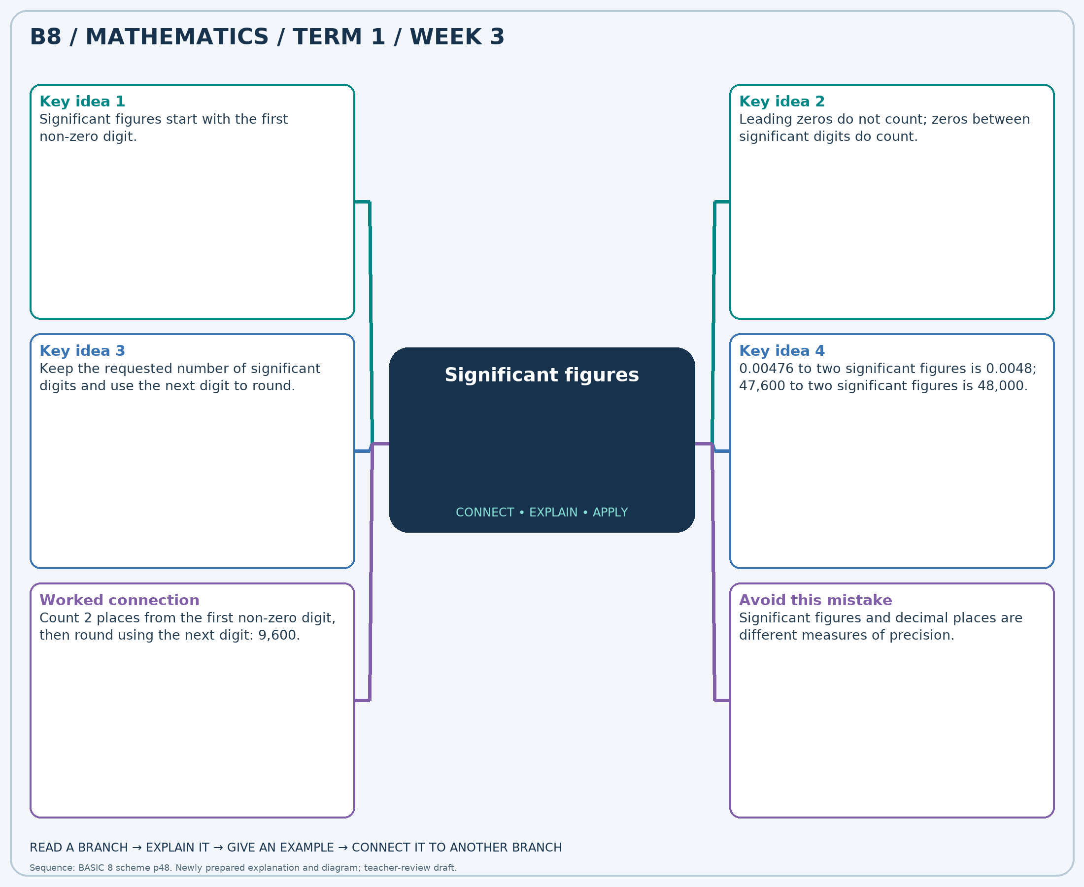
The separate high-resolution PNG can be projected or printed larger. Explain each branch and connect it with an example.

Week 3 — Practice

Section A — Multiple-choice questions
Choose ONE correct answer for each question. Each question has four alternatives.
1. Round 9,101 to 1 significant figure(s).
A. 8000 B. 11000 C. 10000 D. 9000
2. Round 8,044 to 3 significant figure(s).
A. 8030 B. 8040 C. 8060 D. 8050
3. Round 3,938 to 1 significant figure(s).
A. 6000 B. 5000 C. 3000 D. 4000
4. Round 9,563 to 2 significant figure(s).
A. 9700 B. 9500 C. 9800 D. 9600
5. Round 7,113 to 3 significant figure(s).
A. 7110 B. 7130 C. 7100 D. 7120
6. Round 4,648 to 1 significant figure(s).
A. 4000 B. 7000 C. 5000 D. 6000
7. Round 3,747 to 1 significant figure(s).
A. 3000 B. 6000 C. 5000 D. 4000
8. Round 8,815 to 1 significant figure(s).
A. 9000 B. 8000 C. 10000 D. 11000
9. Round 4,554 to 2 significant figure(s).
A. 4600 B. 4700 C. 4500 D. 4800
10. Round 1,018 to 1 significant figure(s).
A. 0 B. 2000 C. 3000 D. 1000
11. Round 5,031 to 3 significant figure(s).
A. 5030 B. 5020 C. 5040 D. 5050
12. Round 9,715 to 3 significant figure(s).
A. 9720 B. 9730 C. 9740 D. 9710
13. Round 3,734 to 1 significant figure(s).
A. 3000 B. 5000 C. 4000 D. 6000
14. Round 3,632 to 3 significant figure(s).
A. 3620 B. 3650 C. 3640 D. 3630
15. Round 9,125 to 1 significant figure(s).
A. 8000 B. 11000 C. 10000 D. 9000
16. Round 8,950 to 1 significant figure(s).
A. 9000 B. 11000 C. 10000 D. 8000
17. Round 9,115 to 2 significant figure(s).
A. 9300 B. 9000 C. 9200 D. 9100
18. Round 6,489 to 3 significant figure(s).
A. 6500 B. 6510 C. 6480 D. 6490
19. Round 4,114 to 3 significant figure(s).
A. 4130 B. 4120 C. 4110 D. 4100
20. Round 3,458 to 1 significant figure(s).
A. 2000 B. 5000 C. 3000 D. 4000

Section B — Structured essay questions
Answer every part (a), (b), (c). Show your method or explain your choice. Write in a separate answer booklet. Each part: 1 mark for valid working/explanation and 1 for the correct result; 6 marks per question.

1. Apply the related skills and show working or give a reason for each answer.
(a) Round 9,277 to 1 significant figure(s).
(b) Round 4,303 to 2 significant figure(s).
(c) Round 6,601 to 2 significant figure(s).

2. Apply the related skills and show working or give a reason for each answer.
(a) Round 9,416 to 2 significant figure(s).
(b) Round 1,996 to 1 significant figure(s).
(c) Round 8,156 to 1 significant figure(s).

3. Apply the related skills and show working or give a reason for each answer.
(a) Round 7,098 to 1 significant figure(s).
(b) Round 1,783 to 2 significant figure(s).
(c) Round 7,184 to 3 significant figure(s).

4. Apply the related skills and show working or give a reason for each answer.
(a) Round 8,023 to 2 significant figure(s).
(b) Round 2,387 to 2 significant figure(s).
(c) Round 7,186 to 2 significant figure(s).

5. Apply the related skills and show working or give a reason for each answer.
(a) Round 3,718 to 2 significant figure(s).
(b) Round 7,739 to 1 significant figure(s).
(c) Round 2,379 to 2 significant figure(s).

6. Apply the related skills and show working or give a reason for each answer.
(a) Round 2,961 to 2 significant figure(s).
(b) Round 9,735 to 2 significant figure(s).
(c) Round 1,288 to 1 significant figure(s).

7. Apply the related skills and show working or give a reason for each answer.
(a) Round 2,322 to 3 significant figure(s).
(b) Round 9,139 to 1 significant figure(s).
(c) Round 6,944 to 1 significant figure(s).

8. Apply the related skills and show working or give a reason for each answer.
(a) Round 8,117 to 2 significant figure(s).
(b) Round 8,885 to 3 significant figure(s).
(c) Round 8,456 to 3 significant figure(s).

9. Apply the related skills and show working or give a reason for each answer.
(a) Round 7,321 to 2 significant figure(s).
(b) Round 6,970 to 1 significant figure(s).
(c) Round 5,596 to 2 significant figure(s).

10. Apply the related skills and show working or give a reason for each answer.
(a) Round 6,854 to 1 significant figure(s).
(b) Round 1,600 to 3 significant figure(s).
(c) Round 1,882 to 3 significant figure(s).

Week 4 — Place value and expanded form / Sets, union, intersection and squares
Sequence source: BASIC 8 SCHEME OF LEARNING.pdf, first-term Mathematics, page 48. One consolidated weekly unit.

Learning outcomes
- Explain and apply place value and expanded form, solve examples and justify the method.
- Explain and apply sets, union, intersection and squares, solve examples and justify the method.

Teaching notes and suggested sessions
Suggested schedule: five 40-minute sessions, adjusted to the school timetable. Spread the question bank through the week; it is not intended to be completed in one lesson.

1 — Explore and diagnose
5 minutes: recall an earlier skill; 10: demonstrate a concrete or pictorial model; 15: pairs investigate and explain; 10: identify a misconception and set an exit task.

2 — Model and practise
5 minutes: review the exit task; 10: work an example aloud; 15: pairs solve parallel examples; 10: compare methods and correct errors.

3 — Connect representations
5 minutes: recall vocabulary; 10: explain the mind-map; 15: connect a model, a drawing and a symbolic calculation; 10: independent practice.

4 — Apply and explain
5 minutes: estimate or predict; 10: solve a contextual example; 15: attempt selected structured-question parts; 10: compare reasoning and check units.

5 — Check and respond
5 minutes: retrieve the main rule; 15: use selected MCQs diagnostically; 10: explain distractors and misconceptions; 10: reteach or extend in response to evidence.

Topic-specific activities
- Build numbers with digit cards on a place-value chart. Exchange two digits and explain the change.
- Sort numbered cards into overlapping hoops and record the union and intersection.
Resources: board, pencils, number cards, counters, paper strips and squared paper as appropriate. Prior-knowledge check: ask a learner to explain a representation used in the first example before introducing a new rule.
Support: reduce number size without changing the concept; offer a partially completed chart or model; allow oral reasoning before writing. Extension: create a counterexample to a false rule and explain why it fails.

Study notes and worked examples

Place value and expanded form
- Our system is base ten. Ten units in one place exchange for one unit in the next place to the left.
- The digit 3 in 43,216 has value 3,000. Face value and place value are different.
- Expanded form shows a sum of place values: 43,216 = 40,000 + 3,000 + 200 + 10 + 6.
- Zero holds an empty place. Removing the zero from 40,216 changes the number.
Worked example: What is the value of the digit in the millions place in 7,951,726,071?
Solution: The digit is 1; 1 × 1,000,000 = 1,000,000.
Common misconception: Do not confuse the digit itself with the value of the place it occupies.

Sets, union, intersection and squares
- A set is a collection of distinct elements; list each element once.
- The union contains elements in either set. The intersection contains only elements in both.
- A square number is an integer multiplied by itself; its non-negative square root reverses the operation.
- In a Venn diagram, shared elements go in the overlap.
Worked example: A={13, 14, 15, 16, 17, 18}; B={17, 18, 19, 20, 21, 22, 23}. How many elements are in their intersection?
Solution: Required set: {17, 18}. Count=2.
Common misconception: Do not count shared elements twice in a union.
Independent study: read the map, cover it and reconstruct the branches. Solve an unused question from each skill and explain the reasoning to a partner. Consult the teacher key only after an honest attempt.

Week 4 — Visual mind-map
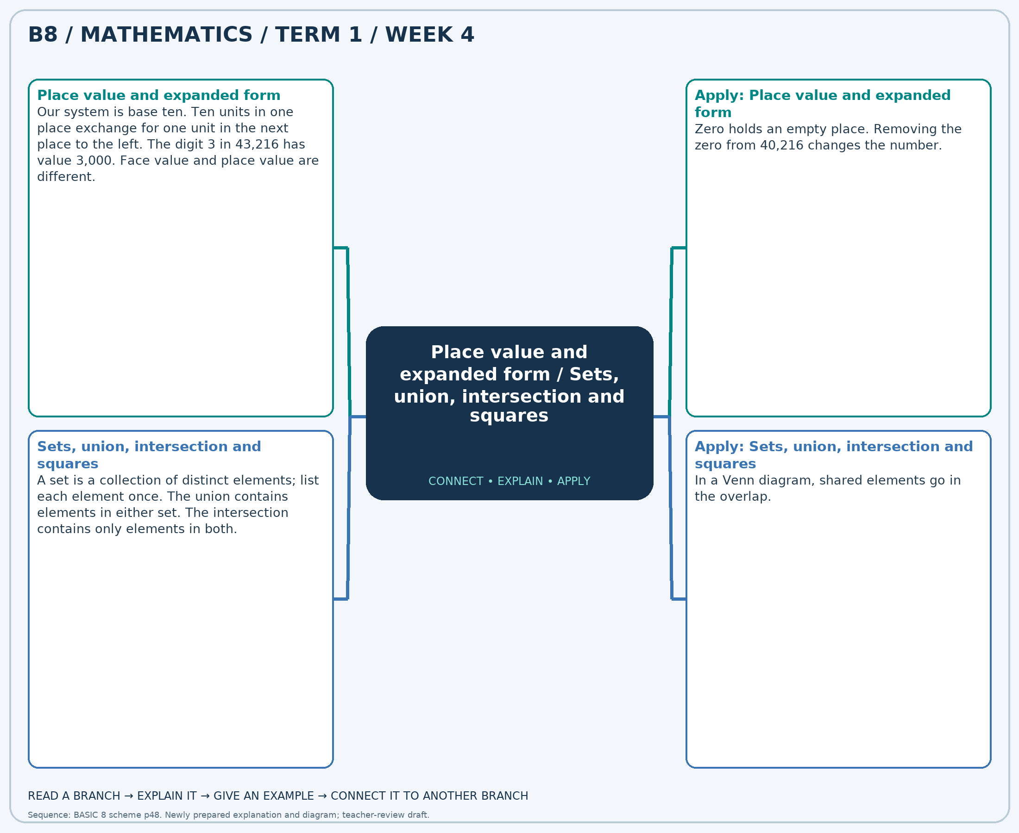
The separate high-resolution PNG can be projected or printed larger. Explain each branch and connect it with an example.

Week 4 — Practice

Section A — Multiple-choice questions
Choose ONE correct answer for each question. Each question has four alternatives.
1. What is the value of the digit in the thousands place in 8,276,673,353?
A. 3000 B. 30000 C. 3 D. 300
2. A={15, 16, 17}; B={16, 17, 18, 19, 20, 21}. How many elements are in their union?
A. 7 B. 6 C. 9 D. 8
3. A number has 3 ten-thousands, 4 hundreds and 6 ones, with zeros elsewhere. Write it in figures.
A. 30460 B. 34006 C. 3406 D. 30406
4. A={10, 11, 12, 13, 14}; B={11, 12, 13, 14, 15, 16, 17}. How many elements are in their intersection?
A. 6 B. 4 C. 5 D. 3
5. What is the value of the digit in the thousands place in 7,908,157,230?
A. 70000 B. 7000 C. 7 D. 700
6. Find the non-negative square root of 81.
A. 9 B. 11 C. 8 D. 10
7. What is the value of the digit in the millions place in 4,509,449,866?
A. 900000 B. 90000000 C. 9 D. 9000000
8. A={10, 11, 12, 13, 14, 15, 16}; B={15, 16, 17}. How many elements are in their union?
A. 9 B. 10 C. 8 D. 7
9. A number has 9 ten-thousands, 8 hundreds and 2 ones, with zeros elsewhere. Write it in figures.
A. 9802 B. 98002 C. 90820 D. 90802
10. A={7, 8, 9}; B={8, 9, 10, 11, 12, 13, 14}. How many elements are in their intersection?
A. 2 B. 1 C. 3 D. 4
11. What is the value of the digit in the ten-millions place in 2,328,815,598?
A. 2000000 B. 200000000 C. 20000000 D. 2
12. Find the non-negative square root of 9.
A. 5 B. 4 C. 2 D. 3
13. What is the value of the digit in the thousands place in 2,246,941,004?
A. 10000 B. 1000 C. 100 D. 1
14. A={15, 16, 17, 18, 19, 20, 21}; B={19, 20, 21, 22, 23}. How many elements are in their union?
A. 9 B. 10 C. 11 D. 8
15. A number has 8 ten-thousands, 6 hundreds and 7 ones, with zeros elsewhere. Write it in figures.
A. 80607 B. 86007 C. 80670 D. 8607
16. A={12, 13, 14, 15, 16, 17}; B={16, 17, 18, 19, 20, 21}. How many elements are in their intersection?
A. 2 B. 3 C. 4 D. 1
17. What is the value of the digit in the millions place in 3,444,840,161?
A. 4 B. 400000 C. 4000000 D. 40000000
18. Find the non-negative square root of 4.
A. 3 B. 4 C. 1 D. 2
19. What is the value of the digit in the ten-thousands place in 6,146,630,940?
A. 3 B. 30000 C. 300000 D. 3000
20. A={15, 16, 17, 18}; B={16, 17, 18, 19}. How many elements are in their union?
A. 5 B. 7 C. 6 D. 4

Section B — Structured essay questions
Answer every part (a), (b), (c). Show your method or explain your choice. Write in a separate answer booklet. Each part: 1 mark for valid working/explanation and 1 for the correct result; 6 marks per question.

1. Apply the related skills and show working or give a reason for each answer.
(a) What is the value of the digit in the hundred-millions place in 6,724,656,300?
(b) A={7, 8, 9, 10, 11, 12}; B={10, 11, 12, 13, 14, 15}. How many elements are in their intersection?
(c) What is the value of the digit in the thousands place in 7,058,461,129?

2. Apply the related skills and show working or give a reason for each answer.
(a) A={4, 5, 6}; B={5, 6, 7, 8, 9}. How many elements are in their intersection?
(b) What is the value of the digit in the hundreds place in 4,638,809,199?
(c) A={1, 2, 3, 4}; B={3, 4, 5, 6, 7, 8}. How many elements are in their union?

3. Apply the related skills and show working or give a reason for each answer.
(a) What is the value of the digit in the tens place in 3,760,906,312?
(b) A={3, 4, 5, 6}; B={6, 7, 8}. How many elements are in their union?
(c) A number has 3 ten-thousands, 8 hundreds and 8 ones, with zeros elsewhere. Write it in figures.

4. Apply the related skills and show working or give a reason for each answer.
(a) A={4, 5, 6, 7, 8}; B={8, 9, 10, 11}. How many elements are in their union?
(b) A number has 7 ten-thousands, 4 hundreds and 4 ones, with zeros elsewhere. Write it in figures.
(c) Find the non-negative square root of 81.

5. Apply the related skills and show working or give a reason for each answer.
(a) A number has 5 ten-thousands, 4 hundreds and 5 ones, with zeros elsewhere. Write it in figures.
(b) Find the non-negative square root of 81.
(c) What is the value of the digit in the ten-thousands place in 8,275,733,276?

6. Apply the related skills and show working or give a reason for each answer.
(a) Find the non-negative square root of 25.
(b) What is the value of the digit in the tens place in 8,045,393,334?
(c) A={12, 13, 14}; B={13, 14, 15, 16, 17}. How many elements are in their intersection?

7. Apply the related skills and show working or give a reason for each answer.
(a) What is the value of the digit in the hundred-millions place in 5,487,343,890?
(b) A={9, 10, 11, 12, 13, 14, 15}; B={13, 14, 15, 16, 17}. How many elements are in their intersection?
(c) What is the value of the digit in the hundred-thousands place in 7,905,390,468?

8. Apply the related skills and show working or give a reason for each answer.
(a) A={1, 2, 3, 4, 5, 6}; B={5, 6, 7, 8, 9, 10, 11}. How many elements are in their intersection?
(b) What is the value of the digit in the hundred-thousands place in 4,539,316,538?
(c) A={1, 2, 3, 4}; B={2, 3, 4, 5, 6, 7, 8}. How many elements are in their union?

9. Apply the related skills and show working or give a reason for each answer.
(a) What is the value of the digit in the ten-millions place in 3,725,600,898?
(b) A={14, 15, 16, 17}; B={16, 17, 18, 19}. How many elements are in their union?
(c) A number has 3 ten-thousands, 6 hundreds and 4 ones, with zeros elsewhere. Write it in figures.

10. Apply the related skills and show working or give a reason for each answer.
(a) A={3, 4, 5, 6, 7, 8}; B={8, 9, 10, 11}. How many elements are in their union?
(b) A number has 9 ten-thousands, 4 hundreds and 4 ones, with zeros elsewhere. Write it in figures.
(c) Find the non-negative square root of 16.

Week 5 — Sets, union, intersection and squares / Multiplying and dividing by powers of ten
Sequence source: BASIC 8 SCHEME OF LEARNING.pdf, first-term Mathematics, page 48. One consolidated weekly unit.

Learning outcomes
- Explain and apply sets, union, intersection and squares, solve examples and justify the method.
- Explain and apply multiplying and dividing by powers of ten, solve examples and justify the method.

Teaching notes and suggested sessions
Suggested schedule: five 40-minute sessions, adjusted to the school timetable. Spread the question bank through the week; it is not intended to be completed in one lesson.

1 — Explore and diagnose
5 minutes: recall an earlier skill; 10: demonstrate a concrete or pictorial model; 15: pairs investigate and explain; 10: identify a misconception and set an exit task.

2 — Model and practise
5 minutes: review the exit task; 10: work an example aloud; 15: pairs solve parallel examples; 10: compare methods and correct errors.

3 — Connect representations
5 minutes: recall vocabulary; 10: explain the mind-map; 15: connect a model, a drawing and a symbolic calculation; 10: independent practice.

4 — Apply and explain
5 minutes: estimate or predict; 10: solve a contextual example; 15: attempt selected structured-question parts; 10: compare reasoning and check units.

5 — Check and respond
5 minutes: retrieve the main rule; 15: use selected MCQs diagnostically; 10: explain distractors and misconceptions; 10: reteach or extend in response to evidence.

Topic-specific activities
- Sort numbered cards into overlapping hoops and record the union and intersection.
- Move digit cards on a chart including tenths, hundredths and thousandths.
Resources: board, pencils, number cards, counters, paper strips and squared paper as appropriate. Prior-knowledge check: ask a learner to explain a representation used in the first example before introducing a new rule.
Support: reduce number size without changing the concept; offer a partially completed chart or model; allow oral reasoning before writing. Extension: create a counterexample to a false rule and explain why it fails.

Study notes and worked examples

Sets, union, intersection and squares
- A set is a collection of distinct elements; list each element once.
- The union contains elements in either set. The intersection contains only elements in both.
- A square number is an integer multiplied by itself; its non-negative square root reverses the operation.
- In a Venn diagram, shared elements go in the overlap.
Worked example: A={14, 15, 16, 17, 18, 19, 20}; B={20, 21, 22}. How many elements are in their union?
Solution: Required set: {14, 15, 16, 17, 18, 19, 20, 21, 22}. Count=9.
Common misconception: Do not count shared elements twice in a union.

Multiplying and dividing by powers of ten
- Multiplying by 10, 100 or 1,000 increases each digit’s place value by that factor.
- Dividing reverses the place-value shift.
- 4.26×100=426, while 4.26÷100=0.0426.
- Use a place-value chart; appending zeros to a decimal is not a general multiplication rule.
Worked example: Calculate 9.09 ÷ 1000.
Solution: Change each digit’s place value by the factor 1000: 0.00909.
Common misconception: 4.260 has the same value as 4.26; it is not ten times as large.
Independent study: read the map, cover it and reconstruct the branches. Solve an unused question from each skill and explain the reasoning to a partner. Consult the teacher key only after an honest attempt.

Week 5 — Visual mind-map
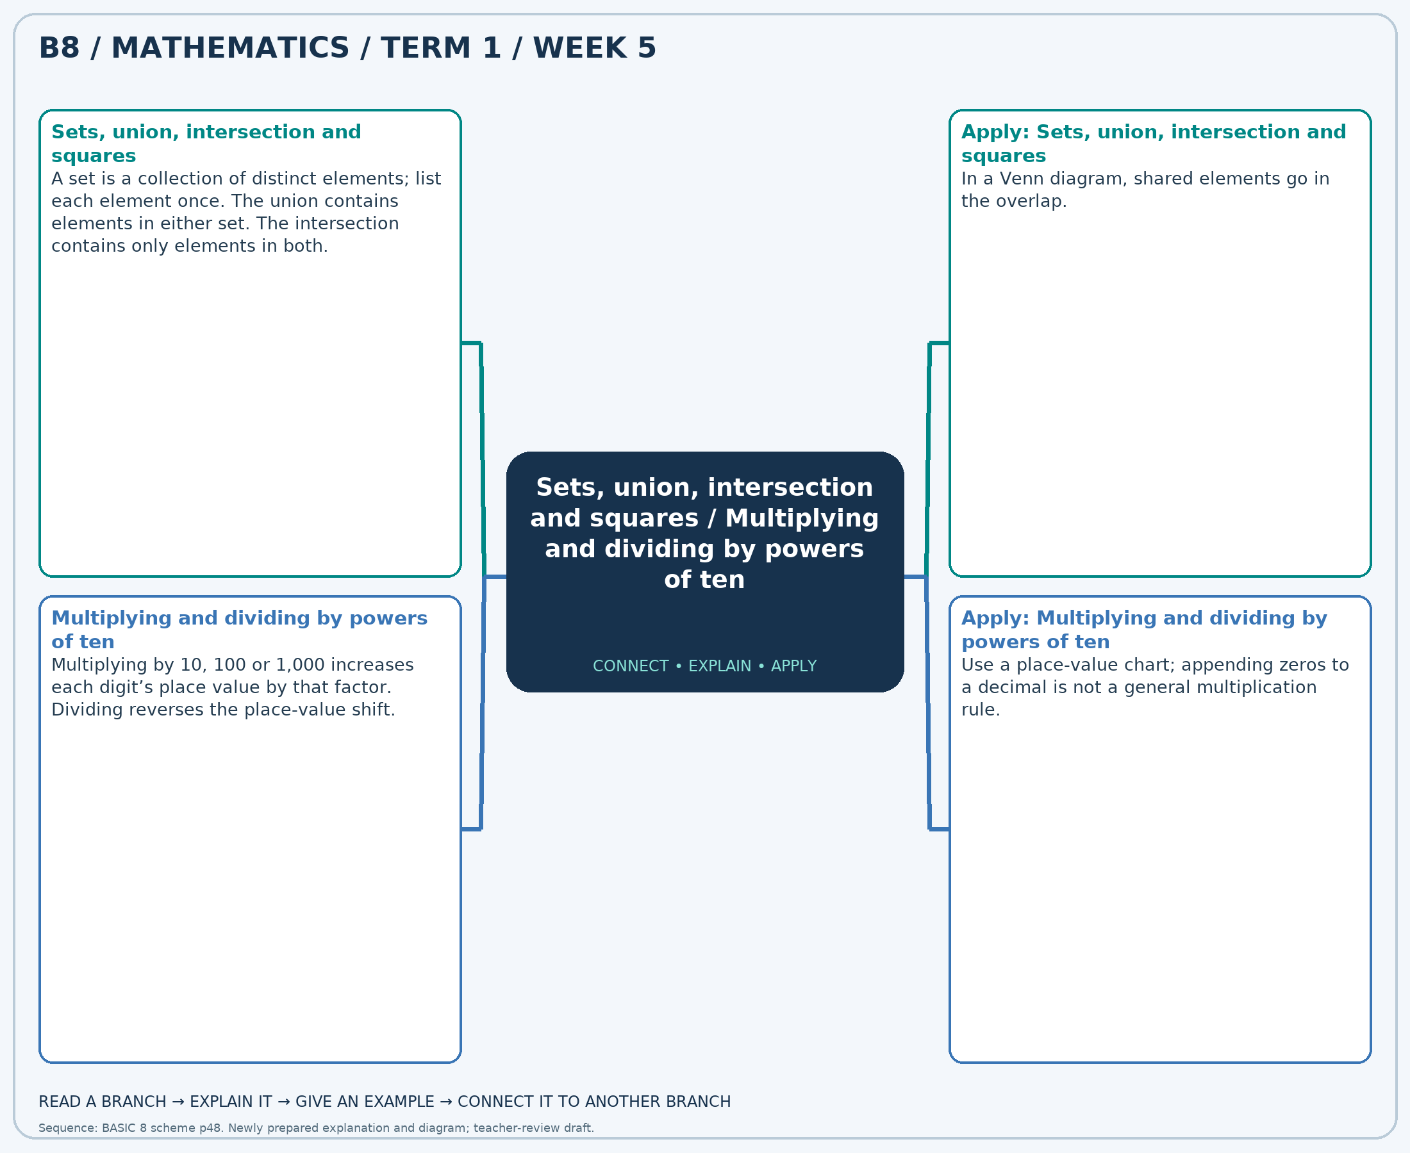
The separate high-resolution PNG can be projected or printed larger. Explain each branch and connect it with an example.

Week 5 — Practice

Section A — Multiple-choice questions
Choose ONE correct answer for each question. Each question has four alternatives.
1. A={7, 8, 9, 10, 11, 12, 13}; B={9, 10, 11, 12, 13, 14, 15}. How many elements are in their union?
A. 11 B. 10 C. 9 D. 8
2. Calculate 8.76 × 1000.
A. 8762 B. 8761 C. 8760 D. 8759
3. A={7, 8, 9, 10}; B={9, 10, 11}. How many elements are in their intersection?
A. 4 B. 1 C. 2 D. 3
4. Calculate 6.82 ÷ 10.
A. 0.682 B. -0.318 C. 1.682 D. 2.682
5. Find the non-negative square root of 36.
A. 6 B. 5 C. 8 D. 7
6. Calculate 3.87 × 100.
A. 387 B. 389 C. 388 D. 386
7. A={3, 4, 5, 6}; B={4, 5, 6, 7, 8, 9}. How many elements are in their union?
A. 8 B. 6 C. 9 D. 7
8. Calculate 9.09 × 10.
A. 91.9 B. 90.9 C. 92.9 D. 89.9
9. A={11, 12, 13, 14}; B={14, 15, 16, 17, 18, 19}. How many elements are in their intersection?
A. 3 B. 0 C. 1 D. 2
10. Calculate 8.43 ÷ 10.
A. -0.157 B. 2.843 C. 1.843 D. 0.843
11. Find the non-negative square root of 9.
A. 3 B. 2 C. 4 D. 5
12. Calculate 9.67 × 10.
A. 98.7 B. 96.7 C. 97.7 D. 95.7
13. A={9, 10, 11}; B={10, 11, 12, 13, 14, 15}. How many elements are in their union?
A. 8 B. 7 C. 6 D. 9
14. Calculate 7.34 × 1000.
A. 7342 B. 7339 C. 7341 D. 7340
15. A={7, 8, 9, 10, 11, 12, 13}; B={12, 13, 14, 15, 16, 17, 18}. How many elements are in their intersection?
A. 2 B. 1 C. 3 D. 4
16. Calculate 6.02 ÷ 10.
A. 1.602 B. 2.602 C. 0.602 D. -0.398
17. Find the non-negative square root of 25.
A. 5 B. 7 C. 6 D. 4
18. Calculate 5.75 × 1000.
A. 5749 B. 5752 C. 5751 D. 5750
19. A={14, 15, 16}; B={16, 17, 18, 19, 20}. How many elements are in their union?
A. 7 B. 8 C. 6 D. 9
20. Calculate 2.04 × 1000.
A. 2040 B. 2041 C. 2039 D. 2042

Section B — Structured essay questions
Answer every part (a), (b), (c). Show your method or explain your choice. Write in a separate answer booklet. Each part: 1 mark for valid working/explanation and 1 for the correct result; 6 marks per question.

1. Apply the related skills and show working or give a reason for each answer.
(a) A={2, 3, 4, 5, 6}; B={5, 6, 7, 8}. How many elements are in their union?
(b) Calculate 3.55 ÷ 10.
(c) Find the non-negative square root of 16.

2. Apply the related skills and show working or give a reason for each answer.
(a) Calculate 3.54 ÷ 1000.
(b) Find the non-negative square root of 16.
(c) Calculate 7.8 × 10.

3. Apply the related skills and show working or give a reason for each answer.
(a) Find the non-negative square root of 25.
(b) Calculate 3.25 × 10.
(c) A={10, 11, 12, 13, 14, 15}; B={15, 16, 17}. How many elements are in their intersection?

4. Apply the related skills and show working or give a reason for each answer.
(a) Calculate 6.1 × 100.
(b) A={8, 9, 10}; B={9, 10, 11}. How many elements are in their intersection?
(c) Calculate 5.82 × 1000.

5. Apply the related skills and show working or give a reason for each answer.
(a) A={9, 10, 11, 12, 13, 14, 15}; B={14, 15, 16, 17}. How many elements are in their intersection?
(b) Calculate 7.93 × 100.
(c) A={2, 3, 4, 5, 6, 7}; B={4, 5, 6, 7, 8, 9}. How many elements are in their union?

6. Apply the related skills and show working or give a reason for each answer.
(a) Calculate 3.33 × 10.
(b) A={5, 6, 7, 8, 9}; B={6, 7, 8, 9, 10}. How many elements are in their union?
(c) Calculate 5.48 ÷ 1000.

7. Apply the related skills and show working or give a reason for each answer.
(a) A={5, 6, 7, 8, 9, 10}; B={8, 9, 10, 11, 12}. How many elements are in their union?
(b) Calculate 1.96 ÷ 100.
(c) Find the non-negative square root of 25.

8. Apply the related skills and show working or give a reason for each answer.
(a) Calculate 1.19 ÷ 100.
(b) Find the non-negative square root of 9.
(c) Calculate 7.4 × 100.

9. Apply the related skills and show working or give a reason for each answer.
(a) Find the non-negative square root of 16.
(b) Calculate 2.34 × 100.
(c) A={5, 6, 7, 8, 9, 10, 11}; B={10, 11, 12}. How many elements are in their intersection?

10. Apply the related skills and show working or give a reason for each answer.
(a) Calculate 1.71 × 1000.
(b) A={15, 16, 17, 18, 19}; B={17, 18, 19, 20, 21, 22}. How many elements are in their intersection?
(c) Calculate 1.66 × 10.

Week 6 — Multiplication strategies / Multi-step number problems
Sequence source: BASIC 8 SCHEME OF LEARNING.pdf, first-term Mathematics, page 48. One consolidated weekly unit.

Learning outcomes
- Explain and apply multiplication strategies, solve examples and justify the method.
- Explain and apply multi-step number problems, solve examples and justify the method.

Teaching notes and suggested sessions
Suggested schedule: five 40-minute sessions, adjusted to the school timetable. Spread the question bank through the week; it is not intended to be completed in one lesson.

1 — Explore and diagnose
5 minutes: recall an earlier skill; 10: demonstrate a concrete or pictorial model; 15: pairs investigate and explain; 10: identify a misconception and set an exit task.

2 — Model and practise
5 minutes: review the exit task; 10: work an example aloud; 15: pairs solve parallel examples; 10: compare methods and correct errors.

3 — Connect representations
5 minutes: recall vocabulary; 10: explain the mind-map; 15: connect a model, a drawing and a symbolic calculation; 10: independent practice.

4 — Apply and explain
5 minutes: estimate or predict; 10: solve a contextual example; 15: attempt selected structured-question parts; 10: compare reasoning and check units.

5 — Check and respond
5 minutes: retrieve the main rule; 15: use selected MCQs diagnostically; 10: explain distractors and misconceptions; 10: reteach or extend in response to evidence.

Topic-specific activities
- Draw a partitioned rectangle and connect its smaller areas to the partial products.
- Use a shop-stock or shopping story. Draw a bar model and compare two solution methods.
Resources: board, pencils, number cards, counters, paper strips and squared paper as appropriate. Prior-knowledge check: ask a learner to explain a representation used in the first example before introducing a new rule.
Support: reduce number size without changing the concept; offer a partially completed chart or model; allow oral reasoning before writing. Extension: create a counterexample to a false rule and explain why it fails.

Study notes and worked examples

Multiplication strategies
- Partition a factor and use the distributive property: 24×6=(20×6)+(4×6)=144.
- Doubling one factor and halving an even other factor preserves the product.
- In multi-digit multiplication, include every partial product and align place values.
- Estimate first, calculate carefully and compare the product with the estimate.
Worked example: Calculate 262 × 38.
Solution: 262×(30+8) = 7860+2096 = 9956.
Common misconception: The tens digit contributes tens, not units: the 2 in 23×14 represents 20×14.

Multi-step number problems
- Identify the quantities, units and the final question before calculating.
- Use a diagram or a written plan to select the operations from the relationships.
- Label intermediate answers, then complete the remaining steps.
- Estimate and interpret the answer in the original situation.
Worked example: A shop has 9 packs of 4 pencils and sells 6 pencils. How many pencils remain?
Solution: Start with 9×4=36; subtract 6 to obtain 30 pencils.
Common misconception: A correct intermediate calculation may not answer the final question.
Independent study: read the map, cover it and reconstruct the branches. Solve an unused question from each skill and explain the reasoning to a partner. Consult the teacher key only after an honest attempt.

Week 6 — Visual mind-map
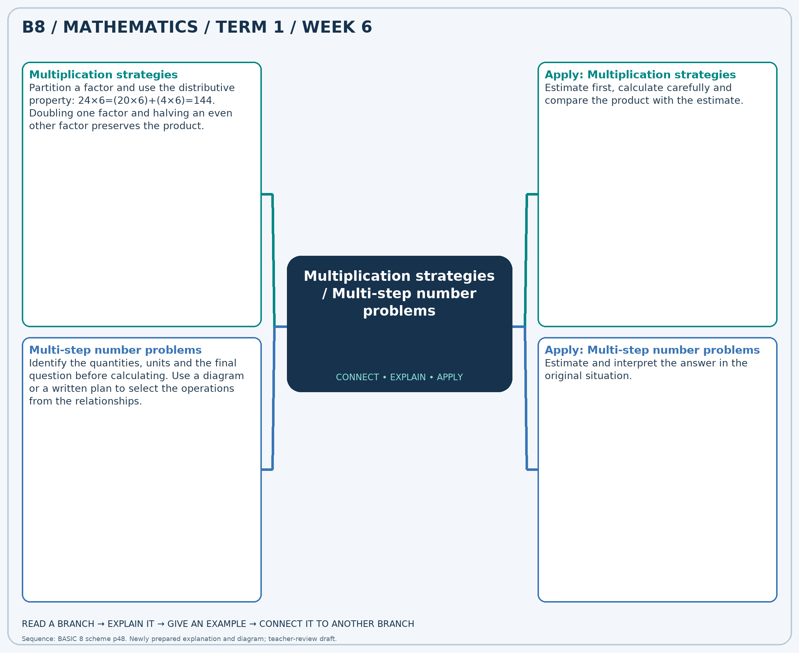
The separate high-resolution PNG can be projected or printed larger. Explain each branch and connect it with an example.

Week 6 — Practice

Section A — Multiple-choice questions
Choose ONE correct answer for each question. Each question has four alternatives.
1. Calculate 405 × 14.
A. 6075 B. 5670 C. 419 D. 5265
2. A shop has 3 packs of 12 pencils and sells 21 pencils. How many pencils remain?
A. 15 B. 27 C. 36 D. 57
3. Calculate 432 × 22.
A. 9936 B. 9504 C. 454 D. 9072
4. A shop has 4 packs of 5 pencils and sells 13 pencils. How many pencils remain?
A. 12 B. 7 C. 22 D. 33
5. Calculate 128 × 23.
A. 2816 B. 3072 C. 2944 D. 151
6. A shop has 6 packs of 7 pencils and sells 17 pencils. How many pencils remain?
A. 30 B. 59 C. 32 D. 25
7. Calculate 264 × 22.
A. 286 B. 5544 C. 5808 D. 6072
8. A shop has 3 packs of 5 pencils and sells 13 pencils. How many pencils remain?
A. 28 B. 7 C. 2 D. 21
9. Calculate 448 × 36.
A. 15680 B. 484 C. 16128 D. 16576
10. A shop has 3 packs of 9 pencils and sells 15 pencils. How many pencils remain?
A. 27 B. 42 C. 21 D. 12
11. Calculate 180 × 35.
A. 215 B. 6480 C. 6300 D. 6120
12. A shop has 8 packs of 8 pencils and sells 52 pencils. How many pencils remain?
A. 68 B. 20 C. 116 D. 12
13. Calculate 292 × 28.
A. 7884 B. 320 C. 8176 D. 8468
14. A shop has 6 packs of 5 pencils and sells 15 pencils. How many pencils remain?
A. 26 B. 20 C. 15 D. 45
15. Calculate 475 × 17.
A. 8075 B. 7600 C. 8550 D. 492
16. A shop has 7 packs of 8 pencils and sells 44 pencils. How many pencils remain?
A. 59 B. 12 C. 100 D. 20
17. Calculate 433 × 33.
A. 466 B. 14289 C. 14722 D. 13856
18. A shop has 7 packs of 12 pencils and sells 12 pencils. How many pencils remain?
A. 96 B. 31 C. 72 D. 84
19. Calculate 151 × 12.
A. 163 B. 1812 C. 1963 D. 1661
20. A shop has 4 packs of 8 pencils and sells 9 pencils. How many pencils remain?
A. 21 B. 41 C. 31 D. 23

Section B — Structured essay questions
Answer every part (a), (b), (c). Show your method or explain your choice. Write in a separate answer booklet. Each part: 1 mark for valid working/explanation and 1 for the correct result; 6 marks per question.

1. Apply the related skills and show working or give a reason for each answer.
(a) Calculate 166 × 33.
(b) A shop has 9 packs of 9 pencils and sells 75 pencils. How many pencils remain?
(c) Calculate 473 × 23.

2. Apply the related skills and show working or give a reason for each answer.
(a) A shop has 3 packs of 9 pencils and sells 6 pencils. How many pencils remain?
(b) Calculate 327 × 28.
(c) A shop has 8 packs of 7 pencils and sells 51 pencils. How many pencils remain?

3. Apply the related skills and show working or give a reason for each answer.
(a) Calculate 324 × 13.
(b) A shop has 6 packs of 8 pencils and sells 13 pencils. How many pencils remain?
(c) Calculate 186 × 14.

4. Apply the related skills and show working or give a reason for each answer.
(a) A shop has 9 packs of 5 pencils and sells 3 pencils. How many pencils remain?
(b) Calculate 259 × 12.
(c) A shop has 7 packs of 8 pencils and sells 35 pencils. How many pencils remain?

5. Apply the related skills and show working or give a reason for each answer.
(a) Calculate 414 × 29.
(b) A shop has 9 packs of 9 pencils and sells 45 pencils. How many pencils remain?
(c) Calculate 122 × 31.

6. Apply the related skills and show working or give a reason for each answer.
(a) A shop has 4 packs of 8 pencils and sells 24 pencils. How many pencils remain?
(b) Calculate 431 × 28.
(c) A shop has 4 packs of 12 pencils and sells 37 pencils. How many pencils remain?

7. Apply the related skills and show working or give a reason for each answer.
(a) Calculate 398 × 23.
(b) A shop has 5 packs of 4 pencils and sells 19 pencils. How many pencils remain?
(c) Calculate 255 × 36.

8. Apply the related skills and show working or give a reason for each answer.
(a) A shop has 4 packs of 10 pencils and sells 17 pencils. How many pencils remain?
(b) Calculate 493 × 25.
(c) A shop has 3 packs of 7 pencils and sells 3 pencils. How many pencils remain?

9. Apply the related skills and show working or give a reason for each answer.
(a) Calculate 391 × 36.
(b) A shop has 6 packs of 6 pencils and sells 29 pencils. How many pencils remain?
(c) Calculate 440 × 32.

10. Apply the related skills and show working or give a reason for each answer.
(a) A shop has 4 packs of 12 pencils and sells 40 pencils. How many pencils remain?
(b) Calculate 137 × 16.
(c) A shop has 3 packs of 4 pencils and sells 7 pencils. How many pencils remain?

Week 7 — Whole-number and decimal operations / Multiplication strategies / Division and checking
Sequence source: BASIC 8 SCHEME OF LEARNING.pdf, first-term Mathematics, page 48. One consolidated weekly unit.

Learning outcomes
- Explain and apply whole-number and decimal operations, solve examples and justify the method.
- Explain and apply multiplication strategies, solve examples and justify the method.
- Explain and apply division and checking, solve examples and justify the method.

Teaching notes and suggested sessions
Suggested schedule: five 40-minute sessions, adjusted to the school timetable. Spread the question bank through the week; it is not intended to be completed in one lesson.

1 — Explore and diagnose
5 minutes: recall an earlier skill; 10: demonstrate a concrete or pictorial model; 15: pairs investigate and explain; 10: identify a misconception and set an exit task.

2 — Model and practise
5 minutes: review the exit task; 10: work an example aloud; 15: pairs solve parallel examples; 10: compare methods and correct errors.

3 — Connect representations
5 minutes: recall vocabulary; 10: explain the mind-map; 15: connect a model, a drawing and a symbolic calculation; 10: independent practice.

4 — Apply and explain
5 minutes: estimate or predict; 10: solve a contextual example; 15: attempt selected structured-question parts; 10: compare reasoning and check units.

5 — Check and respond
5 minutes: retrieve the main rule; 15: use selected MCQs diagnostically; 10: explain distractors and misconceptions; 10: reteach or extend in response to evidence.

Topic-specific activities
- Calculate receipts and totals from a price list, comparing exact answers with estimates.
- Draw a partitioned rectangle and connect its smaller areas to the partial products.
- Share counters into equal groups and check the result by multiplication.
Resources: board, pencils, number cards, counters, paper strips and squared paper as appropriate. Prior-knowledge check: ask a learner to explain a representation used in the first example before introducing a new rule.
Support: reduce number size without changing the concept; offer a partially completed chart or model; allow oral reasoning before writing. Extension: create a counterexample to a false rule and explain why it fails.

Study notes and worked examples

Whole-number and decimal operations
- Align decimal points when adding or subtracting decimals.
- For multiplication, track the factors’ place values and check with an estimate.
- For division, an equivalent calculation with an integer divisor may be useful.
- State money answers with their currency; two decimal places are normally used for amounts in cedis.
Worked example: Calculate 85.90 + 46.01.
Solution: Add aligned hundredths: (8590+4601)/100=131.91.
Common misconception: Aligning final digits instead of decimal points changes the place values.

Multiplication strategies
- Partition a factor and use the distributive property: 24×6=(20×6)+(4×6)=144.
- Doubling one factor and halving an even other factor preserves the product.
- In multi-digit multiplication, include every partial product and align place values.
- Estimate first, calculate carefully and compare the product with the estimate.
Worked example: Calculate 478 × 26.
Solution: 478×(20+6) = 9560+2868 = 12428.
Common misconception: The tens digit contributes tens, not units: the 2 in 23×14 represents 20×14.

Division and checking
- Division may mean sharing equally or finding how many equal groups fit.
- Multiplication reverses division: 7×8=56 means 56÷7=8.
- Work from the greatest place and regroup when needed. Record a zero in an empty quotient place.
- Check: divisor × quotient + remainder = dividend. The remainder is smaller than the divisor.
Worked example: Calculate 272 ÷ 8.
Solution: 8×34=272, so the quotient is 34.
Common misconception: Do not leave an empty place in the quotient when a zero is needed.
Independent study: read the map, cover it and reconstruct the branches. Solve an unused question from each skill and explain the reasoning to a partner. Consult the teacher key only after an honest attempt.

Week 7 — Visual mind-map
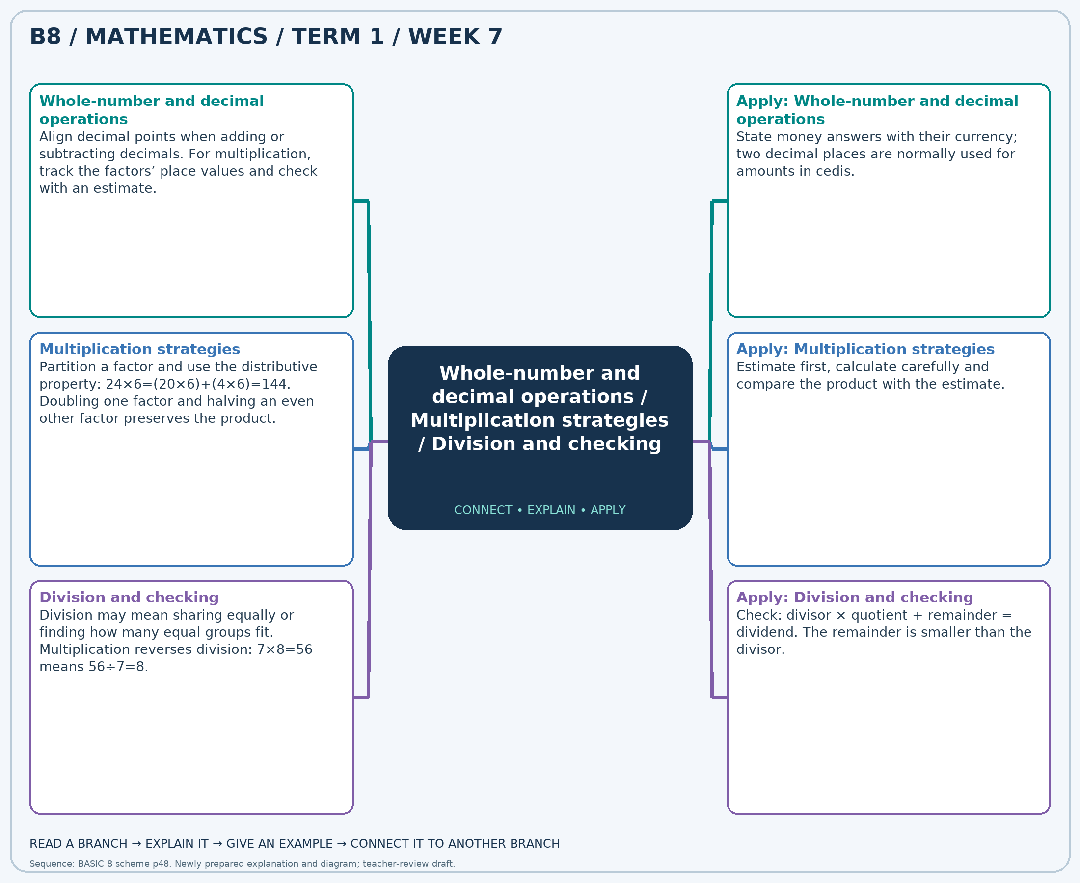
The separate high-resolution PNG can be projected or printed larger. Explain each branch and connect it with an example.

Week 7 — Practice

Section A — Multiple-choice questions
Choose ONE correct answer for each question. Each question has four alternatives.
1. Calculate 21.42 + 6.90.
A. 28.32 B. 27.32 C. 30.32 D. 29.32
2. Calculate 489 × 23.
A. 11736 B. 10758 C. 11247 D. 512
3. Calculate 300 ÷ 5.
A. 295 B. 59 C. 60 D. 61
4. Calculate 90.62 − 67.67.
A. 23.95 B. 21.95 C. 24.95 D. 22.95
5. Calculate 293 × 36.
A. 10548 B. 10841 C. 329 D. 10255
6. Calculate 576 ÷ 8.
A. 71 B. 73 C. 72 D. 568
7. 6 books cost GH₵37.56 each. Find the total cost in Ghana cedis.
A. 224.36 B. 226.36 C. 225.36 D. 227.36
8. Calculate 365 × 14.
A. 379 B. 4745 C. 5110 D. 5475
9. Calculate 216 ÷ 8.
A. 27 B. 26 C. 28 D. 208
10. Calculate 74.32 + 7.60.
A. 82.92 B. 81.92 C. 80.92 D. 83.92
11. Calculate 452 × 19.
A. 471 B. 9040 C. 8136 D. 8588
12. Calculate 156 ÷ 6.
A. 26 B. 150 C. 27 D. 25
13. Calculate 19.81 − 6.44.
A. 12.37 B. 13.37 C. 14.37 D. 15.37
14. Calculate 106 × 29.
A. 135 B. 3074 C. 2968 D. 3180
15. Calculate 130 ÷ 5.
A. 27 B. 26 C. 25 D. 125
16. 9 books cost GH₵22.80 each. Find the total cost in Ghana cedis.
A. 205.2 B. 204.2 C. 206.2 D. 207.2
17. Calculate 356 × 29.
A. 9968 B. 10324 C. 385 D. 10680
18. Calculate 390 ÷ 5.
A. 78 B. 79 C. 77 D. 385
19. Calculate 84.73 + 71.15.
A. 154.88 B. 156.88 C. 157.88 D. 155.88
20. Calculate 395 × 33.
A. 12640 B. 13035 C. 13430 D. 428

Section B — Structured essay questions
Answer every part (a), (b), (c). Show your method or explain your choice. Write in a separate answer booklet. Each part: 1 mark for valid working/explanation and 1 for the correct result; 6 marks per question.

1. Apply the related skills and show working or give a reason for each answer.
(a) Calculate 5.24 + 41.20.
(b) Calculate 220 × 31.
(c) Calculate 366 ÷ 6.

2. Apply the related skills and show working or give a reason for each answer.
(a) Calculate 345 × 18.
(b) Calculate 195 ÷ 5.
(c) Calculate 86.25 + 9.06.

3. Apply the related skills and show working or give a reason for each answer.
(a) Calculate 292 ÷ 4.
(b) Calculate 43.72 + 22.22.
(c) Calculate 379 × 37.

4. Apply the related skills and show working or give a reason for each answer.
(a) Calculate 12.16 + 24.70.
(b) Calculate 408 × 28.
(c) Calculate 240 ÷ 6.

5. Apply the related skills and show working or give a reason for each answer.
(a) Calculate 346 × 34.
(b) Calculate 168 ÷ 4.
(c) Calculate 71.89 + 3.39.

6. Apply the related skills and show working or give a reason for each answer.
(a) Calculate 235 ÷ 5.
(b) Calculate 96.54 + 56.67.
(c) Calculate 463 × 24.

7. Apply the related skills and show working or give a reason for each answer.
(a) Calculate 9.60 + 89.12.
(b) Calculate 492 × 17.
(c) Calculate 282 ÷ 3.

8. Apply the related skills and show working or give a reason for each answer.
(a) Calculate 333 × 26.
(b) Calculate 88 ÷ 2.
(c) Calculate 12.01 + 15.68.

9. Apply the related skills and show working or give a reason for each answer.
(a) Calculate 184 ÷ 4.
(b) Calculate 99.54 + 50.80.
(c) Calculate 313 × 27.

10. Apply the related skills and show working or give a reason for each answer.
(a) Calculate 7.55 + 11.48.
(b) Calculate 483 × 30.
(c) Calculate 536 ÷ 8.

Week 8 — Whole-number and decimal operations / Laws of indices
Sequence source: BASIC 8 SCHEME OF LEARNING.pdf, first-term Mathematics, page 48. One consolidated weekly unit.

Learning outcomes
- Explain and apply whole-number and decimal operations, solve examples and justify the method.
- Explain and apply laws of indices, solve examples and justify the method.

Teaching notes and suggested sessions
Suggested schedule: five 40-minute sessions, adjusted to the school timetable. Spread the question bank through the week; it is not intended to be completed in one lesson.

1 — Explore and diagnose
5 minutes: recall an earlier skill; 10: demonstrate a concrete or pictorial model; 15: pairs investigate and explain; 10: identify a misconception and set an exit task.

2 — Model and practise
5 minutes: review the exit task; 10: work an example aloud; 15: pairs solve parallel examples; 10: compare methods and correct errors.

3 — Connect representations
5 minutes: recall vocabulary; 10: explain the mind-map; 15: connect a model, a drawing and a symbolic calculation; 10: independent practice.

4 — Apply and explain
5 minutes: estimate or predict; 10: solve a contextual example; 15: attempt selected structured-question parts; 10: compare reasoning and check units.

5 — Check and respond
5 minutes: retrieve the main rule; 15: use selected MCQs diagnostically; 10: explain distractors and misconceptions; 10: reteach or extend in response to evidence.

Topic-specific activities
- Calculate receipts and totals from a price list, comparing exact answers with estimates.
- Expand powers into repeated factors, combine or cancel factors, then recover the rule.
Resources: board, pencils, number cards, counters, paper strips and squared paper as appropriate. Prior-knowledge check: ask a learner to explain a representation used in the first example before introducing a new rule.
Support: reduce number size without changing the concept; offer a partially completed chart or model; allow oral reasoning before writing. Extension: create a counterexample to a false rule and explain why it fails.

Study notes and worked examples

Whole-number and decimal operations
- Align decimal points when adding or subtracting decimals.
- For multiplication, track the factors’ place values and check with an estimate.
- For division, an equivalent calculation with an integer divisor may be useful.
- State money answers with their currency; two decimal places are normally used for amounts in cedis.
Worked example: Calculate 29.30 + 5.43.
Solution: Add aligned hundredths: (2930+543)/100=34.73.
Common misconception: Aligning final digits instead of decimal points changes the place values.

Laws of indices
- For the same non-zero base, multiplying powers adds exponents: a^m×a^n=a^(m+n).
- Dividing powers subtracts exponents: a^m÷a^n=a^(m-n).
- A power of a power multiplies exponents: (a^m)^n=a^(mn).
- These rules do not generally simplify a sum such as a^m+a^n by adding exponents.
Worked example: Write 5^5 ÷ 5^2 as 5^k. Find k.
Solution: Subtract exponents: 5-2=3.
Common misconception: Check that the bases match before using the product or quotient rule.
Independent study: read the map, cover it and reconstruct the branches. Solve an unused question from each skill and explain the reasoning to a partner. Consult the teacher key only after an honest attempt.

Week 8 — Visual mind-map
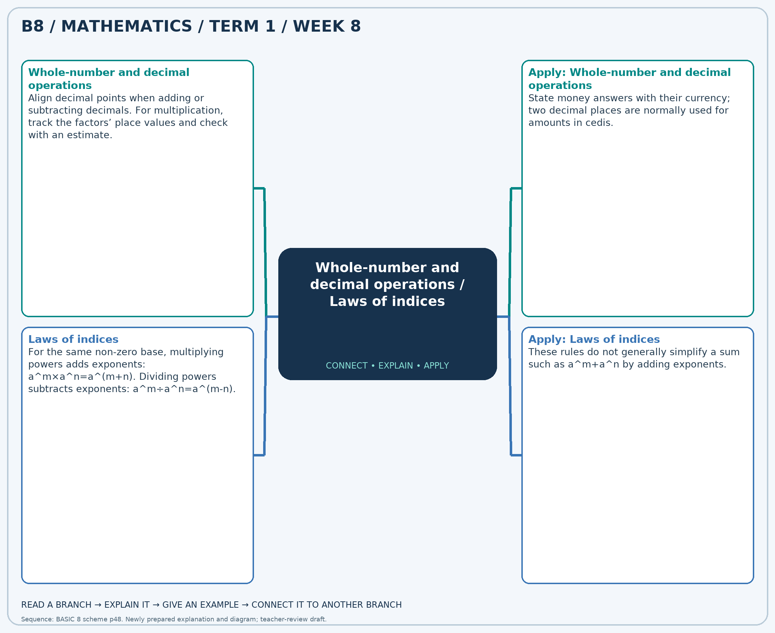
The separate high-resolution PNG can be projected or printed larger. Explain each branch and connect it with an example.

Week 8 — Practice

Section A — Multiple-choice questions
Choose ONE correct answer for each question. Each question has four alternatives.
1. Calculate 72.16 + 20.79.
A. 91.95 B. 92.95 C. 93.95 D. 94.95
2. Write 6^5 × 6^3 as 6^k. Find k.
A. 7 B. 10 C. 9 D. 8
3. Calculate 41.42 − 3.92.
A. 38.5 B. 39.5 C. 36.5 D. 37.5
4. Write 4^4 ÷ 4^3 as 4^k. Find k.
A. 0 B. 3 C. 2 D. 1
5. 6 books cost GH₵7.83 each. Find the total cost in Ghana cedis.
A. 46.98 B. 45.98 C. 48.98 D. 47.98
6. Write (5^5)^1 as 5^k. Find k.
A. 4 B. 5 C. 7 D. 6
7. Calculate 72.82 + 70.87.
A. 144.69 B. 142.69 C. 145.69 D. 143.69
8. Write 7^6 × 7^2 as 7^k. Find k.
A. 10 B. 7 C. 8 D. 9
9. Calculate 25.04 − 9.02.
A. 16.02 B. 17.02 C. 18.02 D. 15.02
10. Write 2^3 ÷ 2^1 as 2^k. Find k.
A. 4 B. 2 C. 3 D. 1
11. 5 books cost GH₵62.80 each. Find the total cost in Ghana cedis.
A. 316 B. 313 C. 315 D. 314
12. Write (5^6)^2 as 5^k. Find k.
A. 13 B. 14 C. 11 D. 12
13. Calculate 60.95 + 79.05.
A. 140 B. 141 C. 139 D. 142
14. Write 2^5 × 2^2 as 2^k. Find k.
A. 7 B. 8 C. 9 D. 6
15. Calculate 64.79 − 1.46.
A. 62.33 B. 63.33 C. 64.33 D. 65.33
16. Write (3^3)^2 as 3^k. Find k.
A. 6 B. 8 C. 5 D. 7
17. 5 books cost GH₵8.09 each. Find the total cost in Ghana cedis.
A. 42.45 B. 39.45 C. 40.45 D. 41.45
18. Write 4^5 × 4^3 as 4^k. Find k.
A. 7 B. 9 C. 8 D. 10
19. Calculate 69.30 + 19.28.
A. 90.58 B. 88.58 C. 89.58 D. 87.58
20. Write 4^3 ÷ 4^2 as 4^k. Find k.
A. 0 B. 1 C. 3 D. 2

Section B — Structured essay questions
Answer every part (a), (b), (c). Show your method or explain your choice. Write in a separate answer booklet. Each part: 1 mark for valid working/explanation and 1 for the correct result; 6 marks per question.

1. Apply the related skills and show working or give a reason for each answer.
(a) Calculate 29.55 + 71.42.
(b) Write 5^5 ÷ 5^3 as 5^k. Find k.
(c) 6 books cost GH₵12.87 each. Find the total cost in Ghana cedis.

2. Apply the related skills and show working or give a reason for each answer.
(a) Write 7^4 ÷ 7^3 as 7^k. Find k.
(b) 9 books cost GH₵46.35 each. Find the total cost in Ghana cedis.
(c) Write 6^5 × 6^2 as 6^k. Find k.

3. Apply the related skills and show working or give a reason for each answer.
(a) 2 books cost GH₵50.06 each. Find the total cost in Ghana cedis.
(b) Write 2^5 × 2^1 as 2^k. Find k.
(c) Calculate 96.37 − 52.61.

4. Apply the related skills and show working or give a reason for each answer.
(a) Write 3^3 × 3^1 as 3^k. Find k.
(b) Calculate 81.15 − 8.02.
(c) Write (5^3)^1 as 5^k. Find k.

5. Apply the related skills and show working or give a reason for each answer.
(a) Calculate 96.35 − 7.27.
(b) Write (4^4)^3 as 4^k. Find k.
(c) Calculate 28.66 + 65.60.

6. Apply the related skills and show working or give a reason for each answer.
(a) Write (4^4)^1 as 4^k. Find k.
(b) Calculate 84.36 + 37.82.
(c) Write 6^4 ÷ 6^2 as 6^k. Find k.

7. Apply the related skills and show working or give a reason for each answer.
(a) Calculate 29.48 + 44.77.
(b) Write 7^7 ÷ 7^1 as 7^k. Find k.
(c) 9 books cost GH₵24.74 each. Find the total cost in Ghana cedis.

8. Apply the related skills and show working or give a reason for each answer.
(a) Write 7^3 ÷ 7^2 as 7^k. Find k.
(b) 8 books cost GH₵85.58 each. Find the total cost in Ghana cedis.
(c) Write 7^3 × 7^1 as 7^k. Find k.

9. Apply the related skills and show working or give a reason for each answer.
(a) 8 books cost GH₵50.93 each. Find the total cost in Ghana cedis.
(b) Write 7^3 × 7^3 as 7^k. Find k.
(c) Calculate 99.27 − 5.75.

10. Apply the related skills and show working or give a reason for each answer.
(a) Write 7^7 × 7^2 as 7^k. Find k.
(b) Calculate 87.46 − 64.66.
(c) Write (6^7)^3 as 6^k. Find k.

Week 9 — Laws of indices / Simple exponential equations
Sequence source: BASIC 8 SCHEME OF LEARNING.pdf, first-term Mathematics, page 48. One consolidated weekly unit.

Learning outcomes
- Explain and apply laws of indices, solve examples and justify the method.
- Explain and apply simple exponential equations, solve examples and justify the method.

Teaching notes and suggested sessions
Suggested schedule: five 40-minute sessions, adjusted to the school timetable. Spread the question bank through the week; it is not intended to be completed in one lesson.

1 — Explore and diagnose
5 minutes: recall an earlier skill; 10: demonstrate a concrete or pictorial model; 15: pairs investigate and explain; 10: identify a misconception and set an exit task.

2 — Model and practise
5 minutes: review the exit task; 10: work an example aloud; 15: pairs solve parallel examples; 10: compare methods and correct errors.

3 — Connect representations
5 minutes: recall vocabulary; 10: explain the mind-map; 15: connect a model, a drawing and a symbolic calculation; 10: independent practice.

4 — Apply and explain
5 minutes: estimate or predict; 10: solve a contextual example; 15: attempt selected structured-question parts; 10: compare reasoning and check units.

5 — Check and respond
5 minutes: retrieve the main rule; 15: use selected MCQs diagnostically; 10: explain distractors and misconceptions; 10: reteach or extend in response to evidence.

Topic-specific activities
- Expand powers into repeated factors, combine or cancel factors, then recover the rule.
- Create a table of powers of 2, 3 and 5 and use it to find missing exponents.
Resources: board, pencils, number cards, counters, paper strips and squared paper as appropriate. Prior-knowledge check: ask a learner to explain a representation used in the first example before introducing a new rule.
Support: reduce number size without changing the concept; offer a partially completed chart or model; allow oral reasoning before writing. Extension: create a counterexample to a false rule and explain why it fails.

Study notes and worked examples

Laws of indices
- For the same non-zero base, multiplying powers adds exponents: a^m×a^n=a^(m+n).
- Dividing powers subtracts exponents: a^m÷a^n=a^(m-n).
- A power of a power multiplies exponents: (a^m)^n=a^(mn).
- These rules do not generally simplify a sum such as a^m+a^n by adding exponents.
Worked example: Write 6^5 × 6^2 as 6^k. Find k.
Solution: Add exponents: 5+2=7.
Common misconception: Check that the bases match before using the product or quotient rule.

Simple exponential equations
- An exponential equation contains an unknown exponent.
- When possible, write both sides with the same base.
- If 2^x=32 and 32=2^5, then x=5.
- Substitute the answer back into the original equation to verify it.
Worked example: Solve 5^x=625 for x.
Solution: 625=5^4, so x=4.
Common misconception: Do not find the exponent by dividing the right-hand value by the base.
Independent study: read the map, cover it and reconstruct the branches. Solve an unused question from each skill and explain the reasoning to a partner. Consult the teacher key only after an honest attempt.

Week 9 — Visual mind-map
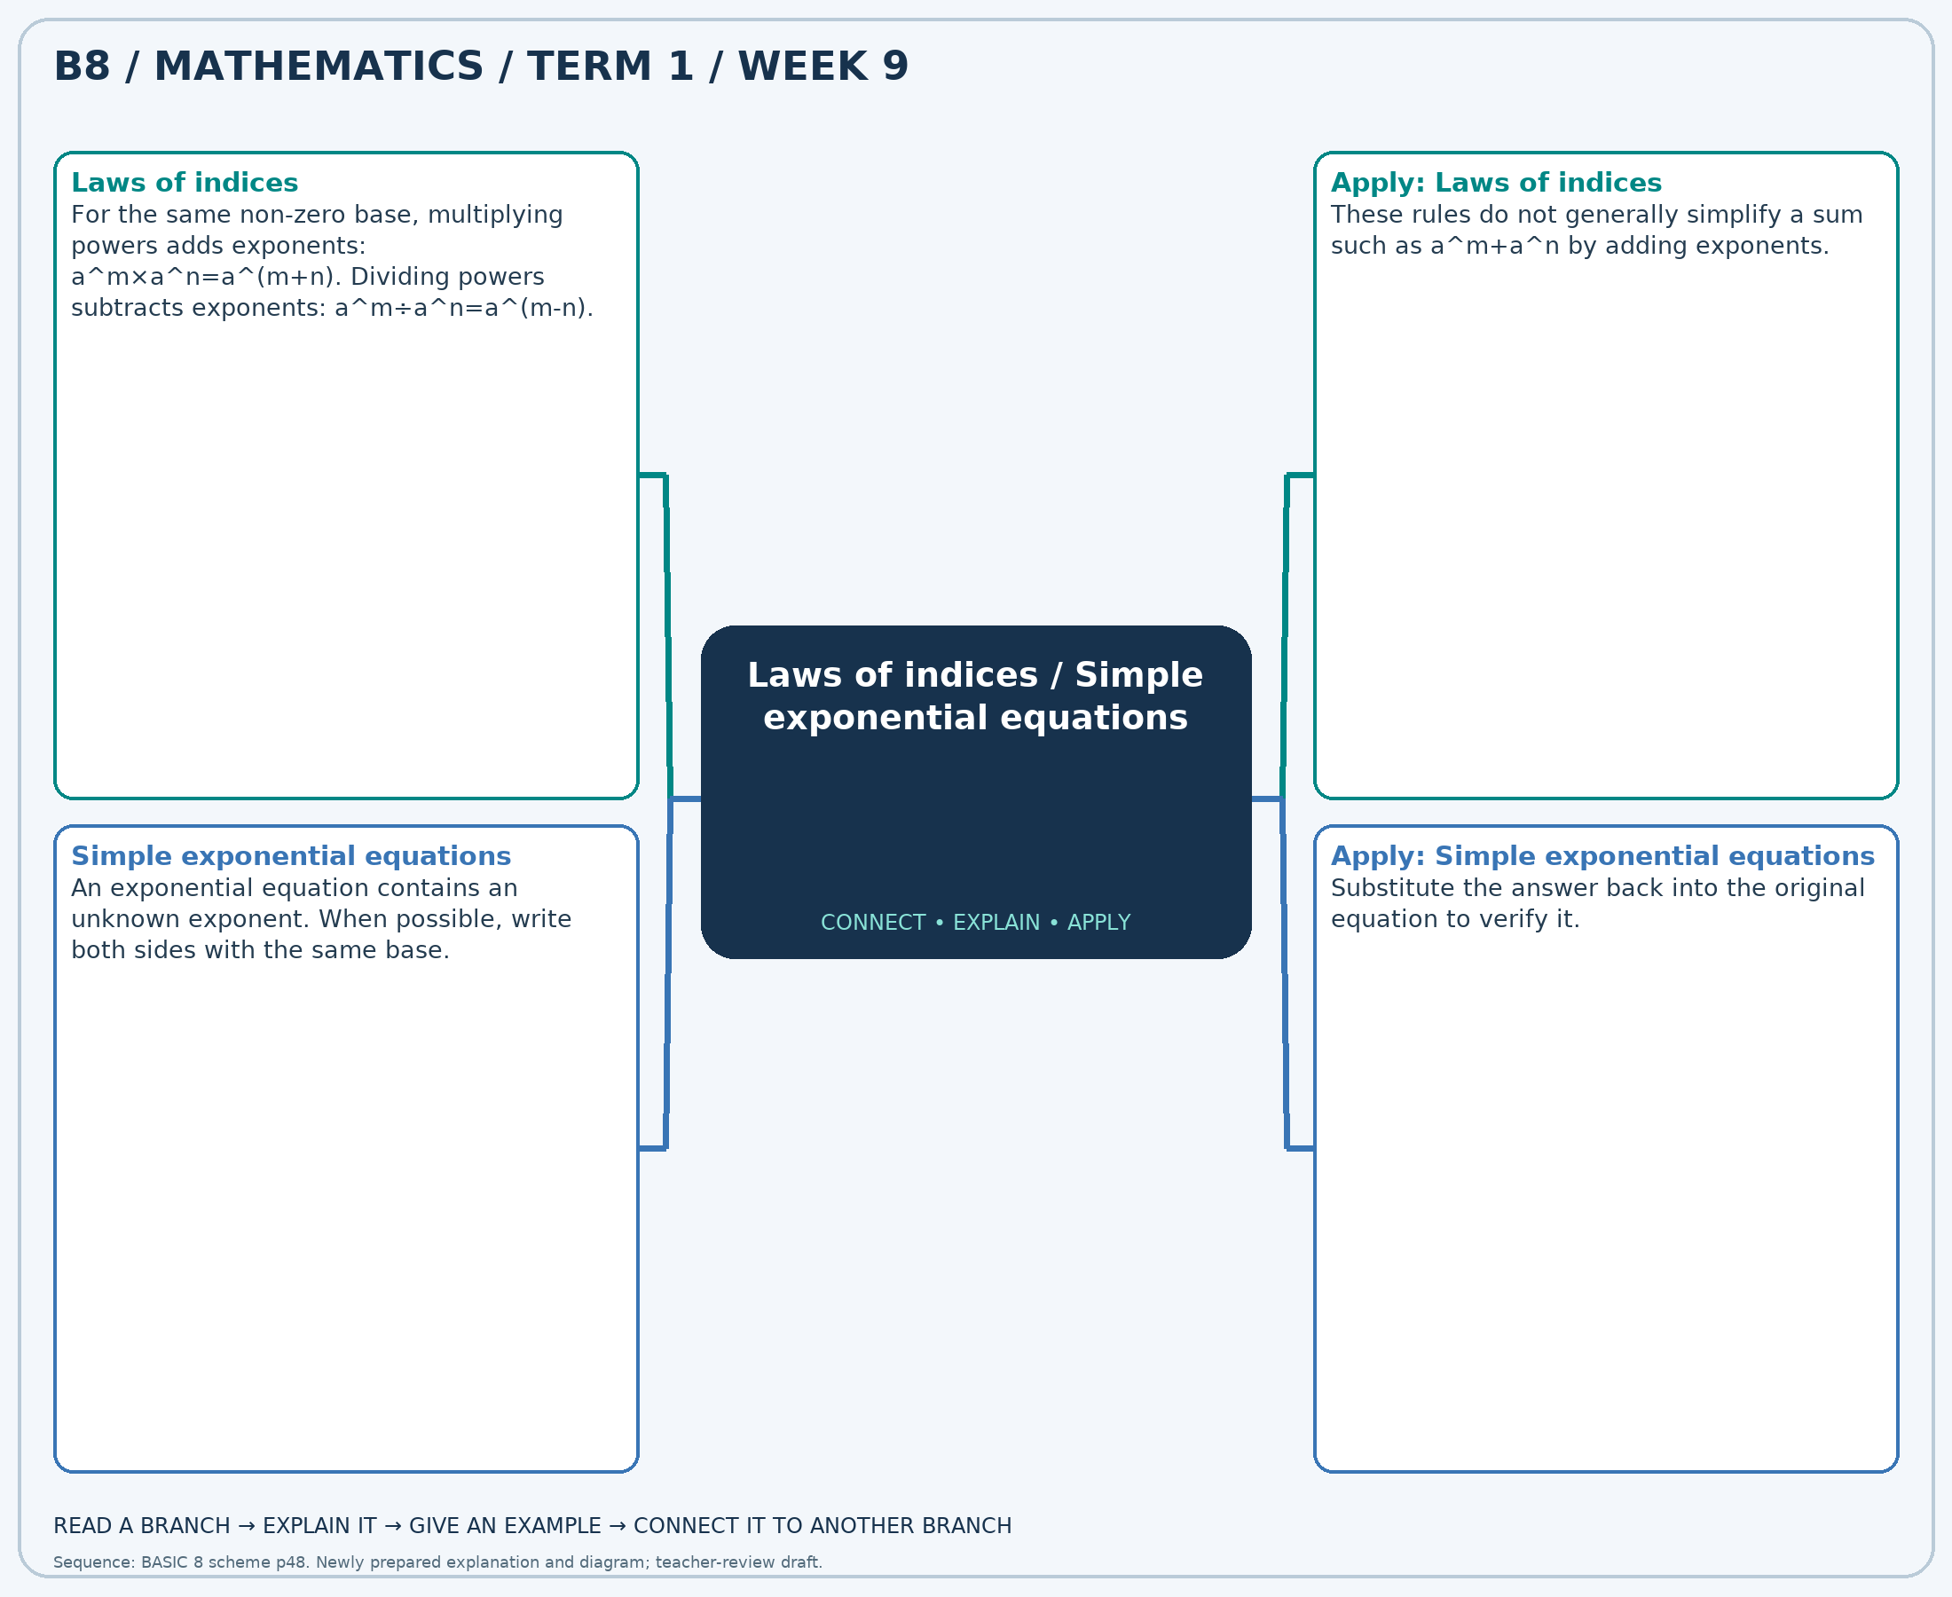
The separate high-resolution PNG can be projected or printed larger. Explain each branch and connect it with an example.

Week 9 — Practice

Section A — Multiple-choice questions
Choose ONE correct answer for each question. Each question has four alternatives.
1. Write 3^5 × 3^2 as 3^k. Find k.
A. 7 B. 9 C. 8 D. 6
2. Solve 5^x=625 for x.
A. 3 B. 4 C. 5 D. 6
3. Write 2^3 ÷ 2^1 as 2^k. Find k.
A. 3 B. 4 C. 2 D. 1
4. Solve 4^x=16 for x.
A. 4 B. 3 C. 2 D. 1
5. Write (6^7)^2 as 6^k. Find k.
A. 16 B. 14 C. 15 D. 13
6. Solve 2^x=64 for x.
A. 5 B. 8 C. 6 D. 7
7. Write 2^3 × 2^3 as 2^k. Find k.
A. 6 B. 5 C. 7 D. 8
8. Solve 3^x=81 for x.
A. 6 B. 5 C. 4 D. 3
9. Write 6^3 ÷ 6^3 as 6^k. Find k.
A. 1 B. 2 C. 0 D. -1
10. Solve 4^x=4096 for x.
A. 5 B. 7 C. 8 D. 6
11. Write (6^3)^3 as 6^k. Find k.
A. 9 B. 10 C. 8 D. 11
12. Solve 5^x=25 for x.
A. 3 B. 1 C. 4 D. 2
13. Write 7^5 × 7^1 as 7^k. Find k.
A. 8 B. 6 C. 5 D. 7
14. Solve 3^x=9 for x.
A. 4 B. 1 C. 3 D. 2
15. Write 5^7 ÷ 5^2 as 5^k. Find k.
A. 6 B. 4 C. 5 D. 7
16. Solve 5^x=3125 for x.
A. 4 B. 7 C. 5 D. 6
17. Write (4^4)^1 as 4^k. Find k.
A. 4 B. 5 C. 3 D. 6
18. Solve 4^x=256 for x.
A. 5 B. 3 C. 6 D. 4
19. Write 6^5 × 6^1 as 6^k. Find k.
A. 6 B. 7 C. 8 D. 5
20. Solve 3^x=27 for x.
A. 5 B. 4 C. 3 D. 2

Section B — Structured essay questions
Answer every part (a), (b), (c). Show your method or explain your choice. Write in a separate answer booklet. Each part: 1 mark for valid working/explanation and 1 for the correct result; 6 marks per question.

1. Apply the related skills and show working or give a reason for each answer.
(a) Write 4^7 × 4^3 as 4^k. Find k.
(b) Solve 4^x=16 for x.
(c) Write (4^6)^2 as 4^k. Find k.

2. Apply the related skills and show working or give a reason for each answer.
(a) Solve 5^x=625 for x.
(b) Write (5^3)^2 as 5^k. Find k.
(c) Solve 2^x=8 for x.

3. Apply the related skills and show working or give a reason for each answer.
(a) Write (2^3)^1 as 2^k. Find k.
(b) Solve 2^x=16 for x.
(c) Write 2^3 ÷ 2^2 as 2^k. Find k.

4. Apply the related skills and show working or give a reason for each answer.
(a) Solve 4^x=16 for x.
(b) Write 4^6 ÷ 4^2 as 4^k. Find k.
(c) Solve 5^x=625 for x.

5. Apply the related skills and show working or give a reason for each answer.
(a) Write 7^5 ÷ 7^3 as 7^k. Find k.
(b) Solve 5^x=25 for x.
(c) Write 4^5 × 4^2 as 4^k. Find k.

6. Apply the related skills and show working or give a reason for each answer.
(a) Solve 3^x=9 for x.
(b) Write 7^5 × 7^3 as 7^k. Find k.
(c) Solve 5^x=625 for x.

7. Apply the related skills and show working or give a reason for each answer.
(a) Write 5^5 × 5^2 as 5^k. Find k.
(b) Solve 4^x=16 for x.
(c) Write (3^3)^3 as 3^k. Find k.

8. Apply the related skills and show working or give a reason for each answer.
(a) Solve 2^x=8 for x.
(b) Write (4^7)^3 as 4^k. Find k.
(c) Solve 3^x=243 for x.

9. Apply the related skills and show working or give a reason for each answer.
(a) Write (3^4)^1 as 3^k. Find k.
(b) Solve 3^x=243 for x.
(c) Write 7^4 ÷ 7^2 as 7^k. Find k.

10. Apply the related skills and show working or give a reason for each answer.
(a) Solve 3^x=27 for x.
(b) Write 4^6 ÷ 4^3 as 4^k. Find k.
(c) Solve 3^x=243 for x.

Week 10 — Powers and repeated factors / Gradient of a straight line
Sequence source: BASIC 8 SCHEME OF LEARNING.pdf, first-term Mathematics, page 48. One consolidated weekly unit.

Learning outcomes
- Explain and apply powers and repeated factors, solve examples and justify the method.
- Explain and apply gradient of a straight line, solve examples and justify the method.

Teaching notes and suggested sessions
Suggested schedule: five 40-minute sessions, adjusted to the school timetable. Spread the question bank through the week; it is not intended to be completed in one lesson.

1 — Explore and diagnose
5 minutes: recall an earlier skill; 10: demonstrate a concrete or pictorial model; 15: pairs investigate and explain; 10: identify a misconception and set an exit task.

2 — Model and practise
5 minutes: review the exit task; 10: work an example aloud; 15: pairs solve parallel examples; 10: compare methods and correct errors.

3 — Connect representations
5 minutes: recall vocabulary; 10: explain the mind-map; 15: connect a model, a drawing and a symbolic calculation; 10: independent practice.

4 — Apply and explain
5 minutes: estimate or predict; 10: solve a contextual example; 15: attempt selected structured-question parts; 10: compare reasoning and check units.

5 — Check and respond
5 minutes: retrieve the main rule; 15: use selected MCQs diagnostically; 10: explain distractors and misconceptions; 10: reteach or extend in response to evidence.

Topic-specific activities
- Build square arrays or repeated-factor diagrams and write matching index notation.
- Plot points on squared paper and draw a rise/run triangle to count changes.
Resources: board, pencils, number cards, counters, paper strips and squared paper as appropriate. Prior-knowledge check: ask a learner to explain a representation used in the first example before introducing a new rule.
Support: reduce number size without changing the concept; offer a partially completed chart or model; allow oral reasoning before writing. Extension: create a counterexample to a false rule and explain why it fails.

Study notes and worked examples

Powers and repeated factors
- A power writes repeated multiplication: 3^4=3×3×3×3=81.
- The base is the repeated factor; the exponent counts occurrences.
- For a non-zero base, power zero equals 1.
- A power is not multiplication by its exponent: 3^4 is not 3×4.
Worked example: Evaluate 2^3.
Solution: 2 × 2 × 2 = 8.
Common misconception: The zero-exponent rule here requires a non-zero base; do not apply it to 0^0.

Gradient of a straight line
- Gradient is vertical change divided by horizontal change.
- For two points, m=(y2-y1)/(x2-x1), provided their x-values differ.
- A line rising left to right has positive gradient; a falling line has negative gradient. A horizontal line has zero gradient.
- In y=mx+c, m is gradient and c is the y-intercept. A vertical line has undefined gradient.
Worked example: A line is y=4x+4. Find y when x=6.
Solution: Substitute: y=4×(6)+4=28.
Common misconception: Use the same point order in both differences; do not reverse only one subtraction.
Independent study: read the map, cover it and reconstruct the branches. Solve an unused question from each skill and explain the reasoning to a partner. Consult the teacher key only after an honest attempt.

Week 10 — Visual mind-map
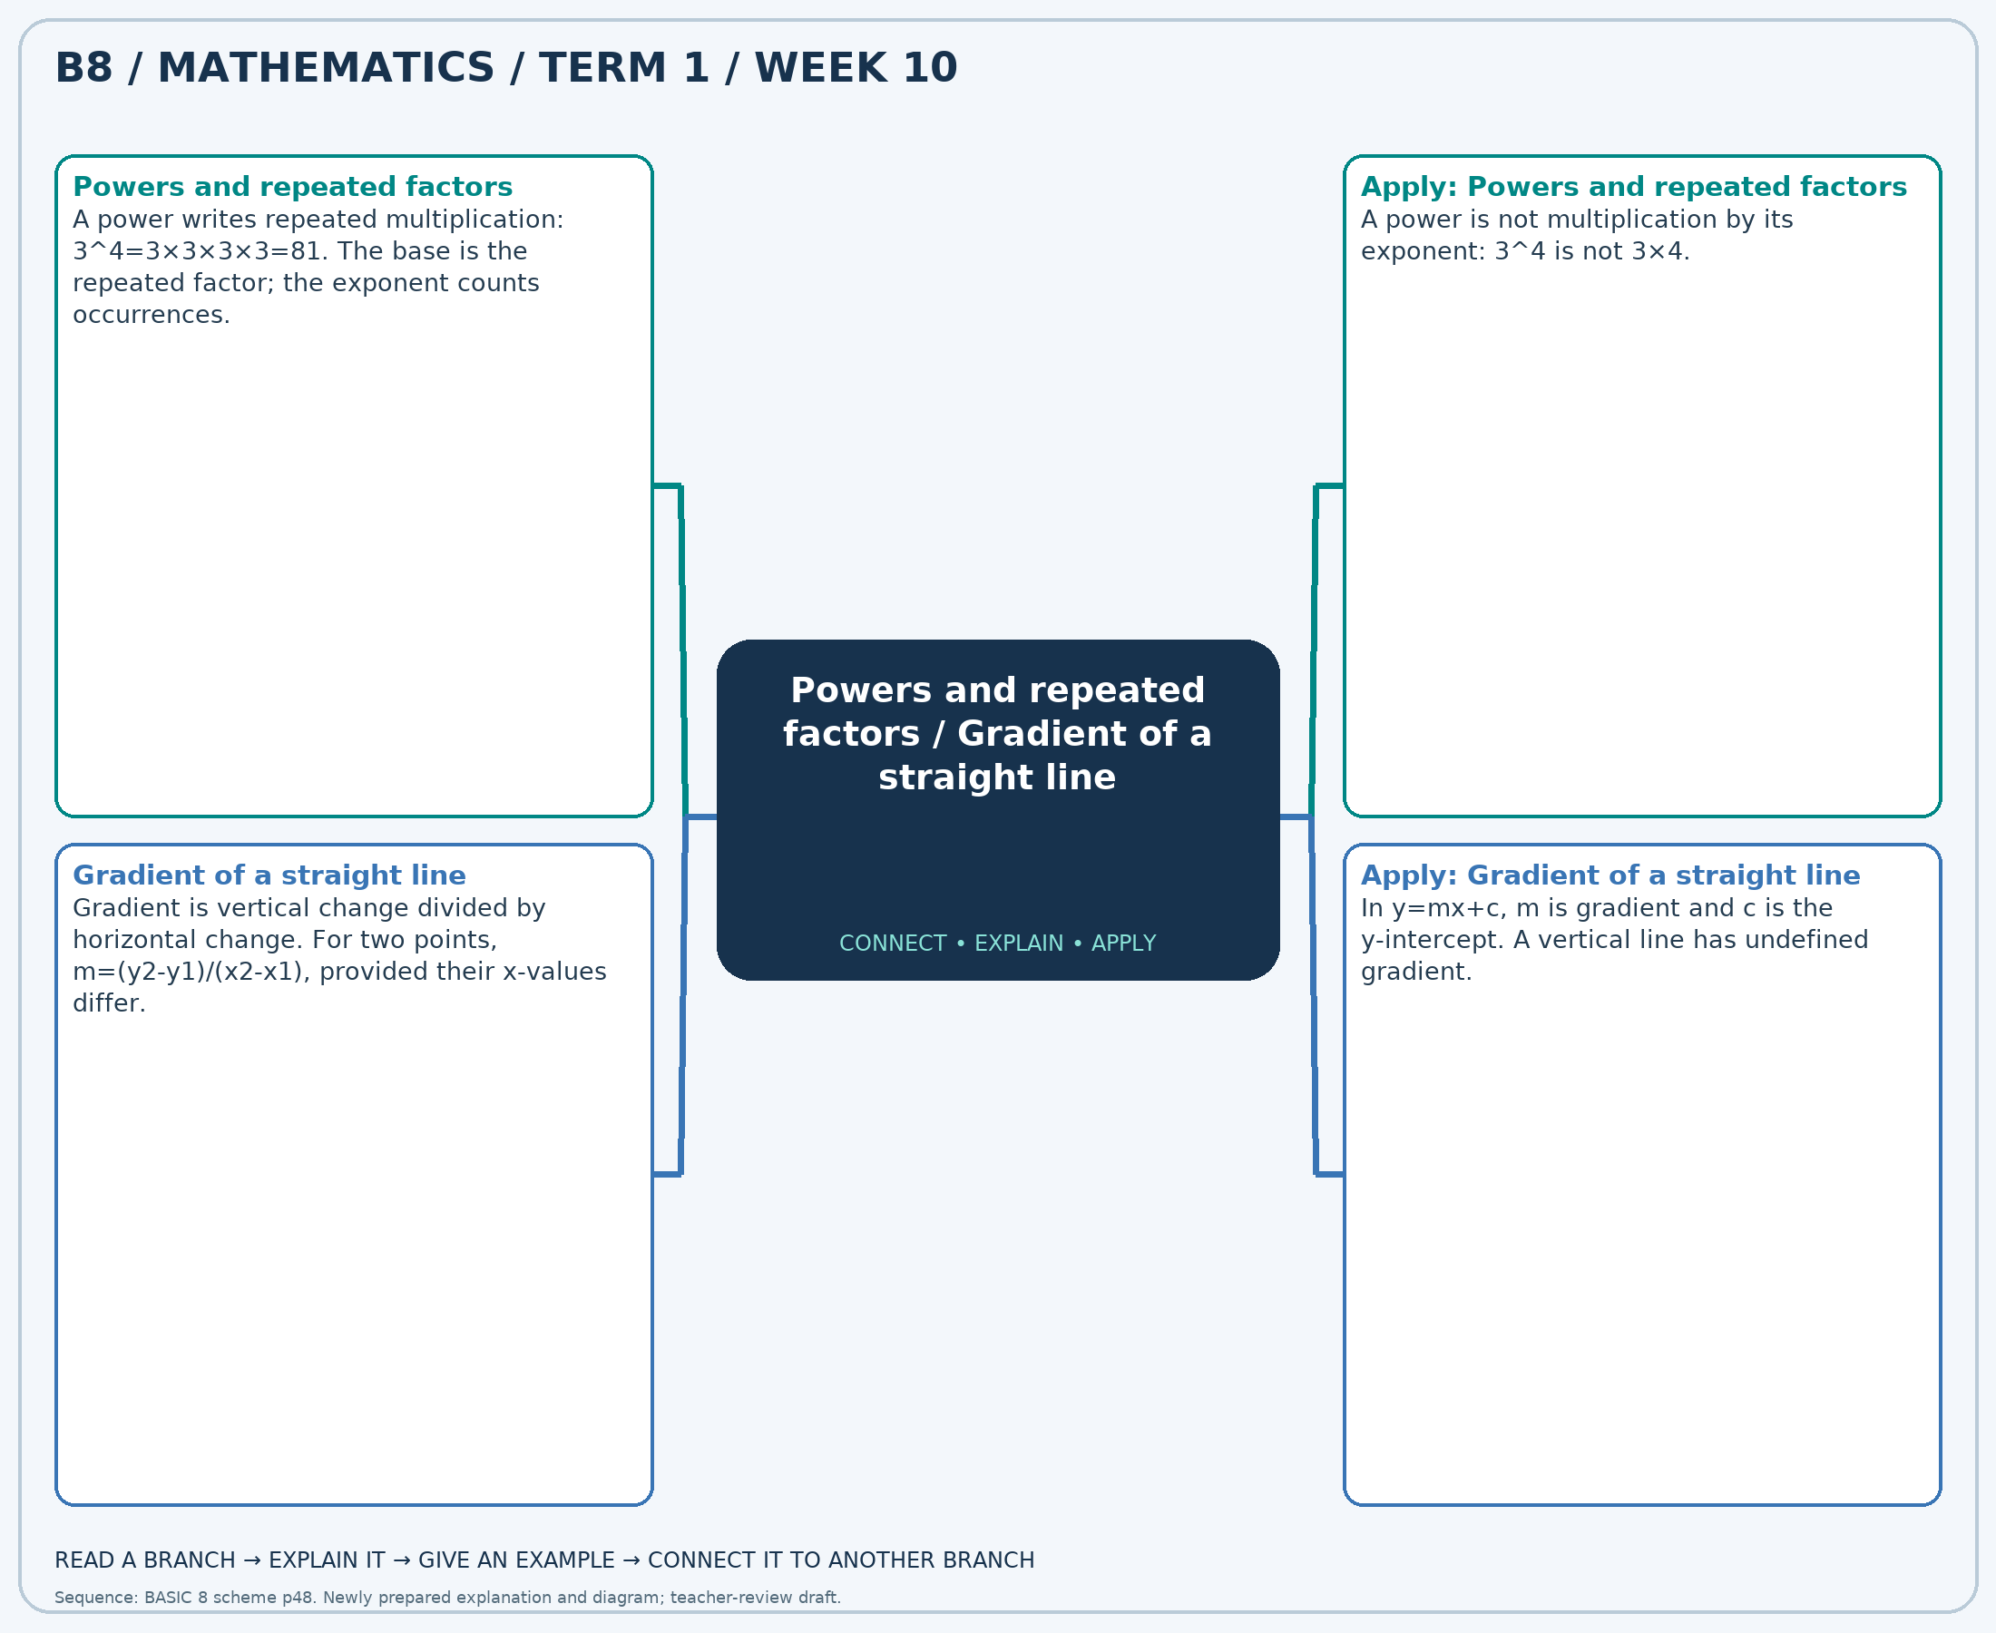
The separate high-resolution PNG can be projected or printed larger. Explain each branch and connect it with an example.

Week 10 — Practice

Section A — Multiple-choice questions
Choose ONE correct answer for each question. Each question has four alternatives.
1. Evaluate 7^3.
A. 344 B. 345 C. 342 D. 343
2. Find the gradient through (3, -6) and (5, -10).
A. -2 B. -3 C. 0 D. -1
3. Evaluate 5^0.
A. 3 B. 1 C. 0 D. 2
4. A line is y=-2x+5. Find y when x=6.
A. -8 B. -5 C. -6 D. -7
5. Evaluate 7^4.
A. 2402 B. 2400 C. 2403 D. 2401
6. A line has gradient -3 and passes through (3, -9). Find c in y=-3x+c.
A. 1 B. 0 C. -1 D. 2
7. Evaluate 5^3.
A. 124 B. 126 C. 127 D. 125
8. Find the gradient through (1, 1) and (7, -11).
A. -1 B. -3 C. -2 D. 0
9. Evaluate 3^0.
A. 3 B. 2 C. 1 D. 0
10. A line is y=4x-1. Find y when x=-1.
A. -4 B. -6 C. -3 D. -5
11. Evaluate 3^2.
A. 11 B. 10 C. 8 D. 9
12. Find the gradient through (3, 11) and (5, 19).
A. 3 B. 4 C. 6 D. 5
13. Evaluate 5^4.
A. 625 B. 624 C. 626 D. 627
14. A line is y=-2x+3. Find y when x=4.
A. -4 B. -6 C. -3 D. -5
15. Evaluate 6^2.
A. 36 B. 38 C. 35 D. 37
16. A line has gradient -2 and passes through (-1, 2). Find c in y=-2x+c.
A. 0 B. 1 C. 2 D. -1
17. Evaluate 6^3.
A. 217 B. 216 C. 215 D. 218
18. Find the gradient through (2, 8) and (8, 20).
A. 1 B. 2 C. 3 D. 4
19. Evaluate 7^0.
A. 2 B. 1 C. 0 D. 3
20. A line is y=3x-3. Find y when x=8.
A. 21 B. 22 C. 23 D. 20

Section B — Structured essay questions
Answer every part (a), (b), (c). Show your method or explain your choice. Write in a separate answer booklet. Each part: 1 mark for valid working/explanation and 1 for the correct result; 6 marks per question.

1. Apply the related skills and show working or give a reason for each answer.
(a) Evaluate 6^2.
(b) A line is y=-2x-5. Find y when x=7.
(c) Evaluate 3^4.

2. Apply the related skills and show working or give a reason for each answer.
(a) A line is y=3x-1. Find y when x=1.
(b) Evaluate 6^4.
(c) Find the gradient through (3, 6) and (8, 16).

3. Apply the related skills and show working or give a reason for each answer.
(a) Evaluate 6^4.
(b) Find the gradient through (-1, 0) and (1, 4).
(c) Evaluate 3^0.

4. Apply the related skills and show working or give a reason for each answer.
(a) Find the gradient through (-1, 0) and (2, 3).
(b) Evaluate 3^0.
(c) A line has gradient -2 and passes through (0, -2). Find c in y=-2x+c.

5. Apply the related skills and show working or give a reason for each answer.
(a) Evaluate 3^0.
(b) A line has gradient 3 and passes through (-2, -7). Find c in y=3x+c.
(c) Evaluate 5^3.

6. Apply the related skills and show working or give a reason for each answer.
(a) A line has gradient -1 and passes through (-1, 2). Find c in y=-1x+c.
(b) Evaluate 6^3.
(c) A line is y=1x+1. Find y when x=3.

7. Apply the related skills and show working or give a reason for each answer.
(a) Evaluate 7^3.
(b) A line is y=1x-2. Find y when x=2.
(c) Evaluate 7^2.

8. Apply the related skills and show working or give a reason for each answer.
(a) A line is y=2x+3. Find y when x=5.
(b) Evaluate 6^2.
(c) Find the gradient through (0, -2) and (5, -7).

9. Apply the related skills and show working or give a reason for each answer.
(a) Evaluate 5^3.
(b) Find the gradient through (2, 13) and (8, 37).
(c) Evaluate 5^0.

10. Apply the related skills and show working or give a reason for each answer.
(a) Find the gradient through (-1, -2) and (2, -8).
(b) Evaluate 5^0.
(c) A line has gradient 2 and passes through (0, 5). Find c in y=2x+c.

Week 11 — Gradient of a straight line
Sequence source: BASIC 8 SCHEME OF LEARNING.pdf, first-term Mathematics, page 48. One consolidated weekly unit.

Learning outcomes
- Explain and apply gradient of a straight line, solve examples and justify the method.

Teaching notes and suggested sessions
Suggested schedule: five 40-minute sessions, adjusted to the school timetable. Spread the question bank through the week; it is not intended to be completed in one lesson.

1 — Explore and diagnose
5 minutes: recall an earlier skill; 10: demonstrate a concrete or pictorial model; 15: pairs investigate and explain; 10: identify a misconception and set an exit task.

2 — Model and practise
5 minutes: review the exit task; 10: work an example aloud; 15: pairs solve parallel examples; 10: compare methods and correct errors.

3 — Connect representations
5 minutes: recall vocabulary; 10: explain the mind-map; 15: connect a model, a drawing and a symbolic calculation; 10: independent practice.

4 — Apply and explain
5 minutes: estimate or predict; 10: solve a contextual example; 15: attempt selected structured-question parts; 10: compare reasoning and check units.

5 — Check and respond
5 minutes: retrieve the main rule; 15: use selected MCQs diagnostically; 10: explain distractors and misconceptions; 10: reteach or extend in response to evidence.

Topic-specific activities
- Plot points on squared paper and draw a rise/run triangle to count changes.
Resources: board, pencils, number cards, counters, paper strips and squared paper as appropriate. Prior-knowledge check: ask a learner to explain a representation used in the first example before introducing a new rule.
Support: reduce number size without changing the concept; offer a partially completed chart or model; allow oral reasoning before writing. Extension: create a counterexample to a false rule and explain why it fails.

Study notes and worked examples

Gradient of a straight line
- Gradient is vertical change divided by horizontal change.
- For two points, m=(y2-y1)/(x2-x1), provided their x-values differ.
- A line rising left to right has positive gradient; a falling line has negative gradient. A horizontal line has zero gradient.
- In y=mx+c, m is gradient and c is the y-intercept. A vertical line has undefined gradient.
Worked example: Find the gradient through (-3, -12) and (2, 3).
Solution: (3-(-12))/(2-(-3))=15/5=3.
Common misconception: Use the same point order in both differences; do not reverse only one subtraction.
Independent study: read the map, cover it and reconstruct the branches. Solve an unused question from each skill and explain the reasoning to a partner. Consult the teacher key only after an honest attempt.

Week 11 — Visual mind-map
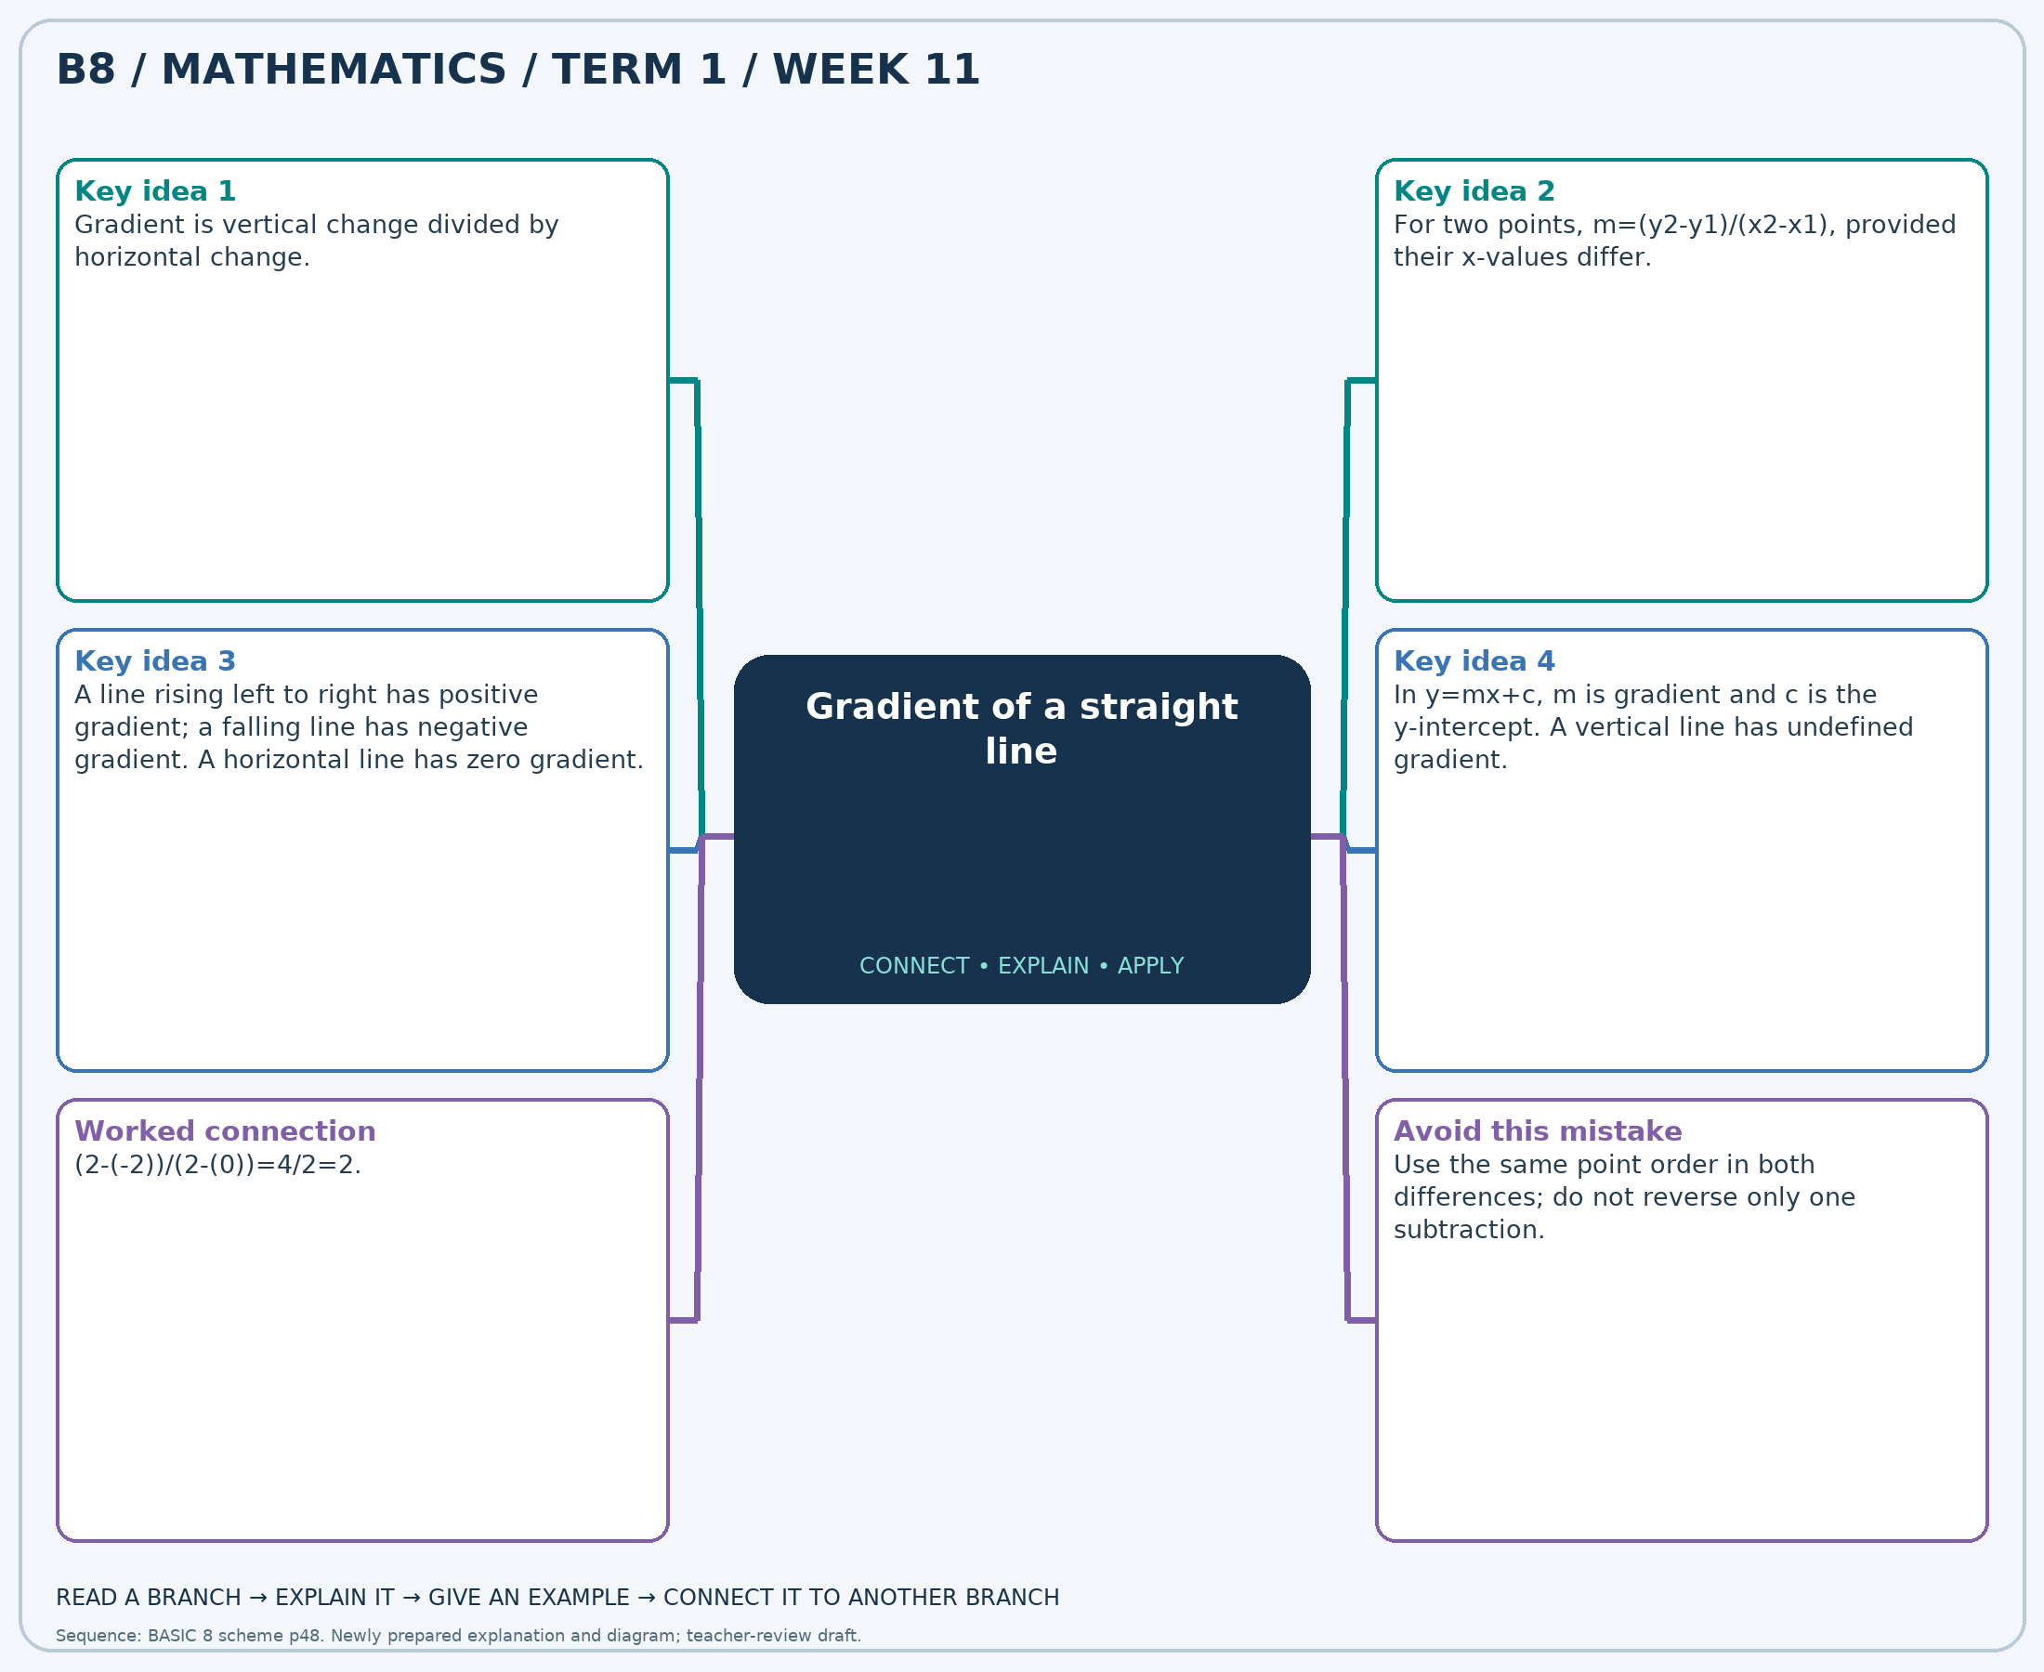
The separate high-resolution PNG can be projected or printed larger. Explain each branch and connect it with an example.

Week 11 — Practice

Section A — Multiple-choice questions
Choose ONE correct answer for each question. Each question has four alternatives.
1. Find the gradient through (0, -3) and (4, 1).
A. 1 B. 2 C. 0 D. 3
2. A line is y=2x+0. Find y when x=5.
A. 12 B. 9 C. 10 D. 11
3. A line has gradient -3 and passes through (1, 0). Find c in y=-3x+c.
A. 3 B. 4 C. 2 D. 5
4. Find the gradient through (1, 2) and (4, -1).
A. 1 B. 0 C. -1 D. -2
5. A line is y=2x+4. Find y when x=3.
A. 11 B. 12 C. 10 D. 9
6. A line has gradient -2 and passes through (1, -6). Find c in y=-2x+c.
A. -3 B. -4 C. -5 D. -2
7. Find the gradient through (2, 1) and (6, 5).
A. 2 B. 1 C. 3 D. 0
8. A line is y=-3x+2. Find y when x=3.
A. -6 B. -8 C. -7 D. -5
9. A line has gradient -2 and passes through (-1, 3). Find c in y=-2x+c.
A. 2 B. 1 C. 3 D. 0
10. Find the gradient through (-1, 6) and (4, -4).
A. -3 B. 0 C. -1 D. -2
11. A line is y=2x+0. Find y when x=4.
A. 8 B. 10 C. 7 D. 9
12. A line has gradient -1 and passes through (-2, -3). Find c in y=-1x+c.
A. -4 B. -6 C. -5 D. -3
13. Find the gradient through (2, 8) and (6, 16).
A. 3 B. 1 C. 4 D. 2
14. A line is y=4x-5. Find y when x=5.
A. 17 B. 15 C. 16 D. 14
15. A line has gradient 1 and passes through (1, 0). Find c in y=1x+c.
A. -1 B. 1 C. 0 D. -2
16. Find the gradient through (0, -3) and (4, -7).
A. -2 B. 0 C. -1 D. 1
17. A line is y=-2x-1. Find y when x=1.
A. -2 B. -1 C. -3 D. -4
18. A line has gradient -2 and passes through (3, -11). Find c in y=-2x+c.
A. -5 B. -3 C. -6 D. -4
19. Find the gradient through (0, -1) and (5, 4).
A. 1 B. 3 C. 2 D. 0
20. A line is y=-1x-3. Find y when x=2.
A. -3 B. -4 C. -6 D. -5

Section B — Structured essay questions
Answer every part (a), (b), (c). Show your method or explain your choice. Write in a separate answer booklet. Each part: 1 mark for valid working/explanation and 1 for the correct result; 6 marks per question.

1. Apply the related skills and show working or give a reason for each answer.
(a) Find the gradient through (2, -11) and (8, -29).
(b) A line is y=-2x+4. Find y when x=4.
(c) A line has gradient -2 and passes through (-3, 1). Find c in y=-2x+c.

2. Apply the related skills and show working or give a reason for each answer.
(a) A line is y=2x+5. Find y when x=3.
(b) A line has gradient 3 and passes through (2, 5). Find c in y=3x+c.
(c) Find the gradient through (-3, -7) and (2, 13).

3. Apply the related skills and show working or give a reason for each answer.
(a) A line has gradient 1 and passes through (0, -1). Find c in y=1x+c.
(b) Find the gradient through (-2, 0) and (1, -6).
(c) A line is y=-3x-5. Find y when x=6.

4. Apply the related skills and show working or give a reason for each answer.
(a) Find the gradient through (-3, -15) and (3, 9).
(b) A line is y=4x-5. Find y when x=5.
(c) A line has gradient -1 and passes through (-3, 8). Find c in y=-1x+c.

5. Apply the related skills and show working or give a reason for each answer.
(a) A line is y=1x+3. Find y when x=8.
(b) A line has gradient -3 and passes through (1, -5). Find c in y=-3x+c.
(c) Find the gradient through (2, 12) and (6, 28).

6. Apply the related skills and show working or give a reason for each answer.
(a) A line has gradient 2 and passes through (-1, 3). Find c in y=2x+c.
(b) Find the gradient through (3, 14) and (9, 32).
(c) A line is y=1x-2. Find y when x=4.

7. Apply the related skills and show working or give a reason for each answer.
(a) Find the gradient through (2, -2) and (8, -20).
(b) A line is y=-2x-1. Find y when x=7.
(c) A line has gradient 4 and passes through (-3, -7). Find c in y=4x+c.

8. Apply the related skills and show working or give a reason for each answer.
(a) A line is y=2x+0. Find y when x=1.
(b) A line has gradient -2 and passes through (0, -1). Find c in y=-2x+c.
(c) Find the gradient through (-3, -7) and (3, 11).

9. Apply the related skills and show working or give a reason for each answer.
(a) A line has gradient 4 and passes through (-2, -8). Find c in y=4x+c.
(b) Find the gradient through (0, 0) and (4, 8).
(c) A line is y=4x+0. Find y when x=7.

10. Apply the related skills and show working or give a reason for each answer.
(a) Find the gradient through (2, 6) and (5, 9).
(b) A line is y=3x-1. Find y when x=2.
(c) A line has gradient 4 and passes through (2, 5). Find c in y=4x+c.

Week 12 — Gradient of a straight line
Sequence source: BASIC 8 SCHEME OF LEARNING.pdf, first-term Mathematics, page 48. One consolidated weekly unit.

Learning outcomes
- Explain and apply gradient of a straight line, solve examples and justify the method.

Teaching notes and suggested sessions
Suggested schedule: five 40-minute sessions, adjusted to the school timetable. Spread the question bank through the week; it is not intended to be completed in one lesson.

1 — Explore and diagnose
5 minutes: recall an earlier skill; 10: demonstrate a concrete or pictorial model; 15: pairs investigate and explain; 10: identify a misconception and set an exit task.

2 — Model and practise
5 minutes: review the exit task; 10: work an example aloud; 15: pairs solve parallel examples; 10: compare methods and correct errors.

3 — Connect representations
5 minutes: recall vocabulary; 10: explain the mind-map; 15: connect a model, a drawing and a symbolic calculation; 10: independent practice.

4 — Apply and explain
5 minutes: estimate or predict; 10: solve a contextual example; 15: attempt selected structured-question parts; 10: compare reasoning and check units.

5 — Check and respond
5 minutes: retrieve the main rule; 15: use selected MCQs diagnostically; 10: explain distractors and misconceptions; 10: reteach or extend in response to evidence.

Topic-specific activities
- Plot points on squared paper and draw a rise/run triangle to count changes.
Resources: board, pencils, number cards, counters, paper strips and squared paper as appropriate. Prior-knowledge check: ask a learner to explain a representation used in the first example before introducing a new rule.
Support: reduce number size without changing the concept; offer a partially completed chart or model; allow oral reasoning before writing. Extension: create a counterexample to a false rule and explain why it fails.

Study notes and worked examples

Gradient of a straight line
- Gradient is vertical change divided by horizontal change.
- For two points, m=(y2-y1)/(x2-x1), provided their x-values differ.
- A line rising left to right has positive gradient; a falling line has negative gradient. A horizontal line has zero gradient.
- In y=mx+c, m is gradient and c is the y-intercept. A vertical line has undefined gradient.
Worked example: Find the gradient through (3, -8) and (6, -17).
Solution: (-17-(-8))/(6-(3))=-9/3=-3.
Common misconception: Use the same point order in both differences; do not reverse only one subtraction.
Independent study: read the map, cover it and reconstruct the branches. Solve an unused question from each skill and explain the reasoning to a partner. Consult the teacher key only after an honest attempt.

Week 12 — Visual mind-map
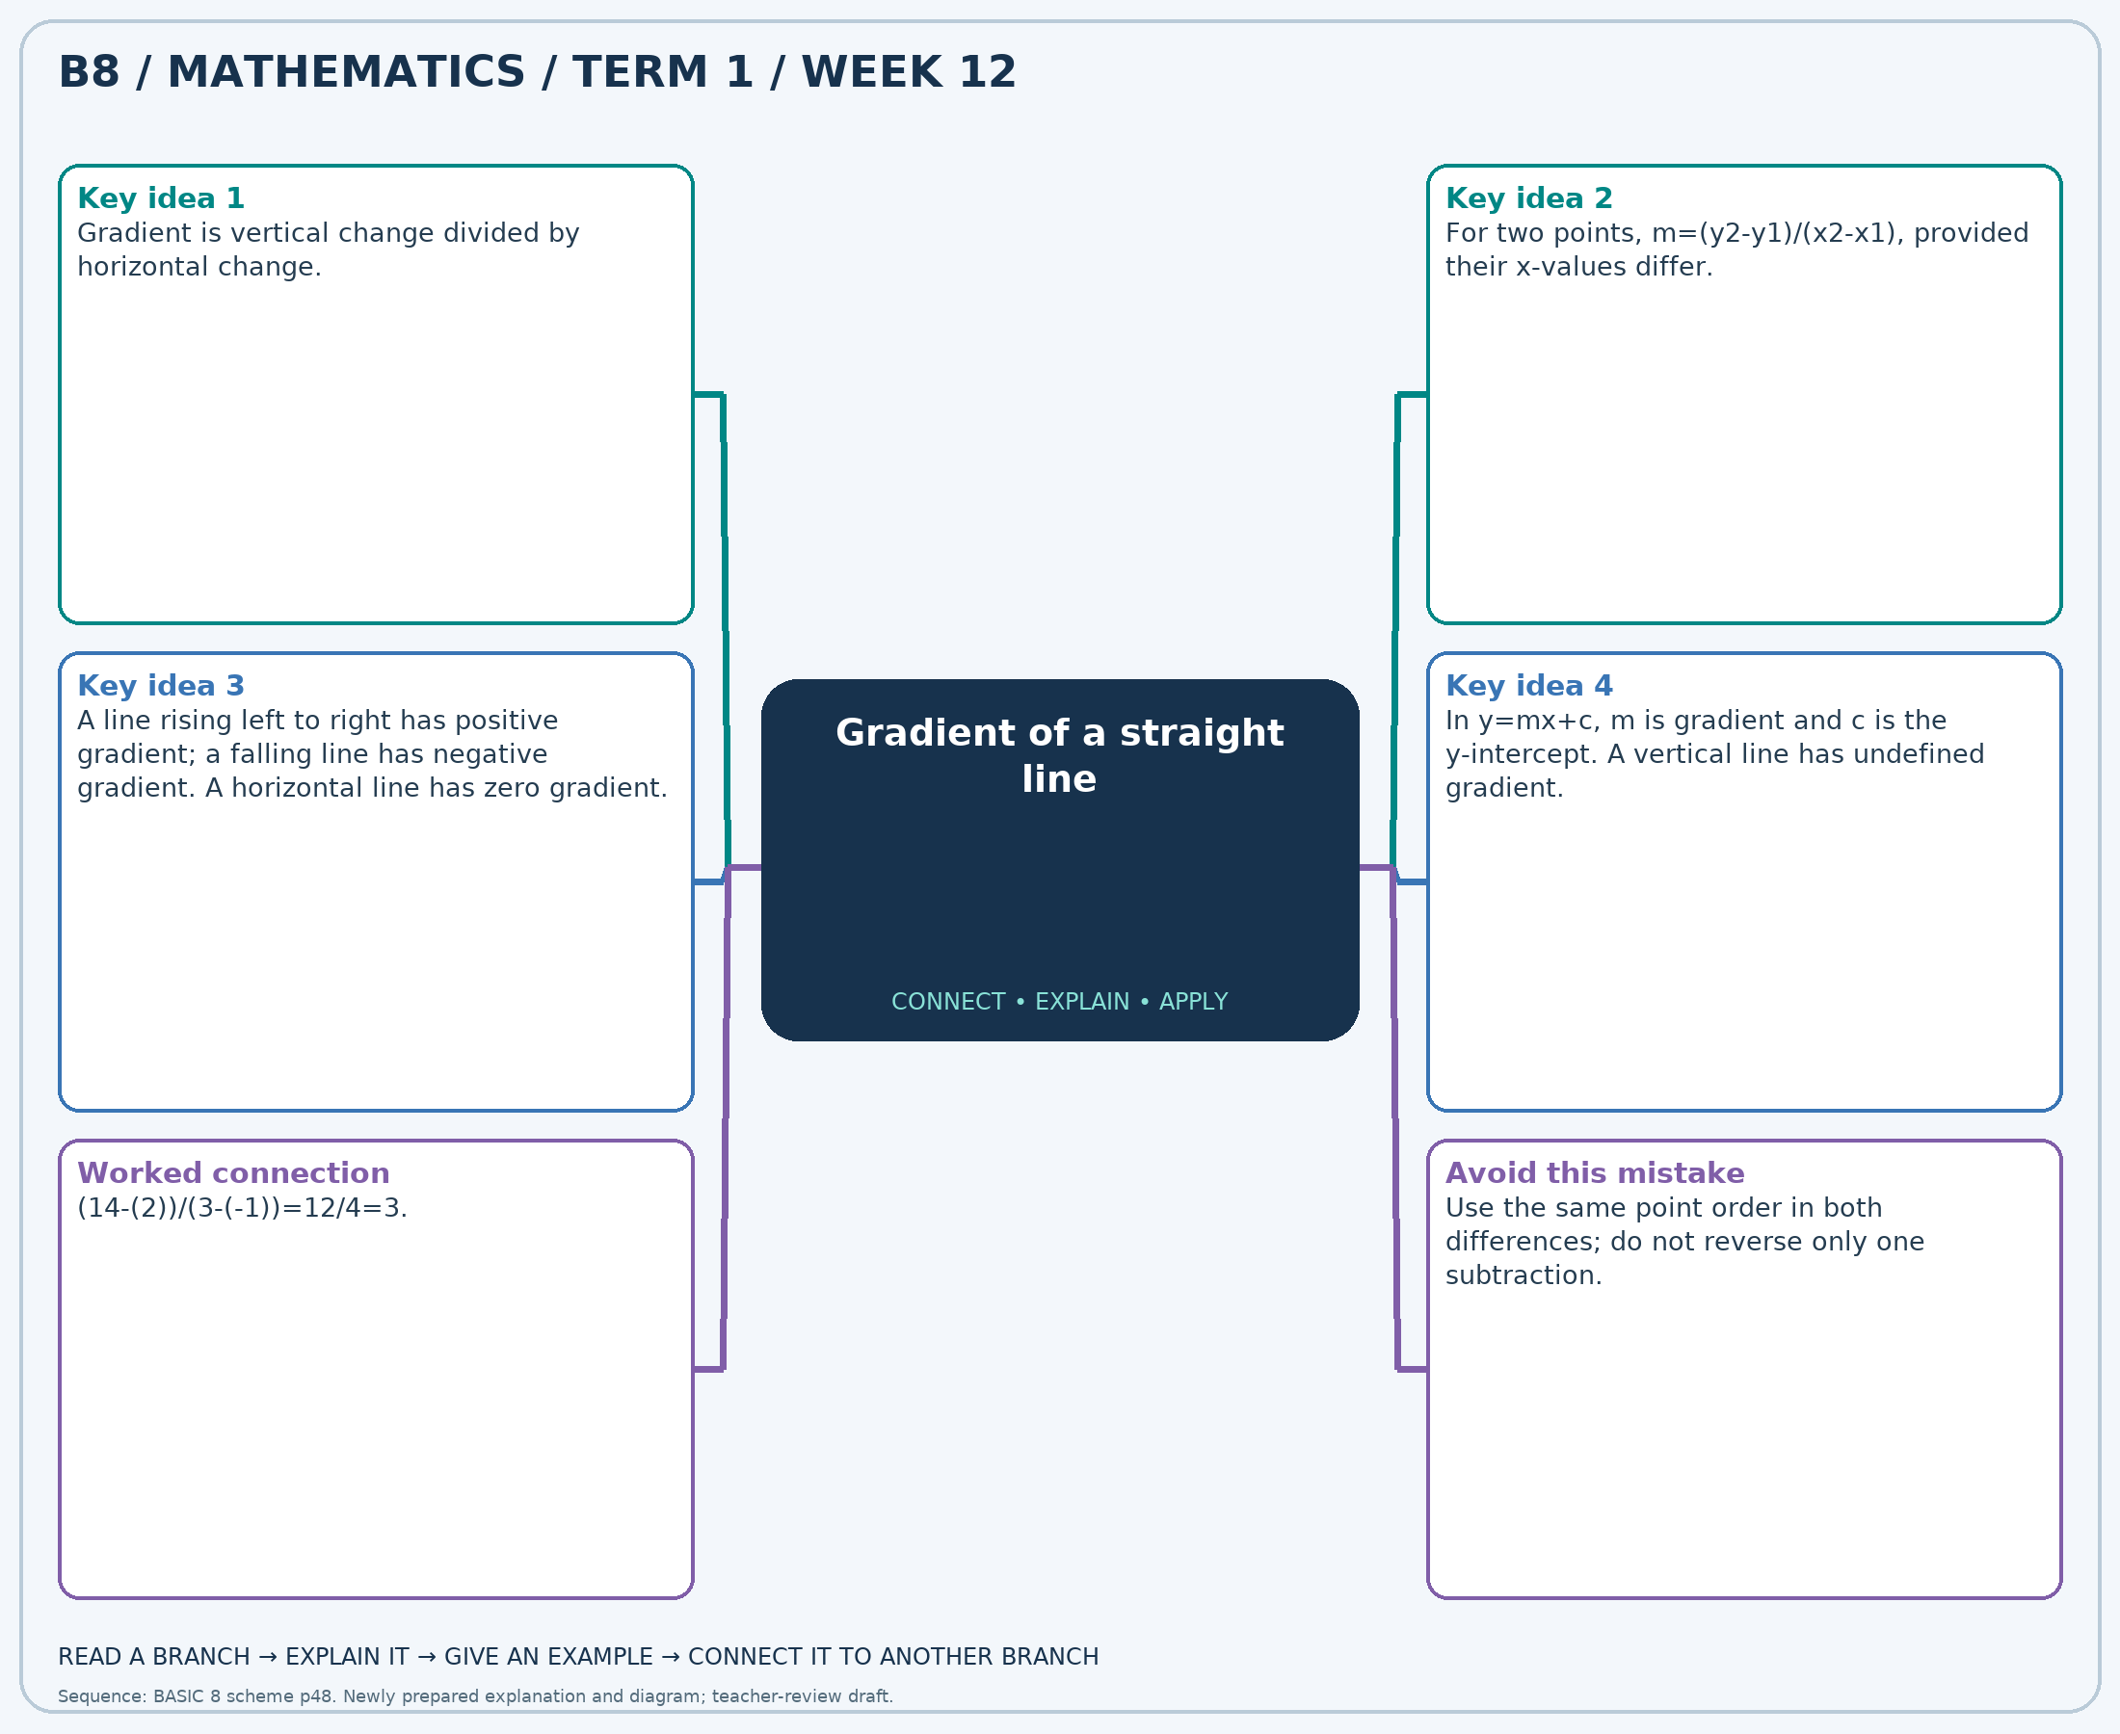
The separate high-resolution PNG can be projected or printed larger. Explain each branch and connect it with an example.

Week 12 — Practice

Section A — Multiple-choice questions
Choose ONE correct answer for each question. Each question has four alternatives.
1. Find the gradient through (-1, -4) and (1, 4).
A. 3 B. 5 C. 6 D. 4
2. A line is y=-3x+3. Find y when x=4.
A. -7 B. -9 C. -10 D. -8
3. A line has gradient -3 and passes through (1, -7). Find c in y=-3x+c.
A. -2 B. -5 C. -3 D. -4
4. Find the gradient through (2, 3) and (7, 18).
A. 5 B. 2 C. 4 D. 3
5. A line is y=-2x+1. Find y when x=7.
A. -12 B. -14 C. -13 D. -11
6. A line has gradient 3 and passes through (0, -1). Find c in y=3x+c.
A. 1 B. 0 C. -1 D. -2
7. Find the gradient through (-1, -8) and (2, 4).
A. 5 B. 6 C. 3 D. 4
8. A line is y=-1x-1. Find y when x=5.
A. -6 B. -5 C. -4 D. -7
9. A line has gradient 3 and passes through (3, 9). Find c in y=3x+c.
A. 2 B. -1 C. 1 D. 0
10. Find the gradient through (-1, 1) and (2, 13).
A. 5 B. 3 C. 4 D. 6
11. A line is y=-1x+0. Find y when x=2.
A. 0 B. -1 C. -2 D. -3
12. A line has gradient 2 and passes through (1, -2). Find c in y=2x+c.
A. -5 B. -2 C. -4 D. -3
13. Find the gradient through (-3, 9) and (3, -3).
A. 0 B. -1 C. -3 D. -2
14. A line is y=1x+3. Find y when x=2.
A. 7 B. 6 C. 4 D. 5
15. A line has gradient -1 and passes through (-3, 8). Find c in y=-1x+c.
A. 5 B. 4 C. 6 D. 7
16. Find the gradient through (3, -1) and (9, -7).
A. 0 B. 1 C. -2 D. -1
17. A line is y=-2x+0. Find y when x=7.
A. -15 B. -14 C. -13 D. -12
18. A line has gradient -1 and passes through (1, 4). Find c in y=-1x+c.
A. 6 B. 4 C. 7 D. 5
19. Find the gradient through (1, -4) and (5, -16).
A. -4 B. -1 C. -2 D. -3
20. A line is y=-3x-5. Find y when x=8.
A. -29 B. -30 C. -27 D. -28

Section B — Structured essay questions
Answer every part (a), (b), (c). Show your method or explain your choice. Write in a separate answer booklet. Each part: 1 mark for valid working/explanation and 1 for the correct result; 6 marks per question.

1. Apply the related skills and show working or give a reason for each answer.
(a) Find the gradient through (0, -2) and (6, 10).
(b) A line is y=-1x-4. Find y when x=4.
(c) A line has gradient 3 and passes through (0, 1). Find c in y=3x+c.

2. Apply the related skills and show working or give a reason for each answer.
(a) A line is y=-3x+4. Find y when x=5.
(b) A line has gradient 4 and passes through (2, 3). Find c in y=4x+c.
(c) Find the gradient through (2, -3) and (5, -6).

3. Apply the related skills and show working or give a reason for each answer.
(a) A line has gradient -3 and passes through (-2, 1). Find c in y=-3x+c.
(b) Find the gradient through (-3, -5) and (3, 1).
(c) A line is y=4x+3. Find y when x=2.

4. Apply the related skills and show working or give a reason for each answer.
(a) Find the gradient through (1, 5) and (6, 25).
(b) A line is y=-3x-5. Find y when x=2.
(c) A line has gradient 3 and passes through (-3, -14). Find c in y=3x+c.

5. Apply the related skills and show working or give a reason for each answer.
(a) A line is y=3x+2. Find y when x=1.
(b) A line has gradient 1 and passes through (2, 5). Find c in y=1x+c.
(c) Find the gradient through (1, 0) and (4, 3).

6. Apply the related skills and show working or give a reason for each answer.
(a) A line has gradient 3 and passes through (0, 3). Find c in y=3x+c.
(b) Find the gradient through (-2, -8) and (0, 0).
(c) A line is y=-1x+5. Find y when x=1.

7. Apply the related skills and show working or give a reason for each answer.
(a) Find the gradient through (-3, 10) and (-1, 4).
(b) A line is y=1x+1. Find y when x=6.
(c) A line has gradient 2 and passes through (-3, -3). Find c in y=2x+c.

8. Apply the related skills and show working or give a reason for each answer.
(a) A line is y=-2x+0. Find y when x=5.
(b) A line has gradient -3 and passes through (-1, 1). Find c in y=-3x+c.
(c) Find the gradient through (-3, -11) and (2, 9).

9. Apply the related skills and show working or give a reason for each answer.
(a) A line has gradient -1 and passes through (2, -2). Find c in y=-1x+c.
(b) Find the gradient through (3, -6) and (9, -18).
(c) A line is y=-2x-3. Find y when x=5.

10. Apply the related skills and show working or give a reason for each answer.
(a) Find the gradient through (-2, -4) and (0, -2).
(b) A line is y=3x-1. Find y when x=6.
(c) A line has gradient -2 and passes through (2, -8). Find c in y=-2x+c.

