Basic 8 Science — Week 1
  - Types and characteristics of mixtures • Term 1 • Week 1 ONLY
Name: __________________________________ Class: __________
Date: __________________ Teacher: ________________________
SCOPE: WEEK 1 ONLY. Later weeks and both tests for this subject are NOT included in this partial batch. Emergency teacher-review draft — rebuilt edition.
Sequence source: BASIC 8 SCHEME OF LEARNING.pdf, p62; indicator reference B8.1.1.1.1. Topic descriptions informed by the local curriculum data. Explanations and activities are newly prepared, including supporting concepts.

Learning outcomes
- Explain the key ideas in types and characteristics of mixtures using accurate vocabulary.
- Identify examples and justify classification or tool choices using evidence.
- Apply the ideas to familiar school or home situations and correct a common misconception.

Teacher lesson notes
One consolidated weekly unit. Suggested organisation: three 40-minute teaching sessions plus guided practice and assessment in the remaining timetable periods. Spread the questions over the week.
Prior knowledge: elicit a familiar example and ask for a reason. Record one correct idea and one misconception to revisit at the end of the week.

Session 1 — Observe
5 minutes: recall examples; 10: demonstrate or show pictures; 15: pairs describe features; 10: introduce the first five key terms and check explanations.

Session 2 — Investigate
5 minutes: retrieve vocabulary; 10: model an explanation; 15: perform the specific activity below; 10: compare observations and introduce the remaining terms.

Session 3 — Apply
5 minutes: correct a misconception; 10: explain map branches; 15: use application questions; 10: collect an exit response and identify who needs reteaching.

Topic-specific activity
Observe labelled samples of salt and water, sand and water, and cooking oil and water. Predict, stir, allow to stand, then record whether each is uniform and whether layers or sediment form. Use observations to justify classifications.

Safety and resources
Use small quantities of familiar materials. Do not taste mixtures. Clean spills and wash hands.
Resources: the examples or pictures specified in the activity, board, pencils, exercise books and the supplied visual map. If equipment is unavailable, use labelled drawings and role-play rather than claiming a practical was performed.

Support and extension
Support: offer picture labels, read technical vocabulary aloud and accept an oral explanation before writing. Extension: compare related concepts, propose a counterexample and justify a new application. Use wrong MCQ choices to diagnose misconceptions, not merely score letters.

Study notes

Mixture
Two or more substances physically combined without forming one new pure substance.
The substances retain their chemical identities, proportions can vary and physical methods can separate them.

Homogeneous mixture
A mixture with uniform composition throughout at the scale considered.
Dissolved salt is uniformly distributed, but both salt and water remain present. Uniform appearance does not establish purity.

Heterogeneous mixture
A mixture with non-uniform composition and different regions or phases.
Visible sand-rich and water-rich regions provide evidence of non-uniformity. This differs from a fully dissolved solute in a solution.

Solute
The substance dissolved in a solvent.
Sugar dissolves and is distributed through the water. Water has the dissolving role in this example.

Solvent
The substance that dissolves a solute.
The water dissolves salt and forms the continuous liquid phase. In this familiar example it is also present in the larger amount.

Solution
A homogeneous mixture of solute distributed in solvent.
The dissolved particles are too small to be trapped by ordinary filter paper. Removing visible grains is not the same as removing dissolved salt.

Suspension
A mixture with dispersed particles that may settle and can often be filtered.
Larger soil particles settle under gravity. Fine particles and harmful organisms may remain, so clearer appearance does not ensure safety.

Immiscible liquids
Liquids that do not mix into one uniform liquid phase.
Shaking disperses droplets temporarily; it does not turn the pair into a stable uniform solution. Separate phases form again.

Miscible liquids
Liquids that mix uniformly in all proportions under stated conditions.
Water and ethanol form a uniform liquid mixture; oil and water form separate phases. Alcohol demonstrations require supervision and no flames.

Air
A familiar mixture of gases, mainly nitrogen and oxygen.
Air contains several gases, not one pure gas. Mixtures can combine gases as well as solids or liquids.
Revision routine: cover each definition, explain the idea, supply a new example and compare it with a related term. Reconstruct the map from memory before checking it.

Week 1 — Visual mind-map
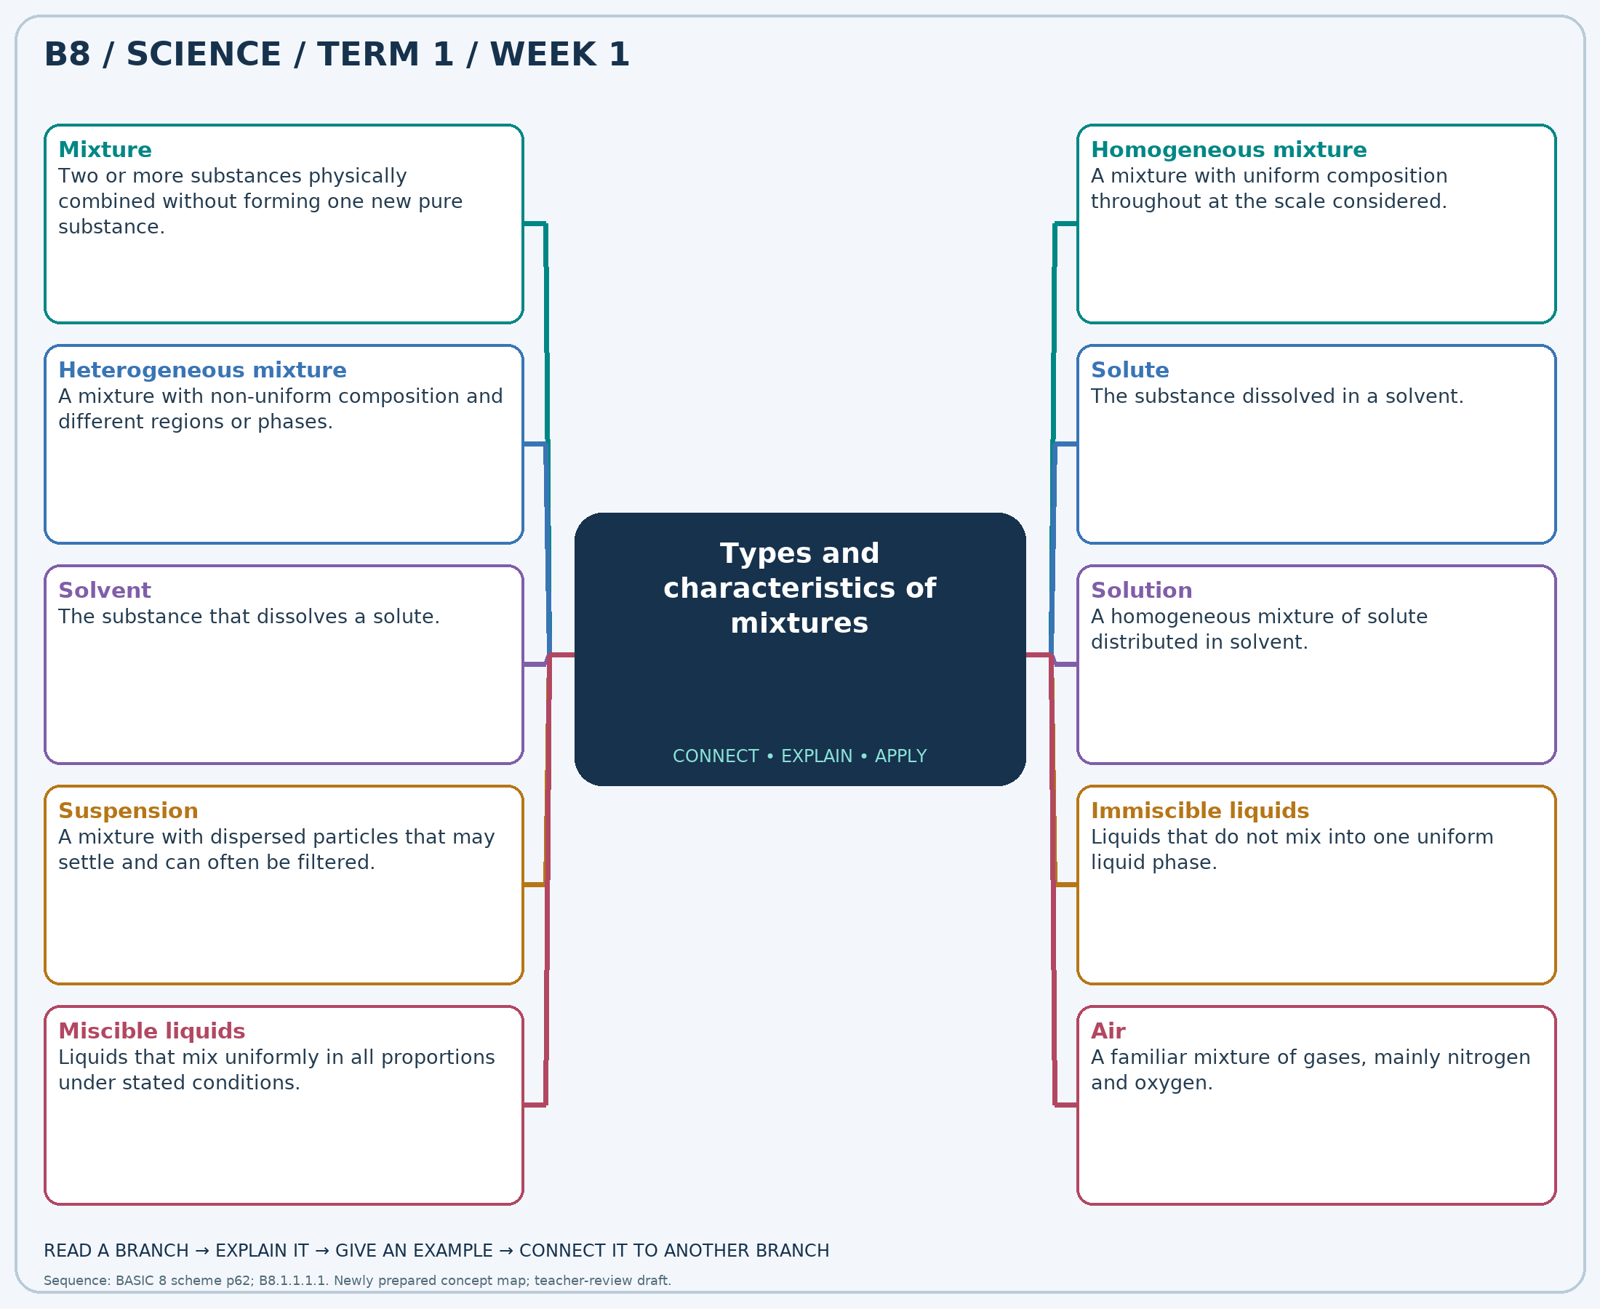
Explain each branch and supply another example. A separate high-resolution PNG is included.

Week 1 — Practice

Section A — Multiple-choice questions
Choose ONE correct answer for each question. Each question has four alternatives.
1. Which term best matches this description: two or more substances physically combined without forming one new pure substance?
A. Single pure compound B. Atom C. Element D. Mixture
2. Which term best matches this description: a mixture with uniform composition throughout at the scale considered?
A. Homogeneous mixture B. Single element C. Pure metal D. Heterogeneous mixture
3. Which term best matches this description: a mixture with non-uniform composition and different regions or phases?
A. Pure substance B. Homogeneous mixture C. Single compound D. Heterogeneous mixture
4. Which term best matches this description: the substance dissolved in a solvent?
A. Filter paper B. Solute C. Container D. Solvent
5. Which term best matches this description: the substance that dissolves a solute?
A. Sediment B. Residue C. Solute D. Solvent
6. Which term best matches this description: a homogeneous mixture of solute distributed in solvent?
A. Suspension B. Pile of crystals C. Pure element D. Solution
7. Which term best matches this description: a mixture with dispersed particles that may settle and can often be filtered?
A. True solution B. Element C. Pure liquid D. Suspension
8. Which term best matches this description: liquids that do not mix into one uniform liquid phase?
A. Immiscible liquids B. Pure gases C. Miscible liquids D. Dissolved solids
9. Which term best matches this description: liquids that mix uniformly in all proportions under stated conditions?
A. Miscible liquids B. Immiscible liquids C. Suspended solids D. Sediment
10. Which term best matches this description: a familiar mixture of gases, mainly nitrogen and oxygen?
A. Air B. Pure copper C. Pure distilled water D. Pure oxygen
11. Salt is stirred into water without becoming a new compound. What material results?
A. Element B. Single pure compound C. Atom D. Mixture
12. Samples from different parts of a well-stirred salt solution have the same concentration. Which type is it?
A. Pure metal B. Single element C. Heterogeneous mixture D. Homogeneous mixture
13. Sand settles at the bottom of water, leaving different proportions in different regions. Which type is shown?
A. Pure substance B. Single compound C. Heterogeneous mixture D. Homogeneous mixture
14. In sugar water, which role does the sugar have?
A. Solvent B. Container C. Solute D. Filter paper
15. A little salt dissolves in a large amount of water. What role does water have?
A. Solvent B. Sediment C. Residue D. Solute
16. Salt fully dissolves in water and does not settle on standing. What has formed?
A. Solution B. Pure element C. Pile of crystals D. Suspension
17. Muddy water becomes clearer at the top after standing. What type describes the original mixture?
A. Suspension B. Element C. Pure liquid D. True solution
18. Cooking oil and water form separate layers after shaking and standing. How are they described?
A. Pure gases B. Dissolved solids C. Miscible liquids D. Immiscible liquids
19. A teacher shows water mixing uniformly with ethanol. How are the liquids described?
A. Immiscible liquids B. Sediment C. Miscible liquids D. Suspended solids
20. Which everyday material disproves the claim that every mixture must be a solid in a liquid?
A. Air B. Pure copper C. Pure distilled water D. Pure oxygen

Section B — 10 structured essay questions
Answer every part (a), (b), (c) in your exercise book. Suggested marks: (a) 1, (b) 1, (c) 2, giving 4 marks per question. Explain relationships and use examples where requested.

Question 1
(a) Explain the term “Mixture”.
(b) Salt is stirred into water without becoming a new compound. What material results?
(c) Explain two reasons salt water belongs to this category rather than being a pure compound.

Question 2
(a) Explain the term “Homogeneous mixture”.
(b) Samples from different parts of a well-stirred salt solution have the same concentration. Which type is it?
(c) Explain why looking uniform does not mean containing only one substance.

Question 3
(a) Explain the term “Heterogeneous mixture”.
(b) Sand settles at the bottom of water, leaving different proportions in different regions. Which type is shown?
(c) Describe observations supporting this classification of sand and water.

Question 4
(a) Explain the term “Solute”.
(b) In sugar water, which role does the sugar have?
(c) Distinguish the roles of sugar and water in the mixture.

Question 5
(a) Explain the term “Solvent”.
(b) A little salt dissolves in a large amount of water. What role does water have?
(c) Explain the role of water compared with the role of salt.

Question 6
(a) Explain the term “Solution”.
(b) Salt fully dissolves in water and does not settle on standing. What has formed?
(c) Explain why ordinary filtration does not remove dissolved salt from water.

Question 7
(a) Explain the term “Suspension”.
(b) Muddy water becomes clearer at the top after standing. What type describes the original mixture?
(c) Explain why standing muddy water may become clearer without becoming safe to drink.

Question 8
(a) Explain the term “Immiscible liquids”.
(b) Cooking oil and water form separate layers after shaking and standing. How are they described?
(c) Explain why shaking does not permanently remove the distinction between oil and water.

Question 9
(a) Explain the term “Miscible liquids”.
(b) A teacher shows water mixing uniformly with ethanol. How are the liquids described?
(c) Contrast these liquids with oil and water.

Question 10
(a) Explain the term “Air”.
(b) Which everyday material disproves the claim that every mixture must be a solid in a liquid?
(c) Explain why this material is a mixture and name its two major gases.

