Basic 4 Science — Term 1
  - Weeks 1–12 • Weekly lesson notes, study notes, visual mind-maps and practice
Name: __________________________________ Class: __________
Date: __________________ Teacher: ________________________
BATCH 2 — COMPLETE WEEKLY SEQUENCE FOR THIS GRADE, TEACHER-REVIEW DRAFT. Week 1 is included from Batch 1 so this Science book is self-contained. This is not a claim of official curriculum approval or independent teacher certification.
Each teaching week contains one consolidated lesson unit, suggested teaching sessions, study notes, one visual mind-map, 20 four-option MCQs and 10 three-part structured questions. These are weekly units, not separate full daily lesson plans. Keep the separate teacher answer book away from pupil copies.
Source sequence: first-term-library/BASIC 4 SCHEME OF LEARNING.pdf, Science table page 24. Weeks 13–15 are reserved in this scheme for revision/examinations/vacation, so no new weekly content is added there. Mid-term assumes Weeks 1–6; end-of-term assumes Weeks 1–12. Confirm the school’s calendar.
Important: the B4 source contains several indicator mismatches. The crosswalk states the interpretation instead of silently claiming exact alignment. In particular, B4 Week 5 is an introductory materials-properties lesson inferred from its Materials block, not a verified B4 indicator. Obtain teacher confirmation before use. Supporting vocabulary sometimes extends beyond the wording of the indicator.

Weekly sequence and source crosswalk
Week / topic | Source reference → used reference | Editorial decision
1. Classifying insects, birds, mammals and reptiles | B4.1.1.1.1 → B4.1.1.1.1 | Matches the supplied Week 1 indicator.
2. Animal life processes: movement, nutrition and reproduction | B4.1.1.1.2 → B4.1.1.1.2 | Direct indicator match; feeding categories provide supporting vocabulary.
3. Plant forms: trees, shrubs, climbers and creepers | B4.1.1.1.3 → B4.1.1.2.2 | Source suffix is absent in local curriculum; plant-form description is taken from B4.1.1.2.2 within the scheduled living-things block.
4. Comparing the physical features of animal groups | B4.1.1.1.4 → B4.1.1.2.3 | Source suffix is absent locally; use the animal-feature description under B4.1.1.2.3. Includes amphibians as named in that description.
5. Materials and observable properties | B4.1.2.1.1 → Supporting material-property concepts; compare B5.1.2.1.1 | The cited B4 indicator is absent locally. This introductory properties unit is an explicit editorial interpretation of the scheduled Materials block; confirm with the school.
6. Liquid mixtures and simple separation | B4.1.2.1.2 → B4.1.2.2.1 | The source suffix is absent locally; liquid–liquid mixture description B4.1.2.2.1 is used within the scheduled Materials block.
7. Cyclic movements and repeating patterns | B4.2.1.1.1 → B4.2.1.1.1 | Direct indicator match. Classroom models support the idea of recurrence rather than claiming every cycle has the same duration.
8. Objects in the daytime and nighttime sky | B4.2.1.1.2 → B4.2.1.2.1 | Source suffix is absent locally; sky-object description B4.2.1.2.1 is used within the scheduled Earth Science block.
9. Evaporation, transpiration and evapotranspiration | B4.2.1.1.3 → B4.2.1.3.1 | Source suffix is absent locally; evapotranspiration description B4.2.1.3.1 supplies the scheduled Earth Science lesson.
10. Making water safer and preventing recontamination | B4.2.1.1.4 → B4.2.1.5.1 | Source suffix is absent locally; safe-water description B4.2.1.5.1 supplies this Earth Science lesson. This is education, not a guarantee that a classroom treatment produces potable water.
11. Plant parts and their functions | B4.2.2.1.1 → B4.2.2.1.1 | Direct indicator match; function vocabulary supports observation and labelling.
12. Seeds and germination | B4.2.2.1.2 → B4.2.2.1.2 | Direct indicator match. Germination conditions are distinguished from the later needs of an established green seedling.

Week 1 — Classifying insects, birds, mammals and reptiles
Scheme reference: B4.1.1.1.1. Reference used: B4.1.1.1.1. Matches the supplied Week 1 indicator.

Learning outcomes
- Explain the main ideas in classifying insects, birds, mammals and reptiles using accurate vocabulary.
- Use observations or models to identify examples and justify explanations.
- Apply the ideas to a familiar situation, recognise a misconception and state relevant safety precautions.

Teacher lesson notes
Suggested weekly structure: three 40-minute teaching sessions, plus distributed practice and feedback in remaining timetable periods. Adjust to actual lesson periods. The full question bank should not be imposed as one 40-minute task.
Prior-knowledge check: ask learners for a familiar example related to the week. Record what they think happens and why. Retain one initial claim to revisit after the activity.

Session 1 — Observe and define
5 min: retrieve related knowledge; 10 min: show a model, picture or safe specimen; 15 min: pairs record observations and discuss the first five terms; 10 min: check explanations with short oral questions.

Session 2 — Investigate and explain
5 min: recall vocabulary; 10 min: model a justified explanation; 15 min: carry out the specific activity below, recording real observations; 10 min: introduce the remaining terms and compare evidence.

Session 3 — Apply and assess
5 min: revisit an initial misconception; 10 min: explain the map connections; 15 min: attempt selected application questions and structured parts; 10 min: review explanations and plan reteaching or extension.

Topic-specific activity and resources
Sort photographs of an ant, butterfly, hen, bat, goat, snake and lizard. Justify each group by body features, not habitat alone. Include a fish as an example outside the four target groups. Draw and label one representative of each target group.
Resources: the teacher-selected examples, pictures or apparatus described above; board, pencils, exercise books and the supplied map. If a practical cannot be completed, use a clearly labelled photograph or model and do not report predicted results as observed results.

Safety
Use pictures; do not handle unknown animals, reptiles or stinging insects.

Support, extension and feedback
Support: provide picture labels and a word bank, read unfamiliar words aloud, and let learners explain orally before writing. Extension: compare two related concepts, suggest a counterexample or critique a model. Feedback: ask why a distractor is wrong and use the answer to identify the misconception.

Study notes

Insect
An animal in a group whose adults have six legs and three main body regions.
Adult ants and butterflies have six legs attached to the thorax. Wings alone are unreliable because not all insects have them and birds also have wings.

Bird
An animal belonging to the group characterised by feathers.
Feathers identify the group. Flight is not essential: hens and ostriches are birds even though their flight abilities differ.

Mammal
An animal in a group with hair at some life stage and milk production by females for their young.
Hair and feeding young with milk support classification as a mammal. Movement alone does not determine the group.

Reptile
An animal in a group generally characterised by dry scaly skin and breathing through lungs.
Snakes and lizards share these features. Snakes lack legs, so legs cannot be required for the group; fish scales also show why multiple features matter.

Thorax
The middle of the three main body regions of an insect, carrying its legs.
The thorax lies between the head and abdomen. Legs and, when present, wings attach there.

Antennae
Paired sensory structures on an insect’s head.
These structures detect environmental information such as touch and chemicals. They are not extra walking legs.

Feathers
The distinctive body covering of birds, helping insulation and in many birds flight.
Both have feathers despite different habits. Covering is useful classification evidence whereas habitat alone is not.

Hair
A characteristic mammalian covering that may be dense or sparse.
Goats have hair and females feed young with milk. Using more than one feature makes the classification stronger.

Backbone
An internal supporting structure shared by vertebrates.
Birds, mammals and reptiles have backbones. Insects have an external supporting covering and no backbone.

Classification
Grouping organisms according to shared features.
Good grouping uses consistent evidence about shared features. Colour, fear or whether an animal is liked is less useful for these biological groups.
Independent study: reconstruct the map from memory, give a fresh example for three branches and answer one explanation question without copying the notes. Correct errors after discussing the reason with a teacher or partner.

Week 1 — Visual mind-map
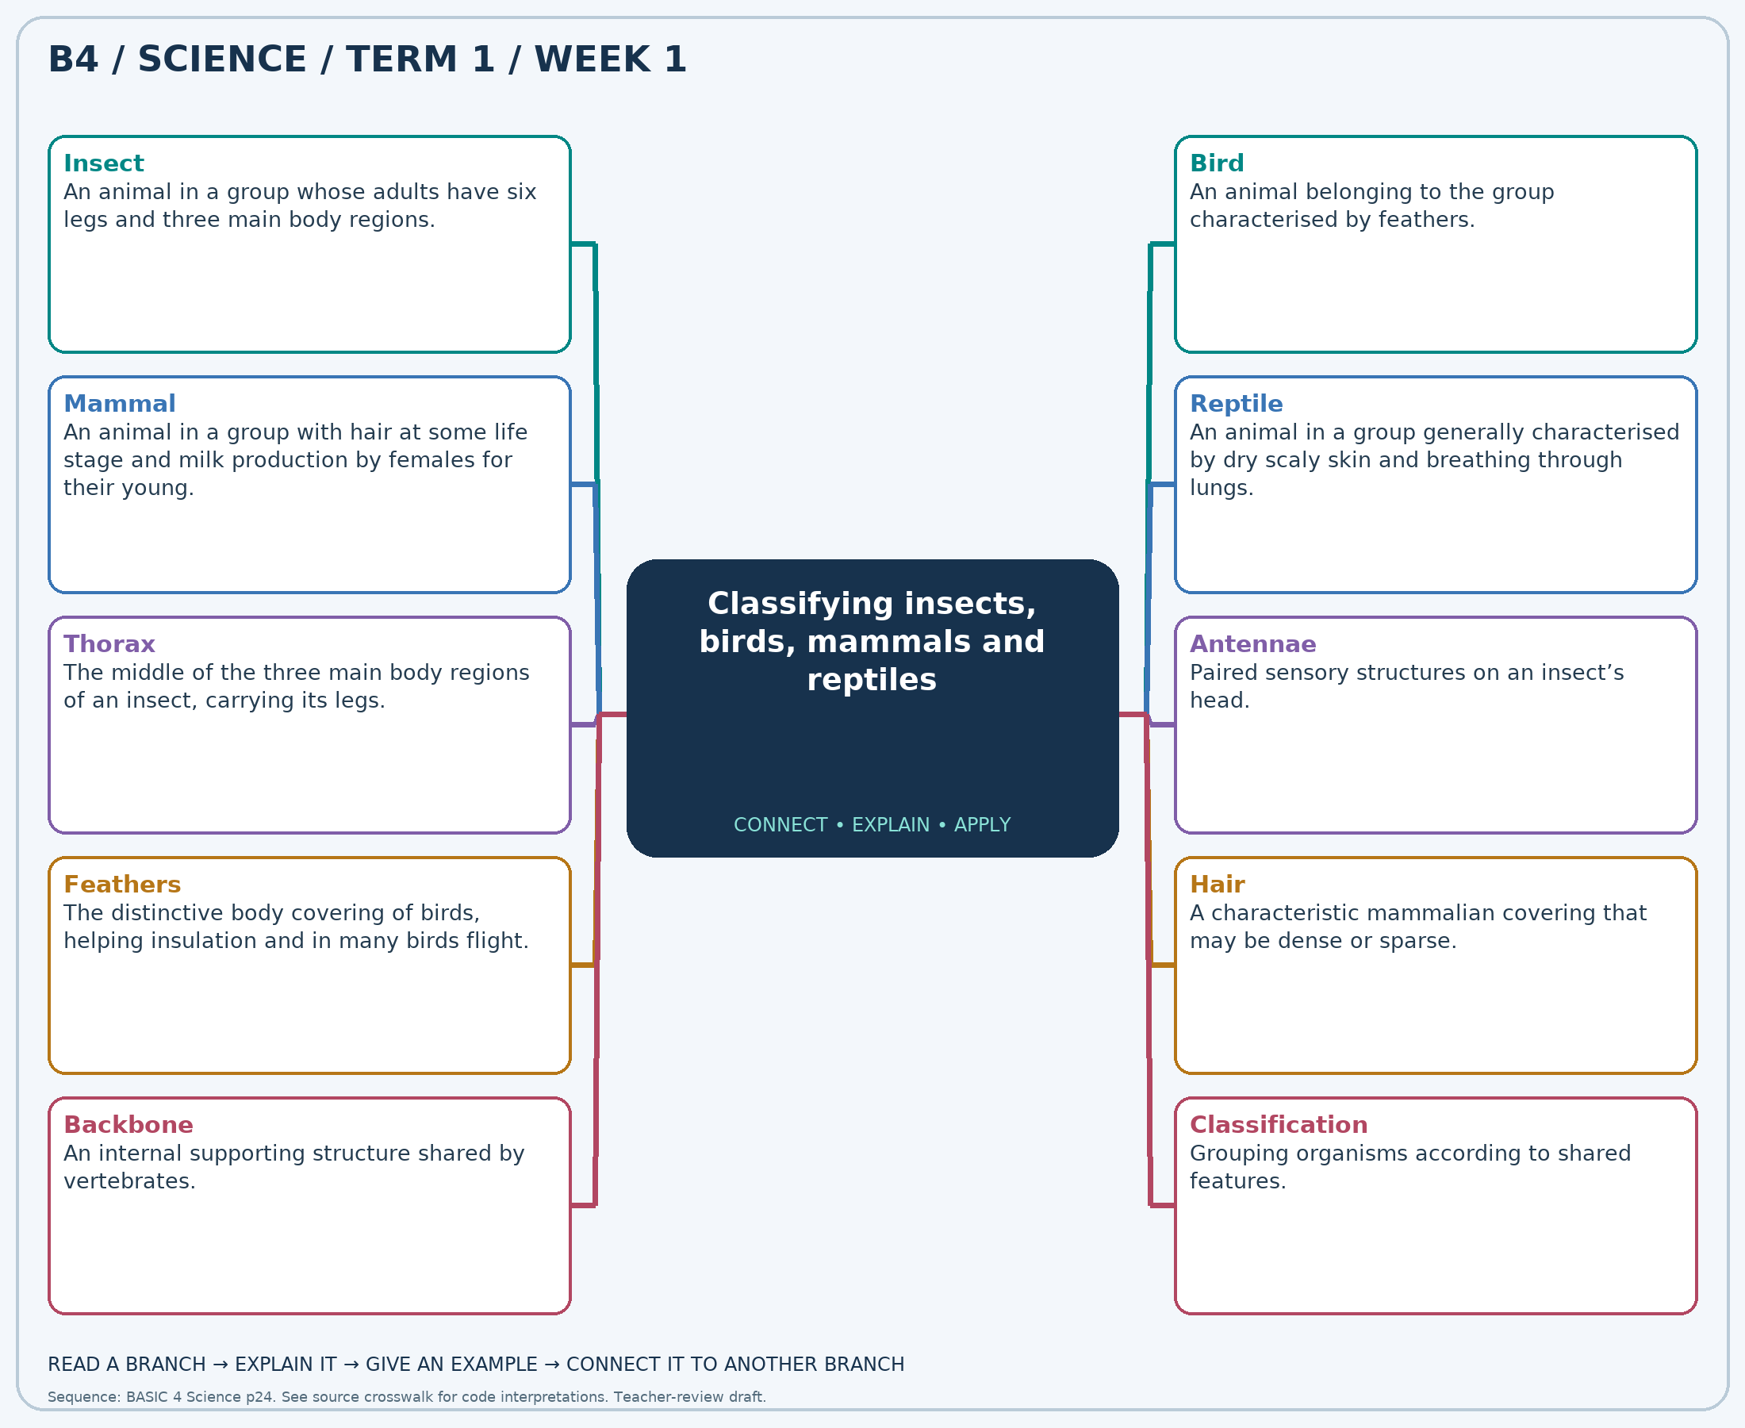
Read each branch, explain the link to the central topic, and add your own example. The separate high-resolution PNG supports projection or larger printing. Concept-map connections do not imply every process occurs in a single linear order.

Week 1 — Practice and assessment

Section A — Multiple-choice questions
Choose ONE correct answer for each question. Each question has four alternatives.
1. Which term best matches this description: an animal in a group whose adults have six legs and three main body regions?
A. Bird B. Insect C. Reptile D. Mammal
2. Which term best matches this description: an animal belonging to the group characterised by feathers?
A. Reptile B. Mammal C. Insect D. Bird
3. Which term best matches this description: an animal in a group with hair at some life stage and milk production by females for their young?
A. Reptile B. Bird C. Mammal D. Insect
4. Which term best matches this description: an animal in a group generally characterised by dry scaly skin and breathing through lungs?
A. Mammal B. Insect C. Reptile D. Bird
5. Which term best matches this description: the middle of the three main body regions of an insect, carrying its legs?
A. Tail B. Head C. Abdomen D. Thorax
6. Which term best matches this description: paired sensory structures on an insect’s head?
A. Scales B. Hooves C. Feathers D. Antennae
7. Which term best matches this description: the distinctive body covering of birds, helping insulation and in many birds flight?
A. Feathers B. Hair C. Insect shell D. Dry reptile scales
8. Which term best matches this description: a characteristic mammalian covering that may be dense or sparse?
A. Insect wings B. Feathers C. Hair D. Fish scales
9. Which term best matches this description: an internal supporting structure shared by vertebrates?
A. Feathers B. Antennae C. Six legs D. Backbone
10. Which term best matches this description: grouping organisms according to shared features?
A. Condensation B. Evaporation C. Germination D. Classification
11. An adult animal has six legs, antennae, a head, thorax and abdomen. Which group fits it?
A. Reptile B. Bird C. Insect D. Mammal
12. A hen cannot fly far but has feathers. In which group should it be classified?
A. Bird B. Insect C. Mammal D. Reptile
13. A bat flies but has hair and feeds its young milk. Which group includes it?
A. Reptile B. Mammal C. Insect D. Bird
14. An animal has dry scales, breathes with lungs and crawls on land. Which target group best fits it?
A. Insect B. Bird C. Reptile D. Mammal
15. Which insect body region should connect to all six legs in a butterfly drawing?
A. Abdomen B. Tail C. Head D. Thorax
16. An ant touches objects with two slender structures on its head. What are these?
A. Feathers B. Scales C. Hooves D. Antennae
17. A duck and a hen share which distinctive body covering?
A. Feathers B. Dry reptile scales C. Insect shell D. Hair
18. Which covering on a goat helps distinguish it from a hen?
A. Fish scales B. Hair C. Feathers D. Insect wings
19. A hen, goat and lizard share which structure that an insect lacks?
A. Antennae B. Backbone C. Feathers D. Six legs
20. Pupils group animal cards using covering, leg number and feeding of young. What process are they using?
A. Germination B. Evaporation C. Condensation D. Classification

Section B — 10 structured essay questions
Answer all parts (a), (b), (c). Write in a separate exercise book. Suggested marks per question: (a) 1, (b) 1, (c) 2, total 4. Use accurate terms and explain relationships or evidence where asked.

Question 1
(a) Explain the term “Insect”.
(b) An adult animal has six legs, antennae, a head, thorax and abdomen. Which group fits it?
(c) Explain why legs and body regions are better evidence than wings alone when identifying an adult insect.

Question 2
(a) Explain the term “Bird”.
(b) A hen cannot fly far but has feathers. In which group should it be classified?
(c) Explain why an ostrich remains in this group even though it cannot fly.

Question 3
(a) Explain the term “Mammal”.
(b) A bat flies but has hair and feeds its young milk. Which group includes it?
(c) Explain how a bat and a goat can belong to the same group despite moving differently.

Question 4
(a) Explain the term “Reptile”.
(b) An animal has dry scales, breathes with lungs and crawls on land. Which target group best fits it?
(c) Explain why lacking legs does not prevent a snake from belonging to this group.

Question 5
(a) Explain the term “Thorax”.
(b) Which insect body region should connect to all six legs in a butterfly drawing?
(c) Describe the location of this region and state what attaches to it.

Question 6
(a) Explain the term “Antennae”.
(b) An ant touches objects with two slender structures on its head. What are these?
(c) Explain why an insect with two of these structures still has six legs.

Question 7
(a) Explain the term “Feathers”.
(b) A duck and a hen share which distinctive body covering?
(c) Explain how this covering supports grouping a hen and a duck together.

Question 8
(a) Explain the term “Hair”.
(b) Which covering on a goat helps distinguish it from a hen?
(c) Give two features that support classifying a goat as a mammal.

Question 9
(a) Explain the term “Backbone”.
(b) A hen, goat and lizard share which structure that an insect lacks?
(c) Explain how this structure separates an insect from a bird without referring to wings.

Question 10
(a) Explain the term “Classification”.
(b) Pupils group animal cards using covering, leg number and feeding of young. What process are they using?
(c) Explain why grouping only by colour is less useful than grouping by body structure.

Week 2 — Animal life processes: movement, nutrition and reproduction
Scheme reference: B4.1.1.1.2. Reference used: B4.1.1.1.2. Direct indicator match; feeding categories provide supporting vocabulary.

Learning outcomes
- Explain the main ideas in animal life processes: movement, nutrition and reproduction using accurate vocabulary.
- Use observations or models to identify examples and justify explanations.
- Apply the ideas to a familiar situation, recognise a misconception and state relevant safety precautions.

Teacher lesson notes
Suggested weekly structure: three 40-minute teaching sessions, plus distributed practice and feedback in remaining timetable periods. Adjust to actual lesson periods. The full question bank should not be imposed as one 40-minute task.
Prior-knowledge check: ask learners for a familiar example related to the week. Record what they think happens and why. Retain one initial claim to revisit after the activity.

Session 1 — Observe and define
5 min: retrieve related knowledge; 10 min: show a model, picture or safe specimen; 15 min: pairs record observations and discuss the first five terms; 10 min: check explanations with short oral questions.

Session 2 — Investigate and explain
5 min: recall vocabulary; 10 min: model a justified explanation; 15 min: carry out the specific activity below, recording real observations; 10 min: introduce the remaining terms and compare evidence.

Session 3 — Apply and assess
5 min: revisit an initial misconception; 10 min: explain the map connections; 15 min: attempt selected application questions and structured parts; 10 min: review explanations and plan reteaching or extension.

Topic-specific activity and resources
Use pictures of a goat, hen, cat and butterfly. Record movement, food and young in a table. Ask learners to distinguish moving a body part from changing location. Construct simple parent–young matching cards and justify dietary classifications using examples.
Resources: the teacher-selected examples, pictures or apparatus described above; board, pencils, exercise books and the supplied map. If a practical cannot be completed, use a clearly labelled photograph or model and do not report predicted results as observed results.

Safety
Use photographs or observe familiar animals at a distance. Do not feed, chase or handle unfamiliar animals.

Support, extension and feedback
Support: provide picture labels and a word bank, read unfamiliar words aloud, and let learners explain orally before writing. Extension: compare two related concepts, suggest a counterexample or critique a model. Feedback: ask why a distractor is wrong and use the answer to identify the misconception.

Study notes

Movement
A change in the position of a whole organism or one of its body parts.
Movement can involve just one body part. Turning a head is movement even if the animal stays in the same place.

Locomotion
Movement of an organism from one place to another.
The entire animal changes location. Movement of a wing without changing place would not by itself be locomotion.

Nutrition
Obtaining and using food materials needed for life.
Food supplies materials for growth and repair and energy for activities. Eating is part of nutrition, not the only event in it.

Herbivore
An animal whose diet consists mainly of plant material.
The diet, rather than the animal’s size, supports the classification. Grass is plant material that provides nutrients.

Carnivore
An animal whose diet consists mainly of other animals.
The main food source is other animals. Classifying diet is different from judging whether the animal is dangerous.

Omnivore
An animal that normally eats both plant and animal material.
Grains are plant material and insects are animal material. Both are represented in the diet.

Reproduction
The biological process by which organisms produce new individuals.
New individuals continue the group over generations. Not every individual must reproduce to be alive.

Offspring
The young produced by a parent or parents.
A kid is a young goat. It resembles its parents in many features but need not look identical in every detail.

Egg-laying
A reproductive pattern in which young develop in eggs laid outside the parent’s body.
A developing chick can hatch from a fertilised egg under suitable conditions. Not every egg contains a developing chick.

Live birth
A reproductive pattern in which developed young emerge alive from the mother.
Goats normally give birth to live young and feed them milk. Different animal groups have different reproductive patterns.
Independent study: reconstruct the map from memory, give a fresh example for three branches and answer one explanation question without copying the notes. Correct errors after discussing the reason with a teacher or partner.

Week 2 — Visual mind-map
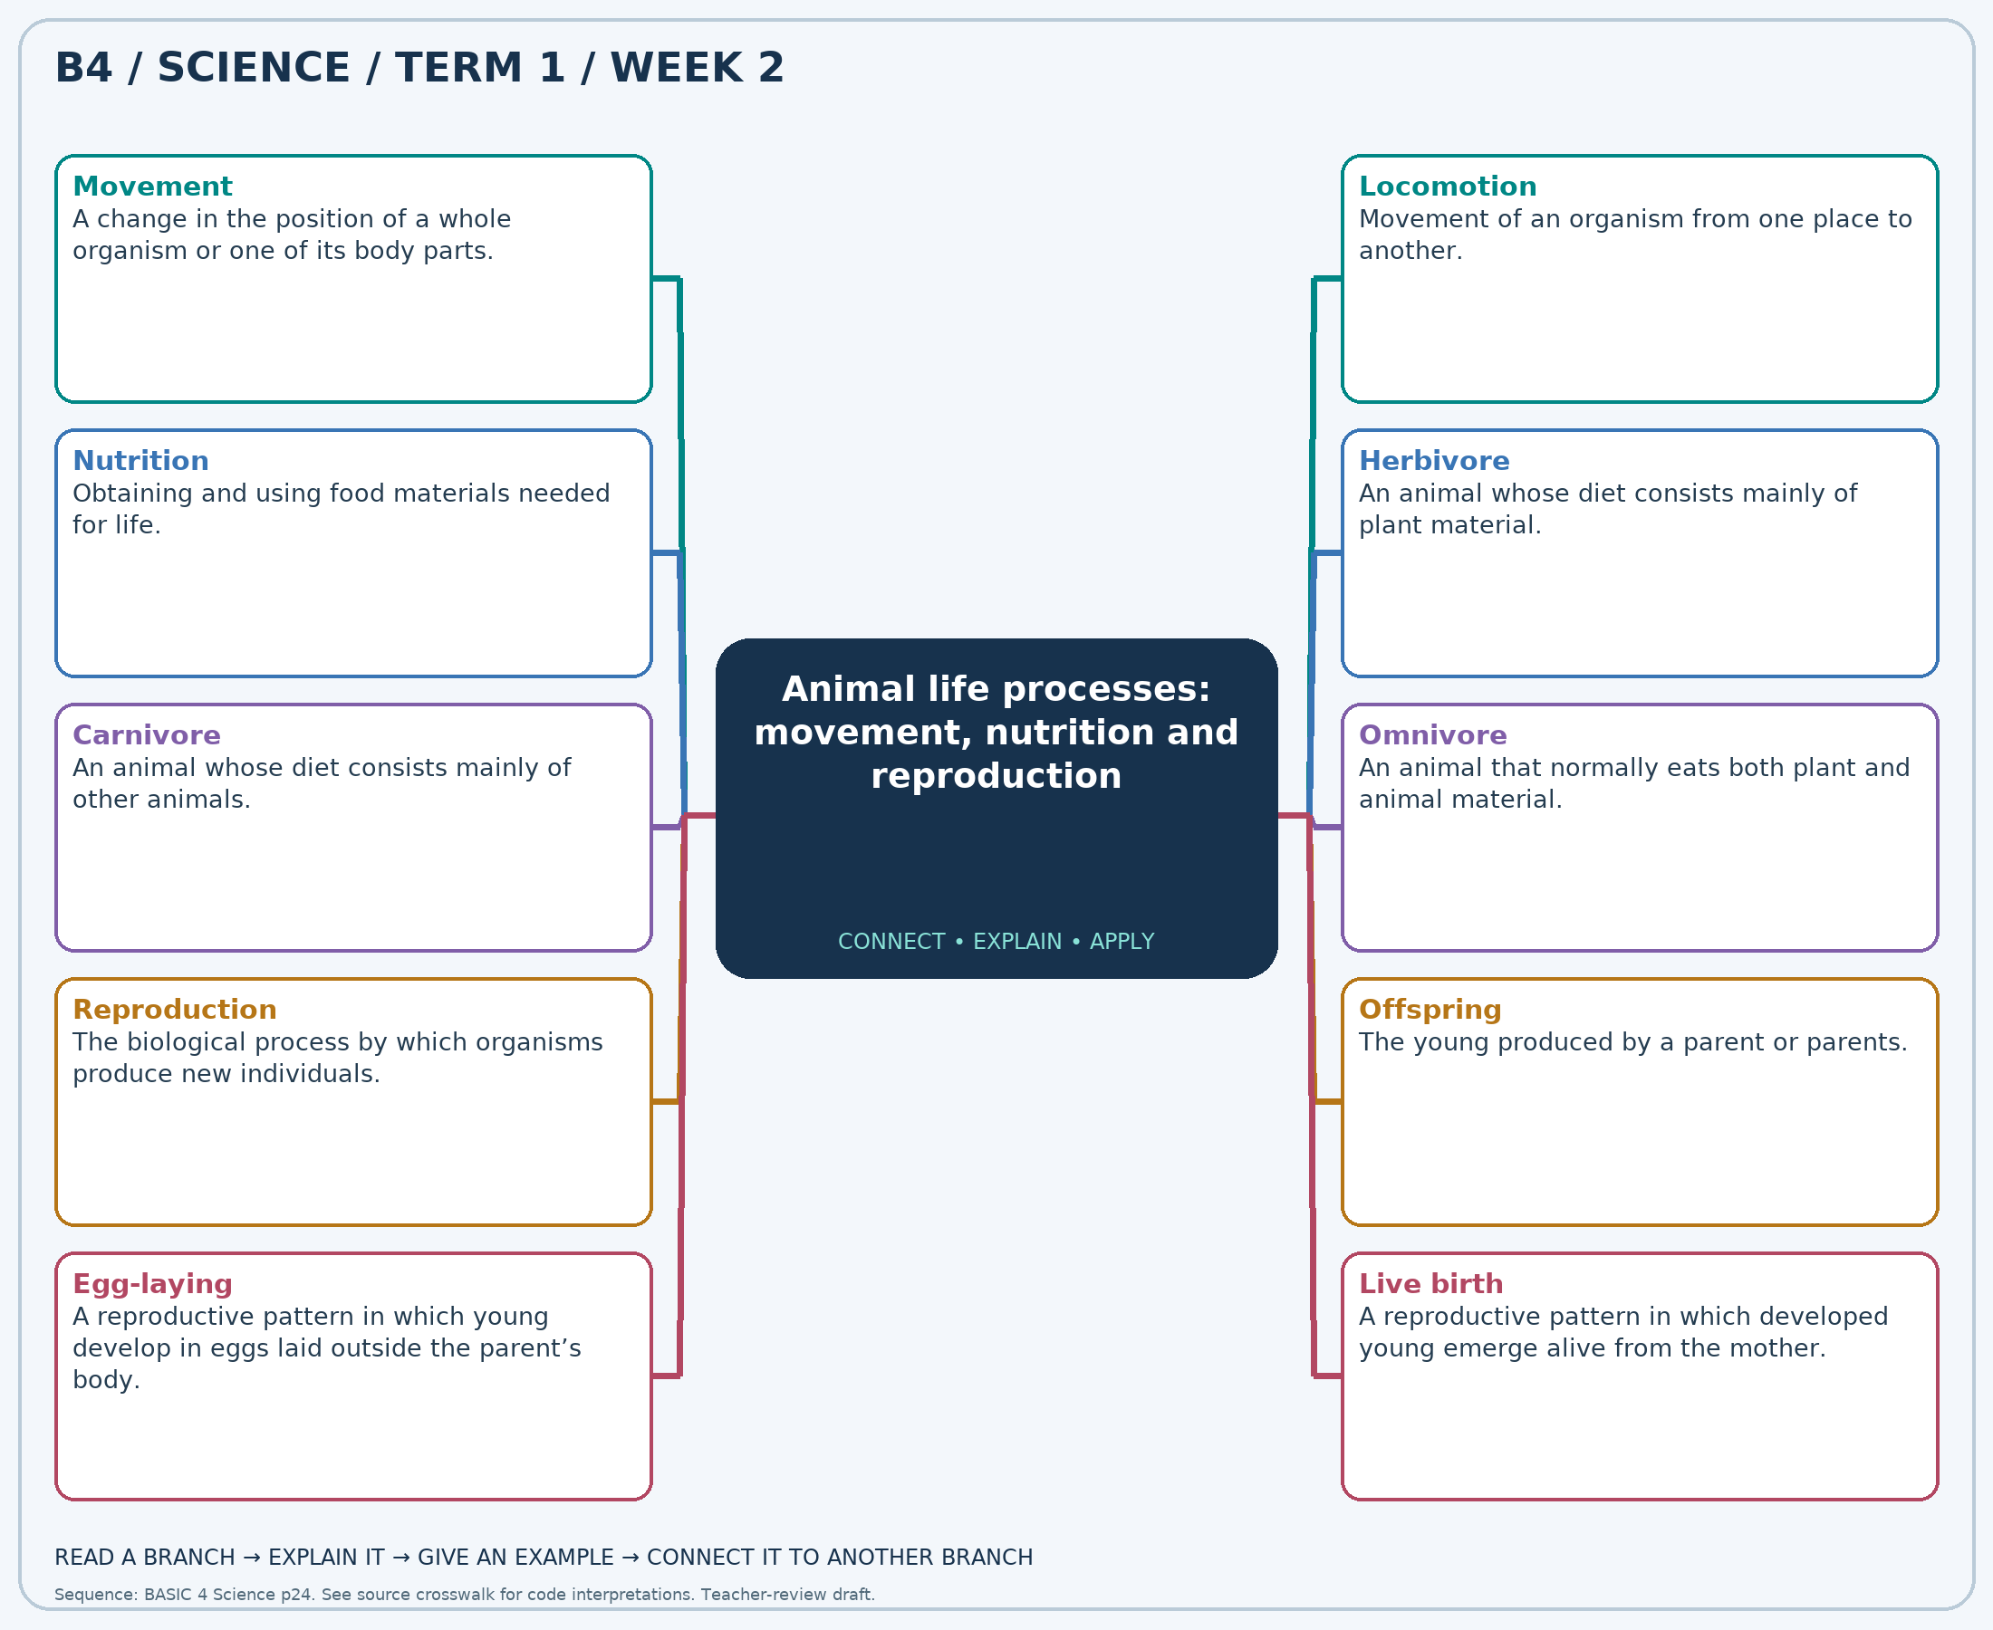
Read each branch, explain the link to the central topic, and add your own example. The separate high-resolution PNG supports projection or larger printing. Concept-map connections do not imply every process occurs in a single linear order.

Week 2 — Practice and assessment

Section A — Multiple-choice questions
Choose ONE correct answer for each question. Each question has four alternatives.
1. Which term best matches this description: a change in the position of a whole organism or one of its body parts?
A. Germination B. Movement C. Condensation D. Rusting
2. Which term best matches this description: movement of an organism from one place to another?
A. Digestion only B. Locomotion C. Respiration only D. Excretion only
3. Which term best matches this description: obtaining and using food materials needed for life?
A. Pollination B. Nutrition C. Reproduction D. Condensation
4. Which term best matches this description: an animal whose diet consists mainly of plant material?
A. Omnivore B. Herbivore C. Carnivore D. Producer
5. Which term best matches this description: an animal whose diet consists mainly of other animals?
A. Herbivore B. Carnivore C. Photosynthetic organism D. Producer
6. Which term best matches this description: an animal that normally eats both plant and animal material?
A. Producer B. Carnivore only C. Omnivore D. Herbivore only
7. Which term best matches this description: the biological process by which organisms produce new individuals?
A. Weathering B. Condensation C. Evaporation D. Reproduction
8. Which term best matches this description: the young produced by a parent or parents?
A. Offspring B. Shelter C. Predator D. Habitat
9. Which term best matches this description: a reproductive pattern in which young develop in eggs laid outside the parent’s body?
A. Egg-laying B. Condensation C. Budding of leaves D. Seed production
10. Which term best matches this description: a reproductive pattern in which developed young emerge alive from the mother?
A. Seed dispersal B. Pollination C. Live birth D. Egg-laying
11. A goat turns its head while standing in one place. Which life activity is shown?
A. Germination B. Movement C. Rusting D. Condensation
12. A hen walks from its coop to a water bowl. What kind of movement is this?
A. Excretion only B. Locomotion C. Digestion only D. Respiration only
13. A goat eats grass to obtain materials and energy. Which life process is involved?
A. Nutrition B. Condensation C. Reproduction D. Pollination
14. A cow feeds mainly on grass. Which dietary group fits it?
A. Herbivore B. Omnivore C. Carnivore D. Producer
15. A lion eats mainly animal flesh. Which dietary group fits it?
A. Producer B. Photosynthetic organism C. Herbivore D. Carnivore
16. A hen eats grains and insects. Which dietary group fits it?
A. Omnivore B. Herbivore only C. Producer D. Carnivore only
17. An adult animal produces young of its own kind. Which life process is shown?
A. Condensation B. Evaporation C. Weathering D. Reproduction
18. What is the general term for a goat’s kid in relation to its parents?
A. Habitat B. Predator C. Shelter D. Offspring
19. A hen lays eggs from which chicks may hatch. Which reproductive pattern is shown?
A. Seed production B. Egg-laying C. Condensation D. Budding of leaves
20. A goat gives birth to a kid rather than laying an egg. Which pattern is shown?
A. Live birth B. Egg-laying C. Seed dispersal D. Pollination

Section B — 10 structured essay questions
Answer all parts (a), (b), (c). Write in a separate exercise book. Suggested marks per question: (a) 1, (b) 1, (c) 2, total 4. Use accurate terms and explain relationships or evidence where asked.

Question 1
(a) Explain the term “Movement”.
(b) A goat turns its head while standing in one place. Which life activity is shown?
(c) Explain why the goat has moved even without changing its location.

Question 2
(a) Explain the term “Locomotion”.
(b) A hen walks from its coop to a water bowl. What kind of movement is this?
(c) Distinguish moving a body part from changing the location of the whole animal.

Question 3
(a) Explain the term “Nutrition”.
(b) A goat eats grass to obtain materials and energy. Which life process is involved?
(c) Give two reasons animals need food.

Question 4
(a) Explain the term “Herbivore”.
(b) A cow feeds mainly on grass. Which dietary group fits it?
(c) Explain why the cow belongs to this dietary group.

Question 5
(a) Explain the term “Carnivore”.
(b) A lion eats mainly animal flesh. Which dietary group fits it?
(c) Explain the evidence for placing a lion in this group.

Question 6
(a) Explain the term “Omnivore”.
(b) A hen eats grains and insects. Which dietary group fits it?
(c) Use the hen’s foods to justify its dietary classification.

Question 7
(a) Explain the term “Reproduction”.
(b) An adult animal produces young of its own kind. Which life process is shown?
(c) Explain why reproduction matters to the continuation of a group of animals.

Question 8
(a) Explain the term “Offspring”.
(b) What is the general term for a goat’s kid in relation to its parents?
(c) Describe one similarity and one possible difference between an offspring and its parent.

Question 9
(a) Explain the term “Egg-laying”.
(b) A hen lays eggs from which chicks may hatch. Which reproductive pattern is shown?
(c) Explain why laying an egg does not guarantee that it will hatch into a chick.

Question 10
(a) Explain the term “Live birth”.
(b) A goat gives birth to a kid rather than laying an egg. Which pattern is shown?
(c) Compare the birth of a kid with the hatching of a chick.

Week 3 — Plant forms: trees, shrubs, climbers and creepers
Scheme reference: B4.1.1.1.3. Reference used: B4.1.1.2.2. Source suffix is absent in local curriculum; plant-form description is taken from B4.1.1.2.2 within the scheduled living-things block.

Learning outcomes
- Explain the main ideas in plant forms: trees, shrubs, climbers and creepers using accurate vocabulary.
- Use observations or models to identify examples and justify explanations.
- Apply the ideas to a familiar situation, recognise a misconception and state relevant safety precautions.

Teacher lesson notes
Suggested weekly structure: three 40-minute teaching sessions, plus distributed practice and feedback in remaining timetable periods. Adjust to actual lesson periods. The full question bank should not be imposed as one 40-minute task.
Prior-knowledge check: ask learners for a familiar example related to the week. Record what they think happens and why. Retain one initial claim to revisit after the activity.

Session 1 — Observe and define
5 min: retrieve related knowledge; 10 min: show a model, picture or safe specimen; 15 min: pairs record observations and discuss the first five terms; 10 min: check explanations with short oral questions.

Session 2 — Investigate and explain
5 min: recall vocabulary; 10 min: model a justified explanation; 15 min: carry out the specific activity below, recording real observations; 10 min: introduce the remaining terms and compare evidence.

Session 3 — Apply and assess
5 min: revisit an initial misconception; 10 min: explain the map connections; 15 min: attempt selected application questions and structured parts; 10 min: review explanations and plan reteaching or extension.

Topic-specific activity and resources
Observe safe school plants or photographs. Draw a tree, shrub, climber and creeper. Label stem position and support. Sort new examples by visible features rather than memorised names; record any uncertain specimen for teacher discussion.
Resources: the teacher-selected examples, pictures or apparatus described above; board, pencils, exercise books and the supplied map. If a practical cannot be completed, use a clearly labelled photograph or model and do not report predicted results as observed results.

Safety
Do not taste plant parts or touch unknown sap, thorns or irritant leaves. Do not climb trees or pull down climbing plants.

Support, extension and feedback
Support: provide picture labels and a word bank, read unfamiliar words aloud, and let learners explain orally before writing. Extension: compare two related concepts, suggest a counterexample or critique a model. Feedback: ask why a distractor is wrong and use the answer to identify the misconception.

Study notes

Tree
A woody plant usually having one main trunk and branches above the ground.
A main woody trunk supports the crown. Height alone is not enough because young trees can be short.

Shrub
A woody plant commonly having several stems branching near the ground.
Several low branches and woody stems support this classification. A shrub need not have the single main trunk typical of a tree.

Climber
A plant with a stem that uses external support to grow upward.
The stem uses the stake for support rather than holding itself fully upright. Twining or tendrils may help attachment.

Creeper
A plant whose weak stems spread mainly along the ground.
Its stems spread horizontally and do not support a tall upright body. The growth habit, not the fruit’s size, decides the form.

Herb
A plant with relatively soft, non-woody stems.
The stem texture is the key feature. The everyday meaning of a cooking herb is narrower than this botanical description.

Trunk
The main woody stem of a typical tree.
The trunk holds branches above the ground and contains pathways for transport. Roots have a different anchoring and absorbing role.

Tendril
A slender plant structure that can coil around a support.
Coiling helps attachment and support. The structure is not a root absorbing water from soil.

Woody stem
A relatively hard, persistent stem containing wood.
Wood contributes support and persistence. Both trees and shrubs can have woody stems despite different branching patterns.

Support
A structure that holds a climbing stem in a useful position.
The trellis provides mechanical support. It does not replace water, light or mineral nutrients needed by the plant.

Growth habit
The characteristic way a plant’s stems grow and are arranged.
Growth habit combines stem arrangement and support. Plant identification is stronger when observations are recorded before assigning labels.
Independent study: reconstruct the map from memory, give a fresh example for three branches and answer one explanation question without copying the notes. Correct errors after discussing the reason with a teacher or partner.

Week 3 — Visual mind-map
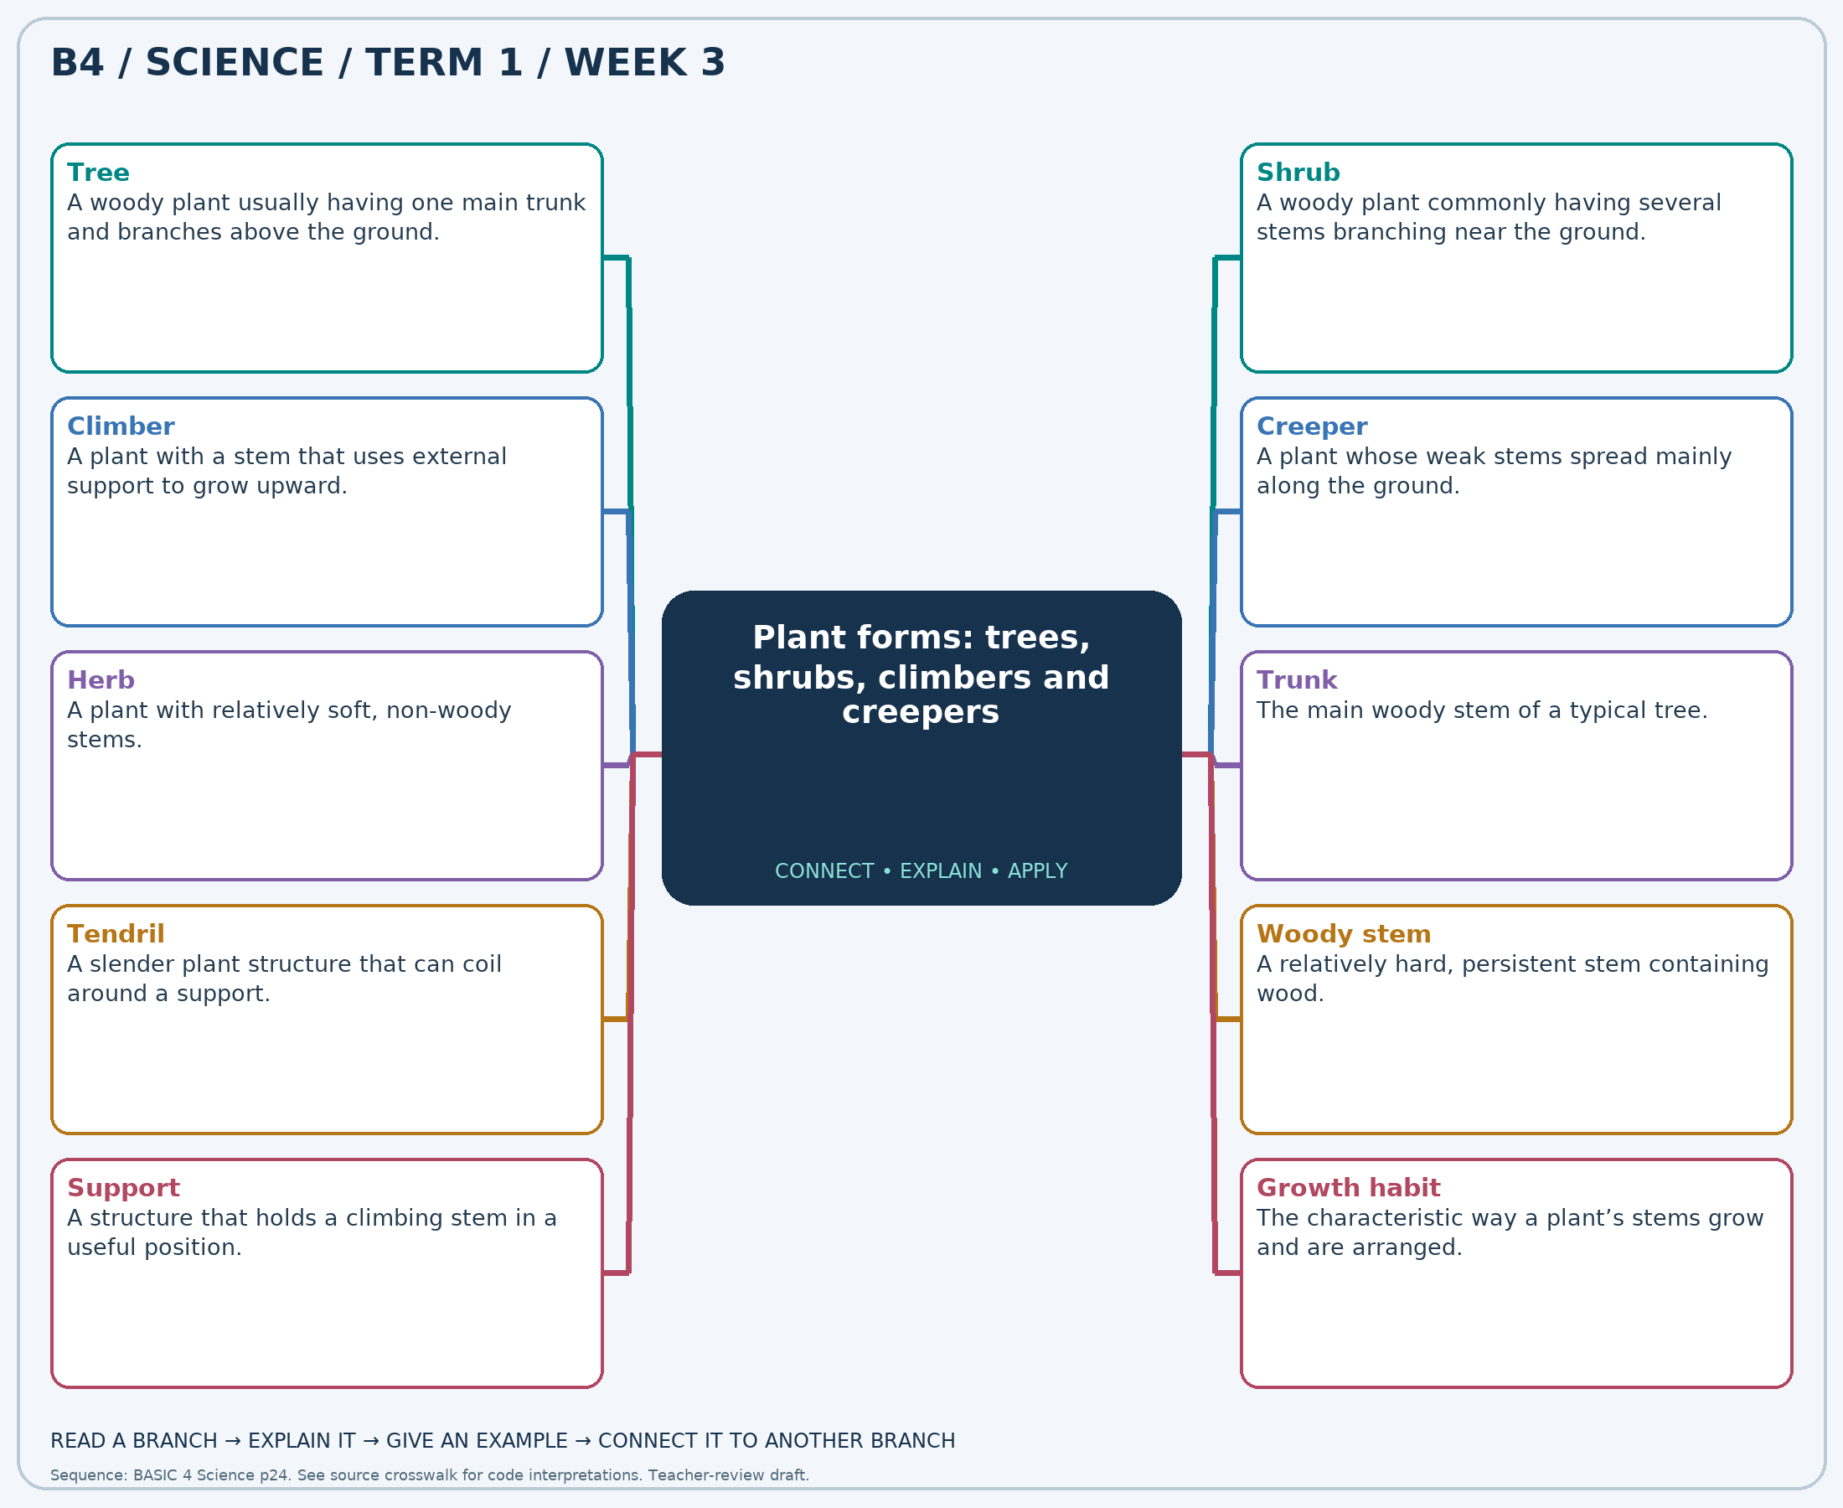
Read each branch, explain the link to the central topic, and add your own example. The separate high-resolution PNG supports projection or larger printing. Concept-map connections do not imply every process occurs in a single linear order.

Week 3 — Practice and assessment

Section A — Multiple-choice questions
Choose ONE correct answer for each question. Each question has four alternatives.
1. Which term best matches this description: a woody plant usually having one main trunk and branches above the ground?
A. Tree B. Climber C. Creeper D. Small herb
2. Which term best matches this description: a woody plant commonly having several stems branching near the ground?
A. Tree with one main trunk B. Climber C. Shrub D. Creeper
3. Which term best matches this description: a plant with a stem that uses external support to grow upward?
A. Free-standing tree B. Woody shrub C. Climber D. Creeper only
4. Which term best matches this description: a plant whose weak stems spread mainly along the ground?
A. Tree B. Creeper C. Upright shrub D. Tall woody trunk
5. Which term best matches this description: a plant with relatively soft, non-woody stems?
A. Woody shrub B. Woody tree C. Herb D. Dry trunk
6. Which term best matches this description: the main woody stem of a typical tree?
A. Root hair B. Seed coat C. Petal D. Trunk
7. Which term best matches this description: a slender plant structure that can coil around a support?
A. Tendril B. Seed coat C. Storage root D. Petal
8. Which term best matches this description: a relatively hard, persistent stem containing wood?
A. Leaf blade B. Seed coat C. Woody stem D. Soft petal
9. Which term best matches this description: a structure that holds a climbing stem in a useful position?
A. Water source B. Seed embryo C. Support D. Plant food
10. Which term best matches this description: the characteristic way a plant’s stems grow and are arranged?
A. Soil temperature only B. Seed taste C. Flower colour only D. Growth habit
11. A mango plant has a strong main trunk and a branching crown. Which plant form fits it?
A. Creeper B. Small herb C. Climber D. Tree
12. A hibiscus bush has several woody stems from close to the soil. Which form best fits it?
A. Creeper B. Shrub C. Tree with one main trunk D. Climber
13. A bean vine grows upward around a stake. Which form is shown?
A. Climber B. Woody shrub C. Creeper only D. Free-standing tree
14. A pumpkin plant spreads over the soil without climbing a support. Which form is shown?
A. Upright shrub B. Tree C. Creeper D. Tall woody trunk
15. A small plant has soft green stems rather than persistent woody branches. Which description fits?
A. Woody tree B. Dry trunk C. Herb D. Woody shrub
16. Which part of a mango tree supports its major branches?
A. Root hair B. Petal C. Trunk D. Seed coat
17. A climbing plant grips a thin support with a curling structure. What is it called?
A. Tendril B. Storage root C. Petal D. Seed coat
18. Which stem type helps trees and shrubs support their branches over many seasons?
A. Seed coat B. Soft petal C. Leaf blade D. Woody stem
19. A gardener adds a trellis for a vine. What role does the trellis mainly serve?
A. Plant food B. Support C. Seed embryo D. Water source
20. A class compares plants that stand upright, climb or spread on the ground. Which feature are they comparing?
A. Soil temperature only B. Flower colour only C. Growth habit D. Seed taste

Section B — 10 structured essay questions
Answer all parts (a), (b), (c). Write in a separate exercise book. Suggested marks per question: (a) 1, (b) 1, (c) 2, total 4. Use accurate terms and explain relationships or evidence where asked.

Question 1
(a) Explain the term “Tree”.
(b) A mango plant has a strong main trunk and a branching crown. Which plant form fits it?
(c) Explain why a young mango plant can still be classified as a tree.

Question 2
(a) Explain the term “Shrub”.
(b) A hibiscus bush has several woody stems from close to the soil. Which form best fits it?
(c) Compare the stem arrangement of a shrub and a typical tree.

Question 3
(a) Explain the term “Climber”.
(b) A bean vine grows upward around a stake. Which form is shown?
(c) Explain the role of the stake in the bean vine’s growth.

Question 4
(a) Explain the term “Creeper”.
(b) A pumpkin plant spreads over the soil without climbing a support. Which form is shown?
(c) Identify the feature that makes this plant a creeper.

Question 5
(a) Explain the term “Herb”.
(b) A small plant has soft green stems rather than persistent woody branches. Which description fits?
(c) Explain why stem structure is more useful than culinary use for this classification.

Question 6
(a) Explain the term “Trunk”.
(b) Which part of a mango tree supports its major branches?
(c) State two functions associated with a tree’s main stem.

Question 7
(a) Explain the term “Tendril”.
(b) A climbing plant grips a thin support with a curling structure. What is it called?
(c) Explain how a tendril helps a climber reach upward.

Question 8
(a) Explain the term “Woody stem”.
(b) Which stem type helps trees and shrubs support their branches over many seasons?
(c) Explain a shared stem feature of trees and shrubs.

Question 9
(a) Explain the term “Support”.
(b) A gardener adds a trellis for a vine. What role does the trellis mainly serve?
(c) Explain why a trellis cannot replace watering a climbing plant.

Question 10
(a) Explain the term “Growth habit”.
(b) A class compares plants that stand upright, climb or spread on the ground. Which feature are they comparing?
(c) Describe two observations useful when deciding whether a plant is a climber or creeper.

Week 4 — Comparing the physical features of animal groups
Scheme reference: B4.1.1.1.4. Reference used: B4.1.1.2.3. Source suffix is absent locally; use the animal-feature description under B4.1.1.2.3. Includes amphibians as named in that description.

Learning outcomes
- Explain the main ideas in comparing the physical features of animal groups using accurate vocabulary.
- Use observations or models to identify examples and justify explanations.
- Apply the ideas to a familiar situation, recognise a misconception and state relevant safety precautions.

Teacher lesson notes
Suggested weekly structure: three 40-minute teaching sessions, plus distributed practice and feedback in remaining timetable periods. Adjust to actual lesson periods. The full question bank should not be imposed as one 40-minute task.
Prior-knowledge check: ask learners for a familiar example related to the week. Record what they think happens and why. Retain one initial claim to revisit after the activity.

Session 1 — Observe and define
5 min: retrieve related knowledge; 10 min: show a model, picture or safe specimen; 15 min: pairs record observations and discuss the first five terms; 10 min: check explanations with short oral questions.

Session 2 — Investigate and explain
5 min: recall vocabulary; 10 min: model a justified explanation; 15 min: carry out the specific activity below, recording real observations; 10 min: introduce the remaining terms and compare evidence.

Session 3 — Apply and assess
5 min: revisit an initial misconception; 10 min: explain the map connections; 15 min: attempt selected application questions and structured parts; 10 min: review explanations and plan reteaching or extension.

Topic-specific activity and resources
Compare labelled pictures of a goat, bird, lizard, butterfly and adult frog. Construct a feature matrix for covering, limbs, antennae and backbone. Use at least two features for difficult examples such as bats and snakes.
Resources: the teacher-selected examples, pictures or apparatus described above; board, pencils, exercise books and the supplied map. If a practical cannot be completed, use a clearly labelled photograph or model and do not report predicted results as observed results.

Safety
Use pictures and prepared models. Do not collect frogs, snakes, insects or unknown animal remains.

Support, extension and feedback
Support: provide picture labels and a word bank, read unfamiliar words aloud, and let learners explain orally before writing. Extension: compare two related concepts, suggest a counterexample or critique a model. Feedback: ask why a distractor is wrong and use the answer to identify the misconception.

Study notes

Amphibian
An animal in a group including frogs, often with moist skin and a life cycle linked to water.
Many frogs change from aquatic larvae to adults that can spend time on land. The pattern differs from a lizard’s dry scaly covering.

Moist skin
A usually damp body covering characteristic of many amphibians.
A frog’s skin must be protected from drying and damage. A lizard typically has a drier, scaly covering.

Dry scales
A protective covering typical of reptiles such as lizards.
Dry scales are useful reptile evidence when combined with other features. Scales alone do not separate reptiles from every other animal group.

Six legs
The usual number of legs on an adult insect.
Adult insects have three pairs of legs. Spiders have four pairs and are not insects, even though both groups include small crawling animals.

Three body regions
The insect arrangement of head, thorax and abdomen.
Head, thorax and abdomen have different roles. Legs attach to the thorax, so labels should reflect the actual arrangement.

Mammary glands
Structures in female mammals that produce milk for their young.
Milk provides nourishment for the young. Together with hair, this supports mammalian classification more reliably than walking on four legs alone.

Feathers
A distinctive body covering identifying birds.
The pigeon has feathers; the bat has hair and feeds its young milk. Shared flight does not mean the same animal group.

Vertebrate
An animal possessing a backbone.
They have internal skeletons with backbones despite their different coverings. A butterfly lacks a backbone.

Exoskeleton
An external supporting and protective covering.
The covering supports and protects from outside. A vertebrate’s main supporting skeleton is internal.

Classification key
A sequence of feature-based choices used to identify an organism.
Each choice should use observable, clear features. An ambiguous question such as “is it nice?” is not a sound scientific distinction.
Independent study: reconstruct the map from memory, give a fresh example for three branches and answer one explanation question without copying the notes. Correct errors after discussing the reason with a teacher or partner.

Week 4 — Visual mind-map
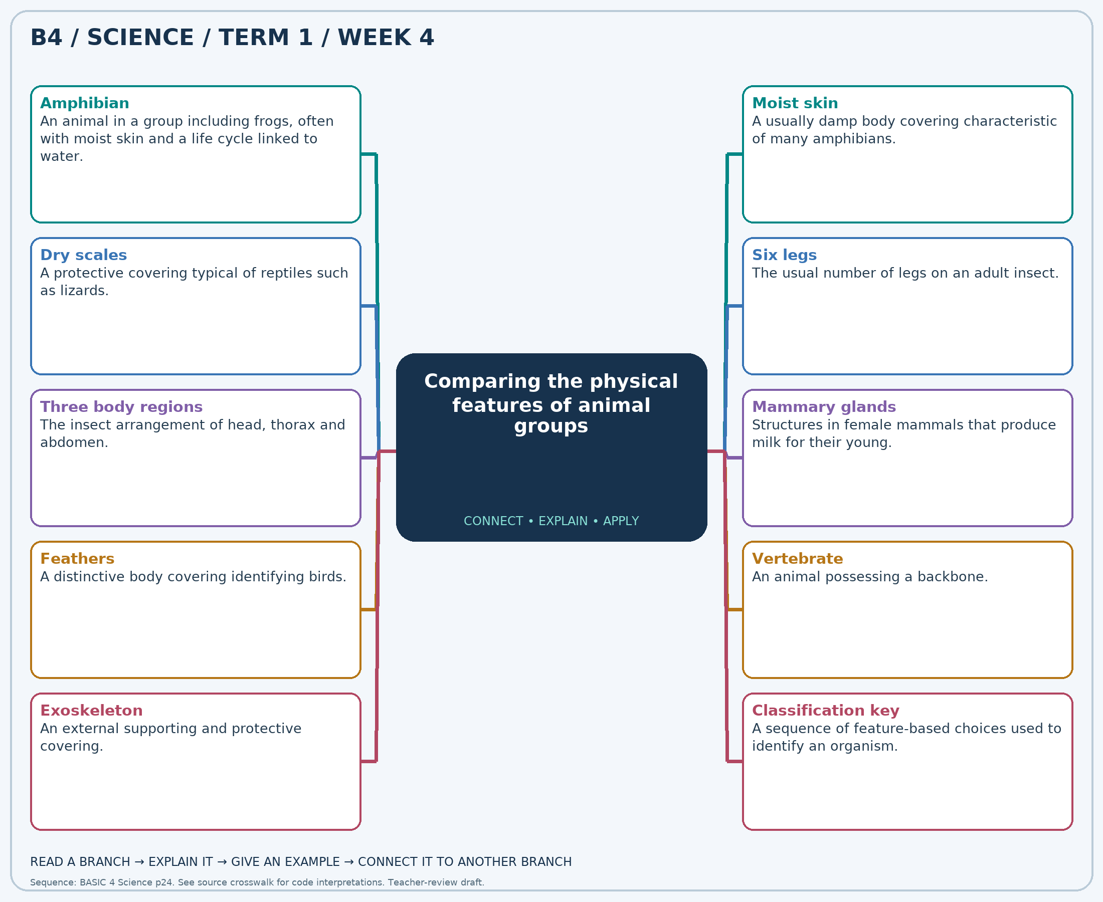
Read each branch, explain the link to the central topic, and add your own example. The separate high-resolution PNG supports projection or larger printing. Concept-map connections do not imply every process occurs in a single linear order.

Week 4 — Practice and assessment

Section A — Multiple-choice questions
Choose ONE correct answer for each question. Each question has four alternatives.
1. Which term best matches this description: an animal in a group including frogs, often with moist skin and a life cycle linked to water?
A. Insect B. Reptile C. Bird D. Amphibian
2. Which term best matches this description: a usually damp body covering characteristic of many amphibians?
A. Moist skin B. Dry scales C. Feathers D. Dense fur
3. Which term best matches this description: a protective covering typical of reptiles such as lizards?
A. Fur B. Dry scales C. Feathers D. Moist bare frog skin
4. Which term best matches this description: the usual number of legs on an adult insect?
A. No body regions B. Six legs C. Four walking legs D. Eight legs
5. Which term best matches this description: the insect arrangement of head, thorax and abdomen?
A. Three body regions B. One undivided trunk C. Only head and tail D. Four identical body regions
6. Which term best matches this description: structures in female mammals that produce milk for their young?
A. Feathers B. Antennae C. Tendrils D. Mammary glands
7. Which term best matches this description: a distinctive body covering identifying birds?
A. Dry reptile scales B. Moist bare skin C. Feathers D. Hair
8. Which term best matches this description: an animal possessing a backbone?
A. Vertebrate B. Arachnid C. Invertebrate D. Insect
9. Which term best matches this description: an external supporting and protective covering?
A. Internal skull only B. Feather coat C. Backbone D. Exoskeleton
10. Which term best matches this description: a sequence of feature-based choices used to identify an organism?
A. Weather forecast B. Calendar C. Food recipe D. Classification key
11. An adult frog has moist skin and began life as an aquatic tadpole. Which group fits it?
A. Insect B. Amphibian C. Bird D. Reptile
12. Which covering is commonly observed on a frog rather than a lizard?
A. Moist skin B. Dense fur C. Feathers D. Dry scales
13. Which covering helps identify a lizard among the pictured animals?
A. Fur B. Dry scales C. Moist bare frog skin D. Feathers
14. Which feature distinguishes an adult butterfly from a spider?
A. Four walking legs B. Six legs C. Eight legs D. No body regions
15. An ant drawing should show which main body arrangement?
A. One undivided trunk B. Three body regions C. Only head and tail D. Four identical body regions
16. A mother goat feeds her kid with milk produced by which structures?
A. Antennae B. Mammary glands C. Tendrils D. Feathers
17. A bat and a pigeon both fly. Which covering identifies the pigeon as a bird?
A. Moist bare skin B. Feathers C. Dry reptile scales D. Hair
18. A goat, lizard and frog all have which general classification?
A. Arachnid B. Insect C. Vertebrate D. Invertebrate
19. An insect’s firm outer covering is an example of what?
A. Feather coat B. Backbone C. Internal skull only D. Exoskeleton
20. A chart asks “feathers present?” and then offers further choices. What kind of identification tool is it?
A. Calendar B. Weather forecast C. Food recipe D. Classification key

Section B — 10 structured essay questions
Answer all parts (a), (b), (c). Write in a separate exercise book. Suggested marks per question: (a) 1, (b) 1, (c) 2, total 4. Use accurate terms and explain relationships or evidence where asked.

Question 1
(a) Explain the term “Amphibian”.
(b) An adult frog has moist skin and began life as an aquatic tadpole. Which group fits it?
(c) Compare two features of a frog and a lizard.

Question 2
(a) Explain the term “Moist skin”.
(b) Which covering is commonly observed on a frog rather than a lizard?
(c) Explain why touching or drying a frog’s skin can be harmful.

Question 3
(a) Explain the term “Dry scales”.
(b) Which covering helps identify a lizard among the pictured animals?
(c) Explain why more than one feature should be used in classification.

Question 4
(a) Explain the term “Six legs”.
(b) Which feature distinguishes an adult butterfly from a spider?
(c) Explain why a spider should not be placed in the insect group.

Question 5
(a) Explain the term “Three body regions”.
(b) An ant drawing should show which main body arrangement?
(c) Name the three regions and state where the legs attach.

Question 6
(a) Explain the term “Mammary glands”.
(b) A mother goat feeds her kid with milk produced by which structures?
(c) Explain why milk production is useful evidence for classifying a goat.

Question 7
(a) Explain the term “Feathers”.
(b) A bat and a pigeon both fly. Which covering identifies the pigeon as a bird?
(c) Explain why flight alone cannot separate birds from mammals.

Question 8
(a) Explain the term “Vertebrate”.
(b) A goat, lizard and frog all have which general classification?
(c) Explain a shared feature of these animals and contrast it with an insect.

Question 9
(a) Explain the term “Exoskeleton”.
(b) An insect’s firm outer covering is an example of what?
(c) Compare external and internal support using an insect and a goat.

Question 10
(a) Explain the term “Classification key”.
(b) A chart asks “feathers present?” and then offers further choices. What kind of identification tool is it?
(c) Write one useful yes/no feature question for identifying an animal group.

Week 5 — Materials and observable properties
Scheme reference: B4.1.2.1.1. Reference used: Supporting material-property concepts; compare B5.1.2.1.1. The cited B4 indicator is absent locally. This introductory properties unit is an explicit editorial interpretation of the scheduled Materials block; confirm with the school.

Learning outcomes
- Explain the main ideas in materials and observable properties using accurate vocabulary.
- Use observations or models to identify examples and justify explanations.
- Apply the ideas to a familiar situation, recognise a misconception and state relevant safety precautions.

Teacher lesson notes
Suggested weekly structure: three 40-minute teaching sessions, plus distributed practice and feedback in remaining timetable periods. Adjust to actual lesson periods. The full question bank should not be imposed as one 40-minute task.
Prior-knowledge check: ask learners for a familiar example related to the week. Record what they think happens and why. Retain one initial claim to revisit after the activity.

Session 1 — Observe and define
5 min: retrieve related knowledge; 10 min: show a model, picture or safe specimen; 15 min: pairs record observations and discuss the first five terms; 10 min: check explanations with short oral questions.

Session 2 — Investigate and explain
5 min: recall vocabulary; 10 min: model a justified explanation; 15 min: carry out the specific activity below, recording real observations; 10 min: introduce the remaining terms and compare evidence.

Session 3 — Apply and assess
5 min: revisit an initial misconception; 10 min: explain the map connections; 15 min: attempt selected application questions and structured parts; 10 min: review explanations and plan reteaching or extension.

Topic-specific activity and resources
Use safe samples of paper, cloth, a plastic container, a wooden block and a smooth metal spoon. Observe texture, transparency, flexibility and water absorption. Record the property before suggesting a suitable use. Test one property at a time.
Resources: the teacher-selected examples, pictures or apparatus described above; board, pencils, exercise books and the supplied map. If a practical cannot be completed, use a clearly labelled photograph or model and do not report predicted results as observed results.

Safety
No sharp glass, electrical conductivity tests, tasting, heating or forceful bending. Clean water spills promptly.

Support, extension and feedback
Support: provide picture labels and a word bank, read unfamiliar words aloud, and let learners explain orally before writing. Extension: compare two related concepts, suggest a counterexample or critique a model. Feedback: ask why a distractor is wrong and use the answer to identify the misconception.

Study notes

Hardness
Resistance of a material to indentation or scratching.
Hardness concerns resistance to local deformation. A hard material may still fracture under impact; glass provides a familiar example.

Softness
The ease with which a material yields under gentle pressure.
A soft filling changes shape under pressure and provides comfort. The outer cover may need different properties such as strength.

Smooth texture
A surface with relatively few noticeable bumps under gentle touch.
Texture describes the surface rather than the entire object’s shape. Safe touching can compare texture without scratching or damaging samples.

Rough texture
A surface with noticeable bumps or irregularities.
A rough surface can rub against and abrade another material. The same property can be unsuitable for something meant to feel gentle on skin.

Transparent
Allowing enough light through for objects to be seen clearly.
Light passes through so the image remains visible. Being colourless and being transparent are related observations but not the same definition.

Opaque
Not allowing objects to be seen through the material because light is blocked.
Blocking light protects privacy or shades an object. Thinness alone does not prove that a material will be transparent.

Flexible
Able to bend without readily breaking under suitable conditions.
Flexibility concerns bending. A material can be flexible but not stretch very much, so flexibility and elasticity should not be confused.

Absorbent
Able to take liquid into spaces within a material.
Water enters spaces in the fibres. A waterproof surface instead resists water passing through it.

Waterproof
Resistant to water passing through under the intended conditions.
The coating or material resists water penetration. Seams and tears can still allow leaks, so the whole object must be checked.

Material selection
Choosing a substance for an object based on the properties needed.
The intended use determines which properties matter. No single material is best for every purpose.
Independent study: reconstruct the map from memory, give a fresh example for three branches and answer one explanation question without copying the notes. Correct errors after discussing the reason with a teacher or partner.

Week 5 — Visual mind-map
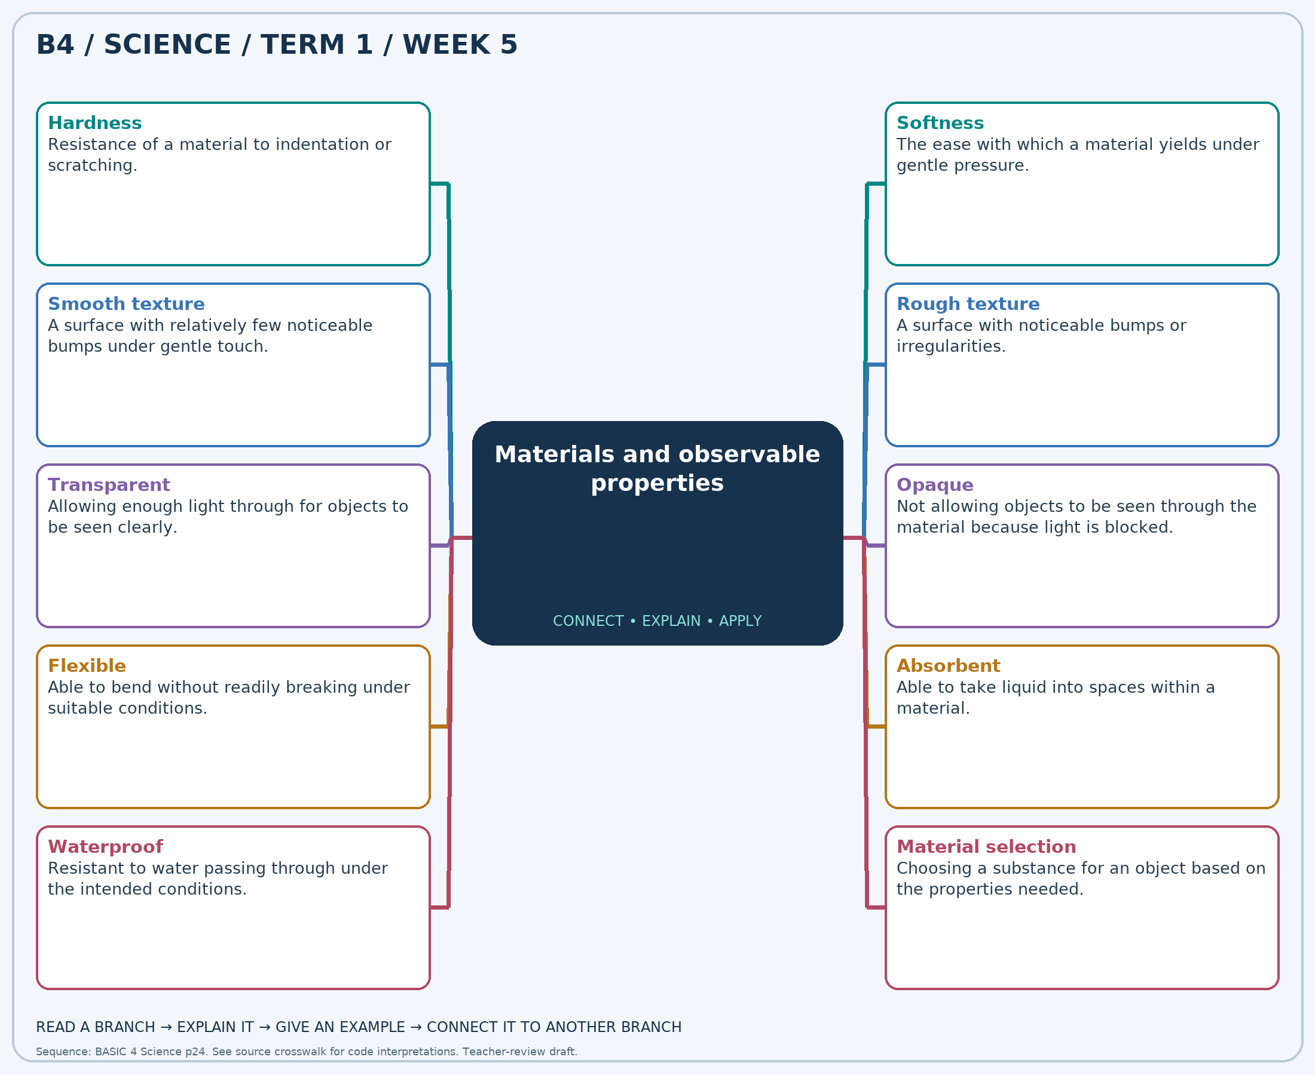
Read each branch, explain the link to the central topic, and add your own example. The separate high-resolution PNG supports projection or larger printing. Concept-map connections do not imply every process occurs in a single linear order.

Week 5 — Practice and assessment

Section A — Multiple-choice questions
Choose ONE correct answer for each question. Each question has four alternatives.
1. Which term best matches this description: resistance of a material to indentation or scratching?
A. Hardness B. Transparency C. Absorption D. Colour
2. Which term best matches this description: the ease with which a material yields under gentle pressure?
A. Metallic shine B. Softness C. Transparency D. Waterproofing
3. Which term best matches this description: a surface with relatively few noticeable bumps under gentle touch?
A. Opacity only B. Smooth texture C. Rough texture D. Absorbency
4. Which term best matches this description: a surface with noticeable bumps or irregularities?
A. Rough texture B. Transparent C. Stretchy D. Perfectly smooth
5. Which term best matches this description: allowing enough light through for objects to be seen clearly?
A. Absorbent B. Soft only C. Transparent D. Opaque
6. Which term best matches this description: not allowing objects to be seen through the material because light is blocked?
A. Elastic only B. Soluble C. Opaque D. Transparent
7. Which term best matches this description: able to bend without readily breaking under suitable conditions?
A. Absorbent only B. Brittle C. Always transparent D. Flexible
8. Which term best matches this description: able to take liquid into spaces within a material?
A. Absorbent B. Waterproof C. Opaque only D. Metallic
9. Which term best matches this description: resistant to water passing through under the intended conditions?
A. Waterproof B. Soluble C. Absorbent D. Fragile
10. Which term best matches this description: choosing a substance for an object based on the properties needed?
A. Material selection B. Animal reproduction C. Seed germination D. Condensation
11. A wooden block is harder to dent with gentle pressure than a sponge. Which property is compared?
A. Transparency B. Colour C. Absorption D. Hardness
12. A cushion compresses readily when pressed. Which property is useful here?
A. Metallic shine B. Transparency C. Waterproofing D. Softness
13. A polished spoon feels even compared with coarse sandpaper. Which property describes the spoon’s surface?
A. Absorbency B. Smooth texture C. Rough texture D. Opacity only
14. Sandpaper helps remove small surface layers because of which texture?
A. Rough texture B. Perfectly smooth C. Transparent D. Stretchy
15. A clear plastic window lets a learner see a picture behind it. Which property is shown?
A. Soft only B. Transparent C. Absorbent D. Opaque
16. A cardboard cover hides the picture behind it. Which optical property is shown?
A. Elastic only B. Transparent C. Soluble D. Opaque
17. A plastic folder bends slightly without snapping. Which useful property is shown?
A. Always transparent B. Brittle C. Flexible D. Absorbent only
18. A cloth towel takes up spilled water. Which property is useful?
A. Absorbent B. Waterproof C. Opaque only D. Metallic
19. A raincoat keeps rain from soaking clothing underneath. Which property is required?
A. Absorbent B. Soluble C. Fragile D. Waterproof
20. A learner chooses absorbent cloth for a towel instead of a plastic sheet. What process is being carried out?
A. Seed germination B. Animal reproduction C. Condensation D. Material selection

Section B — 10 structured essay questions
Answer all parts (a), (b), (c). Write in a separate exercise book. Suggested marks per question: (a) 1, (b) 1, (c) 2, total 4. Use accurate terms and explain relationships or evidence where asked.

Question 1
(a) Explain the term “Hardness”.
(b) A wooden block is harder to dent with gentle pressure than a sponge. Which property is compared?
(c) Explain why a hard material is not necessarily unbreakable.

Question 2
(a) Explain the term “Softness”.
(b) A cushion compresses readily when pressed. Which property is useful here?
(c) Explain why a cushion may use different materials for its filling and cover.

Question 3
(a) Explain the term “Smooth texture”.
(b) A polished spoon feels even compared with coarse sandpaper. Which property describes the spoon’s surface?
(c) Distinguish surface texture from an object’s overall shape.

Question 4
(a) Explain the term “Rough texture”.
(b) Sandpaper helps remove small surface layers because of which texture?
(c) Give one useful and one unsuitable use for a rough surface.

Question 5
(a) Explain the term “Transparent”.
(b) A clear plastic window lets a learner see a picture behind it. Which property is shown?
(c) Explain why transparency is useful for a viewing window.

Question 6
(a) Explain the term “Opaque”.
(b) A cardboard cover hides the picture behind it. Which optical property is shown?
(c) Explain why a thin card may still be opaque.

Question 7
(a) Explain the term “Flexible”.
(b) A plastic folder bends slightly without snapping. Which useful property is shown?
(c) Distinguish bending from stretching using a familiar example.

Question 8
(a) Explain the term “Absorbent”.
(b) A cloth towel takes up spilled water. Which property is useful?
(c) Explain why an absorbent towel is more useful than a waterproof sheet for drying hands.

Question 9
(a) Explain the term “Waterproof”.
(b) A raincoat keeps rain from soaking clothing underneath. Which property is required?
(c) Explain why a raincoat with a tear may leak despite waterproof fabric.

Question 10
(a) Explain the term “Material selection”.
(b) A learner chooses absorbent cloth for a towel instead of a plastic sheet. What process is being carried out?
(c) Explain how the required use should guide a material choice.

Week 6 — Liquid mixtures and simple separation
Scheme reference: B4.1.2.1.2. Reference used: B4.1.2.2.1. The source suffix is absent locally; liquid–liquid mixture description B4.1.2.2.1 is used within the scheduled Materials block.

Learning outcomes
- Explain the main ideas in liquid mixtures and simple separation using accurate vocabulary.
- Use observations or models to identify examples and justify explanations.
- Apply the ideas to a familiar situation, recognise a misconception and state relevant safety precautions.

Teacher lesson notes
Suggested weekly structure: three 40-minute teaching sessions, plus distributed practice and feedback in remaining timetable periods. Adjust to actual lesson periods. The full question bank should not be imposed as one 40-minute task.
Prior-knowledge check: ask learners for a familiar example related to the week. Record what they think happens and why. Retain one initial claim to revisit after the activity.

Session 1 — Observe and define
5 min: retrieve related knowledge; 10 min: show a model, picture or safe specimen; 15 min: pairs record observations and discuss the first five terms; 10 min: check explanations with short oral questions.

Session 2 — Investigate and explain
5 min: recall vocabulary; 10 min: model a justified explanation; 15 min: carry out the specific activity below, recording real observations; 10 min: introduce the remaining terms and compare evidence.

Session 3 — Apply and assess
5 min: revisit an initial misconception; 10 min: explain the map connections; 15 min: attempt selected application questions and structured parts; 10 min: review explanations and plan reteaching or extension.

Topic-specific activity and resources
Place small amounts of cooking oil and water in a labelled clear container. Observe before and after gentle stirring, then after standing. Compare with a teacher-prepared safe uniform liquid mixture, such as water with a little food colouring. Use drawings to plan separation without tasting.
Resources: the teacher-selected examples, pictures or apparatus described above; board, pencils, exercise books and the supplied map. If a practical cannot be completed, use a clearly labelled photograph or model and do not report predicted results as observed results.

Safety
Use familiar, non-toxic materials only. No fuels, unknown solvents or flames. Do not drink mixtures; clean slippery spills immediately.

Support, extension and feedback
Support: provide picture labels and a word bank, read unfamiliar words aloud, and let learners explain orally before writing. Extension: compare two related concepts, suggest a counterexample or critique a model. Feedback: ask why a distractor is wrong and use the answer to identify the misconception.

Study notes

Mixture
Two or more substances physically combined.
The substances remain present even when stirred. Putting materials together does not necessarily form a new chemical substance.

Immiscible liquids
Liquids that do not form one uniform liquid phase when combined.
The liquids remain in separate phases. Shaking can make small droplets temporarily but does not permanently make them mix uniformly.

Miscible liquids
Liquids that mix uniformly under the stated conditions.
The pair mixes at the liquid level rather than separating into layers. A uniform appearance alone does not show that only one substance is present.

Layer
A distinct region of one liquid above or below another.
Distinct regions make the boundary visible and can support separation. The location depends partly on density, not simply on colour.

Density
Mass per unit volume of a substance.
Cooking oil usually has lower density than water and forms the upper layer. Density is not the same as the total mass of a large container.

Settling time
The period allowed for a disturbed mixture to separate or become less turbulent.
Small droplets can combine into clearer layers while the mixture stands. Repeated shaking delays the observation of a stable boundary.

Decantation
Carefully pouring off one separated liquid region without greatly disturbing the rest.
Careful pouring can remove part of a layer but may mix some liquid at the boundary. It is not always a complete separation.

Separating funnel
An apparatus with a tap used to separate suitable immiscible liquid layers.
The lower layer leaves first, and the tap is closed near the boundary. The apparatus is unsuitable for separating two fully miscible liquids by this method.

Observation
A record of what is noticed or measured during an investigation.
The statement records an event and a time rather than claiming an untested cause. Explanations should be based on such evidence.

Fair comparison
A comparison keeping relevant conditions the same except the chosen variable.
Keeping volume, containers and waiting time similar helps relate the difference to stirring rather than another changed condition.
Independent study: reconstruct the map from memory, give a fresh example for three branches and answer one explanation question without copying the notes. Correct errors after discussing the reason with a teacher or partner.

Week 6 — Visual mind-map
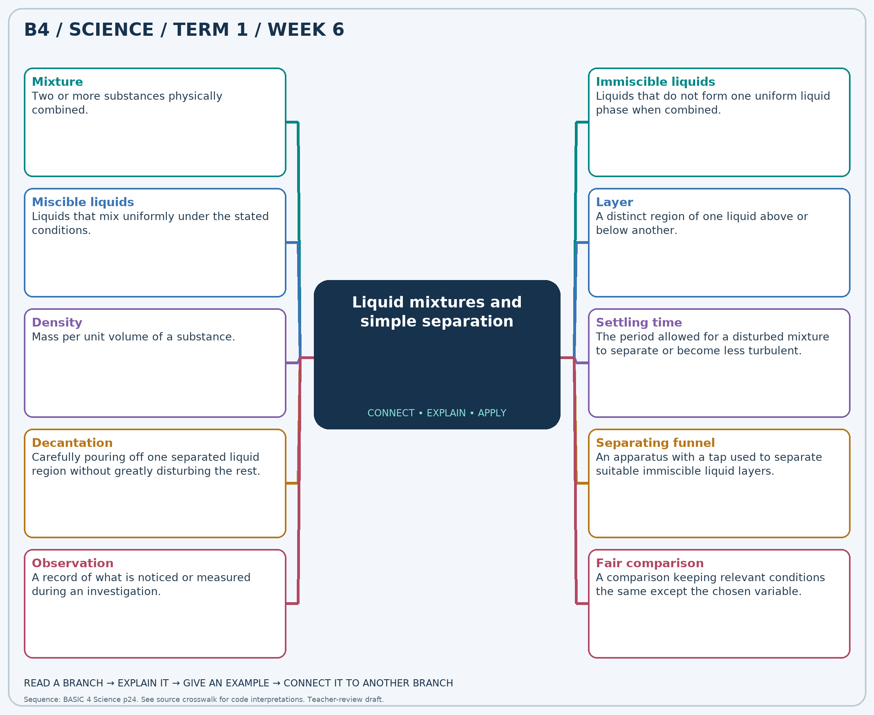
Read each branch, explain the link to the central topic, and add your own example. The separate high-resolution PNG supports projection or larger printing. Concept-map connections do not imply every process occurs in a single linear order.

Week 6 — Practice and assessment

Section A — Multiple-choice questions
Choose ONE correct answer for each question. Each question has four alternatives.
1. Which term best matches this description: two or more substances physically combined?
A. A single animal cell B. A new pure element C. Mixture D. A seed
2. Which term best matches this description: liquids that do not form one uniform liquid phase when combined?
A. Miscible liquids B. Pure gases C. Solid crystals D. Immiscible liquids
3. Which term best matches this description: liquids that mix uniformly under the stated conditions?
A. Miscible liquids B. Immiscible liquids C. Two solid layers D. Undissolved pebbles
4. Which term best matches this description: a distinct region of one liquid above or below another?
A. Embryo B. Vapour only C. Root hair D. Layer
5. Which term best matches this description: mass per unit volume of a substance?
A. Temperature scale B. Density C. Colour only D. Length only
6. Which term best matches this description: the period allowed for a disturbed mixture to separate or become less turbulent?
A. Combustion B. Settling time C. Germination D. Freezing
7. Which term best matches this description: carefully pouring off one separated liquid region without greatly disturbing the rest?
A. Decantation B. Magnetism C. Grinding D. Melting
8. Which term best matches this description: an apparatus with a tap used to separate suitable immiscible liquid layers?
A. Separating funnel B. Thermometer C. Balance D. Microscope
9. Which term best matches this description: a record of what is noticed or measured during an investigation?
A. A safety rule only B. A fictional story C. An unsupported guess D. Observation
10. Which term best matches this description: a comparison keeping relevant conditions the same except the chosen variable?
A. Ignoring measurements B. Fair comparison C. Using different liquids D. Changing every condition
11. Water and cooking oil are put into the same container. What has been made?
A. A new pure element B. Mixture C. A single animal cell D. A seed
12. Oil and water form separate layers after standing. How are they described?
A. Solid crystals B. Pure gases C. Miscible liquids D. Immiscible liquids
13. A teacher’s approved pair of liquids forms one uniform phase after mixing. Which term describes the pair?
A. Miscible liquids B. Immiscible liquids C. Undissolved pebbles D. Two solid layers
14. After standing, oil occupies a separate upper region in water. What is this region called?
A. Embryo B. Vapour only C. Layer D. Root hair
15. Equal volumes of cooking oil and water have different masses. Which property differs?
A. Colour only B. Length only C. Temperature scale D. Density
16. A class leaves stirred oil and water untouched before observing the boundary. What are they allowing?
A. Freezing B. Germination C. Settling time D. Combustion
17. A teacher gently pours an upper layer into another vessel. Which simple method is attempted?
A. Grinding B. Decantation C. Melting D. Magnetism
18. A teacher drains the lower liquid through a tap while watching the boundary. Which apparatus is used?
A. Balance B. Thermometer C. Separating funnel D. Microscope
19. A pupil writes “two layers formed after five minutes”. What kind of record is this?
A. An unsupported guess B. Observation C. A safety rule only D. A fictional story
20. Two groups compare stirring and not stirring using equal liquid volumes and the same waiting time. What design feature helps them?
A. Changing every condition B. Ignoring measurements C. Fair comparison D. Using different liquids

Section B — 10 structured essay questions
Answer all parts (a), (b), (c). Write in a separate exercise book. Suggested marks per question: (a) 1, (b) 1, (c) 2, total 4. Use accurate terms and explain relationships or evidence where asked.

Question 1
(a) Explain the term “Mixture”.
(b) Water and cooking oil are put into the same container. What has been made?
(c) Explain why both original liquids are still present after mixing.

Question 2
(a) Explain the term “Immiscible liquids”.
(b) Oil and water form separate layers after standing. How are they described?
(c) Explain why shaking does not permanently remove the two layers.

Question 3
(a) Explain the term “Miscible liquids”.
(b) A teacher’s approved pair of liquids forms one uniform phase after mixing. Which term describes the pair?
(c) Explain why a uniform mixture can still contain two substances.

Question 4
(a) Explain the term “Layer”.
(b) After standing, oil occupies a separate upper region in water. What is this region called?
(c) Explain why visible layers are useful when planning separation.

Question 5
(a) Explain the term “Density”.
(b) Equal volumes of cooking oil and water have different masses. Which property differs?
(c) Explain why saying “oil floats because there is less oil” is not a good explanation.

Question 6
(a) Explain the term “Settling time”.
(b) A class leaves stirred oil and water untouched before observing the boundary. What are they allowing?
(c) Explain why observations immediately after shaking may differ from observations later.

Question 7
(a) Explain the term “Decantation”.
(b) A teacher gently pours an upper layer into another vessel. Which simple method is attempted?
(c) Explain one limitation of separating layers by pouring.

Question 8
(a) Explain the term “Separating funnel”.
(b) A teacher drains the lower liquid through a tap while watching the boundary. Which apparatus is used?
(c) Explain why a visible boundary matters when using this apparatus.

Question 9
(a) Explain the term “Observation”.
(b) A pupil writes “two layers formed after five minutes”. What kind of record is this?
(c) Separate an observation about a mixture from a possible explanation.

Question 10
(a) Explain the term “Fair comparison”.
(b) Two groups compare stirring and not stirring using equal liquid volumes and the same waiting time. What design feature helps them?
(c) Name two conditions that should stay the same in this comparison.

Week 7 — Cyclic movements and repeating patterns
Scheme reference: B4.2.1.1.1. Reference used: B4.2.1.1.1. Direct indicator match. Classroom models support the idea of recurrence rather than claiming every cycle has the same duration.

Learning outcomes
- Explain the main ideas in cyclic movements and repeating patterns using accurate vocabulary.
- Use observations or models to identify examples and justify explanations.
- Apply the ideas to a familiar situation, recognise a misconception and state relevant safety precautions.

Teacher lesson notes
Suggested weekly structure: three 40-minute teaching sessions, plus distributed practice and feedback in remaining timetable periods. Adjust to actual lesson periods. The full question bank should not be imposed as one 40-minute task.
Prior-knowledge check: ask learners for a familiar example related to the week. Record what they think happens and why. Retain one initial claim to revisit after the activity.

Session 1 — Observe and define
5 min: retrieve related knowledge; 10 min: show a model, picture or safe specimen; 15 min: pairs record observations and discuss the first five terms; 10 min: check explanations with short oral questions.

Session 2 — Investigate and explain
5 min: recall vocabulary; 10 min: model a justified explanation; 15 min: carry out the specific activity below, recording real observations; 10 min: introduce the remaining terms and compare evidence.

Session 3 — Apply and assess
5 min: revisit an initial misconception; 10 min: explain the map connections; 15 min: attempt selected application questions and structured parts; 10 min: review explanations and plan reteaching or extension.

Topic-specific activity and resources
Observe or model a rotating wheel, clock hand and swinging pendulum. Record a chosen starting position and when it is reached again. Sort examples into rotating, oscillating and non-repeating movements. Relate regular recurrence to day and night.
Resources: the teacher-selected examples, pictures or apparatus described above; board, pencils, exercise books and the supplied map. If a practical cannot be completed, use a clearly labelled photograph or model and do not report predicted results as observed results.

Safety
Use small teacher-controlled models. Keep fingers clear of moving parts; do not run into swinging objects or stare at the Sun.

Support, extension and feedback
Support: provide picture labels and a word bank, read unfamiliar words aloud, and let learners explain orally before writing. Extension: compare two related concepts, suggest a counterexample or critique a model. Feedback: ask why a distractor is wrong and use the answer to identify the misconception.

Study notes

Cycle
A sequence of events or positions that returns and repeats.
Returning to a starting state allows repetition to be recognised. Different cycles may take very different times.

Rotation
Turning around an axis.
The object turns about an axis rather than travelling along a straight line. One full turn returns its orientation to the start.

Oscillation
Repeated movement to and fro about a central position.
The movement alternates around a central position. One full oscillation includes the return to the same side in the same direction of motion.

Period
The time taken for one complete cycle.
The measurement is a time interval. Measuring several turns and dividing by their number can reduce the effect of timing errors.

Clock hand
A pointer whose regular turning can show the passage of time.
The hand revisits positions at regular intervals. Different hands complete their cycles at different rates.

Axis
An imaginary or physical line about which an object turns.
The axis identifies the line of turning. It should not be confused with a path around another object.

Day–night cycle
The regular alternation of daylight and darkness as Earth rotates.
Earth’s rotation changes whether a place receives direct sunlight. The Sun does not switch off at night.

Orbit
A path followed by an object as it moves around another under gravity.
Orbiting is movement around another body. Rotation is spinning around the object’s own axis, so the two motions differ.

Prediction
A statement about what is expected to happen based on evidence or a pattern.
A repeated pattern supports an expectation that can be tested. A prediction should be checked rather than treated as certain regardless of evidence.

Repeated measurement
Measuring the same quantity more than once to check consistency.
Repeated readings reveal variation and possible mistakes. Conditions should stay similar if results are to be compared.
Independent study: reconstruct the map from memory, give a fresh example for three branches and answer one explanation question without copying the notes. Correct errors after discussing the reason with a teacher or partner.

Week 7 — Visual mind-map
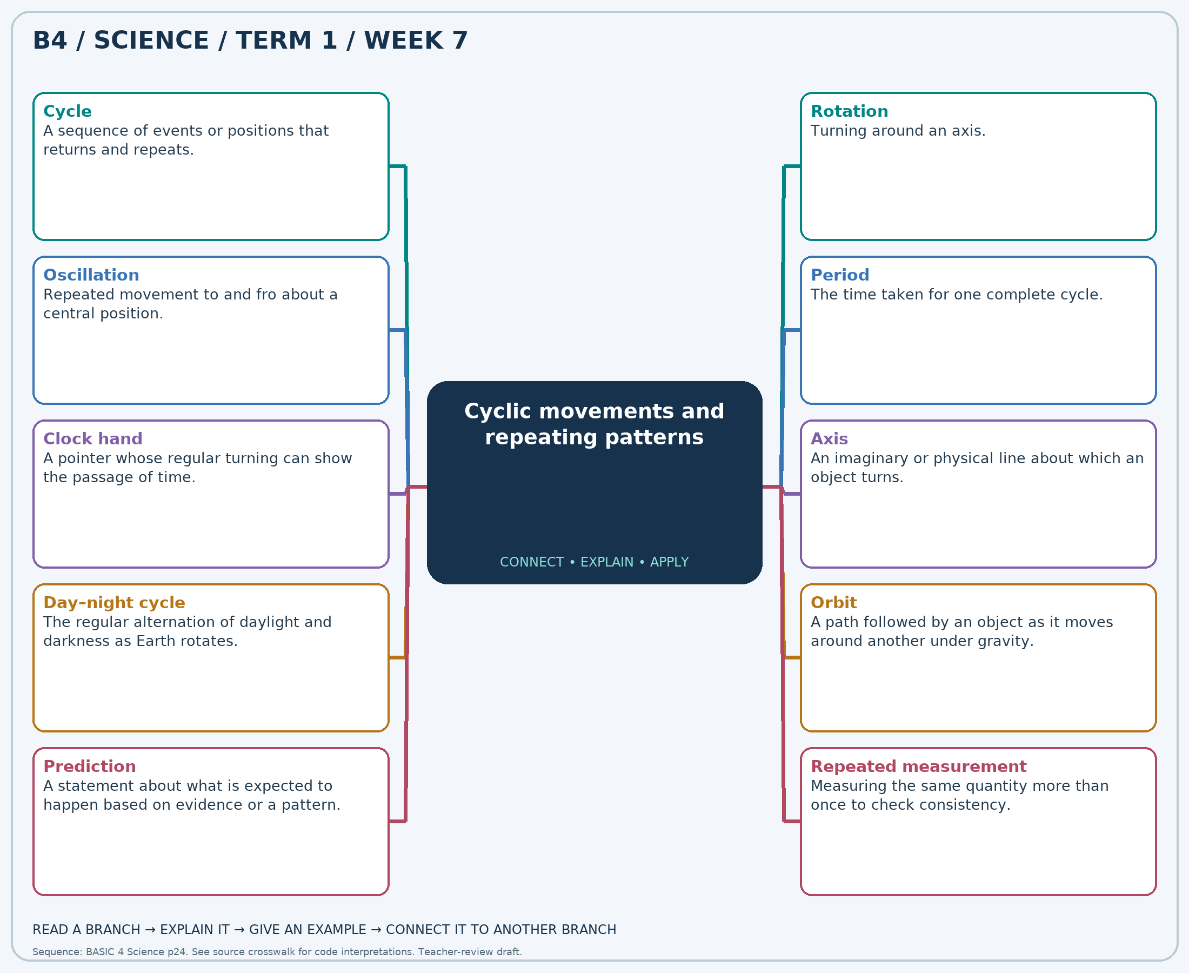
Read each branch, explain the link to the central topic, and add your own example. The separate high-resolution PNG supports projection or larger printing. Concept-map connections do not imply every process occurs in a single linear order.

Week 7 — Practice and assessment

Section A — Multiple-choice questions
Choose ONE correct answer for each question. Each question has four alternatives.
1. Which term best matches this description: a sequence of events or positions that returns and repeats?
A. Permanent rest B. Cycle C. A single unrelated event D. Random disappearance
2. Which term best matches this description: turning around an axis?
A. Rotation B. Melting C. Germination D. Straight-line sliding
3. Which term best matches this description: repeated movement to and fro about a central position?
A. Condensation B. Oscillation C. One-way flight D. Growth
4. Which term best matches this description: the time taken for one complete cycle?
A. Length B. Mass C. Period D. Density
5. Which term best matches this description: a pointer whose regular turning can show the passage of time?
A. Clock hand B. A dissolved sugar grain C. A falling broken cup D. A growing leaf
6. Which term best matches this description: an imaginary or physical line about which an object turns?
A. Its shadow only B. A cloud layer C. A growing root D. Axis
7. Which term best matches this description: the regular alternation of daylight and darkness as Earth rotates?
A. Rusting B. Boiling C. Plant germination D. Day–night cycle
8. Which term best matches this description: a path followed by an object as it moves around another under gravity?
A. Orbit B. A plant root C. A liquid layer D. A weather thermometer
9. Which term best matches this description: a statement about what is expected to happen based on evidence or a pattern?
A. A plant drawing B. A record of yesterday only C. Prediction D. A definition of mass
10. Which term best matches this description: measuring the same quantity more than once to check consistency?
A. Repeated measurement B. Changing the model each time C. Ignoring time D. Recording only a guess
11. A wheel turns until a marked point returns to its starting place, then repeats. What pattern is shown?
A. A single unrelated event B. Permanent rest C. Cycle D. Random disappearance
12. A globe spins around its fixed support. Which motion is shown?
A. Straight-line sliding B. Germination C. Melting D. Rotation
13. A pendulum moves left, right and back again. What kind of motion is this?
A. One-way flight B. Oscillation C. Growth D. Condensation
14. A learner measures the time for a marked wheel to make one full turn. What quantity is found?
A. Period B. Mass C. Length D. Density
15. Which familiar object repeatedly turns around a clock face?
A. A dissolved sugar grain B. A growing leaf C. Clock hand D. A falling broken cup
16. What does a globe rotate around in a classroom model?
A. A cloud layer B. Its shadow only C. A growing root D. Axis
17. A place on Earth repeatedly faces the Sun and then turns away. Which cycle results?
A. Rusting B. Day–night cycle C. Boiling D. Plant germination
18. Earth travels around the Sun along what kind of path?
A. A liquid layer B. Orbit C. A weather thermometer D. A plant root
19. A learner uses several regular wheel turns to estimate when the next turn will end. What is being made?
A. Prediction B. A plant drawing C. A definition of mass D. A record of yesterday only
20. Three timings are taken for the same model’s turns. What practice improves the evidence?
A. Repeated measurement B. Changing the model each time C. Ignoring time D. Recording only a guess

Section B — 10 structured essay questions
Answer all parts (a), (b), (c). Write in a separate exercise book. Suggested marks per question: (a) 1, (b) 1, (c) 2, total 4. Use accurate terms and explain relationships or evidence where asked.

Question 1
(a) Explain the term “Cycle”.
(b) A wheel turns until a marked point returns to its starting place, then repeats. What pattern is shown?
(c) Explain how a marked point helps demonstrate a repeating pattern.

Question 2
(a) Explain the term “Rotation”.
(b) A globe spins around its fixed support. Which motion is shown?
(c) Describe the axis and one full turn in a globe model.

Question 3
(a) Explain the term “Oscillation”.
(b) A pendulum moves left, right and back again. What kind of motion is this?
(c) Explain why movement from one side to the other is only part of a full cycle.

Question 4
(a) Explain the term “Period”.
(b) A learner measures the time for a marked wheel to make one full turn. What quantity is found?
(c) Describe a method for estimating the time of one turn using several turns.

Question 5
(a) Explain the term “Clock hand”.
(b) Which familiar object repeatedly turns around a clock face?
(c) Compare the repetition of an hour hand and a minute hand.

Question 6
(a) Explain the term “Axis”.
(b) What does a globe rotate around in a classroom model?
(c) Distinguish an axis of rotation from a path of travel.

Question 7
(a) Explain the term “Day–night cycle”.
(b) A place on Earth repeatedly faces the Sun and then turns away. Which cycle results?
(c) Explain the role of Earth’s rotation in this repeated pattern.

Question 8
(a) Explain the term “Orbit”.
(b) Earth travels around the Sun along what kind of path?
(c) Distinguish Earth’s orbit from Earth’s rotation.

Question 9
(a) Explain the term “Prediction”.
(b) A learner uses several regular wheel turns to estimate when the next turn will end. What is being made?
(c) Explain how observing several cycles can support a testable prediction.

Question 10
(a) Explain the term “Repeated measurement”.
(b) Three timings are taken for the same model’s turns. What practice improves the evidence?
(c) Explain why one timing may be less reliable than several comparable timings.

Week 8 — Objects in the daytime and nighttime sky
Scheme reference: B4.2.1.1.2. Reference used: B4.2.1.2.1. Source suffix is absent locally; sky-object description B4.2.1.2.1 is used within the scheduled Earth Science block.

Learning outcomes
- Explain the main ideas in objects in the daytime and nighttime sky using accurate vocabulary.
- Use observations or models to identify examples and justify explanations.
- Apply the ideas to a familiar situation, recognise a misconception and state relevant safety precautions.

Teacher lesson notes
Suggested weekly structure: three 40-minute teaching sessions, plus distributed practice and feedback in remaining timetable periods. Adjust to actual lesson periods. The full question bank should not be imposed as one 40-minute task.
Prior-knowledge check: ask learners for a familiar example related to the week. Record what they think happens and why. Retain one initial claim to revisit after the activity.

Session 1 — Observe and define
5 min: retrieve related knowledge; 10 min: show a model, picture or safe specimen; 15 min: pairs record observations and discuss the first five terms; 10 min: check explanations with short oral questions.

Session 2 — Investigate and explain
5 min: recall vocabulary; 10 min: model a justified explanation; 15 min: carry out the specific activity below, recording real observations; 10 min: introduce the remaining terms and compare evidence.

Session 3 — Apply and assess
5 min: revisit an initial misconception; 10 min: explain the map connections; 15 min: attempt selected application questions and structured parts; 10 min: review explanations and plan reteaching or extension.

Topic-specific activity and resources
Use teacher-prepared day and night photographs. Classify Sun, Moon, stars and clouds, noting that the Moon can sometimes be seen by day. Make a dated sky-observation table using safe unaided viewing away from the Sun.
Resources: the teacher-selected examples, pictures or apparatus described above; board, pencils, exercise books and the supplied map. If a practical cannot be completed, use a clearly labelled photograph or model and do not report predicted results as observed results.

Safety
Never look directly at the Sun, through binoculars or through a telescope. Children’s observations require adult supervision; do not travel outdoors alone at night.

Support, extension and feedback
Support: provide picture labels and a word bank, read unfamiliar words aloud, and let learners explain orally before writing. Extension: compare two related concepts, suggest a counterexample or critique a model. Feedback: ask why a distractor is wrong and use the answer to identify the misconception.

Study notes

Sun
The star nearest to Earth, supplying daylight and much of Earth’s energy.
The Sun produces its own light. Daylight remains dangerous to stare at directly, even when the Sun looks dim through haze.

Moon
Earth’s natural satellite, seen mainly because it reflects sunlight.
The Moon reflects sunlight and can be above the horizon in daylight. It is not restricted to appearing only at night.

Star
A very distant luminous object that produces its own light.
Stars appear small mainly because they are far away. The Sun is a star but appears much larger because it is much nearer.

Cloud
A visible collection of tiny water droplets or ice crystals in the atmosphere.
Clouds belong to Earth’s atmosphere and can move with the air. They are not solid objects in outer space.

Planet
A body orbiting a star and seen by reflected light rather than producing starlight.
Planets can appear as bright points from Earth. Their appearance alone may not reliably distinguish them without information or a sky guide.

Atmosphere
The layer of gases surrounding Earth.
Clouds form within the atmosphere, relatively close compared with the Moon or stars. This distinguishes weather phenomena from distant astronomical objects.

Horizon
The apparent boundary where the sky meets the ground or sea.
It is an apparent boundary affected by the observer’s location. Buildings or hills may block a clear view of it.

Shadow
A darker region formed when an object blocks light.
The blocked light creates the darker region. Changes in light direction alter a shadow’s direction and length.

Reflected light
Light redirected from a surface rather than newly produced by that surface.
Sunlight strikes the Moon and some is directed toward Earth. The Moon therefore acts differently from the Sun as a light source.

Sky record
A dated description or drawing of visible sky conditions and objects.
Recording time and conditions allows observations to be compared. Failure to see an object may reflect cloud cover rather than its absence from the sky.
Independent study: reconstruct the map from memory, give a fresh example for three branches and answer one explanation question without copying the notes. Correct errors after discussing the reason with a teacher or partner.

Week 8 — Visual mind-map
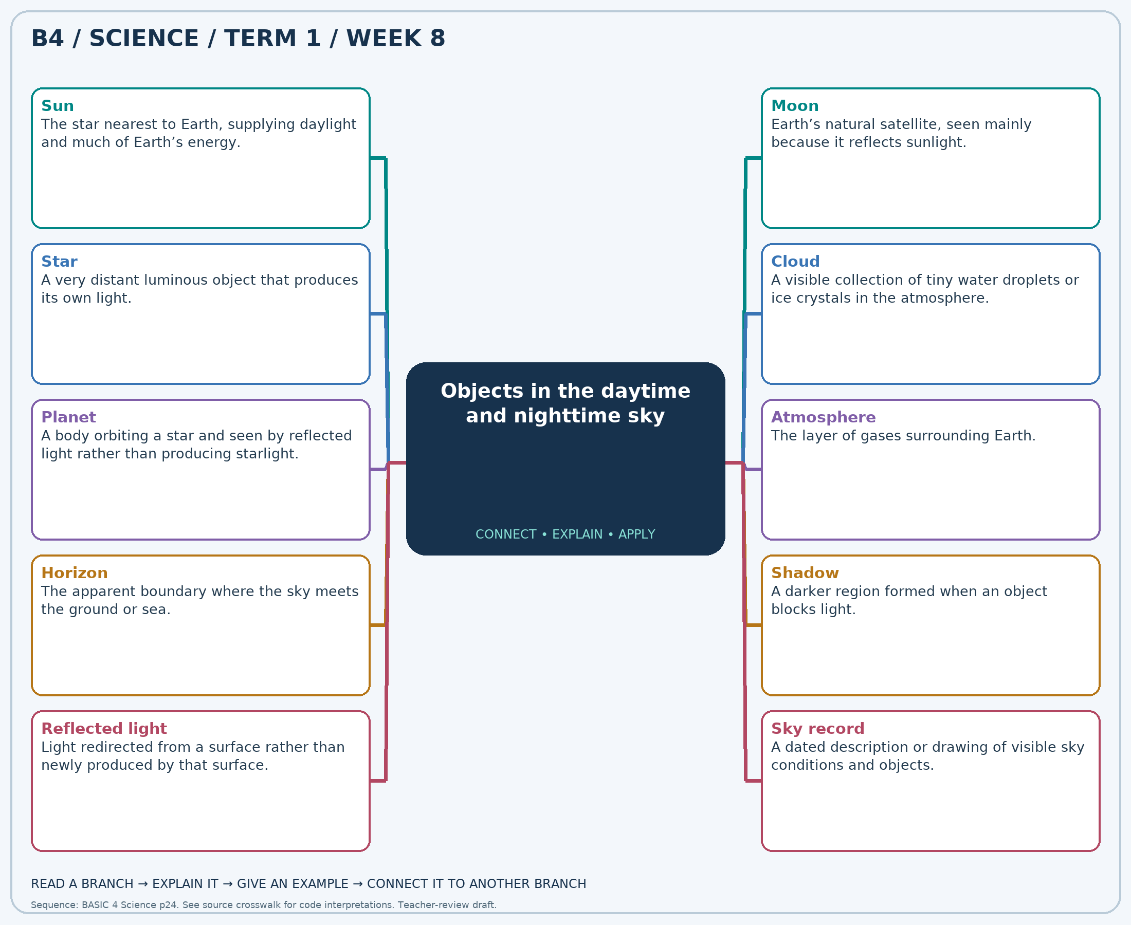
Read each branch, explain the link to the central topic, and add your own example. The separate high-resolution PNG supports projection or larger printing. Concept-map connections do not imply every process occurs in a single linear order.

Week 8 — Practice and assessment

Section A — Multiple-choice questions
Choose ONE correct answer for each question. Each question has four alternatives.
1. Which term best matches this description: the star nearest to Earth, supplying daylight and much of Earth’s energy?
A. Moon B. Streetlight C. Sun D. Cloud
2. Which term best matches this description: earth’s natural satellite, seen mainly because it reflects sunlight?
A. Flame B. Sun C. Moon D. Electric lamp
3. Which term best matches this description: a very distant luminous object that produces its own light?
A. Pieces of the Moon B. Cloud droplets C. Nearby insects only D. Star
4. Which term best matches this description: a visible collection of tiny water droplets or ice crystals in the atmosphere?
A. A nearby planet B. Cloud C. The Sun’s surface D. A fixed star
5. Which term best matches this description: a body orbiting a star and seen by reflected light rather than producing starlight?
A. Star producing its own light B. Planet C. Cloud D. Artificial lamp
6. Which term best matches this description: the layer of gases surrounding Earth?
A. Deep inside the Sun B. Atmosphere C. Inside a seed D. Below all rocks
7. Which term best matches this description: the apparent boundary where the sky meets the ground or sea?
A. A root tip B. The bottom of a cup C. The centre of a flower D. Horizon
8. Which term best matches this description: a darker region formed when an object blocks light?
A. A cloud inside the ground B. A star C. Shadow D. A new Moon
9. Which term best matches this description: light redirected from a surface rather than newly produced by that surface?
A. Heat from a street drain B. Light made by lunar flames C. Sound waves D. Reflected light
10. Which term best matches this description: a dated description or drawing of visible sky conditions and objects?
A. A food recipe B. Sky record C. A soil-mass calculation D. A fictional weather claim
11. Which natural body is the main source of daytime light on Earth?
A. Cloud B. Moon C. Streetlight D. Sun
12. Which body can be visible at night and sometimes during the day without producing its own light like a star?
A. Flame B. Moon C. Sun D. Electric lamp
13. Tiny points of light in a dark sky are often examples of what?
A. Pieces of the Moon B. Cloud droplets C. Nearby insects only D. Star
14. A changing white or grey shape drifts across the daytime sky. What is it likely to be?
A. A fixed star B. The Sun’s surface C. Cloud D. A nearby planet
15. A bright sky object such as Venus reflects sunlight. Which category fits it?
A. Planet B. Star producing its own light C. Cloud D. Artificial lamp
16. In which part of Earth’s environment do ordinary weather clouds occur?
A. Atmosphere B. Below all rocks C. Deep inside the Sun D. Inside a seed
17. What boundary is used when describing a body as rising into view?
A. The centre of a flower B. A root tip C. Horizon D. The bottom of a cup
18. A tree blocks sunlight and produces a dark patch on the ground. What is formed?
A. A star B. Shadow C. A new Moon D. A cloud inside the ground
19. Moonlight reaches our eyes mainly as which kind of light?
A. Sound waves B. Heat from a street drain C. Light made by lunar flames D. Reflected light
20. A pupil records time, cloud cover and whether the Moon is visible. What useful record is made?
A. A fictional weather claim B. Sky record C. A food recipe D. A soil-mass calculation

Section B — 10 structured essay questions
Answer all parts (a), (b), (c). Write in a separate exercise book. Suggested marks per question: (a) 1, (b) 1, (c) 2, total 4. Use accurate terms and explain relationships or evidence where asked.

Question 1
(a) Explain the term “Sun”.
(b) Which natural body is the main source of daytime light on Earth?
(c) Explain why the Sun is a light source and why direct viewing is unsafe.

Question 2
(a) Explain the term “Moon”.
(b) Which body can be visible at night and sometimes during the day without producing its own light like a star?
(c) Explain why the statement “the Moon is only in the night sky” is incorrect.

Question 3
(a) Explain the term “Star”.
(b) Tiny points of light in a dark sky are often examples of what?
(c) Explain why the Sun and distant stars can look very different in size.

Question 4
(a) Explain the term “Cloud”.
(b) A changing white or grey shape drifts across the daytime sky. What is it likely to be?
(c) Explain how a cloud differs from a star.

Question 5
(a) Explain the term “Planet”.
(b) A bright sky object such as Venus reflects sunlight. Which category fits it?
(c) Explain why a bright point in the sky is not always a star.

Question 6
(a) Explain the term “Atmosphere”.
(b) In which part of Earth’s environment do ordinary weather clouds occur?
(c) Explain why clouds are much closer to us than the Moon.

Question 7
(a) Explain the term “Horizon”.
(b) What boundary is used when describing a body as rising into view?
(c) Explain why observers at different locations may have different views near the horizon.

Question 8
(a) Explain the term “Shadow”.
(b) A tree blocks sunlight and produces a dark patch on the ground. What is formed?
(c) Explain why a tree’s shadow can change during the day.

Question 9
(a) Explain the term “Reflected light”.
(b) Moonlight reaches our eyes mainly as which kind of light?
(c) Trace the path that makes the Moon visible to us.

Question 10
(a) Explain the term “Sky record”.
(b) A pupil records time, cloud cover and whether the Moon is visible. What useful record is made?
(c) Explain why cloud cover should be recorded along with visible sky objects.

Week 9 — Evaporation, transpiration and evapotranspiration
Scheme reference: B4.2.1.1.3. Reference used: B4.2.1.3.1. Source suffix is absent locally; evapotranspiration description B4.2.1.3.1 supplies the scheduled Earth Science lesson.

Learning outcomes
- Explain the main ideas in evaporation, transpiration and evapotranspiration using accurate vocabulary.
- Use observations or models to identify examples and justify explanations.
- Apply the ideas to a familiar situation, recognise a misconception and state relevant safety precautions.

Teacher lesson notes
Suggested weekly structure: three 40-minute teaching sessions, plus distributed practice and feedback in remaining timetable periods. Adjust to actual lesson periods. The full question bank should not be imposed as one 40-minute task.
Prior-knowledge check: ask learners for a familiar example related to the week. Record what they think happens and why. Retain one initial claim to revisit after the activity.

Session 1 — Observe and define
5 min: retrieve related knowledge; 10 min: show a model, picture or safe specimen; 15 min: pairs record observations and discuss the first five terms; 10 min: check explanations with short oral questions.

Session 2 — Investigate and explain
5 min: recall vocabulary; 10 min: model a justified explanation; 15 min: carry out the specific activity below, recording real observations; 10 min: introduce the remaining terms and compare evidence.

Session 3 — Apply and assess
5 min: revisit an initial misconception; 10 min: explain the map connections; 15 min: attempt selected application questions and structured parts; 10 min: review explanations and plan reteaching or extension.

Topic-specific activity and resources
Observe equal small amounts of water in labelled dishes over time. Separately, the teacher places a clear bag briefly over a leafy shoot and an empty control bag in similar conditions. Record droplets and discuss limitations; remove the bag promptly to avoid harming the plant.
Resources: the teacher-selected examples, pictures or apparatus described above; board, pencils, exercise books and the supplied map. If a practical cannot be completed, use a clearly labelled photograph or model and do not report predicted results as observed results.

Safety
No heating equipment is required. Do not leave plastic bags where children or animals can place them over their heads. Use only healthy familiar plants and avoid excessive heat.

Support, extension and feedback
Support: provide picture labels and a word bank, read unfamiliar words aloud, and let learners explain orally before writing. Extension: compare two related concepts, suggest a counterexample or critique a model. Feedback: ask why a distractor is wrong and use the answer to identify the misconception.

Study notes

Evaporation
The change of liquid water at its surface into water vapour.
Water can enter the air as vapour from the surface. It need not reach boiling temperature for this to occur.

Water vapour
Water in its gaseous form, normally invisible.
The gas is not normally seen directly. A visible mist consists mainly of tiny liquid droplets rather than the invisible gas itself.

Transpiration
Loss of water vapour from a plant, mainly through leaf openings.
Water travels through the plant and is released mainly from leaves. This loss is not the same as rain falling onto the leaf.

Evapotranspiration
The combined transfer of water to the air by evaporation and plant transpiration.
The term joins water loss from non-living surfaces with water loss through plants. Both contribute water vapour to the atmosphere.

Stomata
Small leaf openings involved in gas exchange and water-vapour loss.
Openings permit gases to move between the leaf and air. Their regulation affects water loss as well as gas exchange.

Condensation
The change of water vapour into liquid droplets on cooling.
Vapour released into the bag can cool and form liquid. The droplets are evidence to interpret with a control, not direct sight of vapour.

Control setup
A comparison arrangement lacking the factor being investigated.
It helps reveal whether droplets could arise without the leaves. Comparing both bags supports a more careful explanation.

Surface area
The extent of an exposed surface.
More exposed water surface allows evaporation from a larger area. Other conditions must be comparable for a fair test.

Air movement
Movement of surrounding air that can carry water vapour away.
Moving air removes moist air near the surface, helping more water evaporate. Temperature and humidity also affect drying.

Measurement table
An organised record of values such as time and remaining water.
A table preserves the sequence and units for comparison. Consistent measuring methods make differences more meaningful.
Independent study: reconstruct the map from memory, give a fresh example for three branches and answer one explanation question without copying the notes. Correct errors after discussing the reason with a teacher or partner.

Week 9 — Visual mind-map
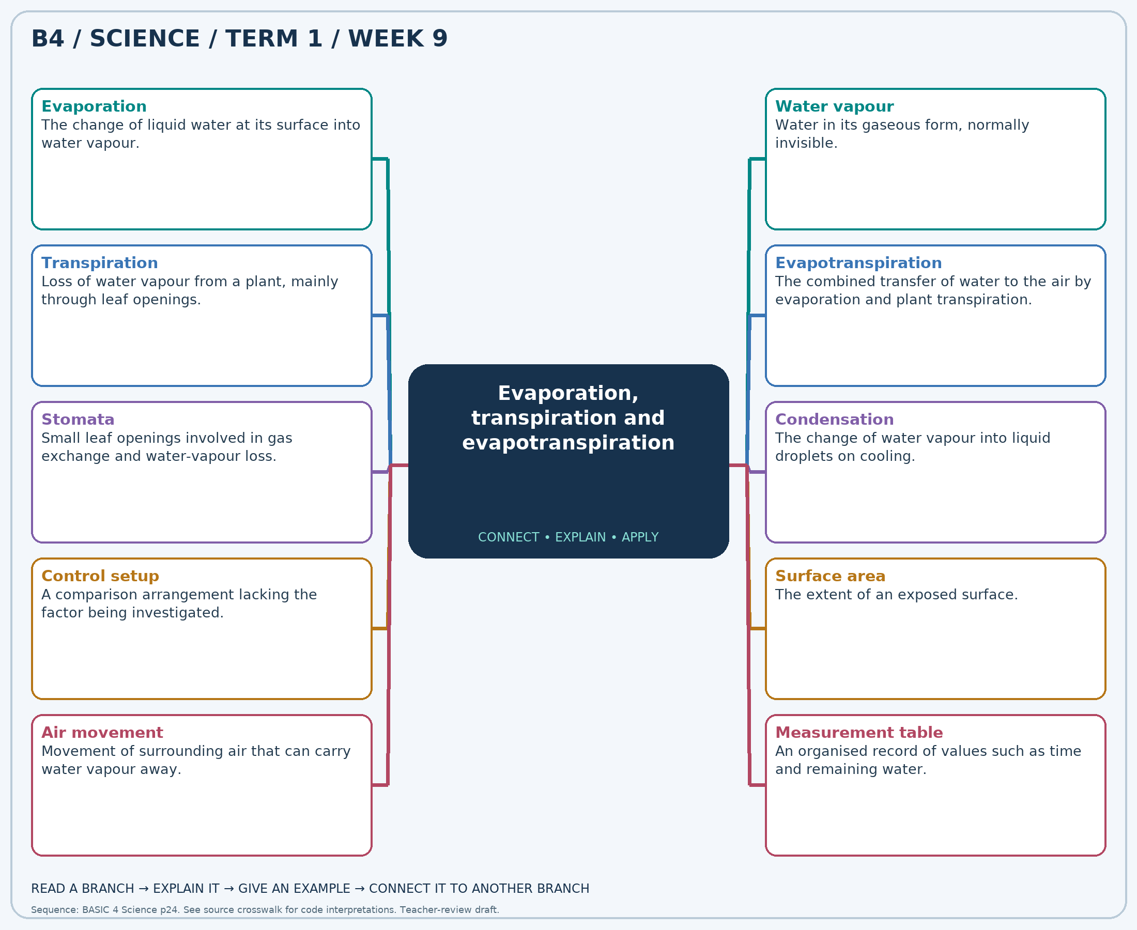
Read each branch, explain the link to the central topic, and add your own example. The separate high-resolution PNG supports projection or larger printing. Concept-map connections do not imply every process occurs in a single linear order.

Week 9 — Practice and assessment

Section A — Multiple-choice questions
Choose ONE correct answer for each question. Each question has four alternatives.
1. Which term best matches this description: the change of liquid water at its surface into water vapour?
A. Rusting B. Evaporation C. Freezing D. Germination
2. Which term best matches this description: water in its gaseous form, normally invisible?
A. Visible sand B. Water vapour C. Dry salt D. Solid ice
3. Which term best matches this description: loss of water vapour from a plant, mainly through leaf openings?
A. Transpiration B. Freezing C. Seed dispersal D. Pollination
4. Which term best matches this description: the combined transfer of water to the air by evaporation and plant transpiration?
A. Freezing only B. Condensation only C. Precipitation only D. Evapotranspiration
5. Which term best matches this description: small leaf openings involved in gas exchange and water-vapour loss?
A. Petals only B. Seed coats only C. Large woody thorns D. Stomata
6. Which term best matches this description: the change of water vapour into liquid droplets on cooling?
A. Melting B. Burning C. Condensation D. Seed formation
7. Which term best matches this description: a comparison arrangement lacking the factor being investigated?
A. A result to ignore B. A second plant specimen C. A fertilizer D. Control setup
8. Which term best matches this description: the extent of an exposed surface?
A. Water’s chemical identity B. Surface area C. Amount of salt necessarily D. Air’s mass necessarily
9. Which term best matches this description: movement of surrounding air that can carry water vapour away?
A. Absence of all water B. A change into rock C. No evaporation D. Air movement
10. Which term best matches this description: an organised record of values such as time and remaining water?
A. A drawing without labels B. Measurement table C. A guess written only at the end D. An unrelated shopping list
11. A shallow puddle becomes smaller on a dry afternoon without soaking into the ground. Which process can explain the loss?
A. Evaporation B. Freezing C. Germination D. Rusting
12. What form of water enters the air during evaporation?
A. Dry salt B. Visible sand C. Water vapour D. Solid ice
13. A leafy shoot releases water to the air. Which plant process is involved?
A. Pollination B. Transpiration C. Freezing D. Seed dispersal
14. A field loses water from soil surfaces and from leaves. What combined term covers both?
A. Evapotranspiration B. Condensation only C. Freezing only D. Precipitation only
15. Through which leaf structures does much transpiration occur?
A. Petals only B. Stomata C. Large woody thorns D. Seed coats only
16. Droplets appear inside a bag around a leafy shoot. Which change produces the visible drops?
A. Condensation B. Melting C. Burning D. Seed formation
17. An empty bag is kept beside a bag with leaves under similar conditions. What role does the empty bag serve?
A. Control setup B. A fertilizer C. A result to ignore D. A second plant specimen
18. The same volume of water dries faster in a wide shallow dish than a narrow cup under similar conditions. Which feature is greater in the dish?
A. Water’s chemical identity B. Amount of salt necessarily C. Surface area D. Air’s mass necessarily
19. A wet cloth often dries faster in a breeze than in still air. Which factor helps explain it?
A. No evaporation B. A change into rock C. Air movement D. Absence of all water
20. A learner records water level every hour using the same method. What helps organise the evidence?
A. A guess written only at the end B. Measurement table C. An unrelated shopping list D. A drawing without labels

Section B — 10 structured essay questions
Answer all parts (a), (b), (c). Write in a separate exercise book. Suggested marks per question: (a) 1, (b) 1, (c) 2, total 4. Use accurate terms and explain relationships or evidence where asked.

Question 1
(a) Explain the term “Evaporation”.
(b) A shallow puddle becomes smaller on a dry afternoon without soaking into the ground. Which process can explain the loss?
(c) Explain why a puddle can dry without boiling.

Question 2
(a) Explain the term “Water vapour”.
(b) What form of water enters the air during evaporation?
(c) Distinguish invisible water vapour from visible mist.

Question 3
(a) Explain the term “Transpiration”.
(b) A leafy shoot releases water to the air. Which plant process is involved?
(c) Explain how water from roots can eventually reach the air.

Question 4
(a) Explain the term “Evapotranspiration”.
(b) A field loses water from soil surfaces and from leaves. What combined term covers both?
(c) Distinguish the two processes included in this term.

Question 5
(a) Explain the term “Stomata”.
(b) Through which leaf structures does much transpiration occur?
(c) Explain why leaf openings matter for both gas exchange and water loss.

Question 6
(a) Explain the term “Condensation”.
(b) Droplets appear inside a bag around a leafy shoot. Which change produces the visible drops?
(c) Explain why droplets rather than invisible vapour are seen inside the bag.

Question 7
(a) Explain the term “Control setup”.
(b) An empty bag is kept beside a bag with leaves under similar conditions. What role does the empty bag serve?
(c) Explain why the empty bag improves the plant-water investigation.

Question 8
(a) Explain the term “Surface area”.
(b) The same volume of water dries faster in a wide shallow dish than a narrow cup under similar conditions. Which feature is greater in the dish?
(c) Explain why equal starting volumes are needed when comparing the containers.

Question 9
(a) Explain the term “Air movement”.
(b) A wet cloth often dries faster in a breeze than in still air. Which factor helps explain it?
(c) Explain why a breeze can speed drying without heating water to boiling.

Question 10
(a) Explain the term “Measurement table”.
(b) A learner records water level every hour using the same method. What helps organise the evidence?
(c) Name two headings needed for a useful water-loss record.

Week 10 — Making water safer and preventing recontamination
Scheme reference: B4.2.1.1.4. Reference used: B4.2.1.5.1. Source suffix is absent locally; safe-water description B4.2.1.5.1 supplies this Earth Science lesson. This is education, not a guarantee that a classroom treatment produces potable water.

Learning outcomes
- Explain the main ideas in making water safer and preventing recontamination using accurate vocabulary.
- Use observations or models to identify examples and justify explanations.
- Apply the ideas to a familiar situation, recognise a misconception and state relevant safety precautions.

Teacher lesson notes
Suggested weekly structure: three 40-minute teaching sessions, plus distributed practice and feedback in remaining timetable periods. Adjust to actual lesson periods. The full question bank should not be imposed as one 40-minute task.
Prior-knowledge check: ask learners for a familiar example related to the week. Record what they think happens and why. Retain one initial claim to revisit after the activity.

Session 1 — Observe and define
5 min: retrieve related knowledge; 10 min: show a model, picture or safe specimen; 15 min: pairs record observations and discuss the first five terms; 10 min: check explanations with short oral questions.

Session 2 — Investigate and explain
5 min: recall vocabulary; 10 min: model a justified explanation; 15 min: carry out the specific activity below, recording real observations; 10 min: introduce the remaining terms and compare evidence.

Session 3 — Apply and assess
5 min: revisit an initial misconception; 10 min: explain the map connections; 15 min: attempt selected application questions and structured parts; 10 min: review explanations and plan reteaching or extension.

Topic-specific activity and resources
Use drawings to order settling, appropriate filtration, approved disinfection and clean storage. Demonstrate only removal of visible particles using a teacher-prepared model, clearly labelled NOT FOR DRINKING. Compare pictures of safe and unsafe storage practices.
Resources: the teacher-selected examples, pictures or apparatus described above; board, pencils, exercise books and the supplied map. If a practical cannot be completed, use a clearly labelled photograph or model and do not report predicted results as observed results.

Safety
Do not drink demonstration water. Heating and any disinfectant handling are adult-only. Follow local public-health guidance and product instructions; no chemical doses are supplied here.

Support, extension and feedback
Support: provide picture labels and a word bank, read unfamiliar words aloud, and let learners explain orally before writing. Extension: compare two related concepts, suggest a counterexample or critique a model. Feedback: ask why a distractor is wrong and use the answer to identify the misconception.

Study notes

Potable water
Water considered suitable for drinking under applicable safety guidance.
Safety includes more than appearance. Harmful microbes or chemicals can be invisible, so a trusted safe supply or approved treatment is needed.

Contamination
Introduction of harmful or unwanted substances into water.
Microbes or dirt can enter a previously safe supply. Preventing contamination after treatment is as important as the treatment step.

Sedimentation
Allowing suspended particles to settle under gravity.
Settling can remove some visible particles from the upper water but does not reliably remove dissolved chemicals or all microbes.

Filtration
Passing a mixture through a barrier that retains selected particles.
Simple filters may remove visible particles without removing pathogens or dissolved pollutants. Demonstration filtrate must not be treated as safe drinking water.

Boiling
Heating water until it boils, used under suitable guidance to inactivate many pathogens.
Proper boiling addresses many microbes, but it does not reliably remove harmful dissolved chemicals. Cooling and storage must avoid recontamination.

Disinfection
A treatment intended to inactivate harmful microorganisms.
The method must suit the contamination and be correctly applied. A disinfectant is not a universal remover of all chemical pollutants.

Covered storage
Keeping water in a clean container protected by an appropriate lid.
A lid limits entry of dirt, insects and hands, but the container itself must also be clean. A dirty lid or vessel can still contaminate water.

Clean dispensing
Removing water without dipping dirty hands or utensils into the supply.
Avoiding contact with the stored water reduces transfer of microbes. A clean serving cup still matters after dispensing.

Protected source
A water source managed to reduce entry of waste and pollutants.
Prevention reduces contamination before collection. It does not remove the need for monitoring or correct treatment when required.

Hygiene
Practices that reduce transfer of dirt and disease-causing organisms.
Clean hands and utensils reduce contamination during collection, storage and serving. Multiple barriers work together rather than relying on one step alone.
Independent study: reconstruct the map from memory, give a fresh example for three branches and answer one explanation question without copying the notes. Correct errors after discussing the reason with a teacher or partner.

Week 10 — Visual mind-map
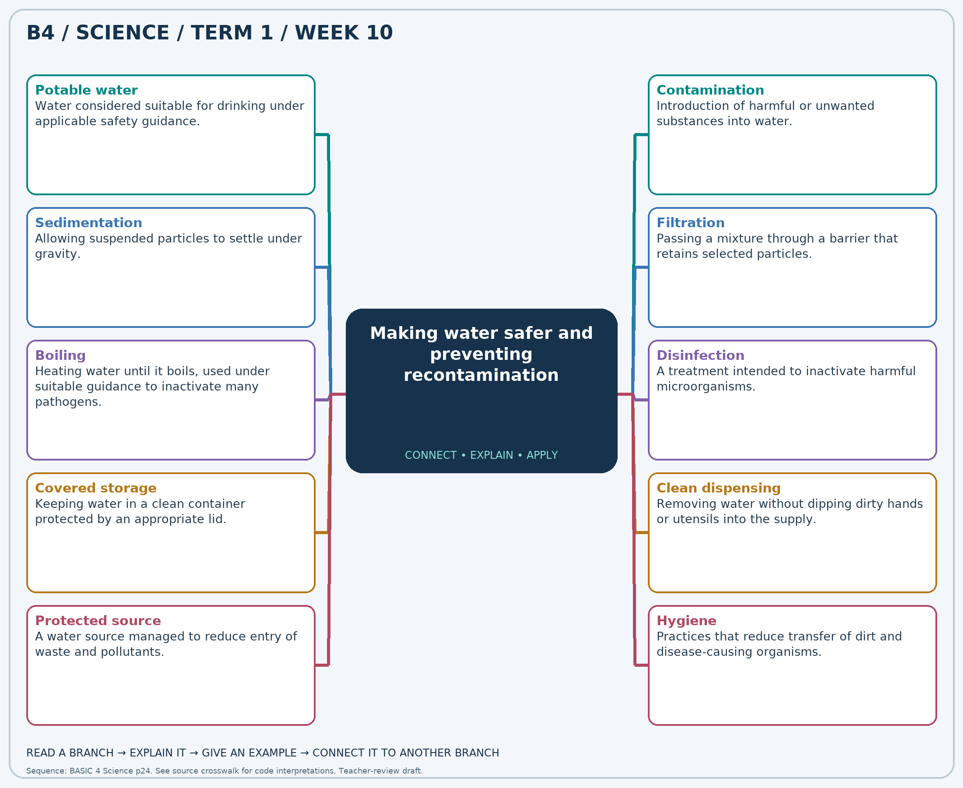
Read each branch, explain the link to the central topic, and add your own example. The separate high-resolution PNG supports projection or larger printing. Concept-map connections do not imply every process occurs in a single linear order.

Week 10 — Practice and assessment

Section A — Multiple-choice questions
Choose ONE correct answer for each question. Each question has four alternatives.
1. Which term best matches this description: water considered suitable for drinking under applicable safety guidance?
A. Potable water B. Any transparent liquid C. Muddy water D. Salt water automatically
2. Which term best matches this description: introduction of harmful or unwanted substances into water?
A. Photosynthesis B. Purification C. Germination D. Contamination
3. Which term best matches this description: allowing suspended particles to settle under gravity?
A. Melting B. Sedimentation C. Boiling D. Transpiration
4. Which term best matches this description: passing a mixture through a barrier that retains selected particles?
A. Evaporation B. Burning C. Filtration D. Pollination
5. Which term best matches this description: heating water until it boils, used under suitable guidance to inactivate many pathogens?
A. Stirring with a dirty stick B. Leaving it uncovered C. Boiling D. Adding sand
6. Which term best matches this description: a treatment intended to inactivate harmful microorganisms?
A. Increasing sediment B. Disinfection C. Adding dirt D. Making water colourful
7. Which term best matches this description: keeping water in a clean container protected by an appropriate lid?
A. Covered storage B. Chemical mixing by pupils C. Waste dumping D. Open exposure
8. Which term best matches this description: removing water without dipping dirty hands or utensils into the supply?
A. Open dumping B. Clean dispensing C. Soil mixing D. Using unwashed cups inside storage
9. Which term best matches this description: a water source managed to reduce entry of waste and pollutants?
A. A seedbed B. A source left open to rubbish C. Protected source D. An evaporation experiment
10. Which term best matches this description: practices that reduce transfer of dirt and disease-causing organisms?
A. Rusting B. Hygiene C. Weather forecasting D. Seed dispersal
11. Which term describes water suitable for drinking, not merely water that looks clear?
A. Potable water B. Any transparent liquid C. Muddy water D. Salt water automatically
12. Dirty hands touch the inside of a drinking-water container. What risk is introduced?
A. Purification B. Germination C. Contamination D. Photosynthesis
13. Muddy water is left still so heavier particles collect at the bottom. Which process occurs?
A. Melting B. Transpiration C. Sedimentation D. Boiling
14. A classroom filter catches visible sand while water passes through. Which method is demonstrated?
A. Burning B. Filtration C. Pollination D. Evaporation
15. Which heat-based method can help disinfect microbiologically unsafe water when properly carried out by an adult?
A. Adding sand B. Boiling C. Leaving it uncovered D. Stirring with a dirty stick
16. An approved treatment is used according to official instructions to reduce disease-causing microbes. What is its purpose called?
A. Adding dirt B. Making water colourful C. Disinfection D. Increasing sediment
17. A clean drinking-water vessel is closed after filling. Which protection practice is used?
A. Chemical mixing by pupils B. Open exposure C. Covered storage D. Waste dumping
18. A household pours water or uses a clean tap rather than reaching into the vessel. Which practice reduces contamination?
A. Soil mixing B. Using unwashed cups inside storage C. Open dumping D. Clean dispensing
19. A community prevents waste dumping near its water supply. What type of protection is strengthened?
A. A source left open to rubbish B. An evaporation experiment C. Protected source D. A seedbed
20. Hands are washed before handling clean water containers. Which broad practice is demonstrated?
A. Hygiene B. Rusting C. Seed dispersal D. Weather forecasting

Section B — 10 structured essay questions
Answer all parts (a), (b), (c). Write in a separate exercise book. Suggested marks per question: (a) 1, (b) 1, (c) 2, total 4. Use accurate terms and explain relationships or evidence where asked.

Question 1
(a) Explain the term “Potable water”.
(b) Which term describes water suitable for drinking, not merely water that looks clear?
(c) Explain why clear water is not automatically suitable for drinking.

Question 2
(a) Explain the term “Contamination”.
(b) Dirty hands touch the inside of a drinking-water container. What risk is introduced?
(c) Explain how treated water can become unsafe again.

Question 3
(a) Explain the term “Sedimentation”.
(b) Muddy water is left still so heavier particles collect at the bottom. Which process occurs?
(c) State one benefit and one limitation of allowing muddy water to stand.

Question 4
(a) Explain the term “Filtration”.
(b) A classroom filter catches visible sand while water passes through. Which method is demonstrated?
(c) Explain why filtered classroom water must not be drunk.

Question 5
(a) Explain the term “Boiling”.
(b) Which heat-based method can help disinfect microbiologically unsafe water when properly carried out by an adult?
(c) Explain one limitation of boiling as a water-safety method.

Question 6
(a) Explain the term “Disinfection”.
(b) An approved treatment is used according to official instructions to reduce disease-causing microbes. What is its purpose called?
(c) Explain why treatment choice must depend on the type of contamination.

Question 7
(a) Explain the term “Covered storage”.
(b) A clean drinking-water vessel is closed after filling. Which protection practice is used?
(c) Explain why both a clean container and a cover matter.

Question 8
(a) Explain the term “Clean dispensing”.
(b) A household pours water or uses a clean tap rather than reaching into the vessel. Which practice reduces contamination?
(c) Explain how dipping a dirty cup can affect the entire stored supply.

Question 9
(a) Explain the term “Protected source”.
(b) A community prevents waste dumping near its water supply. What type of protection is strengthened?
(c) Explain why prevention near a source can help the whole community.

Question 10
(a) Explain the term “Hygiene”.
(b) Hands are washed before handling clean water containers. Which broad practice is demonstrated?
(c) Name two hygiene practices that protect drinking water.

Week 11 — Plant parts and their functions
Scheme reference: B4.2.2.1.1. Reference used: B4.2.2.1.1. Direct indicator match; function vocabulary supports observation and labelling.

Learning outcomes
- Explain the main ideas in plant parts and their functions using accurate vocabulary.
- Use observations or models to identify examples and justify explanations.
- Apply the ideas to a familiar situation, recognise a misconception and state relevant safety precautions.

Teacher lesson notes
Suggested weekly structure: three 40-minute teaching sessions, plus distributed practice and feedback in remaining timetable periods. Adjust to actual lesson periods. The full question bank should not be imposed as one 40-minute task.
Prior-knowledge check: ask learners for a familiar example related to the week. Record what they think happens and why. Retain one initial claim to revisit after the activity.

Session 1 — Observe and define
5 min: retrieve related knowledge; 10 min: show a model, picture or safe specimen; 15 min: pairs record observations and discuss the first five terms; 10 min: check explanations with short oral questions.

Session 2 — Investigate and explain
5 min: recall vocabulary; 10 min: model a justified explanation; 15 min: carry out the specific activity below, recording real observations; 10 min: introduce the remaining terms and compare evidence.

Session 3 — Apply and assess
5 min: revisit an initial misconception; 10 min: explain the map connections; 15 min: attempt selected application questions and structured parts; 10 min: review explanations and plan reteaching or extension.

Topic-specific activity and resources
Observe a familiar plant or a clear labelled drawing. Trace water from soil through roots and stem to leaves. Match root, stem, leaf, flower, fruit and seed to functions, and produce a labelled diagram with arrows that end on the correct part.
Resources: the teacher-selected examples, pictures or apparatus described above; board, pencils, exercise books and the supplied map. If a practical cannot be completed, use a clearly labelled photograph or model and do not report predicted results as observed results.

Safety
Do not taste plant parts or damage protected plants. Avoid thorns and irritant sap; wash hands after soil contact.

Support, extension and feedback
Support: provide picture labels and a word bank, read unfamiliar words aloud, and let learners explain orally before writing. Extension: compare two related concepts, suggest a counterexample or critique a model. Feedback: ask why a distractor is wrong and use the answer to identify the misconception.

Study notes

Root
A plant part commonly anchoring the plant and absorbing water and dissolved minerals.
Roots hold the plant and absorb water and minerals. They do not normally absorb prepared sugary food directly from soil.

Stem
A supporting plant part containing transport pathways between roots and leaves.
Support positions leaves for light, and internal pathways transport materials. The stem is not merely a solid stick with no internal functions.

Leaf
A plant organ commonly specialised for making food in light.
Many leaves receive light and exchange gases. Green tissues use light energy to make sugars from water and carbon dioxide.

Flower
A reproductive structure of a flowering plant.
Flowers support reproduction, not just decoration. After pollination and fertilisation, seeds may develop and parts of the flower may form fruit.

Fruit
A structure commonly developing from a flower’s ovary and containing or protecting seeds.
Fruits protect seeds and can help dispersal. Not all fruits are sweet or eaten by people.

Seed
A structure containing a young plant and resources or tissues supporting its early development.
A viable seed contains a living embryo. Water, oxygen and suitable temperature support germination, but a damaged or dead seed may not grow.

Seed coat
The outer protective covering of a seed.
The covering provides protection. Water uptake and growth lead to changes that allow the emerging root to break through it.

Photosynthesis
The process in which green tissues use light to make sugars from water and carbon dioxide.
Light supplies energy; water and carbon dioxide supply materials. The plant is not eating soil in the way an animal eats food.

Pollination
Transfer of pollen to a flower’s stigma.
Pollen transfer is part of reproduction. It is not identical to fertilisation, which is a later biological event when successful reproduction proceeds.

Transport
Movement of water and other materials between plant parts.
Materials move between organs that perform different jobs. Damage to important transport pathways can affect distant parts of a plant.
Independent study: reconstruct the map from memory, give a fresh example for three branches and answer one explanation question without copying the notes. Correct errors after discussing the reason with a teacher or partner.

Week 11 — Visual mind-map
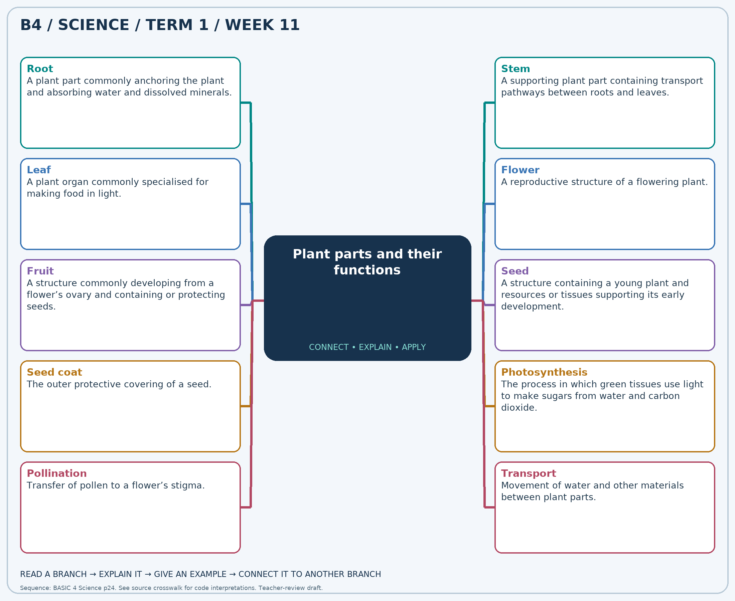
Read each branch, explain the link to the central topic, and add your own example. The separate high-resolution PNG supports projection or larger printing. Concept-map connections do not imply every process occurs in a single linear order.

Week 11 — Practice and assessment

Section A — Multiple-choice questions
Choose ONE correct answer for each question. Each question has four alternatives.
1. Which term best matches this description: a plant part commonly anchoring the plant and absorbing water and dissolved minerals?
A. Pollen grain B. Root C. Petal D. Fruit skin
2. Which term best matches this description: a supporting plant part containing transport pathways between roots and leaves?
A. Pollen only B. Seed coat only C. Fruit pulp only D. Stem
3. Which term best matches this description: a plant organ commonly specialised for making food in light?
A. Flower stalk only B. Root hair C. Seed coat D. Leaf
4. Which term best matches this description: a reproductive structure of a flowering plant?
A. Tree bark only B. Absorbing root tip C. Flower D. Root hair
5. Which term best matches this description: a structure commonly developing from a flower’s ovary and containing or protecting seeds?
A. Stem node only B. Leaf blade C. Fruit D. Root hair
6. Which term best matches this description: a structure containing a young plant and resources or tissues supporting its early development?
A. A glass bead B. Seed C. A plastic button D. A clean stone
7. Which term best matches this description: the outer protective covering of a seed?
A. Pollen tube B. Petal C. Leaf stalk D. Seed coat
8. Which term best matches this description: the process in which green tissues use light to make sugars from water and carbon dioxide?
A. Rusting B. Digestion in a stomach C. Photosynthesis D. Sedimentation
9. Which term best matches this description: transfer of pollen to a flower’s stigma?
A. Germination B. Root absorption C. Evaporation D. Pollination
10. Which term best matches this description: movement of water and other materials between plant parts?
A. Only seed protection B. Transport C. Only shading D. Only reproduction
11. Which part usually takes water from the soil into a plant?
A. Fruit skin B. Pollen grain C. Petal D. Root
12. Which part holds leaves up and links them with the roots?
A. Seed coat only B. Stem C. Fruit pulp only D. Pollen only
13. Which green part is usually a major site of photosynthesis?
A. Leaf B. Seed coat C. Flower stalk only D. Root hair
14. Which part may produce pollen and later give rise to seeds after reproductive processes?
A. Root hair B. Tree bark only C. Flower D. Absorbing root tip
15. A mango surrounds a seed with fleshy tissue. Which structure is the mango as a whole?
A. Leaf blade B. Root hair C. Stem node only D. Fruit
16. What can grow into a new plant when suitable germination conditions are present?
A. A clean stone B. Seed C. A glass bead D. A plastic button
17. Which part protects the young plant inside a bean seed?
A. Leaf stalk B. Seed coat C. Pollen tube D. Petal
18. A green leaf uses sunlight to make food. Which process is this?
A. Digestion in a stomach B. Rusting C. Photosynthesis D. Sedimentation
19. An insect carries pollen from one flower to a suitable stigma. Which process occurs?
A. Root absorption B. Pollination C. Germination D. Evaporation
20. Water taken up by roots reaches leaves through internal pathways. Which function is shown?
A. Only shading B. Only reproduction C. Transport D. Only seed protection

Section B — 10 structured essay questions
Answer all parts (a), (b), (c). Write in a separate exercise book. Suggested marks per question: (a) 1, (b) 1, (c) 2, total 4. Use accurate terms and explain relationships or evidence where asked.

Question 1
(a) Explain the term “Root”.
(b) Which part usually takes water from the soil into a plant?
(c) State two important functions of roots.

Question 2
(a) Explain the term “Stem”.
(b) Which part holds leaves up and links them with the roots?
(c) Explain how support and transport both help the plant.

Question 3
(a) Explain the term “Leaf”.
(b) Which green part is usually a major site of photosynthesis?
(c) Explain why leaves are often positioned where they can receive light.

Question 4
(a) Explain the term “Flower”.
(b) Which part may produce pollen and later give rise to seeds after reproductive processes?
(c) Explain why a flower is more than a colourful decoration.

Question 5
(a) Explain the term “Fruit”.
(b) A mango surrounds a seed with fleshy tissue. Which structure is the mango as a whole?
(c) State two ways a fruit can help the next generation of plants.

Question 6
(a) Explain the term “Seed”.
(b) What can grow into a new plant when suitable germination conditions are present?
(c) Explain why not every seed necessarily germinates.

Question 7
(a) Explain the term “Seed coat”.
(b) Which part protects the young plant inside a bean seed?
(c) Explain why a protective covering must still permit germination under suitable conditions.

Question 8
(a) Explain the term “Photosynthesis”.
(b) A green leaf uses sunlight to make food. Which process is this?
(c) Distinguish the source of energy from the materials used to make plant food.

Question 9
(a) Explain the term “Pollination”.
(b) An insect carries pollen from one flower to a suitable stigma. Which process occurs?
(c) Explain why pollination and seed germination are different processes.

Question 10
(a) Explain the term “Transport”.
(b) Water taken up by roots reaches leaves through internal pathways. Which function is shown?
(c) Explain why harm to a stem can affect leaves above it.

Week 12 — Seeds and germination
Scheme reference: B4.2.2.1.2. Reference used: B4.2.2.1.2. Direct indicator match. Germination conditions are distinguished from the later needs of an established green seedling.

Learning outcomes
- Explain the main ideas in seeds and germination using accurate vocabulary.
- Use observations or models to identify examples and justify explanations.
- Apply the ideas to a familiar situation, recognise a misconception and state relevant safety precautions.

Teacher lesson notes
Suggested weekly structure: three 40-minute teaching sessions, plus distributed practice and feedback in remaining timetable periods. Adjust to actual lesson periods. The full question bank should not be imposed as one 40-minute task.
Prior-knowledge check: ask learners for a familiar example related to the week. Record what they think happens and why. Retain one initial claim to revisit after the activity.

Session 1 — Observe and define
5 min: retrieve related knowledge; 10 min: show a model, picture or safe specimen; 15 min: pairs record observations and discuss the first five terms; 10 min: check explanations with short oral questions.

Session 2 — Investigate and explain
5 min: recall vocabulary; 10 min: model a justified explanation; 15 min: carry out the specific activity below, recording real observations; 10 min: introduce the remaining terms and compare evidence.

Session 3 — Apply and assess
5 min: revisit an initial misconception; 10 min: explain the map connections; 15 min: attempt selected application questions and structured parts; 10 min: review explanations and plan reteaching or extension.

Topic-specific activity and resources
Place viable bean seeds on moist paper in a labelled transparent container with access to air. Compare with a dry-paper control under similar warmth. Record daily changes, sketch the first root and shoot, and stop if mould develops. Keep a simple time-and-observation table.
Resources: the teacher-selected examples, pictures or apparatus described above; board, pencils, exercise books and the supplied map. If a practical cannot be completed, use a clearly labelled photograph or model and do not report predicted results as observed results.

Safety
Do not eat experimental seeds. Avoid mould contact and overwatering; wash hands after handling materials. Use clean containers and teacher supervision.

Support, extension and feedback
Support: provide picture labels and a word bank, read unfamiliar words aloud, and let learners explain orally before writing. Extension: compare two related concepts, suggest a counterexample or critique a model. Feedback: ask why a distractor is wrong and use the answer to identify the misconception.

Study notes

Germination
The beginning of growth of a seed’s embryo under suitable conditions.
A viable embryo resumes growth. This is different from producing the seed inside a flower and fruit.

Embryo
The young plant inside a seed.
The embryo contains the beginnings of root and shoot. A viable embryo, not simply a seed-shaped object, is needed for growth.

Seed coat
The protective outer covering of a seed.
The covering protects the contents, but swelling and growing tissues can break through it. Splitting alone without continued growth is not complete evidence of healthy germination.

Radicle
The young root that commonly emerges first during germination.
The emerging root helps establish absorption and anchorage. Its function differs from the shoot that later carries leaves.

Plumule
The young shoot of the embryo.
The shoot supports future leaves and access to light. Roots and shoots develop different structures suited to different jobs.

Cotyledon
A seed leaf that may store food or help transfer stored food to the embryo.
Stored food supports growth before the seedling makes enough food by photosynthesis. Cotyledon roles vary among different seeds.

Moisture
Water available to the seed without completely excluding air.
Water uptake activates growth processes. Excess water can exclude oxygen, so damp conditions are not the same as submerging every seed.

Oxygen
A gas needed for respiration by a germinating seed.
Respiration supplies energy for growth. Waterlogged conditions may reduce gas availability even when plenty of water is present.

Suitable temperature
A range of warmth allowing germination processes to proceed normally.
Growth processes depend on temperature; extremely hot or cold conditions may prevent germination. The suitable range depends on the species.

Control
A comparison setup used to help test the role of one factor.
The comparison helps isolate the effect of moisture. Several seeds in each condition reduce the risk of drawing conclusions from one unusual seed.
Independent study: reconstruct the map from memory, give a fresh example for three branches and answer one explanation question without copying the notes. Correct errors after discussing the reason with a teacher or partner.

Week 12 — Visual mind-map
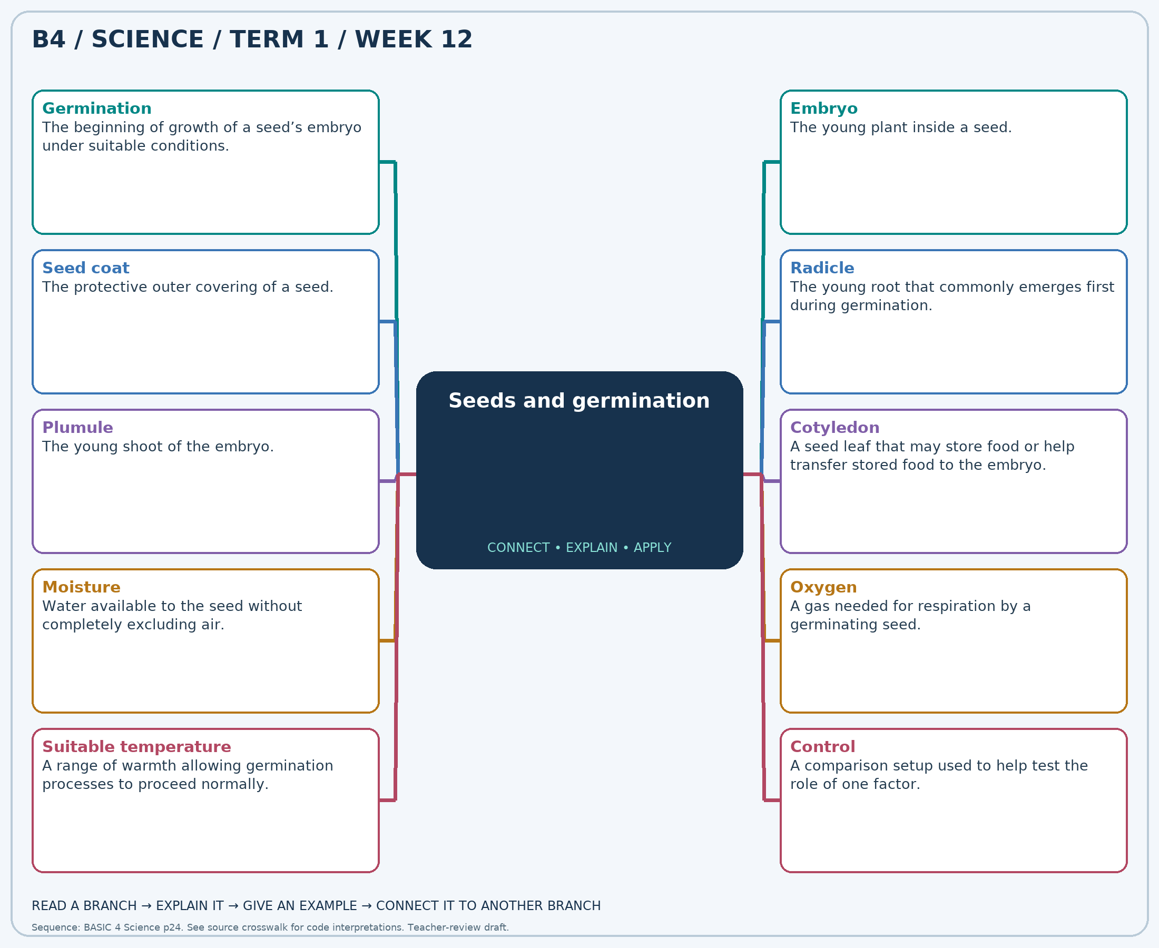
Read each branch, explain the link to the central topic, and add your own example. The separate high-resolution PNG supports projection or larger printing. Concept-map connections do not imply every process occurs in a single linear order.

Week 12 — Practice and assessment

Section A — Multiple-choice questions
Choose ONE correct answer for each question. Each question has four alternatives.
1. Which term best matches this description: the beginning of growth of a seed’s embryo under suitable conditions?
A. Rusting B. Pollination C. Germination D. Condensation
2. Which term best matches this description: the young plant inside a seed?
A. Embryo B. Seed jar C. Soil pebble D. Plastic label
3. Which term best matches this description: the protective outer covering of a seed?
A. Stem bark B. Leaf vein C. Petal D. Seed coat
4. Which term best matches this description: the young root that commonly emerges first during germination?
A. Fruit B. Pollen grain C. Radicle D. Petal
5. Which term best matches this description: the young shoot of the embryo?
A. Plumule B. Root hair only C. Soil grain D. Seed jar
6. Which term best matches this description: a seed leaf that may store food or help transfer stored food to the embryo?
A. Root hairs B. Cloud droplets C. Petals D. Cotyledon
7. Which term best matches this description: water available to the seed without completely excluding air?
A. Paint B. Petrol C. Dry sand only D. Moisture
8. Which term best matches this description: a gas needed for respiration by a germinating seed?
A. Smoke only B. Carbon monoxide C. Oxygen D. Helium
9. Which term best matches this description: a range of warmth allowing germination processes to proceed normally?
A. The name of the seed B. The colour of the label C. Suitable temperature D. The number of jar sides
10. Which term best matches this description: a comparison setup used to help test the role of one factor?
A. Control B. A guaranteed best treatment C. A plant flower D. A food supply
11. A bean seed swells, splits its coat and produces a young root. What process is beginning?
A. Condensation B. Rusting C. Pollination D. Germination
12. Which living structure develops into the seedling?
A. Soil pebble B. Embryo C. Plastic label D. Seed jar
13. Which covering often splits when a soaked viable bean begins to grow?
A. Petal B. Leaf vein C. Seed coat D. Stem bark
14. A small root appears from the seed before the shoot is visible. What is it called?
A. Fruit B. Radicle C. Pollen grain D. Petal
15. Which developing structure grows upward and gives rise to shoot tissues and leaves?
A. Root hair only B. Plumule C. Seed jar D. Soil grain
16. The fleshy seed leaves of a bean supply food during early growth. What are they called?
A. Cloud droplets B. Cotyledon C. Root hairs D. Petals
17. Moist paper supports germination better than dry paper for otherwise similar viable beans. Which need is supplied?
A. Moisture B. Paint C. Dry sand only D. Petrol
18. Which gas must be available so a germinating seed can release energy from stored food?
A. Oxygen B. Helium C. Carbon monoxide D. Smoke only
19. Two moist seeds grow differently in very cold and moderately warm conditions. Which environmental factor differs?
A. The number of jar sides B. The colour of the label C. Suitable temperature D. The name of the seed
20. Dry paper is compared with moist paper while seed type and warmth are kept the same. What is the dry setup’s role?
A. A food supply B. A guaranteed best treatment C. Control D. A plant flower

Section B — 10 structured essay questions
Answer all parts (a), (b), (c). Write in a separate exercise book. Suggested marks per question: (a) 1, (b) 1, (c) 2, total 4. Use accurate terms and explain relationships or evidence where asked.

Question 1
(a) Explain the term “Germination”.
(b) A bean seed swells, splits its coat and produces a young root. What process is beginning?
(c) Distinguish germination from the earlier production of a seed.

Question 2
(a) Explain the term “Embryo”.
(b) Which living structure develops into the seedling?
(c) Explain why a glass bead cannot germinate even if it receives water.

Question 3
(a) Explain the term “Seed coat”.
(b) Which covering often splits when a soaked viable bean begins to grow?
(c) Explain why continued observations are needed after a seed coat splits.

Question 4
(a) Explain the term “Radicle”.
(b) A small root appears from the seed before the shoot is visible. What is it called?
(c) Explain why early root growth helps a new seedling.

Question 5
(a) Explain the term “Plumule”.
(b) Which developing structure grows upward and gives rise to shoot tissues and leaves?
(c) Compare the main roles of the young root and young shoot.

Question 6
(a) Explain the term “Cotyledon”.
(b) The fleshy seed leaves of a bean supply food during early growth. What are they called?
(c) Explain why a germinating seed can begin growing before it has large green leaves.

Question 7
(a) Explain the term “Moisture”.
(b) Moist paper supports germination better than dry paper for otherwise similar viable beans. Which need is supplied?
(c) Explain why both dryness and excessive water can prevent healthy germination.

Question 8
(a) Explain the term “Oxygen”.
(b) Which gas must be available so a germinating seed can release energy from stored food?
(c) Explain why a seed needs air as well as water.

Question 9
(a) Explain the term “Suitable temperature”.
(b) Two moist seeds grow differently in very cold and moderately warm conditions. Which environmental factor differs?
(c) Explain why “the hotter the better” is not a sound germination rule.

Question 10
(a) Explain the term “Control”.
(b) Dry paper is compared with moist paper while seed type and warmth are kept the same. What is the dry setup’s role?
(c) Explain why the same seed type and several seeds should be used in both setups.

