Basic 5 Science — Term 1
  - Weeks 1–12 • Weekly lesson notes, study notes, visual mind-maps and practice
Name: __________________________________ Class: __________
Date: __________________ Teacher: ________________________
BATCH 2 — COMPLETE WEEKLY SEQUENCE FOR THIS GRADE, TEACHER-REVIEW DRAFT. Week 1 is included from Batch 1 so this Science book is self-contained. This is not a claim of official curriculum approval or independent teacher certification.
Each teaching week contains one consolidated lesson unit, suggested teaching sessions, study notes, one visual mind-map, 20 four-option MCQs and 10 three-part structured questions. These are weekly units, not separate full daily lesson plans. Keep the separate teacher answer book away from pupil copies.
Source sequence: first-term-library/BASIC 5 SCHEME OF LEARNING.pdf, Science table page 26. Weeks 13–15 are reserved in this scheme for revision/examinations/vacation, so no new weekly content is added there. Mid-term assumes Weeks 1–6; end-of-term assumes Weeks 1–12. Confirm the school’s calendar.
Important: the B4 source contains several indicator mismatches. The crosswalk states the interpretation instead of silently claiming exact alignment. In particular, B4 Week 5 is an introductory materials-properties lesson inferred from its Materials block, not a verified B4 indicator. Obtain teacher confirmation before use. Supporting vocabulary sometimes extends beyond the wording of the indicator.

Weekly sequence and source crosswalk
Week / topic | Source reference → used reference | Editorial decision
1. Growth, sensitivity, respiration and excretion | B5.1.1.1.1 → B5.1.1.1.1 | Matches the supplied Week 1 indicator.
2. Living, dead and never-alive things | B5.1.1.2.1 → B5.1.1.2.1 | Direct indicator match; dormant seeds are distinguished from dead material.
3. Classifying materials and justifying their uses | B5.1.2.1.1 → B5.1.2.1.1 | Direct indicator match. Core property explanations and practice are shared with B4’s introductory editorial unit; B5 activity demands justified comparisons.
4. Reversible and irreversible changes | B5.1.2.2.1 → B5.1.2.2.1 | Direct indicator match. Reversibility is discussed under ordinary classroom conditions; not every irreversible change is chemical.
5. Forming and separating mixtures | B5.1.2.3.1 → B5.1.2.3.1 | Direct indicator match; separation is selected according to component properties.
6. How day and night are formed | B5.2.1.1.1 → B5.2.1.1.1 | Direct indicator match; model limitations are explicitly taught.
7. Benefits of the Sun to Earth | B5.2.1.2.1 → B5.2.1.2.1 | Direct indicator match; solar benefits are taught alongside safe exposure.
8. Evaporation, condensation and cloud formation | B5.2.1.3.1–2 → B5.2.1.3.1–2 | Direct indicator match; clouds are tiny droplets or ice crystals, not simply invisible water vapour.
9. Carbon dioxide: uses and effects | B5.2.1.4.1 → B5.2.1.4.1 | Direct indicator match; distinguish carbon dioxide from carbon monoxide and avoid unsafe gas demonstrations.
10. Protecting water and keeping air cleaner | B5.2.1.5.1–2 → B5.2.1.5.1–2 | Direct indicator match; community actions are taught without unsafe field sampling.
11. How plant structures suit their functions | B5.2.2.1.1 → B5.2.2.1.1 | Direct indicator match; this grade emphasises structure–function relationships rather than labels alone.
12. Comparing bean and maize germination | B5.2.2.1.2 → B5.2.2.1.2 | Direct indicator match. Common bean and maize observations are used without generalising to every bean species or every germination pattern.

Week 1 — Growth, sensitivity, respiration and excretion
Scheme reference: B5.1.1.1.1. Reference used: B5.1.1.1.1. Matches the supplied Week 1 indicator.

Learning outcomes
- Explain the main ideas in growth, sensitivity, respiration and excretion using accurate vocabulary.
- Use observations or models to identify examples and justify explanations.
- Apply the ideas to a familiar situation, recognise a misconception and state relevant safety precautions.

Teacher lesson notes
Suggested weekly structure: three 40-minute teaching sessions, plus distributed practice and feedback in remaining timetable periods. Adjust to actual lesson periods. The full question bank should not be imposed as one 40-minute task.
Prior-knowledge check: ask learners for a familiar example related to the week. Record what they think happens and why. Retain one initial claim to revisit after the activity.

Session 1 — Observe and define
5 min: retrieve related knowledge; 10 min: show a model, picture or safe specimen; 15 min: pairs record observations and discuss the first five terms; 10 min: check explanations with short oral questions.

Session 2 — Investigate and explain
5 min: recall vocabulary; 10 min: model a justified explanation; 15 min: carry out the specific activity below, recording real observations; 10 min: introduce the remaining terms and compare evidence.

Session 3 — Apply and assess
5 min: revisit an initial misconception; 10 min: explain the map connections; 15 min: attempt selected application questions and structured parts; 10 min: review explanations and plan reteaching or extension.

Topic-specific activity and resources
Record a seedling’s height and leaf number on several dates. Make a four-column table for growth, sensitivity, respiration and excretion. Separate what can be directly observed from what is explained using biological knowledge.
Resources: the teacher-selected examples, pictures or apparatus described above; board, pencils, exercise books and the supplied map. If a practical cannot be completed, use a clearly labelled photograph or model and do not report predicted results as observed results.

Safety
Use safe observation. No tasting unknown substances, prolonged breath-holding or contact with hot objects.

Support, extension and feedback
Support: provide picture labels and a word bank, read unfamiliar words aloud, and let learners explain orally before writing. Extension: compare two related concepts, suggest a counterexample or critique a model. Feedback: ask why a distractor is wrong and use the answer to identify the misconception.

Study notes

Growth
A lasting increase in an organism’s size and usually its dry mass.
Repeated measurements of the same plant support the conclusion. A brief change in water content alone is not enough to demonstrate lasting growth.

Sensitivity
The ability to detect and respond to changes in the surroundings.
Heat is the stimulus and withdrawing the hand is the response. The response protects the person from injury.

Respiration
Chemical processes in cells that release usable energy from food.
Cells require energy for movement, growth and repair, even when the person is not visibly active. Respiration is not simply moving air in and out.

Excretion
Removal of waste products made by the body’s chemical processes.
Carbon dioxide is a metabolic waste produced during aerobic respiration. Removing it is excretion, unlike removing undigested food by egestion.

Stimulus
A detectable change that can trigger a response.
The light is the change detected. Narrowing the eyes is the response, not the stimulus.

Response
A change in an organism’s activity caused by a detected stimulus.
The direction of light is the stimulus and bending growth is the response. Plants can respond slowly without walking.

Kidneys
Organs that remove urea and excess water from blood to form urine.
Kidneys form urine, whereas the bladder stores it before release. Both contribute to the urinary system but perform different jobs.

Carbon dioxide
A gaseous waste of aerobic respiration removed through human lungs.
Cells produce carbon dioxide; blood carries it to the lungs and breathing removes it. Oxygen is taken in for aerobic respiration rather than being its waste gas.

Breathing
Movement of air into and out of the lungs.
Breathing exchanges air. Cellular respiration releases energy chemically; breathing supports it by supplying oxygen and removing carbon dioxide.

Energy
The resource released from food during respiration that supports life activities.
Food contains chemical energy. Cells transfer some of this into useful forms to power their activities.
Independent study: reconstruct the map from memory, give a fresh example for three branches and answer one explanation question without copying the notes. Correct errors after discussing the reason with a teacher or partner.

Week 1 — Visual mind-map
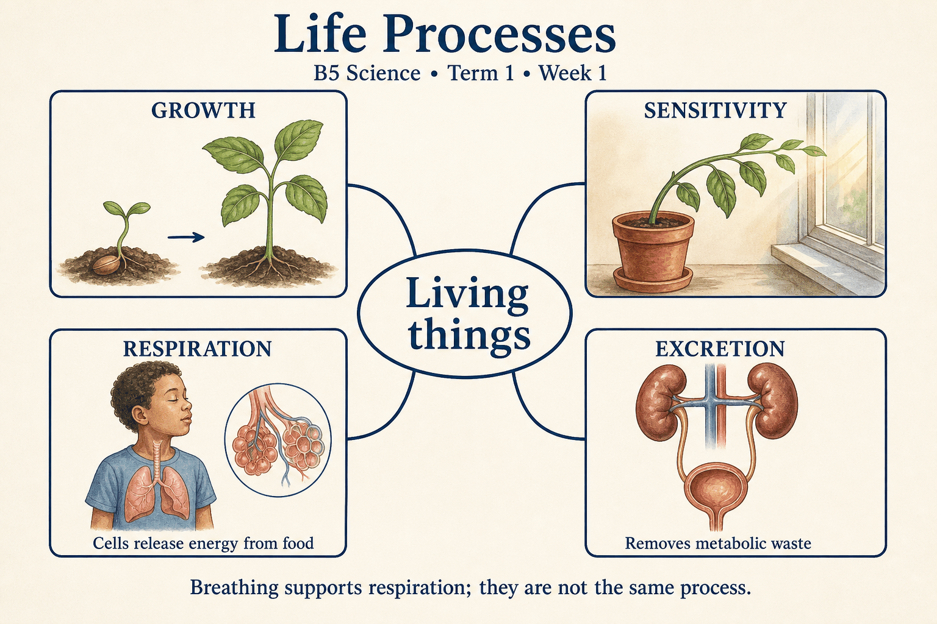
Read each branch, explain the link to the central topic, and add your own example. The separate high-resolution PNG supports projection or larger printing. Concept-map connections do not imply every process occurs in a single linear order.

Week 1 — Practice and assessment

Section A — Multiple-choice questions
Choose ONE correct answer for each question. Each question has four alternatives.
1. Which term best matches this description: a lasting increase in an organism’s size and usually its dry mass?
A. Sensitivity B. Excretion C. Respiration D. Growth
2. Which term best matches this description: the ability to detect and respond to changes in the surroundings?
A. Sensitivity B. Excretion C. Reproduction D. Growth
3. Which term best matches this description: chemical processes in cells that release usable energy from food?
A. Growth B. Excretion C. Respiration D. Pollination
4. Which term best matches this description: removal of waste products made by the body’s chemical processes?
A. Reproduction B. Nutrition C. Excretion D. Germination
5. Which term best matches this description: a detectable change that can trigger a response?
A. Nutrient B. Excretory organ C. Stimulus D. Response
6. Which term best matches this description: a change in an organism’s activity caused by a detected stimulus?
A. Response B. Organ C. Stimulus D. Waste product
7. Which term best matches this description: organs that remove urea and excess water from blood to form urine?
A. Stomach B. Lungs C. Heart D. Kidneys
8. Which term best matches this description: a gaseous waste of aerobic respiration removed through human lungs?
A. Oxygen B. Nitrogen only C. Helium D. Carbon dioxide
9. Which term best matches this description: movement of air into and out of the lungs?
A. Urine formation B. Cellular respiration C. Digestion D. Breathing
10. Which term best matches this description: the resource released from food during respiration that supports life activities?
A. Feathers B. Sunlight directly C. Energy D. Soil
11. A seedling becomes taller and develops more leaves over two weeks. Which life process is shown?
A. Excretion B. Sensitivity C. Growth D. Respiration
12. A person withdraws a hand from an uncomfortably hot surface. Which life process is shown?
A. Growth B. Excretion C. Reproduction D. Sensitivity
13. Muscle cells release energy from food while a child runs. Which process is involved?
A. Growth B. Respiration C. Excretion D. Pollination
14. The lungs remove carbon dioxide produced by cells. Which life process is this?
A. Excretion B. Nutrition C. Reproduction D. Germination
15. Bright light causes a person to narrow their eyes. What role does the bright light play?
A. Nutrient B. Stimulus C. Excretory organ D. Response
16. A plant shoot bends towards a light source. What is the bending in general biological terms?
A. Response B. Organ C. Waste product D. Stimulus
17. Which organs form urine rather than merely storing it?
A. Stomach B. Heart C. Kidneys D. Lungs
18. Which respiratory waste gas moves from the blood into the lungs to be breathed out?
A. Oxygen B. Helium C. Nitrogen only D. Carbon dioxide
19. The chest rises and falls as air moves in and out. Which process can be observed?
A. Cellular respiration B. Digestion C. Urine formation D. Breathing
20. What does respiration supply for movement, growth and repair?
A. Energy B. Sunlight directly C. Feathers D. Soil

Section B — 10 structured essay questions
Answer all parts (a), (b), (c). Write in a separate exercise book. Suggested marks per question: (a) 1, (b) 1, (c) 2, total 4. Use accurate terms and explain relationships or evidence where asked.

Question 1
(a) Explain the term “Growth”.
(b) A seedling becomes taller and develops more leaves over two weeks. Which life process is shown?
(c) Describe how you would collect evidence that a seedling is growing.

Question 2
(a) Explain the term “Sensitivity”.
(b) A person withdraws a hand from an uncomfortably hot surface. Which life process is shown?
(c) Identify the stimulus and response and explain the benefit of the response.

Question 3
(a) Explain the term “Respiration”.
(b) Muscle cells release energy from food while a child runs. Which process is involved?
(c) Explain why a sleeping person still needs this process.

Question 4
(a) Explain the term “Excretion”.
(b) The lungs remove carbon dioxide produced by cells. Which life process is this?
(c) Explain why carbon-dioxide removal counts as this process.

Question 5
(a) Explain the term “Stimulus”.
(b) Bright light causes a person to narrow their eyes. What role does the bright light play?
(c) Distinguish the stimulus from the response in the bright-light example.

Question 6
(a) Explain the term “Response”.
(b) A plant shoot bends towards a light source. What is the bending in general biological terms?
(c) Explain how this observation shows that plants have sensitivity.

Question 7
(a) Explain the term “Kidneys”.
(b) Which organs form urine rather than merely storing it?
(c) Distinguish the roles of the kidneys and bladder.

Question 8
(a) Explain the term “Carbon dioxide”.
(b) Which respiratory waste gas moves from the blood into the lungs to be breathed out?
(c) Describe the route of this waste from cells to the outside air.

Question 9
(a) Explain the term “Breathing”.
(b) The chest rises and falls as air moves in and out. Which process can be observed?
(c) Give one difference and one connection between breathing and respiration.

Question 10
(a) Explain the term “Energy”.
(b) What does respiration supply for movement, growth and repair?
(c) Name two activities needing energy and explain how respiration supports them.

Week 2 — Living, dead and never-alive things
Scheme reference: B5.1.1.2.1. Reference used: B5.1.1.2.1. Direct indicator match; dormant seeds are distinguished from dead material.

Learning outcomes
- Explain the main ideas in living, dead and never-alive things using accurate vocabulary.
- Use observations or models to identify examples and justify explanations.
- Apply the ideas to a familiar situation, recognise a misconception and state relevant safety precautions.

Teacher lesson notes
Suggested weekly structure: three 40-minute teaching sessions, plus distributed practice and feedback in remaining timetable periods. Adjust to actual lesson periods. The full question bank should not be imposed as one 40-minute task.
Prior-knowledge check: ask learners for a familiar example related to the week. Record what they think happens and why. Retain one initial claim to revisit after the activity.

Session 1 — Observe and define
5 min: retrieve related knowledge; 10 min: show a model, picture or safe specimen; 15 min: pairs record observations and discuss the first five terms; 10 min: check explanations with short oral questions.

Session 2 — Investigate and explain
5 min: recall vocabulary; 10 min: model a justified explanation; 15 min: carry out the specific activity below, recording real observations; 10 min: introduce the remaining terms and compare evidence.

Session 3 — Apply and assess
5 min: revisit an initial misconception; 10 min: explain the map connections; 15 min: attempt selected application questions and structured parts; 10 min: review explanations and plan reteaching or extension.

Topic-specific activity and resources
Classify photographs of a growing plant, sleeping animal, viable dry seed, dead leaf, wooden chair, rock and plastic bottle. Give evidence for each choice. Discuss why movement alone and present appearance alone can be misleading.
Resources: the teacher-selected examples, pictures or apparatus described above; board, pencils, exercise books and the supplied map. If a practical cannot be completed, use a clearly labelled photograph or model and do not report predicted results as observed results.

Safety
Do not bring decaying animals or mouldy material into class. Use clean samples or photographs and wash hands after handling natural materials.

Support, extension and feedback
Support: provide picture labels and a word bank, read unfamiliar words aloud, and let learners explain orally before writing. Extension: compare two related concepts, suggest a counterexample or critique a model. Feedback: ask why a distractor is wrong and use the answer to identify the misconception.

Study notes

Living thing
An organism carrying out life processes, even if some are not obvious at the moment.
Growth and response support the classification, while respiration also occurs. Several life-process observations provide stronger evidence than one superficial feature.

Dead organism
An organism that once lived but has irreversibly stopped its life processes.
Its history includes life, unlike a rock. Temporary stillness or sleep does not by itself show death.

Never-alive material
A material that has never itself been a living organism.
A crystal can become larger by deposition without carrying out the integrated life processes of an organism. Growth-like change alone is insufficient.

Dormancy
A low-activity state in which a viable organism can resume growth under suitable conditions.
The embryo remained alive but relatively inactive. A failure to grow immediately does not prove that the seed is dead.

Dead plant material
Material derived from a plant that is no longer a living organism.
The plank has a biological origin but does not carry out the life processes of a whole tree. A manufactured object can contain once-living material.

Artificial movement
Motion produced by a mechanism rather than evidence of an organism’s life processes.
A motor moves the toy. It does not thereby reproduce biologically, obtain nutrients as an organism or grow through cellular processes.

Respiration
Cellular processes releasing usable energy from food.
Living cells require energy for maintenance. Respiration is chemical activity in cells, not merely visible movement or breathing motions.

Response to stimuli
A change in activity caused by detecting an environmental change.
The plant responds through differential growth rather than walking. A slow response still provides evidence relevant to life.

Evidence
Observations or measurements used to support a conclusion.
Recorded observations support the explanation. Where evidence is incomplete, the learner should acknowledge uncertainty rather than invent a result.

Biological reproduction
Production of new organisms by living systems.
New organisms arise through biological processes. A machine producing similar-looking objects is not evidence that the machine is alive.
Independent study: reconstruct the map from memory, give a fresh example for three branches and answer one explanation question without copying the notes. Correct errors after discussing the reason with a teacher or partner.

Week 2 — Visual mind-map
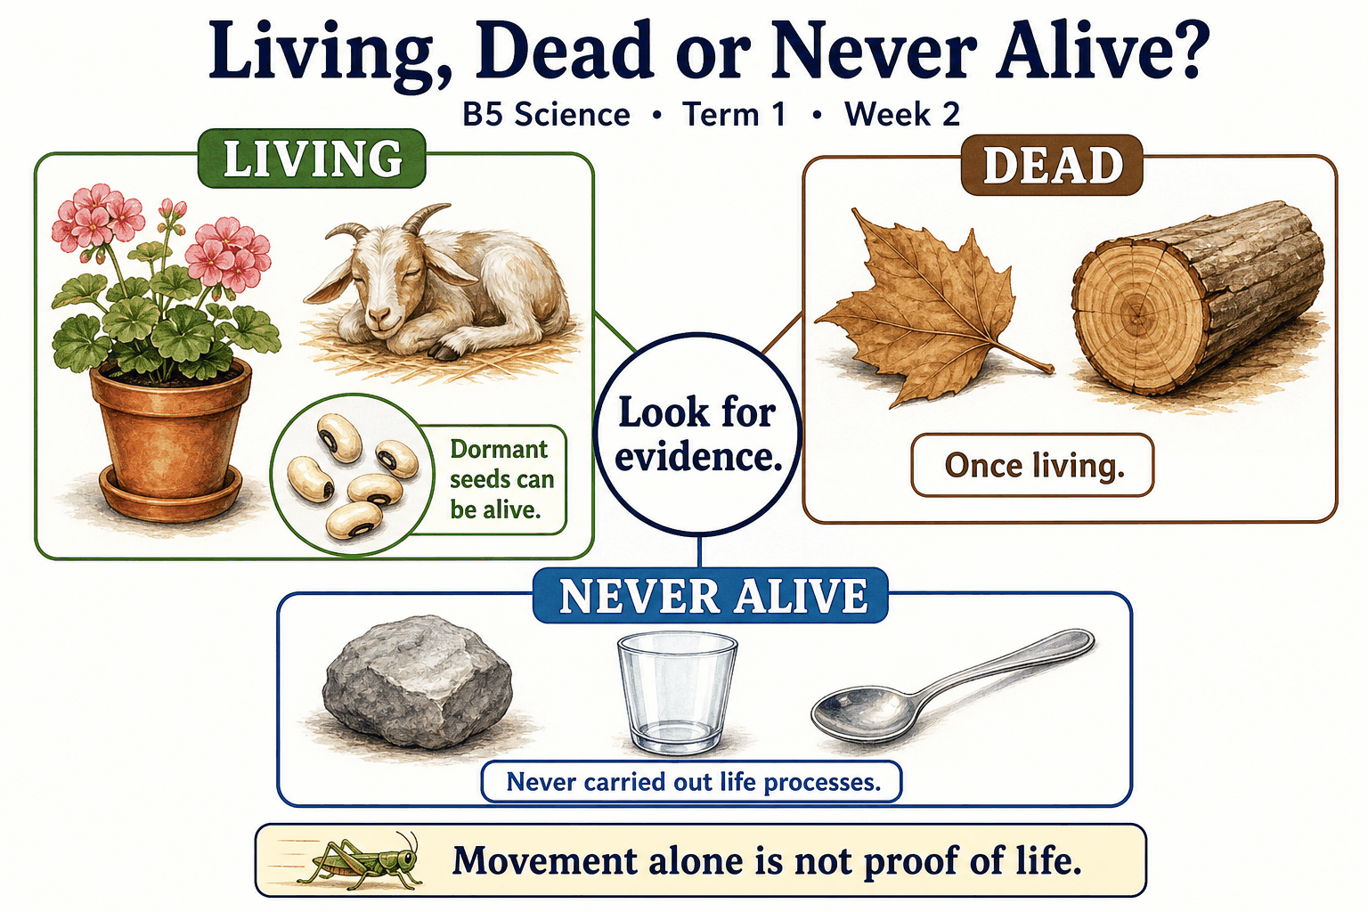
Read each branch, explain the link to the central topic, and add your own example. The separate high-resolution PNG supports projection or larger printing. Concept-map connections do not imply every process occurs in a single linear order.

Week 2 — Practice and assessment

Section A — Multiple-choice questions
Choose ONE correct answer for each question. Each question has four alternatives.
1. Which term best matches this description: an organism carrying out life processes, even if some are not obvious at the moment?
A. Never-alive mineral B. Plastic object C. Living thing D. Dead organism
2. Which term best matches this description: an organism that once lived but has irreversibly stopped its life processes?
A. Healthy dormant seed B. Growing seedling C. Dead organism D. Never-alive stone
3. Which term best matches this description: a material that has never itself been a living organism?
A. Dead plant B. Living animal C. Dormant embryo D. Never-alive material
4. Which term best matches this description: a low-activity state in which a viable organism can resume growth under suitable conditions?
A. Dormancy B. Melting C. Permanent mineral growth D. Death
5. Which term best matches this description: material derived from a plant that is no longer a living organism?
A. A living tree B. A growing embryo C. Never-derived-from-life material D. Dead plant material
6. Which term best matches this description: motion produced by a mechanism rather than evidence of an organism’s life processes?
A. Artificial movement B. Seed respiration C. Proof of animal life D. Plant growth
7. Which term best matches this description: cellular processes releasing usable energy from food?
A. Crystal deposition B. Respiration C. Rusting D. Combustion in a toy motor
8. Which term best matches this description: a change in activity caused by detecting an environmental change?
A. Melting only B. Response to stimuli C. Plastic manufacture D. Permanent death
9. Which term best matches this description: observations or measurements used to support a conclusion?
A. Evidence B. The colour of the container alone C. A guess without testing D. An unrelated preference
10. Which term best matches this description: production of new organisms by living systems?
A. A photocopier copying paper B. Biological reproduction C. A toy moving D. A crystal cracking
11. A healthy seedling grows and responds to light. Which category fits it?
A. Dead organism B. Never-alive mineral C. Plastic object D. Living thing
12. A formerly living animal has died and no longer carries out life processes. Which category applies?
A. Dead organism B. Healthy dormant seed C. Never-alive stone D. Growing seedling
13. Which category fits a mineral crystal considered as an object rather than its surroundings?
A. Living animal B. Never-alive material C. Dormant embryo D. Dead plant
14. A viable dry seed later germinates after receiving suitable conditions. What earlier state explains its inactivity?
A. Death B. Permanent mineral growth C. Melting D. Dormancy
15. A dry wooden plank was once part of a living tree. Which description fits its origin and present status?
A. A living tree B. Dead plant material C. Never-derived-from-life material D. A growing embryo
16. A battery-powered toy car moves across the floor. What best describes this movement?
A. Seed respiration B. Plant growth C. Proof of animal life D. Artificial movement
17. Which continuing process supports a resting living animal even when it is not walking?
A. Combustion in a toy motor B. Rusting C. Respiration D. Crystal deposition
18. A plant shoot bends gradually toward light. Which life characteristic is shown?
A. Melting only B. Permanent death C. Response to stimuli D. Plastic manufacture
19. A learner uses growth records and a successful germination test to justify a classification. What supports the claim?
A. The colour of the container alone B. An unrelated preference C. A guess without testing D. Evidence
20. A bean plant produces viable seeds capable of making new bean plants. Which life process is represented?
A. A toy moving B. A photocopier copying paper C. A crystal cracking D. Biological reproduction

Section B — 10 structured essay questions
Answer all parts (a), (b), (c). Write in a separate exercise book. Suggested marks per question: (a) 1, (b) 1, (c) 2, total 4. Use accurate terms and explain relationships or evidence where asked.

Question 1
(a) Explain the term “Living thing”.
(b) A healthy seedling grows and responds to light. Which category fits it?
(c) Give two pieces of evidence that a healthy seedling is alive.

Question 2
(a) Explain the term “Dead organism”.
(b) A formerly living animal has died and no longer carries out life processes. Which category applies?
(c) Explain why a sleeping animal should not be classified this way merely because it is still.

Question 3
(a) Explain the term “Never-alive material”.
(b) Which category fits a mineral crystal considered as an object rather than its surroundings?
(c) Explain why a growing crystal is not treated as a living plant.

Question 4
(a) Explain the term “Dormancy”.
(b) A viable dry seed later germinates after receiving suitable conditions. What earlier state explains its inactivity?
(c) Explain why a dry seed needs a viability test rather than classification by appearance alone.

Question 5
(a) Explain the term “Dead plant material”.
(b) A dry wooden plank was once part of a living tree. Which description fits its origin and present status?
(c) Explain why a wooden chair is not alive even though its material came from a tree.

Question 6
(a) Explain the term “Artificial movement”.
(b) A battery-powered toy car moves across the floor. What best describes this movement?
(c) Explain why movement alone is an unreliable test for life.

Question 7
(a) Explain the term “Respiration”.
(b) Which continuing process supports a resting living animal even when it is not walking?
(c) Explain why a still living organism may remain biologically active.

Question 8
(a) Explain the term “Response to stimuli”.
(b) A plant shoot bends gradually toward light. Which life characteristic is shown?
(c) Explain how a plant can respond without moving from place to place.

Question 9
(a) Explain the term “Evidence”.
(b) A learner uses growth records and a successful germination test to justify a classification. What supports the claim?
(c) Explain why a classification should include reasons rather than a label alone.

Question 10
(a) Explain the term “Biological reproduction”.
(b) A bean plant produces viable seeds capable of making new bean plants. Which life process is represented?
(c) Compare biological reproduction with a photocopier producing copies.

Week 3 — Classifying materials and justifying their uses
Scheme reference: B5.1.2.1.1. Reference used: B5.1.2.1.1. Direct indicator match. Core property explanations and practice are shared with B4’s introductory editorial unit; B5 activity demands justified comparisons.

Learning outcomes
- Explain the main ideas in classifying materials and justifying their uses using accurate vocabulary.
- Use observations or models to identify examples and justify explanations.
- Apply the ideas to a familiar situation, recognise a misconception and state relevant safety precautions.

Teacher lesson notes
Suggested weekly structure: three 40-minute teaching sessions, plus distributed practice and feedback in remaining timetable periods. Adjust to actual lesson periods. The full question bank should not be imposed as one 40-minute task.
Prior-knowledge check: ask learners for a familiar example related to the week. Record what they think happens and why. Retain one initial claim to revisit after the activity.

Session 1 — Observe and define
5 min: retrieve related knowledge; 10 min: show a model, picture or safe specimen; 15 min: pairs record observations and discuss the first five terms; 10 min: check explanations with short oral questions.

Session 2 — Investigate and explain
5 min: recall vocabulary; 10 min: model a justified explanation; 15 min: carry out the specific activity below, recording real observations; 10 min: introduce the remaining terms and compare evidence.

Session 3 — Apply and assess
5 min: revisit an initial misconception; 10 min: explain the map connections; 15 min: attempt selected application questions and structured parts; 10 min: review explanations and plan reteaching or extension.

Topic-specific activity and resources
Compare paper, cloth, wood, metal and plastic using a property matrix. Test absorption and flexibility safely, keeping sample sizes and test conditions comparable. Recommend materials for a towel, window, raincoat and folder, giving both an advantage and a limitation for each choice.
Resources: the teacher-selected examples, pictures or apparatus described above; board, pencils, exercise books and the supplied map. If a practical cannot be completed, use a clearly labelled photograph or model and do not report predicted results as observed results.

Safety
No sharp glass, electrical conductivity tests, tasting, heating or forceful bending. Clean water spills promptly.

Support, extension and feedback
Support: provide picture labels and a word bank, read unfamiliar words aloud, and let learners explain orally before writing. Extension: compare two related concepts, suggest a counterexample or critique a model. Feedback: ask why a distractor is wrong and use the answer to identify the misconception.

Study notes

Hardness
Resistance of a material to indentation or scratching.
Hardness concerns resistance to local deformation. A hard material may still fracture under impact; glass provides a familiar example.

Softness
The ease with which a material yields under gentle pressure.
A soft filling changes shape under pressure and provides comfort. The outer cover may need different properties such as strength.

Smooth texture
A surface with relatively few noticeable bumps under gentle touch.
Texture describes the surface rather than the entire object’s shape. Safe touching can compare texture without scratching or damaging samples.

Rough texture
A surface with noticeable bumps or irregularities.
A rough surface can rub against and abrade another material. The same property can be unsuitable for something meant to feel gentle on skin.

Transparent
Allowing enough light through for objects to be seen clearly.
Light passes through so the image remains visible. Being colourless and being transparent are related observations but not the same definition.

Opaque
Not allowing objects to be seen through the material because light is blocked.
Blocking light protects privacy or shades an object. Thinness alone does not prove that a material will be transparent.

Flexible
Able to bend without readily breaking under suitable conditions.
Flexibility concerns bending. A material can be flexible but not stretch very much, so flexibility and elasticity should not be confused.

Absorbent
Able to take liquid into spaces within a material.
Water enters spaces in the fibres. A waterproof surface instead resists water passing through it.

Waterproof
Resistant to water passing through under the intended conditions.
The coating or material resists water penetration. Seams and tears can still allow leaks, so the whole object must be checked.

Material selection
Choosing a substance for an object based on the properties needed.
The intended use determines which properties matter. No single material is best for every purpose.
Independent study: reconstruct the map from memory, give a fresh example for three branches and answer one explanation question without copying the notes. Correct errors after discussing the reason with a teacher or partner.

Week 3 — Visual mind-map
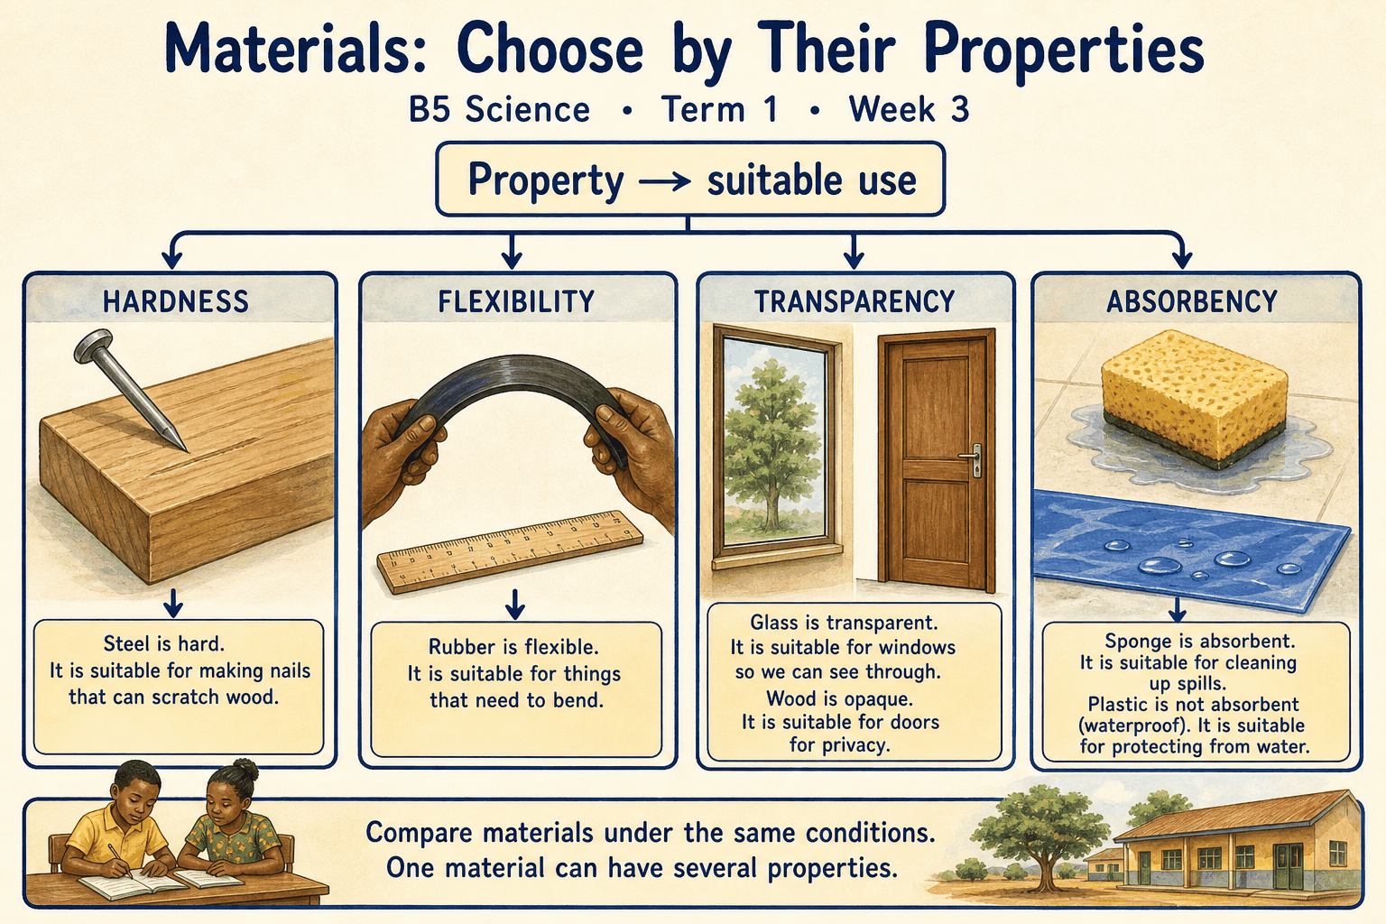
Read each branch, explain the link to the central topic, and add your own example. The separate high-resolution PNG supports projection or larger printing. Concept-map connections do not imply every process occurs in a single linear order.

Week 3 — Practice and assessment

Section A — Multiple-choice questions
Choose ONE correct answer for each question. Each question has four alternatives.
1. Which term best matches this description: resistance of a material to indentation or scratching?
A. Hardness B. Transparency C. Absorption D. Colour
2. Which term best matches this description: the ease with which a material yields under gentle pressure?
A. Softness B. Transparency C. Waterproofing D. Metallic shine
3. Which term best matches this description: a surface with relatively few noticeable bumps under gentle touch?
A. Opacity only B. Smooth texture C. Rough texture D. Absorbency
4. Which term best matches this description: a surface with noticeable bumps or irregularities?
A. Stretchy B. Rough texture C. Transparent D. Perfectly smooth
5. Which term best matches this description: allowing enough light through for objects to be seen clearly?
A. Transparent B. Absorbent C. Opaque D. Soft only
6. Which term best matches this description: not allowing objects to be seen through the material because light is blocked?
A. Transparent B. Elastic only C. Soluble D. Opaque
7. Which term best matches this description: able to bend without readily breaking under suitable conditions?
A. Absorbent only B. Always transparent C. Flexible D. Brittle
8. Which term best matches this description: able to take liquid into spaces within a material?
A. Absorbent B. Opaque only C. Metallic D. Waterproof
9. Which term best matches this description: resistant to water passing through under the intended conditions?
A. Soluble B. Fragile C. Waterproof D. Absorbent
10. Which term best matches this description: choosing a substance for an object based on the properties needed?
A. Seed germination B. Condensation C. Animal reproduction D. Material selection
11. A wooden block is harder to dent with gentle pressure than a sponge. Which property is compared?
A. Transparency B. Absorption C. Colour D. Hardness
12. A cushion compresses readily when pressed. Which property is useful here?
A. Transparency B. Metallic shine C. Softness D. Waterproofing
13. A polished spoon feels even compared with coarse sandpaper. Which property describes the spoon’s surface?
A. Smooth texture B. Absorbency C. Rough texture D. Opacity only
14. Sandpaper helps remove small surface layers because of which texture?
A. Rough texture B. Perfectly smooth C. Transparent D. Stretchy
15. A clear plastic window lets a learner see a picture behind it. Which property is shown?
A. Transparent B. Absorbent C. Opaque D. Soft only
16. A cardboard cover hides the picture behind it. Which optical property is shown?
A. Opaque B. Transparent C. Elastic only D. Soluble
17. A plastic folder bends slightly without snapping. Which useful property is shown?
A. Always transparent B. Absorbent only C. Flexible D. Brittle
18. A cloth towel takes up spilled water. Which property is useful?
A. Opaque only B. Waterproof C. Absorbent D. Metallic
19. A raincoat keeps rain from soaking clothing underneath. Which property is required?
A. Fragile B. Waterproof C. Absorbent D. Soluble
20. A learner chooses absorbent cloth for a towel instead of a plastic sheet. What process is being carried out?
A. Seed germination B. Condensation C. Animal reproduction D. Material selection

Section B — 10 structured essay questions
Answer all parts (a), (b), (c). Write in a separate exercise book. Suggested marks per question: (a) 1, (b) 1, (c) 2, total 4. Use accurate terms and explain relationships or evidence where asked.

Question 1
(a) Explain the term “Hardness”.
(b) A wooden block is harder to dent with gentle pressure than a sponge. Which property is compared?
(c) Explain why a hard material is not necessarily unbreakable.

Question 2
(a) Explain the term “Softness”.
(b) A cushion compresses readily when pressed. Which property is useful here?
(c) Explain why a cushion may use different materials for its filling and cover.

Question 3
(a) Explain the term “Smooth texture”.
(b) A polished spoon feels even compared with coarse sandpaper. Which property describes the spoon’s surface?
(c) Distinguish surface texture from an object’s overall shape.

Question 4
(a) Explain the term “Rough texture”.
(b) Sandpaper helps remove small surface layers because of which texture?
(c) Give one useful and one unsuitable use for a rough surface.

Question 5
(a) Explain the term “Transparent”.
(b) A clear plastic window lets a learner see a picture behind it. Which property is shown?
(c) Explain why transparency is useful for a viewing window.

Question 6
(a) Explain the term “Opaque”.
(b) A cardboard cover hides the picture behind it. Which optical property is shown?
(c) Explain why a thin card may still be opaque.

Question 7
(a) Explain the term “Flexible”.
(b) A plastic folder bends slightly without snapping. Which useful property is shown?
(c) Distinguish bending from stretching using a familiar example.

Question 8
(a) Explain the term “Absorbent”.
(b) A cloth towel takes up spilled water. Which property is useful?
(c) Explain why an absorbent towel is more useful than a waterproof sheet for drying hands.

Question 9
(a) Explain the term “Waterproof”.
(b) A raincoat keeps rain from soaking clothing underneath. Which property is required?
(c) Explain why a raincoat with a tear may leak despite waterproof fabric.

Question 10
(a) Explain the term “Material selection”.
(b) A learner chooses absorbent cloth for a towel instead of a plastic sheet. What process is being carried out?
(c) Explain how the required use should guide a material choice.

Week 4 — Reversible and irreversible changes
Scheme reference: B5.1.2.2.1. Reference used: B5.1.2.2.1. Direct indicator match. Reversibility is discussed under ordinary classroom conditions; not every irreversible change is chemical.

Learning outcomes
- Explain the main ideas in reversible and irreversible changes using accurate vocabulary.
- Use observations or models to identify examples and justify explanations.
- Apply the ideas to a familiar situation, recognise a misconception and state relevant safety precautions.

Teacher lesson notes
Suggested weekly structure: three 40-minute teaching sessions, plus distributed practice and feedback in remaining timetable periods. Adjust to actual lesson periods. The full question bank should not be imposed as one 40-minute task.
Prior-knowledge check: ask learners for a familiar example related to the week. Record what they think happens and why. Retain one initial claim to revisit after the activity.

Session 1 — Observe and define
5 min: retrieve related knowledge; 10 min: show a model, picture or safe specimen; 15 min: pairs record observations and discuss the first five terms; 10 min: check explanations with short oral questions.

Session 2 — Investigate and explain
5 min: recall vocabulary; 10 min: model a justified explanation; 15 min: carry out the specific activity below, recording real observations; 10 min: introduce the remaining terms and compare evidence.

Session 3 — Apply and assess
5 min: revisit an initial misconception; 10 min: explain the map connections; 15 min: attempt selected application questions and structured parts; 10 min: review explanations and plan reteaching or extension.

Topic-specific activity and resources
Observe melting ice and refreezing through photographs or teacher-prepared samples. Compare dissolving salt, tearing paper, cooking an egg and burning wood using cards. Explain which original material or shape could be recovered and by what safe method.
Resources: the teacher-selected examples, pictures or apparatus described above; board, pencils, exercise books and the supplied map. If a practical cannot be completed, use a clearly labelled photograph or model and do not report predicted results as observed results.

Safety
Learners do not burn materials or handle hot equipment. Heating demonstrations are teacher-only; no tasting experimental mixtures.

Support, extension and feedback
Support: provide picture labels and a word bank, read unfamiliar words aloud, and let learners explain orally before writing. Extension: compare two related concepts, suggest a counterexample or critique a model. Feedback: ask why a distractor is wrong and use the answer to identify the misconception.

Study notes

Reversible change
A change that can be undone to recover the starting material or condition by an appropriate process.
Changing temperature can return water to solid form. The water remains the same substance despite its state change.

Irreversible change
A change not readily undone to restore the original under ordinary conditions.
Cooking changes the egg’s materials in ways not reversed by cooling. The conclusion concerns ordinary practical reversal, not merely a change in temperature.

Melting
A change from solid to liquid.
Energy transfer changes the arrangement and movement of particles. Water is not lost merely because its solid shape disappears.

Freezing
A change from liquid to solid.
Removing enough thermal energy permits solid formation. It is the reverse state change of melting.

Evaporation
Change of liquid to gas from a surface below or at boiling conditions.
Water enters the air as vapour while dissolved salt may remain. Evaporation is not the same as destroying the water substance.

Condensation
Change of a gas or vapour into liquid.
Cooling can return vapour to liquid. The water in the droplets was previously in gaseous form.

Dissolving
Formation of a solution as a solute becomes distributed in a solvent.
The salt remains distributed through the solution and can be recovered by suitable water removal. It has not disappeared from existence.

Combustion
A burning reaction that commonly produces new substances and releases energy.
Ash and gases differ from the starting wood. Cooling the products does not rebuild the original wood.

Rusting
A corrosion process involving iron, oxygen and suitable moisture.
Rust is a new corrosion product rather than a temporary change in shape. Preventing exposure can reduce further damage, but drying does not restore lost iron automatically.

Physical change
A change such as shape or state without necessarily creating a new substance.
Cutting changes size and shape without making the material a new substance. It may still be difficult to restore the original sheet, showing that reversibility and chemical identity are different questions.
Independent study: reconstruct the map from memory, give a fresh example for three branches and answer one explanation question without copying the notes. Correct errors after discussing the reason with a teacher or partner.

Week 4 — Visual mind-map
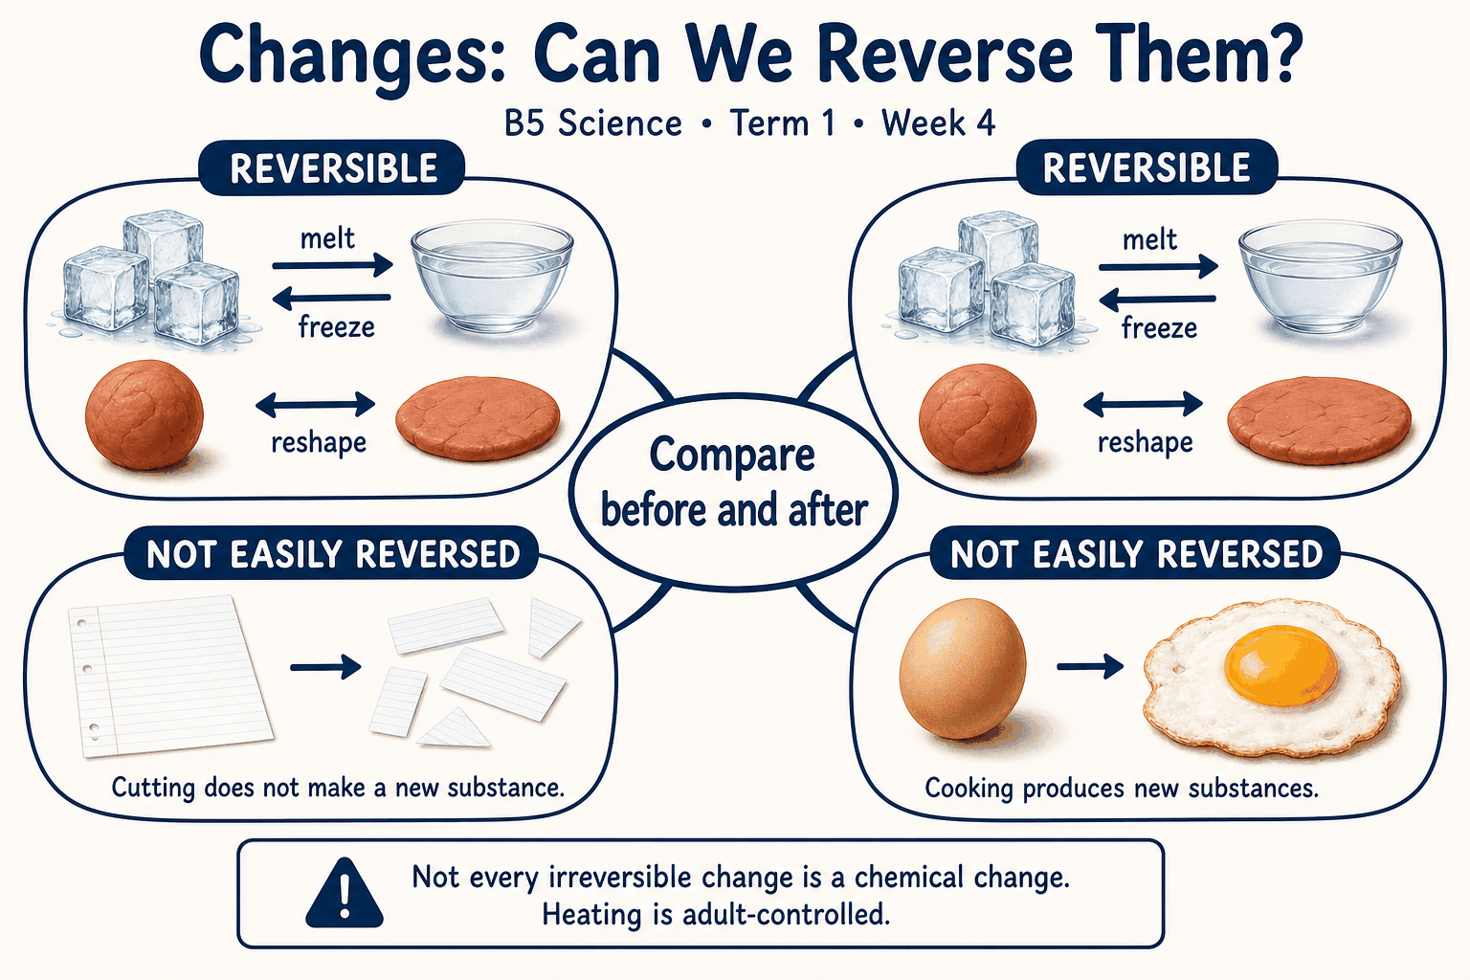
Read each branch, explain the link to the central topic, and add your own example. The separate high-resolution PNG supports projection or larger printing. Concept-map connections do not imply every process occurs in a single linear order.

Week 4 — Practice and assessment

Section A — Multiple-choice questions
Choose ONE correct answer for each question. Each question has four alternatives.
1. Which term best matches this description: a change that can be undone to recover the starting material or condition by an appropriate process?
A. Reversible change B. Permanent disappearance C. An always-chemical change D. Biological reproduction
2. Which term best matches this description: a change not readily undone to restore the original under ordinary conditions?
A. Temporary bending B. Simple reversible melting C. Irreversible change D. Condensation only
3. Which term best matches this description: a change from solid to liquid?
A. Melting B. Freezing C. Condensation D. Seed germination
4. Which term best matches this description: a change from liquid to solid?
A. Dissolving B. Freezing C. Boiling D. Rusting
5. Which term best matches this description: change of liquid to gas from a surface below or at boiling conditions?
A. Rusting B. Germination C. Freezing D. Evaporation
6. Which term best matches this description: change of a gas or vapour into liquid?
A. Melting B. Condensation C. Combustion D. Tearing
7. Which term best matches this description: formation of a solution as a solute becomes distributed in a solvent?
A. Growth B. Dissolving C. Freezing D. Burning
8. Which term best matches this description: a burning reaction that commonly produces new substances and releases energy?
A. Simple stretching B. Melting only C. Combustion D. Freezing
9. Which term best matches this description: a corrosion process involving iron, oxygen and suitable moisture?
A. Seed reproduction B. Condensation C. Rusting D. Melting
10. Which term best matches this description: a change such as shape or state without necessarily creating a new substance?
A. Biological growth B. Physical change C. Photosynthesis D. Automatic formation of a new element
11. Ice melts and the water can later be frozen again. Which broad description fits?
A. Permanent disappearance B. Biological reproduction C. An always-chemical change D. Reversible change
12. A cooked egg cannot simply be cooled back into a raw egg. Which description is appropriate?
A. Simple reversible melting B. Temporary bending C. Condensation only D. Irreversible change
13. An ice cube becomes liquid water in a warm room. Which change occurs?
A. Freezing B. Seed germination C. Melting D. Condensation
14. Water placed in a suitable freezer becomes ice. Which process occurs?
A. Dissolving B. Freezing C. Boiling D. Rusting
15. Water slowly leaves a salt solution exposed to dry air. Which process removes the water?
A. Rusting B. Germination C. Evaporation D. Freezing
16. Water droplets form when water vapour cools on a suitable surface. Which change occurs?
A. Tearing B. Condensation C. Melting D. Combustion
17. Salt grains become invisible when stirred into water. Which process occurs?
A. Freezing B. Dissolving C. Burning D. Growth
18. Wood burns to ash and gases. Which process is shown?
A. Melting only B. Combustion C. Simple stretching D. Freezing
19. An iron object slowly develops rust in damp conditions. Which change occurs?
A. Rusting B. Condensation C. Seed reproduction D. Melting
20. Paper is cut into small pieces while remaining paper. Which general kind of change is shown?
A. Biological growth B. Physical change C. Photosynthesis D. Automatic formation of a new element

Section B — 10 structured essay questions
Answer all parts (a), (b), (c). Write in a separate exercise book. Suggested marks per question: (a) 1, (b) 1, (c) 2, total 4. Use accurate terms and explain relationships or evidence where asked.

Question 1
(a) Explain the term “Reversible change”.
(b) Ice melts and the water can later be frozen again. Which broad description fits?
(c) Explain how melting and freezing can form a reversible pair.

Question 2
(a) Explain the term “Irreversible change”.
(b) A cooked egg cannot simply be cooled back into a raw egg. Which description is appropriate?
(c) Explain why cooling does not undo cooking an egg.

Question 3
(a) Explain the term “Melting”.
(b) An ice cube becomes liquid water in a warm room. Which change occurs?
(c) Explain why melting ice does not mean the water has ceased to exist.

Question 4
(a) Explain the term “Freezing”.
(b) Water placed in a suitable freezer becomes ice. Which process occurs?
(c) Describe how freezing can reverse an earlier melting change.

Question 5
(a) Explain the term “Evaporation”.
(b) Water slowly leaves a salt solution exposed to dry air. Which process removes the water?
(c) Explain how evaporation can help recover salt from a solution.

Question 6
(a) Explain the term “Condensation”.
(b) Water droplets form when water vapour cools on a suitable surface. Which change occurs?
(c) Explain how this process relates to evaporation.

Question 7
(a) Explain the term “Dissolving”.
(b) Salt grains become invisible when stirred into water. Which process occurs?
(c) Explain why invisible dissolved salt can still be present.

Question 8
(a) Explain the term “Combustion”.
(b) Wood burns to ash and gases. Which process is shown?
(c) Explain why burning wood is not reversed simply by cooling the ash.

Question 9
(a) Explain the term “Rusting”.
(b) An iron object slowly develops rust in damp conditions. Which change occurs?
(c) Explain why drying a rusty nail does not make it new again.

Question 10
(a) Explain the term “Physical change”.
(b) Paper is cut into small pieces while remaining paper. Which general kind of change is shown?
(c) Explain why an irreversible-looking change need not always be chemical.

Week 5 — Forming and separating mixtures
Scheme reference: B5.1.2.3.1. Reference used: B5.1.2.3.1. Direct indicator match; separation is selected according to component properties.

Learning outcomes
- Explain the main ideas in forming and separating mixtures using accurate vocabulary.
- Use observations or models to identify examples and justify explanations.
- Apply the ideas to a familiar situation, recognise a misconception and state relevant safety precautions.

Teacher lesson notes
Suggested weekly structure: three 40-minute teaching sessions, plus distributed practice and feedback in remaining timetable periods. Adjust to actual lesson periods. The full question bank should not be imposed as one 40-minute task.
Prior-knowledge check: ask learners for a familiar example related to the week. Record what they think happens and why. Retain one initial claim to revisit after the activity.

Session 1 — Observe and define
5 min: retrieve related knowledge; 10 min: show a model, picture or safe specimen; 15 min: pairs record observations and discuss the first five terms; 10 min: check explanations with short oral questions.

Session 2 — Investigate and explain
5 min: recall vocabulary; 10 min: model a justified explanation; 15 min: carry out the specific activity below, recording real observations; 10 min: introduce the remaining terms and compare evidence.

Session 3 — Apply and assess
5 min: revisit an initial misconception; 10 min: explain the map connections; 15 min: attempt selected application questions and structured parts; 10 min: review explanations and plan reteaching or extension.

Topic-specific activity and resources
Prepare labelled sand-and-water, salt-and-water, and oil-and-water samples. Predict which method suits each. Demonstrate settling and filtration of sand; use diagrams for evaporation and separating-funnel procedures. Record which component is retained or collected.
Resources: the teacher-selected examples, pictures or apparatus described above; board, pencils, exercise books and the supplied map. If a practical cannot be completed, use a clearly labelled photograph or model and do not report predicted results as observed results.

Safety
No tasting mixtures. Learners do not heat samples or handle unknown solvents. Demonstration filtrate is not drinking water; clean oil spills promptly.

Support, extension and feedback
Support: provide picture labels and a word bank, read unfamiliar words aloud, and let learners explain orally before writing. Extension: compare two related concepts, suggest a counterexample or critique a model. Feedback: ask why a distractor is wrong and use the answer to identify the misconception.

Study notes

Mixture
Two or more substances physically combined while retaining their chemical identities.
Components can often be separated by physical properties. Their proportions can vary without becoming one fixed-composition pure substance.

Soluble
Able to dissolve in a stated solvent under given conditions.
Solubility depends on both solute and solvent and on conditions. The dissolved substance is still present even when individual grains are unseen.

Insoluble
Not dissolving appreciably in a stated solvent under the conditions.
The visible solid can settle or be trapped by a suitable filter. Its behaviour differs from dissolved salt in the same liquid.

Filtration
Separation using a porous barrier that retains suitable solid particles.
The solid particle size allows retention, while liquid passes. Dissolved salt would generally pass through ordinary filter paper.

Residue
Material retained on a filter during filtration.
It is the retained portion, not the liquid collected below. Naming both portions makes the method and result clear.

Filtrate
The fluid that passes through a filter.
Passing through a filter does not prove drinking-water safety. Dissolved pollutants and some microbes may remain.

Evaporation
Conversion of liquid to vapour, usable for recovering a non-volatile dissolved solid.
The solvent is removed, leaving the salt. This simple method does not collect the water unless vapour is also captured and condensed.

Decantation
Careful pouring off of a liquid from settled material or a suitable separate layer.
The method works best after settling and with careful pouring. Fine suspended material can still remain in the poured liquid.

Immiscible
Describing liquids that form separate phases instead of mixing uniformly.
A visible boundary enables separation of suitable liquid layers. Shaking may disperse droplets temporarily without making a permanent solution.

Separating funnel
A tapped apparatus used to drain one suitable immiscible liquid layer from another.
The lower layer exits first, so the boundary is watched carefully. Fully miscible liquids do not provide that separable boundary.
Independent study: reconstruct the map from memory, give a fresh example for three branches and answer one explanation question without copying the notes. Correct errors after discussing the reason with a teacher or partner.

Week 5 — Visual mind-map
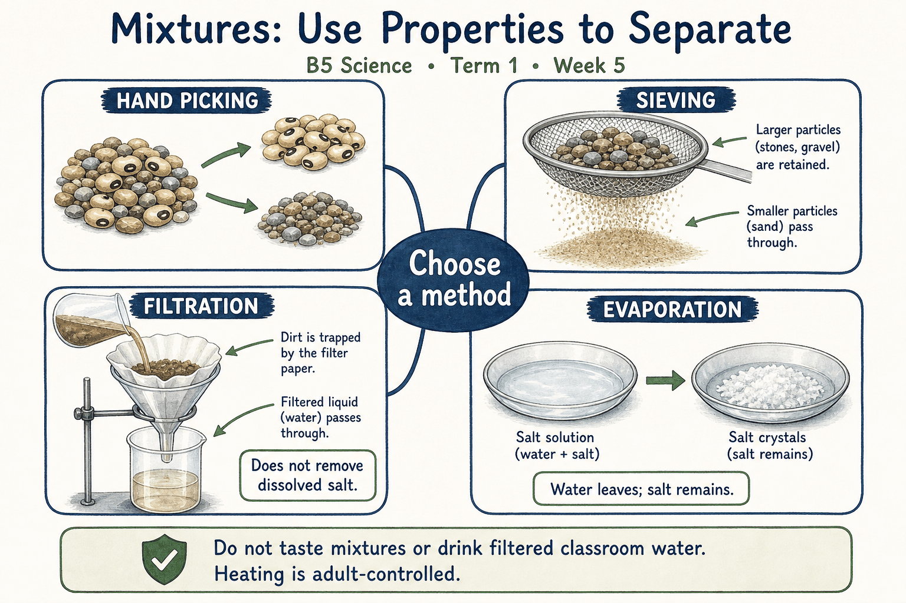
Read each branch, explain the link to the central topic, and add your own example. The separate high-resolution PNG supports projection or larger printing. Concept-map connections do not imply every process occurs in a single linear order.

Week 5 — Practice and assessment

Section A — Multiple-choice questions
Choose ONE correct answer for each question. Each question has four alternatives.
1. Which term best matches this description: two or more substances physically combined while retaining their chemical identities?
A. An element B. A seed C. Mixture D. A single atom
2. Which term best matches this description: able to dissolve in a stated solvent under given conditions?
A. Magnetic necessarily B. Waterproof necessarily C. Soluble D. Insoluble in all liquids
3. Which term best matches this description: not dissolving appreciably in a stated solvent under the conditions?
A. Fully dissolved B. A new element C. Gaseous D. Insoluble
4. Which term best matches this description: separation using a porous barrier that retains suitable solid particles?
A. Filtration B. Combustion C. Distillation only D. Melting
5. Which term best matches this description: material retained on a filter during filtration?
A. Solvent gas B. Vapour C. Filtrate D. Residue
6. Which term best matches this description: the fluid that passes through a filter?
A. Residue B. Filter cone C. Undissolved gravel D. Filtrate
7. Which term best matches this description: conversion of liquid to vapour, usable for recovering a non-volatile dissolved solid?
A. Magnetism B. Freezing the salt only C. Evaporation D. Paper cutting
8. Which term best matches this description: careful pouring off of a liquid from settled material or a suitable separate layer?
A. Germination B. Decantation C. Grinding D. Melting
9. Which term best matches this description: describing liquids that form separate phases instead of mixing uniformly?
A. Both solid B. Both gaseous C. Immiscible D. Fully miscible
10. Which term best matches this description: a tapped apparatus used to drain one suitable immiscible liquid layer from another?
A. Measuring balance B. Thermometer C. Separating funnel D. Microscope
11. Sand and water are placed together without forming a new pure compound. What is made?
A. A seed B. A single atom C. An element D. Mixture
12. Salt forms a solution in water. Which property of salt in water is demonstrated?
A. Insoluble in all liquids B. Waterproof necessarily C. Soluble D. Magnetic necessarily
13. Sand remains as grains after stirring in water. Which description applies?
A. Insoluble B. Gaseous C. Fully dissolved D. A new element
14. Sand is trapped on filter paper while water passes through. Which method is used?
A. Distillation only B. Filtration C. Combustion D. Melting
15. What is the sand left on the filter paper called?
A. Filtrate B. Vapour C. Residue D. Solvent gas
16. What is the liquid collected below the filter paper called?
A. Filtrate B. Undissolved gravel C. Residue D. Filter cone
17. Which process can leave salt behind as water from a salt solution enters the air?
A. Paper cutting B. Freezing the salt only C. Evaporation D. Magnetism
18. Clearer liquid is gently poured away from settled sand. Which method is attempted?
A. Decantation B. Germination C. Grinding D. Melting
19. Cooking oil and water form layers after standing. Which description fits them?
A. Immiscible B. Both gaseous C. Fully miscible D. Both solid
20. A teacher drains the lower layer and closes a tap near the oil–water boundary. Which apparatus is used?
A. Thermometer B. Separating funnel C. Microscope D. Measuring balance

Section B — 10 structured essay questions
Answer all parts (a), (b), (c). Write in a separate exercise book. Suggested marks per question: (a) 1, (b) 1, (c) 2, total 4. Use accurate terms and explain relationships or evidence where asked.

Question 1
(a) Explain the term “Mixture”.
(b) Sand and water are placed together without forming a new pure compound. What is made?
(c) Explain why sand and water are treated as a mixture.

Question 2
(a) Explain the term “Soluble”.
(b) Salt forms a solution in water. Which property of salt in water is demonstrated?
(c) Explain why the solvent must be named when discussing solubility.

Question 3
(a) Explain the term “Insoluble”.
(b) Sand remains as grains after stirring in water. Which description applies?
(c) Compare the separation of sand from water with removal of dissolved salt.

Question 4
(a) Explain the term “Filtration”.
(b) Sand is trapped on filter paper while water passes through. Which method is used?
(c) Explain why the same paper cannot remove all dissolved material.

Question 5
(a) Explain the term “Residue”.
(b) What is the sand left on the filter paper called?
(c) Distinguish the retained sand from the collected liquid.

Question 6
(a) Explain the term “Filtrate”.
(b) What is the liquid collected below the filter paper called?
(c) Explain why this liquid should not automatically be drunk.

Question 7
(a) Explain the term “Evaporation”.
(b) Which process can leave salt behind as water from a salt solution enters the air?
(c) Explain which component is recovered and which is not collected in an open evaporation setup.

Question 8
(a) Explain the term “Decantation”.
(b) Clearer liquid is gently poured away from settled sand. Which method is attempted?
(c) Explain one limitation of this method for muddy water.

Question 9
(a) Explain the term “Immiscible”.
(b) Cooking oil and water form layers after standing. Which description fits them?
(c) Explain why stirring alone cannot permanently make the two liquids uniform.

Question 10
(a) Explain the term “Separating funnel”.
(b) A teacher drains the lower layer and closes a tap near the oil–water boundary. Which apparatus is used?
(c) Explain why this apparatus is unsuitable for separating dissolved salt from water by draining layers.

Week 6 — How day and night are formed
Scheme reference: B5.2.1.1.1. Reference used: B5.2.1.1.1. Direct indicator match; model limitations are explicitly taught.

Learning outcomes
- Explain the main ideas in how day and night are formed using accurate vocabulary.
- Use observations or models to identify examples and justify explanations.
- Apply the ideas to a familiar situation, recognise a misconception and state relevant safety precautions.

Teacher lesson notes
Suggested weekly structure: three 40-minute teaching sessions, plus distributed practice and feedback in remaining timetable periods. Adjust to actual lesson periods. The full question bank should not be imposed as one 40-minute task.
Prior-knowledge check: ask learners for a familiar example related to the week. Record what they think happens and why. Retain one initial claim to revisit after the activity.

Session 1 — Observe and define
5 min: retrieve related knowledge; 10 min: show a model, picture or safe specimen; 15 min: pairs record observations and discuss the first five terms; 10 min: check explanations with short oral questions.

Session 2 — Investigate and explain
5 min: recall vocabulary; 10 min: model a justified explanation; 15 min: carry out the specific activity below, recording real observations; 10 min: introduce the remaining terms and compare evidence.

Session 3 — Apply and assess
5 min: revisit an initial misconception; 10 min: explain the map connections; 15 min: attempt selected application questions and structured parts; 10 min: review explanations and plan reteaching or extension.

Topic-specific activity and resources
Use a globe or ball and a steady torch in a dim room. Mark a Ghana location. Rotate the globe while keeping the lamp in one place; observe illumination of the mark. Draw the lit and unlit sides and explain model limitations.
Resources: the teacher-selected examples, pictures or apparatus described above; board, pencils, exercise books and the supplied map. If a practical cannot be completed, use a clearly labelled photograph or model and do not report predicted results as observed results.

Safety
Use a battery torch, not flame. Never look at the Sun or direct a bright torch into anyone’s eyes. Keep the room safe to move in.

Support, extension and feedback
Support: provide picture labels and a word bank, read unfamiliar words aloud, and let learners explain orally before writing. Extension: compare two related concepts, suggest a counterexample or critique a model. Feedback: ask why a distractor is wrong and use the answer to identify the misconception.

Study notes

Rotation
Earth’s turning around its own axis.
Turning changes which side faces sunlight. The yearly journey around the Sun is a different motion.

Axis
The imaginary line about which Earth rotates.
The line runs between the poles in the model. It is not a physical stick running through real Earth for people to see.

Daylight
The condition at a place receiving direct sunlight on Earth’s lit side.
The lamp-facing side receives light. A full classroom room may still have stray light, so the model simplifies real conditions.

Night
The condition at a place turned away from direct sunlight.
Earth blocks direct sunlight from reaching that side. The Sun continues producing light even though the location faces away.

Approximately 24 hours
The approximate duration of an ordinary solar day.
The ordinary day is about 24 hours. The classroom model is sped up and is not a time-scale reproduction of Earth’s rotation.

West to east
The direction of Earth’s rotation when described geographically.
This rotation makes the Sun appear to move across the sky in the opposite broad direction. Appearance from the ground differs from the underlying cause.

Sunrise
The apparent appearance of the Sun above the local horizon as Earth turns.
The observer’s changing orientation brings the Sun into view. Local land and cloud conditions can affect what is actually seen.

Sunset
The apparent disappearance of the Sun below the local horizon as Earth turns.
The observer’s view changes because Earth turns. The Sun continues lighting other parts of Earth.

Globe model
A simplified representation of Earth used to investigate its shape and movements.
The model helps explain relationships but is not to scale in distance, size or speed. Model limits should be stated rather than hidden.

Simultaneous day and night
The occurrence of daylight in one part of Earth while another faces away from the Sun.
Only the side facing the source receives direct light. Locations on opposite sides can therefore experience different times of day.
Independent study: reconstruct the map from memory, give a fresh example for three branches and answer one explanation question without copying the notes. Correct errors after discussing the reason with a teacher or partner.

Week 6 — Visual mind-map
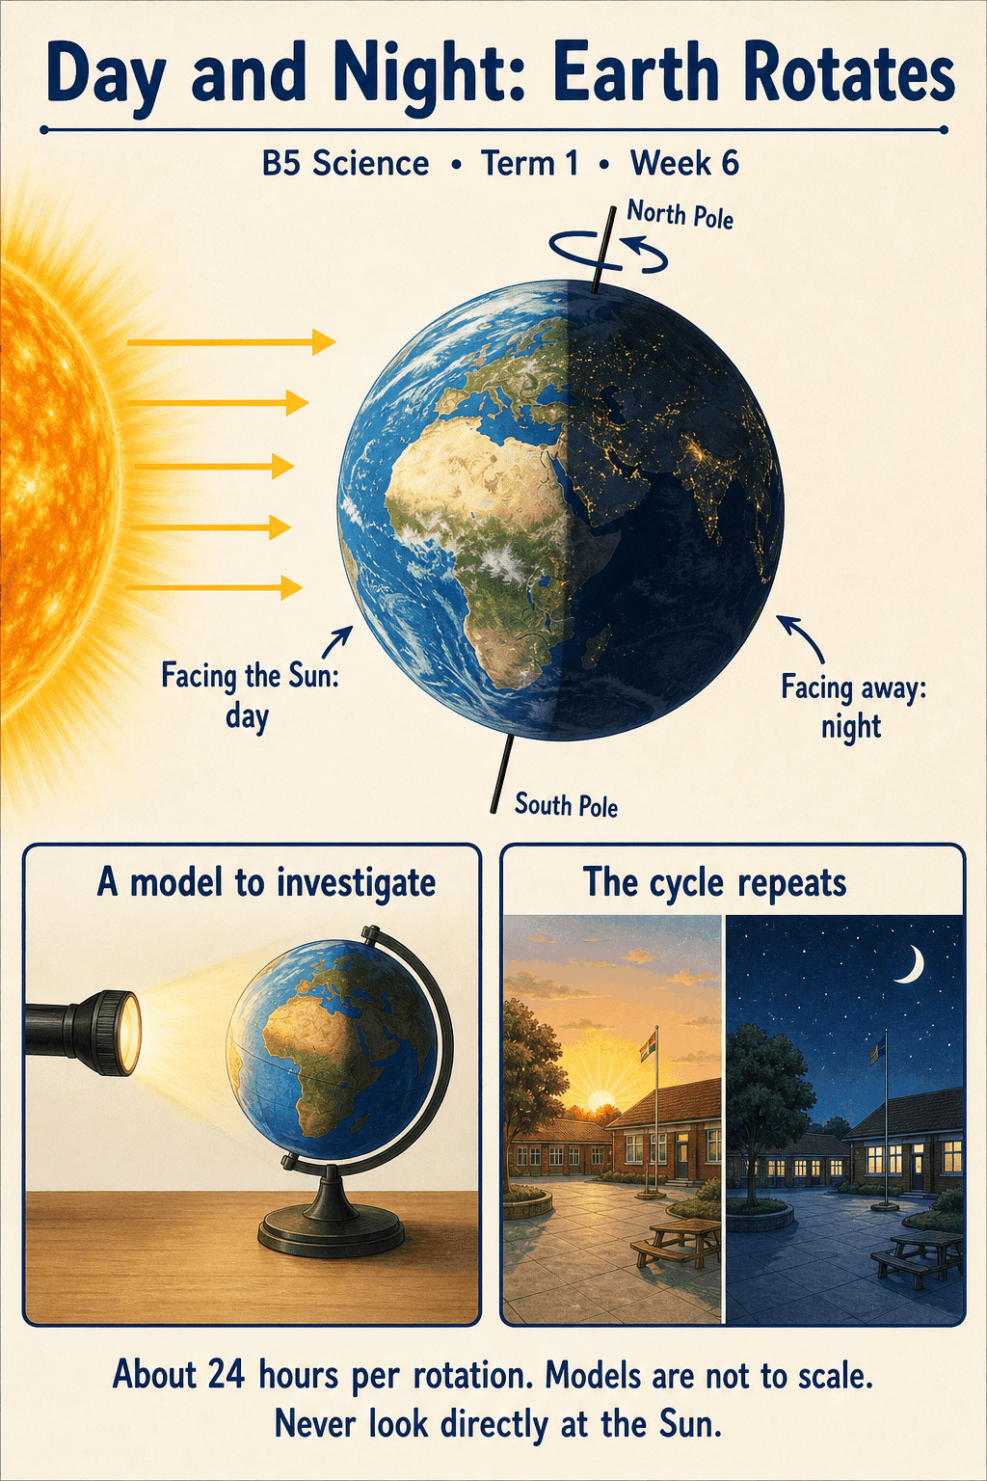
Read each branch, explain the link to the central topic, and add your own example. The separate high-resolution PNG supports projection or larger printing. Concept-map connections do not imply every process occurs in a single linear order.

Week 6 — Practice and assessment

Section A — Multiple-choice questions
Choose ONE correct answer for each question. Each question has four alternatives.
1. Which term best matches this description: earth’s turning around its own axis?
A. The Sun switching off B. Rotation C. The Moon blocking all sunlight daily D. Earth’s yearly orbit alone
2. Which term best matches this description: the imaginary line about which Earth rotates?
A. Axis B. Its nearest cloud C. The Moon’s shadow only D. A river
3. Which term best matches this description: the condition at a place receiving direct sunlight on Earth’s lit side?
A. Night B. Daylight C. A lunar eclipse necessarily D. The absence of the Sun
4. Which term best matches this description: the condition at a place turned away from direct sunlight?
A. Earth disappearing B. Permanent winter C. The Sun burning out D. Night
5. Which term best matches this description: the approximate duration of an ordinary solar day?
A. One year B. One month C. Approximately 24 hours D. One minute
6. Which term best matches this description: the direction of Earth’s rotation when described geographically?
A. East to west B. No direction at all C. West to east D. North straight into the Sun
7. Which term best matches this description: the apparent appearance of the Sun above the local horizon as Earth turns?
A. The Sun being newly created B. Plant germination C. A monthly orbit D. Sunrise
8. Which term best matches this description: the apparent disappearance of the Sun below the local horizon as Earth turns?
A. The Sun becoming a planet B. Earth stopping permanently C. Sunset D. Seed dispersal
9. Which term best matches this description: a simplified representation of Earth used to investigate its shape and movements?
A. A natural satellite B. A real star C. Globe model D. An exact full-size Earth
10. Which term best matches this description: the occurrence of daylight in one part of Earth while another faces away from the Sun?
A. Day everywhere at once B. The Sun travelling through Earth C. Night everywhere at once D. Simultaneous day and night
11. Which motion chiefly causes the regular alternation of day and night?
A. The Moon blocking all sunlight daily B. Earth’s yearly orbit alone C. The Sun switching off D. Rotation
12. What does the globe turn around in a day-and-night model?
A. A river B. Its nearest cloud C. The Moon’s shadow only D. Axis
13. The Ghana mark on a globe faces the torch. Which condition is represented?
A. Night B. Daylight C. A lunar eclipse necessarily D. The absence of the Sun
14. The Ghana mark turns to the side away from the torch. What is represented?
A. The Sun burning out B. Night C. Permanent winter D. Earth disappearing
15. About how long is the familiar daylight-to-daylight daily cycle?
A. Approximately 24 hours B. One month C. One minute D. One year
16. In which direction does Earth generally rotate?
A. North straight into the Sun B. West to east C. East to west D. No direction at all
17. A location rotates into the illuminated side and the Sun comes into view. What event is modelled?
A. Plant germination B. Sunrise C. A monthly orbit D. The Sun being newly created
18. A location rotates away from the illuminated side and the Sun leaves view. What event is modelled?
A. Earth stopping permanently B. The Sun becoming a planet C. Sunset D. Seed dispersal
19. A ball with a marked location is used beside a lamp. What kind of teaching aid is this?
A. An exact full-size Earth B. A real star C. A natural satellite D. Globe model
20. The lamp lights one hemisphere while the opposite side is dark. Which global condition is demonstrated?
A. Night everywhere at once B. The Sun travelling through Earth C. Simultaneous day and night D. Day everywhere at once

Section B — 10 structured essay questions
Answer all parts (a), (b), (c). Write in a separate exercise book. Suggested marks per question: (a) 1, (b) 1, (c) 2, total 4. Use accurate terms and explain relationships or evidence where asked.

Question 1
(a) Explain the term “Rotation”.
(b) Which motion chiefly causes the regular alternation of day and night?
(c) Distinguish the motion causing day and night from Earth’s yearly motion.

Question 2
(a) Explain the term “Axis”.
(b) What does the globe turn around in a day-and-night model?
(c) Explain what the globe’s support represents and what it does not literally show.

Question 3
(a) Explain the term “Daylight”.
(b) The Ghana mark on a globe faces the torch. Which condition is represented?
(c) Explain the meaning of the illuminated mark in the model.

Question 4
(a) Explain the term “Night”.
(b) The Ghana mark turns to the side away from the torch. What is represented?
(c) Explain why night does not mean the Sun has switched off.

Question 5
(a) Explain the term “Approximately 24 hours”.
(b) About how long is the familiar daylight-to-daylight daily cycle?
(c) Explain why rotating a model in seconds does not change the real duration of a day.

Question 6
(a) Explain the term “West to east”.
(b) In which direction does Earth generally rotate?
(c) Relate Earth’s turning to the Sun’s apparent daily movement.

Question 7
(a) Explain the term “Sunrise”.
(b) A location rotates into the illuminated side and the Sun comes into view. What event is modelled?
(c) Explain why sunrise does not mean the Sun has just begun to exist.

Question 8
(a) Explain the term “Sunset”.
(b) A location rotates away from the illuminated side and the Sun leaves view. What event is modelled?
(c) Explain how another place can still have daylight when your location has sunset.

Question 9
(a) Explain the term “Globe model”.
(b) A ball with a marked location is used beside a lamp. What kind of teaching aid is this?
(c) State two ways this classroom model differs from the real Earth–Sun system.

Question 10
(a) Explain the term “Simultaneous day and night”.
(b) The lamp lights one hemisphere while the opposite side is dark. Which global condition is demonstrated?
(c) Explain why all places on Earth do not have daylight at the same time.

Week 7 — Benefits of the Sun to Earth
Scheme reference: B5.2.1.2.1. Reference used: B5.2.1.2.1. Direct indicator match; solar benefits are taught alongside safe exposure.

Learning outcomes
- Explain the main ideas in benefits of the sun to earth using accurate vocabulary.
- Use observations or models to identify examples and justify explanations.
- Apply the ideas to a familiar situation, recognise a misconception and state relevant safety precautions.

Teacher lesson notes
Suggested weekly structure: three 40-minute teaching sessions, plus distributed practice and feedback in remaining timetable periods. Adjust to actual lesson periods. The full question bank should not be imposed as one 40-minute task.
Prior-knowledge check: ask learners for a familiar example related to the week. Record what they think happens and why. Retain one initial claim to revisit after the activity.

Session 1 — Observe and define
5 min: retrieve related knowledge; 10 min: show a model, picture or safe specimen; 15 min: pairs record observations and discuss the first five terms; 10 min: check explanations with short oral questions.

Session 2 — Investigate and explain
5 min: recall vocabulary; 10 min: model a justified explanation; 15 min: carry out the specific activity below, recording real observations; 10 min: introduce the remaining terms and compare evidence.

Session 3 — Apply and assess
5 min: revisit an initial misconception; 10 min: explain the map connections; 15 min: attempt selected application questions and structured parts; 10 min: review explanations and plan reteaching or extension.

Topic-specific activity and resources
Create an energy-connection chart linking the Sun to green plants, food chains, warming, drying and solar devices. Compare safe shaded and sunlit surfaces by observation without touching hot objects. Discuss both benefits and risks of excessive exposure.
Resources: the teacher-selected examples, pictures or apparatus described above; board, pencils, exercise books and the supplied map. If a practical cannot be completed, use a clearly labelled photograph or model and do not report predicted results as observed results.

Safety
Never look directly at the Sun. Avoid prolonged heat exposure; use shade, suitable clothing and normal school sun-safety arrangements. Do not use lenses to focus sunlight.

Support, extension and feedback
Support: provide picture labels and a word bank, read unfamiliar words aloud, and let learners explain orally before writing. Extension: compare two related concepts, suggest a counterexample or critique a model. Feedback: ask why a distractor is wrong and use the answer to identify the misconception.

Study notes

Solar energy
Energy received from the Sun as radiation.
Solar radiation supplies light and contributes warming. It supports many processes but is not the only possible energy source anywhere on Earth.

Photosynthesis
Use of light energy by green organisms to make sugars from water and carbon dioxide.
Light supplies energy for making food. Soil minerals and water support growth but are not substitutes for the light-driven process.

Food chain
A sequence showing transfer of food matter and energy between organisms.
Energy stored by the producer passes through feeding relationships. Organisms do not pass all received energy unchanged to the next level.

Warming
An increase in temperature as energy is transferred to a body.
Absorbed radiation can increase temperature. Colour, material, wind and exposure time also affect the result.

Evaporation
Surface loss of liquid water into the air as vapour.
Energy helps water enter the air. Wind and humidity also influence drying, so sunlight is not the only relevant factor.

Water cycle
Repeated movement of water among atmosphere, land and water bodies.
Solar energy supports evaporation and the return of water to the atmosphere. Gravity and other conditions help later movements such as rainfall and runoff.

Solar panel
A device designed to convert incoming sunlight into usable energy, with photovoltaic panels producing electricity.
Photovoltaic cells convert light to electricity. Available power depends on sunlight and the system, while storage can support use at other times.

Solar heating
Using absorbed sunlight to raise the temperature of a material such as water.
Incoming radiation is absorbed and transferred as thermal energy. A hot-water device is not necessarily producing electricity.

Visible light
The part of radiation that human eyes can detect under suitable conditions.
Light reaches objects and some is reflected to the eyes. Visibility is different from staring directly at the source, which is unsafe for the Sun.

Sun protection
Practices reducing harmful excessive sunlight or heat exposure.
Sunlight has benefits but excessive ultraviolet exposure and heat can harm people. Protection allows safer use of outdoor environments.
Independent study: reconstruct the map from memory, give a fresh example for three branches and answer one explanation question without copying the notes. Correct errors after discussing the reason with a teacher or partner.

Week 7 — Visual mind-map
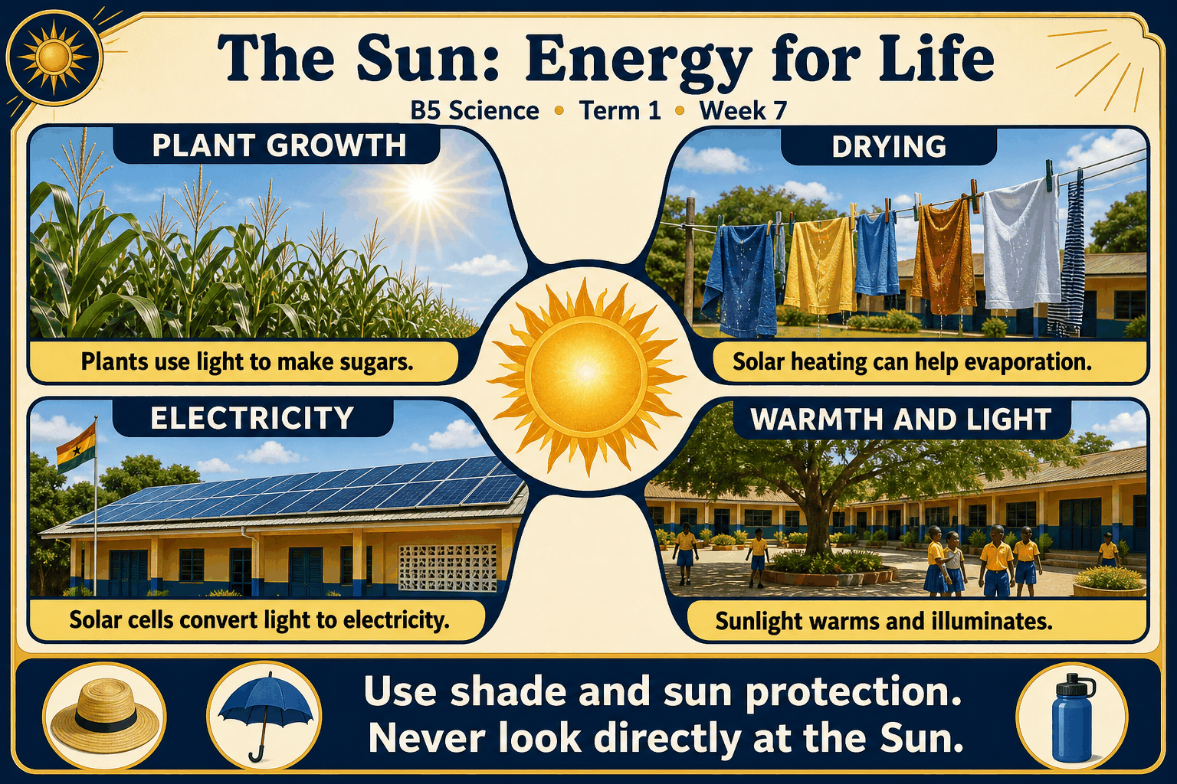
Read each branch, explain the link to the central topic, and add your own example. The separate high-resolution PNG supports projection or larger printing. Concept-map connections do not imply every process occurs in a single linear order.

Week 7 — Practice and assessment

Section A — Multiple-choice questions
Choose ONE correct answer for each question. Each question has four alternatives.
1. Which term best matches this description: energy received from the Sun as radiation?
A. Energy made by the Moon’s light production B. A classroom battery only C. Solar energy D. Deep-sea salt only
2. Which term best matches this description: use of light energy by green organisms to make sugars from water and carbon dioxide?
A. Digestion in an animal B. Photosynthesis C. Rusting D. Sedimentation
3. Which term best matches this description: a sequence showing transfer of food matter and energy between organisms?
A. Food chain B. A water-pipe map C. A rock scale D. A clock cycle
4. Which term best matches this description: an increase in temperature as energy is transferred to a body?
A. Creation of a new element B. Automatic freezing C. Warming D. Loss of all energy
5. Which term best matches this description: surface loss of liquid water into the air as vapour?
A. Rusting only B. Evaporation C. Seed formation D. Freezing
6. Which term best matches this description: repeated movement of water among atmosphere, land and water bodies?
A. A plastic-making cycle B. A daily toy-car race C. Water cycle D. A stone’s growth cycle
7. Which term best matches this description: a device designed to convert incoming sunlight into usable energy, with photovoltaic panels producing electricity?
A. A dry stone alone B. An unconnected spoon C. A paper label D. Solar panel
8. Which term best matches this description: using absorbed sunlight to raise the temperature of a material such as water?
A. Photosynthesis inside metal B. Animal respiration C. Freezing by sunlight D. Solar heating
9. Which term best matches this description: the part of radiation that human eyes can detect under suitable conditions?
A. Sound from the Sun B. Underground minerals C. Solid particles only D. Visible light
10. Which term best matches this description: practices reducing harmful excessive sunlight or heat exposure?
A. Blocking all plant photosynthesis B. Sun protection C. Removing the atmosphere D. Increasing unsafe exposure
11. What is the original energy source driving many natural processes on Earth?
A. Solar energy B. A classroom battery only C. Deep-sea salt only D. Energy made by the Moon’s light production
12. Which process links sunlight to food production in a green leaf?
A. Sedimentation B. Photosynthesis C. Rusting D. Digestion in an animal
13. Grass uses sunlight, a grasshopper eats grass and a bird eats the grasshopper. What relationship is represented?
A. A rock scale B. A water-pipe map C. A clock cycle D. Food chain
14. A surface exposed to sunlight becomes warmer than a similar shaded surface. Which effect is shown?
A. Loss of all energy B. Warming C. Creation of a new element D. Automatic freezing
15. Sunlight helps wet clothes dry by supporting which process?
A. Seed formation B. Rusting only C. Freezing D. Evaporation
16. The Sun helps water leave the sea, later forming clouds and rain. Which larger cycle is supported?
A. A daily toy-car race B. Water cycle C. A stone’s growth cycle D. A plastic-making cycle
17. Which device can power a suitable lamp using photovoltaic conversion?
A. A paper label B. A dry stone alone C. An unconnected spoon D. Solar panel
18. A designed solar water heater warms water without burning fuel at the point of heating. Which use is shown?
A. Photosynthesis inside metal B. Animal respiration C. Solar heating D. Freezing by sunlight
19. Which contribution from the Sun allows normal outdoor vision by day?
A. Underground minerals B. Visible light C. Solid particles only D. Sound from the Sun
20. A class uses shade and suitable clothing during an outdoor activity. Which practice is shown?
A. Increasing unsafe exposure B. Removing the atmosphere C. Sun protection D. Blocking all plant photosynthesis

Section B — 10 structured essay questions
Answer all parts (a), (b), (c). Write in a separate exercise book. Suggested marks per question: (a) 1, (b) 1, (c) 2, total 4. Use accurate terms and explain relationships or evidence where asked.

Question 1
(a) Explain the term “Solar energy”.
(b) What is the original energy source driving many natural processes on Earth?
(c) Give two different processes supported by energy from the Sun.

Question 2
(a) Explain the term “Photosynthesis”.
(b) Which process links sunlight to food production in a green leaf?
(c) Explain why sunlight is important to many green plants.

Question 3
(a) Explain the term “Food chain”.
(b) Grass uses sunlight, a grasshopper eats grass and a bird eats the grasshopper. What relationship is represented?
(c) Explain how a bird’s food energy can be linked indirectly to sunlight.

Question 4
(a) Explain the term “Warming”.
(b) A surface exposed to sunlight becomes warmer than a similar shaded surface. Which effect is shown?
(c) Name two conditions to control when comparing warming in sun and shade.

Question 5
(a) Explain the term “Evaporation”.
(b) Sunlight helps wet clothes dry by supporting which process?
(c) Explain why drying rates can differ even on two sunny days.

Question 6
(a) Explain the term “Water cycle”.
(b) The Sun helps water leave the sea, later forming clouds and rain. Which larger cycle is supported?
(c) Explain the Sun’s role without claiming it causes every water-cycle step in the same way.

Question 7
(a) Explain the term “Solar panel”.
(b) Which device can power a suitable lamp using photovoltaic conversion?
(c) Explain why a solar-powered system may include a battery.

Question 8
(a) Explain the term “Solar heating”.
(b) A designed solar water heater warms water without burning fuel at the point of heating. Which use is shown?
(c) Distinguish solar water heating from photovoltaic electricity generation.

Question 9
(a) Explain the term “Visible light”.
(b) Which contribution from the Sun allows normal outdoor vision by day?
(c) Explain how sunlight helps us see objects without looking at the Sun.

Question 10
(a) Explain the term “Sun protection”.
(b) A class uses shade and suitable clothing during an outdoor activity. Which practice is shown?
(c) Give two sensible measures for a school activity in strong sunshine.

Week 8 — Evaporation, condensation and cloud formation
Scheme reference: B5.2.1.3.1–2. Reference used: B5.2.1.3.1–2. Direct indicator match; clouds are tiny droplets or ice crystals, not simply invisible water vapour.

Learning outcomes
- Explain the main ideas in evaporation, condensation and cloud formation using accurate vocabulary.
- Use observations or models to identify examples and justify explanations.
- Apply the ideas to a familiar situation, recognise a misconception and state relevant safety precautions.

Teacher lesson notes
Suggested weekly structure: three 40-minute teaching sessions, plus distributed practice and feedback in remaining timetable periods. Adjust to actual lesson periods. The full question bank should not be imposed as one 40-minute task.
Prior-knowledge check: ask learners for a familiar example related to the week. Record what they think happens and why. Retain one initial claim to revisit after the activity.

Session 1 — Observe and define
5 min: retrieve related knowledge; 10 min: show a model, picture or safe specimen; 15 min: pairs record observations and discuss the first five terms; 10 min: check explanations with short oral questions.

Session 2 — Investigate and explain
5 min: recall vocabulary; 10 min: model a justified explanation; 15 min: carry out the specific activity below, recording real observations; 10 min: introduce the remaining terms and compare evidence.

Session 3 — Apply and assess
5 min: revisit an initial misconception; 10 min: explain the map connections; 15 min: attempt selected application questions and structured parts; 10 min: review explanations and plan reteaching or extension.

Topic-specific activity and resources
Use a cold sealed container to observe droplets forming on its outside; keep a similar uncooled container as a comparison. Build an arrow diagram of evaporation, condensation, cloud formation, precipitation and collection. Label water’s state at each step.
Resources: the teacher-selected examples, pictures or apparatus described above; board, pencils, exercise books and the supplied map. If a practical cannot be completed, use a clearly labelled photograph or model and do not report predicted results as observed results.

Safety
Use cold or room-temperature materials rather than learner-operated boiling apparatus. Wipe spills and do not drink experiment water.

Support, extension and feedback
Support: provide picture labels and a word bank, read unfamiliar words aloud, and let learners explain orally before writing. Extension: compare two related concepts, suggest a counterexample or critique a model. Feedback: ask why a distractor is wrong and use the answer to identify the misconception.

Study notes

Evaporation
Movement of liquid water into the air as water vapour from a surface.
Surface molecules enter the air, and this can occur below boiling temperature. Control leakage and absorption before attributing all loss to evaporation.

Water vapour
Water in gaseous form, normally invisible.
The gas is usually invisible. Visible mist and clouds contain small droplets or ice rather than being a direct view of the invisible gas.

Condensation
Conversion of water vapour into liquid droplets.
Moist air cools near the surface and water condenses. With a sound sealed container, the drops need not have passed through its wall.

Cooling
A decrease in temperature as energy is transferred away.
Cooling can bring air to conditions where vapour condenses on suitable particles. Merely rising does not guarantee a cloud without sufficient moisture and suitable conditions.

Cloud droplets
Tiny suspended liquid drops forming part of many clouds.
The droplets scatter light and may remain suspended in moving air. A cloud may also contain ice crystals, especially at colder temperatures.

Condensation nuclei
Small airborne particles on which water can begin condensing.
Water condenses onto small surfaces. This does not mean every visible cloud is simply dust without water.

Precipitation
Water falling from clouds to Earth, such as rain.
Droplets or ice particles can grow until falling becomes important. Not every cloud produces rain at the observer’s location.

Runoff
Water flowing over the land surface toward lower areas.
Water follows slopes and channels. Some rainfall also soaks into the ground, so not all rain becomes surface flow.

Infiltration
Entry of water from the surface into soil.
Soil spaces receive water that may later be stored or move deeper. Surface condition and soil properties affect the rate.

Collection
Accumulation of water in places such as rivers, lakes and oceans.
Collected water can later evaporate or be used and returned through other routes. A cycle has connected pathways rather than a single permanent end point.
Independent study: reconstruct the map from memory, give a fresh example for three branches and answer one explanation question without copying the notes. Correct errors after discussing the reason with a teacher or partner.

Week 8 — Visual mind-map
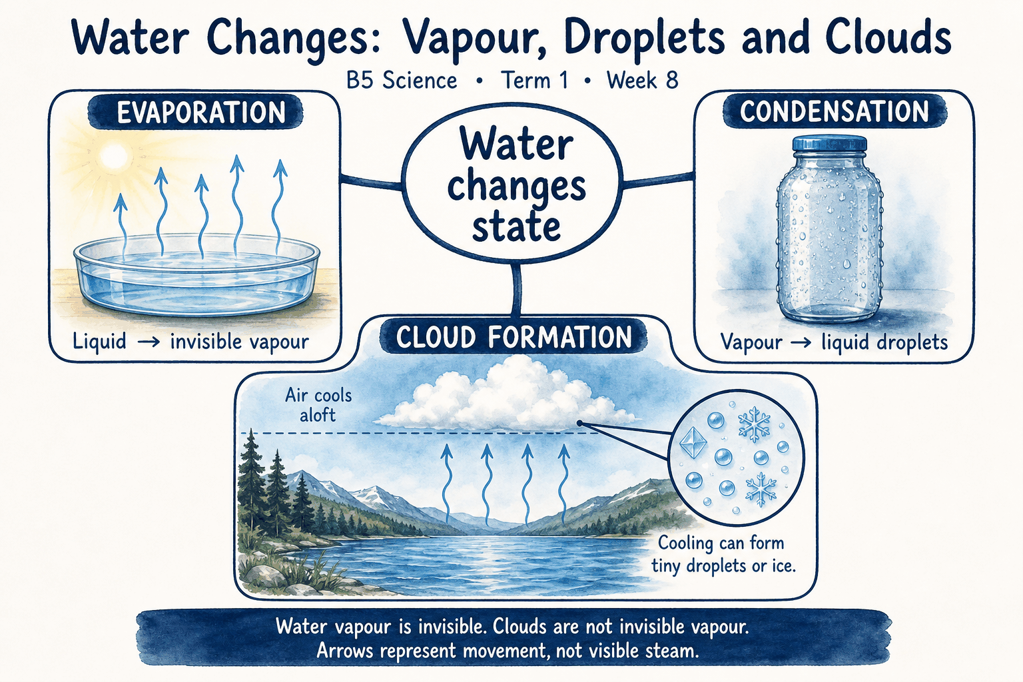
Read each branch, explain the link to the central topic, and add your own example. The separate high-resolution PNG supports projection or larger printing. Concept-map connections do not imply every process occurs in a single linear order.

Week 8 — Practice and assessment

Section A — Multiple-choice questions
Choose ONE correct answer for each question. Each question has four alternatives.
1. Which term best matches this description: movement of liquid water into the air as water vapour from a surface?
A. Crystal growth only B. Evaporation C. Seed reproduction D. Freezing
2. Which term best matches this description: water in gaseous form, normally invisible?
A. Solid salt B. Only ice cubes C. Water vapour D. Visible sand
3. Which term best matches this description: conversion of water vapour into liquid droplets?
A. Combustion B. Condensation C. Germination D. Liquid leaking through intact glass necessarily
4. Which term best matches this description: a decrease in temperature as energy is transferred away?
A. Turning all air into rock B. Cooling C. Unlimited heating D. Creating new water atoms
5. Which term best matches this description: tiny suspended liquid drops forming part of many clouds?
A. Cloud droplets B. Only dry oxygen gas C. Solid sand grains alone D. Empty space
6. Which term best matches this description: small airborne particles on which water can begin condensing?
A. They are all raindrops already B. Condensation nuclei C. They replace water entirely D. They are roots
7. Which term best matches this description: water falling from clouds to Earth, such as rain?
A. Evaporation B. Precipitation C. Underground storage only D. Plant absorption only
8. Which term best matches this description: water flowing over the land surface toward lower areas?
A. Solar reflection B. Atmospheric condensation C. Root respiration D. Runoff
9. Which term best matches this description: entry of water from the surface into soil?
A. Transpiration from leaves B. Freezing above the Sun C. Cloud formation D. Infiltration
10. Which term best matches this description: accumulation of water in places such as rivers, lakes and oceans?
A. Combustion B. Seed dormancy C. Collection D. Pollination
11. Water in a shallow tray gradually decreases under suitable drying conditions. Which process may explain it?
A. Evaporation B. Seed reproduction C. Freezing D. Crystal growth only
12. Which form of water is present in humid air even when no cloud is visible?
A. Solid salt B. Water vapour C. Visible sand D. Only ice cubes
13. Drops form on the outside of a cold sealed bottle. Which process explains them?
A. Condensation B. Liquid leaking through intact glass necessarily C. Germination D. Combustion
14. Moist air rises and its temperature decreases. Which change can promote cloud formation?
A. Turning all air into rock B. Unlimited heating C. Creating new water atoms D. Cooling
15. What makes many clouds visible rather than being entirely invisible vapour?
A. Empty space B. Only dry oxygen gas C. Solid sand grains alone D. Cloud droplets
16. Tiny particles help cloud droplets start forming in moist cooling air. What role do these particles play?
A. They are all raindrops already B. They replace water entirely C. Condensation nuclei D. They are roots
17. Cloud droplets grow sufficiently and fall as rain. Which water-cycle stage is this?
A. Plant absorption only B. Evaporation C. Precipitation D. Underground storage only
18. Rainwater moves along the ground into a stream. Which process is shown?
A. Atmospheric condensation B. Solar reflection C. Runoff D. Root respiration
19. Rainwater soaks into a garden rather than immediately running away. Which process occurs?
A. Infiltration B. Freezing above the Sun C. Cloud formation D. Transpiration from leaves
20. After runoff, water gathers in a reservoir. Which broad water-cycle stage is represented?
A. Seed dormancy B. Pollination C. Combustion D. Collection

Section B — 10 structured essay questions
Answer all parts (a), (b), (c). Write in a separate exercise book. Suggested marks per question: (a) 1, (b) 1, (c) 2, total 4. Use accurate terms and explain relationships or evidence where asked.

Question 1
(a) Explain the term “Evaporation”.
(b) Water in a shallow tray gradually decreases under suitable drying conditions. Which process may explain it?
(c) Explain one alternative cause of falling water level that a fair investigation should exclude.

Question 2
(a) Explain the term “Water vapour”.
(b) Which form of water is present in humid air even when no cloud is visible?
(c) Distinguish humid air from a visible cloud.

Question 3
(a) Explain the term “Condensation”.
(b) Drops form on the outside of a cold sealed bottle. Which process explains them?
(c) Explain the likely source of water on a cold sealed bottle’s outside.

Question 4
(a) Explain the term “Cooling”.
(b) Moist air rises and its temperature decreases. Which change can promote cloud formation?
(c) Explain why cooling and moisture both matter in cloud formation.

Question 5
(a) Explain the term “Cloud droplets”.
(b) What makes many clouds visible rather than being entirely invisible vapour?
(c) Explain why calling a cloud “only water gas” is inaccurate.

Question 6
(a) Explain the term “Condensation nuclei”.
(b) Tiny particles help cloud droplets start forming in moist cooling air. What role do these particles play?
(c) Explain the difference between a supporting particle and the water droplet around it.

Question 7
(a) Explain the term “Precipitation”.
(b) Cloud droplets grow sufficiently and fall as rain. Which water-cycle stage is this?
(c) Explain why the presence of clouds does not guarantee immediate rain.

Question 8
(a) Explain the term “Runoff”.
(b) Rainwater moves along the ground into a stream. Which process is shown?
(c) Distinguish water flowing over the ground from water entering soil.

Question 9
(a) Explain the term “Infiltration”.
(b) Rainwater soaks into a garden rather than immediately running away. Which process occurs?
(c) Explain why paved ground and a garden may respond differently to rainfall.

Question 10
(a) Explain the term “Collection”.
(b) After runoff, water gathers in a reservoir. Which broad water-cycle stage is represented?
(c) Explain why collection is not the final stopping point for all water.

Week 9 — Carbon dioxide: uses and effects
Scheme reference: B5.2.1.4.1. Reference used: B5.2.1.4.1. Direct indicator match; distinguish carbon dioxide from carbon monoxide and avoid unsafe gas demonstrations.

Learning outcomes
- Explain the main ideas in carbon dioxide: uses and effects using accurate vocabulary.
- Use observations or models to identify examples and justify explanations.
- Apply the ideas to a familiar situation, recognise a misconception and state relevant safety precautions.

Teacher lesson notes
Suggested weekly structure: three 40-minute teaching sessions, plus distributed practice and feedback in remaining timetable periods. Adjust to actual lesson periods. The full question bank should not be imposed as one 40-minute task.
Prior-knowledge check: ask learners for a familiar example related to the week. Record what they think happens and why. Retain one initial claim to revisit after the activity.

Session 1 — Observe and define
5 min: retrieve related knowledge; 10 min: show a model, picture or safe specimen; 15 min: pairs record observations and discuss the first five terms; 10 min: check explanations with short oral questions.

Session 2 — Investigate and explain
5 min: recall vocabulary; 10 min: model a justified explanation; 15 min: carry out the specific activity below, recording real observations; 10 min: introduce the remaining terms and compare evidence.

Session 3 — Apply and assess
5 min: revisit an initial misconception; 10 min: explain the map connections; 15 min: attempt selected application questions and structured parts; 10 min: review explanations and plan reteaching or extension.

Topic-specific activity and resources
Use a process chart linking respiration, combustion and photosynthesis. Sort statements about useful roles, greenhouse effects and unsafe high concentrations. Interpret simple pictures of plant growth, a fire extinguisher label and poor ventilation without releasing gases.
Resources: the teacher-selected examples, pictures or apparatus described above; board, pencils, exercise books and the supplied map. If a practical cannot be completed, use a clearly labelled photograph or model and do not report predicted results as observed results.

Safety
No gas production, sealed-space breathing tests or fire-extinguisher discharge by learners. Never enter confined spaces or use burning fuel indoors for demonstrations.

Support, extension and feedback
Support: provide picture labels and a word bank, read unfamiliar words aloud, and let learners explain orally before writing. Extension: compare two related concepts, suggest a counterexample or critique a model. Feedback: ask why a distractor is wrong and use the answer to identify the misconception.

Study notes

Carbon dioxide
A gas containing carbon and oxygen, involved in respiration and photosynthesis.
Plants use carbon dioxide in making sugars. The gas’s useful biological role does not make every concentration safe to breathe.

Photosynthesis
Light-driven production of sugars by green tissues using water and carbon dioxide.
Carbon becomes part of plant material. Plants also respire, so their gas exchanges depend on the processes occurring rather than one simple rule for every moment.

Respiration
Cellular processes releasing usable energy from food.
Carbon dioxide moves from cells into blood and to the lungs for removal. Breathing exchanges air but is not identical to cellular respiration.

Combustion
Burning reactions that can release carbon dioxide from carbon-containing fuels.
Combustion transfers carbon in fuel to gaseous products, often including carbon dioxide. Incomplete burning can also create dangerous carbon monoxide.

Greenhouse gas
A gas that absorbs and emits infrared radiation, affecting Earth’s energy balance.
A natural greenhouse effect helps keep Earth warmer than it would otherwise be. Increasing greenhouse-gas concentrations can enhance warming and disrupt climate.

Ventilation
Exchange of indoor air with suitable fresh air.
Air exchange reduces buildup and can also reduce some other indoor pollutants. It does not make a dangerous confined space automatically safe to enter.

Carbon monoxide
A poisonous gas different from carbon dioxide, often associated with incomplete combustion.
The two names refer to different substances. Burning fuel in poorly ventilated spaces can expose people to carbon monoxide, requiring prevention rather than classroom experimentation.

Fire suppression
Reducing conditions needed for combustion to continue.
Carbon dioxide can reduce oxygen around a fire, but extinguishers have specific uses and hazards. Only trained adults should choose and operate them.

Carbon storage
Retention of carbon in materials such as growing plants and soil.
Some carbon remains in biomass for a period. It can return through respiration, decay or burning, so storage is part of a cycle rather than permanent disappearance.

Emission reduction
Lowering the release of a substance into the environment.
Avoiding unnecessary burning reduces pollution at its source. Safe waste management and efficient energy use are practical supporting measures.
Independent study: reconstruct the map from memory, give a fresh example for three branches and answer one explanation question without copying the notes. Correct errors after discussing the reason with a teacher or partner.

Week 9 — Visual mind-map
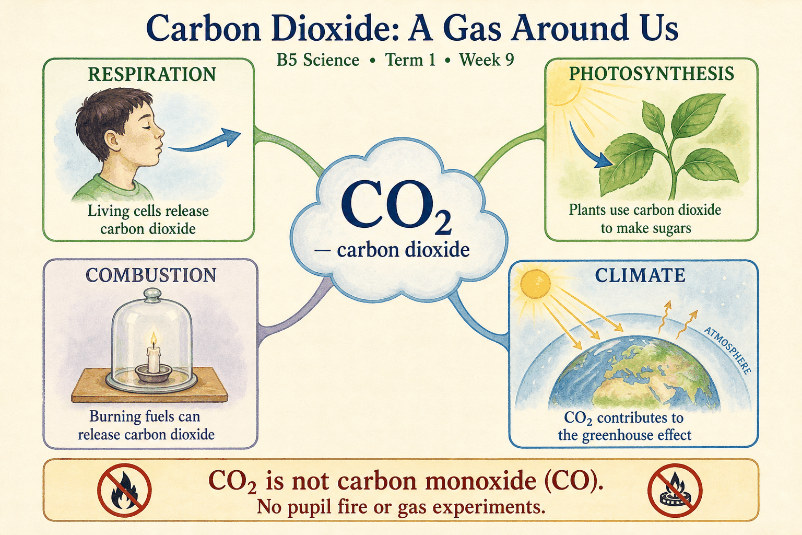
Read each branch, explain the link to the central topic, and add your own example. The separate high-resolution PNG supports projection or larger printing. Concept-map connections do not imply every process occurs in a single linear order.

Week 9 — Practice and assessment

Section A — Multiple-choice questions
Choose ONE correct answer for each question. Each question has four alternatives.
1. Which term best matches this description: a gas containing carbon and oxygen, involved in respiration and photosynthesis?
A. Hydrogen only B. Helium C. Carbon dioxide D. Carbon monoxide
2. Which term best matches this description: light-driven production of sugars by green tissues using water and carbon dioxide?
A. Burning dry wood B. Photosynthesis C. Rusting of iron D. Animal breathing out
3. Which term best matches this description: cellular processes releasing usable energy from food?
A. Condensing clouds B. Melting ice C. Freezing water D. Respiration
4. Which term best matches this description: burning reactions that can release carbon dioxide from carbon-containing fuels?
A. Combustion B. Condensation only C. Freezing of pure water D. Germination without respiration
5. Which term best matches this description: a gas that absorbs and emits infrared radiation, affecting Earth’s energy balance?
A. Greenhouse gas B. It is chemically identical to oxygen C. It removes all sunlight D. It is only an opaque solid roof
6. Which term best matches this description: exchange of indoor air with suitable fresh air?
A. Adding smoke B. Breathing into closed bags C. Ventilation D. Sealing every opening indefinitely
7. Which term best matches this description: a poisonous gas different from carbon dioxide, often associated with incomplete combustion?
A. Carbon monoxide B. Pure oxygen C. Nitrogen alone D. Water vapour only
8. Which term best matches this description: reducing conditions needed for combustion to continue?
A. Making water drinkable B. Increasing oxygen supply C. Fire suppression D. Feeding a plant directly
9. Which term best matches this description: retention of carbon in materials such as growing plants and soil?
A. Removal of all atmospheric gases B. Production of metal C. Instant creation of carbon from nothing D. Carbon storage
10. Which term best matches this description: lowering the release of a substance into the environment?
A. Ignoring fuel use B. Emission reduction C. Blocking all photosynthesis D. Creating more smoke
11. Which gas is taken in as a carbon source when a green leaf photosynthesises?
A. Carbon monoxide B. Hydrogen only C. Carbon dioxide D. Helium
12. Which process removes carbon dioxide from the air while green plants make food in suitable conditions?
A. Burning dry wood B. Photosynthesis C. Rusting of iron D. Animal breathing out
13. Which process in human cells produces carbon dioxide as a common waste of aerobic food-energy release?
A. Freezing water B. Condensing clouds C. Respiration D. Melting ice
14. Which process can release carbon dioxide when charcoal burns?
A. Condensation only B. Freezing of pure water C. Combustion D. Germination without respiration
15. Which role does carbon dioxide play in the atmosphere’s heat-related energy balance?
A. It is chemically identical to oxygen B. It removes all sunlight C. It is only an opaque solid roof D. Greenhouse gas
16. A crowded room needs adequate fresh-air exchange. Which practice helps prevent excessive accumulation of exhaled gases?
A. Sealing every opening indefinitely B. Adding smoke C. Ventilation D. Breathing into closed bags
17. Which dangerous gas may be produced by incompletely burning fuel and must not be confused with carbon dioxide?
A. Water vapour only B. Carbon monoxide C. Pure oxygen D. Nitrogen alone
18. A correctly selected carbon-dioxide extinguisher may suppress an appropriate fire. What purpose is being served?
A. Fire suppression B. Increasing oxygen supply C. Making water drinkable D. Feeding a plant directly
19. A tree incorporates carbon into its growing tissues. Which role is illustrated?
A. Carbon storage B. Instant creation of carbon from nothing C. Production of metal D. Removal of all atmospheric gases
20. Reducing unnecessary burning of waste can reduce releases of carbon dioxide and other pollutants. Which broad action is this?
A. Blocking all photosynthesis B. Creating more smoke C. Ignoring fuel use D. Emission reduction

Section B — 10 structured essay questions
Answer all parts (a), (b), (c). Write in a separate exercise book. Suggested marks per question: (a) 1, (b) 1, (c) 2, total 4. Use accurate terms and explain relationships or evidence where asked.

Question 1
(a) Explain the term “Carbon dioxide”.
(b) Which gas is taken in as a carbon source when a green leaf photosynthesises?
(c) Explain why a gas can be useful to plants and still be unsafe in excess for people.

Question 2
(a) Explain the term “Photosynthesis”.
(b) Which process removes carbon dioxide from the air while green plants make food in suitable conditions?
(c) Explain the role of carbon dioxide in plant food production.

Question 3
(a) Explain the term “Respiration”.
(b) Which process in human cells produces carbon dioxide as a common waste of aerobic food-energy release?
(c) Trace how carbon dioxide produced in cells leaves a person’s body.

Question 4
(a) Explain the term “Combustion”.
(b) Which process can release carbon dioxide when charcoal burns?
(c) Explain why charcoal burning indoors is unsafe beyond merely producing carbon dioxide.

Question 5
(a) Explain the term “Greenhouse gas”.
(b) Which role does carbon dioxide play in the atmosphere’s heat-related energy balance?
(c) Distinguish a useful natural effect from problems caused by increasing its strength.

Question 6
(a) Explain the term “Ventilation”.
(b) A crowded room needs adequate fresh-air exchange. Which practice helps prevent excessive accumulation of exhaled gases?
(c) Explain why ventilation matters in an occupied classroom.

Question 7
(a) Explain the term “Carbon monoxide”.
(b) Which dangerous gas may be produced by incompletely burning fuel and must not be confused with carbon dioxide?
(c) Explain why similar names do not mean two gases have the same effects.

Question 8
(a) Explain the term “Fire suppression”.
(b) A correctly selected carbon-dioxide extinguisher may suppress an appropriate fire. What purpose is being served?
(c) Explain why knowing a gas can suppress some fires does not authorise pupils to use an extinguisher.

Question 9
(a) Explain the term “Carbon storage”.
(b) A tree incorporates carbon into its growing tissues. Which role is illustrated?
(c) Explain how stored plant carbon can later return to the atmosphere.

Question 10
(a) Explain the term “Emission reduction”.
(b) Reducing unnecessary burning of waste can reduce releases of carbon dioxide and other pollutants. Which broad action is this?
(c) Give two actions that can reduce unnecessary releases from burning.

Week 10 — Protecting water and keeping air cleaner
Scheme reference: B5.2.1.5.1–2. Reference used: B5.2.1.5.1–2. Direct indicator match; community actions are taught without unsafe field sampling.

Learning outcomes
- Explain the main ideas in protecting water and keeping air cleaner using accurate vocabulary.
- Use observations or models to identify examples and justify explanations.
- Apply the ideas to a familiar situation, recognise a misconception and state relevant safety precautions.

Teacher lesson notes
Suggested weekly structure: three 40-minute teaching sessions, plus distributed practice and feedback in remaining timetable periods. Adjust to actual lesson periods. The full question bank should not be imposed as one 40-minute task.
Prior-knowledge check: ask learners for a familiar example related to the week. Record what they think happens and why. Retain one initial claim to revisit after the activity.

Session 1 — Observe and define
5 min: retrieve related knowledge; 10 min: show a model, picture or safe specimen; 15 min: pairs record observations and discuss the first five terms; 10 min: check explanations with short oral questions.

Session 2 — Investigate and explain
5 min: recall vocabulary; 10 min: model a justified explanation; 15 min: carry out the specific activity below, recording real observations; 10 min: introduce the remaining terms and compare evidence.

Session 3 — Apply and assess
5 min: revisit an initial misconception; 10 min: explain the map connections; 15 min: attempt selected application questions and structured parts; 10 min: review explanations and plan reteaching or extension.

Topic-specific activity and resources
Use pictures of waste dumping, runoff, smoke, dusty roads, clean drains and protected water containers. Create a source–pathway–effect–prevention table. Design a school poster recommending achievable actions and identify hazards that require adults or authorities.
Resources: the teacher-selected examples, pictures or apparatus described above; board, pencils, exercise books and the supplied map. If a practical cannot be completed, use a clearly labelled photograph or model and do not report predicted results as observed results.

Safety
No collecting sewage, entering drains, touching chemical containers or standing beside smoke or heavy traffic. Any clean-up must be adult-supervised and exclude hazardous waste.

Support, extension and feedback
Support: provide picture labels and a word bank, read unfamiliar words aloud, and let learners explain orally before writing. Extension: compare two related concepts, suggest a counterexample or critique a model. Feedback: ask why a distractor is wrong and use the answer to identify the misconception.

Study notes

Water pollution
Contamination making water harmful or unsuitable for intended uses.
Pollution may include microbes, chemicals or excess materials. A change may be harmful even when the water still looks clear.

Sewage
Wastewater that may contain human waste and disease-causing organisms.
Human-waste contamination can transmit disease. Treatment and sanitation should prevent it reaching drinking-water sources.

Runoff pollution
Movement of pollutants into water as water flows over land.
Materials on the land can travel with runoff. Appropriate use, storage and protective practices can reduce entry into water.

Oil contamination
Introduction of oil into water or soil where it can cause harm.
Oil can harm organisms and is difficult to remove fully. Correct collection and disposal prevent a problem that is harder to solve afterward.

Air pollution
Presence of harmful substances or particles in the air.
Smoke can contain harmful particles and gases. Avoiding unnecessary burning reduces exposure rather than relying on people to tolerate it.

Particulate matter
Small solid or liquid particles suspended in air.
Small particles can enter the airways. Some are too small to see individually, so lack of obvious visible dust does not prove clean air.

Source control
Preventing or reducing pollution where it is produced.
Reducing the source protects more people and places. Downstream protective measures alone may leave the original hazard unchanged.

Proper waste disposal
Handling discarded materials through appropriate collection, treatment or safe disposal routes.
Keeping waste out of drains reduces blockages and movement into water. Hazardous materials need specialised handling beyond ordinary litter collection.

Ventilation
Exchange of air to reduce indoor accumulation of pollutants when outdoor conditions are suitable.
Air exchange can help indoor conditions, but outdoor smoke may require additional source-control and school safety decisions. Ventilation is not a licence for indoor burning.

Community responsibility
Coordinated actions by people and authorities to protect shared resources.
Shared sources can be affected by many users. Cooperation, reporting hazards and safe routines protect people beyond one household.
Independent study: reconstruct the map from memory, give a fresh example for three branches and answer one explanation question without copying the notes. Correct errors after discussing the reason with a teacher or partner.

Week 10 — Visual mind-map
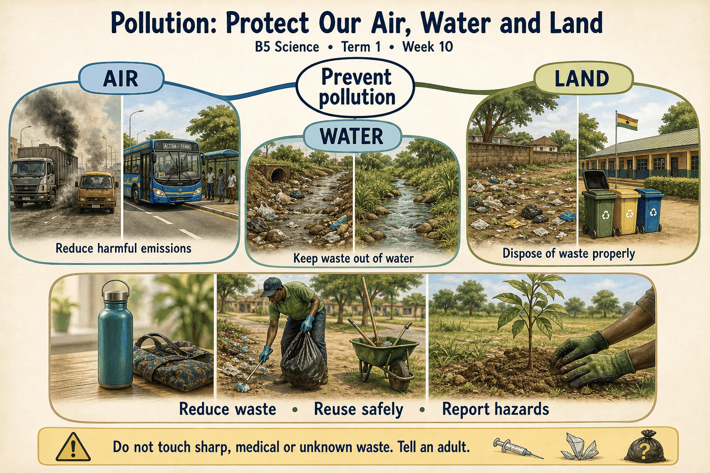
Read each branch, explain the link to the central topic, and add your own example. The separate high-resolution PNG supports projection or larger printing. Concept-map connections do not imply every process occurs in a single linear order.

Week 10 — Practice and assessment

Section A — Multiple-choice questions
Choose ONE correct answer for each question. Each question has four alternatives.
1. Which term best matches this description: contamination making water harmful or unsuitable for intended uses?
A. Photosynthesis B. Seed germination C. Safe storage D. Water pollution
2. Which term best matches this description: wastewater that may contain human waste and disease-causing organisms?
A. Sewage B. Clean labelled drinking water C. Unopened bottled water D. A dry paper label
3. Which term best matches this description: movement of pollutants into water as water flows over land?
A. Sunlight reflection B. Water disappearing from existence C. Runoff pollution D. Plant flowering
4. Which term best matches this description: introduction of oil into water or soil where it can cause harm?
A. Oil contamination B. Increased oxygen production by oil C. Automatic water purification D. Safer drinking water
5. Which term best matches this description: presence of harmful substances or particles in the air?
A. Clean-air protection B. Cloud-free weather only C. Safe ventilation by itself D. Air pollution
6. Which term best matches this description: small solid or liquid particles suspended in air?
A. Water in a sealed bottle B. Only visible rocks on the ground C. Particulate matter D. Pure sunlight
7. Which term best matches this description: preventing or reducing pollution where it is produced?
A. Ignoring the cause B. Source control C. Spreading pollution elsewhere D. Creating a new smoke source
8. Which term best matches this description: handling discarded materials through appropriate collection, treatment or safe disposal routes?
A. Open dumping B. Proper waste disposal C. Deliberate water contamination D. Uncontrolled burning
9. Which term best matches this description: exchange of air to reduce indoor accumulation of pollutants when outdoor conditions are suitable?
A. Ventilation B. Adding dust C. Sealing in smoke D. Burning fuel inside
10. Which term best matches this description: coordinated actions by people and authorities to protect shared resources?
A. Unplanned dumping B. Community responsibility C. Private ownership of all air D. One person ignoring everyone else
11. Wastewater enters a stream used by a community. Which environmental problem is illustrated?
A. Safe storage B. Photosynthesis C. Water pollution D. Seed germination
12. Which discharge poses a particular microbial risk if released untreated into a stream?
A. Clean labelled drinking water B. Sewage C. A dry paper label D. Unopened bottled water
13. Rain carries fertiliser from a field into a nearby stream. Which pathway is shown?
A. Sunlight reflection B. Plant flowering C. Water disappearing from existence D. Runoff pollution
14. Used oil is poured into a drain leading toward water. What pollution risk is created?
A. Increased oxygen production by oil B. Safer drinking water C. Oil contamination D. Automatic water purification
15. Smoke from open waste burning enters a classroom. Which environmental problem occurs?
A. Safe ventilation by itself B. Cloud-free weather only C. Clean-air protection D. Air pollution
16. Dust and fine smoke particles can be breathed into the respiratory system. What general pollutant category is involved?
A. Particulate matter B. Water in a sealed bottle C. Only visible rocks on the ground D. Pure sunlight
17. A school prevents open burning instead of only closing windows when smoke arrives. Which approach is used?
A. Source control B. Spreading pollution elsewhere C. Creating a new smoke source D. Ignoring the cause
18. Rubbish is put into designated collection rather than a drain. Which practice is shown?
A. Proper waste disposal B. Open dumping C. Deliberate water contamination D. Uncontrolled burning
19. A classroom receives suitable fresh air rather than trapping indoor fumes. Which practice is shown?
A. Adding dust B. Ventilation C. Burning fuel inside D. Sealing in smoke
20. Families, schools and local authorities cooperate to protect a water source. Which idea is illustrated?
A. One person ignoring everyone else B. Private ownership of all air C. Unplanned dumping D. Community responsibility

Section B — 10 structured essay questions
Answer all parts (a), (b), (c). Write in a separate exercise book. Suggested marks per question: (a) 1, (b) 1, (c) 2, total 4. Use accurate terms and explain relationships or evidence where asked.

Question 1
(a) Explain the term “Water pollution”.
(b) Wastewater enters a stream used by a community. Which environmental problem is illustrated?
(c) Explain why appearance alone cannot establish that stream water is safe.

Question 2
(a) Explain the term “Sewage”.
(b) Which discharge poses a particular microbial risk if released untreated into a stream?
(c) Explain why untreated human wastewater must be kept away from water supplies.

Question 3
(a) Explain the term “Runoff pollution”.
(b) Rain carries fertiliser from a field into a nearby stream. Which pathway is shown?
(c) Explain how pollution can reach a stream even without direct dumping into it.

Question 4
(a) Explain the term “Oil contamination”.
(b) Used oil is poured into a drain leading toward water. What pollution risk is created?
(c) Explain why prevention is preferable to trying to clean a polluted stream later.

Question 5
(a) Explain the term “Air pollution”.
(b) Smoke from open waste burning enters a classroom. Which environmental problem occurs?
(c) Explain why smoke should not be treated as harmless simply because it disperses.

Question 6
(a) Explain the term “Particulate matter”.
(b) Dust and fine smoke particles can be breathed into the respiratory system. What general pollutant category is involved?
(c) Explain why invisible particles can still be a health concern.

Question 7
(a) Explain the term “Source control”.
(b) A school prevents open burning instead of only closing windows when smoke arrives. Which approach is used?
(c) Explain an advantage of reducing pollution at its source.

Question 8
(a) Explain the term “Proper waste disposal”.
(b) Rubbish is put into designated collection rather than a drain. Which practice is shown?
(c) Explain why pupils should not collect unknown chemical waste during a clean-up.

Question 9
(a) Explain the term “Ventilation”.
(b) A classroom receives suitable fresh air rather than trapping indoor fumes. Which practice is shown?
(c) Explain why ventilation does not make indoor charcoal burning an acceptable classroom activity.

Question 10
(a) Explain the term “Community responsibility”.
(b) Families, schools and local authorities cooperate to protect a water source. Which idea is illustrated?
(c) Give one suitable pupil action and one action requiring adults or authorities.

Week 11 — How plant structures suit their functions
Scheme reference: B5.2.2.1.1. Reference used: B5.2.2.1.1. Direct indicator match; this grade emphasises structure–function relationships rather than labels alone.

Learning outcomes
- Explain the main ideas in how plant structures suit their functions using accurate vocabulary.
- Use observations or models to identify examples and justify explanations.
- Apply the ideas to a familiar situation, recognise a misconception and state relevant safety precautions.

Teacher lesson notes
Suggested weekly structure: three 40-minute teaching sessions, plus distributed practice and feedback in remaining timetable periods. Adjust to actual lesson periods. The full question bank should not be imposed as one 40-minute task.
Prior-knowledge check: ask learners for a familiar example related to the week. Record what they think happens and why. Retain one initial claim to revisit after the activity.

Session 1 — Observe and define
5 min: retrieve related knowledge; 10 min: show a model, picture or safe specimen; 15 min: pairs record observations and discuss the first five terms; 10 min: check explanations with short oral questions.

Session 2 — Investigate and explain
5 min: recall vocabulary; 10 min: model a justified explanation; 15 min: carry out the specific activity below, recording real observations; 10 min: introduce the remaining terms and compare evidence.

Session 3 — Apply and assess
5 min: revisit an initial misconception; 10 min: explain the map connections; 15 min: attempt selected application questions and structured parts; 10 min: review explanations and plan reteaching or extension.

Topic-specific activity and resources
Observe leaf shape, veins, stem support, branching roots and flowers from safe specimens or pictures. For each, complete “structure → function → benefit”. Produce a labelled drawing with two written explanations, and compare plants without claiming every species has identical structures.
Resources: the teacher-selected examples, pictures or apparatus described above; board, pencils, exercise books and the supplied map. If a practical cannot be completed, use a clearly labelled photograph or model and do not report predicted results as observed results.

Safety
Avoid unknown sap and thorns. Do not taste plant parts or uproot protected plants. Use teacher-selected specimens.

Support, extension and feedback
Support: provide picture labels and a word bank, read unfamiliar words aloud, and let learners explain orally before writing. Extension: compare two related concepts, suggest a counterexample or critique a model. Feedback: ask why a distractor is wrong and use the answer to identify the misconception.

Study notes

Leaf blade
The broad expanded part of many leaves that exposes surface to light.
A broad surface can intercept light, although leaf shapes vary with species and conditions. Surface area is one adaptation, not a universal identical design.

Leaf veins
Transport and supporting structures running through a leaf.
Veins connect with transport pathways in the stem and help distribute water and products. Their arrangement can also provide physical support.

Stomata
Small openings involved in leaf gas exchange and water-vapour loss.
Gas exchange supports photosynthesis and respiration. Openings also allow water loss, so regulation is important.

Root hairs
Small root-surface extensions increasing contact area with soil water.
Many small extensions contact water around soil particles. They differ from large lateral roots even though both contribute to a root system’s effectiveness.

Branching roots
A spreading root arrangement reaching more soil and providing anchorage.
A wider spread explores more soil and supports the plant. The arrangement still needs suitable water and oxygen conditions to function well.

Stem support
The role of a stem in holding leaves and reproductive structures in useful positions.
Positioning leaves can improve light access and hold flowers for reproduction. Support works together with transport, not instead of it.

Xylem
Plant tissue mainly transporting water and dissolved minerals from roots.
The transport system connects roots and aerial organs. Naming the tissue does not mean the stem contains ordinary open drinking straws of the same scale as the model.

Phloem
Plant tissue transporting sugars and other organic materials between sources and sinks.
Sugar can move from producing regions to places needing or storing it. This differs from the principal water-and-mineral role of xylem.

Petal
A flower part that can help attract pollinators in many species.
Colour or scent may help attract pollinators, but not every flower relies on bright petals. Wind-pollinated plants can have less conspicuous flowers.

Seed dispersal
Movement of seeds away from the parent plant.
Dispersal can reduce local competition and help reach new suitable places. Success still depends on later conditions for survival and germination.
Independent study: reconstruct the map from memory, give a fresh example for three branches and answer one explanation question without copying the notes. Correct errors after discussing the reason with a teacher or partner.

Week 11 — Visual mind-map
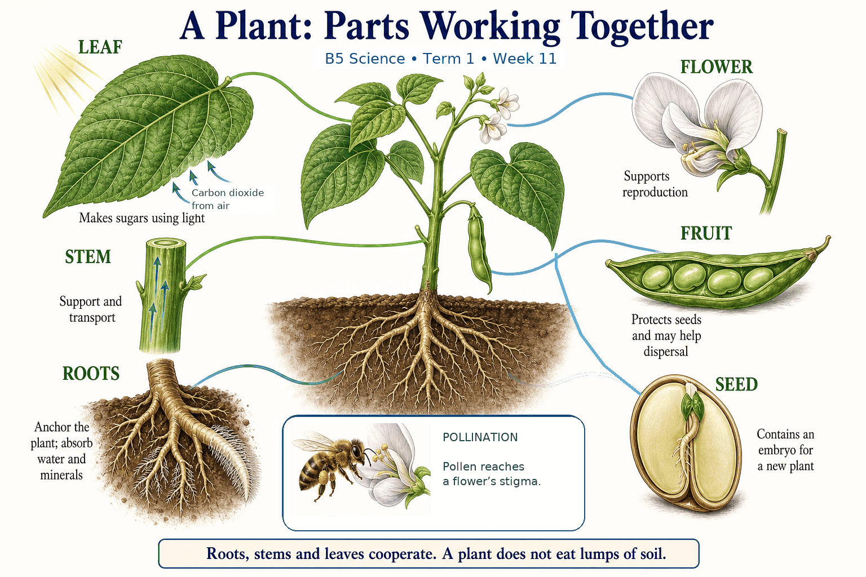
Read each branch, explain the link to the central topic, and add your own example. The separate high-resolution PNG supports projection or larger printing. Concept-map connections do not imply every process occurs in a single linear order.

Week 11 — Practice and assessment

Section A — Multiple-choice questions
Choose ONE correct answer for each question. Each question has four alternatives.
1. Which term best matches this description: the broad expanded part of many leaves that exposes surface to light?
A. A narrow root hair only B. Leaf blade C. A seed jar D. A fruit stone only
2. Which term best matches this description: transport and supporting structures running through a leaf?
A. Seed coats B. Petal colours C. Leaf veins D. Loose soil
3. Which term best matches this description: small openings involved in leaf gas exchange and water-vapour loss?
A. Large fruit pits B. Stomata C. Seed labels D. Wooden stakes
4. Which term best matches this description: small root-surface extensions increasing contact area with soil water?
A. Flower petals B. Root hairs C. Stem thorns only D. Fruit pulp
5. Which term best matches this description: a spreading root arrangement reaching more soil and providing anchorage?
A. Branching roots B. A cloud layer C. A paper label D. A single detached petal
6. Which term best matches this description: the role of a stem in holding leaves and reproductive structures in useful positions?
A. Stem support B. Only dispersing seeds by wind C. Only making pollen D. Only storing rain outside the plant
7. Which term best matches this description: plant tissue mainly transporting water and dissolved minerals from roots?
A. Antennae B. Xylem C. Petal pigment D. Seed coat only
8. Which term best matches this description: plant tissue transporting sugars and other organic materials between sources and sinks?
A. Root soil particles B. Only external bark colour C. Pollen grains D. Phloem
9. Which term best matches this description: a flower part that can help attract pollinators in many species?
A. Root hair B. Leaf vein only C. Main underground root D. Petal
10. Which term best matches this description: movement of seeds away from the parent plant?
A. Only stem stiffening B. Only leaf gas exchange C. Seed dispersal D. Only water absorption
11. Which leaf structure commonly provides a broad area for capturing light?
A. A fruit stone only B. A narrow root hair only C. A seed jar D. Leaf blade
12. A network within a leaf carries materials and helps support the blade. What is it?
A. Loose soil B. Seed coats C. Leaf veins D. Petal colours
13. Through which structures can carbon dioxide enter many leaves?
A. Stomata B. Wooden stakes C. Large fruit pits D. Seed labels
14. Which structures help a root absorb water efficiently by increasing surface area?
A. Flower petals B. Stem thorns only C. Root hairs D. Fruit pulp
15. A root system extends in several directions through the soil. Which structural feature helps it reach resources?
A. A paper label B. A cloud layer C. Branching roots D. A single detached petal
16. A firm stem raises leaves into better light. Which role is demonstrated?
A. Only storing rain outside the plant B. Stem support C. Only making pollen D. Only dispersing seeds by wind
17. Which internal pathway carries much of the absorbed water toward leaves?
A. Petal pigment B. Xylem C. Antennae D. Seed coat only
18. Which tissue moves food made in leaves toward growing or storage parts?
A. Root soil particles B. Only external bark colour C. Pollen grains D. Phloem
19. A brightly coloured flower structure attracts visiting insects. Which part is likely involved?
A. Leaf vein only B. Root hair C. Petal D. Main underground root
20. A fruit’s structure helps an animal carry seeds away. Which function is supported?
A. Only stem stiffening B. Only leaf gas exchange C. Seed dispersal D. Only water absorption

Section B — 10 structured essay questions
Answer all parts (a), (b), (c). Write in a separate exercise book. Suggested marks per question: (a) 1, (b) 1, (c) 2, total 4. Use accurate terms and explain relationships or evidence where asked.

Question 1
(a) Explain the term “Leaf blade”.
(b) Which leaf structure commonly provides a broad area for capturing light?
(c) Explain how a broad leaf surface can support photosynthesis.

Question 2
(a) Explain the term “Leaf veins”.
(b) A network within a leaf carries materials and helps support the blade. What is it?
(c) State two roles of a leaf’s vein system.

Question 3
(a) Explain the term “Stomata”.
(b) Through which structures can carbon dioxide enter many leaves?
(c) Explain one benefit and one water-related cost of leaf openings.

Question 4
(a) Explain the term “Root hairs”.
(b) Which structures help a root absorb water efficiently by increasing surface area?
(c) Explain the link between surface area and absorption.

Question 5
(a) Explain the term “Branching roots”.
(b) A root system extends in several directions through the soil. Which structural feature helps it reach resources?
(c) Explain two benefits of spreading roots.

Question 6
(a) Explain the term “Stem support”.
(b) A firm stem raises leaves into better light. Which role is demonstrated?
(c) Explain why support and transport must operate together.

Question 7
(a) Explain the term “Xylem”.
(b) Which internal pathway carries much of the absorbed water toward leaves?
(c) Trace a water pathway through the plant and state one limit of a straw model.

Question 8
(a) Explain the term “Phloem”.
(b) Which tissue moves food made in leaves toward growing or storage parts?
(c) Distinguish the main transported materials in xylem and phloem.

Question 9
(a) Explain the term “Petal”.
(b) A brightly coloured flower structure attracts visiting insects. Which part is likely involved?
(c) Explain why bright petals are useful in some flowers but not necessary in all flowers.

Question 10
(a) Explain the term “Seed dispersal”.
(b) A fruit’s structure helps an animal carry seeds away. Which function is supported?
(c) Explain how a fruit’s structure can benefit seeds after they leave the parent.

Week 12 — Comparing bean and maize germination
Scheme reference: B5.2.2.1.2. Reference used: B5.2.2.1.2. Direct indicator match. Common bean and maize observations are used without generalising to every bean species or every germination pattern.

Learning outcomes
- Explain the main ideas in comparing bean and maize germination using accurate vocabulary.
- Use observations or models to identify examples and justify explanations.
- Apply the ideas to a familiar situation, recognise a misconception and state relevant safety precautions.

Teacher lesson notes
Suggested weekly structure: three 40-minute teaching sessions, plus distributed practice and feedback in remaining timetable periods. Adjust to actual lesson periods. The full question bank should not be imposed as one 40-minute task.
Prior-knowledge check: ask learners for a familiar example related to the week. Record what they think happens and why. Retain one initial claim to revisit after the activity.

Session 1 — Observe and define
5 min: retrieve related knowledge; 10 min: show a model, picture or safe specimen; 15 min: pairs record observations and discuss the first five terms; 10 min: check explanations with short oral questions.

Session 2 — Investigate and explain
5 min: recall vocabulary; 10 min: model a justified explanation; 15 min: carry out the specific activity below, recording real observations; 10 min: introduce the remaining terms and compare evidence.

Session 3 — Apply and assess
5 min: revisit an initial misconception; 10 min: explain the map connections; 15 min: attempt selected application questions and structured parts; 10 min: review explanations and plan reteaching or extension.

Topic-specific activity and resources
Set up several viable common-bean and maize seeds under similar suitable moisture, air and warmth. Record daily drawings and emergence dates. Compare cotyledons, food reserves, first root, protected shoot and the position of seed leaves during early growth. Use photographs if time is too short to complete observation.
Resources: the teacher-selected examples, pictures or apparatus described above; board, pencils, exercise books and the supplied map. If a practical cannot be completed, use a clearly labelled photograph or model and do not report predicted results as observed results.

Safety
No tasting treated or experimental seeds. Avoid mould and excessive water. Do not claim predicted observations were actually measured; label photographs and supplied data clearly.

Support, extension and feedback
Support: provide picture labels and a word bank, read unfamiliar words aloud, and let learners explain orally before writing. Extension: compare two related concepts, suggest a counterexample or critique a model. Feedback: ask why a distractor is wrong and use the answer to identify the misconception.

Study notes

Cotyledon
A seed leaf whose number and role help distinguish bean and maize seeds.
Common bean has two cotyledons, which hold important food reserves. Maize has one cotyledon with a different role in obtaining stored food.

Two cotyledons
The usual cotyledon count in a common bean embryo.
Two seed leaves are characteristic of this example. The count should not be confused with the number of later foliage leaves.

One cotyledon
The usual cotyledon count in a maize embryo.
Maize’s single cotyledon is specialised in transferring food from reserves to the growing embryo. It does not mean the mature plant has only one leaf.

Endosperm
Food-storage tissue that remains important in a maize grain.
Maize retains substantial reserves in endosperm, while common bean stores much in cotyledons. Both use reserves before photosynthesis supplies enough food.

Radicle
The embryonic root emerging early in germination.
Root development begins establishing uptake and anchorage. Later root arrangements may differ between the plants.

Plumule
The embryonic shoot that develops toward foliage.
The shoot eventually supports photosynthetic leaves. Its emergence is distinct from the initial root’s role.

Coleoptile
A protective sheath surrounding the young grass shoot in maize.
The sheath protects delicate shoot tissues during emergence. It is a feature of the maize example, not a second cotyledon.

Epigeal germination
A pattern in which cotyledons are carried above the ground during emergence.
Elongation below the cotyledons lifts them in this example. The pattern should be confirmed by observations rather than assumed for every plant called a bean.

Hypogeal germination
A pattern in which cotyledon position remains below the ground during emergence.
The seed leaf is not lifted as in the common-bean example. Shoot emergence does not require every seed part to move above the soil.

Fair comparison
An investigation using comparable conditions while examining a chosen difference.
Comparable conditions reduce confounding, and several seeds reveal variation. Real observations should be recorded rather than replaced by an expected textbook sequence.
Independent study: reconstruct the map from memory, give a fresh example for three branches and answer one explanation question without copying the notes. Correct errors after discussing the reason with a teacher or partner.

Week 12 — Visual mind-map
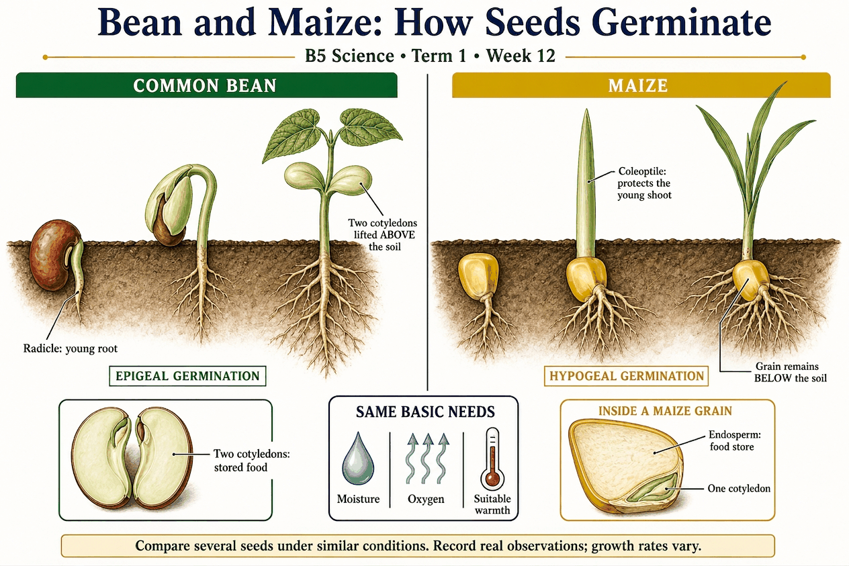
Read each branch, explain the link to the central topic, and add your own example. The separate high-resolution PNG supports projection or larger printing. Concept-map connections do not imply every process occurs in a single linear order.

Week 12 — Practice and assessment

Section A — Multiple-choice questions
Choose ONE correct answer for each question. Each question has four alternatives.
1. Which term best matches this description: a seed leaf whose number and role help distinguish bean and maize seeds?
A. Cotyledon B. Petal C. Root hair D. Pollen grain
2. Which term best matches this description: the usual cotyledon count in a common bean embryo?
A. Ten cotyledons B. One cotyledon C. No embryo D. Two cotyledons
3. Which term best matches this description: the usual cotyledon count in a maize embryo?
A. One cotyledon B. Four cotyledons C. No cotyledon D. Two cotyledons
4. Which term best matches this description: food-storage tissue that remains important in a maize grain?
A. Leaf hairs B. Outer soil C. Endosperm D. Flower petals
5. Which term best matches this description: the embryonic root emerging early in germination?
A. Radicle B. Fruit stalk C. Pollen tube D. Petal
6. Which term best matches this description: the embryonic shoot that develops toward foliage?
A. Plumule B. Petal colour C. Seed container D. Soil particle
7. Which term best matches this description: a protective sheath surrounding the young grass shoot in maize?
A. A fruit’s ripe flesh B. Coleoptile C. A root nodule only D. A bean flower petal
8. Which term best matches this description: a pattern in which cotyledons are carried above the ground during emergence?
A. Seed dispersal B. Pollination C. Hypogeal germination D. Epigeal germination
9. Which term best matches this description: a pattern in which cotyledon position remains below the ground during emergence?
A. Epigeal germination B. Combustion C. Fruit ripening D. Hypogeal germination
10. Which term best matches this description: an investigation using comparable conditions while examining a chosen difference?
A. Changing all conditions B. Using only one guessed result C. Mixing up labels D. Fair comparison
11. What is the general name for each of the two fleshy seed leaves in a common bean?
A. Cotyledon B. Root hair C. Pollen grain D. Petal
12. How many seed leaves are normally present in a common bean seed?
A. No embryo B. One cotyledon C. Ten cotyledons D. Two cotyledons
13. How many cotyledons does a maize embryo normally have?
A. Four cotyledons B. Two cotyledons C. One cotyledon D. No cotyledon
14. Which tissue provides much of the stored food used by a germinating maize embryo?
A. Outer soil B. Leaf hairs C. Flower petals D. Endosperm
15. Which young structure commonly appears early in both germinating bean and maize?
A. Radicle B. Fruit stalk C. Petal D. Pollen tube
16. Which part of the embryo develops into the young shoot in both plants?
A. Seed container B. Soil particle C. Plumule D. Petal colour
17. Which structure protects the emerging maize shoot as it grows upward?
A. Coleoptile B. A root nodule only C. A fruit’s ripe flesh D. A bean flower petal
18. Common bean seedlings often lift their seed leaves above the soil. Which pattern is shown?
A. Hypogeal germination B. Pollination C. Epigeal germination D. Seed dispersal
19. In maize, the cotyledon remains associated with the grain below ground as the shoot emerges. Which pattern fits?
A. Combustion B. Epigeal germination C. Hypogeal germination D. Fruit ripening
20. Bean and maize seeds are compared with similar moisture, air and temperature, using several seeds each. Which design feature is strengthened?
A. Using only one guessed result B. Fair comparison C. Mixing up labels D. Changing all conditions

Section B — 10 structured essay questions
Answer all parts (a), (b), (c). Write in a separate exercise book. Suggested marks per question: (a) 1, (b) 1, (c) 2, total 4. Use accurate terms and explain relationships or evidence where asked.

Question 1
(a) Explain the term “Cotyledon”.
(b) What is the general name for each of the two fleshy seed leaves in a common bean?
(c) Compare cotyledon number in common bean and maize.

Question 2
(a) Explain the term “Two cotyledons”.
(b) How many seed leaves are normally present in a common bean seed?
(c) Explain why counting later leaves is not the same as counting seed leaves.

Question 3
(a) Explain the term “One cotyledon”.
(b) How many cotyledons does a maize embryo normally have?
(c) Explain why maize having one cotyledon does not limit it to one adult leaf.

Question 4
(a) Explain the term “Endosperm”.
(b) Which tissue provides much of the stored food used by a germinating maize embryo?
(c) Compare the main reserve locations in these two seeds.

Question 5
(a) Explain the term “Radicle”.
(b) Which young structure commonly appears early in both germinating bean and maize?
(c) Explain why an early similarity does not mean both mature root systems will be identical.

Question 6
(a) Explain the term “Plumule”.
(b) Which part of the embryo develops into the young shoot in both plants?
(c) Compare the roles of the young root and shoot during establishment.

Question 7
(a) Explain the term “Coleoptile”.
(b) Which structure protects the emerging maize shoot as it grows upward?
(c) Explain why the protective sheath should not be counted as another cotyledon.

Question 8
(a) Explain the term “Epigeal germination”.
(b) Common bean seedlings often lift their seed leaves above the soil. Which pattern is shown?
(c) Describe the observation needed to identify this pattern.

Question 9
(a) Explain the term “Hypogeal germination”.
(b) In maize, the cotyledon remains associated with the grain below ground as the shoot emerges. Which pattern fits?
(c) Explain why an above-ground maize shoot does not mean its cotyledon was lifted above ground.

Question 10
(a) Explain the term “Fair comparison”.
(b) Bean and maize seeds are compared with similar moisture, air and temperature, using several seeds each. Which design feature is strengthened?
(c) Name two conditions to keep similar and explain why several seeds are useful.

