BEACON EDUCATIONAL CONSULT
MOCK EXAMINATION — 2026/2027 ACADEMIC YEAR
MATHEMATICS — BASIC 9 (JHS 3)
Chapter 10: Linear Inequalities (Curriculum Standard B9.2.3.1)
Time Allowed: 2 Hours Total Marks: 100

INSTRUCTIONS TO CANDIDATES
1. Write your name and index number on the answer sheet provided.
2. This paper consists of TWO sections: Section A (Objectives) and Section B (Structured Questions).
3. Section A: Answer ALL forty (40) questions. Each question carries 1 mark. Choose the correct option from A to D.
4. Section B: Answer ALL six (6) questions. Each question carries 10 marks. Show all necessary workings.
5. Study all number-line diagrams carefully before answering the questions that refer to them.
6. Use a non-programmable calculator where necessary.

SECTION A: OBJECTIVE TEST (40 MARKS)
Answer ALL questions in this section. Choose the correct answer from A to D.
1. Solve x + 3 > 5.
A. x < 2
B. x > 2
C. x > 8
D. x > −2
2. Solve 2x ≤ 8.
A. x ≤ 16
B. x < 4
C. x ≤ 4
D. x ≥ 4
3. Solve x − 4 < 1.
A. x < 5
B. x < 4
C. x > 5
D. x < −3
4. Solve 3x > 12.
A. x < 4
B. x > 9
C. x > 36
D. x > 4
5. Solve −x < 3.
A. x > −3
B. x > 3
C. x < 3
D. x < −3
6. Solve −2x ≥ 6.
A. x ≤ 3
B. x ≤ −3
C. x ≥ −3
D. x ≥ 3
7. Solve x + ½ ≥ −3/2.
A. x ≤ −2
B. x ≥ −1
C. x ≥ −2
D. x ≥ 2
8. Solve 3x − 2 ≥ 7.
A. x ≥ 3
B. x ≥ 5
C. x ≥ 2
D. x ≤ 3
9. Solve 5 − x > 2.
A. x > −3
B. x < 3
C. x > 3
D. x < −3
10. Solve x/3 < 2.
A. x < 6
B. x > 6
C. x < 2/3
D. x < 3/2
11. Solve 2x/3 ≥ 4.
A. x ≥ 2
B. x < 6
C. x ≥ 6
D. x ≤ 6
12. Solve 4 − 3x ≤ 10.
A. x ≤ 2
B. x ≤ −2
C. x ≥ 2
D. x ≥ −2
13. Solve 5x + 2 < 3x + 10.
A. x > 4
B. x < 4
C. x < 6
D. x > 8
14. Solve 3(x − 1) ≥ 2x + 1.
A. x ≥ 4
B. x ≥ 2
C. x ≥ −4
D. x ≤ 4
15. Solve −(2/3)x + 3 ≥ 3.
A. x ≥ 3
B. x ≥ 0
C. x ≤ 0
D. x ≤ 3
16. Solve ½(5x − 5) < x + 5.
A. x < 5
B. x > 5
C. x < 15
D. x < 10
Questions 17, 18 and 21 refer to Figs. 1, 2 and 3 below.
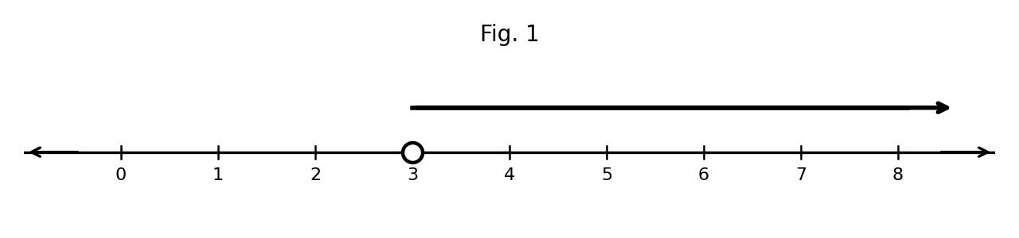
Fig. 1
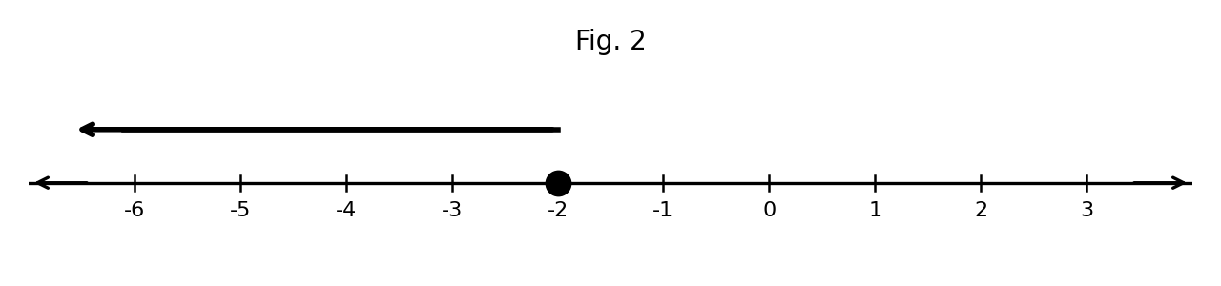
Fig. 2
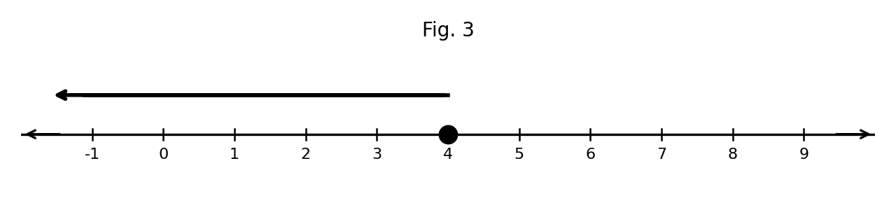
Fig. 3
17. The inequality shown on the number line is
A. x < 3
B. x ≤ 3
C. x ≥ 3
D. x > 3
18. The inequality shown on the number line is
A. x ≤ 2
B. x < −2
C. x ≤ −2
D. x ≥ −2
19. An open (unshaded) circle on a number-line graph shows that
A. the end value is included in the solution
B. the solution is zero
C. the arrow points left
D. the end value is NOT included in the solution
20. A closed (shaded) circle on a number-line graph shows that
A. there is no solution
B. all numbers solve it
C. the end value is included in the solution
D. the end value is not included
21. The inequality shown on the number line is
A. x > 4
B. x < 4
C. x ≥ 4
D. x ≤ 4
22. Which graph represents x < 5?
A. open circle at 5 with arrow to the right
B. open circle at 5 with arrow to the left
C. closed circle at 5 with arrow to the left
D. closed circle at 5 with arrow to the right
23. The solution of −3x − 8 > −26 is (curriculum exemplar)
A. x < −6
B. x > −6
C. x < 6
D. x > 6
24. The solution of 2x − 3 ≤ 19 is (curriculum exemplar)
A. x ≤ 11
B. x < 11
C. x ≥ 11
D. x ≤ 22
25. The solution of 2x ≥ 8 is (curriculum exemplar)
A. x ≤ 4
B. x > 4
C. x ≥ 16
D. x ≥ 4
26. The solution of 5y + 3 < 6 + 2y is (curriculum exemplar)
A. y < 1
B. y < 3
C. y > 3
D. y > 1
27. The solution of 7x/3 < 7 is (curriculum exemplar)
A. x < 21
B. x < 3
C. x > 3
D. x < 1
28. The solution set x < 6 is illustrated on the number line with
A. an open circle at 6 and an arrow to the left
B. an open circle at 6 and an arrow to the right
C. a closed circle at 6 and an arrow to the left
D. a closed circle at −6 and an arrow to the left
29. The statement 'x is at least 7' is written as
A. x ≤ 7
B. x < 7
C. x > 7
D. x ≥ 7
30. The statement 'x is at most 7' is written as
A. x > 7
B. x ≤ 7
C. x < 7
D. x ≥ 7
31. Ama has GH₵50. She buys books at GH₵5 each and wants to keep at least GH₵20. The number n of books she can buy satisfies
A. n ≥ 6
B. n ≤ 10
C. n < 6
D. n ≤ 6
32. Twice a number, increased by 5, is greater than 17. The number satisfies
A. x > 12
B. x > 6
C. x > 11
D. x < 6
33. Kofi's age a is at least 12 years. This is written as
A. a < 12
B. a > 12
C. a ≥ 12
D. a ≤ 12
34. A taxi charges GH₵3 per trip plus GH₵2 per kilometre. With at most GH₵23, the number of kilometres k satisfies
A. k ≤ 10
B. k ≥ 10
C. k ≤ 13
D. k ≤ 20
35. To pass, a student needs at least 45 marks. She has 30 marks so far. The mark t she must score in the final test satisfies
A. t > 75
B. t ≥ 45
C. t ≤ 15
D. t ≥ 15
36. A rectangle has width 4 cm and a perimeter of at most 24 cm. Its length l satisfies
A. l ≤ 20
B. l ≤ 8
C. l ≥ 8
D. l ≤ 10
37. The sum of three consecutive integers is less than 30. The largest possible value of the smallest integer is
A. 9
B. 10
C. 8
D. 27
38. The solution of ½(2x + 3) ≤ x + 2 is
A. no solution
B. x ≥ 2
C. x ≤ 2
D. all real numbers (always true)
39. The values of x that satisfy both x > 2 and x < 5 are
A. x > 2
B. x < 2
C. 2 < x < 5
D. x > 5
40. The smallest integer that satisfies x ≥ −1 is
A. 0
B. −1
C. 1
D. −2

SECTION B: STRUCTURED QUESTIONS (60 MARKS)
Answer ALL questions in this section. Show all workings clearly.

1. Solving simple inequalities
(a) Solve x + 3 > 5. [2 marks]
(b) Solve −2x ≥ 6. [2 marks]
(c) Solve 4 − 3x ≤ 10. [3 marks]
(d) Solve 5x + 2 < 3x + 10. [3 marks]
[Total: 10 marks]

2. Inequalities with fractions and brackets
(a) Solve x + ½ ≥ −3/2 (curriculum exemplar). [2 marks]
(b) Solve −(2/3)x + 3 ≥ 3 (curriculum exemplar). [3 marks]
(c) Solve ½(5x − 5) < x + 5. [3 marks]
(d) Solve 3(x − 1) ≥ 2x + 1. [2 marks]
[Total: 10 marks]

3. Illustrating solutions on the number line
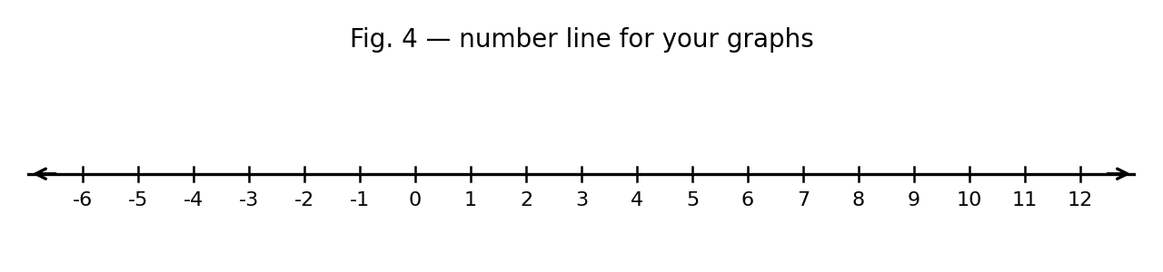
Fig. 4 — Number line for your graphs.
(a) On the number line in Fig. 4, illustrate x < 5. [2 marks]
(b) Illustrate x ≥ −2. [2 marks]
(c) Illustrate x ≤ 4. [2 marks]
(d) Solve −3x − 8 > −26 and illustrate the solution on the number line (curriculum exemplar). [4 marks]
[Total: 10 marks]

4. Reading and explaining graphs
Use Figs. 1, 2 and 3 from Section A.
(a) Write the inequality shown in Fig. 1. [2 marks]
(b) Write the inequality shown in Fig. 2. [2 marks]
(c) Write the inequality shown in Fig. 3. [2 marks]
(d) Explain the difference between an open circle and a closed circle on a number-line graph. [2 marks]
(e) Solve 2x − 3 ≤ 19 and illustrate the solution (curriculum exemplar). [2 marks]
[Total: 10 marks]

5. Real-life problems
(a) Ama has GH₵50. She buys books at GH₵5 each and wants to keep at least GH₵20. Write an inequality for the number n of books. [2 marks]
(b) Solve your inequality and state the greatest number of books Ama can buy. [4 marks]
(c) A taxi charges GH₵3 per trip plus GH₵2 per kilometre. A passenger has at most GH₵23. Write and solve an inequality for the kilometres k. [4 marks]
[Total: 10 marks]

6. Create and solve
(a) Write an inequality of your own with a variable on both sides, and solve it. [4 marks]
(b) Illustrate the solution of your inequality on a number line. [3 marks]
(c) Write a real-life story that your inequality could model. [3 marks]
[Total: 10 marks]

