BEACON EDUCATIONAL CONSULT
MARKING GUIDE — MOCK EXAMINATION 2026/2027
MATHEMATICS — BASIC 9 (JHS 3) — Chapter 11: Angles and Polygons (B9.3.1.1)

Curriculum Standard (NaCCA CCP, Sept 2020): B9.3.1.1 — Apply the properties of angles at a point, angles on a straight line, vertically opposite angles, corresponding angles to solve problems.
Indicators tested: B9.3.1.1.1 Derive the formula (n − 2) × 180° for the sum of angles in any polygon and use it to calculate missing angles; B9.3.1.1.2 Identify similar and congruent triangles and use the knowledge to solve related problems. The standard's angle properties (point, straight line, vertically opposite, corresponding) are tagged at standard level.

SECTION A: ANSWER KEY
Qn | Ans | Content Focus | Indicator
1 | C | Angles at a point | B9.3.1.1
2 | A | Angles on a straight line | B9.3.1.1
3 | C | Vertically opposite angles | B9.3.1.1
4 | B | Angles on a straight line | B9.3.1.1
5 | A | Vertically opposite angles | B9.3.1.1
6 | D | Angles at a point | B9.3.1.1
7 | C | Corresponding angles | B9.3.1.1
8 | D | Alternate angles | B9.3.1.1
9 | B | Co-interior angles | B9.3.1.1
10 | C | Corresponding angles | B9.3.1.1
11 | A | Alternate / co-interior angles | B9.3.1.1
12 | C | Complementary angles | B9.3.1.1
13 | D | Name polygons | B9.3.1.1.1
14 | A | Name polygons | B9.3.1.1.1
15 | D | Angle sum of a triangle | B9.3.1.1.1
16 | B | Polygon angle sum (curriculum exemplar) | B9.3.1.1.1
17 | D | Polygon angle sum (curriculum exemplar) | B9.3.1.1.1
18 | A | Polygon angle sum (curriculum exemplar) | B9.3.1.1.1
19 | B | Polygon angle sum | B9.3.1.1.1
20 | A | Find n from the angle sum | B9.3.1.1.1
21 | D | Regular polygon interior angle | B9.3.1.1.1
22 | A | Regular polygon interior angle | B9.3.1.1.1
23 | B | Exterior angles | B9.3.1.1.1
24 | D | Missing angle in a quadrilateral | B9.3.1.1.1
25 | B | Exterior angle of a triangle | B9.3.1.1.1
26 | C | Missing angles in a hexagon (curriculum exemplar) | B9.3.1.1.1
27 | A | Congruent triangles | B9.3.1.1.2
28 | C | Similar triangles | B9.3.1.1.2
29 | B | Similar triangles ratio (curriculum exemplar) | B9.3.1.1.2
30 | A | Similar triangles scale factor | B9.3.1.1.2
31 | B | Congruence conditions | B9.3.1.1.2
32 | D | Congruence conditions | B9.3.1.1.2
33 | C | Perimeters of similar triangles | B9.3.1.1.2
34 | D | Areas of similar triangles | B9.3.1.1.2
35 | B | Clock angles | B9.3.1.1
36 | C | Angles on a straight line | B9.3.1.1
37 | B | Angles at a point | B9.3.1.1
38 | A | Isosceles triangle angles | B9.3.1.1.1
39 | D | Exterior angles → number of sides | B9.3.1.1.1
40 | C | Angle sum → polygon | B9.3.1.1.1

Full answer key: CACBA DCDBC ACDAD BDABA DABDB CACBA BDCDB CBADC

SECTION A: WORKED SOLUTIONS
1. Answer: C. A full turn about a point is 360°. [B9.3.1.1]
2. Answer: A. A straight line carries 180°. [B9.3.1.1]
3. Answer: C. When two lines cross, opposite angles are equal. [B9.3.1.1]
4. Answer: B. x = 180° − 70° = 110° (angles on a straight line). [B9.3.1.1]
5. Answer: A. x = 65° (vertically opposite angles). [B9.3.1.1]
6. Answer: D. x = 360° − 120° − 95° = 145° (angles at a point). [B9.3.1.1]
7. Answer: C. F-shape: corresponding angles (equal when lines are parallel). [B9.3.1.1]
8. Answer: D. Z-shape: alternate angles (equal when lines are parallel). [B9.3.1.1]
9. Answer: B. C-shape: co-interior angles add to 180°. [B9.3.1.1]
10. Answer: C. x = 110° (corresponding angles, a ∥ b). [B9.3.1.1]
11. Answer: A. y = 180° − 110° = 70° (co-interior angles are supplementary). [B9.3.1.1]
12. Answer: C. 90° − 35° = 55°. [B9.3.1.1]
13. Answer: D. Five sides → pentagon. [B9.3.1.1.1]
14. Answer: A. Six sides → hexagon. [B9.3.1.1.1]
15. Answer: D. Triangle angle sum = 180°. [B9.3.1.1.1]
16. Answer: B. (4 − 2) × 180° = 360° (curriculum exemplar). [B9.3.1.1.1]
17. Answer: D. (5 − 2) × 180° = 540° (curriculum exemplar). [B9.3.1.1.1]
18. Answer: A. (6 − 2) × 180° = 720° (curriculum exemplar). [B9.3.1.1.1]
19. Answer: B. (8 − 2) × 180° = 1,080°. [B9.3.1.1.1]
20. Answer: A. 900 ÷ 180 = 5 = n − 2 → n = 7. [B9.3.1.1.1]
21. Answer: D. 540° ÷ 5 = 108°. [B9.3.1.1.1]
22. Answer: A. 720° ÷ 6 = 120°. [B9.3.1.1.1]
23. Answer: B. 360° ÷ 8 = 45°. [B9.3.1.1.1]
24. Answer: D. x = 360° − 95° − 105° − 70° = 90°. [B9.3.1.1.1]
25. Answer: B. x = 120° − 45° = 75° (exterior angle = sum of opposite interior angles). [B9.3.1.1.1]
26. Answer: C. 2x + 500° = 720° → 2x = 220° → x = 110°. [B9.3.1.1.1]
27. Answer: A. Congruent triangles match exactly: corresponding sides equal. [B9.3.1.1.2]
28. Answer: C. Similar triangles have the same shape: corresponding angles equal. [B9.3.1.1.2]
29. Answer: B. Scale factor 6 ÷ 3 = 2 → x = 4 × 2 = 8. [B9.3.1.1.2]
30. Answer: A. Scale factor 15 ÷ 5 = 3 → 7 × 3 = 21 cm. [B9.3.1.1.2]
31. Answer: B. AAA gives the same shape but any size — similarity, not congruence. [B9.3.1.1.2]
32. Answer: D. RHS = Right angle, Hypotenuse, Side — for right-angled triangles. [B9.3.1.1.2]
33. Answer: C. Perimeters scale like sides: 20 × 3/2 = 30 cm. [B9.3.1.1.2]
34. Answer: D. Areas scale like squares of sides: 2² : 3² = 4 : 9. [B9.3.1.1.2]
35. Answer: B. Quarter turn: 360° ÷ 4 = 90°. [B9.3.1.1]
36. Answer: C. 2x + 3x = 180° → 5x = 180° → x = 36. [B9.3.1.1]
37. Answer: B. 360° ÷ 4 = 90°. [B9.3.1.1]
38. Answer: A. (180° − 40°) ÷ 2 = 70°. [B9.3.1.1.1]
39. Answer: D. 360° ÷ 30° = 12 sides. [B9.3.1.1.1]
40. Answer: C. (n − 2) × 180° = 1,440° → n − 2 = 8 → n = 10 → decagon. [B9.3.1.1.1]

SECTION B: MARKING SCHEME
Reference diagrams (as printed in the question paper):
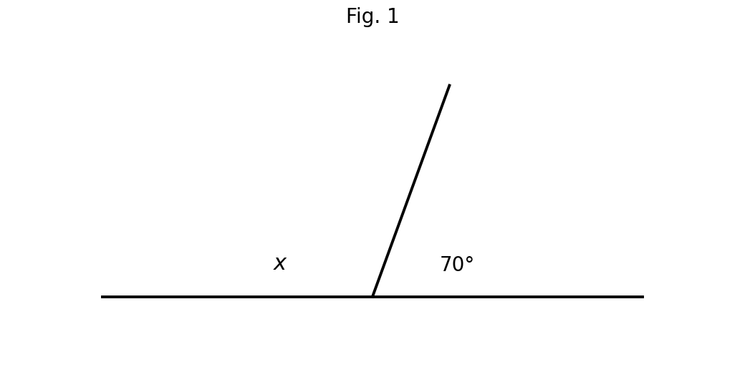
Fig. 1 — angles on a straight line (not to scale).
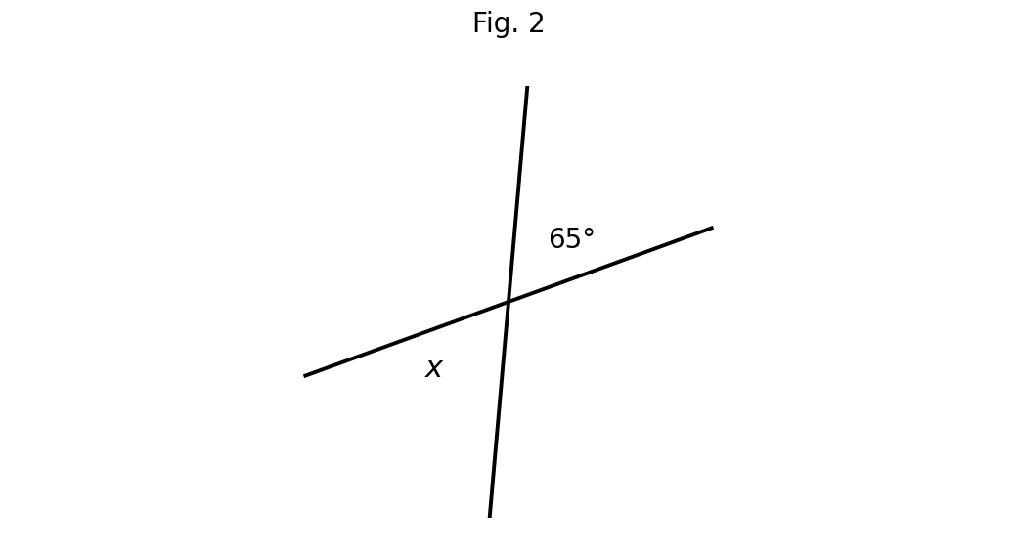
Fig. 2 — vertically opposite angles (not to scale).
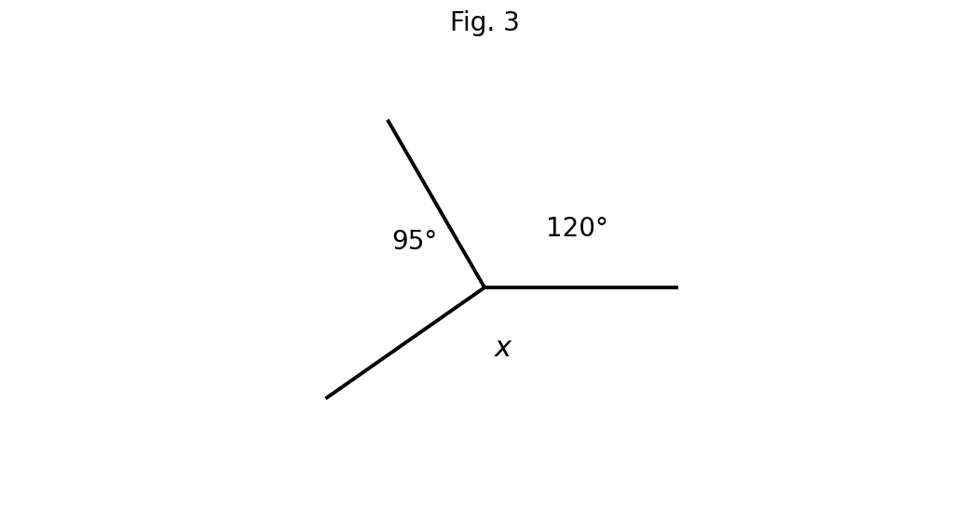
Fig. 3 — angles at a point (not to scale).
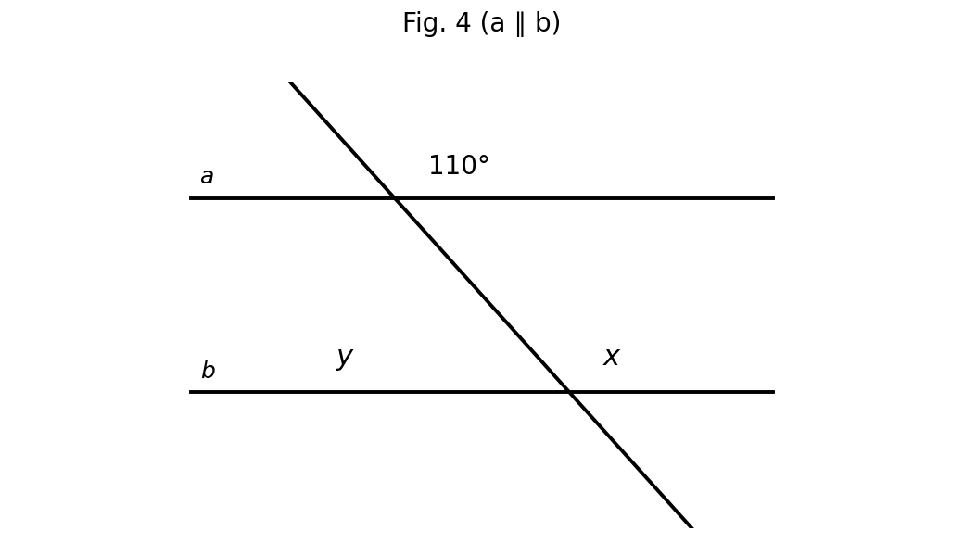
Fig. 4 — parallel lines a and b cut by a transversal (not to scale).
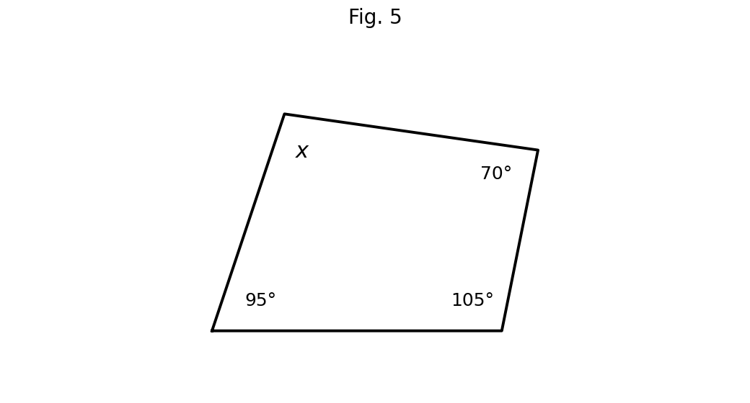
Fig. 5 — quadrilateral (not to scale).
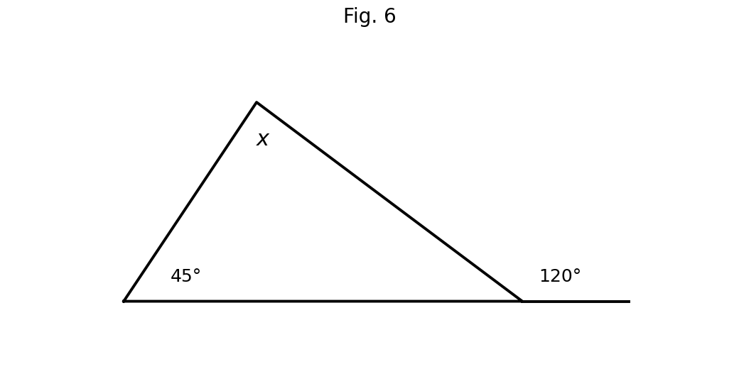
Fig. 6 — exterior angle of a triangle (not to scale).
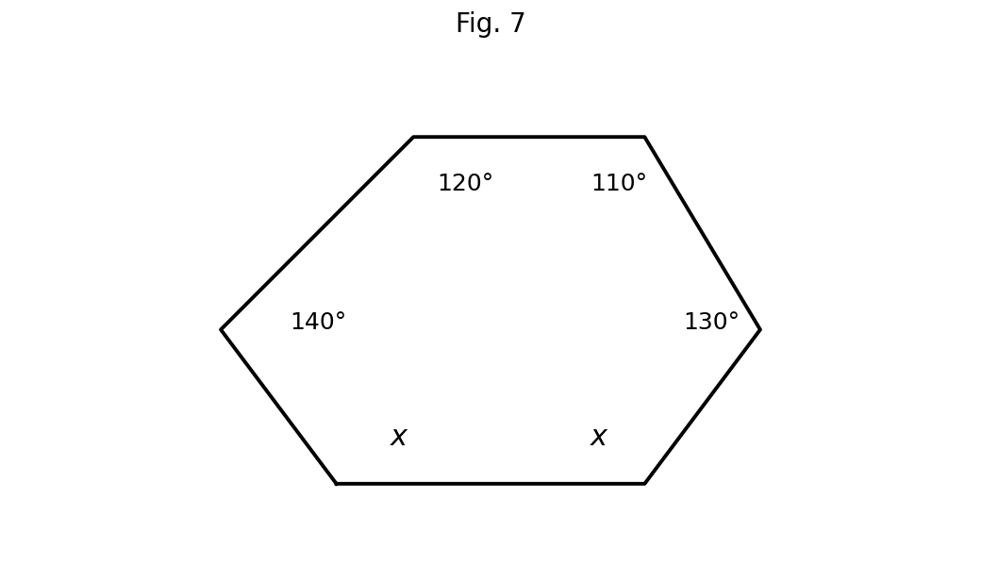
Fig. 7 — hexagon (not to scale).
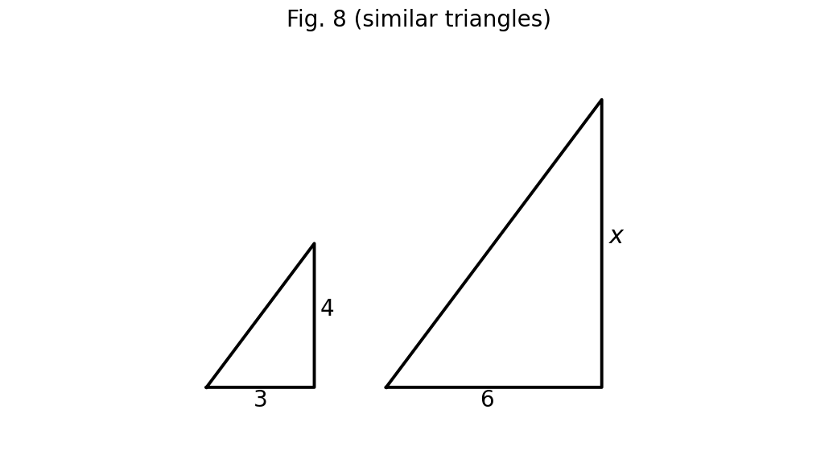
Fig. 8 — similar triangles (not to scale).

1. Angle properties at a point, on a line and opposite angles [10 marks]
Use Figs. 1, 2 and 3 from Section A.
(a) Using Fig. 1, find x and give the reason. Angles on a straight line: x = 180° − 70° = 110°. [2 marks]
(b) Using Fig. 2, find x and give the reason. Vertically opposite angles: x = 65°. [2 marks]
(c) Using Fig. 3, find x and give the reason. Angles at a point: x = 360° − 120° − 95° = 145°. [3 marks]
(d) Find the complement and the supplement of 35°. Complement = 90° − 35° = 55°; supplement = 180° − 35° = 145°. [3 marks]
[Total: 10 marks]

2. Parallel lines and a transversal [10 marks]
Use Fig. 4 from Section A (a ∥ b).
(a) Name the pair of angles that form an 'F-shape'. Corresponding angles. [2 marks]
(b) Name the pair of angles that form a 'Z-shape'. Alternate angles. [2 marks]
(c) State the relationship between co-interior angles. They are supplementary (add up to 180°). [2 marks]
(d) Find x and y in Fig. 4, giving reasons. x = 110° (corresponding angles, a ∥ b). y = 180° − 110° = 70° (co-interior angles are supplementary; equivalently y equals the alternate of the 70° at the top). [4 marks]
[Total: 10 marks]

3. The polygon angle-sum formula [10 marks]
(a) Explain why the sum of interior angles of a polygon is (n − 2) × 180°. From one vertex, an n-sided polygon can be split into (n − 2) triangles; each triangle contributes 180°, so the sum is (n − 2) × 180°. (For a quadrilateral: 2 triangles → 360°.) [3 marks]
(b) Hence find the sum of interior angles of a pentagon. (5 − 2) × 180° = 540°. [2 marks]
(c) Hence find the sum of interior angles of a hexagon. (6 − 2) × 180° = 720°. [2 marks]
(d) A polygon has interior angles summing to 900°. How many sides has it? (n − 2) × 180° = 900° → n − 2 = 5 → n = 7 sides. [3 marks]
[Total: 10 marks]

4. Missing angles in figures [10 marks]
Use Figs. 5, 6 and 7 from Section A.
(a) Find x in Fig. 5. Quadrilateral: x = 360° − 95° − 105° − 70° = 90°. [3 marks]
(b) Find x in Fig. 6. Exterior angle = sum of the two opposite interior angles: 120° = 45° + x → x = 75°. [3 marks]
(c) Find x in Fig. 7. Hexagon sum = 720°. x + x + 130° + 110° + 120° + 140° = 720° → 2x = 220° → x = 110°. [4 marks]
[Total: 10 marks]

5. Similar and congruent triangles [10 marks]
(a) Using Fig. 8, the triangles are similar. Find x. Scale factor = 6 ÷ 3 = 2, so x = 4 × 2 = 8. [3 marks]
(b) Two similar triangles have corresponding sides 5 cm and 15 cm. Find the side corresponding to 7 cm in the smaller triangle. Scale factor 3 → 7 × 3 = 21 cm. [3 marks]
(c) Explain why AAA is not a congruence condition. AAA fixes the shape but not the size: two triangles can have equal angles yet different sizes (similar but not congruent). [2 marks]
(d) Two similar triangles have sides in the ratio 2 : 3. Find the ratio of their areas. Areas scale as the square of the sides: 2² : 3² = 4 : 9. [2 marks]
[Total: 10 marks]

6. Create and solve [10 marks]
(a) Draw (freehand) a polygon of your own, label all but one of its interior angles with values of your choice, and calculate the missing angle. Any valid polygon with a correct use of (n − 2) × 180°. Example: quadrilateral with 100°, 80°, 90° → missing = 360° − 270° = 90°. Award 2 marks for the figure/labels, 2 for the correct missing angle. [4 marks]
(b) Write two angle facts (e.g. about parallel lines) and use them to form a short problem; solve it. Any coherent problem using angle properties, solved correctly. Example: 'Two parallel lines are cut by a transversal; one angle is 115°. Find the alternate and the co-interior angles.' → 115° and 65°. Award 3 marks for a valid problem, 3 for correct answers — capped at 6. [6 marks]
[Total: 10 marks]

CURRICULUM BLUEPRINT
Qn | Content Focus | Indicator | Marks
1 | Angles at a point | B9.3.1.1 | 1
2 | Angles on a straight line | B9.3.1.1 | 1
3 | Vertically opposite angles | B9.3.1.1 | 1
4 | Angles on a straight line | B9.3.1.1 | 1
5 | Vertically opposite angles | B9.3.1.1 | 1
6 | Angles at a point | B9.3.1.1 | 1
7 | Corresponding angles | B9.3.1.1 | 1
8 | Alternate angles | B9.3.1.1 | 1
9 | Co-interior angles | B9.3.1.1 | 1
10 | Corresponding angles | B9.3.1.1 | 1
11 | Alternate / co-interior angles | B9.3.1.1 | 1
12 | Complementary angles | B9.3.1.1 | 1
13 | Name polygons | B9.3.1.1.1 | 1
14 | Name polygons | B9.3.1.1.1 | 1
15 | Angle sum of a triangle | B9.3.1.1.1 | 1
16 | Polygon angle sum (curriculum exemplar) | B9.3.1.1.1 | 1
17 | Polygon angle sum (curriculum exemplar) | B9.3.1.1.1 | 1
18 | Polygon angle sum (curriculum exemplar) | B9.3.1.1.1 | 1
19 | Polygon angle sum | B9.3.1.1.1 | 1
20 | Find n from the angle sum | B9.3.1.1.1 | 1
21 | Regular polygon interior angle | B9.3.1.1.1 | 1
22 | Regular polygon interior angle | B9.3.1.1.1 | 1
23 | Exterior angles | B9.3.1.1.1 | 1
24 | Missing angle in a quadrilateral | B9.3.1.1.1 | 1
25 | Exterior angle of a triangle | B9.3.1.1.1 | 1
26 | Missing angles in a hexagon (curriculum exemplar) | B9.3.1.1.1 | 1
27 | Congruent triangles | B9.3.1.1.2 | 1
28 | Similar triangles | B9.3.1.1.2 | 1
29 | Similar triangles ratio (curriculum exemplar) | B9.3.1.1.2 | 1
30 | Similar triangles scale factor | B9.3.1.1.2 | 1
31 | Congruence conditions | B9.3.1.1.2 | 1
32 | Congruence conditions | B9.3.1.1.2 | 1
33 | Perimeters of similar triangles | B9.3.1.1.2 | 1
34 | Areas of similar triangles | B9.3.1.1.2 | 1
35 | Clock angles | B9.3.1.1 | 1
36 | Angles on a straight line | B9.3.1.1 | 1
37 | Angles at a point | B9.3.1.1 | 1
38 | Isosceles triangle angles | B9.3.1.1.1 | 1
39 | Exterior angles → number of sides | B9.3.1.1.1 | 1
40 | Angle sum → polygon | B9.3.1.1.1 | 1
B1 | Angles at a point, on a line, vertically opposite | B9.3.1.1 | 10
B2 | Parallel lines & transversal (Fig. 4) | B9.3.1.1 | 10
B3 | Polygon angle-sum formula (n − 2) × 180° | B9.3.1.1.1 | 10
B4 | Missing angles in polygons (Figs. 5–7) | B9.3.1.1.1 | 10
B5 | Similar and congruent triangles (Fig. 8) | B9.3.1.1.2 | 10
B6 | Create & solve with angles | B9.3.1.1.1 / .2 | 10
 | TOTAL |  | 100

CURRICULUM COVERAGE BY INDICATOR
Curriculum Area | Section A | Section B | Total | %
B9.3.1.1 (standard) Angle properties: point, straight line, vertically opposite, corresponding | 15 | 20 (B1, B2) | 35 | 35%
B9.3.1.1.1 Polygon angle sum (n − 2) × 180°; missing angles | 17 | 20 (B3, B4) | 37 | 37%
B9.3.1.1.2 Similar and congruent triangles | 8 | 20 (B5, B6) | 28 | 28%
Note: Section A q1–12 and q35–37 test the standard's angle properties (15 marks); q13–26 and q38–40 test the polygon angle-sum indicator (17); q27–34 test similar/congruent triangles (8). Section B: B1–B2 angle properties (20); B3–B4 polygon sums with figures (20); B5–B6 similarity/congruence and create-and-solve (20).

COGNITIVE-LEVEL DISTRIBUTION
Cognitive Level | Section A | Section B | Total | %
Remember | 1 | 0 | 1 | 1%
Understand | 12 | 0 | 12 | 12%
Apply | 25 | 50 | 75 | 75%
Analyse | 2 | 0 | 2 | 2%
Evaluate | 0 | 0 | 0 | 0%
Create | 0 | 10 | 10 | 10%

DIFFICULTY DISTRIBUTION
Difficulty | Section A | Section B | Total | %
Easy | 13 | 10 (B1) | 23 | 23%
Moderate | 23 | 30 (B2, B3, B4) | 53 | 53%
Challenging | 4 | 20 (B5, B6) | 24 | 24%

QUALITY-CONTROL SUMMARY
Check | Status
Curriculum alignment | Standard-level angle properties plus both indicators covered: polygon angle sum (n − 2) × 180° (.1) and similar/congruent triangles (.2).
Section structure | Section A: 40 objectives (40 marks). Section B: 6 structured questions (60 marks). Total 100 marks, 2 hours.
Answer key balance | A=10, B=10, C=10, D=10. Zero consecutive repeats. No sustained cycling pattern.
Diagrams (BECE style) | Eight labelled figures: straight-line angles, vertically opposite, angles at a point, parallel lines with transversal, quadrilateral, triangle exterior angle, hexagon, and similar triangles — all marked 'not to scale' as in BECE papers.
Curriculum exemplars used | Derivation and use of (n − 2) × 180° for triangle/quadrilateral/pentagon/hexagon; hexagon with unknown x; similar-triangle angle/side problems — following the CCP exemplar lists.
Distractor quality | Classic confusions: corresponding vs alternate vs co-interior, complement vs supplement, equal vs proportional sides, AAA as congruence, unscaled ratio traps (2:3 vs 4:9 areas).
Marking guide completeness | Every Section B part carries explicit marks (each question sums to 10); full worked steps and reasons shown; all figures reprinted for the marker.
Blueprint | 46-row blueprint (40 objectives + 6 structured) sums to exactly 100 marks.
Coverage | Standard properties 35%, .1 = 37%, .2 = 28%.
Cognitive spread | Remember 1%, Understand 12%, Apply 75%, Analyse 2%, Create 10%.
Difficulty spread | Easy 23%, Moderate 53%, Challenging 24%.

