BEACON EDUCATIONAL CONSULT
MOCK EXAMINATION — 2026/2027 ACADEMIC YEAR
MATHEMATICS — BASIC 9 (JHS 3)
Chapter 11: Angles and Polygons (Curriculum Standard B9.3.1.1)
Time Allowed: 2 Hours Total Marks: 100

INSTRUCTIONS TO CANDIDATES
1. Write your name and index number on the answer sheet provided.
2. This paper consists of TWO sections: Section A (Objectives) and Section B (Structured Questions).
3. Section A: Answer ALL forty (40) questions. Each question carries 1 mark. Choose the correct option from A to D.
4. Section B: Answer ALL six (6) questions. Each question carries 10 marks. Show all necessary workings.
5. All diagrams are NOT drawn to scale. Study them carefully before answering.
6. Use a non-programmable calculator where necessary.

SECTION A: OBJECTIVE TEST (40 MARKS)
Answer ALL questions in this section. Choose the correct answer from A to D.
1. Angles at a point add up to
A. 90°
B. 180°
C. 360°
D. 270°
2. Angles on a straight line add up to
A. 180°
B. 360°
C. 270°
D. 90°
3. Vertically opposite angles are
A. right angles
B. supplementary
C. equal
D. complementary
Questions 4 to 6 refer to Figs. 1 to 3.
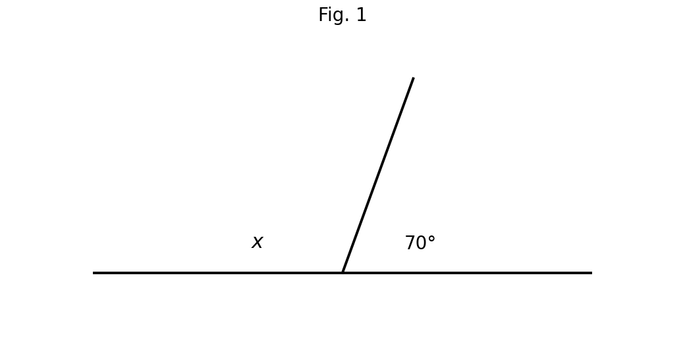
Fig. 1 — angles on a straight line (not to scale).
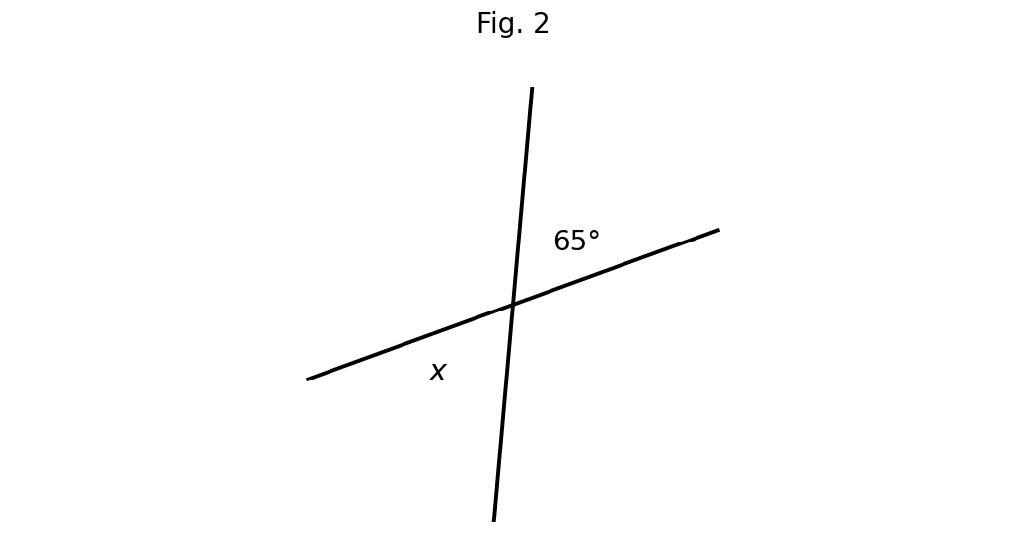
Fig. 2 — vertically opposite angles (not to scale).
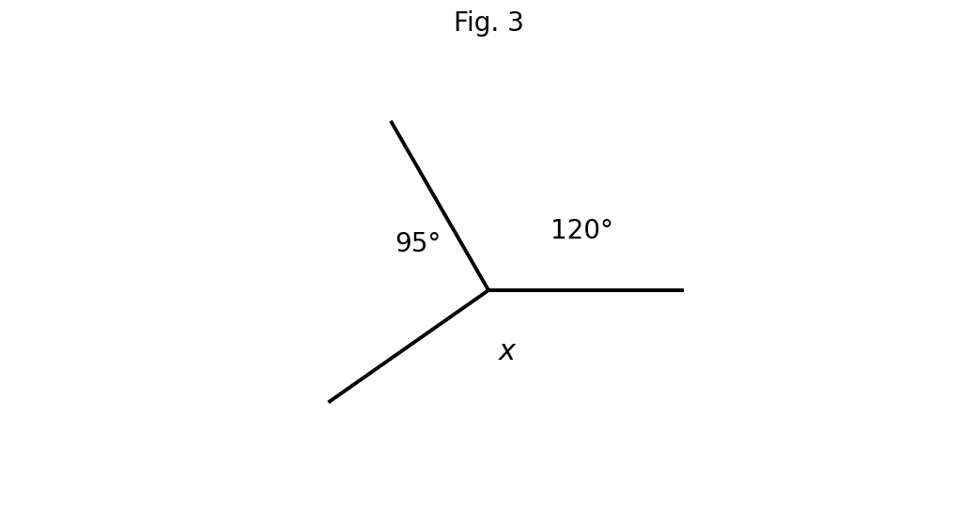
Fig. 3 — angles at a point (not to scale).
4. Find the value of x.
A. 70°
B. 110°
C. 20°
D. 290°
5. Find the value of x.
A. 65°
B. 25°
C. 130°
D. 115°
6. Find the value of x.
A. 95°
B. 215°
C. 120°
D. 145°
7. The 'F-shape' angles formed by a transversal cutting parallel lines are called
A. alternate angles
B. co-interior angles
C. corresponding angles
D. vertically opposite angles
8. The 'Z-shape' angles formed by a transversal cutting parallel lines are called
A. co-interior angles
B. vertically opposite angles
C. corresponding angles
D. alternate angles
9. Co-interior ('C-shape') angles between parallel lines are
A. reflex
B. supplementary
C. equal
D. complementary
Questions 10 and 11 refer to Fig. 4.
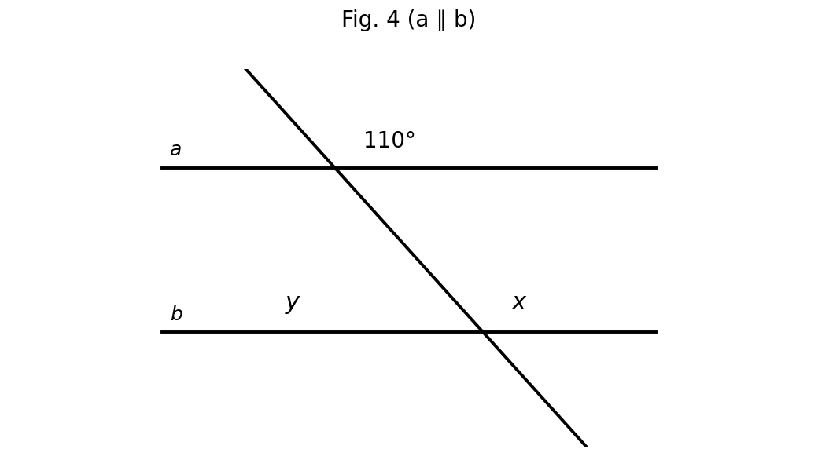
Fig. 4 — parallel lines a and b cut by a transversal (not to scale).
10. Lines a and b are parallel. Find x.
A. 70°
B. 100°
C. 110°
D. 120°
11. Lines a and b are parallel. Find y.
A. 70°
B. 20°
C. 55°
D. 110°
12. The complement of 35° is
A. 35°
B. 145°
C. 55°
D. 65°
13. A polygon with five sides is called a
A. hexagon
B. quadrilateral
C. heptagon
D. pentagon
14. A polygon with six sides is called a
A. hexagon
B. octagon
C. nonagon
D. pentagon
15. The sum of the interior angles of a triangle is
A. 360°
B. 90°
C. 270°
D. 180°
16. Using (n − 2) × 180°, the sum of interior angles of a quadrilateral is
A. 180°
B. 360°
C. 540°
D. 720°
17. The sum of interior angles of a pentagon is
A. 720°
B. 900°
C. 360°
D. 540°
18. The sum of interior angles of a hexagon is
A. 720°
B. 1,080°
C. 540°
D. 900°
19. The sum of interior angles of an octagon is
A. 720°
B. 1,080°
C. 1,260°
D. 1,440°
20. A polygon whose interior angles sum to 900° has
A. 7 sides
B. 8 sides
C. 9 sides
D. 6 sides
21. Each interior angle of a regular pentagon is
A. 144°
B. 72°
C. 120°
D. 108°
22. Each interior angle of a regular hexagon is
A. 120°
B. 108°
C. 135°
D. 60°
23. Each exterior angle of a regular octagon is
A. 30°
B. 45°
C. 90°
D. 40°
Questions 24 to 26 refer to Figs. 5 to 7.
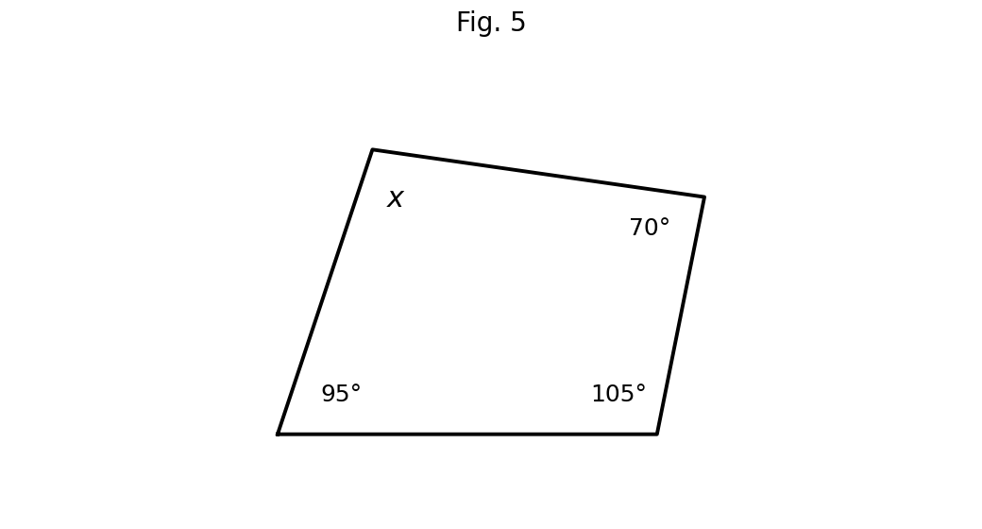
Fig. 5 — quadrilateral (not to scale).
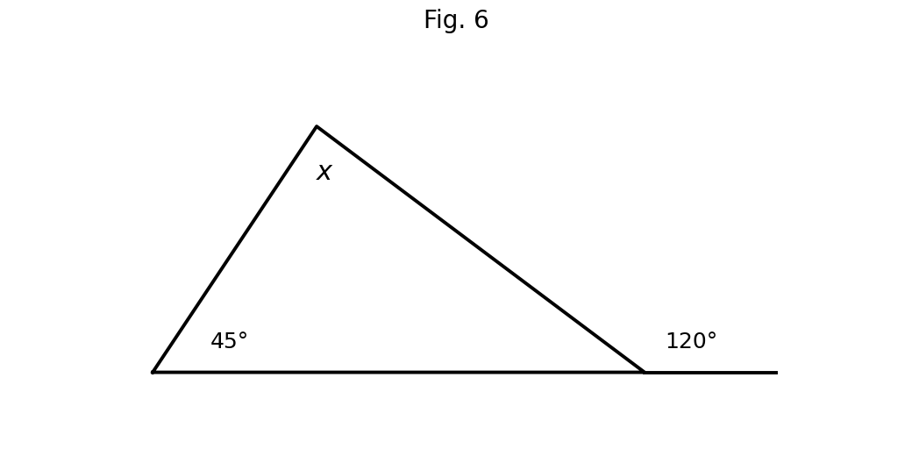
Fig. 6 — exterior angle of a triangle (not to scale).
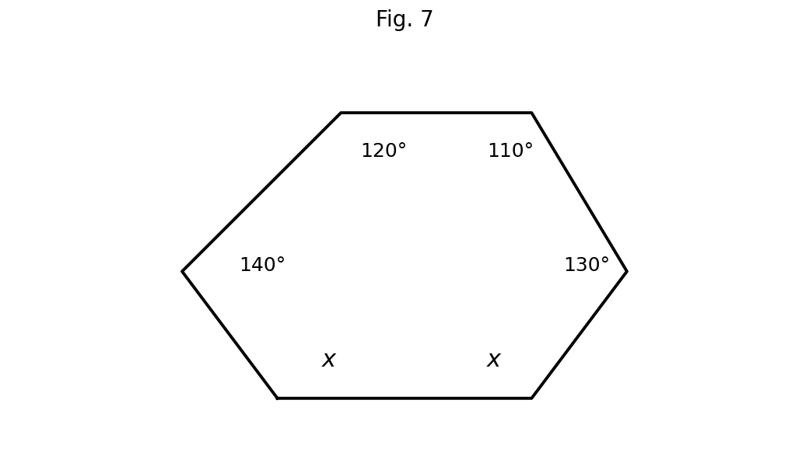
Fig. 7 — hexagon (not to scale).
24. Find x in the quadrilateral.
A. 100°
B. 80°
C. 95°
D. 90°
25. The exterior angle is 120°. Find x.
A. 60°
B. 75°
C. 120°
D. 45°
26. Find x in the hexagon.
A. 120°
B. 130°
C. 110°
D. 100°
27. Congruent triangles have corresponding sides that are
A. equal
B. perpendicular
C. proportional
D. parallel
28. Similar triangles have corresponding angles that are
A. proportional
B. supplementary
C. equal
D. complementary
Question 29 refers to Fig. 8.
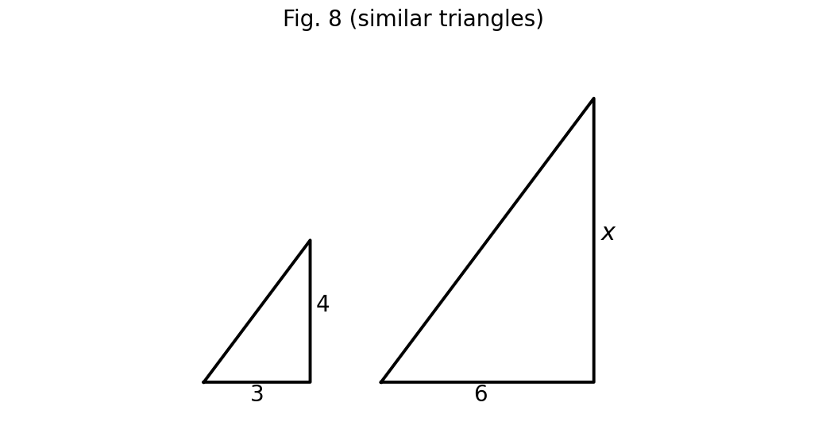
Fig. 8 — similar triangles (not to scale).
29. The triangles are similar. Find x.
A. 12
B. 8
C. 4.5
D. 6
30. Two similar triangles have corresponding sides 5 cm and 15 cm. A side of 7 cm in the smaller triangle corresponds to
A. 21 cm
B. 3 cm
C. 7 cm
D. 14 cm
31. Which condition does NOT guarantee congruent triangles?
A. SSS
B. AAA
C. SAS
D. ASA
32. The RHS congruence condition applies to
A. any triangles
B. obtuse triangles only
C. equilateral triangles only
D. right-angled triangles
33. Two similar triangles have sides in the ratio 2 : 3. If the smaller triangle's perimeter is 20 cm, the larger's is
A. 45 cm
B. 13.3 cm
C. 30 cm
D. 40 cm
34. Two similar triangles have sides in the ratio 2 : 3. The ratio of their areas is
A. 2 : 3
B. 8 : 27
C. 6 : 9
D. 4 : 9
35. The angle between the hands of a clock at 3 o'clock is
A. 60°
B. 90°
C. 180°
D. 30°
36. Two angles on a straight line are 2x and 3x. The value of x is
A. 60
B. 30
C. 36
D. 45
37. Four equal angles at a point each measure
A. 45°
B. 90°
C. 60°
D. 120°
38. An isosceles triangle has a vertex angle of 40°. Each base angle is
A. 70°
B. 40°
C. 55°
D. 140°
39. Each exterior angle of a regular polygon is 30°. The polygon has
A. 30 sides
B. 10 sides
C. 6 sides
D. 12 sides
40. The interior angles of a polygon sum to 1,440°. The polygon is a
A. octagon
B. nonagon
C. decagon
D. dodecagon

SECTION B: STRUCTURED QUESTIONS (60 MARKS)
Answer ALL questions in this section. Show all workings clearly. Diagrams are not to scale.

1. Angle properties at a point, on a line and opposite angles
Use Figs. 1, 2 and 3 from Section A.
(a) Using Fig. 1, find x and give the reason. [2 marks]
(b) Using Fig. 2, find x and give the reason. [2 marks]
(c) Using Fig. 3, find x and give the reason. [3 marks]
(d) Find the complement and the supplement of 35°. [3 marks]
[Total: 10 marks]

2. Parallel lines and a transversal
Use Fig. 4 from Section A (a ∥ b).
(a) Name the pair of angles that form an 'F-shape'. [2 marks]
(b) Name the pair of angles that form a 'Z-shape'. [2 marks]
(c) State the relationship between co-interior angles. [2 marks]
(d) Find x and y in Fig. 4, giving reasons. [4 marks]
[Total: 10 marks]

3. The polygon angle-sum formula
(a) Explain why the sum of interior angles of a polygon is (n − 2) × 180°. [3 marks]
(b) Hence find the sum of interior angles of a pentagon. [2 marks]
(c) Hence find the sum of interior angles of a hexagon. [2 marks]
(d) A polygon has interior angles summing to 900°. How many sides has it? [3 marks]
[Total: 10 marks]

4. Missing angles in figures
Use Figs. 5, 6 and 7 from Section A.
(a) Find x in Fig. 5. [3 marks]
(b) Find x in Fig. 6. [3 marks]
(c) Find x in Fig. 7. [4 marks]
[Total: 10 marks]

5. Similar and congruent triangles
(a) Using Fig. 8, the triangles are similar. Find x. [3 marks]
(b) Two similar triangles have corresponding sides 5 cm and 15 cm. Find the side corresponding to 7 cm in the smaller triangle. [3 marks]
(c) Explain why AAA is not a congruence condition. [2 marks]
(d) Two similar triangles have sides in the ratio 2 : 3. Find the ratio of their areas. [2 marks]
[Total: 10 marks]

6. Create and solve
(a) Draw (freehand) a polygon of your own, label all but one of its interior angles with values of your choice, and calculate the missing angle. [4 marks]
(b) Write two angle facts (e.g. about parallel lines) and use them to form a short problem; solve it. [6 marks]
[Total: 10 marks]

