BEACON EDUCATIONAL CONSULT
MARKING GUIDE — MOCK EXAMINATION 2026/2027
MATHEMATICS — BASIC 9 (JHS 3) — Chapter 12: Inscribed and Circumscribed Figures (B9.3.1.2)

Curriculum Standard (NaCCA CCP, Sept 2020): B9.3.1.2 — Construct inscribed and circumscribed triangles and parallelograms with given dimensions.
Indicators tested: B9.3.1.2.1 Draw inscribed and circumscribed circles for triangles under given conditions (incentre via angle bisectors; circumcentre via perpendicular bisectors); B9.3.1.2.2 Construct parallelograms (square, rectangle, rhombus) under given conditions. Construction instruments, loci and triangle-construction conditions are tagged at standard level.

SECTION A: ANSWER KEY
Qn | Ans | Content Focus | Indicator
1 | D | Incentre (angle-bisector concurrency) | B9.3.1.2.1
2 | C | Incentre equidistant from sides | B9.3.1.2.1
3 | A | Constructing the incentre | B9.3.1.2.1
4 | C | Inscribed-circle radius | B9.3.1.2.1
5 | B | Circumcentre (perpendicular-bisector concurrency) | B9.3.1.2.1
6 | C | Circumcentre equidistant from vertices | B9.3.1.2.1
7 | B | Circumscribed circle | B9.3.1.2.1
8 | A | Locus: perpendicular bisector | B9.3.1.2.1
9 | C | Locus: angle bisector | B9.3.1.2.1
10 | D | Locating the incentre | B9.3.1.2.1
11 | C | Locating the circumcentre | B9.3.1.2.1
12 | D | Construction instruments | B9.3.1.2
13 | B | Inscribed circle (Fig. 1) | B9.3.1.2.1
14 | C | Circumscribed circle radii (Fig. 2) | B9.3.1.2.1
15 | B | Circumcentre of a right triangle | B9.3.1.2.1
16 | A | Circumradius from hypotenuse | B9.3.1.2.1
17 | B | Circumcentre position by triangle type | B9.3.1.2.1
18 | A | Equilateral triangle centres coincide | B9.3.1.2.1
19 | B | Square: side to diagonal (curriculum exemplar) | B9.3.1.2.2
20 | D | Square from diagonal | B9.3.1.2.2
21 | C | Square from diagonal: side length | B9.3.1.2.2
22 | B | Data for a rectangle | B9.3.1.2.2
23 | D | Rectangle: side and diagonal | B9.3.1.2.2
24 | A | Rectangle diagonal (Pythagoras) | B9.3.1.2.2
25 | D | Rhombus property | B9.3.1.2.2
26 | A | Rhombus: diagonals to side | B9.3.1.2.2
27 | B | Data for a parallelogram | B9.3.1.2.2
28 | D | SSS determines a triangle uniquely | B9.3.1.2.2
29 | B | Triangle inequality | B9.3.1.2.2
30 | C | Triangle inequality: least side | B9.3.1.2.2
31 | B | SAS construction | B9.3.1.2.2
32 | A | ASA construction | B9.3.1.2.2
33 | D | Regular hexagon construction | B9.3.1.2.2
34 | A | Hexagon perimeter | B9.3.1.2.2
35 | C | Compound plane shape (curriculum exemplar) | B9.3.1.2.2
36 | A | Locus: circle | B9.3.1.2
37 | D | Locus: perpendicular bisector | B9.3.1.2
38 | C | Bisecting sides for the circumcircle | B9.3.1.2
39 | D | Perpendicular-bisector arcs (Fig. 4) | B9.3.1.2
40 | A | Inscribed circle of a square | B9.3.1.2.2

Full answer key: DCACB CBACD CDBCB ABABD CBDAD ABDBC BADAC ADCDA

SECTION A: WORKED SOLUTIONS
1. The incentre is the point of concurrency of the three angle bisectors.
2. By definition the incentre is equidistant from the three sides of the triangle.
3. Two angle bisectors are enough; the third automatically passes through their intersection I.
4. The inscribed circle touches every side, so its radius is the perpendicular distance from I to any side.
5. The circumcentre is the point of concurrency of the three perpendicular bisectors of the sides.
6. By definition the circumcentre is equidistant from the three vertices.
7. The circumscribed circle passes through all three vertices.
8. The perpendicular bisector is the locus of points equidistant from the two endpoints A and B.
9. An angle bisector is the locus of points equidistant from the two arms of the angle.
10. Any two angle bisectors already meet at the incentre; the third adds nothing new.
11. Any two perpendicular bisectors already meet at the circumcentre.
12. Bisecting and equal lengths are set out with compasses plus a straight ruler.
13. The inscribed circle touches all three sides, so its radius equals the common distance 3 cm.
14. SP, SQ and SR are all radii of the circumscribed circle, so SP = SQ.
15. The midpoint of the hypotenuse is equidistant from all three vertices (angle in a semicircle is 90°).
16. R = ½ × hypotenuse = ½ × 10 cm = 5 cm.
17. For an obtuse-angled triangle the circumcentre falls outside the triangle.
18. By symmetry the incentre and circumcentre of an equilateral triangle coincide.
19. AC = AB × √2 = 6.5 × 1.414 ≈ 9.2 cm.
20. The diagonals of a square bisect each other at right angles: draw AC = 8 cm, bisect it perpendicularly and mark B and D 4 cm from the midpoint.
21. side = 8/√2 = 5.66 ≈ 5.7 cm (or by measurement).
22. Two adjacent sides fix a rectangle completely, since every angle is 90°.
23. width = √(10² − 6²) = √64 = 8 cm.
24. √(8² + 15²) = √289 = 17 cm.
25. All four sides of a rhombus are equal, so the side is set off with the compasses.
26. The diagonals of a rhombus bisect each other at right angles: side = √(3² + 4²) = 5 cm.
27. Two adjacent sides and the included angle determine a parallelogram (SAS-type data).
28. SSS fixes a triangle uniquely up to congruence, so exactly 1 (non-congruent) triangle.
29. 3 + 4 = 7 < 8, breaking the triangle inequality.
30. x must satisfy x > 8 − 5 = 3, so the least whole-number value is 4 cm.
31. Two sides with the included angle: the SAS condition.
32. Two angles with the included side: the ASA condition.
33. Each side of a regular hexagon equals the radius of its circumscribed circle.
34. Perimeter = 6 × 4 cm = 24 cm.
35. Perimeter = 3 square sides + 2 triangle sides = 12 + 8 = 20 cm.
36. A fixed distance from a fixed point gives a circle.
37. Points equidistant from two fixed points lie on the perpendicular bisector of PQ.
38. Bisecting a side at right angles is constructing its perpendicular bisector.
39. The arcs must intersect on both sides of AB, so the radius must exceed ½AB.
40. An inscribed circle of a square has diameter equal to the side: 6 cm.

FIGURES (REPRINTED FOR MARKING)
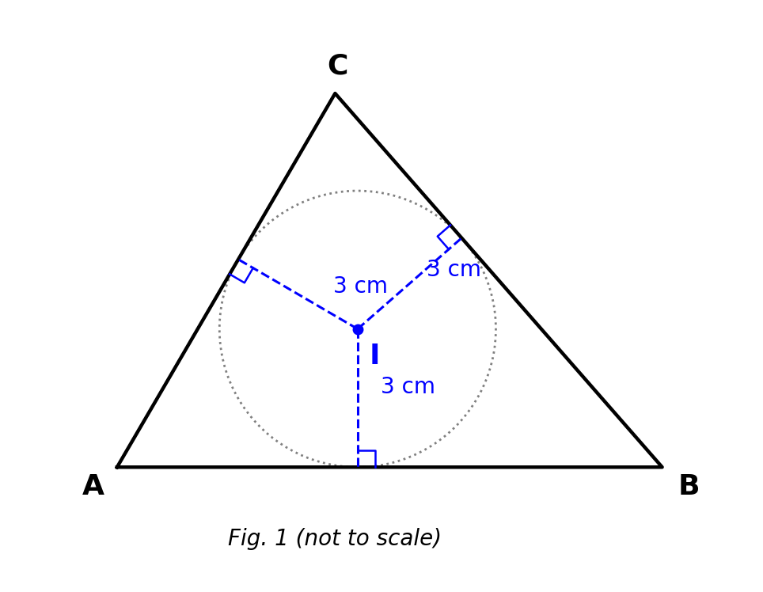
Fig. 1 — triangle ABC with incentre I and equal perpendicular distances to the sides (not to scale).
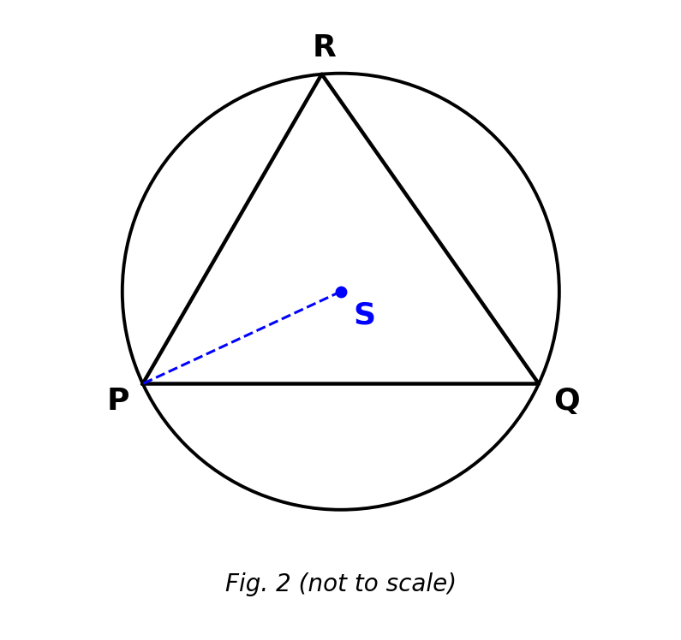
Fig. 2 — circumscribed circle of triangle PQR with centre S (not to scale).
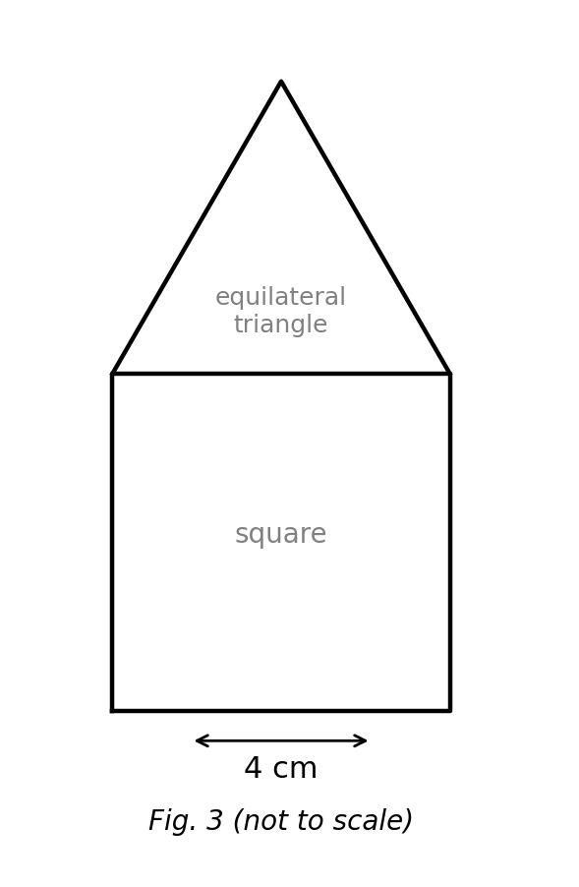
Fig. 3 — compound shape: square with an equilateral triangle on top (not to scale).
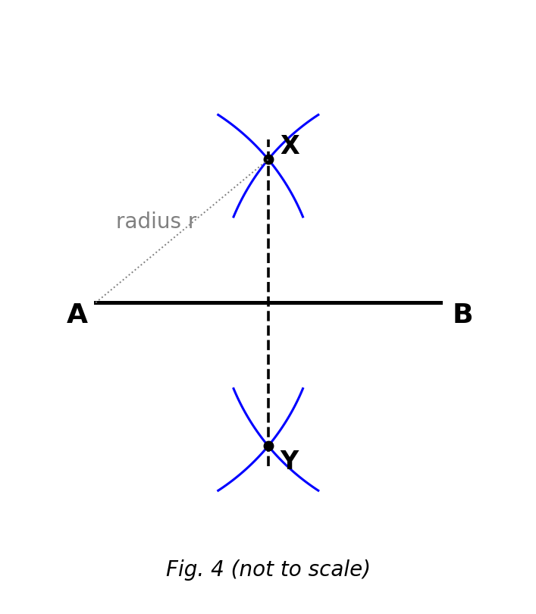
Fig. 4 — perpendicular bisector of AB by equal arcs from A and B (not to scale).

SECTION B: MARKING SCHEME

1. Constructing a triangle and its inscribed circle [10 marks]
Work with a ruler and a pair of compasses for this question.
(a) Construct triangle ABC with AB = 6 cm, ∠ABC = 60° and BC = 5 cm. Draw AB = 6 cm; at B construct 60° and cut off BC = 5 cm; join CA (≈ 5.6 cm). [2 marks]
(b) Bisect ∠BAC and ∠BCA, and mark the intersection of the two bisectors as I. Correct bisector arcs for both angles; I correctly located inside the triangle. [3 marks]
(c) Name the point I and state what meets there. I is the INCENTRE — the point where the three angle bisectors of the triangle meet. [2 marks]
(d) Draw the inscribed circle of the triangle and state its radius to 1 d.p. Circle centred at I touching all three sides; radius ≈ 1.6 cm (accept 1.5–1.7 cm). [3 marks]
[Total: 10 marks]

2. Constructing a triangle and its circumscribed circle [10 marks]
(a) Construct triangle PQR with PQ = 7 cm, QR = 6 cm and PR = 5 cm. Draw PQ = 7 cm; arcs of radius 6 cm from Q and 5 cm from P meet at R; join. [3 marks]
(b) Construct the perpendicular bisectors of PQ and QR, and mark their intersection as S. Correct equal-radius arcs on both sides; S correctly located. [3 marks]
(c) Name S and state its distance property. S is the CIRCUMCENTRE — equidistant from the three vertices P, Q and R. [2 marks]
(d) Draw the circumscribed circle and state its radius to 1 d.p. Circle centred at S through P, Q, R; radius ≈ 3.6 cm (accept 3.5–3.7 cm). [2 marks]
[Total: 10 marks]

3. Constructing a square [10 marks]
(a) Construct square ABCD with AB = 6.5 cm. Base AB = 6.5 cm; perpendiculars at A and B; arcs of 6.5 cm fix D and C; join DC. [4 marks]
(b) Draw and measure the diagonals AC and BD, and record each to 1 d.p. Both diagonals ≈ 9.2 cm (6.5√2 = 9.19 cm; accept 9.0–9.4 cm). [2 marks]
(c) What angle do the diagonals of the square make where they cross? 90° — the diagonals of a square intersect at right angles. [2 marks]
(d) State two other properties of the diagonals of a square. They are equal in length, and they bisect each other. [2 marks]
[Total: 10 marks]

4. Constructing a rectangle from a side and a diagonal [10 marks]
(a) Rectangle PQRS has PQ = 6 cm and diagonal PR = 10 cm. Calculate QR. QR = √(10² − 6²) = √64 = 8 cm. [2 marks]
(b) Using these dimensions, construct the rectangle PQRS. PQ = 6 cm; perpendiculars at Q (and P); QR = 8 cm; PS = 8 cm; join SR. [4 marks]
(c) Draw the second diagonal QS and state its measured length. QS = 10 cm — the diagonals of a rectangle are equal. [2 marks]
(d) Calculate the area of the rectangle. Area = 6 × 8 = 48 cm². [2 marks]
[Total: 10 marks]

5. Parallelogram and rhombus [10 marks]
(a) Construct parallelogram ABCD with AB = 6 cm, AD = 4.5 cm and ∠DAB = 60°. AB = 6 cm; 60° at A with AD = 4.5 cm; arcs of 6 cm from D and 4.5 cm from B fix C. [4 marks]
(b) Measure the diagonal BD and record it to 1 d.p. BD ≈ 5.4 cm (exact √29.25 ≈ 5.41; accept 5.2–5.6 cm). [2 marks]
(c) State the size of ∠ABC, giving a reason. ∠ABC = 120° — adjacent (co-interior) angles of a parallelogram are supplementary: 180° − 60°. [2 marks]
(d) Construct a rhombus whose diagonals are 6 cm and 8 cm, and calculate its side. Diagonals bisect at right angles: half-diagonals 3 cm and 4 cm; side = √(3² + 4²) = 5 cm. [2 marks]
[Total: 10 marks]

6. Equilateral triangle: inscribed and circumscribed circles [10 marks]
(a) Construct an equilateral triangle of side 6 cm. Base 6 cm; arcs of radius 6 cm from both endpoints meet at the apex. [3 marks]
(b) Locate its incentre, draw the inscribed circle and state its radius to 1 d.p. Two angle bisectors meet at the centre; circle touches all sides; r ≈ 1.7 cm (6/(2√3) ≈ 1.73; accept 1.6–1.8 cm). [3 marks]
(c) What do you observe about the incentre and circumcentre of an equilateral triangle? They COINCIDE — the same single point (the centre of the triangle). [2 marks]
(d) Hence state the radius of the circumscribed circle of the triangle to 1 d.p. R = 6/√3 ≈ 3.5 cm (accept 3.4–3.6 cm). [2 marks]
[Total: 10 marks]

CURRICULUM BLUEPRINT
Qn | Content Focus | Indicator | Marks
1 | Incentre (angle-bisector concurrency) | B9.3.1.2.1 | 1
2 | Incentre equidistant from sides | B9.3.1.2.1 | 1
3 | Constructing the incentre | B9.3.1.2.1 | 1
4 | Inscribed-circle radius | B9.3.1.2.1 | 1
5 | Circumcentre (perpendicular-bisector concurrency) | B9.3.1.2.1 | 1
6 | Circumcentre equidistant from vertices | B9.3.1.2.1 | 1
7 | Circumscribed circle | B9.3.1.2.1 | 1
8 | Locus: perpendicular bisector | B9.3.1.2.1 | 1
9 | Locus: angle bisector | B9.3.1.2.1 | 1
10 | Locating the incentre | B9.3.1.2.1 | 1
11 | Locating the circumcentre | B9.3.1.2.1 | 1
12 | Construction instruments | B9.3.1.2 | 1
13 | Inscribed circle (Fig. 1) | B9.3.1.2.1 | 1
14 | Circumscribed circle radii (Fig. 2) | B9.3.1.2.1 | 1
15 | Circumcentre of a right triangle | B9.3.1.2.1 | 1
16 | Circumradius from hypotenuse | B9.3.1.2.1 | 1
17 | Circumcentre position by triangle type | B9.3.1.2.1 | 1
18 | Equilateral triangle centres coincide | B9.3.1.2.1 | 1
19 | Square: side to diagonal (curriculum exemplar) | B9.3.1.2.2 | 1
20 | Square from diagonal | B9.3.1.2.2 | 1
21 | Square from diagonal: side length | B9.3.1.2.2 | 1
22 | Data for a rectangle | B9.3.1.2.2 | 1
23 | Rectangle: side and diagonal | B9.3.1.2.2 | 1
24 | Rectangle diagonal (Pythagoras) | B9.3.1.2.2 | 1
25 | Rhombus property | B9.3.1.2.2 | 1
26 | Rhombus: diagonals to side | B9.3.1.2.2 | 1
27 | Data for a parallelogram | B9.3.1.2.2 | 1
28 | SSS determines a triangle uniquely | B9.3.1.2.2 | 1
29 | Triangle inequality | B9.3.1.2.2 | 1
30 | Triangle inequality: least side | B9.3.1.2.2 | 1
31 | SAS construction | B9.3.1.2.2 | 1
32 | ASA construction | B9.3.1.2.2 | 1
33 | Regular hexagon construction | B9.3.1.2.2 | 1
34 | Hexagon perimeter | B9.3.1.2.2 | 1
35 | Compound plane shape (curriculum exemplar) | B9.3.1.2.2 | 1
36 | Locus: circle | B9.3.1.2 | 1
37 | Locus: perpendicular bisector | B9.3.1.2 | 1
38 | Bisecting sides for the circumcircle | B9.3.1.2 | 1
39 | Perpendicular-bisector arcs (Fig. 4) | B9.3.1.2 | 1
40 | Inscribed circle of a square | B9.3.1.2.2 | 1
B1 | Triangle (SAS) + inscribed circle — incentre | B9.3.1.2.1 | 10
B2 | Triangle (SSS) + circumscribed circle — circumcentre | B9.3.1.2.1 | 10
B3 | Square from a side; diagonal properties | B9.3.1.2.2 | 10
B4 | Rectangle from a side and a diagonal | B9.3.1.2.2 | 10
B5 | Parallelogram (sides + angle) and rhombus | B9.3.1.2.2 | 10
B6 | Equilateral triangle: inscribed & circumscribed circles | B9.3.1.2.1 | 10
 | TOTAL |  | 100

CURRICULUM COVERAGE BY INDICATOR
Curriculum Area | Section A | Section B | Total | %
B9.3.1.2 (standard) Construction tools, loci and triangle-construction conditions | 5 | 0 | 5 | 5%
B9.3.1.2.1 Inscribed & circumscribed circles (incentre / circumcentre) | 17 | 30 (B1, B2, B6) | 47 | 47%
B9.3.1.2.2 Constructing parallelograms (square, rectangle, rhombus) | 18 | 30 (B3, B4, B5) | 48 | 48%
Note: Section A q12 and q36–39 test construction instruments, loci and bisecting technique at the standard level (5 marks); q1–11 and q13–18 test the inscribed/circumscribed-circle indicator .1 (17); q19–35 and q40 test parallelogram constructions, indicator .2 (18). Section B: B1, B2 and B6 inscribed/circumscribed circles (30); B3, B4 and B5 square, rectangle, parallelogram and rhombus (30).

COGNITIVE-LEVEL DISTRIBUTION
Cognitive Level | Section A | Section B | Total | %
Remember | 2 | 0 | 2 | 2%
Understand | 12 | 10 | 22 | 22%
Apply | 18 | 28 | 46 | 46%
Analyse | 8 | 2 | 10 | 10%
Evaluate | 0 | 0 | 0 | 0%
Create | 0 | 20 | 20 | 20%

DIFFICULTY DISTRIBUTION
Difficulty | Section A | Section B | Total | %
Easy | 13 | 10 (B3) | 23 | 23%
Moderate | 23 | 30 (B1, B2, B4) | 53 | 53%
Challenging | 4 | 20 (B5, B6) | 24 | 24%

QUALITY-CONTROL SUMMARY
Check | Status
Curriculum alignment | Standard B9.3.1.2 with both indicators: inscribed/circumscribed circles via incentre/circumcentre (.1) and square/rectangle/rhombus/parallelogram constructions (.2).
Section structure | Section A: 40 objectives (40 marks). Section B: 6 structured construction questions (60 marks). Total 100 marks, 2 hours.
Answer key balance | A=10, B=10, C=10, D=10. Zero consecutive repeats. No sustained cycling pattern.
Diagrams (BECE style) | Four labelled figures: incentre with equal perpendiculars, circumscribed circle with centre S, compound square-plus-triangle shape, and perpendicular-bisector arcs — all marked 'not to scale'.
Curriculum exemplars used | Incentre as concurrency of angle bisectors with measured equal distances; circumcentre with locus equidistant from vertices; square from side 6.5 cm with measured diagonal; square from diagonal; rectangle from side and diagonal; parallelogram from sides and angle; regular compound plane shapes — all from the CCP exemplar lists.
Distractor quality | Classic confusions: incentre vs circumcentre vs centroid, sides vs vertices, half-diagonal vs side, SAS vs ASA vs SSS, triangle-inequality traps, ½AB radius condition.
Marking guide completeness | Every Section B part carries explicit marks (each question sums to 10); construction steps and measured values with tolerances given; all figures reprinted for the marker.
Blueprint | 46-row blueprint (40 objectives + 6 structured) sums to exactly 100 marks.
Coverage | Standard tools/loci 5%, .1 = 47%, .2 = 48%.
Cognitive spread | Remember 2%, Understand 22%, Apply 46%, Analyse 10%, Create 20%.
Difficulty spread | Easy 23%, Moderate 53%, Challenging 24%.

