BEACON EDUCATIONAL CONSULT
MOCK EXAMINATION — 2026/2027 ACADEMIC YEAR
MATHEMATICS — BASIC 9 (JHS 3)
Chapter 12: Inscribed and Circumscribed Figures (Curriculum Standard B9.3.1.2)
Time Allowed: 2 Hours Total Marks: 100

INSTRUCTIONS TO CANDIDATES
1. Write your name and index number on the answer sheet provided.
2. This paper consists of TWO sections: Section A (Objectives) and Section B (Structured Questions).
3. Section A: Answer ALL forty (40) questions. Each question carries 1 mark. Choose the correct option from A to D.
4. Section B: Answer ALL six (6) questions. Each question carries 10 marks. Show all necessary workings.
5. All constructions must be done with a ruler and a pair of compasses. Leave all construction lines visible.
6. All diagrams are NOT drawn to scale. Study them carefully before answering.
7. Use a non-programmable calculator where necessary.

SECTION A: OBJECTIVE TEST (40 MARKS)
Answer ALL questions in this section. Choose the correct answer from A to D.
1. The point where the three angle bisectors of a triangle meet is called the
A. circumcentre
B. centroid
C. orthocentre
D. incentre
2. The incentre of a triangle is equidistant from
A. the midpoints of the three sides
B. the two longest sides
C. the three sides
D. the three vertices
3. To locate the incentre of a triangle by construction, the lines drawn are
A. the bisectors of any two angles
B. the three altitudes
C. the perpendicular bisectors of any two sides
D. the three medians
4. The radius of the inscribed circle of a triangle equals
A. the distance from the incentre to any vertex
B. half of the longest side
C. the perpendicular distance from the incentre to any side
D. a third of the perimeter
5. The point where the perpendicular bisectors of the sides of a triangle meet is called the
A. centroid
B. circumcentre
C. midpoint
D. incentre
6. The circumcentre of a triangle is equidistant from
A. the incentre
B. the three sides
C. the three vertices
D. the midpoints of the sides
7. The circle that passes through all three vertices of a triangle is its
A. inscribed circle
B. circumscribed circle
C. semicircle
D. unit circle
8. The perpendicular bisector of segment AB is the locus of points
A. equidistant from A and B
B. on the segment AB
C. equidistant from two parallel lines
D. 2 cm from A
9. The bisector of ∠ABC is the locus of points
A. midway between A and C
B. equidistant from B and C
C. equidistant from the arms BA and BC
D. a fixed distance from A
10. The minimum number of angle bisectors needed to locate the incentre of a triangle is
A. 0
B. 1
C. 3
D. 2
11. The minimum number of perpendicular bisectors needed to locate the circumcentre of a triangle is
A. 3
B. 0
C. 2
D. 1
12. The instruments used to construct the perpendicular bisector of a line segment are
A. a set square and a protractor
B. a protractor and a ruler
C. a ruler only
D. a pair of compasses and a ruler
Question 13 refers to Fig. 1.
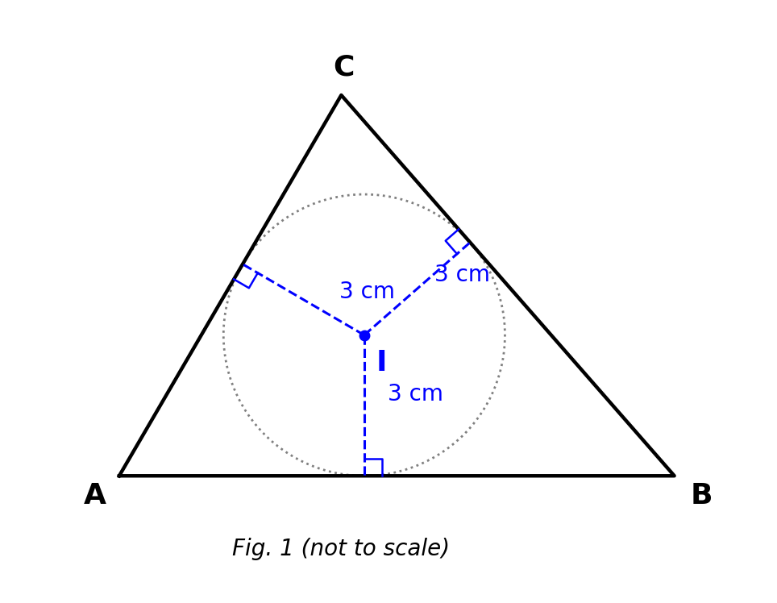
Fig. 1 — triangle ABC with incentre I and equal perpendicular distances to the sides (not to scale).
13. In triangle ABC, I is the incentre and the perpendicular distances from I to each side are 3 cm. The radius of the inscribed circle is
A. 1.5 cm
B. 3 cm
C. 6 cm
D. 9 cm
Question 14 refers to Fig. 2.
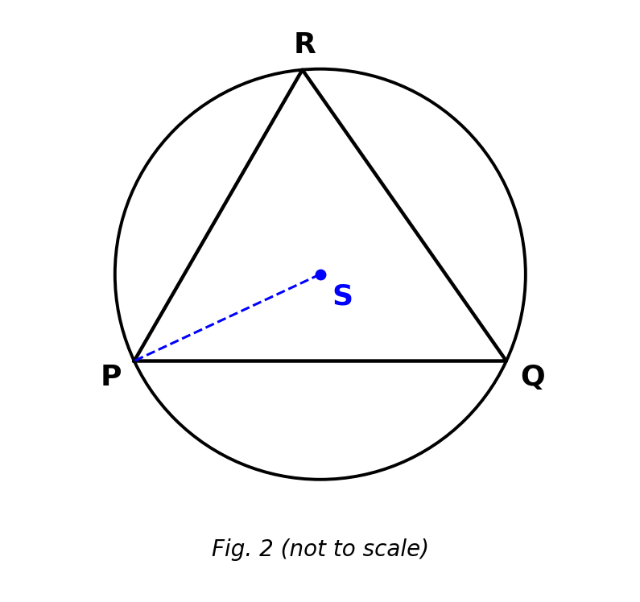
Fig. 2 — circumscribed circle of triangle PQR with centre S (not to scale).
14. S is the centre of the circle passing through P, Q and R. SP is equal to
A. half of PQ
B. the radius of the inscribed circle
C. SQ
D. the perpendicular distance from S to PQ
15. The circumcentre of a right-angled triangle lies at
A. a point outside the triangle
B. the midpoint of the hypotenuse
C. the right-angle vertex
D. the incentre
16. The circumradius of a right-angled triangle whose hypotenuse is 10 cm is
A. 5 cm
B. 20 cm
C. 10 cm
D. 2.5 cm
17. The circumcentre lies OUTSIDE the triangle when the triangle is
A. right-angled
B. obtuse-angled
C. equilateral
D. acute-angled
18. In an equilateral triangle, the incentre and the circumcentre
A. are the same point
B. both lie outside the triangle
C. lie on different sides
D. are the ends of one side
19. A square ABCD is constructed with AB = 6.5 cm. Measuring the diagonal AC gives about
A. 4.6 cm
B. 9.2 cm
C. 13.0 cm
D. 6.5 cm
20. To construct a square from a given diagonal of 8 cm, one should first
A. bisect the 8 cm line into four equal parts
B. construct a 60° angle at one end
C. draw a side of 8 cm
D. draw the 8 cm diagonal and construct its perpendicular bisector
21. Each side of the square in question 20 is approximately
A. 16 cm
B. 11.3 cm
C. 5.7 cm
D. 4.0 cm
22. The minimum data needed to construct a rectangle are
A. one side only
B. the lengths of two adjacent sides
C. one diagonal only
D. one side and one angle
23. A rectangle has length 6 cm and diagonal 10 cm. Its width is
A. 12 cm
B. 16 cm
C. 4 cm
D. 8 cm
24. The diagonal of a rectangle with sides 8 cm and 15 cm is
A. 17 cm
B. 15 cm
C. 23 cm
D. 12 cm
25. The property used when constructing a rhombus with a given side is that a rhombus has
A. equal diagonals
B. all angles equal
C. only one pair of parallel sides
D. all four sides equal
26. A rhombus has diagonals 6 cm and 8 cm. Each side of the rhombus is
A. 5 cm
B. 10 cm
C. 14 cm
D. 7 cm
27. A parallelogram can be constructed uniquely when given
A. one angle only
B. two adjacent sides and the included angle
C. one side only
D. one diagonal only
28. Using the SSS condition with sides 5 cm, 6 cm and 7 cm, the number of different (non-congruent) triangles that can be constructed is
A. 2
B. 3
C. infinitely many
D. 1
29. Which of the following sets of lengths CANNOT form a triangle?
A. 5 cm, 12 cm, 13 cm
B. 3 cm, 4 cm, 8 cm
C. 6 cm, 8 cm, 10 cm
D. 3 cm, 4 cm, 5 cm
30. A triangle has sides 5 cm and 8 cm, with the third side a whole number x cm. The least possible value of x is
A. 13
B. 2
C. 4
D. 3
31. Constructing triangle ABC with AB = 5 cm, BC = 6 cm and ∠ABC = 60° uses the
A. SSS condition
B. SAS condition
C. ASA condition
D. RHS condition
32. Constructing a triangle with angles 60° and 60° and the included side 4 cm uses the
A. ASA condition
B. SAS condition
C. RHS condition
D. SSS condition
33. When constructing a regular hexagon inside a circle of radius r, each side of the hexagon equals
A. πr
B. 2r
C. r/2
D. r
34. A regular hexagon is constructed inside a circle of radius 4 cm. The perimeter of the hexagon is
A. 24 cm
B. 8 cm
C. 16 cm
D. 32 cm
Question 35 refers to Fig. 3.
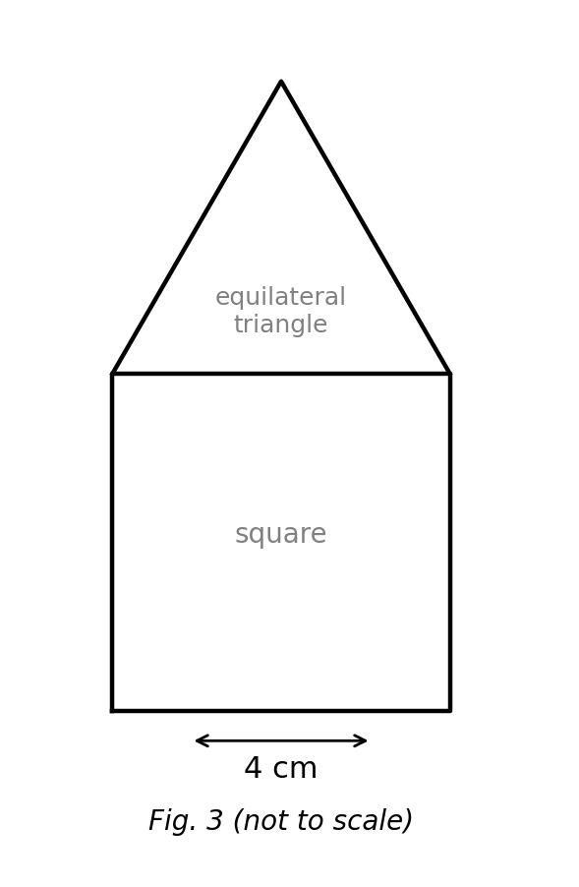
Fig. 3 — compound shape: square with an equilateral triangle on top (not to scale).
35. A square of side 4 cm has an equilateral triangle attached on top. The perimeter of the compound shape is
A. 24 cm
B. 28 cm
C. 20 cm
D. 16 cm
36. The locus of a point at a fixed distance of 4 cm from a fixed point O is
A. a circle of radius 4 cm about O
B. the perpendicular bisector of two points
C. a straight line
D. a pair of parallel lines
37. The locus of a point equidistant from two fixed points P and Q is
A. a circle centred at P
B. the line PQ
C. the bisector of angle POQ
D. the perpendicular bisector of PQ
38. In constructing the circumscribed circle of a triangle, the line drawn to bisect each side is its
A. median
B. altitude
C. perpendicular bisector
D. angle bisector
Question 39 refers to Fig. 4.
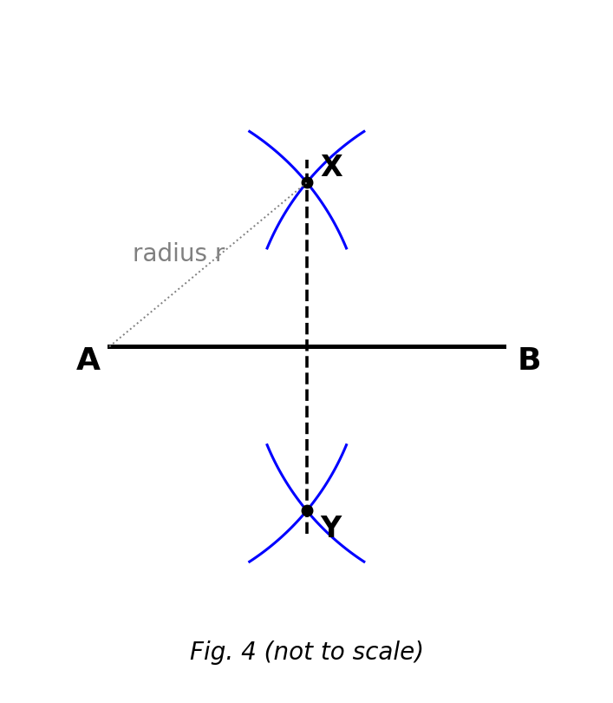
Fig. 4 — perpendicular bisector of AB by equal arcs from A and B (not to scale).
39. Arcs of equal radius from A and B meet at X and Y, and XY bisects AB at right angles. For the construction to work, the radius must be
A. exactly half of AB
B. less than half of AB
C. equal to AB
D. greater than half of AB
40. A circle drawn inside a square of side 6 cm touches all four sides. The diameter of the circle is
A. 6 cm
B. 3 cm
C. 12 cm
D. 9 cm

SECTION B: STRUCTURED QUESTIONS (60 MARKS)
Answer ALL questions in this section. Show all construction and calculation steps clearly. Diagrams are not to scale.

1. Constructing a triangle and its inscribed circle
Work with a ruler and a pair of compasses for this question.
(a) Construct triangle ABC with AB = 6 cm, ∠ABC = 60° and BC = 5 cm. [2 marks]
(b) Bisect ∠BAC and ∠BCA, and mark the intersection of the two bisectors as I. [3 marks]
(c) Name the point I and state what meets there. [2 marks]
(d) Draw the inscribed circle of the triangle and state its radius to 1 d.p. [3 marks]
[Total: 10 marks]

2. Constructing a triangle and its circumscribed circle
(a) Construct triangle PQR with PQ = 7 cm, QR = 6 cm and PR = 5 cm. [3 marks]
(b) Construct the perpendicular bisectors of PQ and QR, and mark their intersection as S. [3 marks]
(c) Name S and state its distance property. [2 marks]
(d) Draw the circumscribed circle and state its radius to 1 d.p. [2 marks]
[Total: 10 marks]

3. Constructing a square
(a) Construct square ABCD with AB = 6.5 cm. [4 marks]
(b) Draw and measure the diagonals AC and BD, and record each to 1 d.p. [2 marks]
(c) What angle do the diagonals of the square make where they cross? [2 marks]
(d) State two other properties of the diagonals of a square. [2 marks]
[Total: 10 marks]

4. Constructing a rectangle from a side and a diagonal
(a) Rectangle PQRS has PQ = 6 cm and diagonal PR = 10 cm. Calculate QR. [2 marks]
(b) Using these dimensions, construct the rectangle PQRS. [4 marks]
(c) Draw the second diagonal QS and state its measured length. [2 marks]
(d) Calculate the area of the rectangle. [2 marks]
[Total: 10 marks]

5. Parallelogram and rhombus
(a) Construct parallelogram ABCD with AB = 6 cm, AD = 4.5 cm and ∠DAB = 60°. [4 marks]
(b) Measure the diagonal BD and record it to 1 d.p. [2 marks]
(c) State the size of ∠ABC, giving a reason. [2 marks]
(d) Construct a rhombus whose diagonals are 6 cm and 8 cm, and calculate its side. [2 marks]
[Total: 10 marks]

6. Equilateral triangle: inscribed and circumscribed circles
(a) Construct an equilateral triangle of side 6 cm. [3 marks]
(b) Locate its incentre, draw the inscribed circle and state its radius to 1 d.p. [3 marks]
(c) What do you observe about the incentre and circumcentre of an equilateral triangle? [2 marks]
(d) Hence state the radius of the circumscribed circle of the triangle to 1 d.p. [2 marks]
[Total: 10 marks]

