BEACON EDUCATIONAL CONSULT
MARKING GUIDE — MOCK EXAMINATION 2026/2027
MATHEMATICS — BASIC 9 (JHS 3) — Chapter 13: Surface Area of Prisms (B9.3.2.1)

Curriculum Standard (NaCCA CCP, Sept 2020): B9.3.2.1 — Derive the formulas for determining the surface area of prisms (i.e. cuboid and triangular prism) and use to solve problems.
Indicators tested: B9.3.2.1.1 Identify cuboids and triangular prisms; draw their nets to construct the 3-D shapes and use it to determine the surface area; B9.3.2.1.2 Use the net of a cuboid to determine its surface area; B9.3.2.1.3 Use the net of a triangular prism to determine its surface area. Prism meaning, lateral-surface ideas, edge totals and units are tagged at standard level.
Note: the official CCP page lists 'B9.3.2.1.4 Express points in the Cartesian plane as position vectors' under this standard; that indicator belongs to the vectors strand (B9.3.2.2) and appears to be a typesetting defect in the PDF. It is not assessed in this chapter mock.

SECTION A: ANSWER KEY
Qn | Ans | Content Focus | Indicator
1 | A | Meaning of a prism | B9.3.2.1
2 | B | Faces of a cuboid | B9.3.2.1.1
3 | A | Vertices of a cuboid | B9.3.2.1.1
4 | C | Edges of a cuboid (Fig. 1) | B9.3.2.1.1
5 | D | Identifying a triangular prism (Fig. 1) | B9.3.2.1.1
6 | C | Net of a cuboid | B9.3.2.1.1
7 | D | Net of a triangular prism | B9.3.2.1.1
8 | A | Identifying a solid from faces, edges, vertices | B9.3.2.1.1
9 | C | Deriving the cuboid surface area | B9.3.2.1
10 | B | Lateral surface of a prism | B9.3.2.1
11 | C | Total edge length of a cuboid | B9.3.2.1
12 | B | Lateral faces of an n-gonal prism | B9.3.2.1
13 | A | Surface area of a cuboid | B9.3.2.1.2
14 | D | Surface area of a cube | B9.3.2.1.2
15 | C | Cube side from surface area | B9.3.2.1.2
16 | D | Surface area of a cuboid | B9.3.2.1.2
17 | A | Surface area from a net (Fig. 2) | B9.3.2.1.2
18 | D | Open box without lid | B9.3.2.1.2
19 | B | Missing height from surface area | B9.3.2.1.2
20 | A | Surface area of a cuboid | B9.3.2.1.2
21 | C | Effect of doubling the side | B9.3.2.1.2
22 | B | Wrapping a gift box | B9.3.2.1.2
23 | C | Painting walls | B9.3.2.1.2
24 | B | Joined cubes | B9.3.2.1.2
25 | C | Triangular-prism surface-area formula | B9.3.2.1.3
26 | D | Right-triangle prism surface area | B9.3.2.1.3
27 | B | Surface area from a net (Fig. 3) | B9.3.2.1.3
28 | A | Isosceles-triangle prism surface area | B9.3.2.1.3
29 | B | Right-triangle prism surface area | B9.3.2.1.3
30 | A | Tent cloth (Fig. 4) | B9.3.2.1.3
31 | D | Identifying a solid from its net | B9.3.2.1.1
32 | B | Equilateral-triangle prism surface area | B9.3.2.1.3
33 | C | Surface area from area and perimeter | B9.3.2.1.3
34 | D | Triangular bases of the prism | B9.3.2.1.1
35 | C | Faces of a triangular prism | B9.3.2.1.1
36 | D | Units of surface area | B9.3.2.1
37 | A | Comparing surface areas | B9.3.2.1.2
38 | B | Net of a pentagonal prism | B9.3.2.1
39 | D | Cuboid with square base | B9.3.2.1.2
40 | A | Cube surface area from edge total | B9.3.2.1.2

Full answer key: ABACD CDACB CBADC DADBA CBCBC DBABA DBCDC DABDA

SECTION A: WORKED SOLUTIONS
1. A prism keeps the same cross-section (shape and size) along its whole length.
2. A cuboid has 6 rectangular faces.
3. A cuboid has 8 vertices (corners).
4. A cuboid has 12 edges.
5. Solid Q has two triangular ends and three rectangular faces: a triangular prism.
6. Unfolded, a cuboid gives six rectangles (three congruent pairs).
7. The net shows the two triangular ends and three rectangular lateral faces.
8. 5 faces, 9 edges, 6 vertices match a triangular prism (a cuboid has 6/12/8).
9. Pairs lw, lh, wh counted twice give 2(lw + lh + wh).
10. The lateral faces unwrap into one rectangle: perimeter × length.
11. Each of l, w, h occurs in 4 parallel edges: 4(l + w + h).
12. One rectangle per base side, so n lateral faces.
13. 2(4×3 + 4×2 + 3×2) = 2(12 + 8 + 6) = 52 cm².
14. 6 × 4² = 6 × 16 = 96 cm².
15. 6a² = 150 → a² = 25 → a = 5 cm.
16. 2(5×4 + 5×3 + 4×3) = 2(20 + 15 + 12) = 94 cm².
17. Faces: 6×4, 6×3, 4×3 in pairs: 2(24 + 18 + 12) = 108 cm².
18. Five faces: base 24 + sides 2(6×5) + 2(4×5) = 24 + 60 + 40 = 124 cm².
19. 2(24 + 6h + 4h) = 148 → 48 + 20h = 148 → h = 5 cm.
20. 2(80 + 50 + 40) = 2 × 170 = 340 cm².
21. SA = 6a², so doubling a multiplies SA by 4.
22. 2(20×15 + 20×10 + 15×10) = 2(300 + 200 + 150) = 1 300 cm².
23. Walls only: 2(5 + 4) × 3 = 54 m².
24. Two cubes give 12 faces; joining hides 2: 10 × (2×2) = 40 cm².
25. Two triangular ends (2A) plus the lateral rectangle P × l.
26. 2(½×3×4) + (3+4+5)×10 = 12 + 120 = 132 cm².
27. 2(½×3×4) + (3+4+5)×8 = 12 + 96 = 108 cm².
28. 2(½×8×3) + (8+5+5)×12 = 24 + 216 = 240 cm².
29. 2(½×6×8) + (6+8+10)×20 = 48 + 480 = 528 cm².
30. Ends: 2(½×2×0.75) = 1.5; slants: 2(1.25×3) = 7.5; total 9 m².
31. 2 triangles + 3 rectangles is exactly the net of a triangular prism.
32. 2(½×6×5.2) + 18×10 = 31.2 + 180 ≈ 211.2 cm².
33. 2(24) + 24×10 = 48 + 240 = 288 cm².
34. The triangles close the two ends (bases) of the prism.
35. 2 triangular ends + 3 rectangular faces = 5 faces.
36. Area is measured in square units (cm², m², …).
37. Cube 96 cm²; cuboid 2(24 + 12 + 8) = 88 cm²; difference 8 cm².
38. One lateral rectangle per side of the pentagon: 5.
39. 2(3×3) + 4(3×8) = 18 + 96 = 114 cm².
40. Edge = 60/12 = 5 cm; SA = 6 × 25 = 150 cm².

FIGURES (REPRINTED FOR MARKING)
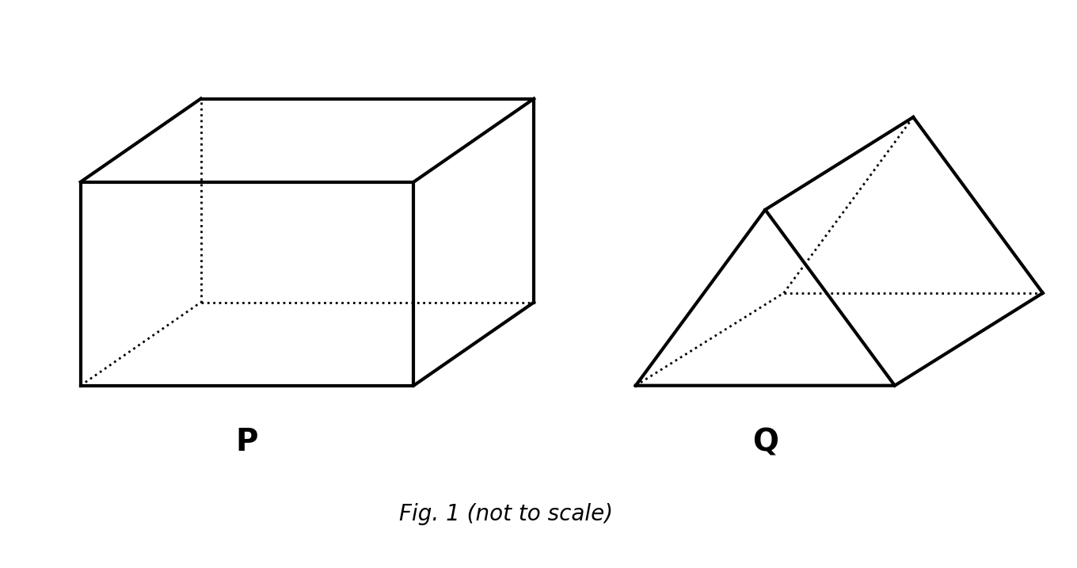
Fig. 1 — solids P and Q (not to scale).
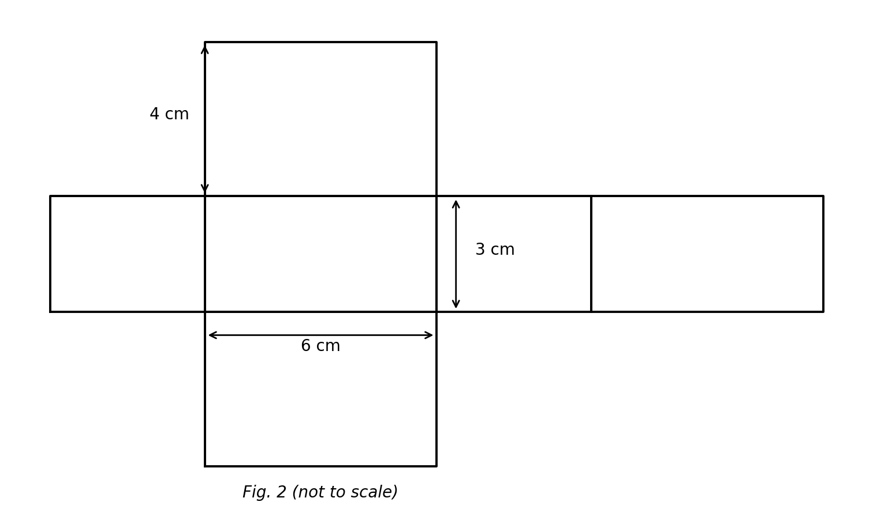
Fig. 2 — net of a cuboid (not to scale).
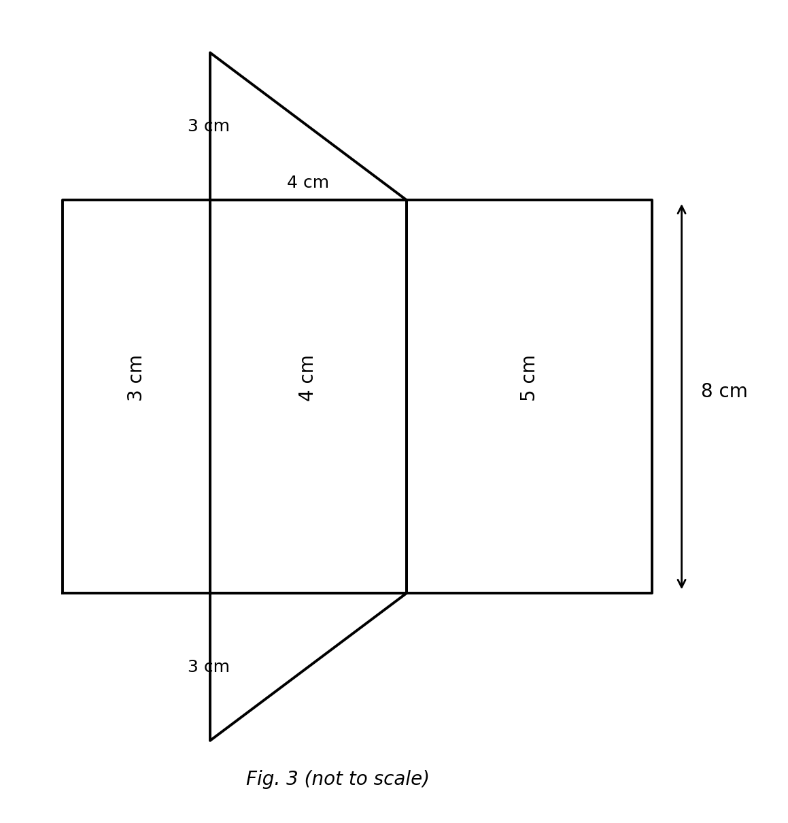
Fig. 3 — net of a triangular prism (not to scale).
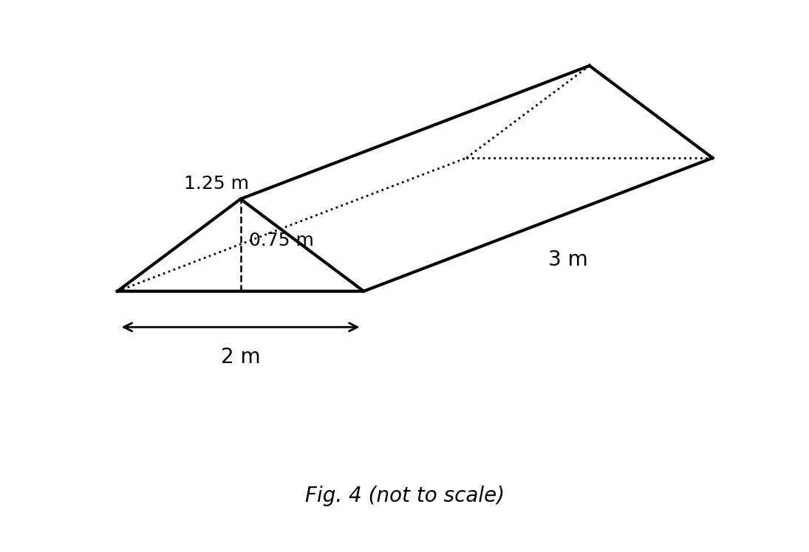
Fig. 4 — tent shaped as a triangular prism (not to scale).

SECTION B: MARKING SCHEME

1. Identifying solids and drawing nets [10 marks]
(a) State the number of faces, edges and vertices of (i) a cuboid and (ii) a triangular prism. (i) Cuboid: 6 faces, 12 edges, 8 vertices. (ii) Triangular prism: 5 faces, 9 edges, 6 vertices. [3 marks]
(b) Sketch the net of a cuboid with length 5 cm, width 3 cm and height 2 cm, and label its rectangles. Correct cross/T-shaped net of six rectangles: two 5×3, two 5×2, two 3×2, correctly labelled. [3 marks]
(c) How many rectangles and how many triangles are in the net of a triangular prism? 3 rectangles and 2 triangles. [2 marks]
(d) Name the solid whose net is 2 triangles and 3 rectangles. A triangular prism. [2 marks]
[Total: 10 marks]

2. Deriving the cuboid surface-area formula [10 marks]
(a) A cuboid has length l, width w and height h. When unfolded, its faces form three congruent pairs. Name the pairs and the area of each pair. Top & bottom = lw each; front & back = lh each; two ends = wh each. [2 marks]
(b) Hence write an expression for the total surface area. SA = 2lw + 2lh + 2wh. [3 marks]
(c) Factorise your expression. SA = 2(lw + lh + wh). [2 marks]
(d) Evaluate the formula for l = 7 cm, w = 5 cm, h = 3 cm. 2(35 + 21 + 15) = 2 × 71 = 142 cm². [3 marks]
[Total: 10 marks]

3. Cuboid surface-area problems [10 marks]
(a) Find the total surface area of a cuboid 12 cm × 9 cm × 6 cm. 2(108 + 72 + 54) = 2 × 234 = 468 cm². [3 marks]
(b) The cuboid is used as an open tank with no top. Find the area of its five faces. 468 − (12 × 9) = 468 − 108 = 360 cm². [3 marks]
(c) Find the surface area of a cube of side 9 cm. 6 × 9² = 6 × 81 = 486 cm². [2 marks]
(d) Which solid has the greater surface area, and by how much? The cube: 486 − 468 = 18 cm² more. [2 marks]
[Total: 10 marks]

4. Deriving the triangular-prism surface area [10 marks]
(a) Describe the net of a triangular prism. Two congruent triangles (the ends) and three rectangles (the lateral faces). [2 marks]
(b) If the cross-section has area A and perimeter P, and the prism has length l, write the surface-area formula. SA = 2A + P × l. [3 marks]
(c) Use the formula for a right-triangle cross-section 5 cm, 12 cm, 13 cm with length 20 cm. A = ½ × 5 × 12 = 30; P = 30; SA = 2(30) + 30 × 20 = 60 + 600 = 660 cm². [3 marks]
(d) Explain why all three rectangles have the same length l. Each lateral face runs the full length of the prism, so every rectangle has one side equal to l. [2 marks]
[Total: 10 marks]

5. Triangular-prism problems [10 marks]
(a) Find the surface area of a prism whose isosceles-triangle cross-section has base 10 cm, height 12 cm and equal sides 13 cm, with length 20 cm. A = ½ × 10 × 12 = 60; P = 10 + 13 + 13 = 36; SA = 2(60) + 36 × 20 = 120 + 720 = 840 cm². [4 marks]
(b) Find the lateral surface area only (the three rectangles). P × l = 36 × 20 = 720 cm². [3 marks]
(c) If the length is doubled to 40 cm, find the new surface area and the increase. SA = 120 + 36 × 40 = 120 + 1440 = 1560 cm²; increase = 1560 − 840 = 720 cm². [3 marks]
[Total: 10 marks]

6. Applications [10 marks]
(a) A gift carton 30 cm × 20 cm × 10 cm is wrapped without overlap. Find the area of paper needed. 2(600 + 300 + 200) = 2 × 1100 = 2 200 cm². [3 marks]
(b) If the carton has no lid, find the paper needed. 2 200 − (30 × 20) = 2 200 − 600 = 1 600 cm². [2 marks]
(c) A cake tin is a triangular prism with equilateral-triangle cross-section of side 8 cm (height ≈ 6.9 cm) and length 15 cm. Estimate its surface area. 2 × (½ × 8 × 6.9) + (24 × 15) = 55.2 + 360 ≈ 415.2 cm² (accept 415–416 cm²). [3 marks]
(d) A cube of side 6 cm and a cuboid 10 cm × 6 cm × h cm have equal surface areas. Find h. Cube SA = 216; 2(60 + 10h + 6h) = 216 → 120 + 32h = 216 → h = 96/32 = 3 cm. [2 marks]
[Total: 10 marks]

CURRICULUM BLUEPRINT
Qn | Content Focus | Indicator | Marks
1 | Meaning of a prism | B9.3.2.1 | 1
2 | Faces of a cuboid | B9.3.2.1.1 | 1
3 | Vertices of a cuboid | B9.3.2.1.1 | 1
4 | Edges of a cuboid (Fig. 1) | B9.3.2.1.1 | 1
5 | Identifying a triangular prism (Fig. 1) | B9.3.2.1.1 | 1
6 | Net of a cuboid | B9.3.2.1.1 | 1
7 | Net of a triangular prism | B9.3.2.1.1 | 1
8 | Identifying a solid from faces, edges, vertices | B9.3.2.1.1 | 1
9 | Deriving the cuboid surface area | B9.3.2.1 | 1
10 | Lateral surface of a prism | B9.3.2.1 | 1
11 | Total edge length of a cuboid | B9.3.2.1 | 1
12 | Lateral faces of an n-gonal prism | B9.3.2.1 | 1
13 | Surface area of a cuboid | B9.3.2.1.2 | 1
14 | Surface area of a cube | B9.3.2.1.2 | 1
15 | Cube side from surface area | B9.3.2.1.2 | 1
16 | Surface area of a cuboid | B9.3.2.1.2 | 1
17 | Surface area from a net (Fig. 2) | B9.3.2.1.2 | 1
18 | Open box without lid | B9.3.2.1.2 | 1
19 | Missing height from surface area | B9.3.2.1.2 | 1
20 | Surface area of a cuboid | B9.3.2.1.2 | 1
21 | Effect of doubling the side | B9.3.2.1.2 | 1
22 | Wrapping a gift box | B9.3.2.1.2 | 1
23 | Painting walls | B9.3.2.1.2 | 1
24 | Joined cubes | B9.3.2.1.2 | 1
25 | Triangular-prism surface-area formula | B9.3.2.1.3 | 1
26 | Right-triangle prism surface area | B9.3.2.1.3 | 1
27 | Surface area from a net (Fig. 3) | B9.3.2.1.3 | 1
28 | Isosceles-triangle prism surface area | B9.3.2.1.3 | 1
29 | Right-triangle prism surface area | B9.3.2.1.3 | 1
30 | Tent cloth (Fig. 4) | B9.3.2.1.3 | 1
31 | Identifying a solid from its net | B9.3.2.1.1 | 1
32 | Equilateral-triangle prism surface area | B9.3.2.1.3 | 1
33 | Surface area from area and perimeter | B9.3.2.1.3 | 1
34 | Triangular bases of the prism | B9.3.2.1.1 | 1
35 | Faces of a triangular prism | B9.3.2.1.1 | 1
36 | Units of surface area | B9.3.2.1 | 1
37 | Comparing surface areas | B9.3.2.1.2 | 1
38 | Net of a pentagonal prism | B9.3.2.1 | 1
39 | Cuboid with square base | B9.3.2.1.2 | 1
40 | Cube surface area from edge total | B9.3.2.1.2 | 1
B1 | Identifying solids; drawing nets | B9.3.2.1.1 | 10
B2 | Deriving the cuboid surface-area formula | B9.3.2.1.2 | 10
B3 | Cuboid surface-area problems | B9.3.2.1.2 | 10
B4 | Deriving the triangular-prism surface area | B9.3.2.1.3 | 10
B5 | Triangular-prism problems | B9.3.2.1.3 | 10
B6 | Applications (wrapping, open carton, cake tin) | B9.3.2.1.2 | 10
 | TOTAL |  | 100

CURRICULUM COVERAGE BY INDICATOR
Curriculum Area | Section A | Section B | Total | %
B9.3.2.1 (standard) Prism meaning, derivation ideas, lateral surface, edges & units | 7 | 0 | 7 | 7%
B9.3.2.1.1 Identify cuboids/triangular prisms; nets | 10 | 10 (B1) | 20 | 20%
B9.3.2.1.2 Net of a cuboid → surface area | 15 | 30 (B2, B3, B6) | 45 | 45%
B9.3.2.1.3 Net of a triangular prism → surface area | 8 | 20 (B4, B5) | 28 | 28%
Note: Section A q1 and q9–12, q36, q38 test standard-level ideas (7 marks); q2–8 and q31, q34, q35 test identification and nets (.1, 10); q13–24 and q37, q39, q40 test cuboid surface area (.2, 15); q25–30 and q32, q33 test triangular-prism surface area (.3, 8). Section B: B1 identification/nets (10); B2–B3 and B6 cuboid nets and applications (30); B4–B5 triangular prisms (20).

COGNITIVE-LEVEL DISTRIBUTION
Cognitive Level | Section A | Section B | Total | %
Remember | 5 | 0 | 5 | 5%
Understand | 10 | 15 | 25 | 25%
Apply | 20 | 29 | 49 | 49%
Analyse | 5 | 7 | 12 | 12%
Evaluate | 0 | 0 | 0 | 0%
Create | 0 | 9 | 9 | 9%

DIFFICULTY DISTRIBUTION
Difficulty | Section A | Section B | Total | %
Easy | 15 | 10 (B1) | 25 | 25%
Moderate | 23 | 30 (B2, B3, B4) | 53 | 53%
Challenging | 2 | 20 (B5, B6) | 22 | 22%

QUALITY-CONTROL SUMMARY
Check | Status
Curriculum alignment | Standard B9.3.2.1 with all three usable indicators: identify solids & nets (.1), cuboid surface area (.2), triangular-prism surface area (.3).
Section structure | Section A: 40 objectives (40 marks). Section B: 6 structured questions (60 marks). Total 100 marks, 2 hours.
Answer key balance | A=10, B=10, C=10, D=10. Zero consecutive repeats. No sustained cycling pattern.
Diagrams (BECE style) | Four labelled figures: 3-D cuboid P and triangular prism Q, cross net of a 6×4×3 cuboid, net of a 3-4-5 triangular prism of length 8, and a tent prism — all marked 'not to scale'.
Curriculum exemplars used | Sorting cuboids/triangular prisms; identifying nets; measuring net sections and adding for surface area; cuboid and triangular-prism surface-area computations — following the CCP exemplar lists.
Distractor quality | Classic confusions: faces vs edges vs vertices, lw+lh+wh without doubling, lateral = A×l vs P×l, forgetting the open lid, halving errors, cube side from SA.
Marking guide completeness | Every Section B part carries explicit marks (each question sums to 10); derivations shown step by step; all figures reprinted for the marker.
Blueprint | 46-row blueprint (40 objectives + 6 structured) sums to exactly 100 marks.
Coverage | Standard 7%, .1 = 20%, .2 = 45%, .3 = 28%.
Cognitive spread | Remember 5%, Understand 25%, Apply 49%, Analyse 12%, Create 9%.
Difficulty spread | Easy 25%, Moderate 53%, Challenging 22%.

