BEACON EDUCATIONAL CONSULT
MOCK EXAMINATION — 2026/2027 ACADEMIC YEAR
MATHEMATICS — BASIC 9 (JHS 3)
Chapter 13: Surface Area of Prisms (Curriculum Standard B9.3.2.1)
Time Allowed: 2 Hours Total Marks: 100

INSTRUCTIONS TO CANDIDATES
1. Write your name and index number on the answer sheet provided.
2. This paper consists of TWO sections: Section A (Objectives) and Section B (Structured Questions).
3. Section A: Answer ALL forty (40) questions. Each question carries 1 mark. Choose the correct option from A to D.
4. Section B: Answer ALL six (6) questions. Each question carries 10 marks. Show all necessary workings.
5. All diagrams are NOT drawn to scale. Study them carefully before answering.
6. Use a non-programmable calculator where necessary.

SECTION A: OBJECTIVE TEST (40 MARKS)
Answer ALL questions in this section. Choose the correct answer from A to D.
1. The cross-section of a prism is
A. the same shape and size along its length
B. a circle that widens along the length
C. a shape that changes along the length
D. a single point at each end
2. The number of faces of a cuboid is
A. 8
B. 6
C. 12
D. 4
3. The number of vertices of a cuboid is
A. 8
B. 12
C. 6
D. 10
Questions 4 and 5 refer to Fig. 1.
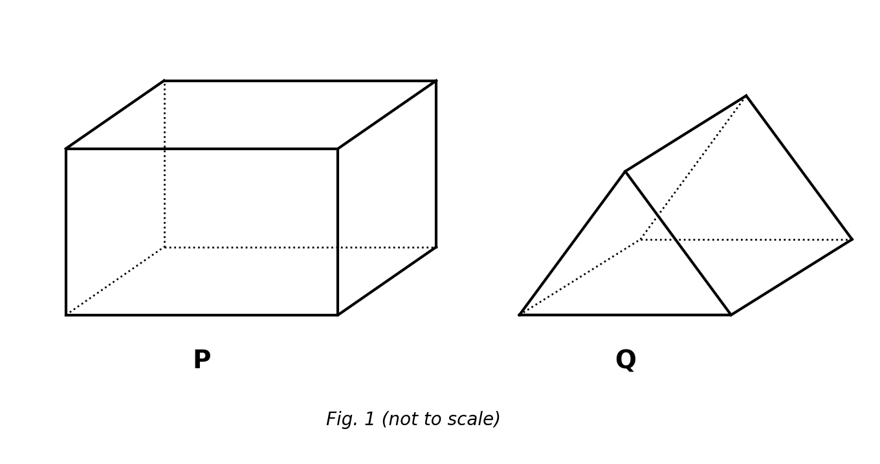
Fig. 1 — solids P and Q (not to scale).
4. The number of edges of solid P is
A. 6
B. 8
C. 12
D. 9
5. Solid Q is a
A. pyramid
B. cone
C. cuboid
D. triangular prism
6. The net of a cuboid is made up of
A. 4 rectangles and 2 squares
B. 6 squares
C. 6 rectangles
D. 4 rectangles and 2 triangles
7. The net of a triangular prism is made up of
A. 3 triangles and 2 rectangles
B. 2 triangles and 4 rectangles
C. 6 rectangles
D. 2 triangles and 3 rectangles
8. A solid with 5 faces, 9 edges and 6 vertices is a
A. triangular prism
B. square-based pyramid
C. cone
D. cuboid
9. When a cuboid of length l, width w and height h is unfolded, the six rectangles have a total area of
A. l × w × h
B. lw + lh + wh
C. 2(lw + lh + wh)
D. 4(lw + lh + wh)
10. The lateral (side) surface area of any prism equals
A. area of cross-section × length
B. perimeter of cross-section × length
C. 2 × area of cross-section × length
D. half the perimeter × length
11. The total length of all the edges of a cuboid l, w, h is
A. l + w + h
B. 6(l + w + h)
C. 4(l + w + h)
D. 2(l + w + h)
12. A prism whose base is an n-sided polygon has how many rectangular lateral faces?
A. n − 2
B. n
C. n + 2
D. 2n
13. The surface area of a cuboid 4 cm × 3 cm × 2 cm is
A. 52 cm²
B. 24 cm²
C. 40 cm²
D. 94 cm²
14. The surface area of a cube of side 4 cm is
A. 48 cm²
B. 64 cm²
C. 16 cm²
D. 96 cm²
15. The surface area of a cube is 150 cm². Its side is
A. 10 cm
B. 25 cm
C. 5 cm
D. 6 cm
16. The surface area of a cuboid 5 cm × 4 cm × 3 cm is
A. 60 cm²
B. 84 cm²
C. 120 cm²
D. 94 cm²
Question 17 refers to Fig. 2.
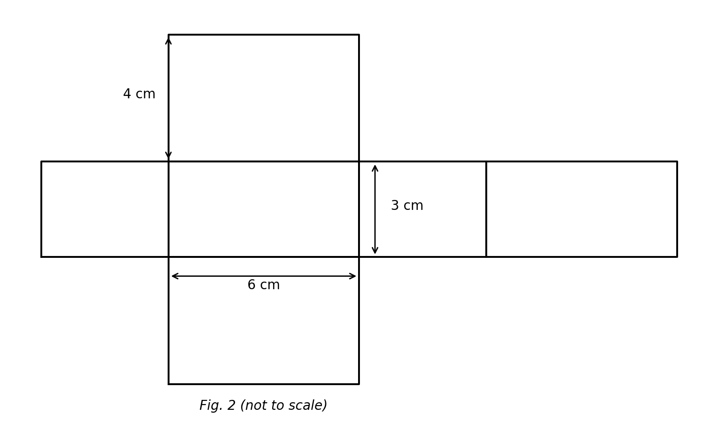
Fig. 2 — net of a cuboid (not to scale).
17. The net folds into a cuboid. Its surface area is
A. 108 cm²
B. 72 cm²
C. 96 cm²
D. 54 cm²
18. An open box with no lid has base 6 cm × 4 cm and height 5 cm. The total area of its five faces is
A. 120 cm²
B. 148 cm²
C. 100 cm²
D. 124 cm²
19. A cuboid has length 6 cm, width 4 cm and surface area 148 cm². Its height is
A. 4 cm
B. 5 cm
C. 6 cm
D. 7 cm
20. The surface area of a cuboid 10 cm × 8 cm × 5 cm is
A. 340 cm²
B. 230 cm²
C. 400 cm²
D. 170 cm²
21. When the side of a cube is doubled, its surface area becomes
A. the same
B. 2 times as large
C. 4 times as large
D. 8 times as large
22. A gift box measures 20 cm × 15 cm × 10 cm. Ignoring overlaps, the wrapping paper needed to cover it completely is
A. 700 cm²
B. 1 300 cm²
C. 650 cm²
D. 3 000 cm²
23. The four walls of a room 5 m × 4 m and height 3 m are to be painted. The painted area is
A. 60 m²
B. 94 m²
C. 54 m²
D. 47 m²
24. Two cubes of side 2 cm are joined face to face to form a cuboid. The surface area of the cuboid is
A. 32 cm²
B. 40 cm²
C. 48 cm²
D. 44 cm²
25. A prism has triangular cross-section of area A and perimeter P, with length l. Its surface area is
A. A + Pl
B. 2A + ½Pl
C. 2A + Pl
D. 2(A + Pl)
26. A triangular prism has right-triangle cross-section with sides 3 cm, 4 cm and 5 cm, and length 10 cm. Its surface area is
A. 120 cm²
B. 144 cm²
C. 96 cm²
D. 132 cm²
Question 27 refers to Fig. 3.
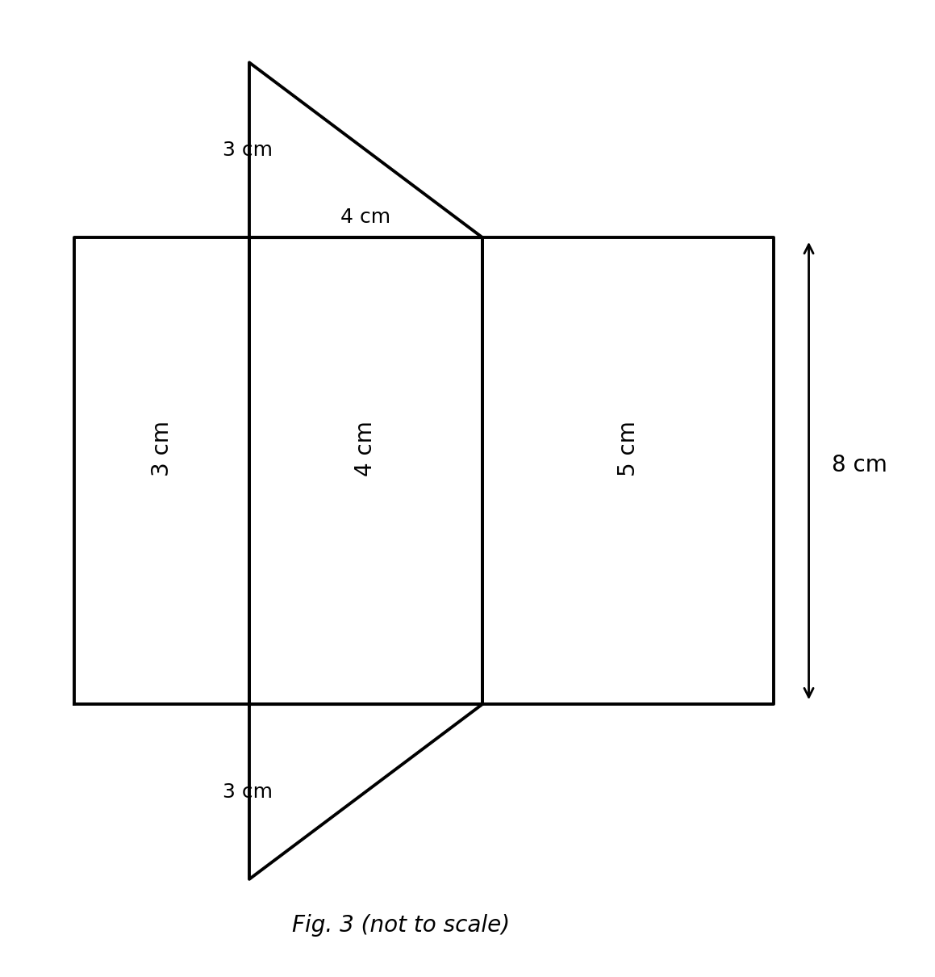
Fig. 3 — net of a triangular prism (not to scale).
27. The net folds into a triangular prism. Its surface area is
A. 120 cm²
B. 108 cm²
C. 84 cm²
D. 96 cm²
28. A prism has isosceles-triangle cross-section with base 8 cm, height 3 cm and equal sides 5 cm. Its length is 12 cm. Its surface area is
A. 240 cm²
B. 216 cm²
C. 228 cm²
D. 264 cm²
29. A triangular prism has right-triangle cross-section 6 cm–8 cm–10 cm and length 20 cm. Its surface area is
A. 480 cm²
B. 528 cm²
C. 576 cm²
D. 432 cm²
Question 30 refers to Fig. 4.
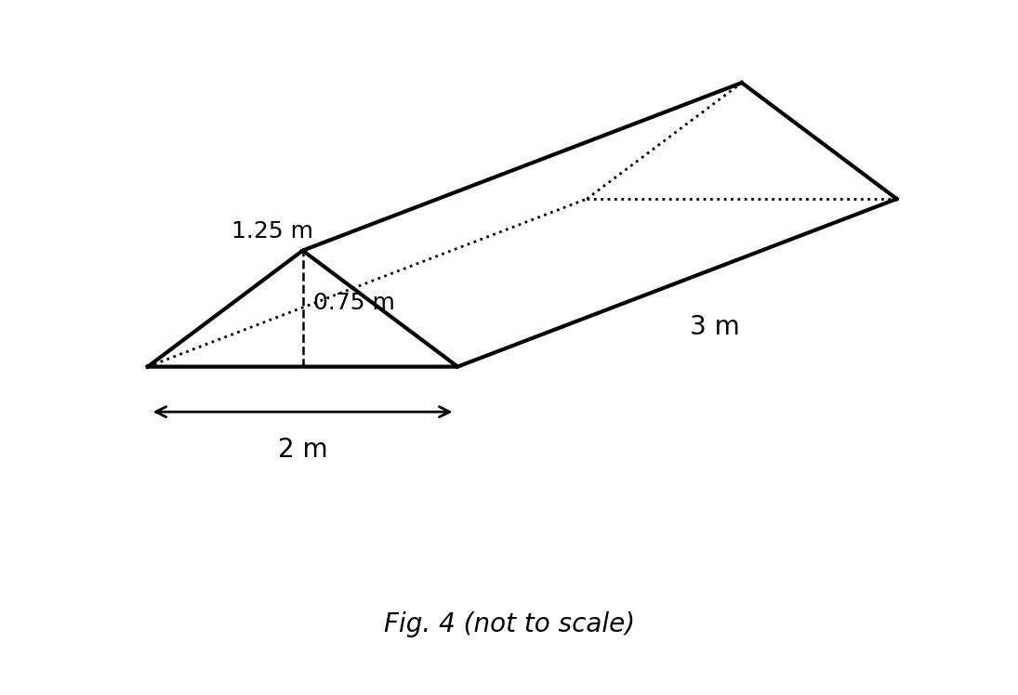
Fig. 4 — tent shaped as a triangular prism (not to scale).
30. The tent is a triangular prism with isosceles triangular ends (base 2 m, height 0.75 m, slant sides 1.25 m) and length 3 m. The cloth for the two ends and the two slanted faces (no floor) is
A. 9 m²
B. 10.5 m²
C. 7.5 m²
D. 8.25 m²
31. A net of 2 triangles and 3 rectangles folds into a
A. cuboid
B. pyramid
C. cone
D. triangular prism
32. A triangular prism has equilateral-triangle cross-section of side 6 cm (triangle height ≈ 5.2 cm) and length 10 cm. Its surface area is about
A. 195.6 cm²
B. 211.2 cm²
C. 226.8 cm²
D. 180 cm²
33. A prism has triangular cross-section of area 24 cm² and perimeter 24 cm. Its length is 10 cm. Its surface area is
A. 240 cm²
B. 264 cm²
C. 288 cm²
D. 312 cm²
34. In the net of a triangular prism, the two congruent triangles become the
A. lateral faces of the prism
B. diagonals of the prism
C. vertices of the prism
D. bases (ends) of the prism
35. The number of faces of a triangular prism is
A. 6
B. 7
C. 5
D. 4
36. Surface area of a solid is measured in
A. units
B. cubic units
C. units of length
D. square units
37. The difference between the surface areas of a cube of side 4 cm and a cuboid 6 cm × 4 cm × 2 cm is
A. 8 cm²
B. 4 cm²
C. 16 cm²
D. 24 cm²
38. The net of a prism with a pentagonal base contains how many rectangles?
A. 6
B. 5
C. 7
D. 3
39. A cuboid has a square base of side 3 cm and height 8 cm. Its surface area is
A. 132 cm²
B. 96 cm²
C. 108 cm²
D. 114 cm²
40. The total edge length of a cube is 60 cm. Its surface area is
A. 150 cm²
B. 100 cm²
C. 125 cm²
D. 300 cm²

SECTION B: STRUCTURED QUESTIONS (60 MARKS)
Answer ALL questions in this section. Show all workings clearly. Diagrams are not to scale.

1. Identifying solids and drawing nets
(a) State the number of faces, edges and vertices of (i) a cuboid and (ii) a triangular prism. [3 marks]
(b) Sketch the net of a cuboid with length 5 cm, width 3 cm and height 2 cm, and label its rectangles. [3 marks]
(c) How many rectangles and how many triangles are in the net of a triangular prism? [2 marks]
(d) Name the solid whose net is 2 triangles and 3 rectangles. [2 marks]
[Total: 10 marks]

2. Deriving the cuboid surface-area formula
(a) A cuboid has length l, width w and height h. When unfolded, its faces form three congruent pairs. Name the pairs and the area of each pair. [2 marks]
(b) Hence write an expression for the total surface area. [3 marks]
(c) Factorise your expression. [2 marks]
(d) Evaluate the formula for l = 7 cm, w = 5 cm, h = 3 cm. [3 marks]
[Total: 10 marks]

3. Cuboid surface-area problems
(a) Find the total surface area of a cuboid 12 cm × 9 cm × 6 cm. [3 marks]
(b) The cuboid is used as an open tank with no top. Find the area of its five faces. [3 marks]
(c) Find the surface area of a cube of side 9 cm. [2 marks]
(d) Which solid has the greater surface area, and by how much? [2 marks]
[Total: 10 marks]

4. Deriving the triangular-prism surface area
(a) Describe the net of a triangular prism. [2 marks]
(b) If the cross-section has area A and perimeter P, and the prism has length l, write the surface-area formula. [3 marks]
(c) Use the formula for a right-triangle cross-section 5 cm, 12 cm, 13 cm with length 20 cm. [3 marks]
(d) Explain why all three rectangles have the same length l. [2 marks]
[Total: 10 marks]

5. Triangular-prism problems
(a) Find the surface area of a prism whose isosceles-triangle cross-section has base 10 cm, height 12 cm and equal sides 13 cm, with length 20 cm. [4 marks]
(b) Find the lateral surface area only (the three rectangles). [3 marks]
(c) If the length is doubled to 40 cm, find the new surface area and the increase. [3 marks]
[Total: 10 marks]

6. Applications
(a) A gift carton 30 cm × 20 cm × 10 cm is wrapped without overlap. Find the area of paper needed. [3 marks]
(b) If the carton has no lid, find the paper needed. [2 marks]
(c) A cake tin is a triangular prism with equilateral-triangle cross-section of side 8 cm (height ≈ 6.9 cm) and length 15 cm. Estimate its surface area. [3 marks]
(d) A cube of side 6 cm and a cuboid 10 cm × 6 cm × h cm have equal surface areas. Find h. [2 marks]
[Total: 10 marks]

