BEACON EDUCATIONAL CONSULT
MARKING GUIDE — MOCK EXAMINATION 2026/2027
MATHEMATICS — BASIC 9 (JHS 3) — Chapter 14: Vectors (B9.3.2.2)

Curriculum Standard (NaCCA CCP, Sept 2020): B9.3.2.2 — Solve problems involving bearings and addition/subtraction of vectors.
Indicators tested: B9.3.2.2.1 Show an understanding of parallel vectors and perpendicular vectors; B9.3.2.2.2 Apply the triangular and parallelogram laws of addition to resolve vectors. Position vectors, notation, magnitude and bearing-direction displacements are tagged at standard level (the CCP lists position vectors under the misprinted B9.3.2.1.4, which belongs to this strand).

SECTION A: ANSWER KEY
Qn | Ans | Content Focus | Indicator
1 | D | Position vectors (Fig. 1) | B9.3.2.2
2 | B | Position vectors (Fig. 1) | B9.3.2.2
3 | D | Column vector notation | B9.3.2.2
4 | B | Magnitude of a vector | B9.3.2.2
5 | A | Vector between two points | B9.3.2.2
6 | C | Negative of a vector | B9.3.2.2
7 | A | Equal vectors | B9.3.2.2
8 | D | Scalar multiplication | B9.3.2.2
9 | C | Condition for parallel vectors | B9.3.2.2.1
10 | B | Recognising parallel vectors | B9.3.2.2.1
11 | C | Finding an unknown in parallel vectors | B9.3.2.2.1
12 | B | Parallel vectors (curriculum exemplar) | B9.3.2.2.1
13 | A | Condition for perpendicular vectors | B9.3.2.2.1
14 | C | Perpendicular vectors (curriculum exemplar) | B9.3.2.2.1
15 | A | Recognising perpendicular vectors | B9.3.2.2.1
16 | D | Dot product formula | B9.3.2.2.1
17 | C | Unknown in perpendicular vectors | B9.3.2.2.1
18 | D | Parallel vectors with a scale factor | B9.3.2.2.1
19 | B | Testing parallel vectors | B9.3.2.2.1
20 | C | Testing parallel and perpendicular | B9.3.2.2.1
21 | A | Parallel vectors | B9.3.2.2.1
22 | C | Recognising perpendicular vectors | B9.3.2.2.1
23 | A | Triangle law | B9.3.2.2.2
24 | B | Triangle law on a grid (Fig. 2) | B9.3.2.2.2
25 | A | Subtracting column vectors | B9.3.2.2.2
26 | B | Vector between two points (curriculum exemplar) | B9.3.2.2.2
27 | D | Magnitude of PQ | B9.3.2.2.2
28 | A | Isosceles triangle from vectors | B9.3.2.2.2
29 | B | Parallelogram law (Fig. 3) | B9.3.2.2.2
30 | A | Adding column vectors | B9.3.2.2.2
31 | D | Combined scalar multiplication and addition | B9.3.2.2.2
32 | C | Combined operations on vectors | B9.3.2.2.2
33 | A | Equal vectors in a parallelogram | B9.3.2.2.2
34 | C | Parallelogram vertices (curriculum exemplar) | B9.3.2.2.2
35 | D | Resultant of two journeys | B9.3.2.2.2
36 | B | Magnitude of a resultant | B9.3.2.2.2
37 | D | Finding an endpoint from a vector | B9.3.2.2.2
38 | C | Midpoint and vectors | B9.3.2.2.2
39 | D | Zero vector | B9.3.2.2.2
40 | B | Bearing direction as a vector | B9.3.2.2

Full answer key: DBDBA CADCB CBACA DCDBC ACABA BDABA DCACD BDCDB

SECTION A: WORKED SOLUTIONS
1. M is 2 right, 3 up: OM = (2, 3).
2. N is 1 left, 2 up: ON = (−1, 2).
3. Right is +x, down is −y: (3, −2).
4. √(3² + 4²) = √25 = 5.
5. AB = (4−1, 6−2) = (3, 4).
6. Change every sign: (3, −4).
7. Equal vectors match in both magnitude and direction.
8. Multiply each component by 2: (4, −6).
9. Parallel means a = kb for some number k.
10. (6, 8) = 2(3, 4).
11. Cross products equal: 3k = 2 × 6 = 12 → k = 4.
12. 3x·x = 2·6 → 3x² = 12 → x² = 4 → x = 2 or −2.
13. Perpendicular ⇔ dot product = 0.
14. 3(−4) + 4(3) = 0.
15. 2(5) + 5(−2) = 0.
16. Dot product multiplies matching components and adds: ac + bd.
17. 2x + 4(−1) = 0 → x = 2.
18. (4, 12) = 4(1, 3), so (p, 3) = (1, 3): p = 1.
19. (−4, 6) = −2(2, −3): parallel.
20. Dot = 4 ≠ 0 and cross = 1−4 = −3 ≠ 0: neither.
21. Cross products equal: 6x = 2 × 3 = 6 → x = 1.
22. (−3)(4) + 4(3) = 0.
23. Head-to-tail: AB + BC = AC.
24. a ends at (2,1); b ends at (5,−1): resultant (5, −1).
25. (2−1, 5−2) = (1, 3).
26. PQ = (7−1, 5−(−3)) = (6, 8).
27. √(6² + 8²) = 10.
28. |PQ| = 10 and |QR| = |(−10, 0)| = 10, two equal sides.
29. The diagonal from the common origin is the resultant.
30. (2+3, 1+4) = (5, 5).
31. 2(2,3) + (1,−1) = (4,6) + (1,−1) = (5, 5).
32. 3(1,2) − 2(2,1) = (3,6) − (4,2) = (−1, 4).
33. PQ and SR are opposite sides, equal and parallel in the same sense.
34. PQ = SR: (5−x, 7−y) = (1, 1) → x = 4, y = 6.
35. (3−1, 4+2) = (2, 6).
36. √(3² + 4²) = 5.
37. B = A + AB = (1+2, 1+5) = (3, 6).
38. Half the vector reaches the midpoint: ½PQ.
39. Opposite vectors cancel: (0, 0).
40. East is the +x direction: (5, 0).

FIGURES (REPRINTED FOR MARKING)
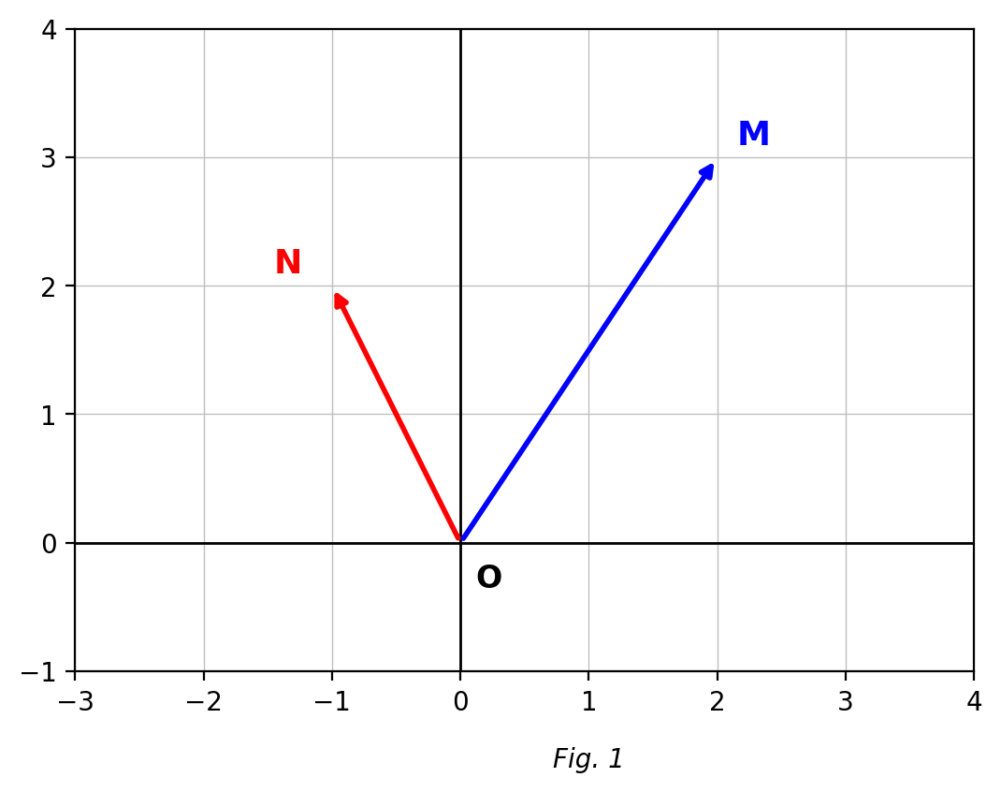
Fig. 1 — position vectors of M and N (O is the origin).
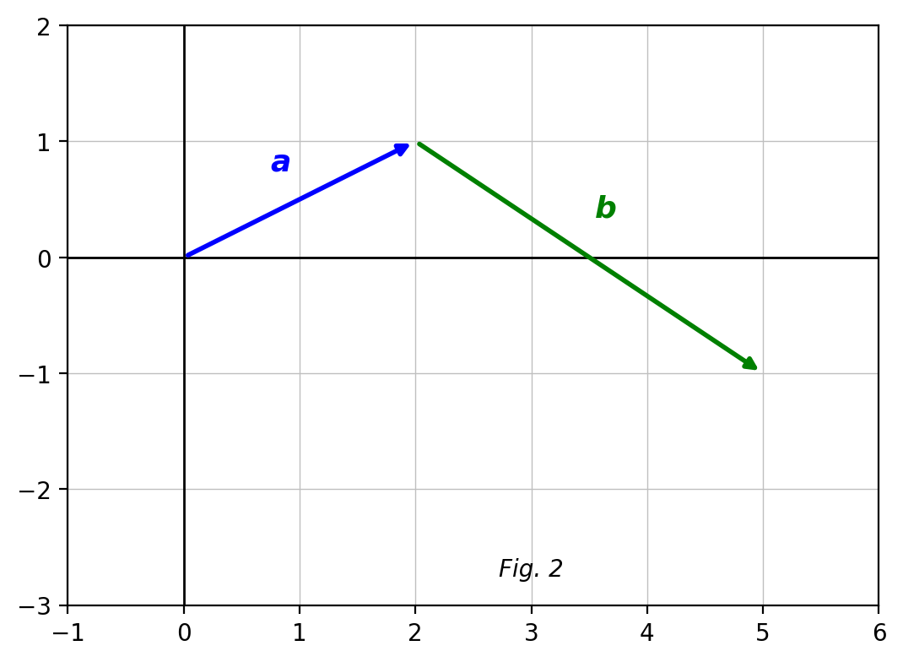
Fig. 2 — vectors a and b drawn head-to-tail.
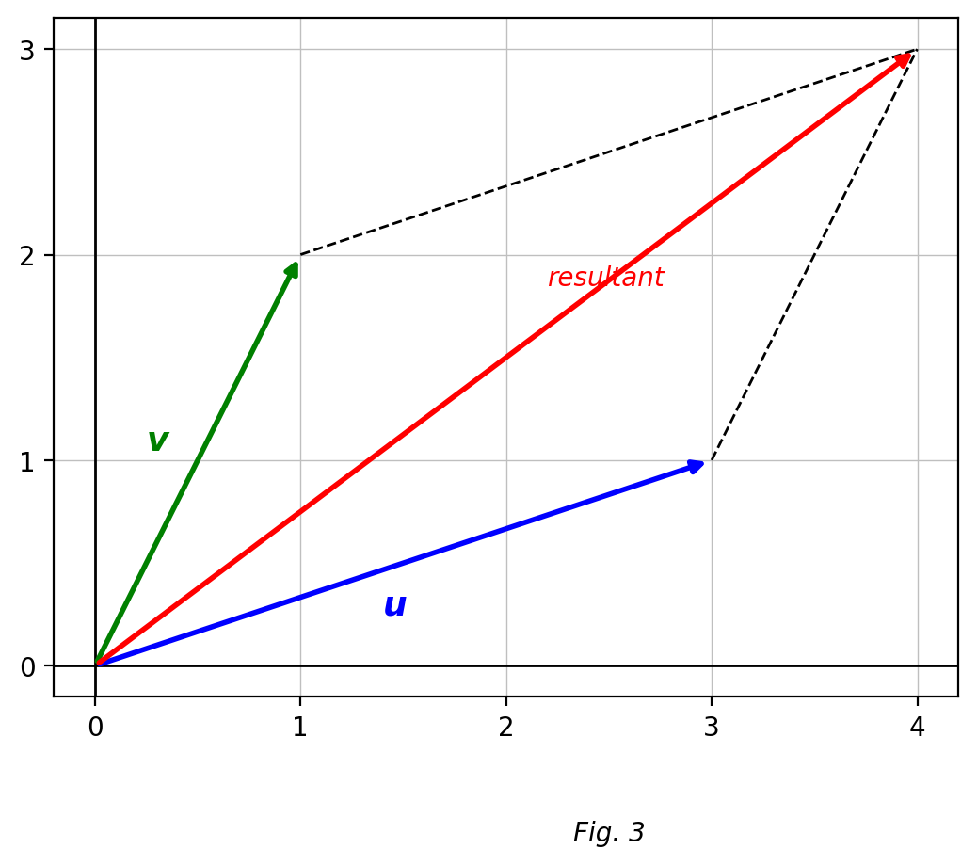
Fig. 3 — the parallelogram law of addition.

SECTION B: MARKING SCHEME

1. Position vectors and notation [10 marks]
(a) With O as origin, write the position vectors of M(2, 3) and N(−1, 2). OM = (2, 3); ON = (−1, 2). [2 marks]
(b) Find the column vector that translates A(1, 2) to B(4, 6). AB = (4 − 1, 6 − 2) = (3, 4). [2 marks]
(c) Calculate the magnitude of AB. |AB| = √(3² + 4²) = √25 = 5 units. [3 marks]
(d) Point C satisfies OC = 2 × OM. Find the coordinates of C. OC = 2(2, 3) = (4, 6), so C(4, 6). [3 marks]
[Total: 10 marks]

2. Parallel vectors [10 marks]
(a) State the condition for two column vectors to be parallel. One is a scalar multiple of the other (a = kb), i.e. cross-multiplying gives equal products. [2 marks]
(b) Find the values of x if the vectors (3x, 2) and (6, x) are parallel. 3x·x = 2·6 → 3x² = 12 → x² = 4 → x = 2 or x = −2. [3 marks]
(c) Find k if (k, 6) is parallel to (2, 3). 3k = 12 → k = 4. [2 marks]
(d) Show that (2, −3) and (−6, 9) are parallel. (−6, 9) = −3(2, −3), a scalar multiple, so they are parallel. [3 marks]
[Total: 10 marks]

3. Perpendicular vectors [10 marks]
(a) State the condition for two column vectors to be perpendicular. Their dot product is zero: ac + bd = 0. [2 marks]
(b) Which of (−3, 4), (−3, −4), (−4, 3), (−4, −3) is perpendicular to (3, 4)? (−4, 3): dot product = 3(−4) + 4(3) = −12 + 12 = 0. [2 marks]
(c) Find x if (x, 4) is perpendicular to (2, −1). 2x + 4(−1) = 0 → 2x = 4 → x = 2. [3 marks]
(d) Show that (1, 2) and (2, 1) are NOT perpendicular. Dot product = 1(2) + 2(1) = 4 ≠ 0, so they are not perpendicular. [3 marks]
[Total: 10 marks]

4. The triangle law of addition [10 marks]
(a) State the triangle law of vector addition. AB + BC = AC (head-to-tail joining gives the resultant). [2 marks]
(b) P(1, −3), Q(7, 5) and R(−3, 5). Express PQ, QR and PR as column vectors. PQ = (6, 8); QR = (−10, 0); PR = (−4, 8). [3 marks]
(c) Show that triangle PQR is isosceles. |PQ| = √(36 + 64) = 10; |QR| = 10; two sides equal, so PQR is isosceles. [3 marks]
(d) Verify that PQ + QR = PR. (6, 8) + (−10, 0) = (−4, 8) = PR. ✓ [2 marks]
[Total: 10 marks]

5. The parallelogram law of addition [10 marks]
(a) State the parallelogram law of vector addition. Two vectors drawn from a common point have as resultant the diagonal of the parallelogram they determine. [2 marks]
(b) Find the resultant of (2, 1) and (3, 4), and its magnitude to 1 d.p. Resultant = (5, 5); |(5, 5)| = √50 ≈ 7.1 units. [3 marks]
(c) PQRS is a parallelogram with P(x, y), Q(5, 7), R(2, 4), S(1, 3). Find x and y. PQ = SR → (5 − x, 7 − y) = (2 − 1, 4 − 3) = (1, 1) → x = 4, y = 6. [3 marks]
(d) Give the reason for setting PQ = SR in part (c). Opposite sides of a parallelogram are equal and parallel, so as vectors PQ = SR. [2 marks]
[Total: 10 marks]

6. Vector journeys [10 marks]
(a) A boat sails (3, 4) and then (−1, 2). Find the resultant displacement. (3, 4) + (−1, 2) = (2, 6). [2 marks]
(b) Find the magnitude of this resultant to 1 d.p. √(4 + 36) = √40 ≈ 6.3 units. [2 marks]
(c) Write the vector that returns the boat to its starting point. −(2, 6) = (−2, −6). [2 marks]
(d) A walker goes 6 km due east and then 8 km due north. Write both displacements as column vectors and find the straight-line distance from the start. (6, 0) and (0, 8); resultant (6, 8); distance = √(36 + 64) = 10 km. [4 marks]
[Total: 10 marks]

CURRICULUM BLUEPRINT
Qn | Content Focus | Indicator | Marks
1 | Position vectors (Fig. 1) | B9.3.2.2 | 1
2 | Position vectors (Fig. 1) | B9.3.2.2 | 1
3 | Column vector notation | B9.3.2.2 | 1
4 | Magnitude of a vector | B9.3.2.2 | 1
5 | Vector between two points | B9.3.2.2 | 1
6 | Negative of a vector | B9.3.2.2 | 1
7 | Equal vectors | B9.3.2.2 | 1
8 | Scalar multiplication | B9.3.2.2 | 1
9 | Condition for parallel vectors | B9.3.2.2.1 | 1
10 | Recognising parallel vectors | B9.3.2.2.1 | 1
11 | Finding an unknown in parallel vectors | B9.3.2.2.1 | 1
12 | Parallel vectors (curriculum exemplar) | B9.3.2.2.1 | 1
13 | Condition for perpendicular vectors | B9.3.2.2.1 | 1
14 | Perpendicular vectors (curriculum exemplar) | B9.3.2.2.1 | 1
15 | Recognising perpendicular vectors | B9.3.2.2.1 | 1
16 | Dot product formula | B9.3.2.2.1 | 1
17 | Unknown in perpendicular vectors | B9.3.2.2.1 | 1
18 | Parallel vectors with a scale factor | B9.3.2.2.1 | 1
19 | Testing parallel vectors | B9.3.2.2.1 | 1
20 | Testing parallel and perpendicular | B9.3.2.2.1 | 1
21 | Parallel vectors | B9.3.2.2.1 | 1
22 | Recognising perpendicular vectors | B9.3.2.2.1 | 1
23 | Triangle law | B9.3.2.2.2 | 1
24 | Triangle law on a grid (Fig. 2) | B9.3.2.2.2 | 1
25 | Subtracting column vectors | B9.3.2.2.2 | 1
26 | Vector between two points (curriculum exemplar) | B9.3.2.2.2 | 1
27 | Magnitude of PQ | B9.3.2.2.2 | 1
28 | Isosceles triangle from vectors | B9.3.2.2.2 | 1
29 | Parallelogram law (Fig. 3) | B9.3.2.2.2 | 1
30 | Adding column vectors | B9.3.2.2.2 | 1
31 | Combined scalar multiplication and addition | B9.3.2.2.2 | 1
32 | Combined operations on vectors | B9.3.2.2.2 | 1
33 | Equal vectors in a parallelogram | B9.3.2.2.2 | 1
34 | Parallelogram vertices (curriculum exemplar) | B9.3.2.2.2 | 1
35 | Resultant of two journeys | B9.3.2.2.2 | 1
36 | Magnitude of a resultant | B9.3.2.2.2 | 1
37 | Finding an endpoint from a vector | B9.3.2.2.2 | 1
38 | Midpoint and vectors | B9.3.2.2.2 | 1
39 | Zero vector | B9.3.2.2.2 | 1
40 | Bearing direction as a vector | B9.3.2.2 | 1
B1 | Position vectors & notation | B9.3.2.2 | 10
B2 | Parallel vectors | B9.3.2.2.1 | 10
B3 | Perpendicular vectors | B9.3.2.2.1 | 10
B4 | Triangle law of addition | B9.3.2.2.2 | 10
B5 | Parallelogram law of addition | B9.3.2.2.2 | 10
B6 | Vector journeys (application) | B9.3.2.2.2 | 10
 | TOTAL |  | 100

CURRICULUM COVERAGE BY INDICATOR
Curriculum Area | Section A | Section B | Total | %
B9.3.2.2 (standard) Position vectors, notation, magnitude, bearing directions | 9 | 10 (B1) | 19 | 19%
B9.3.2.2.1 Parallel and perpendicular vectors | 14 | 20 (B2, B3) | 34 | 34%
B9.3.2.2.2 Triangle and parallelogram laws of addition | 17 | 30 (B4, B5, B6) | 47 | 47%
Note: Section A q1–8 and q40 test standard-level notation, magnitude and position vectors (9 marks); q9–22 test parallel/perpendicular vectors (.1, 14); q23–39 test the addition laws (.2, 17). Section B: B1 position vectors (10); B2–B3 parallel and perpendicular (20); B4–B6 triangle law, parallelogram law and journeys (30).

COGNITIVE-LEVEL DISTRIBUTION
Cognitive Level | Section A | Section B | Total | %
Remember | 2 | 4 | 6 | 6%
Understand | 12 | 10 | 22 | 22%
Apply | 22 | 32 | 54 | 54%
Analyse | 4 | 14 | 18 | 18%
Evaluate | 0 | 0 | 0 | 0%
Create | 0 | 0 | 0 | 0%

DIFFICULTY DISTRIBUTION
Difficulty | Section A | Section B | Total | %
Easy | 16 | 10 (B1) | 26 | 26%
Moderate | 22 | 30 (B2, B3, B4) | 52 | 52%
Challenging | 2 | 20 (B5, B6) | 22 | 22%

QUALITY-CONTROL SUMMARY
Check | Status
Curriculum alignment | Standard B9.3.2.2 with both indicators: parallel/perpendicular vectors (.1) and triangle/parallelogram addition laws (.2), plus position vectors and bearing-direction displacements at standard level.
Section structure | Section A: 40 objectives (40 marks). Section B: 6 structured questions (60 marks). Total 100 marks, 2 hours.
Answer key balance | A=10, B=10, C=10, D=10. Zero consecutive repeats. No sustained cycling pattern.
Diagrams (BECE style) | Three grid figures: position vectors of M and N; head-to-tail addition a + b; and the parallelogram law with its resultant diagonal.
Curriculum exemplars used | (3x,2) ∥ (6,x); perpendicular choice to (3,4); P(1,−3), Q(7,5), R(−3,5) isosceles proof; parallelogram P(x,y), Q(5,7), R(2,4), S(1,3) — all adapted from the CCP exemplar lists with original values.
Distractor quality | Classic sign and component-swap errors: (3,2) vs (2,3), (−3,4) vs (4,3), RS vs SR, dot vs cross conditions, magnitude squared traps.
Marking guide completeness | Every Section B part carries explicit marks (each question sums to 10); all vector workings shown; figures reprinted for the marker.
Blueprint | 46-row blueprint (40 objectives + 6 structured) sums to exactly 100 marks.
Coverage | Standard 19%, .1 = 34%, .2 = 47%.
Cognitive spread | Remember 6%, Understand 22%, Apply 54%, Analyse 18%.
Difficulty spread | Easy 26%, Moderate 52%, Challenging 22%.

