BEACON EDUCATIONAL CONSULT
MOCK EXAMINATION — 2026/2027 ACADEMIC YEAR
MATHEMATICS — BASIC 9 (JHS 3)
Chapter 14: Vectors — Parallel, Perpendicular and Addition Laws (Curriculum Standard B9.3.2.2)
Time Allowed: 2 Hours Total Marks: 100

INSTRUCTIONS TO CANDIDATES
1. Write your name and index number on the answer sheet provided.
2. This paper consists of TWO sections: Section A (Objectives) and Section B (Structured Questions).
3. Section A: Answer ALL forty (40) questions. Each question carries 1 mark. Choose the correct option from A to D.
4. Section B: Answer ALL six (6) questions. Each question carries 10 marks. Show all necessary workings.
5. Column vectors are written (x, y) meaning x units right and y units up.
6. All diagrams are NOT drawn to scale unless on a grid. Study them carefully before answering.
7. Use a non-programmable calculator where necessary.

SECTION A: OBJECTIVE TEST (40 MARKS)
Answer ALL questions in this section. Choose the correct answer from A to D.
Questions 1 and 2 refer to Fig. 1.
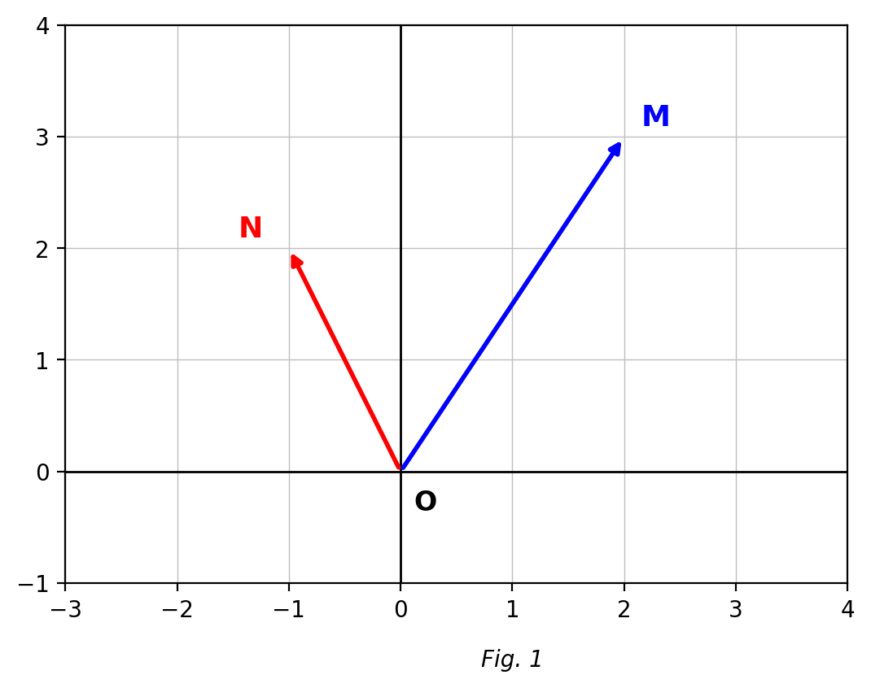
Fig. 1 — position vectors of M and N (O is the origin).
1. With O as the origin, the position vector of M is
A. (3, 2)
B. (−2, −3)
C. (2, −3)
D. (2, 3)
2. With O as the origin, the position vector of N is
A. (2, −1)
B. (−1, 2)
C. (−2, 1)
D. (1, −2)
3. A movement of 3 units right and 2 units down is written as the column vector
A. (3, 2)
B. (−3, 2)
C. (2, 3)
D. (3, −2)
4. The magnitude of the vector (3, 4) is
A. 7
B. 5
C. 12
D. 25
5. The vector that translates A(1, 2) to B(4, 6) is
A. (3, 4)
B. (−3, −4)
C. (4, 3)
D. (5, 8)
6. The negative of the vector (−3, 4) is
A. (3, 4)
B. (−3, −4)
C. (3, −4)
D. (4, −3)
7. Two vectors are equal when they have
A. the same magnitude and the same direction
B. the same magnitude only
C. the same direction only
D. the same starting point
8. 2 × (2, −3) =
A. (2, −6)
B. (4, 6)
C. (4, −3)
D. (4, −6)
9. Two vectors are parallel when
A. their dot product is zero
B. their magnitudes are equal
C. one is a scalar multiple of the other
D. they start from the same point
10. The vector (6, 8) is parallel to
A. (4, 3)
B. (3, 4)
C. (−3, 4)
D. (8, 6)
11. If (k, 6) is parallel to (2, 3), then k =
A. 6
B. 9
C. 4
D. 2
12. The vectors (3x, 2) and (6, x) are parallel when x is
A. 12
B. 2 or −2
C. 4
D. 6
13. Two vectors are perpendicular when
A. their dot product is zero
B. their magnitudes are equal
C. one is a scalar multiple of the other
D. they have the same direction
14. A vector perpendicular to (3, 4) is
A. (4, 3)
B. (3, −4)
C. (−4, 3)
D. (−3, 4)
15. A vector perpendicular to (2, 5) is
A. (5, −2)
B. (5, 2)
C. (−2, −5)
D. (2, −5)
16. The dot product of (a, b) and (c, d) is
A. ad + bc
B. ab + cd
C. ac − bd
D. ac + bd
17. If (x, 4) is perpendicular to (2, −1), then x =
A. 8
B. 4
C. 2
D. −2
18. If (p, 3) is parallel to (4, 12), then p =
A. 9
B. 3
C. 4
D. 1
19. The vectors (2, −3) and (−4, 6) are
A. perpendicular
B. parallel
C. equal
D. neither parallel nor perpendicular
20. The vectors (1, 2) and (2, 1) are
A. perpendicular
B. equal
C. neither parallel nor perpendicular
D. parallel
21. If (x, 2) is parallel to (3, 6), then x =
A. 1
B. 6
C. 2
D. 3
22. A vector perpendicular to (−3, 4) is
A. (3, 4)
B. (−4, −3)
C. (4, 3)
D. (4, −3)
23. The triangle law of vector addition states that AB + BC =
A. AC
B. CA
C. BA
D. CB
Question 24 refers to Fig. 2.
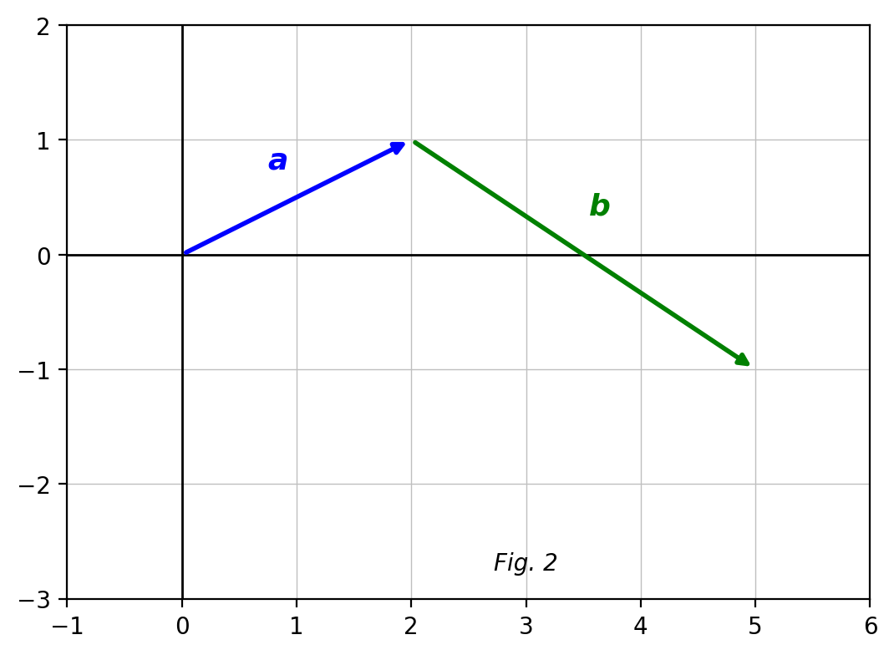
Fig. 2 — vectors a and b drawn head-to-tail.
24. Using the grid, a + b =
A. (1, −5)
B. (5, −1)
C. (5, 1)
D. (−5, 1)
25. (2, 5) − (1, 2) =
A. (1, 3)
B. (3, 7)
C. (1, −3)
D. (3, 3)
26. If P(1, −3) and Q(7, 5), the column vector PQ is
A. (−6, −8)
B. (6, 8)
C. (6, −8)
D. (8, 6)
27. The magnitude of PQ in question 26 is
A. 100
B. 14
C. 8
D. 10
28. Triangle PQR with P(1, −3), Q(7, 5), R(−3, 5) is isosceles because
A. PQ = QR = 10 units
B. PQ = PR
C. QR = PR
D. all sides are equal
Question 29 refers to Fig. 3.
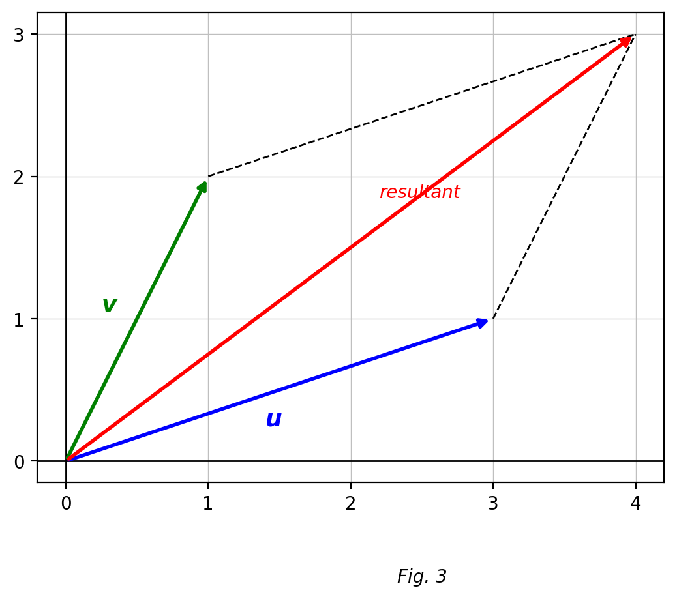
Fig. 3 — the parallelogram law of addition.
29. In the parallelogram law, the resultant of u and v is the vector along
A. the shorter side
B. the diagonal from the common start point
C. either dashed side
D. the longer of u and v
30. The resultant of (2, 1) and (3, 4) is
A. (5, 5)
B. (5, 4)
C. (1, 3)
D. (6, 4)
31. If a = (2, 3) and b = (1, −1), then 2a + b =
A. (3, 5)
B. (5, 2)
C. (4, 4)
D. (5, 5)
32. If a = (1, 2) and b = (2, 1), then 3a − 2b =
A. (−1, −4)
B. (7, 4)
C. (−1, 4)
D. (1, 4)
33. In parallelogram PQRS, the vector PQ is equal to
A. SR
B. QS
C. RS
D. QR
34. PQRS is a parallelogram with P(x, y), Q(5, 7), R(2, 4) and S(1, 3). The values of x and y are
A. x = 6, y = 4
B. x = 3, y = 5
C. x = 4, y = 6
D. x = 5, y = 6
35. A boat sails (3, 4) and then (−1, 2). Its total displacement is
A. (2, 2)
B. (−4, −6)
C. (4, 2)
D. (2, 6)
36. The magnitude of the resultant of (3, 0) and (0, 4) is
A. 25
B. 5
C. 7
D. 12
37. If AB = (2, 5) and A is (1, 1), then B is
A. (1, −4)
B. (−1, −4)
C. (6, 3)
D. (3, 6)
38. If M is the midpoint of PQ, then PM equals
A. PQ
B. −½ PQ
C. ½ PQ
D. 2 PQ
39. (2, 3) + (−2, −3) equals
A. (−4, −6)
B. (4, 6)
C. (0, 6)
D. the zero vector (0, 0)
40. A displacement of 5 km due east of O, written as a column vector, is
A. (0, 5)
B. (5, 0)
C. (−5, 0)
D. (5, 5)

SECTION B: STRUCTURED QUESTIONS (60 MARKS)
Answer ALL questions in this section. Show all workings clearly.

1. Position vectors and notation
(a) With O as origin, write the position vectors of M(2, 3) and N(−1, 2). [2 marks]
(b) Find the column vector that translates A(1, 2) to B(4, 6). [2 marks]
(c) Calculate the magnitude of AB. [3 marks]
(d) Point C satisfies OC = 2 × OM. Find the coordinates of C. [3 marks]
[Total: 10 marks]

2. Parallel vectors
(a) State the condition for two column vectors to be parallel. [2 marks]
(b) Find the values of x if the vectors (3x, 2) and (6, x) are parallel. [3 marks]
(c) Find k if (k, 6) is parallel to (2, 3). [2 marks]
(d) Show that (2, −3) and (−6, 9) are parallel. [3 marks]
[Total: 10 marks]

3. Perpendicular vectors
(a) State the condition for two column vectors to be perpendicular. [2 marks]
(b) Which of (−3, 4), (−3, −4), (−4, 3), (−4, −3) is perpendicular to (3, 4)? [2 marks]
(c) Find x if (x, 4) is perpendicular to (2, −1). [3 marks]
(d) Show that (1, 2) and (2, 1) are NOT perpendicular. [3 marks]
[Total: 10 marks]

4. The triangle law of addition
(a) State the triangle law of vector addition. [2 marks]
(b) P(1, −3), Q(7, 5) and R(−3, 5). Express PQ, QR and PR as column vectors. [3 marks]
(c) Show that triangle PQR is isosceles. [3 marks]
(d) Verify that PQ + QR = PR. [2 marks]
[Total: 10 marks]

5. The parallelogram law of addition
(a) State the parallelogram law of vector addition. [2 marks]
(b) Find the resultant of (2, 1) and (3, 4), and its magnitude to 1 d.p. [3 marks]
(c) PQRS is a parallelogram with P(x, y), Q(5, 7), R(2, 4), S(1, 3). Find x and y. [3 marks]
(d) Give the reason for setting PQ = SR in part (c). [2 marks]
[Total: 10 marks]

6. Vector journeys
(a) A boat sails (3, 4) and then (−1, 2). Find the resultant displacement. [2 marks]
(b) Find the magnitude of this resultant to 1 d.p. [2 marks]
(c) Write the vector that returns the boat to its starting point. [2 marks]
(d) A walker goes 6 km due east and then 8 km due north. Write both displacements as column vectors and find the straight-line distance from the start. [4 marks]
[Total: 10 marks]

