BEACON EDUCATIONAL CONSULT
MARKING GUIDE — MOCK EXAMINATION 2026/2027
MATHEMATICS — BASIC 9 (JHS 3) — Chapter 15: Enlargement (B9.3.3.1)

Curriculum Standard (NaCCA CCP, Sept 2020): B9.3.3.1 — Demonstrate understanding of how to perform an enlargement on a geometrical shape given a scale factor and describe the properties of the image under the transformation (i.e. congruence, similarity, etc.).
Indicators tested: B9.3.3.1.1 Know examples of situations in everyday life that depict enlargement; B9.3.3.1.2 Understand enlargement, draw enlargements with given scale factors (including negative and fractional k) and determine scale factors from object–image pairs; B9.3.3.1.3 Investigate the concept of congruent and similar shapes. Centre/scale-factor definitions and invariant properties are tagged at standard level.

SECTION A: ANSWER KEY
Qn | Ans | Content Focus | Indicator
1 | A | Defining an enlargement | B9.3.3.1
2 | C | Angles are invariant | B9.3.3.1
3 | D | Lengths scale by |k| | B9.3.3.1
4 | A | Area scales by k² | B9.3.3.1
5 | D | Scale factor 1 | B9.3.3.1
6 | C | Scale factor −1 | B9.3.3.1
7 | D | Finding the centre | B9.3.3.1
8 | B | Perimeter scales by |k| | B9.3.3.1
9 | C | Everyday enlargement | B9.3.3.1.1
10 | B | Projector image | B9.3.3.1.1
11 | A | Shadows as enlargement | B9.3.3.1.1
12 | B | Non-examples of enlargement | B9.3.3.1.1
13 | A | Photocopier percentages | B9.3.3.1.1
14 | D | Zoom as enlargement | B9.3.3.1.1
15 | A | Scale factor from lengths | B9.3.3.1.2
16 | B | Fractional scale factor | B9.3.3.1.2
17 | C | Negative scale factor | B9.3.3.1.2
18 | B | Scale factor from a diagram (Fig. 1) | B9.3.3.1.2
19 | D | Negative scale factor from a diagram (Fig. 2) | B9.3.3.1.2
20 | B | Fractional scale factor from a diagram (Fig. 3) | B9.3.3.1.2
21 | D | Image of a point | B9.3.3.1.2
22 | A | Image under negative k | B9.3.3.1.2
23 | C | Enlargement about another centre | B9.3.3.1.2
24 | D | Effect of a fractional k | B9.3.3.1.2
25 | C | Effect of k < −1 | B9.3.3.1.2
26 | B | Coordinate rule | B9.3.3.1.2
27 | D | Perimeter ratio | B9.3.3.1.2
28 | A | Area under enlargement | B9.3.3.1.2
29 | B | Scale factor from areas | B9.3.3.1.2
30 | C | Centre of enlargement (Fig. 1) | B9.3.3.1.2
31 | B | Congruent shapes | B9.3.3.1.3
32 | C | Similar shapes | B9.3.3.1.3
33 | A | Enlargement gives similar images | B9.3.3.1.3
34 | C | When the image is congruent | B9.3.3.1.3
35 | B | Area ratio of similar triangles | B9.3.3.1.3
36 | A | Proportional sides | B9.3.3.1.3
37 | D | Always-similar pairs | B9.3.3.1.3
38 | A | Not necessarily similar | B9.3.3.1.3
39 | C | Area ratio from k | B9.3.3.1.3
40 | D | Verifying similarity | B9.3.3.1.3

Full answer key: ACDAD CDBCB ABADA BCBDB DACDC BDABC BCACB ADACD

SECTION A: WORKED SOLUTIONS
1. Every enlargement needs a centre and a scale factor.
2. Enlargement preserves all angles.
3. Each length is multiplied by |k|.
4. Areas scale by k².
5. k = 1 leaves the object unchanged in size: congruent.
6. k = −1 gives the object rotated 180° about the centre, same size.
7. Lines through corresponding vertices all meet at the centre of enlargement.
8. Perimeters scale by |k| = 2.
9. Blowing a photo up to poster size keeps the shape and changes the size.
10. A projector image is the same shape at a different size.
11. A shadow is a similar, larger copy: enlargement.
12. A mirror reflection is a reflection (flip), not an enlargement.
13. 150% = 1.5.
14. Zoom ×3 means k = 3.
15. k = 12/4 = 3.
16. k = 3/6 = ½.
17. Opposite side and twice the size: k = −2.
18. Each Q-vertex = 2 × the P-vertex: k = 2.
19. Q lies opposite O at twice the distance: k = −2.
20. Q is half the size on the same side: k = ½.
21. 3 × (2, 3) = (6, 9).
22. −2 × (4, −2) = (−8, 4).
23. From centre (1,1): (3,1)−(1,1) = (2,0); ×2 = (4,0); + (1,1) = (5,1).
24. A fractional positive k shrinks the image on the same side.
25. k < −1 enlarges the image onto the opposite side.
26. (x, y) → (kx, ky) about O.
27. Perimeter ratio equals |k|.
28. 10 × 3² = 90 cm².
29. k² = 4/36 = 1/9 → k = 1/3 or −1/3.
30. Lines joining P and Q vertices pass through O: centre (0, 0).
31. Congruent: same shape and same size.
32. Similar: equal angles and proportional sides.
33. Every enlargement produces a similar image.
34. |k| = 1 keeps the size: congruent.
35. 2² : 3² = 4 : 9.
36. Scale 9/3 = 3, so 5 × 3 = 15 cm.
37. Squares always have equal angles and proportional sides.
38. Rectangles can have different side ratios (e.g. 1×2 vs 1×3).
39. 1 : 4² = 1 : 16.
40. 6/2 = 9/3 = 3: similar with k = 3.

FIGURES (REPRINTED FOR MARKING)
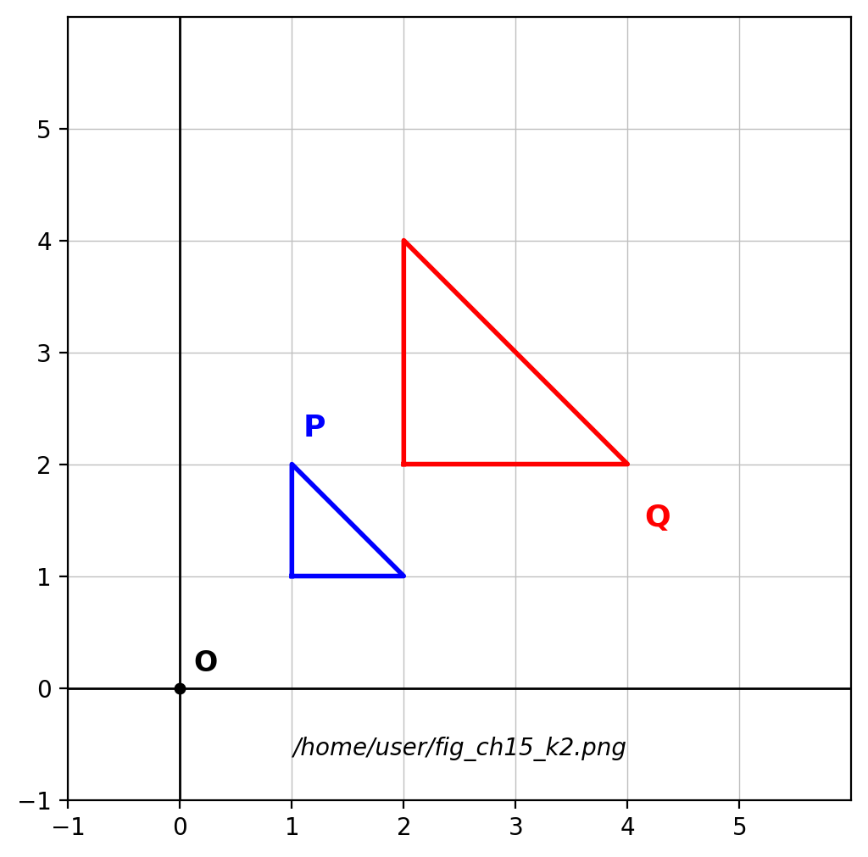
Fig. 1 — object P and image Q on a grid.
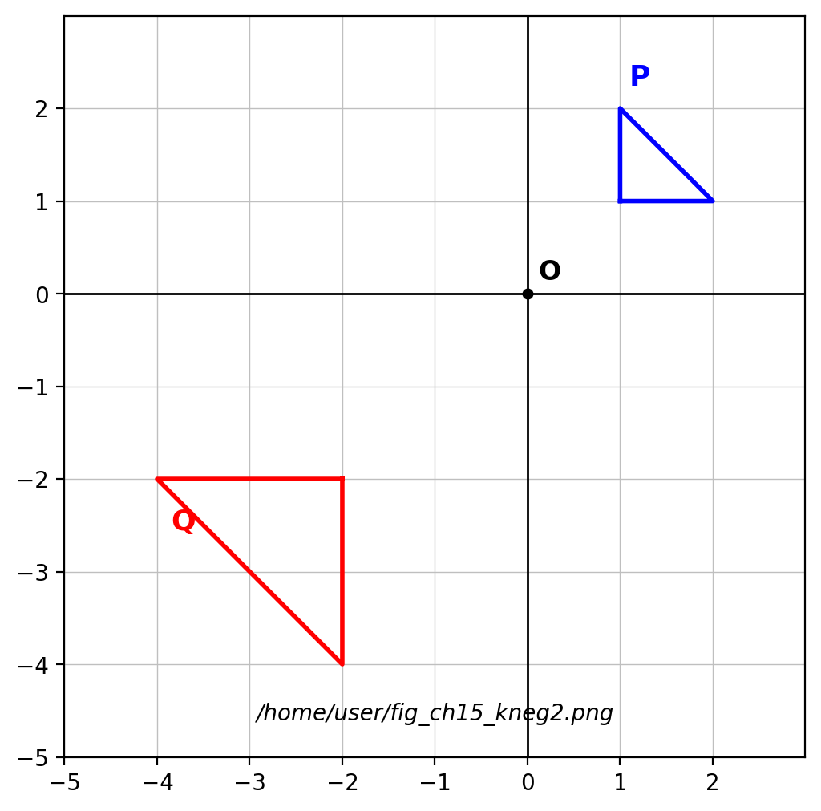
Fig. 2 — object P and image Q on a grid.
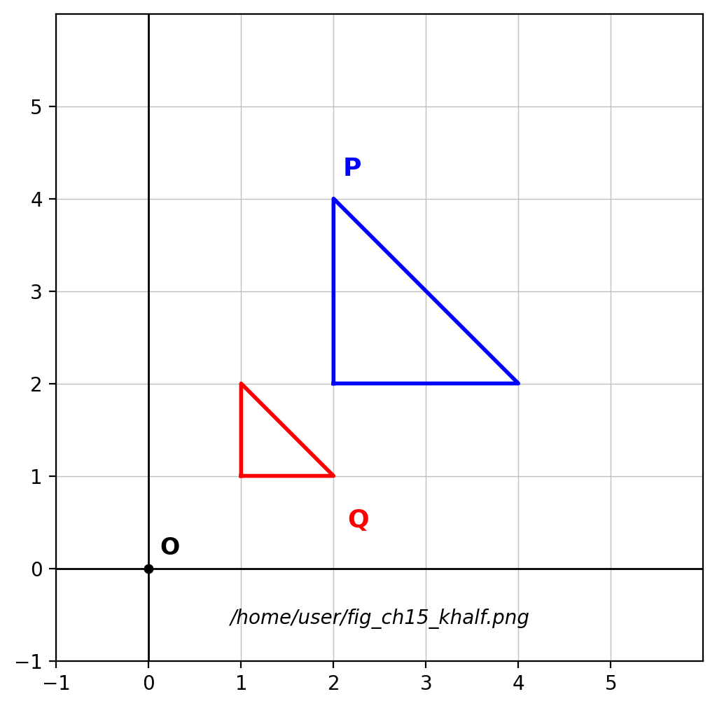
Fig. 3 — object P and image Q on a grid.

SECTION B: MARKING SCHEME

1. Everyday enlargements and properties [10 marks]
(a) Give two everyday situations that depict enlargement. Any two valid: printing a photo at a larger size; a projector image on a screen; a shadow; a map blown up; zooming in on a phone. [2 marks]
(b) State the two pieces of information that define an enlargement. The centre of enlargement and the scale factor. [2 marks]
(c) Under an enlargement, what happens to (i) the angles and (ii) the lengths of the object? (i) Angles are unchanged. (ii) Lengths are multiplied by |k|. [3 marks]
(d) Describe the image when the scale factor is −1. The image is congruent to the object but on the opposite side of the centre (the object turned through 180° about the centre). [3 marks]
[Total: 10 marks]

2. Drawing enlargements on a grid [10 marks]
(a) A triangle has vertices (1, 1), (3, 1) and (1, 2). Draw its image under an enlargement with centre O and scale factor 2. Image vertices (2, 2), (6, 2), (2, 4) correctly plotted. [3 marks]
(b) Draw the image of the same triangle under an enlargement with centre O and k = −1. Image vertices (−1, −1), (−3, −1), (−1, −2). [3 marks]
(c) Draw the image under an enlargement with centre O and k = ½. Image vertices (0.5, 0.5), (1.5, 0.5), (0.5, 1). [2 marks]
(d) State how each image compares in size with the object. k = 2: twice as large; k = −1: same size; k = ½: half the size. [2 marks]
[Total: 10 marks]

3. Scale factors from diagrams [10 marks]
(a) [Fig. 1] State the scale factor and the centre of the enlargement that maps P onto Q. k = 2, centre O(0, 0). [3 marks]
(b) [Fig. 2] State the scale factor of the enlargement that maps P onto Q. k = −2 (image on the opposite side, twice as large). [2 marks]
(c) [Fig. 3] State the scale factor of the enlargement that maps P onto Q. k = ½ (image smaller, same side). [2 marks]
(d) Explain the effect of a negative scale factor on the position of the image. The image lies on the opposite side of the centre from the object (inverted through the centre). [3 marks]
[Total: 10 marks]

4. Enlargement coordinates and areas [10 marks]
(a) Find the image of (2, −3) under an enlargement with centre O and scale factor 4. (8, −12). [2 marks]
(b) Find the image of (2, 4) under an enlargement with centre (1, 1) and scale factor 3. Vector from centre: (1, 3); ×3 = (3, 9); image = (1 + 3, 1 + 9) = (4, 10). [3 marks]
(c) An object has area 12 cm². Find the image area when k = −2. Area × k² = 12 × 4 = 48 cm². [3 marks]
(d) An image has area 50 cm² and the object has area 2 cm². Find the possible values of k. k² = 50/2 = 25 → k = 5 or k = −5. [2 marks]
[Total: 10 marks]

5. Congruent and similar shapes [10 marks]
(a) What are congruent shapes? Shapes with the same shape and the same size (one fits exactly on the other). [2 marks]
(b) What are similar shapes? Shapes with equal corresponding angles and proportional corresponding sides (same shape, possibly different size). [2 marks]
(c) Two similar triangles are in the ratio 3 : 5. The smaller has perimeter 21 cm. Find the perimeter of the larger. 21 × 5/3 = 35 cm. [3 marks]
(d) If the smaller triangle has area 18 cm², find the area of the larger. Area ratio 9 : 25 → 18 × 25/9 = 50 cm². [3 marks]
[Total: 10 marks]

6. Verifying similarity [10 marks]
(a) An object has sides 4 cm, 5 cm, 6 cm and its image has sides 12 cm, 15 cm, 18 cm. Show that the shapes are similar and state k. 12/4 = 15/5 = 18/6 = 3, all ratios equal → similar with k = 3. [3 marks]
(b) Are the two shapes congruent? Give a reason. No — corresponding sides are not equal (k ≠ 1), so same shape but different size. [2 marks]
(c) If the object has area 10 cm², find the area of the image. 10 × 3² = 90 cm². [3 marks]
(d) State the single transformation that maps the object onto the image. An enlargement with scale factor 3 (about the centre joining corresponding vertices). [2 marks]
[Total: 10 marks]

CURRICULUM BLUEPRINT
Qn | Content Focus | Indicator | Marks
1 | Defining an enlargement | B9.3.3.1 | 1
2 | Angles are invariant | B9.3.3.1 | 1
3 | Lengths scale by |k| | B9.3.3.1 | 1
4 | Area scales by k² | B9.3.3.1 | 1
5 | Scale factor 1 | B9.3.3.1 | 1
6 | Scale factor −1 | B9.3.3.1 | 1
7 | Finding the centre | B9.3.3.1 | 1
8 | Perimeter scales by |k| | B9.3.3.1 | 1
9 | Everyday enlargement | B9.3.3.1.1 | 1
10 | Projector image | B9.3.3.1.1 | 1
11 | Shadows as enlargement | B9.3.3.1.1 | 1
12 | Non-examples of enlargement | B9.3.3.1.1 | 1
13 | Photocopier percentages | B9.3.3.1.1 | 1
14 | Zoom as enlargement | B9.3.3.1.1 | 1
15 | Scale factor from lengths | B9.3.3.1.2 | 1
16 | Fractional scale factor | B9.3.3.1.2 | 1
17 | Negative scale factor | B9.3.3.1.2 | 1
18 | Scale factor from a diagram (Fig. 1) | B9.3.3.1.2 | 1
19 | Negative scale factor from a diagram (Fig. 2) | B9.3.3.1.2 | 1
20 | Fractional scale factor from a diagram (Fig. 3) | B9.3.3.1.2 | 1
21 | Image of a point | B9.3.3.1.2 | 1
22 | Image under negative k | B9.3.3.1.2 | 1
23 | Enlargement about another centre | B9.3.3.1.2 | 1
24 | Effect of a fractional k | B9.3.3.1.2 | 1
25 | Effect of k < −1 | B9.3.3.1.2 | 1
26 | Coordinate rule | B9.3.3.1.2 | 1
27 | Perimeter ratio | B9.3.3.1.2 | 1
28 | Area under enlargement | B9.3.3.1.2 | 1
29 | Scale factor from areas | B9.3.3.1.2 | 1
30 | Centre of enlargement (Fig. 1) | B9.3.3.1.2 | 1
31 | Congruent shapes | B9.3.3.1.3 | 1
32 | Similar shapes | B9.3.3.1.3 | 1
33 | Enlargement gives similar images | B9.3.3.1.3 | 1
34 | When the image is congruent | B9.3.3.1.3 | 1
35 | Area ratio of similar triangles | B9.3.3.1.3 | 1
36 | Proportional sides | B9.3.3.1.3 | 1
37 | Always-similar pairs | B9.3.3.1.3 | 1
38 | Not necessarily similar | B9.3.3.1.3 | 1
39 | Area ratio from k | B9.3.3.1.3 | 1
40 | Verifying similarity | B9.3.3.1.3 | 1
B1 | Everyday enlargements & properties | B9.3.3.1.1 | 10
B2 | Drawing enlargements on a grid | B9.3.3.1.2 | 10
B3 | Scale factors from diagrams | B9.3.3.1.2 | 10
B4 | Enlargement coordinates & areas | B9.3.3.1.2 | 10
B5 | Congruent and similar shapes | B9.3.3.1.3 | 10
B6 | Verifying similarity | B9.3.3.1.3 | 10
 | TOTAL |  | 100

CURRICULUM COVERAGE BY INDICATOR
Curriculum Area | Section A | Section B | Total | %
B9.3.3.1 (standard) Centre & scale factor, invariant properties, perimeter/area scaling | 8 | 0 | 8 | 8%
B9.3.3.1.1 Everyday situations depicting enlargement | 6 | 10 (B1) | 16 | 16%
B9.3.3.1.2 Performing enlargements; determining scale factors (incl. negative & fractional k) | 16 | 30 (B2, B3, B4) | 46 | 46%
B9.3.3.1.3 Congruent and similar shapes | 10 | 20 (B5, B6) | 30 | 30%
Note: Section A q1–8 test standard-level definitions and properties (8 marks); q9–14 everyday situations (.1, 6); q15–30 performing enlargements and reading scale factors, including negative and fractional k (.2, 16); q31–40 congruent and similar shapes (.3, 10). Section B: B1 real life & properties (10); B2–B4 drawing enlargements, diagrams, coordinates and areas (30); B5–B6 congruence and similarity (20).

COGNITIVE-LEVEL DISTRIBUTION
Cognitive Level | Section A | Section B | Total | %
Remember | 2 | 4 | 6 | 6%
Understand | 15 | 15 | 30 | 30%
Apply | 17 | 33 | 50 | 50%
Analyse | 6 | 8 | 14 | 14%
Evaluate | 0 | 0 | 0 | 0%
Create | 0 | 0 | 0 | 0%

DIFFICULTY DISTRIBUTION
Difficulty | Section A | Section B | Total | %
Easy | 16 | 20 (B1, B5) | 36 | 36%
Moderate | 22 | 30 (B2, B3, B4) | 52 | 52%
Challenging | 2 | 10 (B6) | 12 | 12%

QUALITY-CONTROL SUMMARY
Check | Status
Curriculum alignment | Standard B9.3.3.1 with all three indicators: everyday enlargement situations (.1), performing enlargements and determining scale factors including negative/fractional k (.2), congruent & similar shapes (.3).
Section structure | Section A: 40 objectives (40 marks). Section B: 6 structured questions (60 marks). Total 100 marks, 2 hours.
Answer key balance | A=10, B=10, C=10, D=10. Zero consecutive repeats. No sustained cycling pattern.
Diagrams (BECE style) | Three grid figures showing object P and image Q for k = 2, k = −2 and k = ½, following the CCP's 'state the transformation mapping P onto Q' exemplars.
Curriculum exemplars used | Mapping P onto Q/R on grids; investigating negative, >1 and fractional scale factors; determining k from object–image pairs; verifying congruent/similar shapes via properties.
Distractor quality | Classic confusions: k vs k², ½ vs −½ vs 2, same-side vs opposite-side images, congruent vs similar, squares vs rectangles similarity, area-ratio traps (2:3 vs 4:9).
Marking guide completeness | Every Section B part carries explicit marks (each question sums to 10); image coordinates and centres shown; all figures reprinted for the marker.
Blueprint | 46-row blueprint (40 objectives + 6 structured) sums to exactly 100 marks.
Coverage | Standard 8%, .1 = 16%, .2 = 46%, .3 = 30%.
Cognitive spread | Remember 6%, Understand 30%, Apply 50%, Analyse 14%.
Difficulty spread | Easy 36%, Moderate 52%, Challenging 12%.

