BEACON EDUCATIONAL CONSULT
MOCK EXAMINATION — 2026/2027 ACADEMIC YEAR
MATHEMATICS — BASIC 9 (JHS 3)
Chapter 15: Enlargement (Curriculum Standard B9.3.3.1)
Time Allowed: 2 Hours Total Marks: 100

INSTRUCTIONS TO CANDIDATES
1. Write your name and index number on the answer sheet provided.
2. This paper consists of TWO sections: Section A (Objectives) and Section B (Structured Questions).
3. Section A: Answer ALL forty (40) questions. Each question carries 1 mark. Choose the correct option from A to D.
4. Section B: Answer ALL six (6) questions. Each question carries 10 marks. Show all necessary workings.
5. All grid diagrams use unit squares; O is the origin.
6. Use a non-programmable calculator where necessary.

SECTION A: OBJECTIVE TEST (40 MARKS)
Answer ALL questions in this section. Choose the correct answer from A to D.
1. An enlargement is completely defined by
A. a centre and a scale factor
B. an angle and a distance
C. a line of symmetry
D. a direction and a length
2. Under an enlargement, the angles of the object are
A. halved
B. multiplied by the scale factor
C. unchanged
D. doubled
3. Under an enlargement of scale factor k, the lengths of the object are
A. unchanged
B. multiplied by k²
C. increased by k
D. multiplied by |k|
4. Under an enlargement of scale factor k, the area of the object is multiplied by
A. k²
B. k
C. 2k
D. √k
5. An enlargement with scale factor 1 gives an image that is
A. smaller than the object
B. a mirror image of the object
C. twice the object
D. congruent to the object
6. An enlargement with scale factor −1 gives an image that is
A. a smaller copy of the object
B. a larger copy of the object
C. the object turned through 180° about the centre
D. a translation of the object
7. The lines joining corresponding vertices of an object and its image under an enlargement all pass through
A. the origin
B. the midpoint of the object
C. the image
D. the centre of enlargement
8. An enlargement with scale factor 2 changes the perimeter of the object by a factor of
A. 8
B. 2
C. √2
D. 4
9. Which situation is an example of enlargement?
A. flipping a page of a book
B. turning a door on its hinges
C. printing a small photograph as a poster
D. sliding a box across the floor
10. A projector throws an image on a screen. The image is an enlargement because it is
A. the same size but a different shape
B. the same shape but a different size
C. a reflection of the slide
D. a translation of the slide
11. The shadow of a triangle on a wall has the same shape but a larger size. This is an example of
A. enlargement
B. rotation
C. translation
D. reflection
12. Which of the following is NOT an enlargement?
A. blowing up a passport photo to poster size
B. a reflection in a plane mirror
C. zooming in on a phone screen
D. the shadow of a chair at sunset
13. Photocopying a document at 150% corresponds to a scale factor of
A. 1.5
B. 0.15
C. 15
D. 150
14. Zooming ×3 on a phone map corresponds to a scale factor of
A. 0.3
B. 30
C. 1/3
D. 3
15. An object length of 4 cm has an image length of 12 cm. The scale factor is
A. 3
B. 1/3
C. 8
D. 48
16. An object length of 6 cm has an image length of 3 cm. The scale factor is
A. 2
B. ½
C. 3
D. 18
17. The image lies on the opposite side of the centre and is twice as large as the object. The scale factor is
A. −½
B. ½
C. −2
D. 2
Questions 18 and 30 refer to Fig. 1.
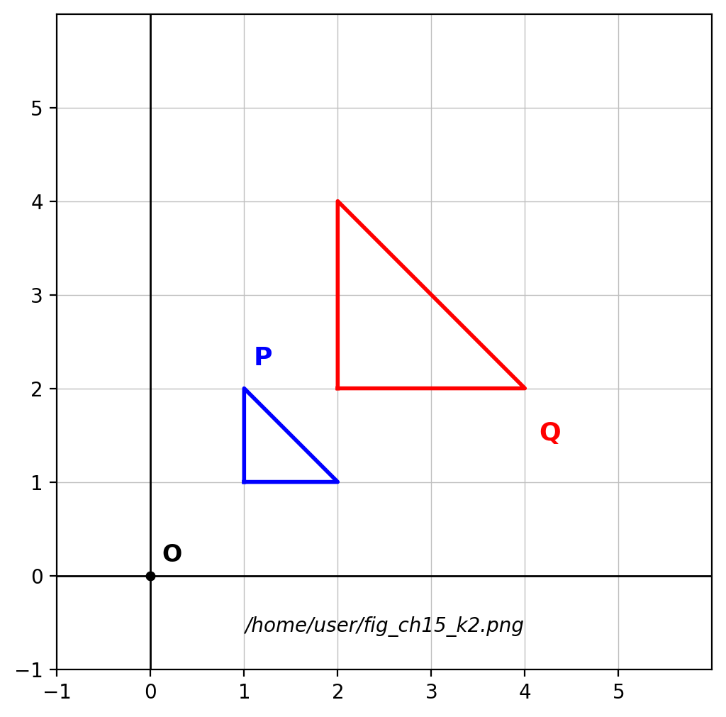
Fig. 1 — object P and image Q on a grid.
18. The scale factor of the enlargement that maps P onto Q is
A. 4
B. 2
C. ½
D. −2
Question 19 refers to Fig. 2.
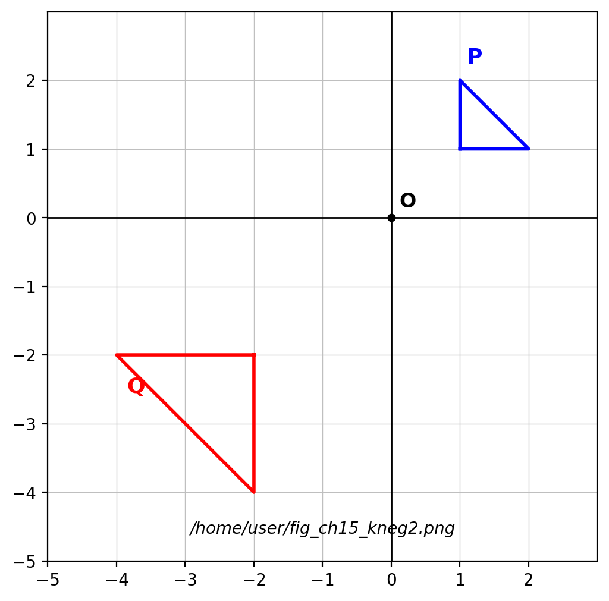
Fig. 2 — object P and image Q on a grid.
19. The scale factor of the enlargement that maps P onto Q is
A. 2
B. −½
C. ½
D. −2
Question 20 refers to Fig. 3.
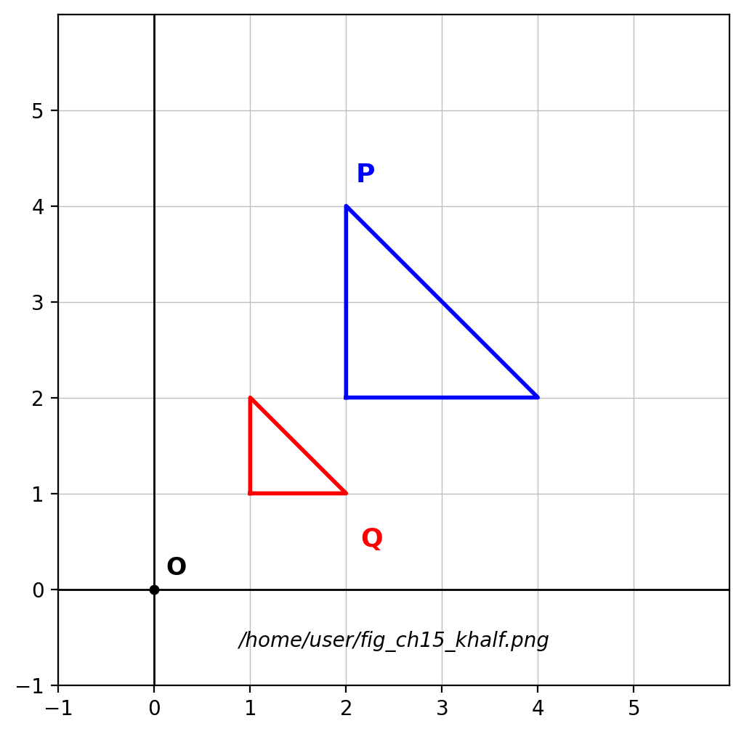
Fig. 3 — object P and image Q on a grid.
20. The scale factor of the enlargement that maps P onto Q is
A. −2
B. ½
C. −½
D. 2
21. The image of (2, 3) under an enlargement with centre O and scale factor 3 is
A. (9, 6)
B. (5, 6)
C. (2, 9)
D. (6, 9)
22. The image of (4, −2) under an enlargement with centre O and scale factor −2 is
A. (−8, 4)
B. (8, −4)
C. (−8, −4)
D. (2, −4)
23. An enlargement with centre (1, 1) and scale factor 2 maps (3, 1) to
A. (7, 1)
B. (4, 2)
C. (5, 1)
D. (6, 2)
24. When 0 < k < 1, the image is
A. larger and on the opposite side of the centre
B. larger and on the same side of the centre
C. smaller and on the opposite side of the centre
D. smaller and on the same side of the centre
25. When k < −1, the image is
A. larger and on the same side of the centre
B. smaller and on the opposite side of the centre
C. larger and on the opposite side of the centre
D. smaller and on the same side of the centre
26. Under an enlargement with centre O and scale factor k, the point (x, y) maps to
A. (kx, y)
B. (kx, ky)
C. (x/k, y/k)
D. (x + k, y + k)
27. The ratio of the perimeter of the image to the perimeter of the object equals
A. 1/|k|
B. k²
C. 2k
D. |k|
28. An object has area 10 cm². With scale factor 3, the image area is
A. 90 cm²
B. 30 cm²
C. 13 cm²
D. 900 cm²
29. An image has area 4 cm² and the object has area 36 cm². A possible scale factor is
A. 9
B. 1/3 or −1/3
C. 3 or −3
D. 1/9
30. The centre of the enlargement that maps P onto Q is
A. (1, 0)
B. (1, 1)
C. (0, 0)
D. (2, 2)
31. Congruent shapes have
A. the same shape but different sizes
B. the same shape and the same size
C. different shapes but the same size
D. different shapes and sizes
32. Similar shapes have
A. equal areas
B. equal perimeters
C. equal angles and proportional sides
D. equal sides only
33. The image under any enlargement is always
A. similar to the object
B. a mirror image of the object
C. congruent to the object
D. larger than the object
34. The image of an enlargement is congruent to the object when
A. k = 2
B. k = 0
C. |k| = 1
D. k > 1
35. Similar triangles with sides in the ratio 2 : 3 have areas in the ratio
A. 8 : 27
B. 4 : 9
C. √2 : √3
D. 2 : 3
36. Two similar rectangles have shorter sides 3 cm and 9 cm. If the longer side of the smaller is 5 cm, the longer side of the larger is
A. 15 cm
B. 45 cm
C. 11 cm
D. 25 cm
37. Which pair of shapes is ALWAYS similar?
A. any two rectangles
B. any two isosceles triangles
C. any two rhombuses
D. any two squares
38. Which pair of shapes is NOT necessarily similar?
A. any two rectangles
B. any two equilateral triangles
C. any two squares
D. any two circles
39. Similar shapes with scale factor 4 have areas in the ratio
A. 1 : 64
B. 1 : 4
C. 1 : 16
D. 1 : 8
40. An object with sides 2 cm and 3 cm maps to a shape with sides 6 cm and 9 cm. The shapes are
A. congruent
B. similar with scale factor 9
C. neither similar nor congruent
D. similar with scale factor 3

SECTION B: STRUCTURED QUESTIONS (60 MARKS)
Answer ALL questions in this section. Show all workings clearly.

1. Everyday enlargements and properties
(a) Give two everyday situations that depict enlargement. [2 marks]
(b) State the two pieces of information that define an enlargement. [2 marks]
(c) Under an enlargement, what happens to (i) the angles and (ii) the lengths of the object? [3 marks]
(d) Describe the image when the scale factor is −1. [3 marks]
[Total: 10 marks]

2. Drawing enlargements on a grid
(a) A triangle has vertices (1, 1), (3, 1) and (1, 2). Draw its image under an enlargement with centre O and scale factor 2. [3 marks]
(b) Draw the image of the same triangle under an enlargement with centre O and k = −1. [3 marks]
(c) Draw the image under an enlargement with centre O and k = ½. [2 marks]
(d) State how each image compares in size with the object. [2 marks]
[Total: 10 marks]

3. Scale factors from diagrams
(a) [Fig. 1] State the scale factor and the centre of the enlargement that maps P onto Q. [3 marks]
(b) [Fig. 2] State the scale factor of the enlargement that maps P onto Q. [2 marks]
(c) [Fig. 3] State the scale factor of the enlargement that maps P onto Q. [2 marks]
(d) Explain the effect of a negative scale factor on the position of the image. [3 marks]
[Total: 10 marks]

4. Enlargement coordinates and areas
(a) Find the image of (2, −3) under an enlargement with centre O and scale factor 4. [2 marks]
(b) Find the image of (2, 4) under an enlargement with centre (1, 1) and scale factor 3. [3 marks]
(c) An object has area 12 cm². Find the image area when k = −2. [3 marks]
(d) An image has area 50 cm² and the object has area 2 cm². Find the possible values of k. [2 marks]
[Total: 10 marks]

5. Congruent and similar shapes
(a) What are congruent shapes? [2 marks]
(b) What are similar shapes? [2 marks]
(c) Two similar triangles are in the ratio 3 : 5. The smaller has perimeter 21 cm. Find the perimeter of the larger. [3 marks]
(d) If the smaller triangle has area 18 cm², find the area of the larger. [3 marks]
[Total: 10 marks]

6. Verifying similarity
(a) An object has sides 4 cm, 5 cm, 6 cm and its image has sides 12 cm, 15 cm, 18 cm. Show that the shapes are similar and state k. [3 marks]
(b) Are the two shapes congruent? Give a reason. [2 marks]
(c) If the object has area 10 cm², find the area of the image. [3 marks]
(d) State the single transformation that maps the object onto the image. [2 marks]
[Total: 10 marks]

