BEACON EDUCATIONAL CONSULT
MARKING GUIDE — MOCK EXAMINATION 2026/2027
MATHEMATICS — BASIC 9 (JHS 3) — Chapter 16: Data Handling I (B9.4.1.1)

Curriculum Standard (NaCCA CCP, Sept 2020): B9.4.1.1 — Select, justify, and use appropriate methods of collecting data (grouped/ungrouped), use the data to construct and interpret frequency tables and histogram and use it to determine the mode and to solve and/or pose problems.
Indicators tested: B9.4.1.1.1 Select and justify a method to collect data (quantitative and qualitative); B9.4.1.1.2 Organise data (grouped/ungrouped), present it in frequency tables and other representations and analyse it to solve problems; B9.4.1.1.3 Use a histogram to determine the mode of given data to solve problems.

SECTION A: ANSWER KEY
Qn | Ans | Content Focus | Indicator
1 | C | Quantitative data | B9.4.1.1.1
2 | A | Qualitative data | B9.4.1.1.1
3 | C | Choosing a method: survey (curriculum exemplar) | B9.4.1.1.1
4 | D | Choosing a method: mode of travel (curriculum exemplar) | B9.4.1.1.1
5 | A | Choosing a method: observation | B9.4.1.1.1
6 | D | Choosing a method: experiment (curriculum exemplar) | B9.4.1.1.1
7 | A | Interview method | B9.4.1.1.1
8 | B | Secondary data | B9.4.1.1.1
9 | D | Tally marks | B9.4.1.1.2
10 | A | Total frequency | B9.4.1.1.2
11 | D | Mode of ungrouped data | B9.4.1.1.2
12 | B | Mode of ungrouped data | B9.4.1.1.2
13 | C | Range | B9.4.1.1.2
14 | D | Median of an even number of values | B9.4.1.1.2
15 | B | Reading a stem-and-leaf plot (Fig. 2) | B9.4.1.1.2
16 | A | Counting leaves (Fig. 2) | B9.4.1.1.2
17 | D | Bar chart features | B9.4.1.1.2
18 | A | Line graphs | B9.4.1.1.2
19 | B | Pie chart angles | B9.4.1.1.2
20 | C | Pictographs | B9.4.1.1.2
21 | B | Waffle diagrams | B9.4.1.1.2
22 | D | Box-and-whisker plots | B9.4.1.1.2
23 | B | Class width | B9.4.1.1.2
24 | C | Modal class | B9.4.1.1.2
25 | D | Frequency of a value | B9.4.1.1.2
26 | C | Histograms for grouped data | B9.4.1.1.2
27 | A | Why histogram bars touch | B9.4.1.1.2
28 | C | Missing frequency | B9.4.1.1.2
29 | D | Mode from a histogram | B9.4.1.1.3
30 | A | Modal class from a histogram (Fig. 1) | B9.4.1.1.3
31 | B | Total frequency from a histogram (Fig. 1) | B9.4.1.1.3
32 | D | Reading a frequency (Fig. 1) | B9.4.1.1.3
33 | B | Comparing frequencies (Fig. 1) | B9.4.1.1.3
34 | C | Histogram vs bar chart | B9.4.1.1.3
35 | A | Mode of grouped data | B9.4.1.1.3
36 | C | Modal class (curriculum exemplar table) | B9.4.1.1.3
37 | B | Keeping the mode | B9.4.1.1.3
38 | A | Median class from a histogram (Fig. 1) | B9.4.1.1.3
39 | B | Identifying the modal class | B9.4.1.1.3
40 | C | Missing bar frequency | B9.4.1.1.3

Full answer key: CACDA DABDA DBCDB ADABC BDBCD CACDA BDBCA CBABC

SECTION A: WORKED SOLUTIONS
1. Quantitative data are numbers from counting or measuring.
2. Qualitative data describe qualities and are non-numerical.
3. Popularity among friends is gathered quickly with a questionnaire (survey).
4. A survey counts learners' travel modes; observation would miss reasons and coverage.
5. Vehicles are counted as they pass: observation.
6. Bulb lifespans must be tested under control: experiment (the CCP's own exemplar).
7. Face-to-face questioning is an interview.
8. Registers already kept are secondary data / existing records.
9. 13 = 5 + 5 + 3: two crossed groups of five and three strokes.
10. Frequencies count every value, so they add up to the number of data values.
11. 5 occurs five times, more than any other value.
12. 7 occurs three times.
13. 12 − 3 = 9.
14. Middle two values 5 and 7: (5 + 7)/2 = 6.
15. Stem 2 with leaf 4 means 24.
16. Leaves: 3 + 4 + 2 = 9 values.
17. Bar charts represent categories, so the bars have gaps.
18. A line graph shows trends over time.
19. 3/30 × 360° = 36°.
20. 4.5 × 10 = 45 books.
21. 100 squares = 100%, so one square = 1%.
22. Box plots show median, quartiles and extremes.
23. 168, 169, 170, 171: four whole numbers.
24. The modal class has the greatest frequency, 12.
25. 4 appears four times.
26. Continuous grouped data are drawn as a histogram.
27. Continuous classes join up, so the bars touch.
28. 3 + x + 6 + 5 + 2 = 20 → x = 4.
29. The tallest bar is the modal class.
30. Tallest bar: 30–39 (frequency 10).
31. 4 + 7 + 10 + 6 + 3 = 30.
32. The bar 20–29 has height 7.
33. 10 − 3 = 7.
34. Histograms represent continuous measurements: no gaps.
35. Grouped data give a modal class, not one exact value.
36. Greatest frequency (11) is on 172–175.
37. x must be 4; with 2 or 6 the mode would change or tie.
38. Cumulative 4, 11, 21: the 15th and 16th values fall in 30–39.
39. 8 is the greatest frequency: the third class.
40. 40 − (8 + 12 + 10 + 6) = 40 − 36 = 4.

FIGURES (REPRINTED FOR MARKING)
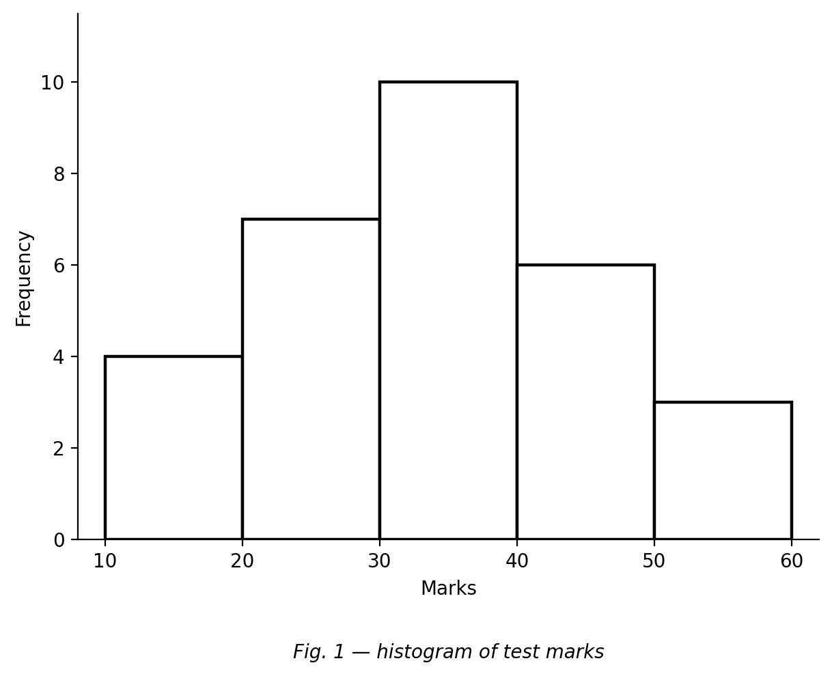
Fig. 1 — histogram of test marks.
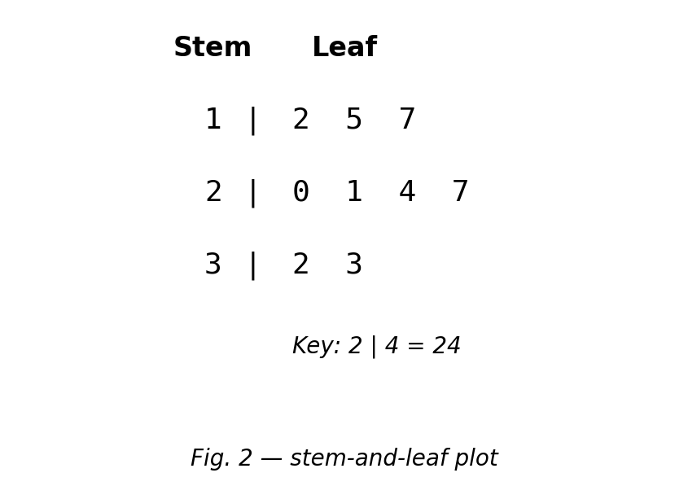
Fig. 2 — stem-and-leaf plot.

SECTION B: MARKING SCHEME

1. Data types and collection methods [10 marks]
(a) Define quantitative and qualitative data, giving one example of each. Quantitative: numerical data from counting/measuring (e.g. heights, test scores). Qualitative: descriptive, non-numerical data (e.g. favourite colour, type of food). [3 marks]
(b) Choose and justify a method to find the most common mode of travel by learners in your school. A questionnaire/survey — it reaches many learners quickly and gives countable (quantitative) responses that can be tallied. [3 marks]
(c) Which method would you use to determine the lifespan of bulbs? Justify. An experiment — the bulbs must actually be life-tested under controlled conditions; no existing records exist. [2 marks]
(d) State one advantage of a questionnaire over an interview. It is quicker/cheaper and can cover many respondents at once (or respondents answer privately/anonymously). [2 marks]
[Total: 10 marks]

2. Ungrouped frequency table [10 marks]
(a) The marks out of 10 of 20 pupils are: 4, 7, 5, 6, 4, 8, 5, 7, 6, 5, 9, 5, 5, 7, 4, 6, 8, 5, 6, 7. Construct a frequency table for the data. Mark: 4→3; 5→6; 6→4; 7→4; 8→2; 9→1 (tallies acceptable); total 20. [4 marks]
(b) Write down the mode. 5 (occurs 6 times). [2 marks]
(c) Calculate the range. 9 − 4 = 5. [2 marks]
(d) How many pupils wrote the test? Sum of frequencies = 20. [2 marks]
[Total: 10 marks]

3. Grouped frequency table [10 marks]
Thirty bulbs were life-tested. Lifespans (hours): 164–167 frequency 4; 168–171 frequency 7; 172–175 frequency 11; 176–179 frequency 8.
(a) State the class width of the interval 168–171. 4 (it contains the 4 whole numbers 168, 169, 170, 171). [2 marks]
(b) Write down the modal class. 172–175 (greatest frequency, 11). [2 marks]
(c) Show that a total of 30 bulbs were tested. 4 + 7 + 11 + 8 = 30. [3 marks]
(d) How many bulbs lasted 172 hours or more? 11 + 8 = 19 bulbs. [3 marks]
[Total: 10 marks]

4. Stem-and-leaf, pictograph and pie chart [10 marks]
(a) The ages of a club are 12, 15, 17, 20, 21, 24, 27, 32, 33. Draw a stem-and-leaf plot for the data. Stems 1, 2, 3 with leaves: 1 | 2 5 7; 2 | 0 1 4 7; 3 | 2 3, plus a key (e.g. 2 | 4 = 24 style). [3 marks]
(b) Use your plot to find the range of the ages. 33 − 12 = 21 years. [2 marks]
(c) In a pictograph one symbol represents 10 books. Show how 45 books would be drawn. Four full symbols and one half symbol (4½ × 10 = 45). [3 marks]
(d) In a survey of 30 people, 3 chose cocoa. Find the sector angle for cocoa in a pie chart. 3/30 × 360° = 36°. [2 marks]
[Total: 10 marks]

5. Histograms [10 marks]
A test was marked out of 60. The marks of 30 students were grouped as follows: 10–19 frequency 4; 20–29 frequency 7; 30–39 frequency 10; 40–49 frequency 6; 50–59 frequency 3.
(a) Draw a histogram of the data. Five touching bars on the mark axis with heights 4, 7, 10, 6, 3; correct axes labelled (marks, frequency). [4 marks]
(b) Write down the modal class. 30–39 (frequency 10). [2 marks]
(c) How many students wrote the test? 4 + 7 + 10 + 6 + 3 = 30. [2 marks]
(d) Which class contains the median? Explain briefly. The 15th and 16th values; cumulative frequencies 4, 11, 21 place both in 30–39, so the median lies in 30–39. [2 marks]
[Total: 10 marks]

6. Create and solve [10 marks]
(a) Create a set of seven whole numbers with mode 6 and range 5. Any valid set, e.g. 3, 4, 6, 6, 6, 7, 8 (mode 6 occurs 3 times; range 8 − 3 = 5). [3 marks]
(b) Present your data in a frequency table. Correct counts for each value used; frequencies sum to 7. [3 marks]
(c) State the mode and the range of your data. Mode 6; range 5 (must match the created data). [2 marks]
(d) Pose one question that can be answered from your table, and solve it. Any coherent question with a correct answer, e.g. 'How many 6s are there?' → 3, or 'What is the total frequency?' → 7. [2 marks]
[Total: 10 marks]

CURRICULUM BLUEPRINT
Qn | Content Focus | Indicator | Marks
1 | Quantitative data | B9.4.1.1.1 | 1
2 | Qualitative data | B9.4.1.1.1 | 1
3 | Choosing a method: survey (curriculum exemplar) | B9.4.1.1.1 | 1
4 | Choosing a method: mode of travel (curriculum exemplar) | B9.4.1.1.1 | 1
5 | Choosing a method: observation | B9.4.1.1.1 | 1
6 | Choosing a method: experiment (curriculum exemplar) | B9.4.1.1.1 | 1
7 | Interview method | B9.4.1.1.1 | 1
8 | Secondary data | B9.4.1.1.1 | 1
9 | Tally marks | B9.4.1.1.2 | 1
10 | Total frequency | B9.4.1.1.2 | 1
11 | Mode of ungrouped data | B9.4.1.1.2 | 1
12 | Mode of ungrouped data | B9.4.1.1.2 | 1
13 | Range | B9.4.1.1.2 | 1
14 | Median of an even number of values | B9.4.1.1.2 | 1
15 | Reading a stem-and-leaf plot (Fig. 2) | B9.4.1.1.2 | 1
16 | Counting leaves (Fig. 2) | B9.4.1.1.2 | 1
17 | Bar chart features | B9.4.1.1.2 | 1
18 | Line graphs | B9.4.1.1.2 | 1
19 | Pie chart angles | B9.4.1.1.2 | 1
20 | Pictographs | B9.4.1.1.2 | 1
21 | Waffle diagrams | B9.4.1.1.2 | 1
22 | Box-and-whisker plots | B9.4.1.1.2 | 1
23 | Class width | B9.4.1.1.2 | 1
24 | Modal class | B9.4.1.1.2 | 1
25 | Frequency of a value | B9.4.1.1.2 | 1
26 | Histograms for grouped data | B9.4.1.1.2 | 1
27 | Why histogram bars touch | B9.4.1.1.2 | 1
28 | Missing frequency | B9.4.1.1.2 | 1
29 | Mode from a histogram | B9.4.1.1.3 | 1
30 | Modal class from a histogram (Fig. 1) | B9.4.1.1.3 | 1
31 | Total frequency from a histogram (Fig. 1) | B9.4.1.1.3 | 1
32 | Reading a frequency (Fig. 1) | B9.4.1.1.3 | 1
33 | Comparing frequencies (Fig. 1) | B9.4.1.1.3 | 1
34 | Histogram vs bar chart | B9.4.1.1.3 | 1
35 | Mode of grouped data | B9.4.1.1.3 | 1
36 | Modal class (curriculum exemplar table) | B9.4.1.1.3 | 1
37 | Keeping the mode | B9.4.1.1.3 | 1
38 | Median class from a histogram (Fig. 1) | B9.4.1.1.3 | 1
39 | Identifying the modal class | B9.4.1.1.3 | 1
40 | Missing bar frequency | B9.4.1.1.3 | 1
B1 | Data types & collection methods | B9.4.1.1.1 | 10
B2 | Ungrouped frequency table | B9.4.1.1.2 | 10
B3 | Grouped frequency table | B9.4.1.1.2 | 10
B4 | Stem-and-leaf, pictograph & pie chart | B9.4.1.1.2 | 10
B5 | Histograms & the mode | B9.4.1.1.3 | 10
B6 | Create and solve with data | B9.4.1.1.3 | 10
 | TOTAL |  | 100

CURRICULUM COVERAGE BY INDICATOR
Curriculum Area | Section A | Section B | Total | %
B9.4.1.1.1 Selecting & justifying data-collection methods | 8 | 10 (B1) | 18 | 18%
B9.4.1.1.2 Organising data; frequency tables & representations | 20 | 30 (B2, B3, B4) | 50 | 50%
B9.4.1.1.3 Histograms; determining the mode; posing problems | 12 | 20 (B5, B6) | 32 | 32%
Note: Section A q1–8 test choosing and justifying collection methods (.1, 8 marks); q9–28 organising data, tallies, frequency tables and representations (.2, 20); q29–40 histograms and the mode (.3, 12). Section B: B1 methods and justification (10); B2–B4 ungrouped/grouped tables, stem-and-leaf, pictograph and pie chart (30); B5–B6 histograms, mode and create-and-solve (20).

COGNITIVE-LEVEL DISTRIBUTION
Cognitive Level | Section A | Section B | Total | %
Remember | 2 | 0 | 2 | 2%
Understand | 16 | 11 | 27 | 27%
Apply | 17 | 37 | 54 | 54%
Analyse | 5 | 7 | 12 | 12%
Evaluate | 0 | 0 | 0 | 0%
Create | 0 | 5 | 5 | 5%

DIFFICULTY DISTRIBUTION
Difficulty | Section A | Section B | Total | %
Easy | 16 | 20 (B2, B3) | 36 | 36%
Moderate | 22 | 30 (B1, B4, B5) | 52 | 52%
Challenging | 2 | 10 (B6) | 12 | 12%

QUALITY-CONTROL SUMMARY
Check | Status
Curriculum alignment | Standard B9.4.1.1 with all three indicators: selecting/justifying collection methods (.1), organising data into frequency tables and representations (.2), histograms and the mode (.3).
Section structure | Section A: 40 objectives (40 marks). Section B: 6 structured questions (60 marks). Total 100 marks, 2 hours.
Answer key balance | A=10, B=10, C=10, D=10. Zero consecutive repeats. No sustained cycling pattern.
Diagrams (BECE style) | A histogram of grouped test marks and a stem-and-leaf plot with key, mirroring BECE data-handling items.
Curriculum exemplars used | Book-club and mode-of-travel survey scenarios, bulb life-test experiment and grouped bulb-lifespan table (164–167 etc.) — adapted from the CCP exemplars with original values.
Distractor quality | Classic confusions: mode vs median vs range, ½ symbol pictographs, pie angles (36° vs 30°), class width 3 vs 4, modal class vs tallest frequency, mean-of-two-middle-values median.
Marking guide completeness | Every Section B part carries explicit marks (each question sums to 10); full tables, counts and justifications shown; figures reprinted for the marker.
Blueprint | 46-row blueprint (40 objectives + 6 structured) sums to exactly 100 marks.
Coverage | .1 = 18%, .2 = 50%, .3 = 32%.
Cognitive spread | Remember 2%, Understand 27%, Apply 54%, Analyse 12%, Create 5%.
Difficulty spread | Easy 36%, Moderate 52%, Challenging 12%.

