BEACON EDUCATIONAL CONSULT
MOCK EXAMINATION — 2026/2027 ACADEMIC YEAR
MATHEMATICS — BASIC 9 (JHS 3)
Chapter 16: Data Handling I — Collection, Frequency Tables & Histograms (Curriculum Standard B9.4.1.1)
Time Allowed: 2 Hours Total Marks: 100

INSTRUCTIONS TO CANDIDATES
1. Write your name and index number on the answer sheet provided.
2. This paper consists of TWO sections: Section A (Objectives) and Section B (Structured Questions).
3. Section A: Answer ALL forty (40) questions. Each question carries 1 mark. Choose the correct option from A to D.
4. Section B: Answer ALL six (6) questions. Each question carries 10 marks. Show all necessary workings.
5. All tables and diagrams in this paper are part of the questions; read them carefully.
6. Use a non-programmable calculator where necessary.

SECTION A: OBJECTIVE TEST (40 MARKS)
Answer ALL questions in this section. Choose the correct answer from A to D.
1. Quantitative data are
A. descriptive data expressed in words
B. data taken from existing records
C. numerical data obtained by counting or measuring
D. data collected by interview only
2. Qualitative data are
A. descriptive (non-numerical) data
B. grouped data
C. secondary data
D. numerical data
3. Musa wants to find the books that are most popular among his friends. The best method of collecting the data is
A. using a database
B. an experiment
C. a questionnaire or survey
D. observation
4. To find the most common mode of travel by learners in a school, the best method is
A. an experiment
B. observation only
C. measurement with instruments
D. a survey using a questionnaire
5. Counting vehicles passing a junction between 7 am and 8 am is best done by
A. observation
B. questionnaire
C. experiment
D. interview
6. Life-testing thirty bulbs to the nearest hour is an example of data collection by
A. using existing records
B. survey
C. interview
D. experiment
7. Asking respondents questions face to face and recording their answers is called
A. an interview
B. a questionnaire
C. observation
D. an experiment
8. Using the school's attendance register, kept over the years, to study attendance is using
A. observation
B. existing records (secondary data)
C. an interview
D. primary data from an experiment
9. The correct tally for 13 is
A. thirteen separate single strokes as standard practice
B. one group of five and three strokes
C. three complete groups of five
D. two complete tally groups of five and three extra strokes
10. The sum of the frequencies in a frequency table always equals
A. the number of data values
B. the range
C. the mode
D. the number of classes
11. The mode of the data 2, 3, 4, 4, 4, 4, 5, 5, 5, 5, 5, 6, 6, 7, 7 is
A. 6
B. 7
C. 4
D. 5
12. The mode of 4, 7, 7, 9, 7, 4 is
A. 6
B. 7
C. 4
D. 9
13. The range of 12, 5, 9, 3, 8 is
A. 7
B. 12
C. 9
D. 8
14. The median of 3, 5, 7, 9 is
A. 7
B. 8
C. 5
D. 6
Questions 15 and 16 refer to Fig. 2.
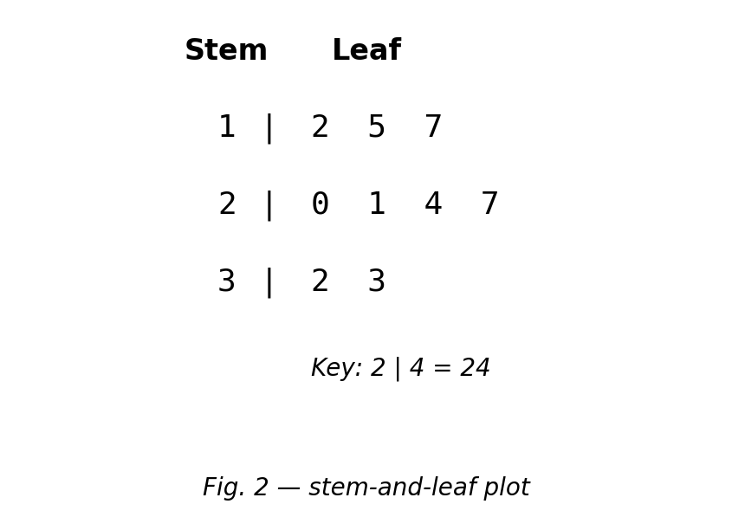
Fig. 2 — stem-and-leaf plot.
15. The value represented by 2 | 4 is
A. 240
B. 24
C. 42
D. 6
16. The number of data values shown is
A. 9
B. 7
C. 8
D. 10
17. In a bar chart, the bars
A. are always drawn horizontal
B. must show continuous data
C. touch each other
D. are separated by gaps
18. The representation best suited to showing change over time is a
A. line graph
B. waffle diagram
C. pie chart
D. pictograph
19. In a pie chart, a frequency of 3 out of a total of 30 gives a sector angle of
A. 30°
B. 36°
C. 60°
D. 108°
20. In a pictograph one symbol represents 10 books. Four and a half symbols represent
A. 50 books
B. 14 books
C. 45 books
D. 40 books
21. In a 10 × 10 waffle diagram, each small square represents
A. 5%
B. 1%
C. 10%
D. 0.1%
22. A box-and-whisker plot displays the median together with
A. the mode only
B. the frequency of every value
C. the mean only
D. the quartiles and extreme values
23. The class width of the class interval 168–171 (whole-number data) is
A. 5
B. 4
C. 8
D. 3
24. A grouped table has frequencies 5, 9, 12 and 7. The modal class is the class with frequency
A. 7
B. 5
C. 12
D. 9
25. In the data 2, 3, 4, 4, 4, 4, 5, 5, 5, 5, 5, 6, 6, 7, 7 the frequency of 4 is
A. 3
B. 5
C. 6
D. 4
26. The diagram used to represent continuous grouped data is a
A. pie chart
B. waffle diagram
C. histogram
D. pictograph
27. In a histogram the bars touch each other because
A. the data are continuous
B. the bars must be equal in height
C. the data are categorical
D. all frequencies are equal
28. A frequency table has frequencies 3, x, 6, 5, 2 with a total of 20. The value of x is
A. 3
B. 6
C. 4
D. 8
29. In a histogram, the mode is read from
A. the last bar
B. the middle bar
C. the shortest bar
D. the tallest bar
Questions 30 to 33 and question 38 refer to Fig. 1.
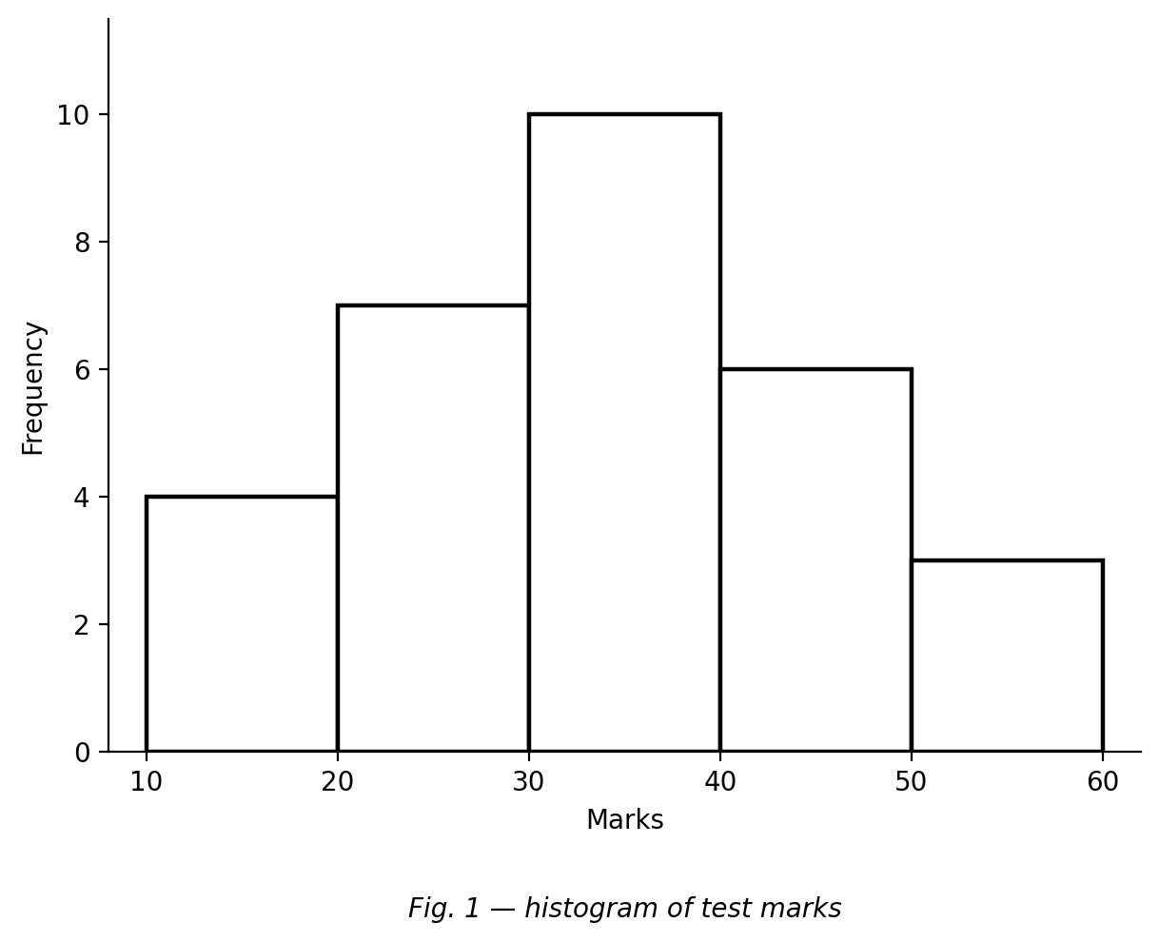
Fig. 1 — histogram of test marks.
30. The modal class is
A. 30–39
B. 50–59
C. 10–19
D. 20–29
31. The total number of students is
A. 25
B. 30
C. 35
D. 10
32. The frequency of the class 20–29 is
A. 6
B. 10
C. 4
D. 7
33. The difference between the greatest and the least frequency is
A. 10
B. 7
C. 3
D. 4
34. A histogram has no gaps between its bars because the data are
A. categorical
B. discrete categories
C. continuous (grouped measurements)
D. qualitative
35. For grouped data, the mode is given as
A. the modal class
B. the midpoint of the first class
C. half of the greatest frequency
D. a single exact value
36. Bulb lifespans (hours): 164–167 f = 4; 168–171 f = 7; 172–175 f = 11; 176–179 f = 8. The modal class is
A. 176–179
B. 164–167
C. 172–175
D. 168–171
37. If the mode of the data 2, 4, 4, x, 6 is 4, then x could be
A. 2
B. 4
C. 6
D. any number
38. The class that contains the median mark is
A. 30–39
B. 20–29
C. 40–49
D. 10–19
39. Five classes have frequencies 2, 5, 8, 5, 2. The modal class is
A. the fifth class
B. the third class
C. the first class
D. the second class
40. A histogram has total frequency 40. Four bars show 8, 12, 10 and 6. The fifth bar shows
A. 6
B. 10
C. 4
D. 14

SECTION B: STRUCTURED QUESTIONS (60 MARKS)
Answer ALL questions in this section. Show all workings clearly.

1. Data types and collection methods
(a) Define quantitative and qualitative data, giving one example of each. [3 marks]
(b) Choose and justify a method to find the most common mode of travel by learners in your school. [3 marks]
(c) Which method would you use to determine the lifespan of bulbs? Justify. [2 marks]
(d) State one advantage of a questionnaire over an interview. [2 marks]
[Total: 10 marks]

2. Ungrouped frequency table
(a) The marks out of 10 of 20 pupils are: 4, 7, 5, 6, 4, 8, 5, 7, 6, 5, 9, 5, 5, 7, 4, 6, 8, 5, 6, 7. Construct a frequency table for the data. [4 marks]
(b) Write down the mode. [2 marks]
(c) Calculate the range. [2 marks]
(d) How many pupils wrote the test? [2 marks]
[Total: 10 marks]

3. Grouped frequency table
Thirty bulbs were life-tested. Lifespans (hours): 164–167 frequency 4; 168–171 frequency 7; 172–175 frequency 11; 176–179 frequency 8.
(a) State the class width of the interval 168–171. [2 marks]
(b) Write down the modal class. [2 marks]
(c) Show that a total of 30 bulbs were tested. [3 marks]
(d) How many bulbs lasted 172 hours or more? [3 marks]
[Total: 10 marks]

4. Stem-and-leaf, pictograph and pie chart
(a) The ages of a club are 12, 15, 17, 20, 21, 24, 27, 32, 33. Draw a stem-and-leaf plot for the data. [3 marks]
(b) Use your plot to find the range of the ages. [2 marks]
(c) In a pictograph one symbol represents 10 books. Show how 45 books would be drawn. [3 marks]
(d) In a survey of 30 people, 3 chose cocoa. Find the sector angle for cocoa in a pie chart. [2 marks]
[Total: 10 marks]

5. Histograms
A test was marked out of 60. The marks of 30 students were grouped as follows: 10–19 frequency 4; 20–29 frequency 7; 30–39 frequency 10; 40–49 frequency 6; 50–59 frequency 3.
(a) Draw a histogram of the data. [4 marks]
(b) Write down the modal class. [2 marks]
(c) How many students wrote the test? [2 marks]
(d) Which class contains the median? Explain briefly. [2 marks]
[Total: 10 marks]

6. Create and solve
(a) Create a set of seven whole numbers with mode 6 and range 5. [3 marks]
(b) Present your data in a frequency table. [3 marks]
(c) State the mode and the range of your data. [2 marks]
(d) Pose one question that can be answered from your table, and solve it. [2 marks]
[Total: 10 marks]

