BEACON EDUCATIONAL CONSULT
MARKING GUIDE — MOCK EXAMINATION 2026/2027
MATHEMATICS — BASIC 9 (JHS 3) — Chapter 17: Data Handling II (B9.4.1.2)

Curriculum Standard (NaCCA CCP, Sept 2020): B9.4.1.2 — Select, justify, and use appropriate methods of collecting data (quantitative and qualitative), organise and analyse the data (grouped/ungrouped) to interpret the results using the descriptive statistics (measures of central tendency and range).
Indicators tested: B9.4.1.2.1 Select a method for collecting data, taking into consideration how bias (language, ethics, cost, time and timing, privacy, cultural sensitivity) may influence data; B9.4.1.2.2 Organise and analyse data and interpret the results using minimum, maximum, measures of central tendency and range; B9.4.1.2.3 Demonstrate the effect on the mean, median and mode when extreme data is included in a data set.

SECTION A: ANSWER KEY
Qn | Ans | Content Focus | Indicator
1 | C | Leading questions (curriculum exemplar) | B9.4.1.2.1
2 | B | Rewriting biased questions (curriculum exemplar) | B9.4.1.2.1
3 | A | Biased samples (curriculum exemplar) | B9.4.1.2.1
4 | C | Correcting a biased sample (curriculum exemplar) | B9.4.1.2.1
5 | B | Sources of bias | B9.4.1.2.1
6 | C | Cultural sensitivity | B9.4.1.2.1
7 | A | Timing bias | B9.4.1.2.1
8 | D | Privacy | B9.4.1.2.1
9 | B | Mean of ungrouped data | B9.4.1.2.2
10 | D | Mean of ungrouped data | B9.4.1.2.2
11 | C | Median after sorting | B9.4.1.2.2
12 | B | Mode | B9.4.1.2.2
13 | D | Range | B9.4.1.2.2
14 | A | Minimum and maximum (curriculum exemplar) | B9.4.1.2.2
15 | C | Range of the data (curriculum exemplar) | B9.4.1.2.2
16 | D | Mean from a frequency table | B9.4.1.2.2
17 | B | Sum from the mean | B9.4.1.2.2
18 | D | Missing value from the mean | B9.4.1.2.2
19 | A | Median of an even number of values | B9.4.1.2.2
20 | C | Mode from a chart (Fig. 1) | B9.4.1.2.2
21 | A | Choosing a measure | B9.4.1.2.2
22 | D | Properties of the mean | B9.4.1.2.2
23 | A | Mean of a sequence | B9.4.1.2.2
24 | B | Updating the mean | B9.4.1.2.2
25 | C | Interpreting the mode (curriculum exemplar) | B9.4.1.2.2
26 | A | Interpreting the median | B9.4.1.2.2
27 | B | Total frequency (Fig. 1) | B9.4.1.2.2
28 | A | Mean from a chart (Fig. 1) | B9.4.1.2.2
29 | B | Effect of an extreme value on the mean (curriculum exemplar) | B9.4.1.2.3
30 | D | Mean is sensitive | B9.4.1.2.3
31 | C | Median is robust | B9.4.1.2.3
32 | D | Median unchanged by an extreme | B9.4.1.2.3
33 | C | Mode unchanged by a single extreme | B9.4.1.2.3
34 | A | Comparing sensitivity | B9.4.1.2.3
35 | C | New mean after adding a value | B9.4.1.2.3
36 | D | Direction of the effect (curriculum exemplar) | B9.4.1.2.3
37 | B | Which measure survives | B9.4.1.2.3
38 | A | Outliers | B9.4.1.2.3
39 | D | Extreme salaries (curriculum-style interpretation) | B9.4.1.2.3
40 | B | Mean and median after an extreme | B9.4.1.2.3

Full answer key: CBACB CADBD CBDAC DBDAC ADABC ABABD CDCAC DBADB

SECTION A: WORKED SOLUTIONS
1. The negative tag 'don't you think…' leads respondents to agree.
2. A neutral rating scale (very poor to very good) lets respondents choose freely.
3. Footballers experience more injuries, so the sample overstates injuries.
4. A variety of sports gives a representative sample.
5. The CCP lists language, ethics, cost, time/timing, privacy and cultural sensitivity as bias factors.
6. Pork questions can offend where pork is culturally/religiously avoided.
7. Morning-only data miss the rest of the trading day.
8. Exact personal income asked publicly violates privacy.
9. (4 + 6 + 8 + 10 + 12)/5 = 40/5 = 8.
10. (5 + 7 + 9)/3 = 21/3 = 7.
11. Sorted: 2, 3, 5, 8, 9 → middle value 5.
12. 3 occurs three times.
13. 20 − 3 = 17.
14. Nearest-hour limits: 164 and 179.
15. 179 − 164 = 15 hours.
16. (2×3 + 3×5 + 4×2)/10 = 29/10 = 2.9.
17. Sum = mean × n.
18. Sum = 24; 24 − 16 = 8.
19. (6 + 8)/2 = 7.
20. Tallest bar: 2 siblings (frequency 8).
21. The median ignores the size of extreme values.
22. The mean adds every value, so all are used.
23. 15/5 = 3.
24. (150 + 26)/11 = 16.
25. The modal lifespan is what most bulbs achieve — best for stocking.
26. Half the bulbs lasted at least the median lifespan.
27. 2 + 4 + 8 + 4 + 2 = 20 students.
28. (0×2 + 1×4 + 2×8 + 3×4 + 4×2)/20 = 40/20 = 2.
29. (2 + 3 + 3 + 5 + 300)/5 = 313/5 = 62.6.
30. The mean uses every value, so extremes pull it hard.
31. The median depends only on order, not size.
32. Sorted: 3, 4, 5, 6, 100 → middle is still 5.
33. A single new value occurs once, so the mode is unchanged.
34. Mean jumps from 12.8 to about 61.6; median and mode stay put.
35. (40 + 20)/6 = 10.
36. Replacing with a larger value raises the total, so the mean rises.
37. The mode stays 9 (still the most frequent); the mean jumps.
38. An outlier is a value far from the rest of the data.
39. The extreme 10 000 inflates the mean; the median stays near the workers' pay.
40. Mean = 105/6 = 17.5; median = (7 + 8)/2 = 7.5.

FIGURE (REPRINTED FOR MARKING)
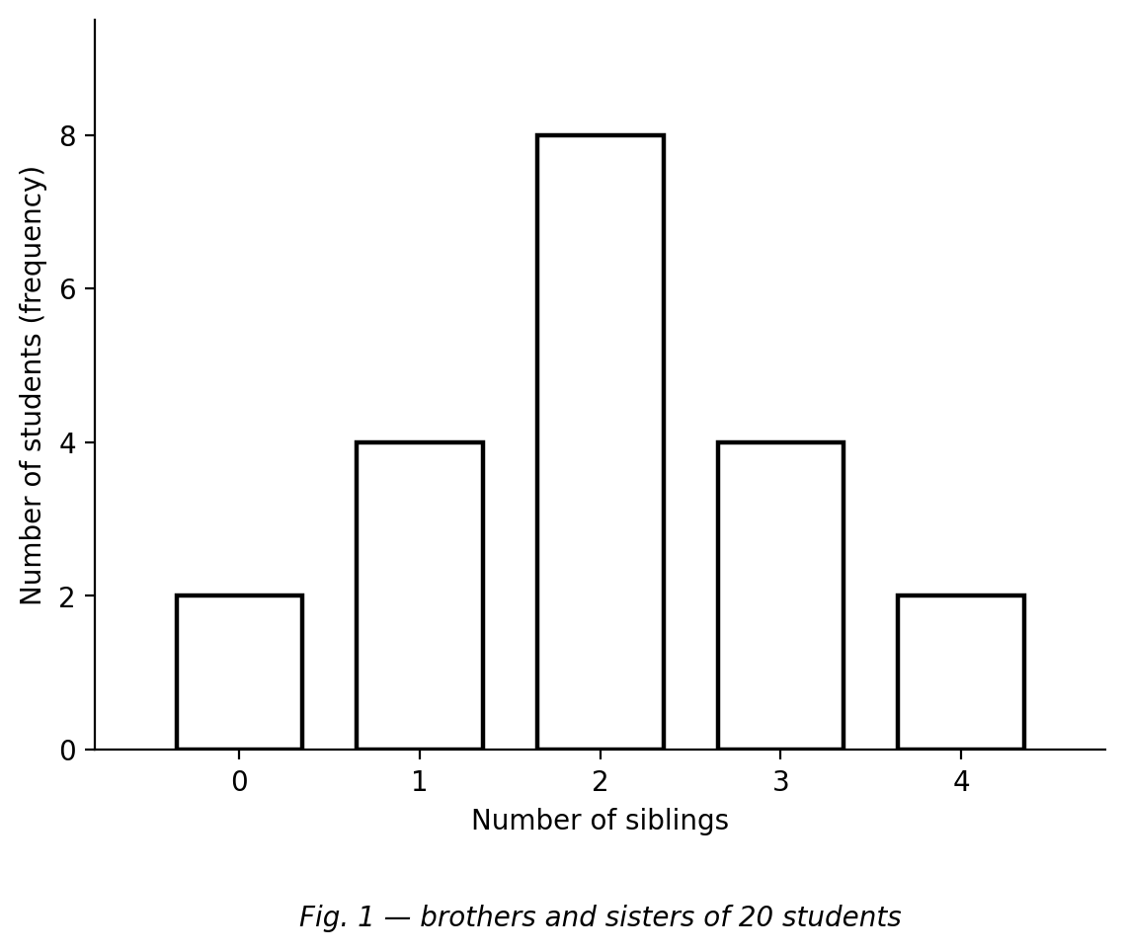
Fig. 1 — bar chart of the number of brothers and sisters of 20 students.

SECTION B: MARKING SCHEME

1. Bias in data collection [10 marks]
(a) Explain why the question 'Overall, don't you think the teaching of mathematics is very good?' is biased. It is a leading question — the wording pushes respondents to answer 'yes' and hides their true opinion. [2 marks]
(b) Rewrite the question without bias, including a suitable response scale. 'Overall, how will you rate the teaching of mathematics?' with scale: very poor, poor, fair, good, very good. [3 marks]
(c) Ama surveyed only the football team about sport-related injuries. Why is this biased? Football is a contact sport, so footballers will report more injuries than players of other sports — the sample is not representative (selection bias). [3 marks]
(d) What should Ama do to remove the bias? Ask more people who play a variety of sports, both contact and non-contact (athletics, tennis, volleyball, etc.). [2 marks]
[Total: 10 marks]

2. Descriptive statistics of ungrouped data [10 marks]
(a) The ages of 10 club members are 12, 14, 13, 15, 14, 12, 16, 14, 13, 15. Calculate the mean age. Sum = 138; mean = 138/10 = 13.8 years. [3 marks]
(b) Find the median age. Sorted: 12, 12, 13, 13, 14, 14, 14, 15, 15, 16; median = (14 + 14)/2 = 14 years. [3 marks]
(c) Write down the mode. 14 (occurs 3 times). [2 marks]
(d) Calculate the range. 16 − 12 = 4 years. [2 marks]
[Total: 10 marks]

3. Descriptive statistics of grouped data [10 marks]
Bulb lifespans (hours) were grouped as 164–167, 168–171, 172–175 and 176–179.
(a) State the minimum lifespan to the nearest hour. 164 hours. [2 marks]
(b) State the maximum lifespan to the nearest hour. 179 hours. [2 marks]
(c) Calculate the range of the lifespans. 179 − 164 = 15 hours. [2 marks]
(d) If the frequencies were 4, 7, 11, 8, write down the modal class. 172–175. [2 marks]
(e) Which lifespan would you consider when ordering bulbs for your shop? Justify. The mode/modal class (172–175) — it is the lifespan customers most often get, so it best guides stocking. [2 marks]
[Total: 10 marks]

4. Working with the mean [10 marks]
(a) The mean of four numbers is 6. Find their sum. Sum = mean × n = 6 × 4 = 24. [2 marks]
(b) Three of the numbers are 5, 7 and 4. Find the fourth. 24 − (5 + 7 + 4) = 24 − 16 = 8. [3 marks]
(c) The mean age of 10 people is 15 years. A 26-year-old joins them. Find the new mean. (150 + 26)/11 = 176/11 = 16 years. [3 marks]
(d) Explain why the mean increased. The added value (26) is greater than the old mean (15), so it pulls the mean up. [2 marks]
[Total: 10 marks]

5. Effect of extreme data [10 marks]
(a) For the data 2, 3, 3, 5, 7, calculate the mean, the median and the mode. Mean = 20/5 = 4; median = 3; mode = 3. [3 marks]
(b) The 7 is replaced by 300. Calculate the new mean. (2 + 3 + 3 + 5 + 300)/5 = 313/5 = 62.6. [2 marks]
(c) Find the new median and the new mode. What do you notice? Median = 3; mode = 3 — both are unchanged by the extreme value. [3 marks]
(d) Which measure was affected most, and why? The mean — it uses every value, so the extreme 300 pulls it from 4 to 62.6. [2 marks]
[Total: 10 marks]

6. Interpreting with extreme values [10 marks]
(a) Five workers earn GH₵ 900, 950, 1 000, 1 050 and the manager earns GH₵ 10 000. Calculate the mean salary. (900 + 950 + 1 000 + 1 050 + 10 000)/5 = 13 900/5 = GH₵ 2 780. [2 marks]
(b) Find the median salary. GH₵ 1 000 (the middle value). [2 marks]
(c) Which measure better represents the typical salary? Justify. The median — four of the five salaries lie near 1 000, while the manager's extreme salary inflates the mean to 2 780, which nobody actually earns near. [3 marks]
(d) Describe the effect of the manager's salary on the mean. It pulls the mean far above the workers' salaries, making the mean misleading for a 'typical' pay. [3 marks]
[Total: 10 marks]

CURRICULUM BLUEPRINT
Qn | Content Focus | Indicator | Marks
1 | Leading questions (curriculum exemplar) | B9.4.1.2.1 | 1
2 | Rewriting biased questions (curriculum exemplar) | B9.4.1.2.1 | 1
3 | Biased samples (curriculum exemplar) | B9.4.1.2.1 | 1
4 | Correcting a biased sample (curriculum exemplar) | B9.4.1.2.1 | 1
5 | Sources of bias | B9.4.1.2.1 | 1
6 | Cultural sensitivity | B9.4.1.2.1 | 1
7 | Timing bias | B9.4.1.2.1 | 1
8 | Privacy | B9.4.1.2.1 | 1
9 | Mean of ungrouped data | B9.4.1.2.2 | 1
10 | Mean of ungrouped data | B9.4.1.2.2 | 1
11 | Median after sorting | B9.4.1.2.2 | 1
12 | Mode | B9.4.1.2.2 | 1
13 | Range | B9.4.1.2.2 | 1
14 | Minimum and maximum (curriculum exemplar) | B9.4.1.2.2 | 1
15 | Range of the data (curriculum exemplar) | B9.4.1.2.2 | 1
16 | Mean from a frequency table | B9.4.1.2.2 | 1
17 | Sum from the mean | B9.4.1.2.2 | 1
18 | Missing value from the mean | B9.4.1.2.2 | 1
19 | Median of an even number of values | B9.4.1.2.2 | 1
20 | Mode from a chart (Fig. 1) | B9.4.1.2.2 | 1
21 | Choosing a measure | B9.4.1.2.2 | 1
22 | Properties of the mean | B9.4.1.2.2 | 1
23 | Mean of a sequence | B9.4.1.2.2 | 1
24 | Updating the mean | B9.4.1.2.2 | 1
25 | Interpreting the mode (curriculum exemplar) | B9.4.1.2.2 | 1
26 | Interpreting the median | B9.4.1.2.2 | 1
27 | Total frequency (Fig. 1) | B9.4.1.2.2 | 1
28 | Mean from a chart (Fig. 1) | B9.4.1.2.2 | 1
29 | Effect of an extreme value on the mean (curriculum exemplar) | B9.4.1.2.3 | 1
30 | Mean is sensitive | B9.4.1.2.3 | 1
31 | Median is robust | B9.4.1.2.3 | 1
32 | Median unchanged by an extreme | B9.4.1.2.3 | 1
33 | Mode unchanged by a single extreme | B9.4.1.2.3 | 1
34 | Comparing sensitivity | B9.4.1.2.3 | 1
35 | New mean after adding a value | B9.4.1.2.3 | 1
36 | Direction of the effect (curriculum exemplar) | B9.4.1.2.3 | 1
37 | Which measure survives | B9.4.1.2.3 | 1
38 | Outliers | B9.4.1.2.3 | 1
39 | Extreme salaries (curriculum-style interpretation) | B9.4.1.2.3 | 1
40 | Mean and median after an extreme | B9.4.1.2.3 | 1
B1 | Bias in data collection | B9.4.1.2.1 | 10
B2 | Descriptive statistics (ungrouped) | B9.4.1.2.2 | 10
B3 | Descriptive statistics (grouped) | B9.4.1.2.2 | 10
B4 | Working with the mean | B9.4.1.2.2 | 10
B5 | Effect of extreme data | B9.4.1.2.3 | 10
B6 | Interpreting with extreme values | B9.4.1.2.3 | 10
 | TOTAL |  | 100

CURRICULUM COVERAGE BY INDICATOR
Curriculum Area | Section A | Section B | Total | %
B9.4.1.2.1 Bias-aware data collection | 8 | 10 (B1) | 18 | 18%
B9.4.1.2.2 Descriptive statistics & interpretation | 20 | 30 (B2, B3, B4) | 50 | 50%
B9.4.1.2.3 Effect of extreme data on mean, median & mode | 12 | 20 (B5, B6) | 32 | 32%
Note: Section A q1–8 test bias in collection (.1, 8 marks); q9–28 descriptive statistics and interpretation (.2, 20); q29–40 the effect of extreme data (.3, 12). Section B: B1 bias scenarios from the CCP exemplars (10); B2–B4 descriptive statistics ungrouped/grouped and mean reversals (30); B5–B6 extreme-data effects and interpretation (20).

COGNITIVE-LEVEL DISTRIBUTION
Cognitive Level | Section A | Section B | Total | %
Remember | 1 | 0 | 1 | 1%
Understand | 14 | 10 | 24 | 24%
Apply | 18 | 32 | 50 | 50%
Analyse | 7 | 15 | 22 | 22%
Evaluate | 0 | 0 | 0 | 0%
Create | 0 | 3 | 3 | 3%

DIFFICULTY DISTRIBUTION
Difficulty | Section A | Section B | Total | %
Easy | 12 | 20 (B2, B3) | 32 | 32%
Moderate | 26 | 30 (B1, B4, B5) | 56 | 56%
Challenging | 2 | 10 (B6) | 12 | 12%

QUALITY-CONTROL SUMMARY
Check | Status
Curriculum alignment | Standard B9.4.1.2 with all three indicators: bias-aware collection (.1), descriptive statistics and interpretation (.2), effect of extreme data on mean/median/mode (.3).
Section structure | Section A: 40 objectives (40 marks). Section B: 6 structured questions (60 marks). Total 100 marks, 2 hours.
Answer key balance | A=10, B=10, C=10, D=10. Zero consecutive repeats. No sustained cycling pattern.
Diagrams (BECE style) | A bar chart of siblings data used for mode, total and mean items, as BECE data-interpretation items do.
Curriculum exemplars used | The biased maths-teaching question and its neutral rewrite; Ama's football-team injury survey; bulb minimum/maximum/range/mean/median/mode and stocking decision; replacing a bulb with 300 hours — all adapted from the CCP exemplars with original values.
Distractor quality | Classic confusions: mean vs median vs mode sensitivity, sum vs mean, swapped mean/median pairs, mode taken as the tallest frequency itself, range vs maximum.
Marking guide completeness | Every Section B part carries explicit marks (each question sums to 10); all workings and justifications shown; the figure reprinted for the marker.
Blueprint | 46-row blueprint (40 objectives + 6 structured) sums to exactly 100 marks.
Coverage | .1 = 18%, .2 = 50%, .3 = 32%.
Cognitive spread | Remember 1%, Understand 24%, Apply 50%, Analyse 22%, Create 3%.
Difficulty spread | Easy 32%, Moderate 56%, Challenging 12%.

