BEACON EDUCATIONAL CONSULT
MOCK EXAMINATION — 2026/2027 ACADEMIC YEAR
MATHEMATICS — BASIC 9 (JHS 3)
Chapter 17: Data Handling II — Bias, Descriptive Statistics & Extreme Data (Curriculum Standard B9.4.1.2)
Time Allowed: 2 Hours Total Marks: 100

INSTRUCTIONS TO CANDIDATES
1. Write your name and index number on the answer sheet provided.
2. This paper consists of TWO sections: Section A (Objectives) and Section B (Structured Questions).
3. Section A: Answer ALL forty (40) questions. Each question carries 1 mark. Choose the correct option from A to D.
4. Section B: Answer ALL six (6) questions. Each question carries 10 marks. Show all necessary workings.
5. The diagram in this paper is part of the questions; study it carefully.
6. Use a non-programmable calculator where necessary.

SECTION A: OBJECTIVE TEST (40 MARKS)
Answer ALL questions in this section. Choose the correct answer from A to D.
1. A survey question 'Overall, don't you think the teaching of mathematics is very good?' is biased because it
A. is too short
B. uses difficult words
C. leads respondents towards answering 'yes'
D. has too many options
2. A better, neutral version of the question is 'Overall, how will you rate the teaching of mathematics?' with the scale
A. agree – disagree only
B. very poor – poor – fair – good – very good
C. true – false
D. yes – no
3. Ama surveyed only the school's football team about sport-related injuries. The main problem is that
A. the sample is only footballers (selection bias)
B. injuries never happen
C. football is not a sport
D. the team is too small to exist
4. To remove the bias, Ama should ask
A. more footballers only
B. only the coaches
C. people in a variety of sports, contact and non-contact
D. only spectators
5. According to the curriculum, which group of factors may introduce bias into data collection?
A. mean, median and mode
B. language, ethics, cost, time and timing, privacy, cultural sensitivity
C. bar charts and pie charts
D. rulers, compasses and protractors
6. Asking 'If you eat pork, name your favourite method of cooking it' in a community where pork is forbidden may offend respondents. The influencing factor is
A. privacy
B. cost
C. cultural sensitivity
D. timing
7. A survey on market sales conducted only between 7 am and 9 am is likely to be biased because of
A. timing — morning traders are not representative of the whole day
B. the cost of printing
C. the language used
D. the privacy of traders
8. Asking respondents to state their exact personal income in a public place raises the issue of
A. timing
B. sample size
C. cost
D. privacy
9. The mean of 4, 6, 8, 10, 12 is
A. 40
B. 8
C. 6
D. 10
10. The mean of 5, 7, 9 is
A. 6
B. 8
C. 21
D. 7
11. The median of 3, 8, 5, 2, 9 is
A. 8
B. 27
C. 5
D. 3
12. The mode of 2, 3, 3, 4, 5, 3, 2 is
A. 5
B. 3
C. 2
D. 4
13. The range of 14, 3, 9, 20, 7 is
A. 11
B. 20
C. 53
D. 17
14. Bulb lifespans were recorded to the nearest hour from 164 to 179. The minimum and maximum lifespans are
A. 164 hours and 179 hours
B. 164 hours and 176 hours
C. 168 hours and 179 hours
D. 167 hours and 176 hours
15. The range of the bulb lifespans 164–179 hours is
A. 343 hours
B. 14 hours
C. 15 hours
D. 16 hours
16. Values 2, 3, 4 occur with frequencies 3, 5, 2. The mean is
A. 3.0
B. 2.5
C. 9.0
D. 2.9
17. The sum of n values equals
A. mean ÷ n
B. mean × n
C. n ÷ mean
D. mean + n
18. The mean of four numbers is 6. If three of them are 5, 7 and 4, the fourth is
A. 24
B. 6
C. 10
D. 8
19. The median of 4, 6, 8, 10 is
A. 7
B. 6
C. 8
D. 28
Questions 20, 27 and 28 refer to Fig. 1.
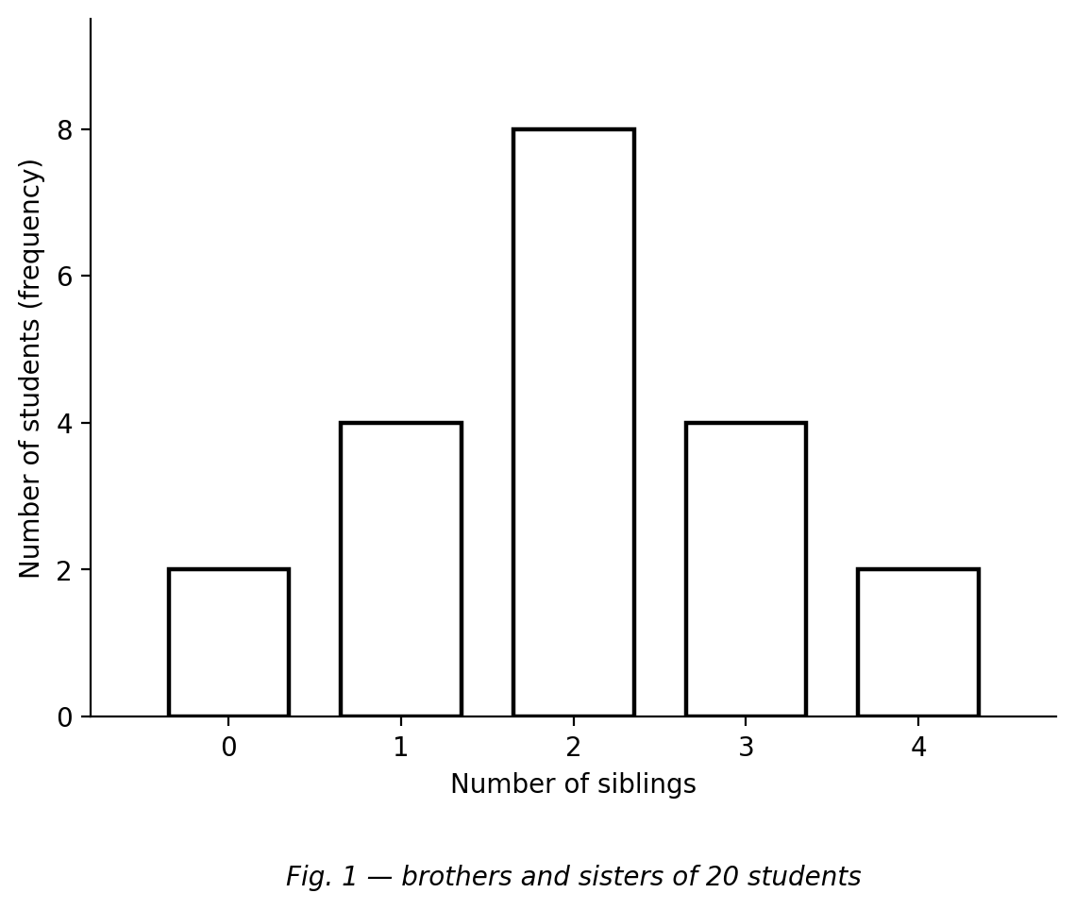
Fig. 1 — bar chart of the number of brothers and sisters of 20 students.
20. The mode of the data is
A. 3 siblings
B. 20 siblings
C. 2 siblings
D. 8 siblings
21. When a data set contains extreme values, the most reliable measure of central tendency is usually the
A. median
B. sum
C. mean
D. range
22. The measure of central tendency that uses every value in the data set is the
A. median
B. mode
C. range
D. mean
23. The mean of the first five natural numbers 1, 2, 3, 4, 5 is
A. 3
B. 3.5
C. 15
D. 2.5
24. The mean age of 10 people is 15 years. A 26-year-old joins them. The new mean is
A. 41 years
B. 16 years
C. 15 years
D. 17 years
25. A shopkeeper ordering bulbs to sell would mostly rely on which statistic, to stock the lifespan customers most often get?
A. the maximum
B. the minimum
C. the mode
D. the range
26. The median lifespan of the bulbs tells the shopkeeper that
A. half of the bulbs lasted at least that long
B. most bulbs failed before that time
C. the lifespans are all equal
D. all bulbs lasted that long
27. The number of students represented is
A. 40
B. 20
C. 8
D. 24
28. The mean number of siblings is
A. 2
B. 1
C. 3
D. 4
29. The mean of 2, 3, 3, 5, 7 is 4. If the 7 is replaced by 300, the new mean is
A. 20.0
B. 62.6
C. 313
D. 4.0
30. The measure of central tendency most affected by an extreme value is the
A. frequency
B. median
C. mode
D. mean
31. The measure LEAST affected by adding one extreme value to 2, 3, 3, 5, 7 is the
A. mean
B. sum
C. median (and the mode)
D. range
32. The median of 3, 4, 5, 6, 7 is 5. If 7 is replaced by 100, the new median is
A. 25
B. 6
C. 100
D. 5
33. Adding one extreme value that occurs only once to a data set leaves which measure unchanged?
A. the range
B. the mean
C. the mode
D. the sum
34. Data 10, 12, 12, 14, 16: replacing 16 with 160 changes which measure the most?
A. the mean
B. the mode
C. the median
D. none of them
35. The mean of five values is 8. A sixth value of 20 is added. The new mean is
A. 8
B. 28
C. 10
D. 14
36. Bulbs with mean lifespan 170 hours: one bulb is replaced by a 300-hour bulb. The mean will
A. become 300
B. decrease
C. stay exactly 170
D. increase
37. A data set has mean 9, median 9 and mode 9. One extreme value 100 is added. Which measure stays 9?
A. the mean
B. the mode
C. the sum
D. all of them
38. A value that is far away from the rest of the data is called
A. an outlier (extreme value)
B. a class interval
C. a frequency
D. a mode
39. Five workers earn GH₵ 900–1 050 but the manager earns GH₵ 10 000. The typical salary is best described by the
A. sum
B. mean
C. maximum
D. median
40. Data 5, 6, 7, 8, 9 has mean 7. Adding 70 gives
A. mean 7.5 and median 17.5
B. mean 17.5 and median 7.5
C. mean 12 and median 7
D. mean 7 and median 70

SECTION B: STRUCTURED QUESTIONS (60 MARKS)
Answer ALL questions in this section. Show all workings clearly.

1. Bias in data collection
(a) Explain why the question 'Overall, don't you think the teaching of mathematics is very good?' is biased. [2 marks]
(b) Rewrite the question without bias, including a suitable response scale. [3 marks]
(c) Ama surveyed only the football team about sport-related injuries. Why is this biased? [3 marks]
(d) What should Ama do to remove the bias? [2 marks]
[Total: 10 marks]

2. Descriptive statistics of ungrouped data
(a) The ages of 10 club members are 12, 14, 13, 15, 14, 12, 16, 14, 13, 15. Calculate the mean age. [3 marks]
(b) Find the median age. [3 marks]
(c) Write down the mode. [2 marks]
(d) Calculate the range. [2 marks]
[Total: 10 marks]

3. Descriptive statistics of grouped data
Bulb lifespans (hours) were grouped as 164–167, 168–171, 172–175 and 176–179.
(a) State the minimum lifespan to the nearest hour. [2 marks]
(b) State the maximum lifespan to the nearest hour. [2 marks]
(c) Calculate the range of the lifespans. [2 marks]
(d) If the frequencies were 4, 7, 11, 8, write down the modal class. [2 marks]
(e) Which lifespan would you consider when ordering bulbs for your shop? Justify. [2 marks]
[Total: 10 marks]

4. Working with the mean
(a) The mean of four numbers is 6. Find their sum. [2 marks]
(b) Three of the numbers are 5, 7 and 4. Find the fourth. [3 marks]
(c) The mean age of 10 people is 15 years. A 26-year-old joins them. Find the new mean. [3 marks]
(d) Explain why the mean increased. [2 marks]
[Total: 10 marks]

5. Effect of extreme data
(a) For the data 2, 3, 3, 5, 7, calculate the mean, the median and the mode. [3 marks]
(b) The 7 is replaced by 300. Calculate the new mean. [2 marks]
(c) Find the new median and the new mode. What do you notice? [3 marks]
(d) Which measure was affected most, and why? [2 marks]
[Total: 10 marks]

6. Interpreting with extreme values
(a) Five workers earn GH₵ 900, 950, 1 000, 1 050 and the manager earns GH₵ 10 000. Calculate the mean salary. [2 marks]
(b) Find the median salary. [2 marks]
(c) Which measure better represents the typical salary? Justify. [3 marks]
(d) Describe the effect of the manager's salary on the mean. [3 marks]
[Total: 10 marks]

