BEACON EDUCATIONAL CONSULT
MARKING GUIDE — MOCK EXAMINATION 2026/2027
MATHEMATICS — BASIC 9 (JHS 3) — Chapter 18: Probability (B9.4.2.1)

Curriculum Standard (NaCCA CCP, Sept 2020): B9.4.2.1 — Identify the sample space for a probability experiment involving two dependent events and express the probabilities of given events as fractions, decimals, percentages and/or ratios to solve problems.
Indicators tested: B9.4.2.1.1 Perform a probability experiment involving two dependent events (e.g. drawing coloured bottle tops from a bag without replacement); B9.4.2.1.2 Express the probabilities of the events as fractions, decimals, percentages and/or ratios using a tree diagram, table or another graphic organiser. Sample-space basics and the probability scale are tagged at standard level.

SECTION A: ANSWER KEY
Qn | Ans | Content Focus | Indicator
1 | A | Sample space of a coin | B9.4.2.1
2 | C | Sample space of a die | B9.4.2.1
3 | B | Two-coin sample space | B9.4.2.1
4 | A | Probability scale | B9.4.2.1
5 | B | Certain and impossible | B9.4.2.1
6 | A | Complementary probability | B9.4.2.1
7 | B | Probability formula | B9.4.2.1
8 | C | Fraction–decimal–percentage | B9.4.2.1
9 | A | Without replacement → dependent (curriculum exemplar) | B9.4.2.1.1
10 | D | First-draw probability (curriculum exemplar) | B9.4.2.1.1
11 | A | Second-draw probability after a red | B9.4.2.1.1
12 | D | Dependence of the trials (curriculum exemplar) | B9.4.2.1.1
13 | B | Sample space of two dependent draws | B9.4.2.1.1
14 | D | With replacement → independent | B9.4.2.1.1
15 | B | Two blues without replacement | B9.4.2.1.1
16 | C | Yellow then blue | B9.4.2.1.1
17 | A | First ace from a deck (curriculum exemplar) | B9.4.2.1.1
18 | D | Two aces without replacement (curriculum exemplar) | B9.4.2.1.1
19 | C | Ace then Jack (curriculum exemplar) | B9.4.2.1.1
20 | D | Second ace probability | B9.4.2.1.1
21 | C | Why the denominator changes | B9.4.2.1.1
22 | B | Red then red | B9.4.2.1.1
23 | C | Same-colour probability | B9.4.2.1.1
24 | B | Multiplication rule for dependent events | B9.4.2.1.1
25 | C | Fraction to percentage | B9.4.2.1.2
26 | A | Decimal to fraction | B9.4.2.1.2
27 | D | Fraction to decimal | B9.4.2.1.2
28 | B | Percentage to fraction | B9.4.2.1.2
29 | C | Probability as a ratio | B9.4.2.1.2
30 | D | Tree-diagram path (Fig. 1) | B9.4.2.1.2
31 | A | Branch probabilities sum to 1 (Fig. 1) | B9.4.2.1.2
32 | D | Small probability as percentage | B9.4.2.1.2
33 | B | Fraction to percentage | B9.4.2.1.2
34 | A | Probability as a ratio | B9.4.2.1.2
35 | D | Two greens without replacement | B9.4.2.1.2
36 | C | At least one red via the complement | B9.4.2.1.2
37 | D | Fraction to percentage | B9.4.2.1.2
38 | B | Fraction to decimal | B9.4.2.1.2
39 | A | Small probability as percentage | B9.4.2.1.2
40 | C | Decimal to ratio | B9.4.2.1.2

Full answer key: ACBAB ABCAD ADBDB CADCD CBCBC ADBCD ADBAD CDBAC

SECTION A: WORKED SOLUTIONS
1. A coin lands Heads or Tails.
2. A die shows 1, 2, 3, 4, 5 or 6.
3. {HH, HT, TH, TT} = 4 outcomes.
4. All probabilities lie on the 0-to-1 scale.
5. Certain = 1; impossible = 0.
6. An event and its complement cover all outcomes: total 1.
7. P = favourable ÷ total.
8. 1 ÷ 4 = 0.25 = 25%.
9. Without replacement the bag's contents change, so the events are dependent.
10. 3 red out of 6 tops: 3/6 = ½.
11. One red gone leaves 2 red in 5 tops: 2/5.
12. Yes — removing the first top changes the remaining totals and hence the probabilities.
13. RR, RG, RP, GR, GG, GP, PR, PG = 8; PP cannot happen with one pink top.
14. With replacement nothing changes, so trials are independent.
15. 2/5 × 1/4 = 2/20 = 1/10.
16. 3/5 × 2/4 = 6/20 = 3/10.
17. 4 aces in 52 cards: 4/52 = 1/13.
18. 4/52 × 3/51 = 12/2652 = 1/221.
19. 4/52 × 4/51 = 16/2652 = 4/663.
20. 3 aces left in 51 cards: 3/51 = 1/17.
21. One item is gone, so the denominator (total left) decreases.
22. 4/8 × 3/7 = 12/56 = 3/14.
23. P(RR) + P(BB) = 3/14 + 3/14 = 3/7.
24. For dependent events multiply by the conditional probability.
25. 3 ÷ 4 = 0.75 = 75%.
26. 0.2 = 2/10 = 1/5.
27. 1 ÷ 8 = 0.125.
28. 40/100 = 2/5.
29. 3 favourable out of 5 leaves 2 unfavourable: 3 : 2.
30. 3/6 × 2/5 = 6/30 = 1/5.
31. 3/6 + 2/6 + 1/6 = 6/6 = 1.
32. 1 ÷ 221 ≈ 0.0045 = 0.45%.
33. 100 ÷ 13 ≈ 7.7%.
34. 2 favourable out of 5 leaves 3 unfavourable: 2 : 3.
35. 2/6 × 1/5 = 2/30 = 1/15.
36. P(no red) = 3/6 × 2/5 = 1/5, so P(at least one red) = 1 − 1/5 = 4/5.
37. 1 ÷ 10 = 0.1 = 10%.
38. 3 ÷ 10 = 0.3.
39. 4 ÷ 663 ≈ 0.006 = 0.6%.
40. 0.45 = 45 : 100 overall → 45 : 55 = 9 : 11 favourable : unfavourable.

FIGURE (REPRINTED FOR MARKING)
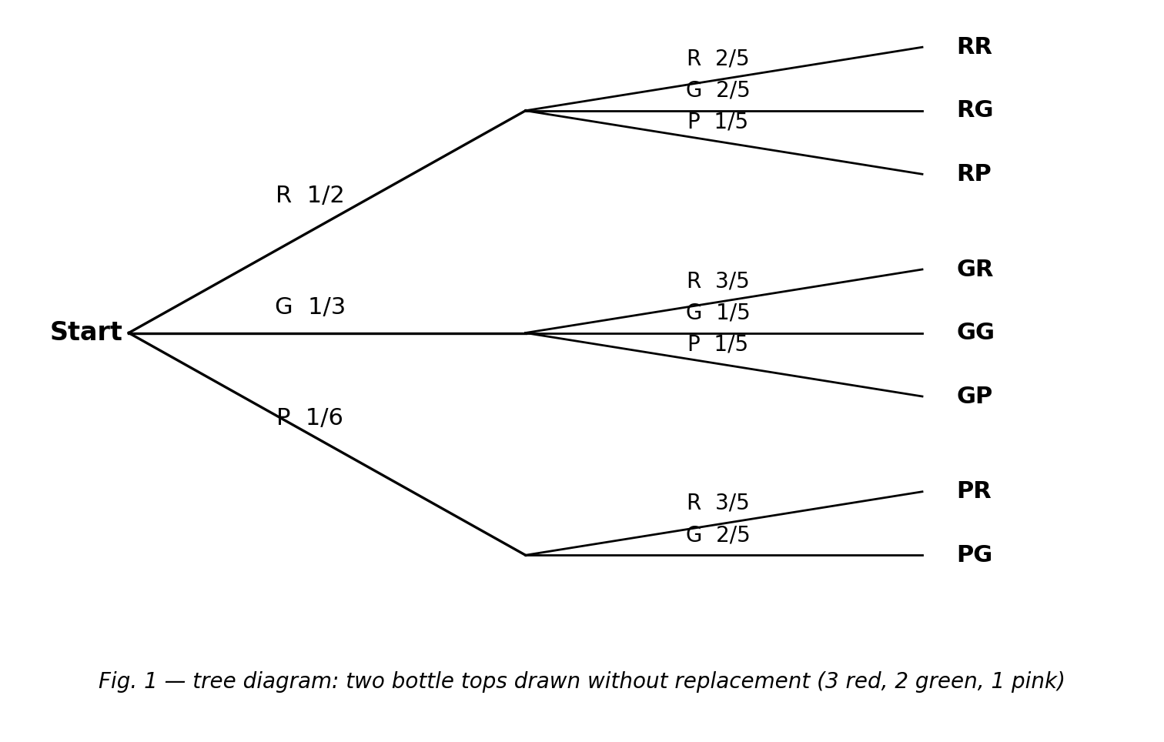
Fig. 1 — tree diagram for two draws without replacement from 3 red, 2 green, 1 pink.

SECTION B: MARKING SCHEME

1. Sample space and dependence [10 marks]
(a) A bag contains 3 red, 2 green and 1 pink bottle tops. Two tops are drawn without replacement. List the possible ordered colour pairs. RR, RG, RP, GR, GG, GP, PR, PG (PP is impossible — only one pink top). [3 marks]
(b) Explain why the two draws are dependent events. The first draw removes a top, changing the numbers left, so the second probability depends on the first outcome. [2 marks]
(c) Find P(first draw is red) and express it as a fraction, a decimal and a percentage. 3/6 = ½ = 0.5 = 50%. [3 marks]
(d) Find P(pink then pink). 1/6 × 0/5 = 0 — impossible, since only one pink top exists. [2 marks]
[Total: 10 marks]

2. Tree diagram [10 marks]
(a) A bag has 2 blue and 3 yellow marbles. Two are drawn without replacement. Draw a probability tree diagram with fractions on the branches. First stage B 2/5, Y 3/5; from B: B 1/4, Y 3/4; from Y: B 2/4, Y 2/4. [4 marks]
(b) Use the tree to find P(blue then blue). 2/5 × 1/4 = 2/20 = 1/10. [2 marks]
(c) Find P(the two marbles are different colours). P(BY) + P(YB) = 2/5×3/4 + 3/5×2/4 = 3/10 + 3/10 = 3/5. [2 marks]
(d) Express P(blue then blue) as a decimal and a percentage. 1/10 = 0.1 = 10%. [2 marks]
[Total: 10 marks]

3. Card experiments (curriculum exemplars) [10 marks]
(a) One card is drawn from a standard 52-card deck. Find P(Ace) as a fraction. 4/52 = 1/13. [2 marks]
(b) Two cards are drawn without replacement. Find P(two Aces). 4/52 × 3/51 = 12/2652 = 1/221. [3 marks]
(c) Find P(Ace then Jack) without replacement. 4/52 × 4/51 = 16/2652 = 4/663. [3 marks]
(d) Express 1/13 as a percentage to 1 decimal place. 100/13 ≈ 7.7%. [2 marks]
[Total: 10 marks]

4. Converting probabilities [10 marks]
(a) Express 3/4 as a decimal and as a percentage. 0.75 and 75%. [2 marks]
(b) Express 0.2 as a fraction and as a ratio of favourable : unfavourable. 1/5; favourable : unfavourable = 1 : 4. [3 marks]
(c) Express 40% as a fraction in lowest terms. 40/100 = 2/5. [2 marks]
(d) A probability of 3/5 gives which favourable : unfavourable ratio? 3 : 2 (3 favourable out of 5, so 2 unfavourable). [3 marks]
[Total: 10 marks]

5. Dependent draws from 4 red and 4 blue [10 marks]
(a) Two sweets are taken without replacement. Find P(red then red). 4/8 × 3/7 = 12/56 = 3/14. [3 marks]
(b) Find P(both sweets the same colour). P(RR) + P(BB) = 3/14 + 3/14 = 6/14 = 3/7. [4 marks]
(c) Hence find P(the sweets are different colours). 1 − 3/7 = 4/7. [3 marks]
[Total: 10 marks]

6. At least one red [10 marks]
(a) From the 3-red, 2-green, 1-pink bag, two tops are drawn without replacement. Find P(no red). 3/6 × 2/5 = 6/30 = 1/5. [3 marks]
(b) Hence find P(at least one red). 1 − 1/5 = 4/5. [3 marks]
(c) Express this probability as a percentage. 4/5 = 80%. [2 marks]
(d) Why is the complement method convenient here? 'At least one red' covers many paths (RG, RP, GR, PR, RR…); 'no red' is a single short path, so 1 − P(no red) is quicker. [2 marks]
[Total: 10 marks]

CURRICULUM BLUEPRINT
Qn | Content Focus | Indicator | Marks
1 | Sample space of a coin | B9.4.2.1 | 1
2 | Sample space of a die | B9.4.2.1 | 1
3 | Two-coin sample space | B9.4.2.1 | 1
4 | Probability scale | B9.4.2.1 | 1
5 | Certain and impossible | B9.4.2.1 | 1
6 | Complementary probability | B9.4.2.1 | 1
7 | Probability formula | B9.4.2.1 | 1
8 | Fraction–decimal–percentage | B9.4.2.1 | 1
9 | Without replacement → dependent (curriculum exemplar) | B9.4.2.1.1 | 1
10 | First-draw probability (curriculum exemplar) | B9.4.2.1.1 | 1
11 | Second-draw probability after a red | B9.4.2.1.1 | 1
12 | Dependence of the trials (curriculum exemplar) | B9.4.2.1.1 | 1
13 | Sample space of two dependent draws | B9.4.2.1.1 | 1
14 | With replacement → independent | B9.4.2.1.1 | 1
15 | Two blues without replacement | B9.4.2.1.1 | 1
16 | Yellow then blue | B9.4.2.1.1 | 1
17 | First ace from a deck (curriculum exemplar) | B9.4.2.1.1 | 1
18 | Two aces without replacement (curriculum exemplar) | B9.4.2.1.1 | 1
19 | Ace then Jack (curriculum exemplar) | B9.4.2.1.1 | 1
20 | Second ace probability | B9.4.2.1.1 | 1
21 | Why the denominator changes | B9.4.2.1.1 | 1
22 | Red then red | B9.4.2.1.1 | 1
23 | Same-colour probability | B9.4.2.1.1 | 1
24 | Multiplication rule for dependent events | B9.4.2.1.1 | 1
25 | Fraction to percentage | B9.4.2.1.2 | 1
26 | Decimal to fraction | B9.4.2.1.2 | 1
27 | Fraction to decimal | B9.4.2.1.2 | 1
28 | Percentage to fraction | B9.4.2.1.2 | 1
29 | Probability as a ratio | B9.4.2.1.2 | 1
30 | Tree-diagram path (Fig. 1) | B9.4.2.1.2 | 1
31 | Branch probabilities sum to 1 (Fig. 1) | B9.4.2.1.2 | 1
32 | Small probability as percentage | B9.4.2.1.2 | 1
33 | Fraction to percentage | B9.4.2.1.2 | 1
34 | Probability as a ratio | B9.4.2.1.2 | 1
35 | Two greens without replacement | B9.4.2.1.2 | 1
36 | At least one red via the complement | B9.4.2.1.2 | 1
37 | Fraction to percentage | B9.4.2.1.2 | 1
38 | Fraction to decimal | B9.4.2.1.2 | 1
39 | Small probability as percentage | B9.4.2.1.2 | 1
40 | Decimal to ratio | B9.4.2.1.2 | 1
B1 | Sample space & dependence | B9.4.2.1.1 | 10
B2 | Probability tree diagram | B9.4.2.1.2 | 10
B3 | Card experiments | B9.4.2.1.2 | 10
B4 | Converting probabilities | B9.4.2.1.2 | 10
B5 | Dependent draws | B9.4.2.1.1 | 10
B6 | At least one (complement) | B9.4.2.1.1 | 10
 | TOTAL |  | 100

CURRICULUM COVERAGE BY INDICATOR
Curriculum Area | Section A | Section B | Total | %
B9.4.2.1 (standard) Sample space, probability scale & formula | 8 | 0 | 8 | 8%
B9.4.2.1.1 Two dependent events (bottle tops, cards) without replacement | 16 | 30 (B1, B5, B6) | 46 | 46%
B9.4.2.1.2 Tree diagrams; fractions, decimals, percentages & ratios | 16 | 30 (B2, B3, B4) | 46 | 46%
Note: Section A q1–8 test sample-space basics and the probability scale (standard, 8 marks); q9–24 two dependent events without replacement, including the CCP's bottle-top and card-deck exemplars (.1, 16); q25–40 tree diagrams and expressing probabilities as fractions/decimals/percentages/ratios (.2, 16). Section B: B1, B5, B6 dependent experiments and the complement (30); B2–B4 tree diagrams and conversions (30).

COGNITIVE-LEVEL DISTRIBUTION
Cognitive Level | Section A | Section B | Total | %
Remember | 1 | 0 | 1 | 1%
Understand | 12 | 6 | 18 | 18%
Apply | 21 | 37 | 58 | 58%
Analyse | 6 | 13 | 19 | 19%
Evaluate | 0 | 0 | 0 | 0%
Create | 0 | 4 | 4 | 4%

DIFFICULTY DISTRIBUTION
Difficulty | Section A | Section B | Total | %
Easy | 16 | 10 (B4) | 26 | 26%
Moderate | 20 | 30 (B1, B2, B6) | 50 | 50%
Challenging | 4 | 20 (B3, B5) | 24 | 24%

QUALITY-CONTROL SUMMARY
Check | Status
Curriculum alignment | Standard B9.4.2.1 with both indicators: two dependent events without replacement (.1) and expressing probabilities as fractions/decimals/percentages/ratios via tree diagrams (.2).
Section structure | Section A: 40 objectives (40 marks). Section B: 6 structured questions (60 marks). Total 100 marks, 2 hours.
Answer key balance | A=10, B=10, C=10, D=10. Zero consecutive repeats. No sustained cycling pattern.
Diagrams (BECE style) | A full probability tree diagram for the CCP's 3-red, 2-green, 1-pink bottle-top experiment with fractions on every branch.
Curriculum exemplars used | Anita's bottle-top bag (sample space, dependence, tree diagram); two Aces without replacement (1/221); Ace then Jack (4/663) — all from the CCP exemplar lists with original values elsewhere.
Distractor quality | Classic errors: with- vs without-replacement denominators (4/25 vs 1/10), 1/13 vs 1/17, percentage shifts of ×10 (0.45% vs 4.5%), ratio favourable:unfavourable vs favourable:total, forgetting PP is impossible.
Marking guide completeness | Every Section B part carries explicit marks (each question sums to 10); full tree diagrams, products and conversions shown; the figure reprinted for the marker.
Blueprint | 46-row blueprint (40 objectives + 6 structured) sums to exactly 100 marks.
Coverage | Standard 8%, .1 = 46%, .2 = 46%.
Cognitive spread | Remember 1%, Understand 18%, Apply 58%, Analyse 19%, Create 4%.
Difficulty spread | Easy 26%, Moderate 50%, Challenging 24%.

