BEACON EDUCATIONAL CONSULT
MOCK EXAMINATION — 2026/2027 ACADEMIC YEAR
MATHEMATICS — BASIC 9 (JHS 3)
Chapter 18: Probability — Two Dependent Events (Curriculum Standard B9.4.2.1)
Time Allowed: 2 Hours Total Marks: 100

INSTRUCTIONS TO CANDIDATES
1. Write your name and index number on the answer sheet provided.
2. This paper consists of TWO sections: Section A (Objectives) and Section B (Structured Questions).
3. Section A: Answer ALL forty (40) questions. Each question carries 1 mark. Choose the correct option from A to D.
4. Section B: Answer ALL six (6) questions. Each question carries 10 marks. Show all necessary workings.
5. Unless stated otherwise, all draws are made WITHOUT replacement.
6. Use a non-programmable calculator where necessary.

SECTION A: OBJECTIVE TEST (40 MARKS)
Answer ALL questions in this section. Choose the correct answer from A to D.
1. The sample space for tossing a coin once is
A. {Heads, Tails}
B. {1, 2}
C. {Heads}
D. {0, 1, 2}
2. The sample space for rolling a fair die has
A. 4 outcomes
B. 36 outcomes
C. 6 equally likely outcomes
D. 2 outcomes
3. The number of outcomes in the sample space when two coins are tossed is
A. 16
B. 4
C. 2
D. 8
4. The probability of any event lies between
A. 0 and 1
B. −1 and 1
C. 0 and 100
D. 1 and 10
5. The probability of a certain event and of an impossible event are respectively
A. 1 and 1
B. 1 and 0
C. 0 and 0
D. 0 and 1
6. For any event E, P(E) + P(not E) =
A. 1
B. ½
C. 0
D. 2
7. The probability of an event is calculated as
A. total ÷ favourable
B. favourable outcomes ÷ total outcomes
C. favourable − total
D. unfavourable ÷ favourable
8. The fraction ¼ expressed as a decimal and as a percentage is
A. 0.75 and 75%
B. 2.5 and 2.5%
C. 0.25 and 25%
D. 0.4 and 40%
9. Drawing two bottle tops from a bag WITHOUT replacement gives
A. dependent events
B. certain events
C. independent events
D. impossible events
10. A bag has 3 red, 2 green and 1 pink bottle top. The probability that the first draw is red is
A. ⅓
B. ⅙
C. ⅔
D. ½
11. If the first draw (without replacement) is red, the probability that the second draw is red is
A. 2/5
B. 3/5
C. 1/6
D. 3/6
12. In the bottle-top experiment, does the first trial affect the second?
A. Only when drawing with replacement
B. No — the bag stays the same
C. Only if a pink top is drawn
D. Yes — the first draw changes what is left in the bag
13. Drawing two tops (without replacement) from 3 red, 2 green, 1 pink, the number of possible ordered colour pairs is
A. 6
B. 8 (PP is impossible)
C. 9
D. 36
14. Drawing WITH replacement gives
A. mutually exclusive events
B. impossible events
C. dependent events
D. independent events
15. A bag has 2 blue and 3 yellow marbles. Two are drawn without replacement. P(blue then blue) =
A. 4/25
B. 1/10
C. 2/10
D. 1/4
16. With the same bag, P(yellow then blue) =
A. 3/20
B. 6/25
C. 3/10
D. 1/10
17. The probability that the first card drawn from a full deck is an Ace is
A. 1/13
B. 4/13
C. 1/52
D. 1/4
18. The probability of drawing two Aces in two trials without replacement is
A. 12/52
B. 1/169
C. 1/17
D. 1/221
19. The probability of drawing an Ace and then a Jack, without replacement, is
A. 16/2652 × 2
B. 1/221
C. 4/663
D. 8/52
20. After one Ace has been removed from a full deck, the probability the next card is an Ace is
A. 3/52
B. 4/51 × 4
C. 1/13
D. 1/17
21. Drawing without replacement changes the probability of the second draw because the
A. outcomes become equally likely
B. number of colours increases
C. total number of items left decreases
D. bag becomes heavier
22. A bag has 4 red and 4 blue sweets. Two are taken without replacement. P(red then red) =
A. 1/4
B. 3/14
C. 12/64
D. 16/56
23. With the same bag, P(both sweets the same colour) =
A. 1/2
B. 4/7
C. 3/7
D. 3/14
24. For two dependent events A then B, P(A and B) =
A. P(A) − P(B)
B. P(A) × P(B given A)
C. P(A) × P(B) always
D. P(A) + P(B)
25. 3/4 expressed as a percentage is
A. 34%
B. 43%
C. 75%
D. 80%
26. 0.2 expressed as a fraction in lowest terms is
A. 1/5
B. 1/2
C. 2/100
D. 2/5
27. 1/8 expressed as a decimal is
A. 1.8
B. 0.8
C. 0.18
D. 0.125
28. 40% expressed as a fraction in lowest terms is
A. 4/5
B. 2/5
C. 40/10
D. 1/40
29. A probability of 3/5 means the ratio of favourable to unfavourable outcomes is
A. 2 : 3
B. 5 : 3
C. 3 : 2
D. 3 : 5
Questions 30 and 31 refer to Fig. 1.
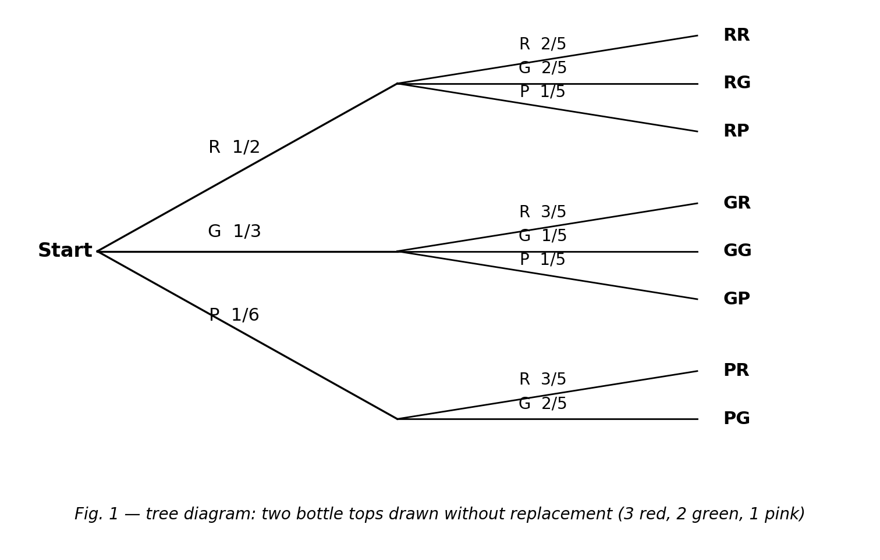
Fig. 1 — tree diagram for two draws without replacement from 3 red, 2 green, 1 pink.
30. The probability of the path R → R is
A. 6/11
B. 3/6
C. 2/5
D. 1/5
31. The sum of the three first-stage branch probabilities (3/6 + 2/6 + 1/6) is
A. 1
B. 0
C. 6
D. ½
32. 1/221 expressed as a percentage to 2 significant figures is about
A. 0.22%
B. 45%
C. 4.5%
D. 0.45%
33. 1/13 expressed as a percentage to 1 decimal place is about
A. 0.77%
B. 7.7%
C. 7.5%
D. 13%
34. A probability of 2/5 gives the ratio favourable : unfavourable =
A. 2 : 3
B. 2 : 5
C. 3 : 2
D. 5 : 2
35. From the 3-red, 2-green, 1-pink bag, two tops drawn without replacement: P(green then green) =
A. 1/9
B. 4/36
C. 2/15
D. 1/15
36. From the same bag, P(at least one red in two draws) =
A. 9/10
B. 1/5
C. 4/5
D. 3/5
37. 1/10 expressed as a percentage is
A. 1%
B. 0.1%
C. 90%
D. 10%
38. 3/10 expressed as a decimal is
A. 0.03
B. 0.3
C. 0.33
D. 3.0
39. 4/663 as a percentage is about
A. 0.6%
B. 60%
C. 6%
D. 0.06%
40. A probability of 0.45 expressed as a ratio favourable : unfavourable is
A. 45 : 100
B. 9 : 20
C. 9 : 11
D. 11 : 9

SECTION B: STRUCTURED QUESTIONS (60 MARKS)
Answer ALL questions in this section. Show all workings clearly.

1. Sample space and dependence
(a) A bag contains 3 red, 2 green and 1 pink bottle tops. Two tops are drawn without replacement. List the possible ordered colour pairs. [3 marks]
(b) Explain why the two draws are dependent events. [2 marks]
(c) Find P(first draw is red) and express it as a fraction, a decimal and a percentage. [3 marks]
(d) Find P(pink then pink). [2 marks]
[Total: 10 marks]

2. Tree diagram
(a) A bag has 2 blue and 3 yellow marbles. Two are drawn without replacement. Draw a probability tree diagram with fractions on the branches. [4 marks]
(b) Use the tree to find P(blue then blue). [2 marks]
(c) Find P(the two marbles are different colours). [2 marks]
(d) Express P(blue then blue) as a decimal and a percentage. [2 marks]
[Total: 10 marks]

3. Card experiments (curriculum exemplars)
(a) One card is drawn from a standard 52-card deck. Find P(Ace) as a fraction. [2 marks]
(b) Two cards are drawn without replacement. Find P(two Aces). [3 marks]
(c) Find P(Ace then Jack) without replacement. [3 marks]
(d) Express 1/13 as a percentage to 1 decimal place. [2 marks]
[Total: 10 marks]

4. Converting probabilities
(a) Express 3/4 as a decimal and as a percentage. [2 marks]
(b) Express 0.2 as a fraction and as a ratio of favourable : unfavourable. [3 marks]
(c) Express 40% as a fraction in lowest terms. [2 marks]
(d) A probability of 3/5 gives which favourable : unfavourable ratio? [3 marks]
[Total: 10 marks]

5. Dependent draws from 4 red and 4 blue
(a) Two sweets are taken without replacement. Find P(red then red). [3 marks]
(b) Find P(both sweets the same colour). [4 marks]
(c) Hence find P(the sweets are different colours). [3 marks]
[Total: 10 marks]

6. At least one red
(a) From the 3-red, 2-green, 1-pink bag, two tops are drawn without replacement. Find P(no red). [3 marks]
(b) Hence find P(at least one red). [3 marks]
(c) Express this probability as a percentage. [2 marks]
(d) Why is the complement method convenient here? [2 marks]
[Total: 10 marks]

