BEACON EDUCATIONAL CONSULT
MARKING GUIDE — MOCK EXAMINATION 2026/2027
MATHEMATICS — BASIC 9 (JHS 3) — Chapter 7: Ratio, Rate and Proportion (B9.1.4.1)

Curriculum Standard (NaCCA CCP, Sept 2020): B9.1.4.1 — Apply the understanding of ratio, rate and proportions to solve problems that involve rates, ratios, and proportional reasoning and use it to solve real-world mathematical problems.
Indicators tested: B9.1.4.1.1 Represent proportional relationships by equations; B9.1.4.1.2 Use proportional relationships to solve multistep ratio and percent problems (simple interest, tax, discount, commission, depreciation, NHIL, insurance); B9.1.4.1.3 Rates and proportional reasoning in SSNIT contributions; B9.1.4.1.4 Recognise and graph proportional relationships, interpreting the unit rate as the slope.

SECTION A: ANSWER KEY
Qn | Ans | Content Focus | Indicator
1 | B | Simplify a ratio | B9.1.4.1.2
2 | A | Share in a given ratio | B9.1.4.1.2
3 | B | Find quantities from a ratio | B9.1.4.1.2
4 | D | Speed as a rate | B9.1.4.1.4
5 | B | Cost through unit rate | B9.1.4.1.4
6 | A | Proportional equation t = pn | B9.1.4.1.1
7 | C | Recognise direct proportion | B9.1.4.1.4
8 | B | Read a proportional graph (curriculum exemplar) | B9.1.4.1.4
9 | D | Use a proportional graph (curriculum exemplar) | B9.1.4.1.4
10 | A | Unit rate as slope (curriculum exemplar) | B9.1.4.1.4
11 | D | Simple interest formula | B9.1.4.1.2
12 | B | Simple interest (curriculum exemplar) | B9.1.4.1.2
13 | A | Amount after interest (curriculum exemplar) | B9.1.4.1.2
14 | D | Amount after extended period (curriculum exemplar) | B9.1.4.1.2
15 | C | Amount after interest | B9.1.4.1.2
16 | B | Find the principal | B9.1.4.1.2
17 | D | VAT calculation | B9.1.4.1.2
18 | B | VAT-inclusive price (curriculum exemplar) | B9.1.4.1.2
19 | D | VAT paid (curriculum exemplar) | B9.1.4.1.2
20 | A | Discount (curriculum exemplar) | B9.1.4.1.2
21 | C | Discount amount (curriculum exemplar) | B9.1.4.1.2
22 | D | Commission (curriculum exemplar) | B9.1.4.1.2
23 | B | Depreciation, first year (curriculum exemplar) | B9.1.4.1.2
24 | C | Depreciation, second year (curriculum exemplar) | B9.1.4.1.2
25 | A | NHIL exclusive price (curriculum exemplar) | B9.1.4.1.2
26 | C | NHIL charged (curriculum exemplar) | B9.1.4.1.2
27 | D | Insurance premium and value (curriculum exemplar) | B9.1.4.1.2
28 | C | SSNIT worker rate, Act 766 (curriculum exemplar) | B9.1.4.1.3
29 | D | SSNIT employer rate, Act 766 (curriculum exemplar) | B9.1.4.1.3
30 | A | SSNIT total rate, Act 766 (curriculum exemplar) | B9.1.4.1.3
31 | C | Worker contribution, Act 766 (curriculum exemplar) | B9.1.4.1.3
32 | B | Employer contribution, Act 766 (curriculum exemplar) | B9.1.4.1.3
33 | C | Total SSNIT, Act 766 (curriculum exemplar) | B9.1.4.1.3
34 | B | SSNIT worker rate, PNDCL 247 (curriculum exemplar) | B9.1.4.1.3
35 | C | Employer contribution, PNDCL 247 (curriculum exemplar) | B9.1.4.1.3
36 | A | Basic salary from contribution (curriculum exemplar) | B9.1.4.1.3
37 | D | Ratio from an equation | B9.1.4.1.2
38 | A | Map scale as a rate | B9.1.4.1.4
39 | C | Inverse proportion | B9.1.4.1.4
40 | A | Constant of proportionality | B9.1.4.1.1

Full answer key: BABDB ACBDA DBADC BDBDA CDBCA CDCDA CBCBC ADACA

SECTION A: WORKED SOLUTIONS
1. Answer: B. HCF of 12 and 18 is 6: 12 : 18 = 2 : 3. [B9.1.4.1.2]
2. Answer: A. Total parts = 2 + 3 = 5; Ama gets 2/5 × 120 = GH₵48. [B9.1.4.1.2]
3. Answer: B. Total parts = 3 + 5 = 8; boys = 3/8 × 40 = 15. [B9.1.4.1.2]
4. Answer: D. Speed = 180 km ÷ 3 h = 60 km/h. [B9.1.4.1.4]
5. Answer: B. Unit price = 12 ÷ 4 = GH₵3 per pen; 7 pens = 7 × 3 = GH₵21. [B9.1.4.1.4]
6. Answer: A. t = pn = 4.50 × 6 = GH₵27.00. [B9.1.4.1.1]
7. Answer: C. A straight line through the origin means one quantity is a constant multiple of the other — direct proportion. [B9.1.4.1.4]
8. Answer: B. 8 × GH₵1.50 = GH₵12.00 (read from Fig. 1; 8 → 12 on the graph). [B9.1.4.1.4]
9. Answer: D. 15 × GH₵1.50 = GH₵22.50 (the graph extended). [B9.1.4.1.4]
10. Answer: A. Slope = 3/2 = GH₵1.50 per avocado (curriculum exemplar). [B9.1.4.1.4]
11. Answer: D. In I = PRT/100, R is the rate of interest per annum. [B9.1.4.1.2]
12. Answer: B. I = (4,500 × 3 × 3)/100 = GH₵405. [B9.1.4.1.2]
13. Answer: A. Amount = 4,500 + 405 = GH₵4,905. [B9.1.4.1.2]
14. Answer: D. Interest for 5 years = (4,500 × 3 × 5)/100 = 675; amount = 4,500 + 675 = GH₵5,175. [B9.1.4.1.2]
15. Answer: C. I = (2,000 × 5 × 2)/100 = 200; amount = 2,000 + 200 = GH₵2,200. [B9.1.4.1.2]
16. Answer: B. P = (I × 100)/(R × T) = (300 × 100)/(5 × 4) = GH₵1,500. [B9.1.4.1.2]
17. Answer: D. VAT = 12.5% of 400 = 400 × 0.125 = GH₵50. [B9.1.4.1.2]
18. Answer: B. VAT inclusive = 112.5% of the basic cost; basic cost = 4,500 ÷ 1.125 = GH₵4,000. [B9.1.4.1.2]
19. Answer: D. VAT = 4,500 − 4,000 = GH₵500 (equivalently 12.5% of 4,000). [B9.1.4.1.2]
20. Answer: A. New value = 80,500 × (100 − 10)% = 80,500 × 0.90 = GH₵72,450. [B9.1.4.1.2]
21. Answer: C. Discount = 10% of 80,500 = GH₵8,050. [B9.1.4.1.2]
22. Answer: D. Commission = 3.5% of 68,000 = 68,000 × 0.035 = GH₵2,380. [B9.1.4.1.2]
23. Answer: B. Depreciation = 5% of 1,800 = 90; value = 1,800 − 90 = GH₵1,710. [B9.1.4.1.2]
24. Answer: C. Depreciation = 10% of 1,800 = 180; value = 1,800 − 180 = GH₵1,620 (depreciation is on the original value). [B9.1.4.1.2]
25. Answer: A. NHIL exclusive = 1,200 ÷ 1.025 = GH₵1,170.73. [B9.1.4.1.2]
26. Answer: C. NHIL = 1,200 − 1,170.73 = GH₵29.27. [B9.1.4.1.2]
27. Answer: D. Premium = 5% of value, so value = 30,000 ÷ 0.05 = GH₵600,000. [B9.1.4.1.2]
28. Answer: C. Act 766: worker contributes 5.5% of basic salary. [B9.1.4.1.3]
29. Answer: D. Act 766: employer contributes 13% of basic salary. [B9.1.4.1.3]
30. Answer: A. Total = 13% + 5.5% = 18.5% of basic salary. [B9.1.4.1.3]
31. Answer: C. 5.5% of 3,256.50 = GH₵179.11 (179.1075). [B9.1.4.1.3]
32. Answer: B. 13% of 3,256.50 = GH₵423.35 (423.345). [B9.1.4.1.3]
33. Answer: C. 18.5% of 3,256.50 = GH₵602.45 (602.4525; using the combined rate). [B9.1.4.1.3]
34. Answer: B. PNDCL 247: worker contributes 5% of basic salary. [B9.1.4.1.3]
35. Answer: C. Employer rate 12.5% is 2.5 times the worker's 5%: 440.54 × 2.5 = GH₵1,101.35. [B9.1.4.1.3]
36. Answer: A. Worker's 5% = 440.54, so basic = 440.54 ÷ 0.05 = GH₵8,810.80. [B9.1.4.1.3]
37. Answer: D. 3a = 4b ⇒ a/b = 4/3, so a : b = 4 : 3. [B9.1.4.1.2]
38. Answer: A. 4 cm × 50,000 = 200,000 cm = 2,000 m = 2 km. [B9.1.4.1.4]
39. Answer: C. Worker-days are constant: 5 × 12 = 60; 60 ÷ 10 = 6 days (inverse proportion). [B9.1.4.1.4]
40. Answer: A. k = y/x = 12/3 = 4. [B9.1.4.1.1]

SECTION B: MARKING SCHEME

1. Ratio and sharing [10 marks]
(a) Express 36 : 48 in its simplest form. 36 : 48 = (36 ÷ 12) : (48 ÷ 12) = 3 : 4. [2 marks]
(b) Share GH₵450 between Esi and Yaw in the ratio 2 : 3. Total parts = 2 + 3 = 5. Esi = 2/5 × 450 = GH₵180; Yaw = 3/5 × 450 = GH₵270. Check: 180 + 270 = 450. [4 marks]
(c) The angles of a triangle are in the ratio 2 : 3 : 4. Find each angle. Total parts = 2 + 3 + 4 = 9; angles sum to 180°. 2/9 × 180° = 40°; 3/9 × 180° = 60°; 4/9 × 180° = 80°. Check: 40° + 60° + 80° = 180°. [4 marks]
[Total: 10 marks]

2. Rates and proportion [10 marks]
(a) A bus travels 240 km in 3 hours. Find its speed. Speed = 240 ÷ 3 = 80 km/h. [2 marks]
(b) If 6 loaves of bread cost GH₵39.00, find the cost of 10 loaves. Unit price = 39 ÷ 6 = GH₵6.50 per loaf; 10 loaves = 10 × 6.50 = GH₵65.00. [3 marks]
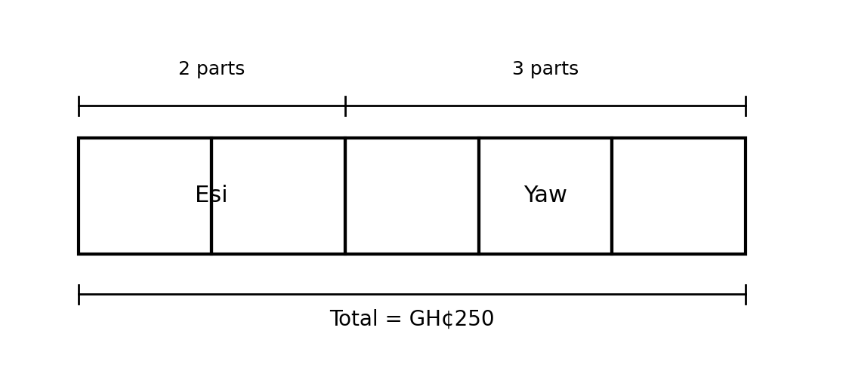
Fig. 2 — GH₵250 shared between Esi and Yaw in the ratio 2 : 3
(c) Fig. 2 shows GH₵250 shared between Esi and Yaw in the ratio 2 : 3. Find each person's share. Total parts = 5; one part = 250 ÷ 5 = GH₵50. Esi = 2 × 50 = GH₵100; Yaw = 3 × 50 = GH₵150. [5 marks]
[Total: 10 marks]

3. Simple interest [10 marks]
A girl deposited GH₵4,500 at the bank at a rate of 3% per annum.
(a) Write down the simple interest formula and explain each letter. I = PRT/100, where I = interest, P = principal, R = rate per annum, T = time in years. [2 marks]
(b) Find the simple interest earned in 3 years, and the amount. I = (4,500 × 3 × 3)/100 = GH₵405. Amount = 4,500 + 405 = GH₵4,905. [4 marks]
(c) What is the amount at the end of the fifth year? I = (4,500 × 3 × 5)/100 = GH₵675. Amount = 4,500 + 675 = GH₵5,175. [2 marks]
(d) A different investment of GH₵2,000 amounts to GH₵2,400 in 4 years at simple interest. Find the rate. I = 2,400 − 2,000 = GH₵400. R = (I × 100)/(P × T) = (400 × 100)/(2,000 × 4) = 5%. [2 marks]
[Total: 10 marks]

4. VAT, discount and commission [10 marks]
(a) A man bought an item at GH₵4,500.00, VAT inclusive at 12.5%. Calculate the basic cost and the VAT paid. Basic cost = 4,500 ÷ 1.125 = GH₵4,000. VAT = 4,500 − 4,000 = GH₵500 (or 12.5% of 4,000). [4 marks]
(b) A car costs GH₵80,500.00. What is its new value if there is a discount of 10%? Discount = 80,500 × 0.10 = GH₵8,050. New value = 80,500 − 8,050 = GH₵72,450. [3 marks]
(c) An agent's commission on the sale of a car is 3 1/2%. Calculate the commission on a car sold for GH₵68,000.00. Commission = 3.5% of 68,000 = (3.5 × 68,000)/100 = GH₵2,380. [3 marks]
[Total: 10 marks]

5. SSNIT contributions [10 marks]
The table shows the SSNIT contribution rates.
 | Act 766 | PNDCL 247
Employer | 13.0% of basic salary | 12.5% of basic salary
Worker | 5.5% of basic salary | 5.0% of basic salary
Total | 18.5% of basic salary | 17.5% of basic salary
(a) A worker's basic monthly salary is GH₵3,256.50. Calculate the SSNIT contributions under Act 766 by (i) the worker and (ii) the employer. (i) Worker: 5.5% of 3,256.50 = GH₵179.11 (179.1075); (ii) Employer: 13% of 3,256.50 = GH₵423.35 (423.345). [4 marks]
(b) What is the total SSNIT contribution at the end of every month? 18.5% of 3,256.50 = GH₵602.45 (602.4525). [2 marks]
(c) Mr Bediako's monthly SSNIT contribution under PNDCL 247 is GH₵440.54. How much does his employer contribute, and what is his basic salary per month? Employer rate 12.5% vs worker 5%, i.e. 2.5 × 440.54 = GH₵1,101.35. Basic salary = 440.54 ÷ 0.05 = GH₵8,810.80. [4 marks]
[Total: 10 marks]

6. Graphing a proportional relationship [10 marks]
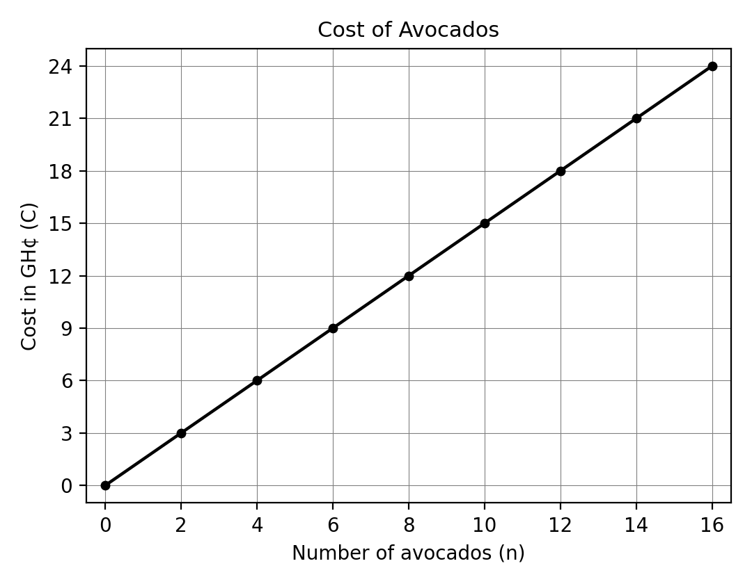
Fig. 1 — Cost of avocados
(a) From the graph, how much do 8 avocados cost? Read across from n = 8: C = GH₵12.00. [2 marks]
(b) Determine the unit rate (the slope of the line). Using the point (2, 3): slope = 3 ÷ 2 = GH₵1.50 per avocado. [2 marks]
(c) Write the equation connecting the cost C and the number n of avocados. C = 1.5n. [2 marks]
(d) Write your own word problem that matches this graph, and solve it using the equation. Any coherent problem consistent with C = 1.5n, solved correctly. Example: 'How much do 15 avocados cost?' C = 1.5 × 15 = GH₵22.50. Award 2 marks for a valid problem, 2 for the correct solution. [4 marks]
[Total: 10 marks]

CURRICULUM BLUEPRINT
Qn | Content Focus | Indicator | Marks
1 | Simplify a ratio | B9.1.4.1.2 | 1
2 | Share in a given ratio | B9.1.4.1.2 | 1
3 | Find quantities from a ratio | B9.1.4.1.2 | 1
4 | Speed as a rate | B9.1.4.1.4 | 1
5 | Cost through unit rate | B9.1.4.1.4 | 1
6 | Proportional equation t = pn | B9.1.4.1.1 | 1
7 | Recognise direct proportion | B9.1.4.1.4 | 1
8 | Read a proportional graph (curriculum exemplar) | B9.1.4.1.4 | 1
9 | Use a proportional graph (curriculum exemplar) | B9.1.4.1.4 | 1
10 | Unit rate as slope (curriculum exemplar) | B9.1.4.1.4 | 1
11 | Simple interest formula | B9.1.4.1.2 | 1
12 | Simple interest (curriculum exemplar) | B9.1.4.1.2 | 1
13 | Amount after interest (curriculum exemplar) | B9.1.4.1.2 | 1
14 | Amount after extended period (curriculum exemplar) | B9.1.4.1.2 | 1
15 | Amount after interest | B9.1.4.1.2 | 1
16 | Find the principal | B9.1.4.1.2 | 1
17 | VAT calculation | B9.1.4.1.2 | 1
18 | VAT-inclusive price (curriculum exemplar) | B9.1.4.1.2 | 1
19 | VAT paid (curriculum exemplar) | B9.1.4.1.2 | 1
20 | Discount (curriculum exemplar) | B9.1.4.1.2 | 1
21 | Discount amount (curriculum exemplar) | B9.1.4.1.2 | 1
22 | Commission (curriculum exemplar) | B9.1.4.1.2 | 1
23 | Depreciation, first year (curriculum exemplar) | B9.1.4.1.2 | 1
24 | Depreciation, second year (curriculum exemplar) | B9.1.4.1.2 | 1
25 | NHIL exclusive price (curriculum exemplar) | B9.1.4.1.2 | 1
26 | NHIL charged (curriculum exemplar) | B9.1.4.1.2 | 1
27 | Insurance premium and value (curriculum exemplar) | B9.1.4.1.2 | 1
28 | SSNIT worker rate, Act 766 (curriculum exemplar) | B9.1.4.1.3 | 1
29 | SSNIT employer rate, Act 766 (curriculum exemplar) | B9.1.4.1.3 | 1
30 | SSNIT total rate, Act 766 (curriculum exemplar) | B9.1.4.1.3 | 1
31 | Worker contribution, Act 766 (curriculum exemplar) | B9.1.4.1.3 | 1
32 | Employer contribution, Act 766 (curriculum exemplar) | B9.1.4.1.3 | 1
33 | Total SSNIT, Act 766 (curriculum exemplar) | B9.1.4.1.3 | 1
34 | SSNIT worker rate, PNDCL 247 (curriculum exemplar) | B9.1.4.1.3 | 1
35 | Employer contribution, PNDCL 247 (curriculum exemplar) | B9.1.4.1.3 | 1
36 | Basic salary from contribution (curriculum exemplar) | B9.1.4.1.3 | 1
37 | Ratio from an equation | B9.1.4.1.2 | 1
38 | Map scale as a rate | B9.1.4.1.4 | 1
39 | Inverse proportion | B9.1.4.1.4 | 1
40 | Constant of proportionality | B9.1.4.1.1 | 1
B1 | Ratio and sharing | B9.1.4.1.2 | 10
B2 | Rates and proportion (incl. tape diagram) | B9.1.4.1.4 | 10
B3 | Simple interest | B9.1.4.1.2 | 10
B4 | VAT, discount and commission | B9.1.4.1.2 | 10
B5 | SSNIT contributions | B9.1.4.1.3 | 10
B6 | Graphing proportional relationships + create-and-solve | B9.1.4.1.4 / .1 | 10
 | TOTAL |  | 100

CURRICULUM COVERAGE BY INDICATOR
Curriculum Area | Section A | Section B | Total | %
B9.1.4.1.1 Proportional relationships by equations | 2 | 2 (B6c) | 4 | 4%
B9.1.4.1.2 Multistep ratio & percent (interest, VAT, discount, commission, depreciation, NHIL, insurance) | 21 | 30 (B1, B3, B4) | 51 | 51%
B9.1.4.1.3 SSNIT contributions and benefits | 9 | 10 (B5) | 19 | 19%
B9.1.4.1.4 Graphs of proportional relationships; unit rate as slope; rates | 8 | 18 (B2, B6) | 26 | 26%
Note: Section A q6 and q40 test equations of proportion (2 marks); q1–3 and q11–27 and q37 test multistep ratio/percent problems (21); q28–36 test SSNIT (9); q4–5, q7–10, q38–39 test rates and graphs (8). Section B: B1, B3, B4 = percent problems (30); B5 = SSNIT (10); B2 and B6 = rates, graphs and create-and-solve (20), of which B6(c) equation (2 marks) is credited to .1.

COGNITIVE-LEVEL DISTRIBUTION
Cognitive Level | Section A | Section B | Total | %
Remember | 5 | 0 | 5 | 5%
Understand | 2 | 0 | 2 | 2%
Apply | 24 | 50 | 74 | 74%
Analyse | 9 | 0 | 9 | 9%
Evaluate | 0 | 0 | 0 | 0%
Create | 0 | 10 | 10 | 10%

DIFFICULTY DISTRIBUTION
Difficulty | Section A | Section B | Total | %
Easy | 17 | 10 (B1) | 27 | 27%
Moderate | 15 | 30 (B2, B3, B4) | 45 | 45%
Challenging | 8 | 20 (B5, B6) | 28 | 28%

QUALITY-CONTROL SUMMARY
Check | Status
Curriculum alignment | All four indicators of B9.1.4.1 covered: proportional equations (.1), multistep ratio & percent problems (.2), SSNIT (.3), graphs and unit rate as slope (.4).
Section structure | Section A: 40 objectives (40 marks). Section B: 6 structured questions (60 marks). Total 100 marks, 2 hours.
Answer key balance | A=10, B=10, C=10, D=10. Zero consecutive repeats. No sustained cycling pattern.
Diagrams (BECE style) | Fig. 1 — proportional graph (cost of avocados, curriculum exemplar) used in Section A q8–10 and Section B Q6; Fig. 2 — ratio tape/bar model used in Section B Q2(c); SSNIT rate table included.
Curriculum exemplars used | Avocado graph (₵1.50 slope); GH₵4,500 at 3% p.a.; VAT-inclusive GH₵4,500; car discount GH₵80,500; commission 3 1/2% on GH₵68,000; phone depreciation GH₵1,800; NHIL GH₵1,200; insurance premium GH₵30,000; SSNIT salary GH₵3,256.50 and GH₵440.54 — all from the CCP.
Distractor quality | Plausible errors: inverted ratios (3:2), adding instead of multiplying rates, banker's-rounding traps (423.34 vs 423.35), misreading inclusive/exclusive VAT, direct-vs-inverse proportion confusion (24 days vs 6 days).
Marking guide completeness | Every Section B part carries explicit marks (each question sums to 10); full worked steps shown; rounding convention (round half up) noted.
Blueprint | 46-row blueprint (40 objectives + 6 structured) sums to exactly 100 marks.
Coverage | .1 = 4%, .2 = 51%, .3 = 19%, .4 = 26%.
Cognitive spread | Remember 5%, Understand 2%, Apply 74%, Analyse 9%, Create 10%.
Difficulty spread | Easy 27%, Moderate 45%, Challenging 28%.

