BEACON EDUCATIONAL CONSULT
MOCK EXAMINATION — 2026/2027 ACADEMIC YEAR
MATHEMATICS — BASIC 9 (JHS 3)
Chapter 7: Ratio, Rate and Proportion (Curriculum Standard B9.1.4.1)
Time Allowed: 2 Hours Total Marks: 100

INSTRUCTIONS TO CANDIDATES
1. Write your name and index number on the answer sheet provided.
2. This paper consists of TWO sections: Section A (Objectives) and Section B (Structured Questions).
3. Section A: Answer ALL forty (40) questions. Each question carries 1 mark. Choose the correct option from A to D.
4. Section B: Answer ALL six (6) questions. Each question carries 10 marks. Show all necessary workings.
5. Study all diagrams carefully before answering the questions that refer to them.
6. Use a non-programmable calculator where necessary.

SECTION A: OBJECTIVE TEST (40 MARKS)
Answer ALL questions in this section. Choose the correct answer from A to D.
1. Express 12 : 18 in its simplest form.
A. 3 : 2
B. 2 : 3
C. 4 : 6
D. 12 : 18
2. GH₵120 is shared between Ama and Kofi in the ratio 2 : 3. How much does Ama receive?
A. GH₵48
B. GH₵72
C. GH₵60
D. GH₵50
3. In a class, the ratio of boys to girls is 3 : 5. If there are 40 pupils, how many boys are there?
A. 12
B. 15
C. 25
D. 24
4. A car travels 180 km in 3 hours. Find its speed.
A. 540 km/h
B. 90 km/h
C. 45 km/h
D. 60 km/h
5. If 4 pens cost GH₵12, find the cost of 7 pens.
A. GH₵14
B. GH₵21
C. GH₵24
D. GH₵28
6. The total cost t of items is proportional to the number n at GH₵4.50 each (t = pn). Find t when n = 6.
A. GH₵27.00
B. GH₵13.50
C. GH₵10.50
D. GH₵27.50
7. The graph of two quantities is a straight line through the origin. The relationship is
A. inversely proportional
B. constant
C. directly proportional
D. zero
Questions 8 to 10 refer to Fig. 1 below.
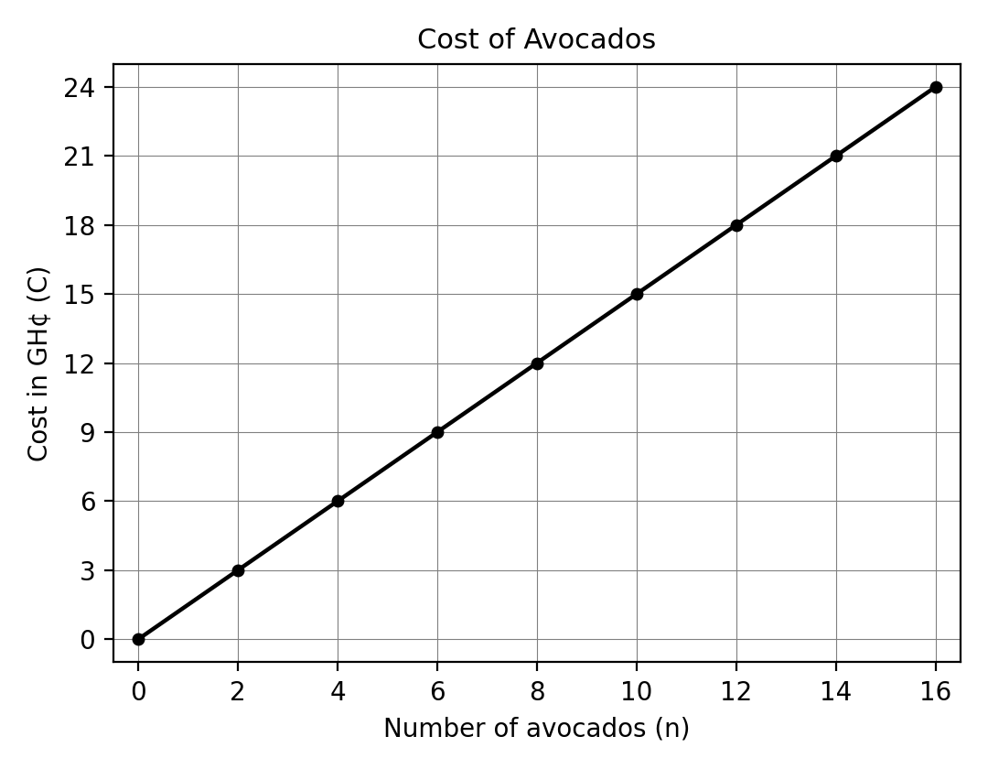
Fig. 1 — The graph shows the cost of avocados.
8. How much do 8 avocados cost?
A. GH₵10.50
B. GH₵12.00
C. GH₵16.00
D. GH₵8.00
9. Using the graph, how much do 15 avocados cost?
A. GH₵24.00
B. GH₵15.00
C. GH₵20.00
D. GH₵22.50
10. The unit rate of the graph (its slope) is
A. GH₵1.50 per avocado
B. GH₵3.00 per avocado
C. GH₵2.00 per avocado
D. GH₵0.50 per avocado
11. In the simple interest formula I = PRT/100, the letter R represents the
A. time in years
B. amount
C. principal
D. rate of interest per annum
12. Find the simple interest on GH₵4,500 invested at 3% per annum for 3 years.
A. GH₵4,905
B. GH₵405
C. GH₵135
D. GH₵450
13. The amount at the end of the 3 years in the previous question is
A. GH₵4,905
B. GH₵4,505
C. GH₵4,635
D. GH₵5,175
14. The amount at the end of the fifth year is
A. GH₵5,025
B. GH₵5,850
C. GH₵4,905
D. GH₵5,175
15. Find the amount on GH₵2,000 invested at 5% per annum simple interest for 2 years.
A. GH₵2,500
B. GH₵2,100
C. GH₵2,200
D. GH₵2,020
16. The simple interest on a principal for 4 years at 5% per annum is GH₵300. The principal is
A. GH₵60
B. GH₵1,500
C. GH₵3,000
D. GH₵1,200
17. The VAT rate in Ghana is 12.5%. The VAT on an item priced GH₵400 (exclusive) is
A. GH₵450
B. GH₵500
C. GH₵12.50
D. GH₵50
18. A man bought an item at GH₵4,500.00, VAT inclusive, at 12.5%. The basic cost of the item is
A. GH₵4,500
B. GH₵4,000
C. GH₵3,937.50
D. GH₵4,062.50
19. The VAT paid by the man is
A. GH₵562.50
B. GH₵450
C. GH₵625
D. GH₵500
20. A car costs GH₵80,500.00. Its new value after a discount of 10% is
A. GH₵72,450
B. GH₵72,500
C. GH₵70,450
D. GH₵79,695
21. The discount allowed on the car is
A. GH₵10,050
B. GH₵8,500
C. GH₵8,050
D. GH₵805
22. An agent's commission on the sale of a car is 3 1/2%. The commission on a car sold for GH₵68,000.00 is
A. GH₵238
B. GH₵2,040
C. GH₵3,400
D. GH₵2,380
23. A mobile phone originally worth GH₵1,800 depreciates by 5% of its original value in the first year. Its value at the end of the first year is
A. GH₵1,755
B. GH₵1,710
C. GH₵90
D. GH₵1,620
24. In the second year the phone depreciates by 10% of the original value. Its value at the end of the second year is
A. GH₵1,710
B. GH₵1,530
C. GH₵1,620
D. GH₵1,638
25. The NHIL inclusive price of a television set is GH₵1,200.00. If the NHIL is charged at 2.5%, the cost of the television (NHIL exclusive) is
A. GH₵1,170.73
B. GH₵1,170.00
C. GH₵30.00
D. GH₵1,230.00
26. The NHIL charged is
A. GH₵25.00
B. GH₵29.00
C. GH₵29.27
D. GH₵30.00
27. Kofi Mereku paid an insurance premium of GH₵30,000.00. If the premium is 5% of the value of the house, the insured value is
A. GH₵60,000
B. GH₵150,000
C. GH₵1,500,000
D. GH₵600,000
28. Under Act 766, the SSNIT contribution rate of the worker is
A. 13% of basic salary
B. 5% of basic salary
C. 5.5% of basic salary
D. 18.5% of basic salary
29. Under Act 766, the SSNIT contribution rate of the employer is
A. 12.5% of basic salary
B. 17.5% of basic salary
C. 5.5% of basic salary
D. 13% of basic salary
30. The total monthly SSNIT contribution under Act 766 is
A. 18.5% of basic salary
B. 8.5% of basic salary
C. 17.5% of basic salary
D. 18% of basic salary
31. A worker's basic monthly salary is GH₵3,256.50. The worker's SSNIT contribution under Act 766 is
A. GH₵423.35
B. GH₵162.83
C. GH₵179.11
D. GH₵179.00
32. The employer's SSNIT contribution on the same salary is
A. GH₵423.34
B. GH₵423.35
C. GH₵406.56
D. GH₵179.11
33. The total SSNIT contribution at the end of every month is
A. GH₵625.00
B. GH₵602.46
C. GH₵602.45
D. GH₵586.17
34. Under PNDCL 247, the worker's SSNIT contribution rate is
A. 5.5% of basic salary
B. 5% of basic salary
C. 12.5% of basic salary
D. 13% of basic salary
35. Mr Bediako's monthly SSNIT contribution under PNDCL 247 is GH₵440.54. His employer contributes
A. GH₵440.54
B. GH₵1,221.50
C. GH₵1,101.35
D. GH₵881.08
36. Mr Bediako's basic salary per month is
A. GH₵8,810.80
B. GH₵3,524.32
C. GH₵4,405.40
D. GH₵8,810.00
37. If 3a = 4b, then a : b is
A. 3 : 4
B. 12 : 1
C. 1 : 12
D. 4 : 3
38. A map has a scale of 1 : 50,000. A road measures 4 cm on the map. The actual length of the road is
A. 2 km
B. 200 m
C. 200,000 km
D. 20 km
39. 5 workers take 12 days to complete a job. At the same rate, 10 workers will take
A. 4 days
B. 24 days
C. 6 days
D. 9 days
40. y is directly proportional to x, so y = kx. If y = 12 when x = 3, then k =
A. 4
B. 36
C. 15
D. 9

SECTION B: STRUCTURED QUESTIONS (60 MARKS)
Answer ALL questions in this section. Show all workings clearly.

1. Ratio and sharing
(a) Express 36 : 48 in its simplest form. [2 marks]
(b) Share GH₵450 between Esi and Yaw in the ratio 2 : 3. [4 marks]
(c) The angles of a triangle are in the ratio 2 : 3 : 4. Find each angle. [4 marks]
[Total: 10 marks]

2. Rates and proportion
(a) A bus travels 240 km in 3 hours. Find its speed. [2 marks]
(b) If 6 loaves of bread cost GH₵39.00, find the cost of 10 loaves. [3 marks]
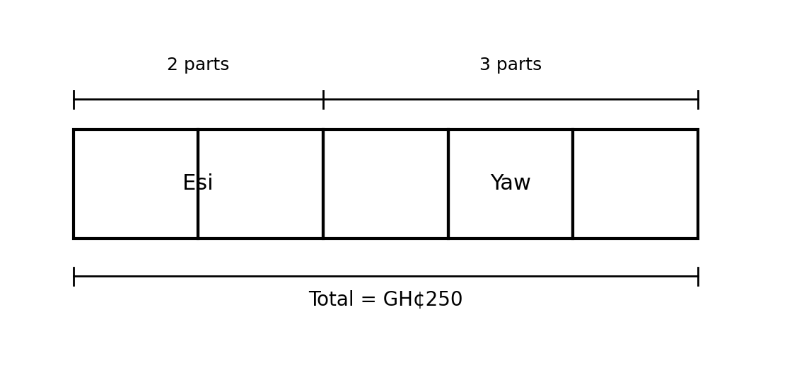
Fig. 2 — GH₵250 shared between Esi and Yaw in the ratio 2 : 3
(c) Fig. 2 shows GH₵250 shared between Esi and Yaw in the ratio 2 : 3. Find each person's share. [5 marks]
[Total: 10 marks]

3. Simple interest
A girl deposited GH₵4,500 at the bank at a rate of 3% per annum.
(a) Write down the simple interest formula and explain each letter. [2 marks]
(b) Find the simple interest earned in 3 years, and the amount. [4 marks]
(c) What is the amount at the end of the fifth year? [2 marks]
(d) A different investment of GH₵2,000 amounts to GH₵2,400 in 4 years at simple interest. Find the rate. [2 marks]
[Total: 10 marks]

4. VAT, discount and commission
(a) A man bought an item at GH₵4,500.00, VAT inclusive at 12.5%. Calculate the basic cost and the VAT paid. [4 marks]
(b) A car costs GH₵80,500.00. What is its new value if there is a discount of 10%? [3 marks]
(c) An agent's commission on the sale of a car is 3 1/2%. Calculate the commission on a car sold for GH₵68,000.00. [3 marks]
[Total: 10 marks]

5. SSNIT contributions
The table shows the SSNIT contribution rates.
 | Act 766 | PNDCL 247
Employer | 13.0% of basic salary | 12.5% of basic salary
Worker | 5.5% of basic salary | 5.0% of basic salary
Total | 18.5% of basic salary | 17.5% of basic salary
(a) A worker's basic monthly salary is GH₵3,256.50. Calculate the SSNIT contributions under Act 766 by (i) the worker and (ii) the employer. [4 marks]
(b) What is the total SSNIT contribution at the end of every month? [2 marks]
(c) Mr Bediako's monthly SSNIT contribution under PNDCL 247 is GH₵440.54. How much does his employer contribute, and what is his basic salary per month? [4 marks]
[Total: 10 marks]

6. Graphing a proportional relationship
Fig. 1 — Cost of avocados
(a) From the graph, how much do 8 avocados cost? [2 marks]
(b) Determine the unit rate (the slope of the line). [2 marks]
(c) Write the equation connecting the cost C and the number n of avocados. [2 marks]
(d) Write your own word problem that matches this graph, and solve it using the equation. [4 marks]
[Total: 10 marks]

