BEACON EDUCATIONAL CONSULT
MARKING GUIDE — MOCK EXAMINATION 2026/2027
MATHEMATICS — BASIC 9 (JHS 3) — Chapter 8: Simultaneous Linear Equations (B9.2.1.1)

Curriculum Standard (NaCCA CCP, Sept 2020): B9.2.1.1 — Demonstrate the ability to construct tables of values for pairs of linear relations, graph the relations in a number plane and determine the intersection of the lines to solve simultaneous linear equations.
Indicators tested: B9.2.1.1.1 Construct a table of values for two linear relations and graph the relation; B9.2.1.1.2 Use graphs of two linear relations to determine subsequent missing elements in ordered pairs; B9.2.1.1.3 Use graphs to solve equations involving two linear relations.

SECTION A: ANSWER KEY
Qn | Ans | Content Focus | Indicator
1 | D | Table of values | B9.2.1.1.1
2 | A | Table of values (curriculum exemplar) | B9.2.1.1.1
3 | C | Table of values (curriculum exemplar) | B9.2.1.1.1
4 | A | Table of values | B9.2.1.1.1
5 | B | Ordered pairs on a line | B9.2.1.1.1
6 | A | Points on a line | B9.2.1.1.1
7 | C | Complete a table | B9.2.1.1.1
8 | B | Complete a table | B9.2.1.1.1
9 | C | Gradient | B9.2.1.1.2
10 | D | y-intercept | B9.2.1.1.2
11 | C | Ordered pair (curriculum exemplar) | B9.2.1.1.2
12 | B | Ordered pair (curriculum exemplar) | B9.2.1.1.2
13 | C | Intersection of two lines (curriculum exemplar) | B9.2.1.1.2
14 | B | x-intercept | B9.2.1.1.2
15 | A | y-intercept | B9.2.1.1.2
16 | C | Gradient | B9.2.1.1.2
17 | B | Simultaneous equations (curriculum exemplar) | B9.2.1.1.3
18 | D | Simultaneous equations (curriculum exemplar) | B9.2.1.1.3
19 | B | Simultaneous equations | B9.2.1.1.3
20 | C | Simultaneous equations | B9.2.1.1.3
21 | A | Parallel lines: no solution | B9.2.1.1.3
22 | D | Coincident lines | B9.2.1.1.3
23 | B | Read the intersection (Fig. 1) | B9.2.1.1.3
24 | A | Read a value from the graph | B9.2.1.1.2
25 | B | Elimination method | B9.2.1.1.3
26 | D | Elimination method | B9.2.1.1.3
27 | B | Elimination method | B9.2.1.1.3
28 | D | Word problem | B9.2.1.1.3
29 | A | Word problem (cost) | B9.2.1.1.3
30 | D | Word problem (ages) | B9.2.1.1.3
31 | C | Word problem (livestock) | B9.2.1.1.3
32 | D | Substitution method | B9.2.1.1.3
33 | A | Table of values | B9.2.1.1.1
34 | D | Table of values | B9.2.1.1.1
35 | A | Relation from a table | B9.2.1.1.1
36 | C | Table from a relation | B9.2.1.1.1
37 | A | Shape of a linear graph | B9.2.1.1.1
38 | B | x-intercept | B9.2.1.1.2
39 | D | Solution from intersection | B9.2.1.1.3
40 | C | Graphical method | B9.2.1.1.3

Full answer key: DACAB ACBCD CBCBA CBDBC ADBAB DBDAD CDADA CABDC

SECTION A: WORKED SOLUTIONS
1. Answer: D. 2 × 3 + 1 = 7. [B9.2.1.1.1]
2. Answer: A. −(−3) + 5 = 8 (curriculum table value). [B9.2.1.1.1]
3. Answer: C. ½ × 4 − 3 = 2 − 3 = −1. [B9.2.1.1.1]
4. Answer: A. 3 × (−2) − 2 = −6 − 2 = −8. [B9.2.1.1.1]
5. Answer: B. (−1, 3): −1 + 4 = 3 ✓. The others give 1 + 4 = 5 ≠ 3; −4 + 4 = 0 ≠ 1; 0 + 4 = 4 ≠ −4. [B9.2.1.1.1]
6. Answer: A. (2, 4): 2 × 2 − 1 = 3 ≠ 4, so it is not on the line; (1, 1), (3, 5), (0, −1) all satisfy y = 2x − 1. [B9.2.1.1.1]
7. Answer: C. −0 + 5 = 5. [B9.2.1.1.1]
8. Answer: B. ½ × (−2) − 3 = −1 − 3 = −4. [B9.2.1.1.1]
9. Answer: C. y = −x + 4 is y = mx + c with m = −1. [B9.2.1.1.2]
10. Answer: D. c = −2. [B9.2.1.1.2]
11. Answer: C. −(−1) + 4 = 5 (curriculum exemplar). [B9.2.1.1.2]
12. Answer: B. −1 − 2 = −3 (curriculum exemplar). [B9.2.1.1.2]
13. Answer: C. −x + 4 = x − 2 → 6 = 2x → x = 3, y = 1 → (3, 1). [B9.2.1.1.2]
14. Answer: B. Set y = 0: 0 = x − 2 → x = 2. [B9.2.1.1.2]
15. Answer: A. Set x = 0: y = 4 → (0, 4). [B9.2.1.1.2]
16. Answer: C. m = ½. [B9.2.1.1.2]
17. Answer: B. −x + 7 = 2x + 1 → 3x = 6 → x = 2, y = 5 (curriculum exemplar). [B9.2.1.1.3]
18. Answer: D. x + 4 = 6 − x → 2x = 2 → x = 1, y = 5 (curriculum exemplar). [B9.2.1.1.3]
19. Answer: B. 2x = x + 3 → x = 3, y = 6. [B9.2.1.1.3]
20. Answer: C. x + 1 = 2x − 1 → x = 2, y = 3. [B9.2.1.1.3]
21. Answer: A. Equal gradients (2) with different intercepts → parallel lines → no common point → no solution. [B9.2.1.1.3]
22. Answer: D. The equations describe the same line; every point on it satisfies both → infinitely many solutions. [B9.2.1.1.3]
23. Answer: B. From Fig. 1 the lines cross at (2, 3). [B9.2.1.1.3]
24. Answer: A. Read/extend the line: 2 × 4 − 1 = 7. [B9.2.1.1.2]
25. Answer: B. Adding: 2x = 10 → x = 5; y = 7 − 5 = 2. [B9.2.1.1.3]
26. Answer: D. Subtracting: x = 3; y = 5 − 3 = 2. [B9.2.1.1.3]
27. Answer: B. Adding: 4x = 12 → x = 3; y = 5 − 3 = 2. [B9.2.1.1.3]
28. Answer: D. x + y = 10 and x − y = 4 → x = 7, y = 3. [B9.2.1.1.3]
29. Answer: A. p = q + 2; 3p + 2q = 16 → 3(q + 2) + 2q = 16 → 5q = 10 → q = 2, p = 4. [B9.2.1.1.3]
30. Answer: D. A = K + 3; A + K = 25 → 2K + 3 = 25 → K = 11, A = 14. [B9.2.1.1.3]
31. Answer: C. 2g + s = 700 and g + 2s = 800 → g + s = 500 and g − s = −100 → g = 200, s = 300. [B9.2.1.1.3]
32. Answer: D. 3x = x + 8 → 2x = 8 → x = 4, y = 12. [B9.2.1.1.3]
33. Answer: A. −3 + 5 = 2. [B9.2.1.1.1]
34. Answer: D. 0 − 3 = −3. [B9.2.1.1.1]
35. Answer: A. y increases by 2 for each step and starts at 1 → y = 2x + 1. [B9.2.1.1.1]
36. Answer: C. x − 2 gives: 0 → −2, 2 → 0, 4 → 2. [B9.2.1.1.1]
37. Answer: A. m = −1 < 0 (slopes down) and c = +5. [B9.2.1.1.1]
38. Answer: B. 0 = ½x − 3 → x = 6. [B9.2.1.1.2]
39. Answer: D. The intersection gives the (x, y) pair satisfying both relations: x = 2, y = 5. [B9.2.1.1.3]
40. Answer: C. The intersection of the two lines. [B9.2.1.1.3]

SECTION B: MARKING SCHEME

1. Tables of values and intersection [10 marks]
x | -2 | -1 | 0 | 1 | 2 | 3 | 4
y = −x + 4 | 6 | 5 | 4 | 3 | 2 | 1 | 0
y = x − 2 | -4 | -3 | -2 | -1 | 0 | 1 | 2
(a) Copy and complete the table of values for the relation y = −x + 4 for x from −2 to 4. y1 = −x + 4 gives: 6, 5, 4, 3, 2, 1, 0. [2 marks]
(b) Copy and complete the table of values for the relation y = x − 2 for the same values of x. y2 = x − 2 gives: −4, −3, −2, −1, 0, 1, 2. [2 marks]
(c) Using a graph sheet, draw both lines and determine the coordinates of their intersection. Plot the points and join with straight lines; the lines intersect at (3, 1) (curriculum exemplar). [3 marks]
(d) Determine the corresponding values of y for both relations when x = −1. When x = −1: y = −x + 4 gives 5; y = x − 2 gives −3 (curriculum exemplar). [3 marks]
[Total: 10 marks]

2. Graphing two linear relations [10 marks]
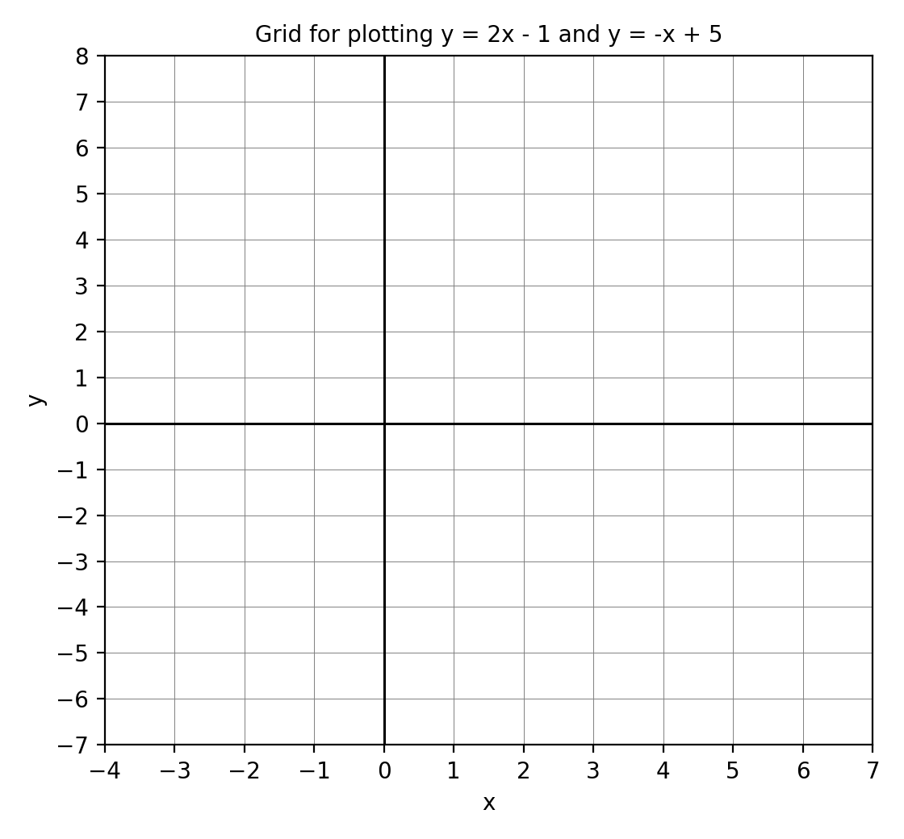
Fig. 2 — Use this empty grid for Question 2.
(a) Copy and complete a table of values for y = 2x − 1 for x from −2 to 4. y = 2x − 1 gives: −5, −3, −1, 1, 3, 5, 7. [2 marks]
(b) Copy and complete a table of values for y = −x + 5 for the same values of x. y = −x + 5 gives: 7, 6, 5, 4, 3, 2, 1. [2 marks]
(c) Plot the points and draw both straight lines on the grid in Fig. 2. Two straight lines: y = 2x − 1 through (0, −1) with slope 2; y = −x + 5 through (0, 5) with slope −1 (the correctly drawn lines are shown in Fig. 1, Question 5). [2 marks]
(d) State the coordinates of the intersection of the two lines. The lines cross at (2, 3). [2 marks]
(e) Hence write down the solution of the simultaneous equations y = 2x − 1 and y = −x + 5. x = 2 and y = 3. [2 marks]
[Total: 10 marks]

3. Solving simultaneous equations algebraically [10 marks]
(a) Using elimination, solve x + y = 7 and x − y = 3. Adding: 2x = 10 → x = 5; then y = 7 − 5 = 2. Solution: (5, 2). Check: 5 + 2 = 7 ✓, 5 − 2 = 3 ✓. [3 marks]
(b) Using elimination, solve 2x + y = 8 and x + y = 5. Subtracting: x = 3; then y = 5 − 3 = 2. Solution: (3, 2). Check: 6 + 2 = 8 ✓, 3 + 2 = 5 ✓. [3 marks]
(c) Using substitution, solve y = 3x and 2x + y = 15. 2x + 3x = 15 → 5x = 15 → x = 3; y = 3 × 3 = 9. Solution: (3, 9). Check: 6 + 9 = 15 ✓. [4 marks]
[Total: 10 marks]

4. Word problems [10 marks]
(a) The sum of two numbers is 10 and their difference is 4. Write two equations to represent this. Let the numbers be x and y: x + y = 10 and x − y = 4. [2 marks]
(b) Solve your equations to find the two numbers. Adding: 2x = 14 → x = 7; y = 10 − 7 = 3. The numbers are 7 and 3. [3 marks]
(c) Two goats and one sheep cost GH₵700. One goat and two sheep cost GH₵800. Write equations for the cost g of a goat and s of a sheep. 2g + s = 700 and g + 2s = 800. [2 marks]
(d) Solve the equations to find the cost of a goat and of a sheep. Adding: 3g + 3s = 1,500 → g + s = 500. Subtracting the second original from the first: g − s = −100. So g = 200, s = 300. A goat costs GH₵200 and a sheep GH₵300. [3 marks]
[Total: 10 marks]

5. Reading the graph (Fig. 1) [10 marks]
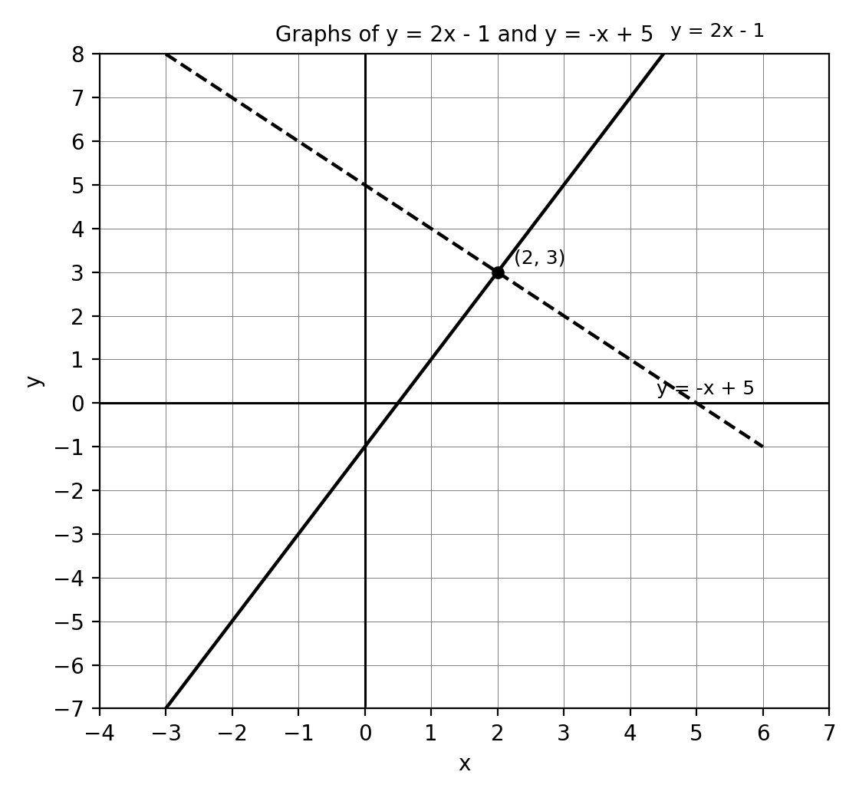
Fig. 1 — Graphs of y = 2x − 1 and y = −x + 5
(a) State the coordinates of the intersection of the two lines. (2, 3). [2 marks]
(b) Write down the gradient of each line. y = 2x − 1 has gradient 2; y = −x + 5 has gradient −1. [2 marks]
(c) Write down the y-intercept of each line. y = 2x − 1 cuts the y-axis at −1; y = −x + 5 cuts the y-axis at 5. [2 marks]
(d) Use the graph to find the value of x for which 2x − 1 = −x + 5. The lines have equal y at their intersection, so x = 2. [2 marks]
(e) From the graph, find y on the line y = 2x − 1 when x = −2. y = 2(−2) − 1 = −5. [2 marks]
[Total: 10 marks]

6. Create and solve [10 marks]
(a) Write down two linear relations of your own and construct a table of values for one of them (x = 0, 1, 2, 3). Any two valid linear relations with a correct table. Example: y = x + 2 (values 2, 3, 4, 5) and y = 2x − 1. Award 1 mark for relations, 2 for a correct table. [3 marks]
(b) Solve your two relations simultaneously (algebraically or graphically). Correct method and solution for the chosen pair. Example: x + 2 = 2x − 1 → x = 3, y = 5. Award 2 marks for method, 2 for solution. [4 marks]
(c) Write a word problem that can be modelled by two linear equations, and solve it. Any coherent problem solved correctly. Example: 'Two books and one pen cost GH₵25; one book and one pen cost GH₵15. Find the cost of a book.' → book = GH₵10, pen = GH₵5. Award 1 mark for problem, 2 for solution. [3 marks]
[Total: 10 marks]

CURRICULUM BLUEPRINT
Qn | Content Focus | Indicator | Marks
1 | Table of values | B9.2.1.1.1 | 1
2 | Table of values (curriculum exemplar) | B9.2.1.1.1 | 1
3 | Table of values (curriculum exemplar) | B9.2.1.1.1 | 1
4 | Table of values | B9.2.1.1.1 | 1
5 | Ordered pairs on a line | B9.2.1.1.1 | 1
6 | Points on a line | B9.2.1.1.1 | 1
7 | Complete a table | B9.2.1.1.1 | 1
8 | Complete a table | B9.2.1.1.1 | 1
9 | Gradient | B9.2.1.1.2 | 1
10 | y-intercept | B9.2.1.1.2 | 1
11 | Ordered pair (curriculum exemplar) | B9.2.1.1.2 | 1
12 | Ordered pair (curriculum exemplar) | B9.2.1.1.2 | 1
13 | Intersection of two lines (curriculum exemplar) | B9.2.1.1.2 | 1
14 | x-intercept | B9.2.1.1.2 | 1
15 | y-intercept | B9.2.1.1.2 | 1
16 | Gradient | B9.2.1.1.2 | 1
17 | Simultaneous equations (curriculum exemplar) | B9.2.1.1.3 | 1
18 | Simultaneous equations (curriculum exemplar) | B9.2.1.1.3 | 1
19 | Simultaneous equations | B9.2.1.1.3 | 1
20 | Simultaneous equations | B9.2.1.1.3 | 1
21 | Parallel lines: no solution | B9.2.1.1.3 | 1
22 | Coincident lines | B9.2.1.1.3 | 1
23 | Read the intersection (Fig. 1) | B9.2.1.1.3 | 1
24 | Read a value from the graph | B9.2.1.1.2 | 1
25 | Elimination method | B9.2.1.1.3 | 1
26 | Elimination method | B9.2.1.1.3 | 1
27 | Elimination method | B9.2.1.1.3 | 1
28 | Word problem | B9.2.1.1.3 | 1
29 | Word problem (cost) | B9.2.1.1.3 | 1
30 | Word problem (ages) | B9.2.1.1.3 | 1
31 | Word problem (livestock) | B9.2.1.1.3 | 1
32 | Substitution method | B9.2.1.1.3 | 1
33 | Table of values | B9.2.1.1.1 | 1
34 | Table of values | B9.2.1.1.1 | 1
35 | Relation from a table | B9.2.1.1.1 | 1
36 | Table from a relation | B9.2.1.1.1 | 1
37 | Shape of a linear graph | B9.2.1.1.1 | 1
38 | x-intercept | B9.2.1.1.2 | 1
39 | Solution from intersection | B9.2.1.1.3 | 1
40 | Graphical method | B9.2.1.1.3 | 1
B1 | Tables of values & intersection (curriculum exemplar pair) | B9.2.1.1.1 / .2 | 10
B2 | Graphing two linear relations on a grid | B9.2.1.1.1 | 10
B3 | Solving simultaneous equations algebraically | B9.2.1.1.3 | 10
B4 | Word problems modelled by simultaneous equations | B9.2.1.1.3 | 10
B5 | Reading graphs: intersection, gradients, intercepts | B9.2.1.1.2 | 10
B6 | Create & solve with linear relations | B9.2.1.1.3 | 10
 | TOTAL |  | 100

CURRICULUM COVERAGE BY INDICATOR
Curriculum Area | Section A | Section B | Total | %
B9.2.1.1.1 Tables of values; graphing linear relations | 13 | 20 (B1, B2) | 33 | 33%
B9.2.1.1.2 Ordered pairs; gradients and intercepts from graphs | 10 | 10 (B5) | 20 | 20%
B9.2.1.1.3 Solving simultaneous linear equations (graphical & algebraic) | 17 | 30 (B3, B4, B6) | 47 | 47%
Note: Section A q1–8 and q33–37 test tables of values and relations (13 marks); q9–16, q24 and q38 test ordered pairs, gradients and intercepts (10); q17–23 and q25–32, q39–40 test solving simultaneous equations (17). Section B: B1–B2 tables & graphing (20); B5 reading graphs (10); B3, B4, B6 solving and modelling (30). B1 is credited jointly to .1 and .2.

COGNITIVE-LEVEL DISTRIBUTION
Cognitive Level | Section A | Section B | Total | %
Remember | 0 | 0 | 0 | 0%
Understand | 9 | 0 | 9 | 9%
Apply | 25 | 50 | 75 | 75%
Analyse | 6 | 0 | 6 | 6%
Evaluate | 0 | 0 | 0 | 0%
Create | 0 | 10 | 10 | 10%

DIFFICULTY DISTRIBUTION
Difficulty | Section A | Section B | Total | %
Easy | 15 | 10 (B5) | 25 | 25%
Moderate | 21 | 40 (B1, B2, B3, B4) | 61 | 61%
Challenging | 4 | 10 (B6) | 14 | 14%

QUALITY-CONTROL SUMMARY
Check | Status
Curriculum alignment | All three indicators of B9.2.1.1 covered: tables of values & graphing (.1), missing ordered-pair elements from graphs (.2), solving simultaneous equations via graphs (.3).
Section structure | Section A: 40 objectives (40 marks). Section B: 6 structured questions (60 marks). Total 100 marks, 2 hours.
Answer key balance | A=10, B=10, C=10, D=10. Zero consecutive repeats. No sustained cycling pattern.
Diagrams (BECE style) | Fig. 1 — graphed pair y = 2x − 1 and y = −x + 5 with marked intersection (2, 3), used in Section A q23–24 and Section B Q5; Fig. 2 — blank plotting grid for Section B Q2; completed table of values for Q1 in the marking guide (blank in the question paper).
Curriculum exemplars used | y = −x + 5 and y = ½x − 3 table values; y = −x + 4 and y = x − 2 intersection (3, 1) and x = −1 values (5, −3); y = −x + 7 with y = 2x + 1 → (2, 5); y = x + 4 with y = 6 − x → (1, 5).
Distractor quality | Plausible errors: swapping coordinates (5, 2) vs (2, 5), sign errors on intercepts, points on only one of the lines, parallel/coincident-line misconceptions.
Marking guide completeness | Every Section B part carries explicit marks (each question sums to 10); full worked steps and checks shown; completed tables of values included.
Blueprint | 46-row blueprint (40 objectives + 6 structured) sums to exactly 100 marks.
Coverage | .1 = 33%, .2 = 20%, .3 = 47%.
Cognitive spread | Understand 9%, Apply 75%, Analyse 6%, Create 10%.
Difficulty spread | Easy 25%, Moderate 61%, Challenging 14%.

