BEACON EDUCATIONAL CONSULT
MOCK EXAMINATION — 2026/2027 ACADEMIC YEAR
MATHEMATICS — BASIC 9 (JHS 3)
Chapter 8: Simultaneous Linear Equations (Curriculum Standard B9.2.1.1)
Time Allowed: 2 Hours Total Marks: 100

INSTRUCTIONS TO CANDIDATES
1. Write your name and index number on the answer sheet provided.
2. This paper consists of TWO sections: Section A (Objectives) and Section B (Structured Questions).
3. Section A: Answer ALL forty (40) questions. Each question carries 1 mark. Choose the correct option from A to D.
4. Section B: Answer ALL six (6) questions. Each question carries 10 marks. Show all necessary workings.
5. Study all diagrams and graphs carefully before answering the questions that refer to them.
6. Use a non-programmable calculator where necessary.

SECTION A: OBJECTIVE TEST (40 MARKS)
Answer ALL questions in this section. Choose the correct answer from A to D.
1. The value of y when x = 3 on the line y = 2x + 1 is
A. 5
B. 6
C. 8
D. 7
2. The value of y when x = −3 on the relation y = −x + 5 is
A. 8
B. −2
C. 3
D. 2
3. The value of y when x = 4 on the relation y = ½x − 3 is
A. −2
B. 1
C. −1
D. −5
4. The value of y when x = −2 on the line y = 3x − 2 is
A. −8
B. −4
C. −6
D. 4
5. Which ordered pair lies on the line y = x + 4?
A. (−4, 1)
B. (−1, 3)
C. (0, −4)
D. (1, 3)
6. Which point does NOT lie on the line y = 2x − 1?
A. (2, 4)
B. (0, −1)
C. (1, 1)
D. (3, 5)
7. Completing the table for y = −x + 5: when x = 0, y is
A. 0
B. −5
C. 5
D. 1
8. Completing the table for y = ½x − 3: when x = −2, y is
A. −1
B. −4
C. 2
D. −2
9. The gradient of the line y = −x + 4 is
A. −4
B. 1
C. −1
D. 4
10. The y-intercept of the line y = x − 2 is
A. 2
B. 0
C. 1
D. −2
11. On the line y = −x + 4, when x = −1, y is
A. −5
B. −3
C. 5
D. 3
12. On the line y = x − 2, when x = −1, y is
A. 1
B. −3
C. −1
D. 3
13. The coordinates of the intersection of y = −x + 4 and y = x − 2 are
A. (1, 3)
B. (2, 2)
C. (3, 1)
D. (−3, 7)
14. The line y = x − 2 crosses the x-axis at x =
A. 0
B. 2
C. 4
D. −2
15. The line y = −x + 4 meets the y-axis at
A. (0, 4)
B. (1, 4)
C. (4, 0)
D. (0, −4)
16. The gradient of the line y = ½x − 3 is
A. −3
B. 2
C. ½
D. −½
17. Solving y = −x + 7 and y = 2x + 1 simultaneously gives
A. (1, 6)
B. (2, 5)
C. (3, 4)
D. (5, 2)
18. Solving y = x + 4 and y = 6 − x simultaneously gives
A. (−1, 5)
B. (5, 1)
C. (2, 4)
D. (1, 5)
19. Solving y = 2x and y = x + 3 simultaneously gives
A. (6, 3)
B. (3, 6)
C. (3, 5)
D. (2, 4)
20. Solving y = x + 1 and y = 2x − 1 simultaneously gives
A. (1, 2)
B. (2, 1)
C. (2, 3)
D. (3, 2)
21. The lines y = 2x + 1 and y = 2x − 3 have
A. no solution (they are parallel)
B. the solution (1, 3)
C. exactly one solution
D. infinitely many solutions
22. The equations y = x + 2 and y = x + 2 have
A. no solution
B. exactly one solution
C. the solution (0, 2) only
D. infinitely many solutions
Questions 23 and 24 refer to Fig. 1 below.
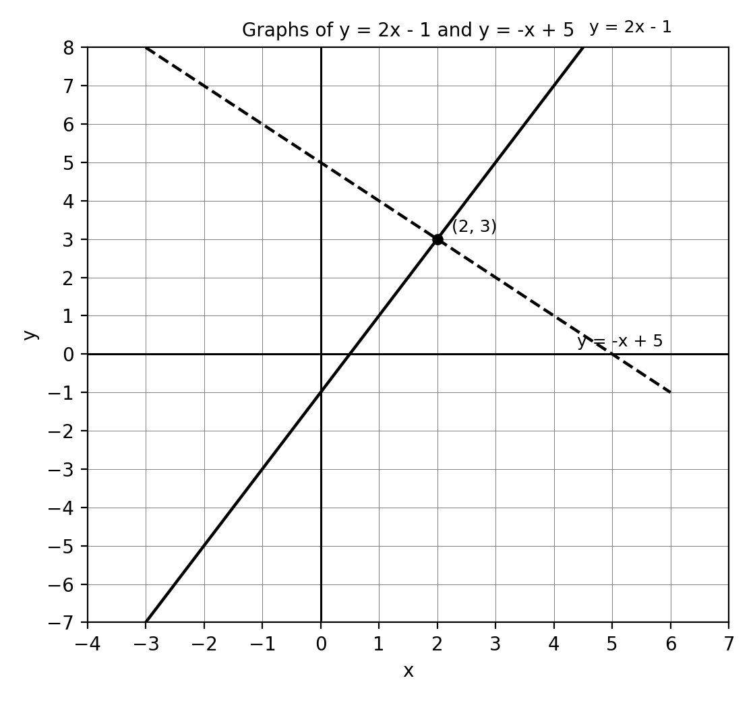
Fig. 1 — Graphs of y = 2x − 1 and y = −x + 5.
23. The graphs of y = 2x − 1 and y = −x + 5 intersect at
A. (1, 1)
B. (2, 3)
C. (0, 5)
D. (3, 2)
24. Using the graph, when x = 4 the value of y on y = 2x − 1 is
A. 7
B. 3
C. 8
D. 6
25. Solve simultaneously: x + y = 7 and x − y = 3.
A. x = 2, y = 5
B. x = 5, y = 2
C. x = 4, y = 3
D. x = 5, y = 3
26. Solve simultaneously: 2x + y = 8 and x + y = 5.
A. x = 4, y = 0
B. x = 3, y = 3
C. x = 2, y = 3
D. x = 3, y = 2
27. Solve simultaneously: 3x − y = 7 and x + y = 5.
A. x = 1, y = 4
B. x = 3, y = 2
C. x = 2, y = 1
D. x = 3, y = −2
28. The sum of two numbers is 10 and their difference is 4. The numbers are
A. 6 and 4
B. 8 and 2
C. 5 and 5
D. 7 and 3
29. A pen costs GH₵2 more than a pencil. Three pens and two pencils together cost GH₵16. The price of a pen is
A. GH₵4
B. GH₵5
C. GH₵6
D. GH₵3
30. Ama is 3 years older than Kofi. The sum of their ages is 25. Ama's age is
A. 12
B. 13
C. 15
D. 14
31. Two goats and one sheep cost GH₵700; one goat and two sheep cost GH₵800. The cost of a goat is
A. GH₵300
B. GH₵250
C. GH₵200
D. GH₵350
32. Solving y = 3x and y = x + 8 simultaneously gives
A. (12, 4)
B. (4, 20)
C. (8, 24)
D. (4, 12)
33. The value of y when x = 3 on the relation y = −x + 5 is
A. 2
B. 3
C. −2
D. 8
34. The value of y when x = 0 on the relation y = ½x − 3 is
A. 3
B. 0
C. −1.5
D. −3
35. The relation shown by the table x: 0, 1, 2, 3; y: 1, 3, 5, 7 is
A. y = 2x + 1
B. y = 2x − 1
C. y = 3x + 1
D. y = x + 1
36. Which table of values represents y = x − 2?
A. (−2, 0), (0, 2), (2, 4)
B. (0, 2), (2, 4), (4, 6)
C. (0, −2), (2, 0), (4, 2)
D. (0, 2), (2, 0), (4, −2)
37. The graph of y = −x + 5 is
A. a line sloping downwards from left to right, crossing the y-axis at 5
B. a line sloping upwards from left to right, crossing the y-axis at 5
C. a line sloping downwards from left to right, crossing the y-axis at −5
D. a line sloping upwards from left to right, crossing the y-axis at −5
38. The line y = ½x − 3 crosses the x-axis at x =
A. −6
B. 6
C. −3
D. 3
39. The graphs of two relations intersect at (2, 5). The solution of the simultaneous equations is
A. x = 7
B. x = 5 and y = 2
C. x = 2 only
D. x = 2 and y = 5
40. Graphically, the solution of simultaneous linear equations is found at
A. the y-intercepts of the lines
B. the x-intercepts of the lines
C. the intersection of the two lines
D. the midpoint of the lines

SECTION B: STRUCTURED QUESTIONS (60 MARKS)
Answer ALL questions in this section. Show all workings clearly.

1. Tables of values and intersection
x | -2 | -1 | 0 | 1 | 2 | 3 | 4
y = −x + 4
y = x − 2
(a) Copy and complete the table of values for the relation y = −x + 4 for x from −2 to 4. [2 marks]
(b) Copy and complete the table of values for the relation y = x − 2 for the same values of x. [2 marks]
(c) Using a graph sheet, draw both lines and determine the coordinates of their intersection. [3 marks]
(d) Determine the corresponding values of y for both relations when x = −1. [3 marks]
[Total: 10 marks]

2. Graphing two linear relations
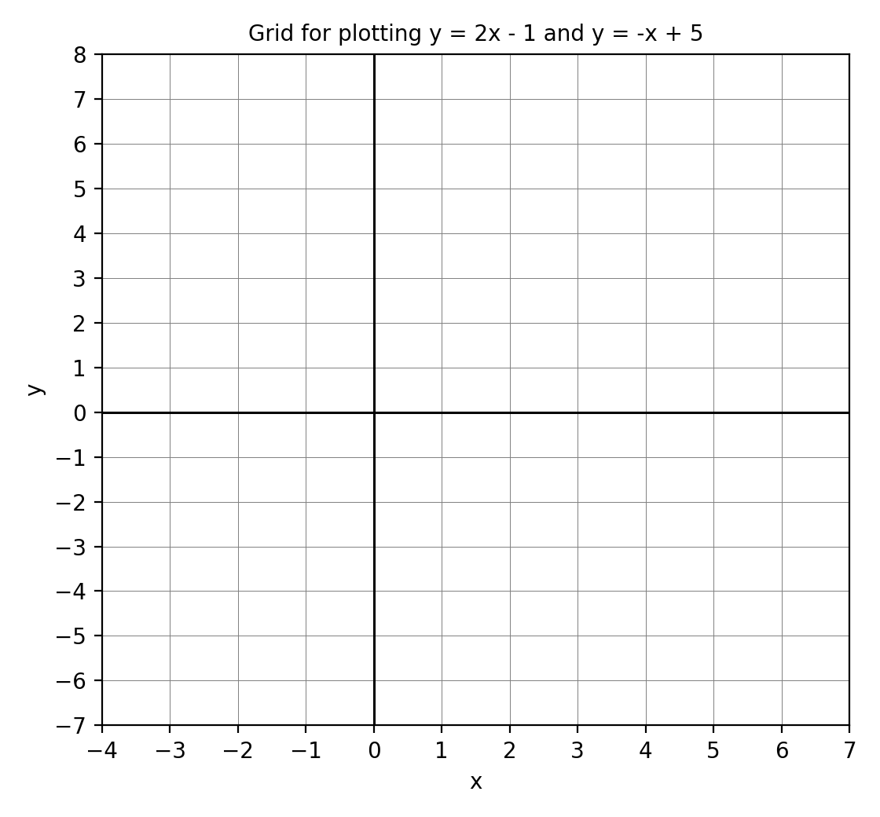
Fig. 2 — Use this empty grid for Question 2.
(a) Copy and complete a table of values for y = 2x − 1 for x from −2 to 4. [2 marks]
(b) Copy and complete a table of values for y = −x + 5 for the same values of x. [2 marks]
(c) Plot the points and draw both straight lines on the grid in Fig. 2. [2 marks]
(d) State the coordinates of the intersection of the two lines. [2 marks]
(e) Hence write down the solution of the simultaneous equations y = 2x − 1 and y = −x + 5. [2 marks]
[Total: 10 marks]

3. Solving simultaneous equations algebraically
(a) Using elimination, solve x + y = 7 and x − y = 3. [3 marks]
(b) Using elimination, solve 2x + y = 8 and x + y = 5. [3 marks]
(c) Using substitution, solve y = 3x and 2x + y = 15. [4 marks]
[Total: 10 marks]

4. Word problems
(a) The sum of two numbers is 10 and their difference is 4. Write two equations to represent this. [2 marks]
(b) Solve your equations to find the two numbers. [3 marks]
(c) Two goats and one sheep cost GH₵700. One goat and two sheep cost GH₵800. Write equations for the cost g of a goat and s of a sheep. [2 marks]
(d) Solve the equations to find the cost of a goat and of a sheep. [3 marks]
[Total: 10 marks]

5. Reading the graph (Fig. 1)
Fig. 1 — Graphs of y = 2x − 1 and y = −x + 5
(a) State the coordinates of the intersection of the two lines. [2 marks]
(b) Write down the gradient of each line. [2 marks]
(c) Write down the y-intercept of each line. [2 marks]
(d) Use the graph to find the value of x for which 2x − 1 = −x + 5. [2 marks]
(e) From the graph, find y on the line y = 2x − 1 when x = −2. [2 marks]
[Total: 10 marks]

6. Create and solve
(a) Write down two linear relations of your own and construct a table of values for one of them (x = 0, 1, 2, 3). [3 marks]
(b) Solve your two relations simultaneously (algebraically or graphically). [4 marks]
(c) Write a word problem that can be modelled by two linear equations, and solve it. [3 marks]
[Total: 10 marks]

